Chapter 1: Introduction

* 1. Statement of the problem:

Heating, Ventilating, and Air Conditioning (HVAC) equipment perform heating and/or cooling for residential, commercial or industrial buildings. The HVAC system may also be responsible for providing fresh outdoor air to dilute interior airborne contaminants in order to provide thermal comfort in the occupied space.

Accurate load calculations have a direct impact on energy efficiency, occupant comfort, indoor air quality, and building durability. The load calculation is the first step of the iterative HVAC design procedure, detailed load calculations include high complexity due to variety of affecting parameters such as space components, material’s thermal conductivity, occupants, sun exposure, climate,….etc.[1]

Problems associated with sizing:

Some HVAC contractors bypass the HVAC design process by using rules of thumb and [mess up the Manual load calculations](http://www.energyvanguard.com/blog-building-science-HERS-BPI/bid/25796/Got-Manual-J-Don-t-Assume-It-s-Correct) which lead to over or under sizing of the system.

* Oversized air conditioners don't run for a long time because they satisfy the cooling load quickly and then shut off. Properly sized air conditioners run longer.
* An oversized air conditioner can have a lot more start-ups and shut-downs than a properly sized air conditioner. That means you'll probably be repairing it more often and replacing it sooner.
* Under-size Air Conditioning system runs all the time, and the temperature rises beyond the comfort level.[2]

Rules of thumb:

A rule of thumb is a [principle](https://en.wikipedia.org/wiki/Principle) with broad application that is not intended to be strictly accurate or reliable for every situation. It is an easily applied procedure for approximately calculating or for making some determination, and that what we aim for in this project, simplifying the load calculations as possible with preserving acceptable level of accuracy.

Results in this report are applicable for Palestine considering data of 2015. Results are feasible and within acceptable range of accuracy.

Chapter 2: Theory

* 1. Fundamentals of heat transfer:

This section represents fundamentals of heat transfer relevant to air conditioning calculations.[3]

There are three modes of heat transfer which are: convection, radiation, and conduction

* In conduction mode of heat transfer, the systems are in physical contact and heat is transferred from one molecule to the adjacent one.

q/A

Rcond

T2

T1

Figure (1.2) representation of conduction heat transfer by electrical resistance

The general equation for heat transfer by conduction is given by the Fourier’s law of conduction which is expressed as follows:

$\frac{q}{A}=\frac{T1-T2}{Rcond}$ (2.1)

Where Rcond is the thermal resistance due to conduction heat transfer which is defined as:

$Rcond=\frac{x}{k}$ ${m^{2}.k}/W$ (2.2)

* In convection heat transfer, heat is transferred from one system to another by means of moving fluid.

q/A

Rconv

Tw

Tf

Figure (2.2) representation of convection heat transfer by electrical resistance

The general equation for heat transfer by convection is given by Newton’s law of cooling which is defined as:

$\frac{q}{A}=\frac{Tw-Tf}{Rconv}$ (2.3)

Where Rconv is the thermal resistance due to convection heat transfer which is defined as:

$Rconv=\frac{1}{h}$ ${m^{2}.k}/W$ ( 2.4 )

* Heat transfer by radiation can take place in complete vacuum. It is an electromagnetic radiation.

The net heat exchange by radiation between two bodies is given by the following equation:

$qr=σA1Ff12ε({T1}^{4}-{T2}^{4})$ (2.5)

Where $σ$ is the Stefan-Boltzmann constant, A1is the surface area of body1, F12 is the shape factor which indicates the fraction of thermal energy leaving body1 and reaching body2,

$ε$ Is the equivalent emissivity of two objects, T1 and T2 are the absolute temperatures of body1 and body2, respectively.

* General heat transfer equation is given as:

$q=UA(Ti-To)$ (2.6)

Where U is the overall heat transfer coefficient and is defined as:

(2.7)

* 1. Heating load calculation

1. Heat loss through all exposed construction material:

$Qwall=UwAw(Ti-To)$ (2.8)

$Qpartition=UpAp(Ti-Tun)$ (2.9)

$Qglass=UgAg(Ti-To)$ (2.10)

$Qfloor=UfAf(Ti-Tg)$ (2.11)

$Qroof=UrAr(Ti-To)$ (2.12)

$Qceiling=UcAc(Ti-To)$ (2.13)

$Qdoor=UdAd(Ti-To)$ (2.14)

1. Heat loss by ventilation:

Q ventilation-sensible = $1.2×V×\left(To-Ti\right)$ (2.15)

Q ventilation-latent = $3×V×\left(wo-wi\right)$ (2.16)

Where V is the volumetric flow rate of the outside air introduced to the space in (L/s),wo is the humidity ratio of the outside air ,and wi is the humidity ration of the inside air.

1. Total heating load :

QHL= (2.17)

* 1. Cooling load calculation

1. Heat gain rate due to vertical sunlit walls

$Q=UA\left(CLTD\right)corr$ (2.18)

$\left(CLTD\right)corr=\left(CLTD+LM\right)k+\left(25.5-Ti\right)+\left(T o,m-29.4\right)$ (2.19)

1. Heat gain rate due to sunlit windows:

$Qconv=UA\left(CLTD\right)corr$ (2.20)

$\left(CLTD\right)corr=\left(CLTD+LM\right)k+\left(25.5-Ti\right)+\left(T o,m-29.4\right)$ (2.21)

$Qtrans=A*SHG*SC*CLF$ (2.22)

1. Heat gain from partitions:

$Qpartition=UpAp(Ti-Tun)$ (2.23)

1. Heat gain from floor:

$Qf=UfAf(Ti-Tg)$ (2.24)

1. Heat gain from doors:

$Qd=UdAd(Ti-Tun)$ (2.25)

1. Heat gain from occupants, lights, appliances:

$Qocc=n\left(Qsens\left(CLF\right)occ+Qlatent\right)$ (2.26)

$Qlight=A×light intensity×DF$ (2.27)

1. Heat gain due to ventilation:

Q ventilation-sensible = $1.2×V×\left(Ti-To\right)$ (2.28)

Q ventilation-latent = $3×V×\left(wi-wo\right)$ (2.29)

1. Total cooling load:

(2.30)

* 1. The proposed model:

1. The weighted average overall heat transfer coefficient:

$Uov=\sum{\frac{UiAi}{\sum{Ai}}}$ (2.31)

$Uov=\frac{UwAw+UpAp+UgAg+UrAr+UfAf+UdAd}{Aw+Ap+Ag+Ar+Af+Ad}$ (2.32)

1. the average outside temperature:

$Tavg=\sum{\frac{TiAi}{At}}$ (2.33)

$Tavg=\frac{TwAw+TpAp+TgAg+TrAr+TfAf+TdAd}{At}$ (2.34)

Where At is the total area from which heat is lost.

1. The total heating load for any room is then calculated by:

(2.35)

* 1. Error determination

Mean absolute percentage errors are used in the analysis:

1. the mean absolute percentage error:

$\%error=|\frac{true value-approximate value }{true value}|×100$ (2.36)

Chapter 3: Constraints, Standards/Codes and Earlier Course Work

* 3.1:Constraints:

In the previous stage of our work, multiple linear regression models were developed to calculate the required heating and cooling loads based on some assumptions had to be followed in order to simplify the analysis. The main gap in that model that it misses a true reference. Due to the huge number of combinations it was impossible to refer to detailed manual calculations, so we had to rely only on values obtained from the HAP software. Depending on HAP results was a risk, because we had to face the challenge of using new software and deal with its assumptions and complications. Adding to that, the model relied on a statistical approach assuming presumed spaces, but it wasn’t proven for real cases. Another conflict was faced is the need for the overall heat transfer coefficient values for walls and windows, which are not easy to be determined by regular users.

This time, more practical procedures must be followed in order to develop a realistic tool that considers all affecting parameters, as well as provides easy and accurate guidelines for load calculation.

First we had to think of studying real cases. Choosing different rooms with different applications was the first step; at this point we required the help of some consulting offices to provide us with Architectural schemes.

Six different rooms with different applications were chosen, and their required heating and cooling loads were calculated manually, which was a real time consuming, but provided us a true, reliable reference to relate our results to.

Our huge constraint here is the large number of variables relating to the load, so the biggest challenge was replacing multiple values with a single representative value. Weighted average method was reasonable at this stage, but it had to be tested first against true values to confirm its validity.

* 3.2 standards

To build up rules of thumb for Palestinian cities it was referred to the Palestinian code and the energy efficient building code for the region classifications, in addition to the construction materials including walls, ceilings, roofs and floors.

3.2.1 Region classification:



Figure (3.1): zone classification map of West Bank and Gaza

The location of Palestine is at the eastern coast of the Mediterranean Sea. Palestine is located to the south of Lebanon and to the west of Jordan.

Nablus district is located in the northern part of the West Bank. At a latitude of 32.1 $°$ and longitude 35.2 $°$.Its bounded by Jenin and Israel from the north. .Tulkarm and Israel from the west. Ramallah and Jericho from the south and Jordan River from the east. The district is elevated 570 m above sea level. [5], [6]

3.2.2 Climate:

Nablus district has hot dry summers and relatively moderate rainy winters. The southwest and northwest winds are the prevailing in this area. During the summer, wind moves with relatively cooler air from the Mediterranean towards the north in winter the wind moves from west to east over the Mediterranean. The khamaseen desert storm may occur during the period from April to June. [6]

3.2.3 Temperature:

The geographical position of Nablus district in the northern part of the West Bank gives it a comparatively lower temperature range than other districts. During January the coldest month, the average maximum temperature reaches 21.1 $℃$ and the average minimum temperature reaches 0.2 $℃$. During August (the hottest month) the average maximum temperature is 39.5 $℃$, and the average minimum temperature is 21 $℃$.[5] [6]

3.2.4 Humidity:

The mean annual relative humidity of Nablus district is 64%. During the Khamaseen period the relative humidity decreases to reach its minimum value of 28% (in May) .maximum humidity of 100% is usually registered in December, January and February. Detailed data of relative humidity is given in the appendix. [5],[6]

3.2.5 Sunshine Radiation:

The annual average solar radiation received in Nablus district is 17.8 MJ/ $m^{2}/day$.during august, the district receives an average of 11 hours/day of sunshine, with an average maximum solar radiation of 25 MJ/ $m^{2}/day$.In December ,the district receives an average of only 5 hours/day of sunshine and an average solar radiation of 9 MJ/ $m^{2}/day$.[6]

* 3.3 earlier course work

1. HVAC (heating , ventilation and cooling for residential buildings )
2. MATLAB

Chapter 4: System Components

This chapter specifies all components in detail referring to the code of standards [4].

Architectural schemes of the rooms under study are also listed.

* **4.1 Internals**:

4.1.1wall:

Most common used internals in the region were assumed in our study. Specifications of internals and their construction materials are detailed below:

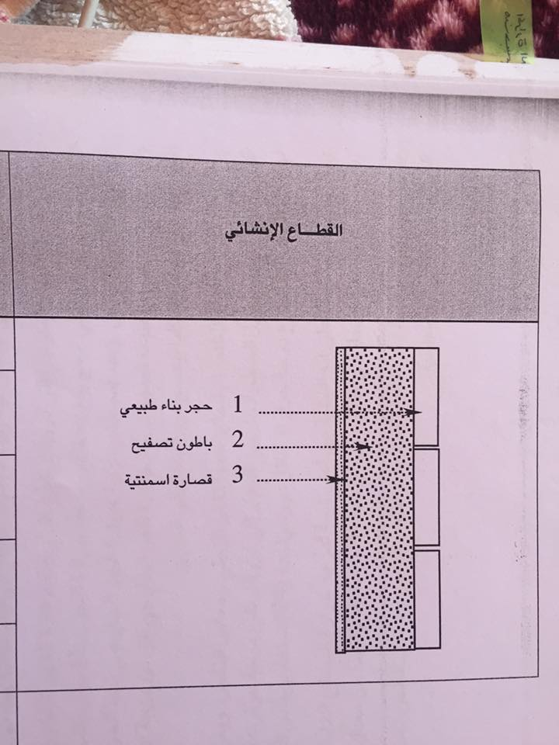

Figure(4.1): Construction materials of walls.

Table ( 4.1 ):Construction material of walls

|  |  |  |  |  |
| --- | --- | --- | --- | --- |
| Layer:  inside to outside | Thickness  (mm) | Density  ( $kg/m^{2})$ | Specific Heat $(kJ/kg.K$ ) | R value $$(m^{2}.K /W)$$ |
| Inside surface Resistance | 0.00 | 0.00 | 0.00 | 0.12000 |
| Plaster | 30.00 | 2000 | 1.00 | 0.02500 |
| Concrete | 200.00 | 2300 | 1.00 | 0.11428 |
| Stone | 70.00 | 2250 | 1.00 | 0.04118 |
| Outside surface resistance | 0.00 | 0.00 | 0.00 | 0.06000 |

|  |  |
| --- | --- |
| Overall U value: | 2.774 $W/m^{2}.K$ |

4.1.2 Partitions:

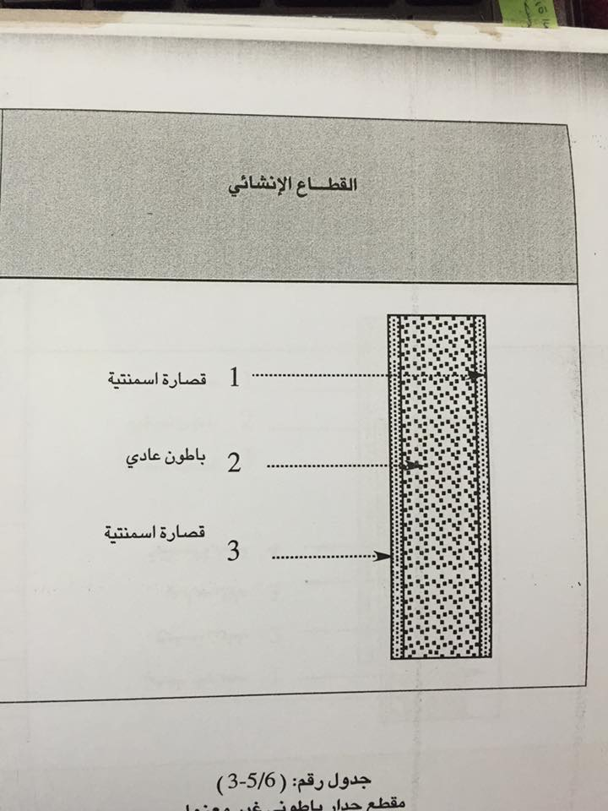

Figure (4.2): construction material of partitions

Table (4. 2): construction material of partitions

|  |  |  |  |  |
| --- | --- | --- | --- | --- |
| Layer:  inside to outside | Thickness  (mm) | Density  ( $kg/m^{2})$ | Specific Heat $(kJ/kg.K$ ) | R value $$(m^{2}.K /W)$$ |
| Inside surface Resistance | 0.00 | 0.00 | 0.00 | 0.12000 |
| plaster | 20.000 | 2000.0 | 1.00 | 0.01700 |
| Concrete | 100.000 | 2300.0 | 1.00 | 0.11400 |
| Plaster | 30.000 | 2000.0 | 1.00 | 0.02500 |
| Inside surface resistance | 0.00 | 0.00 | 0.00 | 0.12000 |

|  |  |
| --- | --- |
| Overall U value: | 3.005 $W/m^{2}.K$ |

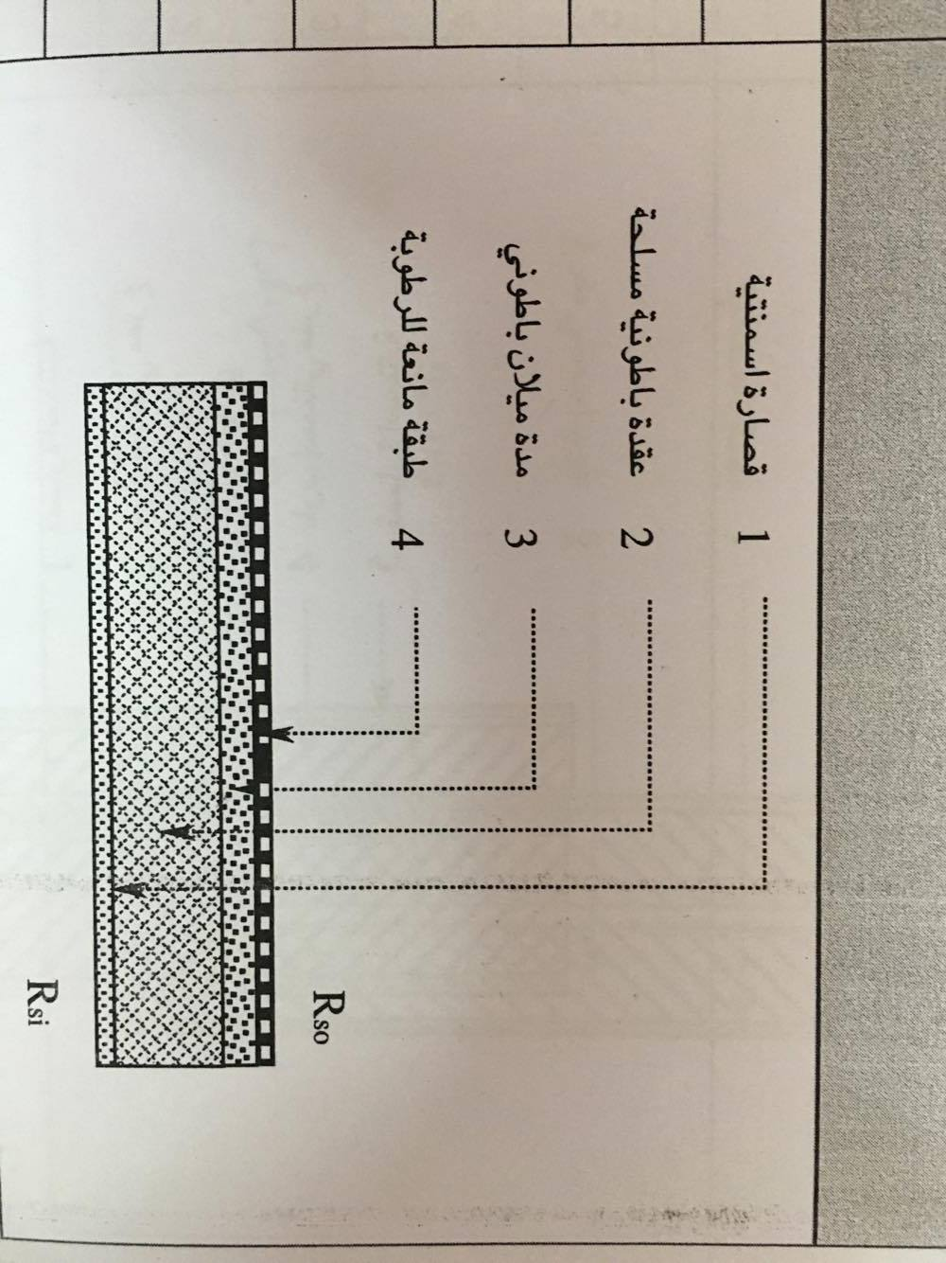4.1.3 Floor:

.

Figure (4.3): construction materials of floors

Table (4. 3): construction material of floor:

|  |  |  |  |  |
| --- | --- | --- | --- | --- |
| Layer:  inside to outside | Thickness  (mm) | Density  ( $kg/m^{2})$ | Specific Heat $(kJ/kg.K$ ) | R value $$(m^{2}.K /W)$$ |
| Inside surface Resistance | 0.00 | 0.00 | 0.00 | 0.12000 |
| Plaster | 20.000 | 2000.0 | 1.00 | 0.016667 |
| Reinforced concrete | 120.00 | 2500.0 | 1.00 | 0.068571 |
| Concrete | 80.000 | 2300 | 1.00 | 0.045714 |
| Insulation | 4.800 | 2300.0 | 1.00 | 0.12000 |
| Outside surface resistance | 0.00 | 0.00 | 0.00 | 0.000 |

|  |  |
| --- | --- |
| Overall U value: | 3.46 $W/m^{2}.K$ |

4.1.4 Roof:

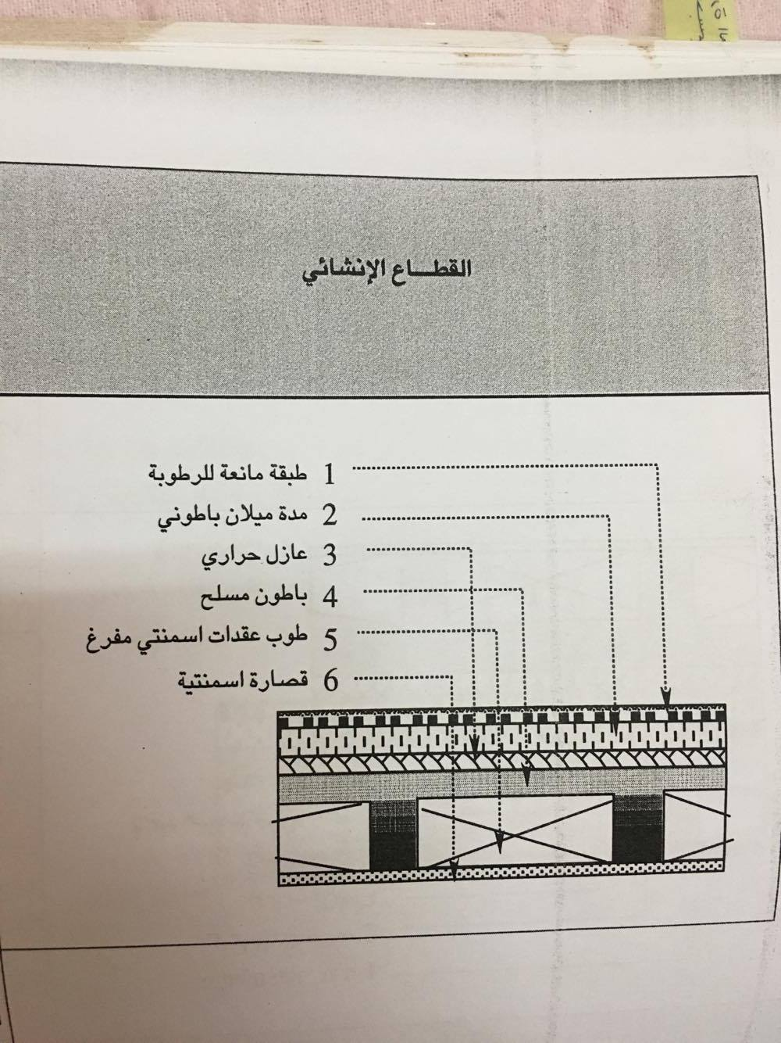

Figure (4.4): construction material of the roof.

Table (4.4): construction material of the roof.

|  |  |  |  |  |
| --- | --- | --- | --- | --- |
| Layer:  inside to outside | Thickness  (mm) | Density  ( $kg/m^{2})$ | Specific Heat $(kJ/kg.K$ ) | R value $$(m^{2}.K/W)$$ |
| Inside surface Resistance | 0.00 | 0.00 | 0.00 | 0.12000 |
| plaster | 20.000 | 2000.0 | 1.00 | 0.016667 |
| concrete | 50.00 | 2300 | 1.00 | 0.02857 |
| insulation | 20 | 140 | 1.00 | 0.5 |
| Reinforced concrete | 60.000 | 2500.0 | 1.00 | 0.034285 |
| Cement block | 18.000 | 1400.0 | 1.00 | 0.018947 |
| cement | 20.00 | 2000.0 | 1.00 | 0.01667 |
| Outside surface resistance | 0.00 | 0.00 | 0.00 | 0.000 |

|  |  |
| --- | --- |
| Overall U value: | 1.1 $W/m^{2}.K$ |

4.1.5 Ceiling :

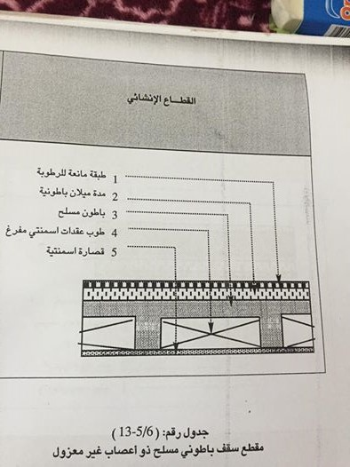

Figure (4.5): construction material of the ceiling.

Table (4.5): construction material of the ceiling.

|  |  |  |  |  |
| --- | --- | --- | --- | --- |
| Layer:  inside to outside | Thickness  (mm) | Density  ( $kg/m^{2})$ | Specific Heat $(kJ/kg.K$ ) | R value $$(m^{2}.K /W)$$ |
| Inside surface Resistance | 0.00 | 0.00 | 0.00 | 0.12000 |
| Plaster | 20.000 | 2300.0 | 1.00 | 0.01818 |
| Cement block | 80.000 | 2300.0 | 1.00 | 0.04571 |
| Reinforced concrete | 70.000 | 2500.0 | 1.00 | 0.04000 |
| Cement bricks | 18.000 | 1620.0 | 1.00 | 0.01636 |
| Cement | 20.000 | 2000.0 | 1.00 | 0.01667 |
| Outside surface resistance | 0.00 | 0.00 | 0.00 | 0.06000 |

|  |  |
| --- | --- |
| Overall U value: | 2.36 $W/m^{2}.K$ |

4.1.6 Window:

|  |  |  |  |  |
| --- | --- | --- | --- | --- |
| Frame Type: | | Aluminum without thermal breaks | | |
| Glazing | **Glass type** | **Transmissivity** | **Reflectivity** | **Absorptivity** |
| Outer Glazing | 3mm clear | 0.810 | 0.083 | 0.107 |
| Glazing #2 | 3mm clear | 0.810 | 0.083 | 0.107 |
| Air gap | 6mm | - | - | - |

Table (4.6): Windows properties.

|  |
| --- |
| Overall U value: 3.237 $W /m^{2}.K$ |

4.1.7 Door:

Table (4.7): Door properties.

|  |  |
| --- | --- |
| U door | 2.4 $W/m^{2}.K$ |

* **4.2 Rooms :**

4.2.1 Room 1:

First room is a guest room located in the ground floor in a villa of two floors .

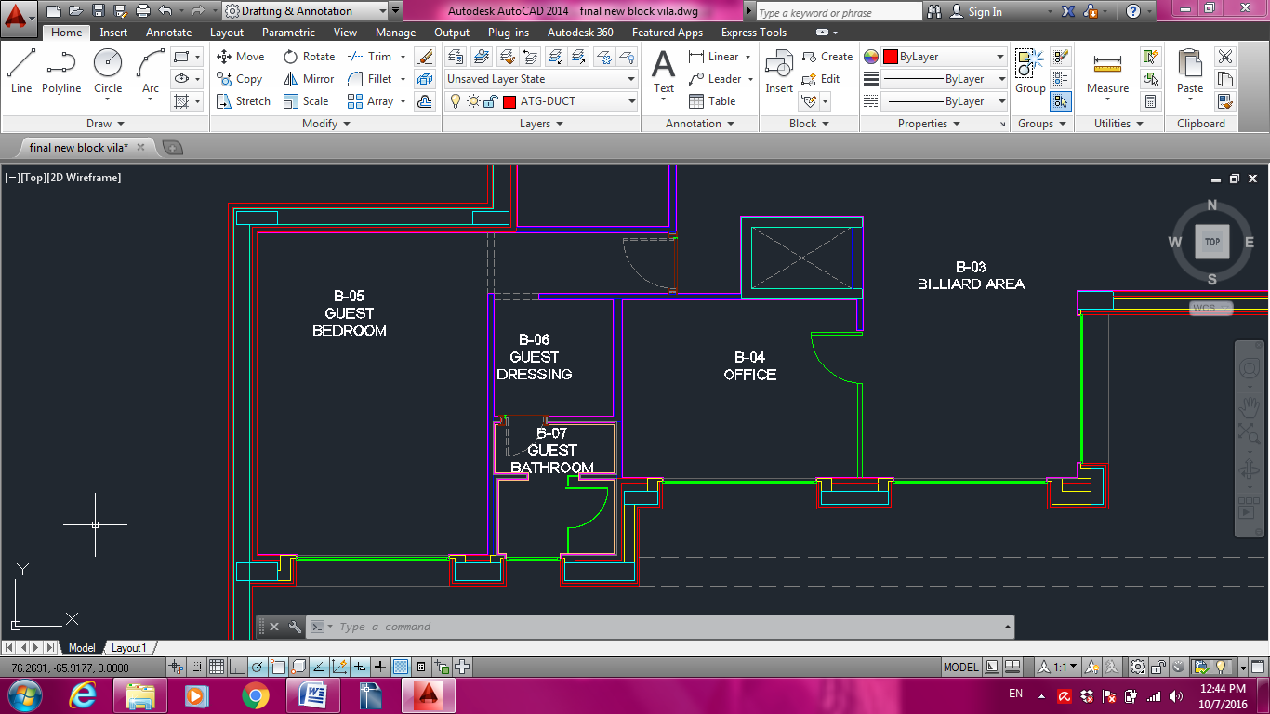

Figure (4.6): configuration of room1

4.2.2 Room 2:

Second room is a master bed room located in the last floor in the same previous villa.

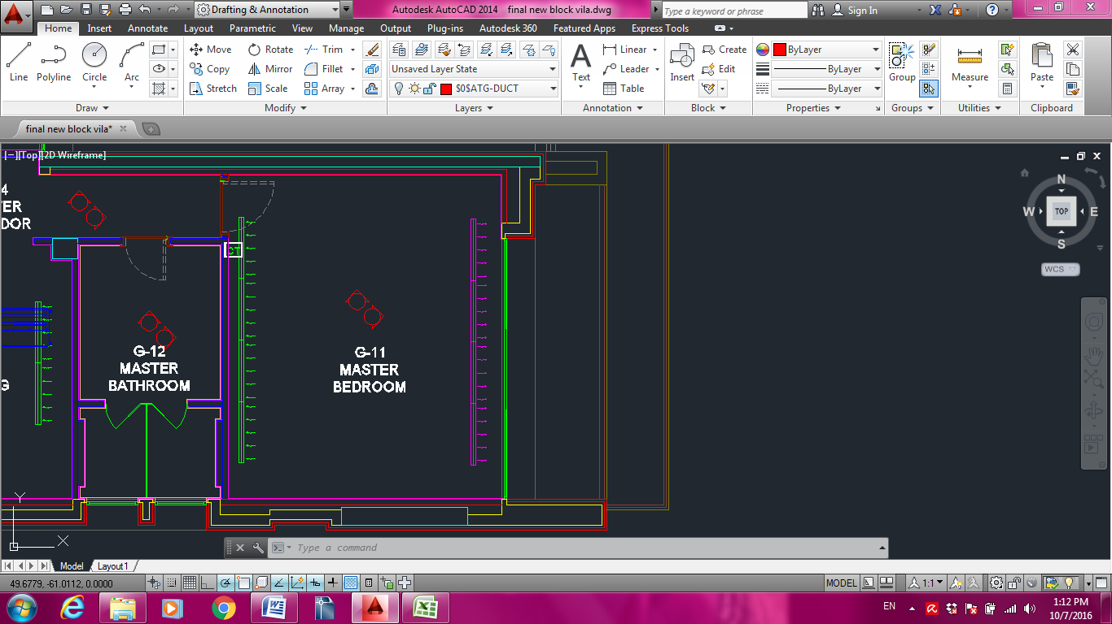

Figure (4.7): configuration of room2

4.2.3 Room 3:

Third room is a dining room between two conditioned floors in another villa.

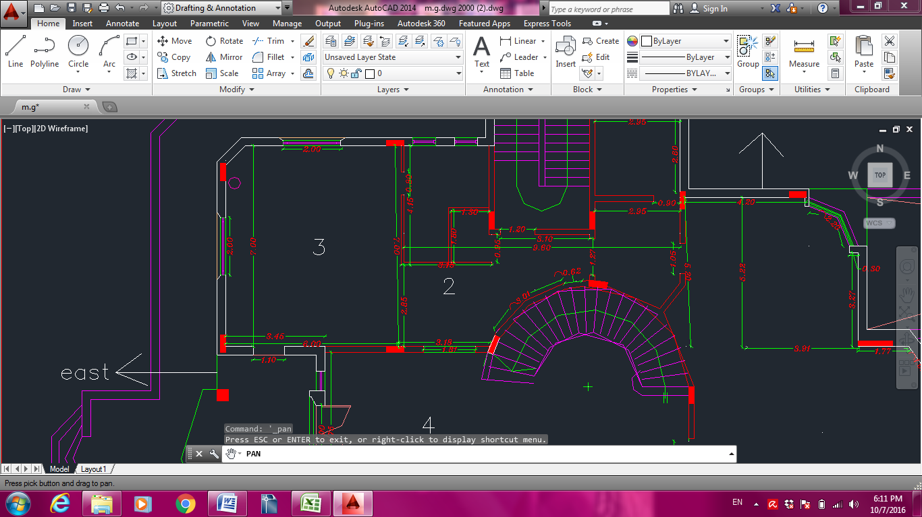

Figure (4.8): configuration of room3

4.2.4 Room 4:

Fourth room is a living room over a conditioned floor in the same previous villa.

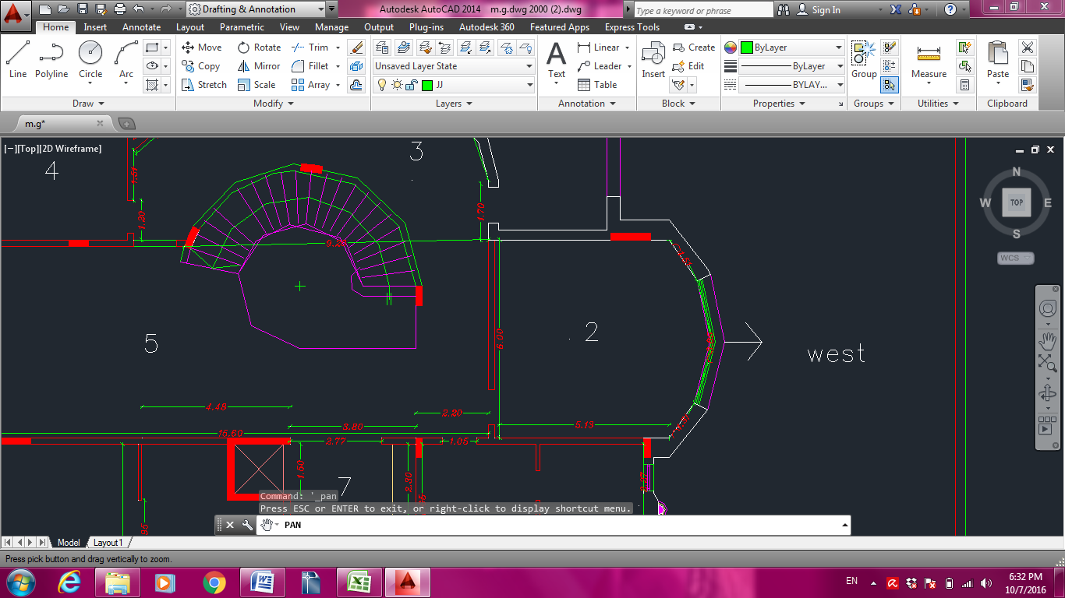

Figure (4.9): configuration of room4

4.2.5 Room 5:

Fifth room was a class room for 20 students in the ground floor.

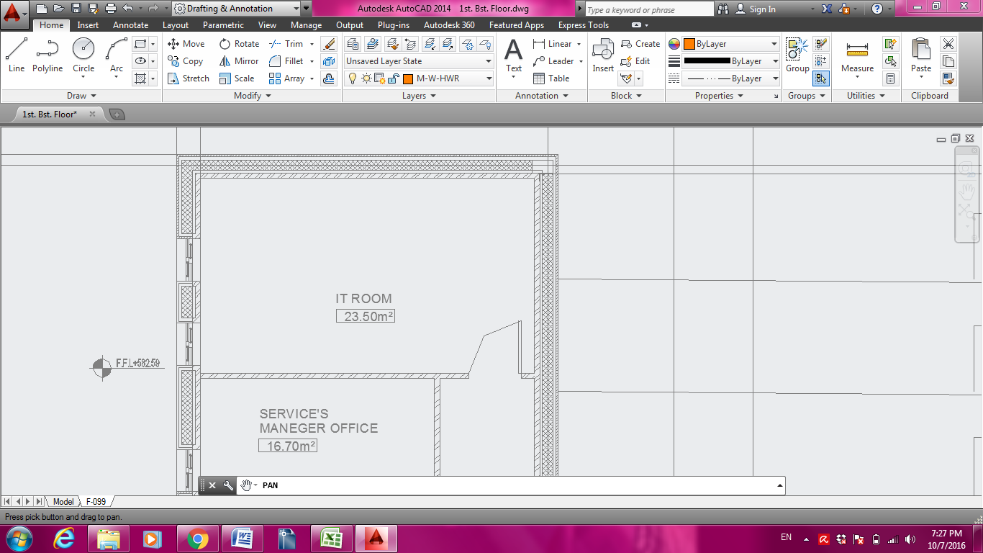

Figure (4.10): configuration of room5

4.2.6 Room 6:

Sixth room was a conference room for 30 occupants between two conditioned floors.

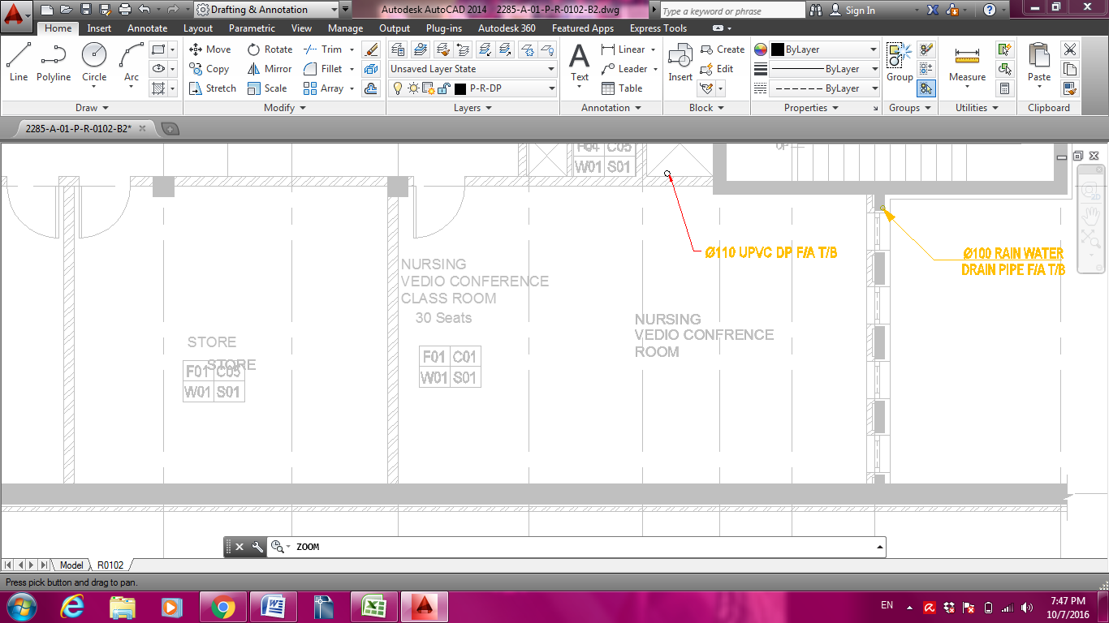

Figure (4.11):Room6 configuration

* **4.3 Design conditions**:

4.3.1 Temperature:

* Winter:

Table (4.8 ):the design temperatures in winter.

|  |  |
| --- | --- |
| Temperature | Dry bulb(c˚) |
| Ti | 23 |
| To (min) | 0.2 |
| Tun | 11.4 |
| Tg | 10.2 |

Where,

Tun =0.5(Ti-To) , Tg =To+10

* Summer:

Table (4.9 ): the design temperatures in summer.

|  |  |
| --- | --- |
| Temperature | Dry bulb(c˚) |
| Ti | 25.5 |
| To (max) | 39.5 |
| Tun | 32 |
| Tg | 29.5 |
| Tadj | 9.333 |

Where,

Tun =0.5(Ti+To) , Tadj=2/3(To-Ti) , Tg=To-10

4.3.2 Humidity:

Table (4.10): the design relative humidity and humidity ratio.

|  |  |  |  |  |
| --- | --- | --- | --- | --- |
|  | RH% | | w(kg/kg dry air | |
|  | Winter | summer | winter | summer |
| inside | 50 | 50 | 9.37 | 10.91 |
| outside | - | - | 1.61 | 30.6 |

Chapter5: Literature Review

* HVAC load calculations require time and attention to detail, and most HVAC contractors rely on rules of thumb to determine the sizes of the cooling systems they install. Usually it's based on square footage of conditioned floor area, and contractors in many areas generally use about 500 or 600 square feet per ton as their rule.
* A new cooling load calculation technique was introduced by ASHRAE Technical Committee (TC) 4.1, Load Calculation Data and Procedures, in 2001 ASHRAE Handbook—Fundamentals. This method, radiant time series (RTS), effectively merged all previous “simplified” load calculation methods (TETD-TA, CLTD-CLF and transfer function). The RTS method and data were derived from fundamental heat balance calculations while maintaining simple concepts and component by-component results. The new method was the result of years of ASHRAE research projects.[7]
* Some companies use online calculators for load estimation such as load calculation program based on Manual J, designed to be quick and easy to use. It calculates the amount of heating and cooling BTU's needed for the whole house. Only data for the US and Canada is listed so for other countries choose "X-Unlisted". Default values can be changed to fit your climate. [8]
* Arthur A. Bell, Jr provided a reference manual assembled to aid the beginning engineer and designer in the design of HVAC systems, In addition, the experienced engineer or designer may find the manual useful as a quick design reference guide and teaching tool. His manual compiles information from various reference sources as well as from college HVAC class notes, from continuing education design seminars and classes, from engineers, and from personnel experience. Rules of thumb listed should be used considering the following: Building loads are based on building gross square footage,

Building loads generally include ventilation and make-up air requirements.

Building loads should be calculated using the ASHRAE Handbook of Fundamentals. These rules of thumb may be used to estimate system loads during the preliminary design stages of a project.[9]

Chapter 6: Methodology

Step 1:

First step in our analysis was choosing real rooms for study. Six rooms with different dimensions and applications were chosen. Specifications of each room are detailed in chapter 4.

Step 2:

Determination of the required heating and cooling loads for the chosen rooms, by applying detailed heating and cooling load equations provided in chapter 2.

Step 3:

Next step was calculating the weighted average overall heat transfer coefficient in order to obtain a single value for the whole components of each room.

The same principle was applied to the outside temperature in order to obtain an average value that represents the outside temperature of each room regarding the adjacent condition.

Then the following equation was applied to each room and compared to the previous results from detailed calculations:

$QHcond=Uov×At×(Ti-Tavg)$

This method was done to study the reliability of considering Uov and Tavg..

Tavg is a value between To and Tun.

Step 4:

* Maximum Heating load model:

In order to preserve at safe side, a maximum value was chosen for Uov and a minimum value for Tavg from the rooms of study.

The resulted model considered the maximum heat loss from internals in addition to the heat lost due to ventilation.

The model was tested at each room and results were compared to the true values using the mean absolute percentage error, which showed an over estimation of the load.

* Average heating load model:

The previous model somehow was over estimated, hence to solve this compliance ,average values for Uov and Tavg were calculated .

$Uov\left(avg\right)=\frac{Uov1+Uov2+Uov3+Uov4+Uov5+Uov6}{6}$

$Tavg\left(avg\right)=\frac{Tavg1+Tavg2+Tavg3+Tavg4+Tavg5+Tavg6}{6}$

The resulted model considered the average heat loss from internals in addition to heat lost due to ventilation.

The model was tested at each room and results were compared to true values, the mean absolute percentage error was very small and almost negligible.

* Maximum cooling load model:

Same procedures were applied to the cooling load, adding heat gain from occupants and lights.

The resulted model considered the maximum heat gain from internals in addition to heat gains from fresh air requirements, occupants and lights.

Comparing to the true values, the mean absolute percentage error was high.

* Average cooling load model:

The resulted model considers the average heat gain from internals in addition to heat lost due to ventilation, occupants and lighting heat gains.

Comparing to the true value, the mean absolute percentage error was small.

Step 5:

In this step all models were compared to the contractor’s scenario that assigns 1 ton air conditioner for each 16 $m^{2}$ of floor area which results in a linear relationship comparing to our model which accounts for all parameters affecting the load.

Step 6:

To simplify our model even further, we thought of developing simple charts that gives directly the required heating load knowing only the number of occupants and the total area from which heat is lost or gained. These charts were developed using matlab .

For the heating load, the resulted chart calculates the heating load at total areas from 20 to 300 in steps of 50 and different levels of occupancy considering a 10L/s/person of fresh air requirements.

For the cooling load, the case was more complex due to the additional variables of the occupants and lighting loads, hence three charts were developed; the first chart calculates the cooling load from internals and ventilation at total areas from 20 to 300 in steps of 50 and different levels of occupancy considering a 10L/s/person of fresh air requirements. The second chart shows a relation between different floor areas and their related lighting loads .Third chart gives the heat gain from occupants at different levels of occupancy and activity. The total cooling load will be the summation of the loads obtained from the three charts at the same number of occupants.

Step 7:

Finally the model from the previous study was applied to each room and results were compared to that obtained from the new model to determine the misconception of our previous assumptions.

Chapter 7: RESULTS and analysis

This chapter provides the detailed results at each step in our methodology. Detailed manual calculations of heating and cooling loads for each room are shown in the proceeding pages.

Room 1:

* Heating load calculations:

Heating load design conditions are based on the minimum temperature reached in 2015.The following table describes the design conditions of room1 considering all exposed temperatures.

Table (7.1) winter design conditions of room 1

|  |  |  |  |  |
| --- | --- | --- | --- | --- |
| **ti** | **To** | **Tg** | **tu** | **Tavg** |
| 23 | 0.2 | 10.2 | 11.4 | 5.416688 |

The following table calculates the heat lost from room internals applying equations (2.8-2.14)

Table (7.2) heat gain from internals of room 1

|  |  |  |  |  |  |  |  |  |  |
| --- | --- | --- | --- | --- | --- | --- | --- | --- | --- |
| **Item** | **At** | **Length** | **Width** | **hiegth** | **u value** | **UA** | **T** | **AT2** | **Q** |
| Floor | 27.9196 | 6.26 | 4.46 | _ | 3.46 | 96.60182 | 10.2 | 284.77992 | 1236.50324 |
| Ceiling | 27.9196 | 6.26 | 4.46 | _ | 2.36 | 65.89026 | 23 | 642.1508 | 0 |
| east door | 2.552 | _ | 1.16 | 2.2 | 2.4 | 6.1248 | 11.4 | 29.0928 | 71.04768 |
| south window | 2.36 | _ | 2.95 | 0.8 | 3.237 | 7.63932 | 0.2 | 0.472 | 174.176496 |
| west wall | 20.032 | _ | 6.26 | 3.2 | 2.774 | 55.56877 | 0.2 | 4.0064 | 1266.96791 |
| North wall | 14.272 | _ | 4.46 | 3.2 | 2.774 | 39.59053 | 0.2 | 2.8544 | 902.664038 |
| East partition | 17.48 | _ | 6.26 | 3.2 | 3.005 | 52.5274 | 11.4 | 199.272 | 609.31784 |
| south wall | 11.912 | _ | 4.46 | 3.2 | 2.774 | 33.04389 | 0.2 | 2.3824 | 753.400646 |
|  |  |  |  |  |  |  |  |  | 5014.07786 |

The following table calculates heating load by assuming weighted average values for U and T applying equation (2.35).

Table (7.3) heating load assuming overall heat transfer coefficient and average outside temperature of room 1

|  |  |  |  |
| --- | --- | --- | --- |
| **Uov** ∑U*A/At | **At** | **Ti-Tavg** | **heating load** |
| 2.868580217 | 96.5276 | 17.583312 | 4868.769144 |

The following table calculates the heat lost due to sensible and latent ventilation loads.

Table (7.4) heating load of outside air requirements for room 1

|  |  |  |  |  |  |  |
| --- | --- | --- | --- | --- | --- | --- |
| **OA requirements** | **occupancy** | **v** | **wi** | **wo** | **ql** | **Qs** |
| 7.5 | 2 | 15 | 9.37 | 1.61 | 349.2 | 410.4 |

* Cooling load calculations:

Cooling load design conditions are based on the maximum temperature reached in 2015.The following table describes the design conditions of room1 considering all exposed temperatures.

Table(7.5) summer design conditions of room 1

|  |  |  |  |  |  |  |  |  |
| --- | --- | --- | --- | --- | --- | --- | --- | --- |
| **ti** | **to** | **tg** | **Tadj** | **Tu** | **To,m** | **Tmax** | **Tmin** | **tavg** |
| 25.5 | 39.5 | 29.5 | 9.333333 | 32 | 27.15 | 39.5 | 14.8 | 30.34723 |

The following table calculates the heat gained from room internals applying equation (2.6)

Table (7.6) conduction heat transfer from unexposed internals of room1

|  |  |  |  |  |
| --- | --- | --- | --- | --- |
| **Item** | **A** | **u value** | **T** | **Q** |
| floor | 27.9196 | 3.46 | 29.5 | 386.407264 |
| ceiling/floor | 27.9196 | 2.36 | 25.5 | 0 |
| east door | 2.552 | 2.4 | 9.333333333 | 57.1648 |
| East partition | 17.48 | 3.005 | 9.333333333 | 490.2557333 |
|  |  |  |  | 933.8277973 |

The following tables calculate the heat gained from sunlit walls and windows.

Table (7.7) heat gain from sunlit walls of room1

|  |  |  |  |  |  |  |  |  |  |  |
| --- | --- | --- | --- | --- | --- | --- | --- | --- | --- | --- |
| **item** | **A** | **Uvalue** | **T** | **CLTD** | **LM** | **K** | **25.5-Ti** | **To,m-29.4** | **CLTDcorr** | **Qcond** |
| west wall | 20.032 | 2.774 | 39.5 | 8 | 0 | 0.83 | 0 | -2.25 | 4.39 | 243.9468915 |
| North wall | 14.272 | 2.774 | 39.5 | 5 | -1.1 | 0.83 | 0 | -2.25 | 0.987 | 39.07585114 |
| south wall | 11.912 | 2.774 | 39.5 | 7 | 0.5 | 0.83 | 0 | -2.25 | 3.975 | 131.3494548 |
|  |  |  |  |  |  |  |  |  |  | 414.3721975 |

Table (7.8) heat gain from sunlit windows of room 1

|  |  |  |  |  |  |  |  |  |  |  |  |  |  |  |  |
| --- | --- | --- | --- | --- | --- | --- | --- | --- | --- | --- | --- | --- | --- | --- | --- |
| **item** | **A** | **Uvalue** | **T** | **CLTD** | **LM** | **K** | **25.5-Ti** | **To,m-29.4** | **CLTDcorr** | **Qcond** | **SHG** | **SC** | **CLF** | **Qtrans** | **Qtot** |
| south window | 2.36 | 3.237 | 39.5 | 7 | 0.5 | 0.83 | 0 | -2.25 | 3.975 | 30.37 | 350 | 0.9 | 0.58 | 431.17 | 461.53 |

Adding up the cooling loads from internals yields the following value

Table (7.9) total cooling load from internals of room 1

|  |
| --- |
| **cooling load ∑Qcond** |
| 1809.738292 |

The following table calculates the cooling load from internals assuming weighted average values for U and T applying equation (2.35)

Table (7.10) cooling load assuming overall heat transfer coefficient and average outside temperature of room 1

|  |  |  |  |
| --- | --- | --- | --- |
| **Uov** | **At** | **Tavg-Ti** | **cooling load ov** |
| 2.86858022 | 96.5276 | 4.8472326 | 1342.18497 |

Assuming 2 people will occupy in room 1, their generated heat and required ventilation are given in the next two tables

Table (7.11) heat gain due to occupants in room1

|  |  |  |  |  |
| --- | --- | --- | --- | --- |
| **occupancy** | **Activity** | **Qs** | **QL** | **Qtot** |
| 2 | seated at rest | 64 | 30 | 188 |

Table (7.12) heat gain due to ventilation in room 1

|  |  |  |  |  |  |
| --- | --- | --- | --- | --- | --- |
| **OA requirements** | **v** | **Wi** | **wo** | **ql** | **qs** |
| 7.5 | 15 | 10.91 | 30.6 | 886.05 | 252 |

The lighting load required for a bedroom is estimated to be $25W/{m^{2}}$,assuming a demand factor of 0.5 .the lighting load is calculated using equation (2.27) as shown in the following table.

Table(7.13) heat gain from lights in room 1

|  |  |  |
| --- | --- | --- |
| **lighting** | **Df** | **Qlight** |
| 697.99 | 0.5 | 348.995 |

Room 2:

* Heating load calculations:

Table(7.14) winter design conditions of room 2

|  |  |  |  |  |
| --- | --- | --- | --- | --- |
| **ti** | **to** | **tg** | **tu** | **Tavg** |
| 23 | 0.2 | 10.2 | 11.4 | 2.269278 |

Table (7.15) heat gain from internals of room 2

|  |  |  |  |  |  |  |  |  |  |
| --- | --- | --- | --- | --- | --- | --- | --- | --- | --- |
| **Item** | **A** | **Length** | **wedth** | **hiegth** | **U** | **UA** | **T** | **AT** | **Q** |
| floor/ceiling | 34.3719 | 6.33 | 5.43 | _ | 3.46 | 118.9268 | 23 | 790.5537 | 0 |
| roof | 34.3719 | 6.33 | 5.43 | _ | 1.1 | 37.80909 | 0.2 | 6.87438 | 862.047252 |
| west door | 2.2 | _ | 1 | 2.2 | 2.4 | 5.28 | 11.4 | 25.08 | 61.248 |
| east window | 4 | _ | 5 | 0.8 | 3.237 | 12.948 | 0.2 | 0.8 | 295.2144 |
| west partition | 18.056 | _ | 6.33 | 3.2 | 3.005 | 54.25828 | 11.4 | 205.8384 | 629.396048 |
| North wall | 17.376 | _ | 5.43 | 3.2 | 2.774 | 48.20102 | 0.2 | 3.4752 | 1098.983347 |
| East wall | 16.256 | _ | 6.33 | 3.2 | 2.774 | 45.09414 | 0.2 | 3.2512 | 1028.146483 |
| south wall | 17.376 | _ | 5.43 | 3.2 | 2.774 | 48.20102 | 0.2 | 3.4752 | 1098.983347 |
|  |  |  |  |  |  |  |  |  | 5074.018878 |

Table (7.16) heating load assuming overall heat transfer coefficient and average outside temperature of room 2

|  |  |  |  |
| --- | --- | --- | --- |
| **Uov ∑U*A/At** | **At** | **Ti-Tavg** | **heating load** |
| 2.574293448 | 109.6359 | 20.730722 | 5850.934775 |

Table (7.17) heat gain due to ventilation in room 2

|  |  |  |  |  |  |  |
| --- | --- | --- | --- | --- | --- | --- |
| **OA requirements** | **occupancy** | **v** | **wi** | **wo** | **ql** | **Qs** |
| 7.5 | 2 | 15 | 9.37 | 1.61 | 349.2 | 410.4 |

* Cooling load calculations:

Table(7.18) summer design conditions of room 2

|  |  |  |  |  |  |  |  |  |
| --- | --- | --- | --- | --- | --- | --- | --- | --- |
| **Ti** | **to** | **tg** | **tadj** | **Tun** | **To,m** | **Tmax** | **Tmin** | **Tavg** |
| 25.5 | 39.5 | 29.5 | 9.333333 | 32 | 27.15 | 39.5 | 14.8 | 33.9265 |

Table (7.19) conduction heat transfer from unexposed internals of room 2

|  |  |  |  |  |
| --- | --- | --- | --- | --- |
| **Item** | **A** | **U** | **T** | **Q** |
| floor/ceiling | 34.3719 | 3.46 | 25.5 | 0 |
| west door | 2.2 | 2.4 | 9.333333333 | 49.28 |
| west partition | 18.056 | 3.2 | 9.333333333 | 539.2725 |
|  |  |  |  | 588.5525 |

Table (7.20) heat gain from sunlit walls of room 2

|  |  |  |  |  |  |  |  |  |  |  |
| --- | --- | --- | --- | --- | --- | --- | --- | --- | --- | --- |
| **item** | **A** | **Uvalue** | **T** | **CLTD** | **LM** | **K** | **25.5-Ti** | **To,m-29.4** | **CLTDcorr** | **Qcond** |
| North wall | 17.376 | 2.774 | 39.5 | 5 | -1.1 | 0.83 | 0 | -2.25 | 0.987 | 47.5744107 |
| East wall | 16.256 | 2.774 | 39.5 | 13 | 0 | 0.83 | 0 | -2.25 | 8.54 | 385.10399 |
| south wall | 17.376 | 2.774 | 39.5 | 11 | 0.5 | 0.83 | 0 | -2.25 | 7.295 | 351.62647 |
|  |  |  |  |  |  |  |  |  |  | 784.304871 |

Table (7.21) heat gain from sunlit roof of room 2

|  |  |  |  |  |  |  |  |  |  |  |  |
| --- | --- | --- | --- | --- | --- | --- | --- | --- | --- | --- | --- |
| **item** | **A** | **Uvalue** | **T** | **CLTD** | **LM** | **K** | **f** | **25.5-Ti** | **To,m-29.4** | **CLTDcorr** | **Qcond** |
| roof | 34.3719 | 1.1 | 39.5 | 22 | -0.5 | 0.5 | 1 | 0 | -2.25 | 8.5 | 321.377265 |

Table (7.22) heat gain from sunlit windows of room 2

|  |  |  |  |  |  |  |  |  |  |  |  |  |  |  |  |
| --- | --- | --- | --- | --- | --- | --- | --- | --- | --- | --- | --- | --- | --- | --- | --- |
| **Item** | **A** | **Uvalue** | **T** | **CLTD** | **LM** | **K** | **25.5-Ti** | **To,m-29.4** | **CLTDcorr** | **Qcond** | **SHG** | **SC** | **CLF** | **Qtrans** | **Qtot** |
| east window | 4 | 3.237 | 39.5 | 7 | 0 | 0.83 | 0 | -2.25 | 3.56 | 46.09488 | 691 | 0.9 | 0.31 | 771.156 | 817.2509 |

Table (7.23) total cooling load from internals of room 2

|  |
| --- |
| **cooling load ∑Qcond** |
| 2511.485549 |

Table (7.24) cooling load assuming overall heat transfer coefficient and average outside temperature of room 2

|  |  |  |  |
| --- | --- | --- | --- |
| **Uov ∑U*A/At** | **At** | **Tavg-Ti** | **cooling load ov** |
| 2.574293448 | 109.6359 | 8.42649716 | 2378.252249 |

Table (7.25) heat gain due to occupants in room 2

|  |  |  |  |  |
| --- | --- | --- | --- | --- |
| **occupancy** | **activity** | **Qs** | **QL** | **Qtot** |
| 2 | seated at rest | 64 | 30 | 188 |

Table (7.26) heat gain due to ventilation in room 2

|  |  |  |  |  |  |
| --- | --- | --- | --- | --- | --- |
| **OA requirements** | **v** | **wi** | **wo** | **ql** | **Qs** |
| 7.5 | 15 | 10.91 | 30.6 | 886.05 | 252 |

Table(7.27) heat gain from lights in room 2

|  |  |  |
| --- | --- | --- |
| **lighting** | **Df** | **Qlight** |
| 859.2975 | 0.5 | 429.64875 |

Room 3

* Heating load calculations:

Table (7.28) winter design conditions of room 3

|  |  |  |  |  |
| --- | --- | --- | --- | --- |
| **ti** | **to** | **tg** | **tu** | **Tavg** |
| 23 | 0.2 | 10.2 | 11.4 | 5.191045 |

Table (7.29) heat gain from internals of room 3

|  |  |  |  |  |  |  |  |  |  |
| --- | --- | --- | --- | --- | --- | --- | --- | --- | --- |
| **Item** | **A** | **Length** | **wedth** | **hiegth** | **U** | **UA** | **T** | **AT** | **Q** |
| floor/ceiling | 42 | 7 | 6 | _ | 2.36 | 99.12 | 23 | 966 | 0 |
| ceiling/floor | 42 | 7 | 6 | _ | 2.36 | 99.12 | 23 | 966 | 0 |
| east door | 8.03 | _ | 3.65 | 2.2 | 2.4 | 19.272 | 11.4 | 91.542 | 223.5552 |
| south door | 2.42 | _ | 1.1 | 2.2 | 2.4 | 5.808 | 11.4 | 27.588 | 67.3728 |
| north window | 1.6 | _ | 2 | 0.8 | 3.237 | 5.1792 | 0.2 | 0.32 | 118.08576 |
| westwindow | 1.6 | _ | 2 | 0.8 | 3.237 | 5.1792 | 0.2 | 0.32 | 118.08576 |
| west wall | 20.8 | _ | 7 | 3.2 | 2.774 | 57.6992 | 0.2 | 4.16 | 1315.54176 |
| North wall | 17.6 | _ | 6 | 3.2 | 2.774 | 48.8224 | 0.2 | 3.52 | 1113.15072 |
| East partition | 14.37 | _ | 7 | 3.2 | 3.005 | 43.18185 | 11.4 | 163.818 | 500.90946 |
| south wall | 8.62 | _ | 3.45 | 3.2 | 2.774 | 23.91188 | 11.4 | 98.268 | 277.377808 |
| south partition | 8.16 | _ | 2.55 | 3.2 | 3.005 | 24.5208 | 23 | 187.68 | 0 |
|  |  |  |  |  |  |  |  |  | 3734.07927 |

Table (7.30) heating load assuming overall heat transfer coefficient and average outside temperature of room 3

|  |  |  |  |
| --- | --- | --- | --- |
| **Uov ∑U*A/At** | **At** | **Ti-Tavg** | **heating load** |
| 2.582622787 | 75.04 | 17.808955 | 3451.375771 |

Table (7.31)heating load of outside air requirements for room 3

|  |  |  |  |  |  |  |
| --- | --- | --- | --- | --- | --- | --- |
| **OA requirements** | **occupancy** | **v** | **wi** | **wo** | **ql** | **Qs** |
| 7.5 | 6 | 45 | 9.37 | 1.61 | 1047.6 | 1231.2 |

* Cooling load calculations:

Table (7.32) summer design conditions of room 3

|  |  |  |  |  |  |  |  |  |
| --- | --- | --- | --- | --- | --- | --- | --- | --- |
| **ti** | **to** | **tg** | **tadj** | **Tun** | **To,m** | **Tmax** | **Tmin** | **Tavg** |
| 25.5 | 39.5 | 29.5 | 9.3333333 | 32 | 27.15 | 39.5 | 14.8 | 36.15778 |

Table (7.33) conduction heat transfer from unexposed internals of room 3

|  |  |  |  |  |
| --- | --- | --- | --- | --- |
| **Item** | **A** | **U** | **T** | **Q** |
| floor/ceiling | 42 | 2.36 | 25.5 | 0 |
| ceiling/floor | 42 | 2.36 | 25.5 | 0 |
| east door | 8.03 | 2.4 | 32 | 179.872 |
| south door | 2.42 | 2.4 | 32 | 54.208 |
| East partition | 14.37 | 3.005 | 32 | 403.0306 |
| south partition | 8.16 | 3.005 | 25.5 | 0 |
|  |  |  |  | 637.1106 |

Table (7.34) heat gain from sunlit walls of room 3

|  |  |  |  |  |  |  |  |  |  |  |
| --- | --- | --- | --- | --- | --- | --- | --- | --- | --- | --- |
| **item** | **A** | **Uvalue** | **T** | **CLTD** | **LM** | **K** | **25.5-Ti** | **To,m-29.4** | **CLTDcorr** | **Qcond** |
| west wall | 20.8 | 2.774 | 39.5 | 13 | 0 | 0.83 | 0 | -2.25 | 8.54 | 492.7512 |
| North wall | 17.6 | 2.774 | 39.5 | 5 | -1.1 | 0.83 | 0 | -2.25 | 0.987 | 48.18771 |
| south wall | 8.62 | 2.774 | 32 | 7 | 0.5 | 0.83 | 0 | -2.25 | 3.975 | 95.04972 |
|  |  |  |  |  |  |  |  |  |  | 635.9886 |

Table (7.35) heat gain from sunlit windows of room 3

|  |  |  |  |  |  |  |  |  |  |  |  |  |  |  |  |
| --- | --- | --- | --- | --- | --- | --- | --- | --- | --- | --- | --- | --- | --- | --- | --- |
| **item** | **A** | **Uvalue** | **T** | **CLTD** | **LM** | **K** | **25.5-Ti** | **To,m-29.4** | **CLTDcorr** | **Qcond** | **SHG** | **SC** | **CLF** | **Qtrans** | **Qtot** |
| north window | 1.6 | 3.237 | 39.5 | 7 | -1.1 | 0.83 | 0 | -2.25 | 2.647 | 13.70934 | 117 | 0.9 | 0.75 | 126.36 | 140.0693 |
| westwindow | 1.6 | 3.237 | 39.5 | 7 | 0 | 0.83 | 0 | -2.25 | 3.56 | 18.43795 | 691 | 0.9 | 0.29 | 288.5616 | 306.9996 |
|  |  |  |  |  |  |  |  |  |  |  |  |  |  |  | 447.0689 |

Table (7.36) total cooling load from internals of room 3

|  |
| --- |
| **cooling load ∑Qcond** |
| 1720.168094 |

Table (7.37) cooling load assuming overall heat transfer coefficient and average outside temperature of room 3

|  |  |  |  |
| --- | --- | --- | --- |
| **Uov ∑U*A/At** | **At** | **Tavg-Ti** | **cooling load ov** |
| 2.582622787 | 75.04 | 10.6577825 | 2065.478 |

Table (7.38) heat gain due to occupants in room 3

|  |  |  |  |  |
| --- | --- | --- | --- | --- |
| **occupancy** | **activity** | **Qs** | **QL** | **Qtot** |
| 6 | seated | 70 | 44 | 684 |

Table (7.39) heat gain due to ventilation in room 3

|  |  |  |  |  |  |
| --- | --- | --- | --- | --- | --- |
| **OA requirements** | **v** | **wi** | **wo** | **ql** | **Qs** |
| 7.5 | 45 | 10.91 | 30.6 | 2658.15 | 756 |

Table(7.40) heat gain from lights in room 3

|  |  |  |
| --- | --- | --- |
| **lighting** | **Df** | **Qlight** |
| 1050 | 0.9 | 945 |

Room 4:

* Heating load calculations:

Table (7.41) winter design conditions of room 4

|  |  |  |  |  |
| --- | --- | --- | --- | --- |
| **ti** | **to** | **tg** | **tu** | **Tavg** |
| 23 | 0.2 | 10.2 | 11.4 | 2.667578 |

Table (7.42) heat gain from internals of room 4

|  |  |  |  |  |  |  |  |  |  |
| --- | --- | --- | --- | --- | --- | --- | --- | --- | --- |
| **Item** | **A** | **Length** | **wedth** | **hiegth** | **U** | **UA** | **T** | **AT** | **Q** |
| floor/ceiling | 36.75 | _ | _ | _ | 2.36 | 86.73 | 23 | 845.25 | 0 |
| roof | 36.75 | _ | _ | _ | 1.1 | 40.425 | 0.2 | 7.35 | 921.69 |
| west door | 2.2 | _ | 1 | 2.2 | 2.4 | 5.28 | 23 | 50.6 | 0 |
| east window | 3.088 | _ | 3.86 | 0.8 | 3.237 | 9.995856 | 0.2 | 0.6176 | 227.9055168 |
| east wall | 18.256 | _ | 6.67 | 3.2 | 2.774 | 50.64214 | 0.2 | 3.6512 | 1154.640883 |
| North wall | 16.416 | _ | 5.13 | 3.2 | 2.774 | 45.53798 | 23 | 377.568 | 0 |
| west partition | 17 | _ | 6 | 3.2 | 3.005 | 51.085 | 23 | 391 | 0 |
| south partition | 16.416 | _ | 5.13 | 3.2 | 3.005 | 49.33008 | 11.4 | 187.1424 | 572.228928 |
|  |  |  |  |  |  |  |  |  | 2876.465328 |

Table (7.43) heating load assuming overall heat transfer coefficient and average outside temperature of room 4

|  |  |  |  |
| --- | --- | --- | --- |
| **Uov ∑U*A/At** | **At** | **Ti-Tavg** | **heating load** |
| 2.308246848 | 74.51 | 20.332422 | 3496.921957 |

Table (7.44) heating load of outside air requirements for room 4

|  |  |  |  |  |  |  |
| --- | --- | --- | --- | --- | --- | --- |
| **OA requirements** | **occupancy** | **v** | **wi** | **wo** | **ql** | **Qs** |
| 7.5 | 6 | 45 | 9.37 | 1.61 | 1047.6 | 1231.2 |

* Cooling load calculations:

Table(7.45) summer design conditions of room 4

|  |  |  |  |  |  |  |  |  |
| --- | --- | --- | --- | --- | --- | --- | --- | --- |
| **ti** | **to** | **tg** | **tadj** | **Tun** | **To,m** | **Tmax** | **Tmin** | **Tavg** |
| 25.5 | 39.5 | 29.5 | 9.333333 | 32 | 27.15 | 39.5 | 14.8 | 43.46575 |

Table (7.46) conduction heat transfer from unexposed internals of room 4

|  |  |  |  |  |
| --- | --- | --- | --- | --- |
| **Item** | **A** | **U** | **T** | **Q** |
| floor/ceiling | 36.75 | 2.36 | 25.5 | 0 |
| west door | 2.2 | 2.4 | 25.5 | 0 |
| west partition | 17 | 3.005 | 25.5 | 0 |
| south partition | 16.416 | 3.005 | 32 | 460.4141 |
|  |  |  |  | 460.4141 |

Table (7.47) heat gain from sunlit walls of room 4

|  |  |  |  |  |  |  |  |  |  |  |
| --- | --- | --- | --- | --- | --- | --- | --- | --- | --- | --- |
| **item** | **A** | **Uvalue** | **T** | **CLTD** | **LM** | **K** | **25.5-Ti** | **To,m-29.4** | **CLTDcorr** | **Qcond** |
| east wall | 18.256 | 2.774 | 39.5 | 13 | 0 | 0.83 | 0 | -2.25 | 8.54 | 432.48391 |
| North wall | 16.416 | 2.774 | 25.5 | 5 | -1.1 | 0.83 | 0 | -2.25 | 0.987 | 44.9459902 |
|  |  |  |  |  |  |  |  |  |  | 477.4299 |

Table (7.48) heat gain from sunlit roof of room 4

|  |  |  |  |  |  |  |  |  |  |  |  |
| --- | --- | --- | --- | --- | --- | --- | --- | --- | --- | --- | --- |
| **item** | **A** | **Uvalue** | **T** | **CLTD** | **LM** | **K** | **f** | **25.5-Ti** | **To,m-29.4** | **CLTDcorr** | **Qcond** |
| roof | 36.75 | 1.1 | 39.5 | 22 | -0.5 | 0.5 | 1 | 0 | -2.25 | 8.5 | 343.6125 |

Table (6.49) heat gain from sunlit windows of room 4

|  |  |  |  |  |  |  |  |  |  |  |  |  |  |  |  |
| --- | --- | --- | --- | --- | --- | --- | --- | --- | --- | --- | --- | --- | --- | --- | --- |
| **Item** | **A** | **Uvalue** | **T** | **CLTD** | **LM** | **K** | **25.5-Ti** | **To,m-29.4** | **CLTDcorr** | **Qcond** | **SHG** | **SC** | **CLF** | **Qtrans** | **Qtot** |
| east window | 3.088 | 3.237 | 39.5 | 7 | 0 | 0.83 | 0 | -2.25 | 3.56 | 35.58524 | 691 | 0.9 | 0.31 | 595.33243 | 630.9177 |

Table (7.50) total cooling load from internals of room 4

|  |
| --- |
| **cooling load ∑Qcond** |
| 1912.374159 |

Table (7.51) cooling load assuming overall heat transfer coefficient and average outside temperature of room 4

|  |  |  |  |
| --- | --- | --- | --- |
| **Uov ∑U*A/At** | **At** | **Tavg-Ti** | **cooling load ov** |
| 2.308246848 | 74.51 | 17.9657496 | 3089.883861 |

Table (7.52) heat gain due to occupants in room 4

|  |  |  |  |  |
| --- | --- | --- | --- | --- |
| **occupancy** | **activity** | **Qs** | **QL** | **Qtot** |
| 6 | seated | 70 | 44 | 684 |

Table (7.53) heat gain due to ventilation in room 4

|  |  |  |  |  |  |
| --- | --- | --- | --- | --- | --- |
| **OA requirements** | **v** | **wi** | **wo** | **ql** | **Qs** |
| 7.5 | 45 | 10.91 | 30.6 | 2658.15 | 756 |

Table(7.54) heat gain from lights in room 4

|  |  |  |
| --- | --- | --- |
| **lighting** | **DF** | **Qlight** |
| 918.75 | 0.9 | 826.875 |

Room 5:

* Heating load calculations:

Table (7.55) winter design conditions of room 5

|  |  |  |  |  |
| --- | --- | --- | --- | --- |
| **ti** | **to** | **tg** | **tu** | **Tavg** |
| 23 | 0.2 | 10.2 | 11.4 | 3.311324 |

Table (7.56) heat gain from internals of room 5

|  |  |  |  |  |  |  |  |  |  |
| --- | --- | --- | --- | --- | --- | --- | --- | --- | --- |
| **Item** | **A** | **Length** | **wedth** | **hiegth** | **U** | **UA** | **T** | **AT** | **Q** |
| floor | 23.5 | _ | _ | _ | 3.46 | 81.31 | 10.2 | 239.7 | 1040.768 |
| ceiling/floor | 23.5 | _ | _ | _ | 2.36 | 55.46 | 23 | 540.5 | 0 |
| south door | 2.2 | _ | 1 | 2.2 | 2.4 | 5.28 | 11.4 | 25.08 | 61.248 |
| west window | 2.88 | _ | 1.6 | 1.8 | 3.237 | 9.32256 | 0.2 | 0.576 | 212.554368 |
| north wall | 26.67 | _ | 6.35 | 4.2 | 2.774 | 73.98258 | 0.2 | 5.334 | 1686.80282 |
| west wall | 12.66 | _ | 3.7 | 4.2 | 2.774 | 35.11884 | 0.2 | 2.532 | 800.709552 |
| east wall | 15.54 | _ | 3.7 | 4.2 | 2.774 | 43.10796 | 0.2 | 3.108 | 982.861488 |
| south partition | 24.47 | _ | 6.35 | 4.2 | 3.005 | 73.53235 | 23 | 562.81 | 0 |
|  |  |  |  |  |  |  |  |  | 4784.94423 |

Table (7.57) heating load assuming overall heat transfer coefficient and average outside temperature of room 5

|  |  |  |  |
| --- | --- | --- | --- |
| **Uov ∑U*A/At** | **At** | **Ti-Tavg** | **heating load** |
| 2.869535002 | 83.45 | 19.688676 | 4714.703399 |

Table (7.58)heating load of outside air requirements for room 5

|  |  |  |  |  |  |  |
| --- | --- | --- | --- | --- | --- | --- |
| **OA requirements** | **occupancy** | **v** | **wi** | **wo** | **Ql** | **qs** |
| 10 | 20 | 200 | 9.37 | 1.61 | 4656 | 5472 |

* Cooling load calculations:

Table(7.59) summer design conditions of room 5

|  |  |  |  |  |  |  |  |  |
| --- | --- | --- | --- | --- | --- | --- | --- | --- |
| **ti** | **to** | **tg** | **tadj** | **Tun** | **To,m** | **Tmax** | **Tmin** | **Tavg** |
| 25.5 | 39.5 | 29.5 | 9.333333 | 32 | 27.15 | 39.5 | 14.8 | 36.48622 |

Table (7.60) conduction heat transfer from unexposed internals of room 5

|  |  |  |  |  |
| --- | --- | --- | --- | --- |
| **Item** | **A** | **U** | **T** | **Q** |
| floor | 23.5 | 3.46 | 29.5 | 325.24 |
| ceiling/floor | 23.5 | 2.36 | 25.5 | 0 |
| south door | 2.2 | 2.4 | 32 | 34.32 |
| south partition | 24.47 | 3.005 | 25.5 | 0 |
|  |  |  |  | 359.56 |

Table (7.61) heat gain from sunlit walls of room 5

|  |  |  |  |  |  |  |  |  |  |  |
| --- | --- | --- | --- | --- | --- | --- | --- | --- | --- | --- |
| **Item** | **A** | **Uvalue** | **T** | **CLTD** | **LM** | **K** | **25.5-Ti** | **To,m-29.4** | **CLTDcorr** | **Qcond** |
| north wall | 26.67 | 2.774 | 39.5 | 5 | -1.1 | 0.83 | 0 | -2.25 | 0.987 | 73.02081 |
| west wall | 12.66 | 2.774 | 39.5 | 8 | 0 | 0.83 | 0 | -2.25 | 4.39 | 154.1717 |
| east wall | 15.54 | 2.774 | 39.5 | 13 | 0 | 0.83 | 0 | -2.25 | 8.54 | 368.142 |
|  |  |  |  |  |  |  |  |  |  | 595.3345 |

Table (7.62) heat gain from sunlit windows of room 5

|  |  |  |  |  |  |  |  |  |  |  |  |  |  |  |  |
| --- | --- | --- | --- | --- | --- | --- | --- | --- | --- | --- | --- | --- | --- | --- | --- |
| **Item** | **A** | **Uvalue** | **T** | **CLTD** | **LM** | **K** | **25.5-Ti** | **To,m-29.4** | **CLTDcorr** | **Qcond** | **SHG** | **SC** | **CLF** | **Qtrans** | **Qtot** |
| west window | 2.88 | 3.237 | 39.5 | 7 | 0 | 0.83 | 0 | -2.25 | 3.56 | 33.18831 | 691 | 0.9 | 0.29 | 519.41088 | 552.5992 |

Table (7.63) total cooling load from internals of room 5

|  |
| --- |
| **cooling load ∑Qcond** |
| 1507.493686 |

Table (7.64) cooling load assuming overall heat transfer coefficient and average outside temperature of room 5

|  |  |  |  |
| --- | --- | --- | --- |
| **Uov ∑U*A/At** | **At** | **Tavg-Ti** | **cooling load ov** |
| 2.869535002 | 83.45 | 10.986219 | 2630.78969 |

Table (7.65) heat gain due to occupants in room 5

|  |  |  |  |  |
| --- | --- | --- | --- | --- |
| **occupancy** | **activity** | **Qs** | **QL** | **Qtot** |
| 20 | office work | 71.5 | 57 | 2570 |

Table (7.66) heat gain due to ventilation in room 5

|  |  |  |  |  |  |
| --- | --- | --- | --- | --- | --- |
| **OA requirements** | **v** | **wi** | **wo** | **ql** | **qs** |
| 10 | 200 | 10.91 | 30.6 | 11814 | 3360 |

Table(7.67) heat gain from lights in room 5

|  |  |  |
| --- | --- | --- |
| **lighting** | **Df** | **Qlight** |
| 1057.5 | 0.85 | 898.875 |

Room 6:

* Heating load calculations:

Table (7.68) winter design conditions of room 6

|  |  |  |  |  |
| --- | --- | --- | --- | --- |
| **Ti** | **to** | **tg** | **tu** | **Tavg** |
| 23 | 0.2 | 10.2 | 11.4 | 5.818667 |

Table (7.69) heat gain from internals of room 6

|  |  |  |  |  |  |  |  |  |  |
| --- | --- | --- | --- | --- | --- | --- | --- | --- | --- |
| **Item** | **A** | **Length** | **wedth** | **hiegth** | **U** | **UA** | **T** | **AT** | **Q** |
| floor/ceiling | 53.07 | 9.15 | 5.8 | _ | 2.36 | 125.2452 | 23 | 1220.61 | 0 |
| ceiling/floor | 53.07 | 9.15 | 5.8 | _ | 2.36 | 125.2452 | 23 | 1220.61 | 0 |
| north door | 2.2 | _ | 1 | 2.2 | 2.4 | 5.28 | 11.4 | 25.08 | 61.248 |
| east window | 5.76 | _ | 3.2 | 1.8 | 3.237 | 18.64512 | 0.2 | 1.152 | 425.108736 |
| north wall | 13.02 | _ | 3.1 | 4.2 | 2.774 | 36.11748 | 11.4 | 148.428 | 418.962768 |
| north partition | 23.63 | _ | 6.15 | 4.2 | 3.005 | 71.00815 | 11.4 | 269.382 | 823.69454 |
| west partition | 24.36 | _ | 5.8 | 4.2 | 3.005 | 73.2018 | 11.4 | 277.704 | 849.14088 |
| east wall | 18.6 | _ | 5.8 | 4.2 | 2.774 | 51.5964 | 0.2 | 3.72 | 1176.39792 |
| south wall | 38.43 | _ | 9.15 | 4.2 | 2.774 | 106.6048 | 0.2 | 7.686 | 2430.5899 |
|  |  |  |  |  |  |  |  |  | 6185.14274 |

Table (7.70) heating load assuming overall heat transfer coefficient and average outside temperature of room 6

|  |  |  |  |
| --- | --- | --- | --- |
| **Uov ∑U*A/At** | **At** | **Ti-Tavg** | **heating load** |
| 2.640407383 | 126 | 17.181333 | 5716.080643 |

Table (7.71)heating load of outside air requirements for room 6

|  |  |  |  |  |  |  |
| --- | --- | --- | --- | --- | --- | --- |
| **OA requirements** | **occupancy** | **v** | **wi** | **wo** | **ql** | **Qs** |
| 10 | 30 | 300 | 9.37 | 1.61 | 6984 | 8208 |

* Cooling load calculations:

Table(7.72) summer design conditions of room 6

|  |  |  |  |  |  |  |  |  |
| --- | --- | --- | --- | --- | --- | --- | --- | --- |
| **Ti** | **to** | **tg** | **tadj** | **Tun** | **To,m** | **Tmax** | **Tmin** | **Tavg** |
| 25.5 | 39.5 | 29.5 | 9.333333 | 32 | 27.15 | 39.5 | 14.8 | 36.5125 |

Table (7.73) conduction heat transfer from unexposed internals of room 6

|  |  |  |  |  |
| --- | --- | --- | --- | --- |
| **Item** | **A** | **U** | **T** | **Q** |
| floor/ceiling | 53.07 | 2.36 | 25.5 | 0 |
| ceiling/floor | 53.07 | 2.36 | 25.5 | 0 |
| north door | 2.2 | 2.4 | 32 | 49.28 |
| north partition | 23.63 | 3.005 | 32 | 662.7427 |
| west partition | 24.36 | 3.005 | 32 | 683.2168 |
|  |  |  |  | 1395.24 |

Table (7.74) heat gain from sunlit walls of room 6

|  |  |  |  |  |  |  |  |  |  |  |
| --- | --- | --- | --- | --- | --- | --- | --- | --- | --- | --- |
| **Item** | **A** | **Uvalue** | **T** | **CLTD** | **LM** | **K** | **25.5-Ti** | **To,m-29.4** | **CLTDcorr** | **Qcond** |
| north wall | 13.02 | 2.774 | 39.5 | 5 | -1.1 | 0.83 | 0 | -2.25 | 0.987 | 35.64795 |
| east wall | 18.6 | 2.774 | 39.5 | 13 | 0 | 0.83 | 0 | -2.25 | 8.54 | 440.6333 |
| south wall | 38.43 | 2.774 | 39.5 | 7 | 0.5 | 0.83 | 0 | -2.25 | 3.975 | 423.7542 |
|  |  |  |  |  |  |  |  |  |  | 900.0354 |

Table (7.75) heat gain from sunlit windows of room 6

|  |  |  |  |  |  |  |  |  |  |  |  |  |  |  |  |
| --- | --- | --- | --- | --- | --- | --- | --- | --- | --- | --- | --- | --- | --- | --- | --- |
| **item** | **A** | **Uvalue** | **T** | **CLTD** | **LM** | **K** | **25.5-Ti** | **To,m-29.4** | **CLTDcorr** | **Qcond** | **SHG** | **SC** | **CLF** | **Qtrans** | **Qtot** |
| east window | 5.76 | 3.237 | 39.5 | 7 | 0 | 0.83 | 0 | -2.25 | 3.56 | 66.3763 | 691 | 0.9 | 0.31 | 1110.464 | 1176.84 |

Table (7.76) total cooling load from internals of room 6

|  |
| --- |
| **cooling load ∑Qcond** |
| 3472.116169 |

Table (7.77) cooling load assuming overall heat transfer coefficient and average outside temperature of room 6

|  |  |  |  |
| --- | --- | --- | --- |
| **Uov ∑U*A/At** | **At** | **Tavg-Ti** | **cooling load ov** |
| 2.640407383 | 126 | 11.0125 | 3663.763275 |

Table (7.78) heat gain due to occupants in room 6

|  |  |  |  |  |
| --- | --- | --- | --- | --- |
| **occupancy** | **activity** | **Qs** | **QL** | **Qtot** |
| 30 | seated | 70 | 44 | 3420 |

Table (7.79) heat gain due to ventilation in room 6

|  |  |  |  |  |  |
| --- | --- | --- | --- | --- | --- |
| **OA requirements** | **v** | **wi** | **wo** | **ql** | **Qs** |
| 10 | 300 | 10.91 | 30.6 | 17721 | 5040 |

Table (7.80) heat gain from lights in room 6

|  |  |  |
| --- | --- | --- |
| **Qlighting** | **Df** | **Qlight** |
| 2122.8 | 0.85 | 1804.38 |

Results summary:

The following table provides a summary for the results combining all rooms:

Table (7.81) heating and cooling loads of each room

|  |  |  |
| --- | --- | --- |
| **room** | **QH calc** | **QC calc** |
| 1 | 5774.3355 | 3443.839 |
| 2 | 5834.2766 | 4226.24 |
| 3 | 6014.8523 | 7273.65 |
| 4 | 5157.2384 | 7347.731 |
| 5 | 14921.713 | 22418.51 |
| 6 | 21390.297 | 34859.71 |

To eliminate the need for U values of all room internals, weighted average method was applied to the overall heat transfer coefficient in order to obtain a single value .the same procedure was applied to the outside temperature to eliminate the conflict of unconditioned or unheated spaces. Applying equations (2.32, 2.34)

Table (7.82) over all heat transfer coefficient and average outside temperatures for each room for both heating and cooling calculations

|  |  |  |  |
| --- | --- | --- | --- |
| **room** | **Uov** | **Tavg-heating** | **Tavg-cooling** |
| 1 | 2.86858 | 5.416688 | 30.34723 |
| 2 | 2.574293 | 2.269278 | 33.9265 |
| 3 | 2.582623 | 5.191045 | 36.15778 |
| 4 | 2.308247 | 2.667578 | 43.46575 |
| 5 | 2.869535 | 3.311324 | 36.48622 |
| 6 | 2.640407 | 5.818667 | 36.5125 |

For U values the results were somehow close because same values of thermal conductivity are used for internals in all rooms, differences occurred only due to different areas.

For Tavg values ,variations can be noticed in rooms with low exposure to the outside as in rooms 2 and 4.

Heating and cooling loads were calculated for each room using weighted average values of overall heat transfer coefficients as well as average outside temperatures to test its validity comparing to true values.

Table (7.83) heating and cooling loads of each room –true values V.S weighted average values

|  |  |  |  |  |
| --- | --- | --- | --- | --- |
| **room** | **QH true** | **QH W avg** | **QC true** | **QC W avg** |
| 1 | 5774.3355 | 5629.026836 | 3443.838568 | 2976.28525 |
| 2 | 5834.2766 | 6611.192468 | 4226.239575 | 4093.00628 |
| 3 | 6014.8523 | 5732.148848 | 7273.649752 | 7618.96006 |
| 4 | 5157.2384 | 5777.695034 | 7347.730818 | 8525.24052 |
| 5 | 14921.713 | 14851.47263 | 22418.50939 | 23541.8054 |
| 6 | 21390.297 | 20921.23449 | 34859.70722 | 35051.3543 |

As can be seen our assumption in using weighted average values showed high validity.

Heating load model:

The resulted model was of the form:

$QH=\left[Uov×At×\left(Ti-Tavg\right)\right]+[\left(1.2×C×\left(Ti-To\right)\right)+\left(3×C×\left(wi-wo\right)\right)]$ (7.1)

Where QH in (W) is the total heating load.

* Fixed values:

Uov $(W/{m^{2}.℃})$: Weighted average overall heat transfer coefficient.

$\left(Ti-Tavg\right)$ $(℃)$: Temperature difference between inside condition and outside average condition.

$\left(wi-wo\right)( g/{kg dry air})$: Humidity ratio difference between inside and outside.

* User defined values:

At $(m^{2})$: total area from which heat is lost

C $(L/S$): volumetric flow rate in L/s $C=n (person)×OA(\frac{L}{s}/person)$

* Maximum heating load model

In order to maintain a good safety factor we choose the maximum obtained value for the overall heat transfer coefficient and the minimum obtained value for the average outside temperature for the rooms of study.

The resulted model was:

$QHmax=\left[2.87×At×20.73\right]+[\left(1.2×C×23\right)+\left(3×C×7.76\right)]$ (7.2)

The model was tested at each room and compared to true values as shown below:

Table (6.84) true heating load VS. Maximum heating load model

|  |  |  |
| --- | --- | --- |
| **room** | **QH true** | **QH equ (max)** |
| 1 | 5774.3355 | 6506.119215 |
| 2 | 5834.2766 | 7285.998834 |
| 3 | 6014.8523 | 6754.112304 |
| 4 | 5157.2384 | 6722.579901 |
| 5 | 14921.713 | 15140.8661 |
| 6 | 21390.297 | 22760.3826 |

* Average heating load model

Maximum heating load model resulted with over estimation which led us to account for average values of both weighted average U values and weighted average outside temperatures for the rooms of study.

The resulted model was:

$QHavg=\left[2.64×At×18.9\right]+[\left(1.2×C×23\right)+\left(3×C×7.76\right)]$ (7.3)

The model was tested at each room and compared to true values as follows:

Table (6.85) true heating load VS. average heating load model

|  |  |  |
| --- | --- | --- |
| **room** | **QH true** | **QH equ (avg)** |
| 1 | 5774.3355 | 5579.54113 |
| 2 | 5834.2766 | 6233.592866 |
| 3 | 6014.8523 | 6033.79584 |
| 4 | 5157.2384 | 6007.35096 |
| 5 | 14921.713 | 14339.8212 |
| 6 | 21390.297 | 21550.896 |

Cooling load model:

The resulted model was of the form:

$QC=\left[Uov×At×\left(Ti-Tavg\right)\right]+[\left(1.2×C×\left(Ti-To\right)\right)+(3×C×(wi-wo))$]+[25 $×DF×Af]+[n\left(qs+ql\right)]$ (7.4)

Where QC in (W) in the total cooling load

* Fixed values:

Uov( $W/{m^{2}.K})$: Weighted average overall heat transfer coefficient.

$\left(Ti-Tavg\right) (℃)$: Temperature difference between inside condition and outside average condition.

$\left(wi-wo\right)({Kg}/{kg dry air)}$: Humidity ration difference between inside and outside.

25 $(\frac{W}{m^{2}})$: lighting load per square meter of floor area

DF : lighting demand factor =0.5

* User defined values:

At $(m^{2})$: total area from which heat is lost

Af ($m^{2})$: floor area

n ; number of occupants

qs, ql (W): occupant’s sensible and latent loads.

C (L/s): volumetric flow rate $C=n (person)×OA(\frac{L}{s}/person$)

* Maximum cooling load model

Assuming maximum value of weighted average over all heat transfer coefficient and maximum average outside temperature, the resulted model was as follows:

$QC max=\left[2.87×At×17.9657\right]+[\left(1.2×C×14\right)+(3×C×19.69)$]+[12.5 $×Af]+[n\left(qs+ql\right)]$ (7.5)

The model was tested at each room and compared to true values as shown below:

Table (6.86) true cooling loads VS. Maximum cooling load model

|  |  |  |
| --- | --- | --- |
| **Room** | **QC true** | **QC equ (max)** |
| 1 | 3443.8386 | 6652.158543 |
| 2 | 4226.2396 | 7408.696676 |
| 3 | 7273.6498 | 8492.329387 |
| 4 | 7347.7308 | 8399.376761 |
| 5 | 22418.509 | 22340.5621 |
| 6 | 34859.707 | 33341.13143 |

* Average heating load model

Maximum heating load model resulted with over estimation specially in the first two rooms due to the high variation of the temperature difference assumed in the model and the true temperature difference in these two rooms, hence we accounted for average values of both weighted average U values and weighted average outside temperatures for the rooms of study.

The resulted model was as follows

$QC avg=\left[2.64×At×10.649\right]+[\left(1.2×C×14\right)+(3×C×19.69)$] $+$ [12.5 $×Af]+[n\left(qs+ql\right)$ (7.6)

The model was tested at each room and compared to true values as follows:

Table (7.87) True heating load VS. Average heating load model

|  |  |  |
| --- | --- | --- |
| **room** | **QC true** | **QC equ (avg)** |
| 1 | 3443.839 | 4388.760169 |
| 2 | 4226.24 | 4837.932276 |
| 3 | 7273.65 | 6732.776534 |
| 4 | 7347.731 | 6652.251454 |
| 5 | 22418.51 | 20383.80989 |
| 6 | 34859.71 | 30386.65836 |

As can be seen, the average model showed higher reliability.

Until this stage 3 values for each load were calculated which are: the true value, the maximum value and the average value.

To determine our model’s boundaries, we derived a confidence interval using the mean absolute percentage error,

$QHupper=QH+\%error×QH$ (7.7)

$QHlower=QH-\%error×QH$ (7.8)

This procedure was applied for both maximum and average load models as shown below:

Table (7.88) maximum mean absolute percentage error for each room-heating load

|  |  |  |  |
| --- | --- | --- | --- |
| **room** | **QH true** | **QH equ (max)** | **error max** |
| 1 | 5774.33555 | 6506.119215 | 0.126730368 |
| 2 | 5834.27657 | 7285.998834 | 0.248826439 |
| 3 | 6014.85234 | 6754.112304 | 0.122905753 |
| 4 | 5157.2384 | 6722.579901 | 0.303523198 |
| 5 | 14921.7135 | 15140.8661 | 0.014686828 |
| 6 | 21390.2966 | 22760.3826 | 0.064051754 |

The average of maximum errors is 0.14678739

So the maximum model bounds are:

$QHmax upper=QHmax+14.68\%$ (7.9)

$QHmax lower=QHmax-14.68\%$ (7.10)

Table (7.89) upper and lower limits of the maximum heating load model

|  |  |  |  |
| --- | --- | --- | --- |
| **room** | **EQnew (max)** | **upper** | **lower** |
| 1 | 6506.119215 | 7461.135 | 5551.103 |
| 2 | 7285.998834 | 8355.492 | 6216.506 |
| 3 | 6754.112304 | 7745.531 | 5762.694 |
| 4 | 6722.579901 | 7709.37 | 5735.79 |
| 5 | 15140.8661 | 17363.35 | 12918.38 |
| 6 | 22760.3826 | 26101.32 | 19419.45 |

Figure (7.1) upper and lower limits of maximum heating load

Table (7.90) average mean absolute percentage error for each room-heating load

|  |  |  |  |
| --- | --- | --- | --- |
| **room** | **QH true** | **QH equ (avg)** | **error avg** |
| 1 | 5774.33555 | 5579.54113 | 0.03373452 |
| 2 | 5834.27657 | 6233.592866 | 0.06844316 |
| 3 | 6014.85234 | 6033.79584 | 0.00314945 |
| 4 | 5157.2384 | 6007.35096 | 0.16483872 |
| 5 | 14921.7135 | 14339.8212 | 0.03899634 |
| 6 | 21390.2966 | 21550.896 | 0.00750805 |

The average of average errors is 0.052778372

The average model bounds are:

$QH avg upper=QH avg+5.3\%$ (7.11)

$QH avg lower=QH avg-5.3\%$ (7.12)

Table (7.91) upper and lower limits of average heating load

|  |  |  |  |
| --- | --- | --- | --- |
| **room** | **QHequ(avg)** | **upper** | **lower** |
| 1 | 5579.54113 | 5579.541 | 5579.541 |
| 2 | 6233.592866 | 6233.593 | 6233.593 |
| 3 | 6033.79584 | 6033.796 | 6033.796 |
| 4 | 6007.35096 | 6007.351 | 6007.351 |
| 5 | 14339.8212 | 14339.82 | 14339.82 |
| 6 | 21550.896 | 21550.9 | 21550.9 |

Figure (7.2) upper and lower limits of average heating load

|  |  |  |  |  |  |  |  |  |  |  |
| --- | --- | --- | --- | --- | --- | --- | --- | --- | --- | --- |
|  |  |  |  |  |  |  |  |  |  |  |
|  |  |  |  |  |  |  |  |  |  |  |
|  |  |  |  |  |  |  |  |  |  |  |

Table (6.92) maximum mean absolute percentage error for each room-cooling load

|  |  |  |  |
| --- | --- | --- | --- |
| **room** | **QC true** | **QC equ (max)** | **error max** |
| 1 | 3443.83857 | 6652.158543 | 0.931611605 |
| 2 | 4226.23958 | 7408.696676 | 0.753023354 |
| 3 | 7273.64975 | 8492.329387 | 0.167547198 |
| 4 | 7347.73082 | 8399.376761 | 0.143125268 |
| 5 | 22418.5094 | 22340.5621 | 0.003476917 |
| 6 | 34859.7072 | 33341.13143 | 0.043562494 |

The average of maximum errors is 0.340391139

So the maximum model boundaries are:

$QC\max{upper}=QC max+34\%$ (7.13)

$QCmax lower=QC max-34\%$ (7.14)

Table (7.93) upper and lower limits of maximum cooling load

|  |  |  |  |
| --- | --- | --- | --- |
| **room** | **QC equ (max)** | **upper** | **lower** |
| 1 | 6652.158543 | 8916.494 | 4387.823 |
| 2 | 7408.696676 | 9930.551 | 4886.842 |
| 3 | 8492.329387 | 11383.04 | 5601.616 |
| 4 | 8399.376761 | 11258.45 | 5540.303 |
| 5 | 22340.5621 | 29945.09 | 14736.03 |
| 6 | 33341.13143 | 44690.16 | 21992.11 |

Figure (7.3) upper and lower limits of maximum cooling load

Table (7.94) average means absolute percentage error for each room-cooling load

|  |  |  |  |
| --- | --- | --- | --- |
| **room** | **QC true** | **QC equ (avg)** | **error avg** |
| 1 | 3443.83857 | 4388.760169 | 0.274380341 |
| 2 | 4226.23958 | 4837.932276 | 0.144736873 |
| 3 | 7273.64975 | 6732.776534 | 0.074360636 |
| 4 | 7347.73082 | 6652.251454 | 0.094652265 |
| 5 | 22418.5094 | 20383.80989 | 0.090759803 |
| 6 | 34859.7072 | 30386.65836 | 0.128315732 |

The average of average errors is 0.134534275

the average model bounds are:

$QC avg uper=QC avg+13.45\%$ (7.15)

$QC avg lower=QC avg-13.45\%$ (7.16)

Table (7.95) upper and lower limits of average cooling load

|  |  |  |  |
| --- | --- | --- | --- |
| **room** | **QC equ (avg)** | **lower** | **Upper** |
| 1 | 4388.760169 | 3798.321501 | 8916.494 |
| 2 | 4837.932276 | 4187.064565 | 9930.551 |
| 3 | 6732.776534 | 5826.987325 | 11383.04 |
| 4 | 6652.251454 | 5757.295627 | 11258.45 |
| 5 | 20383.80989 | 17641.48881 | 29945.09 |
| 6 | 30386.65836 | 26298.61131 | 44690.16 |

Figure (7.4) upper and lower bounds of average cooling load

The model was compared to the contractor’s assumption, in order to illustrate the wide variations as in the following tables and figures

Table (7.96) average heating load Vs market

|  |  |  |
| --- | --- | --- |
| **room** | **QH equ avg** | **QH mareket** |
| 1 | 1.594154608 | 1.744975 |
| 2 | 1.781026533 | 2.14824375 |
| 3 | 1.723941669 | 2.625 |
| 4 | 1.716385989 | 2.296875 |
| 5 | 4.097091771 | 1.46875 |
| 6 | 6.157398857 | 3.316875 |

Figure (7.5) average heating load VS. market heating load

Table (7.97) average cooling load Vs market

|  |  |  |
| --- | --- | --- |
| **room** | **QC eq** | **market** |
| 1 | 1.253931477 | 1.744975 |
| 2 | 1.382266364 | 2.14824375 |
| 3 | 1.923650438 | 2.625 |
| 4 | 1.900643272 | 2.296875 |
| 5 | 5.823945683 | 1.46875 |
| 6 | 8.681902389 | 3.316875 |

Figure (7.6) average cooling load Vs market cooling load

We compared our new model to the model from our previous study as well, to figure out the gaps in the old model.

The average old model was:

QH= $0.2740373+0.0823125C1+0.6751817C2+0.0879653C3$ (7.17)

$QC =4.1370301+0.0613125C1+0.3215411C2+0.0362617C3$ (7.18)

Where C1 is the floor area

C2 is the overall heat transfer coefficient of walls

C3 is the overall heat transfer coefficient of windows

The old model was applied to each room and compared to the new model as shown in the following tables:

Table (7.98) average old model VS average new model –heating load

|  |  |  |
| --- | --- | --- |
| **room** | **QH equ new (avg) KW** | **QH equ old (avg) KW** |
| 1 | 5.57954113 | 4.729845 |
| 2 | 6.233592866 | 5.26095 |
| 3 | 6.03379584 | 5.888838 |
| 4 | 6.00735096 | 5.456698 |
| 5 | 14.3398212 | 4.366057 |
| 6 | 21.550896 | 6.800038 |

Table (7.99) average old model VS average new model -cooling load

|  |  |  |
| --- | --- | --- |
| **room** | **QC equ new (avg) KW** | **QC equ old (avg) KW** |
| 1 | 4.388760169 | 6.858185 |
| 2 | 4.837932276 | 7.253791 |
| 3 | 6.732776534 | 7.721489 |
| 4 | 6.652251454 | 7.399599 |
| 5 | 20.38380989 | 6.587208 |
| 6 | 30.38665836 | 8.400219 |

The misconception in the old model was mainly due to the occupancy level, its effect was neglected in the previous study and it was fixed at 5 occupants in each space. Otherwise results of both models are close and logical.

Table (7.100) average old model Vs average new model for 5 occupants-heating and cooling

|  |  |  |  |
| --- | --- | --- | --- |
| **Qhnew for 5 occ** | **Qh old eq** | **Qc new for 5 occ** | **Qc old eq** |
| 6.72434 | 4.729845215 | 6.37784 | 6.858184709 |
| 7.37839 | 5.260950159 | 6.82701 | 7.253791353 |
| 5.6522 | 5.88883814 | 6.04975 | 7.721489234 |
| 5.62575 | 5.456697515 | 5.96923 | 7.399598609 |
| 6.70782 | 4.36605689 | 7.07581 | 6.587207984 |
| 8.8309 | 6.800037515 | 8.56916 | 8.400218609 |

Final simplification:

The new model requires some inputs that are not always available with users such as: the fresh air requirements for each space, as well as the sensible and latent loads of occupants. We decided to simplify the procedures even further, so we thought of developing simple load charts to the user, which requires only the knowledge of the number of occupants and the total area from which heat is lost, giving the following charts for average and maximum heating loads



Figure (7.7) average heating load chart



Figure (7.8) maximum heating load chart

The procedure is more complex for cooling load due to the various inputs required ,so three charts were developed and the total cooling load will be the summation of the loads obtained from the three charts which are:

* Maximum and average Load from internals and ventilation charts which requires the number of occupants and the total area from which heat is gained.
* Load from lights charts which requires the floor area only.
* Load from occupants chart which requires the number of occupants and their activity level.



Figure (7.9) average cooling load (internals + ventilation) chart





Figure (7.11) lighting load chart



Figure(7.12) occupants load chart

chapter 9: DISCUSSION

* The proposed model approved its reliability referring to the true values obtained from manual calculations.
* The proposed model considers all parameters affecting the load using weighted average values to represent the variable components in a single amount. Applying this procedure dimensioned the analysis considerably.
* HVAC load is dependent on the total area from which heat is lost or gained and not only the floor area as assumed by contractors.
* Occupancy level had a huge effect on the load which is related directly to the ventilation load required, as well as the heat generated by the occupants themselves. Its effect cannot be fixed as assumed previously.
* Maximum and average models are introduced in order to perform an inclusive comparison against true values.
* The average mean absolute percentage error provided the confidence interval required to increase the model reliability.
* Considering average models, the percentage error was very small and can be neglected, which indicates the high reliability of the average models.
* Percentage error was calculated for maximum models as well, here the deviations were noticeable, and hence our reliance will be on average models.
* Our proposed model was compared to contractor’s model that assumes a linear dependence of the load on floor area only, which eliminates the high effect of the other system components. On the other hand our model considers all system components.
* The importance of ventilation was proven by comparing our new model to the model from previous study that assumes a fixed level of occupancy, subsequently a fixed amount of ventilation for all applications, which was the main gap we solved in our new proposed model.
* Charts were modeled to simplify the analysis as possible. It is simple, clear, and with acceptable accuracy level.

chapter 10:

conclusion and recommendations

This project was proposed to simplify HVAC load calculations and develop adequate rules of thumb validated for Palestine or anywhere else with same weather conditions. Our assumption saves time and effort spent in detailed manual calculations, moreover performs acceptable level of accuracy comparing to the market assumption. Objectives were successfully achieved by simple load charts that easily determine the load, requiring only: area, level of occupancy and type of activity in the given space.

Until this phase our focus was on the load design, and ways of simplifying the complex procedures. Future aspirations will be towards system components, efficiency of different units and cost analysis in order to provide a complete feasible study of HVAC systems.

references:

[1]FloridaSolarEnergyCenter,HVACsystems,November11,2016.from(<http://www.fsec.ucf.edu/en/consumer/buildings/commercial/hvac.htm>)

[2]The Elephant in the Room – HVAC for High Performance Homes, 7 Reasons Why Oversizing is a Bad Idea, November 12, 2016 from (<http://bit.ly/jz0Xpn>)

[3] Mohammed A.Alsaad, Mahmoud Hammad. Heating And Cooling Air Conditioning For Residential Building .5th edition .Amman: University of Jordan.

[4]2004, Guidelines for energy efficient building design,Ramallah:Bilasan company

[5] 2016,The temperature and the relative humidity in Nablus for 2015,Ramallah:Palestinian metrological station

[6] Dr.Jad Isaaq, VioletN.Qumsieh, Nadia Al Dajani.Environmental profile for the west bank –Nablus district,Applied research institute, Jerusalem. October 1996.

[7] Steven F. Bruning, P.E. ASHRAE Journal, Load Calculation Spreadsheets. January 2012

[8] Whole House Online Load Calculator, November 11, 2016.from (<http://www.loadcalc.net/>)

[9] Arthur A. Bell Jr. 2000 , The McGraw-Hill Companies, PE, HVAC equations, data, and rules of thumb, United States of America.