Table of Contents
ACKNOWLEDGEMENT 2
Introduction 3
Basics of WiTricity Technology 4
Electricity: 4
Magnetism: 4
Electromagnetism: 4
Magnetic Induction: 5
Energy/Power Coupling 5
Resonance 6
Resonant Magnetic Coupling 6
WiTricity Technology 7
The Invention of WiTricity Technology 8
Coupled Resonators 8
Strong Coupling 8
WiTricity Technology is born 9
our project … 10
The idea behind the project 10

The basic idea ………………………………………...10

practical implementation ………………………….………….11-12

project block diagram…………………………………………………13
transmitter circuit……………………………………………………….14
reciever circuit 15
component values……………………………………………………..15
circuit operation.......................................................16
0ur pcb 17-19
simulation results……………..……………………………………20-24
difficulties……………….…………………………………………………25
conclusion……………………………………………………………….…26
references…………………………………………………………………..27

ACKNOWLEDGEMENT

Introduction

In this era of modernization, electricity has become the cup of life. A moment without electricity makes your thinking go dry. The major source of conventional form of electricity is through wires. The continuous research and development has brought forward a major breakthrough, which provides electricity without the medium of wires. This wonder baby is called WiTricity.
There are certain small but very useful discoveries made in history, which changed the world for ever, Newton’s gravitational law, Watt’s steam engine, Thomson’s bulb and many more. But a renaissance occurred with the invention of Electromagnetic Waves by Maxwell. Sir Jagdish Chandra Bose successfully generated electromagnetic waves having wavelength in the range of 5mm to 25 mm. Thereafter an Italian scientist named Marconi succeeded in transmitting electromagnetic waves up to a distance of several miles.
And with this there started a new era called WIRELESS TECHNOLOGY. Today, as we can see the word ‘wireless’ is common in day – to – day life. Wireless communication has made the world smaller. Almost each and everything is wireless or cordless. Cordless mouse, cordless keyboard, satellite communication, mobiles, cordless microphones and headphones, wireless internet service i.e. WIFI, etc. And these have definitely increased the standard of living.
In fact it dates back to the 19th century, when Nikola Tesla used conduction based systems instead of resonance magnetic fields to transfer wireless power. As it is in Radiative mode, most of the Power was wasted and has less efficiency. Further, in 2005, Dave Gerding coined the term WiTricity which is being used by the MIT researchers today.

Nikola Tesla

Moreover, we all are aware of the use of electromagnetic radiation (radio waves) which is quite well known for wireless transfer of information. In addition, lasers have also been used to transmit energy without wires. However, radio waves are not feasible for power transmissions because the nature of the radiation is such that it spreads across the place, resulting into a large amount of radiations being wasted. And in the case of lasers, apart from requirement of uninterrupted line of sight.

WiTricity is nothing but wireless electricity. Transmission of electrical energy from one object to another without the use of wires is called as WiTricity. WiTricity will ensure that the cell phones, laptops, iPods and other power hungry devices get charged on their own, eliminating the need of plugging them in. Even better, because of WiTricity some of the devices won't require batteries to operate.

Basics of WiTricity Technology

WiTricity technology is transferring electric energy or power over distance without wires. With the basics of electricity and magnetism, and work our way up to the WiTricity technology.

Electricity:

The flow of electrons (current) through a conductor (like a wire), or charges through the atmosphere (like lightning). A convenient way for energy to get from one place to another!

Magnetism:

A fundamental force of nature, which causes certain types of materials to attract or repel each other. Permanent magnets, like the ones on your refrigerator and the earth’s magnetic field, are examples of objects having constant magnetic fields.
Oscillating magnetic fields vary with time, and can be generated by alternating current (AC) flowing on a wire. The strength, direction, and extent of magnetic fields are often represented and visualized by drawings of the magnetic field lines
.
Electromagnetism:

A term for the interdependence of time-varying electric and magnetic fields. For example, it turns out that an oscillating magnetic field produces an electric field and an oscillating electric field produces a magnetic field.

Magnetic Induction:

A loop or coil of conductive material like copper, carrying an alternating current (AC), is a very efficient structure for generating or capturing a magnetic field.

The lines represent the
magnetic field that is created
when current flows through a coil.

If a conductive loop is connected to an AC power source, it will generate an oscillating magnetic field in the vicinity of the loop. A second conducting loop, brought close enough to the first, may “capture” some portion of that oscillating magnetic field, which in turn, generates or induces an electric current in the second coil. The current generated in the second coil may be used to power devices. This type of electrical power transfer from one loop or coil to another is well known and referred to as magnetic induction. Some common examples of devices based on magnetic induction are electric transformers and electric generators.

Energy/Power Coupling:

Energy coupling occurs when an energy source has a means of transferring energy to another object. One simple example is a locomotive pulling a train car— the mechanical coupling between the two enables the locomotive to pull the train, and overcome the forces of friction and inertia that keep the train still—and, the train moves. Magnetic coupling occurs when the magnetic field of one object interacts with a second object and induces an electric current in or on that object. In this way, electric energy can be transferred from a power
source to a powered device. In contrast to the example of mechanical coupling given for the train, magnetic coupling does not require any physical contact between the object generating the energy and the object receiving or capturing that energy.
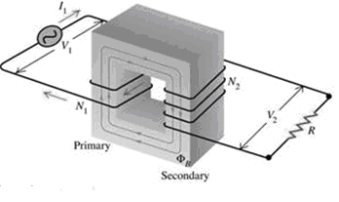

Resonance:

Resonance is a property that exists in many different physical systems. It can be thought of as the natural frequency at which energy can most efficiently be added to an oscillating system. A playground swing is an example of an oscillating system involving potential energy and kinetic energy. The child swings back and forth at a rate that is determined by the length of the swing. The child can make the swing go higher if he properly coordinates his arm and leg action with the motion of the swing. The swing is oscillating at its resonant frequency and the simple movements of the child efficiently transfer energy to the system. Another example of resonance is the way in which a singer can shatter a water glass by singing a single loud, clear note. In this example, the water glass is the resonant oscillating system. Sound waves traveling through the air are captured by the glass, and the sound energy is converted to mechanical vibrations of the glass itself. When the singer hits the note that matches the resonant frequency of the glass, the glass absorbs energy, begins vibrating, and can eventually even shatter. The resonant frequency of the glass depends on the size, shape, thickness of the glass, and how much water is in it.

Resonant Magnetic Coupling:

Magnetic coupling occurs when two objects exchange energy through their varying or oscillating magnetic fields. Resonant coupling occurs when the natural frequencies of the two objects are approximately the same.

WiTricity Technology:

WiTricity power sources and capture devices are specially designed magnetic resonators that efficiently transfer power over large distances via the magnetic near-field. These proprietary source and device designs and the electronic systems that control them support efficient energy transfer over distances that are many times the size of the sources/devices themselves.

This diagram shows the behavior of magnetic field lines

The Invention of WiTricity Technology

The story started late one night a few years ago, with MIT Professor Marin Soljacic standing in his pajamas, staring at his cell phone on the kitchen counter. It was probably the sixth time that month that he was awakened by his mobile phone beeping to let him know that he had forgotten to charge it. At that moment, it occurred to him: “There is electricity wired all through this house, all through my office—everywhere. This phone

should take care of its own charging!” But to make this possible, one would have to find a way to transfer power from the existing wired infrastructure to the cell phone—without wires. Soljacic started thinking of physical phenomena that could make this dream a reality.
Coupled Resonators was fit for the situation To achieve wireless power transfer in a way that is practical and safe, one needs to use a physical phenomenon that enables the power source and the device (in this case, the mobile phone) to exchange energy strongly, while interacting only weakly with living beings and other environmental objects, like furniture and walls. The phenomenon of coupled resonators precisely fits this description. Two resonant objects of the same resonant frequency tend to exchange energy efficiently, while interacting weakly with extraneous off-resonant objects. A child on a swing is a good example of a resonant system. A swing exhibits a type of mechanical resonance, so only when the child pumps her legs at the natural frequency of the swing is he able to impart substantial energy into the motion of the swing. Another example involves acoustic resonances: imagine a room with 10 identical water glasses, but each filled with water up to a different level, so that each resonates at a different frequency (that is, they each emit a different tone or note when tapped, by a utensil, for example). If an opera singer enters that room and sings a very loud single note, the glass having the corresponding resonant frequency can accumulate enough energy to shatter, while the other glasses are unaffected.

Strong Coupling:

Coupled resonators are said to operate in a strongly coupled regime if their energy transfer rate is substantially higher than the rate at which they lose energy due to factors such as material absorption and radiation. In the strongly coupled regime, energy transfer can be very efficient. These considerations are universal, applying to all kinds of resonances (e.g., acoustic, mechanical, electromagnetic, etc.). Soljacic and his colleagues at MIT (Karalis and Joannopoulos) set out to explore and develop the physical theory of how to enable strongly coupled magnetic resonators to transfer power over distances that would enable the kind of wireless device charging that Soljacic first imagined. Their theoretical results were published first in 2006, and again in 2008 in the Annals of Physics.
Once the physical theories were developed, Soljacic and his team (Kurs, Karalis, Moffatt, Joannopoulos, Fisher) set out to validate them experimentally. The theory was developed to cover a broad range of coupled resonator systems, but the experimental work focused on proving that magnetically coupled resonators could exchange energy in the manner predicted by the theory and required for the wireless charging or devices, such as cell phones. The team explored a system of two electro-magnetic resonators coupled through their magnetic fields. They were able to identify the strongly coupled regime in this system, and showed that strong coupling could be achieved over distances that greatly exceeded the size of the resonant objects themselves. The team had proven that in this strongly coupled regime, efficient wireless power transfer could be enabled. Their successful experiment was published in the journal, Science, in 2007.

WiTricity Technology is born:

The experimental design consisted of two copper coils, each a self-resonant system. One of the coils, connected to an AC power supply, was the resonant source. The other coil, the resonant capture device, was connected to a 60 watt light bulb. The power source and capture device were suspended in midair with nylon thread, at distances that ranged from a few centimeters to over 2.5 meters (8.2 ft). Not only was the light bulb illuminated, but the theoretical predictions of high efficiency over distance were proven experimentally. By placing various objects between the source and capture device, the team demonstrated how the magnetic near field can transfer power through certain materials and around metallic obstacles.

Our project

The idea behind the project
Is to create a wireless device to transfer the electric energy by air without wires.

The basic idea
The basic idea was to transfer energy through the air using magnetic field. And this field generated by passing a large AC current in a coil(copper ring ) .
The lines of generated magnetic field cross a another coil which produce current passing through.
The design is to feed a parallel LC tank circuit from an AC voltage source at its resonant frequency, which allows large reactive current to circulate in the circuit while only real power is being drawn from the source. This sets up a large alternating magnetic field in the inductor, which is designed as a single conductive loop in this case.
Now, another LC tank with load attached is brought in proximity to the excited LC circuit, significant amounts of power can be transferred via weak magnetic coupling between them. This is because AC current itself in the transmitting loop is very large, and inductive reactance of the receiver loop is canceled out by the capacitor.
For a practical device, the AC voltage source had to be substituted with an appropriate oscillator, which would take feedback from the tank circuit itself and hence always drive it at it's resonant frequency.

Practical implementation:
In beginning we test if the principle the of our project true or not , so we prepared two coil with huge number of turns ,and we connect first one with atransformer (Isec=12.5A AC ,Vsec=12V AC) . and another coil parallel with small lamp ,second coil is near to the first but not touch with it .
We switched the transformer on , the current with value of 3A pass through first coil ,and this current produce aweak magnetic field. (the voltage across the coil was 4V).
This magntic field cross another coil, and small induction current pass through second coil.
(Iind =1Ma,and the voltage cross the coil=1.4V). But this not enough to light the lamp,so I replaced it by led ,the led is light.
`
on
onn
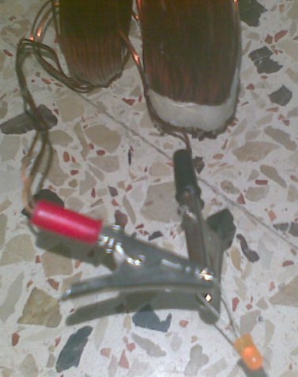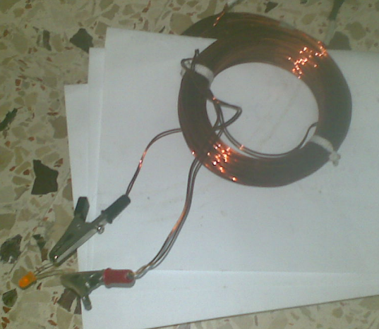

Next table show the related distance between two coils(d) and voltage cross second coil:

VOLTAGE(V) | DISTANCE(mm)
1.22 | 1
1.07 | 2
1.03 | 3
1.01 | 4
0.96 | 6
0.84 | 7
0.78 | 12
0.45 | 30
0.34 | 40
0.22 | 60
0.12 | 80
0.08 | 100
0.06 | 110

project block diagram

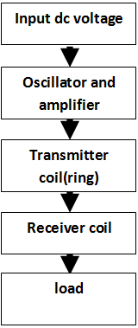

transmitter circuit

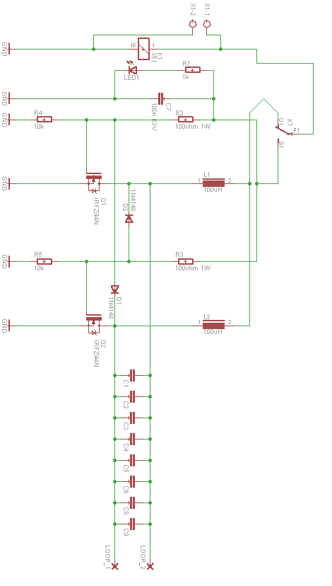

receiver circuit

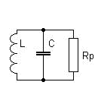

Component values

- Slightly modified royal oscillator (it is an electronic oscillator which has the advantages of simplicity, low component count, sinusoidal waveforms and easy transformer isolation).
- Input voltage was limited to 15V for safety and because the circuit tends to become unstable at higher voltages.
- Mosfets we used were IRFZ48.and we use heat sink to avoid dmage transistors
- Two resistors 100 ohms which is enough and wastes less power. And it was rated at least 1 watt to handle high current.
- Two resistors 10K ohms and one resistor 1K ohms.
- Radio frequency chokes (RFC) were 100uH has ferrite cores to produce much better results.
- Diodes are 1N4148 which is small high-speed ones.
- 8 paralleled 6.8nF Capacitors with ratings 1600V wima FKP1 are used in primary side to handle the heavy current circulates in LC bank while keeping losses tolerable, the capacitors are polypropylene dielectric .and 100nf 63v capacitor.
- In receiver side one metalized polypropylene capacitor, chosen for suitable resonant frequency which is 47 nf.

Circuit operation:

The basic idea is to fed aparallel LC circuit from an AC voltage source t is resonant frequency, which allows a large reactive current to circulate in the circuit while only real power is being drawn from the source .this sets up a large alternating magnetic

field in the inductor , which is designed as a single conductive loop in this case .
Now , another LC tank with load attached is brought in proximity to the excited LC circuit,
Significant amounts of power can be transferred via weak magnetic coupling between them,this is because AC current it self in the transmitting loop is very large ,and inductive reactance of the receiver loop is canceled out by the capacitor.
For a practical device ,the AC voltage source had to be substituted with an appropriate oscillator , which would take feed back from the tank circuit itself and hence always drive it at it's resonant frequency .
The circuit of choice was slightly modified royar oscillator ,such as popuulary used
CCFL inverters and for fly back drivers .
Input voltage was limited to 12v for safety and because the circuit tends to become unstable at higher voltages.

The LC tank circuit is the part where heavy current circulates, and is required to be study. The copper pipe used as conductor heats up significantly under ~20A it's passing continuously. To handle the current while keeping losses tolerable, capacitor consists of 8 paralleled 6.8nF 1600V wima FKP1 capacitors. It's important that capacitors are polypropylene dielectric and foil or foil+film based - other types will heat up and melt in this application.
The transmitter still oscillated at relatively high frequency and had to be tuned by insertion of a ferrite core into the loop. This lowered the frequency to about 400KHZ without load.
On the receiver side only a single capacitor and a loop of 6mm copper wire was used. The wire heats up significantly.

CIRCUIT PCB

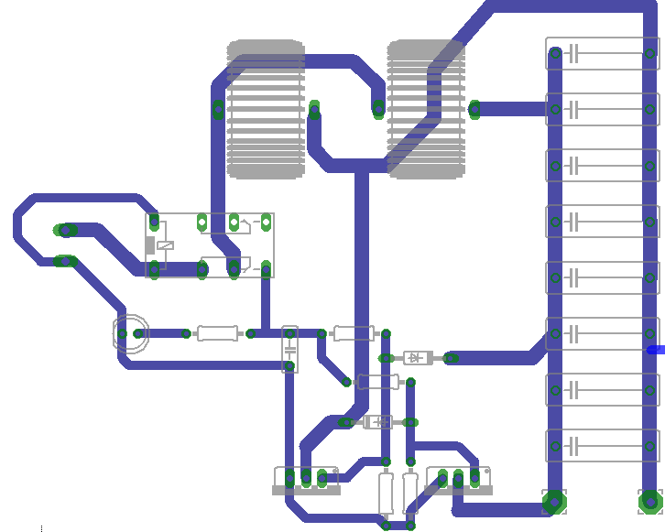
LED
100 ohm 1watt
relay
Chocks 100nh

Capacitors 6800nf 1600v
100 nF 63V
100 OHM 1watt

Mosfets IRZN47
Diods 1n4148
10kohm

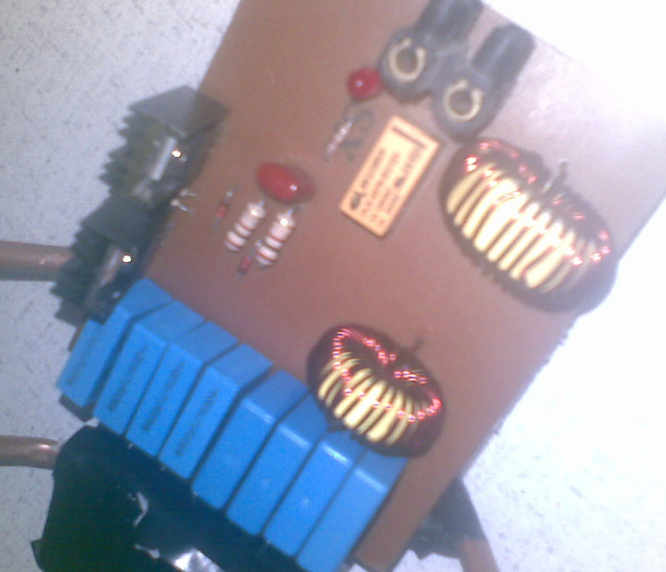

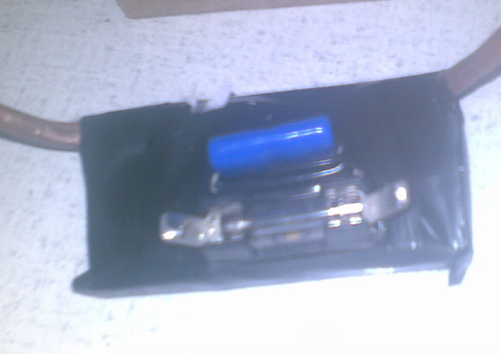

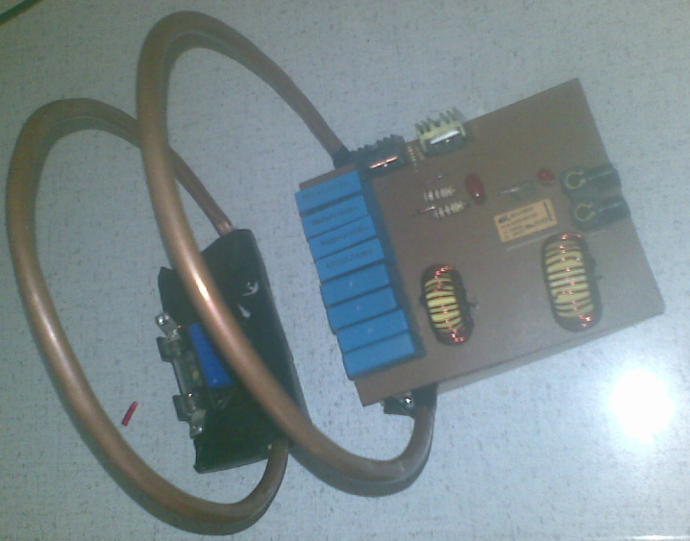

Simulation result :
We applied the the transmitter cct on workbench and we get a simulation and the result was:
We get a good results by simulation

The transmitter cct:
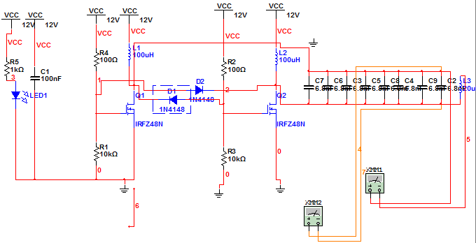

AC current pass through the ring was 1.24A

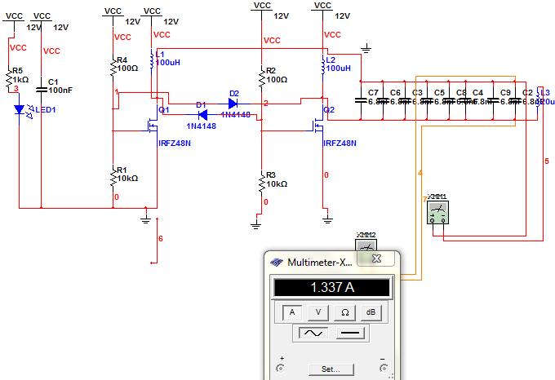

The frequency generated by oscillator(resonant freq) was 155.707KHz

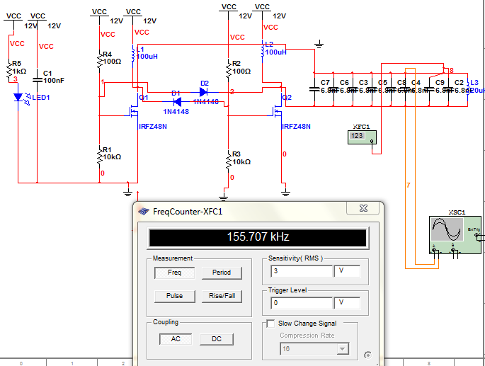

Wave is pure sinusoidal

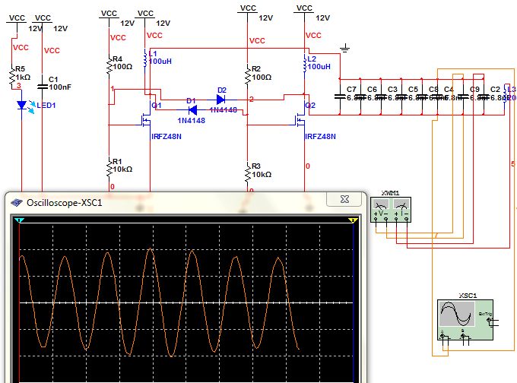

The voltage cross capacitors was 24.4v

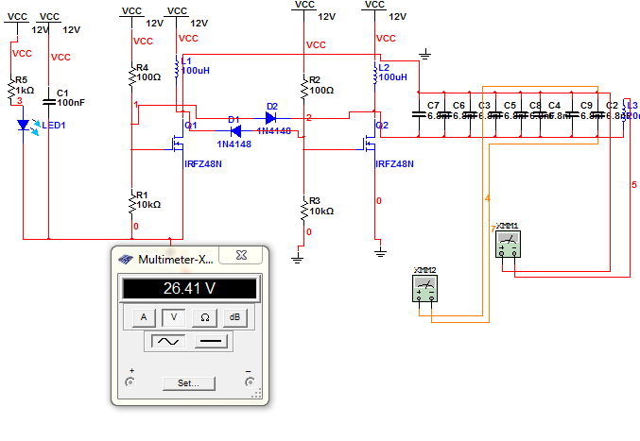

Difficulties:
To transfer the power more efficient we have to pass a large current AC with high freq through the coil, so we try to build oscillator and amplifier and take feedback from LC tank to achieve high freq at resonant, as we see simulation part was successful, but in practical part we have problem and the project didn't work ,and I have no time to solve it alone, and these proplems is:
1-No current pass through the loop, and voltages across the cap =0 (3.4-3.4).
2- one of the mosefet heat up and damage.
3-there a short cct I didn't find it.
2
This mosfet always heat up

Conclusion

WiTricity, if successful will definitely change the way we live. Imagine cell phones, laptops, digital camera's getting self charged! Engineers have got job on hand to research and commercialize the technology. Till then, it is a wait in anticipation.

References

- IEEE Spectrum, May 2009
- http://www.WiTricity.com
- http://www.WiTricitypower.com
- http://www.sciencemag.org/cgi/data/1143254/DC1/1
- http://www.sciencemag.org/cgi/content/abstract/1143254
- http://www.breakingnewsenglish.com/0706/070613-WiTricity.html
- http://www.witric.com/2007/06/10/WiTricity-impact/
- An article published in the Science Magazine as “Wireless Power Transfer via Strongly Coupled Magnetic Resonances” by Andre kurs, Science 317, 83(2007); Dol:10.1126/ science.1143254.
- http://electron9.phys.utk.edu/optics507/modules/m6/coupled_resonators.htm
- “Efficient Non-Radiative Midrange Energy Transfer” by Aristeidies karalis, Marlin Soljacic.

