Architectural design :

1.1- introduction :
The main point in this project to construct a bank which has all nistration, public and service departments for the customers in one integrated building (major branch) and the prevailing situation will be the functional and beautiful architectural situation on this building.

1.2 - site of project :
The site of project will be in Nablus close by government al Rafeedia hospital.
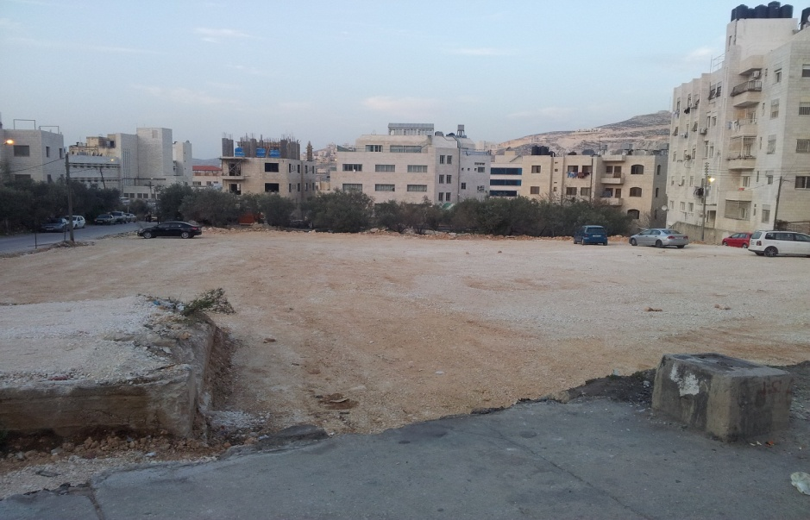
Figure 1-1 The proposed land

.

1.3 - Topography site of the land:
The site of bank has level of inclination and the difference between lowest and highest point approximately 4m and the figure 1.5 shows the inclination in the site of building.
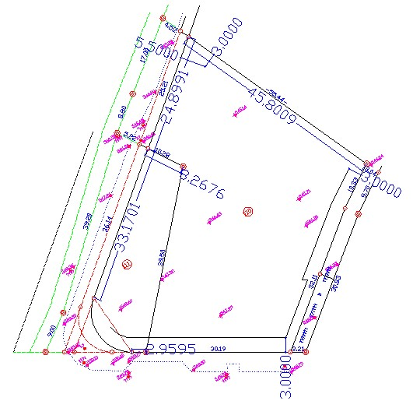
Figure 1-2 Tilt of the earth

1.4- Architectural design :

1.4.1- The Exits and Entrances:
The exits and entrances branch to :
1- Exits and entrances for cars (number_ 2 ) , the entrance of cars is close by manor street and this entrance has a width 4m and leads to employee parking area from east side and leads to the basement and the entrance is close by manor street from west side and has a width 8m and leads to Rafeedia street .
2- Entrances and exits for clients and visitors (number_2), one of them is the main entrance is close by main Rafeedia street from south side and the another one is emergency entrance and this entrance is close by manor street from west side.
3- Entrances for employees only and this entrance is close by manor street form east side.

1.4.2 - Parks for cars
- Parks for employees inside the basement (max.11 cars)
- Outside the building parks for employees (max.16 cars)
- Outside the building parks for clients and visitors (max.18)
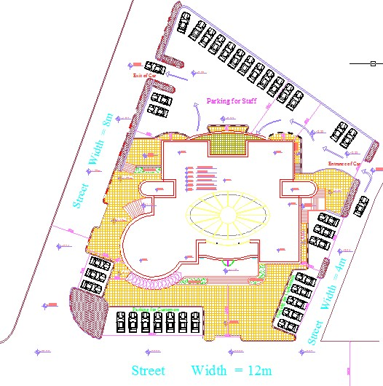
Figure 1-3 The general location and entrances and exits to the bank

1.5 – Floors of the building
- Basement floor its area is 428.57(m²) and height is 3.12m
This floor contains parks for employee (max.11cars) and also contains water tank and its size is 140(m^3) and also contains mechanic and stores rooms
To get the basement floor by using inner stairs only for employees and elevator .
In the case of coming bank van the money is transported from basement floor to ground floor where the bank safe is located by using elevator for employees only.

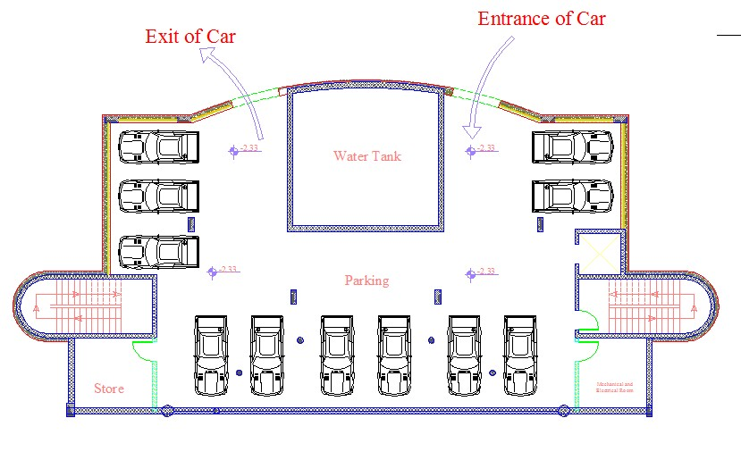
Figure 1-4 The general location for Basement floor

- Ground floor (area 428.57 height 3.12)
This floor is important floor in the building which includes the main, employees and emergency entrance.
This floor includes main mail hall and tellers and service sector and offices which concerns to deal the clients and also contains security and control room and main bank safe.
The employees can move to other floors by using stairs and elevator for employees only and the clients and visitors can use the stairs and elevator for non-employee use.
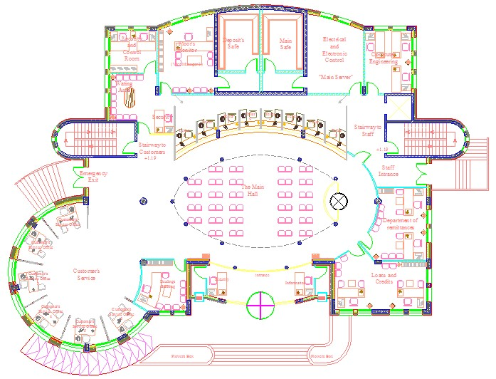

Figure 1-5 The general location and entrances and exits (ground floor)

- The first floor (area 428.57 height 3.12)
This floors contains head manager and conference room and some departments which deals with clients and visitors and also contains on sub- Archives and services room as well .
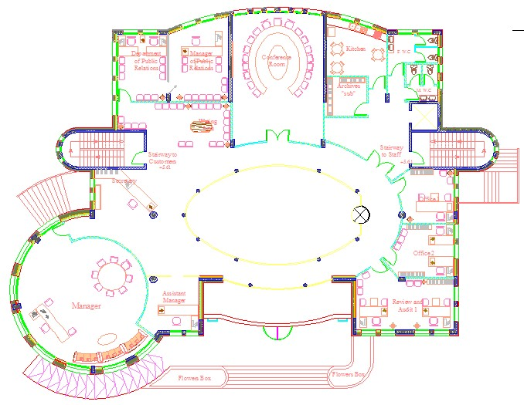
Figure 1-6 The general location and entrances and exits (1st floor)

- The second floor (area 428.57 and height 3.12)
This floor contains teller of VIP customers and some departments which deals with clients and visitors and sub-Archive as well .
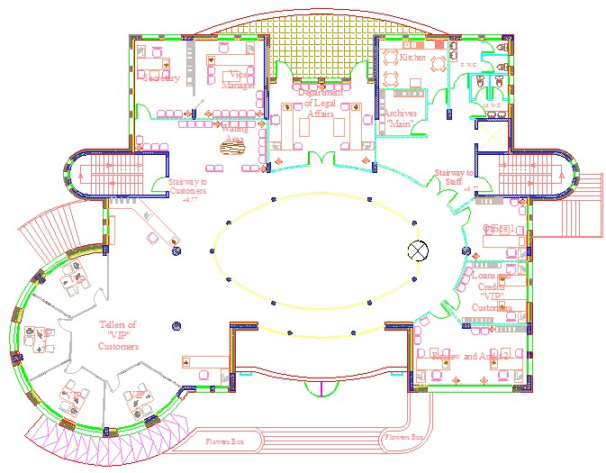
Figure 1-7 The general location and entrances and exits (2nd floor)

1.6 – Architectural Space in The Building :
This extends from the ground floor to the roof This space has been covered by dome of glass and this dome includes upper hole to decrease gain heating in summer season and sometimes use as ventilation hole in summer and this hole will be closed in winter season.

1.7 – Elevation of the Building :
These facades form from blocks, heating insulator, concrete and stone with a thickness 40cm except the southern façade with a thickness 60cm and there is a space between glass windows equals 30cm which uses to shade the window.
The glass wipers have been concentrated in southern facade to increase the heating gain in winter season and the glass wipers have been shaded by using wooden pergola.
The western and eastern façade has used shutters to decrease the heating gain and shade in summer season.
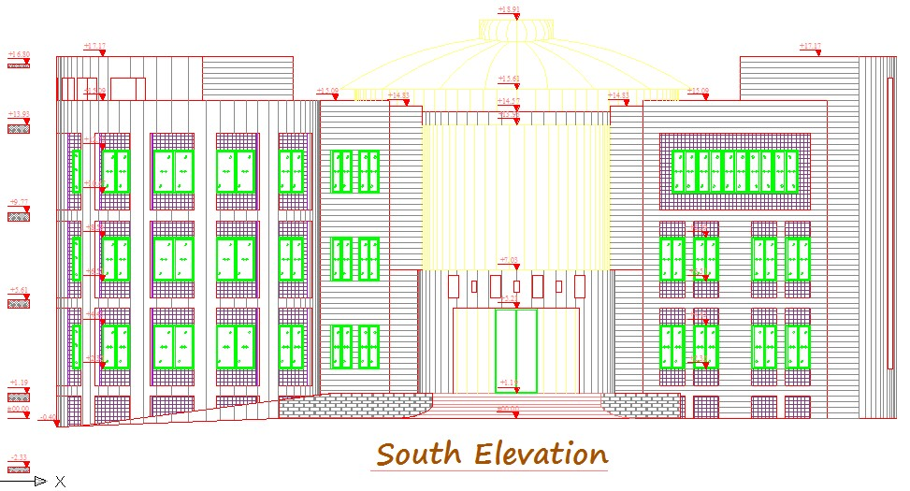
Figure 1-8 South Elevation

1.8 - The height of building
This building heightens from northern side 19.5m and because of difference level from southern side 17.17m

1.9 - Incline Handicapped passages
Handicapped passages have been used with 8 degree inclination and these passages are available in parks and in entrances and exits.

1.10- Elevators and emergency stairs
This building includes 2 exits for emergency cases and these exits are supplied with safety conditions and this building also contains 2 elevators one of them for employees and another for customers.

1.11- Safety conditions:
The control room has been taken into account The surveillance systems in this building have been taken into account The security, running and maintenance staff have been taken into account in this building.
The privacy in all departments in this building has been taken into account.

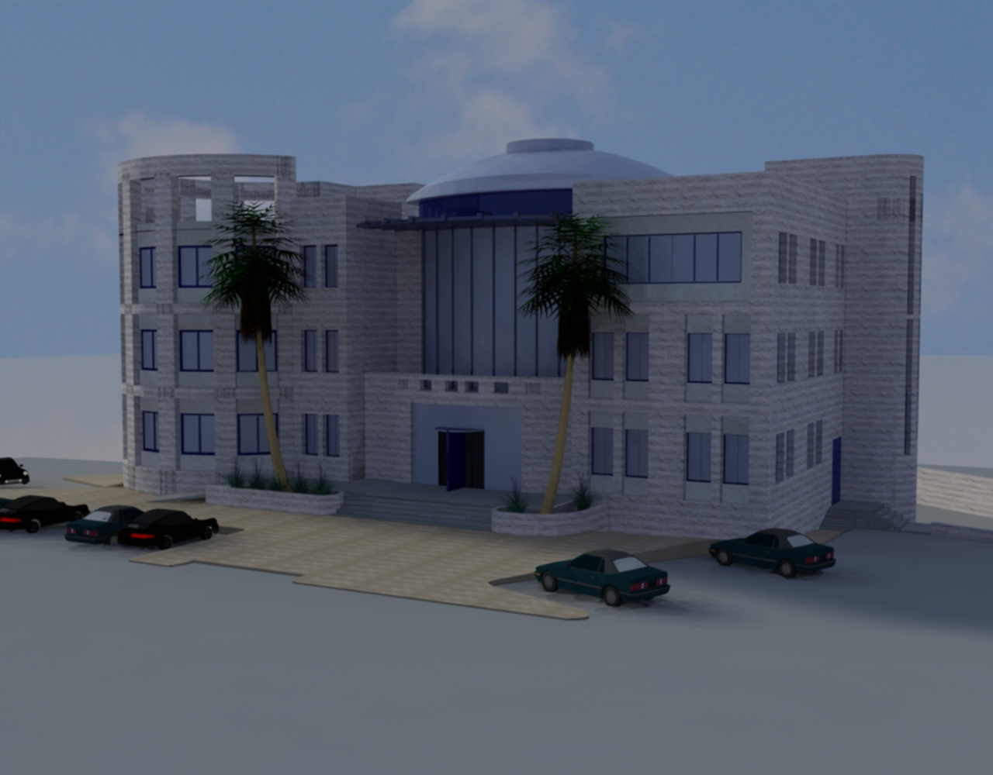
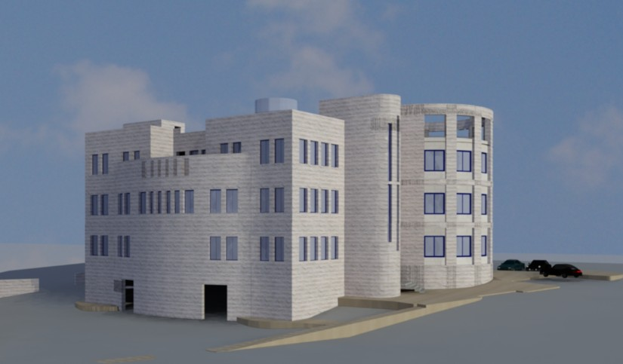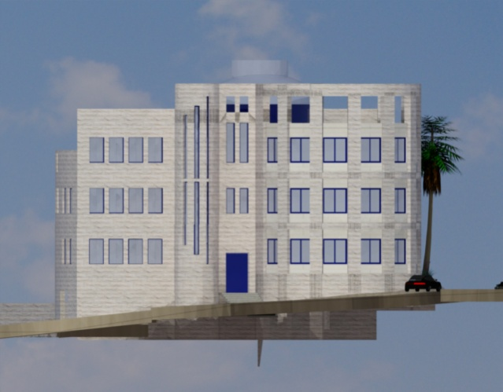
Figure 1-9 elevation from 3D-max

