# Introduction of project :

The Project is an **office building located in (**Bassatien area**) in the city of Nablus near**

**Sufian Street,** It was designed by the Office of AL-AMEED for Engineering

Consultancy and consists of **14 floors** of which **11 or theme above street** level and

three floors down street level with parking, And it’s (area = 550 m2).

**( general photo ) ( 3D modeling of project ) 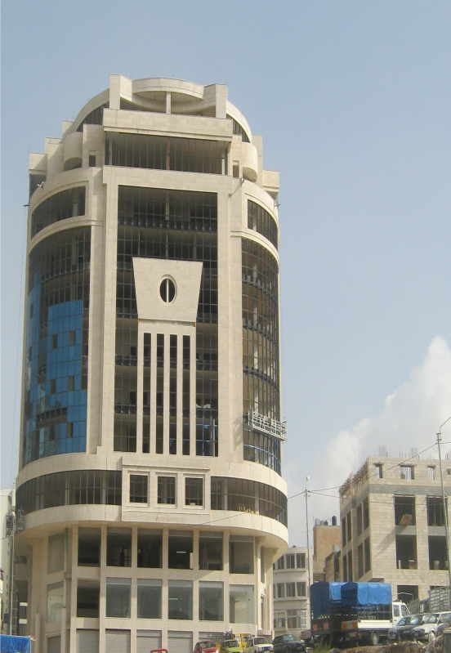….**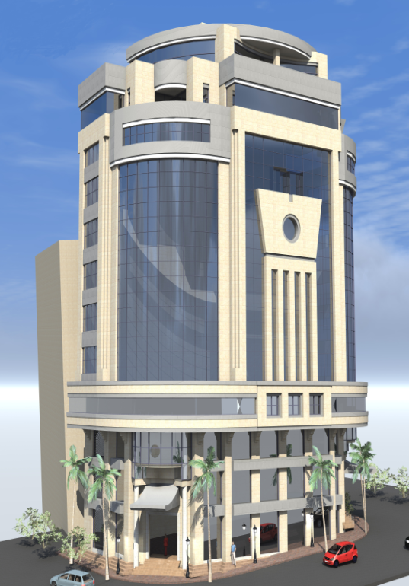

Location of project by (Google earth maps):-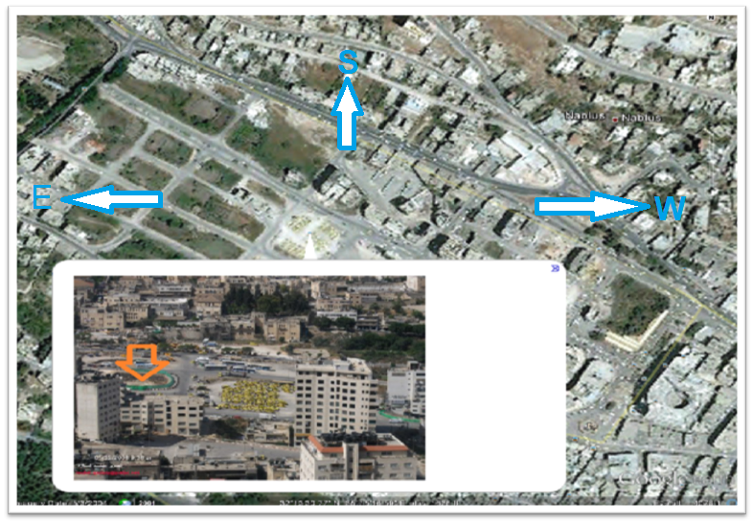

***The works to be done within the*** scope of the project ***are :-***

1. Redesign the architecture plans of this project to be suitable to use

(ex. Get rid of the darkness spaces, Add a ramp for the special needs ...etc)

1. Structural design according to **ACI 38 COD** .
2. Seismic design (study the location of project with respect to frequency of soil and the number of stories, And dynamic analysis) .
3. Electrical woks for the project.
4. Mechanical works of project including (HVAC system, Plumbing system ).
5. Environmental design (ex. Solar Chimney system ).
6. Design water tank at the bottom floor of the building.
7. Use waste solid technique to get rid of the waste from the building.

Note :

The building will be first designed under a static load, after that it will be designed for dynamic by exposing the building to lateral load, and then compare between the results.

Presentation for graduation project:

The first things the first as team we have to work with other in good way to get good results And to do better in all the other ways all of this depends on sharing and good Communication with every single partner in the project and that was done by our team.

We have designed an office building project from construction part to the

Mechanical and electrical and environmental parts in our project as compatible

design as building engineers .

And after the project was finished we hade to prepare for presentation of gradation project and we knew that there is a lot of challenges from the time to the hard working for the presentation as presenter to give all the information in good way to get and to go with.

All this lead us to train every time for this moment and we have done a good job for this moment and we have broken the barriers to give a great presentation and we can tell that we thank our professors that they have supported us in every step the we have done .