

AN-NAJAH NATIONAL UNIVERSITY

FACULITY OF ENGINEERING

COMPUTER ENGINEERING DEPARTMENT

**Electronic Car via Mobile and Traffic Lights**

Prepared By:

Sufyan Tahseen Ramadan

Arkan Twfeeq Deeb

Supervisors:

Ms. Haya Sama’neh

Dr.Hanal Abu-Zanet

2010 – 2011 Semester

**Table of Contents:**

**1.1 Introduction.**

**1.1.1 Parts of the Project**

**1.2 High Level Design.**

### 1.2.1 Logical structure.

#### 1.2.3 Controlling The Car.

#### 1.2.3 The Car.

### 1.3 Hardware.

**1.3.2 The RF Sender.**

**1.3.3 The RF Receiver.**

**1.3.4 H-Bridge.**

**1.3.5 Bluetooth Gold Mate**

**1.5 Problems .**

**1.5.1 : IR Problems :**

**1.6 Conclusion.**

**1.1 Introduction:**

We have built an electronic car that can check the traffic lights on the road and send feedback about the road to the driver(in our project it is controlled by Mobile).and by the way the driver can Control his car.

**1.1.1 So this project consists of two Parts:**

* The traffic light which communicates with the moving car.
* Mobile (Controller) which controls the car motion using Blue tooth

And by using A microcontroller chip (PIC 18f4620) the car will receive from traffic light then send its current case (red, green or Yellow) to the Mobile via the Bluetooth, and the mobile still have the ability to control the car.

**1.2 High Level Design:**

### 1.2.1 Logical structure:

This project consists of three components: Moving Car which is considered as the central component of the project ,the traffic light which communicates with the car using Radio Frequency and the Mobile that connected with the car using Bluetooth.

**Controller**

**(Mobile)**

**Moving Car**

**Traffic Light**

Figure 1.1: shows the logical structure

#### 1.2.3 Controlling The Car:

The Car is basically controlled by a mobile that communicates with it using Bluetooth technology. We built an application for that purpose using J2ME.

The Mobile controls car motion. It can make it moves forward ,backward ,left or right. Also mobile can determine the speed of the car.

On the other hand the Mobile will receive a continuous feedback about the case of the Traffic light existing on the road(Red , Green or yellow).If the light is RED the car is forced to stop.

#### 1.2.3 The Car:

Moving car has the probabilities of all choices for any car ,it can move forward ,backward ,forward with left , forward with right , backward with left and backward with right.

The car has RF receiver which reads a 27 MHz signals from the Traffic light and a Golden Bluetooth chip that communicates with the mobile

### 1.3 Hardware:

* Car.
* 2 DC Motors of the Car.
* Microcontroller(PIC 18f4620).
* H-bridge **L298HN**.
* RF sender and receiver
* Golden mate Bluetooth chip .
* 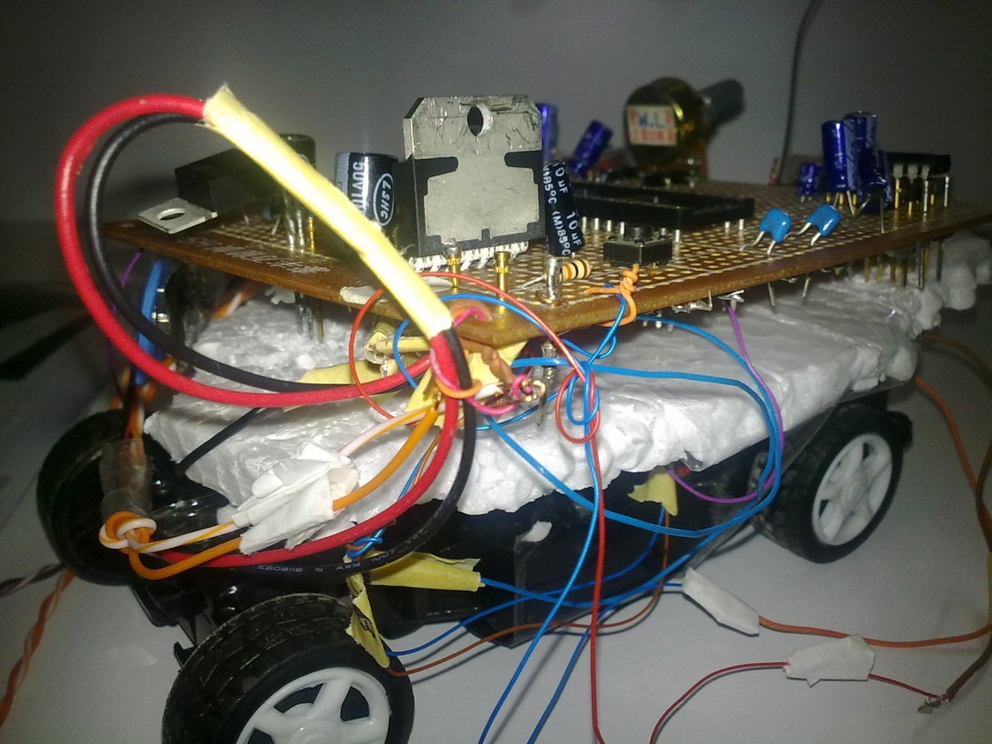

Figure 1.3.1: Photo for the car used in the project.

**1.3.2 RF Sender:**

The RF sender is fixed on the traffic light .It sends 27MHz RF signals according to the case of the traffic light.

The traffic light case is controlled by a Microcontroller circuit. And A relay is used to switch from case to another.

When case changed the sender transmit a code that has start part, Data part and the tail ,for each case there is number of pulses of the data part.

**T**he transmitter send a specific series of electronic pulses with 2.1 MS length for the first four pulses to inform receiver that new data is sent and separated by 700 microseconds.

Then transmitter sends pulses with 700 Microseconds length and with 700 Microseconds separation.

If the traffic is red then 16 pulses is sent, else if it is green the transmitter sends 40 pulses and for yellow it sends nothing.

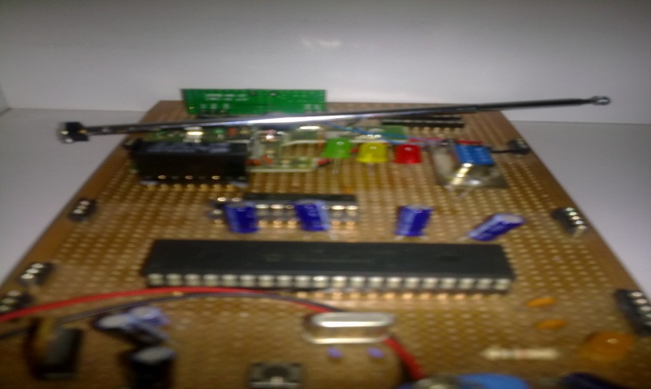

Figure 1.3.2: Photo for RF sender of the traffic light.

The picture below shows the divisions of the code sent by the sender:

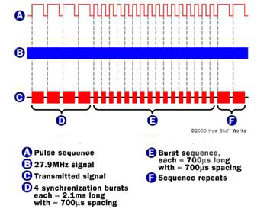

**1.3.3 The RF Receiver:**

It is fixed on the car, it always receives from transmitter, Then the Receiver have to analyze the pulses and eliminates all non- 27MHz signals by a filter then determine which switch is pressed (what is the case of the traffic light).Then it creates analog voltage levels according to the received signals.

**1.3.4 H-Bridge:**

L298HN H-Bridge was used to control the motors of the Car. It allows us to switch between +/-5V across the motor. It also allows us to source the power while using the microcontroller to control the H-Bridge. The H-Bridge is connected using the following configuration:

* 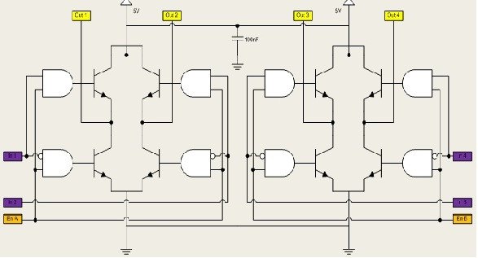H-bridge Schematic :

Figure 1.3.5: shows the H-bridge schematic

The first H-Bridge (to the left) is used to control the front motor of the car. This motor turns the front wheels either left or right. The second H-Bridge (the right) is used to control the rear motor, which is used for the forward and reverse functionality of the car. The inputs and enables of the H-Bridge are connected to port B.

**1.3.5 Bluetooth Gold Mate:**

The Bluetooth Mate Gold is designed specifically to be used with [Arduino Pros](http://www.sparkfun.com/commerce/product_info.php?products_id=9219) and [LilyPad Arduinos](http://www.sparkfun.com/commerce/product_info.php?products_id=9266" \t "_self). These modems work as a serial (RX/TX) pipe, and are a great wireless replacement for serial cables. Any serial stream from 9600 to 115200bps can be passed seamlessly from your device to your target. We've tested these units successfully over open air at 350ft (106m)!

The Bluetooth Mate has on-board voltage regulators, so it can be powered from any 3.3 to 6VDC power supply. We've got level shifting all set up so the RX and TX pins on the remote unit are 3-6VDC tolerant.

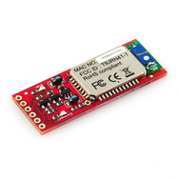

1.3.5 :photo of the Gold mate Bluetooth

1.5 **Problems :**

* Mechanical problems:
* The problem of overcoming the force of friction between the wheel and the ground.
* We spent much time using Infrared then we found it is not suitable for us.
* Power problems that H-Bridge requires high power

1.5.1 : **IR** **Problems :**

* Line of sight: transmitters and receivers must be almost directly aligned (i.e. able to see each other) to communicate
* Blocked by common materials: people, walls, plants, etc. can block transmission
* Short range: performance drops off with longer distances
* Light, weather sensitive: direct sunlight, rain, fog, dust, pollution can affect transmission
* Speed: data rate transmission is lower than typical wired transmission

**1.6 Conclusion:**

The project was an excellent experience to us,we face many problems and challenges, and we can overcome all of those problems.

Really it add a lot of information to our scientific knowledge. also we expressed our selves.

We hope that the Computer section team are satisfied by the project and benefits us of problems solving and debugging.