Factuality of Engineering

Electrical Engineering Department

Smart parking

Prepeard by:

Rafa’ Atya & Najat Sanoury

Submited to :

Dr .Mazen Rasekh

2009-2010

الاهداء

نهدي هذا البحث المتواضع الى كل من ساندنا طوال مسيرتنا الدراسية ,والى كل من ساهم ولو بلمسة بسيطة في انجاح مشروعنا

,ونخص بالذكر د.مازن الراسخ المشرف على مشروعنا الذي لم يدخر جهدا في توجيهنا, والى جميع اعضاء الهيئة التدريسية في قسم الهندسه الكهربائية ممثلة برئيس قسمها د.ماهر خماش.

الى اعز ما املك في هذه الدنيا....الى ابي العزيز... كنت دائما منارة دربي طوال سنواتي الدراسية.

الى امي الغالية .....اليك يامن كنت مفرجة كربي وبلسم لجراحي طوال سنواتي الدراسية.

الى اخوتي واخواتي ..........وجميع صديقاتي...... شكرا على المساندة المعنوية كنتم دائما الى جانبي طوال سنواتي الخمس.

Contents

ABSTRACT 4

INTRODUCTION 5

Motivation 5

1.2 Project Goals 5

1.3 Project Overview 5

1.3.1 Performance Specifications 5

1.3.2 Device Subprojects 6

Microcontroller 7

Visual Basic Interface 7

1.3.3 Project Block Diagram 7

DESIGN PROCEDURE 8

2.1 Hardware Components 8

2.1.1 Guidance System (Red LEDs) 8

2.1.2 Tracking System (Sensors) 8

Software Components 10

2.2.1 Microcontroller 10

2.2.2 Visual Basic Interface 11

3. DESIGN DETAILS 12

3.1 Hardware Components 12

3.1.1 Guidance System (Red LEDs) 12

3.2 Software Components 13

3.2.1 Microcontroller 13

3.2.2 Visual Basic Interface 12

6. CONCLUSIONS 15

6.1 Accomplishments 15

6.2 Challenges 15

6.2.1 Construction 15

6.2.2 Vehicles loop detector 15

6.2.3 OR gate 16

6.3 Future Development Considerations 16

6.3.1 Modification and Development 16

6.3.2 Additional Real World Applications 17

REFERENCES 18

# ABSTRACT

The Smart Parking System offers a simple and comprehensive solution to the problem of finding a convenient parking spot in large, multi-level parking garages. In an age where the adage ‘time is money’ seems more applicable than ever before, this user-friendly and adaptable system will eliminate the time drivers are forced to waste as they circle various parking garage floors looking for the optimal spot. The system itself consists of a user-interface at the entrance of the parking garage, which allows the driver to view all available parking spaces. Although the system will recommend the spot it deems most favorable, the driver is free to view each floor and select any available spot. Once a spot has been selected, a red LEDs built into the spots will guide the driver to their chosen destination. In addition, a ticket with directions will be printed that can be used upon return to the parking garage to guide the driver to their vehicle.

# INTRODUCTION

## Motivation

Having experienced the frustration of needlessly circling large, multi-level parking garages, searching for an open spot and the additional irritation involved in locating that same spot upon return to the garage, we felt a solution was needed. After all, with urban populations on the rise across the country, cities have found the need to expand either outwards or upwards. And as seen by such buildings as the Sears Tower and the Empire State Building, it seems the preferred choice is upwards rather than outwards. This trend seems to have spread to parking garages as well. In fact, the latest parking garages consist of as many as 20 floors of circular, winding roadways designed to confuse and intimidate the average driver. We believed we could use our engineering knowledge and modern technology to design a simple and feasible solution for this growing problem.

## 1.2 Project Goals

The goal of our project was to design and implement a functional Smart Parking System on a prototype parking garage. The ultimate goal is that the ideas and planning demonstrated through this model system can then be easily upgraded to an actual parking facility.

## 1.3 Project Overview

### 1.3.1 Performance Specifications

As the system is to be implemented in large and busy parking garages, there are a number of performance specifications that have to be met to ensure the system operates correctly and efficiently. Most importantly, the visual basic interface must send and receive the appropriate information from the microcontroller. The microcontroller, in turn, must be able to multi-task and have numerous threads running at the same time in order to track multiple cars throughout the garage. The sensors in the road and parking spots must be accurate enough to locate each car in the garage. In order to reliably park each car, these key performance specifications must be met.

### 1.3.2 Device Subprojects

Our device consists of three subprojects.

Sensor and LED Hardware

The sensors are each connected to the input of OR gate also the LED’s connected to the another input of OR gate through buffer and output pins are hard-wired to the microcontroller. Microcontroller

The microcontroller used is16F877A. Our program consists of four separate tasks, one for each of the three floors in our model parking garage and one for the entrance to the garage. Each floor task can handle the LEDs and sensors on its floor and can also pass the car onto the next floor if necessary. The entrance task handles all information sent to and from the Visual Basic Interface.

# Visual Basic Interface

The Visual Basic program receives information from the microcontroller when a car is at the entrance of the garage. Once the program has been sent all necessary information, the screen will update. The chosen spot is then sent back to the microcontroller and return directions are sent to the printer. Our Visual Basic program is organized by screen. Each screen has a series of functions that are called in order to allow the user to navigate chronologically throughout the interface.

## 1.3.3 Project Block Diagram

The block diagram, shown in Figure 1, displays the basic organization and flow of data between the various components of our project. A more detailed explanation of each block will be presented in the following chapters.

# DESIGN PROCEDURE

From beginning to end, our project went through a series of small, but necessary changes. Once we began the construction and implementation phase of our design, we came to realize there were quite a few aspects of our design from our original proposal that were simply too ambitious. For example, we put a solenoid in each spot to prevent any driver to park in another spot. We also developed the sensor we use .

## 2.1 Hardware Components

### 2.1.1 Guidance System (Red LEDs)

The red LEDs used in the guidance system that guide the driver about the spot where he choose were kept the same throughout the project.

### 2.1.2 Tracking System (Sensors)

A number of different sensors were considered to track the cars within the parking garage. The four options that we looked most closely at were Infrared Sensors, Reflective Object Sensors, mechanical Sensors and the vehicles loop detector, Ideally, we were looking for a sensor that would only detect cars (not pedestrians).

Finally we choose the vehicles loop detector (sensor)the basic operation of this sensor is that to achieve the resonant frequency. first we set the frequency and obtained it from 555 timer (172KHz),then we determined the value of the capacitor in the parallel resonant circuit (LC) which convert the square wave to sinusoidal wave and we use 50nF then we turn the inductor to achieve that XL=Xc to arrive to resonant frequency. Then the signal inter to diode which cut the lower part . We convert AC signal to DC signal by rectifier circuit .finally this signal is inter to the input of comparator(LM324)that compared this value to reference voltage (2volt)the output of the comparator is connected to led .

This sensor is burned to all spots in garage when a car stop above it, the metal body will effect in the frequency of the lc circuit and it will not be resonant any more. So the voltage will be below the reference so it will turn on the led.

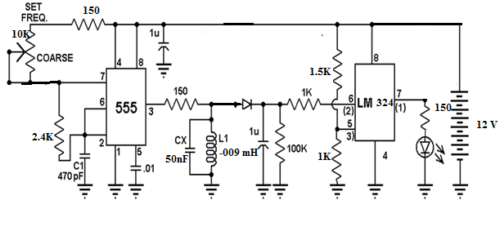

Figure 2

Vehicles loop detector circuit

# Software Components

### 2.2.1 Microcontroller

The microcontroller we considered in our project was the 16F877A. This microcontrollers is programmed through pic c language, which is considerably less complex than the assembly language code used to program the other option available to us.

Figure 3

Microcontroller Task Block Diagram

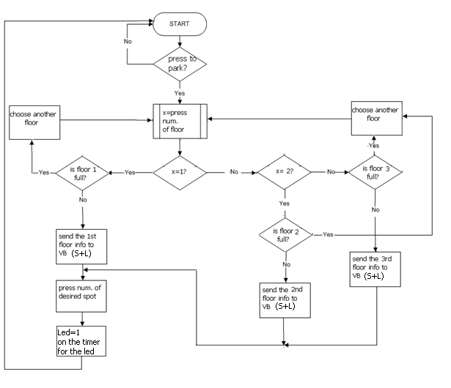

### 2.2.2 Visual Basic Interface

We decided to program the entrance interface in Visual Basic mainly for its graphical environment and ease of use. Alternatively, the interface could have been programmed in JAVA, C++ or any other object oriented programming language. We organized the Visual Basic program by interface screen. Each button on the screen masks a function that is executed when the button is selected. Serial port communication is utilized between the microcontroller and our Visual Basic program because the 16F877A development board comes equipped with a serial port. Parallel port, USB, or wireless communication could have been used just as effectively in place of the serial port. To send and receive information we used pre-defined functions within the MSCOMM library in Visual Basic. 3. DESIGN DETAILS

## 3.1 Hardware Components

### 3.1.1 Guidance System (Red LEDs)

Tracking System (Sensors)

As we show below we connect the led's and the sensors in input of the OR gate, then the output inter the pic .

Also microcontroller send to the led that is located in the chosen spot a signal and give it a timer with ten minutes to bloke it to prevent another driver to choose that spot while he is in the road .

We use the OR gate to solve the problem(when the driver is still in the road and another driver is choose the same spot ,as we show in table below

|  |  |  |
| --- | --- | --- |
| sensor | led | Output of OR gate |
| 0 | 0 | 0 (spot is available) |
| 0 | 1 | 1 (driver is still in the road) |
| 1 | 0 | 1 (driver is parking) |
| 1 | 1 | 1 (driver is parking) |

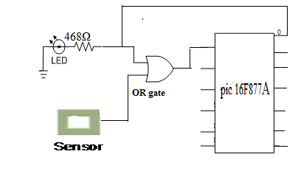

Figure 4: LED and sensors System Configuration

## 3.2 Software Components

### 3.2.1 Microcontroller

The key function of the microcontroller is to control all the LEDs and sensors in the parking garage. We used 24 of the 16F877A I/O pins. Twelve output pins were used for the input of led's to select the chosen spot in the parking garage .also twelve input pin was used for the output of the OR gate.

TABLE 1: MICROCONTROLLER I/O PIN LAYOUT

|  |  |  |
| --- | --- | --- |
| Micro Pin # | I/O | Function |
| A0 | Input | Output of sensor 1 |
| A1 | Input | Output of sensor 2 |
| A2 | Input | Output of sensor 3 |
| A3 | Input | Output of sensor 4 |
| B0 | Input | Output of sensor 5 |
| B1 | Input | Output of sensor 6 |
| B2 | Input | Output of sensor 7 |
| B3 | Input | Output of sensor 8 |
| D0 | Input | Output of sensor 9 |
| D1 | Input | Output of sensor 10 |
| D2 | Input | Output of sensor 11 |
| D3 | Input | Output of sensor 12 |
| E0 | Output | Input of LED 1 |
| E1 | Output | Input of LED 2 |
| E2 | Output | Input of LED 3 |
| C2 | Output | Input of LED 4 |
| A5 | Output | Input of LED 5 |
| B4 | Output | Input of LED 6 |
| B5 | Output | Input of LED 7 |
| B6 | Output | Input of LED 8 |
| D4 | Output | Input of LED 9 |
| D5 | Output | Input of LED 10 |
| D6 | Output | Input of LED 11 |
| D7 | Output | Input of LED 12 |

### 3.2.2 Visual Basic Interface

The code is in appendix .

The entrance interface that the driver uses to view and select the desired parking space is programmed in Visual Basic. This graphic-friendly language allows us to mask function calls and command lines with colorful buttons, so the full functionality of a rigorous computer program is readily available to any common user at the click of a mouse.

The screen shots of the interface are shown in Figure 5. The maps were created in Adobe Photoshop based on the floor plans of the model parking garage. Filled parking spots are crossed out with a red line. Available parking spaces are marked with the letter ‘P’ be picked. . The recommended spot is boxed, and the driver may move the ‘+’ cursor freely to select a spot. Simple and clear screens inform the driver when the system is updating or paused for printing.

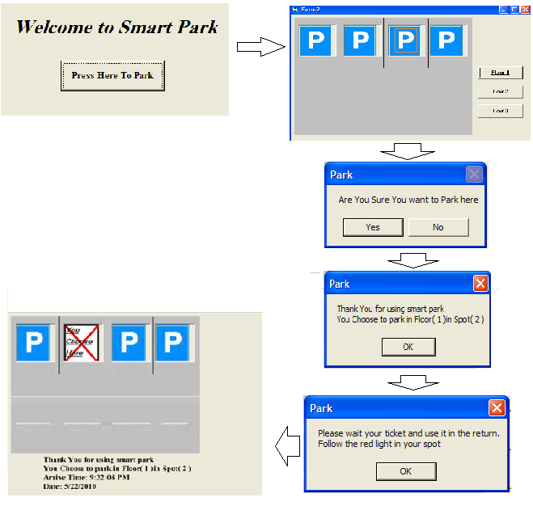

Figure 5: Visual Basic Interface Screen Shots

Aside from interfacing with the driver, the Visual Basic program also has to “interface” with the microcontroller. The program sends and receives information from the microcontroller via a serial port. The exchange of data between 16F877A and Visual Basic is depicted in a flowchart as shown in Figure 2. All data are encrypted in 2 Bytes, assuring fast and accurate transmission through the serial port.

When the driver choose the floor, the microcontroller send a byte that represent the spots with a binary number then the visual analyze it to 1 (for occupied spot) or 0 (for empty spot)

When the driver has chosen a particular parking spot, the Visual Basic program sends this information to the microcontroller. At the same time, the program retrieves the return directions from a table look-up and sends them to a printer via a parallel port to print. The microcontroller checks the status of the selected spot and the availability of the path leading to it then sends the character ‘g’ for “go” when ready to light the path. Upon receiving both “printing complete” signal from the parallel port and ‘g’ from the serial port, the Visual Basic program informs the driver to follow the green lights and loops back to its idle screen until the next car arrives.

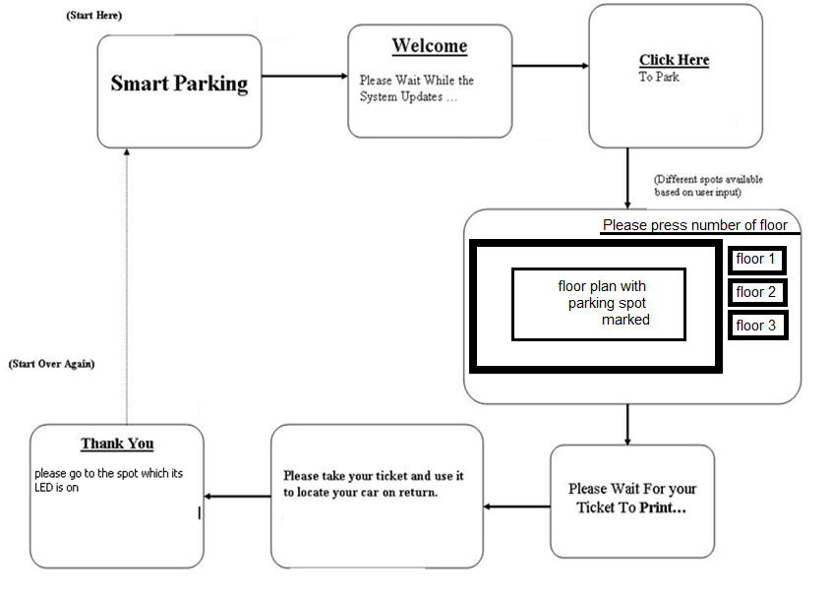

Figure 6: Visual Basic Interface Program Flow Char.

# 6. CONCLUSIONS

## 6.1 Accomplishments

The Smart Parking System met all of our performance specifications. We were able to successfully guide multiple cars to their designated parking spots using the microcontroller’s multi-tasking capabilities. The microcontroller not only controls all the hardware components of the system, it also communicates with the Visual Basic interface through a serial port. . Also, we designed a Visual Basic Interface that is intuitive enough for a first time user to navigate with ease. The program accommodates for physical disabilities, recommends an optimal spot, and also prints return directions on the parking ticket.

## 6.2 Challenges

### 6.2.1 Construction

There were a number of challenges we overcame in the design and testing of the Smart Parking System. The first was the actual construction of the model parking garage. The original PlanCity parking garage went through extensive alterations so that it could be equipped with our system. Holes had to be drilled in the parking garage floors for each sensor and guiding LED in all spots. . In order to simplify the debugging of the circuitry, we color-coded the wires between the floors and labeled each connection with a specific color tape and marker.

### 6.2.2 Vehicles loop detector

we faced a significant problem that we could not reach the resonant frequency in our sensors also in the sensor we had some difficulty in turning the inductor ,and convert the signal from AC to DC signal.

### 6.2.3 OR gate

with increasing the number of stages, the current decrease and not give the enough signal to operate the system in some IC's like OR.

## 6.3 Future Development Considerations

### 6.3.1 Modification and Development

There are a number of improvements and modifications that can be made to our design to increase real world practicality and functionality. The first change is that we can use image processor system to track the car until arrive to the spot. Also we can add a data base to the garage that give the information of every car inter and out to the garage. and give the arrival time.

Other improvements would be additional guidance devices such as a return interface with audio or light guidance. Upon the return, either audio playback or a series of LEDs would guide the driver to their vehicle. Such an interface could also be integrated with the elevator so that the driver might be taken directly to the appropriate floor.

### 6.3.2 Additional Real World Applications

This system can clearly be applied to a number of different parking environments: large parking lots, underground parking facilities, stadium parking, airport parking, etc. The system can be easily networked to monitor and control any number of different parking facilities. Furthermore, this information can be made available online for convenient access.

Not only is this system useful and applicable to parking facilities, it can be easily modified to accommodate the needs of hospitals, resorts or conference centers. A similar guidance system could be used to direct patients and doctors to different wings, hotel guests to various attractions, or clients to the proper meeting room.

The Smart Parking system is beneficial wherever frequent searching processes are involved. For example, it can be used anywhere from locating specific products within large industrial warehouses to finding a book at your local library.

# REFERENCES

[www.marshproducts.com/pdf/Inductive%20**Loop**%20Write%20up](http://www.marshproducts.com/pdf/Inductive%20Loop%20Write%20up)

[www.electro-tech-online.com/.../31170-**vehicle**-**loop**-**detector**](http://www.electro-tech-online.com/.../31170-vehicle-loop-detector)

[www.deltascientific.com](http://www.deltascientific.com)

[www.seattlerobotics.org/guide/**infrared**](http://www.seattlerobotics.org/guide/infrared)

[www.glolab.com/pirparts/**infrared**](http://www.glolab.com/pirparts/infrared)