An-Najah national university
Faculty of engineering

Department of computer

Graduation project

Robotic arm

To: computer engineering department

Instructor:

Sufyan Samara

Prepared by:
Ola Jallad
Hanan Zuheir Ali

1

الاهداء

الى الهادي الامين…. المبعوث رحمة للعالمين ... ذو الخلق العظيم
سيدنا محمد علية افضل الصلاة واتم التسليم
والثلة الاولين...................

الى ارض التين والزيتون.... الى الثرى الطهور
فلسطين الحبيبة...

الى الذين ساروا مقتدين بسيدنا محمد صلى الله عليه وسلم...الى شهدائنا الابرار..
الذين قدموا لله اغلى ما يملكون.........................

الى الحضن الحنون.................
امي وابي...................

Table content:

……Present to
chapater0:
Introducation of robot.

chapter1:
Robot arm.

chapter3:
Arm solution.

chapter4:
Mechnical design.

chapter5:
Electrical circuits.

chapter6:
Software for control arm robot .

chapter 7:
Software for interfacing in MFC .

chapter 8:
Interfacing and electrical circuits.
chapter 9:
Flowchart for the arm.

Ch0: Introducation
A robot:
is a mechanical device that can perform preprogrammed physical tasks. A robot may act under the direct control of a human eg. the robotic arm of the space shuttle or autonomously under the control of a pre-programmed computer Robots may be used to perform tasks that are too dangerous or difficult for humans to implement directly (e.g. the space shuttle arm) or may be used to automate repetitive tasks that can be performed more cheaply by a robot than by the employment of a human (e.g. automobile production).
The word robot is also used to describe an intelligent mechanical device ( machine ) in the form of a human. This form of robot (culturally referred to as androids) is common in science fiction stories. However, such robots are yet to become common-place in reality and much development is yet required in the field of artificial intelligence before they even begin to approach the robots of sci-fi.
Robots have become important over a wide range of applications--from manufacturing, to surgery, to the handling of hazardous materials. Consequently, it's important to understand how they work, and what problems exist in designing effective robots. This project will address one of those problems: positional control.

Ch1: Robot control:
Robot control:
is the theory of how to model and control robot
simplistic model of a robot is to look at as a collection of links
connected by joints. The tip of the robot (the end-effector) is commonly referred to as the tool center point or TCP. As the joints rotate and the links contract and expand, the TCP will change position.
It is of great importance to know the position of the TCP in world coordinates. For example, for a robot to weld in a straight line, the actuators in the joints of the robot have to be controlled in complex manner.
One of a robot's functions is to move to a specified location or along a predetermined path so it can perform a task.
Motion may consist of the robot itself moving, or of an articulated arm being actuated from a fixed pivot position.
Here we want to control the motion of a very simple articulated arm--a two-segment arm that can move only in the x-y-z plane and pivots about the position x=0, y=0 z=0. A stepper motor M₁ at (0,0) is attached to the first arm segment L₁ and controls the angle of L₁ with respect to the x-axis.
A second stepper motor M₂, afixed to the end of L₁, is attached to a second arm segment L₂ and controls its angle with respect to the x-axis. Each arm segment is 100 units long, for a total maximum extension of 200 units.

Ch3. Arm solution
A typical industrial robot is built with fixed length segments that are connected either:
- joints whose angles can be controlled:If each angle and slide distance is known, the position and orientation of the end of the robot arm relative to the base can

be computed with simple trigonometry
- along linear slides whose length can be controlled:
calculating the angles and slides needed to achieve a desired position and orientation — is much harder.
The mathematical procedure for doing this is called an arm solution. For some robot designs, such as the Stanford arm, SCARA robot or cartesian coordinate robots, this can be done in closed form Other robot designs require an iterative solution.

Ch4 :Mechnecial desgin:

Here is the the picture that we design the arm like it :

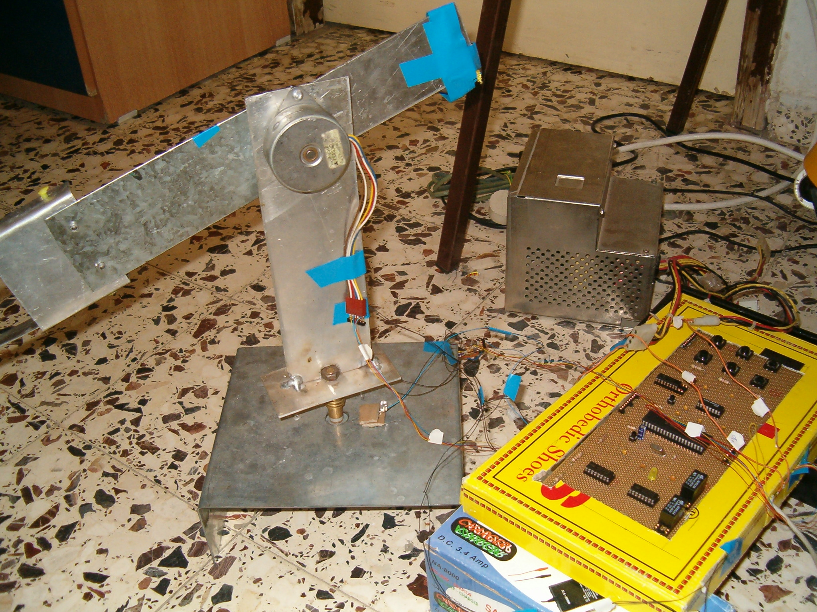

ch4.1: material that we use

We determine the metal that we use it in this we use iron metal and aluminum metal in this project the iron metal we use it in the base and in the segment one and we use the aluminum metal for the segment number *two the base has the following dimension:

*The segment one has length:

The segment number two has length:
*
*The clipper like that:

ch4.2: motors

we use the stepper motor and dc motor we put the stepper motor for the base and for the segment two to rotate and we use the dc motor for clipper.

stepper motor connection:
we connect the stepper after we check the common for it and determine the sequence for each motor.

Ch5. Electrical circuits that we use:

Ch5.1:Select motor:
Since the uses for electric motors grow everyday, there are a wide variety of choices and types of electric motors. Weight, size, power source, torque and cost are all variables that are unique to the type of motor desired. In many cases custom motors can be designed to specification. When selecting an electric motor, take into consideration the size of the space where the electric motor will have to fit, the requirements for power input and motion output, the desired speed of the motion to be produced, the type of current to be used and the overall cost limits. Most manufacturers of electric motors have a wide range of capabilities to meet your needs.

Ch5.2 stepper motor :
stepper motor :
is a brushes, synchronous electric motor that can divide a full rotation into a large number of steps, for example, 200 steps. Stepping motors come in two varieties, permanent magnet and variable reluctance .Permanent magnet motors tend to "cog" as you twist the rotor with your fingers, while variable reluctance motors almost spin freely (although they may cog slightly because of residual magnetization in the rotor). You can also distinguish between the two varieties with an ohmmeter. Variable reluctance motors usually have three (sometimes four) windings, with a common return, while permanent magnet motors usually have two independent windings, with or without center taps. Center-tapped windings are used in unipolar permanent magnet motors.

Ch5.3 Applications for stepper motor
Computer-controlled stepper motors are one of the most versatile forms of positioning systems, particularly when digitally controlled as part of a servo system Stepper motors are
used in floppy disk drives, flatbed scanners, printers, plotters
and many more devices. Note that hard drives no longer use stepper motors, instead utilizing a voice coil and servo feedback for head positioning.

we use two stepper motor for in the following things:

1 the base motor and it is rotate around it self
2. the second motor rotate in x, y plane ( in above ,in down)
.
Ch5.4 DC MOTOR:

Definition to dc motor:
DC MOTORS
· when power applied, turn in one direction at a fixed speed
· optimized to run at a fixed, usually high RPM.
· Torque is highest at the rated speed and lowest at low speeds
· speed can be varied if a PWM controller is added
· almost all can be reversed
· inexpensive and commonly available
· available in wide range of speeds and power.
· suitabe for turning, spinning, etc.
· not suitable for positioning unless some kind of position feedback is added
· if the applied load is greater than the capacity of the motor, the motor will stall and possibly burn out
· MakingThings carries DC motors and controllers

We use the dc motor in project for:
We use it to move the clipper and make it to catch the things .

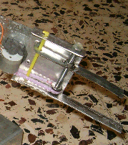

Ch5.5 ULN2003 DRIVER:

The ULN2003 are high voltage, high current darlington
arrays each containing seven open collector darlington
pairs with common emitters. Each channel rated at 500mA and can withstand peak currents of 600mA. Suppression diodes are included for inductiveload driving and the

inputs are pinned opposite the outputs to simplify board layout the figure.2 show the uln2003 diagram

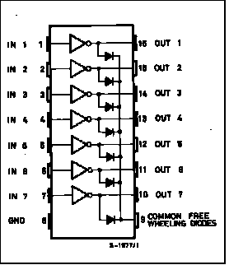
figure.2 uln2003

we use it to amplifier the voltage that output from PIC61F877 and go to motor and we connect it to motor as in figure.3:
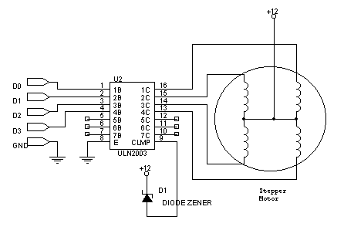
figure.3 motor with uln2003

ch 5.6 relay for dc motor:
It use relay to dc motor FOR the folllwing purpose :
starting with simple ON/OFF control and building up to full bi-directional speed control of two motors.

button:
we use it to know when the cliper catah the thing that it carry and in the basic system to PIC

ch 5.7 Keypad:

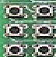
figure.4 keypad buttons

we use it to controll the robot arm through manual mode :
(the figure.4 show keypad)

button1: make the robot arm rotate to right.
button2: make the arm rotate left
button3:make the arm move down
buttton 4: make the arm move above.

Ch6:The software for project:

We write the code in PICC programme:

include "C:\Documents and Settings\Administrator \ggg.h #
include <stdlib.h>#
include <math.h>#
int loop
int i=0
int j=1
char c,ca
//int detectm2=0
//int detectm1=0
int md=0
int mu=0
int ml=0
int mr=0
int count=0
int count1=0
int deg
int deg2
function timed getc//
char timed_getc(){
long timeout
short timeout_error
() restart_wdt
timeout_error=FALSE

timeout=0

while(!kbhit()&&(++timeout<50000)) // 1/2 second
{
delay_us(10);
restart_wdt();
}
11

if(kbhit())

return(getc)
{

else

timeout_error=TRUE
() restart_wdt

return(0)

}
}

Chp7: Interfacing for project in mfc
We use MFC for make the interfacing of project as appear in figure.5

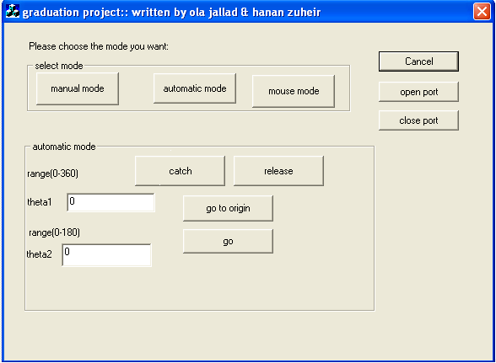

figure.5 interface in mfc .
we write code in mfc for the following:
1.open port for serial connection to send to pic16f877:
void CProjectDlg::OnOpen ()
{
// TODO: Add your control notification handler code here
(m_d.SetPortOpen(true

}
2. close the serial port:

void CProjectDlg::OnOpen ()
{
m_d.SetPortOpen(false)
}
3.send function to send character in serial:

void CProjectDlg::Send(unsigned char b)
{

CByteArray barray

(barray.Add(b
(COleVariant var(barray

(m_d.SetOutput(var
}
4. mode option:

4.1 automatic mode:
this mode for control the arm automatical by send the character a to pic:
void CProjectDlg::OnAut ()
{
Send('a')
}
then if you want to move the robot by arm in specific angle make the following:

1.click in the button go origin to allow the arm to go to origin.
2: enter the theta1 and theta2 and the make the robot turn

13
right or left or down or above.

void CProjectDlg::OnGo ()
{

(UpdateData(true
if(0<=m_theta1 && m_theta1<=360 && 0<=m_theta2) && m_theta2<=180)
{
count1=int(m_theta1/7.5)
count2=int(m_theta2/6.42857)
if(m_theta2>=0 && m_theta2<=45)
count2=7
/*CString st
st.Format("%d%d",count1,count2)
AfxMessageBox(st )
*/

Send(count1)

CString st
st.Format("%d%d",count1,count2)
AfxMessageBox(st )
Soso ()

}}
4.2cliper move:
to make the cliper catah something make the following

1. catch button:
this make the cliper catch the object by send character
t- to pic as follow:-
void CProjectDlg::OnCatch()

{
(‘ Send('t
}
2. relaese mode:
to release the object from cliper we send character
(r) to pic as follow:

void CProjectDlg::OnRlease()
{

(Send('r'
}
4.3 manual mode:
this mode allow you to control the arm throught keypad by send character " m" to pic in circuits as follow:
void CProjectDlg::OnMan()
{
( UpdateData(false

m_mode=" manual mode "
(‘Send('m'
The button in keypad operate like that :

button1: make the robot arm rotate to right.
button2: make the arm rotate left
button3:make the arm move down
buttton 4: make the arm move above.
4.4 mouse mode:

This mode will move the arm according to mouse mode and the arm will move according to follow:
1. If you turn the wheel forward : the arm will move right
2. If you turn the wheel back : the arm will move left
3. If you click the left button: the arm move up
4. If you click the right button: the arm move after .

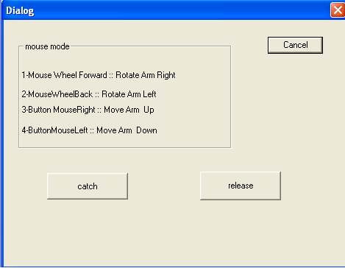

Flow chart for arm ch9

Open port
Select mode

Manual
automatic

go to origin
Select the button

Enter theta or theta2
Turn above
Button 1,2,3,4,5,6

Turn the arm left
Turn the arm left or right accordiging to thaeta
Turn the arm above or down according to theta2
Catah cliper
Release the cliper
Turn down
Turn right

