
بسم الله الرحمن الرحيم

An-Najah National University
Faculty of Engineering
Electrical Engineering Department

IR control Motor
Final project

Prepared by:
Reyad Hayek.

Submitted to:
Dr.Ra'ad Jaber.

9th may 2009

Content:

*Abstract

*Acknowledgments.

CH#1: IR Remote system.
1.1 Modern IR Remote construction.
1.2 How IR Remote work.
1.3 The IR Remote algorithm.
1.4 How we can control the remote by the computer?

CH#2: Microcontroller.
2.1 What is microcontroller?
2.2 PIC 18F877.
2.3 PIC function.

CH#3:Stepper Motor.
3.1 type of stepper motor.
3.2 How stepper motors work?
3.3 stepper motor drive.

CH#4: DC motor.
4.1 How stepper motors work?
4.2 stepper motor drive.

CH#5: Camera.
5.1 type of camera.
5.2 How camera connect to pc or TV.

*Appendices.

*References.

*Abstract:
My project is to design model of watching a camera and controlling it using microcontroller.

We will show in my project:
*-Remote model.
*-PIC microcontroller and its circuit.
-How to connect the microcontroller with motors. *
-PIC program to control for stepper motor.*
*-about motors DC & stepper motors.
*-The camera and its connection.

Finally we will present the model we constructed designing programming and constructing, the problems and their solutions.

*Acknowledgments.

First and foremost we would like to thank our advisor, Dr.Ra'ad Jaber not only for acting as our advisor in this project, but also for his patience. His clear –mindedness acted as the compass by which this work was guided, this steady hand often grounding ideas that might otherwise have simply flown away. Without his encouragement and assistance, the work presented here would not have come to function.

Thanks to our parents, brothers and sisters, who maintained a staunch belief in our abilities even when we not have the courage?

To all those who have not been mentioned for reasons of brevity, you are in our heart.

To all those who giving me any support and help.

CH#1: IR Remote system.

One of the most frustrating things about remote control of our home theater components is making sure that none of the IR (infra-red) sensors on the components are blocked from view of the remote control unit in our hands. We have all experienced having to press the buttons several times, perhaps moving the remote over our heads or off to one side, stretching our arm full length, to let it send the IR pulse to the satellite box, receiver, or DVD player. This can be even more of a problem if your components are in a cabinet with doors.
We have received so many questions about this issue; we decided it was time to prepare an article on how to solve it. The cost is about $200, but once the system is installed, problems will all but disappear. You will be able to use all of your remote controls if you like, or just one universal remote, with the same results: the components will respond to your button pushing without having to move the remote control from your lap.

Seeing in the infrared
A source of near infrared light is as close as your television remote control.
Infrared remote control 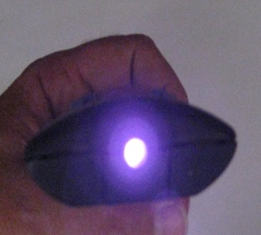
Infrared remote control
Look directly into the front of the remote control and push some buttons. You can't see anything change. But now point the remote at an inexpensive digital camera or video camera and push the buttons. Now, in the camera's screen, you see a brightly flashing beacon of light. You can use it as a flashlight to read by, as long as you look in the camera screen.

How to make simple Infrared Sensor Modules?
IR LED emits infrared radiation. This radiation illuminates the surface in front of LED. Surface reflects the infrared light. Depending on reflectivity of the surface, amount of light reflected varies. This reflected light is made incident on reverse biased IR sensor. When photons are incident on reverse biased junction of this diode, electron-hole pairs are generated, which results in reverse leakage current. Amount of electron-hole pairs generated depends on intensity of incident IR radiation. More intense radiation results in more reverse leakage current. This current can be passed through a resistor so as to get proportional voltage. Thus as intensity of incident rays varies, voltage across resistor will vary accordingly.
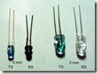
This voltage can then be given to OPAMP based comparator. Output of the comparator can be read by uC. Alternatively, you can use on-chip ADC in AVR microcontroller to measure this voltage and perform comparison in software.

IR LED and IR sensor:
IR LED is used as a source of infrared rays. It comes in two packages 3mm or 5mm. 3mm is better as it is requires less space. IR sensor is nothing but a diode, which is sensitive for infrared radiation.

This infrared transmitter and receiver is called as IR TX-RX pair. It can be obtained from any decent electronics component shop and costs less than 10Rs. Following snap shows 3mm and 5mm IR pairs.
Color of IR transmitter and receiver is different. However you may come across pairs which appear exactly same or even has opposite colors than shown in above pic and it is not possible to distinguish between TX and RX visually. In case you will have to take help of millimeter to distinguish between them.

BASIC INFRARED TX-RX
The transmitting section of this infrared Tx-Rx is unusually simple but it works rather well: the infrared LED pulses at a frequency of 160Hz and its range, with its receiver, is between 2 and 4m depending on the transformer used and the setting of the 100k pot. With other receivers it may reach a range of 15m, without any lens but with a perfect alignment between TX and Rx. The receiving section uses an infrared phototransistor and an additional infrared emitter is placed next to it in order to provide a light bias thus improving sensitivity. The 100k pot. Will also adjust sensitivity by setting the right operating point for the transistor. The supply should be well regulated in order to avoid self-oscillations. The audio transformer is a small output transformer recovere d from an old transistor radio

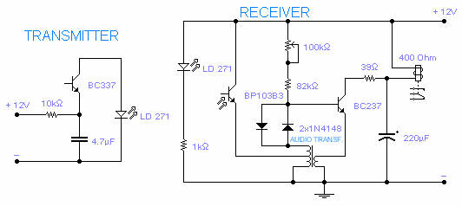
Simple Remote system (on off)

How we can control the remote by the computer?
We can out different signal from the serial port, the signal consist of sequence of bit which defers from the others.
But on manual remote we can't out than two signals (on-off).
So we use the microcontroller to out many signals from the transmitter,
We used TOSP receiver IC which work on frequency 38khz ,so we must carry the signal which we need to transmit on carrier 38khz to make match connection.

But we know that the serial can't out this frequency so, what we have to do?
* We built 555 timers with frequency 38 kHz.
*make the serial port out 1200bit/sec.
*Connect the max232 IC to serial port to regulate the voltage.
We use max232 IC to regulate the voltage out (-10, +10) ______ (0, 5) v
*enter these two signals 555timer & the serial port to Schmitt trigger.
*connect 330ohm and IR led to the out of the Schmitt trigger.
*IR is ready to transfer the data which decide by the computer.

See the figure
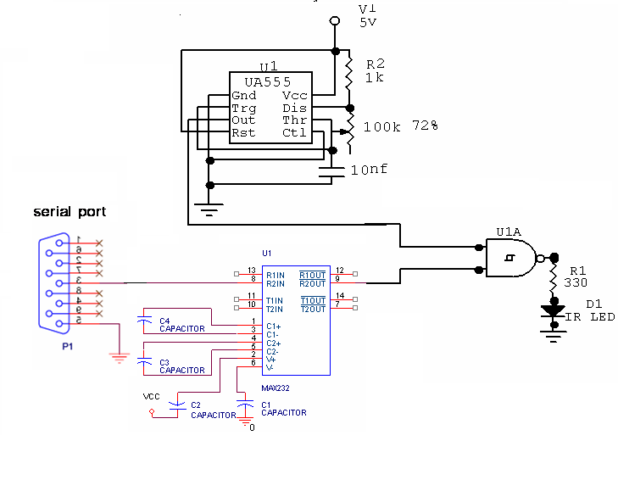
555 timer calculations
T1=0.69(R1+R2) C T2=0.69(R2) C T=0.69(R1+2R2) C
T=0.69(1k+2*72)*10*10^-9
=2.6e-5 sec, F=1/T =1/ 2.6e-5=38kHz
To out the signal to IR LED with f=38 kHz we sum the two signal (555 timer & max232) to Schmitt trigger that make pulse modulation.

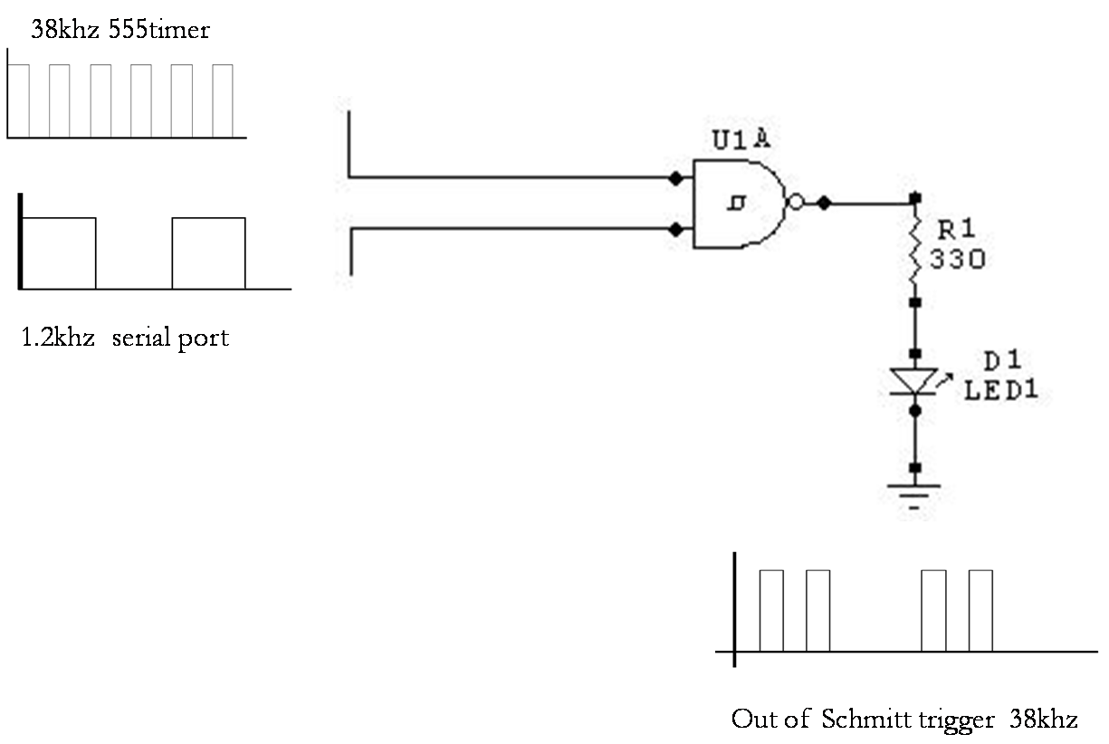

We out the signal that we want to control the motors by code in C sharp left, right & up, down .At maximum the distance reach to 20 meters between Tx & Rx , its depend on the power on IR LED and type of the LED.

The receiver will receive the signal for distance not than 20m, it input the data to the PIC to decide the signal what its means?
The signal reaches to receiver device (TSOP) which connected to microcontroller by the circuit shown.

See the figure
These three pins connected to microcontroller in input port
* DCD data pin which transport data from IR receiver to microcontroller.
* RTS it's like Vcc voltage from microcontroller its reach to 5v.
* GND ground 0v.
This circuit receives the signal like that out from IR sender with frequency 38k .but with small attenuation; microcontroller can decide the correct signal

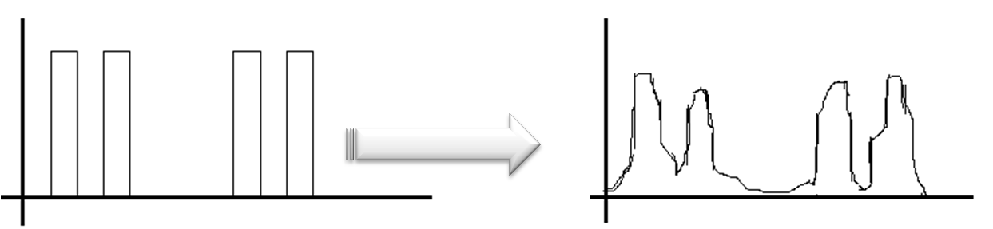

But how to out the signal from the serial port? We use Csharp to out he signals.
Software design for IR transmitter to out 4 different signals using C sharp form serial port.
There is 4 signals two signals to move the car forward and reverse, and the other to move it to left or right.
Each signal consists of 4 bits to make minimum probability to interference between the signals.

Forward backward right left
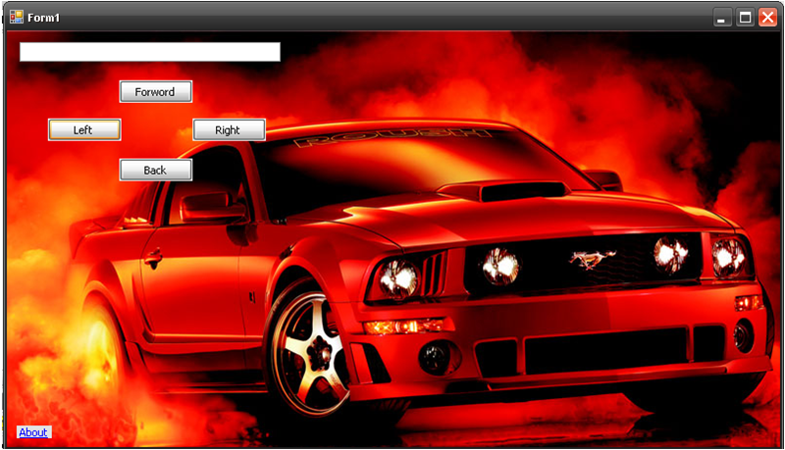
The code of sender IR remote:
byte Receive()
{
int flag;
int bit1,bit2;
int i;
byte data;
flag =0;
restart_wdt();
bit1 = input(PIN_E0);
delay_ms(0.026315789473684210526315789473684);
bit2 = input(PIN_E0);
delay_ms(0.026315789473684210526315789473684);
} if( bit1==1 && bit2==1)
restart_wdt();
bit1 = input(PIN_E0);
delay_ms(0.026315789473684210526315789473684);
bit2 = input(PIN_E0);
delay_ms(0.026315789473684210526315789473684);
} if( bit1==1 && bit2==1)
shift_left(&data,1,0);
shift_left(&data,1,0);
shift_left(&data,1,0);
shift_left(&data,1,0);
} for(i=0;i<4;i++)
bit1 = input(PIN_E0);
delay_ms(0.0263157894);
bit2 = input(PIN_E0);
delay_ms(0.0263157894);
restart_wdt();
} if(bit1== 0 && bit2==1)
//receive zero
shift_left(&data,1,0);
{ flag++;
} else if(bit1==1 && bit2==0 )
//receive one
shift_left(&data,1,1);
flag++;
{{{
else
data='\0';
{ else
data='\0';
} return data;

CH#2: Microcontroller.
This chapter will discuss information about the microcontroller and the tasks that were related to the beginning of this chapter, the theoretical background about microcontrollers and in particularly PIC16F877 will be presented in details.
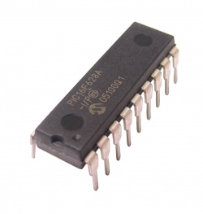
Its wide application device we use it in my project to decide the signal which received from the IR remote to control the motors (DC or stepper) motor by special program.

What is the microcontroller?
A microcontroller is a cheap single chip microcontroller. Single chip microcontroller indicates that the complete microcomputer system lies within the confine of the integrated circuit chip.
Microcontrollers are capable of storing and running the program that was written, complied and download into it, the main parts of a microcontroller generally consist of the central processing unit (CPU), Random Access Memory (RAM) , Read Only Memory (ROM) , input/output lines (I/O lines) , serial and parallel ports timers and anther peripherals such as analog to digital (A/D) converter.

Why to use a microcontroller?
Microcontroller is inexpensive microcomputers. The microcontroller's ability to store and run unique program makes it very flexible. For example, one can program a microcontroller to perform functions based on predetermine situation (1/O-line logic) and selections. The microcontroller's capability to carry out mathematical and logic functions allows it to imitate complicated logic and electronic circuits.
Other program can make the microcontroller behave like neural circuit or a fuzzy-logic controller. Microcontrollers are accountable for the "intelligence" in most smart on the consumer market.

(PIC 16F877)
At the beginning the microcontroller that was selected in the project was PIC16F877 from microchip Technology Incorporate, this was done after a long search and reading and comparison between it and other potential microcontrollers that can be used in this project.

Some of the reasons and key features for selecting the PIC16F877.
1. Up to 8K x 14 word of FLASH program Memory, which is quite enough for this project
2. Only 35 signal word instruction to learn with Assembly, therefore, it is not so hard to learn.
3. Interrupt capability.
4. Low price.

PIC16F877 | PIC16F876 | PIC16F875 | PIC16F873 | Key features
DC-20 MHz | DC-20 MHz | DC-20 MHz | DC-20 MHz | Operating freq
8K | 8K | 4K | 4K | Flash program
368 | 368 | 192 | 192 | Data memory
14 | 13 | 14 | 13 | interrupts
MSSP | MSSP | MSSP | MSSP | I/O

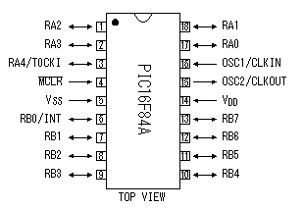
PIC16F84A
The control of the stepper Motor is done
by this Picot have explained in the
Operation principle, coil,
I will introduce a control circuit for stepper motor.
Coil, coil and coil are controlled by the Software, The program which controls the motors according to the signal received.

Schematic showing serial port and basic cct

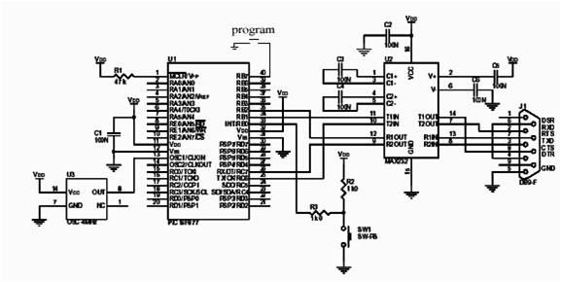

We program the pic using boot loader to make it ready to receive the code that we prepare.
The code drives the pic to control the motors according to the signal it received.

The code of PIC.
#include "F:\Car New\ir\Copy of car-test\car.h"
#include "F:\Car New\ir\Copy of car-test\WirlessReciver.h"

byte i;
void main}()
setup_adc_ports(NO_ANALOGS|VSS_VDD);

setup_adc(ADC_OFF|ADC_TAD_MUL_0);
setup_spi(FALSE);
setup_wdt(WDT_OFF);

setup_timer_0(RTCC_INTERNAL);
setup_timer_1(T1_DISABLED);
setup_timer_2(T2_DISABLED,0,1);

setup_timer_3(T3_DISABLED|T3_DIV_BY_1);
setup_comparator(NC_NC_NC_NC);
setup_vref(FALSE);

setup_low_volt_detect(FALSE);

setup_oscillator(False);
SET_TRIS_b(0X00);
// TODO: USER CODE!!

while(true})
i=0;
i=Recive();
delay_ms(2);
// printf(i);
if(i==9){
// Forward
output_b (0x01);
}
// back
else if(i==5){
output_b (0x02);
}
//right
else if(i==3){
output_b (0x04);
}
// left
else if(i==7){
output_b (0x08);
}
}

}

CH#3:Stepper Motors.

Type of stepper motor.
Type of stepper motor corresponding to number of steps which motor rotate
1-50 steps and the step degree = 360\50 = 7.2 degrees.
2-100 steps and the step degree = 360\100 = 3.6 degrees.
3-200 steps and the step degree = 360\200 = 1.8 degrees.

And depend on the shape of rotor of stepper motor
We can classified the motor corresponding to torque which is high or low ,almost all of the stepper motor have low torque, There's different in the shape and number of wires to connect it.

How Stepper Motors Work?
Stepper motors consist of a permanent magnet rotating shaft, called the rotor, and electromagnets on the stationary portion that surrounds the motor, called the stator. Figure 1 illustrates one complete rotation of a stepper motor. At position 1, we can see that the rotor is beginning at the upper electromagnet, which is currently active (has voltage applied to it). To move the rotor clockwise (CW), the upper electromagnet is deactivated and the right electromagnet is activated, causing the rotor to move 90 degrees CW, aligning itself with the active magnet. This process is repeated in the same manner at the south and west electromagnets until we once again reach the starting position.
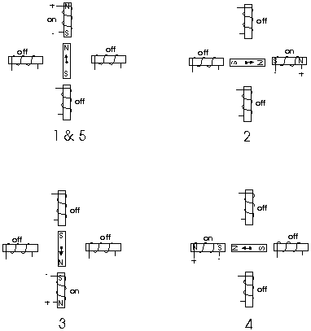

Figure 1
In the above example, we used a motor with a resolution of 90 degrees or demonstration purposes. In reality, this would not be a very practical motor for most applications. The average stepper motor's resolution -- the amount of degrees rotated per pulse -- is much higher than this. For example, a motor with a resolution of 5 degrees would move its rotor 5 degrees per step, thereby requiring 72 pulses (steps) to complete a full 360 degree rotation.
You may double the resolution of some motors by a process known as "half-stepping". Instead of switching the next electromagnet in the rotation on one at a time, with half stepping you turn on both electromagnets, causing an equal attraction between, thereby doubling the resolution. As you can see in Figure 2, in the first position only the upper electromagnet is active, and the rotor is drawn completely to it. In position 2, both the top and right electromagnets are active, causing the rotor to position itself between the two active poles. Finally, in position 3, the top magnet is deactivated and the rotor is drawn all the way right. This process can then be repeated for the entire rotation.
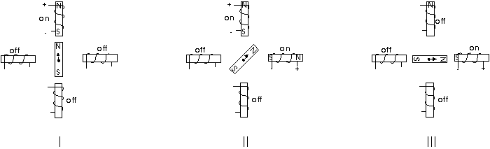
Figure 2
There are several types of stepper motors. 4-wire stepper motors contain only two electromagnets; however the operation is more complicated than those with three or four magnets, because the driving circuit must be able to reverse the current after each step. For our purposes, we will be using a 6-wire motor.
Unlike our example motors which rotated 90 degrees per step, real-world motors employ a series of mini-poles on the stator and rotor to increase resolution. Although this may seem to add more complexity to the process of driving the motors, the operation is identical to the simple 90 degree motor we used in our example. An example of a multipole motor can be seen in Figure 3. In position 1, the north pole of the rotor's perminant magnet is aligned with the south pole of the stator's electromagnet. Note that multiple positions are aligned at once. In position 2, the upper electromagnet is deactivated and the next one to its immediate left is activated, causing the rotor to rotate a precise amount of degrees. In this example, after eight steps the sequence repeats.
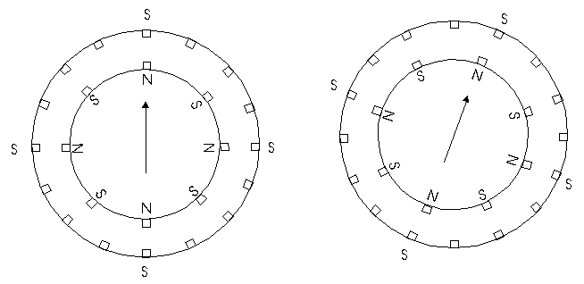Figure 3
The specific stepper motor we are using for our experiments (ST-02: 5VDC, 5 degrees per step) has 6 wires coming out of the casing. If we follow Figure 5, the electrical equivalent of the stepper motor, we can see that 3 wires go to each half of the coils, and that the coil windings are connected in pairs. This is true for all four-phase stepper motors.
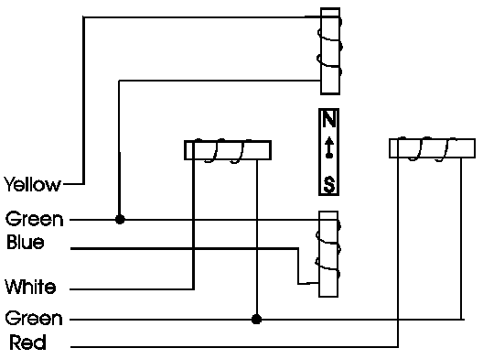
Figure 5
However, if you do not have an equivalent diagram for the motor you want to use, you can make a resistance chart to decipher the mystery connections. There is a 13 ohm resistance between the center-tap wire and each end lead, and 26 ohms between the two end leads. Wires originating from separate coils are not connected, and therefore would not read on the ohm meter.
Stepper motor drive.
This is a 2-phase unipolar PM type stepper motor with 48-poles.
Step angle | 7.5 degrees ( 360 degrees/48 )
Drive voltage | 5 to 6V
Coil current | 250mA(5V)/2 coils

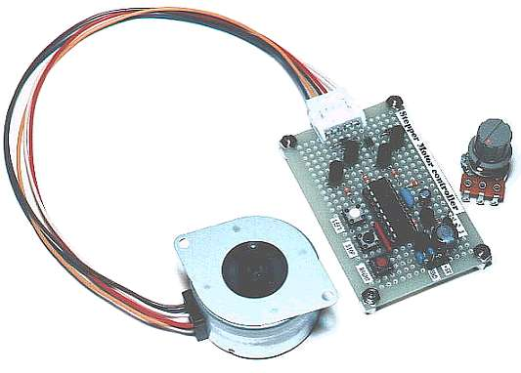
The circuit drive which can drive the stepper motor show below, the figure is the schematic of our first test circuit. The PIC's output lines are first buffered by a 4050 hex buffer chip, and are
then connected to an NPN transistor. The transistor used, TIP120, is actually a NPN Darlington (it is shown as a standard NPN). The TIP120's act like switches, activating one stepper motor coil at a time.

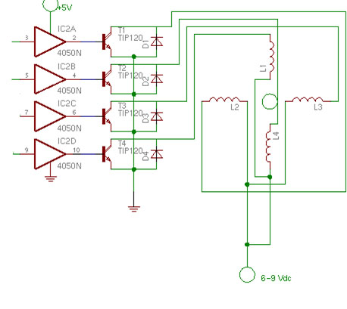
The circuit shows how we must connect the stepper motor to the microcontroller and connect other devices Drive cct protect the microcontroller from high current and control the motor to rotate left or right. We put this motor to steering the car because it has low torque and we can rotate it smoothly.
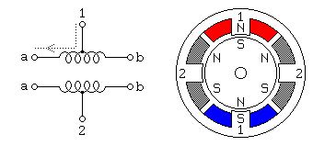

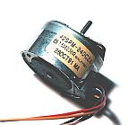
CH#4: DC Motors.

Type of DC motor.
3V DC motor, 5V, 9V, and 12V.
This circuit will bring a fast moving DC motor to a stop in seconds. The braking action is automatically applied whenever DC power is removed.
Permanent Magnet DC Motor
A permanent magnet DC motor consists of a permanent magnet stator and
Armature windings in the rotor. The armature winding is supplied with a DC voltage that causes a DC current to flow in the windings. Interaction between the magnetic field produced by the armature current and that of the permanent magnet stator causes the rotor to rotate. The equivalent circuit of a PM DC motor
Motor drivers are essentially little current amplifiers; their function is to take a low-current control signal, and turn it into a proportionally higher-current signal that can drive a motor. Note here that the control signal is likely on the order of 10 mA, and the motor may require 100's of mA to make it turn.

You can think of motor drivers connecting control circuits and motors, very simply, as a "wrapper" around the motor. Schematically, the arrangement looks like this:
There are a whole slew of motor driver designs available to meet most any robotic need they all vary in the requirements they try to meet (so read their descriptions very closely).
Drive circuit connected to port of microcontroller which make it output port.
Drive cct protect the microcontroller from high current and control the motor to return left or right using relay and TIP transistors.
We connect the motor to drive the car forward backward because it has more torque than stepper motor
Drive cct for DC motor

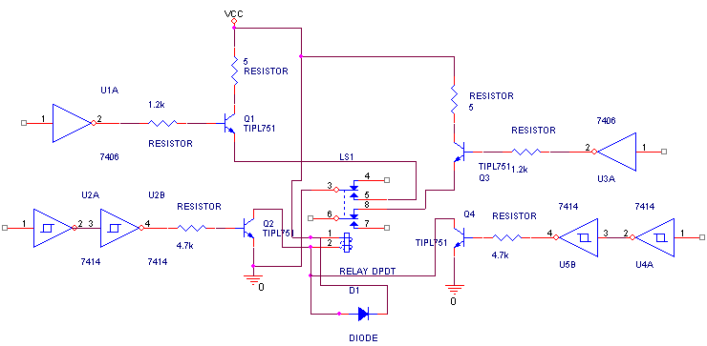

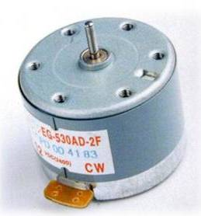

We can use H bridge IC as drive circuit for DC motor, its has two drive circuits inside, we can use it as one drive circuit for stepper motor.

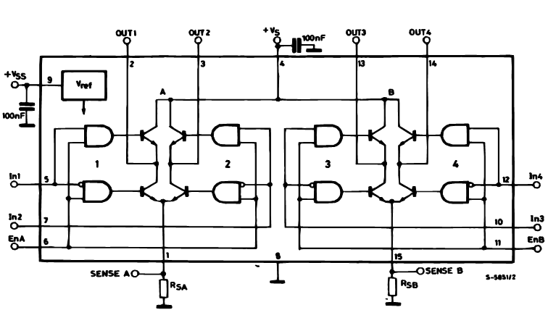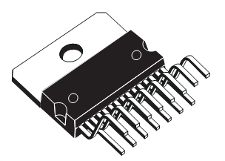

CH#5: Camera.
There are many type of camera we can use it to connect it to computer or TV I will show how connect it to TV, such that and the most simplest it’s the messenger camera, it's connect to computer by USB cable
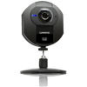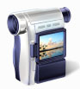
Messenger camera USB camera TV camera
And there a TV camera which connect to TV,
A video camera catch a video or image from any place which we drive the car. This camera has ready-made program on computer to receive the signal from the camera, it’s has a modulator and receiver hardware or receive the signal But it not available in the market and very expensive, so we replace it by messenger camera. Signal by UHF, VHF range on TV so, use a USB messenger camera, it's connected to computer immediately by USB cable.
Its easy to use and its can capture picture or video.
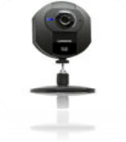
We will show how to connect a video camera to 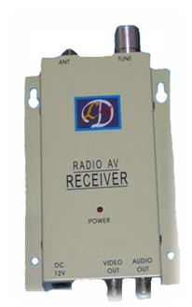
Your Windows PC and save your movies in a digital
Format. As you will see for yourself it is a simple
Procedure. Just follow these steps:
1. Connect your video camera to the power supply and then connect it to your PC using a Firmware or USB cable. If you have a choice, we recommend using a Firmware cable because the transfer rate is better.
2. Turn on the camera and wait for Windows Vista to detect and install the appropriate drivers.
Web camera connected to either USB or analog video capture card
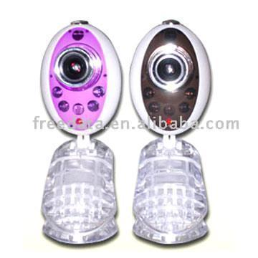
The best way to connect a Web camera to your computer will depend on the type of camera you own. While some cameras can connect to any video capture card, others require that you use a specific capture card for the camera to work. The documentation that came with your Web camera will help you determine what kind of capture card you'll need to use.
In addition, some Web cameras have a built in microphone, while others do not. If your Web camera does not have a built–in microphone, you will need a separate microphone to capture sound. Plug it into the jack (often labeled Mic) on your computer or sound card. If you do not have a microphone and your Web camera does not have one built in, you will not be able to record sound without another audio recording device, such as a camcorder.
Connecting a Web camera.

How to Connect Your Video Camera to the Television.
Technology can be difficult to work with if you don’t have any knowledge about it, however, with simple instructions you can learn how to get technology to work for you instead of against you! Follow the instructions below to connect your video camera to your television without too much frustration.
Step 1: Connecting the S-Video Cable
The first thing you want to do is pick up an S-Video cable, which you should be able to find most places that sell camcorders. On the back of your camcorder, find the S-video out jack and plug the S-Video cord into it. Then on the back of your TV find the S-Video in jack and plug the other end of the S-Video cord into it.
Step 2: Connecting the Audio Jacks
You now want to take the audio cord, the one with the red and white ends, and plug it into the audio out jacks on your camcorder, they should be color coded red and white for you. If you do not have audio out jacks you can use the auxiliary out jacks. Locate the audio in jacks on your TV and plug the audio cord into these which should also be color coded for you.
Step 3: Turn Your Equipment On
Turn on both the camcorder and the TV. At this time you also want to turn on a video on the camcorder so that it is playing.
Step 4: Find the Correct Channel on Your TV
Next you want to turn on your TV and find the channel that you have plugged your camcorder in to. You may have to press the source or input button on the remote to find the correct channel. This is why you want to have your camcorder playing, so you will automatically know when you find the right channel.
Step 5: Sit Back And Enjoy!
Enjoy your videos! You can also, at this point, make copies of the videos using your VCR or DVD Recorder if you have one and are interested. If this is something of interest to you but you don’t know how to use a DVD Recorder, check out my instructions on how to use one when copying from a VCR to a DVD, it is the same process.

VHF/UHF TV modulator
Computer ,video game ,video camera ,games computer; all of these produce video signals that must be display via a television set. If the TV receiver in question does not have a video input and its owner is reluctant to vandalize it in order to fit one then this sort of modulator
A TV modulator is really no more than a transmitter. It is a very small transmitter, admittedly, but none the less that is what it is. What does a modulator actually does? In general and this design is no exception to the rule it is a simple oscillator that generates a frequency somewhere in the VHF or UHF region. The oscillator is modulated with the video signal and the modulated carrier wave thus generated is fed into the TV set's aerial input via a cable. Then hall that remains to do is tune the TV to the correct frequency.

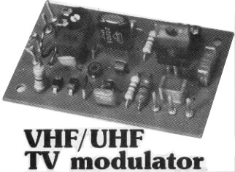

The block diagram of figure I shows how this is achieved.
The TV modulator is made up of two parts, namely a modulatable crystal oscillator and a harmonics generator. The oscillator operates at a frequency of 27 MHz, which is quite low so inexpensive crystals are readily available. The harmonics generator converts the oscillator signal into a sort of frequency spectrum containing all the multiples of 27 MHz up to about 1800 MHz The TV modulator's output signal is made up of a large number of little peaks, each of which is a complete transmitter signal. At least one of these will always be in band I (VHF channels 2. . . 4), one in band III (VHF channels S. . .12) and many of them will be in bands IV and V (UHF channels 21.. .69).

But this is a second project and it's not easy to implement, so we replace the wireless camera by a messenger camera because it simplicity and very cheap, its USB connection to the computer.

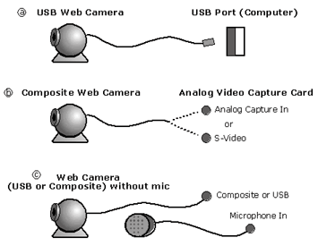

All drive circuit and the camera built in the car which we control and it Cary the camera that take pictures to computer.

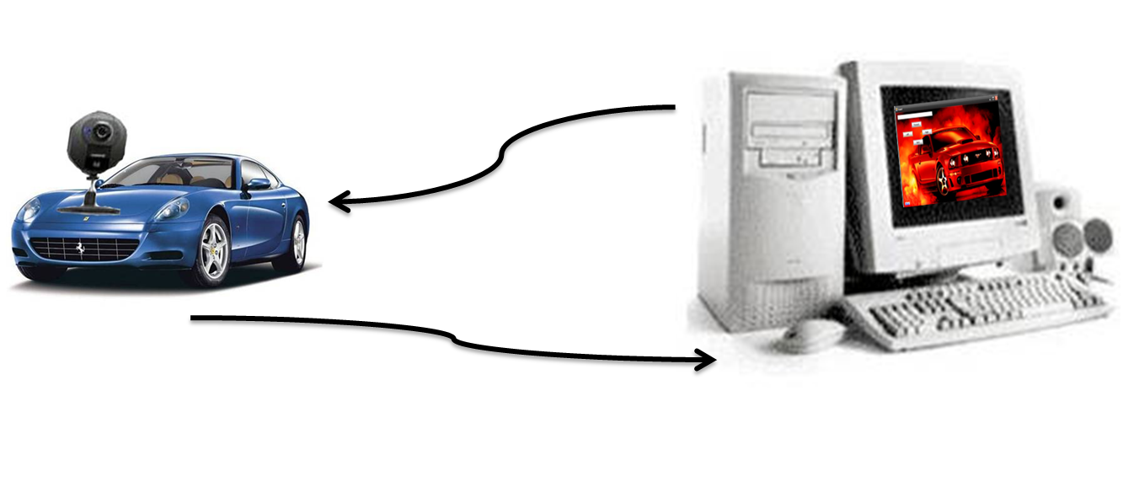

*Conclusion
From our project we have to define the importance steps that we understand it and what we give useful result from.
After analyses the theoretical steps we built the circuits we need to the project like IR sender and receiver, drive circuit for DC and stepper motor
and the basic circuit for the microcontroller.
After testing the circuits to bring together and built it on the car drive.
The problem we face on the IR circuits and don’t work on far distance, so we make sure that the frequency unchanged.
Finally we can control any device or machine we need using wireless like IR or RF ….
Most of electrical devices today wireless control.

*Reference
http://en.Stepper Motor Driver.htm
http://www.retorn.com/picx1.htm
http://www.Shopping Search Results from Answers.com.mht
http://www.qsl.net/w3fpr/n6kr.htm
Electronics Projects.com http://www.
engineeringhobbyist.com http://www.
http://www.Integrated circuit.com.mht

