**-**

13/5/2012

Student

Ali Jumah

Dyaa Taslaq

Osama Draidi

Superviser:

Dr.Jamaal kharoshee

Remote sensing (Wagen)

AN NAJAH NATIONAL UNIVERSITY

Table of Contents

Introduction 3

Why:?????? 3

History of Robotics 4

Remote sensing (Wagen) 5

Our model 6

Items required 7

Microcontroller 8

Noise and disturbances 8

Project flow and sequencing 9

Sensors 10

Motion sensor 11

Tempreture sensor 12

Wireless camera 14

Wireless 15

Encoder/decoder 15

Operating characteristics of encoder and decoder 18

Modulation & demodulation 19

IR transmission 19

Radio Frequency tranciever 24

RF TX 24

RF RX 25

Final strategy in preparing the model 28

Results 28

Circuit drawings 29

Software used 30

References 31

Introduction

The Common Controller device controls the Unmanned Systems. This bot (a robotic machine) is Multifunctional Utility. This small Unmanned Ground bot is (a portable, tracked bot).It has a network of detection sensors, monitoring camera.

This bot is supposed to send the read data remotely from these unmanned systems (i.e. sensors, camera) to land observer.

Once the bot found an action (i.e. person, blaze, gas… etc.) the bot could transmit a live video with text information to a land observer.

Why??????

To build up an Indoor machine (bot) that can be remotely controlled to be used for missions generally hazardous to humans. i.e.

1. To discover places which are considered dangerous on humans.

2. To discover if there are alive people in air polluted areas.

3. To discover if there are alive people in house blazes.

4. To assist the cops in their duties.

History of Robotics

The history of robot has its roots as far back as ancient myths and legends. Modern concepts were begun to be developed when the Industrial Revolution allowed the use of more complex mechanics and the subsequent introduction of electricity made it possible to power machines with small compact motors. After the 1920s the modern formulation of a humanoid machine was developed to the stage where it was possible to envisage human sized robots with the capacity for near human thoughts and movements, first envisaged millennia before. The first uses of modern robots were in factories as industrial robots - simple fixed machines capable of manufacturing tasks which allowed production without the need for human assistance. Digitally controlled [industrial robots](http://en.wikipedia.org/wiki/Industrial_robot) and robots making use of [artificial intelligence](http://en.wikipedia.org/wiki/Artificial_intelligence) have been built since the 1960s.

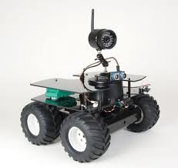 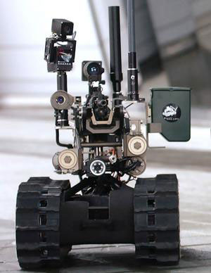

Figure 1 bot models

Remote Sensing (Wagen)

There are two main types of remote sensing: passive remote sensing and active remote sensing. Passive sensors detect natural radiation that is emitted or reflected by the object or surrounding areas. Reflected [sunlight](http://en.wikipedia.org/wiki/Sunlight) is the most common source of radiation measured by passive sensors. Examples of passive remote sensors include film [photography](http://en.wikipedia.org/wiki/Photography), [infrared](http://en.wikipedia.org/wiki/Infrared), [charge-coupled devices](http://en.wikipedia.org/wiki/Charge-coupled_devices), and radiometers. Active collection, on the other hand, emits energy in order to scan objects and areas whereupon a sensor then detects and measures the radiation that is reflected or backscattered from the target. [RADAR](http://en.wikipedia.org/wiki/RADAR) and [LiDAR](http://en.wikipedia.org/wiki/Lidar" \o "Lidar) are examples of active remote sensing where the time delay between emission and return is measured, establishing the location, height, speed and direction of an object.

Remote sensing makes it possible to collect data on dangerous or inaccessible areas. Remote sensing applications include monitoring [deforestation](http://en.wikipedia.org/wiki/Deforestation) in areas such as the [Amazon Basin](http://en.wikipedia.org/wiki/Amazon_Basin), [glacial](http://en.wikipedia.org/wiki/Glacier)features in Arctic and Antarctic regions, and [depth sounding](http://en.wikipedia.org/wiki/Depth_sounding) of coastal and ocean depths. Military collection during the [Cold War](http://en.wikipedia.org/wiki/Cold_War) made use of stand-off collection of data about dangerous border areas. Remote sensing also replaces costly and slow data collection on the ground, ensuring in the process that areas or objects are not disturbed.

Orbital platforms collect and transmit data from different parts of the [electromagnetic spectrum](http://en.wikipedia.org/wiki/Electromagnetic_spectrum), which in conjunction with larger scale aerial or ground-based sensing and analysis, provides researchers with enough information to monitor trends such as [El Niño](http://en.wikipedia.org/wiki/El_Ni%C3%B1o) and other natural long and short term phenomena. Other uses include different areas of the [earth sciences](http://en.wikipedia.org/wiki/Earth_science) such as [natural resource management](http://en.wikipedia.org/wiki/Natural_resource_management), agricultural fields such as land usage and conservation, and national security and overhead, ground-based and stand-off collection on border areas.[[4]](http://en.wikipedia.org/wiki/Remote_sensing#cite_note-3)

By satellite, aircraft, spacecraft, buoy, ship, and helicopter images, data is created to analyze and compare things like vegetation rates, erosion, pollution, forestry, weather, and land use. These things can be mapped, imaged, tracked and observed. The process of remote sensing is also helpful for city planning, archaeological investigations, military observation and geomorphological surveying.

Our model

This project consists of control circuit.

The control circuit contains the brain (pic) which take the reading from sensors (temperature and motion sensors), convert the voltage reading to analogue signal, send it using RF (Tx,Rx).

At receiving side we use another pic to analyses data and display it on the screen.

Also we use a wireless camera for monitoring action.

Items required

1. Bots.
2. Microcontroller (PIC 18F4620).
3. RF transmitter receiver.
4. HT12E and HT12D decoder and encoder.
5. Serial cable.
6. Temperature sensor.
7. Motion sensor.
8. USB to RS232 convertor.
9. Batteries.
10. Wireless camera.

Microcontroller

The brain of the project, the center of process and the decision maker is microcontroller PIC. It’s very popular, easy to program, it has modules support our requirements, and we are well trained to use it.

1. We chose PIC18f4620 with RISK CPU.
2. 8K*14 words flash program memory which is enough.
3. 5v power supply is required.
4. Current source/sink up to 25mA.
5. It includes timers, interrupts, ADC, PWM, ……. etc.
6. 32 I/O pins implemented in 5 ports.
7. Max current into VDD=250mA.
8. A programmer circuit was built to download code to PIC, JDM programmer.
9. Software used was PIC-C with CCS compiler.

Noise and disturbances

The biggest enemy to PIC was noise. The high frequency signals received from communication devices cause the PIC to become unstable and suffers from changing values of the registers which sometimes results in restart in PIC. When problem occurs and PIC outputs unpredicted results, it can be tested isolating PIC from input-output and then manually input data and test output on LEDs.

Solution

1. Input side: due to wireless circuit causes high frequency signals which can be eliminated using capacitors at the input side of PIC as well as photo-couplers to guarantee stable performance.
2. Capacitors are connected shunt to input which short circuit high frequencies.

Impedance of capacitor is given by the following formula:

$$Z=\frac{1}{2πfc}$$

220uf was enough to depress noise.

Project flow and sequencing

1. Learning how to program the microcontroller.
2. Study the general concept of sensors.
3. Then, programing the PIC to work as ADC.
4. Connect the basic circuit for the PIC, also connect the circuit for temperature and motion sensor with proper amplification.
5. Testing the circuit of the PIC and sensors together without RF.
6. Connect the circuit of RF with encoder decoder.
7. Programing PIC at the receiver side to take data from RX, analyzing it, and display it on the screen
8. Connect the whole circuit together (RF TX, RX), (PIC at RX and TX side), (sensors).
9. Preparing the Wagen and put the TX circuit on it.

Sensors

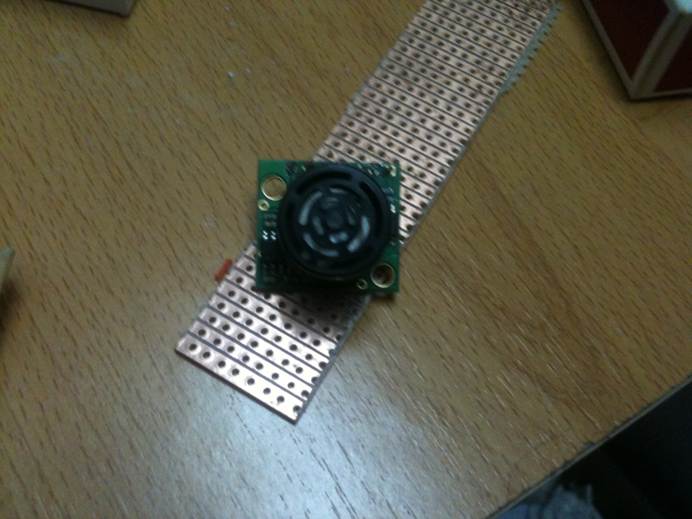

In order for the Wagen to interact with its environmental, several different sensors are necessary. Motion sensors are needed so we can determine if there is any human or any living body in the area. A temperature sensor is used to give us a reading for the temperature in the discovering area.

Motion sensor

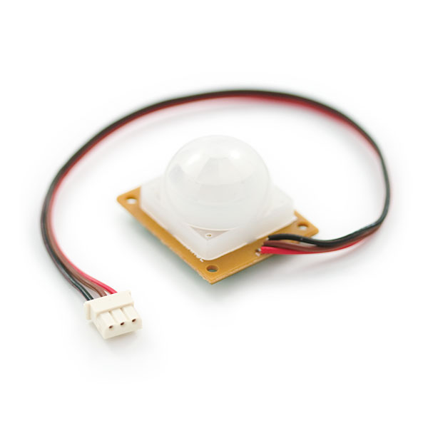

This is a simple to use motion sensor. Power it up and wait 1-2 seconds for the sensor to get a snapshot of the still room. If anything moves after that period, the 'alarm' pin will go low. Red wire is power (5 to 12V). Brown wire is GND. Black wire is open collector Alarm. This unit works great from 5 to 12V. You can also install a jumper wire past the 5V regulator on board to make this unit work at 3.3V. Sensor uses 1.6mA@3.3V. The alarm pin is an [open collector](http://en.wikipedia.org/wiki/Open_collector)  meaning you will need a pull up resistor on the alarm pin. The open drain setup allows multiple motion sensors to be connected on a single input pin. If any of the motion sensors go off, the input pin will be pulled low.

Temperature sensor

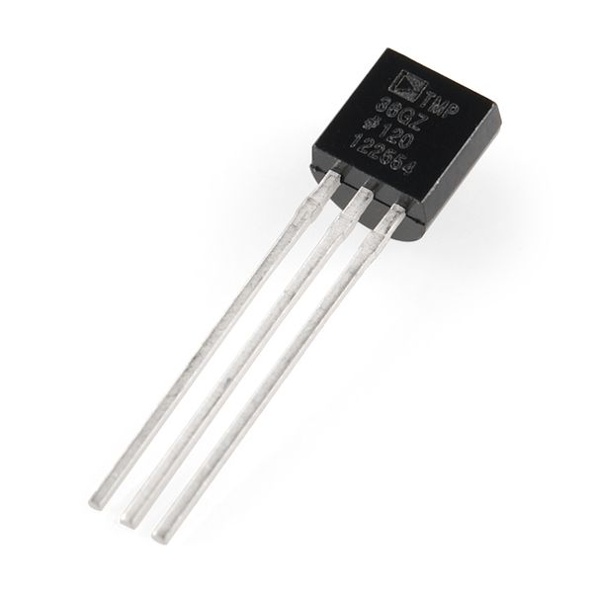

 The LM335A is a very easy-to-use analog temperature sensor. The LM335A works like a Zener diode with a breakdown voltage proportional to absolute temperature at 10mV/°K. Hook up a resistor from 5V and GND, and the LM335A will output an analog voltage of 2.98V (298 Kelvin is 25C or room temperature).  The output of the sensor is linear, and when calibrated at 25°C the LM335A has typically less than 1°C error over a 100°C temperature range. The sensor can operate continuously from −40°C to 100°C.

Calibration of the sensor requires a pot connected across the sensor, with the wiper of the potentiometer connected to the adjustment pin of the LM335.

Variation of output current with temperature:

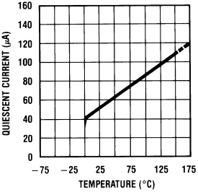

The PIC at receiving side will restore the data of temperature sensor and display the temperature on the screen with following mathematical equation:

Temperature $=$ $\frac{reading data*5*100}{255*11}$

Problem: The output of Temperature sensor is 10mv per 1C, so it can’t be detecting using PIC.

Solution: We amplify the output of the Temperature sensor up to 11 times using LM amplifier.

Wireless camera:

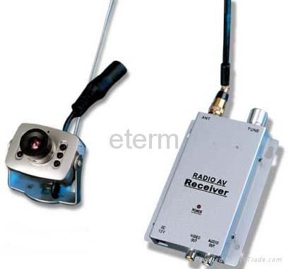

Description

1. 1.2G Wireless Mini Color Cmos Camera
2. Voltage: DC+9V
3. Current: 300mA

Wireless

We want to add advantage to our project by adding wireless. This was done by using transmitter and receiver to send and receive the data of the sensors.

The communication achieved using encoder/decoder and ASK transmitter/receiver.

Encoder/decoder

This project is based on coding and decoding of binary & trinary signals, coding is to give each state (zero, one and open) a special shape look at the following diagram:

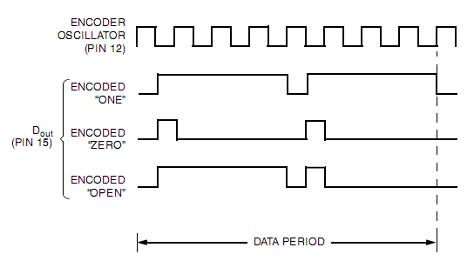

Figure 17 Encoded data

to encode our signal we use the encoder HT12E which convert the parallel 13-bits(4-bits for data ,7-bits for address) to a serial decoded signal look at the following figure .

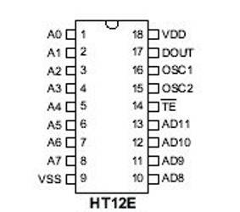

Figure 18 Encoder IC

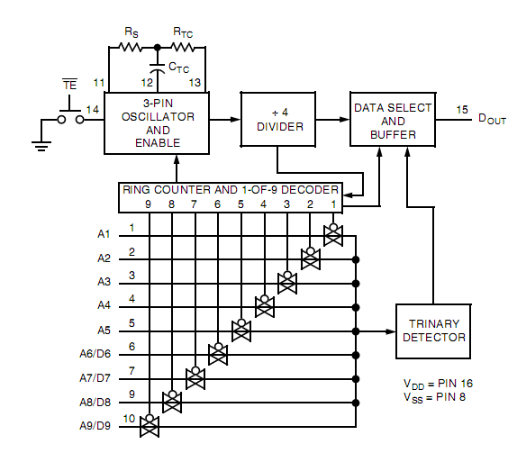

Figure 19 Encoder structure

Note that the trinary detector is for 5-bit address but the 4-bit data is must be binary data.

The 5-bit trinary address means that you can use 243 receiver for one sender.

The frequency of the oscillator (baud rate) is determined by Rs, Rtc and Ctc.

The decoder is the opposite of the encoder it converts a serial encoded signal to parallel data, here we use HT12D decoder look at figure .

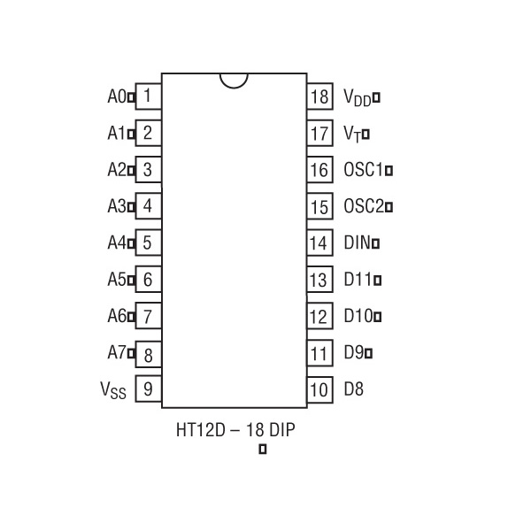

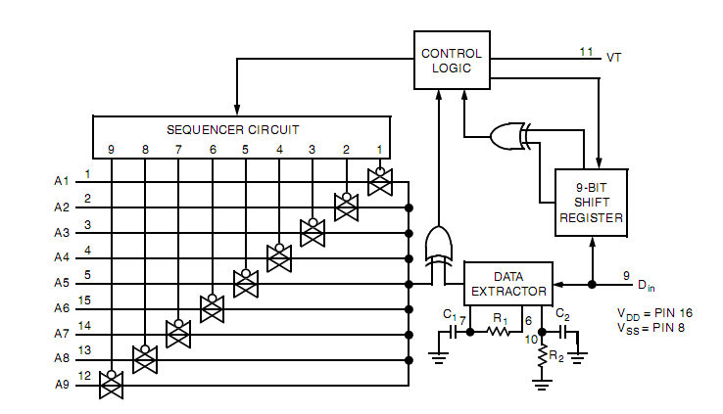

Figure 20 Decoder IC and structure

Note the frequency of the data extractor must be equal the frequency of the oscillator in encoder to accept the signal.

Operating characteristics of encoder and decoder

At the beginning the encoder is work when the line 14 (transmit enable) is low so in our applications we connect it to ground, when the encoder start encoding it send data as words each word consist of 9-bits, but it send each 9-bit twice to more security.

When the decoder receive the data it check that each 9-bit equal the next 9-bit if true it check the 5-bit address if equal the local 5-bit of address if true it extract the 4-bit of data on output and the line 11(valid data) will be 1.

Modulation & demodulation

To modulate our encoded signal we use an infrared technology and ASK (amplitude shift key) look at the following figure:

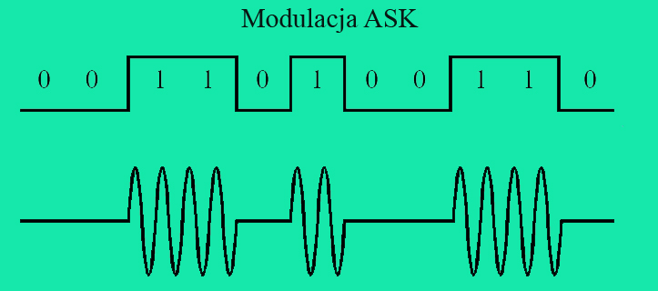

IR transmission

In modulation we use the following circuit which consist of 555 timer which generate a 38 kHz- you can see it from figure 5 -, we control the 555 timer by line 4 and we connect it to encoded data so when the data is one the 555 timer will enable and generate a signal, but when data is zero the 555 timer will be disabled and no generated signals.

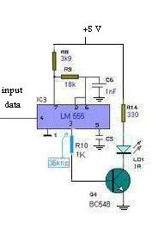

Figure 21 IR sender circuit

From searching on internet , we find a famous receiver tsop 1736 which receive and demodulate the IR signals at frequency 36 KHz . but in markets we find tsop 1738 (the operating frequency determined by least significant digit of its name tsop 17**38**).

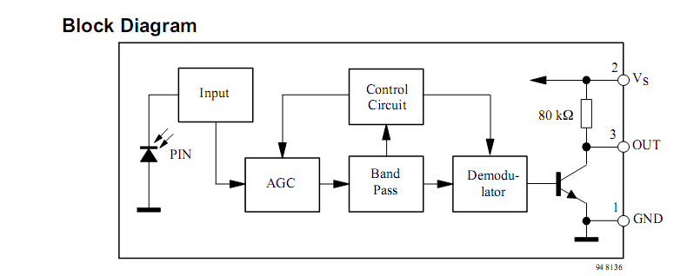

Figure 22 TSOP block diagram

Note that the modulation frequency must be at least twice of baud frequency (in our applications baud frequency is 1.7 KHz and modulation frequency is 38 KHz).

However , we must mention an important thing concerning the tsop’s output , it gives a weak signal less than 1 volt.

In order to resolve this problem we used a transistor to amplify signal, you can see it from figure.

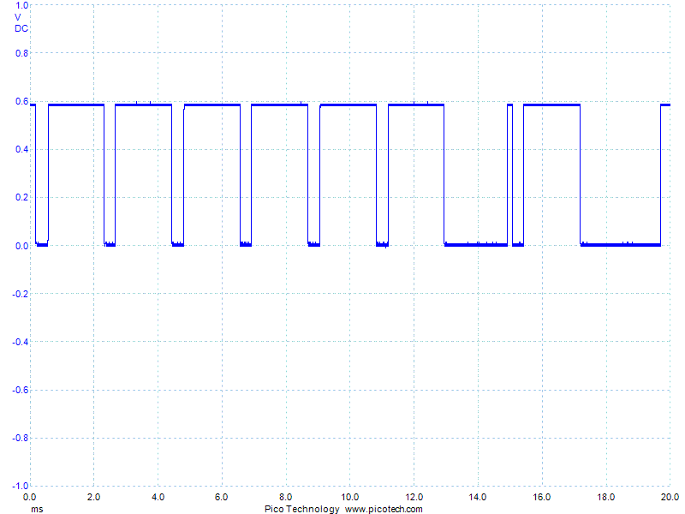

Figure 23 Output of TSOP before amplifier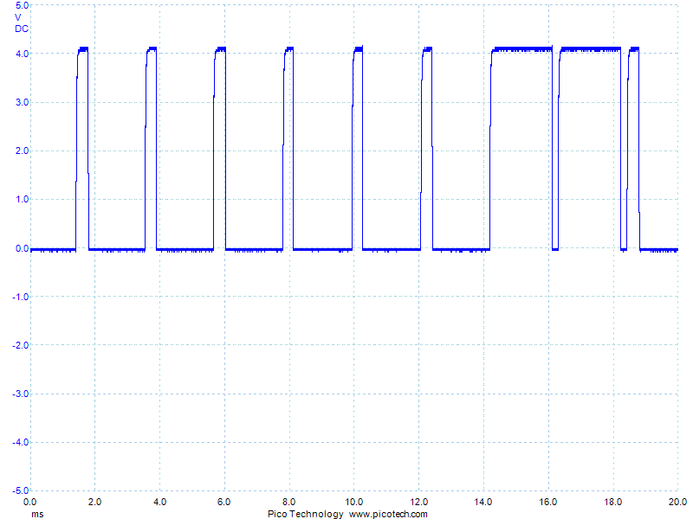

Figure 24 Signal after amplification reaching 4.2v

Now the receiver circuit which receives output data from sender circuit through infrared (IR) radiation.

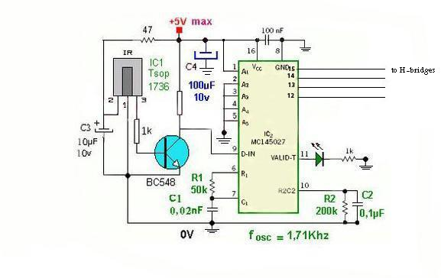

Figure 25 Reciever circuit

1. The IR circuit was not practical due the need to line of sight(LOS). Moreover, the receiver(tsop) weakly recieves signal that is impossible to suit our needs in the robot which keeps moving.
2. The coverage area must wherever goes the robot. Applying RF transmission was necessity to suit our needs.

Radio Frequency transceiver

Because the signal is transmitted through infrared radiation, we faced a problem in the received signal, sometimes the transmitted signal arrives to the receiver and other times it doesn’t. So we used a radio frequency (RF) radiation instead of infrared radiation.

Radio transmitter _ RT4-XXX



Figure 26 RT4 433.92

RT4-XXX is a Radio Transmitter Module with SAW Resonator and External Antenna.

**General description:**

1. The RT4-XXX is a hybrid circuit that allows realizing a complete radio transmitter adding a coding circuit.
2. It shows stable electric characteristics thanks to the "Thick film hybrid" technology.
3. XXX: working frequency (315, 418, 433.92 MHz).

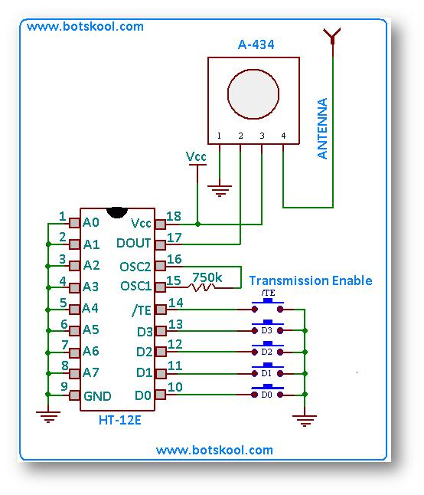

Figure 27 Sender circuit

Radio receiver RR3-XXX



Figure 27 RR3 433.92

RR3-XXX is a Super Regenerative Radio Receiver With Laser Trimmed Inductor .

**General description:**

1. The RR3-XXX is a super regenerative data receiver.
2. Sensitivity typically exceeds -100dBm (2.2uVrms) when matched to 50 ohm.
3. It shows high frequency stability also in presence of mechanical vibrations, manual handling and in a wide range of temperature.
4. The frequency accuracy is very high thanks to laser trimming process.
5. **XXX:** custom-specified working frequency (200 ÷ 450 MHz) .
6. Standard European and U.S. frequencies (315MHz, 418MHz, 433.92MHz) are readly available from stock.

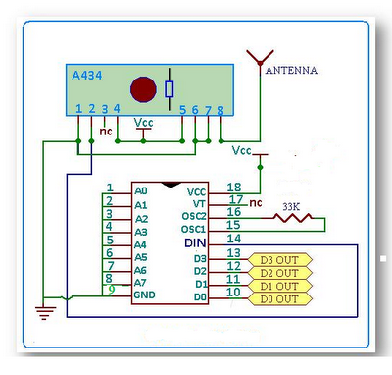

Figure 28 Reciever circuit

When we made an interface between the receiver circuit and the micro controller we faced the problem of noise on the micro controller. in order to resolve this problem we had to separate the micro controller and receiver circuit from each other. This is done by using optocoupler and capacitors to get rid of noise.

Final strategy in preparing the model

1. The output voltage of the sensor will be converting to analogue signal using PIC microcontroller at transmission side.
2. This signal will be send to another PIC at receiving side using RF (TX, RX).
3. The PIC at receiving side will analyze incoming data and display it on the mentoring screen.
4. Connecting the transmission side of wireless camera to supply voltage of 9V, and also at receiving side. Then connecting the receiving side of camera to another mentoring screen.

Results

1. Half automatic bot with full automatic of sending and receiving of sensors data.
2. Excellent team work and planning skills as well as budget management
3. Deep experience in HT’s encoder decoder, the ability to manipulate electronic circuits as well.
4. Background about sensors specially motion sensor and temperature sensor and others.
5. Interfacing circuits and the ability to solve problems of the transferred signals between different electronic devices.
6. The ability to apply wireless communication either IR or RF and understand the limitations of IR transcieving.
7. Breaking the limits, doing the impossible and hoping for more.

Circuit drawings

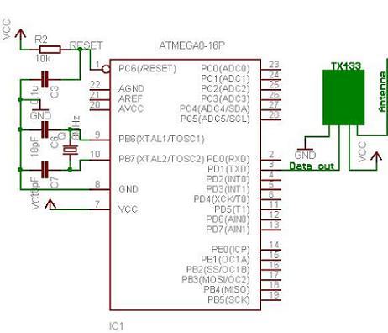

Transmission circuit

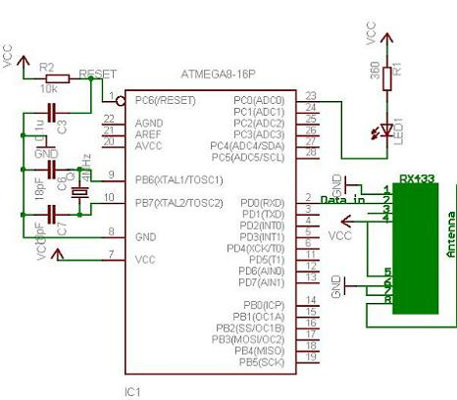

Receiving circuit

Software used

Many usefull and famous programs were used for programming robot and rebort writing as well as cicuit drawings:

1. Code writing and compiling: PIC-C language compiled by CCS compiler.
2. Code downloading to PIC using JDM programmer: WIN PGM.
3. Circuit drawings: Proteus 7 Professional.
4. Report writing: MICROSOFT OFFICE.

References

<http://jap.hu/electronic/rf.html>

<http://www.electrotech.com>

<http://www.spycamera4u.com/wireless_camera_and_receiver_set.htm>

<http://en.wikipedia.org/wiki/Duty_cycle>

<http://www.answers.com/topic/sensor#ixzz1gnOoSZLj>

<http://www.pcmag.com/encyclopedia_term/0,2542,t=thermal+sensor&i=52823,00.asp>

[http://www.sparkfun.c](http://en.wikipedia.org/wiki/Smoke_detector)om

[www.datasheetcatalog.com](http://www.datasheetcatalog.com)