Student Name: Ali Al-bada

Student No. 10301130

Graduation Project 2

PLC light traffic

Dr. loae Mlhes
Dr. Raed Al-Qadi
Dr. haea sama'na

Graduation project 2
PLC traffic light

Introduction about the project:-
It is about controlling and managing traffic lights of Crossroads using PLC, and providing different modes, rush hour mode, fast mode, and normal mode, and they can be selected manually by the software interface or be automatic at specific time, that can be set in the interface.

Introduction about PLC: -
PLC Programmable Logical Controller it's an easy and powerful way of controlling different production lines, like filling cutting stuff and other things.
There is a different part of the PLCs; most of the different is about the number of I/O and the number of slots that the PLC can take. The slots can be an external I/O, Network card if u wants to connect it to the local network, and other parts.
PLC components:-
The main part of the PLC is the CPU that control the I/O as u can see in the figure below, each I/O connected physically with the devices need to be controlled, by giving a digital signal to the output devices and taking a signal from the devices, depending on this signal will do some certain job.
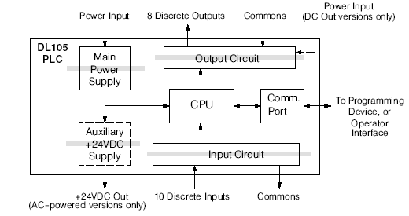
Types of I/O:-
Input can be photo electric, push Button, Limit Switches, or any other devices can be connected to the PLC and give a signal.
Outputs can be Solenoids, Indicator Lamps, Relays, Contactor, or any other device can be operates by digital signal.
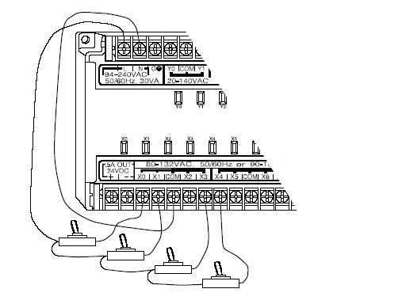

Safety mugger in the PLC:-
In the figure below u can see that all the parts of the PLC are isolated so when any part is malfunction don't affects the other parts.

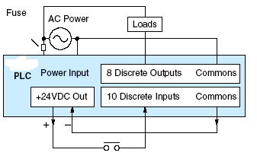

Programming language:-
The PLC is programmed through Ladders language, it's similar to drawing control circuit using relay but in horizontal way, and in the next table u can see the differences between the symbols of the two ways.
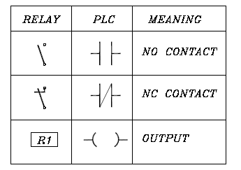

And in the next example u can see the common point between the two technics.
First the relay technic:-
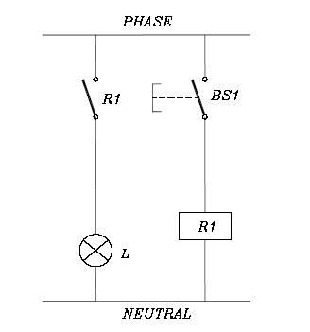
In this example we will have a button when click on it, it will activate the relay, and when that happens the circuit will be closed and the light will be on.
Second the ladder technic:-
To do what we have done in the previos example, we will have the next code.
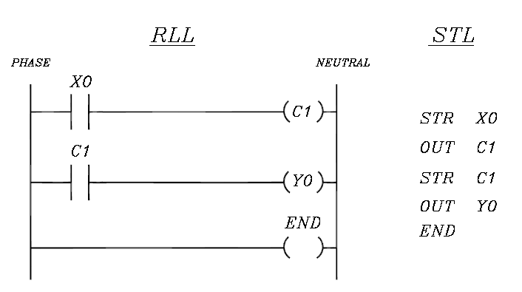
X0: is a variable that represent the input, and this input can be represent as button or one of the things been mention before.
C1: is a variable that represent a logical state not physical, and this variable must be at the beginning of the line when we represent it as contact (this variable can have many other way to be represented).
Y0:is a variable that represent the output, can be one of the output mention previously on the I/O types.
Every code must be ended with end.
Types of the variable that the PLC deal with:-
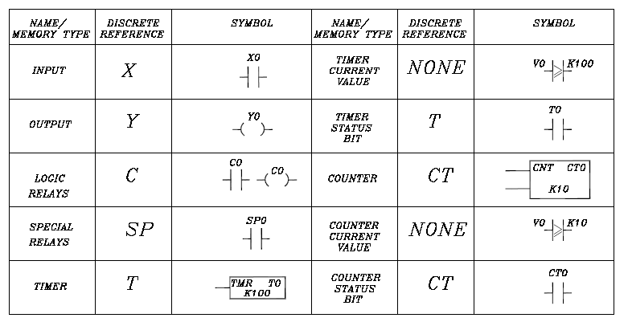

Programs I have used in the Project
DirctSoft32 program:-
Software uses to write ladder language and controlling the memory of the PLC through it, we can send the code to the PLC trough the serial port, the Local Network, the Modem.
We can see through the software the status of every variable while the PLC is running.

Vuniq4.5 (scada)
I use it to interface the I/O operations of the PLC

