An-Najah National University



Faculty of Engineering
Computer Engineering Department

Car Tracked Via Mouse

Prepared by:

Fadi Talib Rob'a.
Shawqi Fuad Kojok.

Submitted To:
Dr.luai malhis

-2006-

شكر وتقدير

نتقدم بالشكر والتقدير الى الدكتور لؤي ملحيس المشرف على هذا المشروع
الذي كان لتوجيهاته الاثر الكبير في انجاز هذا المشروع ...

كما نتقدم بالشكر الى الدكتور رائد القاضي و الاستاذ المهندس
اشرف عرموش والاستاذ المهندس سفيان سماره

والى جميع المشرفين المساعدين وخاصه المهندس أنس طعمه .

Introduction

We designed and created a software-based graphical control interface for control car tracked via mouse ,the car controlled from computer serially through the mouse eg.when you move mouse right the car turn right ,and the opposite is true ., and when you move the mouse to forward or backward it will in the same position

Hardware

We use two basic component in our hardware:
1-H-Bridge.
2-pic circuit

H-Bridge
H-bridge Sometimes called a "full bridge" the H-bridge is so named because it has four switching elements at the "corners" of the H and the motor forms the cross bar. The basic bridge is shown in the figure to the right.
Of course the letter H doesn't have the top and bottom joined together, but hopefully the picture is clear. This is also something of a theme of this tutorial where I will state something, and then tell you it isn't really true :-).
The key fact to note is that there are, in theory, four switching elements within the bridge. These four elements are often called, high side left, high side right, low side right, and low side left (when traversing in clockwise order).
The switches are turned on in pairs, either high left and lower right, or lower left and high right, but never both switches on the same "side" of the bridge. If both switches on one side of a bridge are turned on it creates a short circuit between the
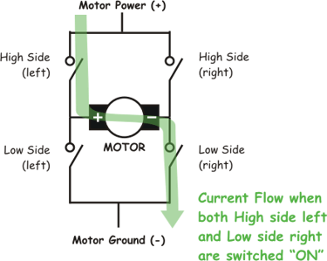

battery plus and battery minus terminals. This phenomena is called shoot through in the Switch-Mode Power Supply (SMPS) literature. If the bridge is sufficiently powerful it will absorb that load and your batteries will simply drain quickly. Usually however the switches in question melt.

To power the motor, you turn on two switches that are diagonally opposed. In the picture to the right, imagine that the high side left and low side right switches are turned on. The current flow is shown in green.
The current flows and the motor begins to turn in a "positive" direction. What happens if you turn on the high side right and low side left switches? You guessed it, current flows the other direction through the motor and the motor turns in the opposite direction.
Pretty simple stuff right? Actually it is just that simple, the tricky part comes in when you decide what to use for switches. Anything that can carry a current will work, from four SPST switches, one DPDT switch, relays, transistors, to enhancement mode power MOSFETs.
One more topic in the basic theory section, quadrants. If each switch can be controlled independently then you can do some interesting things with the bridge, some folks call such a bridge a "four quadrant device" (4QD get it?). If you built it out of a single DPDT relay, you can really only control forward or reverse. You can build a small truth table that tells you for each of the switch's states, what the bridge will do. As each switch has one of two states, and there are four switches, there are 16 possible states. However, since any state that turns both switches on one side on is "bad" (smoke issues forth), there are in fact only four useful states (the four quadrants) where the transistors are turned on.
High Side  Left | High Side  Right | Lower  Left | Lower  Right | Quadrant Description
On | Off | Off | On | Motor goes Clockwise
Off | On | On | Off | Motor goes Counter-clockwise
On | On | Off | Off | Motor "brakes" and decelerates
Off | Off | On | On | Motor "brakes" and decelerates
The last two rows describe a maneuver where you "short circuit" the motor which causes the motors generator effect to work against itself. The turning motor generates a voltage which tries to force the motor to turn the opposite direction. This causes the motor to rapidly stop spinning and is called "braking" on a lot of H-bridge designs.
Of course there is also the state where all the transistors are turned off. In this case the motor coasts if it was spinning and does nothing if it was doing nothing.

PIC CIRCUIT
Pic cct consist of the basic component such as oscillator (4 MHz)
And reset cct and serial cct which discussed below :
Serial communication:
SCI is an abbreviation for Serial Communication Interface and, as a special subsystem, it exists on most microcontrollers. When it is not available, as is the case with PIC16F84, it can be created in software.
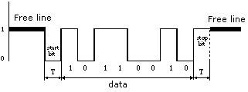
As with hardware communication, we use standard NRZ (Non Return to Zero) format also known as 8 (9)-N-1, or 8 or 9 data bits, without parity bit and with one stop bit. Free line is defined as the status of logic one. Start of transmission - Start Bit, has the status of logic zero. The data bits follow the start bit (the first bit is the low significant bit), and after the bits we place the Stop Bit of logic one. The duration of the stop bit 'T' depends on the transmission rate and is adjusted according to the needs of the transmission. For the transmission speed of 9600 baud, T is 104 uS.
Pin designations on RS232 connector |  | 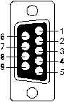
1. CD | (Carrier Detect)
2. RXD | (Receive Data)
3. TXD | (Transmit Data)
4. DTR | (Data terminal Ready)
5. GND | (Ground)
6. DSR | (Data Set Ready)
7. RTS | (Request To Send)
8. CTS | (Clear To Send)
9. RI | (Ring Indicator)
In order to connect a microcontroller to a serial port on a PC computer, we need to adjust the level of the signals so communicating can take place. The signal level on a PC is -10V for logic zero, and +10V for logic one. Since the signal level on the microcontroller is +5V for logic one, and 0V for logic zero, we need an intermediary stage that will convert the levels. One chip specially designed for this task is MAX232. This chip receives signals from -10 to +10V and converts them into 0 and 5V.

Schematic of our project

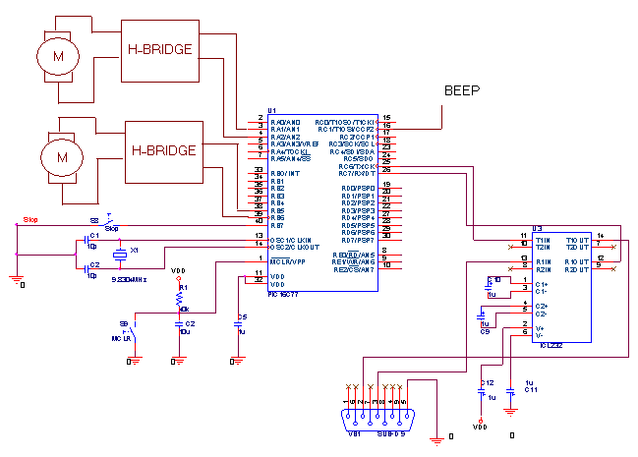

Software

Our software consist of two part:
1-C.net 2005 program
2-PICC program.

C.net 2005 program:
We did a program as a graphical user interface to control the move of the car using button on the interface and using a space to control the car via mouse the interface as shown next:

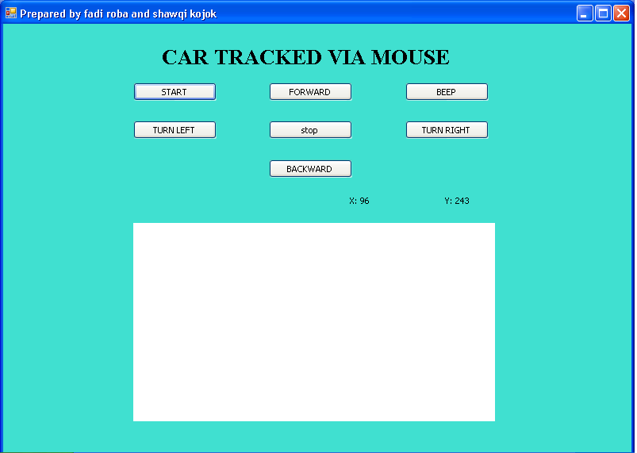

PICC CODE:

We write a code to receive command from the serial interface then it control the car the code is shown next:

#include "C:\Documents and Settings\fadi\Desktop\mm\motor.h"
#use rs232(baud=9600, xmit=PIN_c6,rcv=PIN_c7)
char c;

void main()
{

setup_adc_ports(NO_ANALOGS);
setup_adc(ADC_OFF);
setup_psp(PSP_DISABLED);
setup_spi(FALSE);
setup_counters(RTCC_INTERNAL,RTCC_DIV_1);
setup_timer_1(T1_DISABLED);
setup_timer_2(T2_DISABLED,0,1);
while(1){
while(!kbhit())
{
restart_wdt();
}
c=getc();
if(c=='p')
{

output_bit(PIN_B4,1);
delay_ms(1000);
output_bit(PIN_B4,0);
}
if(c=='s')
{

output_bit(PIN_B4,0);
output_bit(PIN_A1,0);
output_bit(PIN_A2,0);
output_bit(PIN_B5,0);
output_bit(PIN_B6,0);
}
if(c=='r')
{

output_bit(PIN_A1,0);
output_bit(PIN_A2,1);
delay_ms(2000);
restart_wdt();
output_bit(PIN_A2,0);

}
if(c=='d')
{

output_bit(PIN_A1,0);
output_bit(PIN_A2,0);
}
if(c=='h')
{

output_bit(PIN_A1,0);
output_bit(PIN_A2,1);
restart_wdt();

}

if(c=='l')
{

output_bit(PIN_A2,0);
output_bit(PIN_A1,1);
delay_ms(2000);
restart_wdt();
output_bit(PIN_A1,0);
}
if(c=='k')
{

output_bit(PIN_A2,0);
output_bit(PIN_A1,1);

restart_wdt();
}

if(c=='b')
{

output_bit(PIN_B5,0);
output_bit(PIN_B6,1);

}
if(c=='f')
{

output_bit(PIN_B6,0);
output_bit(PIN_B5,1);

}
}
while(1)
{
restart_wdt();
}

}

