An-najah National University

Engineering colledge

Computer Engineering Department

Final project documentation

Project name: ECG machine

Student name:Neda Abd Alrazeq
Maymoona ishtay

Project supervisior: haya samaneh

2007-2008

ECG basic Idea:
Electrical waves cause the heart muscle to pump. These waves pass through the body and can be measured at electrodes (electrical contacts) attached to the skin. Electrodes on different sides of the heart measure the activity of different parts of the heart muscle. An ECG displays the voltage between pairs of these electrodes, and the muscle activity that they measure, from different directions. This display indicates the overall rhythm of the heart, and weaknesses in different parts of the heart muscle. It is the best way to measure and diagnose abnormal rhythms of the heart, particularly abnormal rhythms caused by damage to the conductive tissue that carries electrical signals, or abnormal r hythms caused by levels of salts, such as potassium, that are too high or low.In myocardial infarction (MI), the ECG can identify damaged heart muscle. But it can only identify damage to muscle in certain areas, so it can't rule out damage in other areas. The ECG cannot reliably measure the pumping ability of the heart; ultrasound is used for that.
Introduction:

Our project is to build ECG machine that take 3 point from the human body using electrodes and enter this small voltage to amplification circuit in order to give voltage signal that can be introduce.

So our project depend on amplification circuit ,this circuit contain powerful amplifier which has high gain in order to be able to take signal that can be seen and measured .
Our project its so sensitive because we have high voltage gain and wire and electrodes connect to the human body ,all these component give us
Noise that will be effect to our signal, so now we need very accurate filter that able to remove this noise from our signal without effect it.
After we have accurate signal we will enter this signal to PC in order to be analysis and get the heart rate according to database stored in our program we build it using C# language.

In order to enter this signal to PC we need to convert this signal to digital value in order to be able to deal with it in PC.

This is small introduction about our project we give small idea about our work now we will give the basic circuit for our project and the main structure of the circuit that we used

Project Component:

1. amplification circuit

2. shift circuit

3. PIC 18F4620 circuit contain ADC circuit

4. C# interface progame

amplification circuit:

Amplification circuit is the most important part of this project that take small voltage from the human body .enter it to this circuit and give output as signal with amplitude from -5 volt to + 5 volt.

In this circuit we have operational amplifier (AD624) which has a very high CMRR (90dB) and high gain (1000), with power supply +9V and -9V.

The ECG is converted into electrical voltage by electrodes. A typical surface electrode used for ECG recording is made of Ag/AgCl, The disposable electrodes are attached to the patients? skin and can be easily removed.
Once the electrodes convert the ECG into electrical voltage, these voltage can be fed into an instrumentation amplifier, and then be processed.

Instrumentation Amplifier:
We choose Analog Device AD624 instrumentation amplifier to amplify the ECG voltage from electrodes, which is in the range of several mV.
The AD624 is set up with gain of 1000, and is supplied by +9 V and -9V battery power. Some important features of the AD624 are listed below
Supply voltage | -/+ 9 volt power
Gain | 1,100,200,500,1000,2500
CMRR | 130dB(gain =500 to 1000)
Gain Bandwidth | 25 MHz
Input offset | 25uV max
The circuit used is:
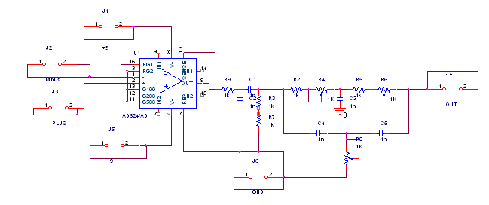
Her in this circuit we give the how the AD624 operational amplifier connect and the value of resistance and capacitor value must connect to it

Filters circuit:

next step after amplification is filter circuit in order to remove un liked noise that will be affect to our signal .in this circuit we will use 3 type of filter to remove noise.
1. high pass filter or (low frequency filter):

this filter is called is the low frequency filter, because signals above the threshold are allowed to pass) is set at either 0.5 Hz or 1 Hz

2. low pass filter(high frequency filter) :

high frequency filter because signals below the threshold are
allowed to pass set at 40Hz

we combine these two filter in one filter which is called band pass filter .
the circuit of band pass filter is shown in the circuit below.

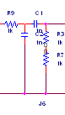

3. notch filter:

This filter is the most important filter .its work is important in ordewr to remove 50Hz noise this noise come from the air and any electronic machine around our circuit.this 50Hz can be come from power supply while we used it.so instead of power supply we used 2 DC battery with 9 volts to take the power.
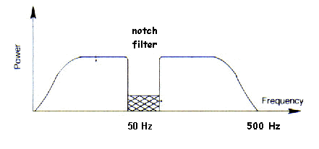

The circuit for notch filter that will be used and the value of capacitor and resistor that used as shown in the circuit below

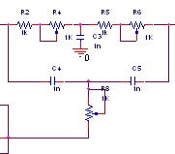

When we reach this point we must have pure ECG signal that can be seen on the oscilloscope without any problem after we connect the circuit to two electrode on the left and right hand.

Step 2:

All above procedure is the first step in our project .output the ECG signal is the first step, the second step is to show the ECG signal on PC.

PIC Basic circuit:

From step one we produce ECG signal ,and we can see it on the oscilloscope ,now we need to see it on PC so we need to digitalize this signal and draw this digital value on PC.
So in order to convert signal to digital we need Analog to Digital converter(ADC) ,her we use ADC in the PIC18F4620 ,so we build the basic circuit of PIC18F4620 and make initialize of the ADC to be ready to receive the signal and convert it to digital value.

Her we have problem because our signal is given value between -5volt and +5 volt but the ADC in PIC can only take the positive value and deal with negative value as (zero) so we need shift circuit.

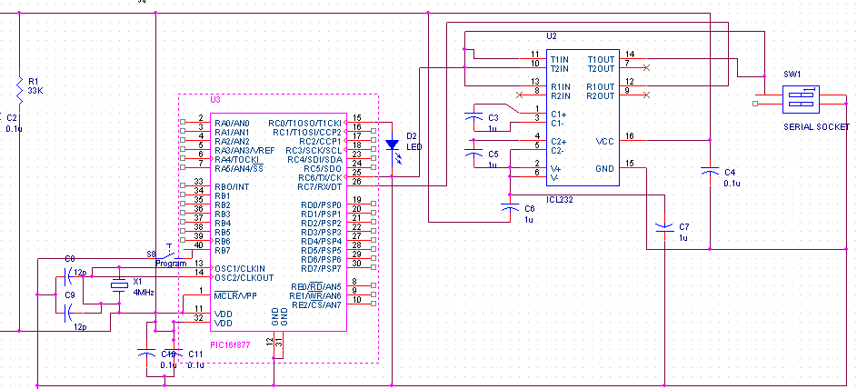

Shift circuit:

As we said above ADC cant deal with negative value so we need shift circuit to shift signal from-5volt to +5vlot to be signal from 0__5 volt .in this circuit we will use 2 amplifier type (LM741 instrumental amplifier ) with voltage offset -9 volt to +9 volt to be accurate . This shift circuit we use as shown below:

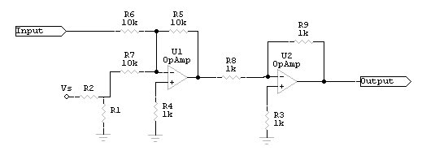

The amount by which the voltage is shifted is determined by the voltage divider. To determine the values of the voltage divider resistors, use the voltage divider formula, along with the supply voltage (Vs) and the voltage you want to add to the input signal (Va).
(R2/(R1+R2))=(Va/Vs).
when we find the value of resistance we calculate the value of R=R2= 1k
and we put the value of voltage ref = 5volt

this circuit give us the approperiat signal which have the signal with voltage between 0 to 5 volt this signal can be enter to ADC and ADC will digitize it to digital value to draw them on PC.
Interface On PC:
We will take the digital value from the serial port and draw this value on the C# interface in our PC

This form use to draw the ECG signal from the input machine

