بسم الله الرحمن الرحيم
AN-NAJAH NATIONAL UNIVERSITY


FACULTY OF ENGINEERING
ELECTRICAL ENGENEERING

Project Title
Design and implementation of speech driven computer

Prepared by:
Fida'a khdaish
Nida'a Boobale
Supervised Dr . Jamal Kharoshee

Dedication

We present this project for:
Our parents they give us their time, care, money, and every thing we need it.
Our brothers they stand beside us and give us their hand and their encouragement.
Our teachers they provide us with science and enable us to produce this project and dialing us as their family.
Nation scientists they work day and to develop life and make it easier for people.
Every on gives us any kind of help.

Abstract

This project investigates building a speech recognition system that use human voices as data input method, the system convert this voice to commend,
The main ideas and steps of the project are:

- Build first part of system on MATLAB program language that can recognize human voice and converter this voice to different command.
- Build second part of system on Aoutoit languages that execute commend.
- Allowing user to speak through a microphone, then the system receive this voice and convert it to commend.
- Using data base to review old commend that was spoken in specific date.

Contents

Dedication..................................................................................2
Abstract......................................................................................3
List of Tables.............................................................................7
List of Figures............................................................................8

1. INTRODUCTION................................................................9
1.1 Background.....................................................................10
1.2 Project Objectives............................................................10
1.3 Ways of driving a computer.............................................11
1.4 purpose methods fro design..............................................11
1.5 Scope of the Project..........................................................11

2. SPEECH RECOGNITION.................................................13
2.1 Introduction.....................................................................14
2.2 Definition.........................................................................14
2.3 History of speech Recognition........................................14
2.4 Major obstacles standing in the way of commercial use......................................................................................15
2.5 Speech Recognition Process.............................................16
2.6 Speech Recognition Categories........................................18
2.7 Recognition Style..............................................................18
2.8 Which style is the Best? ...................................................19
2.9 Speech Recognition Advantages.......................................19
2.10 Available Speech Recognition Systems for Industrial Use Range From....................................................................20

3. COMPONENTS OF SPEECH RECOGNITION SYSTEM ................................................................................................................21
3.1 Introduction......................................................................22
3.2 Speech Recognition software...........................................22
3.3 Computer System requirements.......................................22
3.4 Sound Card.......................................................................22
3.5 Microphone......................................................................27 3.5.1Signallevel......................................................................30
3.5.2 Impedance.....................................................................31
3.6 Other Microphone Issue...................................................31
3.7 Tips on Voice Recognition...............................................32

4. INTRODUCYITIN TO MATLAB......................................34
4.1 Introduction......................................................................
4.2 To Start MATLAB.............................................................36
4.3 Commands are use in this Project.......................................37
4.3.1 While................................................................................37
4.3.2 Menu................................................................................37
4.3.3 Data..................................................................................38
4.3.4 Save..................................................................................38
4.3.5 Disp..................................................................................39
4.3.6 Msgbox.............................................................................39
4.3.7 Load..................................................................................40
4.3.8 Input..................................................................................41
4.3.9 Audio recorder..................................................................41
4.3.10 record..............................................................................42
4.3.11 pause ..............................................................................43
4.3.12 strfind.............................................................................43
4.3.13 strcmp.............................................................................44
4.3.14 wavread..........................................................................44
4.3.15 specgram........................................................................45
4.3.16 strcat...............................................................................46
4.3.17 min.................................................................................47
4.3.18 wavplay..........................................................................48
4.3.19 questdlg..........................................................................48
4.3.20 uigetfile..........................................................................49
4.3.21 corrcoef..........................................................................49

5. INTRODUCYITIN TO AUTOIT.........................................51
5.1 Introduction.....................................................................52
5.2 To Start Auto it................................................................53
5.3 Commands are use in this Project...................................54
5.3.1 Run...............................................................................54
5.3.2 Send..............................................................................55
5.3.3 Shutdown......................................................................55
5.3.4 Win Active....................................................................55
5.4 Function keyboard...........................................................56
5.5 Compiling Scripts with Aut2Exe.....................................59
5.5.1 Method 1 - Start Menu..................................................59
5.5.2 Method 2 - Right Click.................................................61
5.5.3 Method 3 - The Command Line....................................61
5.6 Auto It Window Information Tool...................................62

Appendix
Project code...........................................................................64

Conclusion....................................................................................82

References..................................................................................83

List of Tables

Parameter of Run Command....................................................39
Data Types For wavplay..........................................................48
Parameter of Run Command....................................................54
Return value of Run Command................................................54
Parameter of send Command...................................................55
Return Value of shutdown Command......................................55
Parameter of WinActive Command.........................................56
Parameter of WinActive Command.........................................56
Special keys can be sent and should be enclosed in braces.....58

List of Figures

VRS Computation Required Vs Computation Available..........16
Error Rate VS Task Difficulty...................................................16
Typical Voice Recognition Process...........................................17
Sound card block diagram.........................................................26
Microphone Interfacing.............................................................28
Microphone Symbol..................................................................29
Microphone................................................................................30
Microphone Circuit....................................................................32
MATLAB Main Window..........................................................36
Autoit Main Window.................................................................53
Aut2Exe window.......................................................................60
Right click..................................................................................61
AutoIt Window Information Tool.............................................63

CHAPTER 1

INTRODUCTION

Introduction

1.1 Background

Nowadays, the technology became involved in every thing in our life, because the development in the technology has a lot of advantages in our life, it is making life easier, and it save a lot of time, which we can use it in another useful places.
When we are talking about the technology, we must refer to the important technology in this century, which are the computer and its applications. Using computer nowadays has becomes a necessary for all, it provides people within all fields in addition; it expands to include not only some controlling systems, or product lines, but also to speech fields.

In this project we are looking for away that allow all people including handicapped people to use the computer, if we think about handicapped people we will fined that the voice is the best way to be used by group of people to allow them to interactive with computers.

1.2 Project Objectives

We can summarize the objectives of our project as follow:

- To build a voice advertisement system; where the system inputs are spoken messages that user can speech them in English language to the computer through a microphone, the system will do a process on these spoken messages and change them to execute certain command.
- Increase the ratio of arriving message to larger number of Beneficiaries from this system in its environment.
- Possibility to use this system in a noisy environment or large space environment, where the voice through speakers will not be arrived to all Beneficiaries.
- To increase windows command that can be executed by voice

We applied most courses which are studied in our university, and we use the modern technology to benefit people in our country to easy their life, the modern technologies which used in our project are the Speech Recognition Technology.

1.3 Ways of driving a computer

Computer and speech = History + development

1.4 purpose method fro design

Methodology + diagrams relations of H.W & SW Autit….

1.5 Scope of the Project

We divide our project to nine chapters each chapter covers one part of project stages, these chapters can be described as folloowng:

Chapter 1 Introduction

This chapter include an introduction about the project and its objectives, and then we make a scope in project stages through its chapters.

Speech Recognition 2 Chapter

This chapter covers all things about speech recognition: its definition, background history, the major obstacls that face SRS, SR process, Advantages and Categories, and recognition Style.

Chapter 3 Components of Speech Recognition System

In this chapter we talk about SRA components, and what the rule that each components play in SR process, and what the effects that they make in SR procees, what the constrains that each component must be matched.

Chapter 4 Introduction to MATLAB

In this chapter we try to sammarize about MATLAB programe then describe how the command are used in this project.

Chapter 5 Introductions to Aout it

In this chapter we try to summarize how we start in Aout it programming language, then describe how to make a project and save it and compile it …etc, after that we describe the parts of Aout it command uses.

CHAPTER 2

SPEECH RECOGNITION

Speech recognition

2.1 Introduction

With extensive research and development, speech recognition systems are making many computer based applications easier to manage. They can also provide accessibility to people who are unable to manage their voluntary muscles and are confined to the limitations of a wheelchair.
Using modern technology, including complex programming languages, we are able to conduct high quality research into the factors associated with speech recognition.
However, a recurring problem in this field is the negative effects of exterior ambient noised and/or multiple speakers. It is difficult for a system to correctly recognize a word in a noise environment, as a commercial recognition system would merge the noise and spoken voice together as one. To maximize speech recognition accuracy, and thus enhance its application, ambient noise and/or background conversation should be eliminated from the speech recognition system.

2.2 Definition

Speech or voice recognition is the ability of machine or program to receive and interpret dictation, to understand and carry out spoken commands.
Speech or voice recognition is the ability to interpret spoken words and convert them into computer cretin command speech recognition programs allow you to enter commend by speaking into a microphone, rather than using a keyboard.

2.3 History of speech Recognition

To War with Mother Russia the U.S Department of Defense sponsored the first academic pursuits in speech recognition in the late 1940's. In an attempt to intercept and decode Russian messages that they sent along the ware, as a result the government funded the Speech Understanding Research (SUR) program at Carnegie Mellon University.

- In 1952, as government-funding research began to gain momentum, Bell laboratories developed an automatic speech recognition system that successfully identified the digits 0-9 spoken to it over the telephone.
- In 1959, MIT developed a system that successfully identifies vowel sounds with 93% accuracy.
- In 1966, a system with 50 vocabulary words was successfully tested.
- In the early 1970's the SUR program began to produce results in the from the HARPY system. This system could recognize complete sentences that consisted of a limited rage of grammar structures. This program required massive amounts of computing power to work, 50 state of the art computers.
- In the 1980's, Hidden Markov Models (HMM) become the standard statistical approach for computation.

2.4 Major obstacles standing in the way of commercial use

- Computing Power, lots of power required, but little available
- The ability to recognize speech from any person (not just the particular voices the system has been designed around).
- A continuity of speech capability (so that the person speaking did not have to break after every word).

The successes from the 50's to the 80's gained more attention and interest, eventually continuous speech become imaginable.

Speech works and Dragon systems take over as major producer of speech recognition technology. As these two compete in the field, eventually a point is reached where computation required gets low enough and computation available become high enough for wide spread commercial use.

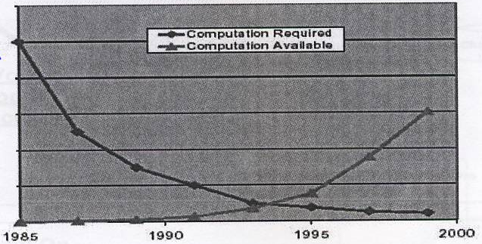

Figure 2.1 VRS Computation Required Vs Computation Available

At the same time, the task difficulty increased coupled with the decrease in error rate made for wide spread use.

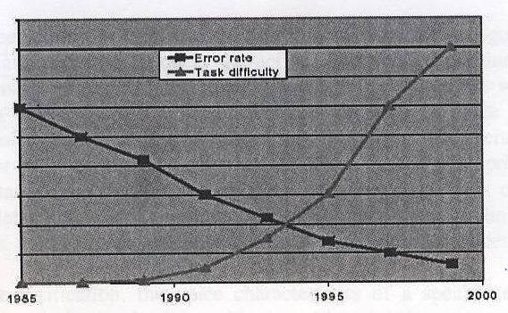

Figure 2.2 Error Rate VS Task Difficulty

- In 1996, the consumer company, Charles Schwab became the first company to implement a speech recognition system for its customer interface.
- In 1997 Dragon Systems release "Naturally Speaking" the first continuous speech dictation software.

In 2002, TellMe supplies the first global voice portal, and later that year, NetByTel launched the first voice enabler. This enabled users to fill out a web-based data from over the phone

2.5 Speech Recognition Process

When speaker talk in microphone, the sound signal is digitized and the digitized signal is compared to previously recorded samples held in a database. The result is a done with this information is dependent on the application(s) associated with the basic voice recognition on application. A diagram of a typical voice recognition process is shown in figure 3.4

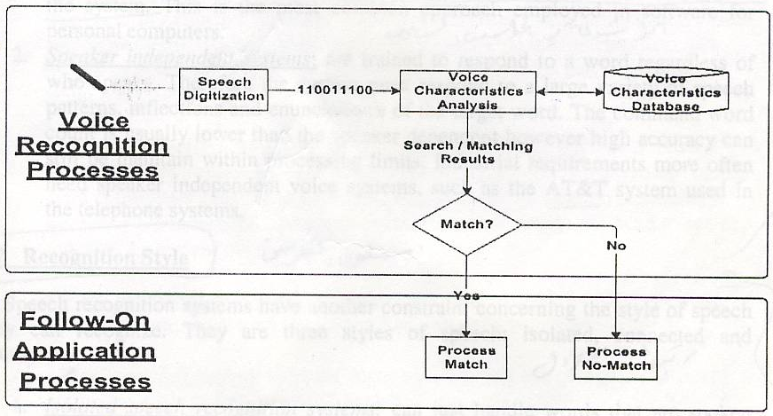

Figure 2.3 Typical Voice Recognition Process

Voice recognition process is classified into two specific categories: identification and verification. Identification is the act of identifying individual and verification simply consists of confirming someone's identity. Compared with identification, verification is the more simple and reliable process. In voice identification, the identification is accomplished by comparing the spoken PIN (Personal identification Number) or password to the individual's digitally stored voiceprint samples. Thee reference samples are previously digitized and recorded words or phrases that are stored for later comparison to a live sample. Comparing and finding a match between an entry in the reference database and a live sample can successfully identify the individual.
In voice verification, the voice characteristics of a speaker are compared to a reference sample in the database with a resulting right/wrong condition. Most voice verification systems allow for a keyboard-entered password as an auxiliary means of verification. This helps to avoid possible wrong conditions resulting from normal
Variations in person's vocalization patterns that result from a cold, laryngitis, or any other reasons. In a real world, voice verification is a real capability and is much more popular than voice identification. Voice verification has become a reality because of increases in processing power and improvements in algorithms. If same improvements occur with voice identification, the technology also will become more reliable and practical.

2.6 Speech Recognition Categories

Speech recognition is classified into two categories, speaker dependent and speaker independent.

- Speaker dependent systems: are trained by the individual who will be using the system. These systems are capable of achieving a high command count and better than 95% accuracy for word recognition. The drawback to this approach is that the system only responds accurately only to the individual who trained the system. This is the most common approach employed in software for personal computers.
- Speaker independent systems: are trained to respond to a word regardless of who speaks. Therefore the system must respond to a large variety of speech patterns, inflections and enunciation's of the target word. The command word count is usually lower than the speaker dependent however high accuracy can still be maintain within processing limits. Industrial requirements more often need speaker independent voice systems, such as the AT&T system used in the telephone systems.

2.7 Recognition Style

Speech recognition systems have another constraint concerning the style of speech they can recognize. They are three styles of speech: isolated, connected and continuous.

- Isolated speech recognition systems: can just handle words that are spoken separately. This is the most common speech recognition systems available today. The user must pause between each word or command spoken. The speech recognition circuit is set up to identify isolated words of .96 second lengths.
- Connected speech recognition systems: are a half way point between isolated word and continuous speech recognition. Allows users to speak multiple words this can be set up to identify words or phrases 1.92 seconds in length this reduces the word recognition vocabulary number to 20.
- Continuous speech recognition systems: are the natural conversational speech we are use to in everyday life. It is extremely difficult for a recognizer to shift are you doing?" sounds like "Hi, howyadoin" Continuous speech recognition systems are under continual development

2.8 Which style is the Best?

However good continuous speech recognition has become popular, some users prefer to use, or have to use, isolated speech recognition. These include some users with speech difficulties who, having compared the two systems, still prefer the isolate speech recognition method of speaking (and checking) one word at time, Some users with speech difficulties may have no choice at all, as isolate speech is the only choice that improves sufficiently over time to accommodate their needs and abilities. Continuous speech recognition was so ineffective that they couldn't even get beyond the first phase of the training process. However, using isolate voice recognition software, successful recognition for one project member improve from an initial 30% rate to 70%+ within a few months.

2.9 Speech Recognition Advantages

A "natural" data input methodology: VTT increases efficiency of workers that perform extensive typing or data entry activities (both numbers and words can be dictated). This could be particularly beneficial in legal, medical and insurance environments where large amount of dictation and transcription occur.

- High security (typically must be "trained" for each user): Voice Security Systems Voice Protect speaker verification technology uses a person's voice print to uniquely identify individuals using speaker verification technology. Speech is processed through a non-contact method; you do not need to see or to touch the person to be able to recognize them.

- Eyes-and hands-free operation: you don't need to use your hands or your eyes when you work with the system just you need your voice.

- Flexibility (language): there are many systems that can recognize different languages such as English, and Spanish.

2.10 Available Speech Recognition Systems for Industrial Use Range From

- Relatively limited with a small number of words.
- Complex ones that can recognize hundreds, even thousands, of words.
- Systems that recognize all speakers (limited words).
- System that must be trained (extensive vocabularies).

CHAPTER 3

COMPONENTS OF SPEECH
RECOGNITION SYSTEM

Components of Speech Recognition System

3.1 Introduction

Most speech recognition systems require the following components to operate effectively: speech recognition software, compatible computer system, sound card, and a microphone. A portable dictation recorder that lets a user dictate away from the computer is optional.

3.2 Speech Recognition software

Using modern technology, including complex programming languages, we are able to get high quality speech recognition system; speech recognition software will discuss in "chapter 8 in" details.

3.3 Computer System requirements

Running voice recognition software places great demands on a computer system. In generally, a computer with a powerful processor, plenty of RAM (working memory), and enough hard drive space will be sufficient. The product manual or the software manufacturer's Web site will likely list the specific computer requirements.

3.4 Sound Card

Introduction:
Computer systems need a way of inputting a sound, storing it and possibly, modifying a stored copy and finally it must also be able to reproduce the sound. The collection of circuits associated with these tasks it is often available in one unit that is usually referred to as a sound card.
Before the arrival of sound cards, personal computers were limited to beeps from a tiny speaker on the motherboard. In the late 1980s, sound cards ushered in the multimedia PC and took computer games to a whole different level.

Anatomy of a sound card:

A typical sound card has:
- A digital signal processor (DSP) that handles most computation.
- A digital to analog converter (DAC) for audio leaving the computer.
- An analog to digital converter (ADC) for audio coming into the computer.
- Read only memory or flash memory for storing data.
- Musical instrument digital interface (MIDI) for connecting to external music equipment.
- Jacks for connecting speakers and microphone, as well line in and line out.
- A game port for connecting a joystick or game pad.

Current sound cards usually plug into a peripheral component interconnect (PCL) slot, while some older or index pensive cars may use the industry standard architecture (ISA) BUS. Many of the computers available today incorporate the sound card as a chipset right on the motherboard. This leaves another slot open for other peripherals.
Sound cards may be connecting to:
- Headphones
- Amplified speakers
- An analog input source
  - Microphone
  - Radio
  - Tape deck
  - CD player
- A digital input source
  - A digital audiotape(DAT)
  - CD-ROM drive
- An analogue output device-tape deck
- A digital output device
  - DAT
  - CD recordable (CD-R)

Catching the wave:

Typically a sound card can do four things with sound:
- Plat pre-recorded music(from CDs or sound files such as wav or mp3) games or DVDs
- Record audio in various media from external sources (microphone or tape player).
- Synthesize sounds
- Process existing sounds

The DAC and ADC provide the means for getting the audio in and out of sound card while the DSP oversees the process the DSP also takes care of any alterations to the sound such as echo or reverb because the DSP focuses on the audio processing the computers main processor can take care of other tasks

Early sound cards used FM synthesis to create sounds FM synthesis takes at varying frequencies and combines them to create an approximation of a particular sound such as the blare of trumpet while FM synthesis has matured to the point where it can sound very realistic it does not compare to Wavetable synthesis Wavetable synthesis works by recording a tiny sample of the actual instrument This sample is then played in a loop to re-crest the original instrument with incredible accuracy Wavetable synthesis has become the standard for most sound cards but some of the inexpensive brands still use FM synthesis A few cards provide both types

Very sophisticated sound cards have more support for MIDI instruments using a music program a MIDI-equipped music instrument can be attached to the sound card to allow user to see on the computer screen the music score of what users playing

Producing sound:

A sound card create a sound file in wav format from the date input through the microphone the process of converting that data into file to be recorded to the hard disk is:

- The sound card receives a continuous analog – waveform input signal from the microphone jack the analog signals received very in both amplitude and frequency.

- Software in the computer selects which input (s) will be used depending on whither the microphone sound is being mixed with a CD in the CD-ROM drive.

- The mixed analog waveform signal is processed in real-time by an analog – to- digital converter (ADC) circuit chip creating a binary (digital) output of 1s and 0s.

- The digital output from the ACD flows into the DSP the DSP is programmed by asset of instructions stored on another chip on the sound card one of the functions of the DSP is to compress the now-digital data in order to save space the DSP also allows the computers processor to perform other tasks while this is taking place.

- The output from the DSP is fed to the computers data bus by way of connections on the sound card (or traces on the motherboard to and from the sound chipset).

- The digital data is processed by the computers processor and routed to the hard-disk controller it is then sent on to the hard-disk drive as a recorded wav file.

To listen to prerecorded wav file the process is simply reversed:

- The digital data is read from the hard disk and passed on to the central processor

- The central processor passed the data to the DSP on the sound card.

- The DSP uncompressed the digital data.

- The uncompressed digital data-stream from the DSP is processed in real-time by digital -to- analog converter (DAC) circuit chip creating an analogue signal that the user hear in the headphones or thought the speakers, depending on which is connect to the sound-card's headphones jack.

Sound card upgrades
Sound upgrades are on option if the motherboard dose not have a sound chipset built in or if the user wants higher performance. A common upgrade path is to move from an ISA sound card to a PCI sound card. Generally, your intended application determines whether you need a new sound card. For some audio application, such as telephony or certain games, full-duplex sound has the ability to accept a sound input while simultaneously providing sound output.

In windows, to test full-duplex capability by launching two copies of sound record.
To do this, click:
1. Start menu
2. Programs
3. Accessories
4. Sound recorder
Repeat the process to launch two copies of the program. You can test for full-duplex by playing a file on one windows sound recorder and, while that file is playing, making a recording with the other.

The sound card is a critical part of a speech recognition system. Recognition problems may be the result of poor sound card performance or incompatibility between the sound card and the voice recognition software. Most speech recognition programs contain a utility program that evaluates the quality of the sound card. If the computers sound card is in adequate, the user will need to get a vendor-approved sound card. Voice recognition software vendors usually provide an approved list of sound cards in the product manual or on their Web site.

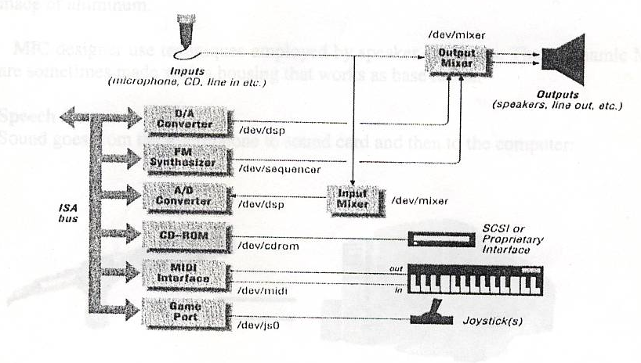

Figure 3.1 Sound card block diagram

3.5 Microphone

The microphone has an important rule in speech recognition process so that we will cover all things about it in more details in this chapter.

Meet the microphone:
A microphone is the first component of any recording or transmitting system, MIC usually defines as "a device that converting an acoustical sound wave into an equivalent electrical signal, which has essentially similar wave characteristics".
However, microphone cannot affectivity sort out desired sound (direct sound) from undesired reverberation (reflected speech).Also; a microphone cannot improve the acoustic environment in which it's placed.

What is the microphone?
A microphone basically a collector of sounds, taking acoustical energy input and converting it to electrical energy. The problem is that the a acoustical energy contained in our voice is full of sounds that sudden start and then stops, so one of the required characteristics of MIC is that it must be responsive to rapid changes in a acoustical energy.

Microphone shapes:
The shape of the MIC supplies no clue to its performance capabilities. No way of equality between the size of the MIC and the equality, since extremely small size may be a recording necessity, weight can meaning less, it could be unthinkable to sell MIC by the bound. By comparing the MIC specification is useful, but the final analysis it is the performance of the MIC in a specific application.

Microphone case:
The case of the microphone can be die cast zinc, zinc alloy or mechanical aluminum of steel, with case finished chromes, bronze anodized aluminum, or some nonreflecting or brass color. For elect ret types there may be battery compartment made of aluminum.

MIC designer use techniques employed by speaker engineers. Thus, dynamic MICs are sometimes made with a housing that works as base reflex.

Speech flow:
Sound goes from the microphone to sound card and then to the computer:

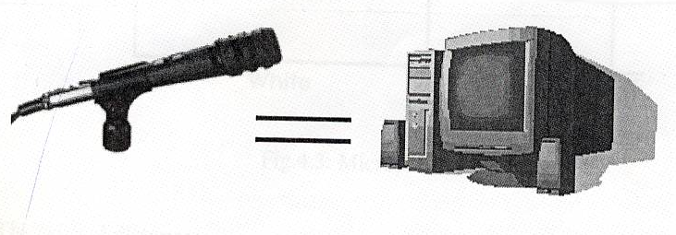

Fig.3.2 Microphone Interfacing.

Microphone requirements:
As a collector of sound, MICs must often meet a number of requirements:

- By considering the MIC as a supplier of two level of sound in the form of electrical voltages. One of these voltages corresponds directly to the "self-noise level of the MIC", the other voltage is that produced by the conversion of the energy supplied by the sound source. The self-noise voltage must be small in comparison to the sound signal voltage.
2. The output signal voltage should be distorted over the frequency range of the sound source. The MIC should not be frequency selective operating characteristics, unless the MIC is so made for special purpose, further; this operating characteristic must exist over a wide dynamic range, that is, from the softest to the loudest sound.

3. The polar characteristics of the MIC should be the same for all operatic frequencies.

4. The MIC should be as unobtrusive so as not distract attention from the performer.

5. The MIC must be able to tolerance repeated connections and disconnections, as well as physical abuse.

6. In special application, the finish of the MIC should have a very low value of light reflectivity.

7. The out put of the MIC should be large enough to be able to drive a following preamplifier.

Microphone symbol:
As shown in figure 3.3:
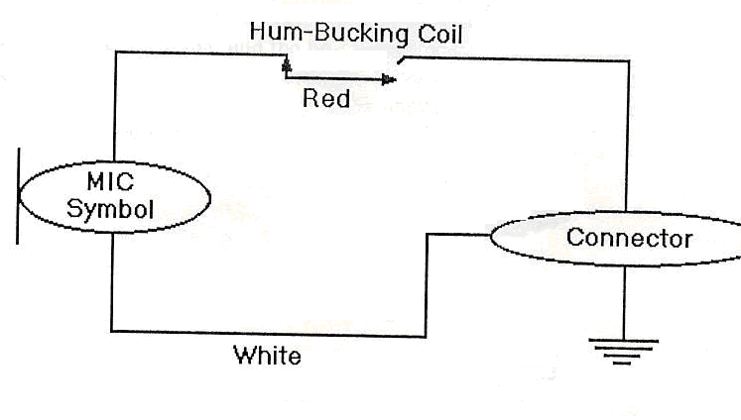Fig.3.3: Microphone Symbol

The critical distance:
In every room, there is a distance (measured from the talker) where the direct speech and the reflected speech are equal in intensity. In acoustic, this is known as the critical distance and is abbreviated Dc.

The importance of Dc the MIC placement:

Because if a MIC is placed at Dc or farther from a talker, the speech quality picked up will be very poor. The poor sound quality is often describe as "echoey", reverberant, or "bottom of the boarded". The talker's words will also be hard to understand as the reflected speech overlaps and blurs the direct speech.

The produce an excellent audio:

In general, an unidirectional MIC should be placed no farther from the talker than 320 percent of Dc, e.g. if Dc is 10 feet, an unidirectional may be placed up to 3 feet
from the talker, A unidirectional MIC should be positioned no father than 50 percent of Dc, e.g. if Dc is 10 feet, a unidirectional maybe placed up to 5 feet from the talker

* If the MIC must be placed farther away than 50 percent of Dc:
- The room should make less reflective vie acoustical solutions. The will increase the Dc.
- Accepting the substandard audio provided with a>50 percent of Dc talker to MIC distance.
There is on other solution!!

Important note:

This built in doses not address the intelligibility problems that are caused by unwanted background noise such as air conditioners. Poor speech to noise ratio will ruin speech intelligibility even if the MIC is located <50percent of Dc. Intelligibility problems caused by background noise must be solved by silencing the noise source or by moving the MIC closer to the talker.

The performance of speech recognition system is severely affected by the quality of input speech signal and the best quality signals are normally available only through close talk microphone's recordings. However, in most real world applications, close talk microphone recording are often unavailable and researchers are limited to work with noisy recordings from far-talk microphone.

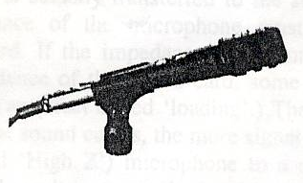
Figure 3.4 microphone

Many users of computer sound cards purchase a professional microphone to improve upon the performance of the microphone included differ from those used in professional audio; it is not always easy to make a professional microphone work with a computer. To be successful in connecting a microphone to your computer you must know something about both your microphone and your sound card. The following two pieces of information are important to know about each product

- Signal level
- Electrical impedance

3.5.1 Signal level

Professional microphones put out a very weak signal - less than l millivolt Audio inputs on sound cards, even through they may be labeled "Mic In" or be identified by a small microphone-shaped icon, often are not designed to accept such a low signal level. Most sound card inputs require a minimum signal level of at least 10millivolts. This discrepancy means that if a typical professional microphone is connected to a
sound card input, the user will have to shout into the microphone or hold it just an inch or so away (or both) in order to produce a strong enough signal for the sound card to "hear"

There are two possible solutions. One option is to increase the sensitivity of the sound card input, so that it can more easily detect the signal from the microphone.
(Note: Increasing the sensitivity of the input will always add some noise, so use only as much additional gain as necessary.)

If the input sensitivity cannot be increased, another option is to amplify the microphone signal before it goes into the sound card input. This can be done by running the microphone signal through a device called a mic preamplifier.

Either way, you will have to know the typical output level of the microphone (found on the microphone's specification sheet and the sensitivity of the sound card input in order to know how much amplification is needed, and whether a particular a particular mic preamp will do the job.

3.5.2 Impedance

Impedance is an electrical characteristic similar to resistance. It is important because the relationship between the impedance of a microphone and the impedance of the sound card to which it is connected can have a significant effect on how much of the microphone's signal is actually transferred to the sound card. For acceptable results, the output impedance of the microphone must be less than the input impedance of the sound card. If the impedance of the microphone is the same or higher than the input impedance of the sound card, some or all of the microphone signal strength will be lost (an effect called 'loading'.) The higher the microphone's impedance is compared to the sound card's, the more signal will be lost. Connecting a high impedance (also called 'High Z) microphone to a sound card with an input impedance of 600 ohms will result in so much signal loss that the talker's voice will be inaudible. Professional microphones typically have an output impedance of less than 600 ohms and most sound cards have an input impedance of 600 to 2,000 ohms, so impedance is not usually a problem.

3.6 Other Microphone Issue

How long can the microphone cable be? Because computer sound card inputs use the unbalanced wiring scheme, microphone cables longer than 15 feet will usually pick up electromagnetic interference or cause the sound to become muffled. To preserve sound quality, use the shortest MIC cable possible.

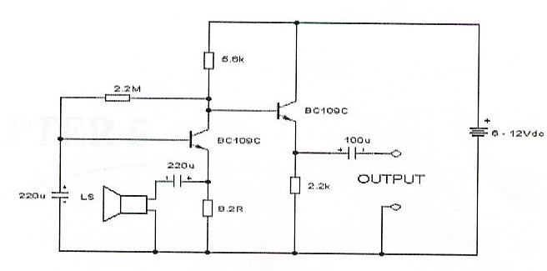

Figure 3.5 Microphone Circuit

3.7 Tips on Voice Recognition

For accurate voice recognition, the software must receive clear, intelligible sound from the microphone. For this to happen, the microphone must be placed in an area where it receives relatively noise-free sound from the talker. The following guidelines will help you to get the best performance from your microphone and your voice recognition software.

- Place the microphone close to the talker. As the background noise level increases, the ratio of signal to noise decreases and the performance of the voice recognition software degrade. The noisier the room is, the closer the microphone must be placed to the talker to provide sufficient signal-to-noise ratio for good voice recognition. In most situations, a talker-to-mic distance of less than one foot is optimum. In noisy environments, the mic should be within 6 inches of the talker's mouth for good results; a headworn, lavalier/tie clip, or gooseneck-type microphone is usually the best choice.

- Use a directional microphone. Unidirectional microphones (referred to as noise-canceling by some manufacturers), which are less sensitive to sounds coming from the rear and sides, can help isolate your voice from ambient noise. Unidirectional microphones also help when the primary noise source is directly behind the microphone (such as the computers fan or hard drive). A unidirectional microphone aimed at the computer operator may still pick up noise from sources located behind the operator.

- Use a windscreen or pop filter. Windscreens prevent air currents from the mouth from striking the microphone abruptly, which can cause a popping or thumping noise which cannot be interpreted by the voice recognition software. Condenser microphones are usually more sensitive to popping than dynamic types.

CHAPTER 4

INTRODUCYITIN TO MATLAB

4.1 Introduction

MATLAB is a high-performance language for technical computing. It integrates computation, visualization, and programming in an easy-to-use environment where problems and solutions are expressed in familiar mathematical notation. Typical uses include
- Math and computation
- Algorithm development
- Data acquisition
- Modeling, simulation, and prototyping
- Data analysis, exploration, and visualization
- Scientific and engineering graphics
- Application development, including graphical user interface building

MATLAB is an interactive system whose basic data element is an array that does not require dimensioning. This allows you to solve many technical computing problems, especially those with matrix and vector formulations, in a fraction of the time it would take to write a program in a scalar noninteractive language such as C or Fortran.
The name MATLAB stands for matrix laboratory. MATLAB was originally written to provide easy access to matrix software developed by the LINPACK and EISPACK projects. Today, MATLAB engines incorporate the LAPACK and BLAS libraries, embedding the state of the art in software for matrix computation.
MATLAB has evolved over a period of years with input from many users. In university environments, it is the standard instructional tool for introductory and advanced courses in mathematics, engineering, and science. In industry, MATLAB is the tool of choice for high-productivity research, development, and analysis.
MATLAB features a family of add-on application-specific solutions called toolboxes. Very important to most users of MATLAB, toolboxes allow you to learn and apply specialized technology. Toolboxes are comprehensive collections of MATLAB functions (M-files) that extend the MATLAB environment to solve particular classes of problems. Areas in which toolboxes are available include signal processing, control systems, neural networks, fuzzy logic, wavelets, simulation, and many others.

4.2 To Start MATLAB

Before the following step we must install the Autoit v3 in our computer.

- Click on the Start button on the t Windows task bar.
- Select Programs, MATLAB 7.0.
- Click on MATLAB 7.0.

The MATLAB program should start the windows will appear on the screen see the figure 4.2

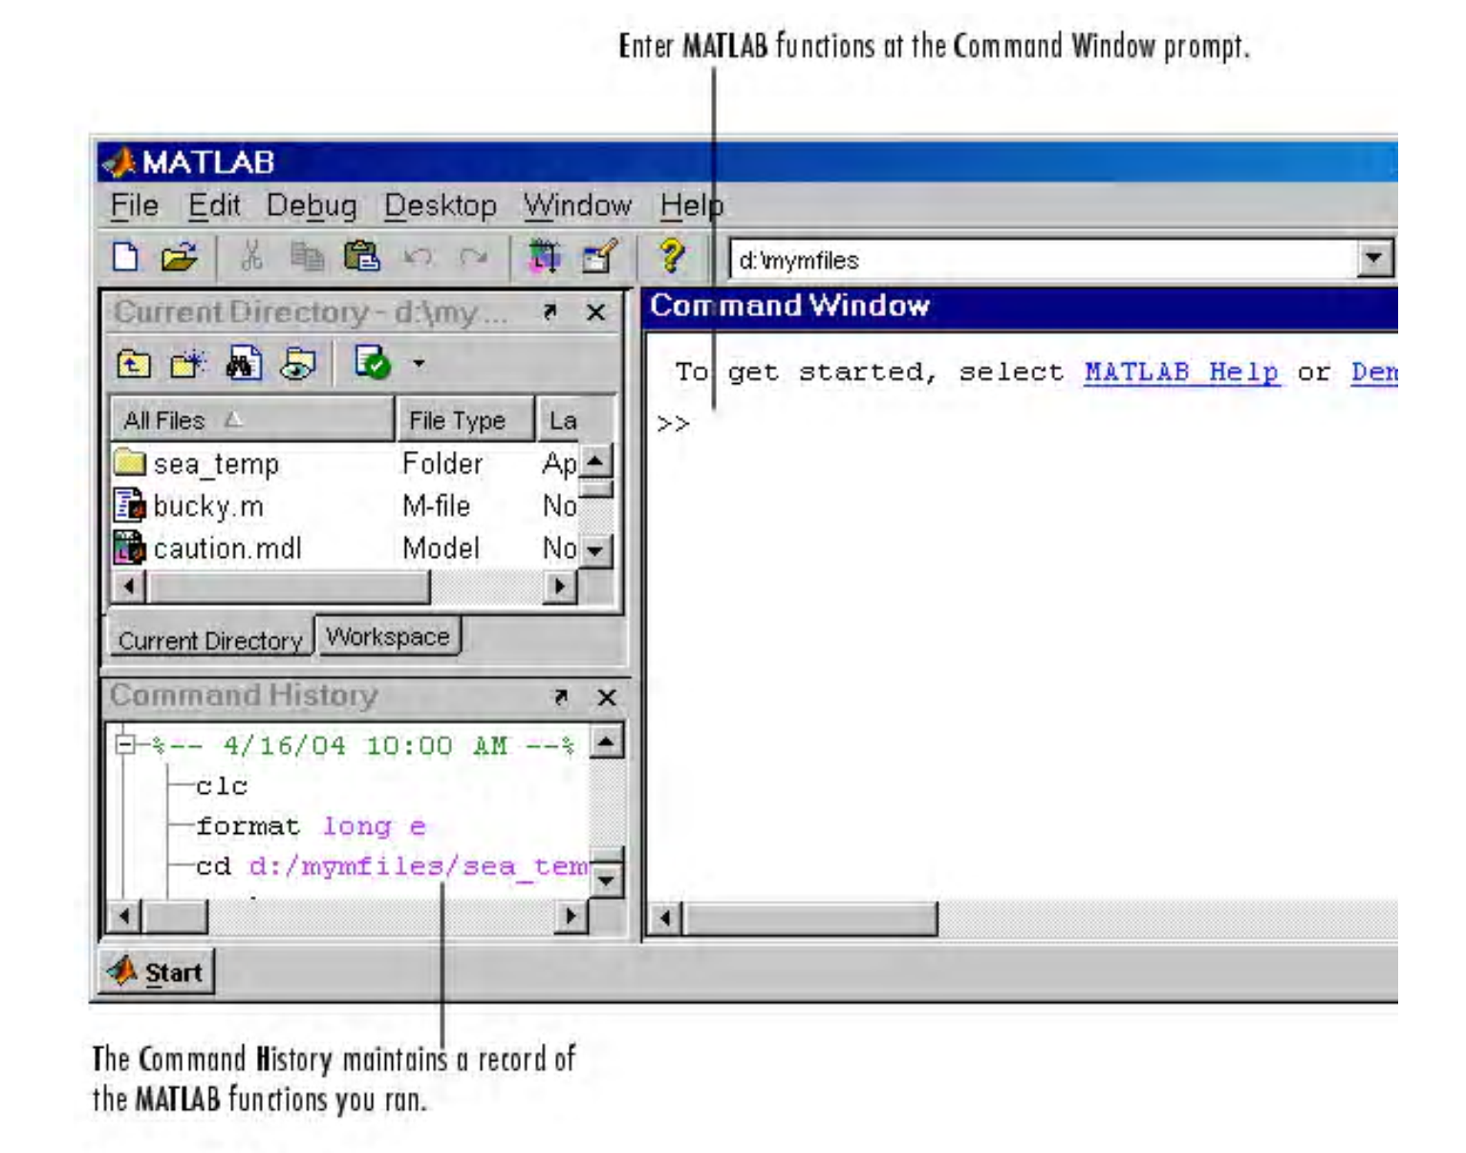

Figure 4.1 MATLAB Main Window

4.3 Commands are use in this Project

4.3.1 while
while Repeat statements an indefinite number of times
Syntax
while expression
statements
end
Description
while repeats statements an indefinite number of times. The statements are executed while the real part of expression has all nonzero elements. expression is usually of the form
expression rel_op expression
where rel_op is ==, <, >, <=, >=, or ~=.
The scope of a while statement is always terminated with a matching end.

4.3.2 menu

Generate a menu of choices for user input)
Syntax

k = menu('mtitle','opt1','opt2',...,'optn')

Description

k = menu('mtitle','opt1','opt2',...,'optn') displays the menu whose title is in the string variable 'mtitle' and whose choices are string variables 'opt1', 'opt2', and so on. menu returns thenumber of the selected menu item. If the user's terminal provides a graphics capability, menu displays the menu items as push buttons in a figure window (Example 1), otherwise they will be given as a numbered list in the command window

4.3.3 Data

View the current MATLAB workspace in the Data area. The area updates after you click Execute to run a query. Variables shown include the MATLAB Workspace Variable you assigned for the query. To clear variables from the Data area, use the clear function in the Command Window

4.3.4 save

Save workspace variables on disk

Syntax

save
save('filename')
save('filename', 'var1', 'var2', ...)
save('filename', '-struct', 's')
save('filename', '-struct', 's', 'f1', 'f2', ...)
save('-regexp', expr1, expr2, ...)
save('..., 'format')
save filename var1 var2 ...

Description

save('filename') stores all workspace variables in the current directory in filename.mat. To save to another directory, use the full pathname for the filename. If filename is the special string stdio, the save command sends the data as standard output.
save('filename', 'var1', 'var2', ...) saves only the specified workspace variables in filename.mat. Use the * wildcard to save only those variables that match the specified pattern. For example, save('A*') saves all variables that start with A.
save('filename', '-struct', 's') saves all fields of the scalar structure s as individual variables within the file filename.
save('filename', '-struct', 's', 'f1', 'f2', ...) saves as individual variables only those structure fields specified (s.f1, s.f2, ...).

Format | How Data Is Stored
-append | The specified existing MAT-file, appended to the end. See Remarks, below.
-ascii | 8-digit ASCII format
-ascii -double | 16-digit ASCII format
-ascii -tabs | Delimits with tabs
-ascii -double -tabs | 16-digit ASCII format, tab delimited
-mat | Binary MAT-file form (default
-v4 | A format that MATLAB Version 4 can open
-v4 | A format that MATLAB Version 6 and earlier can open
Table 4.1 Parameter of Run Command
4.3.5 disp

Display text or array

Syntax

disp(X)

Description

disp(X) displays an array, without printing the array name. If X contains a text string, the string is displayed. Another way to display an array on the screen is to type its name, but this prints a leading "X =," which is not always desirable. Note that disp does not display empty arrays.

4.3.6 msgbox

Display message box
Syntax

msgbox(message)
msgbox(message,title)
msgbox(message,title,'icon')
msgbox(message,title,'custom',iconData,iconCmap)
msgbox(...,'createMode')
h = msgbox(...)

Description

msgbox(message) creates a message box that automatically wraps message to fit an appropriately sized figure. message is a string vector, string matrix, or cell array.

msgbox(message,title) specifies the title of the message box.

msgbox(message,title,'icon') specifies which icon to display in the message box. 'icon'
is 'none', 'error', 'help', 'warn', or 'custom'. The default is 'none'.

4.3.7 load

Load workspace variables from disk

Syntax

load
load('filename')
load('filename', 'X', 'Y', 'Z')
load('filename', '-regexp', exprlist)
load('-mat', 'filename')
load('-ascii', 'filename')
S = load(...)
load filename -regexp expr1 expr2 ...

Description

load loads all the variables from the MAT-file matlab.mat, if it exists, and returns an error if it doesn't exist.

load('filename') loads all the variables from filename given a full pathname or a MATLABPATH relative partial pathname. If filename has no extension, load looks for a file named filename.mat and treats it as a binary MAT-file. If filename has an extension other than .mat, load treats the file as ASCII data.

load('filename', 'X', 'Y', 'Z') loads just the specified variables from the MAT-file. The wildcard '*' loads variables that match a pattern (MAT-file only).

load('filename', '-regexp', exprlist) loads those variables that match any of the regular expressions in exprlist, where exprlist is a comma-delimited list of quoted regular expressions.

load('-mat', 'filename') forces load to treat the file as a MAT-file, regardless of file extension. If the file is not a MAT-file, load returns an error.

load('-ascii', 'filename') forces load to treat the file as an ASCII file, regardless of file extension. If the file is not numeric text, load returns an error.

4.3.8 input

Request user input

Syntax

user_entry = input('prompt')
user_entry = input('prompt','s')

Description

The response to the input prompt can be any MATLAB expression, which is evaluated using the variables in the current workspace.

user_entry = input('prompt') displays prompt as a prompt on the screen, waits for input from the keyboard, and returns the value entered in user_entry.

user_entry = input('prompt','s') returns the entered string as a text variable rather than as a variable name or numerical value.

4.3.9 audiorecorder

Create an audio recorder object

Syntax

y = audiorecorder
y = audiorecorder(Fs,nbits,channels)
y = audiorecorder(Fs,nbits,channels,id)

Description

y = audiorecorder returns a handle to an 8-kHz, 8-bit, mono audio recorder object. The audio recorder object supports methods and properties that you can use to record audio data

y = audiorecorder(Fs,nbits,channels) returns a handle to an audio recorder object using the sampling rate Fs (in Hz), the sample size of nbits, and the number of channels. Fs can be any sampling rate supported by the audio hardware. Common sampling rates are 8000, 11025, 22050, and 44000. The value of nbits must be 8 or 16 (or 24, if a 24-bit device is installed). For mono or stereo, channels must be 1 or 2, respectively.

y = audiorecorder(Fs,nbits,channels,id) returns a handle to an audio recorder object using the audio device specified by its id for input.

4.3.10 record

Record data and event information to a file

Syntax

record(obj)
record(obj,'switch')

Description

Obj : A serial port object.
'switch' : Switch recording capabilities on or off.

record(obj) toggles the recording state for obj.

record(obj,'switch') initiates or terminates recording for obj. switch can be on or off. If switch is on, recording is initiated. If switch is off, recording is terminated.

4.3.11 pause

Halt execution temporarily

Syntax

pause
pause(n)
pause on
pause off

Description

pause, by itself, causes M-files to stop and wait for you to press any key before continuing.

pause(n) pauses execution for n seconds before continuing, where n can be any nonnegative real number. The resolution of the clock is platform specific. A fractional pause of 0.01 seconds should be supported on most platforms.

pause on allows subsequent pause commands to pause execution.

pause off ensures that any subsequent pause or pause(n) statements do not pause execution. This allows normally interactive scripts to run unattended.

4.3.12 strfind

Find one string within another

Syntax

k = strfind(str, pattern)
k = strfind(cellstr, pattern)
Description

k = strfind(str, pattern) searches the string str for occurrences of a shorter string, pattern, and returns the starting index of each such occurrence in the double array k. If pattern is not found in str, or if pattern is longer than str, then strfind returns the empty array [].

k = strfind(cellstr, pattern) searches each string in cell array of strings cellstr for occurrences of a shorter string, pattern, and returns the starting index of each such occurrence in cell array k. If pattern is not found in a string or if pattern is longer then all strings in the cell array, then strfind returns the empty array [], for that string in the cell array.
The search performed by strfind is case sensitive. Any leading and trailing blanks in pattern or in the strings being searched are explicitly included in the comparison.

4.3.13 strcmp

Compare strings

Syntax

k = strcmp('str1', 'str2')
TF = strcmp(S, T)

Description

k = strcmp('str1', 'str2') compares the strings str1 and str2 and returns logical true (1) if the two are identical and logical false (0) otherwise.

TF = strcmp(S, T) where either S or T is a cell array of strings, returns an array TF the same size as S and T containing 1 for those elements of S and T that match and 0 otherwise. S and T must be the same size (or one can be a scalar cell). Either one can also be a character array with the right number of rows.

4.3.14 wavread

Read Microsoft WAVE (.wav) sound file

Syntax

y = wavread('filename')
[y,Fs,bits] = wavread('filename')
[...] = wavread('filename',N)
[...] = wavread('filename',[N1 N2])

Description

wavread supports multichannel data, with up to 32 bits per sample, and supports reading 24- and 32-bit .wav files.

y = wavread('filename') loads a WAVE file specified by the string filename, returning the sampled data in y. The .wav extension is appended if no extension is given. Amplitude values are in the range [-1,+1].

[y,Fs,bits] = wavread('filename') returns the sample rate (Fs) in Hertz and the number of bits per sample (bits) used to encode the data in the file.

[...] = wavread('filename',N) returns only the first N samples from each channel in the file.

[...] = wavread('filename',[N1 N2]) returns only samples N1 through N2 from each channel in the file.

4.3.15 specgram

Time-dependent frequency analysis (spectrogram)

Syntax

B = specgram(a)
B = specgram(a,nfft)
[B,f] = specgram(a,nfft,fs)
[B,f,t] = specgram(a,nfft,fs)
B = specgram(a,nfft,fs,window)
B = specgram(a,nfft,fs,window,numoverlap)
specgram(a)
B = specgram(a,f,fs,window,numoverlap)

Description

specgram computes the windowed discrete-time Fourier transform of a signal using a sliding window. The spectrogram is the magnitude of this function.

B = specgram(a) calculates the windowed discrete-time Fourier transform for the signal in vector a. This syntax uses the default values:

- nfft = min(256,length(a))
- fs = 2
- window is a periodic Hann (Hanning) window of length nfft
- numoverlap = length(window)/2

nfft specifies the FFT length that specgram uses. This value determines the frequencies at which the discrete-time Fourier transform is computed. fs is a scalar that specifies the sampling frequency. window specifies a windowing function and the number of samples specgram uses in its sectioning of vector a. numoverlap is the number of samples by which the sections overlap. Any arguments that you omit from the end of the input parameter list use the default values shown above

If a is real, specgram computes the discrete-time Fourier transform at positive frequencies only. If n is even, specgram returns nfft/2+1 rows (including the zero and Nyquist frequency terms). If n is odd, specgram returns nfft/2 rows. The number of columns in B is

k = fix((n-numoverlap)/(length(window)-numoverlap))

If a is complex, specgram computes the discrete-time Fourier transform at both positive and negative frequencies. In this case, B is a complex matrix with nfft rows. Time increases linearly across the columns of B, starting with sample 1 in column 1. Frequency increases linearly down the rows, starting at 0.

4.3.16 strcat

String concatenation

Syntax

t = strcat(s1, s2, s3, ...)

Description

t = strcat(s1, s2, s3, ...) horizontally concatenates corresponding rows of the character arrays s1, s2, s3, etc. All input arrays must have the same number of rows (or any can be a single string). When the inputs are all character arrays, the output is also a character array.

When any of the inputs is a cell array of strings, strcat returns a cell array of strings formed by concatenating corresponding elements of s1, s2, etc. The inputs must all have the same size (or any can be a scalar). Any of the inputs can also be character arrays.

Trailing spaces in character array inputs are ignored and do not appear in the output. This is not true for inputs that are cell arrays of strings. Use the concatenation syntax [s1 s2 s3 ...] to preserve trailing spaces.

4.3.17 min

Minimum elements of an array

Syntax

C = min(A)
C = min(A,B)

Description

C = min(A) returns the smallest elements along different dimensions of an array.

If A is a vector, min(A) returns the smallest element in A.

If A is a matrix, min(A) treats the columns of A as vectors, returning a row vector containing the minimum element from each column

If A is a multidimensional array, min operates along the first nonsingleton dimension.

C = min(A,B) returns an array the same size as A and B with the smallest elements taken from A or B.

4.3.18 wavplay

Play recorded sound on a PC-based audio output device

Syntax

wavplay(y,Fs)
wavplay(...,'mode')

Description

wavplay(y,Fs) plays the audio signal stored in the vector y on a PC-based audio output device. You specify the audio signal sampling rate with the integer Fs in samples per second. The default value for Fs is 11025 Hz (samples per second). wavplay supports only 1- or 2-channel (mono or stereo) audio signals.

The audio signal y can be one of four data types. The number of bits used to quantize and play back each sample depends on the data type.

Data Type | Quantization
Double-precision (default value) | 16 bits/sample
Single-precision | 16 bits/sample
16-bit signed integer | 16 bits/sample
8-bit unsigned integer | 8 bits/sample
Table 4.2 Data Types for wavplay

4.3.19 questdlg

Create and display question dialog box

Syntax

button = questdlg('qstring')
button = questdlg('qstring','title')
Description
button = questdlg('qstring') displays a modal dialog presenting the question 'qstring'. The dialog has three default buttons, Yes, No, and Cancel. If the user presses one of these three buttons, button is set to the name of the button pressed. If the user presses the close button on the dialog, button is set to the empty string. If the user presses the Return key, button is set to 'Yes'. 'qstring' is a cell array or a string that automatically wraps to fit within the dialog box.

4.3.20 uigetfile
Standard dialog box for retrieving files
Syntax
Uigetfile
uigetfile('FilterSpec')
Description
uigetfile displays a dialog box used to retrieve one or more files. The dialog box lists the files and directories in the current directory.
uigetfile('FilterSpec') displays a dialog box that lists files in the current directory. FilterSpec determines the initial display of files and can include the * wildcard. For example, '*.m' lists all the MATLAB M-files.
If FilterSpec is a string or cell array, uigetfile appends 'All Files' to the list of file types. If FilterSpec is a cell array, the first column contains the list of extensions, and the second column contains the list of descriptions. FilterSpec can also be a filename. In this case the filename becomes the default filename and the file's extension is used as the default filter. If FilterSpec is not specified, uigetfile uses the default list of file types (i.e., all MATLAB files).
uigetfile('FilterSpec','DialogTitle') displays a dialog box that has the title DialogTitle.

4.3.21 corrcoef

Correlation coefficients

Syntax

R = corrcoef(X)
R = corrcoef(x,y)

Description

R = corrcoef(X) returns a matrix R of correlation coefficients calculated from an input matrix X whose rows are observations and whose columns are variables. The (i,j)th element of the matrix R is related to the covariance matrix C = cov(X) by

R(i,j) = C(i,j)/sqrt(C(i,i)C(j,j))

corrcoef(X) is the zeroth lag of the covariance function, that is, the zeroth lag of xcov(x,'coeff') packed into a square array.

R = corrcoef(x,y) where x and y are column vectors is the same as corrcoef([x y]).

CHAPTER 5

INTRODUCYITIN TO AUTOIT

5.1 Introduction

AutoIt v3 is a freeware BASIC-like scripting language designed for automating the Windows GUI. It uses a combination of simulated keystrokes, mouse movement and window/control manipulation in order to automate tasks in a way not possible or reliable with other languages (e.g. VBScript and SendKeys).
AutoIt was initially designed for PC "roll out" situations to configure thousands of PCs, but with the arrival of v3 it is also well suited to performing home automation and the scripting of repetitive tasks.
AutoIt can:
- Execute Windows and DOS executables
- Simulate key strokes (supports most keyboards layouts)
- Simulate mouse movements and clicks
- Move, resize and manipulate windows
- Interact directly with "controls" on a window (set/get text, move, disable, etc.)
- Work with the clipboard to cut/paste text items
- Work with the registry
Unlike AutoIt v2, the new v3 language has a much more standard syntax -similar to VBScript and BASIC - and now supports complex expressions, user functions, looping and everything else that veteran scripters would expect.

As with previous versions, AutoIt has been designed to be as small as possible and stand-alone with no external .dll files or registry entries required. Scripts can also be compiled into stand-alone executables with Aut2Exe.

There have also been updates to the ActiveX and DLL versions of AutoIt called AutoItX - unlike v2 this will be a combined control (COM and standard DLL functions in the same DLL). AutoItX will allow you to add the unique features of AutoIt to your own favourite scripting or programming languages! See the AutoItX Help file (Start \ AutoIt v3 \ Extras \ AutoItX \ AutoItX Help File) for more information and examples.

5.2 To Start Autoit

Before the following step we must install the Autoit v3 in our computer.

- Click on the Start button on the t Windows task bar.
- Select Programs, AutoIt v3.
- Click on SciTE Script Editor.

The Autoit program should start the windows will appear on the screen see the figure 7.1

Title Bar
Menu Bar
Command Window

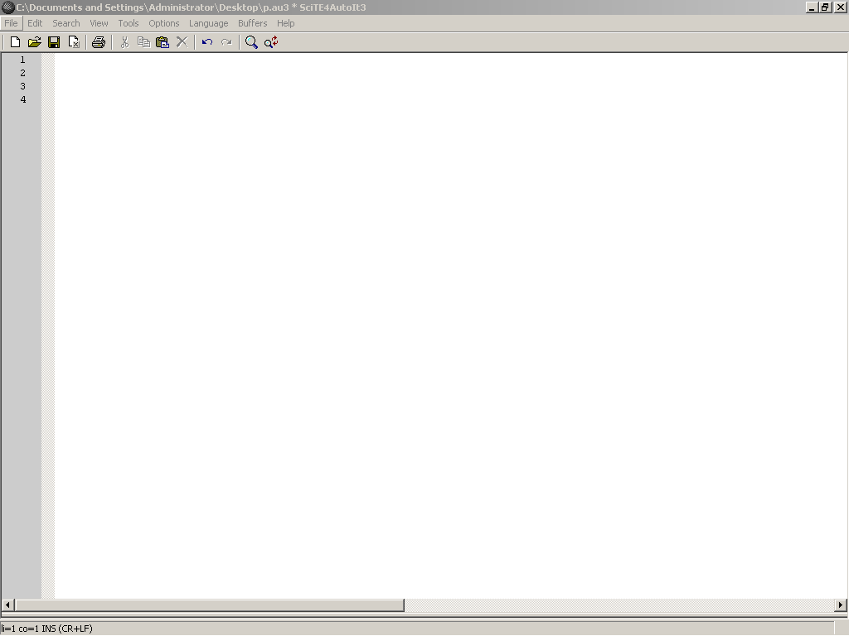

Figure 5.1 Autoit Main Window

5.3 Commands are use in this Project

5.3.1 Run

Runs an external program.
Run ( "filename" [, "workingdir" [, flag[, standard_i/o_flag]]] )

filename | The name of the executable (EXE, BAT, COM, or PIF) to run.
workingdir | [optional] The working directory.
flag | [optional] The "show" flag of the executed program:  @SW_HIDE = Hidden window  @SW_MINIMIZE = Minimized window  @SW_MAXIMIZE = Maximized window
standard_i/o_flag | [optional] Provide a meaningful handle to one or more STD I/O streams of the child process.  1 ($STDIN_CHILD) = Provide a handle to the child's STDIN stream  2 ($STDOUT_CHILD) = Provide a handle to the child's STDOUT stream  4 ($STDERR_CHILD) = Provide a handle to the child's STDERR stream
Table5.1 Parameter of Run Command

Success: | The PID of the process that was launched.
Failure: | Depends on RunErrorsFatal; see Remarks
Table 5.2 Return Value of Run Command

5.3.2 Send

Sends simulated keystrokes to the active window.
Send ( "keys" [, flag] )

keys | The sequence of keys to send.
flag | [optional] Changes how "keys" is processed:  flag = 0 (default), Text contains special characters like + and ! to indicate SHIFT and ALT key-presses.  flag = 1, keys are sent raw.
Table 5.3 Parameter of Send Command

5.3.3 Shutdown

Shuts down the system.
Shutdown ( code )
Return Value
Success: | Returns 1.
Failure: | Returns 0.
Table 5.4 Return Value of shutdown Command
Remarks
The shutdown code is a combination of the following values:
0 = Logoff
1 = Shutdown
2 = Reboot
4 = Force
8 = Power down
32= Standby
64= Hibernate

5.3.4 WinActive

Checks to see if a specified window exists and is currently active
WinActive ( "title" [, "text"] )

title | The title of the window to check. See Title special definition.
text | [optional] The text of the window to check.

Table 5.5 Parameter of WinActive Command

Success: | Returns 1 if window is active.
Failure: | Returns 0 otherwise.

Table 5.6 Parameter of WinActive Command

5.4 Function keyboard

Send Command (if zero flag) | Resulting Keypress
{!} | !
{#} | #
{+} | +
{^} | ^
{{} | {
{}} | }
{SPACE} | SPACE
{ENTER} | ENTER key on the main keyboard
{ALT} | ALT
{BACKSPACE} or {BS} | BACKSPACE
{DELETE} or {DEL} | DELETE
{UP} | Up arrow
{DOWN} | Down arrow
{LEFT} | Left arrow
{RIGHT} | Right arrow
{HOME} | HOME
{END} | END
{ESCAPE} or {ESC} | ESCAPE
{INSERT} or {INS} | INS
{PGUP} | PageUp
{PGDN} | PageDown
{F1} - {F12} | Function keys
{TAB} | TAB
{PRINTSCREEN} | Print Screen key
{LWIN} | Left Windows key
{RWIN} | Right Windows key
{NUMLOCK on} | NUMLOCK (on/off/toggle)
{CAPSLOCK off} | CAPSLOCK (on/off/toggle)
{SCROLLLOCK toggle} | SCROLLLOCK (on/off/toggle)
{BREAK} | for Ctrl+Break processing
{PAUSE} | PAUSE
{NUMPAD0} - {NUMPAD9} | Numpad digits
{NUMPADMULT} | Numpad Multiply
{NUMPADADD} | Numpad Add
{NUMPADSUB} | Numpad Subtract
{NUMPADDIV} | Numpad Divide
{NUMPADDOT} | Numpad period
{NUMPADENTER} | Enter key on the numpad
{APPSKEY} | Windows App key
{LALT} | Left ALT key
{RALT} | Right ALT key
{LCTRL} | Left CTRL key
{RCTRL} | Right CTRL key
{LSHIFT} | Left Shift key
{RSHIFT} | Right Shift key
{SLEEP} | Computer SLEEP key
{ALTDOWN} | Holds the ALT key down until {ALTUP} is sent
{SHIFTDOWN} | Holds the SHIFT key down until {SHIFTUP} is sent
{CTRLDOWN} | Holds the CTRL key down until {CTRLUP} is sent
{LWINDOWN} | Holds the left Windows key down until {LWINUP} is sent
{RWINDOWN} | Holds the right Windows key down until {RWINUP} is sent
{ASC nnnn} | Send the ALT+nnnn key combination
{BROWSER_BACK} | 2000/XP Only: Select the browser "back" button
{BROWSER_FORWARD} | 2000/XP Only: Select the browser "forward" button
{BROWSER_REFRESH} | 2000/XP Only: Select the browser "refresh" button
{BROWSER_STOP} | 2000/XP Only: Select the browser "stop" button
{BROWSER_SEARCH} | 2000/XP Only: Select the browser "search" button
{BROWSER_FAVORITES} | 2000/XP Only: Select the browser "favorites" button
{BROWSER_HOME} | 2000/XP Only: Launch the browser and go to the home page
{VOLUME_MUTE} | 2000/XP Only: Mute the volume
{VOLUME_DOWN} | 2000/XP Only: Reduce the volume
{VOLUME_UP} | 2000/XP Only: Increase the volume
{MEDIA_NEXT} | 2000/XP Only: Select next track in media player
{MEDIA_PREV} | 2000/XP Only: Select previous track in media player
{MEDIA_STOP} | 2000/XP Only: Stop media player
{MEDIA_PLAY_PAUSE} | 2000/XP Only: Play/pause media player
{LAUNCH_MAIL} | 2000/XP Only: Launch the email application
{LAUNCH_MEDIA} | 2000/XP Only: Launch media player
{LAUNCH_APP1} | 2000/XP Only: Launch user app1
{LAUNCH_APP2} | 2000/XP Only: Launch user app2

Table 5.7 special keys can be sent and should be enclosed in braces

5.5 Compiling Scripts with Aut2Exe
It is possible to take your .au3 script and compile it into a standalone executable; this executable can be used without the need for AutoIt to be installed and without the need to have AutoIt3.exe on the machine. In addition, the compiled script is compressed and encrypted and there is the option to bind additional files (also compressed/encrypted) to the exe using the FileInstall function. Also, any #include files will also be compiled into the script so they are not required at run-time.
Caution: the script to be compiled must be free of syntax error as the compilation will not check the syntax.
Aut2Exe can be used in three ways:

5.5.1 Method 1 - Start Menu
Only available if full install performed.
1. Open the Start Menu and browse to the AutoIt v3 group.
2. Click Script Compiler \ Convert .au3 to .exe
3. The main Aut2Exe interface should appear.
4. Use the Browse buttons to select your input (.au3) and output (.exe) files.
5. If you like you can change the icon of the resulting .exe - just browse to the icon you want (some example icons are supplied in Program Files\AutoIt3\Aut2Exe\Icons).

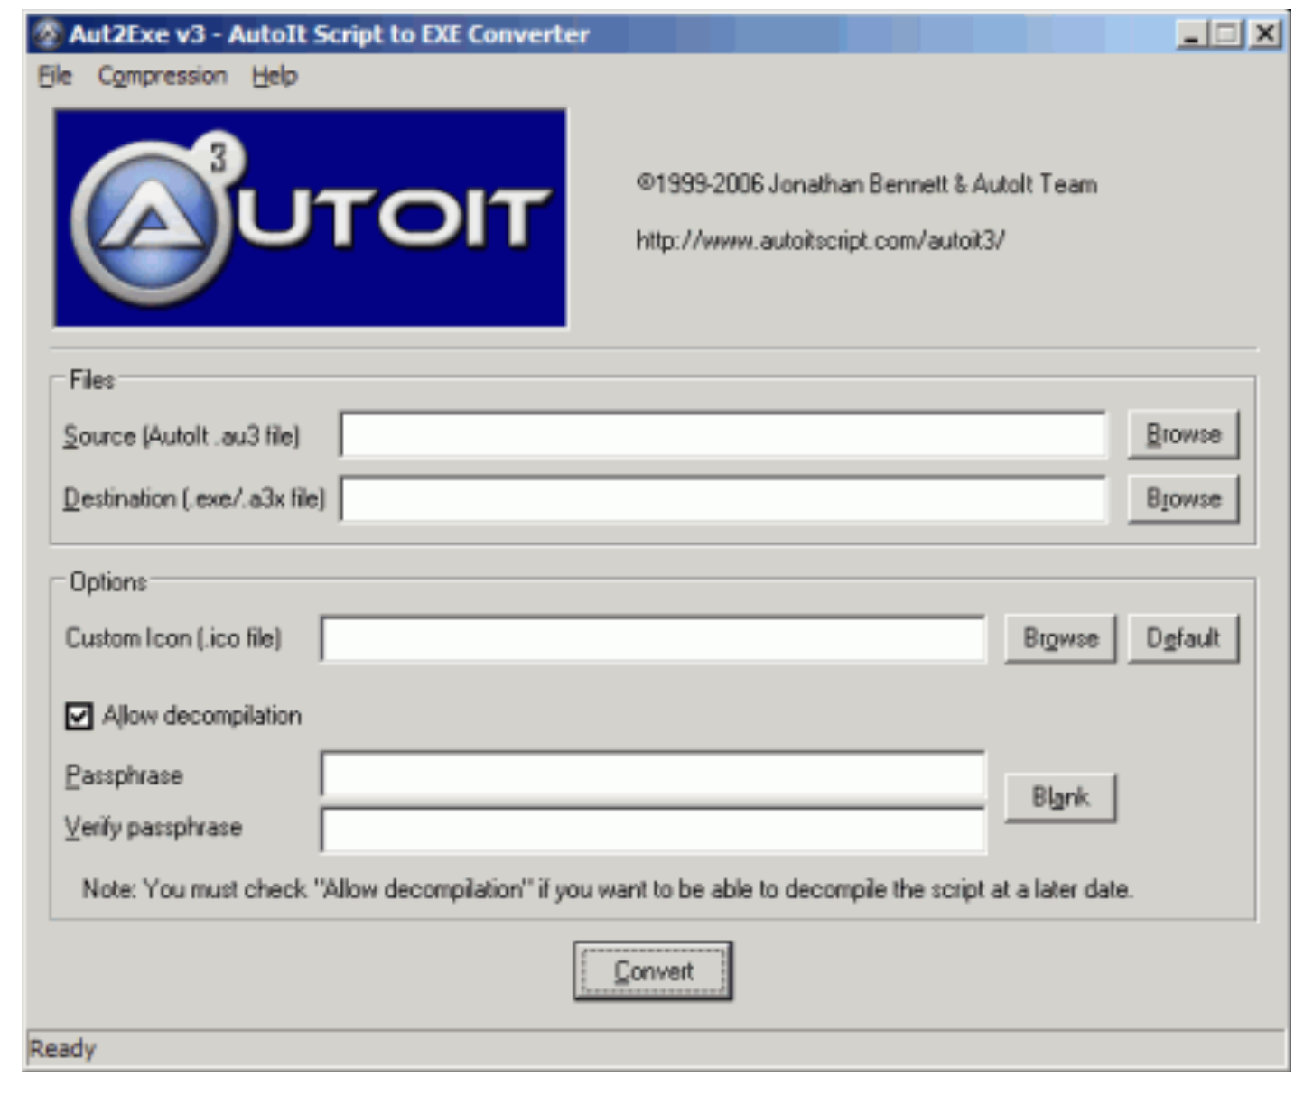
Figure 5.2 Aut2Exe window
6. If you don't want anyone to be able to decompile your script (when a decompiler is made available) then you should enter a passphrase
7. The only other option you might wish to change is the compression level (especially if using FileInstall to add extra files). Use the Compression menu to set this. As with all compression routines the better the compression you select the slower it will be. However, no matter what compression level you select the decompression speed (when the .exe is run) is the same.
8. Click on Convert to compile the script.
Note: scripts can be compile with .a3x extension. They should be run with AutoIt.exe filename.a3x. The .a3x contains the script itself with all referred #include plus the FileInstall files. This format allow to distribute smaller files as they don't include the AutoIt3.exe in each compile script. You still need to have it accessible on the target machine but just AutoIt3.exe.

5.5.2 Method 2 - Right Click
Only available if full install performed.
1. In Explorer browse to the .au3 file that you wish to compile.
2. Right-click the file to access the pop-up menu.
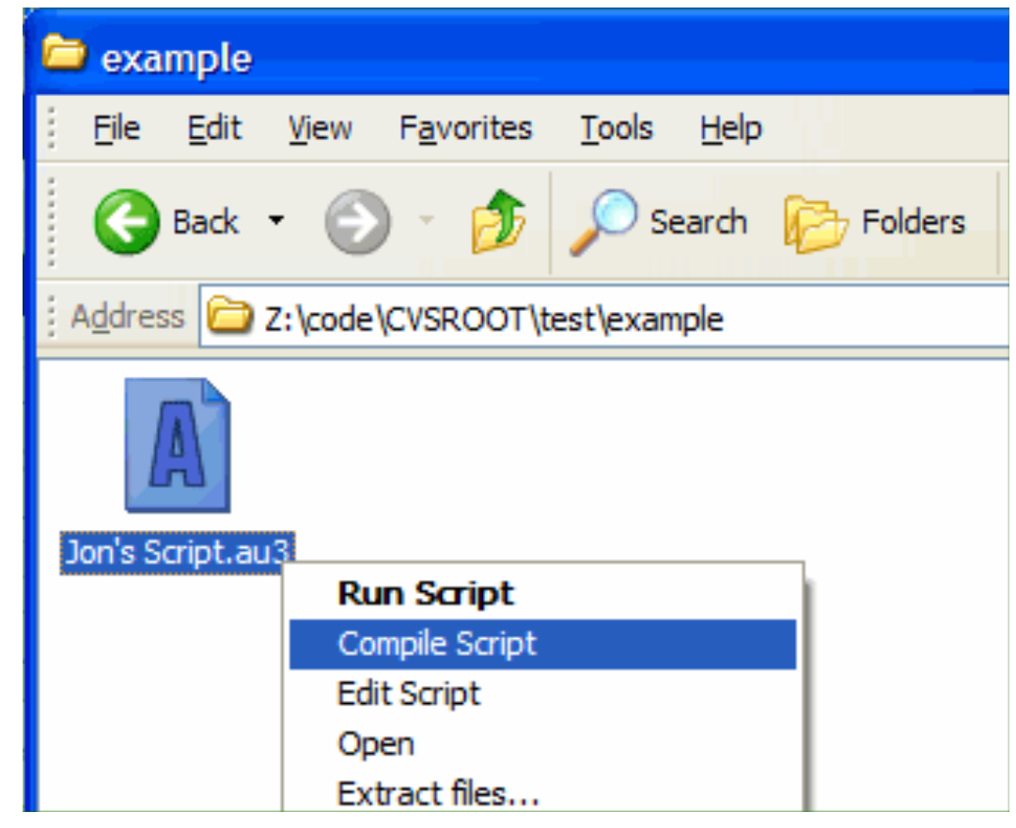

Fegure 5.3 Right Click

3. The file will be silently compiled with the same filename - just with a .exe extension.
When compiling in this way, Aut2Exe uses current icon/compression settings (from the last time Aut2Exe was run manually as in method 1).

5.5.3 Method 3 - The Command Line.
The Aut2Exe.exe program can be run from the command line as follows:
Aut2exe.exe /in <infile.au3> [/out <outfile.exe>] [/icon <iconfile.ico>] [/nodecompile] [/comp 0-4] [/pass <passphrase>] [/nopack] [/ansi] [/unicode]
Long filenames should be enclosed in double-quotes like "C:\Program Files\Test\test.au3". If no "out" file is given the input filename is used with a .exe extension.

5.6 AutoIt Window Information Tool
AutoIt v3 comes with a standalone tool called the AutoIt Window Info Tool (Program Files\AutoIt3\AU3Info.exe). AU3Info allows you to get information from a specified window that can be used to effectively automate it. Information that can be obtained includes:
- Window titles
- Text on the window (visible and hidden)
- Window size and position
- Contents of the status bar
- Position of the mouse pointer
- Colour of the pixels underneath the mouse pointer
- Details of the Control underneath the mouse pointer
To use AU3Info just run it (from the command line or Start menu). AU3Info will remain the top most window at all times so that you can read it. Once active move to the window you are interested in and activate it - the contents of AU3Info will change to show the information that is available. With the help of AU3Info you should be automating in no time!
When AU3Info is running you may want to copy text directly from it using CTRL-C and then paste it into your script to avoid spelling/case errors. For the tabs that have information in a list view (like the control information shown below) just double-click on an entry to copy it to the clipboard. This can be difficult when you want to capture pixel/mouse information as it keeps changing! To help with this you can "freeze" the output of AU3Info by pressing CTRL-ALT-F. Press the keys again to "unfreeze".
Here is an example of AU3Info in use with the Windows "WordPad" editor
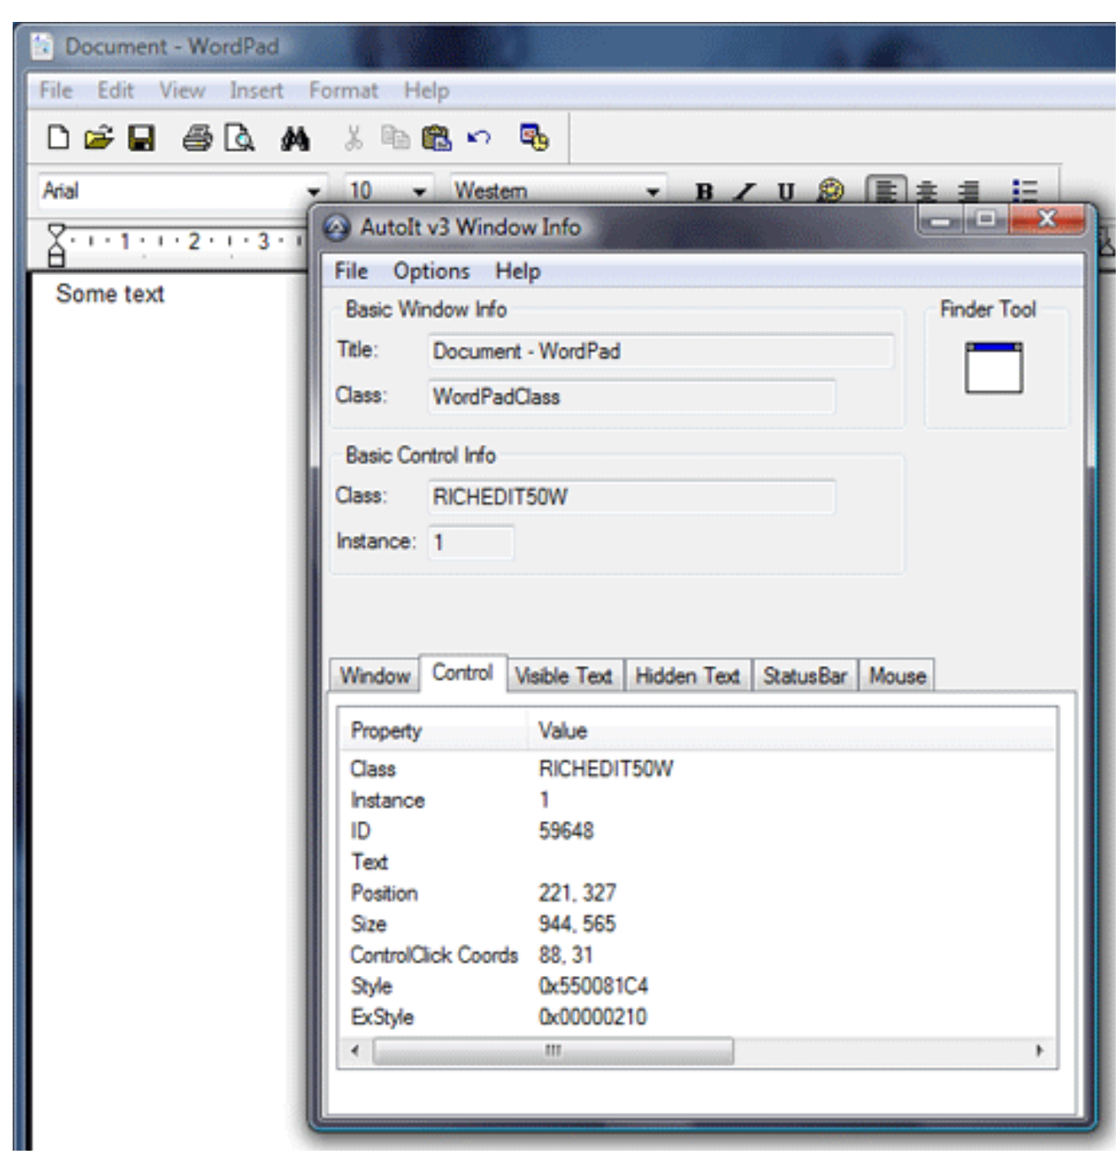
Figure 5.4 AutoIt Window Information Tool

Appendix

PROJECT CODE

Speech into Mirophone
Record speecg by MATLAB Command
Convert Speech to Vector
Add Execute Command
DataBase
Speech into Microphone
Convert Speech to Vector
Convert to Matrx
Comparative
Command 1
Command 2

Command n
Eexecute Command
IF
Start
Save Command
Recognition Command
End
Convert to Matrx

This is the code part of "speechrecognition.m":

function varargout = untitled(varargin)
gui_Singleton = 1;
gui_State = struct('gui_Name', mfilename, ...
'gui_Singleton', gui_Singleton, ...
'gui_OpeningFcn', @untitled_OpeningFcn, ...
'gui_OutputFcn', @untitled_OutputFcn, ...
'gui_LayoutFcn', [],...
'gui_Callback', []);
if nargin && ischar(varargin{1})
gui_State.gui_Callback = str2func(varargin{1});
end

if nargout
[varargout{1:nargout}] = gui_mainfcn(gui_State, varargin{:});
else
gui_mainfcn(gui_State, varargin{:});
end

% End initialization code - DO NOT EDIT
% --- Executes just before untitled is made visible.
function untitled_OpeningFcn(hObject, eventdata, handles, varargin)
{
clc;
}
% This function has no output args, see OutputFcn.
% hObject handle to figure
% eventdata reserved - to be defined in a future version of MATLAB
% handles structure with handles and user data (see GUIDATA)
% varargin command line arguments to untitled (see VARARGIN)
% Choose default command line output for untitled
handles.output = hObject;
% Update handles structure
guidata(hObject, handles);
% UIWAIT makes untitled wait for user response (see UIRESUME)
% uiwait(handles.figure1);
% --- Outputs from this function are returned to the command line.
function varargout = untitled_OutputFcn(hObject, eventdata, handles)
clc;
varargout{1} = handles.output;

%--------------------------------------------------------------------------
%--------------------------------------------------------------------------
%--------------------------------------------------------------------------
% --- Executes on button press in Add a new sound to data base.

function add_Callback(hObject, eventdata, handles)
clc; %Clear Command Window.

if (exist('sound_database.dat')==2) %test database if exist.

load('sound_database.dat','-mat');
%Load workspace database from disk.
classe=data{sound_number,2};
% copy contain data_index to variable class.
message=('The following parameters will be used during recording:');
disp(message); %Display text or array.
message=strcat('Sampling frequency = ', num2str(samplingfrequency));
disp(message);
message=strcat('Bits per sample = ',' ' ,num2str(samplingbits));
%String concatenation.

disp(message);
durata=2;
disp(message);
micrecorder = audiorecorder(samplingfrequency,samplingbits,1);
%Create an audio recorder object.
classe=input('Enter the coomand to be add : ', 's');
%Request user input.
start = input('Press Enter then Start speak into microphone...');
record(micrecorder,durata);
%Record data and event information to a file.
lock=0; %Variable to Discover the Operation failed.

while (isrecording(micrecorder)==1)
%Indicates the status of recording.

disp('Recording...');
pause(0.5); %Halt execution temporarily.
if lock==6
button = questdlg('Sorry Recording Operation failed ,MATLAB is Restart Now', ...
'Exit Dialog','Yes','yes');
%Create and display question dialog box.
winopen('restart_matlab.exe')
%Open file in appropriate application.
end

lock=lock+1;
end

disp('Recording stopped.');
y = getaudiodata(micrecorder, 'uint8');
%Return the recorded audio data to the y variable.
sound_number = sound_number+1; %to access index database.
data{sound_number,1} = y;
data{sound_number,2} = classe;
data{sound_number,3} = datestr(now);
%Return the current date and time in a string using the default
%format.
data{sound_number,4} = 'Microphone';
save('sound_database.dat','data','sound_number','-append');
%Save data on database.
msgbox('Sound added to database','Database result','help');
%Display message box.
disp('Sound added to database');
else
durata = 2; %set variable.
samplingfrequency = 22050;
samplingbits =8;
message=('The following parameters will be used during recording:');
disp(message);
message=strcat('Sampling frequency = ', num2str(samplingfrequency));
disp(message); %Display text or array.
message=strcat('Bits per sample = ',' ' ,num2str(samplingbits));
%String concatenation.
disp(message);
classe=input('Enter the coomand to be add : ', 's');
start = input('Press Enter then Start speak into microphone...');
micrecorder = audiorecorder(samplingfrequency,samplingbits,1);
record(micrecorder,durata);
lock=0; %Variable to Discover the Operation failed.
while (isrecording(micrecorder)==1)
%Indicates the status of recording.
disp('Recording...'); %Display text or array.
pause(0.5); %Halt execution temporarily.
if lock==6
button = questdlg('Sorry Recording Operation failed ,MATLAB is Restart Now', ...
'Exit Dialog','Yes','yes');
winopen('restart_matlab.exe')
%Open file in appropriate application.
end

lock=lock+1; %Variable to Discover the Operation failed.
end

lock=0;
disp('Recording stopped.');
y = getaudiodata(micrecorder, 'uint8');
%Return the recorded audio data to the y variable.
sound_number = 1;
data{sound_number,1} = y; %set on database.
data{sound_number,2} = classe;
data{sound_number,3} = datestr(now);
%Return the current date and time in a string using the default
%format.
data{sound_number,4} = 'Microphone';
save('sound_database.dat','data','sound_number','samplingfrequency','samplingbits');
%save variable on data base.
msgbox('Sound added to database','Database result','help');
disp('Sound added to database'); %Display text or array.
end

%--------------------------------------------------------------------------
%--------------------------------------------------------------------------
%--------------------------------------------------------------------------
% ------------------------Executes on button press in Database Info.

function info_Callback(hObject, eventdata, handles)
clc; %Clear Command Window.
If (exist('sound_database.dat')= =2) %test database if exist.
start = input('Press Enter to show Database ...');
%Request user input.
load('sound_database.dat','-mat');
%Load workspace database from disk.
message=strcat('Database has #',num2str(sound_number),'words:');
%String concatenation.
disp(message); %Display text or array.
disp(' ');
for ii=1:sound_number %view contain database.
message=strcat('Command : ',num2str(ii),'- ' ,data{ii,2},' AT the =' , data{ii,3});
%String concatenation.
disp(message); %Display text or array.
end

else
warndlg('Database is empty.',' Warning ')
end

%--------------------------------------------------------------------------
%--------------------------------------------------------------------------
%--------------------------------------------------------------------------
% ----------------------- Executes on button press in Start Execute.

function start_Callback(hObject, eventdata, handles)
clc; %Clear Command Window.
if (exist('sound_database.dat')= =2) %test database if exist.
load('sound_database.dat','-mat');
%Load workspace database from disk.
Fs = samplingfrequency; %set vaerable.
durata = 2;
start = input('Press Enter then Start speak into microphone...');
%Request user input.
micrecorder = audiorecorder(samplingfrequency,samplingbits,1);
%Create an audio recorder object.
disp('Now, speak into microphone...'); %Display text or array.
record(micrecorder,durata);
%Record data and event information to a file.
lock=0; %Variable to Discover the Operation failed.
while (isrecording(micrecorder)==1)
%Indicates the status of recording.
disp('Recording...'); %Display text or array.
pause(0.5); %Halt execution temporarily.
if lock==6
button = questdlg('Sorry Recording Operation failed ,MATLAB is Restart Now', ...
'Exit Dialog','Yes','yes');
winopen('restart_matlab.exe')
%Open file in appropriate application.
end

lock=lock+1; %Display text or array.
end

disp('Recording stopped.');
y = getaudiodata(micrecorder, 'uint8');
%Return the recorded audio data to the y variable.
%----- code for speech recognition -------
.
disp('Database scanning...'); %Display text or array.
for ii=1:sound_number
SM = corrcoef (data{ii,1},y);
vettore_pesi(ii) = SM(1,2); %store final element in vector.
disp('Database scanning...'); %Display text or array.
speech_id ='not';

end

[max_value,max_index] = max(vettore_pesi);
%detrment the value and index for minmum in the vector.
speech_id = data{max_index,2};
%-----------------------------------------

message = strcat('Recognized speech ID: ',num2str(speech_id));
%String concatenation.
disp(message); %Display text or array.
winopen(strcat(speech_id,'.exe'));
%Open file in appropriate application.
else
warndlg('Database is empty. No matching is possible.',' Warning ')
%Display warning dialog box.
end

%--------------------------------------------------------------------------
%--------------------------------------------------------------------------
%--------------------------------------------------------------------------
% --- Executes on button press in Exit.
function exit_Callback(hObject, eventdata, handles)
button = questdlg('Do you really want to exit program?', ...
'Exit Dialog','Yes','No','No');
%Create and display question dialog box.
if strcmp(button,'Yes') %Compare strings.
exit; %Terminate MATLAB (same as quit).
end

%--------------------------------------------------------------------------
%--------------------------------------------------------------------------
%--------------------------------------------------------------------------
% --- Executes on button press in Delete some command.
function delate_Callback(hObject, eventdata, handles)
clc; %Clear Command Window.
if (exist('sound_database.dat')==2) %test database if exist.
button = questdlg('Do you really want to remove the Database?', ...
'Exit Dialog','Yes','No','No');
if strcmp(button,'Yes') %Compare strings.
delete('C:\MATLAB7\work\sound_database.dat')
%Delete files or graphics objects.
msgbox('Database was succesfully removed from the current directory.','Database removed','help');
%Display message box.

end

else
warndlg('Database is empty.',' Warning ')
%Display warning dialog box.
end

%--------------------------------------------------------------------------
%--------------------------------------------------------------------------
%--------------------------------------------------------------------------
% -------------------------------- Executes on button press in Defult.

function defult_Callback(hObject, eventdata, handles)
button= questdlg('Do you really want to load defult file?', ...
'Exit Dialog','Yes','No','No');
%Create and display question dialog box.
if strcmp(button,'Yes') %Compare strings.
winopen('defult.bat')
%Open file in appropriate application.
msgbox('Database was succesfully load defult file','load defult','help');
%Display message box.
end

%--------------------------------------------------------------------------
%--------------------------------------------------------------------------
%--------------------------------------------------------------------------
% --------------------------------- Executes on button press in Print.

function print_Callback(hObject, eventdata, handles)
clc; %Clear Command Window.
if (exist('sound_database.dat')==2)
%test database if exist.
start = input('Press Enter to print Database ...');
%Request user input.
load('sound_database.dat','-mat');
%Load workspace database from disk.
message=strcat('Database has #',num2str(sound_number),'words:');
%String concatenation.
disp(message); %Display text or array.
disp(' '); %Display text or array.
for ii=1:sound_number %view contain database.
message=strcat('Command : ',num2str(ii),'- ' ,data{ii,2},' AT the =' , data{ii,3});
%String concatenation.
disp(message); %Display text or array.

end

winopen('print'); %Open file in appropriate application.
else
warndlg('Database is empty.',' Warning ')
%Display warning dialog box.
end

%--------------------------------------------------------------------------
%--------------------------------------------------------------------------
%--------------------------------------------------------------------------
% --------------- Executes on button press in Listen Stord Speech.
function listn_Callback(hObject, eventdata, handles)
clc; %Clear Command Window.
if (exist('sound_database.dat')==2)
%test database if exist.
load('sound_database.dat','-mat');
%Load workspace database from disk.
message=strcat('Database has #',num2str(sound_number),'words:');
%String concatenation.
disp(message); %Display text or array.
disp(' '); %Display text or array.
for ii=1:sound_number %view contain database.
message=strcat('Command : ',num2str(ii),'- ' ,data{ii,2});
%String concatenation.
disp(message); %Display text or array.
end

temp1=input('Enter the number command to be listen = ');
%Request user input.
wavplay(data{temp1,1},20550)
%Play recorded sound on a PC-based audio output device.
else
warndlg('Database is empty.',' Warning ')
%Display warning dialog box.
end

%--------------------------------------------------------------------------
%--------------------------------------------------------------------------
%--------------------------------------------------------------------------
% ------------ Executes on button press in Delete some command.

function deletecommand_Callback(hObject, eventdata, handles)
clc; %Clear Command Window.
if (exist('sound_database.dat')==2)
%test database if exist.
load('sound_database.dat','-mat');
%Load workspace database from disk.
message=strcat('Database has #',num2str(sound_number),'words:');
%String concatenation.
disp(message); %Display text or array.
disp(' '); %Display text or array.
for ii=1:sound_number %view contain database.
message=strcat('Command : ',num2str(ii),'- ' ,data{ii,2});
%String concatenation.
disp(message);
%Display text or array.
end

temp2=input('Enter the number command to be Delete = ');
%Request user input.
data(temp2,:) = []; %Delete in database.
sound_number=sound_number-1;
save('sound_database.dat','data','sound_number','-append');
%save variable in database.
disp('Data base become :'); %Display text or array.
for ii=1:sound_number %view contain database.
message=strcat('Command : ',num2str(ii),'- ' ,data{ii,2});
%String concatenation.
disp(message); %Display text or array.
end

else
warndlg('Database is empty.',' Warning ')
%Display warning dialog box.
end

%--------------------------------------------------------------------------
%--------------------------------------------------------------------------
%--------------------------------------------------------------------------
% --- Executes on mouse press over figure background, over a disabled or
% --------------------------- inactive control, or over an axes background.
function figure1_WindowButtonDownFcn(hObject, eventdata, handles

%--------------------------------------------------------------------------
%--------------------------------------------------------------------------
%--------------------------------------------------------------------------
% --- Executes on button press in Restart.

function Restart_Callback(hObject, eventdata, handles)
winopen('restart_matlab.exe')
%Open file in appropriate application.

%--------------------------------------------------------------------------
%--------------------------------------------------------------------------
%--------------------------------------------------------------------------
% ---------------------------- Executes on button press in Backup Database.

function backup_Callback(hObject, eventdata, handles)
if (exist('sound_database.dat')==2)
%test database if exist.
winopen('backup.bat');
%Open file in appropriate application.
msgbox('Backup Database to desktop ','Backup Database','help');
%Display message box.
else
warndlg('Database is empty.',' Warning ');
%Open file in appropriate application.
end

%--------------------------------------------------------------------------
%--------------------------------------------------------------------------
%--------------------------------------------------------------------------
% ------------------------------------------------ creat a new sound files.

function files_Callback(hObject, eventdata, handles)
clc; %Clear Command Window.
button = questdlg('What is the Type File', ...
'Type File','.WAV','.AU','.WAV');
%Create and display question dialog box.
micrecorder = audiorecorder(22050,8,1);
%Create an audio recorder object.
start = input('Press Enter then Start speak into microphone...');
%Request user input.
record(micrecorder,2);
%Record data and event information to a file.
lock=0; %Variable to Discover the Operation failed.
while (isrecording(micrecorder)==1)
%Indicates the status of recording.
disp('Recording...'); %Display text or array.
pause(0.5); %Halt execution temporarily.
if lock==6
button = questdlg('Sorry Recording Operation failed ,MATLAB is Restart Now', ...
'Exit Dialog','Yes','yes');
%Create and display question dialog box.
winopen('restart_matlab.exe')
%Open file in appropriate application.
end

lock=lock+1;
end

lock=0; %Variable to Discover the Operation failed.
disp('Recording stopped.'); %Display text or array.
y = getaudiodata(micrecorder);
%Return the recorded audio data to the y variable.
path='C:\MATLAB7\work\audio_fils\'; %set path for saving folder.
path_name='C:\MATLAB7\work\audio_files\';
if button=='.WAV' %determent type sound file.
wavwrite(y,22050,8,strcat(path_name,input('Please Enter the File Name : ','s')))
%Write a Microsoft WAVE (.wav) sound file.
else
auwrite(y,22050,8,strcat(path_name,input('Please Enter the File Name : ','s'))
%Write NeXT/SUN (.au) sound file.
end

%--------------------------------------------------------------------------
%--------------------------------------------------------------------------
%--------------------------------------------------------------------------

Code part of " Close.au3" :

Send("!{Tab}") ;Sends simulated keystrokes to the active window.
Send("!{F4}") ;Sends simulated keystrokes to the active window.

-----------------------------------------------------------------------------------------

Code part of " Excel .au3" :

run("C:\Program Files\Microsoft Office\OFFICE11\EXCEL.EXE") ;Runs an external program.
-----------------------------------------------------------------------------------------

Code part of " Log off.au3" :

Shutdown ( 0 ) ;Shuts down the system.

-----------------------------------------------------------------------------------------

Code part of " Powerpnt.au3" :

run("C:\Program Files\Microsoft Office\OFFICE11\POWERPNT.EXE") ;Runs an external program.

-----------------------------------------------------------------------------------------

Code part of " Solitaire.au3" :

run("c:\windows\system32\sol.exe") ;Runs an external program.

-----------------------------------------------------------------------------------------

Code part of " Calculator.au3" :

run("calc.exe") ;Runs an external program.

-----------------------------------------------------------------------------------------

Code part of " control panel.au3" :

run("control") ;Runs an external program.

-----------------------------------------------------------------------------------------

Code part of " Internet.au3" :

run("C:\Program Files\Internet Explorer\IEXPLORE.EXE") ;Runs an external program.

-----------------------------------------------------------------------------------------

Code part of " Media Player.au3" :

run("C:\Program Files\Windows Media Player\wmplayer.exe") ;Runs an external program.

-----------------------------------------------------------------------------------------

Code part of " paint.au3" :

run("mspaint.exe") ;Runs an external program.

-----------------------------------------------------------------------------------------

Code part of " shutdown.au3" :

Shutdown(5) ;Shuts down the system.

-----------------------------------------------------------------------------------------

Code part of " WINWORD.au3" :

run('C:\Program Files\Microsoft Office\OFFICE11\WINWORD.exe') ;Runs an external program.

-----------------------------------------------------------------------------------------

Code part of " Computer.au3" :

Run("explorer.exe /root, ,::{20D04FE0-3AEA-1069-A2D8-08002B30309D}") ;Runs an external program.

-----------------------------------------------------------------------------------------

Code part of " help.au3" :

send("{F1}") ;Sends simulated keystrokes to the active window.

-----------------------------------------------------------------------------------------

Code part of " Matlap.au3 " :

Run("MATLAB.exe") ;Runs an external program.

-----------------------------------------------------------------------------------------

Code part of " not_bad.au3 ":

Run("Notepad.exe") ;Runs an external program.

-----------------------------------------------------------------------------------------

Code part of " Restart.au3" :

Shutdown(6) ;Shuts down the system.

-----------------------------------------------------------------------------------------

Code part of " Start.au3" :

Send("^{ESC}") ;Sends simulated keystrokes to the active window.

-----------------------------------------------------------------------------------------

Conclusion

In the last, we want to say that we give advertising system by dictation that able to show online what you speech, and now you can to vacate the place of typing operators from your work.

As we see, to implement any system you must start with system needs and demands. Analyze these demands and begin step by step to give a suggested design leading you to a final one. This data flow lastly gives you a ready to implement optimized system.

Connecting our program with database gives a flexibility of returning any data that entered in any date, and show it again.

Choosing of software is not to select last version and very high level complex one when not needed. You must choose what suitable programs to the designed project and easy to implement on the other hand; easy to use by users which are governed with their hardware and software equipments.

References

- Fundamentals of Speech Recognition. L. Rabiner & B.Juang.1930.

- AutoIt Help Documentation.

- How to build a speech Recognition Application. B. Balentine, D.Morgan, and W.Meisel. 1999.

- MATLAB Help documentation.

- http://www.neurosolutions.com/products/ns/whatisnn.html

- http://www.education.uiowa.edu/icater/at_glossary.htm#V

- http://www.doc.ic.ac.uk/~nd/surprise_96/journal/vol4/cs11/report.html

- http://www.speechtechnology.com

- http://voicerecognition. com

- http://home.iae.nl/users/pouweha/lcd/lcd.shtml

