# *Chapter one:

## Classifications of loads for Nablus city :

The table below shows the classifications of load sectors:

|  |  |
| --- | --- |
| 47% | Residential |
| 25% | Industrial |
| 13% | Commercial |
| 15% | Others |

and as a sector:

And daily load curve for one transformer in ASKAR :

*Elements Of Askar Network :

Askar network consists many parts as substation(east substation) , power transformer, switch gear, cables and transmission lines, transformers, and loads connected to it.

1.1- East substation : it takes 33 kv from connection point but the problem it has wide range from 33kv to 29 kv in different cases as minimum and maximum load.

1.2- Power transformer: it is 33kv/6.6kv (Δ/Υ) , 10MVA.

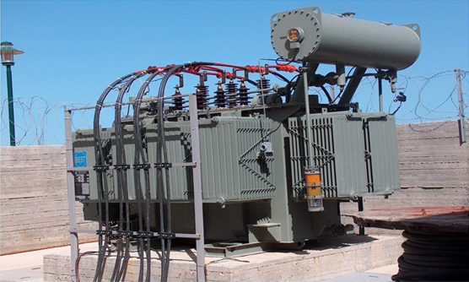

1.3- Cables and transmission lines: Askar substation consists two types of transmissions ACSR (over head transmission) and XLPE (Underground transmission).

XLPE = 120 mm2 and it has R= 0.325 ohm/km and X= 0.124 ohm/km. I rated= 335A

ACSR = 95/15 mm2 and it has R= 0.37 ohm/km and X= 0.279 ohm/km. I rated= 359A

50/8 mm2 and it has R= 0.66 ohm/km and X= 0.297 ohm/km. I rated= 257A

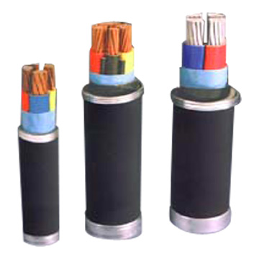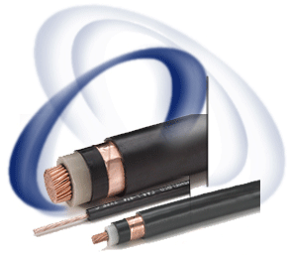

1.4- distribution transformers: we have 59 transformers .

divided in two levels: the first 33kv / 0.4 kv (Δ/Υ) , second 6.6kv/0.4 kv (Δ/Υ) there are 14 transformers 33kv / 0.4 kv (Δ/Υ) and the other 6.6kv/0.4 kv (Δ/Υ)

|  |  |
| --- | --- |
| Capacity (KVA) | Number |
| 630 | **21** |
| 400 | **20** |
| 250 | **9** |
| 1000 | **3** |
| 160 | **2** |
| 1600 | **1** |
| 300 | **1** |
| 150 | **1** |
| 160 | **1** |

**Total=59 transformers**

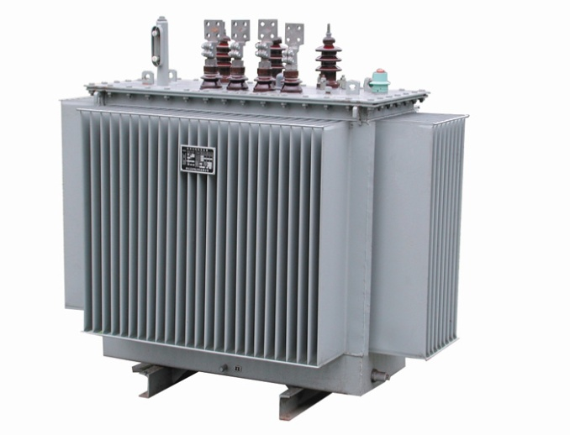

**ASKAR NEWORK**

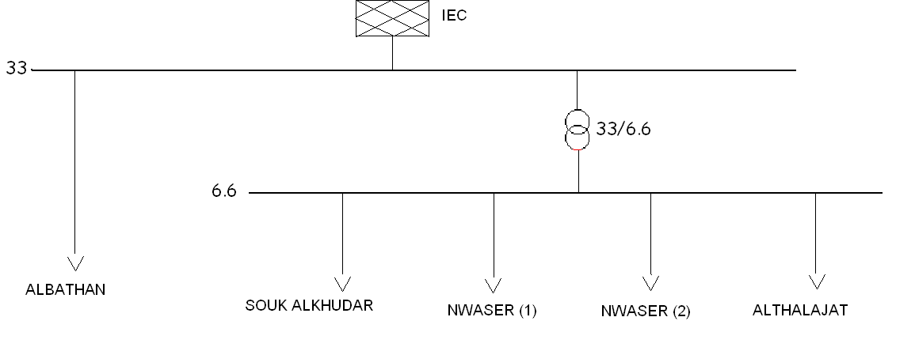

### 1.5- loads connected to Askar substation:

We divided it to 6 types : industrial, commercial, residential, industrial and residential, commercial and residential, commercial residential and industrial. As the table below:

|  |  |
| --- | --- |
| Types | Number of transformers |
| Industrial | **35** |
| Residential | **10** |
| Commercial | **0** |
| Industrial + Residential | **6** |
| Commercial + Residential | **2** |
| All types | **6** |
|  |  |
|  |  |

**Total=59transformers**

### 1.6- Some types of transformers:

We use many types of transformers in our project according to its real impedance taken from name plates of the transformers as below:

|  |  |  |  |
| --- | --- | --- | --- |
| Impedance (%) | Voltage level | Capacity(KVA) | Types |
| 5.07 | 6.6-0.4 | 250 | ARDAN |
| 4.07 | 6.6-0.4 | 400 |  |
| 4.05 | 6.6-0.4 | 630 |  |
| 4.37 | 6.6-0.4 | 250 | ELCO |
| 4.2 | 6.6-0.4 | 400 |  |
| 4.07 | 6.6-0.4 | 630 |  |
| 4.06 | 6.6-0.4 | 250 | TRAVO |
| 4.38 | 33-0.4 | 630 | IMEFY |
| 4.16 | 33-0.4 | 400 |  |
| 4.28 | 33-0.4 | 250 |  |

*Chapter two:

## 2.1Analysis of Askar network using ETAP program.

We use this program to make iterations using one types of mathematical methods to solve one line diagram to find the values wanted to evaluate and improve this network as : voltages, currents, powers and reactive powers, voltages drop , power factors and number of taps for transformers…………..etc.

**And below shows part of our project before and after analysis:**

**Before analysis**

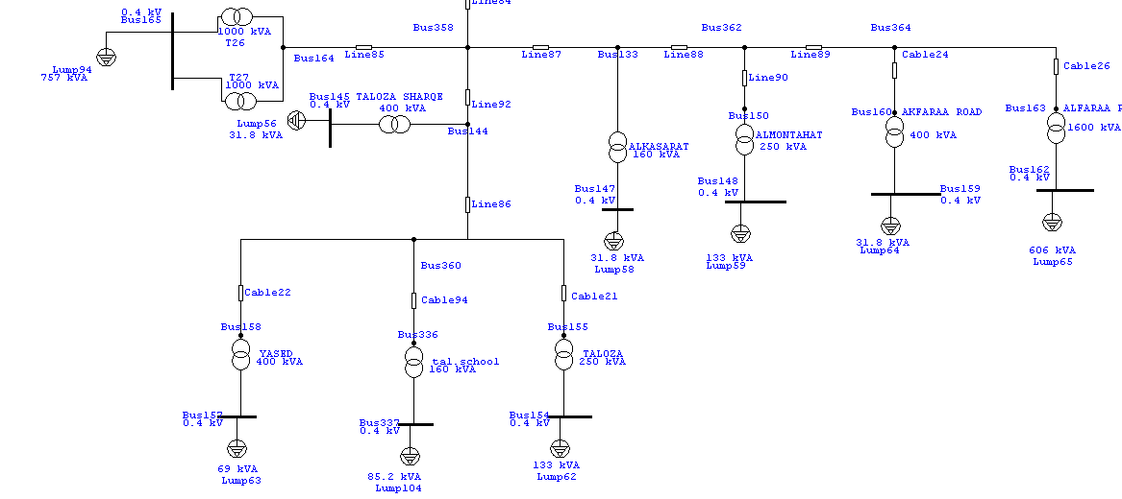

**And after**

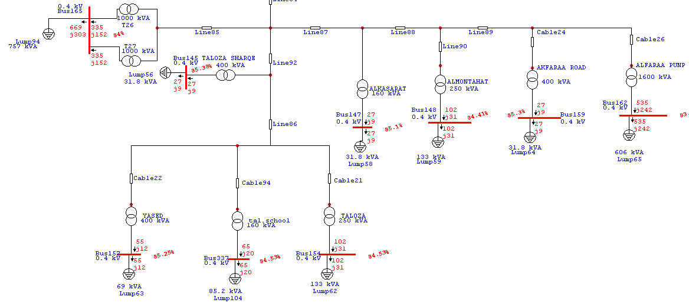

As we see above we notice the red points and values and it shows :

**1**-Power and reactive powers transferred through the buses.

**2**-The percentage of voltages from the buses.

**And all our project in small size:**

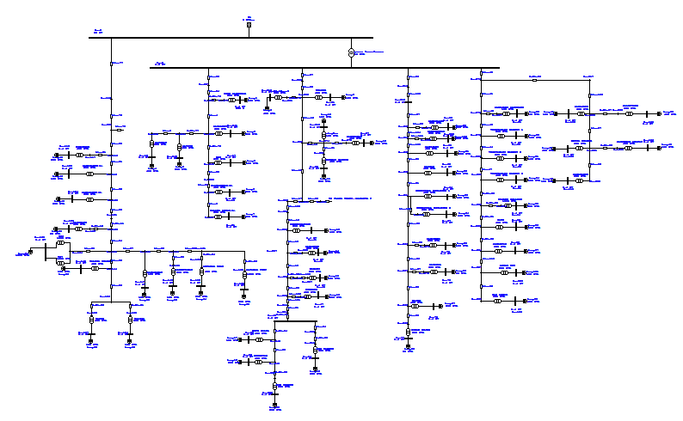

## 2.2 Energy Analyzer:

We use energy analyzer(V.I.P) to find readings of the network by installing it in the distribution board of the tower.

V.I.P system is calibrated to a certain time as 15 minute to take readings.

We can take readings as voltages , currents , p.f, real power and reactive power and harmonics………..etc.

Below shows an example for some readings of AL-KARTOON transformer



And we can take the daily load curve of the load from readings.

Below shows some of the curves of real power and reactive power that is taken for ETAP program. ( see appendix for more details)

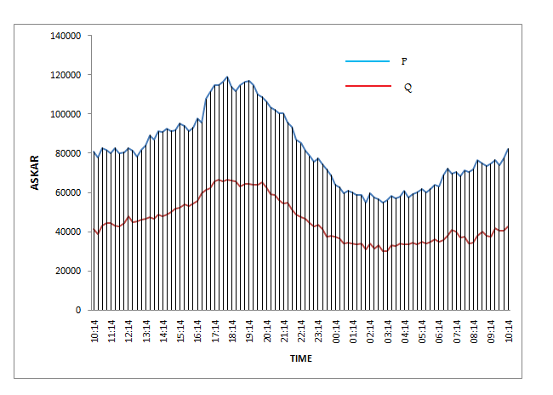

## 2.3 Maximum Case:

### 2.3.1 values of maximum loads in table:(before improvement)

|  |  |  |  |  |  |  |  |  |
| --- | --- | --- | --- | --- | --- | --- | --- | --- |
| Transformer | Vnom  (KV) | Rated  (KVA) | Load  (KVA) | POWER FACTOR | MOTOR LOAD | | STATIC LOAD | |
| P(KW) | Q(KVAR) | P(KW) | Q(KVAR) |
| ALBATHAN | | | | | | | | |
| ESKANDER | 0.4 | 400 | 69.0 | 0.977 | 20 | 4 | 47 | 10 |
| ALMASAKEN(1) | 0.4 | 250 | 133 | 0.956 | 38 | 12 | 89 | 27 |
| ALMASAKEN(2) | 0.4 | 630 | 108 | 0.977 | 32 | 7 | 75 | 16 |
| ALSERAFE | 0.4 | 630 | 238 | 0.911 | 195 | 88 | 22 | 10 |
| ALBADAN PUMP (1) | 0.4 | 1000 | 378 | 0.911 | 310 | 140 | 35 | 15 |
| ALBADAN PUMP (2) | 0.4 | 1000 |
| TALOZA SHARQ | 0.4 | 400 | 31.76 | 0.951 | 18 | 6 | 12 | 4 |
| YASED | 0.4 | 400 | 69 | 0.977 | 20 | 4 | 47 | 10 |
| TALOZA | 0.4 | 250 | 133 | 0.956 | 38 | 12 | 89 | 27 |
| ALKASARAT | 0.4 | 400 | 31.76 | 0.951 | 18 | 6 | 12 | 4 |
| ALMONTAZAHAT | 0.4 | 250 | 133 | 0.956 | 38 | 12 | 89 | 27 |
| AKFARAA ROAD | 0.4 | 400 | 31 | 0.951 | 18 | 6 | 12 | 4 |
| ALFARAA PUMP | 0.4 | 1600 | 605 | 0.911 | 497 | 255 | 55 | 25 |
| TALOZA SCHOOL | 0.4 | 160 | 85 | 0.956 | 24 | 7 | 57 | 17 |
| SOUK ALKHUDAR | | | | | | | | |
| SOUK ALKHUDAR | 0.4 | 300 | 23.68 | 0.838 | 18 | 12 | 2 | 1 |
| ALFOWAT | 0.4 | 630 | 85.11 | 0.931 | 40 | 16 | 40 | 16 |
| ALTITE | 0.4 | 400 | 182.2 | 0.867 | 79 | 45 | 79 | 45 |
| ALZALMOUT | 0.4 | 630 | 85.11 | 0.931 | 40 | 16 | 40 | 16 |
| ROZ | 0.4 | 630 | 85.11 | 0.931 | 40 | 16 | 40 | 16 |
| BLATASHKAR(2) | 0.4 | 400 | 182.2 | 0.867 | 79 | 45 | 79 | 45 |
| BLATASHKAR(1) | 0.4 | 630 | 85.11 | 0.931 | 40 | 16 | 40 | 16 |
| NWASER (1) | | | | | | | | |
| Abdul baset | 0.4 | 630 | 130.66 | 0.638 | 75 | 91 | 8 | 10 |
| NWASER | 0.4 | 400 | 18.66 | 0.741 | 12 | 11 | 1 | 1 |
| ALAGBAR | 0.4 | 160 | 7.464 | 0.741 | 5 | 5 | 1 | 1 |
| ALDUHANAT | 0.4 | 400 | 18.66 | 0.741 | 12 | 11 | 1 | 1 |
| BORHAN YA3ES | 0.4 | 400 | 18.66 | 0.741 | 12 | 11 | 1 | 1 |
| COMUNICATION | 0.4 | 250 | 11.662 | 0.741 | 8 | 7 | 1 | 1 |
| ALKARTON | 0.4 | 630 | 130.66 | 0.638 | 75 | 91 | 8 | 10 |
| MADANI | 0.4 | 250 | 11.662 | 0.741 | 8 | 7 | 1 | 1 |

|  |  |  |  |  |  |  |  |  |
| --- | --- | --- | --- | --- | --- | --- | --- | --- |
| Transformer | Vnom  (KV) | Rated  (KVA) | Load  (KVA) | POWER FACTOR | MOTOR LOAD | | STATIC LOAD | |
| P(KW) | Q(KVAR) | P(KW) | Q(KVAR) |
| HIRBAWI | 0.4 | 400 | 18.66 | 0.741 | 12 | 11 | 1 | 1 |
| KUFR QALEL | 0.4 | 400 | 182.2 | 0.867 | 95 | 54 | 63 | 36 |
| HENDEYAH | 0.4 | 400 | 182 | 0.867 | 95 | 54 | 63 | 36 |
| EIN SEREEN | 0.4 | 630 | 108.7 | 0.977 | 32 | 7 | 75 | 16 |
| ABO WARDEH | 0.4 | 630 | 85.11 | 0.931 | 48 | 19 | 32 | 12 |
| NWASER (2) | | | | | | | | |
| ALMASLAKH | 0.4 | 630 | 279.3 | 0.703 | 177 | 179 | 32 | 12 |
| ALMOUNSHAR | 0.4 | 630 | 279.3 | 0.703 | 177 | 179 | 20 | 20 |
| ALHIJAWI | 0.4 | 400 | 170.1 | 0.753 | 115 | 101 | 13 | 11 |
| ALAQAD | 0.4 | 400 | 78.77 | 0.774 | 55 | 45 | 6 | 5 |
| INDNSTIAL B (1) | 0.4 | 400 | 78.77 | 0.774 | 55 | 45 | 6 | 5 |
| INDNSTIAL B(2) | 0.4 | 630 | 279.3 | 0.703 | 177 | 179 | 20 | 20 |
| ABU-EBAID | 0.4 | 400 | 170 | 0.703 | 55 | 45 | 6 | 5 |
| ALKARMEL | 0.4 | 630 | 279.3 | 0.703 | 177 | 179 | 20 | 20 |
| ALZAGAL | 0.4 | 630 | 279.3 | 0.703 | 177 | 179 | 20 | 20 |
| NAJEM | 0.4 | 400 | 78.77 | 0.774 | 55 | 45 | 6 | 5 |
| ESKAN RUJEB | 0.4 | 250 | 67.66 | 0.995 | 20 | 2 | 47 | 5 |
| ALTHALAJAT | | | | | | | | |
| ALMOJAM3 ALM | 0.4 | 150 | 29.54 | 0.774 | 21 | 17 | 2 | 2 |
| VEGETABLES M(1) | 0.4 | 250 | 49.231 | 0.774 | 34 | 28 | 4 | 3 |
| VEGETABLES M(2) | 0.4 | 250 | 49.231 | 0.774 | 34 | 28 | 4 | 3 |
| VEGETABLES M(3) | 0.4 | 400 | 78.77 | 0.774 | 55 | 45 | 6 | 5 |
| ALDAJANI | 0.4 | 630 | 279.3 | 0.703 | 177 | 197 | 20 | 20 |
| MOUSA KHADER | 0.4 | 630 | 279.3 | 0.703 | 177 | 197 | 20 | 20 |
| ALMATAHEN | 0.4 | 630 | 279.3 | 0.703 | 177 | 197 | 20 | 20 |
| ALLEFTAWE | 0.4 | 630 | 279.3 | 0.703 | 177 | 197 | 20 | 20 |
| ALROKHAM ARA | 0.4 | 400 | 78.77 | 0.774 | 55 | 45 | 6 | 5 |
| HIJAWE COLLEG | 0.4 | 1000 | 443.33 | 0.703 | 280 | 284 | 31 | 32 |
| ZAYED | 0.4 | 400 | 78.77 | 0.774 | 55 | 45 | 6 | 5 |
| ALMADFA3 | 0.4 | 630 | 170.5 | 0.995 | 51 | 5 | 119 | 12 |
| ASKAR NEW | 0.4 | 250 | 67.66 | 0.995 | 20 | 2 | 47 | 5 |
| OLD ASKAR | 0.4 | 630 | 170.5 | 0.995 | 80 | 42 | 187 | 99 |

### 2.3.2 table shows load factor for transformers:

|  |  |  |  |
| --- | --- | --- | --- |
| Transformer | Rated  (KVA) | Load  (KVA) | L.F.  % |
| HIRBAWI | 400 | 18.66 | 4.6 |
| KUFR QALEL | 400 | 182.2 | 45.5 |
| HENDEYAH | 400 | 182 | 45.5 |
| EIN SEREEN | 630 | 108.7 | 17.2 |
| ABO WARDEH | 630 | 85.11 | 13.5 |
| NWASER (2) | | | |
| ALMASLAKH | 630 | 279.3 | 44.3 |
| ALMOUNSHAR | 630 | 279.3 | 44.3 |
| ALHIJAWI | 400 | 170.1 | 42.5 |
| ALAQAD | 400 | 78.77 | 19.6 |
| INDNSTIAL B (1) | 400 | 78.77 | 19.6 |
| INDNSTIAL B(2) | 630 | 279.3 | 44.3 |
| ABU-EBAID | 400 | 170 | 42.5 |
| ALKARMEL | 630 | 279.3 | 44.3 |
| ALZAGAL | 630 | 279.3 | 44.3 |
| NAJEM | 400 | 78.77 | 19.6 |
| ESKAN RUJEB | 250 | 67.66 | 27.0 |
| ALTHALAJAT | | | |
| ALMOJAM3 ALM | 150 | 29.54 | 19.6 |
| VEGETABLES M(1) | 250 | 49.231 | 19.6 |
| VEGETABLES M(2) | 250 | 49.231 | 19.6 |
| VEGETABLES M(3) | 400 | 78.77 | 19.6 |
| ALDAJANI | 630 | 279.3 | 44.3 |
| MOUSA KHADER | 630 | 279.3 | 44.3 |
| ALMATAHEN | 630 | 279.3 | 44.3 |
| ALLEFTAWE | 630 | 279.3 | 44.3 |
| ALROKHAM ARA | 400 | 78.77 | 19.6 |
| HIJAWE COLLEG | 1000 | 443.33 | 44.3 |
| ZAYED | 400 | 78.77 | 19.6 |
| ALMADFA3 | 630 | 170.5 | 27.0 |
| ASKAR NEW | 250 | 67.66 | 27.0 |
| OLD ASKAR | 630 | 170.5 | 27.0 |

|  |  |  |  |
| --- | --- | --- | --- |
| Transformer | Rated  (KVA) | Load  (KVA) | L.F.  % |
| ALBATHAN | | | |
| ESKANDER | 400 | 69.0 | 17.2 |
| ALMASAKEN(1) | 250 | 133 | 53.2 |
| ALMASAKEN(2) | 630 | 108 | 17.1 |
| ALSERAFE | 630 | 238 | 37.7 |
| ALBADAN PUMP (1) | 1000 | 378 | 37.8 |
| ALBADAN PUMP (2) | 1000 | 378 | 37.8 |
| TALOZA SHARQ | 400 | 31.76 | 7.9 |
| YASED | 400 | 69 | 17.2 |
| TALOZA | 250 | 133 | 53.2 |
| ALKASARAT | 400 | 31.76 | 7.9 |
| ALMONTAZAHAT | 250 | 133 | 53.2 |
| AKFARAA ROAD | 400 | 31 | 7.7 |
| ALFARAA PUMP | 1600 | 605 | 37.8 |
| TALOZA SCHOOL | 160 | 85 | 53.1 |
| SOUK ALKHUDAR | | | |
| SOUK ALKHUDAR | 300 | 23.68 | 7.8 |
| ALFOWAT | 630 | 85.11 | 13.5 |
| ALTITE | 400 | 182.2 | 45.5 |
| ALZALMOUT | 630 | 85.11 | 13.5 |
| ROZ | 630 | 85.11 | 13.5 |
| BLATASHKAR(2) | 400 | 182.2 | 45.5 |
| BLATASHKAR(1) | 630 | 85.11 | 13.5 |
| NWASER (1) | | | |
| Abdul baset | 630 | 130.66 | 20.7 |
| NWASER | 400 | 18.66 | 4.6 |
| ALAGBAR | 160 | 7.464 | 4.6 |
| ALDUHANAT | 400 | 18.66 | 4.6 |
| BORHAN YA3ES | 400 | 18.66 | 4.6 |
| COMUNICATION | 250 | 11.662 | 4.6 |
| ALKARTON | 630 | 130.66 | 20.7 |
| MADANI | 250 | 11.662 | 4.6 |

### 2.3.3 table shows the values after analysis:

|  |  |  |
| --- | --- | --- |
| Transformer | nominal  (KV) | % actual  (KV) |
| ALBATHAN | | |
| ESKANDER | 0.4 | 89.5 |
| ALMASAKEN(1) | 0.4 | 89.7 |
| ALMASAKEN(2) | 0.4 | 90.5 |
| ALSERAFE | 0.4 | 84.7 |
| ALBADAN PUMP (1) | 0.4 | 84 |
| ALBADAN PUMP (2) | 0.4 | 84 |
| TALOZA SHARQ | 0.4 | 85.4 |
| YASED | 0.4 | 85.3 |
| TALOZA | 0.4 | 84.5 |
| ALKASARAT | 0.4 | 85.1 |
| ALMONTAZAHAT | 0.4 | 84.4 |
| AKFARAA ROAD | 0.4 | 85.3 |
| ALFARAA PUMP | 0.4 | 83.6 |
| TALOZA SCHOOL | 0.4 | 84.5 |
| SOUK ALKHUDAR | | |
| SOUK ALKHUDAR | 0.4 | 86.3 |
| ALFOWAT | 0.4 | 86.0 |
| ALTITE | 0.4 | 85.0 |
| ALZALMOUT | 0.4 | 86.1 |
| ROZ | 0.4 | 86.0 |
| BLATASHKAR(2) | 0.4 | 84.9 |
| BLATASHKAR(1) | 0.4 | 85.8 |
| NWASER (1) | | |
| Abdul baset | 0.4 | 85.6 |
| NWASER | 0.4 | 86.3 |
| ALAGBAR | 0.4 | 86.2 |
| ALDUHANAT | 0.4 | 86.2 |
| BORHAN YA3ES | 0.4 | 86.2 |
| COMUNICATION | 0.4 | 85.7 |
| ALKARTON | 0.4 | 84.9 |
| MADANI | 0.4 | 85.5 |

|  |  |  |
| --- | --- | --- |
| Transformer | nominal  (KV) | % actual  (KV) |
| HIRBAWI | 0.4 | 85.4 |
| KUFR QALEL | 0.4 | 83.8 |
| HENDEYAH | 0.4 | 83.7 |
| EIN SEREEN | 0.4 | 83.8 |
| ABO WARDEH | 0.4 | 84.8 |
| NWASER (2) | | |
| ALMASLAKH | 0.4 | 84.1 |
| ALMOUNSHAR | 0.4 | 84.0 |
| ALHIJAWI | 0.4 | 84.1 |
| ALAQAD | 0.4 | 84.7 |
| INDNSTIAL B (1) | 0.4 | 84.3 |
| INDNSTIAL B(2) | 0.4 | 83.3 |
| ABU-EBAID | 0.4 | 84.3 |
| ALKARMEL | 0.4 | 83.2 |
| ALZAGAL | 0.4 | 83.2 |
| NAJEM | 0.4 | 84.1 |
| ESKAN RUJEB | 0.4 | 84.5 |
| ALTHALAJAT | | |
| ALMOJAM3 ALM | 0.4 | 85.82 |
| VEGETABLES M(1) | 0.4 | 85.7 |
| VEGETABLES M(2) | 0.4 | 85.6 |
| VEGETABLES M(3) | 0.4 | 85.5 |
| ALDAJANI | 0.4 | 83.9 |
| MOUSA KHADER | 0.4 | 83.7 |
| ALMATAHEN | 0.4 | 83.3 |
| ALLEFTAWE | 0.4 | 83.9 |
| ALROKHAM ARA | 0.4 | 84.5 |
| HIJAWE COLLEG | 0.4 | 83.4 |
| ZAYED | 0.4 | 85.3 |
| ALMADFA3 | 0.4 | 85.6 |
| ASKAR NEW | 0.4 | 85.4 |
| OLD ASKAR | 0.4 | 84.5 |

-We note there are much decreasing in voltage on the buses and it reach 83% from rated voltage on some buses.

Some of them remains in (around 90) when it fed from 33kv in albathan.

Here some pictures of analyais:

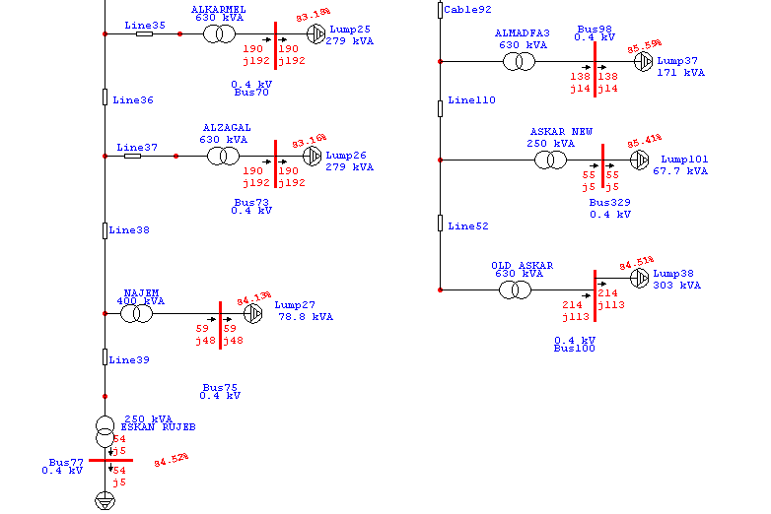

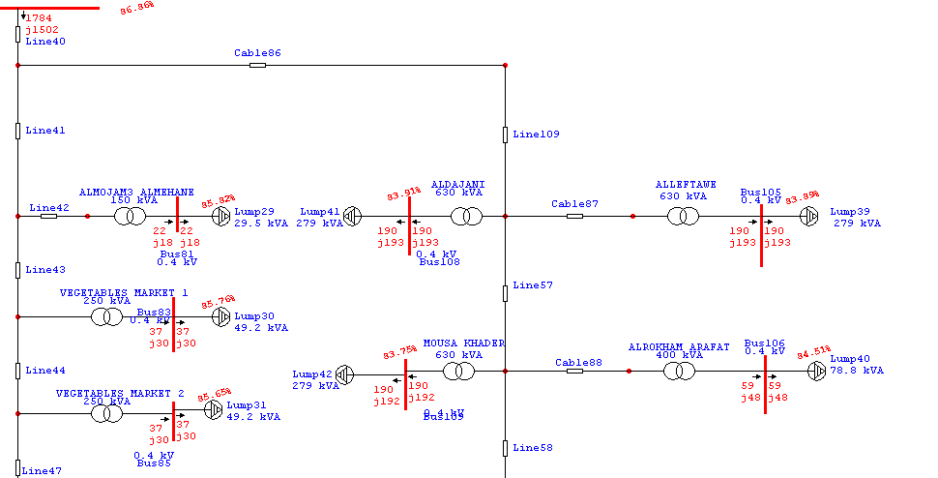

### And summary for the results are:

|  |  |  |  |
| --- | --- | --- | --- |
| MW | Mvar | MVA | % PF |
| Swing Bus(es): | 6.665 | 4.974 | 8.317 | 80.1 Lagging |
| Generators: | 0 | 0 | 0 | 100.0 Lagging |
| Total Demand: | 6.665 | 4.974 | 8.317 | 80.1 Lagging |
| Total Motor Load: | 5.032 | 3.645 | 6.213 | 81.0 Lagging |
| Total Static Load: | 1.399 | 0.634 |
| Apparent Losses: | 0.235 | 0.695 |

## 2.4 Minimum case:

### 2.4.1 values of Minimum loads in table:(before improvement)

|  |  |  |  |  |  |  |  |  |
| --- | --- | --- | --- | --- | --- | --- | --- | --- |
| Transformer | Vnom  (KV) | Rated  (KVA) | Load  (KVA) | POWER FACTOR | MOTOR LOAD | | STATIC LOAD | |
| P(KW) | Q(KVAR) | P(KW) | Q(KVAR) |
| ALBATHAN | | | | | | | | |
| ESKANDER | 0.4 | 400 | 44.9 | 0.975 | 13 | 3 | 31 | 7 |
| ALMASAKEN(1) | 0.4 | 250 | 138 | 0.946 | 39 | 13 | 91 | 31 |
| ALMASAKEN(2) | 0.4 | 630 | 70.8 | 0.975 | 21 | 5 | 48 | 11 |
| ALSERAFE | 0.4 | 630 | 76.6 | 0.854 | 59 | 36 | 7 | 4 |
| ALBADAN PUMP (1) | 0.4 | 1000 | 243 | 0.854 | 187 114 | | 21 13 | |
| ALBADAN PUMP (2) | 0.4 | 1000 |
| TALOZA SHARQ | 0.4 | 400 | 30.9 | 0.903 | 17 | 8 | 11 | 5 |
| YASED | 0.4 | 400 | 44.9 | 0.975 | 13 | 3 | 31 | 7 |
| TALOZA | 0.4 | 250 | 250 | 0.946 | 39 | 13 | 91 | 31 |
| ALKASARAT | 0.4 | 400 | 30.9 | 0.903 | 17 | 8 | 11 | 5 |
| ALMONTAZAHAT | 0.4 | 250 | 138 | 0.946 | 39 | 13 | 91 | 31 |
| AKFARAA ROAD | 0.4 | 400 | 30.9 | 0.903 | 17 | 8 | 11 | 5 |
| ALFARAA PUMP | 0.4 | 1600 | 195 | 0.854 | 150 | 91 | 17 | 10 |
| TALOZA SCHOOL | 0.4 | 160 | 88.3 | 0.946 | 25 | 9 | 58 | 20 |
| SOUK ALKHUDAR | | | | | | | | |
| SOUK ALKHUDAR | 0.4 | 300 | 14.1 | 0.807 | 10 | 7 | 1 | 1 |
| ALFOWAT | 0.4 | 630 | 34.1 | 0.865 | 15 | 9 | 15 | 9 |
| ALTITE | 0.4 | 400 | 87.9 | 0.85 | 42 | 13 | 42 | 13 |
| ALZALMOUT | 0.4 | 630 | 34 | 0.865 | 15 | 9 | 15 | 9 |
| ROZ | 0.4 | 630 | 34 | 0.865 | 15 | 9 | 15 | 9 |
| BLATASHKAR(2) | 0.4 | 400 | 87.9 | 0.85 | 42 | 13 | 42 | 13 |
| BLATASHKAR(1) | 0.4 | 630 | 34 | 0.865 | 15 | 9 | 15 | 9 |
| NWASER (1) | | | | | | | | |
| Abdul baset | 0.4 | 630 | 4.8 | 0.53 | 2 | 4 | 0 | 0 |
| NWASER | 0.4 | 400 | 24.7 | 0.82 | 18 | 13 | 2 | 1 |
| ALAGBAR | 0.4 | 160 | 9.9 | 0.82 | 7 | 5 | 1 | 1 |
| ALDUHANAT | 0.4 | 400 | 24.7 | 0.82 | 18 | 13 | 2 | 1 |
| BORHAN YA3ES | 0.4 | 400 | 24.7 | 0.82 | 18 | 13 | 2 | 1 |
| COMUNICATION | 0.4 | 250 | 15.4 | 0.82 | 11 | 8 | 1 | 1 |
| ALKARTON | 0.4 | 630 | 4.8 | 0.53 | 2 | 4 | 0 | 0 |
| MADANI | 0.4 | 250 | 15.4 | 0.82 | 11 | 8 | 1 | 1 |

|  |  |  |  |  |  |  |  |  |
| --- | --- | --- | --- | --- | --- | --- | --- | --- |
| Transformer | Vnom  (KV) | Rated  (KVA) | Load  (KVA) | POWER FACTOR | MOTOR LOAD | | STATIC LOAD | |
| P(KW) | Q(KVAR) | P(KW) | Q(KVAR) |
| HIRBAWI | 0.4 | 400 | 24.7 | 0.82 | 18 | 13 | 2 | 1 |
| KUFR QALEL | 0.4 | 400 | 87.9 | 0.956 | 50 | 15 | 34 | 10 |
| HENDEYAH | 0.4 | 400 | 87.9 | 0.956 | 50 | 15 | 34 | 10 |
| EIN SEREEN | 0.4 | 630 | 70.8 | 0.975 | 21 | 5 | 48 | 11 |
| ABO WARDEH | 0.4 | 630 | 34 | 0.865 | 18 | 10 | 12 | 7 |
| NWASER (2) | | | | | | | | |
| ALMASLAKH | 0.4 | 630 | 206 | 0.683 | 127 | 135 | 14 | 15 |
| ALMOUNSHAR | 0.4 | 630 | 206 | 0.683 | 127 | 135 | 14 | 15 |
| ALHIJAWI | 0.4 | 400 | 45.6 | 0.864 | 35 | 21 | 4 | 2 |
| ALAQAD | 0.4 | 400 | 38.8 | 0.886 | 31 | 16 | 3 | 2 |
| INDNSTIAL B (1) | 0.4 | 400 | 38.8 | 0.886 | 31 | 16 | 3 | 2 |
| INDNSTIAL B(2) | 0.4 | 630 | 206 | 0.683 | 127 | 135 | 14 | 15 |
| ABU-EBAID | 0.4 | 400 | 38.8 | 0.886 | 31 | 16 | 3 | 2 |
| ALKARMEL | 0.4 | 630 | 206 | 0.683 | 127 | 135 | 14 | 15 |
| ALZAGAL | 0.4 | 630 | 206 | 0.683 | 127 | 135 | 14 | 15 |
| NAJEM | 0.4 | 400 | 38.8 | 0.886 | 31 | 16 | 3 | 2 |
| ESKAN RUJEB | 0.4 | 250 | 41.3 | 0.949 | 12 | 4 | 27 | 9 |
| ALTHALAJAT | | | | | | | | |
| ALMOJAM3 ALM | 0.4 | 150 | 14.5 | 0.886 | 12 | 6 | 1 | 1 |
| VEGETABLES M(1) | 0.4 | 250 | 24.2 | 0.886 | 19 | 10 | 2 | 1 |
| VEGETABLES M(2) | 0.4 | 250 | 24.2 | 0.886 | 19 | 10 | 2 | 1 |
| VEGETABLES M(3) | 0.4 | 400 | 38.8 | 0.886 | 31 | 16 | 3 | 2 |
| ALDAJANI | 0.4 | 630 | 206 | 0.683 | 127 | 135 | 14 | 15 |
| MOUSA KHADER | 0.4 | 630 | 206 | 0.683 | 127 | 135 | 14 | 15 |
| ALMATAHEN | 0.4 | 630 | 206 | 0.683 | 127 | 135 | 14 | 15 |
| ALLEFTAWE | 0.4 | 630 | 206 | 0.683 | 127 | 135 | 14 | 15 |
| ALROKHAM ARA | 0.4 | 400 | 38.8 | 0.886 | 31 | 16 | 3 | 2 |
| HIJAWE COLLEG | 0.4 | 1000 | 326 | 0.683 | 200 | 214 | 22 | 24 |
| ZAYED | 0.4 | 400 | 38.8 | 0.886 | 31 | 16 | 3 | 2 |
| ALMADFA3 | 0.4 | 630 | 104 | 0.949 | 30 | 10 | 69 | 23 |
| ASKAR NEW | 0.4 | 250 | 41.3 | 0.949 | 12 | 4 | 27 | 9 |
| OLD ASKAR | 0.4 | 630 | 220 | 0.871 | 57 | 32 | 134 | 76 |

### 2.4.2 table shows the values after analysis:

|  |  |  |
| --- | --- | --- |
| Transformer | Nom.(kV) | Voltage(%) |
| HIRBAWI | 0.4 | 96.97 |
| KUFR QALEL | 0.4 | 96.51 |
| HENDEYAH | 0.4 | 96.48 |
| EIN SEREEN | 0.4 | 96.75 |
| ABO WARDEH | 0.4 | 96.81 |
| NWASER (2) | | |
| ALMASLAKH | 0.4 | 95.95 |
| ALMOUNSHAR | 0.4 | 95.92 |
| ALHIJAWI | 0.4 | 96.66 |
| ALAQAD | 0.4 | 96.64 |
| INDNSTIAL B (1) | 0.4 | 96.38 |
| INDNSTIAL B(2) | 0.4 | 95.47 |
| ABU-EBAID | 0.4 | 96.37 |
| ALKARMEL | 0.4 | 95.41 |
| ALZAGAL | 0.4 | 95.39 |
| NAJEM | 0.4 | 96.28 |
| ESKAN RUJEB | 0.4 | 96.2 |
| ALTHALAJAT | | |
| ALMOJAM3 ALM | 0.4 | 97.26 |
| VEGETABLES M(1) | 0.4 | 97.23 |
| VEGETABLES M(2) | 0.4 | 97.15 |
| VEGETABLES M(3) | 0.4 | 97.05 |
| ALDAJANI | 0.4 | 95.77 |
| MOUSA KHADER | 0.4 | 95.67 |
| ALMATAHEN | 0.4 | 95.62 |
| ALLEFTAWE | 0.4 | 95.75 |
| ALROKHAM ARA | 0.4 | 96.55 |
| HIJAWE COLLEG | 0.4 | 95.39 |
| ZAYED | 0.4 | 96.87 |
| ALMADFA3 | 0.4 | 96.76 |
| ASKAR NEW | 0.4 | 96.61 |
| OLD ASKAR | 0.4 | 96.01 |

|  |  |  |
| --- | --- | --- |
| Transformer | Nom.(kV) | Voltage(%) |
| ALBATHAN | | |
| ESKANDER | 0.4 | 99.72 |
| ALMASAKEN(1) | 0.4 | 98.74 |
| ALMASAKEN(2) | 0.4 | 99.68 |
| ALSERAFE | 0.4 | 97.38 |
| ALBADAN PUMP (1) | 0.4 | 97.09 |
| ALBADAN PUMP (2) | 0.4 | 97.09 |
| TALOZA SHARQ | 0.4 | 97.4 |
| YASED | 0.4 | 97.38 |
| TALOZA | 0.4 | 96.42 |
| ALKASARAT | 0.4 | 97.11 |
| ALMONTAZAHAT | 0.4 | 96.35 |
| AKFARAA ROAD | 0.4 | 97.38 |
| ALFARAA PUMP | 0.4 | 96.96 |
| TALOZA SCHOOL | 0.4 | 96.42 |
| SOUK ALKHUDAR | | |
| SOUK ALKHUDAR | 0.4 | 97.44 |
| ALFOWAT | 0.4 | 97.34 |
| ALTITE | 0.4 | 97.03 |
| ALZALMOUT | 0.4 | 97.28 |
| ROZ | 0.4 | 97.32 |
| BLATASHKAR(2) | 0.4 | 96.97 |
| BLATASHKAR(1) | 0.4 | 97.27 |
| NWASER (1) | | |
| Abdul baset | 0.4 | 97.5 |
| NWASER | 0.4 | 97.34 |
| ALAGBAR | 0.4 | 97.28 |
| ALDUHANAT | 0.4 | 97.31 |
| BORHAN YA3ES | 0.4 | 97.3 |
| COMUNICATION | 0.4 | 97.08 |
| ALKARTON | 0.4 | 97.2 |
| MADANI | 0.4 | 97.04 |

* The power factor on some transformers is low and we aim to rise both the power factor more than 0.92 and voltages to reach 100% nearly.
* Here some pictures of analyais:

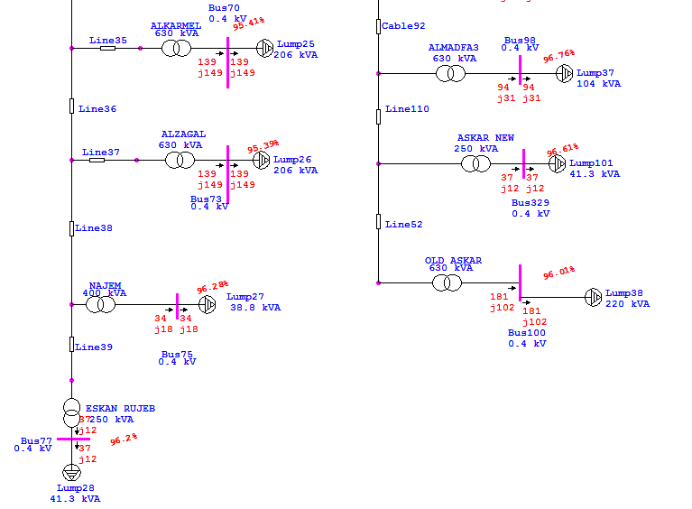

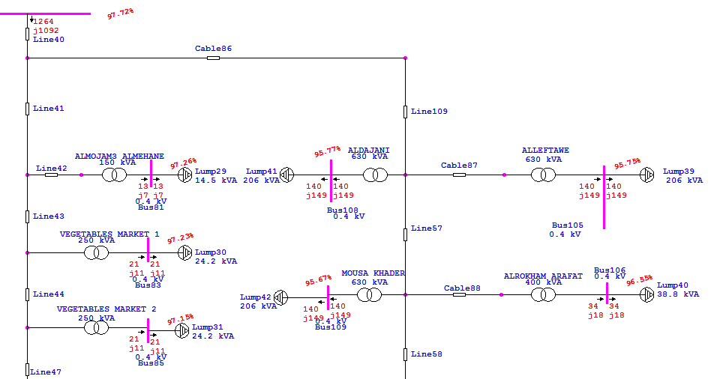

### And summary for the results are:

|  |  |  |  |
| --- | --- | --- | --- |
| MW | Mvar | MVA | % PF |
| Swing Bus(es): | 4.017 | 2.921 | 4.967 | 80.9 Lagging |
| Generators: | 0 | 0 | 0 | 100.0 Lagging |
| Total Demand: | 4.017 | 2.921 | 4.967 | 80.9 Lagging |
| Total Motor Load: | 2.783 | 2.153 | 3.519 | 79.1 Lagging |
| Total Static Load: | 1.167 | 0.544 |
| Apparent Losses: | 0.067 | 0.224 |

## 2.5 Problem Of The Network:

There are many problems we face to the network as:

1- high drop voltage, 2-high losses, 3- low load factor to the transformers,4- low power factor , 5-high load factor to the power transformer. 6- decreasing the voltage coming to east substation.

To solve these problems we will do following topics in the second semester:

a- studying the maximum load case to the network to see the worst case as before.

b- studying the minimum load case to the network to see the situation of the network.

c- make improving to the network by using :increasing the taps of power transformer, distribution transformers ,and using the capacitor.

d- after improving we will study the improving economically .

e- using ring system to make the system more reliability.

f- managing the maximum demand by shifting of maximum demand and conservation of power.

g- redistribution the loads on the transformer to make load factor between (0.65-0.75).