



An-najah National University
Faculty of engineering
Computer Engineering department

Graduation Project Documentation
(Router Manager 2009)

Prepared By: Waseem Omar
Ahmad Darwazeh
Date: 7-1-2009

2008-2009

Introduction:
The idea of this project composed in our minds while studying the Networks course when we learned about the router’s configuration, we saw how hard to keep the whole commands in mind so we started to think about another method to configure the router without knowing these commands at all.
The question was Why not to use a graphical user interface for this operation? It is better and easier for any network.
The idea is powerful and useful for the engineers, network administrators, small office networks, fast configuration.
We chose the CISCO routers to apply our program on it because of the popularity of CISCO which its routers and devices are the most common in the world not in Palestine only.
We started by searching and collecting information about the IOS of CISCO routers and how it stores the information and configuration on its memory to know how to treat them in the best efficient way in our program.
We started from scratch in this program by dealing with routers and know how the response of it with our program is.
We make our best to produce reliable software which can be used in future in companies and computer centers.
Best Wishes:
Waseem Omar.
Ahmad Darwazeh.
Abstract:
The program can be divided into many parts in many ways.
The ways are:
- By permissions, that there are two levels for using the application, the two levels are the user level and the configuration level, the user level is very limited for the user but the configuration level lets the user to make any configuration without any problem. And not to forget that there may be a password between these two levels.
- By commands, that we divided the application into many parts depending on the type of command, for example you will find the interfaces configurations in one panel that is separate from other fields such as routing and access-lists.
- By way of use, that our application contains a GUI part for a router configuration without typing any character of any command, and contains another part acts as a command line that the user can type his commands by his hands, note that the user can mix these two parts in his configuration with a perfect compatibility between them.
The type of connection between the PC and the router is the serial port that we send the commands serially to the router and the IOS of the router can understand them as part of its responsibility.

We worked hard to make the application as friendly as possible for the user to make him relaxed and don’t have to know where is he or in what mode, he must only to know the basic idea of the router operation and what he want to configure.
In addition we added another options to make the application more and more useful and helpful such as the current command line which echoes any command we have made into a text field in the way that it is written in the command line so our application takes another direction as an educational tool for the fresh users of routers to know how to configure the routers and see how the operations implemented in the real command line.
Another useful option is the switch option that the application can configure not only routers, it supports the switch too. In the switch field we have taken the most important piece of the configuration which is the VLANs, you can create delete VLANs, you can configure the interfaces of switch for VLANs too.

Problems:
We have faced many problems from the start of this project to the end of it; we have made many searches and studies to overcome those problems.
We can list these problems as the following:
- The serial connection:
The first and the hardest one is about the connection between the router and the PC which is the serial port, the delay that we must wait to get a complete response from the router was the core of this problem. You cannot make a specific and fixed time to get the response because this delay changes each time depending on many factors such as the serial connection itself, the load on the PC, the load on the router in that moment, and the speed of the CPU on PC.
We solve this problem using a while loop that the program stay in it until we get the whole response.
Here is an example for this loop:
while (!buff.Contains("#"))// check if the router not finish sending // response
{
Thread.Sleep(200);
}
- The device is connected or not:
The second problem is how to maintain sensing if the connected device is alive or not, and if the device is unplugged.
To solve this problem we made a function which has a name of [ is_alive(); ] and using a public variable named [alive] which has a Boolean value of true or false. We poll this value with each action on the application to ensure the connectivity.
Here is the implementation of the function:
public void is_alive()
{
string st = "";
buff = "";
alive = false;
serialPort1.Write("\r");
for (int i = 0; i < 20; i++)
{
Thread.Sleep(500);
st = buff;
if (st.Equals(""))
{
}
else
{
alive = true;
status_toolStripLabel.Text = "Connected";
status_toolStripLabel.Image = connected_img;
break;
}
} // for loop
if (!alive)
{
error_label.Text = "no devices found";
System.Media.SystemSounds.Asterisk.Play();
instruction_label.Text = "Press Restart button to Retry";
status_toolStripLabel.Text = "Disconnected";
status_toolStripLabel.Image = disconnected_img;
//disable all components
disable_all();
right_panel.Enabled = false;
restart_toolStripButton.Enabled = true;
}
} // is_alive function

- The device is changed:
What if while using the application the user want to configure another device?
The solution is by using a button to help you to turn off the application until you disconnect the old device and connect the new one then you can repress it to turn it on again then the application will auto detect a new device and make refresh for all data in the fields to be compatible with the new device.

- Opening the application while device is booting:
This is another case that may make mistakes for the program that it finds the device alive but it cannot get a useful data because the device is booting and the IOS sends information about the router and the BIOS on it not what we want, so we make another function which called [where_we_r ()] this function is not only useful for this case but to know where we are at any instance of time to go to the correct mode that we want. Here is the implementation of the function:
public void where_we_r()
{
//serialPort1.Write("\r");
where_we_are = -1;
buff = "";
is_alive();
if (alive)
{
serialPort1.Write("\r");
int j = 0;
string tmp = "";

while (j == 0)
{
SetProgressBar();
Thread.Sleep(200);
if (!(tmp.Equals(buff)))
{
tmp = buff;
}

string[] lines = tmp.Split('\n');
string last_line = lines[lines.Length - 1];
if (last_line.Equals(""))
{
}
else if (last_line.Contains(">"))
{
where_we_are = 0;
j = 1;
}
else if ((last_line.Contains("vlan")) && (last_line.Contains("#")))
{
where_we_are = 3;
j = 1;
}
else if ((last_line.Contains("config")) && (last_line.Contains("#")))
{
where_we_are = 2;
j = 1;
}
else if (last_line.Contains("#"))
{
buff = "";
serialPort1.Write("copy ru st\n");
Thread.Sleep(500);
if (buff.Contains("Destination filename [startup-config]"))
{
serialPort1.Write("e\n");
Thread.Sleep(300);
where_we_are = 1;
j = 1;
}
}

else
{
if (buff.Contains("Would you like to enter the initial configuration dialog? [yes/no]:") || buff.Contains("Continue with configuration dialog? [yes/no]:"))
{
serialPort1.Write("n\n");
Thread.Sleep(200);
serialPort1.Write("y\n");
Thread.Sleep(200);
buff = "";
}
if (buff.Contains("Press RETURN"))
{
buff = "";
serialPort1.Write("\r");
while (!buff.Contains("User Access Verification") && !buff.Contains(">") && !buff.Contains("Password"))
{
Thread.Sleep(200);
}
}
if (buff.Contains("User Access Verification"))
{
j = 1;
not_in_mode = 1;
}
else if(buff.Contains("Password"))
{
j = 1;
not_in_mode = 2;
}
}
} // while loop
}//if(alive)
}// where_we_r function

Project GUI:
Now it is time to go through the details of our project, and illustrate the project components in much more details:
First of all we have to understand the basic GUI of our application, that are the main categories area, the middle panel that contains details of each category, command line, status and error area, the interfaces table, and some options in the upper area.
As a first step after executing our application, a secondary small window may appear to user asking for a console password, this window will show up if there is a console password enabled on the connected router.
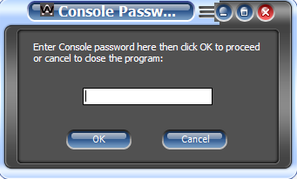

Fig1: Console Password window

If the user entered wrong password this window will re-appear until a correct password is entered or the cancel button is clicked which will close the application.
But if there is no console password enabled then the basic form will appear directly.
If a correct password entered then the basic form will appear in the "user mode" state as shown in the figure below.

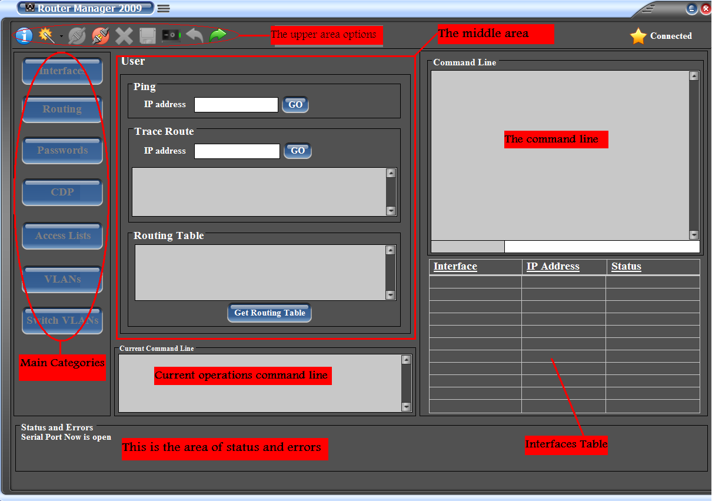
Fig2: basic form components

As we see here the main buttons at the left area are disabled because this is the "user mode" where you can't enter to any category of these ones.
In this mode you can only (according to our application) ping to an IP address, bring a trace to an IP using trace route command, and get the routing table stored on the router memory.

Now if you want to make some configurations on the connected router then you have to go to the enable mode, you can do this by clicking on the right-directed arrow from the upper area.
A text field and two buttons will appear on the upper area beside the "go to enable mode button" if there is an enable password on the router. Enter the password and click on the button beside the password field or press cancel. If the password is correct then you will be in the enable mode, if not, the password field will re-appear and an error message will appear on the errors area.
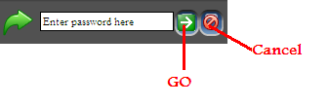

Fig.3: password field that appear if there is a password enabled when you go to enable or user password.
Note: if you want to go back to "user mode" just press the left-directed arrow and the same password field will appear if there is a console password enabled.

The upper area contains:

-Information

-Change Skin

-Open Port

-Close Port

-Erase NVRAM

-Save running configuration

-Restart application

-Return to user mode

-Go to enable mode

The main idea of the "restart button" is that if you want to disconnect the connected router and connect another one or connect a switch, you have to turn the application off then turn it on using this button, this will enable the application to bring some current configurations from the new connected device.

Another element in the upper area is the connected\dis-connected label in the top right corner, this label shows if there are a router or a switch connected to the serial port or not, if a device is connected, then this will appear

If not then this will appear

Enable Mode GUI:
Now you are in the "enable (privilege) mode" where you can do any configuration you want by some simple clicks and some needed entries on our application with an implicit transportations from "enable mode" to "configuration mode" and vice versa.
The following picture shows the application interface in the "enable mode".

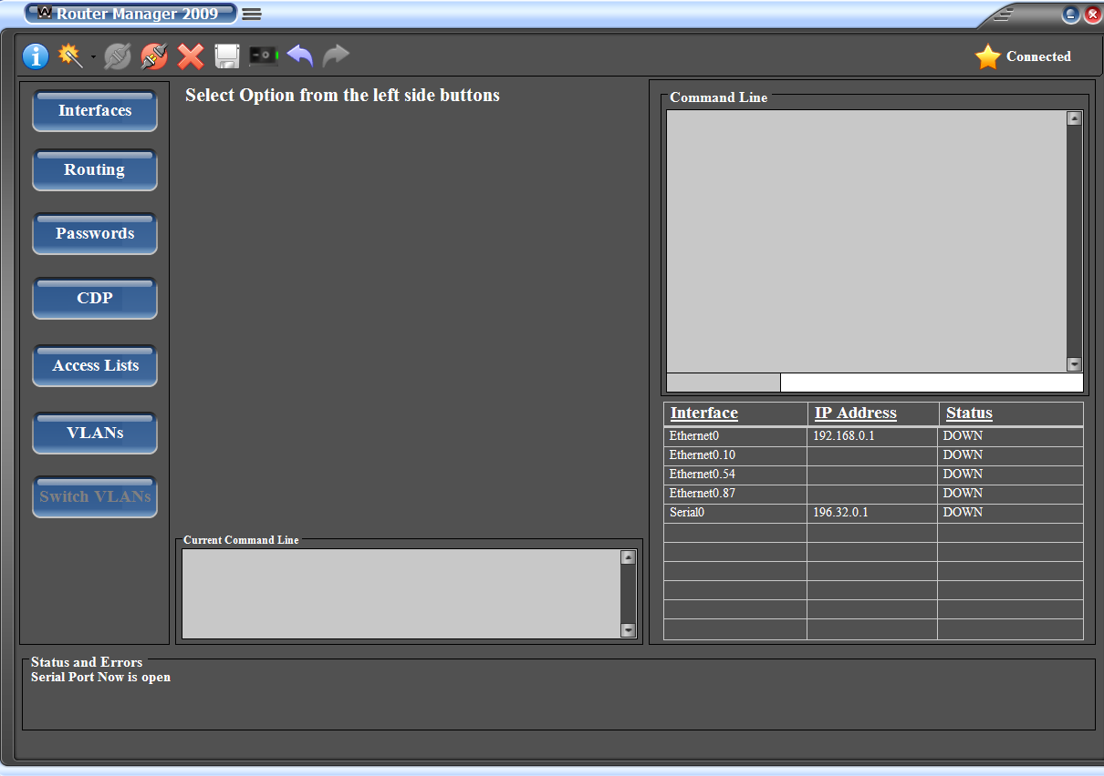
Fig.4: enable mode

As you can see, the main categories buttons are enabled.
During the transportation from "user mode" to "enable mode" we bring the interfaces available on the router and put them with their IPs and addresses in the interfaces table as shown above.
Now you have to choose a category from the left area, which contains, Interfaces, Routing Protocols, Passwords settings, CDP(Cisco Discovery Protocol), Access Lists, VLANs, and Switch options category for VLANs configuration on switches.
When you press a button of any category, its detailed options will appear on the middle of the application, the following pictures shows each category detailed-area.
Interfaces:

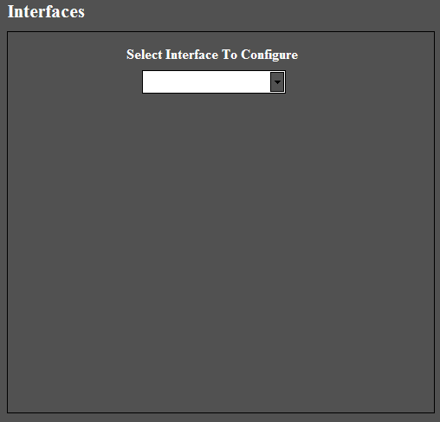
Fig.5: interfaces panel

In this category you have to choose an interface from the combobox shown, to bring its current configurations and change it as you like.

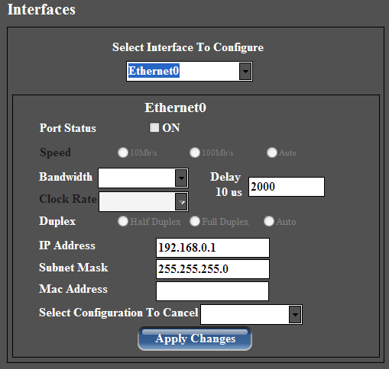
Fig.6: interfaces panel after choosing an interface from combobox

After making changes just press on "apply changes" button, then a progress bar will appear as the application sending the new configurations to the router.

Routing:

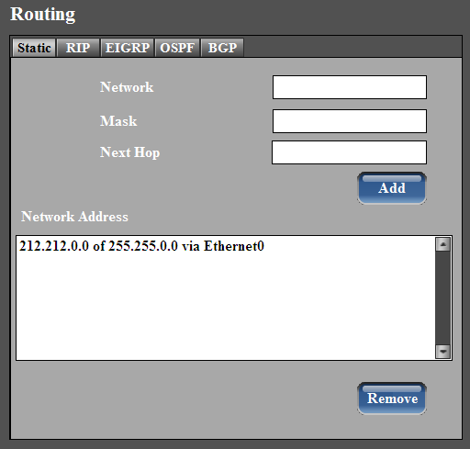
Fig.7: Routing Protocols panel

This panel contains 5 routing protocols, static routes, RIP, EIGRP, OSPF, and BGP.

Each routing protocol has its own tab and its own configuration options. Go to the tab of the routing protocol that you want and configure it as you want then apply changes easily without writing any code.

The good thing that our application bring the current configuration of these routing protocols and put it each on its place clearly.
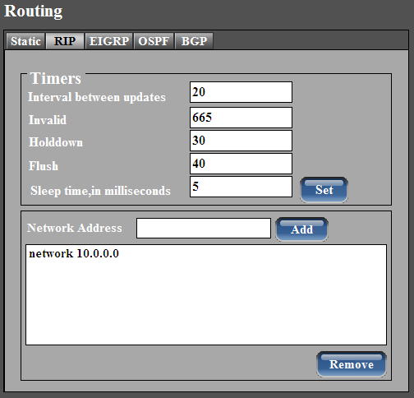
Fig.8: RIP protocol
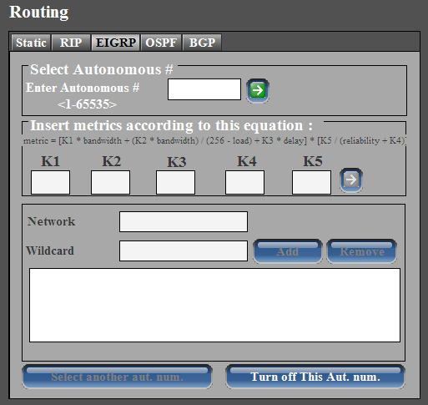
Fig.9: EIGRP protocol

Here you have to enter the autonomous number of the EIGRP area you want to configure, if this number is created before then its current configurations will be displayed to you, if it is not, a new one will be created, just press on the go button.

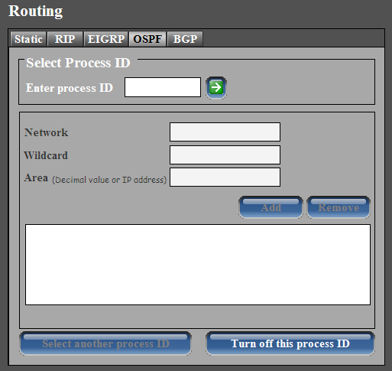
Fig.10: OSPF protocol

Just as in EIGRP, just enter process ID then press on go button, then the current conf. will be displayed if it is a pre-created one, or a new one will be created if it is not.

Passwords:
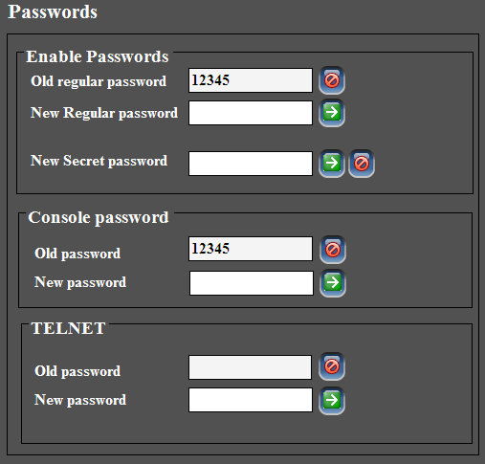
Fig.11: Password settings
Using password settings of our application enables you to create, change, and cancel enable or console or telnet passwords in a very simple way.
By pressing on passwords category button, the enabled passwords will be displayed on its panel, to cancel any one of them just press on the cancel button beside the text field of the old one, to create one, just type the password you want then press on go button.
CDP:
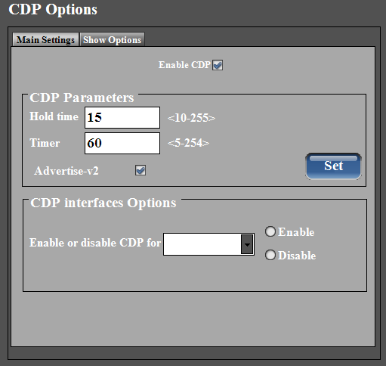
Fig.12: CDP Options

We divide CDP options to two tabs, one for the main settings that you can configure, the other for showing CDP traffic, CDP neighbours, or CDP on the selected interface from combobox shown in fig.13 below.

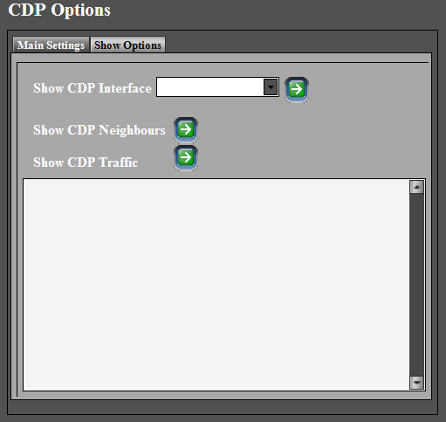
Fig.13: show CDP

Access Lists:
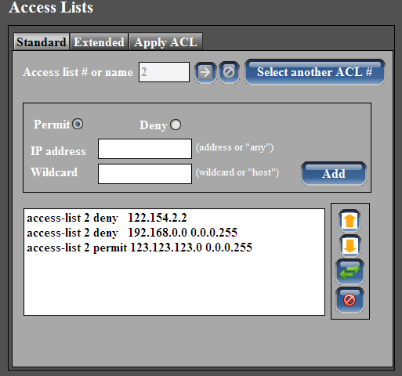
Fig.14: Standard Access Lists

We divide the Access List panel into three tabs, one for standard ACL, one for extended, and the other is for applying any access list to a selected interface.

Once you have entered an access list number, its current conf. will be displayed if it is configured before, else a new ACL will created with the number you have typed.
Note that if you are in standard ACL tab you have to enter a number between 1-99, else, an error message will appear telling you that the number you have entered is for extended ACL as shown in fig.15 below.
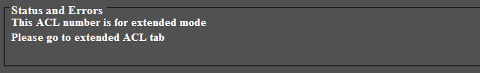
Fig.15: ACL number error

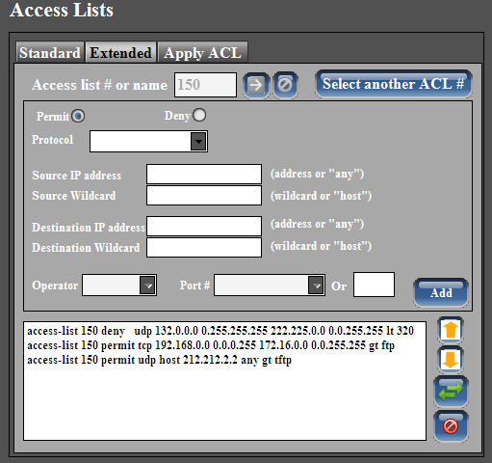
Fig.16: extended ACL
Press "select another ACL #" to get out from the current ACL number and go to another one to create and configure it.
Another strong point for our application that here you can reorder access lists or remove an element from it, while in hyper terminal you have to erase all access list then type it again with the new changes, here you can very easily reorder and edit any access list with simple clicks on the buttons.
If you want to delete an element from an ACL just click on the element from the list box then press on cancel button beside the list box.

If you want to reorder an ACL elements just pick an element and move it up or down using arrows shown in the figure then press the reorder button
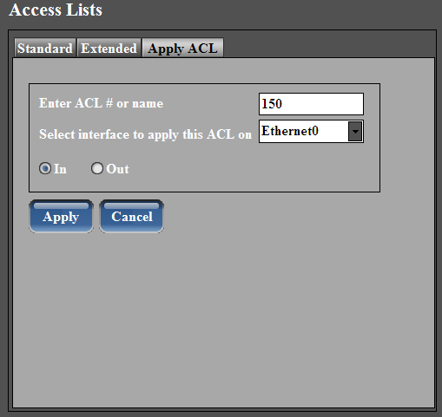
Fig.17: Apply ACL on interface

Pick the interface you want to apply ACL on it from combobox and type the ACL number that you want to apply then press on "apply" button.

To cancel an applied ACL on some interface, repeat the previous steps but this time press on "cancel" button.

VLANs:
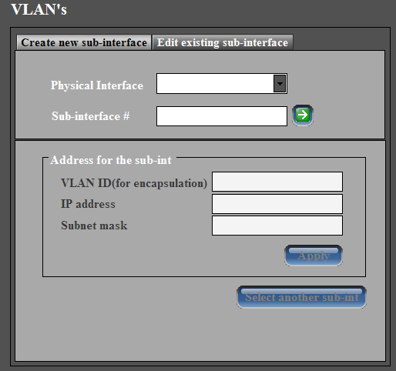
Fig.18: VLANs options of router

Here you can create a new sub-interface and configure it or edit an existing one. After configuring the sub interface just press on "apply" button.

Switch VLANs:
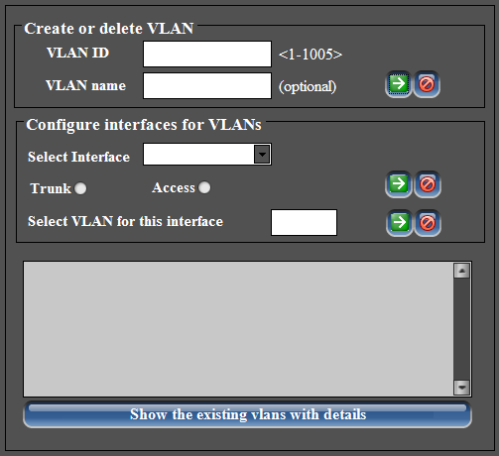
Fig.19: Switch VLANs panel

The button of this category is enabled only if a switch is connected, so you can't go in there until you connect a switch to the serial port of the PC, here you can easily configure any interface on a switch to be in "trunk" or "access" mode and attach it to a VLAN.

Current command line:
It is necessary here to pay attention for a very important part of our application, it is the current command line which displays all command that are sent to the router, which give this application the ability to be an educational material. Look at fig.2

Command Line:
we supply our application with a command line that can be used by the user for much more detailed configurations that we didn't include in the GUI, such as some show commands and other details. Look at fig.2

Prepared by: Ahmad Darwazeh
Waseem Omar
Date: 7-1-2009

