
An Njah national university
faculty of engineering
electrical engineering department

Power line communication
Remote control of electrical equipment
Prepared by; Amani Shelbayeh, Lara Nasser, Sawsan Salah
2009

This project is about control the electrical equipment remotely, by using the FSK signal through the power line. We managed to control two devices in our project.

Table of Contents

1. Team and Acknowledgements ........................................................................... 3
1.1. Team Members................................................................................................ 3
1.2. Acknowledgements.......................................................................................... 3
2. Introduction........................................................................................................ 3
2.1. Project objective............................................................................................... 4
2.2. System concept................................................................................................. 4
2.3. Transmitter section.......................................................................................... 6
2.3.1. Control panel................................................................................................. 7
2.3.2. Trigger circuit………………………………………………………………………………………….. 7
2.3.3. Microcontroller………………………………………………………………………………………… 8
2.3.4. VCO-Voltage Controlled Oscillator …………………............................8
2.3.5. Line Interface Transformer……………………………………………………………………… 9
2.4. Receiver section..............................................................................................11
2.4.1. Line Interface Transformer..........................................................................12
2.4.2. Phase locked loop ……………………………………………………………………………………12
2.4.3. Microcontroller……………………………………………………………………………………….13
2.4.4. Relay circuit…………………………………………………………………………………………….13
3. Source codes......................................................................................................14
3.1. Transmitter code............................................................................................14
3.2. Receiver code ................................................................................................17
4. Conclusions.......................................................................................................19
5. Further scope....................................................................................................19
6. Limitations........................................................................................................20
7. Circuits schematics………………………………………………………………………………………21
7.1 transmitter schematic……………………………………………………………………………….21
7.1.1. Trigger circuit………………………………………………………………………………………..22
7.1.2. VCO circuit…………………………………………………………………………………………….23
7.1.3. MCU FSK Supervisor….……………………………………………………………………….….24
7.1.4..line interface transformer…………………………………………………………………….25
7.2. Receiver side……………………………………………………………………………………………26
7.2.1. Line interface transformer……………………………………………………………………27
7.2.2. Phase locked loop…………………………………………………………………………………28
7.2.3. MCU FSK Supervisor…………………………………………………………………………….29
8. Project hardware……………………………………………………………………………………….30
Appendix 1: list of components……………………………………………………………………..

1. Team and Acknowledgements
1.1. Team Members
Our group for this project consisted of three undergraduate electrical engineering students.
      - Amani Shelbayeh
      - Lara Nasser
      - Sawsan Salah

1.2. Acknowledgements
We would like to acknowledge the efforts and contributions made by the lab technicians in the Electrical and Computer Engineering department at the university. Namely: eng. Manar Qamheyeh and eng. Ala’a AlDeen Bani Odeh, eng. Nuha Odeh.
We would also like to thank Dr. Mazen Rasekh for his time and for agreeing to take on this project. Thank you for your support in making this project a success.

2. Introduction
Power line communication system can be defined as is a system for carrying data on a conductor also used for electric power transmission.
Our project is based on the concept of digital transmission over AC-power lines.
This concept enables the remote control of electrical equipments via the power line. In Industries, remote control by wireless control is very difficult due the presence of high Electromagnetic interference.
Control by Optical means needs line of sight communication, which will not be possible all the time.
Under circumstances, control by data transmission over power lines will be the best option.
This concept will have applications in process control industries and in places where the equipments to be controlled are many and are widely spaced.
Moreover, this concept uses existing power lines for transmission of data and thus does not involve any expenditure for the transmission medium.

This Project aims at implementation of such a Microcontroller based remote control system by transmission of control data over the power lines. FSK line carrier modems are used for transmission of data over the power line. The digital data to be transmitted modulates an FSK generator for onward transmission over the power lines.
Line carrier modems transmits and receives digital data via electric power lines instead of telephone lines or dedicated lines. The FSK modems are interfaced to the power line via high frequency isolation transformers.

Selective remote control means selection and operation of remotely placed equipments from a common transmitter.
Some application areas of such a system ➔
- Industrial Controls
- Domestic appliance Control
- Street Light Control
- Security system Control

2.1 PROJECT OBJECTIVE:
The project involves the design and development of selective remote control system over AC power lines as the communication channel. The system will be designed around the microcontroller AT89C2051. The system will be designed to operate with single phase power line. For interface with Three- phase power lines, only the line interface circuit needs to be modified using three phase transformer.

2.2. System Concept

Selective remote control means, selecting one of the remotely placed equipments and operating it from another centralized location.
In our project, two remotely placed equipments will be used; we will express them by using two lamps.

To identify these remotely placed units, an address has to be assigned to each of the units. Any eight bit word ranging from 00h to FFh can be used as addresses for these remote units. This eight bit word is used as address for the transmission from the transmitter to the receiver. Asynchronous serial communication protocol is used in the system.
UART port of the microcontroller is used for this purpose.

To operate the remotely placed units, a selector switch at the transmitter selects one of the units. This selector switch enables one of the port pins of the microcontroller. When the “Push to Start” switch is operated, a serial data communication process is initiated by the microcontroller, wherein the address of the unit selected is transmitted as FSK signal over the power line. Once this data is transmitted, it will be available at all points wherever the power lines runs.
The FSK signal is generated using a voltage controlled oscillator-VCO. The input to the VCO is from the serial output port of the MCU.
The VCO generates two distinct frequencies corresponding to 1’s and 0’s of the input data. A 60 kHz signal is generated for logic”0” and 75 kHz for logic “1”.
This FSK data is coupled to the power line through a high frequency transformer after suitable amplification.
The receiver at the remote location receives this FSK information through a line interface circuit coupled to the power line. The output of the interface circuit is fed to a Phase Locked Loop. The PLL demodulates the FSK signal. The output will be a serial digital bit stream corresponding to the one transmitted at the transmission end.
The recovered serial data is fed to the serial communication input port of the MCU. The MCU decodes the received data and recovers the transmitted address. This address is compared with all the addresses of the units to be controlled. When a match is found, that particular unit is switched “ON” using a relay circuit. The output of the MCU toggles the relay circuit. Hence the address transmitted for the first time switches “ON” the selected unit, and the same address transmitted second time switches “OFF” the unit
.

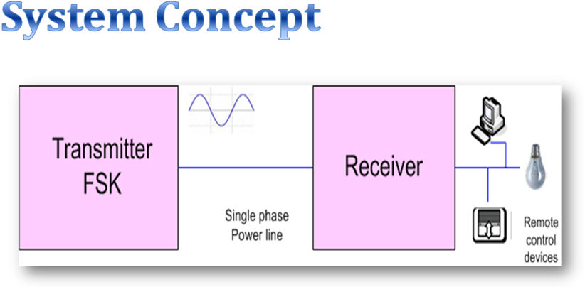

2.3. Transmitter Section

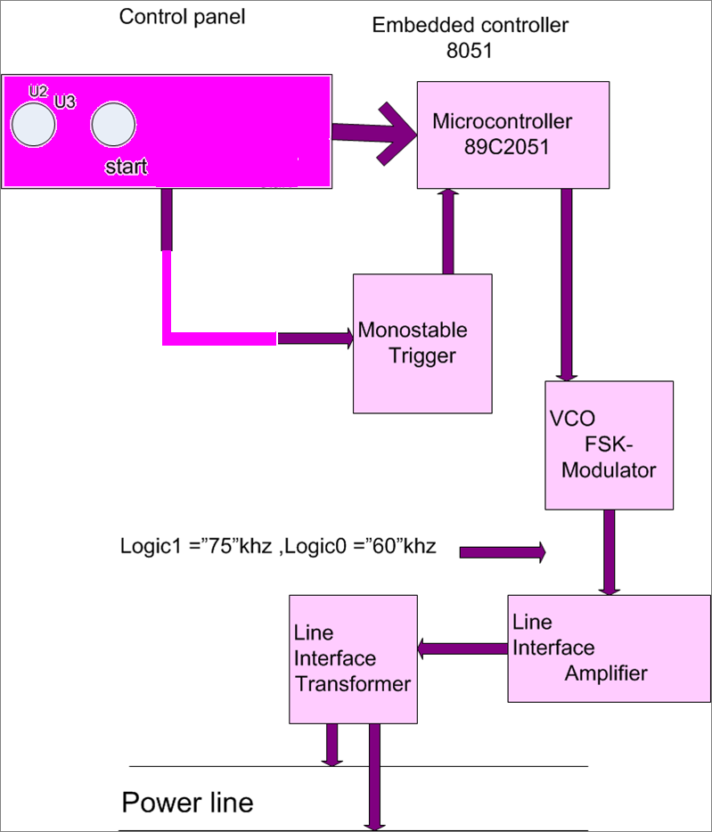

2.3.1. Control Panel
The control panel has the following controls
1) System on/ off switch
2) Selector switches to select the equipment to be controlled.
3) Push switch to switch on / off the selected unit.
4) LED’s to indicate the various operating modes.

2.3.2. Trigger Circuit

A monostable circuit is used for generating trigger pulse for the MCU.
Whenever the Push switch is operated, this circuit generates the trigger pulse.
This pulse is sensed by the Microcontroller and acts upon it as programmed.
This circuit generates a negative going pulse to trigger the MCU.
The monostable used is IC CD4047.
The output is fed to the Microcontroller through the 2-position selector switch on the front panel.
The output of monostable circuit also toggles a D- flip flop to drive a LED. Whenever the Microcontroller is triggered, this LED glows.
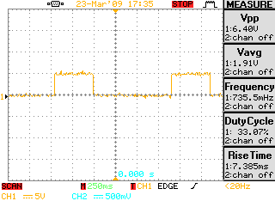
Figure- The output from the trigger circuit

2.3.3. Microcontroller
The microcontroller accepts input from the control panel. The output of the control panel has two output points. These two outputs correspond to the two units to be controlled & are connected to two input ports of the microcontroller. The control panel outputs a pulse signal for each of the unit selected. Whenever the MCU senses this pulse, it selects the proper address and converts it to serial format for transmission through its serial port.
Microcontroller Circuit
The system incorporates the Microcontroller AT89C2051 for controlling the serial communication over the power line.
Port pins P1.0 and P1.1 are used as input port pins for two units to be remote controlled. The selector switch is connected to the port pins referred above.
The serial output data from the MCU is available at connector J5. The output at J5 is connected to the VCO circuit to generate the FSK signal.
The MCU circuit is same for Tx and Rx. In the Tx section only that portion applicable to the transmitter is used.

2.3.4. VCO-Voltage Controlled Oscillator
The VCO accepts serial data as input and outputs FSK signal. When logic 0 is present at the input, it generates 60 kHz signal.
When logic 1 is present at its input, it generates 75 kHz signal.
Hence the output of VCO will be serial FSK data. The IC CD4046 is used for this purpose.

VCO Circuit
This circuit generates the FSK signal. The input to this circuit is from the MCU in the form of serial data.
The VCO is built around the IC U6, CD 4046. The output from MCU is fed to the control input of the VCO
The free running frequency of the VCO is decided by the combination of C10, R18, R19, R20 and R21. The output of the VCO is buffered by the emitter follower Q4 .
The output of the VCO feeds the line interface circuit.
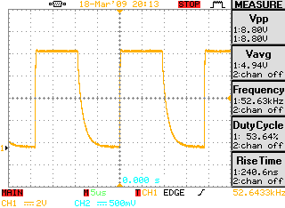
Figure : the output from VCO

2.3.5. Line Interface Transformer

- Line Interface Amplifier
The FSK signal generated by the VCO is amplified by a linear amplifier to increase the level to suitable amplitude for interface.

-Transformer
This is a high frequency ferrite transformer which will interface the FSK signal to the power line. It provides the basic isolation due to the use of separate windings for primary and secondary.
There will be no reverse coupling from the power line to the system, since the high frequency transformer will not develop any magnetic field at 50 Hz, which is the line frequency.
Line Interface Circuit
This circuit performs the function of interfacing the output of VCO to the mains power line. The basic interfacing is done through a high frequency isolation transformer.

The FSK from VCO is fed to base of Q1 through R1. Capacitor C1 is used to decrease the switching time of Q1. Transistor Q1 is driver stage. R2 is used for discharging the base stored charge which in turn will reduce the switch off time of Q1. R3 is the load resistor. The amplified output at Q1 collector is fed to the base of power transistor Q2. R5, D1 and D2 are used to provide discharge path for the base stored charge. Transformer T1 is the driver and isolation transformer for the FSK signal. C4 is the tuning capacitor and also removes any spurious signal. The induced signal in the secondary of the transformer is coupled to the mains line through the coupling capacitors C5 and C6. These capacitors provide a low impedance path for the high frequency FSK signal. At the same time these capacitors presents high impedance to the 50Hz mains frequency. Moreover, the secondary of T1 acts as a short for 50Hz mains frequency and as a normal secondary for the high frequency FSK signal. Thus no reverse voltage from mains line is induced into the circuit. The mains line is connected to J3.C2, C3, C15, C16 are supply bypass capacitors.
After coupling the FSK signal to the power line, the FSK signal will be available at all points wherever the power line runs and the receiver can be connected at any convenient point.

2.4. Receiver Section
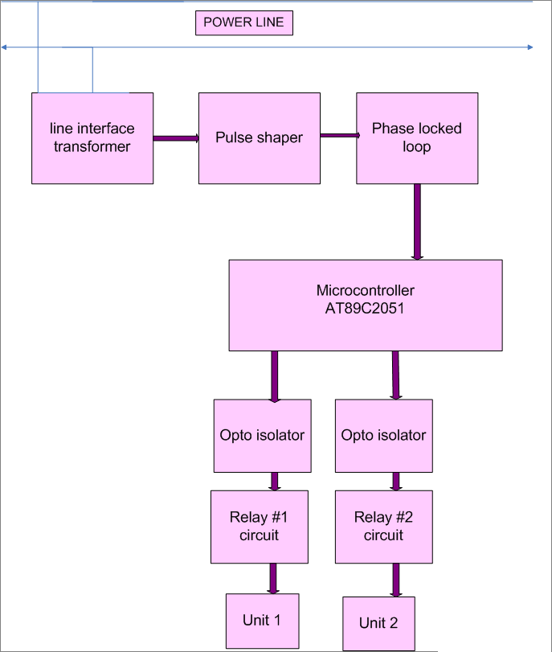

2.4.1. Line Interface Transformer
The line interface transformer at the receiver detects the FSK signal and feeds it the receiver section. This transformer will be exactly the same as used at the transmitter end.
Receiver Line Interface
Refer to the LINE INTERFACE schematic diagram.
The FSK signal received from mains power line. This signal is fed to the primary of the isolation Transformer T2 through coupling capacitors C8 and C9.The induced signal at the secondary of T2 is fed to the amplifier transistor Q3 through C10. R8, R9 and C9 form an attenuating network to reduce the signal to a lower level to prevent over loading of Q3. R10, R11, R12 and R13 are the biasing resistors for Q3. The amplified output at collector of Q3 is fed to base of Q4 through R14 and C11. A square wave signal of about 2v-pp of frequency of the incoming FSK signal will be available at collector of Q4. Resistor R15 and R17 are used as potential divider for the output signal to limit the level to 2v-pp. The final output of the circuit is available at connector J4. C12 and C13 are supply bypass capacitors.

2.4.2. Phase Locked Loop
The PLL decodes the FSK signal output of the pulse shaper and produces a serial data corresponding to the one transmitted at the transmitter end. When 60 kHz signal is received, the output will be logic 0. When 75 kHz signal is received, the output will be logic 1. This serial data output is fed to the receive microcontroller for further decoding.
IC LM567 is the PLL
The free running frequency of the PLL is tuned to 75 khz. The combination of C17, R25 and preset P2 decides this frequency. In the absence of valid input frequency. The output of the PLL is logic high. When the valid frequency is received, the output will go from high to low. The output from the PLL will be an exact replica of serial output at the transmitter MCU.
The output of the PLL decoder is fed to the MCU circuit via an opto isolator. The opto isolator used to prevent interference to the MCU via the power line.

2.4.3. Microcontroller
The output of the PLL is fed to serial receive input port of microcontroller
AT89C2051. The received serial data is stored in one of the registers of the MCU. The MCU holds the addresses of the units to be controlled. The received data is compared with these addresses. One of the stored address matches with the received data. When this match is found, the particular port of MCU assigned to that particular unit will drive an opto coupler, which in turn will drive the selected unit.
MCU Receiver
Refer to the schematic MCU FSK Supervisor.
This circuit receives the serial data from the decoder and drives the proper Relay circuits to operate the remotely placed units.

The circuit receives the data at connector J5, which is the serial input COM port of the MCU.
In the receive section port P1 is the output port. The output port drives three relay circuits corresponding to the three units. The received data is decoded by the MCU and it compares the received data with the local addresses of the three units. When the match is found, that particular relay is switched “ON”. The output contacts of the relay switches “ON” the selected unit to the power line. The output port pins also drives LED’s DS3, DS4 and DS5 to the activation of relays K1, K2 and K3.
The output port of the MCU is connected to the relay circuits through opto isolators to prevent interference from relay circuit back into the MCU circuit. The output of port pins will be high normally. This in turn will ensure logic high at the input of relay drive buffer IC CD 4049, circuit reference U7. The output of U7 will be low and the relay is not operated.
When a valid data is received, the output of MCU will go low and this in turn will make the output of the buffers high. This high level will switch “ON” the relay through transistors Q1, Q2 and Q3.

2.4.4. Relay Circuit
Relay circuits provide drive to the relays. Discrete transistors are used for this purpose. The NO (normally open) contact of relays is connected to the power socket of different units. Whenever a relay operates, the respective socket is switched “on”, and the connected unit is controlled.
3. Source Codes
The source code is in assembly language and used for transmitter and receiver microcontrollers are given in this chapter.

3.1. Transmitter Code
;Program for FSK-Tx remote controller.Rev01
;Will have four switches at transmitter end
org 0000h
sjmp 0030h ;Clear vector table
org 0030h
mov a,#00h ;clear acc
mov p1,#0ffh ;make port p1 an input port
mov scon,#40h ;serial mode1, receive disabled
mov tmod,#20h ;timer1.mode2, 8 bit autoreload
mov th1,#-240 ;baud rate 150
setb tr1 ;start timer
begin:
jb p1.3,next1 ;check SW3 for logic low at pin 14
acall delay1 ;wait for a short period
jb p1.3,next1 ;if p1.2 has gone high, goto next1
mov a,#2ah ;move code 2A to acc, SW3-code
mov sbuf,a ; start sending SW3-code
wait1:
jnb ti,wait1 ;wait for end of transmission
clr ti ;clear TI bit
acall delay2 ; delay before sensing next switch
sjmp begin ;go back to beginning
next1:
jb p1.4,next2 ;check SW4 at pin 15 for logic low
acall delay1 ;monitor low level for some time
jb p1.4,next2 ;if p1.3 is high goto next SW 5
mov a,#3bh ;load code 3B to acc, code for SW4
mov sbuf,a ;start sending SW4 code
wait2:
jnb ti,wait2 ;wait till end of transmission
clr ti ;clear TI flag
acall delay2
sjmp begin
next2:
jb p1.5,begin ;check SW5 at pin 16for logic low
acall delay1
jb p1.5,begin
mov a,#4ch ; 4C is the code for SW5
mov sbuf,a ;start sending SW5 code
wait3:
jnb ti,wait3 ;wait for end of transmission
clr ti
acall delay2
sjmp begin ;go to begin
; DELAY SUB ROUTINES
delay1:
mov r2,#40 ;outer loop counter
again:
mov r3,#250 ;inner loop counter
stay: djnz r3,stay
djnz r2,again
ret
delay2:
mov r4,#05 ;outer loop2 counter
once: mov r5,#255 ;outer loop1 counter
back: mov r6,#255 ;inner most loop counter
hold: djnz r6,hold
djnz r5,back
djnz r4,once
ret
end

3.2. Receiver Code
;ASM program Line FSK remote receiver
org 0000h
sjmp 0030h ;bypass vector lookup table
org 0030h
mov a,#00h ;clear acc
mov p1,#0ffh ;make all port-1 pins high
mov scon,#50h ;serial mode1,receive enable
mov tmod,#20h ;timer1, mode2, auto reload
mov th1,#-240 ;select baud rate-150
setb tr1 ;start timer
begin:
clr ri ;clear RI initially
here:
jnb ri,here ;monitor RI for received data
mov a,sbuf ;copy Rx data to acc
cjne a,#2ah,next1 ;If not equal check next code
cpl p1.0 ; if equal toggle p1.0, relay K1
; operates and unit U1 switches ON
cpl p1.3 ;p1.3 is low and DS3 glows
clr ri ;clear receive interrupt, ri should
;not be cleared till all codes
;are checked
sjmp begin
next1:
cjne a,#3bh,next2 ;if not equal check next code
cpl p1.1 ; if equal, toggle p1.1,relay K2
; operates and U2 switches ON
cpl p1.4 ;make p1.4 low,DS4 glows
clr ri ;clear ri to receive next byte
sjmp begin
next2:
cjne a,#4ch,begin ;if not equal check next code
cpl p1.2 ;if equal, toggle p1.2, relay K3
; operates and U3 switches ON
cpl p1.5 ;make p1.5 low,DS5 glows
clr ri
sjmp begin
;delay sub-routine
delay: mov r2,#250 ;load outer loop counter
back: mov r3,#250 ;load inner loop counter
stay: djnz r3,stay
djnz r2,back
ret
end

4. Conclusion
This project simply demonstrates the capability of transmission of digital data over power lines which have been traditionally used to transmit low frequency analog signals. This is achieved by modulating the digital signal using FSK modulation technique and thus transmitting digital data at higher frequencies. This project thus just demonstrates the basic idea which can be further improved upon so as to be used in various applications.
The limitation of this project is that it will successfully transmit data only over a single same phase power line thus restricting the range of transmission. With some additional hardware, we can achieve data transmission over all three phases of power lines thus enabling the transmission over a greater range. Once that is achieved, this concept can be used in various applications like home automation, home networking, street lighting, security system control, control of various remote devices in industry and even internet access.
5. Further Scope
Greater research in the area of transmission of digital signals over power lines will definitely enable us to come up with various applications of the concept. The biggest application of this concept though could be Internet Access over the Power Lines. In today’s world where access to information on the move has become an essential part of life to survive in the world which moves at cut throat pace, digital transmission over power lines might enable us this access through any of the millions of power socket in the world. This would enable us to access the internet from any location with power supply. The device to be used to access the internet could be simply plugged into the power socket for ready to use “Plug and Play” Internet access. This will of course require us to update the hardware associated with the power lines as now we will have to include routers at transformer sections. Besides this we will have to connect these power lines to the servers. Protocols and standards for the same will have to be developed if this technology has to be implemented on a commercial scale.

Internet access could also be made possible by the setting up of Wi-Fi Hot spots at areas close to transformers. Thus diligent effort in this field just might enable us to access information through the internet in a whole new way and Cable and DSL technologies just might become completely redundant as the ubiquitous power lines itself will provide us the gateway to the warehouse of information-the Internet.

6. Limitations
Although the prospects for the implementation and use of this technology seem bright but there are a few limitations with this concept which would have to be dealt with before its commercial application.
1) The biggest problem that digital data transmission over power lines encounters is the radio interference. Since the power lines are usually uncovered, unshielded and untwisted, they might act as antennas and would thus radiate a large amount of radio energy. This would lead to great interference with the other radio signals being transmitted at the same time. The reverse process would also be affecting the signals being sent over the power lines and thus lead to interference in the data transmission.

2) The power line cable, unlike any other broadband medium (copper twisted pair, fiber, coaxial cable), is inherently unsuited for carrying the frequencies BPL uses. Power lines, copper twisted pair, and coaxial cable all act like natural low pass filters, meaning higher frequencies are attenuated more than lower frequencies when attempting to transmit them through the medium.
Power lines are designed to carry electrical power. They were not designed to carry radio signals. They do this very poorly, loosing much of the signal to losses. Another major problem would be faced when data will have to be sent over the numerous transformers. The transformers being high inductance devices will act as low pass filters allowing only the low frequency components to pass through while blocking the higher frequency signals. We will thus have to use greater number of repeaters in the communication channel.

3) The last problem to be faced would be the same faced by all new technologies the absence of any standard protocols. For the technology to a success and for large scale implementation, a body such as IEEE would have to come forward with a set of rules or standards for digital data transmission over power lines.
This would allow various equipment manufacturing companies to produce equipment conforming to the standard valid over all countries and the service providers to transmit and receive data as per a fixed protocol.
Once solutions to these limitations are found, this technology can be used for various commercial applications as mentioned in the section above.

7. Circuits Schematics:

TRANSMITTER
SIDE
CIRCUIT
SCHEMATICS

TRIGGER CIRCUIT

VCO CIRCUIT

MCU FSK SUPERVISOR

LINE INTERFACE CIRCUIT

RECEIVER
SIDE
CIRCUIT
SCHEMATICS

LINE INTERFACE CIRCUIT

PHASE LOCKED CIRCUIT

MCU FSK SUPERVISOR

Project hardware

Appendix

LIST OF
COMPONENTS

Trigger MCU
Sl No. | Description | Circuit  reference | Value
1 | capacitor | C1 | 1000uF
2 | capacitor | C2 | 0.22uF
3 | capacitor | C3 | 10uF
4 | capacitor | C4 | 0.1uF
5 | resistor | R1 | 470 ohms
6 | resistor | R2 | 470 ohms
7 | resistor | R3 | 6K8
8 | resistor | R4 | 820K
9 | resistor | R5 | 47K
10 | resistor | R6 | 470 ohms
11 | resistor | R7 | 22K
12 |  | U1 | 4047
13 |  | U2 | 4013
14 |  | U3 | 7414
15 |  | Q1 | BC547
16 | LED | D1
17 | Connector junction | J1
18 | switch | Sw1

VCO
Sl. No. | Description | Circuit  Reference | Value
1 | capacitor | C1 | 0.1uF
2 | capacitor | C2 | 100uF
3 | capacitor | C3 | 1000pF
4 | capacitor | C4 | s.c
5 | resistor | R1 | 15K
6 | resistor | R2 | 12K
7 | resistor | R3 | s.c
8 | resistor | R4 | 12K
9 | resistor | R5 | 1K
10 | resistor | R6 | 47K
11 | resistor | R7 | 6K8
12 | resistor | R8 | 12K
13 | resistor | R9 | 1K
14 |  | U1 | MCT2E
15 |  | U2 | MCT2E
16 |  | U3 | 4046
17 | Jumper Connector | J2
18 | Jumper Connector | J1
19 | Potentiometer | P1 | 5K preset
20 |  | Q

PLL: Receiver
Sl. No. | Description | Circuit  Reference | Value
1 | capacitor | C1 | 0.1uF
2 | capacitor | C2 | 100 uF
3 | capacitor | C3 | 47uF
4 | capacitor | C4 | 0.1uF
5 | resistor | R1 | 120K
6 | resistor | R2 | 10K
7 | resistor | R3 | 1K
8 | resistor | R4 | 47K
9 | resistor | R5 | 120K
10 |  | U1 | 78L05
11 |  | U2 | MCT2E
12 |  | U3 | 8PIN-567
13 | Jumper Connector | J2
14 | Jumper Connector | J1
15 | Jumper Connector | J3
16 | Potentiometer | P1

MCU FSK Transmitter
Sl. No. | Description | Circuit  Reference | Value
1 | capacitor | C5 | 47uF
2 | capacitor | C6 | 0.1uF
3 | capacitor | C7 | 2.2pF
4 | capacitor | C8 | 3.3pF
5 | capacitor | C9 | 3.3pF
6 | Resistor | R12 | 470 ohms
7 | Resistor | R13 | 470 ohms
8 | Resistor | R14 | 470 ohms
9 | Resistor | R15 | 470 ohms
10 | Resistor | R16 | 47K
11 | Red LED | D1
12 | Red LED | D2
13 | Red LED | D3
14 | Red LED | D4
15 | Jumper Connectors | J4 | 2pins
16 | Jumper Connectors | J5 | 3pins
17 | Jumper Connectors | J6 | 3pins
18 | Jumper Connectors | J7 | 6pins
19 | Jumper Connectors | J8 | 4pins
20 | Jumper Connectors | J9 | 4pins
21 | crystal
22 | microcontroller |  | 20 pin  ZIF

Line Interface Circuit: Transmitter
Sl. No. | Description | Circuit  Reference | Value
1 | capacitor | C1 | 0.1uF
2 | capacitor | C2 | 100uF
3 | capacitor | C3 | 0.22/400v(Orange)
4 | capacitor | C4 | 100uF
5 | capacitor | C5 | 0.1uF
6 | capacitor | C6 | 0.01uF
7 | capacitor | C7 | 22K-Green(223K)
8 | capacitor | C8 | 0.22/400v(Orange)
9 | capacitor | C9 | 1000uF
10 | resistor | R1 | 12K
11 | resistor | R2 | 1K5
12 | resistor | R3 | 47 ohm
13 | resistor | R4 | 12K
14 | resistor | R5 | 47K
15 | resistor | R6 | 12K
16 | Jumper Connector | J1 | 2pins
17 | Jumper Connector | J2 | 2pins
18 | Jumper Connector | J3 | 2pins
19 | Jumper Connector | J4 | 2pins
20 | diode | D1 | 4148
21 | diode | D2 | 4148
22 | diode | D3 | 4148
23 | Pulse transformer | 1002C
24 | Transistor | U1 | MJE3055
25 | Transistor | U2 | BC 547

Line Interface Receiver
Sl. No. | Description | Circuit  Reference | Value
1 | capacitor | C1 | 100uF
2 | capacitor | C2 | 0.1uF
3 | capacitor | C3 | 0.01uF
4 | capacitor | C4 | 0.22uF
5 | capacitor | C5 | o.c
6 | capacitor | C6 | 0.01uF
7 | capacitor | C7 | 0.22uF
8 | resistor | R1 | 5K6
9 | resistor | R2 | 4K7
10 | resistor | R3 | 6K8
11 | resistor | R4 | 5K6
12 | resistor | R5 | 3K9
13 | resistor | R6 | 47K
14 | resistor | R7 | 4K7
15 | resistor | R8 | 2K7
16 | resistor | R9 | 2K2
17 | resistor | R10 | 12K
18 | resistor | R11 | 2K7
19 | resistor | R12 | 2K2
20 | resistor | R13 | 2K2
21 | Jumper Connector | J1 | 2pins
22 | Jumper Connector | J2 | 2pins
23 | Pulse transformer | 1002C
24 | Transistor | U1 | BC 547
25 | Transistor | U2 | BC 547

MCU FSK Receiver
Sl. No. | Description | Circuit  Reference | Value
1 | capacitor | C5 | 47uF
2 | capacitor | C6 | 0.1uF
3 | capacitor | C7 | 2.2pF
4 | capacitor | C8 | 3.3pF
5 | capacitor | C9 | 3.3pF
6 | Resistor | R2 | 12K
7 | Resistor | R3 | 470 ohm
8 | Resistor | R4 | 10K
9 | Resistor | R5 | 47K
10 | Resistor | R7 | 470 ohm
11 | Resistor | R8 | 12K
12 | Resistor | R9 | 10K
13 | Resistor | R10 | 47K
14 | Resistor | R11 | 12K
15 | Resistor | R12 | 470 ohms
16 | Resistor | R13 | 470 ohms
17 | Resistor | R14 | 470 ohms
18 | Resistor | R15 | 470 ohms
19 | Resistor | R16 | 47K
20 | Resistor | R17 | 470 ohm
21 | Resistor | R18 | 10K
22 | Resistor | R19 | 47K
23 | Red LED | D1
24 | Red LED | D2
25 | Red LED | D3
26 | Red LED | D4
27 | Jumper Connectors | J2 | 3pins
28 | Jumper Connectors | J7 | 3pins
29 | Jumper Connectors | J9 | 3pins
30 | Jumper Connectors | J10 | 6pins
31 | Jumper Connectors | J8 | 3pins
32 | Jumper Connectors | J4 | 3pins
33 | Jumper Connectors | J5 | 3pins
34 | Jumper Connectors | J20 | 5pins
35 | Relay Sugar Cube
36 | Relay Sugar Cube
37 | Relay Sugar Cube
38 |  |  | 16 Pin 4049
39 | crystal
40 | microcontroller | U8 | 20 pin  ZIF
41 |  | U3 | 6 Pin MCT2
42 |  | U6 | 6 Pin MCT2
43 |  | U9 | 6 Pin MCT2
44 |  | U4 | 100N
45 |  | U6 | 100N
46 |  | U10 | 100N

