بسم الله الرحمن الرحيم

An_Najah National University

The Faculty of Engineering

Computer Dept Eng

GRADUATED PROJECT

PEN PLOTTER

Prepared by :ASMA Al SAQA

Pen plotter is a device that plot any bitmap sent to by its computer application by drawing a line by line data .
Tools :
1-pic 16f877 as controller with its basic circuit .
2-ULN2003 and relays.
3-three DC motors : to control the X and Y direction moving

4- DC motor to control the pen up and down moving .
MECHANICAL PART :
This part which take most of time and I make many design for it ,each time I have a problem I think to solve it and reach to other design I try it ,I tried with at least five designs ,
Last I reach to ironic frame with two direction .
For the two direction first I use stepper motors and after I find them from useless printers , and program I find that the motors is very weak and move the direction axis from one side , and so I think to use 2 steppers for each direction which put me in more problems , because the moving is not balance ,because the steppers is too weak and also the torque ; and because I’m not a mechanical engineer , I don’t know what to do to decrease the load so ,and this is the most difficult decision because it need to redesign ,reprogramming and change the hardware , it is to change the motors type from stepper to DC , to reach to the last design

HARDWARE PART

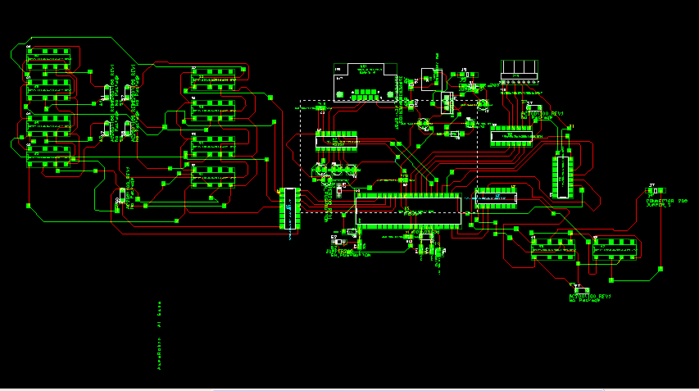

And the following to use three pens instead of one
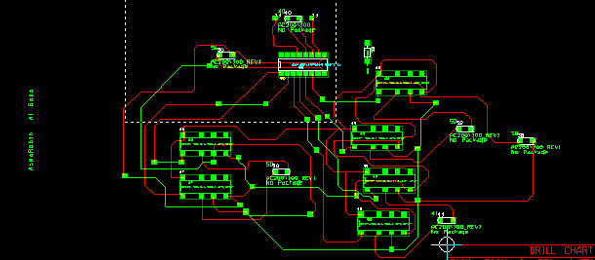

SOFTWARE

I use PIC_C program and TR to program PIC16f877 .
I used Microsoft visual studio 2005 to design my application which treat with the following :

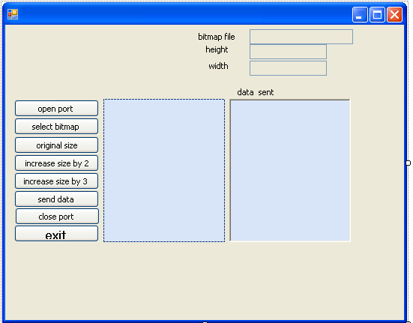

1-files "select bitmap":

a-I use files open browser to select a bitmap and return information about it as width and height and file name .

op.ShowDialog();
s = op.FileName;
if (s == "") { }
else{
Bitmap b = new Bitmap(s);
w = b.Width;
h = b.Height;
int d = w * h;
txt.Text = s;

2-images:
a-after select a bitmap I show it in picture box .

p1.Image = Bitmap.FromFile(s);

b-I show the bitmap name ,width and height in pixels .

te1.Text = w.ToString();
te2.Text = h.ToString();

c-I check the color of each pixel and keep the values in an array ,if the color is black I keep 1 in the array else I keep 0.

for (int i = 0; i < w; i++)
{
ar[i] = new byte[h];
// ar[i][0]=2;
for (int j =0; j< h; j++)
{
// ar[i][j] = b.GetPixel(i, j).B;
String blue = b.GetPixel(i, j).B.ToString();
String red = b.GetPixel(i, j).R.ToString();
String green = b.GetPixel(i, j).G.ToString();
if (blue == "0" && green=="0" && red=="0")
{
ar[i][j] = 1;
}
else
{

ar[i][j] = 0;
}

}
d-also I use it to increase size by 2 or 3 by using flags .
to increase size by 2 :
if(s==""){
MessageBox.Show(" select a bitmap");
}
else{

size_flag = 1;
int w2=(w * 2);
te1.Text =w2.ToString();
w2=h*2;
te2.Text=w2.ToString();
}
}

to increase it by 3:
if (s == "")
{
MessageBox.Show(" select a bitmap");
}
else
{

size_flag =2;
int w2 = (w *3);
te1.Text = w2.ToString();
w2 = h * 3;
te2.Text = w2.ToString();
}
}

to keep the original size :
{

if (s == "")
{
MessageBox.Show(" select a bitmap");
}
else
{

size_flag = 0;

te1.Text = w.ToString();

te2.Text = h.ToString();
}
}

3-serial port

a-when open port is pressed :I check if it is already open else I open it .

if (sp.IsOpen)
{
MessageBox.Show("the port is open");
}
else
{
sp.Open();
sp.BaudRate = 9600;
}

b-send data: I check if the port is open and an image is select then I send the data via serial port .

I check if the user want to draw the bitmap in its original size or to increase by two or three ,
If he want it as it I start to send data to the PIC which move motor s to the position it must go and check if it is one ,draw it by move the pen down ,else will not draw .

If he want to increase size by two , I will draw each pixel as tow pixel in X-direction and two pixel in Y-direction .
If he want to increase size by three ,I will draw each pixel as nine pixels ,three rows by three columns .

if (!sp.IsOpen)
{
MessageBox.Show("the port is not opened");
}
else
{
if (s == "")
{
MessageBox.Show("the bitmap is not opened");
}
else
{

byte[] a = new byte[1]; ;
Bitmap b = new Bitmap(s);
int w = b.Width;
int h = b.Height;
int flag = 0;
if(size_flag==0){
for (int i = 0; i < w; i++)
{
byte[] dd = new byte[1];
dd[0] = 2;
sp.Write(dd, 0, 1);
ta.Text= ta.Text+sp.ReadByte().ToString();
if (flag == 0)
{
flag = 1;
for (int j = 0; j < h; j++)
{
byte[] d = new byte[1];

d[0] = ar[i][j];
sp.Write(d, 0, 1);

ta.Text = ta.Text + sp.ReadByte().ToString();

}

}
else
{
flag = 0;
for (int j = h - 1; j >= 0; j--)
{
byte[] d = new byte[1];
d[0] = ar[i][j];

sp.Write(d, 0, 1);

ta.Text = ta.Text + sp.ReadByte().ToString();

}

}
}
}
else if (size_flag ==1)
{
for (int i= 0; i < w; i++)
{
byte[] dd = new byte[1];
dd[0] = 2;
sp.Write(dd, 0, 1);
ta.Text = ta.Text + sp.ReadByte().ToString();

for (int j = 0; j < h; j++)
{
byte[] d = new byte[1];

d[0] = ar[i][j];

sp.Write(d, 0, 1);

ta.Text = ta.Text + sp.ReadByte().ToString();

sp.Write(d, 0, 1);

ta.Text = ta.Text + sp.ReadByte().ToString();
}

sp.Write(dd, 0, 1);
ta.Text = ta.Text + sp.ReadByte().ToString();
for (int j = h - 1; j >= 0; j--)
{
byte[] d = new byte[1];
d[0] = ar[i][j];

sp.Write(d, 0, 1);
ta.Text = ta.Text + sp.ReadByte().ToString();
sp.Write(d, 0, 1);

ta.Text = ta.Text + sp.ReadByte().ToString();

}

}
}

else if (size_flag ==2)
{
for (int i = 0; i < w; i++)
{
byte[] dd = new byte[1];
dd[0] = 2;
sp.Write(dd, 0, 1);
ta.Text = ta.Text + sp.ReadByte().ToString();

if (flag == 0)
{
flag = 1;
for (int j = 0; j < h; j++)
{
byte[] d = new byte[1];

d[0] = ar[i][j];

sp.Write(d, 0, 1);

ta.Text = ta.Text + sp.ReadByte().ToString();
sp.Write(d, 0, 1);

ta.Text = ta.Text + sp.ReadByte().ToString();
sp.Write(d, 0, 1);

ta.Text = ta.Text + sp.ReadByte().ToString();
}

sp.Write(dd, 0, 1);
ta.Text = ta.Text + sp.ReadByte().ToString();
for (int j =h-1; j>=0; j--)
{
byte[] d = new byte[1];

d[0] = ar[i][j];
;
sp.Write(d, 0, 1);

ta.Text = ta.Text + sp.ReadByte().ToString();
sp.Write(d, 0, 1);
ta.Text = ta.Text + sp.ReadByte().ToString();
sp.Write(d, 0, 1);
ta.Text = ta.Text + sp.ReadByte().ToString();
}
sp.Write(dd, 0, 1);
ta.Text = ta.Text + sp.ReadByte().ToString();
for (int j = 0; j < h; j++)
{
byte[] d = new byte[1];

d[0] = ar[i][j];

sp.Write(d, 0, 1);

ta.Text = ta.Text + sp.ReadByte().ToString();
sp.Write(d, 0, 1);

ta.Text = ta.Text + sp.ReadByte().ToString();
sp.Write(d, 0, 1);

ta.Text = ta.Text + sp.ReadByte().ToString();
}

}
else
{
flag = 0;
for (int j = h - 1; j >= 0; j--)
{
byte[] d = new byte[1];
d[0] = ar[i][j];

sp.Write(d, 0, 1);

ta.Text = ta.Text + sp.ReadByte().ToString();
sp.Write(d, 0, 1);

ta.Text = ta.Text + sp.ReadByte().ToString();
sp.Write(d, 0, 1);

ta.Text = ta.Text + sp.ReadByte().ToString();
}
sp.Write(dd, 0, 1);
ta.Text = ta.Text + sp.ReadByte().ToString();
for (int j = 0; j<h; j++)
{
byte[] d = new byte[1];
d[0] = ar[i][j];

sp.Write(d, 0, 1);

ta.Text = ta.Text + sp.ReadByte().ToString();
sp.Write(d, 0, 1);

ta.Text = ta.Text + sp.ReadByte().ToString();
sp.Write(d, 0, 1);
ta.Text = ta.Text + sp.ReadByte().ToString();
}
sp.Write(dd, 0, 1);
ta.Text = ta.Text + sp.ReadByte().ToString();
for (int j = h - 1; j >= 0; j--)
{
byte[] d = new byte[1];
d[0] = ar[i][j];

sp.Write(d, 0, 1);

ta.Text = ta.Text + sp.ReadByte().ToString();
sp.Write(d, 0, 1);

ta.Text = ta.Text + sp.ReadByte().ToString();
sp.Write(d, 0, 1);

ta.Text = ta.Text + sp.ReadByte().ToString();
}
}
}
}
byte[] d1= new byte[1];
d1[0] = 3;
sp.Write(d1, 0, 1);
ta.Text = ta.Text + sp.ReadByte().ToString();
}

}
}
c-when close is pressed the application will end :

PIC C and PIC 16f877
In PICC code , I get the pixels sent to by serial port and check if it is zero or one then I will move and draw as following :

#include "dc-plot.h"

void pen_up_down(){
//int g=0;
//int o=0;
//int k=0;
restart_wdt();
output_low(PIN_D0);
//delay_ms(100);
//
output_high(PIN_D1);
restart_wdt();
delay_ms(15);

output_low(PIN_D1);
restart_wdt();
}

// void pen_up_up(){

// }
void pen_down_up(){
// int g=0;
// int o=0;
//int k=0;
output_low(PIN_D1);
output_high(PIN_D0);
restart_wdt();
delay_ms(15);
output_low(PIN_D0);
restart_wdt();
}
// void pen_down_down(){

// }

void step_l_to_r(){

int c=0;
int i=0;
output_low(PIN_D2);
output_high(PIN_D3);
restart_wdt();
delay_ms(50);
output_low(PIN_D3);
restart_wdt();
}

void step_r_to_l(){

int c=0;
int i=0;

output_low(PIN_D3);
output_high(PIN_D2);
restart_wdt();
delay_ms(50);
output_low(PIN_D2);
restart_wdt();
}

void step_up(){

output_low(PIN_c4);
output_high(PIN_c5);
restart_wdt();
delay_ms(50);
output_low(PIN_c5);
restart_wdt();
}
void step_down(){

output_low(PIN_c5);
output_high(PIN_c4);
restart_wdt();
delay_ms(50);
output_low(PIN_c4);
restart_wdt();
}
void main()
{
int c=0;
int x=0;
int y=0;
int i=0;
int j=0;
int step_dir;
int pen_flag;
char ch='4';
step_dir=0; //0 l_to_R 1 r_to_l
pen_flag=0;//0 up 1 down

setup_adc_ports(NO_ANALOGS);
setup_adc(ADC_OFF);
setup_psp(PSP_DISABLED);
setup_spi(FALSE);
setup_counters(RTCC_INTERNAL,RTCC_DIV_1);
setup_timer_1(T1_DISABLED);
setup_timer_2(T2_DISABLED,0,1);

while(1){

ch=getc();
putc(ch);
while(ch!=3){
if(ch==0){
x++; //to return to the original place
if(pen_flag==0){
//pen is up and must still up
if(step_dir==0){
step_l_to_r();}
else if(step_dir==1){
step_r_to_l();
}
}

else if(pen_flag==1){ //pen is down and must go up

if(step_dir==0){
step_l_to_r();}
else if(step_dir==1){
step_r_to_l();
}
pen_down_up();

pen_flag=0;
restart_wdt();
}}

else if(ch==1){
x++;
if(pen_flag==0){

if(step_dir==0){
restart_wdt();
step_l_to_r();}
else if(step_dir==1){
step_r_to_l();
restart_wdt();

}

restart_wdt();
pen_up_down();
//pen is up and must go down
restart_wdt();

pen_flag=1;
restart_wdt();

}

else if(pen_flag==1){ //pen is down and must still down

if(step_dir==0){
step_l_to_r();}
else if(step_dir==1){
step_r_to_l();
}
}}

else if(ch==2){
x=0;
step_down();
y++;
if(step_dir==0){
step_dir=1;}
else if(step_dir==1){
step_dir=0;
}

}
ch=getc();
putc(ch);

}

///////////////// to return to the original place ;;;;;;;;;;

}

}

