## الإهداء

يوم تفني في مرابعنا القدر لا يدفن الأقصى لو طال الزمن

في جمال الربيع جمالك ، وفي حنان الأم حنانك ، وفي هدوء الطبيعة هدوءك ، وفي صفاء البحر صفاءك فكيف لا أحبك سنعشقك … في فرحك … وغضبك وأملك … و يأسك … في حاضرك … وماضيك … ومستقبلك .

فقد خلقت في داخلنا وترعرعت في وجداننا … حتى أصبحنا نتنفس سرمدي

#### نهواك … وننتشي أريح عطرك " فلسطين "

# إلى مثال التضحية والعطاء

##### نبع الكرم و الوفاء

###### نور الشمس والضياء ……. " ابائنا "

## إلى اللواتي بذلن الروح

إلى نبوع العطاء والحنان

إلى اللواتي أخجلتنا دموعهن ..............."امهاتنا"

إلى الذين كانو نعم العون والسند

سنبقى نحبهم إلى الأبد ………………………" أخواننا و أخواتنا "

إلى الذين قضينا معهم أجمل الذكريات و أحلى الأيام

أعطيناهم الحب والاخلاص

فأعطونا الوفاء و علمونا الاقدام …………. أصدقائناو زملائنا

### إلى روح الشهداء الأبرار الذين ضحوا بأنفسهم لأجل وطن آمن نعيش فيه بسلام.

**Contents :**

**Chapter one** : **Introduction** ………………………………………………………4

**Chapter two** : **Mechanical system** ……………………………………………. 6

**Chapter three** : **Electrical system** ………………………………………………10

**Chapter four** **: Software** …………………… …………………………………15

**Abstract**

Our project is type of CNC miller that mil printed board circuit in order to install the electronic chips in there places. This PCB miller is divided into two parts ,

Part one :- hard ware i.e the body of the machine that contain stepper motors moves the miller in (x-y) -axis movement in order to reach the point that will be milled by the miller which represent the z-axis , and there is another hardware part which we called it malty loading arm , this part is a box contains the PCB 's and there a mechanical arm pushes one board each time to put it in its specific place , so in this way we can perform many PCB's .

The other part is the software which control the micro controller and give it the proper orders to perform them , and it will give the controller the matrix of x-y dimension of the holes , then the controller will move the stepper motor to perform the orders.

And we will put some accessories to the project such LCD some warning lights or voice, with a beautiful interface and the important is easy to use by any person with littlie help.

**Chapter one :**

**1_ Introduction**

**1.1 What is PCB mill?**

It’s a CNC (Computer Numerical Control) machine which remove areas of [copper](http://en.wikipedia.org/wiki/Copper) from a sheet of [printed circuit board](http://en.wikipedia.org/wiki/Printed_circuit_board) material to recreate the pads, [signal traces](http://en.wikipedia.org/wiki/Signal_trace) and structures according to patterns from a digital circuit board plan known as a layout file. A PCB milling system is similar to a miniature and highly accurate NC milling table. For [machine control](http://en.wikipedia.org/wiki/Control_theory), positioning information and machine control commands are sent from the controlling [software](http://en.wikipedia.org/wiki/Computer_software) via a [serial port](http://en.wikipedia.org/wiki/Serial_port) or [parallel port](http://en.wikipedia.org/wiki/Parallel_port) connection to the milling machine's on-board [controller](http://en.wikipedia.org/wiki/Controller).

**1.2 Design Concepts**

The main concepts commonly used to make a milling device consist of a threaded travel mechanism, a combination X-axis and Y-axis, a precisely controlled motor (either a stepper motor or a DC motor with a position encoder), and a controller for the milling mechanism to correctly position it. For each axis (X_Y) and Z – a motor is connected to the threaded travel mechanism. As the motor turns the screw-like device, a guide on to pot the thread moved back and forth in a straight 1-dimensional line. Combining the X-axis and the Y-axis, an XY-plane is created. This allows a platform to be positioned anywhere in a 2-dimensional plane. The Z axis, either mounted as port of the XY plane or separately above it, allows for a 3rd dimension.

**1.3 Proposed Design**

The design I am proposing uses 3 stepper motors to control the 3 axis of Operation.

Each stepper motor is connected to a push pull (l_298) with (l_297) driver circuit which is controlled by a PIC16F877 microcontroller, the PIC chip receive the current position (G_code) serially by serial cable which connected to PC which use (Kcam4) software, there is an interface between the PIC chip and Kcam4 software by using c-sharp language in order to receive the position of milling holes serially. The code which tracks the G_code in order to move to the specified positions is written in c++ language.

**Chapter two :**

**2. The Mechanical System**

**2.1 Mechanical Design**

The complete mechanical system was designed in 3D solid working environment using Autodesk inverter .In our project we moved the base (y-axes ) and the drill ( z- axes ) .

Our model of consist of base ( 26x38 ) cm , and vertical arm ( 50 cm ) .

x-axes = 94cm .

y-axes =45cm.

z-axes =40cm.

**2.2 Tools:**

-Stepper motors .

-Hand Drill.

-Hacksaw.

-Hacksaw Blades.

The modeling and building BCB:

The stepper motor of the y-axis.

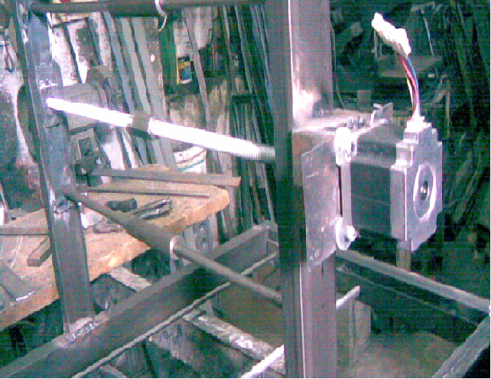

The base of our project:

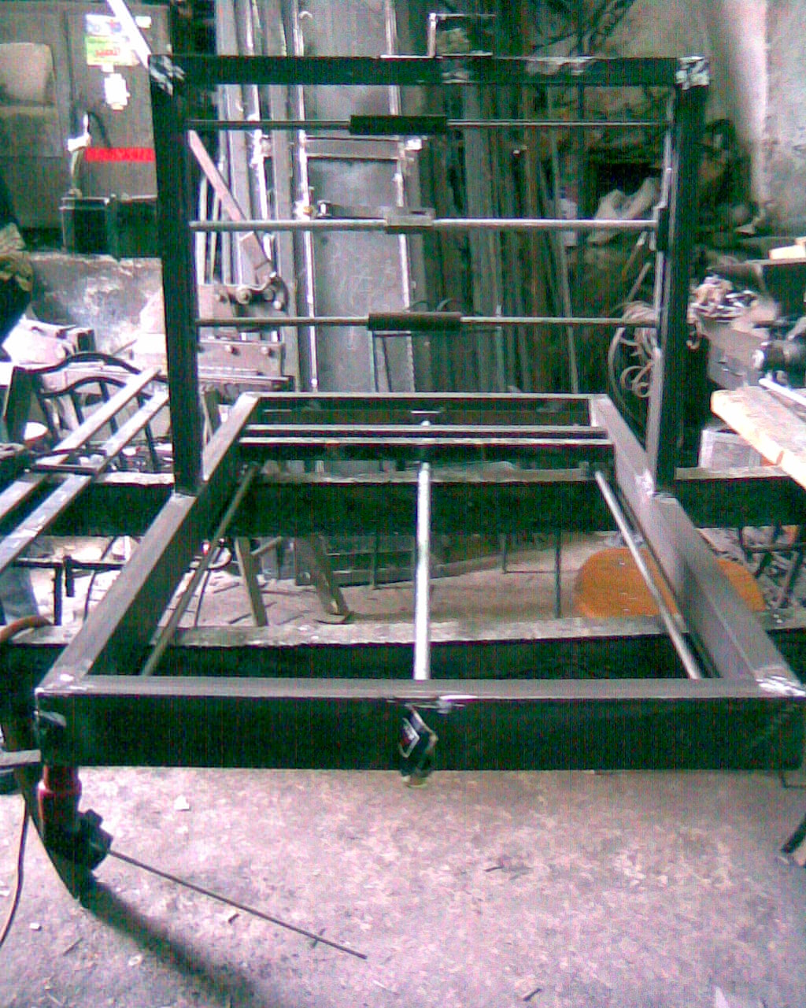

The Z-axis of our project:

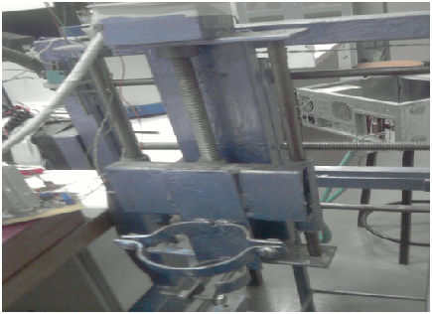

The X-axis of our project:

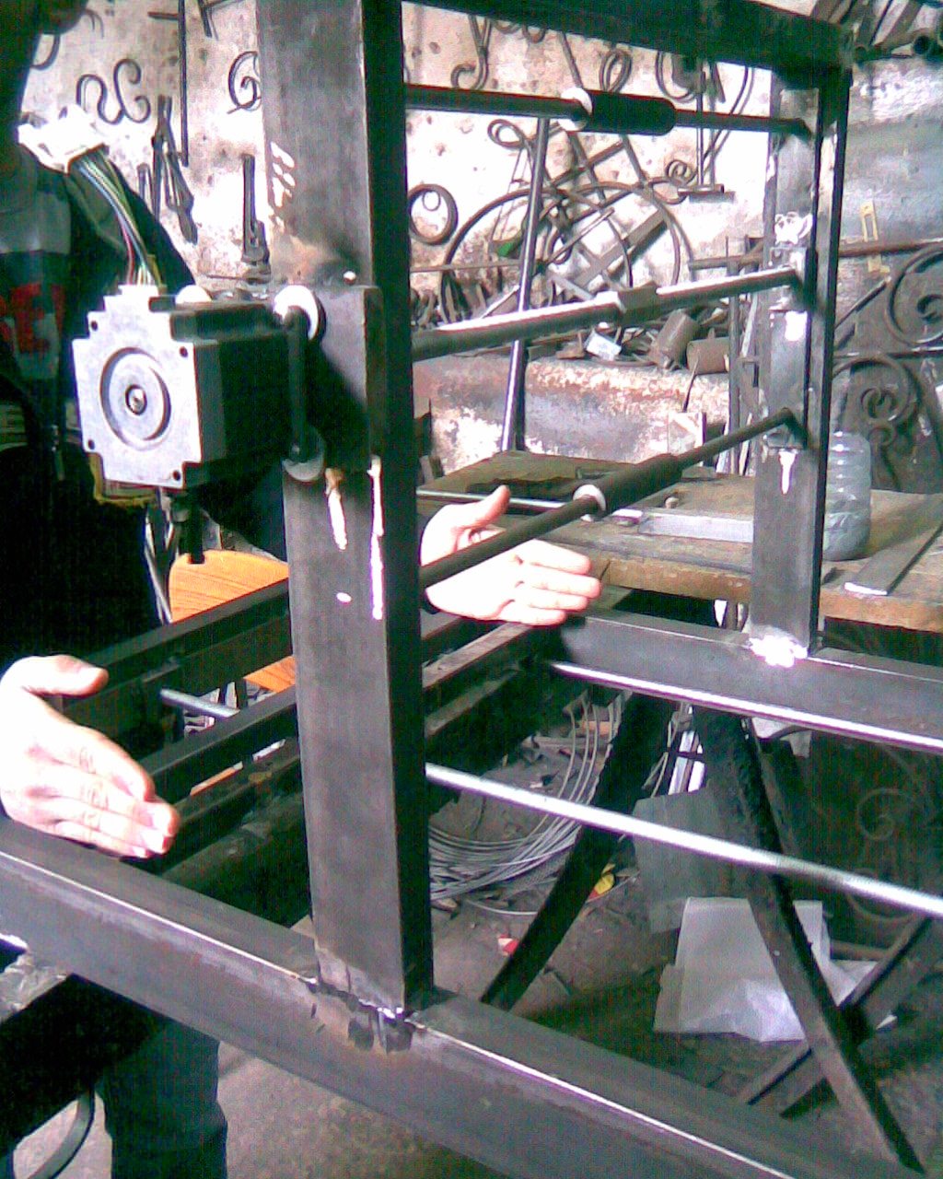

The previous pictures explains the structure of the new model, since the first model was not able to provide the required torque to move the arms, because of the limited current that can be drown by the stepper motors.

The pictures bellow shows the first model :

The base of the first project:

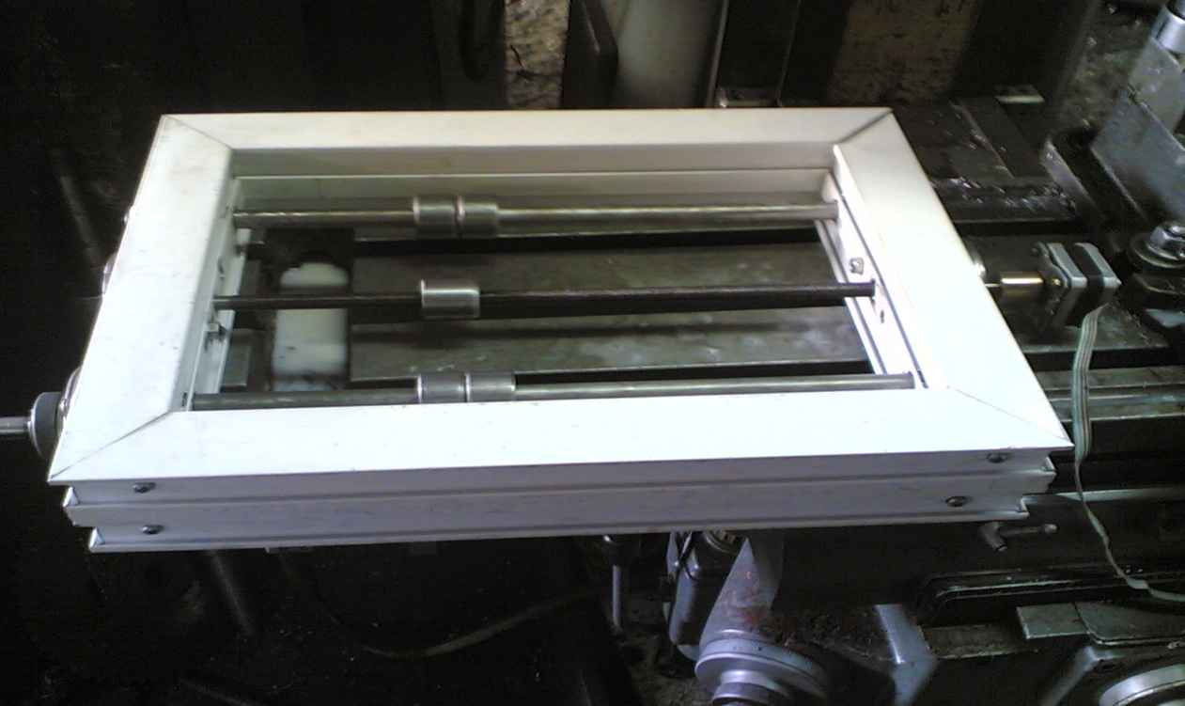

The final model of the first project:

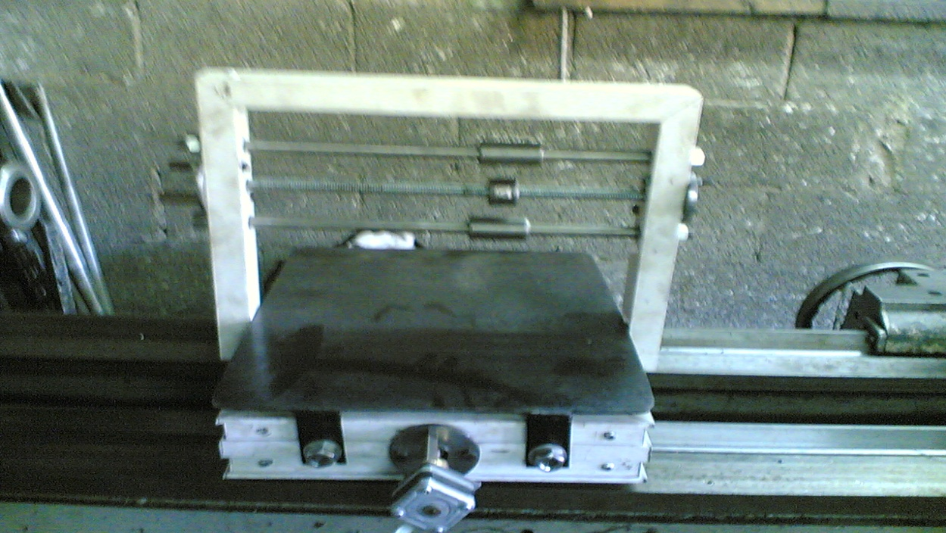

**Chapter three :**

**3. The Electrical System**

**3.1 Circuit Block Diagram**

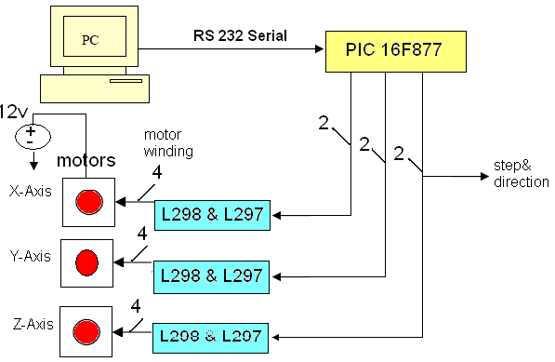

**3.2 Integrated Circuits Used**

PIC16F877 microcontroller

3 x L298 Push Pull Driver

3 x L297 stepper motor controller

**4. Implementing the chips**

**4.1 PIC16F877 microcontroller**

The purpose of the PIC16F877 is to abstract away the complexities of moving the stepper motors to a position linearly, controlling 6 stepper motor control lines, and supplying the driving circuit with square clock pulse 500HZ, to send the 3-axis motors to the desired position.

Explanation:-

On startup, the mill assumes the position (0,0,0). All positions thereafter are relative to the startup position. Once a “go to” position has been received as G_code, the Mill Ready line is driven low, The mill first moves to the (X,Y) position and then changes the Z-axis position if needed.

The basic circuit of pic16f877 :

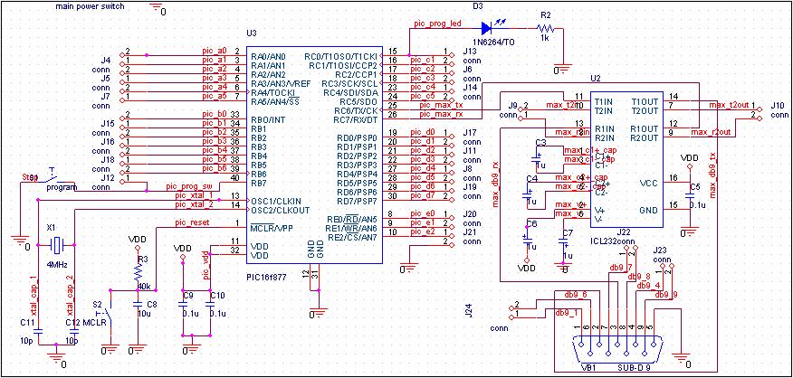

**4.2 L298 Push Pull Driver**

The purpose of the L298 Push Pull Driver is to allow the bipolar stepper motor to draw high current up to 2.5amp.

Explanation:-

The L298 is an integrated monolithic circuit in a 15- lead Multi watt and PowerSO20 packages. It is a high voltage, high current dual full-bridge driver designed to accept standard TTL logic levels and drive inductive loads such as relays, solenoids, DC and stepping motors. Two enable inputs are provided to enable or disable the device independently of the input signals. The emitters of the lower transistors of each bridge are connected together and the corresponding external terminal can be used for the connection of an external sensing resistor. An additional supply input is provided so that the logic works at a lower voltage.

**4.3 L297 stepper motor controller**

The L297/A/D Stepper Motor Controller IC generates four phase drive signals for two phases bipolar and four phase unipolar step motors in microcomputer- Controlled applications. The motor can be driven in half step, normal and wave drive modes and on-chip PWM chopper circuits permit switch mode control of the current in the windings. A feature of this device is that it requires only clock, direction and mode input signals. Since the phase are generated internally the burden on the microprocessor, and the programmer, is greatly reduced.

**Circuit schematic**

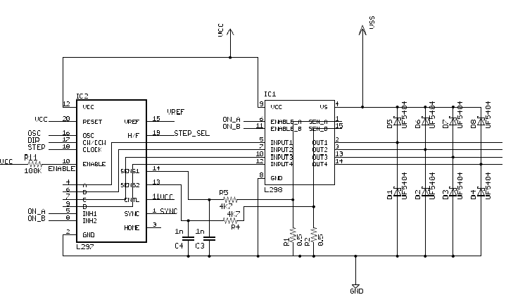

Driving circuit:

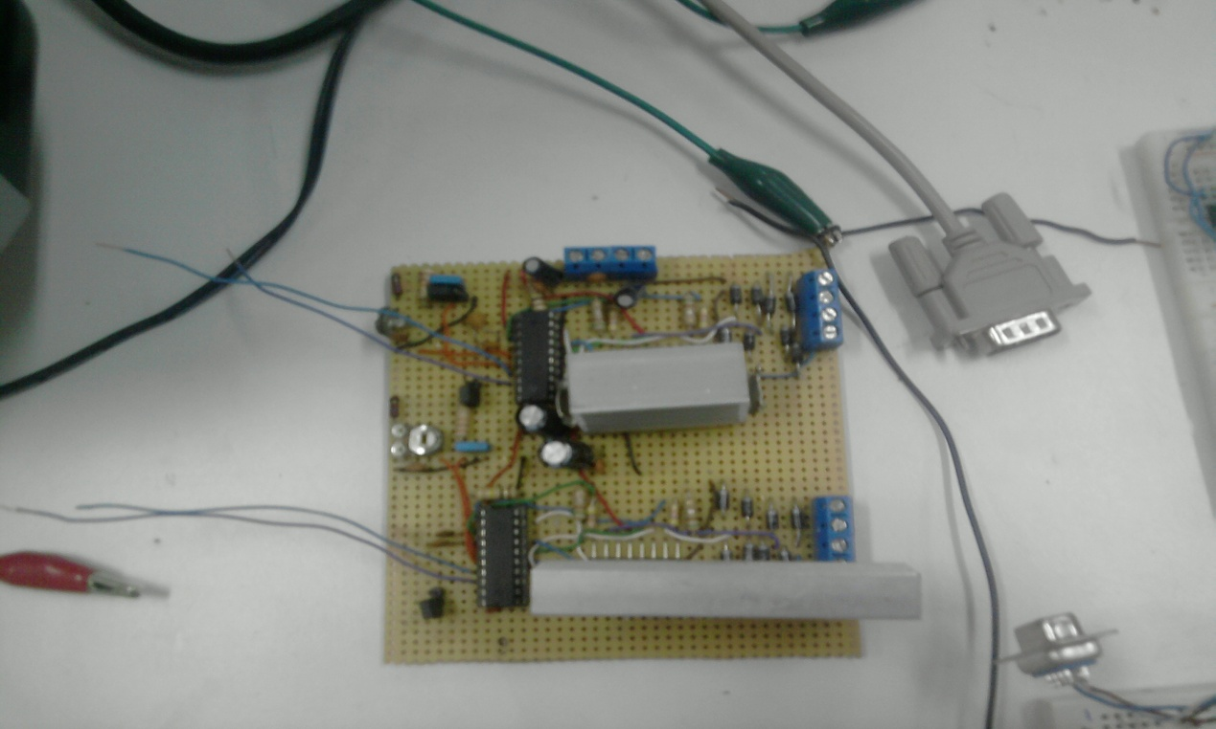

The pic microcontroller and motor driving circuit:

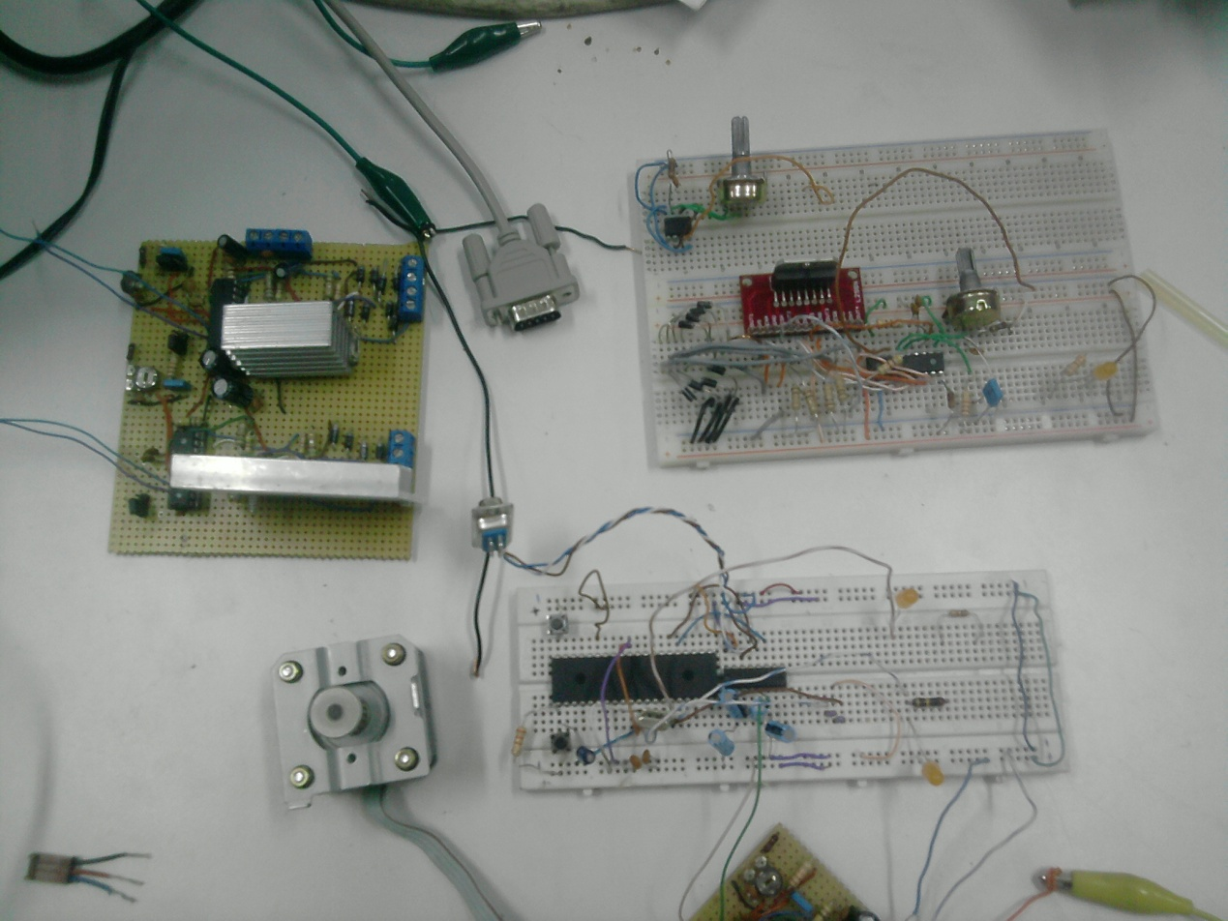

**Chapter four :**

**5. PCB Mill Software**

**5.1Purpose**

The purpose of the PCB Mill software is to provide a graphical environment that allows the user to easily create, modify, visualize, and convert different types of plotter files to DXF (AutoCAD) file, we use for this purpose two programs

1-Image-CAD

2-ExpressPCB

Image-CAD can convert any type of plotter files into DXF, EMF, WMF, HPGL, Text file, but we take DXF file. ExpressPCB is more specified it can just convert ExpressPCB files to DXF file with these options

1. silk screen layer.
2. Pads on top copper layer.
3. Text on top copper layer.
4. Pads on bottom copper layer.
5. Holes.

Examples

Express PCB picture before converting

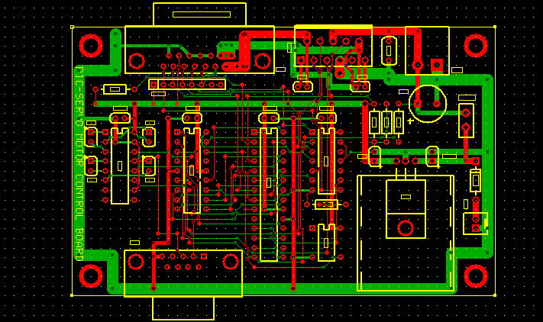

After converting to holes

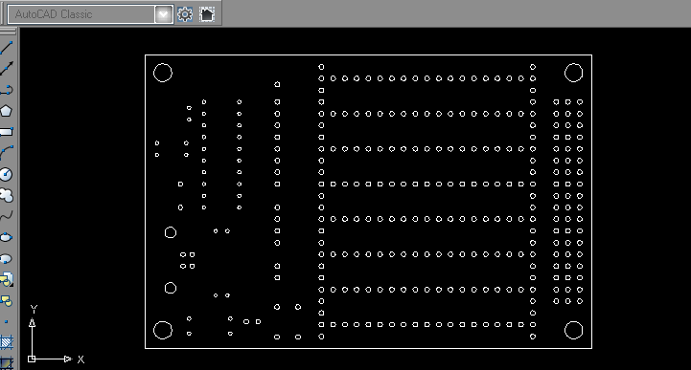

**Image-CAD program**

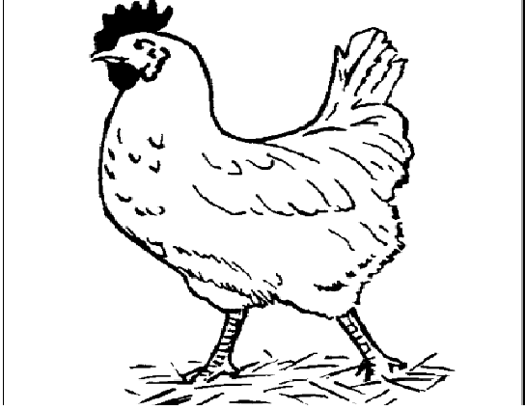

Picture before converting

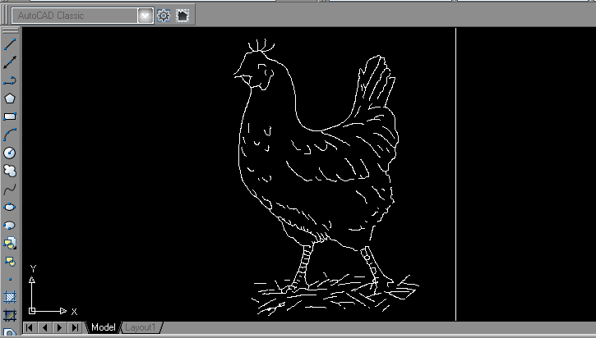

Picture after converting to DXF file.

After this step we will convert these DXF files to G_code by using (Kcam4) program which will transmit this G_code serially to the PIC microcontroller.

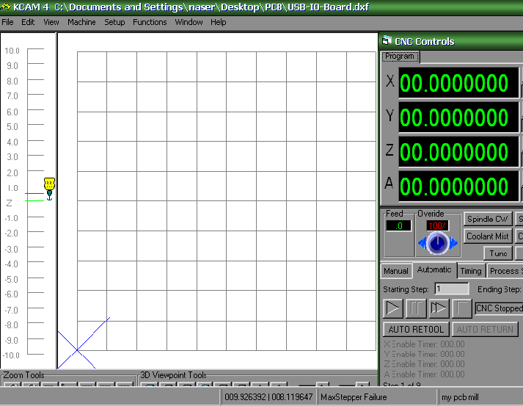

**Kcam4**

G_code shape

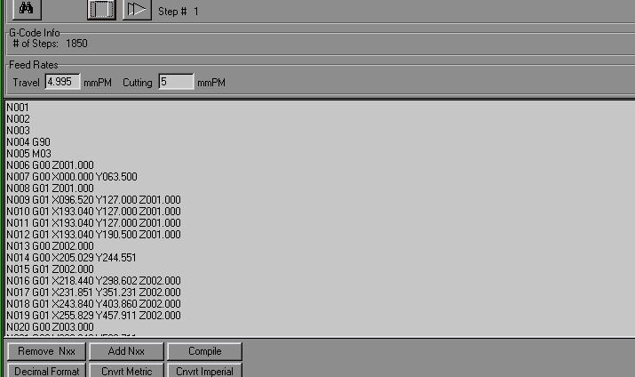

**References:**

1. <http://www.alldatasheet.com>.
2. [www.microkinetics.com](http://www.microkinetics.com)
3. [www.**cnc**masters.com](http://www.cncmasters.com)
4. Build your own CNC machine

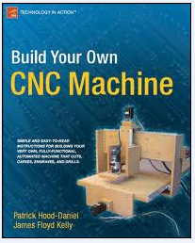

1. CNC robotic by Ceoff Williams

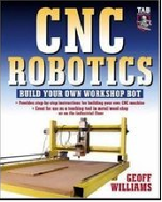

**Appendix**

**Cost analysis:**

|  |  |
| --- | --- |
| NAME OF SYSTEM | cost |
| New mechanical system | 700 nis |
| Old mechanical system | 850 nis |
| Electrical system | 500 nis |
| Software | 100 nis |

**Total cost : 2150 nis .**

**The pic code:**

**#include "C:\Documents and Settings\naser\Desktop\PICC Code\Final Code.h"**

**#include <string.h>**

**#include <stdlib.h>**

**#include <math.h>**

**int i,k;**

**signed int32 drag,oil; //vars dealing with feedrate and delay func**

**int feedrate;**

**unsigned int stepnum;**

**signed int32 x1,y1; //starting point**

**signed int32 x2,y2; //relative position**

**signed int32 x3,y3; //endpoint**

**signed int8 x0,y0; //direction of output: +1, -1, or 0**

**signed int32 dx,dy; //differentials of x and y**

**signed int32 fxy; //value of function**

**int f,a,b,d;**

**signed int32 rad,radrad;**

**char Gcode[2];**

**char c;**

**char xx[5];**

**char yy[5];**

**char zz[5];**

**char ii[5];**

**char jj[5];**

**signed int32 iv;**

**signed int32 jv;**

**signed int32 dxx,dyy;**

**void go_up()**

**{**

**output_low(pin_d1); // enable the clock pulse**

**output_high(pin_d2); // make move into CW direction**

**delay_ms(15);**

**}**

**void go_down()**

**{**

**output_low(pin_d1); // enable the clock pulse**

**output_low(pin_d2); // make move into CCW direction**

**delay_ms(15);**

**}**

**void go_right()**

**{**

**output_low(pin_d3); // enable the clock pulse**

**output_high(pin_d4); // make move into CW direction**

**delay_ms(15);**

**}**

**void go_left()**

**{**

**output_low(pin_d3); // enable the clock pulse**

**output_low(pin_d4); // make move into CCW direction**

**delay_ms(15);**

**}**

**void go_pos(signed int32 x,signed int32 y)**

**{**

**int count;**

**signed int32 k;**

**signed int32 xxx,yyy;**

**for(count=0;count<4;count++){xx[count]='.';}**

**for(count=0;count<4;count++){yy[count]='.';}**

**xxx=x-x1;**

**yyy=y-y1;**

**//delay_ms(1);**

**if(yyy>0)**

**{**

**output_a(0x00);**

**for(k=0;k<yyy;k++)**

**{**

**go_up();**

**}**

**}**

**else if(yyy<0)**

**{**

**yyy=abs(yyy);**

**output_a(0x00);**

**for(k=0;k<yyy;k++)**

**{**

**go_down();**

**}**

**}**

**if(xxx>0)**

**{**

**output_d(0x00);**

**for(k=0;k<xxx;k++)**

**{**

**go_right();**

**}**

**}**

**else if(xxx<0)**

**{**

**xxx=abs(xxx);**

**output_d(0x00);**

**for(k=0;k<xxx;k++)**

**{**

**go_left();**

**}**

**}**

**x1=x;**

**y1=y;**

**// printf("*");**

**}**

**void movex(signed int x0)**

**{**

**if (x0==-1)**

**{**

**//output_d(0x00);**

**go_left();**

**}**

**else if(x0==1)**

**{**

**//output_d(0x00);**

**go_right();**

**}**

**}**

**void movey(signed int y0)**

**{**

**if(y0==-1)**

**{**

**//output_a(0x00);**

**go_down();**

**}**

**else if(y0==1)**

**{**

**// output_a(0x00);**

**go_up();**

**}**

**}**

**void delay()**

**{**

**int i=0;**

**while (++i != ((feedrate + drag) / 30))continue;**

**if(drag > 0)**

**{**

**drag =drag - (oil*oil);**

**--oil;**

**if(drag < 0)**

**drag =0;**

**}**

**}**

**//****************************Circular Interpolation\*\*\*\*\*\*\*\*\*\*\*\*\*\*\*\*\*\*\*\*\*\*\*\*\***

**void getdir()**

**{**

**int binrep;**

**binrep = 0;**

**x0 = y0 = 0;**

**if(d)binrep = binrep + 8;**

**if(f)binrep = binrep + 4;**

**if(a)binrep = binrep + 2;**

**if(b)binrep = binrep + 1;**

**switch(binrep)**

**{**

**case 0: y0 = -1; break;**

**case 1: x0 = -1; break;**

**case 2: x0 = 1; break;**

**case 3: y0 = 1; break;**

**case 4: x0 = 1; break;**

**case 5: y0 = -1; break;**

**case 6: y0 = 1; break;**

**case 7: x0 = -1; break;**

**case 8: x0 = -1; break;**

**case 9: y0 = 1; break;**

**case 10: y0 = -1; break;**

**case 11: x0 = 1; break;**

**case 12: y0 = 1; break;**

**case 13: x0 = 1; break;**

**case 14: x0 = -1; break;**

**case 15: y0 = -1; break;**

**}**

**}**

**void circle()**

**{**

**for(i=0;i<4;i++){xx[i]='.';}**

**for(i=0;i<4;i++){yy[i]='.';}**

**drag =100;**

**oil =1;**

**x2 = x1-iv;**

**y2 = y1-jv;**

**rad =sqrt((x2*x2)+(y2*y2));**

**x3=x3-iv;**

**y3=y3-jv;**

**radrad = rad * rad;**

**//delay_ms(1);**

**do**

**{**

**delay();**

**dxx=x2*x2;**

**dyy=y2*y2;**

**fxy = dxx+dyy-(radrad);**

**dx = 2*x2;**

**dy = 2*y2;**

**f = (fxy < 0)? 0 : 1;**

**a = ( dx < 0)? 0 : 1;**

**b = ( dy < 0)? 0 : 1;**

**getdir( );**

**movex(x0);**

**movey(y0);**

**x2 = x2 + x0;**

**y2 = y2 + y0;**

**}while((x2 != x3) || (y2 != y3));**

**x1=x2+iv;**

**y1=y2+jv;**

**}**

**//****************************Linear Interpolation \*\*\*\*\*\*\*\*\*\*\*\*\*\*\*\*\*\*\*\*\*\*\*\*\*\***

**void setdirection() //sets output directions and initial fxy value for line**

**{**

**dy =y3 - y1;**

**if(dy < 0)**

**{**

**y0 =-1;**

**}**

**else**

**{**

**y0 =1;**

**}**

**dy =abs(y3 - y1);**

**dx =x3 - x1;**

**if(dx < 0)**

**{**

**x0 =-1;**

**}**

**else**

**{**

**x0 =1;**

**}**

**dx =abs(x3 - x1);**

**fxy =dx - dy;**

**}**

**void doLine()**

**{**

**stepnum =x2 =y2 =fxy =0;**

**drag =100;**

**oil =1;**

**setdirection();**

**//delay_ms(1);**

**while((x2 != dx) || (y2 != dy)) // at endpoint?**

**{**

**delay();**

**if(fxy > 0)**

**{**

**movex(x0);**

**++x2;**

**fxy = fxy - dy;**

**}**

**else**

**{**

**movey(y0);**

**++y2;**

**fxy = fxy + dx;**

**}**

**}**

**x1 = x3;**

**y1 = y3;**

**}**

**int flag;**

**void Recv_file()**

**{**

**flag =0;**

**restart_wdt();**

**while(!flag)**

**{**

**c =getc();**

**if(c == 'G' || c == 'M')**

**flag =1;**

**}**

**if(c == 'G')**

**{**

**Gcode[0] = getc();**

**Gcode[1] = getc();**

**if(Gcode[0] == '0')**

**{**

**switch(Gcode[1])**

**{**

**case '0':**

**c = getc();**

**c = getc();**

**if(c == 'X')**

**{**

**for(i=0;i<4;i++)**

**{**

**c = getc();**

**if(c == ' ')**

**{**

**xx[i] =".";**

**break;**

**}**

**xx[i] = c;**

**// printf("%c",xx[i]);**

**}**

**xx[4] = '\0';**

**while(getc() != 'Y'){}**

**for(i=0;i<4;i++)**

**{**

**c = getc();**

**if(c == ' ')**

**{**

**yy[i] =".";**

**break;**

**}**

**yy[i] = c;**

**// printf("%c",yy[i]);**

**}**

**yy[4] = '\0';**

**while(getc() != ';'){}**

**}**

**else if(c == 'Z')**

**{**

**for(i=0;i<4;i++)**

**{**

**xx[i] = '0';**

**yy[i] = '0';**

**}**

**while(getc() != ';'){};**

**}**

**break;**

**case '1':**

**c = getc();**

**c = getc();**

**if(c == 'Z')**

**{**

**for(i=0;i<4;i++)**

**{**

**c = getc();**

**if(c == ' ')**

**{**

**zz[i] =".";**

**break;**

**}**

**zz[i] = c;**

**// printf("%c",zz[i]);**

**}**

**if(c != ';')**

**{**

**while(getc() != ';')**

**{}**

**}**

**} // End if(c == 'Z')**

**else if(c == 'X')**

**{**

**for(i=0;i<4;i++)**

**{**

**c = getc();**

**if(c == ' ')**

**{**

**xx[i] =".";**

**break;**

**}**

**else**

**{**

**xx[i] = c;**

**//printf("%c",xx[i]);**

**}**

**}**

**xx[4] = '\0';**

**// printf("%s",xx);**

**while(getc() != 'Y'){}**

**for(i=0;i<4;i++)**

**{**

**c = getc();**

**if(c == ' ')**

**{**

**yy[i] =".";**

**break;**

**}**

**else**

**{**

**yy[i] = c;**

**//printf("%c",yy[i]);**

**}**

**}**

**yy[4] = '\0';**

**while(getc() != ';'){}**

**}**

**break;**

**case '2':**

**c = getc();**

**c = getc();**

**if(c == 'X')**

**{**

**for(i=0;i<4;i++)**

**{**

**c = getc();**

**if(c == ' ')**

**{**

**xx[i] =".";**

**break;**

**}**

**xx[i] = c;**

**//printf("%c",xx[i]);**

**}**

**xx[4] = '\0';**

**while(getc() != 'Y'){}**

**for(i=0;i<4;i++)**

**{**

**c = getc();**

**if(c == ' ')**

**{**

**yy[i] =".";**

**break;**

**}**

**yy[i] = c;**

**}**

**yy[4] = '\0';**

**while(getc() != 'I'){}**

**for(i=0;i<4;i++)**

**{**

**c = getc();**

**if(c == ' ')**

**{**

**ii[i] =".";**

**break;**

**}**

**ii[i] = c;**

**// printf("%c",ii[i]);**

**}**

**ii[4] = '\0';**

**while(getc() != 'J'){}**

**for(i=0;i<4;i++)**

**{**

**c = getc();**

**if(c == ' ')**

**{**

**jj[i] =".";**

**break;**

**}**

**jj[i] = c;**

**//printf("%c",jj[i]);**

**}**

**jj[4] = '\0';**

**if(c != ';')**

**{**

**while(getc() != ';'){}**

**}**

**}**

**d = 1;**

**break;**

**}//End Switch Statment**

**} // End if(Gcode[0] == '0')**

**else**

**{**

**break;**

**}**

**}**

**else if(c == 'M')**

**{**

**c = getc();**

**if(c == '3')**

**{**

**c =getc();**

**if(c == '0')**

**{**

**printf("End");**

**return;**

**}**

**}**

**}**

**restart_wdt();**

**}**

**void main()**

**{**

**char cc;**

**int counter;**

**int linecounter;**

**int circlecounter;**

**setup_adc_ports(NO_ANALOGS);**

**setup_adc(ADC_OFF);**

**setup_psp(PSP_DISABLED);**

**setup_spi(FALSE);**

**setup_timer_2(T2_DISABLED,0,1);**

**// TODO: USER CODE!!**

**set_tris_b(0x00);**

**x1=0;y1=0;**

**x2=0;y2=0;**

**x3=0;y3=0;**

**iv=0;jv=0;**

**feedrate=100;**

**counter = 0;**

**linecounter = 0;**

**circlecounter = 0;**

**output_high(pin_a5); // Active Enable Pin**

**output_low(pin_b2); // Active INH1 and INH2 for Control pin**

**output_low(pin_b3); // Active the full step Half/Full pin**

**while(1)**

**{**

**if(kbhit())**

**cc = getc();**

**if(cc == '1')**

**{**

**cc =' ';**

**Recv_file();**

**y3 = atoi32(yy);**

**x3 = atoi32(xx);**

**go_pos(x3,y3);**

**delay_ms(9000);**

**printf("*");**

**}**

**else if(cc == '2')**

**{**

**cc =' ';**

**Recv_file();**

**y3 = atoi32(yy);**

**x3 = atoi32(xx);**

**doLine();**

**printf("*");**

**}**

**else if(cc == '3')**

**{**

**cc =' ';**

**Recv_file();**

**y3 = atoi32(yy);**

**x3 = atoi32(xx);**

**iv = atoi32(ii);**

**jv = atoi32(jj);**

**circle();**

**printf("*");**

**}**

**else if(cc == '4')**

**{**

**cc= ' ';**

**Recv_file();**

**// output_low(pin_a4);**

**// output_low(pin_a5);**

**// output_low(pin_d4);**

**// output_low(pin_d5);**

**printf("*");**

**}**

**else if(cc == 'A')**

**{**

**cc =' ';**

**printf("*");**

**}**

**else if(cc == '!')**

**{**

**//Reset Pin**

**// output_low(pin_a4); // chnage to the pin that connect to ResetPin**

**// Enable Pin**

**// output_low(pin_a5); // disable the cip and put the status to low**

**}**

**else if(cc == '*')**

**{**

**cc =' ';**

**printf("*");**

**}**

**}**

**}**