AN-Najah National University

Faculty Of Engineering

ELECTRICAL ENGINEERIG DEPARTMENT

“Graduated project”

“Power plug-meter”

**Student name:**

**_Haifa Sairy.**

**_Nour Khreim.**

**Supervised by:**

**Dr. Mazen Rasekh**

**Abstract:**

Chapter one: introduction.

Chapter two: Applications.

Chapter three: background calculations.

Chapter four: hardware components

Chapter five: procedure

Chapter six: logical and hardware instruction.

Chapter seven: safety.

Chapter eight: results and conclusion.

Chapter nine: Future scenarios.

**Chapter one:**

**Introduction**

With the ever-rising cost of electricity, we're all getting increasingly sensitive about how much power our computers, televisions, appliances and other products are using - not just when we're using them, but also when they're allegedly turned off.

Some, like refrigerators, aren't running full tilt all the time. Others, such as computers, printers, displays and other gear, have "sleep" modes, they power down significantly but they're still on. And some devices, like televisions and cable boxes, aren't really off when we push that "Off" button or switch. All are still drawing a small amount of power, a phenomenon that's called "parasitic load."

**Power plug-meter:** It’s a device which can measure, in real time and have the facilities to output and represents various aspects of AC power. It can also act as a computer-controlled remote switch.

A power plug meter, which also called a "plug load meter" sits in between the power outlet and an individual device and displays how much power (load) the connected device is consuming at the moment.

**Chapter two:**

**Project applications**

Using the device is very easy for users it’s need only to plug in the unit under investigation and flip a switch to turn on the hardware portion ,after that the software portion is enabled , for the purpose of monitoring and reporting power values related to power consumption through running the hyper terminal on windows.

This device is focused on helping users to resolve power related issues in applications that require a mixture of fairly high power levels with sensitive electronic equipment.

Power plug meter can determine the minimum and maximum power consumed by the device ,the energy, the current and the voltage .Having all this information can help you decide whether it's worth turning off or unplugging your TV, desktop or cordless phone when it's not in use or whether your current device should be replaced.

We can see the importance of this device, and it will be useful in various aspects and many applications in many places such as houses, factories, laboratories and electrical equipments shops.

**Chapter three:**

**Background calculations**

In an AC circuit voltage, current, and power are defined as the following:

$$v\left(t\right)=V*cos(wt)$$

**i(t)=I*cos(wt-φ)**

**p(t)= v(t)*i(t)=V*I*cos(wt)*cos(wt-φ)**

When the load is purely resistive, voltage and current are in phase. When the load is either inductive or capacitive, voltage and current are out of phase.

The average (real) power, P. Real power is the energy that flows to the load. It is what the electric company bills home users for. It can then be written as:

**P=Vrms*Irms*cos(φ)**

Reactive power, Q, is the energy that flows back and forth in an inductive or capacitive load. On average, no reactive power is consumed. It can be written as:

**Q=Vrms*Irms*sin(φ)**

Together, real power and reactive power form complex power. This is the actual power that the electric company is supplying. It can be written as:

**S=P+jQ**

**Chapter Four:**

**Hardware components**

For building the basic circuit of the project the following components are used:

1. **Current Sensor (ACS712) :**

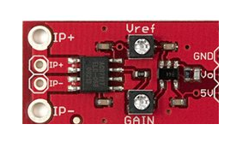

The following circuit show the internal structure of the current sensor:

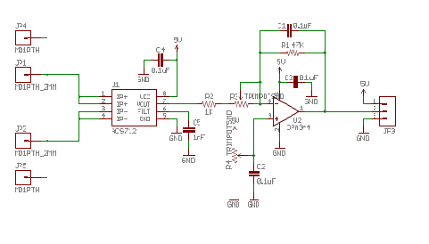

ACS712 provides economical and precise solutions for AC or DC current sensing in industrial, commercial, and communications systems. The device package allows for easy implementation by the customer. Typical applications include motor control, load detection and management, switched-mode power supplies, and over current fault protection.

The device consists of a precise, low-offset, linear Hall sensor circuit with a copper conduction path located near the surface of the die. Applied current flowing through this copper conduction path generates a magnetic field which is sensed by the integrated Hall IC and converted into a proportional voltage. Device accuracy is optimized through the close proximity of the magnetic signal to the Hall transducer. A precise, proportional voltage is provided by the low-offset, chopper-stabilized Bi CMOS Hall IC, which is programmed for accuracy after packaging.

The output of the device has a positive slope when an increasing current flows through the primary copper conduction path (from pins 1 and 2, to pins 3 and 4), which is the path used for current sensing. The internal resistance of this conductive path is 1.2 mΩ typical, providing low power losses.

The thickness of the copper conductor allows survival of the device at up to 5× over current conditions. The terminals of the conductive path are electrically isolated from the sensor leads (pins 5 through 8). This allows the ACS712 current sensor to be used in applications requiring electrical isolation without the use of opto -isolators or other costly isolation techniques.

**Features and benefits:**  
• Low-noise analog signal path  
• Device bandwidth is set via the new FILTER pin  
• 5 µs output rise time in response to step input current  
• 80 kHz bandwidth  
• Total output error 1.5% at TA = 25°C  
• Small footprint, low-profile SOIC8 package  
• 1.2 Omega internal conductor resistance  
• 2.1 kVRMS minimum isolation voltage from pins 1-4 to pins 5-8  
• 5.0 V, single supply operation  
• 66 to 185 mV/A output sensitivity  
• Output voltage proportional to AC or DC currents  
• Factory-trimmed for accuracy  
• Extremely stable output offset voltage  
• Nearly zero magnetic hysteresis  
• Ratio metric output from supply voltage

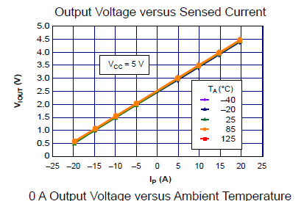

1. **Solid state relay:**

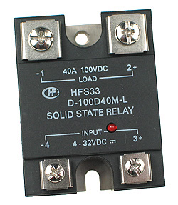

Solid-state relays (SSR) are able to perform many of the same tasks as electromechanical relay (EMR)s. The main difference is that SSRs have no moving mechanical parts within it. Essentially, it is an electronic device that relies on the electrical, magnetic, and optical properties of semiconductors and electrical components to achieve its isolation and relay switching function.

Principle of operation:

Both SSRs and EMRs use a control circuit and a separate circuit for switching the load. When voltage is applied to the input of the SSR, the relay is energized by a light-emitting diode. The light from the diode is beamed into a light-sensitive semiconductor that, in the case of zero-voltage crossover relays, conditions the control circuit to turn on the output solid-state switch at the next zero-voltage crossover. In the case of nonzero-voltage crossover relays, the output solid-state switch is turned on at the precise voltage occurring at the time. Removal of the input power disables the control circuit and the solid-state switch is turned off when the load current passes through the zero point of its cycle.

**Advantages:**

When used correctly in the intended application, the SSR provides many of the characteristics that are often difficult to find in the EMR; a high degree of reliability, long service life, significantly reduced electromagnetic interference, fast response and high vibration resistance. The SSR has no moving parts to wear out or arcing contacts to deteriorate that are often the primary cause of failure with an EMR.

- Long life (reliability) > 109 operations

- Zero-voltage turn-on, low EMI/RFI

-Shock and vibration resistant

-Random turn-on, proportional control

-No contact bounce

-Arc less switching

-No acoustical noise

-Microprocessor compatible

-Fast response

-No moving parts

Thermal considerations:  
 One of the major considerations when using an SSR is properly managing the heat that is generated when switching currents higher than about 5 amperes (A). In this case, the base plate of the SSR should be mounted onto a good heat conductor, like aluminum. Using this technique, the SSR case to heat sink thermal resistance is reduced to a negligible value.

1. **Thermal resistance:**

Thermal resistance is the [temperature](http://en.wikipedia.org/wiki/Temperature) difference across a structure when a unit of [heat](http://en.wikipedia.org/wiki/Heat) energy flows through it in unit [time](http://en.wikipedia.org/wiki/Time). It is the reciprocal of conductance. (It’s a measure of a material's ability to resist [heat transfer](http://www.wisegeek.com/what-is-heat-transfer.htm).)

1. **Transformer:**

The transformer used to decrease the voltage level from 220 v to 110 v.

1. **PIC Microcontroller :**

In this project the PIC(F16877A) is used .

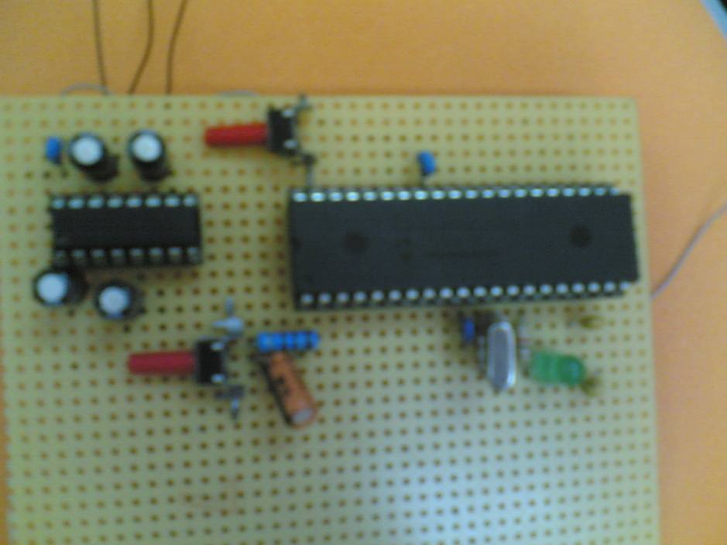

**Chapter Five:**

**Procedure**

The following procedure was made to achieve the aim of the project :-

1. **Calibrating the sensor**:

The following circuit builds to test the output of the sensor.

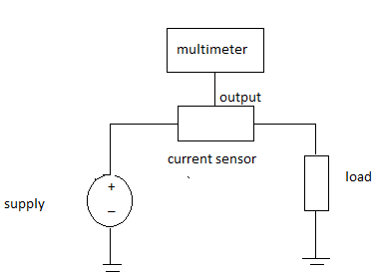

The sensor has two potentiometers one of them to calibrate the reference voltage and the other is the gain potentiometer to have more accuracy.

The voltage reference was setting at 2.5 volt at no load. The output of the sensor varies from 0 to 5 volt.

1. **Testing the solid state relay**:

There’s a very simple way to test an AC Solid State Relay. It just needs a 9 volt battery, a 40-100 Watt light bulb, and an AC source. As the following circuit:

The following circuit shows the way these devices should be connected. The DC control voltage will be the 9-volt battery with “+” connected to terminal 3 and “-“connected to terminal 4.On the load side (terminals 1 and 2) will have the light bulb (load) with one terminal connected to one side of the AC source (wall outlet) and the other terminal connected to terminal 2 of the relay (it can be connected to terminal 1 as they are electrically equivalent). The other wire of the AC source should be connected to terminal 1 of the relay to close the circuit.

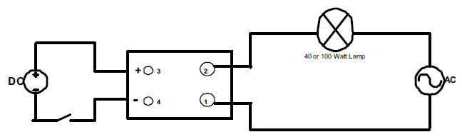

When this is connected, the battery should control when the light is on or off. Applying the9 volts DC will turn the light on and when you remove the DC voltage, the light bulb should turn-off.

If this does not occur, then, there’s a very high probability that the relay has been damaged.

For AC controlled relays the same applies, except that the control voltage will be AC instead of DC. The following figure shows a typical test setup for testing these relays.

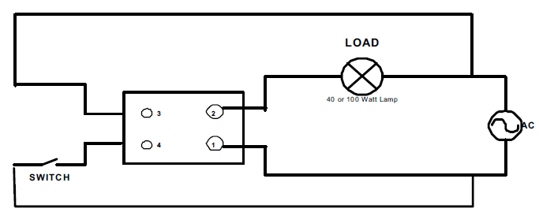

When the switch is open, the light should be off, and with the switch closed, the light should be on. Anything else will indicate a faulty relay.

**Chapter six:**

**logical and hardware instruction**

### Logical Structure

This device sits between the main line and the device under test. The relay is switched on the AC live line. A voltage divider will be used to step down the voltage to the correct level. All signals will be optically isolated ( for safety measures ) before reaching the MCU 'micro controller unit' .

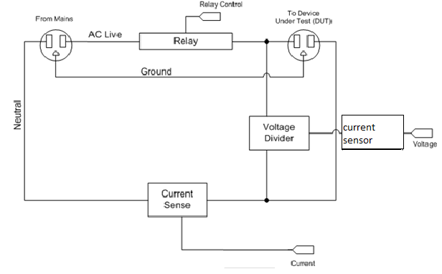

### Hardware / Software Tradeoffs

Hardware designed to bring voltage levels into the appropriate range from 0 to 5 volt for the PIC internal ADC. In software, a PIC will be employed to sample the voltage levels at a frequency of 4 khz and perform the appropriate calculations in real time. The software will also be handling the computer and controlling the relay switch.

**Hardware Design**

### Voltage Measurement

To measure voltage, the general idea is to use a very large voltage divider to divide the (220/sqrt 2) 157V peak-to-peak signal down to level which can be sampled by the ADC. Using a 1001:1 voltage divider (with 1 MΩ and 1 kΩ), 157V peak-to-peak is divided down to 0.157 V peak-to-peak. A very large resistor (1 MΩ) was used in the divider to limit the current between AC live and neutral. Assuming a 157 V drop, only 0.157 mA flows through the 1 MΩ resistor, dissipating 0.03 W, well within the power ratings of the resistor. To calculate the line voltage from the voltage divider output, the following equation can be used:

**V line= 1001 V divider**

### Current Measurement

To measure current, the general idea is to break the neutral line and insert the current-sensor which has internal resistance (1.2m Ω). This would create a small voltage difference across the resistor. Since we know the voltage drop and the resistor value, we can mathematically determine the current through the neutral line. Since the resistance is very small, very little power is dissipated through it. We carefully checked the ratings of this and other circuit components for power ratings.

The resistor is rated for 3 W. We expected a 200 W computer to draw about 1.7 A. This results in a voltage drop of 0.34 V and a power dissipation of 0.58 W. To calculate the line current from the current-sensing resistor voltage drop, the following equation can be used:

**I line= V current-sense/R current-sense (1.2mΩ)**

Opto isolators used to completely isolate the dangerous high voltage circuit from the MCU.This device has a linear transfer characteristics curve for input voltage. The input is differential and the output is scaled to V ref. This single chip allows biasing the signal to Vref / 2, amplify it, and isolate it. The ACS712 was used for both voltage and current measurements. Vref was set to 2.5v.

**Software Design:**

### ADC sampling

### An important feature of the PIC f16877A that it contains a function called ADC converts the analog input signal to digital samples.

**Current and voltage calculation**

### The samples calculated by ADC in the microcontroller are under comparison in order to find the maximum value and send it by the serial cable to the hyper terminal in windows for the display.

### Power Calculations

To calculate real power, voltage and current are multiplied during every sample and summed up. After 1000 samples are taken, the power summation is divided by 1000 to get the average power over 1 second. The following equation describes the operation:

$$\frac{\sum_{i=1}^{1000}{IV}}{1000}$$

To calculate apparent power, Vrms and Irms should be multiplied together every second. However, this is optimized as shown in the next section.

### Energy Calculation

To calculate energy used the average power every second will be converted into kilowatt-hours (divide by 3600) and summed.

### Relay Control

To make the system operated manually we add a switch to the relay to make the Power Meter function

The following is the software code used to program the PIC :

#include "C:\Users\Admin\Desktop\current Sensor\current.h"

float value1;

float value2;

float maxCurr=0;

float maxVol=0;

float sum=0;

int16 i=0;

long tmp;

void main()

{

setup_adc_ports(AN0_AN1_AN3);

setup_adc(ADC_CLOCK_INTERNAL);,

setup_psp(PSP_DISABLED);

setup_spi(FALSE);

setup_timer_0(RTCC_INTERNAL|RTCC_DIV_1);

setup_timer_1(T1_DISABLED);

setup_timer_2(T2_DISABLED,0,1);

setup_comparator(NC_NC_NC_NC);

setup_vref(FALSE);

// TODO: USER CODE!!

while(true)

{

restart_wdt();

set_adc_channel(0);// a0 current

delay_us(10);

value1 = read_adc();

value1 = value1 /1023;

value1 = value1 *5;

value1 = value1 /1.2;

if(value1 > maxCurr)

maxCurr = value1;

restart_wdt();

set_adc_channel(1);// a1 voltage

delay_us(10);

value2 = read_adc();

value2 = value2 /1023;

value2 = value2 *5;

if(value2 > maxVol)

maxVol = value2;

delay_ms(1);

if(i==1000)

{

i=0;

sum = sum /1000.0;

printf("power average %f\r\n", sum);

printf("current max %f\r\n", maxCurr);

printf("voltage max %f\r\n", maxVol);

}

else

{

tmp = value1 * value2;

sum = sum + tmp;

i= i+1;

}

}

}

**Chapter seven:**

Safety

Safety of the device achieved through the use of opto-isolators in the sensor as well as different power supplies. The board divided up into two regions, the MCU safe region, and the unsafe region. Across the regions are the white linear opto isolator and the isolated AC relay. These components ensure that the any wiring mistakes or accidents in the unsafe region will not affect the safe region, which is connected to the MCU, which in turn in connected to computer via serial.

Safety to the operator is achieved by following the same strict guidelines in wiring of a house. The colors of the power lines are always used so that live line is always black, neutral line is white, and ground line is green. Wire twists are used to connect two power wires as one would do in wiring a house socket. In addition to these precautions, we always test our device before a live AC test so that we do not cause any damage to any other equipments or people.

Other than the possible AC power short, this device should not interfere with anyone else’s design.

**Chapter eight:**

**Results and Conclusion**

The system gives us the scaled range from 0 to 5 volt that received to the micro controller and calculated to give the accurate value of current and voltage and power witch displayed on hyper terminal on Windows.

We chose a variable lamps as a load to test the Power Meter ; 100w lamp, 40 w lamp, 200w lamp and 150w lamp.

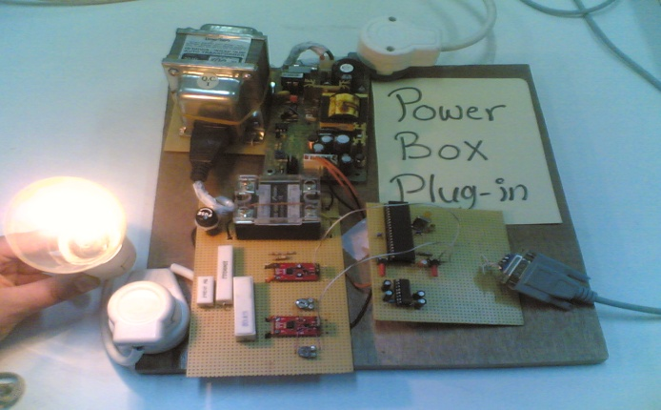

The following figures shows the complete system with results:

For load (40w):

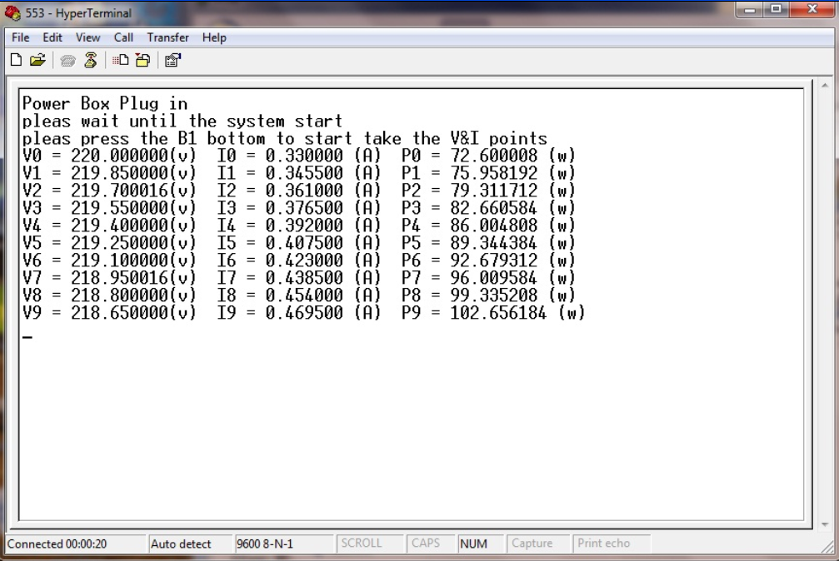

For load (60w):



For load (100w):

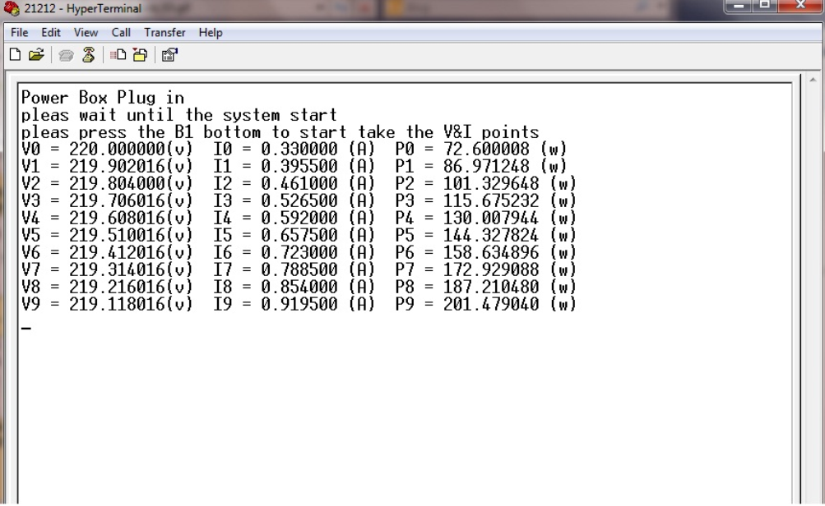

**Chapter nine: Future scenarios.**

**Power factor calculation:**

In the software part , there is a possibility to find the power factor value which represent the phase shift between the current and the voltage signal.

The main idea could be about setting two timers in the MCU as a reference to know where a sample of a certain value in the voltage signal how much it lags or leads a certain equal sample in the current signal, by this way we could measure the phase angle and after that measure the power factor as follow:

**PF= cos(φ)=P/S**

Finding the PF make it easy to find the apparent and reactive power.

**C# Graphing :**

A C# Windows application could be written to communicate with the MCU. Please note that all calculations will be done on the MCU. The C# application will be used to display the power graph and report values. It will be also used as a GUI to issue device commands. The EGUI open source library will be used for graphing.

**Wireless:**

in our product it might be able to replace the serial cable connecting product with the PC by a wireless device, this step will be very useful to make the controlling for devices much easier.

………..Done