بسم الله الرحمن الرحيم

Al-Najah National University
Electrical Engineering Department
Graduation project
24/05/2009
Nablus
Project Name:
Active Noise Reduction
The device that we specified in is the fan



Prepared by the students:
Ahlam Nwaeif Snouber
Safa Adnan Hashaiki

Supervisor Dr :
Jamal Kharoushi
الاهداء

نهدي عملنا المتواضع خالصا لله ورسوله
ومن ثم نبدأ بإهدائه لأرواح شهدائنا الابرار ولاسرانا البواسل مرورا بتغليفه هدية بسيطة لأهلنا الكرام من الأم والاب والأخوة وانتهاءا بتقديمه لدكاترتنا الكرام كل باسمه ونخص مشرفنا الاستاذ جمال خروشة ومعهم استاذنا الفاضل الأستاذ درويش ابوباشا والمهندس محمد دويكات ممن ساعدونا لاتمامه
كما نقدمه لزملائنا وزميلاتنا الأعزاء والصديقات كل في مكانه..

آملين أن يكون فيه خير لأمتنا ومجتمعنا

Contents
1.chapter one
1.1 back ground
1.2 abstract
1.3 introduction
1.4 application
2.chapter two
The kind of integrated circuit which we use
3.chapter three
The process
4. chapter four
The results
5. chapter five
Future development
6.chapter six
The problems which we face through working

CHAPTER ONE

1.1 Background

Sound cancellation
if the sound waves were 180° or one-half a wavelength out of phase, the sum of the waveforms would be zero. They would cancel out each other and there would be no sound.
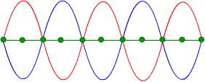
Sum of waves equals zero sound

How is it possible in air?
Although it is difficult to accept that adding two sounds can result in zero sound, you need to remember that sound is a compression wave in air or other media. That means the wave first compresses to an amount greater than normal air pressure. This is the positive part of the sine wave graphic. Then the air expands to a pressure less than normal air pressure. This is the negative part of the sine wave—the part below the zero centerline. Adding the positive pressure and negative pressure will give you the normal air pressure.

Canceling complex waves
Electronically, it would be simple to detect a simple tone, adjust it 180° out of phase and add it to the original, thus canceling out the sound. Unfortunately, most sound is much more complex than a simple sine wave.

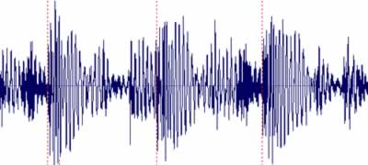
Complex waveform of a spoken word

Spectrum of frequencies
A spoken word consists of a spectrum of frequencies of different amplitudes. This means that to cancel out each waveform, the electronics would need to filter each frequency separately, determine its frequency, create the same frequency and amplitude at 180° out of phase, and then add it to the original.

Not perfect
Since there are so many frequencies and fractions of frequencies in some sounds, it is impossible to cancel them all out with this method. Instead, the electronics selects a narrow band of frequencies and averages out the result. This is a fairly good job at noise cancellation, but it is not 100%.

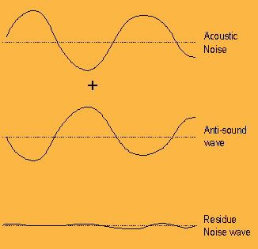

1.2 Abstract
The idea behind this project is that by picking up extraneous noise with a microphone on a pair of headphones, inverting that noise signal with a circuit, and playing the inverted signal back through the headphones' speakers, the two signals will add together to zero and cancel the noise.
The electronics consist of three op-amp circuits: a non-inverting pre-amp, a phase-inverter, and another inverting amplifier. The noise we hear is in stereo, as are the headphones, so the sound-cancelling headphones have two microphones and two circuits in parallel.
The circuit's input is the noise received by the microphones which are mounted on the headphones. The circuit's output is the inverted noise, and this output go to the headphones' speakers along with a "line-in" that could be the music you would usually be playing through your headphones.
Noise cancellation is an important concept to the improvement of our hearing as electronic technology (and the hum it makes) becomes more wide-spread. As we found, perfecting a sound-cancelling technique is difficult because of the precision and sensitivity required-- but the benefits of a simply built system like ours are also important.

1.3 Introduction

Our project rely on the passive acoustic isolation of speakers as well as ANR to provide broadband noise reduction (figure A).
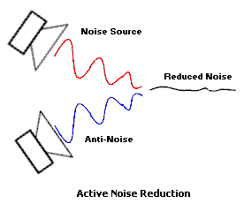

Figure A
ANR systems create anti-noise by first sampling the noise with a microphone. In an open-loop systemAn inverting amplifier outputs the anti-noise signal which is then mixed with the desired audio signal before being played back in the speaker.

Anti-noise is simply an inverted version of the noise signal, so that when noise and anti-noise meet, they cancel each other. The effect is a manifestation of the Superposition Principle. When two identical soundwaves combine that are 180 degrees out of phase, the result is destructive interference.

Open loop systems have the advantage of simplicity, but may not perform as well as other NC types.
On average, open-loop ANR can attenuate noise by 10 to 15dB. It is commonly found in NC for professionals and consumers in a variety of wear and transducer styles (circumaural, supra-aural, open-air, closed-ear, etc.). The open-air and supra-aural styles do not provide substantial passive attenuation, so higher frequency sounds (such as voice) will remain audible

1.4 Applications

First of all, noise has been known to cause stress. Loud noises will give you headaches and make you feel unwell. Constant noise can also give you unhealthy stress that builds up over a long period of time

There are a number of great applications for active noise cancellation devices.
Noise cancellation almost requires the sound to be cancelled at a source, such as from a loud speaker. That is why the effect works well with headsets, since you can contain the original sound and the canceling sound in an area near your ear. In applications where the sound comes from many areas, such as in a room, it is difficult to cancel the sound from each area. But, scientists and engineers are working on solutions.

Headsets
One obvious application is that people working near aircraft or in noisy factories can now wear these electronic noise cancellation headsets to protect their hearing.
Students can wear these headsets to cancel out unwanted noise, while being able to listen to their own music while they study. These headsets are now fairly inexpensive, costing around $50.



Honda cars
Honda is now using noise-cancellation technology in their Japan-only Accord station wagon.
The way it works is that a microphone connected to the car stereo system picks up all the sound inside the car, including music or such from the stereo. Then the noise-cancellation system subtracts the sound of the music coming from the stereo and produces noise-canceling sound waves that match the frequency of unwanted sound.
The noise-canceling sound waves are also sent through the stereo speakers, along with the music. This technique greatly reduces the low frequency vibration noises in the car, without dampening the car's audio system.
Unfortunately, Honda is not shipping the noise-cancellation system outside Japan.



Space satellite antennas
Some space satellites have long antennas. If such an antenna would start to vibrate wildly, it could throw the satellite out of orbit and out of control. By detecting the waveform or any vibration in the antenna, it can be suppressed in the same way that noise is suppressed.
Finally, it has been speculated that infrasonics can affect the heart and cause heart dysrhythmia. Low-frequency sound cancellers are therefore important for people who live near airports or bridges, which both give out a lot of low-frequency sounds .

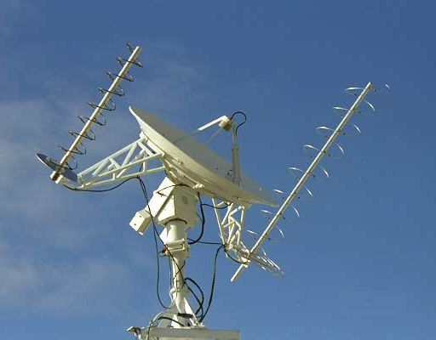

CHAPTER TWO

THE KIND OF INTEGRATED CIRCUIT WHICH WE USE…
1.
Description( NE5532,OP275):-
The NE5532 is a internally compensated dual low noise
OP-AMP. The high small signal and power bandwidth
provides superior performance in high quality AMP, all
control circuits, and telephone applications.

Features
• Internal Frequency Compensation
• Slew Rate: 8V/s
• Input Noise Voltage:
• Full Power Bandwidth: 140KHz

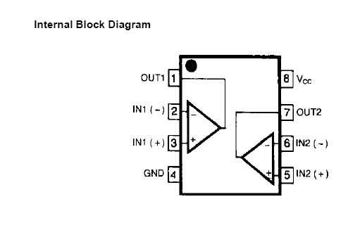

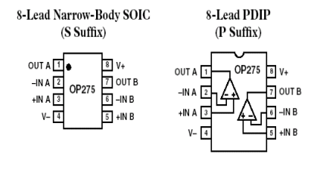

Pin Configuration Diagram for OP275

LM358
Description
The LM358 consist of
two independent, high gain, internally frequency
compensated operational amplifiers which were designed
specifically to operate from a single power supply over a
wide range of voltage. Operation from split power supplies
is also possible and the low power supply current drain is
independent of the magnitude of the power supply voltage.
Application areas include transducer amplifier, DC gain
blocks and all the conventional OP-AMP circuits which now
can be easily implemented in single power supply systems.

Features
• Internally Frequency Compensated for Unity Gain
• Large DC Voltage Gain: 100dB
• Wide Power Supply Range:
LM258/LM258A, LM358/LM358A: 3V~32V (or ±1.5V
~ 16V)
LM2904 : 3V~26V (or ±1.5V ~ 13V)
• Input Common Mode Voltage Range Includes Ground
• Large Output Voltage Swing: 0V DC to Vcc -1.5V DC
• Power Drain Suitable for Battery Operation.

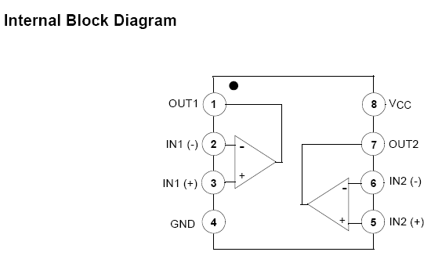

TBA810
The TBA810 is an integrated circuit in a 12-lead quad in-line plastic
package, intended for use as a low frequency class B amplifier.

CHAPTER THREE

The Process

Before we started, we considered trying the following experiments:
- Sound canceling using analog devices
- Sound canceling using software
- Noise cancellation specific to erasing ambient noise and keeping directional noise
We decided to start with sound cancelling using an analog circuit, and go on if we had time (which we didn't).
We obtained:
- Hi-Fi opamps
- several resistors of varying resistances
- electret-condenser microphones
- speaker
- bread board, wire, etc
- tba810 integrated circuit
- LM358 circuit
- (that we didn't use)
bread boar Experimentation
We started by building the circuit. As we went we got a lot of circuits debugging experience! We learned the truly inifinite benefits of the multimeter ,oscilloscope ,measurements ,orcad,capture software to check our circuits and designing it.
.
- d, wire, etc

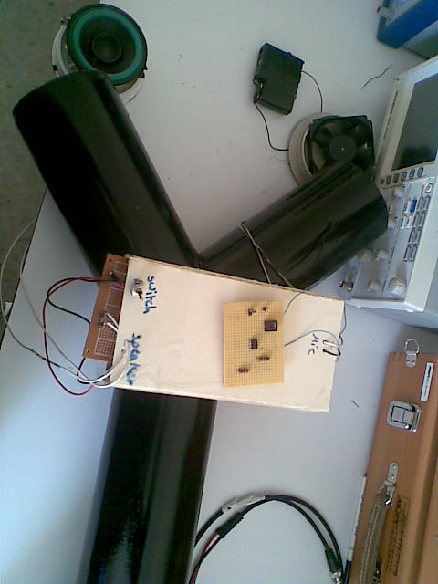

1- the circuit of the microphone which is used to pass the original signal is as follows
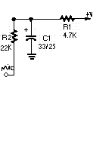
The schematic diagram in Fig. 1 shows the design of the electronics portion of the project. A microphone is connected to J1, a 1/8-inch stereo jack. Electret-condenser microphones need a 2- to 10-volt bias voltage for their internal FET pre-amps. That is supplied by R2. A voltage-dividing network, which also decouples the bias volt-age from the power supply, is provided by Rl and Cl. That is necessary due to the high gain of the entire signal chain.

The first stage
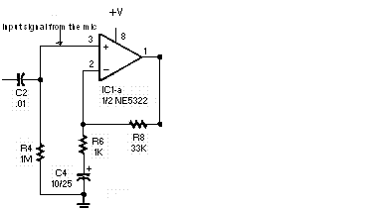

The result of the first stage

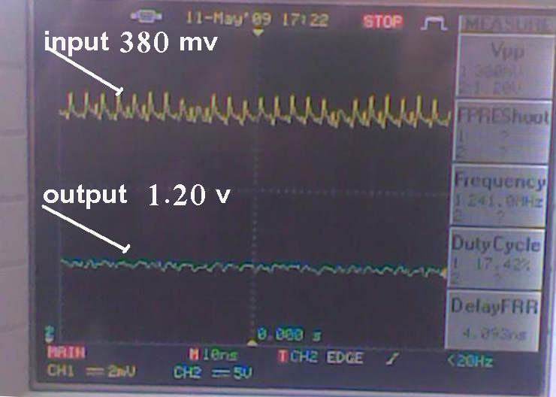

The signals from the microphone then go to ICl-a. an NE5532 set up as a standard non-inverting pre-amp. The gain is set to one plus the ratio of R8/R6 in the feedback path (1+R8/R6) . The total gain for that stage is about 31 dB. Resistor R4 provides a ground reference for the pre-amp. A pair of high-pass filters is formed by C2/R4 and C4/R6. Those filters block any DC that tries to slip through the pre-amp.

The second stage

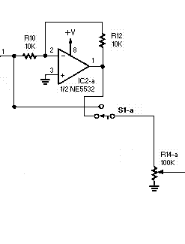

The result of the second stage
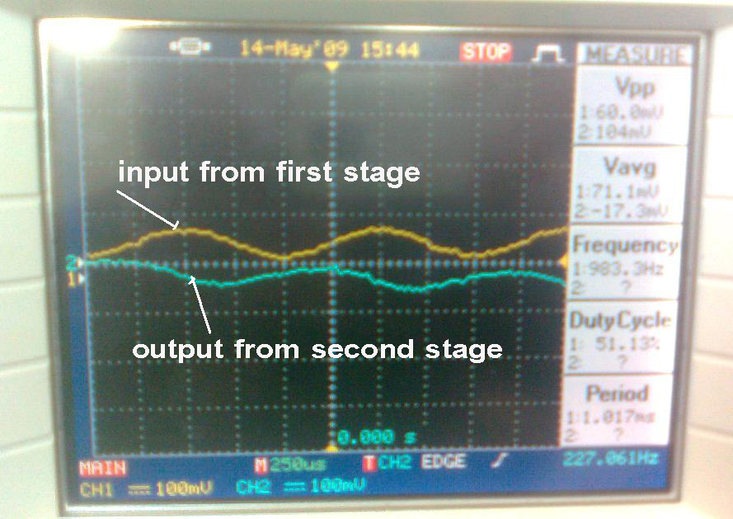

From the output of the pre-amp, the microphone signal is sent down two different paths. It feeds both one pole of Sl-a and the phase-inverter. The phase inverter is nothing more than a second NE5532 configured as
a unity-gain inverting op-amp
(IC2-a). The output of IC2-a is connected to the other pole of
Sl-a.
That way,
Sl-a can select either the inverted or the non-inverted signal. The selected signal on Sl-a’s common pole goes to potentiometer R14-a. That potentiometer sets the level of the microphone signal feeding the speaker amplifier.

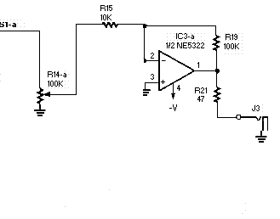
The speaker amplifier is built around IC3-a, a third NE5532 wired as an inverting op-amp stage.
The gain here is set by the ratio of R19/R15. That type of op-amp configuration can be easily modified to add a summing feature by the inclusion of another load
So that we use another circuit to do the same work with out that summing which is the TBA810 CIRCUIT as follows
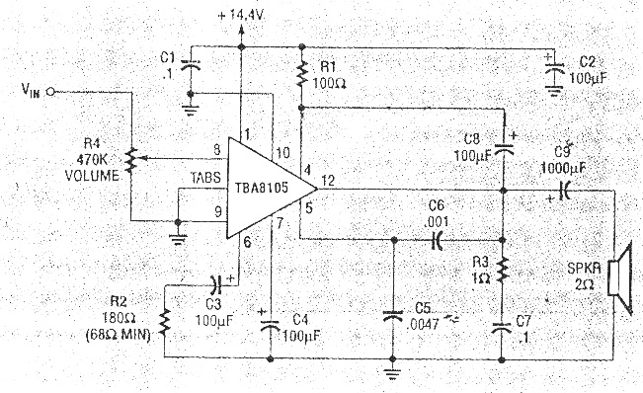
this is Circuit is power amp 7W mono. Use IC TBA810 ( OLD IC).
Output to Speaker 4 OHM. Power Supply 12-14.4V.

7 W AUDIO POWER AMPLIFIER WITH THERMAL SHUT-DOWN
The TBA810 S is an integrated circuit in a 12-lead quad in-line plastic
package, intended for use as a low frequency class B amplifier.
The TBA810 S provides 7 W output power at 16 V/4 O 6 W at 14.4 V/4 8,
2.5 W at 9 V/4 8, 1 W at 6 V/4 51 and works with a wide range of supply voltages
(4 to 20 V); it gives high output current (up to 2.5 A), high efficiency (75% at 6 W
output), very low harmonic and cross-over distortion. The circuit is provided with
a thermal limiting circuit which fundamentally changes the criteria normally used in
determining the size of the heatsink, in addition the TBA 810 S/AS can withstand
short-circuit on the load for supply voltages up to 15 V.
.
cooling tabs are flat and pierced so that an external heatsink can easily be attached.

So that after checking this circuit we find that it is possible for working and mplify the signal to the limited range

Until now we do the electrical part and we achieve all the requirements which include
  - taking the sound through the microphone
  - amplifying it in the first stage
  - inverting that signal totally and with out delay
  - amplifying the signal again to be suitable for the speaker

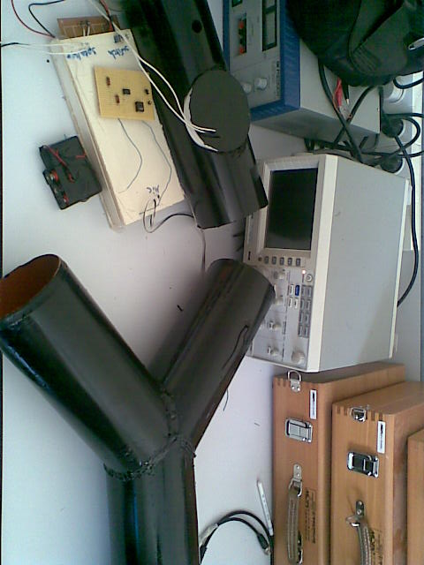

5.now to check our result and to be sure from our results we use testing circuit like this circuit LM318 or its sub suite like LM358
THIS CIRCUIT ADD the original signal from the microphone to the signal out from the speaker
The results which we take it is successful and the result was as follows

The result of the summer cct :

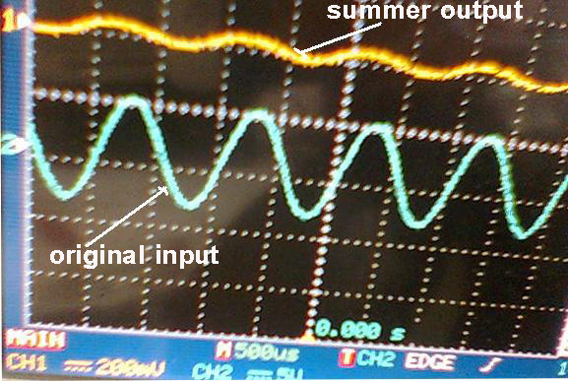

Now we go to apply our project practically on a fan of the computer which is considered as asource of noise for along time
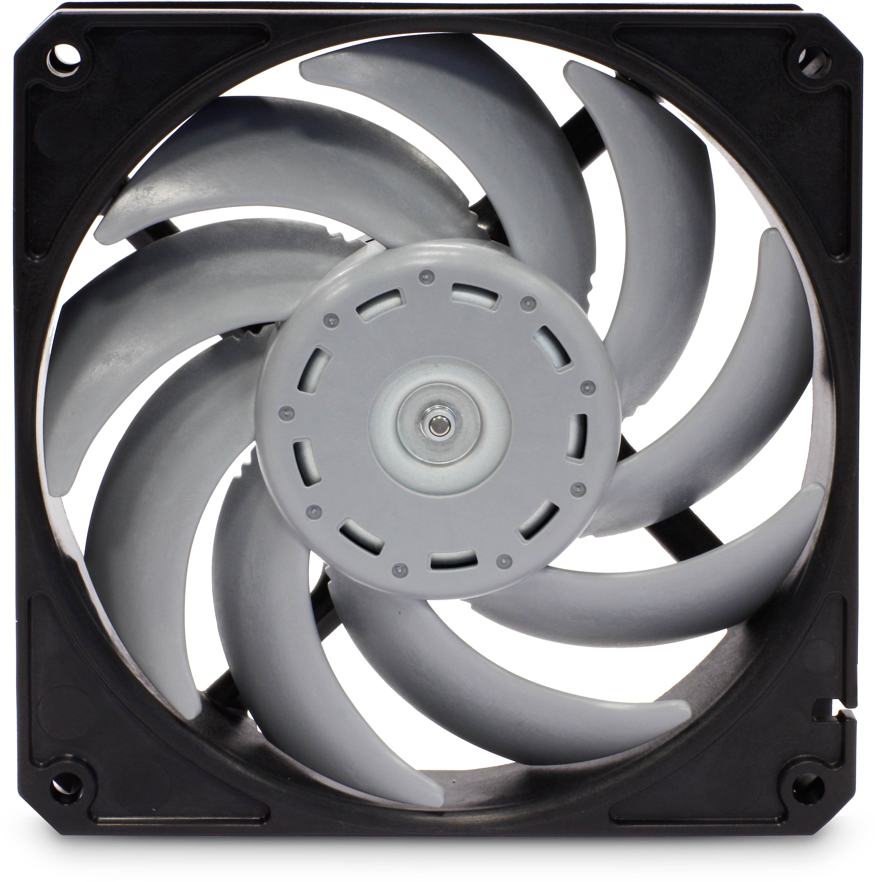
We put the microphone beside it
We return the speaker again from the other side
We turn on the fan
We open the switch of our project

We use two models to sum the sounds
  - 1. first model is Y model as follows
  - 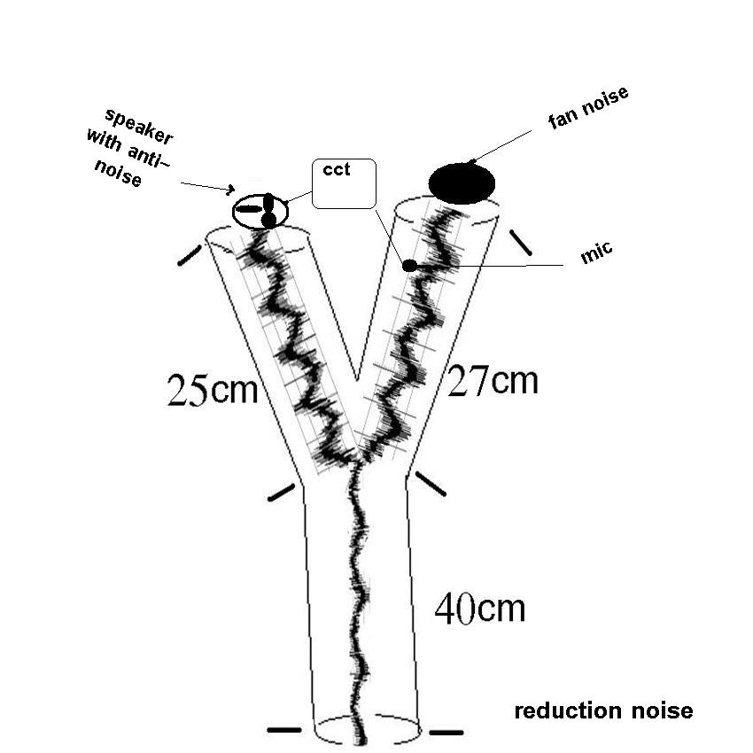

2. the second model is I model as follows
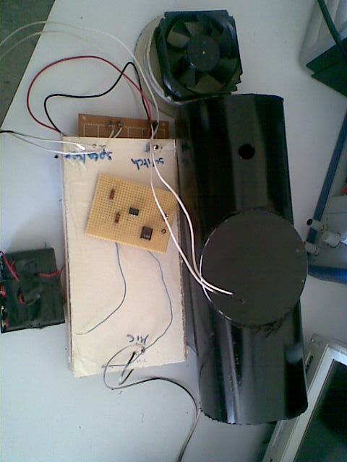
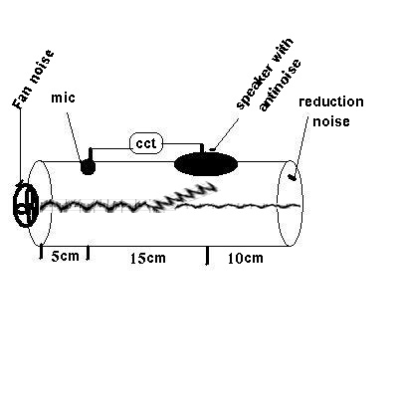
The sounds will mix together on the pole to attenuate the source of the noise

CHAPTER FOUR

The results
The results of our experience is good
The amplitude of noise is reduced as shown here

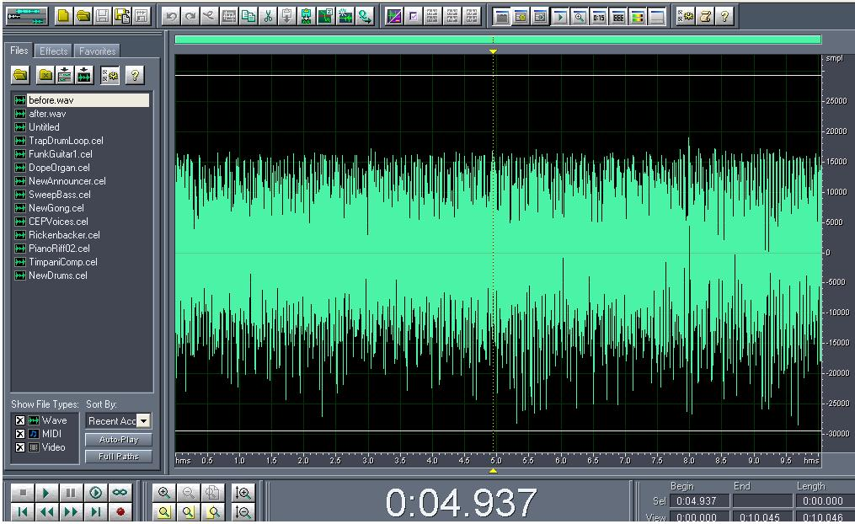
Figure 1 is the sound before

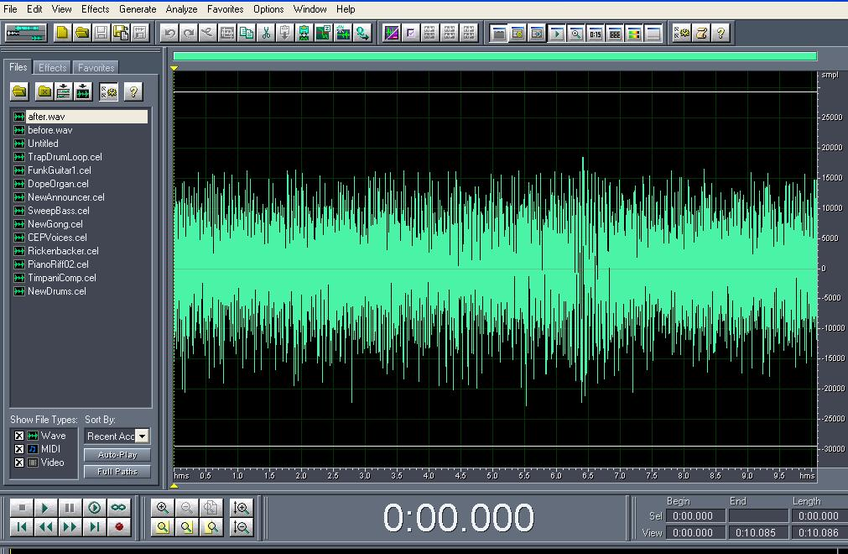
Figure2 is the sound after
We notice that the size of noise decreased

CHAPTER FIVE

Future Development
Active Noise Cancellation (ANC)
The active noise cancellation system implements the acoustically adaptive algorithm that cancels the unwanted sound by generating an antisound (antinoise) of equal amplitude and opposite phase. The original, unwanted sound and the antinoise acoustically combine, resulting in the The cancellation of both sounds.
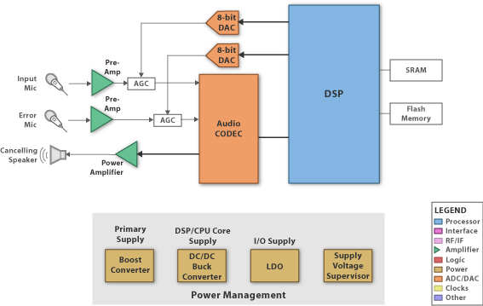

The core subsystems include:
- DSP
- performs system initialization and executes the adaptive signal processing algorithm.
- Silentium proprietary algorithms are embedded in a DSP
- Memory
- stores executing code and data/parameters.
- AGC
- maximizes the ADC SNR and maintains the overall system dynamic range.
- Audio CODEC
- the residual noise signals are converted o digital form by the ADC. The DAC generates the out put anti-noise signals.
- Power Conversion
- converts the battery power to run various functional blocks.

SYSTEM DESCRIPTION
The Development Kit contains the following basic elements:
_ 2 Microphones
_ ANR Controller board
_ LCD Based user interface
_ 1 Speaker
_ CD
_ Power Supply
_ User manual

Two microphones are provided. A reference microphone to capture and
feed the noisy source to the ANR controller and an error microphone to
measure the residual noise during calibration in order to minimize it. This
microphone is not needed after calibration process is done.

The ANR controller equipped with Silentium proprietary algorithms aims
at analyzing the source noise and process an “Anti Noise” signal.
It features an ADSP-BF531 Blackfin processor adaptively follows the signal
changes and provides output in real time.

The LCD user interface is an easy-to-use interface to guide the designer
over the calibration process.
A speaker transmitting the anti noise signal generated by the ANR
controller

CD equipped with all the required instructions which guide the designer
how to build a duct and where the microphones and speaker should be
placed. In addition a bunch of examples is attached.
A standard AC/ DC Power Supply converter to energize the system.
User Manual is a hard copy of instructions and guidelines for designing
an active silencer with ANC.

The Duct is the physical environment where Active Noise Control occurs.
It should be well designed by means of dimensions, material and acoustic
material, to provide the proper physical and acoustical environment.

NOISE REDUCTION
To achieve good noise reduction results, the designer should use both
acoustic material such as foam and barrier and ANC technology. The
acoustic material are dealing with the high frequency components of noise
while the ANC is taking care of the low frequencies.
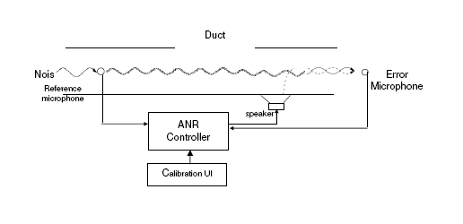
BENEFITS OF IT
_ Reduces noise of machinery fans and blowers up to 20dBA
_ Easily programmable user interface, 2 button operation and
LCD display.
_ Adaptable for both point to point and point to zone ANC
applications
_ Real time adaptive algorithms
_ Self calibrated system
_ Computer connection not necessary
_ Ideal for acoustic and vibration applications

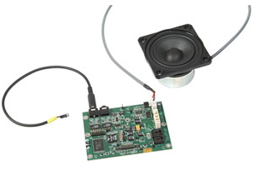
The result is a small, low-cost highly effective solution to
the low/medium-frequency noise, which can be applied to
many different applications, thus producing a successful
commercial solution.

.

CHAPTER SIX

The problems which face us through working

1.determining the kind of amplifier suitable for low noise or low frequency (not any amplifier is suitable)
Then finding the integrated circuit itself contained the amplifie which is NE5532

2. calculation of the value of the gain for each stage calculated by the value of the resistor amounted the amplifier which we solve it by using orcad and capture programme software

3.changing the first case for the circuit of the speaker to tba810 because it doesn’t amplify the sound to the limited range

4. after the successful of our circuit electrically and by using summary circuit ,when we want to apply it practically we don’t find the suitable form
We cant apply to any device because it is for only low noise with long time

5. also the place where the noise can be cancelled or where is the point of cancellation
So we use two schematic to add the two signals together to give us small summation
The first schematic is Y form
And the other is I form

THE END

