

Najah National University

Building Science Department

**Graduation Project 2**

**Bethlehem Commercial Building**

**Supervisor :**

**Dr. Monther Dwaikat**

**Prepared By:**

**Eng. Daoud Daragmeh**

**Eng.Khalid Adeli**

**&**

**Eng.Moheeb Nassar**

**2012**

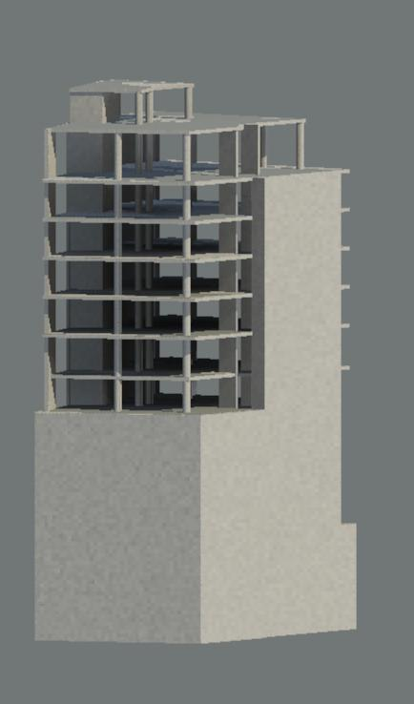

**Al-Quds Commercial building locate in Bethlehem , to the West of the nativity church .**

**The total area of the building proximate about 14000 m2.**

**The building contain five faculities including:**

* **Parking**
* **Stores**
* **Offices**
* **Hotel**
* **Roof restaurant**

**The main faculity is the Hotel .**

**The graduation project of our team countain a redesign for the building , where this redesign was in the Archituctural and structural parts.**

**The design was in Mechanical and Electrecal sides , where each of them includs the following:**

**Mechanical :**

* **Water supply for the building.**
* **Drinage water system .**
* **Fire resistants system includes :**

1. **Hose system.**
2. **Sprinklers system**

**Electrical:**

* **Parking light system.**
* **Hotel light system .**
* **Offices light system.**
* **Roof restaurant ligh system.**
* **Entrances light system.**
* **Lightning protection.**

**The Structural in this project countain the design for statical and dynamic (Earthquakes) forces , and checked for the fire hazaurds in the building.**