***Acknowledgment***

* We would like to take the opportunity to thank people who guided and supported us during this work.
* We are very grateful to our parents whose have always given us their encouragement and support.
* We wish to express our deepest gratitude to our supervisor " Dr.Maher khammash " for showing great interest in our work and for the guidance that he has given us.
* Thanks to the NEDCO company especially “Eng.Allam Abd allfatah” and “Eng .Shadia qamhia” Head of planning and development.Dep .
* Thanks to our friends for their encouragement and mental support during this work.

***Abstract***

Our project is to make a load flow study and analysis for Mojeer Aldeen(Nablus) Electrical Network using ETAP software to improve the power factor and to reduce the electrical losses in the network More over we want to increase the capability of the transformers and the transmission lines.

To do that we will follow the sequence bellow :

* Analyzing this network by collecting data such as resistance and reactance, length, rated voltages, max power and reactive power on each bus .
* We entered these data to the software ( ETAP) and getting the results .
* We will give recommendations and conclusions.
* The improvements for elements of the network.

***Introduction***

***Energy sector in Palestine***

Energy sector in Palestine faced sever since the Israeli occupation , financial and management obstacles due to the severe restrictions imposed by the Israeli occupation. as a result of this situation Palestine has not yet a unified power system , the existing network is local low voltage distributions networks connected to Israeli electrical corporation (IEC) , where around 97% of consumed energy were and still supplied by the IEC .The voltages of the existing distribution networks are : ( 0.4 , 6.6 , 11 , 22 , and 33 KV ) . IEC supplies electricity to the electrified communities by 22 or 33 KV by overhead lines . electricity is purchased from IEC and then distributed to the consumers. The existing electricity situation is characterized in old fashion over loaded networks , high power losses ( more than 20% ) , low power factor ,poor system reliability , high prices of electricity supplied to the consumer due to high tariff determined by the IEC in addition , many villages depend on diesel generators to provide their own needs of electrical energy .Due to all factors mentioned above, it becomes very important to design a national independent power system for the west bank of Palestine which will connect all the west bank areas by a reliable network to a national generating plant . the national power system should have the minimum annual cost and provide the consumer with a high quality of electric energy . this power system should also reduced the cost of KWH and be able to provide electricity to any area in the west bank

***Load flow study***

The Load flow study on a computer is the best way to obtain quantitative answers for the effect of specific control operations. In [power engineering](http://en.wikipedia.org/wiki/Power_engineering), the power flow study (also known as load-flow study) is an important tool involving [numerical analysis](http://en.wikipedia.org/wiki/Numerical_analysis) applied to a power system. Unlike traditional circuit analysis, a power flow study usually uses simplified notation such as a [one-line diagram](http://en.wikipedia.org/wiki/One-line_diagram) and [per-unit system](http://en.wikipedia.org/wiki/Per-unit_system), and focuses on various forms of [AC power](http://en.wikipedia.org/wiki/AC_power) (i.e.: reactive, real, and apparent) rather than [voltage](http://en.wikipedia.org/wiki/Voltage) and [current](http://en.wikipedia.org/wiki/Electric_current). It analyses the power systems in normal steady-state operation. There exist a number of software implementations of power flow studies.

the main information we will obtain from the load study of the network is the magnitude (v)and phase angle (δ) of the voltage at each bus and the real and reactive power (P&Q) flowing in each line.

***Importance of load Study***

Load-flow study is essential in planning the future expansion of any power system no matter how large or complicated it can be and in determining how the power flows in the system in its two components, Real power P and Reactive Power Q . The main information we will obtain from the load study of the network is the magnitude and phase angle of the voltage at each bus and the real and reactive power flowing in each line. However, much additional and complex information is needed by those who design any power system such as the power factor study, types of generators, transformers, etc . In our study we will be concerned mostly with preserving the voltages to a nominal value and observing the changes on power flow.

***Load Flow Calculation***

There are many methods of load flow calculation and here we won't to take about two methods:-

1-Gauss-Seidel method.

2-Newton-Raphson method.

***The world of the power system***

An electrical power system consists of four principle division:

* The generating station
* The transformer line
* The distribution system
* Load

***1. Generators***:

generators are one of the essential components of power systems is the three phase ac generator known as synchronous generator. Synchronous generators have two synchronously rotating fields: one field is produced by the rotor driven at synchronous speed and exited by dc current. The other field is produce in the stator windings by the three phase armature currents. The dc current for the rotor windings by the three-phase armature currents. The dc current for the rotor windings is provided by excitation systems.

***2. Transmission line:***

It is a link between buses and carries the high voltages with long distance and fewer losses.

***3. Distribution:***

The distribution system is that part which connects the distribution to the consumer's service.

***4. Load:***

It is consists of both reactive and real power are specified and both voltage magnitude and angle are determined by the computer as part of solution.

***Voltage control and improving***

There are many methods for controlling the voltage***:***

* + Modifying swing bus
  + Modifying tap changing
  + Adding capacitors

***Generation Buses (swing bus***)

It consists of both voltage magnitude and real power are specified and we will determine the reactive power and angle by the computer program as part of solution so the generation buses is one of the method to solve the parameter of the complex net work . The load study its principle to determine the current, the voltage and real power and reactive power at the generation buses in the network under exiting or contemplated conditions of normal operation. Load flow is essential in design the future development. Every power system have a special operation of the system depend on knowing the effects of this power system with other power systems and we will have new loads ,new generating stations and new transmission lines before they are installed. The required condition according to load studies for any network which consider the most difficult are:

1. Maximum load. 2. Minimum load. 3. Faults.

The computer programs now provide solution of load-flow studies on complex system, so completed results are printed and economically this is our goals to improvement the complex net work and if new economies with this procedure the second aim Is very important it is tell us if improve the net work or not.

***Capacitor Banks.***

Shunt capacitor banks is very important method of controlling voltage at the buses at both transmission and distribution levels along lines or at substation and load. Essentially capacitor is a means of supplying vats at the point of installation. Capacitor banks may be permanently connected, but as regulators of voltage they may be switches on and off the system as changes in load demand. Switching may be manually or automatically controlled either by time clock or in response to voltage or reactive - power requirement. When they parallel with a load having lagging power factor, the capacitor are the source of some or perhaps the entire reactive power factor of the load. Thus as we discusses before, capacitor reduces the line current necessary to supply the load and reduce the voltage drop in the line as the power factor is improved. Since capacitor lower the reactive requirement from generators, more real power output is available.

***Tap changing***

Almost all transformers provide taps on winding to adjust the ratio of transformer by changing Taps when the transformer is reenergized. a change in tap can be made while the transformer is energized ,and such transformers are called load- tap- changer (LTC) transformer or tap-vhanging-under-load(TCUL) transformers.

The tap changing is automatic and operated by motors which respond to relays set to hold the voltage at the prescribed level.

Special circuit allows the change to be made with out interrupting the current.

***Chapter( 1): Nablus Electrical Network Study***

***Nablus Electrical Network Supply 1.1***

Nablus are fed from (4) connection point by Israel Electrical Company (IEC), at 33KV as following:   
  
1.Asker (odeleh & Almeslekh) →→→30MVA namely

2.Sara →→→40MVA namely

Sara consist of three feeders as following:

. Carracon feeder consist of (2) transformer each one has (33-11KV) and also each transformer has→→→ 10MVA.

. Al jam3a→→→5MVA

. Mojeer Al deen feeder consist of (2) transformer each one has (33-11KV) and also each transformer has→→→ 10MVA.

3.Innab →→→7MVA namely

.Hwwara →→→ 20 MVA namely 4

***Element of Mojeer Al-deen Network1.2***

In this section we will study the elements of the network such as transformers, over head lines and underground cables.

***1.2.1 Distribution Transformers***

Mojeer Alden network consists of 76- Δ/Υ - , 6.6/0.4 KV distribution

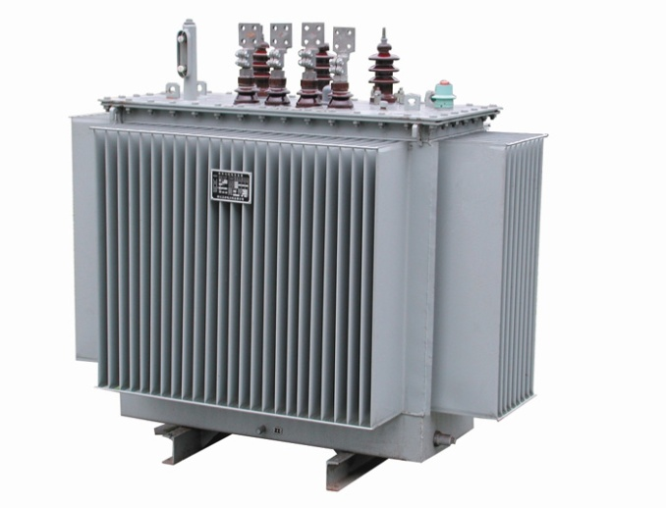transformers.

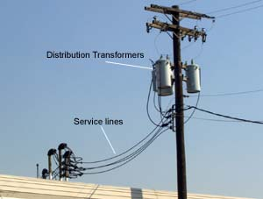

And the table shows the number of each of them and the rated KVA:

|  |  |
| --- | --- |
| Numberof Transformers | Transformer Ratings (KVA |
| 28 | 630 |
| 24 | 400 |
| 11 | 250 |
| 1 | 160 |
| 3 | 1000 |

*In Mojeer Al deen network we notes some kind of transformer as following figures:*

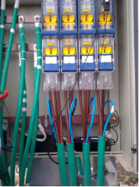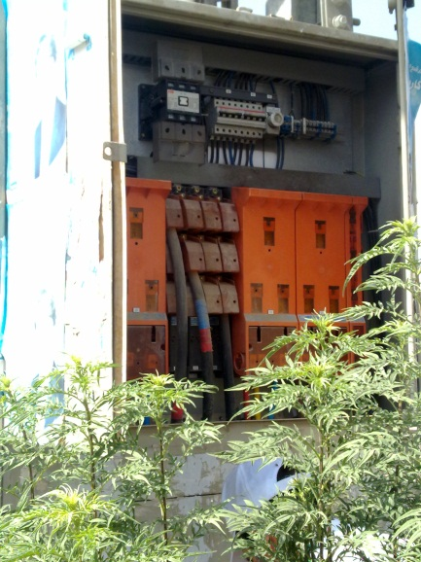

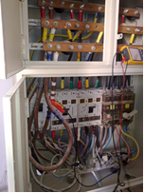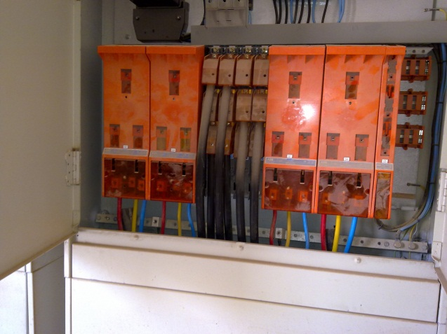

***Transmission Line1.2.2***

There are two type of conductor

1.O.H lines →→→ACSR

2.cables →→→ cu XLPE

1.Overhead lines:

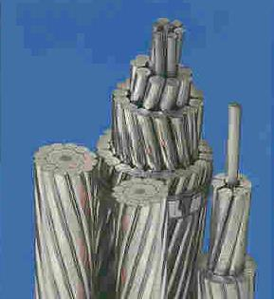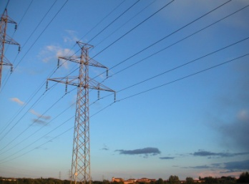

The conducters used in the network are ACSR (95mm2)

The resistance and reactance of the ACSR conducter

In the table below:

|  |  |  |
| --- | --- | --- |
| ACSR  CABLE | R(Ohms/Km) | X(Ohms/Km) |
| 95mm2 | 0.273 | .330 |

2.Under ground cable

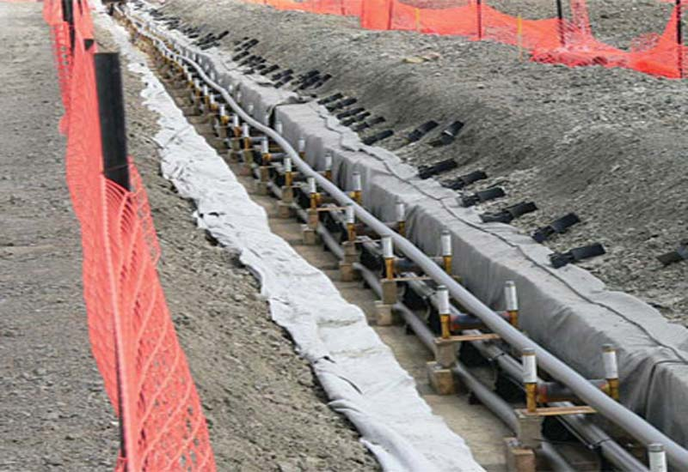 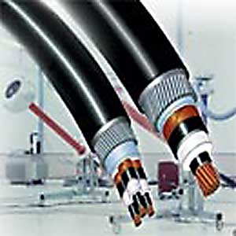

The under ground cable used in the network are XLPE Cu (120mm2).

The resistance and reactance of XLPE in table below

|  |  |  |
| --- | --- | --- |
| XLPE  CABLE | R(Ohms/Km) | X(Ohms/Km) |
| 120mm2 | 0.196 | 0.103 |

***1.3 Energy consumption***

In this section we will talk about the consumption of energy in Nablus electrical network:

***The nature of the load***

The figure bellow shows the consumers classification and their size.

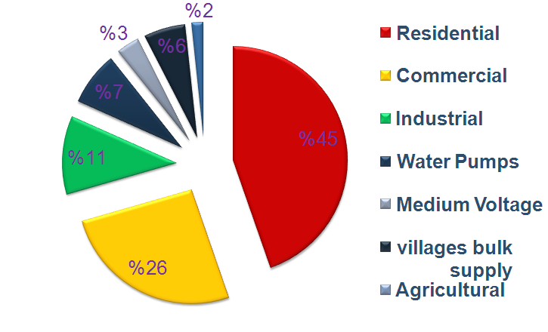

***Chapter (2): Load Flow Analysis***

***2.1 Etap power station program***

It is a load flow program which can simulink the power system receiving the input data (source ,transformer ,T.L & loads) as One Line Diagram schematic And results output report that includes bus voltage , branch losses , load factors power factors …etc. It is also able to do the Fault analysis .. Harmonic analysis .. Transient stability analysis.

***2.2 One line diagram***

In order to have the one line diagram, we followed the network diagram from the network plans , and so we get this plan considered as an input to the ETAP program .

Using appendix (1) to show one line diagram.

***2.3 Data needed for load flow analysis***

***2.3.1 The real and reactive power***

( OR apparent power and P.F OR Ampere and P.F ).

And the given table gives the real and reactive power on each

transformer

|  |  |  |
| --- | --- | --- |
| Transf | P( KW) | Q(Kvar) |
| EIN ALSUBYAN | 125 | 25 |
| YAFA ST | 102 | 30 |
| RAFIDIA HOSPITAL | 210 | 69 |
| RAFIDIA HOSPITAL 2 | 210 | 69 |
| ALARABI HOSPITAL | 304 | 89 |
| BELEBLE | 193 | 56 |
| DER ALROOM | 230 | 47 |
| AL-QASER | 69 | 10 |
| YASER ARAFAT | 39 | 10 |
| SHAMOT | 66 | 24 |
| AL ROZANA | 152 | 22 |
| SEBAWEH | 50 | 10 |
|  |  |  |
| JAWWAL | 183 | 26 |
| HARWASH | 174 | 35 |
| JAM3 ALRAWDA | 108 | 15 |
| 15 STREET NEW | 151 | 38 |
| JAM3 ALSHOHADAA | 119 | 35 |
|  |  |  |
| MANKO | 99 | 56 |
| JAMAL ABD A ALNASER | 141 | 0 |
| BAYT ALMAL | 269 | 55 |
| BANK ALOTHMANI | 214 | 30 |
| REVOLE | 267 | 38 |
| ABU SALHA | 205 | 42 |
| BANK PALESTINE | 43 | 18 |
| AL KONI | 53 | 15 |
| SLHAB | 65 | 21 |
| OM ALBALAT | 196 | 28 |
| ABO GHAZAL | 118 | 43 |
| ITHAD 2 | 111 | 28 |
| DOWAR ASERA1 | 154 | 45 |
| ASERA STREET | 104 | 30 |
| 3MERT KLBONE | 17 | 6 |
| ISKAN ALMOHNDESEN | 114 | 16 |
| ISKAN AL2ATEBA | 41 | 15 |
| ISKAN NAMSAWE | 38 | 14 |
| AL ZAHRA | 155 | 51 |
| ALKAZYA | 96 | 19 |
| WADE QADRA | 57 | 19 |
| DOWAR 2 | 95 | 34 |
| WADE SHAMLE | 117 | 34 |
| ASERA 3 | 142 | 41 |
| ASERA 4 | 96 | 31 |
| SH3BELO | 24 | 168 |
| MKHAYAM EIN | 266 | 67 |
| EIN PUMP 1 | 3 | 1 |
| MKHAYAM EIN | 172 | 35 |
| HIJAWE | 75 | 15 |
| AL QORA | 71 | 21 |
| ESKAN AL JAM3A | 81 | 20 |
| FRETAKH | 104 | 21 |
| ESKAN AL JAM3A 2 | 18 | 7 |
| AL ISRAA | 74 | 24 |
| ALESTHMAR BANK | 40 | 13 |
| GHAZE KAMAL | 203 | 59 |
| AL ARZ | 70 | 23 |
| ANTER | 291 | 141 |

***2.3.2 The length and Resistances***

(The length and R in (Ω/km) and X in (Ω/km)of the lines)

After formatting the one line diagram of the network ,and dividing it into buses we formed this table which shows the length of the lines and their resistance and reactance.

|  |  |  |  |
| --- | --- | --- | --- |
| Cables and lines | Length(M) | Resistance(Ω) | reactance(Ω) |
| Line7 | 865.0 | 0.273000 | 0.330000 |
| Line8 | 80.0 | 0.196000 | 0.103000 |
| Line10 | 110.0 | 0.196000 | 0.103000 |
| Line15 | 150.0 | 0.196000 | 0.103000 |
| Line16 | 145.0 | 0.196000 | 0.103000 |
| Line17 | 70.0 | 0.196000 | 0.103000 |
| Line18 | 140.0 | 0.196000 | 0.103000 |
| Line20 | 350.0 | 0.196000 | 0.103000 |
| Line21 | 41.0 | 0.273000 | 0.330000 |
| Line22 | 410.0 | 0.196000 | 0.103000 |
| Line23 | 35.0 | 0.196000 | 0.103000 |
| Line24 | 95.0 | 0.196000 | 0.103000 |
| Line25 | 305.0 | 0.196000 | 0.103000 |
| Line26 | 200.0 | 0.196000 | 0.103000 |
| Line27 | 104.0 | 0.196000 | 0.103000 |
| Line28 | 150.0 | 0.196000 | 0.103000 |
| Line31 | 535.0 | 0.196000 | 0.103000 |
| Line32 | 25.0 | 0.196000 | 0.103000 |
| Line33 | 360.0 | 0.196000 | 0.103000 |
| Line34 | 440.0 | 0.196000 | 0.103000 |
| Line35 | 436.0 | 0.196000 | 0.103000 |
| Line37 | 130.0 | 0.196000 | 0.103000 |
| Line38 | 670.0 | 0.196000 | 0.103000 |
| Line39 | 50.0 | 0.196000 | 0.086386 |
| Line40 | 650.0 | 0.196000 | 0.103000 |
| Line41 | 395.0 | 0.196000 | 0.103000 |
| Line42 | 210.0 | 0.196000 | 0.103000 |
| Line43 | 45.0 | 0.273000 | 0.330000 |
| Line46 | 290.0 | 0.196000 | 0.103000 |
| Line48 | 530.0 | 0.196000 | 0.103000 |
| Line49 | 800.0 | 0.196000 | 0.103000 |
| Line50 | 500.0 | 0.273000 | 0.330000 |
| Line51 | 200.0 | 0.273000 | 0.330000 |
| Line52 | 400.0 | 0.273000 | 0.330000 |
| Line53 | 455 | 0.273000 | 0.330000 |
| Line54 | 100 | 0.273000 | 0.330000 |
| Line55 | 45.0 | 0.196000 | 0.103000 |
| Line56 | 60.0 | 0.273000 | 0.330000 |
| Line186 | 205.0 | 0.196000 | 0.103000 |
| Line231 | 430.0 | 0.196000 | 0.103000 |
| Line232 | 130.0 | 0.196000 | 0.103000 |
| Line233 | 190.0 | 0.196000 | 0.103000 |
| Line235 | 30.0 | 0.196000 | 0.103000 |
| Line236 | 171.0 | 0.196000 | 0.103000 |
| Line237 | 500.0 | 0.273000 | 0.330000 |
| Line238 | 285.0 | 0.273000 | 0.330000 |
| Line239 | 740.0 | 0.196000 | 0.103000 |
| Line240 | 75.0 | 0.196000 | 0.103000 |
| Line241 | 124.0 | 0.196000 | 0.103000 |
| Line242 | 542.0 | 0.196000 | 0.103000 |
| Line244 | 182 | 0.196000 | 0.103000 |
| Line245 | 458 | 0.196000 | 0.103000 |
| Line247 | 25 | 0.196000 | 0.103000 |
| Line252 | 520 | 0.196000 | 0.103000 |
| Line253 | 360 | 0.196000 | 0.103000 |
| Line254 | 524.0 | 0.247000 | 0.103000 |
| Line255 | 314.0 | 0.196000 | 0.103000 |
| Line256 | 262.0 | 0.196000 | 0.103000 |
| Line257 | 262.0 | 0.196000 | 0.103000 |
| Line258 | 200.0 | 0.196000 | 0.103000 |
| Line259 | 200.0 | 0.196000 | 0.103000 |
| Line260 | 380.0 | 0.196000 | 0.103000 |
| Line261 | 215.0 | 0.196000 | 0.103000 |
| Line262 | 190.0 | 0.342000 | 0.112000 |
| Line263 | 260.0 | 0.196000 | 0.103000 |
| Line264 | 195.0 | 0.196000 | 0.103000 |
| Line265 | 345.0 | 0.196000 | 0.103000 |
| Line266 | 290.0 | 0.196000 | 0.103000 |
| Line267 | 170 | 0.196000 | 0.103000 |
| Line269 | 21 | 0.196000 | 0.103000 |
| Line270 | 170 | 0.273000 | 0.330000 |
| Line271 | 260.0 | 0.196000 | 0.103000 |
| Line272 | 100 | 0.273000 | 0.330000 |
| Line273 | 150.0 | 0.196000 | 0.103000 |

***2.4 Simulation for maximum load case***

This step done by the following criteria:

* drawing the one line diagram (source ,transformer T.L, buses & loads)
* entering R&X in Ω or (Ω /any unit of length) & its length. note (Y) value is not important since the T.L is short (L<80Km)
* entering the typical value (X/R & %Z) for each transformer
* entering the rated voltage for each bus
* entering the actual MVA & P.F for each load
* entering the source as a swing bus, for load flow studies a swing power grid will take up the slack of the power flows in the system, i.e., the voltage magnitude and angle of the power grid terminals will remain at the specified operating values ( V & δ are given ,P & Q are unknown)
* run the load flow analysis to get the output result

Using appendix (2) to show max case.

***2.4.1 The medium voltages & The low tension voltages***

The actual medium voltages and low voltage on each transformer is

shown in the table below :

|  |  |  |  |  |
| --- | --- | --- | --- | --- |
| Transformer  number | Medium voltage(rated)  Kv | Medium voltage(actual)  kv | Low voltage(rated)  kv | Low voltage(actual)  kv |
| EIN ALSUBYAN | 6.6 | 6.57 | 0.4 | 0.396 |
| YAFA ST | 6.6 | 6.57 | 0.4 | 0.396 |
| RAFIDIA HOSPITAL | 6.6 | 6.494 | 0.4 | 0.393 |
| RAFIDIA HOSPITAL 2 | 6.6 | 6.494 | 0.4 | 0.393 |
| ALARABI HOSPITAL | 6.6 | 6.49 | 0.4 | 0.382 |
| BELEBLE | 6.6 | 6.483 | 0.4 | 0.392 |
| DER ALROOM | 6.6 | 6.481 | 0.4 | 0.392 |
| AL-QASER | 6.6 | 6.483 | 0.4 | 0.393 |
| YASER ARAFAT | 6.6 | 6.519 | 0.4 | 0.395 |
| SHAMOT | 6.6 | 6.506 | 0.4 | 0.393 |
| AL ROZANA | 6.6 | 6.48 | 0.4 | 0.392 |
| SEBAWEH | 6.6 | 6.489 | 0.4 | 0.392 |
| JAWWAL | 6.6 | 6.579 | 0.4 | 0.398 |
| HARWASH | 6.6 | 6.576 | 0.4 | 0.393 |
| JAM3 ALRAWDA | 6.6 | 6.576 | 0.4 | 0.396 |
| 15 STREET NEW | 6.6 | 6.576 | 0.4 | 0.398 |
| JAM3 ALSHOHADAA | 6.6 | 6.574 | 0.4 | 0.397 |
| MANKO | 6.6 | 6.577 | 0.4 | 0.398 |
| JAMAL ABD A ALNASER | 6.6 | 6.575 | 0.4 | 0.398 |
| BAYT ALMAL | 6.6 | 6.574 | 0.4 | 0.398 |
| BANK ALOTHMANI | 6.6 | 6.557 | 0.4 | 0.393 |
| REVOLE | 6.6 | 6.552 | 0.4 | 0.396 |
| ABU SALHA | 6.6 | 6.551 | 0.4 | 0.396 |
| BANK PALESTINE | 6.6 | 6.552 | 0.4 | 0.397 |
| AL KONI | 6.6 | 6.551 | 0.4 | 0.397 |
| SLHAB | 6.6 | 6.551 | 0.4 | 0.377 |
| OM ALBALAT | 6.6 | 6.565 | 0.4 | 0.397 |
| ABO GHAZAL | 6.6 | 6.543 | 0.4 | 0.396 |
| ITHAD 2 | 6.6 | 6.517 | 0.4 | 0.394 |
| DOWAR ASERA1 | 6.6 | 6.519 | 0.4 | 0.394 |
| ASERA STREET | 6.6 | 6.487 | 0.4 | 0.392 |
| 3MERT KLBONE | 6.6 | 6.487 | 0.4 | 0.393 |
| ISKAN ALMOHNDESEN | 6.6 | 6.464 | 0.4 | 0.390 |
| ISKAN AL2ATEBA | 6.6 | 6.46 | 0.4 | 0.391 |
| ISKAN NAMSAWE | 6.6 | 6.459 | 0.4 | 0.390 |
| AL ZAHRA | 6.6 | 6.452 | 0.4 | 0.390 |
| ALKAZYA | 6.6 | 6.464 | 0.4 | 0.386 |
| WADE QADRA | 6.6 | 6.384 | 0.4 | 0.385 |
| DOWAR 2 | 6.6 | 6.37 | 0.4 | 0.385 |
| WADE SHAMLE | 6.6 | 6.368 | 0.4 | 0.385 |
| ASERA 3 | 6.6 | 6.363 | 0.4 | 0.384 |
| ASERA 4 | 6.6 | 6.362 | 0.4 | 0.385 |
| SH3BELO | 6.6 | 6.598 | 0.4 | 0.399 |
| MKHAYAM EIN | 6.6 | 6.596 | 0.4 | 0.398 |
| EIN PUMP 1 | 6.6 | 6.586 | 0.4 | 0.399 |
| AL MAHKAMA | 6.6 | 6.584 | 0.4 | 0.398 |
| HIJAWE | 6.6 | 6.577 | 0.4 | 0.398 |
| AL QORA | 6.6 | 6.571 | 0.4 | 0.398 |
| ESKAN AL JAM3A | 6.6 | 6.57 | 0.4 | 0.398 |
| FRETAKH | 6.6 | 6.57 | 0.4 | 0.397 |
| ESKAN AL JAM3A 2 | 6.6 | 6.57 | 0.4 | 0.398 |
| AL ISRAA | 6.6 | 6.577 | 0.4 | 0.398 |
| ALESTHMAR BANK | 6.6 | 6.577 | 0.4 | 0.398 |
| GHAZE KAMAL | 6.6 | 6.574 | 0.4 | 0.397 |
| AL ARZ | 6.6 | 6.572 | 0.4 | 0.398 |
| ANTER | 6.6 | 6.571 | 0.4 | 0.397 |

***2.4.2 Load factor***

The load factor is known as the average power divided by the rated power as shown in given table.

|  |  |  |  |
| --- | --- | --- | --- |
| Trans | Capability KVA | Loading KVA | L F% |
| EIN ALSUBYAN | 630 | 126 | 25% |
| YAFA ST | 400 | 106 | 26% |
| RAFIDIA HOSPITAL | 630 | 110 | 17% |
| RAFIDIA HOSPITAL 2 | 630 | 110 | 17% |
| ALARABI HOSPITAL | 630 | 350 | 56% |
| BELEBLE | 630 | 200 | 32% |
| DER ALROOM | 400 | 144 | 36% |
| AL-QASER | 1000 | 169 | 17% |
| YASER ARAFAT | 400 | 40 | 10% |
| SHAMOT | 400 | 70 | 18% |
| AL ROZANA | 630 | 280 | 44% |
| SEBAWEH | 250 | 51 | 20% |
|  |  |  |  |
| JAWWAL | 630 | 185 | 29% |
| HARWASH | 400 | 177 | 44% |
| JAM3 ALRAWDA | 250 | 180 | 72% |
| 15 STREET NEW | 630 | 156 | 25% |
| JAM3 ALSHOHADAA | 400 | 124 | 31% |
|  |  |  |  |
| MANKO | 630 | 114 | 18% |
| JAMAL ABD A ALNASER | 400 | 141 | 35% |
| BAYT ALMAL | 1000 | 274 | 27% |
| BANK ALOTHMANI | 250 | 217 | 87% |
| REVOLE | 630 | 270 | 43% |
| ABU SALHA | 630 | 209 | 33% |
| BANK PALESTINE | 400 | 47 | 12% |
| AL KONI | 630 | 55 | 9% |
| SLHAB | 630 | 146 | 23% |
| OM ALBALAT | 630 | 198 | 31% |
| ABO GHAZAL | 630 | 125 | 20% |
| ITHAD 2 | 630 | 160 | 25% |
| DOWAR ASERA1 | 400 | 160 | 40% |
| ASERA STREET | 400 | 108 | 27% |
| 3MERT KLBONE | 250 | 18 | 7% |
| ISKAN ALMOHNDESEN | 250 | 115 | 46% |
| ISKAN AL2ATEBA | 630 | 108 | 17% |
| ISKAN NAMSAWE | 250 | 140 | 56% |
| AL ZAHRA | 630 | 162 | 26% |
| ALKAZYA | 160 | 98 | 61% |
| WADE QADRA | 250 | 59 | 24% |
| DOWAR 2 | 400 | 100 | 25% |
| WADE SHAMLE | 400 | 120 | 30% |
| ASERA 3 | 400 | 143 | 36% |
| ASERA 4 | 630 | 100 | 16% |
| SH3BELO | 400 | 168 | 42% |
| MKHAYAM EIN | 400 | 275 | 69% |
| EIN PUMP 1 | 630 | 380 | 60% |
| MKHAYAM EIN | 400 | 275 | 69% |
| HIJAWE | 400 | 76 | 19% |
| AL QORA | 630 | 76 | 12% |
| ESKAN AL JAM3A | 400 | 83 | 21% |
| FRETAKH | 400 | 106 | 27% |
| ESKAN AL JAM3A 2 | 250 | 19 | 8% |
|  |  |  |  |
| AL ISRAA | 630 | 68 | 11% |
| ALESTHMAR BANK | 400 | 66 | 17% |
| GHAZE KAMAL | 400 | 212 | 53% |
| AL ARZ | 630 | 75 | 12% |
| ANTER | 630 | 275 | 44% |

Note :

* low load factor (L.F<.45) for the most of transformer
  + - There is no over loaded transformers in the network, but some of the transformers is under loaded .
    - LF=[.65-.75] give the max. efficiency distribution transformer.
    - The engineers choose the transformer in distribution network with load factor [.45-.55] expressed to the growth of the load by years

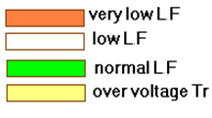

***2.4.3 Power Factor***

The table below shows the power factor, real and reactive power on each transformer:

|  |  |  |  |  |  |
| --- | --- | --- | --- | --- | --- |
| BUS # | RATED KV | MW | MVAR | MVA | PF% |
| Bus7 | 6.600 | 7.8 | 2.1 | 8.048 | 96.5 |
| Bus508 | 6.600 | 1.7 | 0.46 | 1.737 | 97.0 |
| Bus509 | 6.600 | 0.04 | 0.01 | 0.040 | 96.8 |
| Bus511 | 6.600 | 1.37 | 0.32 | 1.456 | 97.0 |
| Bus512 | 0.400 | 0.1 | 0.03 | 0.106 | 95.9 |
| Bus513 | 0.400 | 0.1 | 0.02 | 0.126 | 98.0 |
| Bus514 | 0.400 | 0.04 | 0.01 | 0.040 | 96.9 |
| Bus515 | 0.400 | 0.07 | 0.02 | 0.070 | 94.0 |
| Bus516 | 6.600 | 1.4 | 0.36 | 1.384 | 97.1 |
| Bus517 | 0.400 | 0.2 | 0.07 | 0.220 | 95.0 |
| Bus518 | 6.600 | 0.05 | 0.01 | 0.051 | 98.0 |
| Bus519 | 6.600 | 0.35 | 0.14 | 0.366 | 96.2 |
| Bus520 | 6.600 | 0.2 | 0.05 | 0.234 | 97.8 |
| Bus521 | 0.400 | 0.2 | 0.05 | 0.233 | 98.0 |
| Bus522 | 6.600 | 0.2 | 0.06 | 0.200 | 95.9 |
| Bus523 | 0.400 | 0.2 | 0.06 | 0.199 | 96.0 |
| Bus524 | 6.600 | 0.07 | 0.01 | 0.069 | 99.0 |
| Bus525 | 0.400 | 0.07 | 0.01 | 0.069 | 99.0 |
| Bus526 | 6.600 | 0.3 | 0.04 | 0.296 | 98.9 |
| Bus527 | 0.400 | 0.1 | 0.02 | 0.143 | 99.0 |
| Bus528 | 6.600 | 0.2 | 0.02 | 0.152 | 98.9 |
| Bus529 | 0.400 | 0.2 | 0.02 | 0.152 | 99.0 |
| Bus530 | 6.600 | 0.2 | 0.03 | 0.185 | 99.0 |
| Bus531 | 0.400 | 0.2 | 0.03 | 0.185 | 99.0 |
| Bus532 | 6.600 | 0.2 | 0.04 | 0.177 | 97.9 |
| Bus533 | 0.400 | 0.2 | 0.03 | 0.177 | 98.0 |
| Bus534 | 6.600 | 0.4 | 0.1 | 0.447 | 96.9 |
| Bus535 | 0.400 | 0.2 | 0.04 | 0.155 | 97.0 |
| Bus536 | 0.400 | 0.1 | 0.01 | 0.109 | 99.0 |
| Bus537 | 6.600 | 0.1 | 0.03 | 0.106 | 95.8 |
| Bus538 | 0.400 | 0.1 | 0.03 | 0.104 | 95.9 |
| Bus545 | 6.600 | 0.4 | 0.1 | 0.338 | 96.0 |
| Bus547 | 6.600 | 0.3 | 0.07 | 0.275 | 96.7 |
| Bus548 | 0.400 | 0.3 | 0.07 | 0.274 | 97.0 |
| Bus549 | 0.400 | 0.2 | 0.02 | 0.168 | 99.0 |
| Bus551 | 0.400 | 0 | 0 | 0.003 | 94.9 |
| Bus553 | 0.400 | 0.4 | 0.07 | 0.379 | 98.0 |
| Bus555 | 6.600 | 0.2 | 0.04 | 0.176 | 97.9 |
| Bus556 | 6.600 | 0.3 | 0.2 | 0.255 | 95.5 |
| Bus557 | 0.400 | 0.07 | 0.01 | 0.068 | 98.1 |
| Bus558 | 6.600 | 0.07 | 0.02 | 0.074 | 95.9 |
| Bus559 | 6.600 | 0.2 | 0.05 | 0.186 | 97.2 |
| Bus560 | 0.400 | 0.07 | 0.02 | 0.074 | 97.1 |
| Bus561 | 0.400 | 0.02 | 0.01 | 0.017 | 93.2 |
| Bus563 | 6.600 | 0.02 | 0.01 | 0.017 | 93.1 |
| Bus564 | 0.400 | 0.09 | 0.02 | 0.094 | 98.0 |
| Bus565 | 0.400 | 0.07 | 0.02 | 0.074 | 95.9 |
| Bus566 | 6.600 | 0.2 | 0.03 | 0.198 | 98.9 |
| Bus567 | 0.400 | 0.2 | 0.03 | 0.197 | 99.0 |
| Bus568 | 0.400 | 0.1 | 0.04 | 0.125 | 94.0 |
| Bus569 | 0.400 | 0.2 | 0.04 | 0.159 | 96.0 |
| Bus570 | 0.400 | 0.2 | 0.04 | 0.159 | 96.0 |
| Bus571 | 6.600 | 0.2 | 0.05 | 0.160 | 95.8 |
| Bus572 | 6.600 | 1.3 | 0.4 | 1.333 | 95.4 |
| Bus573 | 0.400 | 0.1 | 0.05 | 0.145 | 94.9 |
| Bus574 | 6.600 | 1.1 | 0.4 | 1.182 | 95.5 |
| Bus575 | 6.600 | 0.02 | 0.01 | 0.018 | 94.2 |
| Bus576 | 0.400 | 0.1 | 0.02 | 0.114 | 99.0 |
| Bus577 | 6.600 | 1 | 0.3 | 1.053 | 95.5 |
| Bus578 | 0.400 | 0.04 | 0.01 | 0.043 | 93.9 |
| Bus579 | 0.400 | 0.04 | 0.01 | 0.040 | 93.8 |
| Bus580 | 6.600 | 0.4 | 0.1 | 0.202 | 94.7 |
| Bus581 | 0.400 | 0.02 | 0.01 | 0.018 | 94.3 |
| Bus582 | 0.400 | 0.1 | 0.03 | 0.107 | 96.1 |
| Bus584 | 0.400 | 0.09 | 0.02 | 0.097 | 98.1 |
| Bus585 | 6.600 | 0.06 | 0.02 | 0.059 | 94.7 |
| Bus586 | 0.400 | 0.06 | 0.02 | 0.059 | 94.9 |
| Bus587 | 0.400 | 0.06 | 0.02 | 0.063 | 90.7 |
| Bus588 | 6.600 | 0.4 | 0.1 | 0.589 | 94.8 |
| Bus589 | 0.400 | 0.09 | 0.03 | 0.099 | 94.2 |
| Bus591 | 6.600 | 0.1 | 0.03 | 0.120 | 95.9 |
| Bus592 | 0.400 | 0.1 | 0.03 | 0.120 | 96.0 |
| Bus593 | 0.400 | 0.1 | 0.04 | 0.146 | 96.1 |
| Bus594 | 6.600 | 0.2 | 0.07 | 0.246 | 95.6 |
| Bus595 | 6.600 | 0.09 | 0.03 | 0.100 | 95.1 |
| Bus596 | 0.400 | 0.09 | 0.03 | 0.099 | 95.2 |
| Bus597 | 0.400 | 0.04 | 0.02 | 0.046 | 92.2 |
| Bus599 | 0.400 | 0.2 | 0.04 | 0.208 | 98.0 |
| Bus600 | 0.400 | 0.05 | 0.02 | 0.055 | 96.2 |
| Bus601 | 6.600 | 0.2 | 0.05 | 0.162 | 94.9 |
| Bus602 | 0.400 | 0.2 | 0.05 | 0.162 | 95.0 |
| Bus604 | 6.600 | 0.3 | 0.06 | 0.264 | 97.6 |
| Bus605 | 6.600 | 0.3 | 0.08 | 0.310 | 97.0 |
| Bus606 | 6.600 | 0.3 | 0.04 | 0.270 | 98.9 |
| Bus607 | 0.400 | 0.3 | 0.04 | 0.269 | 99.0 |
| Bus608 | 0.400 | 0.2 | 0.03 | 0.215 | 99.0 |
| Bus610 | 6.600 | 0.3 | 0.06 | 0.274 | 97.9 |
| Bus611 | 0.400 | 0.3 | 0.05 | 0.274 | 98.0 |
| Bus612 | 0.400 | 0.1 | 0 | 0.141 | 100.0 |
| Bus616 | 0.400 | 0.1 | 0.06 | 0.114 | 87.0 |
| Bus617 | 0.400 | 0.2 | 0.06 | 0.211 | 96.0 |
| Bus618 | 0.400 | 0.07 | 0.02 | 0.074 | 95.0 |
| Bus619 | 6.600 | 0.07 | 0.02 | 0.074 | 95.0 |
| Bus620 | 6.600 | 0.3 | 0.1 | 0.324 | 89.7 |
| Bus621 | 0.400 | 0.3 | 0.1 | 0.322 | 90.0 |
| Bus622 | 6.600 | 0.04 | 0.01 | 0.042 | 95.1 |
| Bus623 | 6.600 | 0.04 | 0.01 | 0.727 | 93.2 |
| Bus624 | 0.400 | 0.04 | 0.01 | 0.042 | 95.1 |
| Bus625 | 0.400 | 0.07 | 0.02 | 0.078 | 95.1 |
| Bus626 | 6.600 | 0.7 | 0.3 | 0.727 | 93.2 |
| Bus627 | 6.600 | 0.4 | 0.2 | 0.397 | 90.8 |
| Bus628 | 6.600 | 0.6 | 0.2 | 0.607 | 92.8 |
| Bus629 | 6.600 | 1.2 | 0.2 | 1.211 | 98.5 |
| Bus630 | 6.600 | 0.8 | 0.2 | 0.797 | 98.2 |
| Bus631 | 6.600 | 0.6 | 0.1 | 0.579 | 98.0 |
| Bus632 | 6.600 | 0.2 | 0.05 | 0.162 | 94.9 |
| Bus633 | 6.600 | 0.2 | 0.05 | 0.162 | 94.9 |
| Bus634 | 6.600 | 0.2 | 0.05 | 0.162 | 94.9 |
| Bus635 | 6.600 | 0.2 | 0.05 | 0.162 | 94.9 |
| Bus636 | 6.600 | 0.2 | 0.05 | 0.162 | 94.9 |
| Bus638 | 6.600 | 1.7 | 0.5 | 1.785 | 95.4 |
| Bus639 | 6.600 | 1.9 | 0.6 | 1.986 | 95.8 |
| Bus641 | 6.600 | 1 | 0.3 | 0.997 | 95.4 |
| Bus642 | 0.400 | 0.2 | 0.03 | 0.175 | 98.0 |
| Bus644 | 6.600 | 0.1 | 0.03 | 0.111 | 97.3 |
| Bus645 | 6.600 | 0.1 | 0.03 | 0.107 | 95.8 |
| Bus647 | 6.600 | 1.4 | 0.4 | 1.444 | 96.2 |
| Bus648 | 6.600 | 1.7 | 0.4 | 1.743 | 97.0 |
| Bus649 | 6.600 | 1.44 | 0.41 | 1.498 | 97.0 |
| Bus650 | 6.600 | 0.4 | 0.1 | 0.366 | 96.2 |
| Bus651 | 6.600 | 0.8 | 0.15 | 0.798 | 98.0 |
| Bus652 | 6.600 | 0.57 | 0.11 | 0.564 | 98.1 |
| Bus653 | 0.400 | 0.3 | 0.09 | 0.314 | 96.0 |
| Bus654 | 0.400 | 0.05 | 0.01 | 0.051 | 98.1 |
| Bus656 | 6.600 | 0.5 | 0.1 | 0.443 | 97.7 |
| Bus657 | 6.600 | 1 | 0.3 | 1.001 | 95.4 |
| Bus658 | 6.600 | 0.8 | 0.3 | 0.822 | 94.8 |
| Bus659 | 6.600 | 0.4 | 0.2 | 0.447 | 97.2 |
| Bus660 | 6.600 | 0.1 | 0.03 | 0.111 | 97.2 |
| Bus661 | 6.600 | 1.6 | 0.5 | 1.654 | 95.5 |
| Bus663 | 6.600 | 0.2 | 0.08 | 0.246 | 94.5 |
| Bus664 | 6.600 | 0.7 | 0.2 | 0.694 | 95.1 |
| Bus665 | 6.600 | 0.4 | 0.1 | 0.466 | 95.4 |
| Bus666 | 6.600 | 0.05 | 0.02 | 0.055 | 96.2 |
| Bus667 | 6.600 | 1.3 | 0.3 | 1.319 | 98.0 |
| Bus668 | 6.600 | 0.4 | 0.06 | 0.413 | 99.1 |
| Bus669 | 6.600 | 0.8 | 0.2 | 0.796 | 98.2 |
| Bus670 | 6.600 | 0.7 | 0.3 | 0.730 | 93.2 |
| Bus671 | 6.600 | 0.8 | 0.2 | 0.808 | 97.7 |

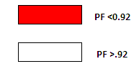

Note : the power factor reach between 0.91 and 0.87 .

This causes more penalties on the total bill

***2.4.4 V % for network***

|  |  |  |  |
| --- | --- | --- | --- |
| BUS # | RATING | OPERATING | Operating% |
| Bus 7 | 6.600 | 6.6 | 100.000 |
| Bus508 | 6.600 | 6.534 | 99.166 |
| Bus509 | 6.600 | 6.518 | 98.76 |
| Bus511 | 6.600 | 6.506 | 98.582 |
| Bus512 | 0.400 | .395 | 98.940 |
| Bus513 | 0.400 | .396 | 99.065 |
| Bus514 | 0.400 | .394 | 98.686 |
| Bus515 | 0.400 | .393 | 98.418 |
| Bus516 | 6.600 | 6.49 | 98.400 |
| Bus517 | 0.400 | .393 | 98.287 |
| Bus518 | 6.600 | 6.48 | 98.31 |
| Bus519 | 6.600 | 6.489 | 98.326 |
| Bus520 | 6.600 | 6.486 | 98.278 |
| Bus521 | 0.400 | 0.391 | 97.84 |
| Bus522 | 6.600 | 6.48 | 98.222 |
| Bus523 | 0.400 | .361 | 98.030 |
| Bus524 | 6.600 | 6.48 | 98.230 |
| Bus525 | 0.400 | .392 | 98.210 |
| Bus526 | 6.600 | 6.481 | 98.200 |
| Bus527 | 0.400 | 0.392 | 97.968 |
| Bus528 | 6.600 | 6.48 | 98.188 |
| Bus529 | 0.400 | .392 | 98.081 |
| Bus530 | 6.600 | 6.578 | 99.680 |
| Bus531 | 0.400 | .398 | 99.554 |
| Bus532 | 6.600 | 6.575 | 99.635 |
| Bus533 | 0.400 | .397 | 99.314 |
| Bus534 | 6.600 | 6.576 | 99.642 |
| Bus535 | 0.400 | .397 | 99.44 |
| Bus536 | 0.400 | .398 | 99.123 |
| Bus537 | 6.600 | 6.574 | 99.601 |
| Bus538 | 0.400 | 0.397 | 99.338 |
| Bus545 | 6.600 | 6.572 | 99.580 |
| Bus547 | 6.600 | 6.593 | 99.946 |
| Bus548 | 0.400 | .397 | 99.401 |
| Bus549 | 0.400 | .398 | 99.70 |
| Bus551 | 0.400 | .399 | 99.781 |
| Bus553 | 0.400 | .397 | 99.467 |
| Bus555 | 6.600 | 6.583 | 99.755 |
| Bus556 | 6.600 | 6.57 | 99.628 |
| Bus557 | 0.400 | 0.398 | 99.491 |
| Bus558 | 6.600 | 6.56 | 99.554 |
| Bus559 | 6.600 | 6.57 | 99.552 |
| Bus560 | 0.400 | 0.398 | 99.389 |
| Bus561 | 0.400 | .0.398 | 99.416 |
| Bus563 | 6.600 | 6.57 | 99.546 |
| Bus564 | 0.400 | 0.397 | 99.356 |
| Bus565 | 0.400 | .397 | 99.483 |
| Bus566 | 6.600 | 6.56 | 99.465 |
| Bus567 | 0.400 | .397 | 99.329 |
| Bus568 | 0.400 | .396 | 99.008 |
| Bus569 | 0.400 | .392 | 98.434 |
| Bus570 | 0.400 | .392 | 98.399 |
| Bus571 | 6.600 | 6.514 | 98.739 |
| Bus572 | 6.600 | 6.514 | 98.687 |
| Bus573 | 0.400 | .393 | 98.359 |
| Bus574 | 6.600 | 6.46 | 98.284 |
| Bus575 | 6.600 | 6.46 | 98.283 |
| Bus575 | 6.600 | 6.46 | 98.283 |
| Bus576 | 0.400 | .388 | 97.379 |
| Bus577 | 6.600 | 6.46 | 97.935 |
| Bus578 | 0.400 | .391 | 97.838 |
| Bus579 | 0.400 | .390 | 97.593 |
| Bus580 | 6.600 | 6.45 | 97.863 |
| Bus581 | 0.400 | .392 | 98.166 |
| Bus582 | 0.400 | .392 | 98.055 |
| Bus584 | 0.400 | .386 | 96.542 |
| Bus585 | 6.600 | 6.38 | 96.722 |
| Bus586 | 0.400 | .384 | 96.333 |
| Bus587 | 0.400 | .384 | 96.325 |
| Bus588 | 6.600 | 6.454 | 96.798 |
| Bus589 | 0.400 | .384 | 96.282 |
| Bus591 | 6.600 | 6.33 | 96.478 |
| Bus592 | 0.400 | .384 | 96.217 |
| Bus593 | 0.400 | .384 | 96.098 |
| Bus594 | 6.600 | 6.36 | 96.414 |
| Bus595 | 6.600 | 6.36 | 96.397 |
| Bus596 | 0.400 | .396 | 96.294 |
| Bus597 | 0.400 | .396 | 99.153 |
| Bus599 | 0.400 | .396 | 99.087 |
| Bus600 | 0.400 | .396 | 99.199 |
| Bus601 | 6.600 | 6.45 | 97.755 |
| Bus602 | 0.400 | .39 | 97.588 |
| Bus604 | 6.600 | 6.53 | 99.255 |
| Bus605 | 6.600 | 6.53 | 99.269 |
| Bus606 | 6.600 | 6.53 | 99.273 |
| Bus607 | 0.400 | .396 | 99.088 |
| Bus608 | 0.400 | .392 | 98.296 |
| Bus610 | 6.600 | 6.57 | 99.601 |
| Bus611 | 0.400 | .398 | 99.511 |
| Bus612 | 0.400 | .398 | 99.464 |
| Bus616 | 0.400 | .398 | 99.492 |
| Bus617 | 0.400 | .398 | 99.160 |
| Bus618 | 0.400 | .398 | 99.499 |
| Bus619 | 6.600 | 6.57 | 99.574 |
| Bus620 | 6.600 | 6.57 | 99.553 |
| Bus621 | 0.400 | .396 | 99.149 |
| Bus622 | 6.600 | 6.56 | 99.649 |
| Bus623 | 6.600 | 6.56 | 99.652 |
| Bus624 | 0.400 | 6.56 | 99.557 |
| Bus625 | 0.400 | .398 | 99.574 |
| Bus626 | 6.600 | 6.56 | 99.681 |
| Bus627 | 6.600 | 6.56 | 99.576 |
| Bus628 | 6.600 | 6.56 | 99.606 |
| Bus629 | 6.600 | 6.56 | 99.621 |
| Bus630 | 6.600 | 6.56 | 99.461 |
| Bus631 | 6.600 | 6.55 | 99.299 |
| Bus632 | 6.600 | 6.45 | 97.841 |
| Bus633 | 6.600 | 6.45 | 97.835 |
| Bus634 | 6.600 | 6.45 | 97.832 |
| Bus635 | 6.600 | 6.45 | 97.823 |
| Bus636 | 6.600 | 6.45 | 97.799 |
| Bus638 | 6.600 | 6.53 | 99.143 |
| Bus639 | 6.600 | 6.53 | 99.467 |
| Bus641 | 6.600 | 6.58 | 99.769 |
| Bus642 | 0.400 | 6.45 | 99.436 |
| Bus644 | 6.600 | 6.57 | 99.547 |
| Bus645 | 6.600 | 6.574 | 99.602 |
| Bus647 | 6.600 | 6.6 | 100.000 |
| Bus648 | 6.600 | 6.56 | 99.550 |
| Bus649 | 6.600 | 6.51 | 98.773 |
| Bus650 | 6.600 | 6.46 | 98.363 |
| Bus651 | 6.600 | 6.46 | 98.315 |
| Bus652 | 6.600 | 6.46 | 98.242 |
| Bus653 | 0.400 | .392 | 98.020 |
| Bus654 | 0.400 | .392 | 98.046 |
| Bus656 | 6.600 | 6.59 | 99.972 |
| Bus657 | 6.600 | 6.58 | 99.784 |
| Bus658 | 6.600 | 6.58 | 99.769 |
| Bus659 | 6.600 | 6.58 | 99.572 |
| Bus660 | 6.600 | 6.57 | 98.374 |
| Bus661 | 6.600 | 6.51 | 98.774 |
| Bus663 | 6.600 | 6.46 | 97.88 |
| Bus664 | 6.600 | 6.46 | 97.935 |
| Bus665 | 6.600 | 6.36 | 96.519 |
| Bus666 | 6.600 | 6.53 | 99.251 |
| Bus667 | 6.600 | 6.57 | 99.645 |
| Bus668 | 6.600 | 6.57 | 99.614 |
| Bus669 | 6.600 | 6.53 | 99.342 |
| *Bus670* | 6.600 | 6.6 | 100.000 |
| Bus671 | 6.600 | 6.57 | 99.682 |

***2.4.5 Summary***

we have to summarize the results, total generation, demand , loading., percentage of losses, and the total power factor for max case.

|  |  |  |  |  |
| --- | --- | --- | --- | --- |
|  | MW | Mvar | MVA | % PF |
| Swing Bus(es): | 7.653 | 1.987 | 7.907 | 96.79  Lag |
| Generators: | 0.000 | 0.000 | 0.000 | 0.000 |
| Total Demand: | 7.653 | 1.987 | 7.907 | 96.79  Lag |
| Total Motor Load: | 6.085 | 1.524 | 6.273 | 97.00  Lag |
| Total Static Load: | 1.480 | 0.370 | 1.526 | 97.01  Llag |
| Apparent Losses: | 0.008 | 0.092 |  |  |

***2.4.6 Problems In The Network***

we notice # of problems:

* .low load factor (L.F<.45) for the most of transformer
* .The P.F for all buses are high (P.F>.92) except {bus587,616,620,621,627,659 }.
* . There is a voltage drop.
* . We notes that the voltage of buses is not acceptable and this voltage will be less when it reached the consumer and the machine and the substances for the consumer work the rated approximately so this causes a lot of problem for the consumer.
* . We will notice in the improvement of the p.f that when the p.f increase the current decrease then the losses decrease.

***2.5 Solutions And Recommendations***

* Increasing the supply from the IEC from the main circuit breaker .
* Using capacitor banks to improve the P.F and so, reducing the power losses , and avoiding the penalties.
* Managing the max peak demand by :

shift of max demand.

using other sources.

* Conservation of energy .
* Increasing the reliability of the system by developing another configurations ( Ring off ) .
* Using PV modules
* Change the connection of the network
* Tab changing in the transformer.
* Using protection system.