الفصل الثاني عشر
THE PALESTINIAN ENTITY MUSEUM
Supervisor: Dr Hasan El Qadi
Dr Khsalid Qmheye
The Concept;
The Entity Museum represents the most important Historical stages that Palestine has gone through in the Recent decades. These stages have changed the history and left a huge impact on the Middle East Area and the world
as well.
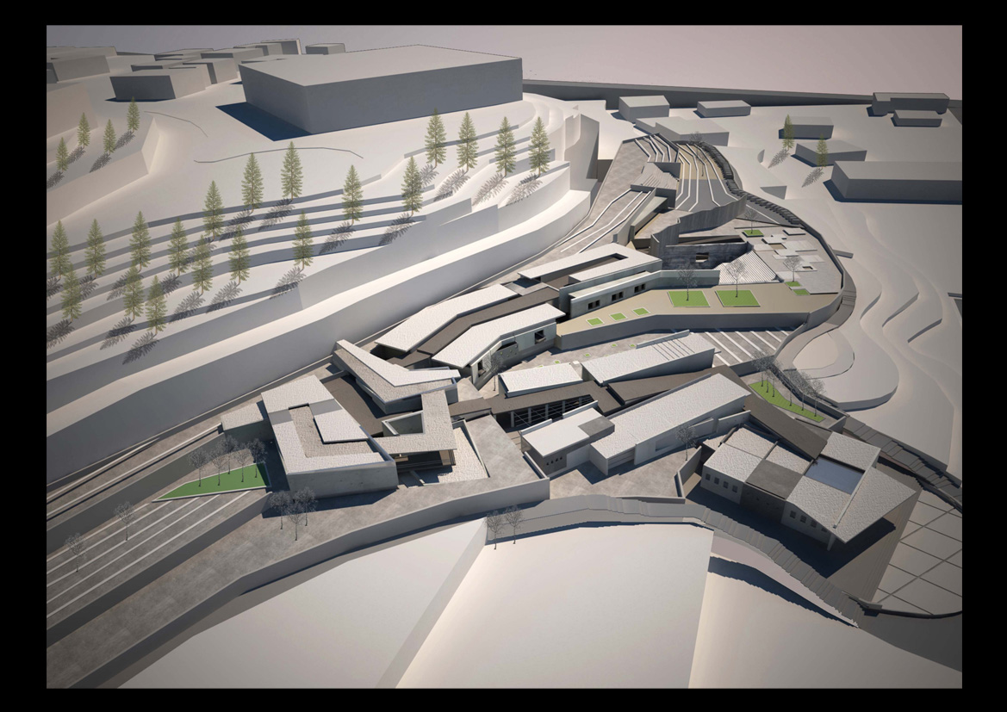

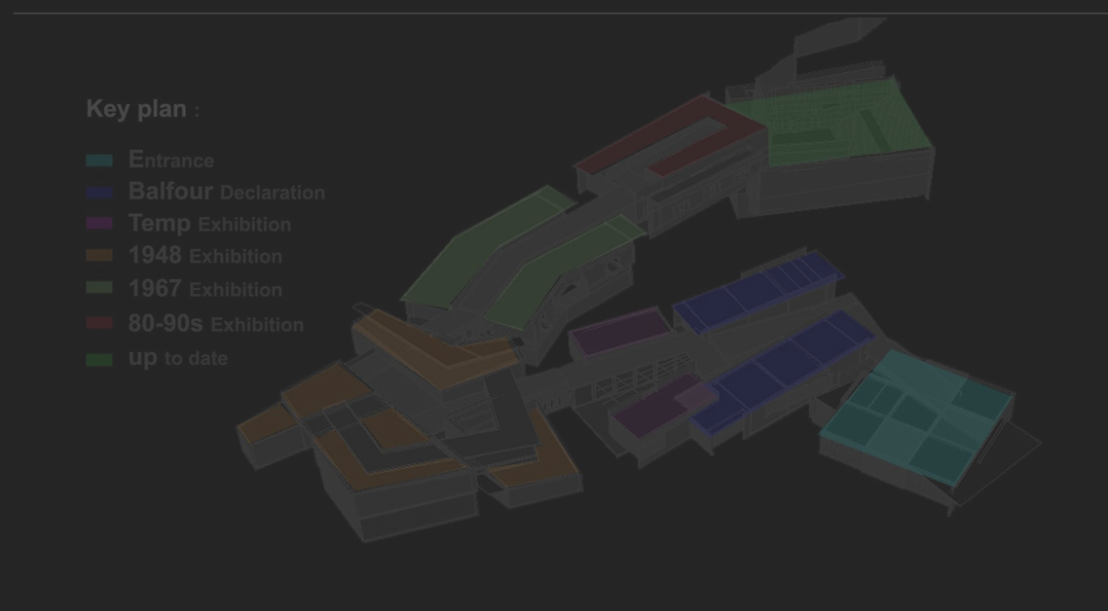

Concept Approach
The concept depends on two main elements;
A grid + An irregular line


+

The grid represents the Settlement and the Civilization of the Palestinian Entity.
The irregular line is embodied by a Path. This path represents the Outside Forces that distort the grid “Palestinian Entity”.

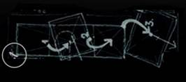
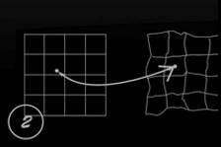

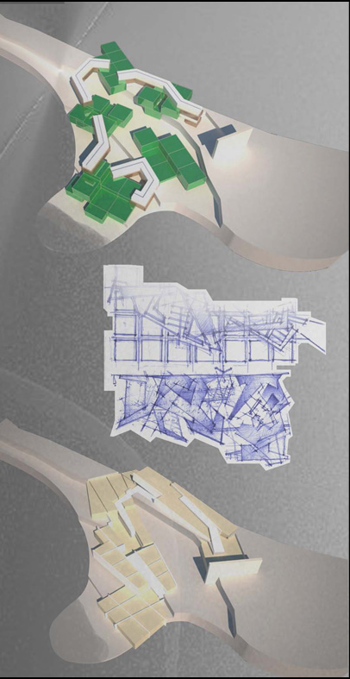
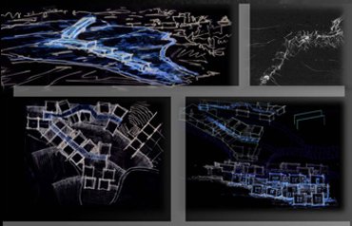

Story Board;
The visitor starts his/her journey by moving within the Path, stopping by Historical Stations which shows the Palestinian life after the impact of the outside powers.
The Path is nearly long and dark indication for the suffering and the fear that the Palestinian lived.
At the End of the Path he/she finds a Bright light that indicates the hope and freedom, but he/she will find his/herself in an open to the sky Jail which indicates the Restricted Freedom and was represented in the project with a Deep Hole.

The visitor has to get out of this Hole by a long Stairs to show that the Freedom Way
is Tough and Hard.

Finally, the visitor gets his/her Freedom by ended his/her journey with an open view of The Old City of Jerusalem and The Rock of The Dom “ City of Peace”.
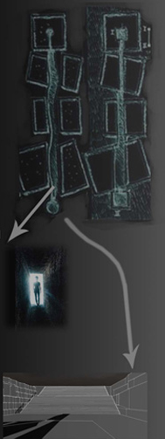
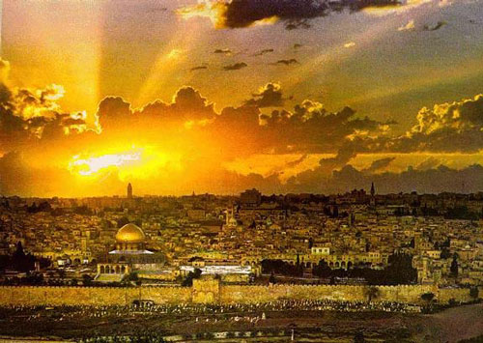

Circulation;
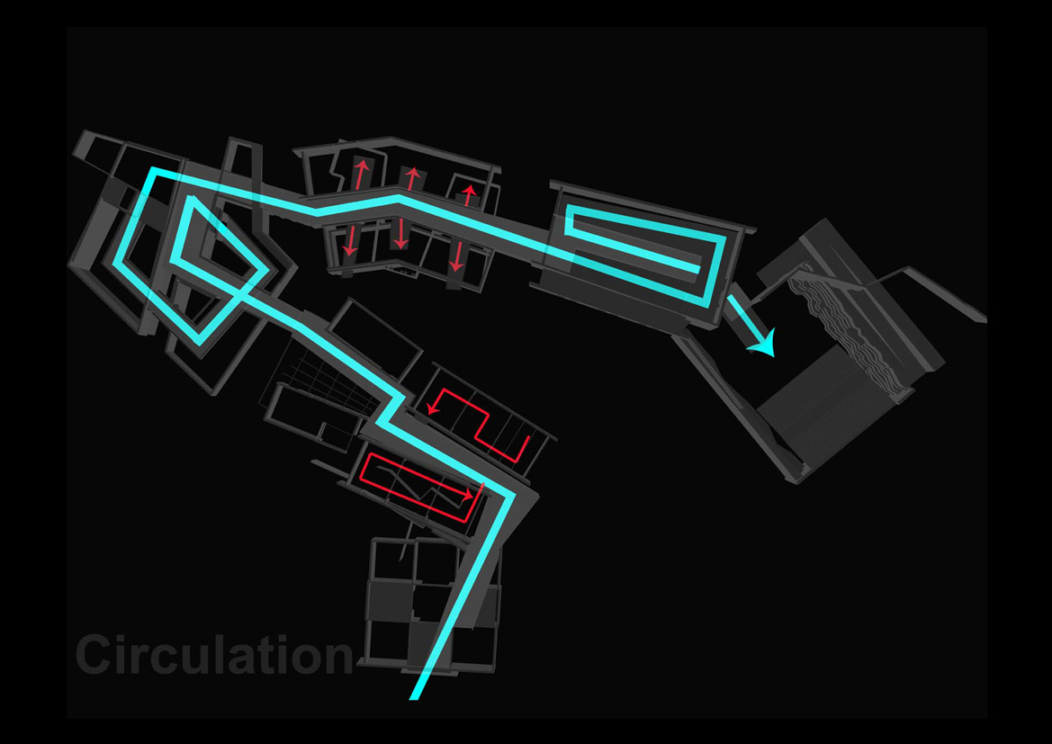
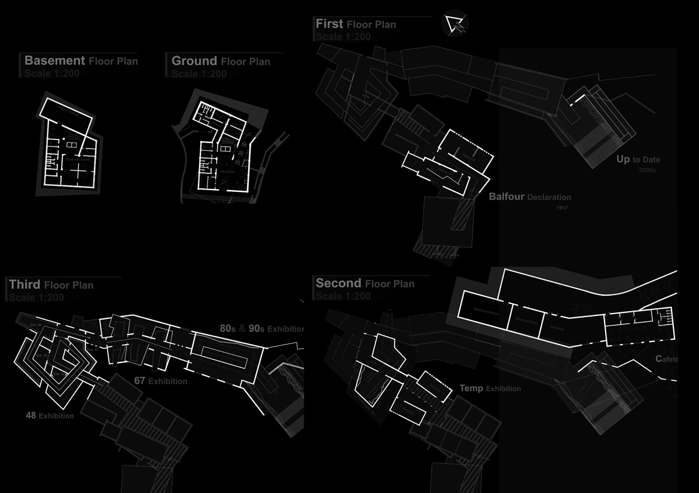
Plans;

Elevations;
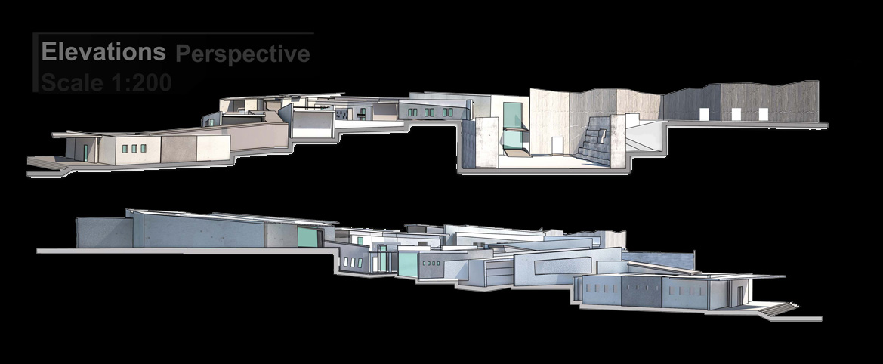

Sections;
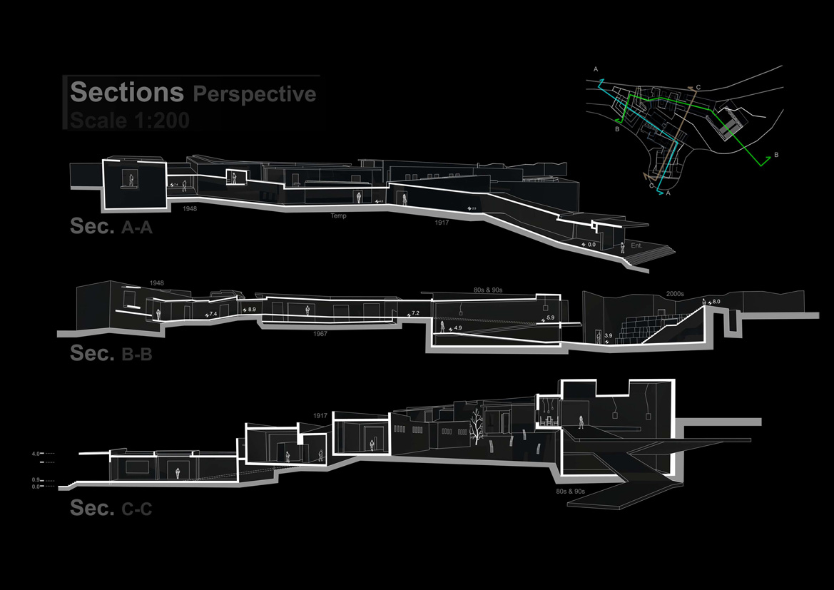

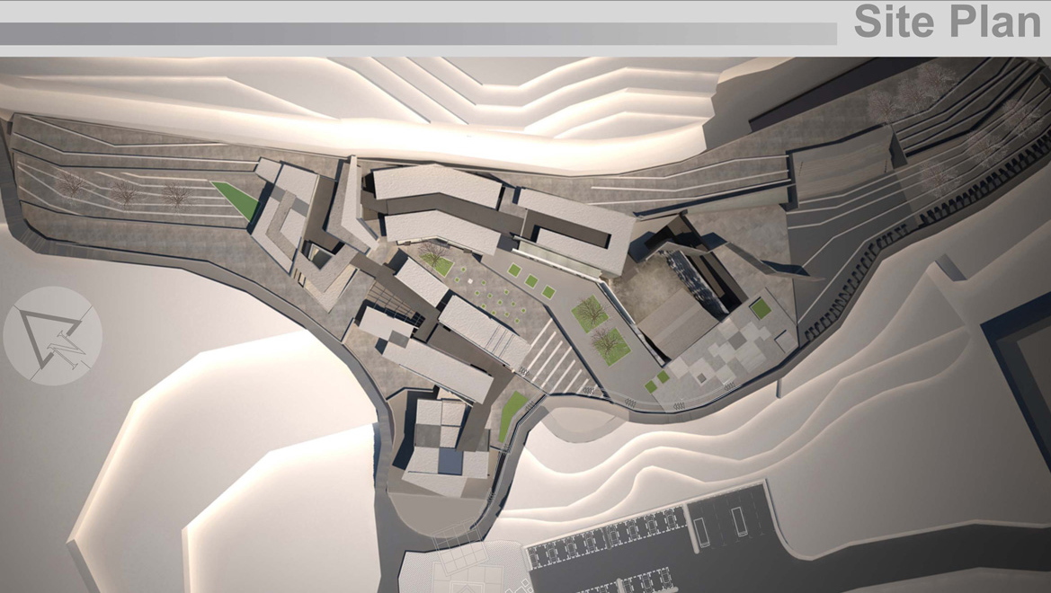
Site Plan;
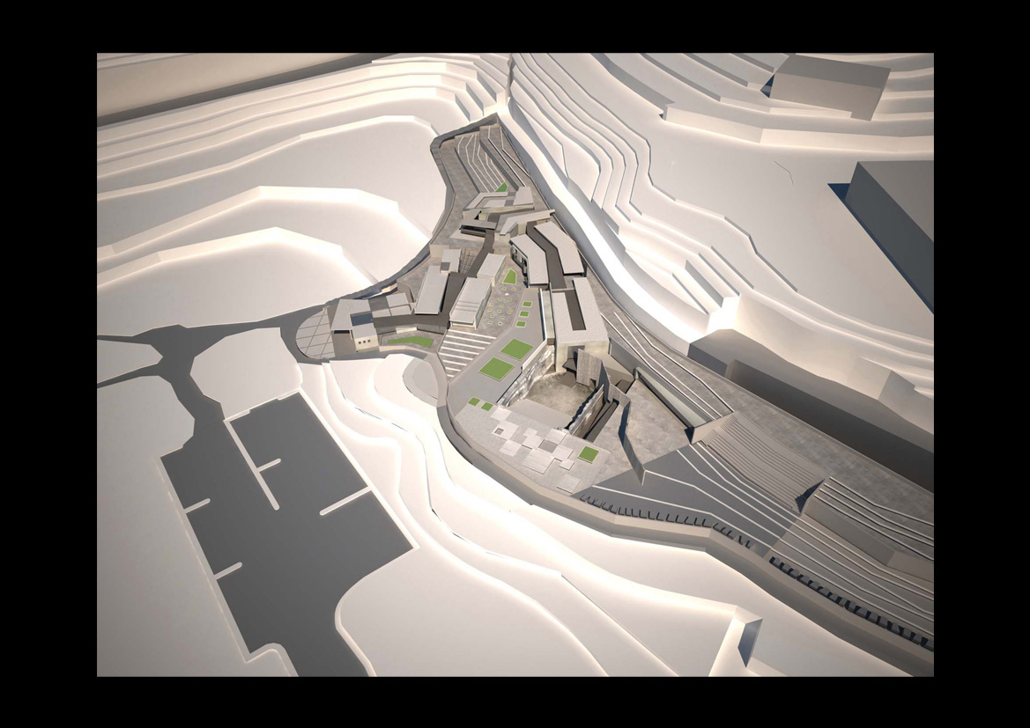
Aerial View;

Perspectives;
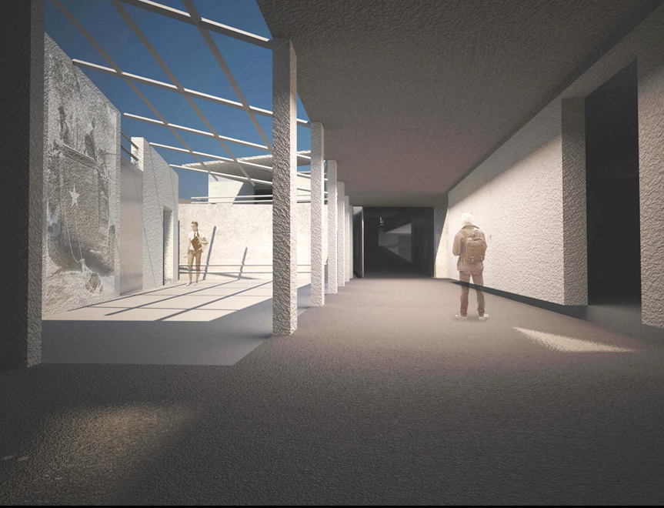
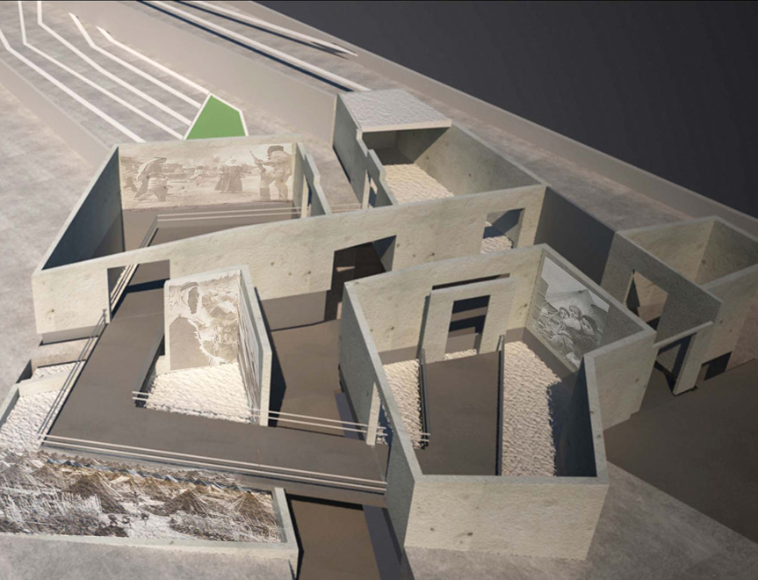
Nakba
1948
Balfour Declaration
1917
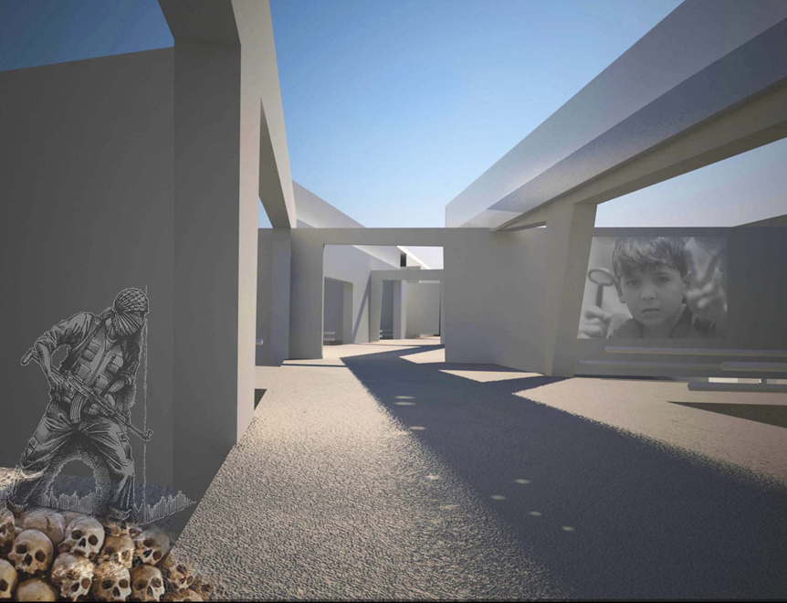
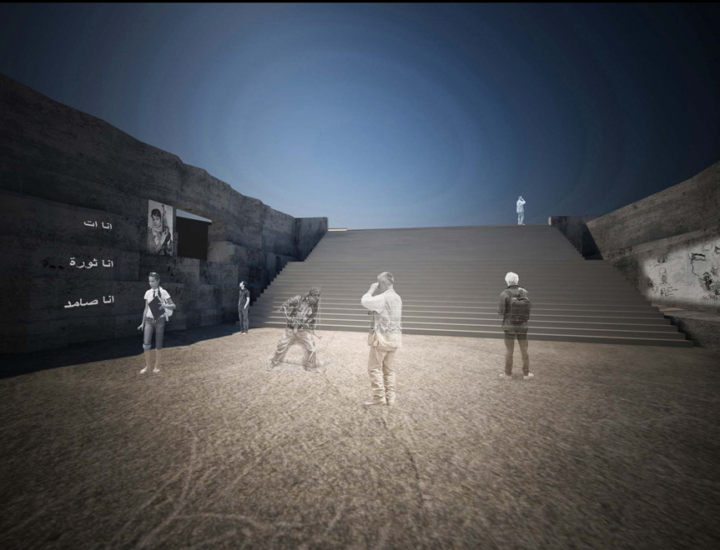
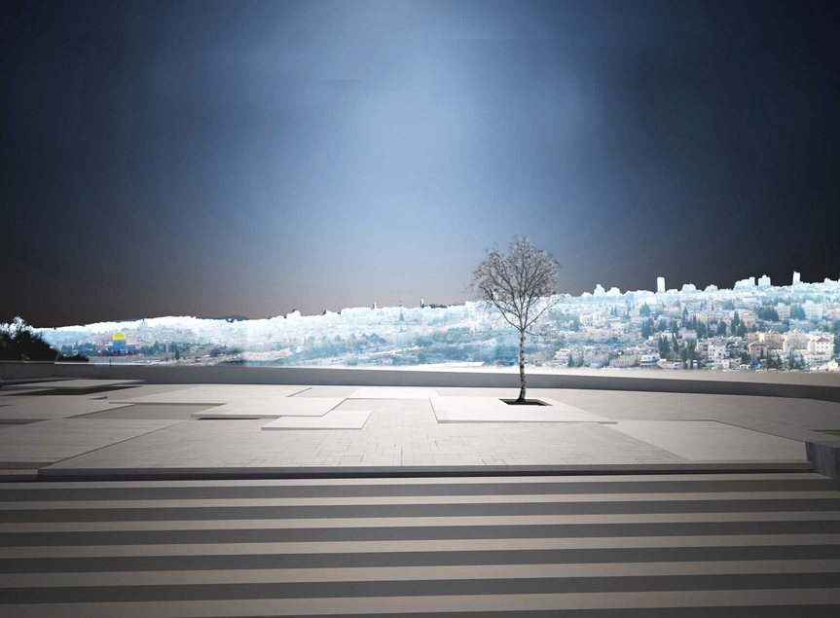

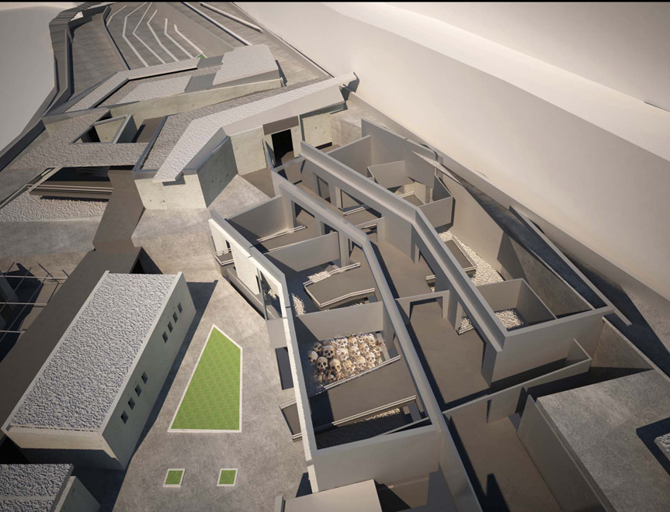

Naksa
1967
Naksa
1967
2000- up to date
Future

