Najah National University
Faculty of Electrical engineering

Introduction to Graduation Project

"Techno-economic feasibility of using photovoltaic generators instead of diesel motor for water pumping"

Supervisors:
Prof. Dr.Marwan M. Mahmud

: Prepared by
Sabreen Staiti
Heba Aseedah
Yasmeen Salah

Table of contents
content | page
Chapter 1  introduction | 2
Chapter 2  The content of pv and diesel systems | 4-6
Chapter 3 The data of well needed | 7-14
Chapter 4  The calculation of wells capital cost for pv and diesel systems | 15-34
Chapter 5  The calculation of average value of yearly pumping water | 35-72
Chapter 6  Economical evaluation of energy supply systems | 73-90
Chapter 7  Net present value ( NPV ) | 91-95
Chapter 8  Life cycle cost | 96-101
Chapter 9  Breakeven point | 102
Introduction
In rural and/or undeveloped areas where there is no power grid and more water is needed than what hand or foot pumps can deliver, the choices for powering pumps are usually solar or a fuel driven engine, usually diesel .There are very distinct differences between the two power sources in terms of cost and reliability. Diesel a very high operation and maintenance cost. Solar is the opposite, with a higher first cost but very low on going operation and maintenance costs.
In terms of reliability, it is much easier (and cheaper) to keep a solar-powered system going than it is a diesel engine. This is evident in field where diesel engines lie rusting and unused by the thousands and solar pumps sometimes run for year without anyone touching them
The first cost of solar is often daunting to donors and project implementers who are tempted to stretch their budgets as far as possible to reach the greatest number of beneficiaries by using a low first-cost option. But most would probably agree that “quantity over quality” is not a good value if the higher quantity option is not likely to be giving good service five years down the road and if beneficiaries are going to be stuck with interventions they cannot afford to sustain over time.
Solar pumping has had clear advantages for a number of years but the differences are becoming more striking in a world of rapidly escalating fuel costs. Not only will some of the world’s poorest people not be able to afford fuel for their pumps, but living at the end of remote supply chains, they may not even be able to get it in the first place as world demand overtakes supply

Chapter 2

The content of photovoltaic and diesel water pumping system

2-1 Photovoltaic water pumping system

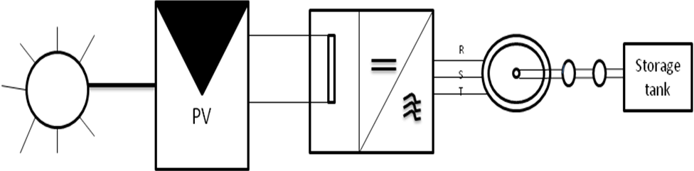

1- Solar radiation
2- Pv generator
3- Inverter
4- ASM
5- A centrifugal pump
6- Storage tank

Components of Water pumping system driven by a diesel

h
S.G
ASM
M
Pump

Diesel
Motor
Three phase
Asyn G
Motor
Well
Storage
Tank
The component of pumping water by diesel:
1- Diesel motor.
2- Synchronous generator.
3- Three phase asynchronous motor.
4- Pump.
5- Storage tank.

Chapter 3
The data of well needed

The data of well needed for our project is:-
اسم صاحب البئر | انس محمد نجيب مسا د
الهاتف | 0599477308
العنوان | برقين
طبيعة الاستخدام | زراعي
معلومات البئر :
الرقم | البيان | الوحدة | الكمية
1. | عمق البئر | متر | 40
2. | مستوى الماء الثابت SWL | متر | 12
3. | مستوى الماء المتحرك DWL | متر | 35
4. | قطر مواسير التعليق | أنش | 2" بربيش
5. | كمية المياه المنتجة خلال ساعة | م³/ساعة | 2.5
6. | معدل عدد ساعات الضخ يوميا | ساعة | 3

معلومات المضخة
الرقم | البيان | التوضيح
1. | قدرة المضخة hp | 5.5
2. | عدد فازات المضخة | 3 فاز

**********************************************************
اسم صاحب البئر | احمد عبد الطيف عامودي
الهاتف | 0522412124
العنوان | مثلث كفر قود
طبيعة الاستخدام | زراعي

معلومات البئر :
الرقم | البيان | الوحدة | الكمية
1. | عمق البئر | متر | 60
2. | مستوى الماء الثابت SWL | متر | 20
3. | مستوى الماء المتحرك DWL | متر | 56
4. | قطر مواسير التعليق | انش | 2"
5. | كمية المياه المنتجة خلال ساعة | م³/ساعة | 3
6. | معدل عدد ساعات الضخ يوميا | ساعة | 12

معلومات المضخة :
الرقم | البيان | التوضيح
1. | قدرة المضخة hp | 5
2. | عدد فازات المضخة | 3 فاز

**********************************************************
اسم صاحب البئر | جميل محمد نجيب مساد
الهاتف | 0522272029
العنوان | برقين
طبيعة الاستخدام | زراعي

معلومات البئر :
الرقم | البيان | الوحدة | الكمية
1. | عمق البئر | متر | 45
2. | مستوى الماء الثابت SWL | متر | 12
3. | مستوى الماء المتحرك DWL | متر | 40
4. | قطر مواسير التعليق | انش | 2" بربيش
5. | كمية المياه المنتجة خلال ساعة | م³/ساعة | 3
6. | معدل عدد ساعات الضخ يوميا | ساعة | 5

معلومات المضخة :
الرقم | البيان | التوضيح
1. | قدرة المضخة hp | 5.5
2. | عدد فازات المضخة | 3 فاز

**********************************************************
اسم صاحب البئر | خليل مصطفى احمد غانم
الهاتف | 042501847
العنوان | مثلث كفر قود
طبيعة الاستخدام | زراعي

معلومات البئر :
الرقم | البيان | الوحدة | الكمية
1. | عمق البئر | متر | 60
2. | مستوى الماء الثابت SWL | متر | 30
3. | مستوى الماء المتحرك DWL | متر | 50
4. | قطر مواسير التعليق | انش | 2"
5. | كمية المياه المنتجة خلال ساعة | م³/ساعة | 4
6. | معدل عدد ساعات الضخ يوميا | ساعة | 12

معلومات المضخة :
الرقم | البيان | التوضيح
1. | قدرة المضخة hp | 7
3. | عدد فازات المضخة | 3 فاز

******************************************************
اسم صاحب البئر | رائد عويص
الهاتف | 0599970669
العنوان | مثلث كفرقود
طبيعة الاستخدام | زراعي + منزلي

معلومات البئر :
الرقم | البيان | الوحدة | الكمية
1. | عمق البئر | متر | 70
2. | مستوى الماء الثابت SWL | متر | 20
3. | مستوى الماء المتحرك DWL | متر | 60
4. | قطر مواسير التعليق | انش | 2"
5. | كمية المياه المنتجة خلال ساعة | م³/ساعة | 3
6. | معدل عدد ساعات الضخ يوميا | ساعة | 12

معلومات المضخة :
الرقم | البيان | التوضيح
1. | قدرة المضخة hp | 5
2. | عدد فازات المضخة | 3 فاز

اسم صاحب البئر | كامل عمر ابراهيم عباس
الهاتف | 0599264086
العنوان | برقين
طبيعة الاستخدام | زراعي

معلومات البئر :
الرقم | البيان | الوحدة | الكمية
1. | عمق البئر | متر | 50
2. | مستوى الماء الثابت SWL | متر | 18
3. | مستوى الماء المتحرك DWL | متر | 32
4. | قطر مواسير التعليق | انش | 2"
5. | كمية المياه المنتجة خلال ساعة | م³/ساعة | 12
6. | معدل عدد ساعات الضخ يوميا | ساعة | 24 صيفا

معلومات المضخة :
الرقم | البيان | التوضيح
1. | قدرة المضخة hp | 5.5
2. | عدد فازات المضخة | 3 فاز

***************************************************************************
اسم صاحب البئر | محمود عبد الطيف عامودي
الهاتف | 0522412124
العنوان | مثلث كفر قود
طبيعة الاستخدام | زراعي

معلومات البئر
الرقم | البيان | الوحدة | الكمية
1. | عمق البئر | متر | 70
2. | مستوى الماء الثابت SWL | متر | 30
3. | مستوى الماء المتحرك DWL | متر | 60
4. | قطر مواسير التعليق | انش | 2"
5. | كمية المياه المنتجة خلال ساعة | م³/ساعة | 3
6. | معدل عدد ساعات الضخ يوميا | ساعة | 12

معلومات المضخة:
الرقم | البيان | التوضيح
1. | قدرة المضخة hp | 5
2. | عدد فازات المضخة | 3 فاز

Chapter 4
The calculation of wells capital cost for PV and diesel systems

4-1 The calculation of capital cost for pv system
رائد عويص
Well depth=70m.
Swl = 20m.
Dwl = 60m.
Pipe = 2inch.
Compute of the well = 3 m³/ hour , 12 hour / day .
Total pumping head (ht) = 60 + (6m) = 66m.
Total water capacity needed per day =3 ×12=36 m³/ day
E_{h} =0.002725×V × h_{T}
=0.002725×36 ×66= 6.47kwh / day
E _{p in} 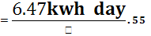=11.76kwh /day .
E _{asm in} 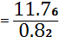 = 14.34 Kwh / day.
E _{inv in} =15.42 kwh / day.
P_{sh} =5.4 kwh /day.
1kw_{p} →5.4 kWh /day.
? → 15.42 kWh / day.
P_{PV}= 2.85 kwp.
PV → 1 w_{p} = 2.5 $
The cost of PV cells : - 2850* 2.5 = 7125 $
Inverter cost = 1800 $
Motor pump set = 1000 $
Piping and accessories = 400 $
The capital cost = 7125 +1800+1000+400
= 10325 $
**********************************
جميل مساد
Well depth=45m.
Swl = 12m.
Dwl = 40m.
Pipe = 2inch.
Output of the well = 3 m³/ hour for 5 hour / day .
Total pumping head (h_{T}) = 40 +(6m) = 46m.
Total water capacity needed per day =3 ×5=15 m³
E_{h} =0.002725×V × h_{T}
=0.002725×15×46= 1.88kwh / day
E _{p in} 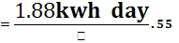=3.42 kwh /day .
E _{ASM in} 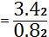 = 4.17 Kwh / day .
E _{inv in} =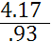 =4.48 kwh / day.
P_{sh} =5.4 kwh /day.
1kw_{p} →5.4 kWh /day.
? → 4.48 kwh / day.
P_{PV}= .829 kwp .
The cost of Pv cells :- 829* 2.5=2072.5 $
Inverter cost = 1400 $
Motor pump set = 800 $
Piping and accessories = 300 $
The capital cost = 2072.5 +1400 +800 +300
= 4572.5 $

********************************************************
خليل غانم
Well depth=60m.
Swl = 30m.
Dwl = 50m.
Pipe = 2inch.
Output of the well = 4 m³/ hour for 12 hour / day .
Total pumping head (h_{T}) = 50 +(6m) = 56m.
Total water capacity needed per day =4 ×12=48 m³
E_{h} =0.002725×V × h_{T}
=0.002725×48×56= 7.32kwh / day
E _{p in} 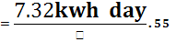=13.3 kwh /day .
E _{ASM in} 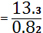 = 16.23 Kwh / day.
E _{inv in} =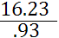 =17.45 kWh / day.
P_{sh} =5.4 kWh /day.
1kw_{p} →5.4 kWh /day.
? → 17.45 kWh / day.
P_{PV}= 3.23 kwp .
The cost of Pv cells :- 3230 *2.5 =8075 $
Inverter cost = 2000 $
Motor pump set = 1200 $
Piping and accessories = 420 $
The capital cost = 8075 +2000 +120 = 11695 $

.**********************************************************

احمد عامودي
Well depth=60m.
Swl = 20m.
Dwl = 56m.
Pipe = 2inch.
Output of the well = 3 m³/ hour for 12 hour / day .
Total pumping head (h _{T}) = 56 + (6m) = 62 m.
Total water capacity needed per day =3 ×12=36 m³
E_{h} =0.002725×V × h _{T}
=0.002725×36×62= 6.08kwh / day
E _{p in} 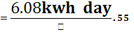=11.05 k w h /day .
E _{ASM in} 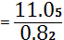 = 13.48 K w h / day .
E _{inv in} =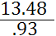 =14.49 k w h / day.
P _{sh} =5.4 k w h /day.
1kw_{p} →5.4 kWh /day.
? → 14.49 kWh / day.
P_{PV}= 2.68 kwp.
.

The cost of Pv cells :- 2068*2.5 =5170 $
Inverter cost = 1800 $
Motor pump set = 1000 $
Piping and accessories = 400 $
The capital cost = 1800 +1000 +400 +5170
= 8370 $

.**********************************************************

أنس مساد .
Well depth=40m
Swl = 12m.
Dwl = 35m.
Pipe = 2inch.
Output of the well = 2.5 m³/ hour for 3 hour / day .
Total pumping head (h _{T}) = 35 + (6m) = 41 m.
Total water capacity needed per day =2.5 ×3=7.5 m³/ day .
E_{h} =0.002725×V × h _{T}
=0.002725×7.5×41= 0.84kwh / day
E _{p in} 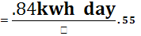=1. 53 k w h /day .
E _{ASM in} 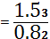 = 1 .86 K w h / day .
E _{inv in} =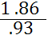 =2 k w h / day .
P _{sh} =5.4 k w h /day.
1kw_{p} →5.4 kwh /day.
? → 2 kwh / day.
P_{PV}= .37 kwp .

The cost of Pv cells :- 370 * 2.5 =925 $
Inverter cost = 1300 $
Motor pump set = 700 $
Piping and accessories = 300 $
The capital cost = 925 +1300 +700 +300
= 3225 $

.**********************************************************

محمود العامودي
Well depth=70m
Swl = 30m.
Dwl = 60m.
Pipe = 2inch.
Output of the well = 3 m³/ hour for 12 hour / day .
Total pumping head (h _{T}) = 60 + (6m) = 66 m.
Total water capacity needed per day =12 ×3=36 m³/ day .
E_{h} =0.002725×V × h _{T}
=0.002725×36×66= 6.47 kwh / day
E _{p in} 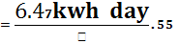=11. 76 k w h /day .
E _{ASM in} = 14 .34 K w h / day .
E _{inv in} =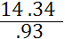 =15.42 k w h / day .
P _{sh} =5.4 k w h /day.
1kw_{p} →5.4 kwh /day.
? → 15.42 kwh / day.
P_{PV}= 2.86 kwp .

The cost of Pv cells :- 2860 * 2.5 =7150 $
Inverter cost = 1800 $
Motor pump set = 1000 $
Piping and accessories = 400 $
The capital cost = 7150 +1800 +1000 +400
= 30350 $

******************************************************
كامل عمر ابراهيم عباس
Well depth=50 m
Swl = 18 m.
Dwl = 32m.
Pipe = 2 inch.
Output of the well = 50 m³/ hour for 4 hour / day .
Total pumping head (h _{T}) = 32 + (6m) = 38 m.
Total water capacity needed per day =50 ×4=200 m³/ day .
E_{h} =0.002725×V × h _{T}
=0.002725×200×38= 20.71 kwh / day
E _{p in} =20.710/ .55 = 37.65 k w h /day .
E _{ASM in} =37.65 / .82 = 45.9 K w h / day .
E _{inv in} =45.9 / .92 =49.37 k w h / day .
P _{sh} =5.4 k w h /day.
1kw_{p} →5.4 kwh /day.
? → 49.3 kwh / day.
P_{PV}= 9.14 kwp .

The cost of Pv cells :- 9140 * 2.5 =22850 $
Inverter cost = 4500$
Motor pump set = 2000 $
Piping and accessories = 500 $
The capital cost = 22850 +4500 +2000 +500
= 29850 $

Capital cost | Hydroulic energy | wells
10325 $ | 6.47kwh / day | رائد عويص  Well depth=70m . 63 m3/ day
4572.5 $ | 1.88kwh / day | جميل مساد  Well depth=45m . 15 m3/ day
11695 $ | 7.32kwh / day | خليل غانم  Well depth=60m . 48 m3/ day
8370 $ | 6.08kwh / day | احمد عامودي  Well depth=60m .36 m3/ day
3225 $ | 0.84kwh / day | أنس مساد  Well depth=40m . 7.5 m3/ day
30350 $ | 6.47 kwh / day | محمود العامودي  Well depth=70m . 36 m3/ day
29850 $ | 20.71 kwh / day | كامل عمر ابراهيم عباس  Well depth=50m . 200 m3/ day

4-2 the calculation of capital cost for diesel system
رائد عويص
Well depth=70m.
Swl = 20m.
Dwl = 60m.
Pipe = 2inch.
Compute of the well = 3 m³/ hour ,12 hour / day .
Total pumping head (h_{T} ) = 60 +(6m) = 66m.
Total water capacity needed per day =3 ×12=36 m³
E_{h} =0.002725×V × h_{T}
=0.002725×36 ×66= 6.47kwh / day
E _{p in} =11.76kwh /day .
E _{ASM in} = 14.34 Kwh / day .

E _{S.G in} = 14.34/0.75 = 19.12 kwh

E _{DIESEL in} =19.12/0.30 = 63.7 kwh
Number of liters diesel needed daily = 63.7/10.5 = 6
Diesel cost = 6* 6 NIS =36 NIS/day
COST OF EQUIPMENT :
Diesel and engine and S.G = 3125 $
Motor pump set = 1000 $
Piping and accessories = 400 $
Capital cost = 4525 $

*******************************************************
جميل مساد
Well depth=45m.
Swl = 12m.
Dwl = 40m.
Pipe = 2inch.
Output of the well = 3 m³/ hour for 5 hour / day .
Total pumping head (h_{T}) = 40 +(6m) = 46m.
Total water capacity needed per day =3 ×5=15 m³
E_{h} =0.002725×V × h_{T}
=0.002725×15×46= 1.88kwh / day
E _{p in} =3.42 kwh /day .
E _{ASM in} = 4.17 Kwh / day .

E _{S.G in} = 4.17/0.75 = 5.56 kwh

E _{DIESEL in} =5.56/0.30 = 18.53 kwh
Number of liters diesel needed daily = 18.53/10.5 = 1.76
Diesel cost = 6* 6 NIS =10.56 NIS/day
COST OF EQUIPMENT :
Diesel and engine and S.G = 3125 $
Motor pump set = 800 $
Piping and accessories = 300 $
Capital cost = 4225 $

***************************************************
خليل غانم
Well depth=60m.
Swl = 30m.
Dwl = 50m.
Pipe = 2inch.
Output of the well = 4 m³/ hour for 12 hour / day .
Total pumping head (h_{T}) = 50 +(6m) = 56m.
Total water capacity needed per day =4 ×12=48 m³
E_{h} =0.002725×V × h_{T}
=0.002725×48×56= 7.32kwh / day
E _{p in} =13.3 kwh /day .
E _{ASM in} = 16.23 Kwh / day .

E _{S.G in} = 16.23/0.75 = 21.64 kwh

E _{DIESEL in} =21.64/0.30 = 72.13 kwh
Number of liters diesel needed daily = 72.13/10.5 = 6.87
Diesel cost = 6* 6.87 NIS =41.22NIS/day
COST OF EQUIPMENT :
Diesel and engine and S.G = 3125 $
Motor pump set = 1200 $
Piping and accessories = 420 $
Capital cost = 4745 $

احمد عامودي
Well depth=60m.
Swl = 20m.
Dwl = 56m.
Pipe = 2inch.
Output of the well = 3 m³/ hour for 12 hour / day .
Total pumping head (h _{T}) = 56 + (6m) = 62 m.
Total water capacity needed per day =3 ×12=36 m³
E_{h} =0.002725×V × h _{T}
=0.002725×36×62= 6.08kwh / day
E _{p in} =11.05 k w h /day .
E _{ASM in} = 13.48 K w h / day .

E _{S.G in} = 13.48/0.75 = 17.97 kwh

E _{DIESEL in} =17.97/0.30 = 59.9 kwh
Number of liters diesel needed daily = 59.9/10.5 = 5.7
Diesel cost = 6* 5.7 NIS =34.2 NIS/day

COST OF EQUIPMENT :
Diesel and engine and S.G = 3125 $
Motor pump set = 1000 $
Piping and accessories = 400 $
Capital cost = 4525 $

**************************************************
أنس مساد .
Well depth=40m
Swl = 12m.
Dwl = 35m.
Pipe = 2inch.
Output of the well = 2.5 m³/ hour for 3 hour / day .
Total pumping head (h _{T}) = 35 + (6m) = 41 m.
Total water capacity needed per day =2.5 ×3=7.5 m³/ day .
E_{h} =0.002725×V × h _{T}
=0.002725×7.5×41= 0.84kwh / day
E _{p in} =1. 53 k w h /day .
E _{ASM in} = 1 .86 K w h / day .

E _{S.G in} = 1.86/0.75 = 2.48 kwh

E _{DIESEL in} =2.48/0.30 = 8.2 kwh
Number of liters diesel needed daily = 8.2/10.5 =.78
Diesel cost = 6* .78 NIS =4.68 NIS/day
COST OF EQUIPMENT :
Diesel and engine and S.G = 3125 $
Motor pump set = 700 $
Piping and accessories = 300 $
Capital cost = 4125 $
*******************************************************
محمود العامودي
Well depth=70m
Swl = 30m.
Dwl = 60m.
Pipe = 2inch.
Output of the well = 3 m³/ hour for 12 hour / day .
Total pumping head (h _{T}) = 60 + (6m) = 66 m.
Total water capacity needed per day =12 ×3=36 m³/ day .
E_{h} =0.002725×V × h _{T}
=0.002725×36×66= 6.47 kwh / day
E _{p in} =11. 76 k w h /day .
E _{ASM in} = 14 .34 K w h / day .

E _{S.G in} = 14.34/0.75 = 19.12 kwh
E _{DIESEL in} =19.12/0.30 = 63.73 kwh
Number of liters diesel needed daily = 63.73/10.5 =6.06
Diesel cost = 6* 6.06 NIS =36.36 NIS/day
COST OF EQUIPMENT :
Diesel and engine and S.G = 3125 $
Motor pump set = 1000 $
Piping and accessories = 400 $
Capital cost = 4525 $
.*********************************************************
كامل عمر ابراهيم عباس
Well depth=50m
Swl = 18m.
Dwl = 32m.
Pipe = 2inch.
Output of the well = 50 m³/ hour for 4 hour / day .
Total pumping head (h _{T}) = 32+ (6m) = 32 m.
Total water capacity needed per day =50×4=200m³/ day .
E_{h} =0.002725×V × h _{T}
=0.002725×200×32= 20.71 kwh / day
E _{p in} = 20.71 / .55 =37.65 k w h /day .
E _{ASM in} = 37.65 / 0.82 = 45.9 K w h / day .
E _{S.G in} = 45.9/0.75 = 61.2 kwh
E _{DIESEL in} =61.2/0.30 = 204 kwh
Number of liters diesel needed daily = 204/10.5 =19.43 $
Diesel cost = 6* 19.43 NIS =116.58 NIS/day
COST OF EQUIPMENT :
Diesel and engine and S.G = 3125 $
Motor pump set = 2000 $
Piping and accessories = 500 $
Capital cost = 5625 $

Capital cost | daily liter diesel needed of # | wells
4525 $ | 6 | رائد عويص  Well depth=70m . 63 m3/ day
4225 $ | 1.76 | جميل مساد  Well depth=45m . 15 m3/ day
4745 $ | 6.87 | خليل غانم  Well depth=60m . 48 m3/ day
4525 $ | 5.7 | احمد عامودي  Well depth=60m . 36 m3/ day
4125 $ | .78 | أنس مساد  Well depth=40m . 7.5 m3/ day
4525 $ | 6.06 | محمود العامودي  Well depth=70m . 36 m3/ day
5625 $ | 19.43 | كامل عمر ابراهيم عباس  Well depth=50m . 200 m3/ day

Chapter 5
The calculation of average value of yearly pumping water
(m³ / day)

رائد عويص
January
E _{pv out} = 2.85 ×2.85 =8.12 kwh
15.42 kwh / day →36 m³ / day
8.12 kwh / day → ?
Average value of daily pumping water dnring January
→ 18.9 m³ / day.
February
E_{pv out} = 2.85 ×3.2 =9.12 kwh
15.42 kwh / day →36 m³ / day
9.12 kwh / day → ?
Average value of daily pumping water during February =21.29 m³ / day.
March
E_{pv out} = 2.85 ×5.2 =14.82 kwh
15.42 kwh / day →36 m³ / day
14.82 kwh / day → ?
Average value of daily pumping water during March =34.59 m³ / day.
April
E_{pv out} = 2.85 ×6.1 =17.38 kwh
15.42 kwh / day →36 m³ / day
17.38 kwh / day → ?
Average value of daily pumping water during April =40.57 m³ / day.
May
E_{pv out} = 2.85 ×7.6 =21.66 kwh
15.42 kwh / day →36 m³ / day
21.66 kwh / day → ?
Average value of daily pumping water during May =50.56 m³ / day.
June
E_{pv out} = 2.85 ×8.2 =23.37 kwh
15.42 kwh / day →36 m³ / day
23.37 kwh / day → ?
Average value of daily pumping water during june =54.56 m³ / day.
July
E_{pv out} = 2.85 ×8.1 =23.08 kwh
15.42 kwh / day →36 m³ / day
23.08 kwh / day → ?
Average value of daily pumping water during July =53.88 m³ / day.
August
E_{pv out} = 2.85 ×8 =22.8 kwh
15.42 kwh / day →36 m³ / day
22.8 kwh / day → ?
Average value of daily pumping water during August =53.23 m³ / day.
September
E_{pv out} = 2.85 ×6.2 =17.67 kwh
15.42 kwh / day →36 m³ / day
17.67 kwh / day → ?
Average value of daily pumping water during September=41.25 m³ / day.
October
E_{pv out} = 2.85 ×4.7 =13.39 kwh
15.42 kwh / day →36 m³ / day
13.39 kwh / day → ?
Average value of daily pumping water during October =31.26 m³ / day.
November
E_{pv out} = 2.85 ×3.65 =10.4 kwh
15.42 kwh / day →36 m³ / day
10.4 kwh / day → ?
Average value of daily pumping water during November =24.28 m³ / day.
December
E_{pv out} = 2.85 ×2.9=8.26 kwh
15.42 kwh / day →36 m³ / day
8.26 kwh / day → ?
Average value of daily pumping water during December =19.28 m³ / day.
Q _{year} =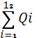=(19.28+24.28+31.26 +41.25+34.59+40.57+53.23+53.88
+54.56+50.56+14.82+21.29+18.9)×30 =13757.1 m³ / year.
m³ / day | E_{pv out} | month
18.9 | 8.12 | January
21.29 | 9.12 | February
34.59 | 14.82 | march
40.57 | 17.38 | April
50.56 | 21.66 | May
54.56 | 23.87 | June
53.88 | 23.08 | July
53.23 | 22.8 | August
41.25 | 17.67 | September
31.26 | 13.39 | October
24.28 | 10.4 | November
19.28 | 8.26 | December

جميل مساد
January
E _{pv out} = 2.85 ×.829 =2.36 kwh / day
4.48 kwh / day →15 m³ / day
2.36 kwh / day → ?
Average value of daily pumping water during January =7.9 m³ / day.
February
E_{pv out} = .829 ×3.2 =2.65 kwh / day
4.48 kwh / day →15 m³ / day
2.65 kwh / day → ?
Average value of daily pumping water during February =8.87 m³ / day.
March
E_{pv out} = .829 ×5.2 =4.31 kwh/ day
4.48 kwh / day →15 m³ / day
4.31 kwh / day → ?
Average value of daily pumping water during March =13.83 m³ / day.
April
E_{pv out} = .829 ×6.1 =5.05 kwh / day
4.48 kwh / day →15 m³ / day
17.38 kwh / day → ?
Average value of daily pumping water during April =16.9 m³ / day
May
E_{pv out} = .829 ×7.6 =6.3 kwh
4.48 kwh / day →15 m³ / day
6.3 kwh / day → ?
Average value of daily pumping water during May =21.09 m³ / day.
June

E_{pv out} = .829 ×8.2 =6.79 kwh
4.48 kwh / day →15 m³ / day
6.79 kwh / day → ?
Average value of daily pumping water during June =22.73 m³ / day.
July
E_{pv out} = .829 ×8.1 =6.7 kwh
4.48 kwh / day →15 m³ / day
6.7 kwh / day → ?
Average value of daily pumping water during July =22.43 m³ / day.
August
E_{pv out} = .829 ×8 =6.63 kwh
4.48 kwh / day →15 m³ / day
6.63 kwh / day → ?
Average value of daily pumping water during August =22.2 m³ / day.
September
E_{pv out} = .829 ×6.2 =5.14 kwh
4.48 kwh / day →15 m³ / day
5.14 kwh / day → ?
Average value of daily pumping water during September=17.21 m³ / day.
October
E_{pv out} = .829 ×4.7 =3.89 kwh
4.48 kwh / day →15 m³ / day
3.89 kwh / day → ?
Average value of daily pumping water during October =13.04 m³ / day.
November
E_{pv out} = .829 ×3.65 =3.02 kwh
4.48 kwh / day →15 m³ / day
3.02 kwh / day → ?
Average value of daily pumping water during November = 10.13 m³ / day.
December
E_{pv out} = .829 ×2.9=2.4 kwh .
4.48 kwh / day →15 m³ / day
2.4 kwh / day → ?
Average value of daily pumping water during December =8.04 m³ / day.
Q _{year} ==(8.04+10.13+16.9+13.83+8.87+7.9+21.09+13.04+17.21
+22.2+22.43+22.73)×30=9856.11 m³ / year.

m³ / day | E_{pv out} | month
7.9 | 2.36 | January
13.83 | 8.87 | February
13.83 | 4.31 | march
16.9 | 5.05 | April
21.09 | 6.3 | May
22.73 | 6.79 | June
22.43 | 6.7 | July
22.2 | 6.63 | August
17.21 | 5.14 | September
13.04 | 3.89 | October
10.13 | 3.02 | November
8.04 | 2.4 | December

**********************************************************
خليل غانم
January
E _{pv out} = 2.85 ×3.23 =9.2 kwh / day
17.45 kwh / day →48 m³ / day
9.2 kwh / day → ?
Average value of daily pumping water during January =25.3 m³ / day.
February
E_{pv out} = 3.23 ×3.2 =10.33 kwh / day
17.45 kwh / day →48 m³ / day
10.33 kwh / day → ?
Average value of daily pumping water during February =28.4 m³ / day.
March
E_{pv out} = 3.23 ×5.2 =16.79 kwh/ day
17.45 kwh / day →48 m³ / day
16.79 kwh / day → ?
Average value of daily pumping water during March =46.18 m³ / day.
April
E_{pv out} = 3.23 ×6.1 =19.7 kwh / day
17.45 kwh / day →48 m³ / day
19.7 kwh / day → ?
Average value of daily pumping water during April =54.19 m³ / day.
May
E_{pv out} = 3.23 ×7.6 =24.55 kwh
17.45 kwh / day →48 m³ / day
24.55 kwh / day → ?
Average value of daily pumping water during May =67.53 m³ / day.
June
E_{pv out} = 3.23 ×8.2 =26.48 kwh
17.45 kwh / day →48 m³ / day
26.48 kwh / day → ?
Average value of daily pumping water during June =72.83 m³ / day.
July
E_{pv out} = 3.23 ×8.1 =26.16 kwh
17.45 kwh / day →48 m³ / day
26.16 kwh / day → ?
Average value of daily pumping water during July =71.96 m³ / day.
August
E_{pv out} = 3.23 ×8 =25.84 kwh
17.45 kwh / day →48 m³ / day
25.84 kwh / day → ?
Average value of daily pumping water during August =71.07 m³ / day.
September
E_{pv out} = 3.23 ×6.2 =20.03 kwh
17.45 kwh / day →48 m³ / day
20.03 kwh / day → ?
Average value of daily pumping water during September=55.09 m³ / day.
October
E_{pv out} = 3.23 ×4.7 =15.18 kwh
17.45 kwh / day →48 m³ / day
15.18 kwh / day → ?
Average value of daily pumping water during October =41.75 m³ / day.
November
E_{pv out} = 3.23 ×3.65 =11.79 kwh
17.45 kwh / day →48 m³ / day
11.79 kwh / day → ?
Average value of daily pumping water during November = 32.43 m³ / day.
December
E_{pv out} = 3.23 ×2.9=9.37 kwh .
17.45 kwh / day →48 m³ / day
9.37 kwh / day → ?
Average value of daily pumping water during December =25.77 m³ / day.
Q _{year} ==(25.77+54.19+46.18+28.4+25.3+32.43+67.53+72.83+
+71.96+71.07+55.04+41.75)×30=15998.1 m³ / year.

m³ / day | E_{pv out} | Month
25.3 | 9.2 | January
28.4 | 10.33 | February
46.18 | 16.79 | march
54.19 | 19.7 | April
67.53 | 24.55 | May
72.83 | 26.48 | June
71.96 | 26.16 | July
11.84 | 25.84 | August
55.09 | 20.03 | September
41.75 | 15.18 | October
32.43 | 11.79 | November
25.77 | 9.37 | December
احمد عامودي
January
E _{pv out} = 2.85 ×2.68 =7.64 kwh / day
14.49 kwh / day →36 m³ / day
7.64 kwh / day → ?
Average value of daily pumping water during January =18.98 m³ / day.
February
E_{pv out} = 2.68 ×3.2 =8.576 kwh / day
14.49 kwh / day →36 m³ / day
8.576 kwh / day → ?
Average value of daily pumping water during February =21.3 m³ / day.
March
E_{pv out} = 2.68 ×5.2 =13.94 kwh/ day
14.49 kwh / day →36 m³ / day
13.94 kwh / day → ?
Average value of daily pumping water during March =34.63 m³ / day.
April
E_{pv out} = 2.68 ×6.1 =16.35 kwh / day
14.49 kwh / day →36 m³ / day
16.35 kwh / day → ?
Average value of daily pumping water during April =40.62 m³ / day.
May
E_{pv out} = 2.68 ×7.6 =20.37 kwh
14.49 kwh / day →36 m³ / day
20.37 kwh / day → ?
Average value of daily pumping water during May =50.61 m³ / day.
June
E_{pv out} = 2.68 ×8.2 =21.97 kwh
14.49 kwh / day →36 m³ / day
21.97 kwh / day → ?
Average value of daily pumping water during June =54.58 m³ / day.
July
E_{pv out} = 2.68 ×8.1 =21.7 kwh
14.49 kwh / day →36 m³ / day
21.7 kwh / day → ?
Average value of daily pumping water during July =53.9 m³ / day.
August
E_{pv out} = 2.68 ×8 =21.44 kwh
14.49 kwh / day →36 m³ / day
21.44 kwh / day → ?
Average value of daily pumping water during August =53.27 m³ / day.
September
E_{pv out} = 2.68 ×6.2 =16.6 kwh
14.49 kwh / day →36 m³ / day
16.6 kwh / day → ?
Average value of daily pumping water during September=41.24 m³ / day.
October
E_{pv out} = 2.68 ×4.7 =12.59 kwh
14.49 kwh / day →36 m³ / day
12.59 kwh / day → ?
Average value of daily pumping water during October =31.28 m³ / day.
November
E_{pv out} = 2.68 ×3.65 =9.78 kwh
14.49 kwh / day →36 m³ / day
9.78 kwh / day → ?
Average value of daily pumping water during November = 24.29 m³ / day.
December
E_{pv out} = 2.68 ×2.9=7.77 kwh .
14.49 kwh / day →36 m³ / day
7.77 kwh / day → ?
Average value of daily pumping water during December =19.3 m³ / day.
Q _{year} ==(19.3+24.29+31.28+18.98+21.3+34.63+40.62+50.61+
+54.58+53.9+53.27+41.24)×30=13320 m³ / year.

m³ / day | E_{pv out} | month
18.98 | 7.64 | January
21.3 | 8.576 | February
34.63 | 13.94 | march
40.62 | 16.35 | April
50.61 | 20.37 | May
54.58 | 21.97 | June
53.9 | 21.7 | July
53.27 | 21.44 | August
41.24 | 16.6 | September
31.28 | 12.59 | October
24.29 | 9.78 | November
19.3 | 7.77 | December
أنس مساد .
January
E _{pv out} = .37 ×2.85 =1.05 kwh / day
2 kwh / day →7.5 m³ / day
1.05 kwh / day → ?
Average value of daily pumping water during January =3.9 m³ / day.
February
E_{pv out} = .37 ×3.2 =1.184 kwh / day
2 kwh / day →7.5 m³ / day
1.184 kwh / day → ?
Average value of daily pumping water during February =4.44 m³ / day.
March
E_{pv out} = .37 ×5.2 =1.92 kwh/ day
2 kwh / day →7.5 m³ / day
1.92 kwh / day → ?
Average value of daily pumping water during March =7.2 m³ / day.
April
E_{pv out} = .37 ×6.1 =2.26 kwh / day
2 kwh / day →7.5 m³ / day
2.26 kwh / day → ?
Average value of daily pumping water during April =8.48 m³ / day.
May
E_{pv out} = .37×7.6 =2.81 kwh
2 kwh / day →7.5 m³ / day
2.81 kwh / day → ?
Average value of daily pumping water during May =10.54 m³ / day.
June
E_{pv out} = .37 ×8.2 =3.03 kwh
2 kwh / day →7.5 m³ / day
3.03 kwh / day → ?
Average value of daily pumping water during June =11.36 m³ / day.
July
E_{pv out} = .37 ×8.1 =3 kwh
2 kwh / day →7.5 m³ / day
3kwh / day → ?
Average value of daily pumping water during July =11.25 m³ / day.
August
E_{pv out} =.37 ×8 =2.96 kwh
2 kwh / day →7.5 m³ / day
2.96 kwh / day → ?
Average value of daily pumping water during August =11.1 m³ / day.
September
E_{pv out} = .37 ×6.2 =2.3 kwh
2 kwh / day →7.5 m³ / day
2.3kwh / day → ?
Average value of daily pumping water during September=8.63 m³ / day.
October
E_{pv out} = .37 ×4.7 =1.74 kwh
2 kwh / day →7.5 m³ / day
1.74 kwh / day → ?
Average value of daily pumping water during October =6.52 m³ / day.
November
E_{pv out} = .37 ×3.65 =1.35 kwh
2 kwh / day →7.5 m³ / day
1.35kwh / day → ?
Average value of daily pumping water during November = 5.06 m³ / day.
December
E_{pv out} = .37 ×2.9=1.07 kwh .
2 kwh / day →7.5 m³ / day
1.07 kwh / day → ?
Average value of daily pumping water during December =4.01 m³ / day.
Q _{year} ==(4.01+5.06+6.52+3.9+4.44+7.2+8.48+10.54+
+11.36+11.25+11.1+8.63)×30=2774.7 m³ / year.

m³ / day | E_{pv out} | month
3.9 | 1.05 | January
4.44 | 1.184 | February
7.2 | 1.92 | march
8.84 | 2.26 | April
10.54 | 2.81 | May
11.36 | 3.03 | June
11.25 | 3 | July
11.1 | 2.96 | August
8.63 | 2.3 | September
6.52 | 1.74 | October
5.06 | 1.35 | November
4.01 | 1.07 | December

محمود العامودي
January
E _{pv out} = 2.86 ×2.85 =8.15 kwh / day
15.42 kwh / day →36 m³ / day
8.15 kwh / day → ?
Average value of daily pumping water during January =19.03 m³ / day.
February
E_{pv out} = 2.86 ×3.2 =9.15 kwh / day
15.42 kwh / day →36 m³ / day
9.15 kwh / day → ?
Average value of daily pumping water during February =21.36 m³ / day.
March
E_{pv out} = 2.86 ×5.2 =12.87 kwh/ day
15.42 kwh / day →36 m³ / day
1.92 kwh / day → ?
Average value of daily pumping water during March =34.72 m³ / day.
April
E_{pv out} = 2.86 ×6.1 =17.45 kwh / day
15.42 kwh / day →36 m³ / day
17.45 kwh / day → ?
Average value of daily pumping water during April =40.74 m³ / day.
May
E_{pv out} = 2.86×7.6 =21.74 kwh
15.42 kwh / day →36 m³ / day
21.74 kwh / day → ?
Average value of daily pumping water during May =50.75 m³ / day.
June
E_{pv out} = 2.86 × 8.2 =23.45 kwh
15.42 kwh / day →36 m³ / day
23.45 kwh / day → ?
Average value of daily pumping water during June =54.75 m³ / day.
July
E_{pv out} = 2.86 ×8.1 =23.2 kwh
15.42 kwh / day →36 m³ / day
23.2kwh / day → ?
Average value of daily pumping water during July =54.08 m³ / day.
August
E_{pv out} =2.86 ×8 =22.88 kwh
15.42 kwh / day →36 m³ / day
22.88 kwh / day → ?
Average value of daily pumping water during August =53.42 m³ / day.
September
E_{pv out} = 2.68 ×6.2 =17.73 kwh
15.42 kwh / day →36 m³ / day
17.73 kwh / day → ?
Average value of daily pumping water during September=41.39 m³ / day.
October
E_{pv out} = 2.86 ×4.7 =13.44 kwh
15.42kwh / day →36 m³ / day
13.44 kwh / day → ?
Average value of daily pumping water during October =31.38 m³ / day.
November
E_{pv out} = 2.86 ×3.65 =10.44 kwh
15.42 kwh / day →36 m³ / day
10.44 kwh / day → ?
Average value of daily pumping water during November = 24.37 m³ / day.
December
E_{pv out} = 2.86 ×2.9=8.29 kwh .
15.42kwh / day →36 m³ / day
8.29 kwh / day → ?
Average value of daily pumping water during December =19.35 m³ / day.
Q _{year} ==(19.35+24.37+31.38+19.03+21.36+34.72+41.39+53.42+
+54.08+54.75+50.75+40.74)×30=13360.2 m³ / year.

m³ / day | E_{pv out} | month
19.03 | 8.15 | January
21.36 | 9.15 | February
34.72 | 14.87 | march
40.74 | 17.45 | April
50.75 | 21.74 | May
54.75 | 23.45 | June
54.08 | 23.2 | July
53.42 | 22.88 | August
41.39 | 17.73 | September
31.38 | 13.44 | October
24.37 | 10.44 | November
19.35 | 8.29 | December

كامل عمر ابراهيم عباس
January
E _{pv out} = 2.85 ×9.14 =26.05 kwh
49.37 kwh / day →200 m³ / day
26.05 kwh / day → ?
Average value of daily pumping water dnring January
→ 105.5 m³ / day.
February
E_{pv out} = 9.14 ×3.2 =29.25 kwh
49.37 kwh / day →200 m³ / day
29.25 kwh / day → ?
Average value of daily pumping water during February =118.5 m³ / day.
March
E_{pv out} = 9.14 ×5.2 =47.53 kwh
49.37 kwh / day →200 m³ / day
47.53 kwh / day → ?
Average value of daily pumping water during March =192.54 m³ / day.
April
E_{pv out} = 9.14 ×6.1 =55.75 kwh
49.37 kwh / day →200 m³ / day
55.75 kwh / day → ?
Average value of daily pumping water during April =225.86 m³ / day.
May
E_{pv out} = 9.14 ×7.6 =69.46 kwh
49.37 kwh / day →200 m³ / day
69.46 kwh / day → ?
Average value of daily pumping water during May =281.4 m³ / day.
June
E_{pv out} = 9.14 ×8.2 =74.95 kwh
49.37 kwh / day →200 m³ / day
74.95 kwh / day → ?
Average value of daily pumping water during june =303.62 m³ / day.
July
E_{pv out} = 9.14 ×8.1 =74.03 kwh
49.37 kwh / day →200 m³ / day
74.03 kwh / day → ?
Average value of daily pumping water during July =299.91 m³ / day.
August
E_{pv out} = 9.14 ×8 =73.12 kwh
49.37 kwh / day →200 m³ / day
73.12 kwh / day → ?
Average value of daily pumping water during August =296.2 m³ / day.
September
E_{pv out} = 9.14×6.2 =56.7 kwh
49.37 kwh / day →200 m³ / day
56.7 kwh / day → ?
Average value of daily pumping water during September=229.7 m³ / day.
October
E_{pv out} = 9.14 ×4.7 =42.96 kwh
49.37 kwh / day →200 m³ / day
42.96 kwh / day → ?
Average value of daily pumping water during October =174.02 m³ / day.
November
E_{pv out} = 9.14×3.65 =33.36kwh
49.37 kwh / day →200 m³ / day
33.36 kwh / day → ?
Average value of daily pumping water during November =135.15 m³ / day.
December
E_{pv out} = 9.14 ×2.9=26.51 kwh
49.37 kwh / day →200m³ / day
26.51 kwh / day → ?
Average value of daily pumping water during December =107.4 m³ / day.
Q _{year} ==(105.5+118.5+192.54+225.86+281.4+303.62+299.91+296.2+
229.7+174.02+135.15+107.4)×30
=74094 m³ / year

month | E_{pv out} | m³ / day
January | 26.05 | 105.5
February | 26.25 | 118.5
march | 47.53 | 192.54
April | 55.75 | 225.86
May | 69.46 | 281.4
June | 74.95 | 303.62
July | 74.03 | 299.91
August | 73.12 | 296.2
September | 56.7 | 229.7
October | 42.96 | 174.02
November | 33.36 | 135.15
December | 26.15 | 107.4

wells | Q _{year} (m³ / year)
رائد عويس | 13757.1
جميل مساد | 9856.11
خليل غانم | 15998.1
احمد العامودي | 13320
أنس مساد | 2774.7
محمود العامودي | 13360.2
كامل عمر ابراهيم عباس | 74094

Chapter 6
Economical evaluation of energy supply systems

Introduction:
Engineers seek solutions to problems, and the economic viability of each
potential solution is normally considered along with the technical
aspects.
For each design, there are usually many possible alternatives. One option
that must be considered in each analysis is often the choice which
achieves technical aspects and the opportunity cost of making one choice
over another must also be considered.
In this chapter, we will study each possible solution in economic point
view to select optimum configuration.

6-1 The economic evaluation of Pv power system for wells:
رائد عويص
Evaluation of the cost of 1 KWh :
- Total energy out from the pv syste=2361.55 KWh/year.
- The total fixed cost of this system = 10325 $
- Depreciation factor = 10 % .
- Maintenance cost = 2.5 % fixed cost .
Annual fixed cost = depreciation factor * total fixed cost Annual fixed cost = 0.1*10325 = 1032.5$ .
Annual running cost = maintenance cost
Annual running cost = 0.025 * 10325 = 258.125 $.
Total annual cost =total Annual fixed cost + total Annual running cost.
Total annual cost = 1032.5 + 258.125 = 1290.625 $.
The cost of unit generated (1 KWh) = total annual cost / total energy output.
The cost of unit generated (1 KWh)=1290.625/2361.55 = 0.546 $/kwh.
Evaluation of the cost of 1 m³ :
Total annual cost = 1290.625 $.
Q=13757.1 m³/ year.
The cost of 1 m³ =1290.625/13757.1= .0938 m³/ year.
For Jameel well ;
Evaluation of the cost of 1 KWh :
- Total energy out from the pv syste=686.2 KWh/year.
- The total fixed cost of this system = 4572.5 $
- Depreciation factor = 10 % .
- Maintenance cost = 2.5 % fixed cost .
Annual fixed cost = depreciation factor * total fixed cost Annual fixed cost = 0.1*4572.5 = 457.25$ .
Annual running cost = maintenance cost
Annual running cost = 0.025 * 4572.5 = 114.31 $.
Total annual cost =total Annual fixed cost + total Annual running cost.
Total annual cost = 457.25 + 114.31 = 571.5625 $.
The cost of unit generated (1 KWh) = total annual cost / total energy output.
The cost of unit generated (1 KWh)=571.5625/686.2 = 0.83 $/kwh.

Evaluation of the cost of 1 m³ :
Total annual cost = 571.5625 $.
Q=9856.11 m³/ year.
The cost of 1 m³ =571.5625 /9856.11 = .058 m³/ year.
For khaleeel well;
Evaluation of the cost of 1 KWh :
- Total energy out from the pv syste=2671.8 KWh/year.
- The total fixed cost of this system = 11695 $
- Depreciation factor = 10 % .
- Maintenance cost = 2.5 % fixed cost .
Annual fixed cost = depreciation factor * total fixed cost Annual fixed cost = 0.1*11695= 1169.5$ .

Annual running cost = maintenance cost
Annual running cost = 0.025 * 11695 = 292.375 $.

Total annual cost =total Annual fixed cost + total Annual running cost.
Total annual cost = 1169.5 + 292.375 = 1461.875 $.

The cost of unit generated (1 KWh) = total annual cost / total energy output.
The cost of unit generated (1 KWh)= 1461.875 /2671.8 = 0.547 $/kwh.

Evaluation of the cost of 1 m³ :
Total annual cost =1461.875 $.
Q=15998.1m³/ year.
The cost of 1 m³ =1461.875 /15998.1 = .0914 m³/ year.
**********************************************************
For Ahmad well ;
Evaluation of the cost of 1 KWh :
- Total energy out from the pv syste=2219.2 KWh/year.
- The total fixed cost of this system = 9900 $
- Depreciation factor = 10 % .
- Maintenance cost = 2.5 % fixed cost .
Annual fixed cost = depreciation factor * total fixed cost Annual fixed cost = 0.1*9900= 990$ .
Annual running cost = maintenance cost
Annual running cost = 0.025 * 9900 = 247.5 $.
Total annual cost =total Annual fixed cost + total Annual running cost.
Total annual cost = 990 + 247.5 = 1237.5 $.
The cost of unit generated (1 KWh) = total annual cost / total energy output.
The cost of unit generated (1 KWh)= 1237.5 /2219.2 = 0.557 $/kwh.
Evaluation of the cost of 1 m³ :
Total annual cost =1237.5 $.
Q=13320 m³/ year.
The cost of 1 m³ =1237.5 /13320= .0914 m³/ year.
******************************************************************
For Anas well ;
Evaluation of the cost of 1 KWh :
- Total energy out from the pv syste=306.6 KWh/year.
- The total fixed cost of this system = 3225 $
- Depreciation factor = 10 % .
- Maintenance cost = 2.5 % fixed cost .
Annual fixed cost = depreciation factor * total fixed cost Annual fixed cost = 0.1*3225= 322.5$ .
Annual running cost = maintenance cost
Annual running cost = 0.025 * 3225 = 80.625 $.
Total annual cost =total Annual fixed cost + total Annual running cost.
Total annual cost = 322.5 + 80.625 = 403.125 $.
The cost of unit generated (1 KWh) = total annual cost / total energy output.
The cost of unit generated (1 KWh)= 403.125 /306.6 = 1.3 $/kwh.
Evaluation of the cost of 1 m³ :
Total annual cost =403.125 $.
Q=2774.7 m³/ year.
The cost of 1 m³ =403.125 /2774.7= .145 m³/ year.
******************************************************************
For Mahmood well ;
Evaluation of the cost of 1 KWh :
- Total energy out from the pv syste=2361.55 KWh/year.
- The total fixed cost of this system = 10325 $
- Depreciation factor = 10 % .
- Maintenance cost = 2.5 % fixed cost .
Annual fixed cost = depreciation factor * total fixed cost Annual fixed cost = 0.1*103 = 1035$ .
Annual running cost = maintenance cost
Annual running cost = 0.025 * 10350 = 258.75 $.
Total annual cost =total Annual fixed cost + total Annual running cost.
Total annual cost = 1035 + 258.75 = 1293.75 $.
The cost of unit generated (1 KWh) = total annual cost / total energy output.
The cost of unit generated (1 KWh)=1293.75/2361.55 = 0.547 $/kwh.
Evaluation of the cost of 1 m³ :
Total annual cost = 1293.75 $.
Q=13360.2 m³/ year.
The cost of 1 m³ =1293.75/13360.2= .097 m³/ year

6-2 The economic evaluation of diesel power system for wells:
For Raad well ;
Evaluation of the cost of 1 KWh :
- Total energy out from the diesel syste=2361.55 KWh/year.
- The total fixed cost of this system = 4525 $
- Diesel cost = 9.09$/day.
- Depreciation factor = 10 % .
- Maintenance cost = 15 % fixed cost .
Annual fixed cost = depreciation factor * total fixed cost Annual fixed cost = 0.1*4525 = 452.5$ .
Annual running cost = maintenance cost +diesel cost + oil cost
Annual running cost = 4452.85$
Total annual cost =total Annual fixed cost + total Annual running cost.
Total annual cost = 4905.35$.
The cost of unit generated (1 KWh) = total annual cost / total energy output.
The cost of unit generated (1 KWh)= 2$/kwh.

Evaluation of the cost of 1 m³ :
Total annual cost = 4905.35$.
Q=13140 m³/ year.
The cost of 1 m³ =4905.35/13140= .373 m³/ year.
**********************************************************
For Jameel well ;
Evaluation of the cost of 1 KWh :
- Total energy out from the diesel system=686.2KWh/year.
- The total fixed cost of this system = 4225 $
- Diesel cost = 2.64$/day.
- Depreciation factor = 10 % .
- Maintenance cost = 15 % fixed cost .
Annual fixed cost = depreciation factor * total fixed cost Annual fixed cost = 0.1*4225 = 422.5$ .
Annual running cost = maintenance cost +diesel cost + oil cost
Annual running cost = 1597.35$
Total annual cost =total Annual fixed cost + total Annual running cost.
Total annual cost = 2019.85$.
The cost of unit generated (1 KWh) = total annual cost / total energy output.
The cost of unit generated (1 KWh)= 2.9$/kwh.
Evaluation of the cost of 1 m³ :
Total annual cost = 2019.85$.
Q=5475 m³/ year.
The cost of 1 m³ = .369 m³/ year.
**********************************************************
For Khaleel well ;
Evaluation of the cost of 1 KWh :
- Total energy out from thediesel system=2635.3KWh/year.
- The total fixed cost of this system = 4745 $
- Diesel cost = 10.3$/day.
- Depreciation factor = 10 % .
- Maintenance cost = 15 % fixed cost .
Annual fixed cost = depreciation factor * total fixed cost Annual fixed cost = 0.1*4745 = 474.5$ .
Annual running cost = maintenance cost +diesel cost + oil cost
Annual running cost = 4929.325$
Total annual cost =total Annual fixed cost + total Annual running cost.
Total annual cost = 5403.825$.
The cost of unit generated (1 KWh) = total annual cost / total energy output.
The cost of unit generated (1 KWh)= 2$/kwh.

Evaluation of the cost of 1 m³ :
Total annual cost = 5403.825$.
Q=17520 m³/ year.
The cost of 1 m³ = .308 m³/ year.
**********************************************************
For Ahmad well ;
Evaluation of the cost of 1 KWh :
- Total energy out from the diesel system=2219.2 KWh/year.
- The total fixed cost of this system = 4525 $
- Diesel cost = 8.55$/day.
- Depreciation factor = 10 % .
- Maintenance cost = 15 % fixed cost .
Annual fixed cost = depreciation factor * total fixed cost Annual fixed cost = 0.1*4525 = 452.5$ .
Annual running cost = maintenance cost +diesel cost + oil cost
Annual running cost = 4018.5$
Total annual cost =total Annual fixed cost + total Annual running cost.
Total annual cost = 4471$.
The cost of unit generated (1 KWh) = total annual cost / total energy output.
The cost of unit generated (1 KWh)= 2$/kwh.

Evaluation of the cost of 1 m³ :
Total annual cost = 4471$.
Q=13140 m³/ year.
The cost of 1 m³ =.34m³/ year.
**********************************************************
For Anas well ;
Evaluation of the cost of 1 KWh :
- Total energy out from the diesel system=306.6KWh/year.
- The total fixed cost of this system = 4125 $
- Diesel cost = 1.17$/day.
- Depreciation factor = 10 % .
- Maintenance cost = 15 % fixed cost .
Annual fixed cost = depreciation factor * total fixed cost Annual fixed cost = 0.1*4125 = 412.5$ .
Annual running cost = maintenance cost +diesel cost + oil cost
Annual running cost = 1045.8$
Total annual cost =total Annual fixed cost + total Annual running cost.
Total annual cost = 1458.3$.
The cost of unit generated (1 KWh) = total annual cost / total energy output.
The cost of unit generated (1 KWh)= 3.5$/kwh.

Evaluation of the cost of 1 m³ :
Total annual cost = 1458.3$.
Q=2737.5 m³/ year.
The cost of 1 m³ = .533 m³/ year.
********************************************************
For Mahmoud well ;
Evaluation of the cost of 1 KWh :
- Total energy out from the diesel syste=2361.55 KWh/year.
- The total fixed cost of this system = 4525 $
- Diesel cost = 9.09$/day.
- Depreciation factor = 10 % .
- Maintenance cost = 15 % fixed cost .
Annual fixed cost = depreciation factor * total fixed cost Annual fixed cost = 0.1*4525 = 452.5$ .
Annual running cost = maintenance cost +diesel cost + oil cost
Annual running cost = 4452.85$
Total annual cost =total Annual fixed cost + total Annual running cost.
Total annual cost = 4905.35$.
The cost of unit generated (1 KWh) = total annual cost / total energy output.
The cost of unit generated (1 KWh)= 2$/kwh.

Evaluation of the cost of 1 m³ :
Total annual cost = 4905.35$.
Q=13140 m³/ year.
The cost of 1 m³ =4905.35/13140= .373 m³/ year.

The table below shows the associated cost of 1kwh generated from each configuration:

The cost of 1 Kwh in $
System type  Wells | PV system | Diesel system
Raad well | .546 | 2
Jameel well | .83 | 2.9
Khaleel well | .547 | 2
Ahmad well | .557 | 2
Anas well | 1.3 | 3.5
Mahmoud well | .547 | 2

The cost of 1 m³ in $
System type  Wells | PV system | Diesel system
Raad well | .0938 | .373
Jameel well | .o58 | .369
Khaleel well | .0914 | .308
Ahmad well | .093 | .34
Anas well | .145 | .533
Mahmoud well | .097 | .373

Chapter 7
Net present value ( NPV )

Net present value ( NPV )
The NPV of an investment project at time t=0 is the sum of the present values of all cash inflows and outflows linked to the investment :
NPV = -I₀ +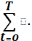 (R_{t} –I_{t})q^{-t} + L_{T}q^{-T}
q^{-t} = (1+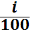)^{-t}
where I₀ is the investment cost at the beginning (t=0) ,T is the life time of project in years, R_{t} is the return in time period t , I_{t} is the investment in time period t , q^{-t} is discounting factor , i is the discount rate and L_{T} is the salvage value .
A project is profitable when NPV0 and the greater the NPV the more profitable.
Negative NPV indicates that minimum interest rate will not be met.

Net Present Value
For Raad well
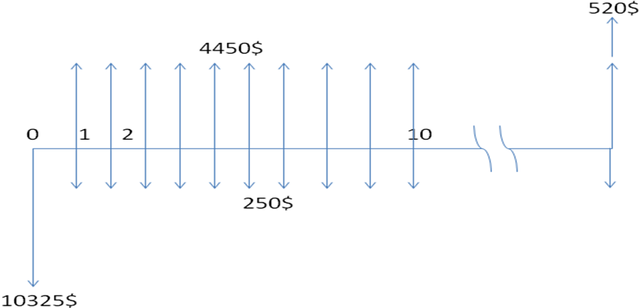
NPV= 520(P/F,8%,20) +4400 (P/A,8%,20) -250(P/A,8%,20) -10325 =30473.3 $
**********************************************************
For jameel well
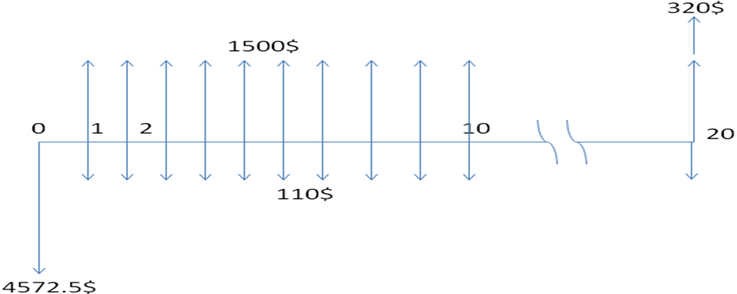
NPV= 230(P/F,8%,20) +1500 (P/A,8%,20) -110(P/A,8%,20) -4572.5=9123.85 $
For khaleel well
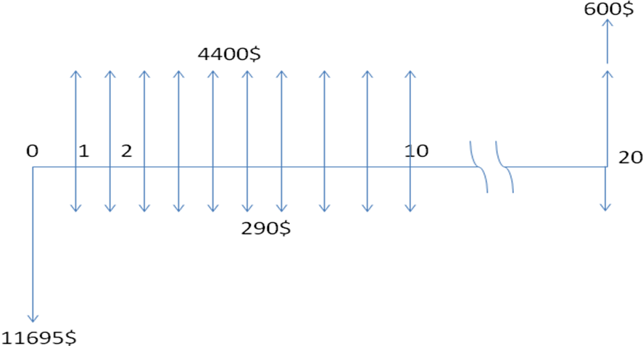
NPV= 600(P/F,8%,20) +4900 (P/A,8%,20) -290(P/A,8%,20) -11695=33694.6 $
**********************************************************
For Ahmad well
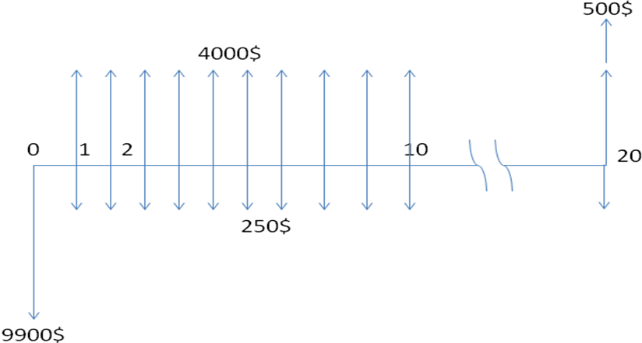
NPV= 500(P/F,8%,20) +4000 (P/A,8%,20) -250(P/A,8%,20) -9900=27024.75 $
For Anas well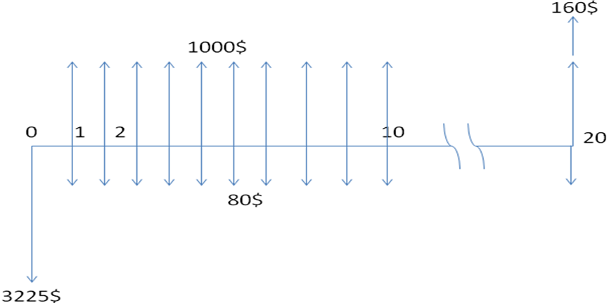
NPV = 160(P/F,8%,20) +1000 (P/A,8%,20) -80(P/A,8%,20) -3225=5841.88 $
for Mahmood well
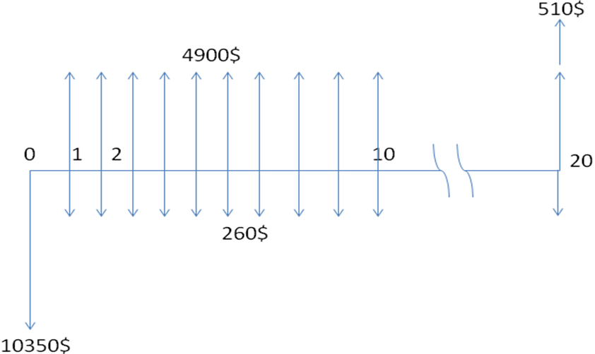
NPV = 510(P/F,8%,20) +4400 (P/A,8%,20) -260(P/A,8%,20) -10350=30405.9$

Chapter 8
Life cycle cost

Life cycle cost
For Raad well
PV system
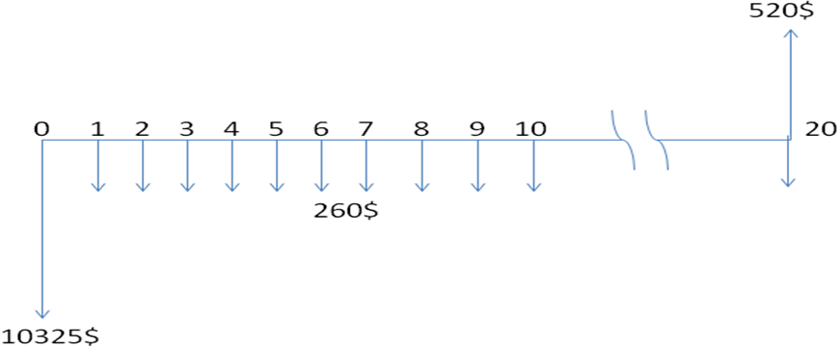
PW = 520(P/F,8%,20) -260(P/A,8%,20) -10325= -12766.14 $
Diesel system

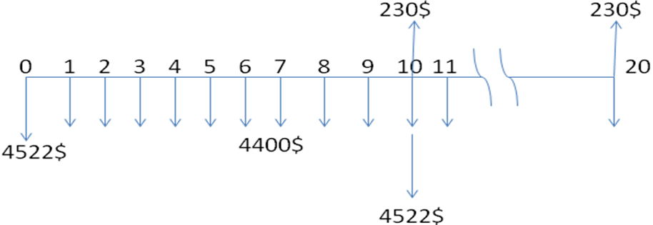
PW = 230(P/F,8%,20) - 4400(P/A,8%,20) -4522-4292(P/F,8%,10)= -49659.9 $
For Jameel well
PV system
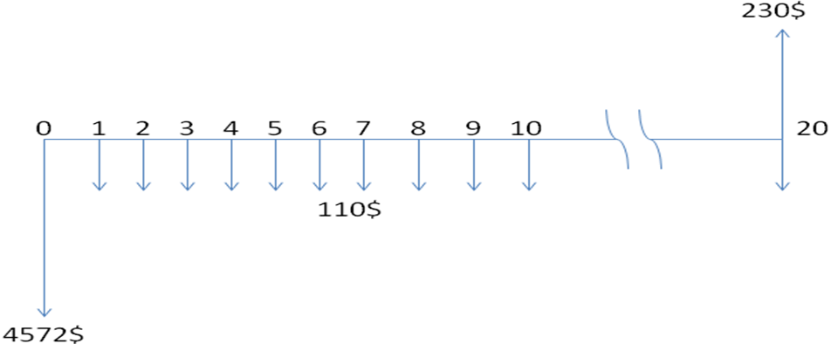
PW = 230(P/F,8%,20) -110(P/A, 8%,20) -4572= -5602,645 $

Diesel system

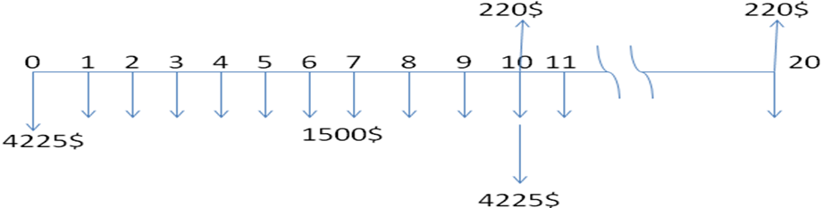
PW = 220(P/F,8%,20) - 1500(P/A,8%,20) -4225-4005(P/F,8%,10)= -20759.9 $

For Khaleel well
PV system
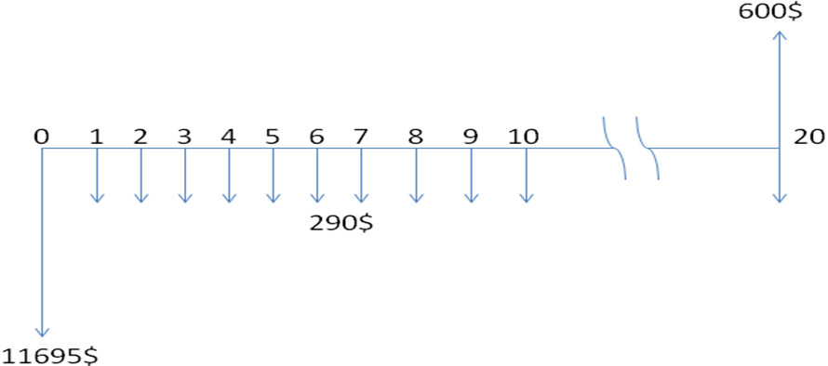 PW = 600(P/F,8%,20) -290(P/A, 8%,20) -11695= -14413 $

Diesel system
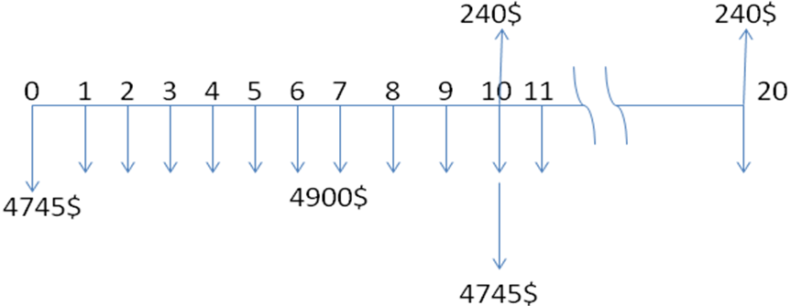
PW = 240(P/F,8%,20) - 4900(P/A,8%,20) -4745-4505(P/F,8%,10)= -54888.4 $
For Ahmad well
PV system
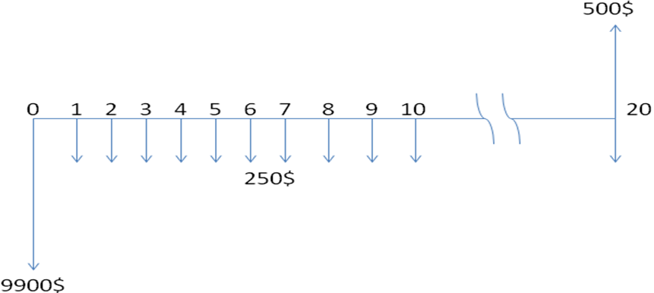
PW = 500(P/F,8%,20) -250(P/A, 8%,20) -9900= -12247 $

Diesel system
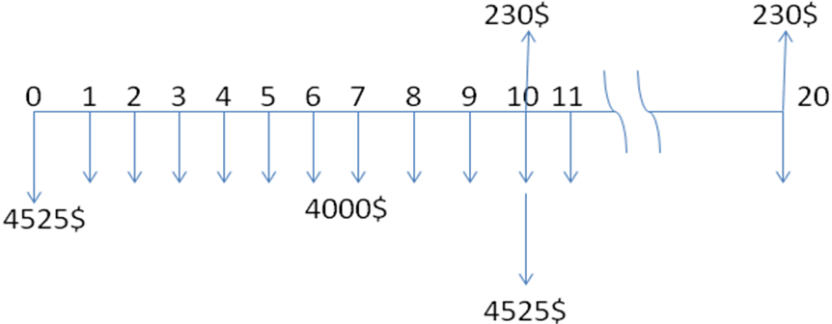
PW = 230(P/F,8%,20) - 4400(P/A,8%,20) -4522-4292(P/F,8%,10)= -49659.9 $

Evaluation results and conclusions
Based on above results the following conclusion can be made :
- The annuity and the production cost of energy uint (KWh) of PV-system are less than the diesel system.
- The net present value ( NPV)of the PV-system is much higher than the NPV of diesel system.
- The life cycle cost of the PV-system is less than the diesel system.
Therefore , utitizing of PV-system is more economic feasible for pumping water .in additional the PV-system do not pollute the environment as the case of using diesel generator.

Chapter 9
Breakeven point

9 -1 The calculation of $/ m³ for pv system
1- 60 m³/day
Well depth=60m.
Swl = 30m.
Dwl = 50m.
Pipe = 2 inch.
Output of the well = 5m³/ hour for 12 hour / day .
Total pumping head (h_{T}) = 50 +(6m) = 56m.
Total water capacity needed per day =5*12 =60
E_{h} =0.002725×V × h_{T}
=0.002725×60×56= 9.156kwh / day
E _{p in} =(9.156 kwh /day)/.55 =16.65 kwh/day.
E _{ASM in} = (16.65 Kwh / day ) /.82= 20.3 kwh /day.
E_{inv in}=21.82
1 kW_{p} -----------→ 5.4 kwh/day
?? -----------------→ 21.82 kwh/day
21.82 kwh/day --------------→60 m³/day
January
E _{pv out} = 2.85 ×4.04 =11.514 kwh
21.82 kwh/day --------------→60 m³/day
11.514 kwh / day → ?
Average value of daily pumping water dnring January
→ 31.66m³ / day.
February
E_{pv out} = 4.04 ×3.2 =12.93 kwh
21.82 kwh/day --------------→60 m³/day
12.93 kwh / day → ?
Average value of daily pumping water during February =35.55 m³ / day.
March
E_{pv out} = 4.04 ×5.2 =21.01 kwh
21.82 kwh/day --------------→60 m³/day
21.01 kwh / day → ?
Average value of daily pumping water during March =57.76 m³ / day.
April
E_{pv out} = 4.04 ×6.1 =24.64 kwh
21.82 kwh/day --------------→60 m³/day
24.64 kwh / day → ?
Average value of daily pumping water during April =67.77 m³ / day.

May
E_{pv out} = 4.04 ×7.6 =30.704 kwh
21.82 kwh/day --------------→60 m³/day
30.704 kwh / day → ?
Average value of daily pumping water during May =84.43 m³ / day.
June
E_{pv out} = 4.04 ×8.2 =33.13 kwh
21.82 kwh/day --------------→60 m³/day
33.13 kwh / day → ?
Average value of daily pumping water during june =91.09 m³ / day.
July
E_{pv out} = 4.04 ×8.1 =32.72 kwh
21.82 kwh/day --------------→60 m³/day
32.72 kwh / day → ?
Average value of daily pumping water during July =89.98 m³ / day.
August
E_{pv out} = 4.04 ×8 =32.32 kwh
21.82 kwh/day --------------→60 m³/day
32.32 kwh / day → ?
Average value of daily pumping water during August =88.87 m³ / day.
September
E_{pv out} = 4.04 ×6.2 =25.05kwh
21.82 kwh/day --------------→60 m³/day
25.05 kwh / day → ?
Average value of daily pumping water during September=68.88 m³ / day.
October
E_{pv out} = 4.04 ×4.7 =18.99 kwh
21.82 kwh/day --------------→60 m³/day
18.99 kwh / day → ?
Average value of daily pumping water during October =52.21 m³ / day.
November
E_{pv out} = 4.04 ×3.65 =14.75kwh
21.82 kwh/day --------------→60 m³/day
14.75 kwh / day → ?
Average value of daily pumping water during November =40.55m³ / day.
December
E_{pv out} = 4.04 ×2.9=11.72 kwh
21.82 kwh/day --------------→60 m³/day
11.72 kwh / day → ?
Average value of daily pumping water during December =32.22 m³ / day.
Q _{year} =^{*30}
=22229.1 m³ / year.

Total energy from pv system
E_{h}*365=3341.94 kwh/year
1 w_{p} --------------→2.5$
4040w_{p} ------------→?
10100$ =cost of cells
Capital cost = cost cells+ cost inv+cost motor pupm + accessories cost
Capital cost= 10100+2200+1400+450 = 14150$
Annual fixed cost = .1 *capital cost = .1* 14150 =1415$
Maintenance cost = .025* capital cost = .025* 14150= 353.75 $/year
Total annual cost= total fixed cost + total running cost
= 1415+353.75=1768.75 $/year
Cost of (1kwh)= total annual cost /total energy =1768.75/3341.94=.53 $/year
$/m³ = total annual cost/ total pumping rate = 1768.75/22229.1 =.0796 $/m³

2 - 80 m³/day
Well depth=60m.
Swl = 30m.
Dwl = 50m.
Pipe = 2 inch.
Output of the well = 4m³/ hour for 20 hour / day .
Total pumping head (h_{T}) = 50 +(6m) = 56m.
Total water capacity needed per day =80m³/day
E_{h} =0.002725×V × h_{T}
=0.002725×80×56= 12.208kwh / day
E _{p in} =(12.208 kwh /day)/.55 =22.2 kwh/day.
E _{ASM in} = (22.2 Kwh / day ) /.82= 27.068 kwh /day.
E_{inv in}=29.106
1 kW_{p} -----------→ 5.4 kwh/day
?? -----------------→ 29.82kwh/day
21.82 kwh/day --------------→60 m³/day
January
E _{pv out} = 2.85 ×5.39 =15.36 kwh
21.82 kwh/day --------------→60 m³/day
15.36 kwh / day → ?
Average value of daily pumping water dnring January
→ 41.21m³ / day.
February
E_{pv out} = 5.39 ×3.2 =17.248 kwh
21.82 kwh/day --------------→60 m³/day
17.248 kwh / day → ?
Average value of daily pumping water during February =46.27m³ / day.
March
E_{pv out} = 5.39 ×5.2 =28.03 kwh
21.82 kwh/day --------------→60 m³/day
28.03 kwh / day → ?
Average value of daily pumping water during March =75.19 m³ / day.
April
E_{pv out} = 5.39 ×6.1 =32.88 kwh
21.82 kwh/day --------------→60 m³/day
32.88 kwh / day → ?
Average value of daily pumping water during April =88.21 m³ / day.
May
E_{pv out} = 5.39 ×7.6 =40.96 kwh
21.82 kwh/day --------------→60 m³/day
40.96 kwh / day → ?
Average value of daily pumping water during May =109.89 m³ / day.

June
E_{pv out} = 5.39 ×8.2 =44.198 kwh
21.82 kwh/day --------------→60 m³/day
44.198 kwh / day → ?
Average value of daily pumping water during june =118.57 m³ / day.
July
E_{pv out} = 5.39 ×8.1 =43.66 kwh
21.82 kwh/day --------------→60 m³/day
43.66 kwh / day → ?
Average value of daily pumping water during July =117.13 m³ / day.
August
E_{pv out} = 5.39 ×8 =43.12 kwh
21.82 kwh/day --------------→60 m³/day
43.12 kwh / day → ?
Average value of daily pumping water during August =115.68 m³ / day.
September
E_{pv out} = 5.39 ×6.2 =33.418kwh
21.82 kwh/day --------------→60 m³/day
33.418 kwh / day → ?
Average value of daily pumping water during September=89.65 m³ / day.
October
E_{pv out} = 5.39 ×4.7 =25.33kwh
21.82 kwh/day --------------→60 m³/day
25.33 kwh / day → ?
Average value of daily pumping water during October =67.96 m³ / day.
November
E_{pv out} = 5.39 ×3.65 =19.67kwh
21.82 kwh/day --------------→60 m³/day
19.67 kwh / day → ?
Average value of daily pumping water during November =52.78m³ / day.
December
E_{pv out} =5.39 ×2.9=15.63 kwh
21.82 kwh/day --------------→60 m³/day
15.63 kwh / day → ?
Average value of daily pumping water during December =41.93 m³ / day.
Q _{year} =^{*30}
=28934.1 m³ / year.

Total energy from pv system
E_{h}*365=4455.92 kwh/year
1 w_{p} --------------→2.5$
5390w_{p} ------------→?
13475$ =cost of cells
Capital cost = cost cells+ cost inv+cost motor pupm + accessories cost
Capital cost= 13475+2500+1600+500 = 18075$
Annual fixed cost = .1 *capital cost = .1* 18075 =1807.5$
Maintenance cost = .025* capital cost = .025* 18075= 451.875 $/year
Total annual cost= total fixed cost + total running cost
= 1807.5+341.875=2149.375 $/year
Cost of (1kwh)= total annual cost /total energy =2149.375/4455.92=.48$/year
$/m³ = total annual cost/ total pumping rate = 2149.375/28934.1 =.0746 $/m³

3 - 120 m³/day
Well depth=60m.
Swl = 30m.
Dwl = 50m.
Pipe = 2 inch.
Output of the well = 30m³/ hour for 4hour / day .
Total pumping head (h_{T}) = 50 +(6m) = 56m.
Total water capacity needed per day =120m³/day
E_{h} =0.002725×V × h_{T}
=0.002725×120×56= 18.312kwh / day
E _{p in} =(18.312 kwh /day)/.55 =33.29 kwh/day.
E _{ASM in} = (33.29 Kwh / day ) /.82= 40.603kwh /day.
E_{inv in}=43.66
1 kW_{p} -----------→ 5.4 kwh/day
?? -----------------→ 43.66 kwh/day
43.66 kwh/day --------------→120 m³/day
January
E _{pv out} = 2.85 ×8.085=23.04kwh
21.82 kwh/day --------------→60 m³/day
23.04 kwh / day → ?
Average value of daily pumping water dnring January
→ 63.32m³ / day.
February
E_{pv out} = 8.085×3.2 =25.87 kwh
21.82 kwh/day --------------→60 m³/day
28.87 kwh / day → ?
Average value of daily pumping water during February =71.1 m³ / day.
March
E_{pv out} = 8.085×5.2 =42.04 kwh
21.82 kwh/day --------------→60 m³/day
42.04 kwh / day → ?
Average value of daily pumping water during March =115.54 m³ / day.
April
E_{pv out} =8.085×6.1 =49.31 kwh
21.82 kwh/day --------------→60 m³/day
49.31 kwh / day → ?
Average value of daily pumping water during April =135.54 m³ / day.
May
E_{pv out} = 8.085×7.6 =61.4884 kwh
21.82 kwh/day --------------→60 m³/day
61.4884 kwh / day → ?
Average value of daily pumping water during May =168.86 m³ / day.
June
E_{pv out} = 8.085×8.2 =66.29 kwh
21.82 kwh/day --------------→60 m³/day
66.29 kwh / day → ?
Average value of daily pumping water during june =182.2 m³ / day.
July
E_{pv out} =8.085×8.1 =65.48 kwh
21.82 kwh/day --------------→60 m³/day
65.48 kwh / day → ?
Average value of daily pumping water during July =179.97 m³ / day.
August
E_{pv out} = 8.085×8 =64.67 kwh
21.82 kwh/day --------------→60 m³/day
64.67 kwh / day → ?
Average value of daily pumping water during August =177.75 m³ / day.
September
E_{pv out} = 8.085×6.2 =50.12kwh
21.82 kwh/day --------------→60 m³/day
50.12 kwh / day → ?
Average value of daily pumping water during September=137.76 m³ / day.
October
E_{pv out} = 8.085×4.7 =38.0 kwh
21.82 kwh/day --------------→60 m³/day
38.0 kwh / day → ?
Average value of daily pumping water during October =104.42m³ / day.
November
E_{pv out} = 8.085×3.65 =29.51kwh
21.82 kwh/day --------------→60 m³/day
29.51 kwh / day → ?
Average value of daily pumping water during November =81.1m³ / day.
December
E_{pv out} = 8.085×2.9=23.44 kwh
21.82 kwh/day --------------→60 m³/day
23.44 kwh / day → ?
Average value of daily pumping water during December =64.43 m³ / day.
Q _{year} =^{*30}
=44459.7 m³ / year.
Total energy from pv system
E_{h}*365=6683.88 kwh/year
1 w_{p} --------------→2.5$
18312w_{p} ------------→?
45780$ =cost of cells
Capital cost = cost cells+ cost inv+cost motor pupm + accessories cost
Capital cost= 45780+3000+2200+500 =51480$
Annual fixed cost = .1 *capital cost = .1* 51480=5148$
Maintenance cost = .025* capital cost = .025* 51480= 1287$/year
Total annual cost= total fixed cost + total running cost
= 5148+1287=6435 $/year
Cost of (1kwh)= total annual cost /total energy =6435/6683.88=.96$/year
$/m³ = total annual cost/ total pumping rate = 6435/44459.7 =.145 $/m³

4 - 35 m³/day
Well depth=60m.
Swl = 30m.
Dwl = 50m.
Pipe = 2inch.
Compute of the well = 3 m³/ hour ,12 hour / day .
Total pumping head (ht) = 50 +(6m) = 56m.
Total water capacity needed per day =3 ×12=35 m³
E_{h} =0.002725×V × h_{T}
=0.002725×35 ×56= 5.341 kwh / day
E _{p in} =5.341 /.55 =9.7 kwh /day .
E _{asm in} =9.7 / .82 = 11.83 Kwh / day .
E _{inv in} =11.83 /.92 =12.86 kwh / day .
P_{sh} =5.4 kwh /day.
1kw_{p} →5.4 kwh /day.
? → 12.86 kwh / day.
P_{PV}= 2.38 kwp .
Pv → 1 wp = 2.5 $

January
E _{pv out} = 2.85 ×2.38 =6.78kwh
12.86 kwh / day →35 m³ / day
6.78 kwh / day → ?
Average value of daily pumping water dnring January
→ 18.45 m³ / day.
February
E_{pv out} = 3.2 ×2.38 =7.62 kwh
12.86 kwh / day →35 m³ / day
7.62 kwh / day → ?
Average value of daily pumping water during February =20.7 m³ / day.
March
E_{pv out} = 5.2 ×2.38 =12.376 kwh
12.86 kwh / day →35 m³ / day
12.375 kwh / day → ?
Average value of daily pumping water during March = 33.86 m³ / day.
April
E_{pv out} = 6.1 ×2.38 =14.5 kwh
12.375 kwh / day →35 m³ / day
14.5 kwh / day → ?
Average value of daily pumping water during April =39.5 m³ / day.
May
E_{pv out} = 7.6 ×2.38 = 18 kwh
12.86 kwh / day →35 m³ / day
18 kwh / day → ?
Average value of daily pumping water during May =48.98 m³ / day.
June
E_{pv out} = 8.2 ×2.38 =19.51 kwh
12.86 kwh / day →35 m³ / day
19.51 kwh / day → ?
Average value of daily pumping water during june =53 m³ / day.
July
E_{pv out} =8.1 ×2.38 =19.27 kwh
12.86 kwh / day →35 m³ / day
19.27 kwh / day → ?
Average value of daily pumping water during July =52.46 m³ / day.
August
E_{pv out} = 8 ×2.38 =19.04 kwh
12.86 kwh / day →35 m³ / day
19.04 kwh / day → ?
Average value of daily pumping water during August =51.82 m³ / day.
September
E_{pv out} = 6.2 ×2.28 =14.75 kwh
12.86 kwh / day →35 m³ / day
14.75 kwh / day → ?
Average value of daily pumping water during September=40 m³ / day.
October
E_{pv out} = 4.7 ×2.38 =11.86 kwh
12.86 kwh / day →35 m³ / day
11.86 kwh / day → ?
Average value of daily pumping water during October =30.44 m³ / day.
November
E_{pv out} =3.65 ×2.38 =8.687 kwh
12.86 kwh / day →35 m³ / day
8.687 kwh / day → ?
Average value of daily pumping water during November =23.64 m³ / day.
December
E_{pv out} = 2.9 ×2.38=6.9 kwh
12.86 kwh / day →35 m³ / day
6.9 kwh / day → ?
Average value of daily pumping water during December =18.78 m³ / day.

Q _{year} =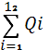=(18.78+23.64+18.45 +20.7+33.86+39.5+48.98+
+53+52.46+51.82+40+30.44)×30
=12948.9 m³ / year.

Total energy from pv system
E_{h}*365=1949.465 kwh/year
1 w_{p} --------------→2.5$
2380w_{p} ------------→?
5950 $ =cost of cells
Capital cost = cost cells+ cost inv+cost motor pupm + accessories cost
Capital cost=5950+1780+1000+400 =9130$
Annual fixed cost = .1 *capital cost = .1*9130=9138$
Maintenance cost = .025* capital cost = .025* 9130= 228.25$/year
Total annual cost= total fixed cost + total running cost
= 913+228.25=1141.25 $/year
Cost of (1kwh)= total annual cost /total energy =1141.25/1949.465=.585$/year
$/m³ = total annual cost/ total pumping rate = 1141.25/12948.9 =.088 $/m³

5 - 20 m³/day
Well depth=60m.
Swl = 30m.
Dwl =50 m.
Pipe = 2inch.
Output of the well = 4m³/ hour for 5 hour / day .
Total pumping head (h_{T}) = 50 +(6m) = 46m.
Total water capacity needed per day =4 ×5=20 m³
E_{h} =0.002725×V × h_{T}
=0.002725×20×56= 3.052kwh / day
E _{p in} =3.052 /.55=5.55 kwh /day .
E _{ASM in} =5.55 /.82 =6.77 Kwh / day .
E _{inv in} =6.77 /.92 =7.358 kwh / day .
P_{sh} =5.4 kwh /day.
1kw_{p} →5.4 kwh /day.
? → 7.358 kwh / day.
P_{PV}= 1.36 kwp .
January
E _{pv out} = 2.85 ×1.36 =3.876 kwh / day
7.358 kwh / day →20 m³ / day
3.876 kwh / day → ?
Average value of daily pumping water during January =10.53 m³ / day.
February
E_{pv out} = 3.2 ×1.36 =4.35 kwh / day
7.358 kwh / day →20 m³ / day
4.35 kwh / day → ?
Average value of daily pumping water during February =11.82 m³ / day.
March
E_{pv out} = 5.2 ×1.36 =7.07 kwh/ day
7.358 kwh / day →20 m³ / day
7.07 kwh / day → ?
Average value of daily pumping water during March =19.22 m³ / day.
April
E_{pv out} = 6.1 ×1.36 =8.296 kwh / day
7.358 kwh / day →20 m³ / day
8.296 kwh / day → ?
Average value of daily pumping water during April =22.55 m³ / day.
May
E_{pv out} = 7.6 ×1.36 =10.336 kwh
7.358 kwh / day →20 m³ / day
10.336 kwh / day → ?
Average value of daily pumping water during May =28 m³ / day.
June
E_{pv out} = 8.2 ×1.36 =11.152 kwh
30.3 kwh / day →20 m³ / day
11.152 kwh / day → ?
Average value of daily pumping water during June =30.3 m³ / day.
July
E_{pv out} = 8.1 ×1.36 =29.89 kwh
7.358 kwh / day →20 m³ / day
29.89 kwh / day → ?
Average value of daily pumping water during July =29.89 m³ / day.
August
E_{pv out} = 8 ×1.36 =29.57 kwh
7.358 kwh / day →20 m³ / day
29.57 kwh / day → ?
Average value of daily pumping water during August =29.57 m³ / day.
September
E_{pv out} = 6.2 ×1.36 =8.43 kwh
7.358 kwh / day →20 m³ / day
8.43 kwh / day → ?
Average value of daily pumping water during September=22.91 m³ / day.
October
E_{pv out} = 4.7 ×1.36 =6.39 kwh
7.358 kwh / day →20 m³ / day
6.39 kwh / day → ?
Average value of daily pumping water during October =17.368 m³ / day.
November
E_{pv out} = 3.65 ×1.36 =4.96 kwh
7.358 kwh / day →20 m³ / day
4.96 kwh / day → ?
Average value of daily pumping water during November =13.48 m³ / day.
December
E_{pv out} = 2.9 ×1.36=3.94 kwh .
7.358 kwh / day →20 m³ / day
3.94 kwh / day → ?
Average value of daily pumping water during December =10.7 m³ / day.
Q _{year} ==(22.55+28+30.3+29.89+29.57+22.91+17.368+13.48+10.7+ 19.22 +11.82+10.53+)×30=9856.11 m³ / year.

Total energy from pv system
E_{h}*365=1113.98 kwh/year
1 w_{p} --------------→2.5$
1360w_{p} ------------→?
3400$ =cost of cells
Capital cost = cost cells+ cost inv+cost motor pupm + accessories cost
Capital cost= 3400+1670+600+350 =6020$
Annual fixed cost = .1 *capital cost = .1*6020=602$
Maintenance cost = .025* capital cost = .025*6020= 150.5 $/year
Total annual cost= total fixed cost + total running cost
=150.5+602=752.5 $/year
Cost of (1kwh)= total annual cost /total energy =752.5/1113.98=.6755 $/year
$/m³ = total annual cost/ total pumping rate =752.5/7390.14 =.098 $/m³
6 - 48 m³ / day
Well depth=60m.
Swl = 30m.
Dwl = 50m.
Pipe = 2inch.
Output of the well = 4 m³/ hour for 12 hour / day .
Total pumping head (h_{T}) = 50 +(6m) = 56m.
Total water capacity needed per day =4 ×12=48 m³
E_{h} =0.002725×V × h_{T}
=0.002725×48×56= 7.32kwh / day
E _{p in} =13.3 kwh /day .
E _{ASM in} = 16.23 Kwh / day .
E _{inv in} = =17.45 kwh / day .
P_{sh} =5.4 kwh /day.
1kw_{p} →5.4 kwh /day.
? → 17.45 kwh / day.
P_{PV}= 3.23 kwp .
January
E _{pv out} = 2.85 ×3.23 =9.2 kwh / day
17.45 kwh / day →48 m³ / day
9.2 kwh / day → ?
Average value of daily pumping water during January =25.3 m³ / day.
February
E_{pv out} = 3.23 ×3.2 =10.33 kwh / day
17.45 kwh / day →48 m³ / day
10.33 kwh / day → ?
Average value of daily pumping water during February =28.4 m³ / day.
March
E_{pv out} = 3.23 ×5.2 =16.79 kwh/ day
17.45 kwh / day →48 m³ / day
16.79 kwh / day → ?
Average value of daily pumping water during March =46.18 m³ / day.

April
E_{pv out} = 3.23 ×6.1 =19.7 kwh / day
17.45 kwh / day →48 m³ / day
19.7 kwh / day → ?
Average value of daily pumping water during April =54.19 m³ / day.
May
E_{pv out} = 3.23 ×7.6 =24.55 kwh
17.45 kwh / day →48 m³ / day
24.55 kwh / day → ?
Average value of daily pumping water during May =67.53 m³ / day.
June
E_{pv out} = 3.23 ×8.2 =26.48 kwh
17.45 kwh / day →48 m³ / day
26.48 kwh / day → ?
Average value of daily pumping water during June =72.83 m³ / day.
July
E_{pv out} = 3.23 ×8.1 =26.16 kwh
17.45 kwh / day →48 m³ / day
26.16 kwh / day → ?
Average value of daily pumping water during July =71.96 m³ / day.

August
E_{pv out} = 3.23 ×8 =25.84 kwh
17.45 kwh / day →48 m³ / day
25.84 kwh / day → ?
Average value of daily pumping water during August =71.07 m³ / day.
September
E_{pv out} = 3.23 ×6.2 =20.03 kwh
17.45 kwh / day →48 m³ / day
20.03 kwh / day → ?
Average value of daily pumping water during September=55.09 m³ / day.
October
E_{pv out} = 3.23 ×4.7 =15.18 kwh
17.45 kwh / day →48 m³ / day
15.18 kwh / day → ?
Average value of daily pumping water during October =41.75 m³ / day.
November
E_{pv out} = 3.23 ×3.65 =11.79 kwh
17.45 kwh / day →48 m³ / day
11.79 kwh / day → ?
Average value of daily pumping water during November = 32.43 m³ / day.
December
E_{pv out} = 3.23 ×2.9=9.37 kwh .
17.45 kwh / day →48 m³ / day
9.37 kwh / day → ?
Average value of daily pumping water during December =25.77 m³ / day.
Q _{year} ==(25.77+54.19+46.18+28.4+25.3+32.43+67.53+72.83+
+71.96+71.07+55.04+41.75)×30=15998.1 m³ / year

Total energy from pv system
E_{h}*365=2635.2 kwh/year
1 w_{p} --------------→2.5$
3230w_{p} ------------→?
3230 $ =cost of cells
Capital cost = cost cells+ cost inv+cost motor pupm + accessories cost
Capital cost=8075+2000+1200+420 =11695 $
Annual fixed cost = .1 *capital cost = .1* 11695=1169.5 $
Maintenance cost = .025* capital cost = .025* 1169.5= 292.375 $/year
Total annual cost= total fixed cost + total running cost
=292.375+1169.5=1461.875 $/year
Cost of (1kwh)= total annual cost /total energy =1461.875/2635.2=.5547$/year
$/m³ = total annual cost/ total pumping rate =1461.875/15998.1 =.091 $/m³

7 - 160 m³ / day
Well depth=60m.
Swl = 30m.
Dwl = 50m.
Pipe = 2inch.
Output of the well = 13 m³/ hour for 12 hour / day .
Total pumping head (h_{T}) = 50 +(6m) = 56m.
Total water capacity needed per day =13 ×12=160 m³
E_{h} =0.002725×V × h_{T}
=0.002725×160×56= 24.416kwh / day
E _{p in} =24.416/.0.55 =44.39 kwh /day .
E _{ASM in} =44.39/0.82 = 54.13 Kwh / day .
E _{inv in} =54.13/0.92 =58.84 kwh / day .
P_{sh} =5.4 kwh /day.
1kw_{p} →5.4 kwh /day.
? →58.84 kwh / day.
P_{PV}= 10.89 kwp .
January
E _{pv out} = 2.85 ×10.89 =31.04 kwh / day
58.84 kwh / day →160 m³ / day
31.04 kwh / day → ?
Average value of daily pumping water during January =84.4 m³ / day.
February
E_{pv out} = 3.23 ×10.89 =34.84 kwh / day
58.84 kwh / day →160 m³ / day
34.84 kwh / day → ?
Average value of daily pumping water during February =94.74 m³ / day.
March
E_{pv out} = 3.23 ×10.89 =56.62 kwh/ day
58.84 kwh / day →160 m³ / day
56.62 kwh / day → ?
Average value of daily pumping water during March =153.96 m³ / day.
April
E_{pv out} = 6.1 ×10.89 =66.42kwh / day
58.84 kwh / day →160 m³ / day
66.42 kwh / day → ?
Average value of daily pumping water during April =180.6 m³ / day.
May
E_{pv out} = 10.89 ×7.6 =82.76 kwh
58.84 kwh / day →120 m³ / day
82.76 kwh / day → ?
Average value of daily pumping water during May =225 m³ / day.
June
E_{pv out} = 10.89 ×8.2 =89.298 kwh
58.84kwh / day →120 m³ / day
89.298kwh / day → ?
Average value of daily pumping water during June =242.8 m³ / day.
July
E_{pv out} = 10.89 ×8.1 =88.209 kwh
58.84 kwh / day →160 m³ / day
88.209 kwh / day → ?
Average value of daily pumping water during July =239.86 m³ / day.
August
E_{pv out} = 10.89 ×8 =87.12 kwh
58.84 kwh / day →160 m³ / day
87.12 kwh / day → ?
Average value of daily pumping water during August =236.9 m³ / day.
September
E_{pv out} = 10.89 ×6.2 =67.518 kwh
58.84 kwh / day →160 m³ / day
67.518 kwh / day → ?
Average value of daily pumping water during September=183.59 m³ / day.
October
E_{pv out} = 10.89 ×4.7 =51.18 kwh
58.84 kwh / day →160 m³ / day
51.18 kwh / day → ?
Average value of daily pumping water during October =139.17 m³ / day.
November
E_{pv out} = 10.89 ×3.65 =39.748 kwh
58.84 kwh / day →160 m³ / day
39.748 kwh / day → ?
Average value of daily pumping water during November =108 m³ / day.
December
E_{pv out} = 10.89 ×2.9=31.58 kwh .
58.84 kwh / day →160 m³ / day
31.58 kwh / day → ?
Average value of daily pumping water during December =85.87 m³ / day.
Q _{year} ==(34.84+94.74+153.96+180.6+225+242.8+239.86+236.9+
+183.59+139.17+108+85.87)×30=1925.33 m³ / year
Total energy from pv system
E_{h}*365=8789.76 kwh/year
1 w_{p} --------------→2.5$
10890w_{p} ------------→?
27225 $ =cost of cells
Capital cost = cost cells+ cost inv+cost motor pupm + accessories cost
Capital cost= 27225+2700+4200+500 =34625 $
Annual fixed cost = .1 *capital cost = .1* 34625=3462.5$
Maintenance cost = .025* capital cost = .025* 34625= 865.625 $/year
Total annual cost= total fixed cost + total running cost
= 3462.5+865.625=4328.125 $/year
Cost of (1kwh)= total annual cost /total energy =3462.5/8789.76=.39 $/year
$/m³ = total annual cost/ total pumping rate =3462.5/1925.33 =1.79 $/m³

9 -2 The calculation of $/ m³ for diesel system
1 – 60 m³/ day
Well depth=60m.
Swl = 30m.
Dwl = 50m.
Pipe = 2 inch.
Output of the well = 5m³/ hour for 12 hour / day .
Total pumping head (h_{T}) = 50 +(6m) = 56m.
Total water capacity needed per day =5*12=60
E_{h} =0.002725×V × h_{T}
=0.002725×60×56= 9.156kwh / day
E _{p in} =(9.156 kwh /day)/.55 =16.65 kwh/day.
E _{ASM in} = (16.65 Kwh / day ) /.82= 20.3 kwh /day.
E _{S.G in} = 20.3/0.75 = 27.07 kwh
E _{DIESEL in} =27.07/0.30 = 90.2 kwh
Number of liters diesel needed daily = 90.2/10.5 = 8.59
Diesel cost = 6* 8.59 NIS =51.56NIS/day =12.89$/day
Diesel cost yearly = 12.86*365 =4704.85 $/year
Capital cost = (12500/4) + (pumping cost) + (accessories cost)
3125 +1400+450 =4975 $
Total energy = E_{h} *365 = 3341.94 kwh/year
6 liters diesel ------------------------------→ 1 liter oil
8.59 liters diesel ------------------------------→ ? liter oil
We need 1.43 liters oil
Cost oil = 1.43 *5 =7.15 NIS -----→1.79 $
Cost oil yearly = 1.79*365= 6103.54 $/year
Annual fixed cost = .1 *capital cost = .1* 4975=497.5$
Maintenance cost = .15 * capital cost = .15* 4975 = 746.25 $/year
Annual running cost =diesel cost +maintenance cost+ oil cost
= 4704.85+652.44+746.25 = 6103.54 $/year

Total annual cost= total fixed cost + total running cost
= 497.5 +6103.54 =6610.04 $/year
Cost of (1kwh)= total annual cost /total energy =6601.04/3341.94=1.98 $/year
$/m³ = total annual cost/ total pumping rate = 6601.04/(60*365) =0.301 $/m³

2- 120 m³/ day
Well depth=60m.
Swl = 30m.
Dwl = 50m.
Pipe = 2 inch.
Output of the well = 10 m³/ hour for12 hour / day .
Total pumping head (h_{T}) = 50 +(6m) = 56m.
Total water capacity needed per day =120
E_{h} =0.002725×V × h_{T}
=0.002725×120×56= 18.312kwh / day
E _{p in} =(18.312 kwh /day)/.55 =33.29 kwh/day.
E _{ASM in} = (33.29 Kwh / day ) /.82= 40.603 kwh /day.
E _{S.G in} = 40.603/0.75 = 54.14 kwh
E _{DIESEL in} =54.14/0.30 = 180.46 kwh
Number of liters diesel needed daily = 180.46/10.5 = 17.19
Diesel cost = 6* 17.19 NIS =103.12NIS/day =25.8$/day
Diesel cost yearly = 25.8*365 =9409.6 $/year
Capital cost = (12500/4) + (pumping cost) + (accessories cost)
3125 +2200+500 =5825 $
Total energy = E_{h} *365 = 2175.84 kwh/year

6 liters diesel ------------------------------→ 1 liter oil
17.19 liters diesel ------------------------------→ ? liter oil
We need 2.865 liters oil
Cost oil = 2.865 *5 =14.325 NIS -----→3.58 $
Cost oil yearly = 3.58*365= 1306.7 $/year
Annual fixed cost = .1 *capital cost = .1*5825=582.5$
Maintenance cost = .15 * capital cost = .15* 5825 = 875.78 $/year
Annual running cost =diesel cost +maintenance cost+ oil cost
= 9409.6+873.78+1306.7 = 11590.08 $/year

Total annual cost= total fixed cost + total running cost
= 582.78 +11590.08 =12172.86 $/year
Cost of (1kwh)= total annual cost /total energy =
12172.86 /2175.84=5.59 $/year
$/m³ = total annual cost/ total pumping rate =
12172.86/ (120*365) =.2779 $/m³

3 - 80 m³/ day
Well depth=60m.
Swl = 30m.
Dwl = 50m.
Pipe = 2 inch.
Output of the well = 6.7 m³/ hour for 12 hour / day .
Total pumping head (h_{T}) = 50 +(6m) = 56m.
Total water capacity needed per day =80
E_{h} =0.002725×V × h_{T}
=0.002725×80×56= 12.208kwh / day
E _{p in} =(12.208 kwh /day)/.55 =22.2 kwh/day.
E _{ASM in} = (22.2 Kwh / day ) /.82= 27.068 kwh /day.
E _{S.G in} = 27.068/0.75 = 36.09 kwh
E _{DIESEL in} =36.09/0.30 = 120.3 kwh
Number of liters diesel needed daily = 120.3/10.5 = 11.46
Diesel cost = 6* 11.46 NIS =68.76NIS/day =17.19$/day
Diesel cost yearly = 17.19*365 =6274.35 $/year
Capital cost = (12500/4) + (pumping cost) + (accessories cost)
3125 +1600+500 =5225$
Total energy = E_{h} *365 = 4455.92 kwh/year

6 liters diesel ------------------------------→ 1 liter oil
11.46 liters diesel ------------------------------→ ? liter oil
We need 1.91 liters oil
Cost oil = 1.91 *5 =9.55 NIS -----→2.388 $
Cost oil yearly = 2.388*365= 871.44$/year
Annual fixed cost = .1 *capital cost = .1*5225=522.5$
Maintenance cost = .15 * capital cost = .15* 5225 = 783.75 $/year
Annual running cost =diesel cost +maintenance cost+ oil cost
= 6274.35+783.75+871.94 = 7929.54 $/year

Total annual cost= total fixed cost + total running cost
= 522.5 +7929.54 =8452.04 $/year
Cost of (1kwh)= total annual cost /total energy =
8452.04 /4455.92=1.89 $/year
$/m³ = total annual cost/ total pumping rate =
8452.04/ (80*365) =.29 $/m³

4 - 20 m³/ day
Well depth=60m.
Swl = 30m.
Dwl = 50m.
Pipe = 2 inch.
Output of the well = 1.67 m³/ hour for 12 hour / day .
Total pumping head (h_{T}) = 50 +(6m) = 56m.
Total water capacity needed per day =20
E_{h} =0.002725×V × h_{T}
=0.002725×20×56= 3.052 kwh / day
E _{p in} =3.052/.55 =5.55 kwh/day.
E _{ASM in} = 5.55 /.82=6.77 kwh /day.
E _{S.G in} = 6.77/.75=9.02 kwh
E _{DIESEL in} =9.02/0.30 = 30.06 kwh
Number of liters diesel needed daily = 30.06/10.5 =2.86
Diesel cost = 6* 2.86 NIS =17.16NIS/day =4.29 $/day
Diesel cost yearly = 4.29*365 =1544.4 $/year
Capital cost = (12500/4) + (pumping cost) + (accessories cost)
3125 +600+350 =4075 $
Total energy = E_{h} *365 = 1113.98 kwh/year

6 liters diesel ------------------------------→ 1 liter oil
17.16 liters diesel ------------------------------→ ? liter oil
We need 2.86 liters oil
Cost oil = 2.86 *5 =14.3 NIS -----→3.575 $
Cost oil yearly = 3.575*365= 1304.875 $/year
Annual fixed cost = .1 *capital cost = .1*4075=407.5 $
Maintenance cost = .15 * capital cost = .15* 4075 =611.25 $/year
Annual running cost =diesel cost +maintenance cost+ oil cost
= 1544.4+2017.5+611.25 =4173.15 $/year

Total annual cost= total fixed cost + total running cost
= 4173.15 +407.5 =4580.65 $/year
Cost of (1kwh)= total annual cost /total energy =
4580.65 /1113.98=4.1 $/year
$/m³ = total annual cost/ total pumping rate =
4580.65/ 20*365) =.62 $/m³

5 - 35 m³/ day
Well depth=60m.
Swl = 30m.
Dwl = 50m.
Pipe = 2 inch.
Output of the well = 3 m³/ hour for 12 hour / day .
Total pumping head (h_{T}) = 50 +(6m) = 56m.
Total water capacity needed per day = 35 m³/ day
E_{h} =0.002725×V × h_{T}
=0.002725×35×56=5.341kwh / day
E _{p in} =5.341/.55 =9.7 kwh/day.
E _{ASM in} = 9.7 /.82=11.83 kwh /day.
E _{S.G in} = 11.83/0.75 = 15.773 kwh
E _{DIESEL in} =15.773/0.30 = 52.576 kwh
Number of liters diesel needed daily = 52.576/10.5 = 5 liter
Diesel cost = 6*5 NIS =30 NIS/day = 7.5 $/day
Diesel cost yearly = 7.5*365 =2700 $/year
Capital cost = (12500/4) + (pumping cost) + (accessories cost)
3125 +1000+400 =4525 $
Total energy = E_{h} *365 = 1949.465 kwh/year
6 liters diesel ------------------------------→ 1 liter oil
5 liters diesel ------------------------------→ ? liter oil
We need .83 liters oil
Cost oil = .83 *5 =4.15 NIS -----→1.0375 $
Cost oil yearly = 1.0375*365= 373.5$/year
Annual fixed cost = .1 *capital cost = .1*4525= 452.5 $
Maintenance cost = .15 * capital cost = .15* 4525 = 678.75 $/year
Annual running cost =diesel cost +maintenance cost+ oil cost
= 2700+678.75+373.5 = 3752.25 $/year
Total annual cost= total fixed cost + total running cost
= 3752.25 +452.5 =4204.75 $/year
Cost of (1kwh)= total annual cost /total energy =
4204.75 /1049.465=2.1 $/year
$/m³ = total annual cost/ total pumping rate =
4204.75/ (35*365) =.329 $/m³

6- 48 m³/ day
Well depth=60m.
Swl = 30m.
Dwl = 50m.
Pipe = 2 inch.
Output of the well = 4 m³/ hour for 12 hour / day .
Total pumping head (h_{T}) = 50 +(6m) = 56m.
Total water capacity needed per day =48
E_{h} =0.002725×V × h_{T}
=0.002725×48×56= 7.32kwh / day
E _{p in} 7.32/.55 =13.3 kwh/day.
E _{ASM in} = 13.3 /.82= 16.23 kwh /day.
E _{S.G in} =16.23/0.75 =21.64 kwh
E _{DIESEL in} =21.64/0.30 = 72.1 kwh
Number of liters diesel needed daily = 72.1/10.5 =6.86
Diesel cost = 6* 6.86 NIS =41.16NIS/day =35.29 $/day
Diesel cost yearly = 35.29*365 = 3755.85 $/year
Capital cost = (12500/4) + (pumping cost) + (accessories cost)
3125 +1200+420 =4745 $
Total energy = E_{h} *365 = 2635.2 kwh/year
6 liters diesel ------------------------------→ 1 liter oil
6.86 liters diesel ------------------------------→ ? liter oil
We need 1.143 liters oil
Cost oil = 1.143 *5 =5.175 NIS -----→1.428 $
Cost oil yearly = 1.428*365=521.64 $/year
Annual fixed cost = .1 *capital cost = .1*4745=474.5 $
Maintenance cost = .15 * capital cost = .15* 4745 = 711.75 $/year
Annual running cost =diesel cost +maintenance cost+ oil cost
= 3755.85+711.75+521.64 = 4989.24 $/year

Total annual cost= total fixed cost + total running cost
= 4989.63 +474.5 =5463.74 $/year
Cost of (1kwh)= total annual cost /total energy =
5463.74 /2635.2=2.07 $/year
$/m³ = total annual cost/ total pumping rate =
5463.74/ (4880*365) =.31 $/m³

7 - 160 m³/ day
Well depth=60m.
Swl = 30m.
Dwl = 50m.
Pipe = 2 inch.
Output of the well = 13 m³/ hour for 12 hour / day .
Total pumping head (h_{T}) = 50 +(6m) = 56m.
Total water capacity needed per day =160 m³/day
E_{h} =0.002725×V × h_{T}
=0.002725×160×56= 24.416 kwh / day
E _{p in} 24.461/.55 =44.39 kwh/day.
E _{ASM in} = 44.39 /.82= 54.13 kwh /day.
E _{S.G in} =54.13/0.75 =72.173 kwh
E _{DIESEL in} =72.173/0.30 = 240.57 kwh
Number of liters diesel needed daily = 240.57/10.5 =22.91
Diesel cost = 6* 22.91 NIS =22.91NIS/day =137.47 $/day
Diesel cost yearly = 137.47*365 = 50177.4 $/year
Capital cost = (12500/4) + (pumping cost) + (accessories cost)
3125 + 4200+500 =7825 $
Total energy = E_{h} *365 = 8911.84 kwh/year
6 liters diesel ------------------------------→ 1 liter oil
22.91 liters diesel ------------------------------→ ? liter oil
We need 3.8 liters oil
Cost oil = 3.8 *5 =19 NIS -----→4.75 $
Cost oil yearly = 4.75*365=173.375 $/year
Annual fixed cost = .1 *capital cost = .1*7825=782.5 $
Maintenance cost = .15 * capital cost = .15* 7825 = 1173.75 $/year
Annual running cost =diesel cost +maintenance cost+ oil cost
= 5177.4+1173.75+173.375 =10430.3 $/year
Total annual cost= total fixed cost + total running cost
= 782.5 +10430.3 =11212.8 $/year
Cost of (1kwh)= total annual cost /total energy =
11212.8 /8911.84=1.25 $/year
$/m³ = total annual cost/ total pumping rate =
11212.8/ (160*365) =.192 $/m³

