

An - Najah National University

Faculty of Engineering

Building Engineering Department

**Structural memo**

**Project name:**

**Primary health care center**

**Prepared by:**

- Ibrahim Ghanem.

- Mohammad Soleman.

- Esam judy.

**Submitted to:**

Dr. Nael mussa

Date: 10/5/2009

1. Introduction: structural

This project concerns with the design of a health care building to resist gravitational loads especially. The building consists of (3) stories with story height equal to 4m, and story area divided in two parts ,the first part equal to 687*3=2061m²,and the second part equal to: 368*3=1104m2 .

This course consists of six chapters as follows:

* Chapter One introduction & description to the project. Also it talks about load analysis, types of loads, equivalent static loads, and load combinations
* Chapter Two deals with the structural analysis, equivalent static load calculations.
* Chapter Three deals with the design of slabs
* Chapter Four deals with the design of stairs landings and flights
* Chapter Five deals with the design of beams
* Chapter Six deals with the design of columns

Objectives :

The main objectives of the project are as follows:

* Analyzing the building as one unit using 3D model by SAP 2000.v9 computer program.
* Design the building elements for gravitational loads.

Architectural Description:

A primary health care center in the east of Nablus City constructed on soft rocks with bearing capacity (B.C) = 15 kg/cm².

The building consists of 3 stories, with 4m story height. The building is divided into two apart. The Figure explain it.

The first building

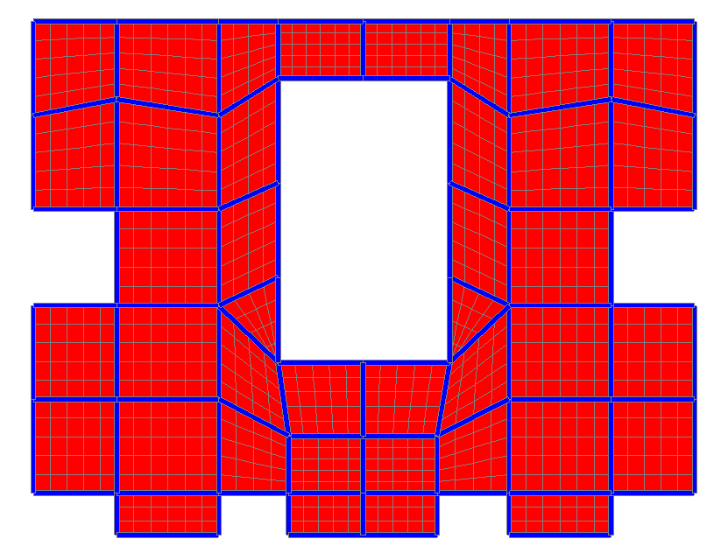

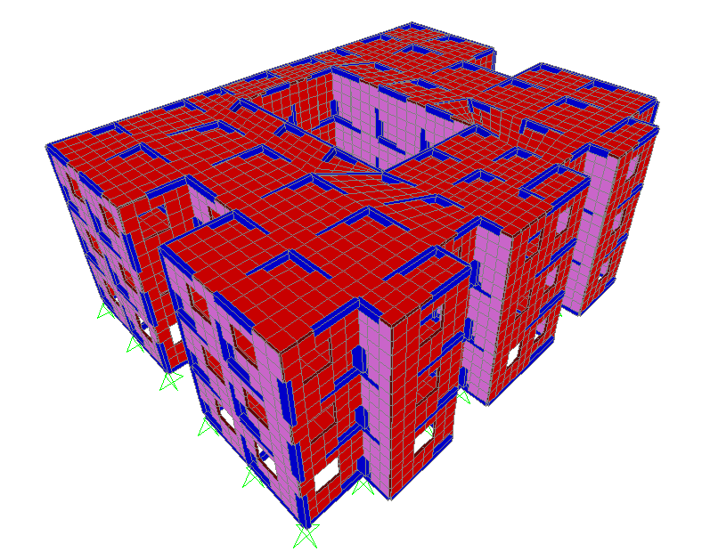

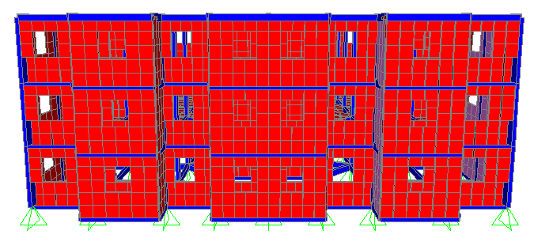

The second building

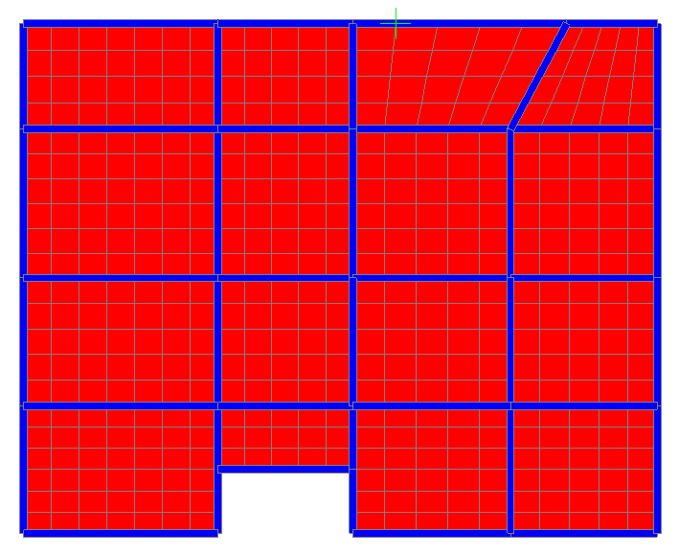

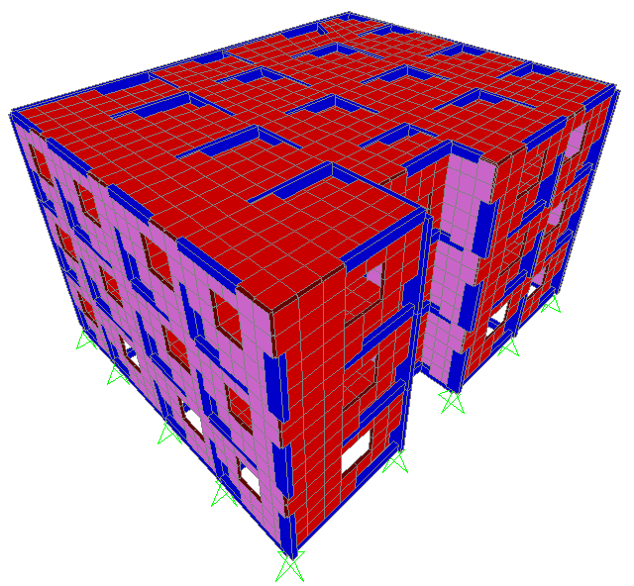

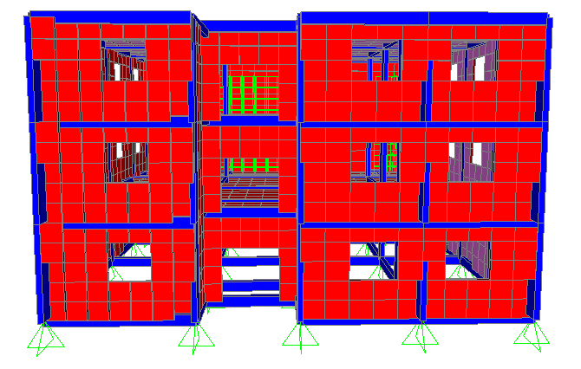

Structural Description

* The structural system used is system of frames and shear walls.
* Slabs will be designed as one way ribbed slabs using blocks.
* The beams will be designed as drop beams.
* The external walls are masonry walls which consist of:

1. Stone
2. Concrete.
3. Concrete blocks of 10cm thickness

* Internal partitions are concrete blocks of 10cm & 20cm thickness.

Design Code:

* ACI 2002 code (American Concrete Institute), is the building code adopted in this project for the design of structural elements.

Materials :

There are two main materials used in the design of reinforced concrete structures as follows:

1. Concrete is considered as a brittle material, its tension strength approximately equal 10% of its compressive strength.

The compressive strength of concrete used in this project:

- fc´ = 250 kg/cm².

The modulus of elasticity of concrete can be calculated according to ACI code by the following formula:

-  (kg/cm² unit) ………................................. (1.1)

2- Steel

Steel is considered as ductile material, with large tensile strength as well as the compressive strength.

fy is equal to 4200 kg/cm² and the modulus of elasticity, ES, is equal to  kg/cm²

Table (1.1), shows some assumed data that are used in analysis and design of the building.

Table (1.1): Data Assumptions

|  |  |
| --- | --- |
| Unit Weight,  (t/m³) | Material |
| MSK(meter/second/kilogram) | Unit |
| 2.50 | Reinforced Concrete |
| 1.5 | glass |
| 1.20 | Concrete Block |
| 2.60 | Stone |
| 2.60 | Tiles |
| 2.00 | Sand |

Load Analysis:

Loads are mainly gravity loads. Gravity loads are acting vertically on the building.

Gravity Loads:

Gravity loads have a vertical action on the structure; there are two main types of gravity loads, live and dead loads. Snow loads are also considered as gravity loads but because the frequency of snow in our country is too little and its duration is too short, the design for snow loads is not included.

1- Live Loads

Live loads mainly caused by people, movable furniture, stored goods. The value of live load depends on the occupancy of the structures.

Live load values are specified by ACI code for different types of structures.

In this project more than one value is used for live load as follows:

* Live load for normal floor = 500 kg/cm².
* Live load for the last story may be arrive to = 800 kg/cm², because of placing water tanks at this floor.
* Live load for stairs = 600 kg/cm².

2- Dead Loads

This load associated with the weight of the structure itself, which consists of the weight of structural elements (weight of concrete and steel), also weight of fixed equipments, weight of internal partitions and external walls are considered as dead loads.

The weight of the structural elements (Wt) can be calculated by multiplying the volume of the element (V) by the unit weight of its material ().

 ……………………….………………………… (1.2)

Load Combinations:

Load combinations are used to increase the total loads which acting on the structure by combined gravity loads (live +dead +superimposed) together using factors for each of them.

According to ACI 2002 Code, many equations for load combinations occur, the worse one should be taken for the structural design.

The following equations combine gravity and lateral loads are used:

* Wu = 1.4 D.L
* W­u= 1.2 D.L + 1.6 L.L

Where :

Wu: Ultimate load.

D.L: Dead load, it include own weight & supper imposed dead load.

L.L: Live loads.

2) Structural Analysis:

Load Calculations:

The building will be designed to resist one type of loads, gravity. Gravity loads include live loads which their values are determined before according to ACI code and dead load which will be calculated in this section.

Dead loads represent the own weight of the building, it includes the following:

1. Weight of structural elements, slabs, beams, columns.
2. Weight of external masonry walls.
3. Supper imposed dead load which mainly include load of tiles, mortar and filling.

Structural Elements Weight:

The own weight of structural elements will be calculated by SAP 2000 program, so proper dimensions of the elements must be given to it.

1- Beams

In order to control deflection according to ACI 2002 code, minimum thickness should be determined using the following table (2.1)

Table (2.1) : Minimum Thickness of One Way Solid Slabs & Beams

|  |  |  |  |  |
| --- | --- | --- | --- | --- |
| Minimum Thickness, (h) | | | | Member |
| Cantilever | Simply Supported | Two End Continuous | One End Continuous |
| Ln / 10 | Ln / 20 | Ln / 28 | Ln / 24 | One Way Solid Slab |
| Ln / 8 | Ln / 16 | Ln / 21 | Ln / 18.5 | Beams |

Where:

L*n* : clear distance between supports, or length of the element

Assume using rectangular columns of dimension 70cm X 25cm. Minimum thickness of beams and ribbed one way slap:

* One end continuous, h min = 4.8 / 18.5 = 0.26m

* Two end continuous, h min = 4.8 / 21 = 0.23m

* Simply supported, h min = 4.8 / 16 = 0.3m

Drop beams with initial dimensions of 50cm depth & 25cm width are used.(the failure of beams are strength not deflection)

2- Slabs

One way ribbed slabs are used in this project, because the small distance between columns. So in order to reduce deflection and cracks in slabs this system must be used. We are used 25cm thickness of the rib slap.

The equivalent thickness in the sap is 20cm (solid slap) to give the same moment of inertia. To achieve this thickness blocks of dimensions (40X20X17) are used, bw = 15cm, figure (2.1) shows a cross section in the one way ribbed slab.

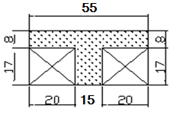

Figure (2.1): one Way Ribbed Slab Cross Section

* Check dimensions of ribs (T-Section) according to ACI code:

» Slab thickness, h ≤ 3.5 bw

25cm < 52.5cm, ok.

» Web width, bW ≥ 10cm

15cm > 10cm, ok.

» Distance between ribs, S < 75cm

55cm < 75cm, ok.

» Flange thickness, t > S/12 & t > 5cm

t = 8cm, ok.

* Weight (WS) per m² of one way solid slab:

WS /m² = Volume X con = 0.2 (1)² X 2.5 = 0.5 t/m²



* Weight of one way ribbed slab (WS /m²):

WS /m² = Concrete volume X con + block volume X  block

 t/m²

From the above differences in Ws/m², and moment of inertia between solid and ribbed slabs are noticed, so to represent one way solid slab on SAP2000 program as shell element modifications on thickness and unit weight must be done as follows:

»» Shell element thickness:



→ h = 0.19m ,use 20cm in sap program.

» Solid slab unit weight:

WS /m² solid = WS/m² ribbed

 

Masonry Walls:

As most of buildings, the external walls are masonry walls of 30cm thickness, it consists of 10cm concrete block, 13cm concrete, and 7cm stone, figure (2.2) shows a cross section in masonry wall.

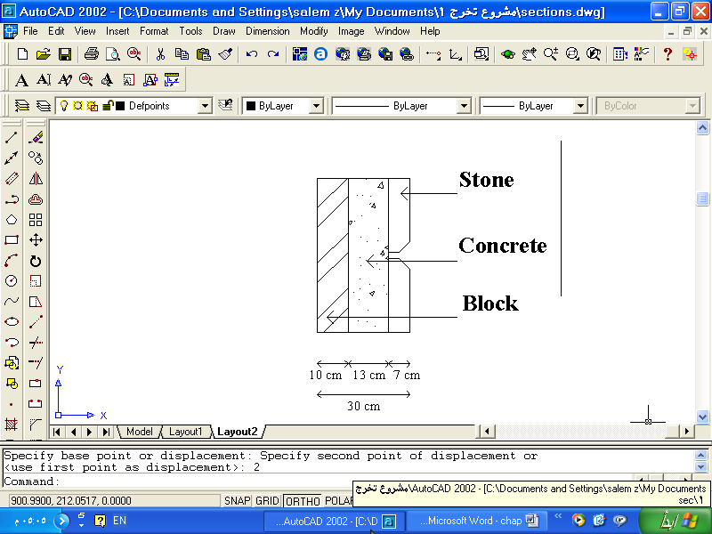

Figure (2.2): Masonry Wall Cross Section

* The weight of masonry wall per meter length is calculated as follows:



Where:

WW : Weight of masonry wall / m´

t : Thickness

H : Story height



Partitions, 10cm & 20cm Brick Walls:

* Partitions of 10cm brick wall thickness: the load of 10cm partitions always considered as a uniform load per m2 of slab, its value = 0.1 t/m².
* 20cm brick wall partitions: the weight per meter length of this wall includes the weight of plaster as shown in figure (2.3).

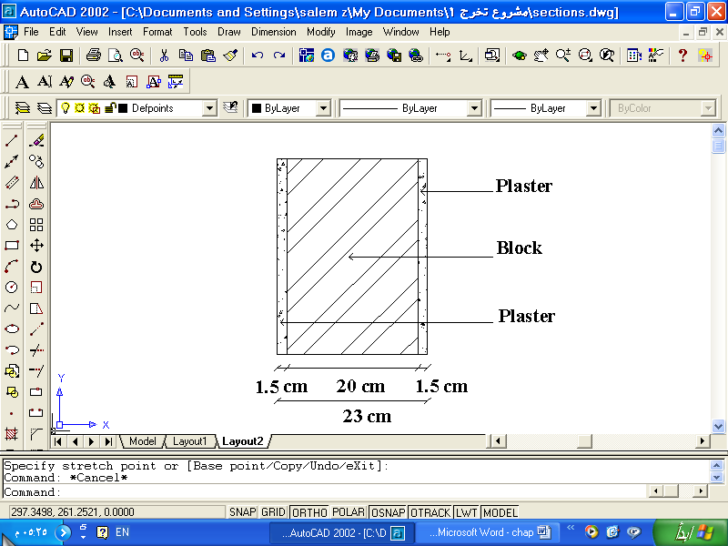

Figure (2.3): 20cm Brick Wall Cross Section

* The weight of brick wall per meter length Wb calculated as follows:

»» 



Supper Imposed Dead Load (S.I.D):

Supper imposed dead load is the imposed load on the structure mainly caused by weight of tiles, mortar (plain concrete), and filling from sand or small size gravel material. Tiles thickness assumed to be = 3cm, mortar thickness 2cm, and filling thickness 8cm, as shown in figure (2.4).The weight of supper imposed dead load calculated as follows:

»» 



Use 0.3t/m2 in sap.

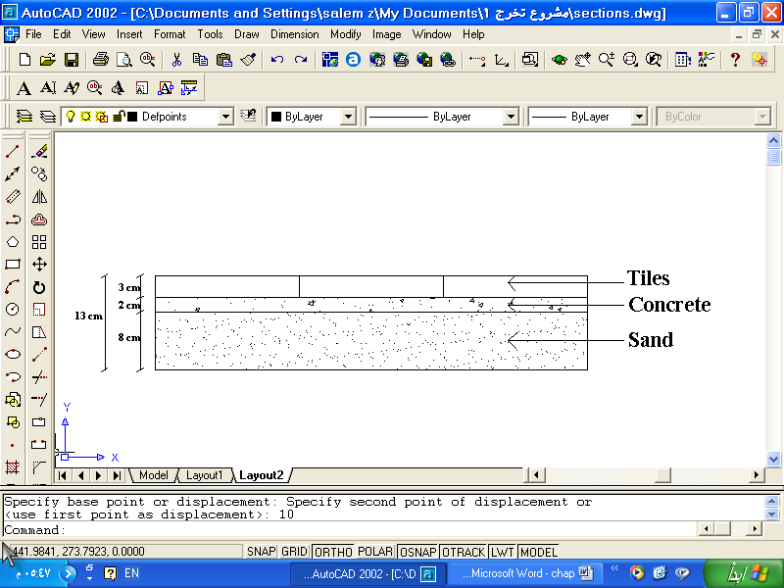

Figure (2.4): Section of Floor

As mentioned before slabs are represented on SAP 2000 as shell elements, and its own weight will be calculated by the program, so, another modification on the shells material can be done to take into account S.I.D loads and partitions loads as follows:

»» Total Weight = Weight of Ribs + S.I.D

»» Total weight = 0.46 + 0.3 = 0.76 t/m²

SAP 2000 Input Data

The following data are given to SAP 2000 program to represent the actual structure as possible:

1- Material

More than one concrete material is defined in the program to consider modifications on unit weight done for shell elements material.

Table (2.2): SAP 2000 Defined Materials

|  |  |
| --- | --- |
| Weight/Volume (t/m³) | Material |
| 2.5 | Concrete |
| 1.5 | glass Wall |

2- Frames & Area Sections:

Structural elements cross sections are defined with proper dimensions.

* Frame Sections Initial Dimensions :

Table (2.3): SAP 2000 Defined Frame Sections

|  |  |  |  |
| --- | --- | --- | --- |
| Material | Width  (cm) | Depth  (cm) | Frame Section |
| Concrete | 25 | 70 | Column |
| Concrete | 25 | 50 | M.drop Beam |
| Concrete | 25 | 40 | C.drop Beam |
| Concrete | 25 | 50 | Tie Beam |

Table (2.7): Slab Weight Calculations

|  |  |  |  |  |  |
| --- | --- | --- | --- | --- | --- |
| Weight  (ton) | Number | Unit weight  (t/m³) | Thickness  (m) | Area  (m²) | Element |
| 945  508 | 3  3 | 2.3  2.3 | 0.2  0.2 | 687  368 | Slab1  Slap2 |

* The weight of slabs includes the weight of S.I.D loads.

1. Beams Weight in the first building:

»» Beams weight = (Area) (Length) (Concrete Unit Weight) N

»» Where N, number of stories, N = 3

»» Total main beams length = 230*3=690m

»» Total tie beams length = 230+216=446m

»» Total combined beams length = 216*3=648m

»» Area of main beam, tie beam = (Depth) (Width) = (0.5) (0.25) = 0.125m²

Depth = Total depth - Slab depth = 0.5 - 0.2 = 0.3m

»»Area of combined beam = (Depth) (Width) = (0.4) (0.25) = 0.1m²

Depth = Total depth - Slab depth = 0.4 - 0.2 = 0.2m

»» Total beams weight = (690+446) (0.125) (2.5)+ (648)(0.1)(2.5) =517 ton.

2. Beams Weight of second building:

»» Beams weight = (Area) (Length) (Concrete Unit Weight) N

»» Where N, number of stories, N = 3

»» Total main beams length = 87*3=261m

»» Total tie beams length = 64*3=192m

»» Total combined beams length = 87+64=151m

»» Area of main beam = (Depth) (Width) = (0.5) (0.25) = 0.125m²

Depth = Total depth - Slab depth = 0.5 - 0.2 = 0.3m

»»Area of combined beam = (Depth) (Width) = (0.4) (0.25) = 0.1m²

Depth = Total depth - Slab depth = 0.4 - 0.2 = 0.2m

»» Total beams weight = (261+192) (0.125) (2.5)+(151)(0.1)(2.5) =179 ton

3. Columns Weight:

»» Column area = (0.75) (0.25) = 0.1875m²

»» Column height = 4 - 0.2 = 3.8

»» Number of columns in the first building = 54*3=162

»» Number of columns in the second building = 24*3=72

»» columns weight in the first building = (Area) (Height) (con) (Number of columns)

= (0.25) (3.8) (2.5) (162) = 385 ton

»» columns weight in the second building = (Area) (Height) (con) (Number of columns)

= (0.25) (3.8) (2.5) (72) = 171 ton

4. Masonry Wall Weight:

»» Unit weight **≈** 2.5 t/m³, thickness = 0.15m

»» Total area of masonry wall **≈** 0.15*area of masonry wall

»» Openings area = 480m²

»» Effective area of masonry wall for the first building

A eff = 462.4*3=1387m².

»» Effective area of masonry wall for the second building

A eff = 272*3=816m²

»» Total masonry wall weight for the first building

= A eff (Thickness) 

= 1387 (0.15) (2.5) = 521 ton

»» Total masonry wall weight for the second building

= A eff (Thickness) 

= 816 (0.15) (2.5) = 306 ton

* The total weight of the first building, W

»» W = Slabs + S.I.D + Columns + Beams + Walls

»» W = 2500 ton

»» W/m² = 2500 / (3*687) = 1.21 t/m²

* The total weight of the second building, W

»» W = Slabs + S.I.D + Columns + Beams + Walls

»» W = 1164 ton

»» W/m² = 1164 / (3*360) = 1.1 t/m².

3) Slabs Design

Introduction:

Slabs are designed as one way ribbed slab. One way ribbed slabs are those panels in which bending takes place in one direction. Panels are supported on all four sides by unyielding supports such as shear walls or beams. The panel will deflect in a dish like form under the external load. Blocks with dimensions of (40cmX20cmX17cm) are used.

Slabs Design for Flexure:

The cross section of rib is shown in figure below, its dimensions are:

- The effective width of rib, beff = 55cm

- Web width, bW = 15cm

- Total slab thickness = 25cm & flange thickness = 8cm.



Figure: A Cross Section in one Way Ribbed Slab

In order to design the slabs for flexure, bending moment diagrams must be determined for the ribs. Since 3D analysis for the building by SAP2000 program is done, so the bending moment diagrams for shell elements representing slabs are taken from SAP2000.

* M11 is a symbol used in SAP2000; it refers to the bending moment diagram for the slab in X-direction.
* M22 refers to bending moment diagram in Y-direction.

The values taken from SAP 2000 for moments are in unit of t.m/m. So, values of M must multiplied by beff = 55cm, to get moment / rib.

* Values of Maximum & Minimum Longitudinal Steel

 ……………………………………… (3.1)

, |Ø=0.9 ..…...…….. (3.2)

, where  ………….. (3.3)

 …………. (3.4)

 ……………………………………….... (3.5)

» Where:

- AS : Area of steel

-: The steel ratio

- b : Width of rib or beam

- d : Effective depth = 25 – 3 = 22cm, using 3cm cover

- fC´: Concrete compressive strength, in (kg/cm²) unit

- fy : Steel yield strength, in (kg/cm²) unit

- MU : The ultimate moment in (t.m) unit

- : Steel yield strain

- Ø : Reduction factor

* For fC´ = 250 kg/cm² & fy = 4200 kg/cm²:

- 

» Minimum positive moment, b = beff = 55cm

- Minimum MU = 4 t.m

» Minimum negative moment, b = bW = 15cm

- Minimum MU = 1.14 t.m

* Longitudinal Reinforcement of a Floor

The following figures taken from SAP 2000 analysis results shows the bending moment diagram for the third floor which represents slabs of the first to the third story.

* Figure below shows M11and M22.

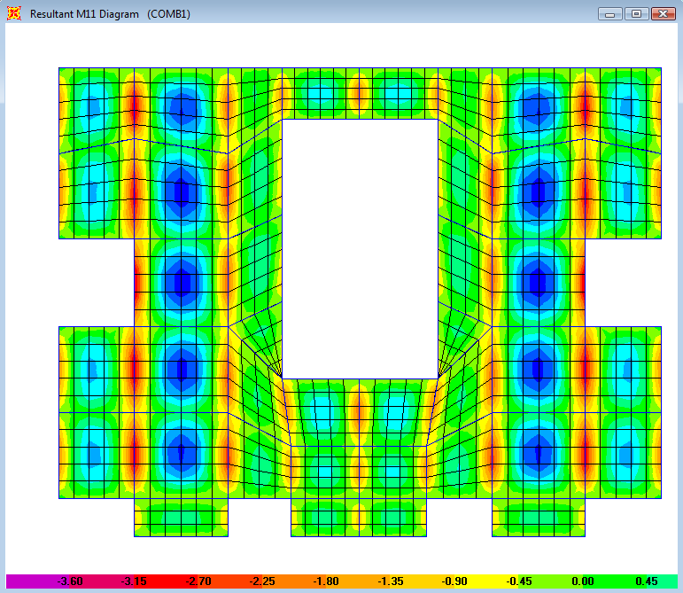

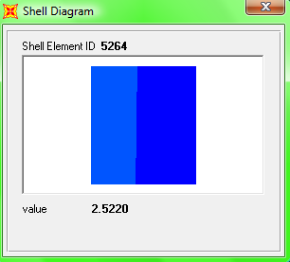 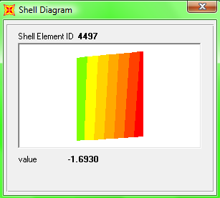

* The maximum values of positive moment = 2.52 X 0.55 = 1.38 t.m.
* the maximum value of negative moments = 1.7 X 0.55= 0.93 t.m.

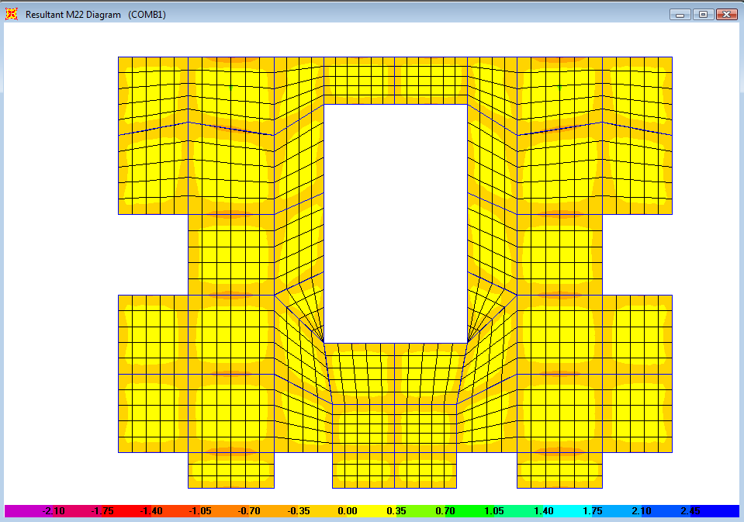

All values of moment of is less than the calculated minimum moments, so use minimum area of steel in one way ribbed slabs.

»» As min = min bW d = 0.0033 (15) (23) = 1.14 cm²

→ use 2 Ø 12mm, for bottom and top steel.

Slabs Design for Shear Forces:

Shear force diagrams are taken from SAP 2000 analysis results for slabs, V13 & V23 are symbols used in SAP 2000 to refer to shear force in both directions. The values taken from SAP 2000 for VU are in (t/m) units.

Ø VC = {Ø (0.53)  bW d} (1.1) ……………………………. (3.7)

Where:

- Ø = 0.75, shear factor

- VC : Concrete shear capacity

VU must be taken at distance d from the face of support.

»» The shear capacity of rib, with bW =15cm & d = 22 cm

» 

The shear categories for beams are as follows:

1. VU ≤ 0.5 Ø VC, no shear requirement.
2. 0.5 Ø VC ≤ VU ≤ Ø VC, use minimum shear reinforcement.

 …………………………………………….. (3.8)

 …………………………………... (3.9)

Where  is the angle of stirrups

3- Ø VC < VU < Ø (VC + Vs min) , use minimum shear reinforcement.

4- Ø (VC + Vs min) < VU < 2 Ø VC, design for shear reinforcement

»» Vs = VU / Ø – VC

»» 

»» S = min of d / 2

60cm

5- 3 Ø VC < VU < 4Ø VC , design for shear reinforcement

»» S = min of d / 4

30cm

6- VU > 4Ø VC , redesign the section

The shear force diagrams in figures below. From figures the maximum value of VU = 3.7 t/m, 3.7 (0.55) = 2 ton.

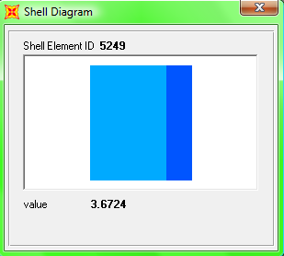

» VU < Ø VC, use minimum shear reinforcement

» Vs min = 3.5 (15) (22)/1000 = 1.2 ton

Using Ø 10mm stirrups, As = 0.785 cm2 for one leg

» Vs = (AV / S) fy d

» Av = 2 X 0.785 = 1.57 cm2 for two legs

» S = 11cm

Use 1Ø10mm@11cm at spans end, 1Ø10mm@25cm at middle of spans.

Shrinkage Steel:

The flange of T-Section of slabs is usually designed for shrinkage.

»» Area of steel for shrinkage = 0.0018 b h.

- h is the flange thickness

»» As shrinkage = 0.0018 (100)(8) = 1.44 cm²/m

Using Ø 8mm steel bars with area of bar = 0.5 cm²

»» 

Use 1 Ø 8mm @ 25cm in both directions

4) Design of Stairs

Introduction:

Stairs are used for vertical movements between different levels. Although electronic elevators are used for the same purpose, and they are quicker than using stairs, we can not get rid of the use of stairs.

Stairs can be considered as emergency exit, so it should be safely designed to take into account the congestion of people during emergency.

Design of the Flights:

The flight is an inclined slab connecting two horizontal slabs (landings). The thickness of flight is taken to be = 15cm. The flights are considered to be supported by the landings, so simply supported beam model is used to represent the flights on SAP 2000 program.

* SAP 2000 Input Data

* The cross section is rectangular with 100cm width and 15cm depth. The ultimate load Wu given as distributed load per meter length, Wu iscalculated from gravitational dead and live load. The scale factor for dead load case entered to SAP = 0.0, because ultimate load is used.

Wu = 1.2 D.L + 1.6 L.L …………………………… (4.1)

»» Dead load = Own weight + S.I.D Load

S.I.D Load is equal to that given for normal floor, S.I.D = 0.3 t/m2

»» Dead load =  Thickness + 0.3

D.L = 2.5 (0.15) + 0.3 = 0.675 t/m2

Live load is taken to be = 0.6 t/m2 for stairs

»» Wu = 1.2 (0.675) + 1.6 (0.6) = 1.77 t/m2

Wu /m´ = 1.77 (1) = 1.77 t/m´

* Analysis Result of Flight Model

The following analysis results of bending moment diagram (B.M.D) & shear force diagram (S.F.D) are taken from SAP 2000.

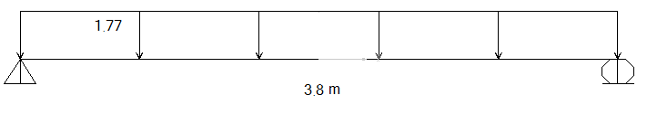

Figure (4.1): Distributed Ultimate Load on Flights

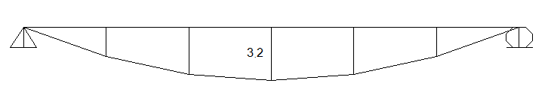

Figure (4.2): The B.M.D of Flights from SAP2000

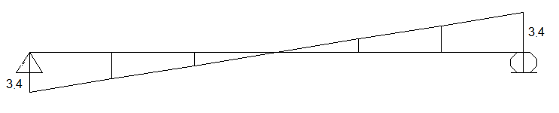

Figure (4.3): S.F.D of Flights from SAP 2000

* Design for flexure

-  ……………………….. (4.2)

Where:

fC´ = concrete compressive strength = 250 kg/cm2

fy = yield strength of steel = 4200 kg/cm2

Mu = ultimate moment = 3.2 t.m

b = width = 100cm

d = effective depth = 12cm

»  = 0.0063

» 

Use  , AS = 0.00225 (100) (12) = 7.5 cm2/m

Using steel bars of Ø 12mm, AS = 1.13 cm2

»  , S is spacing between bars.

Use 1 Ø 12mm @ 15cm

* Use shrinkage steel for other direction.

Use 1Ø 12mm @ 30cm in the other directions

* Check Shear Requirement

→ VU = 3.4 ton

 …………………………… (4.3)

» ton

VU < Ø VC, no shear requirement.

4.3) Design of Landings

Landings can be considered as horizontal slabs that supports the flights. The thickness of landings is the same as flights = 15cm and, landings are supported by the shear walls, so another model of simply supported beam is used for landings design.

* SAP 2000 Input Data

* The cross section of the model is rectangular with 100cm width and 15cm depth. The total span length is = 2.6m.
* The ultimate load is calculated and given to the span as distributed load. Ultimate load on landings is the same calculated for flights in additional to flights load. Flights load is taken as distributed load per meter from the reaction of flights' model, reaction is = 2.3 t /m´.

»» WU = 3.4 + 1.77 = 5.17 t /m´

* Analysis Results of Landings Model

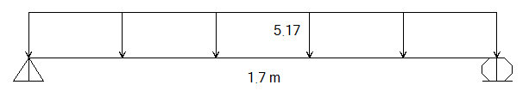

Figure (4.4): Distributed Ultimate Load on Landings

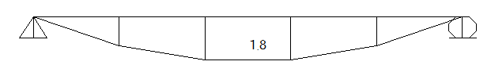

Figure (4.5): B.M.D of landings from SAP 2000

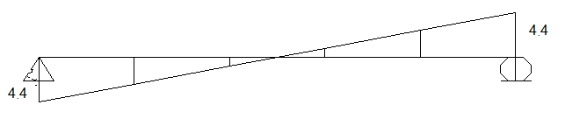

Figure (4.6): S.F.D of Landings from SAP 2000

* Design for flexure

»  = 0.0034

» AS = (0.0034) (100) (12) =4 cm2

Using steel bars of Ø 12mm, AS = 1.13 cm2

» 

Use 1 Ø 12mm @ 15cm

* Use shrinkage steel for other direction, 1Ø 12mm @ 30cm

* Check Shear Requirement

→ VU = 4.4 ton

» ton, VU < Ø VC, ok.

5) Beams Design

Introduction:

Beams are bending members which carry loads primarily normal to their longitudinal axis and transfer these loads from support to support by flexural bending of the member material. Concrete beams are generally rectangular as drop beams.

Beams dimensions:

Table (5.3) shows the final dimensions of beams after analysis of the model.

Table (5.3): Final Dimensions of Beams

|  |  |  |
| --- | --- | --- |
| Width  (cm) | Depth  (cm) | Type of Beam |
| 25 | 50 | Main beam |
| 25 | 40 | Combined beam |
| 25 | 50 | Tie beam |

We are designed the beams by sap (3D).but we make a check of main beam number 2, in the first building.

L=4.

Drop beam (50*25) cm.

Two end continuous. (L/16 for positive, L/10 for negative).

Wu=1.75t/m2.

Beam carry 1.75 t/m2* 4.6m=8t/m.

-The maximum Positive moment, MU = 8 t.m

-The maximum negative moment MU = 13 t.m

 …………………………. (5.1)

 , for Ø = 0.9 …………………….. (5.2)

 …………………………... (5.3)

* b = 25, d = 50 - 5 = 45cm, (5cm cover)

→ ­ max = 0.015, As max= 16.8 cm²

→  min= 0.0033, As min= 3.7 cm²

* Mu(positive) = 8 t.m →  = 0.0045

* Mu(negative) = 13 t.m →  = 0.0072

»  min<  <  max

» As =  b d = 5 cm². (As in sap=4.67 cm²).

» As =  b d = 8 cm². (As in sap=7.2 cm² , 9.66 cm2 ) , some of moment

goes to columns, 3D analyzing is more accurate than 1D and 2D analyzing).

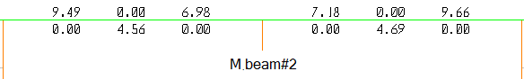

Following figures below shows the longitudinal reinforcement of Beams taken from SAP2000 program.

(the figure explain area of steel of each beam and column for each story)

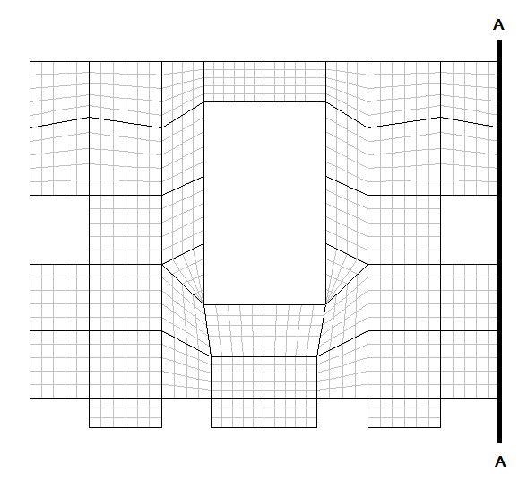

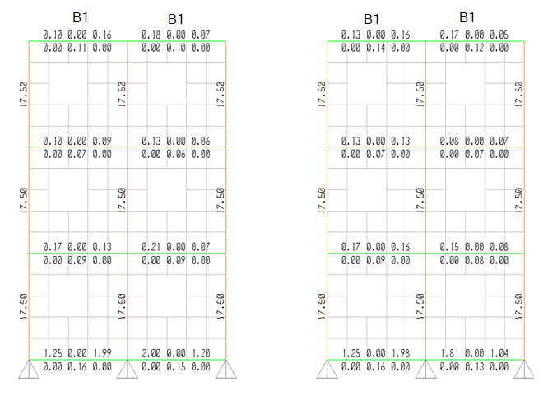

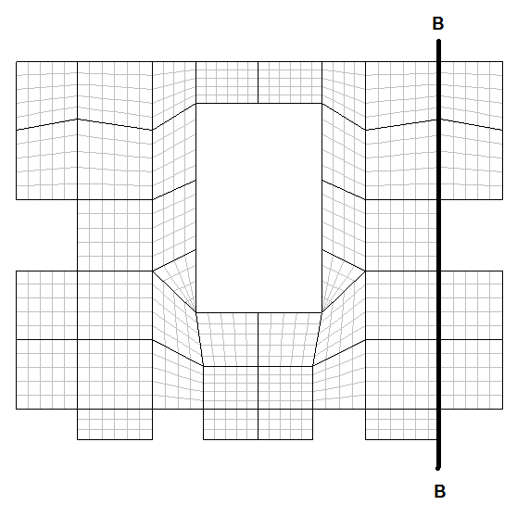

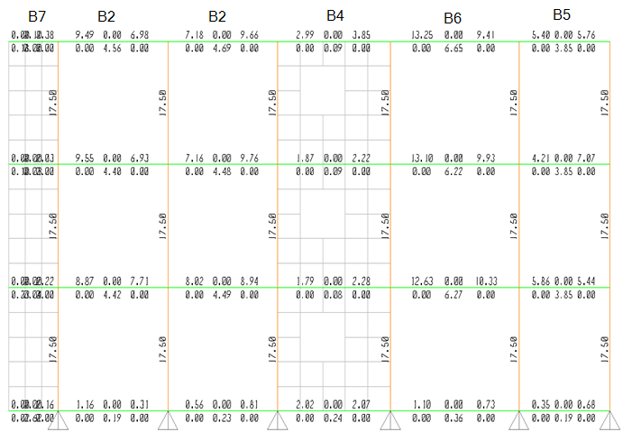

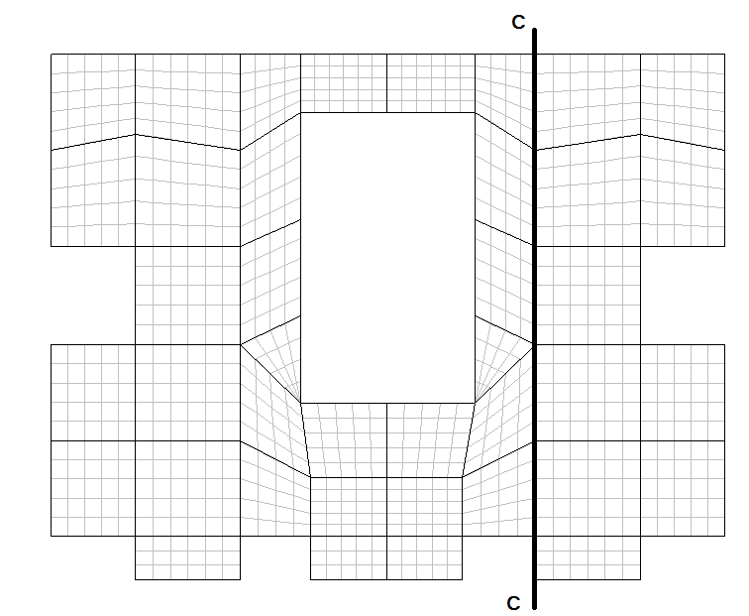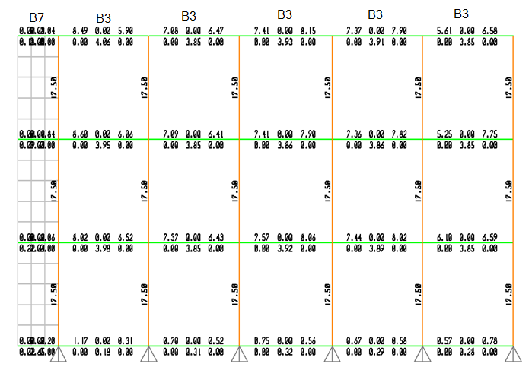

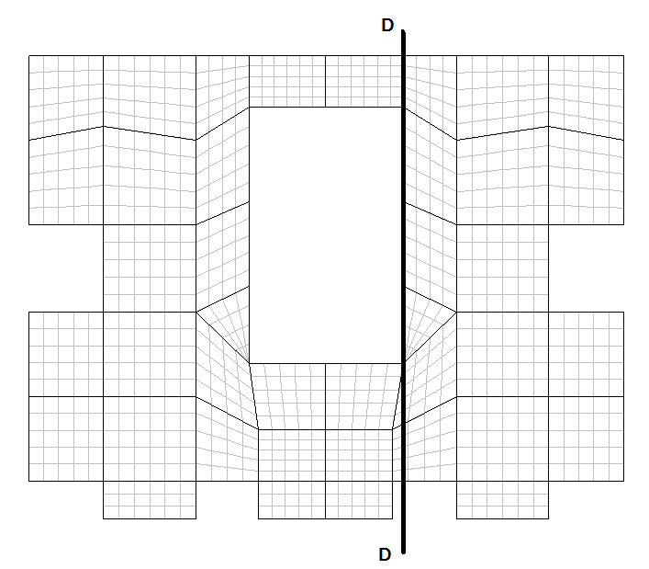

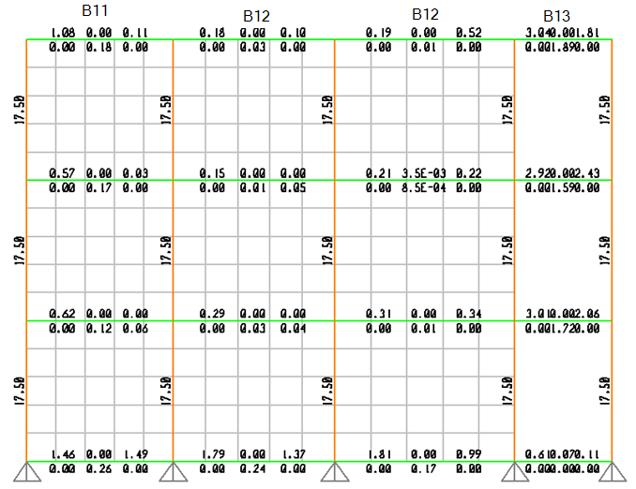

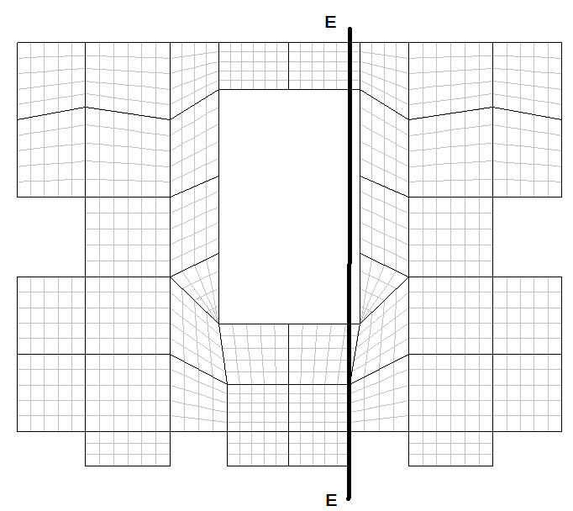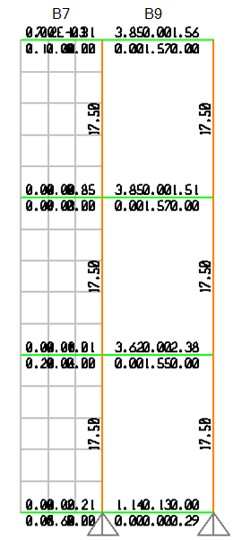

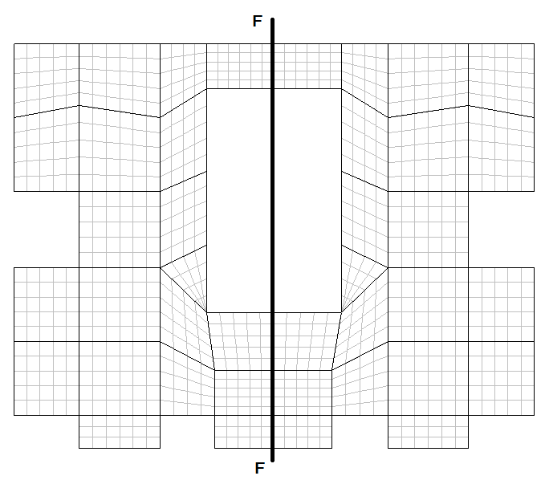

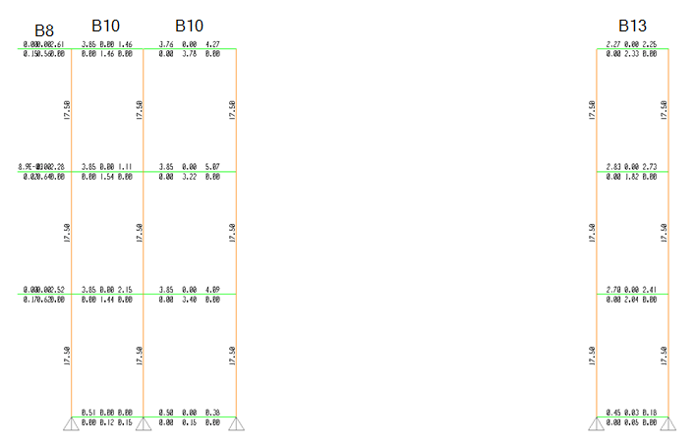

The second building

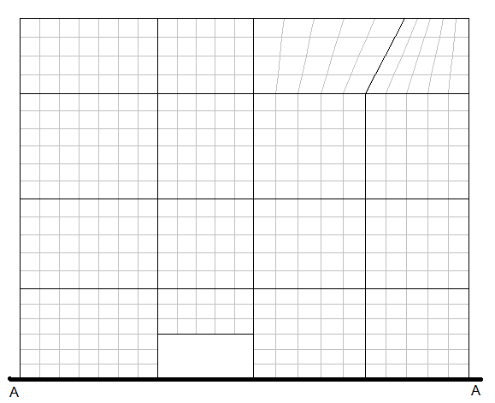

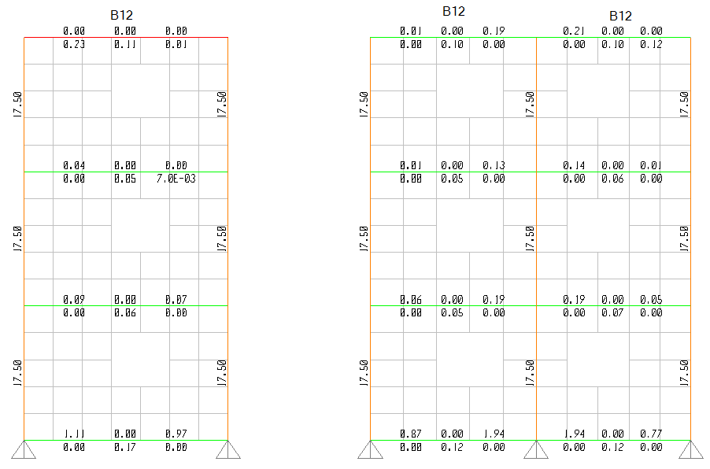

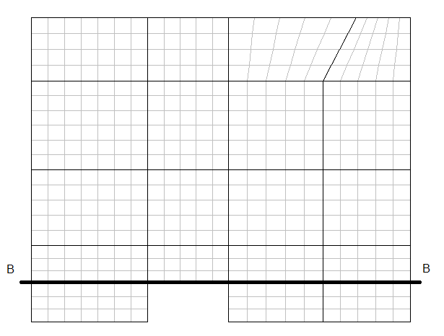

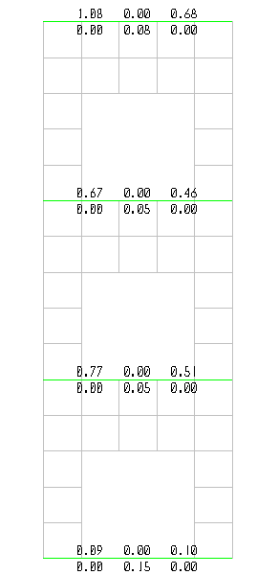

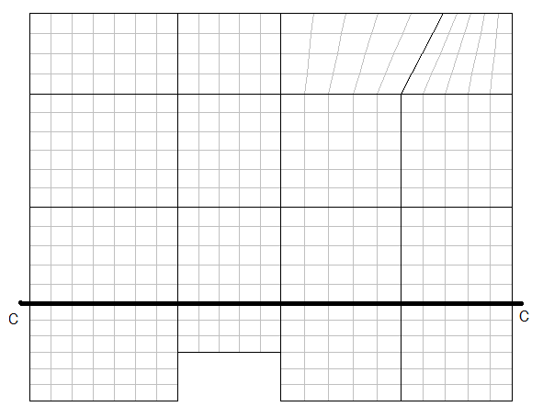

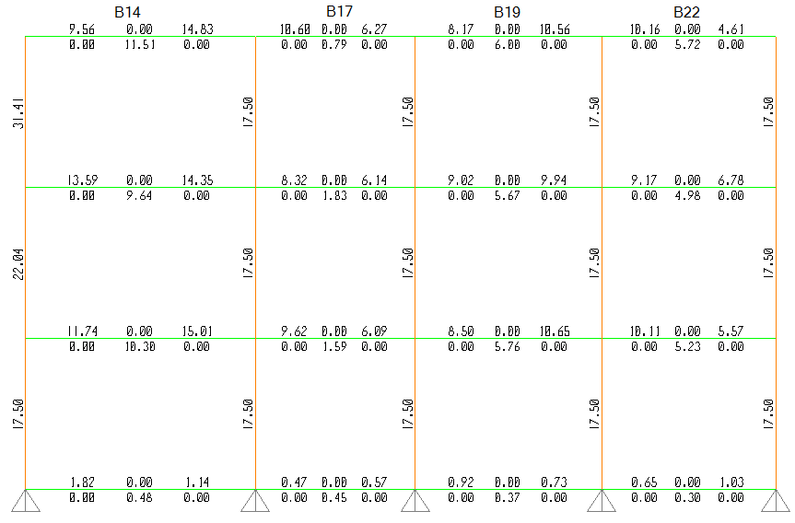

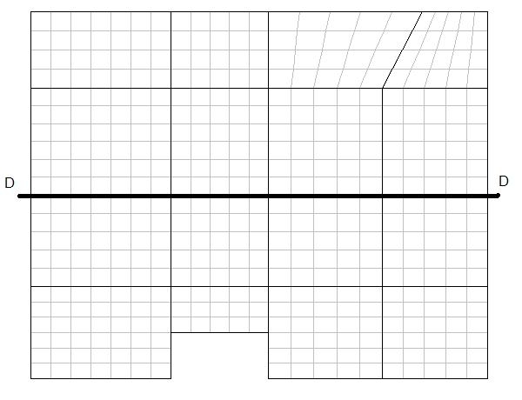

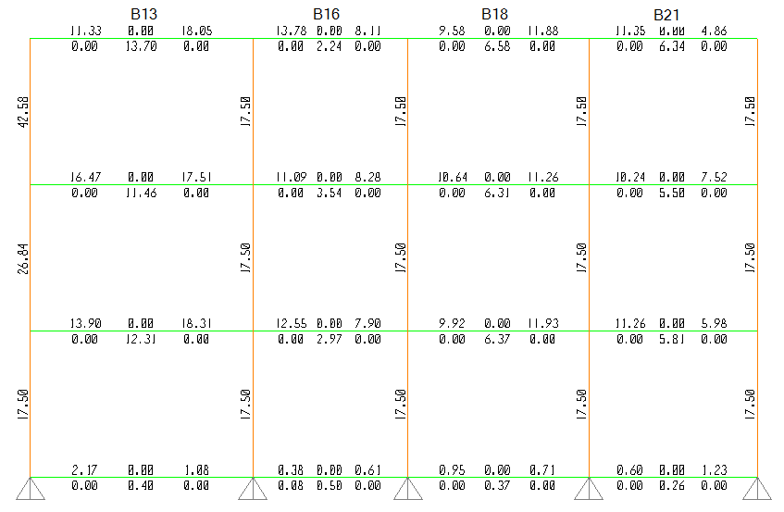

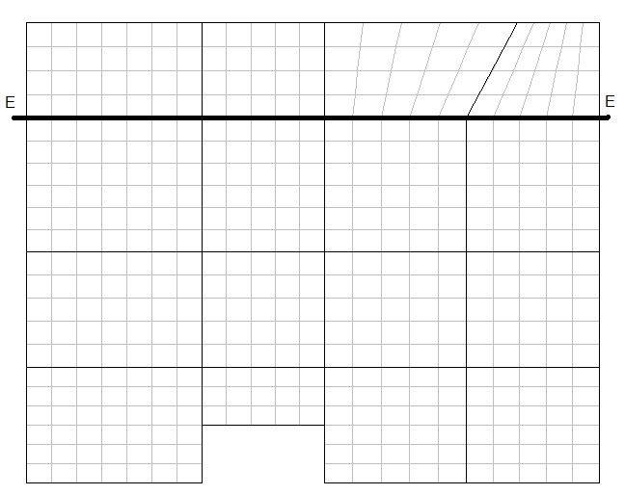

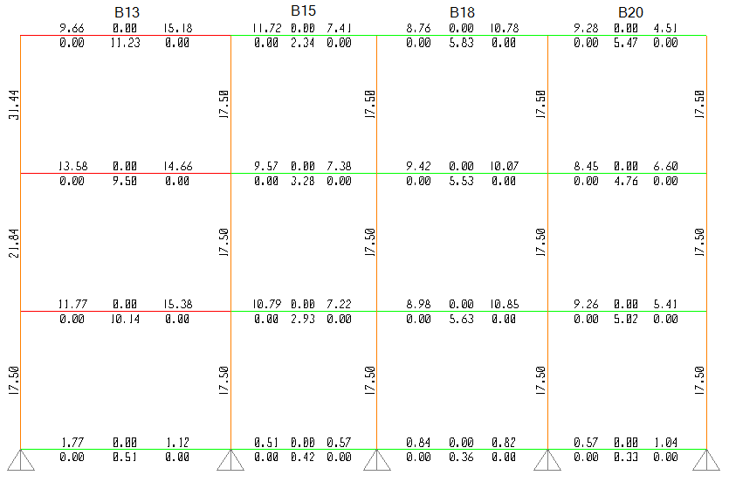

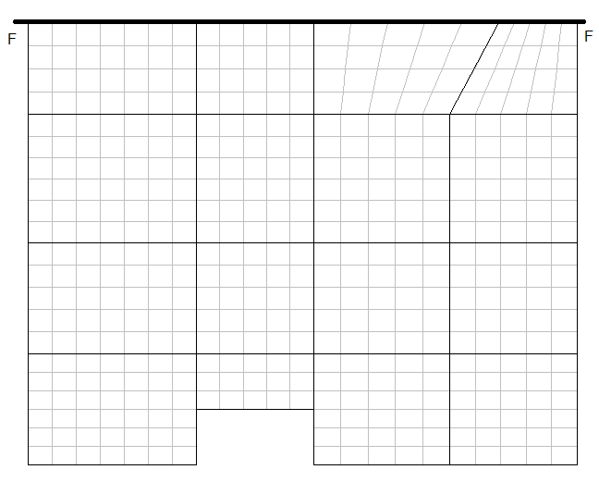

Shear wall appear in this elevation

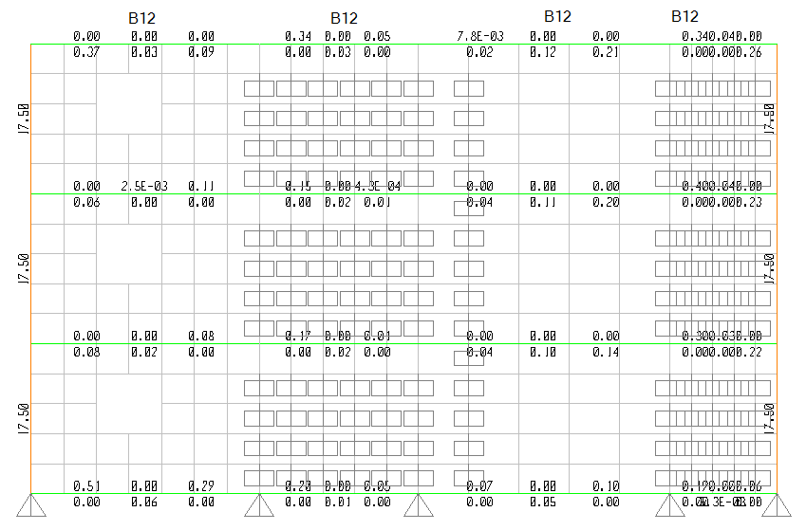

6) Columns Design

Introduction:

Columns are vertical compression members of structural frame intended to support the load carrying beams. They transfer loads from the supper floors to the lower levels and then to the soil through foundations. Failure of one column in a critical location can cause the progressive collapse of the adjoining floors and the ultimate total collapse of the entire structure.

Columns can be classified on the basis of the form and arrangement of reinforcement, the position of load on the cross section, and the length of the column in relation to its lateral dimensions.

There are three types of columns according to the form and arrangement of the reinforcement:

1. Rectangular or square columns reinforced with longitudinal bars and lateral ties.
2. Circular columns reinforced with longitudinal reinforcement and spiral reinforcement or lateral ties.
3. Composite columns where steel structural shape are encased in concrete.

Although tied columns are the most commonly used because of lower construction cost, spirally bound columns are also used where increased ductility is needed.

Column Design Considerations:

Failure of columns could occur as a result of material failure by initial yielding of the steel at the tension face or initial crashing of the concrete at the compressive face, or by loss of lateral structural stability through buckling.

* Long & short columns

* Short columns are those in which the ultimate load is governed by the strength of material and dimensions of cross section.
* Long columns are those in which the ultimate capacity is influenced by slenderness ratio.

The ACI Code considers columns to be short if:

» for braced column

 ……………………………….. (6.1)

 ……………………………….. (6.2)

Where:

* K : effective length factor which depends on the ratio of stiffness of column to stiffness of beams at the top and bottom of the column.

» for braced columns

0.5 ≤ K ≤ 1

» for un-braced columns

K ≥ 1

* LU : un-braced length of column
* r : radius of gyration for cross sectional of column, r = 

» r = 0.3 h, for rectangular cross section

» r = 0.25 diameter, for circular cross section

* : are columns end moment ratio, which is negative for double curvature and positive for single curvature

» In this project rectangular columns are used with dimension 70*25cm

LU = 4m, r = 0.3 (0.7) = 0.21, take K= 0.7

, so, all columns are considered as short columns.

* Longitudinal Reinforcement Considerations According to ACI 318-02

» The nominal compressive strength for axially loaded column is given by:

 ………………………… (6.3)

» The design ultimate load is given by:

 ………………………………………….. (6.4)

Where:

* fc´ : Concrete compressive strength
* Ag : Gross sectional area of the column
* As : Total area of longitudinal reinforcement
* fy : Yield strength of longitudinal reinforcement
* Ø : Strength reduction factor →

Ø = 0.65 for tied columns

Ø = 0.7 for spirally reinforced columns

*  : Factor to consider minimum eccentricity →

 = 0.8 for tied columns

 = 0.85 for spirally columns

» Longitudinal reinforcement ratio:





» Transverse Steel (ties) Considerations According ACI 318-02

1. Longitudinal bars spaced more than 15cm should be supported by lateral ties.
2. The ties should be so arranged that every corner and alternate longitudinal bars shall have lateral support divided by the corner of a tie having an included angle of not more than 135°, and no bar shall be farther than 15cm clear on either side from such laterally supported bars.
3. The size of the tie should not be less than 10mm. If longitudinal bar size is larger than 32mm, then 12mm bars at least should be used as ties.
4. The vertical spacing of the ties must not exceed the minimum of:

* 48 d**S**, d**S** is the tie diameter

* 16 d**b**, d**b** is the longitudinal bar diameter

* The least lateral dimension of the column

Design of Longitudinal Reinforcement:

All columns in the project are designed to be rectangular columns with dimensions of (70cmX25cm), using tied columns type.

The dimensions of columns are checked, according to the maximum area of steel. Columns #14 in the ground story has the maximum ultimate load, PU = 18.5m2 * 1.75t/m2 * 3 = 91 ton, the steel ratio calculated as follows:

Pu = 91 ton, the ultimate load on column #14

Pn (max) = 91 / 0.65 = 149 ton

Using fc´= 250 kg/cm², fy =4200 kg/cm², Ag = 1750 cm²

»» Pn (max) = 0.8 [0.85(250)(Ag – As) + f­y As]

149= 0.8 [0.85 (250)(Ag - As) + 4200 As]

→ Use Asmin

→ 

→ Asmin =17.5 cm2.

The area of longitudinal steel taken from SAP 2000 = 17.5 cm² → 

We use the same cross section for all columns in sap.