Chapter 1

Literature Review

  - Introduction
The lowest part of a structure is generally referred to as the foundation. Its function is to transfer the load of the structure to the soil on which it is resting. A properly designed foundation is one that transfers the load throughout the soil without over-stressing the soil. Overstressing the soil can result in either excessive settlement or shear failure of the soil, both of which cause damage to the structure. Thus, geotechnical and structural engineers who design foundations must evaluate the bearing capacity of soils.
Depending on the structure and soil encountered, various types of foundations are used. A spread footing is simply an enlargement of a load-bearing wall or column that makes it possible to spread the load of the structure over a larger area of the soil. In soil with low load-bearing capacity, the size of the spread footings required is impractically large. In that case, it is more economical to contructs the entire structure over a concrete pad. This is called a mat foundation.
Pile and drilled shaft foundations are used for heavier structures when great depth is required for supporting the load. Piles are structural members made of timber, concrete, or steel that transmit the load of the superstructure to the lower layers of the soil. According to how they transmit their load into the subsoil, piles can be divided into two categories: friction piles and end-bearing pile, the load carried by the pile is transmitted at its tip to a firm stratum.
In the case of drilled shafts, a shaft is drilled into the subsoil and is then filled with concrete. A metal casing may be used while the shaft is being drilled. The casing may be left in place or withdrawn during the placing of concrete. Generally, the diameter of a drilled shaft is much larger than that of a pile. The distinction between piles and drilled shafts becomes hazy at an approximate diameter of 1m, and then the definitions and nomenclature are inaccurate.
Spread footings and mat foundations are generally referred to as shallow foundations, and pile and drilled shaft foundations are classified as deep foundations. In a more general sense, shallow foundations are those foundations that have a depth-of-embedment-to-width ratio of approximately less than four. When the depth-of-embedment-to-width ratio of a foundation is greater than four, it may be classified as a deep foundation.

    - General Requirement
A footing must be able to satisfy stability and deformation requirements as:
- Depth must be below the zone of the seasonal volume changes by freezing, thawing, and plant growth.
- Depth must be adequate to avoid lateral expulsion of material from beneath the footings.
- System must be safe against over twining, rotation, sliding, and soil rapture.
- System must be safe against correction or deterioration due harmful materials present in the soil. This is a particular concern in reclaiming sanitary landfills and sometimes for marine footings.
- The footing should be economical in terms of the method of installation.
- Total earth movements (settlement) and differential movement should be tolerable for both the footing and superstructures elements.
- The footing, and its construction, must meet environmental protection standard.

    - Footing Classification
The type of footing for particular structure is influenced by many factors that may control type of footing to be used, these main factor are: the strength and compressibility of various soil strata at the site the magnitude of the column bad, the position of water table and the depth of footing of adjacent buildings.
We can classify footing as follows:
- Shallow footings; its depth is usually D ≤ B, it contains isolated, combined, strip and raft footing.
- Deep footings; with depth > [4-5]B, pile footing is one type of deep footing.
- Special footing.
1.1.3 Selection of Type of Footing
If the layer of soil of footing level which is suitable for bearing the load is located at a relatively shallow depth, the structure may be supported by shallow footing. If the upper strata are too weak or compressible, the load will be transferred to more suitable soil layer at a greater depth by means of deep footing.

1.1.4 Project Content
Project Title: MR. YAHYA BRAIK BULDING IN NABLUS
The project consists the construction of a seven story building with a plan construction area of about 1800 square meters.
Most of the construction area (except at the south eastern corner) is under-laid by good foundation material of marlstone. The south eastern corner is under-laid by soft plastic silty clay to a depth of 5m from the existing reduced level. So, it is recommended that footings will be constructed on the marlstone formation and the south eastern corner will be treated by excavation the top 5m of silty clay and boulders and re-filled with well-graded granular material.
  - Foundation Types

    - Introduction
Foundation is a supporting portion of a structure located below the structure and it is supported only by soil or rock. It is mainly used to support the structure and then distribute the weight of that structure, so it settles to the ground evenly rather than unevenly.
Each individual foundation must be sized so that the maximum soil bearing pressure does not exceed the allowable soil bearing capacity of the under lying soil mass. In addition, footing settlement must not exceed tolerable limits established for differential and total settlement.

There are two main types of foundations:
- Shallow Foundations.
- Deep Foundations.

    - Shallow foundations
To perform satisfactory, shallow foundations must have two main characteristics:
- They have to be safe against overall shear failure in the soil that supports them.
- They cannot undergo excessive displacement, or settlement. (the term excessive is relative, because the degree of settlement allowed for a structure depends on several considerations).
The most common structural foundation in today’s construction industry is the shallow foundation. Shallow foundation are those founded near to the finished ground surface; generally where the foundation depth (Df) is less than or equal to (3-4) of the foundation depth. These are not strict rules, but merely guide lines; basically, if surface loading or other surface conditions will affect the bearing capacity of a foundation it is then shallow.
Shallow foundation include spread foundation (carrying a single column) combined foundation, continuous foundation and mat (raft) foundation.
Shallow foundation are used when surface soils are sufficiently strong and stiff to support the imposed loads.

Advantage of using Shallow foundations:
- Simple construction procedure.
- Affordable cost.
- Available material (mostly concrete).
- Does not need experts (labors).
Disadvantage of using Shallow foundation:
- Settlement.
- Foundation is subjected to pull off out, torsion, and moment.
- Irregular ground surface (slope).

      - Spread or isolated Foundations
Isolated footing is a foundation that carries a single column. It distributes the column load to an area of soil around the column. Spread foundation may be circular, square, or rectangular. They usually consist of a block or slab of uniform thickness, but they may be stepped or hunched if they are required to spread the load from a heavy column. Figure 1.2 shows spread foundations.

      - Combined Foundations

Combined foundation combines the loads from two or more columns to the soil. It may be rectangular, trapezoidal or cantilever.

      - continuous (wall) Foundations
one dimensional action, cantilevering out on each side of the wall. Continuous footings are used to support a line of loads, rather due a load-bearing wall, or if a line of columns need supporting where columns positions are so close that individual foundation inappropriate. Figure 1.4 shows a wall foundation.

      - Mat (Raft) Foundations
Raft foundation is a combined footing that may cover the entire area under a structure supporting several columns and walls. Mat foundations are sometimes preferred for soils that have low load-bearing capacities but that will have to support high column and/or wall loads. Under some conditions, spread footings would have to cover more than half the building area, and mat foundations might be more economical. Several types of mat foundations are currently used. Some of common types are shown schematically in figure 1.5 and include the following:
- Flat plate, the mat is of a uniform thickness.
- Flat plate thickened under columns.
- Beams and slab, the beams run both ways, and the columns are located at the intersection of the beams.
- Flat plates with pedestals.
- Slab with basement walls as a part of the mat, the walls act as stiffeners for the mat.
Mats may be supported by piles. The piles help in reducing the settlement of a structure built over highly compressible soil. Where the water table is high, mats are often placed over piles to control buoyancy.

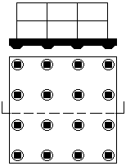
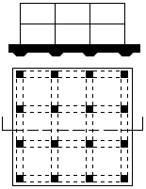
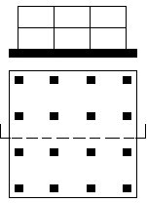
Section Section Section

Plan Plan Plan
(a) (b) (c)
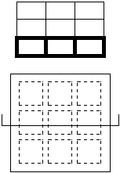
Section Section
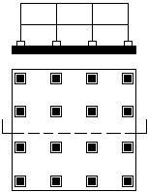

Plan Plan
(d) (e)
Figure 1.5 Common types of mat foundations

    - Deep Foundations

Piles are structural members made of steel, concrete, and/or timber. They are used to build pile foundations, which are deep and more costly than shallow foundations. Despite the cost, the use of piles is often necessary to ensure structural safety. Drilled shaft are cast-in-place piles that generally have a diameter greater than 750 mm with or without steel reinforcement and with or without an enlarged bottom. The first part of this section considered pile foundations, and the second part presents a detailed discussion on drilled shafts.

1.2.3.1 Pile foundations

- Need for pile foundations

Pile foundation are needed in special circumstances. The following are some situations in which piles may be considered for the construction of a foundation.
- When the upper soil layer (s) is (are) highly compressible and too weak to support the load transmitted by the superstructure, piles are used to transmit the load to underlying bedrock or a stronger soil layer, are shown in Figure (a). When bedrock is not encountered at a reasonable depth below the ground surface, piles are used to transmit the structural load to the soil gradually. The resistance to the applied structural load is derived mainly from the frictional resistance developed at the soil-pile interface Figure (b).
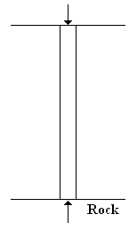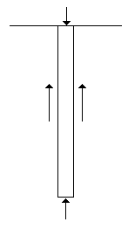
- (b)

- When subjected to horizontal forces (see Figure (c)), pile foundations resist by bending while still supporting the vertical load transmitted by the superstructure. This situation is generally encountered in the design and construction of earth-retaining structures and foundations of tall structures that are subjected to strong wind and/or earthquake forces.
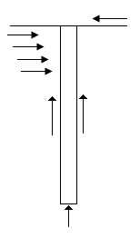
(c)
- In many cases, the soils at the site of a proposed structure may be expansive and collapsible. These soils my extend to a great depth below the ground surface. Expansive soils swell and shrink as the moisture content increases and decreases, and the swelling pressure of such soils can be considerable. If shallow foundations are used, the structure may suffer considerable damage.

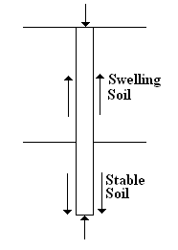
(d)
However, pile foundations may be considered as an alternative when piles are extended beyond the active zone, which swells and shrinks (Figure (d)). Soils such as loess are collapsible. When the moisture content of these soils increases, their structures may break down. A sudden decrease in the void ratio of soil induces large settlements of structures supported by shallow foundations. In such cases, pile foundations may be used, in which piles are extended into stable soil layers beyond the zone of possible moisture change.

- The foundations of some structures, such as transmission towers, offshore plate-forms, and basement mats below the water table, are subjected to uplifting forces. Piles are sometimes used for these foundations to resist the uplifting force (Figure (e)).

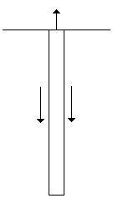
(e)
- Bridge abutments and piers are usually constructed over pile foundations to avoid the possible loss of bearing capacity that a shallow foundation might suffer because of soil erosion at the ground surface (Figure (f)).
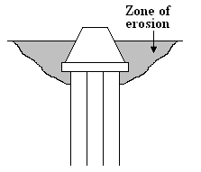
(f)
Although numerous investigations, both theoretical and experimental, have been conducted to predict to behavior and the load-bearing capacity of piles in granular and cohesive soils, the mechanisms are not yet entirely understood and may never be clear. The design of pile foundations may be considered somewhat of an “art” as a result of the uncertainties involved in working with some subsoil conditions.

- Types of piles and their Structural Characteristics
Different types of piles are used in construction work, depending on the type of load to be carried, the subsoil conditions, and the water table. Piles can be divided into these categories:

- Steel piles
Steel piles generally are either pipe piles or rolled steel H-section piles. Pipe piles can be driven into the ground with their ends open or closed. Wide-flange and I-section steel beams can also be used as piles; however, H-section piles are usually preferred because their web and flange thicknesses are equal. In wide-flange and I-section beams, the web thicknesses are smaller than the thicknesses of the flange.
In many cases, the pipe piles are filled with concrete after they are driven. When necessary, steel piles are spliced by welding or by riveting. Figure 14.2a shows a typical splicing by welding for an H-pile. A typical splicing by welding for a pipe pile is shown in Figure 14.2b. Figure 14.2c shows a diagram of splicing an H-pile by rivets or bolts.
When hard driving conditions are expected, such as driving through dense geavel, shale, and soft rock, steel piles can be fitted with driving points or shoes. Figures 14.2d and e are diagrams of two types of shoe used for pipe piles.
Following are some general facts about steel piles.
Usual length: 15m-60m
Usual load: 300 KN – 1200 KN
Advantages:
a. Easy to handle with respect to cutoff and extension to the desire length.
b. Can stand high driving stresses.
c. Can penetrate hard layers such as dense gravel, soft rock.
d. High load-carrying capacity.
Disadvantages:
- Relatively costly material.
- High level of noise during pile driving.
- Subject to corrosion.
- H-piles may be damaged or deflected from the vertical during driving through hard layers or past major obstructions.

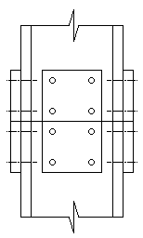
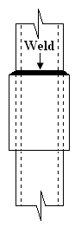
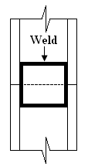

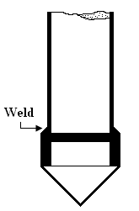
(a) (b) (c)
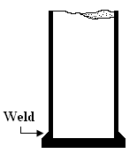

(d) (e)

Figure 14.2 Steel piles: (a) splicing of H-pile by welding; (b) splicing of pipe pile by welding; (c) splicing of H-pile by rivets or blots; (d) flat driving point of pipe pile; (e) conical driving point of pipe pile.

- Concrete piles

Concrete piles may be divided into two basic types: precast piles and cast-in-situ piles. Precast piles can be prepared using ordinary reinforcement and they can be square or octagonal in cross section (Figure 14.3). Rein-forcement is provided to enable the pile to resist the bending moment developed during pickup and transportation, the vertical load, and the bending moment caused by lateral load. The piles are cast to desired length and cured before being transported to the work sites.
Precast piles can also be prestressed by using high-strength steel prestressing cables. The ultimate strength of these steel cables is about 1800 MN/m². During casting of the piles, the cables are pretensioned to 900 to 1300 MN/m², and concrete is poured around them. After curing, the cables are cut, thus producing a compressive force on the pile section.
The general details of the precast concrete piles are as follows:
Usual length: 10m -15m
Usual load: 300KN - 3000KN
Advantages:
- Can be subjected to hard driving.
- Corrosion resistance.
- Can be easily combined with concrete superstructure.
Disadvantage:
- Difficult to achieve proper cutoff.
- Difficult to transport.

The general details about the precast prestressed piles are as follows:
Usual length: 10 m – 45 m
Maximum length: 60 m
Maximum load: 7500 KN – 8500 KN
The advantages and disadvantages are the same as in the case of precast piles.
Cast-in-situ, or cast-in-place are build by making a hole in the ground and then filling it with concrete. Various types of cast-in-place concrete pile are currently used in construction, and most of them have been patented by their manufacturers. These piles may be divided into two broad categories: cased and uncased. Both types may have a pedestal at the bottom.
Cased piles are made by driving a steel casing into the ground with the help of a mandrel places inside the casing. When the pile reaches the proper depth , the mandrel is withdrawn and the casing is filled with concrete. Figures 14.4a, b, c, and d show some examples of cased piles with a pedestal The pedestal is an expanded concrete bulb that is formed by dropping a hammer on fresh concrete.
The general details of cased cast-in-place piles are as follows:
Usual length: 5 m – 15 m
Maximum length: 30 m – 40 m
Usual load: 200KN-500KN
Approximate Maximum load: 800KN
Advantages:
- Relatively cheap
- Possibility of inspection before pouring concrete
- Easy to extend
Disadvantages:
- Difficult to splice after concreting
- Thin casing may be damaged during driving
Allowable load: Qall = As fs + Ac fc
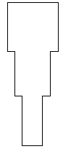
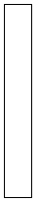
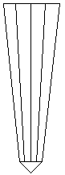
Raymond Monotube or Western Cased Pile
Step-Taper Pile Union Metal Pile Thin metal casing
Corrugated thin Thin, fluted,
cylindrical casing tapered steel Maximum usual
casing driven Length: 30 m – 40 m
maximum usual without mandrel
length: 30m
Maximum usual
Length: 40 m

- (b) (c)
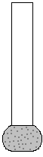
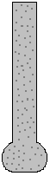

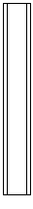

(d) (e) (f) (g)
Figure 14.4 cast in place concrete piles

Figure 14.4f and 14.4g are two types of uncased pile, one without a pedestal and the other with one. The uncased piles are made by first driving the casing to the desired depth and then filling it with fresh concrete. The casing is then gradually withdrawn.
Following are some general details of uncased cast-in-place concrete piles.
Usual length: 5 m – 15 m
Maximum length: 30 m – 40 m
Usual load: 300KN-500KN
Approximate Maximum load: 700KN
Advantages:
- Initially economical
- Can be finished at any elevation
Disadvantages:
- Voids may be created if concrete is placed rapidly
- Difficult to splice after concreting
- In soft soils, the sides of the hole may cave in, thus squeezing the concrete
Allowable load: Qall = Ac fc
where Ac = area of cross section of concrete
fc = allowable stress of concrete

- Wooden (timber) piles

Timber piles are three trucks that have had their branches and bark carefully trimmed off. The maximum length of most timber piles is 10 to 20 m. to qualify for use as a pile, the timber should be straight, sound, and without any defects. The American Society of Civil Engineers’ Manual of Practice, No. 17 (1959), divided timber piles into three classifications:
- Class A piles carry heavy loads. The minimum diameter of the butt should be 356 mm.
- Class B piles are used to carry medium loads. The minimum butt diameter should be 305 to 330 mm.
- Class C piles are used in temporary construction work. They can be used permanently for structures when the entire pile is below the water table. The minimum butt diameter should be 305 mm.
In any case, a pile tip should have a diameter not less than 150 mm.

- Composites piles
The upper and lower potions of composite piles are made of different materials. For example, composite piles may be made of steel and concrete or timber and concrete. Steel and concrete piles consist of a lower portion of steel and an upper portion of cast-in-place concrete. This type of pile is used when the length of the pile required for adequate bearing exceeds the capacity of simple cast-in-place concrete piles. Timber and concrete piles usually consist of a lower portion of timber pile below the permanent water table and an upper portion of concrete. In any case, forming proper joints between two dissimilar materials is difficult, and for that reason composite piles are not widely used.

1.2.3.2 Pier foundation (Drilled shaft):
A pier foundation is easier to build and less costly than the more common perimeter concrete foundation. It is best for building site with a low likelihood of earthquakes or hurricane force winds because the house is not as deeply or as heavily embedded into the ground.
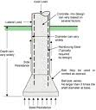
In this type of foundation you have spot footings (Isolated footing) of graved or concrete under wood posts or concrete piers which support beams. Those, in turn, support the floor platform above.
Piers drilled shafts and drilled piers are all refer to a cast-in-place pile which generally having a diameter of about 750 mm or more, with or without steel reinforcement and with or without an enlarged bottom.

1.2.3.3 Caisson Foundation
Caisson foundation is a shaft of concrete placed under a building column of wall and extending down to hardpan or rock. Also it is known as pier foundation. It is a permanent sub-structure that, while being sunk into position, permits excavation to proceed inside and also provides protection for workers against water pressure and collapse of soil.
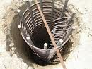
Caisson may be open, pneumatic, or floating type; deep or shallow; large or small; and of circular, square, or rectangular cross section. Large caisson are used as foundation for bridge piers, deep-water, and other structures. Small caissons are used single or in groups to carry such loads as building columns. Caisson are used where they provide the most feasible method of passing obstructions, where soil can’t be otherwise be kept out of the bottom, or where cofferdams can’t be used.
An open caisson is a shaft open at both ends. It is used in dry ground or in moderate amount of water.
A pneumatic caisson is like a box or cylinder in shape; but the top is closed and this compressed air can be forced inside to keep water and soil from entering the bottom of the shaft. A pneumatic caisson is used where the soil can’t be excavated through open shafts or where soil conditions are such that the upward pressure must be balanced. A floating or box caisson consists of an open box with sides and closed bottom, but no top. Ti is usually build on shore and floated to the site where it is weighted and lowered onto a bed previously prepared by divers.

Chapter 2

Geotechnical
Investigation Report

2.1 Introduction
2.1.1 General

This report presents the outcome of the site investigation carried out for the proposed construction site of the proposed new building of Mr. Yahya Braik in the city of Nablus (Plot No. 4+5, Block No. 24008)

2.1.2 Purpose & Scope

Investigation of the underground conditions at a site is prerequisite to the economical design of the substructure elements. It is also necessary to obtain sufficient information for feasibility and economic studies for any project.

It should be also noted that the scarcity of construction sites in the urban areas of the West Bank with considerable urban renewal and the accompanying backfill, often with no quality control, affects the underground conditions and results significant variation within a few meters in any direction.

For this particular project, and due to the known weak soil conditions of the area, and the filled nature of the ground to a considerable depth, the site investigation becomes of special importance to obtain sufficient information about the geotechnical parameters of the ground.

In general, the purpose of the site investigation was to provide the following:
- Information to determine the type of foundation required (shallow or deep).

- Information to allow the geotechnical consultant to make a recommendation on the allowable bearing capacity of the soil.

- Sufficient data/ laboratory tests to make settlement and swelling predictions.

- Location of the groundwater level.

- Information so that the identification and solution of excavation problems can be made.

- Information regarding permeability and compaction properties of the encountered materials.
This was accomplished through the close cooperation of HCL’s geotechnical engineer and the technical staff of its Geotechnical Department.

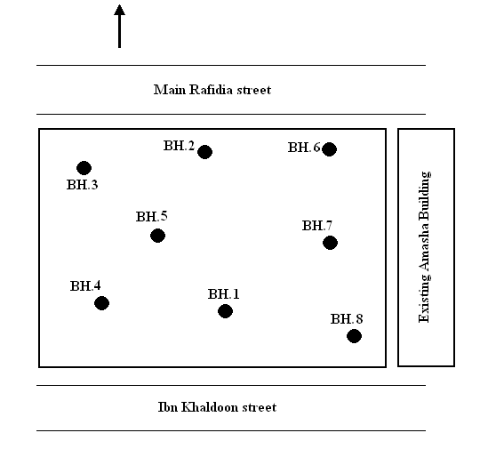

Fig. 1 Approximate location of boreholes

2.2 Site Condition

2.2.1 Description

The project site lies to the south of the main Rafidia street in the city of Nablus and is bordered by an existing Amasha building from the east and Ibn Khaldoon street from the south as shown in the attached plan-lay-out.

No high voltage, electrical or telephone poles, sewer or water pipes were observed within the depths of the drilled boreholes.

A general site plan showing the locations of boreholes is presented in Fig.1.

2.2.2 Subsurface Condition-Topography & General Geology

The studied area, after its excavation to the reduced foundation level is approximately flat. The general soil formation within the depths of the borings consists mostly of medium hard, weathered and fractured marlstone with occasional layers of marl. The exception of the described lithology is that the south eastern corner of the plot (BH.8) is covered by a 5m layer of brown silty clay.
The moisture content of the extracted soil samples is within the “medium to damp” range.
The drilled boreholes for this study reflect the described above general conditions and are enough, in our opinion, to represent the whole area of the proposed construction. They are discussed in more detail in subsequence sections of this report. Boreholes logs with detailed subsurface description are attached.
2.2.3 Ground water
Ground water was not encountered within the depths of the drilled boreholes and no fixed ground water table was observed.

2.3 Field Exploration & Sampling
2.3.1 Drilling
The geotechnical investigation problem agreed upon with the Client to explore the subsurface conditions in accordance with the Jordanian Code for Site Investigations including the drilling of eight boreholes within the boundaries of the site: five to a depth of 9m each and three to a depth of 13m each from the existing ground on the date of field exploration.

The test borings were located in the field by our representative by measuring relative to the property corners and other identifiable landmarks using the provided site plan. The location of the test borings is shown in the Boring Location Map presented in figure 1.

Soil logs for the test borings shown on the Boring Location Plan are presented in Appendix of this report. Soil samples were obtained from the test borings and returned to our office for further review and laboratory analyses. The soils observed during logging of the test borings were classified according to the Unified Soils Classification System (USCS), utilizing field classification procedures outlined in ASTM D 2488.

The borings were advanced using a truck mounted, Mobile B-31 drilling rig. Depths referred to in this report are relative to the existing ground surface elevations at the time of our field investigation. The surface and subsurface conditions described in this report are as observed at the site at the time of our field investigation.
2.3.2 Sampling
Due to the nature of the encountered soils and the fractured condition of the marlstone, mostly within the whole depth of drilling, it was difficult to obtain undisturbed samples. As a practically acceptable solution, disturbed samples suitable for identification and index property testing purposes were sampled at various depths. Samples required for strength tests were remolded in laboratory conditions.
Representative samples were placed in sealed plastic bags and transported to the laboratory for further testing.
In our opinion the obtained samples were of good quality.

2.4 Laboratory Testing

Representative soil samples were collected from the drilled boreholes, tightly sealed and transported to HCL’s laboratories in Nablus.

2.4.1 Tests Carried Out
The following tests were performed to evaluate the engineering properties of the soils influencing the performance of the proposed structures:
- Natural moisture content were determined in accordance with BS 1377 (test No.1)

- Grain size distribution (sieve analysis) in accordance with BS 1377 (test No.7). Standard sieves were used to perform the sieve analysis test on material after washing on sieve No.200.

- Hydrometer analysis in accordance with BS 1377 (test No. 7D). the test was carried out on very fine materials with more than 80% passing sieve No.200.
- Atterberg limits (Liquid and Plastic) in accordance with BS 1377 (Test No.2&3). Liquid and plastic limits tests were conducted on soil samples and the plasticity index (PI) was determined.

- Specific gravity in accordance with BS 1377 (Test No. 6)

- Direct shear test in accordance with ASTM D-3080, where three identical specimens were sheared under three vertical load conditions and the maximum shear stress in each case was measured. The strength parameters, namely cohesion (c) and angle of internal friction (Ø) were determined from the maximum shear-vs.-normal stress plot.

- Swelling Potential Analysis An indication of the susceptibility of the clayey soil encountered to swelling or shrinkage due to increase or decrease in moisture content has been provided by swelling potential evaluation.

According to the carried out experimental and analytical evaluation of different samples extracted from borehole #8 at the upper depths, it was found that the encountered plastic clay has a medium swelling potential.

The results of the mentioned above tests are summarized in the (summary of laboratory test results) in 4.2 below.

2.4.2 Summary of Laboratory Test results

The attached table-form presents the summary of laboratory tests carried out on collected samples from the drilled boreholes.

Hijjawi |  |  | SUMMARY OF LABORATORY TEST RESULTS  Ref.: SI/402 Project: Yahya Braik Building Site: Nablus
BH No. | Sample depth (m) | Moisture content (%) | %Finer Sieve No.200 | Atterberg limits |  | Specific gravity | Shear parameters |  | Unconfined compression (qu) (KN/m²) | USCS classification
 |  |  |  | LL (%) | PI | Specific gravity | C (KN/m²) | Ø (°) | Unconfined compression (qu) (KN/m²) | USCS classification
1 | 0.0-1.0 | 5.4 | 32.0 |  | None
1 | 1.0-9.0 | 5.8 | - |  | None | 2.325 | 0 | 28
2 | 0.0-1.0 | 4.8 | 33.5 |  | None
2 | 1.0-13 | 5.5 | - |  | None | 2.342 | 0 | 29
3 | 0.0-1.0 | 5.5 | 28.7 |  | None
3 | 1.0-9.0 | 5.9 | - |  | None | 2.344 | 0 | 30
4 | 0.0-1.0 | 5.0 | 31.2 |  | None
4 | 1.0-9.0 | 5.7 | - |  | None | 2.330 | 0 | 28
5 | 0.0-1.0 | 4.8 | 33.1 |  | None
5 | 1.0-9.0 | 5.6 | - |  | None | 2.338 | 0 | 29
6 | 0.0-1.5 | 6.7 | 48.8 | 47.5 | 20.0 |  | 39 | 17 | 78 | CL
6 | 1.5-9.0 | 6.1 | - |  | None | 2.345 | 0 | 30
7 | 0.0-1.0 | 6.0 | 38.4 |  | None
7 | 1.0-13 | 6.5 | - |  | None | 2.337 | 0 | 28
8 | 0.0-3.0 | 12.9 | 88.4 | 53.9 | 23.9 | 2.73 | 42 | 15 | 84 | CH
8 | 3.0-5.0 | 12.0 | 72.4 | 53.8 | 23.7 | 2.73 | 42 | 16 | 84 | CH
8 | 5.0-13 | 10.9 | - |  | None | 2.322 | 0 | 27

2.5 Bearing capacity Analysis

Most of the construction area (except at the south eastern corner) is under-laid by good foundation material of marlstone. The south eastern corner is under-laid by soft plastic silty clay to a depth of 5m from the existing reduced level. So, it is recommended that footings will be constructed on the marlstone formation and the south eastern corner will be treated by excavation the top 5m of silty clay and boulders and re-filled with well-graded granular material.

Using the shear test parameters of cohesion and angle of internal friction and the soil density, the following well known Terzaghi equation with correction terms suggested by Schultze can be used to calculate the bearing capacity of rectangular foundation of any sides ratio B:L

qult. = ( $\frac{1+0.3B}{L}$)CNc + $γ₀$ DNq + ($\frac{1-0.2B}{L}$ )($\frac{γ1 B}{2}$ ) $Nγ$
where:
$γ₀$ - Unit weight of soil above foundation level in KN/m³.
$γ$1 - Unit weight of soil below foundation level in KN/m³.
C,Ø - strength parameters of the soil below foundation level in KN/m² and degrees respectively.
B - width of foundation in (m).
L - length of foundation in (m).
Nc, Nq, $Nγ$ - Bearing capacity coefficients dependant on the angle of internal friction of the soil below foundation level (dimensionless).
D – Depth of foundation (m).
Calculation for an assumed raft foundation:
B = 3m
L = 3m
D = 3m
C = 25 KN/m²
Ø = 0°
$γ₀$ = 18 KN/m³
$γ$1= 18 KN/m³
The bearing capacity was computed by a special computer program using both Terzaghi method. The sheet with computation is attached. Based on the calculations, the bearing capacity on the top marlstone is 2.95 Kg/cm².
Bearing capacity of shallow foundations
Terzaghi Method
Date July 22, 2009
Identification Yahya Braik Building
Input Terzaghi Results
Units of measurement SI or E
Foundation Information Bearing Capacity
Shape SQ RE q ult = 885 KPa
B = 3 m q a = 295 KPa
L = 3 m
D = 3 m Allowable Column Load
Soil Information P = 2018 KN
C = 0 KPa
Phi = 25 deg
Gamma = 18 KN/m³
Dw = 20 m
Factor of safety
F = 3
2.6 Selection of Foundation Type

Most of the construction area (except at the south eastern corner) is under-laid by good foundation material of marlstone. The south eastern corner is under-laid by soft plastic silty clay to a depth of 5m from the existing reduced level. So, it is recommended that footings will be constructed on the marlstone formation and the south eastern corner will be treated by excavation the top 5m of silty clay and boulders and re-filled with well-graded granular material. The described material, after the treatment of the south eastern corner as described in 5 above, is capable to carry the loads acting from the superstructure through isolated footings with tie beams. The recommended bearing capacity is 3 Kg/cm²

2.7 Settlement Analysis

The settlement of the foundations designed as described above is negligible.

2.8 Engineering Recommendations

As a result of field and laboratory activities carried out and the analysis of the available data and test results, the following engineering recommendations can be made:

- Type and depth of foundations
Owing to the encountered subsurface conditions, which are discussed in this report, it is recommended to consider isolated footings with tie beams at the existing reduced level after cleaning of all loose excavated materials and inclusions (about 1m from the existing reduced level).

- Treatment of the south eastern corner
It is recommended to replace the top 5m of soft silty clay beneath the foundations at the south eastern corner with well graded granular materials having plasticity index less than 10. The granular material should be applied in layers not exceeding 30 cm in loose thickness and compact each layer to reach not less than 98% of maximum dry density determined by modified Proctor test. As an alternative, the 5m depth can be filled partially with granular material followed by rubble concrete. The design bearing capacity at the top of the replaced foundation material is not recommended to exceed 3.0 Kg/cm².

- Materials for backfilling – compaction criteria
The materials encountered in the drilled boreholes are satisfactory for using for backfilling purposes, except the top silty clay at the south eastern corner of the plot due to its fineness and plasticity. In general, materials for the backfilling should be granular, not containing rocks or lumps over 15 cm in greatest dimension, free from organic matter, with plasticity index (PI) not more than 15. The backfill material should be laid in lifts not exceeding 25 cm in loose thickness and compacted to at least 95 percent of the maximum dry density at optimum moisture content as determined by modified compaction tests (Proctor) (ASTM D-1557)

- Seismic considerations
As far as the seismic activity in the region has not witnessed any serious earthquakes in the last 70 years, the last serious of earthquakes since February 2004 in Palestine and neighboring Middle East countries and their serious consequences made it necessary to consider a seismic precautive factor in the design of the project structures.
Referring to the Unified Building Code Research in Jordan, the area can be considered within Zone B, which corresponds to an intensity of VІ to VІІІ according to the Mercalli Scale (4-6 Richter Scale respectively). According to the seismic zoning chart prepared by An-Najah National University for Palestine (see appendix), the seismic gravity acceleration factor for area (Zone ІV) z = 0.24 – 0.25 g, where g – gravity acceleration.
Finally, it should be noted that the results and recommendations of this report are solely based on the collected samples from the drilled boreholes on July 19th, 2009 and assuming that the subsurface conditions do not significantly deviate from those disclosed in the borehole logs.

Chapter 3

Table of loads

3.1 Table of loads
The following table represent loads that applied on each column, these results are calculated by using tributary area method [Auto CAD 2007]:

Column dimension | W service  ton | Wu  ton | Column#
0.3*0.8 | 79.45 | 107.28 | 1
0.3*0.8 | 110.04 | 137.02 | 2
0.3*1.0 | 151.23 | 204.18 | 3
0.3*0.8 | 187.12 | 252.65 | 4
0.3*1.0 | 205.23 | 277.10 | 5
0.3*1.0 | 253.00 | 341.60 | 6
0.3*1.0 | 291.84 | 394.04 | 7
0.3*1.0 | 311.02 | 419.93 | 8
0.3*1.2 | 355.45 | 479.92 | 9
0.3*1.2 | 516.12 | 696.87 | 10

Chapter 4

Design of footings

4.1 Single footing design
Single footing is a footing that carries a single column. It distribute the column load to an area of soil around the column. Single footing may be circular, square, or rectangular. The method of design chosen to design the single footings in this project is hand calculations in addition to using SAP2000 computer program.

SINGLE FOOTING DESIGN USING HAND CALCULATIONS
4.1.1 Design of isolated footing:
Size of footings:
The area of footing calculated from the actual external loads such that the allowable soil pressure is not exceeded.
Area of footing = $\frac{total load (in cluding self-weight)}{allowable soil pressure}$
where,
Total load = service load (KN)
$q_{all.}$ = net soil pressure (KN/m²)
Find B, L
Design steps:
Determining the depth using the following:
Calculate Vu at distance (d) from the face of the column and $∅Vc$, such that Vu $≤$ $∅Vc$.
Vult. = Wult. * area
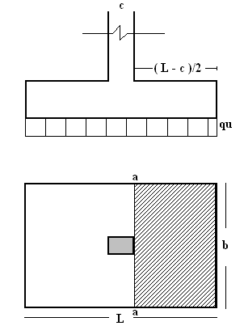
$∅Vc$ = $∅$*0.17*$\sqrt{fc}$ * d* b
where,
$∅$ = 0.75 d: depth (m)
fc = kg/cm² b: width (m)
then you get d
check soil pressure:
Ws: service load (ton)
Footing self-weight = b * h *d *$γ$ * 9.81
Weight soil in footing = b * h * (Df - d) * $γ$
Check:
»» $\frac{Ws+footing self-weight+weight soil in footing}{area}$ < $q_{all.}$ (KN)
Wide beam action:
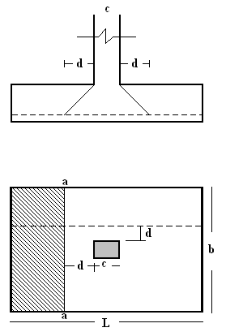
For footing with bending action in one direction the critical section is located a distance d from the face of the column
$V_{u}$ = $q_{u}$ * b * [ $\frac{L}{2}- \frac{c}{2}- d$]
The ultimate shearing force at section a-a can be calculated :
$∅Vc$ = 0.75 * 0.17*$\sqrt{fc}$ * d* b
If no shear reinforcement is to be used, then d can be checked

Punching shear check:
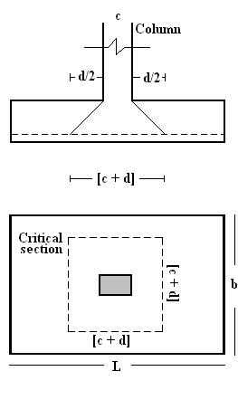
The shear force Vu acts at a section that has a length
$b_{°}$ = 4 (c + d) or 2($c_{1}$+ d) + 2($c_{2}$+ d) and a depth d; the section is subjected to a vertical downward load $p_{u}$ and vertical upward pressure $q_{u}$.
$V_{u}$ = $p_{u}$ - $q_{u}$ (c + d)$²$ for square columns
$V_{u}$ = $p_{u}$ - $q_{u}$ ($c_{1}$ + d) ($c_{2}$+ + d) for square columns
Shear strength is the smallest of:
1. $∅Vc$ = $\frac{∅}{6}$ (1+ $\frac{2}{β_{s}}$) $\sqrt{fc}$ * $b_{°}$ * d
2. $∅Vc$ = $\frac{∅}{12}$ ( $\frac{α_{s}}{{b_{°}}/d}$ + 2) $\sqrt{fc}$ * $b_{°}$ * d
3. $∅Vc$ = $∅$ * 0.33 $\sqrt{fc}$ * $b_{°}$ * d
$∅$ = 0.75
$α_{s}$ = 40 [interior footing]
= 30 [eadge footing]
= 20 [corner footing]
$β_{s}$ = the ratio of the critical section taken at $\frac{d}{2}$ from the face of the column
= $\frac{h}{b}$
$b_{°}$ = parameter of the critical sections taken at $\frac{d}{2}$ from the face of the column
$b_{°}$ = 2 (b+ d) + 2(L+ d)
Calculate area of steel needed:
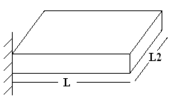
BM = $\frac{Wu* L_{2}*L²}{2}$
where,
M: bending moment (KN.m)
Mn = $\frac{BM}{∅}$ , where $∅$ = 0.9
Rn = $\frac{Mn}{B*d²}$
where,
B: width (mm)
d: depth (mm)
M = $\frac{fy}{fc*0.85}$
$ρ$ = $\frac{1}{m}$ * (1- $\sqrt{1-\frac{2*Rn*m}{fy}}$)
Check $ρ_{min}$,$ρ_{max}$
As = $ρ$ * B*d
Development length:
Check if $L_{d provided}$ > $L_{d}$ its okay, if not increase dimension of footing.
$L_{d}$ = $\frac{0.73*fy}{\sqrt{fc}}$ *d * b
$L_{d provided}$ = ($\frac{L}{2}- \frac{c}{2}$) + $\frac{c}{2}$
Minimum dowel reinforcement:
$A_{s min}$ = 0.005 $A_{g column}$
$A_{g column}$ = b * L
- C1 (0.3*0.8):
Ultimate load in column = 107.28 ton, service load = 79.45 ton
Soil bearing capacity = 2.95 Kg/ cm² = 29.5 ton/m²
Over burden soil pressure = $D_{f}$ * $γ$ = 1.5 * 18 = 27 KN/m²
Over soil pressure = 295 – 27 = 268 KN/m²
Area of footing = $\frac{service load}{B.C}$ = $\frac{79.45 *10}{268}$ = 2.96m²
Use L= 1.75 m, B= 1.75 m, Area = 3.0625 m².
Where: L is the length of the footing.
B is the width of the footing.
- Determine d in B direction:
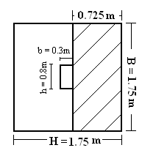
$V_{ult.}$ = $W_{ult.}$* area
= $\frac{107.28*10}{1.75²}$ * 1.75* 0.725
= 444.45 KN
$∅Vc$ = 0.75 * 0.17*$\sqrt{fc}$ * d* b
= 0.75 * 0.17 * $\sqrt{25}$ * 1750* d
= 1115.63 d
d = $\frac{444.45* {10}^{3}}{1115.63}$ = 399 mm
- Determine d in H direction:
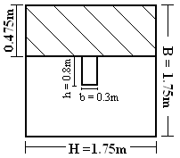
$V_{ult.}$ = $W_{ult.}$* area
= $\frac{107.28*10}{1.75²}$ * 1.75* 0.475
= 291.19 KN
$∅Vc$ = 0.75 * 0.17*$\sqrt{fc}$ * d* b
= 0.75 * 0.17 * $\sqrt{25}$ * 1750* d
= 1115.63 d
d = $\frac{291.19* {10}^{3}}{1115.63}$ = 261.01 mm
Use d = 40 cm

- Check soil pressure:
W service = 794.5 KN
Footing self-weight = b * h *d *$γ$ * 9.81
= 1.75 * 1.75 * 0.4 * 2.7 * 9.81
= 32.45 KN
Weight soil in footing = b * h * (Df - d) * $γ$
= 1.75 * 1.75 * (1.5 – 0.4) * 18
= 60.64 KN
Check:
»» $\frac{794.5+32.45+60.64}{1.75²}$ = 289.83 KN < 295 (KN) ………. OK
- Wide beam action:
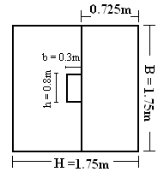
In H direction:
$W_{u}$ = $\frac{P_{u}}{area}$
= $\frac{107.28* 10}{1.75²}$ = 350.3 KN/m²
a = $\frac{H}{2}- \frac{b}{2}- d$
= $\frac{1.75}{2}- \frac{0.3}{2}- 0.4$ = 0.325 m
$V_{u}$ = $w_{u}$ * h * b
= 350.3 * 1.75 * 0.325 = 199.23 KN
The ultimate shearing force at section a-a can be calculated :
$∅Vc$ = 0.75 * 0.17*$\sqrt{fc}$ * d* b
= 0.75 * 0.17 *$\sqrt{25}$ * 400* 1750 * ${10}^{-3}$
= 446.25 KN
»» $V_{u}$ < $∅Vc$ ………. OK

In B direction:
a = $\frac{H}{2}- \frac{b}{2}- d$
= $\frac{1.75}{2}- \frac{0.8}{2}- 0.4$ = 0.075 m
$V_{u}$ = $w_{u}$ * h * b
= 350.3 * 1.75 * 0.075 = 46 KN
The ultimate shearing force at section a-a can be calculated :
$∅Vc$ = 0.75 * 0.17*$\sqrt{fc}$ * d* b
= 0.75 * 0.17 *$\sqrt{25}$ * 400* 1750 * ${10}^{-3}$
= 446.25 KN
»» $V_{u}$ < $∅Vc$ ………. OK

- Punching shear check:
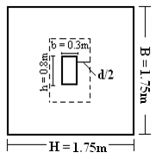

$V_{u}$ = $W_{u}$ [ B*H - (b+ d) (h+ d)]
= 350.3 [1.75*1.75 – (0.3+0.4)(0.8+0.4)]
= 778.55 KN
$α_{s}$ = 30 [edge footing]
$β_{s}$ = $\frac{0.8}{0.3}$ = 2.67
$b_{°}$ = 2 (b+ d) + 2(h+ d)
= 2 (0.3+ 0.4) + 2(0.8+ 0.4)
= 3.8 m
Shear strength is the smallest of:
1. $∅Vc$ = $\frac{∅}{6}$ (1+ $\frac{2}{β_{s}}$) $\sqrt{fc}$ * $b_{°}$ * d
= $\frac{0.75}{6}$ (1+ $\frac{2}{2.67}$) $\sqrt{25}$ * 3.8* 0.4 * 10³
= 1661.6 KN
2. $∅Vc$ = $\frac{∅}{12}$ ( $\frac{α_{s}}{{b_{°}}/d}$ + 2) $\sqrt{fc}$ * $b_{°}$ * d
= $\frac{0.75}{12}$ ( $\frac{30}{{3.8}/{0.4}}$ + 2) $\sqrt{25}$ * 3.8 * 0.4 * 10³
= 2450 KN
3. $∅Vc$ = $∅$ * 0.33 $\sqrt{fc}$ * $b_{°}$ * d
= 0.75 * 0.33 $\sqrt{25}$ * 3.8 * 0.4 * 10³
= 1881 KN
The smallest value is 1661.6 KN > 1277.33 KN
»» $V_{u}$ < $∅Vc$ ………. OK

- Flexural steel:
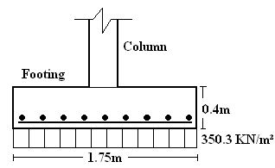
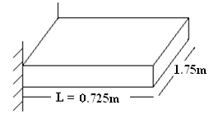
Reinforcement steel in H direction:
BM = $\frac{Wu* L_{2}*L²}{2}$
= $\frac{350.3* 1.75*0.725²}{2}$ = 161 KN.m
Mn = $\frac{BM}{∅}$
= $\frac{161}{0.9}$ = 179 KN.m
Rn = $\frac{Mn}{B*d²}$
= $\frac{179* {10}^{6}}{1750*330²}$ = 0.94
m = $\frac{fy}{fc*0.85}$ = $\frac{420}{25*0.85}$ = 19.76
$ρ$ = $\frac{1}{m}$ * (1- $\sqrt{1-\frac{2*Rn*m}{fy}}$)
= $\frac{1}{19.76}$ * (1- $\sqrt{1-\frac{2*0.94*19.76}{420}}$)
= 0.002288 > $ρ_{min}$ = 0.002
As = $ρ$ * B*d
= 0.002288 * 1750 * 400 = 1602 mm²
Use 8 $∅$ 16 mm
Reinforcement steel in B direction:
BM = $\frac{Wu* L_{2}*L²}{2}$
= $\frac{350.3* 1.75*0.475²}{2}$ = 69 KN.m
Mn = $\frac{BM}{∅}$
= $\frac{69}{0.9}$ = 77 KN.m
Rn = $\frac{Mn}{B*d²}$
= $\frac{77* {10}^{6}}{1750*330²}$ = 0.4
m = $\frac{fy}{fc*0.85}$ = $\frac{420}{25*0.85}$ = 19.76
$ρ$ = $\frac{1}{m}$ * (1- $\sqrt{1-\frac{2*Rn*m}{fy}}$)
= $\frac{1}{19.76}$ * (1- $\sqrt{1-\frac{2*0.4*19.76}{420}}$ )
= 0.000969 < $ρ_{min}$ = 0.002
As = $ρ$ * B*d
= 0.002 * 1750 * 400 = 1400 mm²
Use 10 $∅$ 14 mm

- Development length:
Check if $L_{d provided}$ > $L_{d}$ its okay, if not increase dimension of footing.
$L_{d}$ = $\frac{0.73*fy}{\sqrt{fc}}$ *d * b
= $\frac{0.73*420}{\sqrt{25}}$ * 7.25 * 1 = 444.57 mm
$L_{d1}$ = 725 + $\frac{800}{2}$ = 1125 > 444.57 ……… OK
$L_{d2}$ = 475 + $\frac{300}{2}$ = 625 > 444.57 ……… OK

- Check load transfer from column to footing:
$P_{u}$ = 1072.8 KN
$P_{u bearing}$ = 0.65 * 0.85 * fc * $A_{g column}$
= 0.65 * 0.85 * 25 * 800 * 300 * ${10}^{-3}$
= 3315 KN
$P_{u bearing}$ > $P_{u}$ ………… OK

- Minimum dowel reinforcement:
$A_{s min}$ = 0.005 $A_{g column}$
= 0.005 * 800 * 300
= 1200 mm²
Use 4 $∅$ 20
$L_{dc}$ = $\frac{0.24*fy}{\sqrt{fc}}$ * d * b
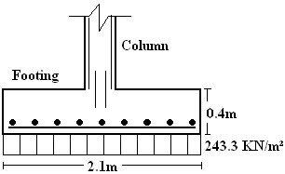
= $\frac{0.24*420}{\sqrt{25}}$ * 72.5 * 1= 147 mm

- Calculation for each column:
Column no. | $W_{service}$  (ton) | $$W_{service}$$  (KN) | $$q_{all.}$$  (KN/m²) | Area  (m²) | $B_{footing}$  (m) | $$H_{footing}$$  (m)
1 | 79.45 | 794.5 | 268 | 3.06 | 1.75 | 1.75
2 | 110.04 | 1100.4 | 268 | 4.41 | 2.1 | 2.1
3 | 151.23 | 1512.3 | 268 | 5.76 | 2.4 | 2.4
4 | 187.12 | 1871.2 | 268 | 7.29 | 2.7 | 2.7
5 | 205.23 | 2052.3 | 268 | 7.84 | 2.8 | 2.8
6 | 253.00 | 2530 | 268 | 9.92 | 3.15 | 3.15
7 | 291.84 | 2918.4 | 268 | 11.22 | 3.35 | 3.35
8 | 311.02 | 3110.2 | 268 | 12.25 | 3.5 | 3.5
9 | 355.45 | 3554.5 | 268 | 14.06 | 3.75 | 3.75
10 | 516.12 | 5161.2 | 268 | 20.25 | 4.5 | 4.5

- Determine d in B direction:
Column no. | W ult. | V ult | $∅$*Vc | d
1 | 350.30 | 444.45 | 1115.63 | 0.40
2 | 310.70 | 587.23 | 1338.75 | 0.45
3 | 354.48 | 893.29 | 1530.00 | 0.60
4 | 346.57 | 1122.89 | 1721.25 | 0.70
5 | 353.44 | 1237.05 | 1785.00 | 0.70
6 | 355.46 | 1595.58 | 2008.13 | 0.80
7 | 361.84 | 1848.53 | 2135.63 | 0.90
8 | 352.81 | 1975.72 | 2231.25 | 0.90
9 | 350.56 | 2267.70 | 2390.63 | 0.95
10 | 359.95 | 3401.57 | 2868.75 | 1.20
- Determine d in B direction:
Column no. | W ult. | V ult | $∅$*Vc | d
1 | 350.30 | 291.19 | 1115.63 | 0.30
2 | 310.70 | 424.11 | 1338.75 | 0.35
3 | 354.48 | 595.52 | 1530.00 | 0.40
4 | 346.57 | 888.95 | 1721.25 | 0.55
5 | 353.44 | 890.68 | 1785.00 | 0.50
6 | 355.46 | 1203.69 | 2008.13 | 0.60
7 | 361.84 | 1424.28 | 2135.63 | 0.70
8 | 352.81 | 1543.54 | 2231.25 | 0.70
9 | 350.56 | 1676.12 | 2390.63 | 0.75
10 | 359.95 | 2672.66 | 2868.75 | 0.95

Use the largest value of d:
Column no. | 1 | 2 | 3 | 4 | 5 | 6 | 7 | 8 | 9 | 10
d | 0.4 | 0.45 | 0.6 | 0.7 | 0.7 | 0.8 | 0.9 | 0.9 | 0.95 | 1.2

- Check soil pressure:
Colum no. | $$W_{service}$$  (ton) | $$W_{service}$$  (KN) | $$B_{footing}$$  (m) | $$H_{footing}$$  (m) | Footing self-weight  (KN) | Weight soil in footing (KN) | Z
1 | 79.45 | 794.5 | 1.75 | 1.75 | 32.45 | 60.64 | 289.82
2 | 110.04 | 1100.4 | 2.1 | 2.1 | 52.56 | 83.35 | 280.34
3 | 151.23 | 1512.3 | 2.4 | 2.4 | 91.54 | 93.31 | 294.64
4 | 187.12 | 1871.2 | 2.7 | 2.7 | 135.16 | 104.98 | 289.62
5 | 205.23 | 2052.3 | 2.8 | 2.8 | 145.36 | 112.90 | 294.71
6 | 253.00 | 2530 | 3.1 | 3.1 | 210.25 | 125.02 | 288.77
7 | 291.84 | 2918.4 | 3.3 | 3.3 | 267.53 | 121.20 | 294.69
8 | 311.02 | 3110.2 | 3.45 | 3.45 | 292.02 | 132.30 | 288.53
9 | 355.45 | 3554.5 | 3.7 | 3.7 | 353.85 | 139.22 | 287.83
10 | 516.12 | 5161.2 | 4.4 | 4.4 | 643.63 | 109.35 | 292.06

Z = $\frac{Ws+footing self-weight+weight soil in footing}{area}$
Z must be less than $q_{all.}$ (KN) which equal 295 KN/m²

- Wide beam action:
In B-direction.
Colum no. | $$W_{ultimate}$$  (ton) | $$W_{ultimate}$$  (KN) | $$H_{footing}$$  (m) | $$B_{footing}$$  (m) | Area  (m²) | Vu | $∅$*Vc
1 | 107.28 | 1072.8 | 1.75 | 1.75 | 3.06 | 199.23 | 446.25
2 | 137.02 | 1370.2 | 2.1 | 2.1 | 4.41 | 293.61 | 602.44
3 | 204.18 | 2041.8 | 2.4 | 2.4 | 5.76 | 382.84 | 918.00
4 | 252.65 | 2526.5 | 2.7 | 2.7 | 7.29 | 467.87 | 1204.88
5 | 277.1 | 2771 | 2.8 | 2.8 | 7.84 | 544.30 | 1249.50
6 | 341.6 | 3416 | 3.1 | 3.1 | 9.92 | 677.78 | 1606.50
7 | 394.04 | 3940.4 | 3.3 | 3.3 | 11.22 | 735.15 | 1922.06
8 | 419.93 | 4199.3 | 3.45 | 3.45 | 12.25 | 839.86 | 2008.13
9 | 479.92 | 4799.2 | 3.7 | 3.7 | 14.06 | 991.83 | 2271.09
10 | 696.87 | 6968.7 | 4.4 | 4.4 | 20.25 | 1393.74 | 3442.50

In H-direction.
Colum no. | $$W_{ultimate}$$  (ton) | $$W_{ultimate}$$  (KN) | $$H_{footing}$$  (m) | $$B_{footing}$$  (m) | Area  (m²) | Vu | $∅$*Vc
1 | 107.28 | 1072.8 | 1.75 | 1.75 | 3.06 | 45.98 | 446.25
2 | 137.02 | 1370.2 | 2.1 | 2.1 | 4.41 | 130.50 | 602.44
3 | 204.18 | 2041.8 | 2.4 | 2.4 | 5.76 | 85.08 | 918.00
4 | 252.65 | 2526.5 | 2.7 | 2.7 | 7.29 | 233.94 | 1204.88
5 | 277.1 | 2771 | 2.8 | 2.8 | 7.84 | 197.93 | 1249.50
6 | 341.6 | 3416 | 3.1 | 3.1 | 9.92 | 298.22 | 1606.50
7 | 394.04 | 3940.4 | 3.3 | 3.3 | 11.22 | 323.47 | 1922.06
8 | 419.93 | 4199.3 | 3.45 | 3.45 | 12.25 | 419.93 | 2008.13
9 | 479.92 | 4799.2 | 3.7 | 3.7 | 14.06 | 415.94 | 2271.09
10 | 696.87 | 6968.7 | 4.4 | 4.4 | 20.25 | 696.87 | 3442.50
- Punching shear:
Colum no. | W ult. | $$α$$ | Bs | $$b_{°}$$ | d | V ult | $∅$*Vc | $∅$*Vc | $∅$*Vc
1 | 350.30 | 30 | 2.67 | 3.8 | 0.40 | 778.54629 | 1662.5 | 2450.0 | 1881
2 | 310.70 | 30 | 2.67 | 4.0 | 0.45 | 1078.916 | 1968.8 | 3023.4 | 2227.5
3 | 354.48 | 30 | 3.33 | 5.0 | 0.60 | 1531.35 | 3000.0 | 5250.0 | 3712.5
4 | 346.57 | 40 | 2.67 | 5.0 | 0.70 | 2006.644 | 3828.1 | 8312.5 | 4331.3
5 | 353.44 | 40 | 3.33 | 5.4 | 0.70 | 2170.1454 | 3780.0 | 8487.5 | 4677.8
6 | 355.46 | 40 | 3.33 | 5.8 | 0.80 | 2734.3492 | 4640.0 | 10900.0 | 5742.0
7 | 361.84 | 40 | 3.33 | 6.2 | 0.90 | 3139.8554 | 5580.0 | 13612.5 | 6905.3
8 | 352.81 | 40 | 3.33 | 6.2 | 0.90 | 3417.716 | 5580.0 | 13612.5 | 6905.3
9 | 350.56 | 40 | 4.00 | 7.0 | 0.95 | 3882.0196 | 6056.3 | 15318.8 | 7994.3
10 | 359.95 | 40 | 4.00 | 7.8 | 1.20 | 5729.82 | 8775.0 | 23850.0 | 11583.0

NOTE: Shear strength is the smallest value of the three mentioned values of $∅$*Vc in the previous table, & Vu must be less than $∅$*Vc.

- Flextural steel:
In B-direction:
Colum no. | W ult. | BM | Mn | $$ρ$$ | As
1 | 350.30 | 161.11 | 179.01 | 0.002288 | 1321
2 | 310.70 | 264.25 | 293.61 | 0.00236 | 1884
3 | 354.48 | 468.97 | 521.08 | 0.001875 | 2544
4 | 346.57 | 673.73 | 748.59 | 0.001691 | 3402
5 | 353.44 | 773.15 | 859.06 | 0.001875 | 3528
6 | 355.46 | 1101.05 | 1223.38 | 0.001766 | 4526
7 | 361.84 | 1367.74 | 1519.71 | 0.001593 | 5478
8 | 352.81 | 1535.74 | 1706.38 | 0.001714 | 5810
9 | 350.56 | 1904.08 | 2115.64 | 0.001765 | 6512
10 | 359.95 | 3414.66 | 3794.07 | 0.001597 | 9944

In H-direction:
Colum no. | W ult. | BM | Mn | $$ρ$$ | As
1 | 350.30 | 69.15 | 76.84 | 0.000969 | 1155
2 | 310.70 | 137.83 | 153.15 | 0.001217 | 1596
3 | 354.48 | 208.43 | 231.59 | 0.000825 | 2544
4 | 346.57 | 422.25 | 469.17 | 0.001053 | 3402
5 | 353.44 | 400.80 | 445.33 | 0.000963 | 3528
6 | 355.46 | 626.60 | 696.22 | 0.000997 | 4526
7 | 361.84 | 811.97 | 902.19 | 0.00094 | 5478
8 | 352.81 | 937.34 | 1041.49 | 0.001039 | 5810
9 | 350.56 | 1040.22 | 1155.80 | 0.000957 | 6512
10 | 359.95 | 2108.03 | 2342.25 | 0.00098 | 9944
- Development length:
Colum no. | $$b_{column}$$ | $$h_{column}$$ | Ld(mm) | Ld1 | Ld2 | NOTE: Ld1 & Ld2 must be more than Ld.
1 | 0.3 | 0.8 | 444.57 | 1125 | 625 | NOTE: Ld1 & Ld2 must be more than Ld.
2 | 0.3 | 0.8 | 551.88 | 1300 | 800 | NOTE: Ld1 & Ld2 must be more than Ld.
3 | 0.3 | 1 | 643.86 | 1550 | 850 | NOTE: Ld1 & Ld2 must be more than Ld.
4 | 0.3 | 0.8 | 735.84 | 1600 | 1100 | NOTE: Ld1 & Ld2 must be more than Ld.
5 | 0.3 | 1 | 766.5 | 1750 | 1050 | NOTE: Ld1 & Ld2 must be more than Ld.
6 | 0.3 | 1 | 873.81 | 1925 | 1225 | NOTE: Ld1 & Ld2 must be more than Ld.
7 | 0.3 | 1 | 935.13 | 2025 | 1325 | NOTE: Ld1 & Ld2 must be more than Ld.
8 | 0.3 | 1 | 981.12 | 2100 | 1400 | NOTE: Ld1 & Ld2 must be more than Ld.
9 | 0.3 | 1.2 | 1057.77 | 2325 | 1425 | NOTE: Ld1 & Ld2 must be more than Ld.
10 | 0.3 | 1.2 | 1287.72 | 2700 | 1800 | NOTE: Ld1 & Ld2 must be more than Ld.

- Check load transfer from column to footing:
Colum no. | $$W_{ultimate}$$  (ton) | $$W_{ultimate}$$  (KN) | $$b_{column}$$ | $$h_{column}$$ | bearing | NOTE: ultimate load < the bearing capacity of each column.
1 | 107.28 | 1072.8 | 0.3 | 0.8 | 3315 | NOTE: ultimate load < the bearing capacity of each column.
2 | 137.02 | 1370.2 | 0.3 | 0.8 | 3315 | NOTE: ultimate load < the bearing capacity of each column.
3 | 204.18 | 2041.8 | 0.3 | 1 | 4143 | NOTE: ultimate load < the bearing capacity of each column.
4 | 252.65 | 2526.5 | 0.3 | 0.8 | 3315 | NOTE: ultimate load < the bearing capacity of each column.
5 | 277.1 | 2771 | 0.3 | 1 | 4143 | NOTE: ultimate load < the bearing capacity of each column.
6 | 341.6 | 3416 | 0.3 | 1 | 4143 | NOTE: ultimate load < the bearing capacity of each column.
7 | 394.04 | 3940.4 | 0.3 | 1 | 4143 | NOTE: ultimate load < the bearing capacity of each column.
8 | 419.93 | 4199.3 | 0.3 | 1.1 | 4558 | NOTE: ultimate load < the bearing capacity of each column.
9 | 479.92 | 4799.2 | 0.3 | 1.2 | 4972 | NOTE: ultimate load < the bearing capacity of each column.
10 | 696.87 | 6968.7 | 0.3 | 1.4 | 5801 | NOTE: ultimate load < the bearing capacity of each column.
- Minimum dowel reinforcement:
Colum no. | $$b_{column}$$ | $$h_{column}$$ | As min
1 | 0.3 | 0.8 | 1200
2 | 0.3 | 0.8 | 1200
3 | 0.3 | 1 | 1500
4 | 0.3 | 0.8 | 1200
5 | 0.3 | 1 | 1500
6 | 0.3 | 1 | 1500
7 | 0.3 | 1 | 1500
8 | 0.3 | 1.1 | 1500
9 | 0.3 | 1.2 | 1800
10 | 0.3 | 1.4 | 1800

4.1.2 Design single footing by using SAP2000:
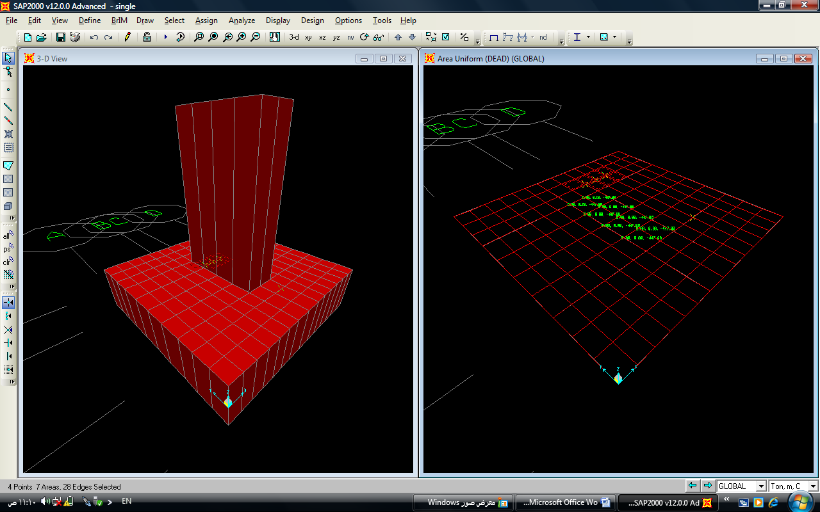

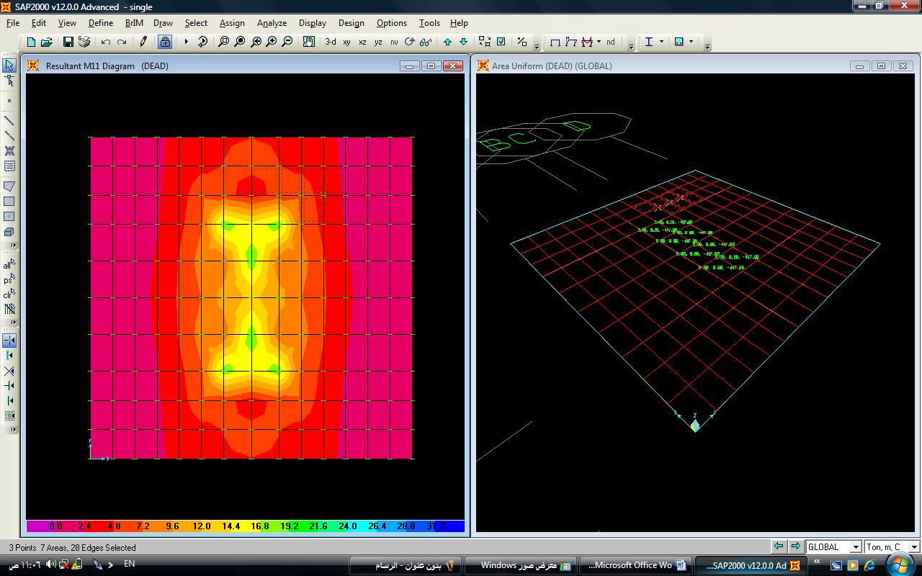
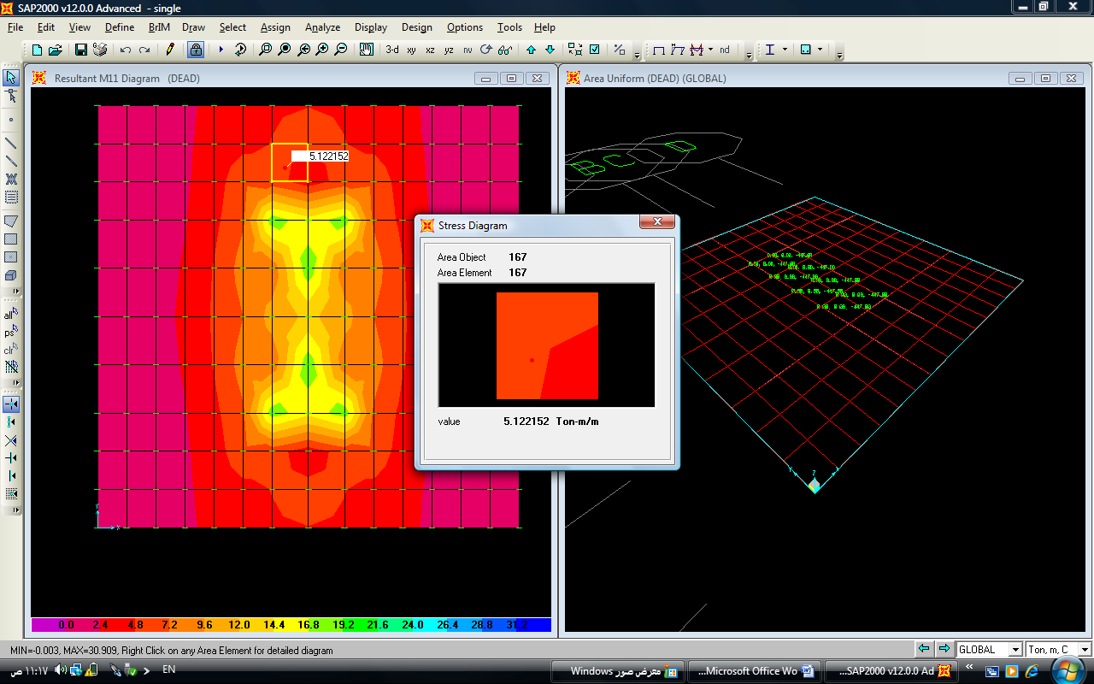

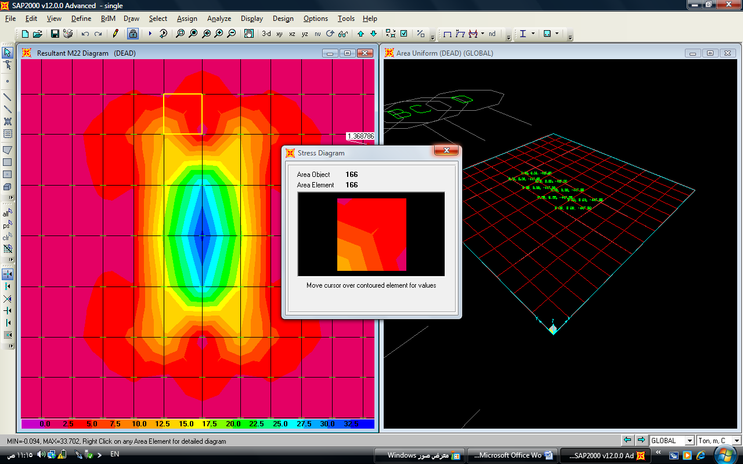

4.1.3 Settlement of isolated footing
Elastic settlement of isolated footing based on the theory of elasticity:
Se = $q_{°}$ * ($α B'$)* $\frac{1- U_{s2}}{Es}$ * $I_{s}$ * $I_{f}$
where:
$q_{°}$: net applied pressure on the foundation.
Us: Poisson’s ratio of soil.
Es: average modulus of elasticity of the soil under the foundation measured from z = 0 to about z = 4B.
B’= $\frac{B}{2}$ for center of foundation
= B for corner of foundation
m’ = $\frac{L}{B}$
n = $\frac{H}{\frac{B}{2}}$
$I_{s}$ : shape factor
$I_{s}$ = $F_{1}$ + $\frac{(1-{ 2U}_{s})}{(1-{ U}_{s} )}$ * $F_{2}$
$F_{1}$ & $F_{2}$ can be calculated from the table (5.2)
$I_{f}$ = depth factor = f (Df/B, Us, and L/B)
Calculated from the table (5.3)
$α$ = 4 for the center of the foundation
$α$ = 1 for the corner of the foundation
$S_{e (rigid)}$= 0.93 $S_{e (flexible, center)}$

m’
n | 1.0 | 1.2 | 1.4 | 1.6 | 1.8 | 2.0 | 2.5 | 3.0 | 3.5 | 4.0
0.5
F1 | 0.049 | 0.046 | 0.044 | 0.042 | 0.041 | 0.040 | 0.038 | 0.038 | 0.037 | 0.037
F2 | 0.074 | 0.077 | 0.080 | 0.081 | 0.083 | 0.084 | 0.085 | 0.086 | 0.087 | 0.087
0.8
F1 | 0.104 | 0.100 | 0.096 | 0.093 | 0.091 | 0.089 | 0.086 | 0.084 | 0.083 | 0.082
F2 | 0.083 | 0.090 | 0.095 | 0.098 | 0.101 | 0.103 | 0.107 | 0.109 | 0.110 | 0.111
1.0
F1 | 0.142 | 0.138 | 0.134 | 0.130 | 0.127 | 0.125 | 0.121 | 0.118 | 0.116 | 0.115
F2 | 0.083 | 0.091 | 0.098 | 0.102 | 0.106 | 0.109 | 0.114 | 0.117 | 0.119 | 0.120
2.0
F1 | 0.285 | 0.290 | 0.292 | 0.292 | 0.291 | 0.289 | 0.284 | 0.279 | 0.275 | 0.271
F2 | 0.064 | 0.074 | 0.083 | 0.090 | 0.091 | 0.102 | 0.114 | 0.121 | 0.127 | 0.131
4.0
F1 | 0.408 | 0.431 | 0.448 | 0.460 | 0.469 | 0.476 | 0.484 | 0.487 | 0.486 | 0.484
F2 | 0.037 | 0.044 | 0.051 | 0.057 | 0.063 | 0.069 | 0.082 | 0.093 | 0.102 | 0.110
6.0
F1 | 0.457 | 0.489 | 0.514 | 0.534 | 0.550 | 0.563 | 0.585 | 0.598 | 0.606 | 0.609
F2 | 0.026 | 0.031 | 0.036 | 0.040 | 0.45 | 0.050 | 0.060 | 0.070 | 0.079 | 0.087
8.0
F1 | 0.482 | 0.519 | 0.549 | 0.573 | 0.594 | 0.611 | 0.643 | 0.664 | 0.678 | 0.688
F2 | 0.020 | 0.023 | 0.027 | 0.031 | 0.035 | 0.038 | 0.047 | 0.055 | 0.063 | 0.071
10.0
F1 | 0.498 | 0.537 | 0.570 | 0.597 | 0.621 | 0.641 | 0.679 | 0.707 | 0.726 | 0.740
F2 | 0.016 | 0.019 | 0.022 | 0.025 | 0.028 | 0.031 | 0.038 | 0.046 | 0.052 | 0.059
12.0
F1 | 0.508 | 0.550 | 0.585 | 0.614 | 0.639 | 0.661 | 0.704 | 0.736 | 0.760 | 0.777
F2 | 0.013 | 0.016 | 0.018 | 0.021 | 0.024 | 0.026 | 0.032 | 0.038 | 0.044 | 0.050
100.0
F1 | 0.555 | 0.605 | 0.649 | 0.688 | 0.722 | 0.753 | 0.819 | 0.872 | 0.918 | 0.956
F2 | 0.002 | 0.002 | 0.002 | 0.003 | 0.003 | 0.003 | 0.004 | 0.005 | 0.006 | 0.006
1000.0
F1 | 0.560 | 0.612 | 0.657 | 0.697 | 0.733 | 0.765 | 0.833 | 0.890 | 0.938 | 0.979
F2 | 0.000 | 0.000 | 0.000 | 0.000 | 0.000 | 0.000 | 0.000 | 0.000 | 0.001 | 0.001
Table 5.2

Poisson Ratio = 0.30 = $μ_{s}$
0.05 | 0.979 | 0.981 | 0.982 | 0.983 | 0.984 | 0.985 | 0.990
0.10 | 0.954 | 0.958 | 0.962 | 0.964 | 0.966 | 0.968 | 0.977
0.20 | 0.902 | 0.911 | 0.917 | 0.923 | 0.927 | 0.930 | 0.951
0.40 | 0.808 | 0.823 | 0.834 | 0.843 | 0.851 | 0.857 | 0.899
0.60 | 0.738 | 0.754 | 0.767 | 0.778 | 0.788 | 0.796 | 0.852
0.80 | 0.687 | 0.703 | 0.716 | 0.728 | 0.738 | 0.747 | 0.813
1.00 | 0.650 | 0.665 | 0.678 | 0.689 | 0.700 | 0.709 | 0.780
2.00 | 0.562 | 0.571 | 0.580 | 0.588 | 0.596 | 0.603 | 0.675
Poisson Ratio = 0.40 = $μ_{s}$
0.05 | 0.989 | 0.990 | 0.991 | 0.992 | 0.992 | 0.993 | 0.995
0.10 | 0.973 | 0.976 | 0.978 | 0.90 | 0.981 | 0.982 | 0.988
0.20 | 0.932 | 0.940 | 0.945 | 0.949 | 0.952 | 0.955 | 0.970
0.40 | 0.848 | 0.862 | 0.872 | 0.881 | 0.887 | 0.893 | 0.927
0.60 | 0.779 | 0.795 | 0.808 | 0.819 | 0.828 | 0.836 | 0.886
0.80 | 0.727 | 0.743 | 0.757 | 0.769 | 0.779 | 0.788 | 0.849
1.00 | 0.689 | 0.704 | 0.718 | 0.730 | 0.740 | 0.749 | 0.818
2.00 | 0.596 | 0.606 | 0.615 | 0.624 | 0.632 | 0.640 | 0.714
Poisson Ratio = 0.50 = $μ_{s}$
0.05 | 0.997 | 0.997 | 0.998 | 0.998 | 0.998 | .0998 | 0.999
0.10 | 0.988 | 0.990 | 0.991 | 0.992 | 0.993 | 0.993 | 0.996
0.20 | 0.960 | 0.966 | 0.969 | 0.972 | 0.974 | 0.976 | 0.985
0.40 | 0.886 | 0899 | 0.908 | 0.916 | 0922 | 0.926 | 0.953
0.60 | 0.818 | 0.834 | 0.847 | 0.857 | 0.886 | 0.873 | 0.917
0.80 | 0.764 | 0.781 | 0.795 | 0.807 | 0.817 | 0.826 | 0.883
1.00 | 0.723 | 0.740 | 0.754 | 0.766 | 0.777 | 0.786 | 0.852
2.00 | 0.622 | 0.633 | 0.643 | 0.653 | 0.662 | 0.670 | 0.747
Table 5.3
Calculation of elastic settlement of isolated footing:
Here a sample calculation will be made from some footing and the result for all footings will summarized in a table:
For column # 1:
Service load = 79.45 ton
H = 1.75m
B = 1.75m
Df = 1.5m
B’ = $\frac{B}{2}$ = $\frac{1.75}{2}$ = 0.875m
Us = 0.3
Es = 62500 KN/m²
$α$ = 4
$q_{°}$ = $\frac{service load}{area of footing}$ = $\frac{79.45}{1.75²}$ = 26 KN/m²
$I_{s}$ = $F_{1}$ + $\frac{(1-{ 2U}_{s} )}{(1-{ U}_{s} )}$ * $F_{2}$
m’ = $\frac{L}{B}$= 1
n = $\frac{H}{\frac{B}{2}}$ = $\frac{5}{\frac{1.75}{2}}$ = 5.7
$F_{1}$ = 0.4497 , $F_{2}$ = 0.03062
$I_{s}$ = $F_{1}$ + $\frac{(1-{ 2U}_{s} )}{(1-{ U}_{s} )}$ * $F_{2}$ → $I_{s}$ = 0.4497 + $\frac{(1-2*0.3)}{(1-0.3 )}$ * 0.03062 = 0.4704
Se = $q_{°}$ * ($α B'$)* $\frac{1- {2*U}_{s}}{Es}$ * $I_{s}$ * $I_{f}$
= 26 * ($4*0.875$)* $\frac{1- 2*0.3}{62500}$ * 0.4704 * 0.576 = 1.58 * ${10}^{-4}$ m
Table illustrate the elastic settlement of each footing:

Colum no. | $$W_{service}$$  (ton) | $$W_{service}$$  (KN) | $$B_{footing}$$  (m) | $$H_{footing}$$  (m) | $$q_{°}$$  (KN/m²) | Se  (mm)
1 | 79.45 | 794.5 | 1.75 | 1.75 | 26 | 0.16
2 | 110.04 | 1100.4 | 2.1 | 2.1 | 25 | 0.22
3 | 151.23 | 1512.3 | 2.4 | 2.4 | 26 | 0.25
4 | 187.12 | 1871.2 | 2.7 | 2.7 | 26 | 0.3
5 | 205.23 | 2052.3 | 2.8 | 2.8 | 26 | 0.28
6 | 253.00 | 2530 | 3.1 | 3.1 | 26 | 0.3
7 | 291.84 | 2918.4 | 3.3 | 3.3 | 27 | 0.34
8 | 311.02 | 3110.2 | 3.45 | 3.45 | 26 | 0.34
9 | 355.45 | 3554.5 | 3.7 | 3.7 | 26 | 0.37
10 | 516.12 | 5161.2 | 4.4 | 4.4 | 27 | 0.42

4.2 Design of pile foundation
- Estimating pile capacity:
The ultimate carrying capacity is equal to the sum of the ultimate resistance of the base of the pile and the ultimate skin friction over the embedded shaft length of the pile, this expressed by:
$Q_{u}$ = $Q_{s}$ + $Q_{p}$
Where:
$Q_{U}$: ultimate pile capacity
$Q_{s}$: frictional resistance
${ Q}_{p}$: load-carrying capacity of the pile point
- Determination of the point bearing capacity:
For piles in saturated clay in undrained cohesion as our case, the point bearing capacity may be estimated as:
${ Q}_{p}$ = 9 ${ C}_{u}$ $A_{p}$
Where:
${ C}_{u}$: undrained cohesion of the soil below the pile tip
$A_{p}$: area of pile trip
- Determination of skin resistance:
The formula of skin resistance of the pile can be expressed as:
Qs = $\sum{\{P*∆L*f\}}$
Where:
P: perimeter of the pile section
$∆L$: incremental pile length
$f$: unit friction resistance at any depth
The unit friction resistance can be written using $α$- method as:
f = $α$ * Cu
where:
$α$: empirical adhesion factor given from figure (5:49)
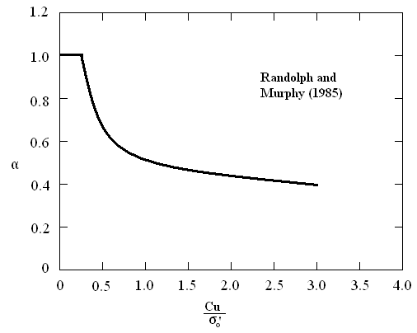
Figure (5.49): The relationship between $α$ and $\frac{C_{u}}{σ_{°}^{'}}$

4.2.1 Calculation of allowable pile capacity of single piles:
Pile diameter = 60 cm
Length of pile = 8 m
Ultimate load = 122.61 ton
$Q_{u}$ = $Q_{s}$ + $Q_{p}$
${ Q}_{p}$ = 9 ${ C}_{u}$ $A_{p}$
= 9*42*(π/4)(0.6²)
= 106.9 KN
Qs = $\sum{\{P*∆L*f\}}$
f = $α$ * Cu
$δ_{°}$ = $\frac{{(δ}_{z=0)}+(δ_{z=8)}}{2}$
Depth (m) | Average depth (m) | $δ_{°}$(KN/m²)
0-8 | 4 | 17*4=68

$\frac{Cu}{δ_{°}}$ = $\frac{42}{68}$ = 0.62 ,
$α$ = 0.62 from figure (5:49)
f = 0.62 * 42 = 26.04 KN/m²
Qs = 8 * π * 0.6 * 26.04 = 392.67 KN
$Q_{u}$ = $Q_{s}$ + $Q_{p}$ = 392.67 + 106.9 = 499.57 KN
F.S = 2.5
$Q_{all.}$ = $\frac{Q_{u} }{F.S}$ = $\frac{499.57 }{2.5}$ = 200 KN
The following table presents the proposed dimensions of piles and there capacities in (KN)

Diameter (m)  Length(m) | 0.6 | 0.8
7 | 164.58632 | 240.50872
8 | 194.65496 | 281.11096
9 | 227.88872 | 325.98712
10 | 261.12248 | 370.86328
11 | 286.44344 | 405.05464
12 | 327.59 | 460.6156

To find the required number of piles for each cap, use the following equation:
No. of piles = $\frac{service load (KN)}{Q_{all.}}$
Number of piles needed at column 1 for example, $\frac{794.5}{240.51}$ $≈$ 4

The number of piles needed is summarized in the table below:
Column no. | Dimension (m) | Service load (ton) | Pile size (L, D) | No. of piles | Cap dimension (m)
1 | 0.3*0.8 | 79.45 | (10,60) | 4 | 2.8*2.8
2 | 0.3*0.8 | 110.04 | (8,60) | 6 | 2.8*2.8
3 | 0.3*1.0 | 151.23 | (8,60) | 8 | 2.8*2.8
4 | 0.3*0.8 | 187.12 | (10,60) | 8 | 2.8*2.8
5 | 0.3*1.0 | 205.23 | (10,60) | 8 | 2.8*2.8
6 | 0.3*1.0 | 253 | (12,60) | 8 | 2.8*2.8
7 | 0.3*1.0 | 291.84 | (10,60) | 12 | 2.8*2.8
8 | 0.3*1.0 | 311.02 | (10,60) | 12 | 2.8*2.8
9 | 0.3*1.2 | 355.45 | (10,60) | 14 | 2.8*2.8
10 | 0.3*1.2 | 516.12 | (12,60) | 16 | 2.8*2.8

4.2.2 Structural pile design
The structural pile design depends on the natural of the soil founded, which is either stiff or weak, the pile is to be designed as short column if the soil is stiff, and designed long column if it is weak.
The minimum area of steal is 0.5% of gross area pf pile, also ties are used starting with 5 cm spacing and ending by 30 cm spacing, see figure (5.50) & (5.51).
The concrete cover must be not less than 7.5 cm.
The structural design for all piles is:
Pile diameter = 80 cm.
Pile gross area = $\frac{π}{4}$ * 60² = 2826 cm²
As min = 0.005 Ag = 0.005 * 2826 = 14.13 cm²
Use 6 $∅$18 mm
Shows the reinforcement details for the pile.
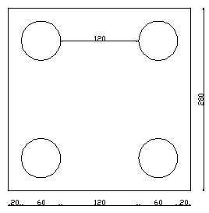

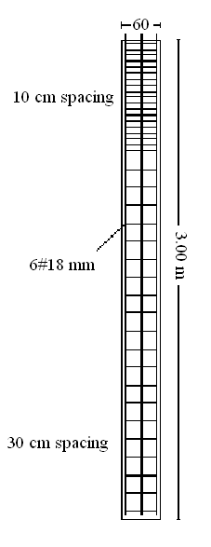

4.2.3 Efficiency of pile group
The efficiency of the load-bearing capacity of a group pile may be defined as:
$μ$ = $\frac{Qg(u)}{\sum{Q_{u}}}$
where,
Qg(u): ultimate load-bearing capacity of the group pile
Qu: ultimate load-bearing capacity of each pile without the group effect

Using a simplified analysis to obtain the group efficiency as shown in:
$μ$ = $\frac{2\left(m+n-2\right)S+4D}{P*m*n}$
where,
m: number of column
n: number of rows
S: spacing between the piles
D: diameter of the pile
P: perimeter of the cross section of each pile
Check the efficiency of the group:

S = 2D = 2* 0.6 = 1.2 m
M = n = 2
$μ$ = $\frac{2\left(2+2-2\right)1.2+4*0.6}{π*0.6*2*2}$ = 0.96 ……… ok

4.2.4 Design of pile cap:
design steps:
- punching shear check:
assume the depth (d).
$∅$ Vc = $∅$ * 1.06 * $\sqrt{fc}$ * $b_{°}$ * d
where,
$∅$ = 0.85 fc (Kg/cm²)
d: depth (m) $b_{°}$: perimeter (m)
If $∅$ Vc > V ultimate …….. OK
If not enlarge the depth
- Wide beam check:
$∅$ Vc = $∅$ * 0.93 * $\sqrt{fc}$ * $b$ * d
where:
$∅$ = 0.85 fc (Kg/cm²)
d: depth (m) $b$: width (m)
Vu = $\frac{ultimate load*no.of piles in column}{no.of piles}$
If $∅$ Vc > V ultimate …….. OK

- Calculate area of steel needed:
Because of symmetry the reinforcement steel in long direction equal the reinforcement steel in the short direction.
Mu = Pu * e
Pu: ultimate load on column
e:distance from the center of pile to the face of the column
Mn = $\frac{BM}{∅}$ , where Φ = 0.9
Rn = $\frac{Mn}{B*d²}$ , where B, d in meter
m = $\frac{fy}{fc*0.85}$
$ρ$ = $\frac{1}{m}$ * (1- $\sqrt{1- \frac{2*Rn*m}{fy}}$ )
Check $ρ_{min}$ & $ρ_{max}$
As = $ρ$* B* d
As : area of steel
Here a sample calculation will be made for some footing and the result for all footing will summarized in a table.

- For columns (1)
Ultimate load = 107.28 ton
Cap dimension = (2.8 * 2.8)
Assumed d = 35 cm, H = 45 cm
- punching shear check:
$∅$ Vc = $∅$ * 1.06 * $\sqrt{fc}$ * $b_{°}$ * d
$b_{°}$ = (30 + 35) + (80 + 35) = 180 cm
$∅$ Vc = 0.85 * 1.06 * $\sqrt{250}$ * 180 * 35
= 139.61 ton > V ultimate …….. OK
- Wide beam shear:
$∅$ Vc = $∅$ * 0.93 * $\sqrt{fc}$ * $b$ * d
Vu = $\frac{107.28 *2}{4}$ = 53.64 ton
$∅$ Vc = 0.85 * 0.93 * $\sqrt{250}$ * 2.8 * ${10}^{-3}$ * 35
$∅$ Vc = 122.49 ton > V ultimate …….. OK
- Calculation area of steel:
Mu = Pu * e
e = $\frac{280}{2}$ – 20 – 30 – 15 = 65 cm
Mu = $\frac{107.28 *2}{4}$ * 2 * 0.65
= 69.73ton.m
Mn = $\frac{BM}{∅}$
Mn = $\frac{69.73}{0.9}$ = 77.48 ton.m * ${10}^{6}$
Rn = $\frac{Mn}{B*d²}$
= $\frac{ 77.48*{10}^{6}}{280*35²}$ = 22.59 Kg/cm²
$ρ$ = $\frac{1}{m}$ * (1- $\sqrt{1- \frac{2*Rn*m}{fy}}$ )
m = $\frac{fy}{fc*0.85}$
= $\frac{4200}{0.85*250}$ = 19.76
$ρ$ = $\frac{1}{19.76}$ * (1- $\sqrt{1- \frac{2*22.59 *19.76}{4200}}$ )
= 0.0057 > $ρ_{min}$ ⇨ Use $ρ_{min}$ = 0.0033
$ρ_{max}$ = 0.75 * $ρ_{balance}$
= 0.75 * ( $\frac{0.85*B*fc}{fy}* \frac{6100}{fy+6100}$ )
= 0.75 * [ $\frac{0.85*0.85*250}{4200}*( \frac{6100}{4200+6100}$ )]
= 0.019
As = $ρ$ * B * d
= 0.0057* 280 * 35 = 55.85 cm²

- For columns (2)
Ultimate load = 137.02 ton
Cap dimension = (2.8 * 2.8)
Assumed d = 45 cm, H = 55 cm
- punching shear check:
$∅$ Vc = $∅$ * 1.06 * $\sqrt{fc}$ * $b_{°}$ * d
$b_{°}$ = (30 + 45) + (80 + 45) = 200 cm
$∅$ Vc = 0.85 * 1.06 * $\sqrt{250}$ * 200 * 45
= 179.50 > V ultimate …….. OK
- Wide beam shear:
$∅$ Vc = $∅$ * 0.93 * $\sqrt{fc}$ * $b$ * d
Vu = $\frac{137.02 *2}{4}$ = 68.51 ton
$∅$ Vc = 0.85 * 0.93 * $\sqrt{250}$ * 2.8 * ${10}^{-3}$ * 45
$∅$ Vc = 157.49 ton > V ultimate …….. OK
- Calculation area of steel:
Mu = Pu * e
e = $\frac{180}{2}$ – 20 – 30 – 15 = 65 cm
Mu = $\frac{137.02 *2}{4}$ * 2 * 0.65
= 89.063 ton.m
Mn = $\frac{BM}{∅}$
Mn = $\frac{89.063 }{0.9}$ = 98.96 ton.m * ${10}^{6}$
Rn = $\frac{Mn}{B*d²}$
= $\frac{98.96*{10}^{6}}{280*45²}$ = 17.45 Kg/cm²
$ρ$ = $\frac{1}{m}$ * (1- $\sqrt{1- \frac{2*Rn*m}{fy}}$ )
m = $\frac{fy}{fc*0.85}$
= $\frac{4200}{0.85*250}$ = 19.76
$ρ$ = $\frac{1}{19.76}$ * (1- $\sqrt{1- \frac{2* 17.45 *19.76}{4200}}$ )
= 0.0043 > $ρ_{min}$ ⇨ Use $ρ_{min}$ = 0.0033
$ρ_{max}$ = 0.75 * $ρ_{balance}$
= 0.75 * ( $\frac{0.85*B*fc}{fy}* \frac{6100}{fy+6100}$ )
= 0.75 * [ $\frac{0.85*0.85*250}{4200}*( \frac{6100}{4200+6100}$ )]
= 0.019
As = $ρ$ * B * d
= 0.0043 * 280 * 45 = 54.71 cm²
- For columns (3)
Ultimate load = 204.18 ton
Cap dimension = (2.8 * 2.8)
Assumed d = 45 cm, H = 55 cm
- punching shear check:
$∅$ Vc = $∅$ * 1.06 * $\sqrt{fc}$ * $b_{°}$ * d
$b_{°}$ = (30 + 45) + (100 + 45) = 220 cm
$∅$ Vc = 0.85 * 1.06 * $\sqrt{250}$ * 220 * 45
= 179.50 > V ultimate …….. OK
- Wide beam shear:
$∅$ Vc = $∅$ * 0.93 * $\sqrt{fc}$ * $b$ * d
Vu = $\frac{204.18 *2}{4}$ = 102.09 ton
$∅$ Vc = 0.85 * 0.93 * $\sqrt{250}$ * 2.8 * ${10}^{-3}$ * 45
$∅$ Vc = 157.49 ton > V ultimate …….. OK
- Calculation area of steel:
Mu = Pu * e
e = $\frac{280}{2}$ – 20 – 30 – 15 = 65 cm
Mu = $\frac{204.18 *2}{4}$ * 2 * 0.65
= 132.72 ton.m
Mn = $\frac{BM}{∅}$
Mn = $\frac{132.72 }{0.9}$ = 147.46 ton.m * ${10}^{6}$
Rn = $\frac{Mn}{B*d²}$
= $\frac{147.46*{10}^{6}}{280*45²}$ = 26.01 Kg/cm²
$ρ$ = $\frac{1}{m}$ * (1- $\sqrt{1- \frac{2*Rn*m}{fy}}$ )
m = $\frac{fy}{fc*0.85}$
= $\frac{4200}{0.85*250}$ = 19.76
$ρ$ = $\frac{1}{19.76}$ * (1- $\sqrt{1- \frac{2* 26.01 *19.76}{4200}}$ )
= 0.0066 > $ρ_{min}$ ⇨ Use $ρ_{min}$ = 0.0033
$ρ_{max}$ = 0.75 * $ρ_{balance}$
= 0.75 * ( $\frac{0.85*B*fc}{fy}* \frac{6100}{fy+6100}$ )
= 0.75 * [ $\frac{0.85*0.85*250}{4200}*( \frac{6100}{4200+6100}$ )]
= 0.019
As = $ρ$ * B * d
= 0.0066 * 280 * 45 = 83.489 cm²

- For columns (4)
Ultimate load = 252.65ton
Cap dimension = (2.8 * 2.8)
Assumed d = 45 cm, H = 55 cm
- punching shear check:
$∅$ Vc = $∅$ * 1.06 * $\sqrt{fc}$ * $b_{°}$ * d
$b_{°}$ = (30 + 45) + (80 + 45) = 200 cm
$∅$ Vc = 0.85 * 1.06 * $\sqrt{250}$ * 200 * 45
= 179.50 > V ultimate …….. OK
- Wide beam shear:
$∅$ Vc = $∅$ * 0.93 * $\sqrt{fc}$ * $b$ * d
Vu = $\frac{252.65 *2}{4}$ = 126.33 ton
$∅$ Vc = 0.85 * 0.93 * $\sqrt{250}$ * 2.8 * ${10}^{-3}$ * 45
$∅$ Vc = 157.49 ton > V ultimate …….. OK
- Calculation area of steel:
Mu = Pu * e
e = $\frac{280}{2}$ – 20 – 30 – 15 = 65 cm
Mu = $\frac{252.65 *2}{4}$ * 2 * 0.65
= 164.22 ton.m
Mn = $\frac{BM}{∅}$
Mn = $\frac{164.22 }{0.9}$ = 182.47ton.m * ${10}^{6}$
Rn = $\frac{Mn}{B*d²}$
= $\frac{182.47*{10}^{6}}{280*45²}$ = 32.18 Kg/cm²
$ρ$ = $\frac{1}{m}$ * (1- $\sqrt{1- \frac{2*Rn*m}{fy}}$ )
m = $\frac{fy}{fc*0.85}$
= $\frac{4200}{0.85*250}$ = 19.76
$ρ$ = $\frac{1}{19.76}$ * (1- $\sqrt{1- \frac{2* 32.18 *19.76}{4200}}$ )
= 0.0084 > $ρ_{min}$ ⇨ Use $ρ_{min}$ = 0.0033
$ρ_{max}$ = 0.75 * $ρ_{balance}$
= 0.75 * ( $\frac{0.85*B*fc}{fy}* \frac{6100}{fy+6100}$ )
= 0.75 * [ $\frac{0.85*0.85*250}{4200}*( \frac{6100}{4200+6100}$ )]
= 0.019
As = $ρ$ * B * d
= 0.0084 * 280 * 45 = 105.23cm²

- For columns (5)
Ultimate load = 277.10 ton
Cap dimension = (2.8 * 2.8)
Assumed d = 45 cm, H = 55 cm
- punching shear check:
$∅$ Vc = $∅$ * 1.06 * $\sqrt{fc}$ * $b_{°}$ * d
$b_{°}$ = (30 + 45) + (100 + 45) = 220 cm
$∅$ Vc = 0.85 * 1.06 * $\sqrt{250}$ * 220 * 45
= 179.50 > V ultimate …….. OK
- Wide beam shear:
$∅$ Vc = $∅$ * 0.93 * $\sqrt{fc}$ * $b$ * d
Vu = $\frac{277.10 *2}{4}$ = 138.55 ton
$∅$ Vc = 0.85 * 0.93 * $\sqrt{250}$ * 2.8 * ${10}^{-3}$ * 45
$∅$ Vc = 157.49 ton > V ultimate …….. OK
- Calculation area of steel:
Mu = Pu * e
e = $\frac{280}{2}$ – 20 – 30 – 15 = 65 cm
Mu = $\frac{277.10 *2}{4}$ * 2 * 0.65
= 180.12 ton.m
Mn = $\frac{BM}{∅}$
Mn = $\frac{180.12 }{0.9}$ = 200.13 ton.m * ${10}^{6}$
Rn = $\frac{Mn}{B*d²}$
= $\frac{200.13*{10}^{6}}{280*45²}$ = 35.296 Kg/cm²
$ρ$ = $\frac{1}{m}$ * (1- $\sqrt{1- \frac{2*Rn*m}{fy}}$ )
m = $\frac{fy}{fc*0.85}$
= $\frac{4200}{0.85*250}$ = 19.76
$ρ$ = $\frac{1}{19.76}$ * (1- $\sqrt{1- \frac{2* 35.29 *19.76}{4200}}$ )
= 0.0092 > $ρ_{min}$ ⇨ Use $ρ_{min}$ = 0.0033
$ρ_{max}$ = 0.75 * $ρ_{balance}$
= 0.75 * ( $\frac{0.85*B*fc}{fy}* \frac{6100}{fy+6100}$ )
= 0.75 * [ $\frac{0.85*0.85*250}{4200}*( \frac{6100}{4200+6100}$ )]
= 0.019
As = $ρ$ * B * d
= 0.0092 * 280 * 45 = 116.54 cm²

- For columns (6)
Ultimate load = 341.6 ton
Cap dimension = (2.8 * 2.8)
Assumed d = 50 cm, H = 60 cm
- punching shear check:
$∅$ Vc = $∅$ * 1.06 * $\sqrt{fc}$ * $b_{°}$ * d
$b_{°}$ = (30 + 50) + (100 + 50) = 230 cm
$∅$ Vc = 0.85 * 1.06 * $\sqrt{250}$ * 230 * 50
= 199.44 > V ultimate …….. OK
- Wide beam shear:
$∅$ Vc = $∅$ * 0.93 * $\sqrt{fc}$ * $b$ * d
Vu = $\frac{341.6 *2}{4}$ = 170.8 ton
$∅$ Vc = 0.85 * 0.93 * $\sqrt{250}$ * 2.8 * ${10}^{-3}$ * 50
$∅$ Vc = 174.98 ton > V ultimate …….. OK
- Calculation area of steel:
Mu = Pu * e
e = $\frac{280}{2}$ – 20 – 30 – 15 = 65 cm
Mu = $\frac{341.6 *2}{4}$ * 2 * 0.65
= 222.04 ton.m
Mn = $\frac{BM}{∅}$
Mn = $\frac{222.04 }{0.9}$ = 246.71 ton.m * ${10}^{6}$
Rn = $\frac{Mn}{B*d²}$
= $\frac{246.71*{10}^{6}}{280*50²}$ = 35.24 Kg/cm²
$ρ$ = $\frac{1}{m}$ * (1- $\sqrt{1- \frac{2*Rn*m}{fy}}$ )
m = $\frac{fy}{fc*0.85}$
= $\frac{4200}{0.85*250}$ = 19.76
$ρ$ = $\frac{1}{19.76}$ * (1- $\sqrt{1- \frac{2* 35.24 *19.76}{4200}}$ )
= 0.0092 > $ρ_{min}$ ⇨ Use $ρ_{min}$ = 0.0033
$ρ_{max}$ = 0.75 * $ρ_{balance}$
= 0.75 * ( $\frac{0.85*B*fc}{fy}* \frac{6100}{fy+6100}$ )
= 0.75 * [ $\frac{0.85*0.85*250}{4200}*( \frac{6100}{4200+6100}$ )]
= 0.019
As = $ρ$ * B * d
= 0.0092 * 280 * 50 = 129.28 cm²

- For columns (7)
Ultimate load = 394.04 ton
Cap dimension = (2.8 * 2.8)
Assumed d = 60 cm, H = 75 cm
- punching shear check:
$∅$ Vc = $∅$ * 1.06 * $\sqrt{fc}$ * $b_{°}$ * d
$b_{°}$ = (30 + 60) + (100 + 60) = 250 cm
$∅$ Vc = 0.85 * 1.06 * $\sqrt{250}$ * 250 * 60
= 239.33> V ultimate …….. OK
- Wide beam shear:
$∅$ Vc = $∅$ * 0.93 * $\sqrt{fc}$ * $b$ * d
Vu = $\frac{394.04 *2}{4}$ = 197.02 ton
$∅$ Vc = 0.85 * 0.93 * $\sqrt{250}$ * 2.8 * ${10}^{-3}$ * 60
$∅$ Vc = 209.98 ton > V ultimate …….. OK
- Calculation area of steel:
Mu = Pu * e
e = $\frac{280}{2}$ – 20 – 30 – 15 = 65 cm
Mu = $\frac{394.04 *2}{4}$ * 2 * 0.65
= 256.13 ton.m
Mn = $\frac{BM}{∅}$
Mn = $\frac{256.13 }{0.9}$ = 284.58 ton.m * ${10}^{6}$
Rn = $\frac{Mn}{B*d²}$
= $\frac{284.58*{10}^{6}}{280*55²}$ = 28.23 Kg/cm²
$ρ$ = $\frac{1}{m}$ * (1- $\sqrt{1- \frac{2*Rn*m}{fy}}$ )
m = $\frac{fy}{fc*0.85}$
= $\frac{4200}{0.85*250}$ = 19.76
$ρ$ = $\frac{1}{19.76}$ * (1- $\sqrt{1- \frac{2* 28.23 *19.76}{4200}}$ )
= 0.0072 > $ρ_{min}$ ⇨ Use $ρ_{min}$ = 0.0033
$ρ_{max}$ = 0.75 * $ρ_{balance}$
= 0.75 * ( $\frac{0.85*B*fc}{fy}* \frac{6100}{fy+6100}$ )
= 0.75 * [ $\frac{0.85*0.85*250}{4200}*( \frac{6100}{4200+6100}$ )]
= 0.019
As = $ρ$ * B * d
= 0.0072 * 280 * 60 = 121.63cm²

- For columns (8)
Ultimate load = 419.93 ton
Cap dimension = (2.8 * 2.8)
Assumed d = 65 cm, H = 75 cm
- punching shear check:
$∅$ Vc = $∅$ * 1.06 * $\sqrt{fc}$ * $b_{°}$ * d
$b_{°}$ = (30 + 65) + (100 + 65) = 260 cm
$∅$ Vc = 0.85 * 1.06 * $\sqrt{250}$ * 260 * 65
= 259.28 > V ultimate …….. OK
- Wide beam shear:
$∅$ Vc = $∅$ * 0.93 * $\sqrt{fc}$ * $b$ * d
Vu = $\frac{419.93. *2}{4}$ = 209.97 ton
$∅$ Vc = 0.85 * 0.93 * $\sqrt{250}$ * 2.8 * ${10}^{-3}$ * 65
$∅$ Vc = 227.48 ton > V ultimate …….. OK
- Calculation area of steel:
Mu = Pu * e
e = $\frac{280}{2}$ – 20 – 30 – 15 = 65 cm
Mu = $\frac{419.93 *2}{4}$ * 2 * 0.65
= 272.95 ton.m
Mn = $\frac{BM}{∅}$
Mn = $\frac{272.95 }{0.9}$ = 303.28 ton.m * ${10}^{6}$
Rn = $\frac{Mn}{B*d²}$
= $\frac{303.28*{10}^{6}}{280*65²}$ = 25.64 Kg/cm²
$ρ$ = $\frac{1}{m}$ * (1- $\sqrt{1- \frac{2*Rn*m}{fy}}$ )
m = $\frac{fy}{fc*0.85}$
= $\frac{4200}{0.85*250}$ = 19.76
$ρ$ = $\frac{1}{19.76}$ * (1- $\sqrt{1- \frac{2* 25.64 *19.76}{4200}}$ )
= 0.0065 > $ρ_{min}$ ⇨ Use $ρ_{min}$ = 0.0033
$ρ_{max}$ = 0.75 * $ρ_{balance}$
= 0.75 * ( $\frac{0.85*B*fc}{fy}* \frac{6100}{fy+6100}$ )
= 0.75 * [ $\frac{0.85*0.85*250}{4200}*( \frac{6100}{4200+6100}$ )]
= 0.019
As = $ρ$ * B * d
= 0.0065* 280 * 55 = 118.75cm²

- For columns (9)
Ultimate load = 479.92 ton
Cap dimension = (2.8 * 2.8)
Assumed d = 70 cm, H = 80 cm
- punching shear check:
$∅$ Vc = $∅$ * 1.06 * $\sqrt{fc}$ * $b_{°}$ * d
$b_{°}$ = (30 + 70) + (120 + 70) = 290 cm
$∅$ Vc = 0.85 * 1.06 * $\sqrt{250}$ * 290 * 70
= 279.22 > V ultimate …….. OK
- Wide beam shear:
$∅$ Vc = $∅$ * 0.93 * $\sqrt{fc}$ * $b$ * d
Vu = $\frac{479.92*2}{4}$ = 239.96 ton
$∅$ Vc = 0.85 * 0.93 * $\sqrt{250}$ * 2.8 * ${10}^{-3}$ * 70
$∅$ Vc = 244.98 ton > V ultimate …….. OK
- Calculation area of steel:
Mu = Pu * e
e = $\frac{280}{2}$ – 20 – 30 – 15 = 65 cm
Mu = $\frac{479.92 *2}{4}$ * 2 * 0.65
= 452.97 ton.m
Mn = $\frac{BM}{∅}$
Mn = $\frac{452.97 }{0.9}$ = 346.61 ton.m * ${10}^{6}$
Rn = $\frac{Mn}{B*d²}$
= $\frac{346.61*{10}^{6}}{280*70²}$ = 25.26 Kg/cm²
$ρ$ = $\frac{1}{m}$ * (1- $\sqrt{1- \frac{2*Rn*m}{fy}}$ )
m = $\frac{fy}{fc*0.85}$
= $\frac{4200}{0.85*250}$ = 19.76
$ρ$ = $\frac{1}{19.76}$ * (1- $\sqrt{1- \frac{2* 25.26 *19.76}{4200}}$ )
= 0.0064 > $ρ_{min}$ ⇨ Use $ρ_{min}$ = 0.0033
$ρ_{max}$ = 0.75 * $ρ_{balance}$
= 0.75 * ( $\frac{0.85*B*fc}{fy}* \frac{6100}{fy+6100}$ )
= 0.75 * [ $\frac{0.85*0.85*250}{4200}*( \frac{6100}{4200+6100}$ )]
= 0.019
As = $ρ$ * B * d
= 0.0064* 280 * 65 = 125.88 cm²

- For columns (10)
Ultimate load = 696.87 ton
Cap dimension = (2.8 * 2.8)
Assumed d = 100 cm, H = 110 cm
- punching shear check:
$∅$ Vc = $∅$ * 1.06 * $\sqrt{fc}$ * $b_{°}$ * d
$b_{°}$ = (30 + 100) + (120 + 100) = 350 cm
$∅$ Vc = 0.85 * 1.06 * $\sqrt{250}$ * 350 * 100
= 398.89 > V ultimate …….. OK
- Wide beam shear:
$∅$ Vc = $∅$ * 0.93 * $\sqrt{fc}$ * $b$ * d
Vu = $\frac{696.87 *2}{4}$ = 348.44 ton
$∅$ Vc = 0.85 * 0.93 * $\sqrt{250}$ * 2.8 * ${10}^{-3}$ * 100
$∅$ Vc = 349.97 ton > V ultimate …….. OK
- Calculation area of steel:
Mu = Pu * e
e = $\frac{280}{2}$ – 20 – 30 – 15 = 65 cm
Mu = $\frac{696.87 *2}{4}$ * 2 * 0.65
= 452.97 ton.m
Mn = $\frac{BM}{∅}$
Mn = $\frac{452.97 }{0.9}$ = 503.30 ton.m * ${10}^{6}$
Rn = $\frac{Mn}{B*d²}$
= $\frac{503.30*{10}^{6}}{280*100²}$ = 17.98 Kg/cm²
$ρ$ = $\frac{1}{m}$ * (1- $\sqrt{1- \frac{2*Rn*m}{fy}}$ )
m = $\frac{fy}{fc*0.85}$
= $\frac{4200}{0.85*250}$ = 19.76
$ρ$ = $\frac{1}{19.76}$ * (1- $\sqrt{1- \frac{2* 17.98*19.76}{4200}}$ )
= 0.0045 > $ρ_{min}$ ⇨ Use $ρ_{min}$ = 0.0033
$ρ_{max}$ = 0.75 * $ρ_{balance}$
= 0.75 * ( $\frac{0.85*B*fc}{fy}* \frac{6100}{fy+6100}$ )
= 0.75 * [ $\frac{0.85*0.85*250}{4200}*( \frac{6100}{4200+6100}$ )]
= 0.019
As = $ρ$ * B * d
= 0.0045* 280 * 100 = 125.38 cm²

4.2.5 Tables illustrate the results of designing piles caps:
- Punching shear check:
Column no. | Column Dimension |  | d | $$b_{°}$$ | Wu | Vu | $∅$Vc
1 | 30 | 80 | 35 | 180 | 107.28 | 53.64 | 139.61
2 | 30 | 80 | 45 | 200 | 137.02 | 68.51 | 179.5
3 | 30 | 100 | 45 | 220 | 204.18 | 102.09 | 179.5
4 | 30 | 80 | 45 | 200 | 252.65 | 126.33 | 179.5
5 | 30 | 100 | 45 | 220 | 277.1 | 138.55 | 179.5
6 | 30 | 100 | 50 | 230 | 341.6 | 170.8 | 199.44
7 | 30 | 100 | 60 | 250 | 394.04 | 197.02 | 239.33
8 | 30 | 100 | 65 | 260 | 419.93 | 209.97 | 259.28
9 | 30 | 120 | 70 | 290 | 479.92 | 239.96 | 279.22
10 | 30 | 120 | 100 | 350 | 696.87 | 348.44 | 398.89

- Wide beam check:
Column no. | Wu | Vu | d | $∅$Vc
1 | 107.28 | 53.64 | 35 | 122.49
2 | 137.02 | 68.51 | 45 | 157.49
3 | 204.18 | 102.09 | 45 | 157.49
4 | 252.65 | 126.33 | 45 | 157.49
5 | 277.1 | 138.55 | 45 | 157.49
6 | 341.6 | 170.8 | 50 | 174.98
7 | 394.04 | 197.02 | 60 | 209.98
8 | 419.93 | 209.97 | 65 | 227.48
9 | 479.92 | 239.96 | 70 | 244.98
10 | 696.87 | 348.44 | 100 | 349.97

NOTE: $∅$Vc must be more than V ultimate
- Area of steel needed:
Column no. | e (cm) | Wu | Mu | Mn | d (cm) | Rn | $$ρ$$ | As (cm²)
1 | 65 | 107.28 | 69.732 | 77.48 | 35 | 22.589 | 0.0057 | 55.852
2 | 65 | 137.02 | 89.063 | 98.959 | 45 | 17.453 | 0.0043 | 54.706
3 | 65 | 204.18 | 132.72 | 147.46 | 45 | 26.008 | 0.0066 | 83.489
4 | 65 | 252.65 | 164.22 | 182.47 | 45 | 32.182 | 0.0084 | 105.23
5 | 65 | 277.1 | 180.12 | 200.13 | 45 | 35.296 | 0.0092 | 116.54
6 | 65 | 341.6 | 222.04 | 246.71 | 50 | 35.244 | 0.0092 | 129.28
7 | 65 | 394.04 | 256.13 | 284.58 | 60 | 28.233 | 0.0072 | 121.63
8 | 65 | 419.93 | 272.95 | 303.28 | 65 | 25.637 | 0.0065 | 118.75
9 | 65 | 479.92 | 311.95 | 346.61 | 70 | 25.263 | 0.0064 | 125.88
10 | 65 | 696.87 | 452.97 | 503.3 | 100 | 17.975 | 0.0045 | 125.38

    - Settlement of piles:
4.2.6.1 Elastic settlement of piles:
The following table represent the pile dimensions:
Group name | Length (m) | Diameter (m)
A | 8 | 0.6
B | 10 | 0.6
C | 12 | 0.6

A sample calculation will be made here for some footing and the result for all footings will summarized in a table.
- For group A:
$S_{e}$ = $S_{e(1)}$ + $S_{e(2)}$ + $S_{e(3)}$
L = 8m, D = 0.6 m
Es = 62500 KN/m²
Ep = 4.7 * $\sqrt{fc}$
= 4.7 * $\sqrt{25}$ = 23.5 MPa
$Q_{WS}$ = $\frac{392.67}{3}$ = 130.89 KN
$Q_{WP}$ = $\frac{106.9}{3}$ = 35.63 KN
$S_{e(1)}$ = $\frac{{(Q}_{WP}+ ζ* Q_{WS})*L }{E_{p}* A_{p}}$
$A_{p}$ = $\frac{π}{4}$ * 0.6² = 0.28 m²
$S_{e(1)}$ = $\frac{(35.6+ 0.5* 130.9)*8000}{23*{10}^{6}* 0.2}$ = 0.18 mm
$S_{e(2)}$ = $\frac{q_{wp} *D (1-{U²}_{s) I_{wp}}}{Es}$
$q_{wp}$ = $\frac{Q_{wp}}{A_{p}}$ = $\frac{35.6}{0.28}$ = 127KN/m²
$S_{e(2)}$ = $\frac{127 *0.6 \left(1-{0.3}^{2}\right)*0.85}{62500}$ = 0.94 mm
$S_{e(3)}$ = $\frac{Q_{WS}*D*(1-{U²}_{s) l_{ws}}}{\left(ρ*L\right)*Es}$
$I_{ws}$ = 2 + 0.35 $\sqrt{\frac{L}{D}}$
= 2 + 0.35 $\sqrt{\frac{8}{0.6}}$ = 3.28
$S_{e(3)}$ = $\frac{130.9*0.6*\left(1-{0.3}^{2}\right)*3.28}{\left(π*0.6*8\right)*62500}$ = 0.25 mm
$S_{e}$ = $S_{e(1)}$ + $S_{e(2)}$ + $S_{e(3)}$
= 0.18 + 0.94 + 0.25 = 1.37 mm

- For group B:
L = 10 m, D = 0.6 m
Es = 62500 KN/m²
Ep = 4.7 * $\sqrt{fc}$
= 4.7 * $\sqrt{25}$ = 23.5 MPa
$Q_{WS}$ = $\frac{554}{3}$ = 184.67 KN
$Q_{WP}$ = $\frac{106.9}{3}$ = 35.63 KN
$A_{p}$ = $\frac{π}{4}$ * 0.6² = 0.28 m²
$S_{e(1)}$ = $\frac{(35.6 + 0.5* 185)*10000}{23*{10}^{6}* 0.28}$ = 0.20 mm
$q_{wp}$ = $\frac{Q_{wp}}{A_{p}}$ = $\frac{35.6}{0.28}$ = 127KN/m²
$S_{e(2)}$ = $\frac{127 *0.6 \left(1-{0.3}^{2}\right)*0.85}{62500}$ = 0.94 mm
$I_{ws}$ = 2 + 0.35 $\sqrt{\frac{L}{D}}$
= 2 + 0.35 $\sqrt{\frac{10}{0.6}}$ = 3.43
$S_{e(3)}$ = $\frac{185*0.6*\left(1-{0.3}^{2}\right)*3.43}{\left(π*0.6*10\right)*62500}$ = 0.29 mm
$S_{e}$ = $S_{e(1)}$ + $S_{e(2)}$ + $S_{e(3)}$
= 0.2 + 0.94 + 0.29 = 1.43 mm
- For group C:
L = 12 m, D = 0.6 m
Es = 62500 KN/m²
Ep = 4.7 * $\sqrt{fc}$
= 4.7 * $\sqrt{25}$ = 23.5 MPa
$Q_{WS}$ = $\frac{789}{3}$ = 263 KN
$Q_{WP}$ = $\frac{106.9}{3}$ = 35.63 KN
$A_{p}$ = $\frac{π}{4}$ * 0.6² = 0.28 m²
$S_{e(1)}$ = $\frac{(35.6+ 0.5* 263)*12000}{23*{10}^{6}* 0.28}$ = 0.31 mm
$q_{wp}$ = $\frac{Q_{wp}}{A_{p}}$ = $\frac{35.6}{0.28}$ = 127KN/m²
$S_{e(2)}$ = $\frac{127 *0.6 \left(1-{0.3}^{2}\right)*0.85}{62500}$ = 0.94 mm
$I_{ws}$ = 2 + 0.35 $\sqrt{\frac{L}{D}}$
= 2 + 0.35 $\sqrt{\frac{12}{0.6}}$ = 3.57
$S_{e(3)}$ = $\frac{263*0.6*\left(1-{0.3}^{2}\right)*3.57}{\left(π*0.6*12\right)*62500}$ = 0.36 mm
$S_{e}$ = $S_{e(1)}$ + $S_{e(2)}$ + $S_{e(3)}$
= 0.31 + 0.94 + 0.36 = 1.61 mm
Group name | Length (m) | Diameter (m) | $S_{1}$ (mm) | $S_{2}$ (mm) | $S_{3}$ (mm) | $S_{total}$ (mm)
A | 8 | 0.6 | 0.18 | 0.94 | 0.25 | 1.37
B | 10 | 0.6 | 0.20 | 0.94 | 0.29 | 1.43
C | 12 | 0.6 | 0.31 | 0.94 | 0.36 | 1.61

4.2.6.2 Elastic settlement of group of piles:
Elastic settlement of group A:
$S_{e}$ = S * $\sqrt{\frac{B_{g}}{D}}$
= 1.37 * $\sqrt{\frac{2.8}{0.6}}$ = 2.96 mm
$S_{e(rigid)}$ = 0.93 * $S_{e(elastic)}$
= 0.93 * 2.96
= 2.75 mm

Elastic settlement of group B:
$S_{e}$ = S * $\sqrt{\frac{B_{g}}{D}}$
= 1.43 * $\sqrt{\frac{2.8}{0.6}}$ = 3.09 mm
$S_{e(rigid)}$ = 0.93 * $S_{e(elastic)}$
= 0.93 * 3.09
= 2.87 mm
Elastic settlement of group C:
$S_{e}$ = S * $\sqrt{\frac{B_{g}}{D}}$
= 1.61 * $\sqrt{\frac{2.8}{0.6}}$ = 2.01
$S_{e(rigid)}$ = 0.93 * $S_{e(elastic)}$
= 0.93 * 2.01
= 1.87 mm

Group name | Length (m) | Diameter (m) | $S_{e(elastic)}$ (mm) | $S_{e(rigid)}$ (mm)
A | 8 | 0.6 | 2.96 | 2.75
B | 10 | 0.6 | 3.09 | 2.87
C | 12 | 0.6 | 2.01 | 1.87

Chapter 5

Discussion and Conclusion

  - Discussion and Conclusion
In this chapter some comparison will be done, quantities calculation and the result of the project will be discussed, and the recommendations of the proper and most economical type of foundation for this building .
- Volume of concrete and steel needed for isolated footing:
Sample calculations:
Volume = B * H * d
Footing $C_{1}$ = 1.75 * 1.75 * 0.4 * 8 = 9.8 m³

Volume of steel required:
Volume = As * L
Footing $C_{1}$ = 16.02 * (175-14) + 14.00 * (175 - 14) = 4833.22cm³

The following table represents all calculations:
Colum no. | $$B_{footing}$$  (m) | $$H_{footing}$$  (m) | Depth (m) | Volume of concrete (m³) | Volume of steel (cm³)
1 | 1.75 | 1.75 | 0.40 | 9.8 | 4832.8
2 | 2.1 | 2.1 | 0.45 | 15.9 | 8076.4
3 | 2.4 | 2.4 | 0.60 | 27.6 | 13017.6
4 | 2.7 | 2.7 | 0.70 | 40.8 | 19353.6
5 | 2.8 | 2.8 | 0.70 | 43.9 | 20854.4
6 | 3.1 | 3.1 | 0.80 | 63.5 | 29859.2
7 | 3.3 | 3.3 | 0.90 | 80.8 | 38134.8
8 | 3.45 | 3.45 | 0.90 | 88.2 | 42336.0
9 | 3.7 | 3.7 | 0.95 | 106.9 | 50756.6
10 | 4.4 | 4.4 | 1.20 | 194.4 | 92083.2

- Volume of concrete and steel needed for pile footing:

- For the caps:
Volume of concrete = 2.8 * 2.8 * 0.35 * 4 = 10.98 m³
Volume of steel = As *(B + L) * no. of cap = 1252 m³

Column no. | Cap dimension (m) | No. of piles | d  (cm) | Volume of concrete (m³) | As  (cm²) | Volume of steel  (cm³)
1 | 2.8*2.8 | 4 | 35 | 10.976 | 55.852 | 1252
2 | 2.8*2.8 | 6 | 45 | 21.168 | 54.706 | 1839
3 | 2.8*2.8 | 8 | 45 | 28.224 | 83.489 | 3741
4 | 2.8*2.8 | 8 | 45 | 28.224 | 105.23 | 4715
5 | 2.8*2.8 | 8 | 45 | 28.224 | 116.54 | 5221
6 | 2.8*2.8 | 8 | 50 | 31.36 | 129.28 | 5792
7 | 2.8*2.8 | 12 | 60 | 56.448 | 121.63 | 8174
8 | 2.8*2.8 | 12 | 65 | 61.152 | 118.75 | 7980
9 | 2.8*2.8 | 14 | 70 | 76.832 | 125.88 | 9869
10 | 2.8*2.8 | 16 | 100 | 125.44 | 125.38 | 11235

- Total volume of concrete required for caps:
$\sum{volume of concrete}$ = 468.1 m³

- Total volume of steel required for caps:
$\sum{volume of steel}$ = 59813.13 cm³

- For the piles:
Volume of concrete = $\frac{π}{4}$ * 0.6² * 10 * 4 * 8 = 11.31 m³
Volume of steel = $\frac{π}{4}$ * 0.018² * 10 * 4 * 8 = 0.081389 m³
Column no. | Pile size (L, D) | No. of piles | Volume of concrete (m³) | Volume of steel  (m³)
1 | (10,60) | 4 | 90.43 | 0.081389
2 | (8,60) | 6 | 108.52 | 0.097667
3 | (8,60) | 8 | 144.69 | 0.130222
4 | (10,60) | 8 | 180.86 | 0.162778
5 | (10,60) | 8 | 180.86 | 0.162778
6 | (12,60) | 8 | 217.04 | 0.195333
7 | (10,60) | 12 | 271.30 | 0.244166
8 | (10,60) | 12 | 271.30 | 0.244166
9 | (10,60) | 14 | 316.51 | 0.284861
10 | (12,60) | 16 | 434.07 | 0.390666

- Total volume of concrete in piles:
$\sum{volume of concrete}$ = 2216 m³

- Total volume of steel in piles:
$\sum{volume of steel}$ = 4.8 m³

As a result of the previous analysis of the quantities of concrete and steel needed for the different types of foundation, in addition to the settlement calculations, isolated footing recommended to be used instead of the other types, as the single footing is the most economic type and as the thickness of the clay layer is equal 5m, then it can be removed and construct the footings on the bed rock which has allowable bearing capacity which equal 2.95 Kg/cm².
In the following table the difference between the amount of concrete and steel used in each type of footing:
Comparison | Isolated footing | Pile footing
Volume of concrete (m³) | 671.8 | 2216
Weight of steel (ton) | 1.148412 | 4.785662

References:
- Principles of geotechnical engineering Braga M. Das,2007.
- Foundation analysis and design (Hard cover). By Joseph E. Bowles.
- Foundation design and construction by Auther M.J. Tomlison.
- Principles of foundation engineering. Fifth Edition. Braja M. Das, California State University, Sacramento.
- Terzaghi, K. and Peck, R.B (1976). Soil Mechanices in Engineering Practice, 2d ed., Wiley, New York.
- Bowles,J. E. (1982). Foundation Design and Analysis. McGraw-Hill, New York.
- Vesic, A.S.(1977). Design of Pile Foundations.
- Sowers, G.F, Introduction Soil Mechanics and Foundation (Forth Edition).
- ACI code 2002.

