An-Najah National University  
Engineering Collage  
Building Engineering Department



Graduation project:

AL-RAZI HEALTH CENTER

Supervised by: Dr. Khaled Qamhieh

Designed By : Akram Maali

Project description

AL-RAZI HEALTH CENTER" building is to be constructed in Nablus City.

On a 970 m2 area. It consists of two stories, Ground floor area is 570 m2 areas and First floor area is 400 m2

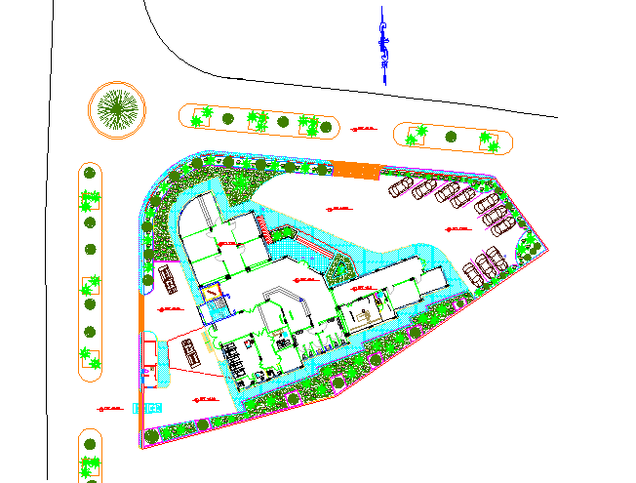 The Ground Floor will be contain three Department are Emergency and Clinics and Laboratory department and The first floor will be contain Complement of the Department of Clinics and Department of Administration Finally Cafeteria and Green roof Area.

Project Site

The project is located near the housing “AL-​​Amiriya” in in the area of “Aljunied” located in the southern mountain in NABLUS

The project is structural analysis and design of

a proposed new building for Nablus Health center. The analysis and design are done using **3D model using SAP2000 program**. The building is **2 stories** above the ground. The area of each story is about 570m2, and its height is 3.8m.

In this project, the American Concrete Institute **(ACI) Code 2008** is used in designing concrete.