An Najah Nation University
Computer Engineering Department
Hardware Graduation Project
Medical Alarm

Presented to : Dr Raed AlQadi

Instructor : Ibrahim Amereah

Prepared by : Baha Atereh ( 10127299 )
Abdallah Radi ( 10125545 )

Introduction:

The Medical Alarm is an electronic medicine alarm, The idea of the project is due to the fact that most people specially the old men and women forget to take their medicine on time, which may cause loses may reach to life of some one, our device is designed to handle medication in the form of solid tablets, and has the ability to deliver the
medication one tablet at a time.
The Medical Alarm project is divided into its basic components. For
input into our system, the user enter the times of taken medicine using time a
Keypad, which in turn is connected to a micro-controller (PIC 16f877). The pic 16f877 micro-controller, which all design is based, coordinates the
Functioning of the whole system. Finally, a voice alarm will sound to remind the user to take his/her medication, and the medication is physically dispensed.
This machine is useful in real-life application, and can be used
by everyone. Furthermore, our machine is easy to use and is of a
reasonable size.
After months of design, testing and modification to our project we
successfully built a functioning medicine alarm. Our primary goals were achieved and the design assembly satisfied all of the requirements of our project. Overall, we can thus consider this project to be a successful.
The following report documents the progression of our design project into
its final stages. It describes the initial design, construction, and testing of our
Project codes. However, creativity and modifications are continuously required to produce a successful outcome.

Project goal:

Our objective in this project is to build an electronic medicine alarm. A machine, which will deliver medication and provide an
Alarm, is a very useful and practical device. The machine is designed to handle medication in the form of solid tablets. Which one pill at a time will be dispensed The primary goal is to create a functional electronic medicine alarm, with alarm, and dispensing capability. First, the individual will be
Prompted to enter the time using a 16-button keypad. The keypad will be connected to a LCD for verification that the time entered for the next dosage is accurate. This information will be stored into the PIC micro-controller of this system; once the real time clock of our device has reached the stored time for the user’s next dosage the device will activate our alarm. At this point the medication will be dispensed using a segmented container, rotated by a stepper motor, into another hole from which the user can take the pills.

Initial Design:

Our project is designed to satisfy all of the requirements of our
Medicine delivers. The major components include a PIC16F877 micro-controller, 2 stepper motor, 16 button keypad, ds1302 real time clock chip, beep, and LCD screen. The dosage time will be manually
Entered by the user, through a 16 -button keypad. After that the pic 16f877 while compare the time stored in the EPROM of pic with the time in the real time clock until time match then alarm will sound. After the
Alarm has been turned off a stepper motor will be initiated to rotate a suitable tube and then user can press special button (get med button) to has the med (the other stepper will rotate to deliver the medicine).

Hardware:

To begin, once the micro-board was build, we first tested the microcontroller
itself to see if the PIC would perform correctly with output and input
pins by down load test code which written by dr Raed Alqadi (
Hyper-terminal program). For our first stage of the
Project’s development we had two goals, to establish a tone output to a speaker for our alarm signal, and also test and determine the phase sequence of our stepper motor.
So we began with the stepper motor. The motor has 6 wires; we had to determine the phase sequence. We assumed the pure white and black wire was for ground, while the other 4 wires were for the
Four phases of the motor. We needed to determine the correct sequence of phases to be charged up so that the motor would turn continuously in the same direction.
To do this, we hooked up a voltage generator, set at 7.5V, to the motor and
Proceeded to charge each phase individually and watch the rotation of the motor shaft. After trying many different sequences we finally found the one that would keep the motor rotating in one direction.
PIC is two low to operate the motor, so we had to use a push-pull 4-channel
Driver chip (ULN 2003A) to amplify the current to acceptable levels.
We initially used ports C0 through C3 on the micro-controller for the motor (the other motor has the same steps but we use the A0->A3 pin).
To interface the LCD screen with the PIC. First we connect it to 7 pins of port D pins. Then we connect the key bad then were pushed on the keypad and that worked for all the buttons. We were informed that we should de-bounce the signal from the keypad so that micro-controller
Would determine if a button, so we use software denouncing.
Then we connect the real time clock using 3 pins E0 to E2.

The following picture bellow describes the complete hard ware design of our project (notice we include in our CD, orcad design of our project):

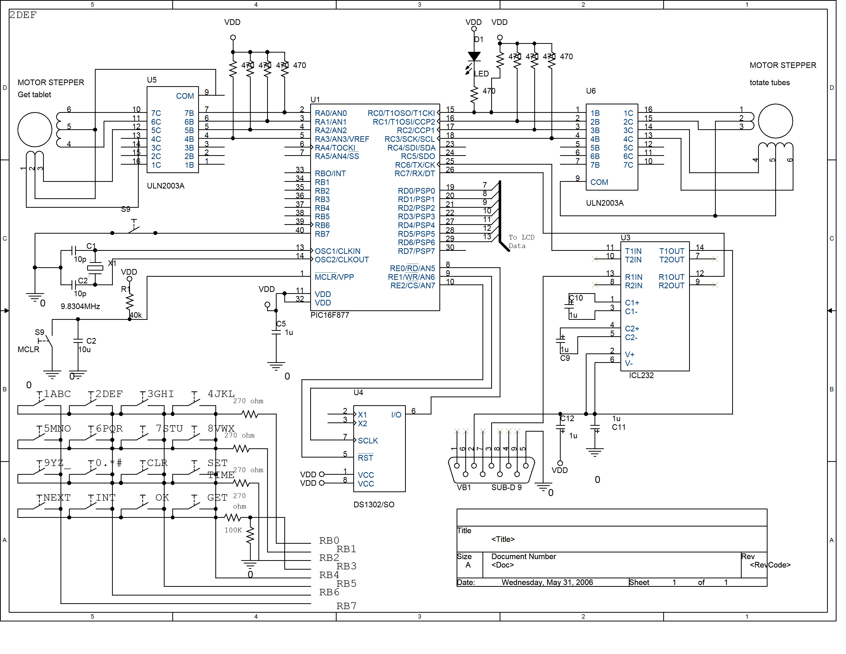
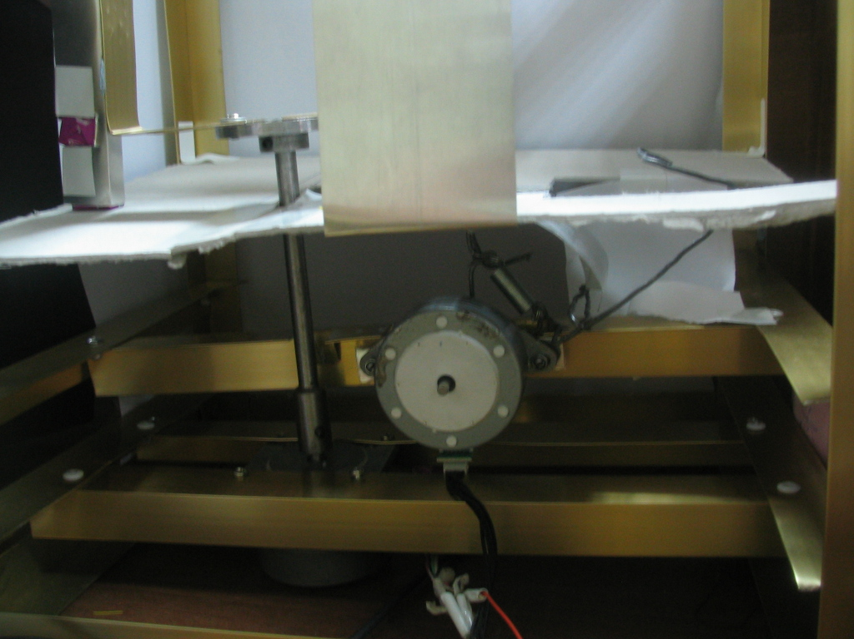
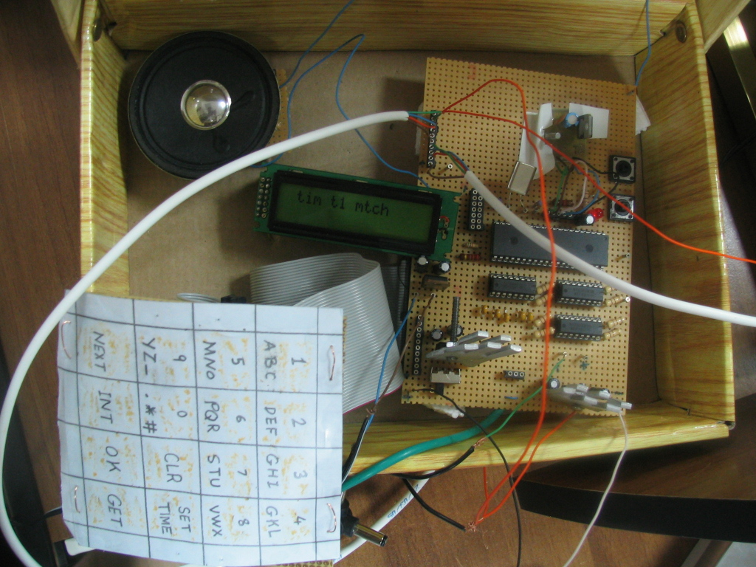

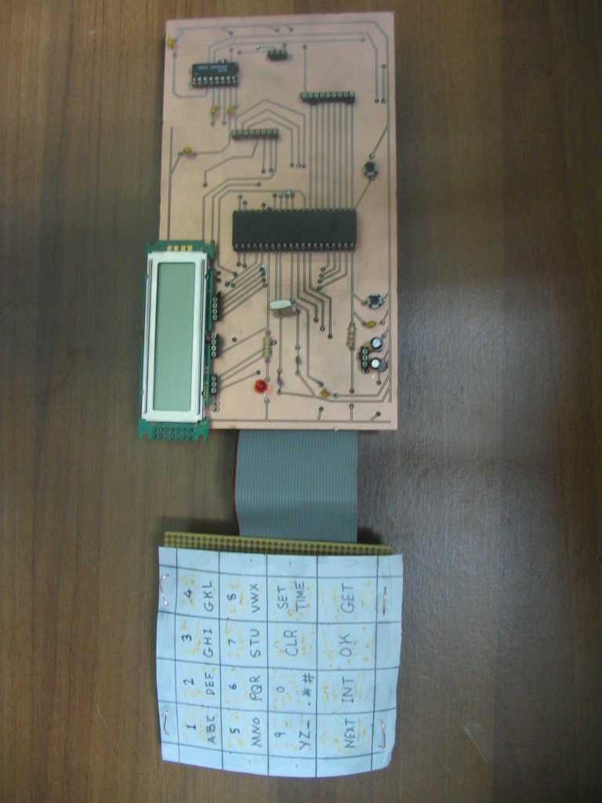
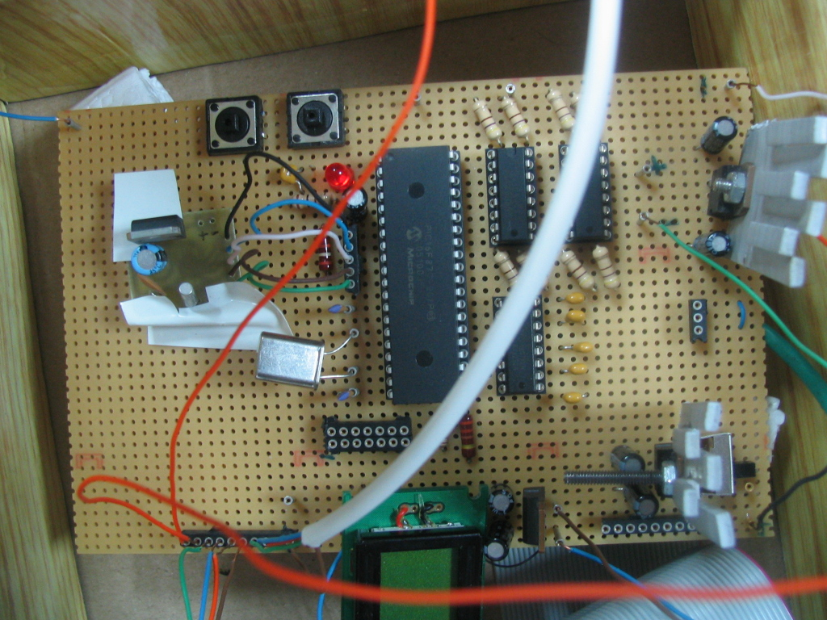

Software:

Our initial idea of having the C programming language and assembly languages.
As the pic 16f877 works it display welcome screen then it wait fro the user to press button of initializing tube of new medicine ,if user do so then it ask the user to enter the name of medicine then the number of tablets then how many time the user will take the medicine a day then the location of the tube then the times that the user would take medicine in then the pic save all that in the EPROM of pic, then the pic in continuous way compare the times stored in the EPROM with the real time clock if match the pic rotate the stepper motor if need and start the alarm beep to and decrement the number of the tablets in the tube and store it again in the EPROM the following code describe the way in which the pic do the previous steps:

#include "F:\project_component\final_project_9\project_9.h"
#include <LCD.C>
#include <KBD.C>
#include <DS1302.C>
////////////////////////////////////////////////////////////////////////////////////////////////////////////////////
char c1 [5]={' ','1','a','b','c'};
char c2 [5]={' ','2','d','e','f'};
char c3 [5]={' ','3','g','h','i'};
char c4 [5]={' ','4','j','k','l'};
char c5 [5]={' ','5','m','n','o'};
char c6 [5]={' ','6','p','q','r'};
char c7 [5]={' ','7','s','t','u'};
char c8 [5]={' ','8','v','w','x'};
char c9 [5]={' ','9','y','z','_'};
char c10 [5]={' ','0','.','*','#'};
char namearray[10]={' ',' ',' ',' ',' ',' ',' ',' ',' ',' '};
char mystring[2]={'1','1'};

int delay = 10;
int8 condition=1;
byte address;
int8 i;
int nmarraryindex;
int counter;
char temp;
char k;
char current;
char value;
char value2;
int32 tmr1cntr=0;
byte hour,min,sec,day,mth,year,dow;
int timtakday;
int step = 0x33;
//int32 tmr1cntr=0;
byte hourones,hourtens;
char location;
byte tabletnumber;
long stepsNumber;
int direction;
long ii;
int setimcondition;
/////////////////////////////////////////////////////////////////////////////////////////////////////////////////
#int_TIMER0
TIMER0_isr()
{
tmr1cntr++;
if(tmr1cntr==2000){ //if(tmr1cntr==53000) every 58.8 minute call check time function
tmr1cntr=0;

#asm
clrwdt
#endasm
rtc_get_time(hour,min,sec);
delay_ms(50);
value=read_eeprom (0x30);
delay_ms(140);
tabletnumber=read_eeprom (0x3B);
delay_ms(140);
restart_wdt();
if(value=='1' && tabletnumber == 0x00){
lcd_putc("\f no tablets in tube \n plz set tube1 again");
restart_wdt();
}
if(value=='1' && tabletnumber != 0x00){// first tube is set
restart_wdt();
value=read_eeprom(0x3c);
value=value-0x30;
address=0x3E;
restart_wdt();
for(i=0;i<(value*2);i++){
hourtens=read_eeprom(address);
delay_ms(140);
address++;
hourones=read_eeprom(address);
delay_ms(140);
sprintf(mystring,"%2x",hour);
address++;
if(mystring[0] == hourtens && mystring[1] == hourones){ // if tim matches
restart_wdt();
location=read_eeprom(0x3D);
delay_ms(140);
if(location=='0'){
//movestepper180(100,1); //imp
///////////////////////////////////////

delay=10; // A0 A1 A2 A3 big stepper
stepsNumber=100;
direction=1;
for(ii=0;ii<stepsNumber;ii++){
if(direction == 1)
{
rotate_right(&step,1);
}
else
{
rotate_left(&step,1);
}

//PIN_D0 ==> 0001
if((step & 0x01)==0){
output_bit(PIN_A0,0);
}
else{
output_bit(PIN_A0,1);
}

//PIN_D1 ==> 0010
if((step & 0x02)==0){
output_bit(PIN_A1,0);
}
else{
output_bit(PIN_A1,1);
}

//PIN_D2 ==> 0100
if((step & 0x04)==0){
output_bit(PIN_A2,0);
}
else{
output_bit(PIN_A2,1);
}

//PIN_D3 ==> 1000
if((step & 0x08)==0){
output_bit(PIN_A3,0);
}
else{
output_bit(PIN_A3,1);
}

delay_ms(delay);

restart_wdt();
}}
///////////////////////////////////////

write_eeprom(0x6D,'0');
write_eeprom(0x3D,'1');
delay_ms(140);
tabletnumber=read_eeprom(0x3B);
restart_wdt();
delay_ms(140);
tabletnumber--;
write_eeprom(0x3B,tabletnumber);
delay_ms(140);
restart_wdt();
lcd_putc("\f tim t1 mtch");
//makebeep(); //imp
i=value;// break the for loop
} // end if time matches
}// end for
}//end first tube
/////////////////
value=read_eeprom (0x60);
delay_ms(140);
restart_wdt();
tabletnumber=read_eeprom (0x6B);
delay_ms(140);
if(value=='1' && tabletnumber == 0x00){
lcd_putc("\f no tablets in tube \n plz set tube2 again");
restart_wdt();
}
if(value=='1' && tabletnumber != 0x00){// second tube is set
restart_wdt();
value=read_eeprom(0x6C);
value=value-0x30;
address=0x6E;
restart_wdt();
for(i=0;i<(value*2);i++){
hourtens=read_eeprom(address);
delay_ms(140);
address++;
hourones=read_eeprom(address);
delay_ms(140);
sprintf(mystring,"%2x",hour);
restart_wdt();
address++;
if(mystring[0] == hourtens && mystring[1] == hourones){ // if tim matches
location=read_eeprom(0x6D);
delay_ms(140);
restart_wdt();
if(location=='0'){
//movestepper180(100,1);//imp
///////////////////////////////////////////////
delay=10;
stepsNumber=100;
direction=1;
for(ii=0;ii<stepsNumber;ii++){
if(direction == 1)
{
rotate_right(&step,1);
}
else
{
rotate_left(&step,1);
}

//PIN_D0 ==> 0001
if((step & 0x01)==0){
output_bit(PIN_A0,0);
}
else{
output_bit(PIN_A0,1);
}

//PIN_D1 ==> 0010
if((step & 0x02)==0){
output_bit(PIN_A1,0);
}
else{
output_bit(PIN_A1,1);
}

//PIN_D2 ==> 0100
if((step & 0x04)==0){
output_bit(PIN_A2,0);
}
else{
output_bit(PIN_A2,1);
}

//PIN_D3 ==> 1000
if((step & 0x08)==0){
output_bit(PIN_A3,0);
}
else{
output_bit(PIN_A3,1);
}

delay_ms(delay);

restart_wdt();
}

}
///////////////////////////////////////////////
write_eeprom(0x3D,'0');
write_eeprom(0x6D,'1');
delay_ms(140);
tabletnumber=read_eeprom(0x5B);
delay_ms(140);
tabletnumber--;
write_eeprom(0x6B,tabletnumber);
delay_ms(140);
lcd_putc("\f tim t2 mtch");
//makebeep(); imp
restart_wdt();
i=value;// break the for loop
} // end if time matches
}// end for
}//end second tube

} // end if timer== 1000
}
///////////////////////////////////////////////////////////////////////////////////////////////////////////////////

void movestepper180(long stepsNumber,int direction);
void intitializefunc();
void spacelcdfunc();
void clearlcdfunc();
void nextfunc();
void getmedicinefunc(long stepsNumber,int direction);
void okfunc();
//void getmedicinefunc2();
//void makebeep();
///////////////////////////

void main()
{

setup_adc_ports(NO_ANALOGS);
setup_adc(ADC_OFF);
setup_psp(PSP_DISABLED);
setup_spi(FALSE);
setup_counters(RTCC_INTERNAL,RTCC_DIV_256);
setup_timer_1(T1_DISABLED);
setup_timer_2(T2_DISABLED,0,1);
enable_interrupts(INT_TIMER0);
enable_interrupts(global);
lcd_init();
kbd_init();
rtc_init();
//rtc_set_datetime(day,mth,year,dow,hour,min); //Set the date/time \\

rtc_set_datetime(0x20,0x12,0x06,0x02,0x11,0x55);

lcd_putc("medical alarm");

delay_ms(2000);

counter=0;
while(true){
#asm
clrwdt
#endasm
k=kbd_getc();

if(k!=0){
//lcd_putc(k);
#asm
clrwdt
#endasm
/*char const KEYS[4][4]={{'1','2','3','a'},
{'4','5','6','b'},
{'7','8','9','c'},
{'*','0','e','d'}};*/
if(k=='1' || k=='2'|| k=='3' || k=='a' || k=='4' || k=='5' || k=='6' || k=='b' || k=='7' || k=='8'){
counter++;
current=k;
#asm
clrwdt
#endasm
}
if(k=='9')
clearlcdfunc();

if(k=='c')
spacelcdfunc();

if(k=='*')
nextfunc();

if(k=='0')
intitializefunc();

if(k=='e'){
okfunc();
}

if(k=='d')
getmedicinefunc(11,1);
}} // end if

}
///////////////////////////////////////////////////////////////////////////////////////////////////////////
void intitializefunc(){
#asm
clrwdt
#endasm
value2=read_eeprom(0x60);
delay_ms(140);
value=read_eeprom(0x30);
delay_ms(140);
if(value=='0'){
lcd_putc("\f t1 medcn name \n");
nmarraryindex=0;
write_eeprom(0x30,'1');
delay_ms(140);
value2='1';
address=0x31;
condition=1;
}

else if(value2=='0'){
lcd_putc("\f t2 medcn name \n");
nmarraryindex=0;
write_eeprom(0x60,'1');
delay_ms(140);
address=0x61;
condition=1;
}
else {
lcd_putc("\f no empty tube");
condition=0;
}
}
///////////////////////////////////////////////////////////////////////////////////////////////////
void clearlcdfunc(){
#asm
clrwdt
#endasm
lcd_putc('\b');
lcd_putc(' ');
lcd_putc('\b');
nmarraryindex--;
}
//////////////////////////////////////////////////////////////////////////////////////
void spacelcdfunc(){ // set time
setimcondition=1;

//byte hour,min,sec,day,mth,year,dow;
//rtc_set_datetime(day,mth,year,dow,hour,min); //Set the date/time
//rtc_set_datetime(0x20,0x12,0x06,0x02,0x11,0x55);
lcd_putc("\f enter time hr/min \n");
delay_ms(1000);
counter=0;
nmarraryindex=0;

}

///////////////////////////////////////////////////////////////////////////////////
void okfunc(){
#asm
clrwdt
#endasm
if(condition==1){
lcd_putc(" \f name is saved");
i=0;
for(i=0;i<10;i++,address++){ // save name 10 chars
value=namearray[i]; //char
write_eeprom (address, value);
delay_ms(200);
#asm
clrwdt
#endasm
}// end for
nmarraryindex=0;
lcd_putc("\f tablets number: \n");
condition=2;
counter=0;
}//end if
else if(condition==2){ // 2 digit
value=namearray[0];
//write_eeprom (address,value); // save tablets number
//delay_ms(140);
#asm
clrwdt
#endasm
lcd_putc(" \f number is saved "); // 1 byte integer
value2=namearray[1];
value=((value-0x30)*10)+(value2-0x30);
write_eeprom (address, value);
#asm
clrwdt
#endasm
delay_ms(2000);
lcd_putc("\f #take aday\location :\n");
#asm
clrwdt
#endasm
nmarraryindex=0;
condition=3;
counter=0;
}
else if(condition==3){ // save number taken aday
lcd_putc("\f # is saved");
value=namearray[0]; // 1 byte char
timtakday = value-0x30;
#asm
clrwdt
#endasm
write_eeprom (address+1, value);
delay_ms(150);
nmarraryindex=0;
#asm
clrwdt
#endasm
delay_ms(2000);
write_eeprom (address+2,namearray[1]); // locatino '0' or '1'
//lcd_putc("\f end tube init");
delay_ms(1000);
lcd_putc("\f tms 2 tak md \n");
condition=4;
counter=0;
}
else if(condition==4){ // saves times in day
lcd_putc("\f times saved");
address=address+3;
timtakday=timtakday*2;
for(i=0;i<(timtakday*2);i++,address++){ //
value=namearray[i]; //
write_eeprom(address,value);
delay_ms(140);
#asm
clrwdt
#endasm
}// end for
#asm
clrwdt
#endasm
delay_ms(140);
nmarraryindex=0;
#asm
clrwdt
#endasm

lcd_putc("\f end tube init");
delay_ms(1000);
lcd_putc("\f home ");
counter=0;
condition=5;

}

if(setimcondition==1){
setimcondition=0;

namearray[0]=namearray[0]-0x30;
namearray[0]=namearray[0]<<4;
namearray[1]=namearray[1]-0x30;
namearray[0]=namearray[0] | namearray[1]; //hours

namearray[2]=namearray[2]-0x30;
namearray[2]=namearray[2]<<4;
namearray[3]=namearray[3]-0x30;
namearray[2]=namearray[2] | namearray[3]; //minuts
#asm
clrwdt
#endasm
rtc_set_datetime(day,mth,year,dow,hour,min); //Set the date/time
rtc_set_datetime(0x20,0x12,0x06,0x02,namearray[0],namearray[2]);// contain bcd
namearray[0]=' ';
namearray[1]=' ';
namearray[2]=' ';
namearray[3]=' ';
delay_ms(500);
rtc_get_date(day,mth,year,dow);
delay_ms(100);
rtc_get_time(hour,min,sec);
/delay_ms(200);
lcd_putc('\f');
printf(lcd_putc,"%2X/%2X/%2X\n%2X:%2X:%2X",day,mth,year,hour,min,sec);
delay_ms(250);
}
}

/////////////////////////////////////////////////////////////////////////////////
void nextfunc(){

//lcd_putc(k);
#asm
clrwdt
#endasm

if(counter > 4 ) {
counter=counter%4;
if(counter==0){
counter=4;
//lcd_putc(k);
#asm
clrwdt
#endasm
}}
if( current =='1'){
lcd_putc(c1[counter]);
namearray[nmarraryindex]=c1[counter];

counter=0;
#asm
clrwdt
#endasm

}

if(current=='2'){
lcd_putc(c2[counter]);
namearray[nmarraryindex]=c2[counter];
counter=0;
#asm
clrwdt
#endasm

}

if(current=='3'){
lcd_putc(c3[counter]);
namearray[nmarraryindex]=c3[counter];
counter=0;
#asm
clrwdt
#endasm

}

if(current=='a'){
lcd_putc(c4[counter]);
namearray[nmarraryindex]=c4[counter];
counter=0;
#asm
clrwdt
#endasm

}

if(current=='4'){
lcd_putc(c5[counter]);
namearray[nmarraryindex]=c5[counter];
counter=0;
#asm
clrwdt
#endasm

}
if(current=='5'){
lcd_putc(c6[counter]);
namearray[nmarraryindex]=c6[counter];
counter=0;
#asm
clrwdt
#endasm
}
if(current=='6'){
lcd_putc(c7[counter]);
namearray[nmarraryindex]=c7[counter];
counter=0;
#asm
clrwdt
#endasm

}
if(current=='b'){
lcd_putc(c8[counter]);
namearray[nmarraryindex]=c8[counter];
counter=0;
#asm
clrwdt
#endasm

}
if(current=='7'){
lcd_putc(c9[counter]);
namearray[nmarraryindex]=c9[counter];
counter=0;
#asm
clrwdt
#endasm

}
if(current=='8'){
lcd_putc(c10[counter]);
namearray[nmarraryindex]=c10[counter];
counter=0;
#asm
clrwdt
#endasm

}
nmarraryindex++;
}

////////////////////////////////////////////////////////////////////////////////////////////////////////

void getmedicinefunc(long stepsNumber,int direction){ /// small stepper
//rotate
delay=200; // A0 A1 A2 A3 big stepper
stepsNumber=11;
direction=1;
/// C0 C1 C2 C3

/// directiion = 1

for(i=0;i<stepsNumber;i++){
if(direction == 1)
{
rotate_right(&step,1);
}
else
{
rotate_left(&step,1);
}

//PIN_D0 ==> 0001
if((step & 0x01)==0){
output_bit(PIN_C0,0);
}
else{
output_bit(PIN_C0,1);
}

//PIN_D1 ==> 0010
if((step & 0x02)==0){
output_bit(PIN_C1,0);
}
else{
output_bit(PIN_C1,1);
}

//PIN_D2 ==> 0100
if((step & 0x04)==0){
output_bit(PIN_C2,0);
}
else{
output_bit(PIN_C2,1);
}

//PIN_D3 ==> 1000
if((step & 0x08)==0){
output_bit(PIN_C3,0);
}
else{
output_bit(PIN_C3,1);
}

delay_ms(delay);

restart_wdt();
}
//////////// CHNAGE THE DIRECTION TO GO BACK
delay_ms(3000);
direction=0;
stepsNumber=11;
delay=200;
for(i=0;i<stepsNumber;i++){
if(direction == 1)
{
rotate_right(&step,1);
}
else
{
rotate_left(&step,1);
}

//PIN_D0 ==> 0001
if((step & 0x01)==0){
output_bit(PIN_C0,0);
}
else{
output_bit(PIN_C0,1);
}

//PIN_D1 ==> 0010
if((step & 0x02)==0){
output_bit(PIN_C1,0);
}
else{
output_bit(PIN_C1,1);
}

//PIN_D2 ==> 0100
if((step & 0x04)==0){
output_bit(PIN_C2,0);
}
else{
output_bit(PIN_C2,1);
}

//PIN_D3 ==> 1000
if((step & 0x08)==0){
output_bit(PIN_C3,0);
}
else{
output_bit(PIN_C3,1);
}

delay_ms(delay);

restart_wdt();
}

}

////////////////////////////////////////////////////////////////////////////////////////////////////////////////
//void makebeep(){
// this function is implemented over in the check time function
//}
////////////////////////////////////////////////////////////////////////////////////////////////////////////////

Final Testing:

We test LCD screen, the keypad, the power and serial port connector,
and the ds1302,and the stepper. We then tested the program with the hardware to see if the sequence of everything would go smoothly.
project finally was completed and was working properly, correct information, the PIC accepted all the data inputs from the keypad perfectly, the voice alarm sounded repeatedly until turned off, and the PIC activated the stepper motor to turn the tubes.

Final Design:

The end product of our design consists of sixth main parts; the microcontroller,
2 stepper motor, keypad, beep, liquid crystal display (lcd), the real time clock ds1302. The micro-controller is the heart of our unit with all
the other components connecting into the ports of the micro-controller’s PIC. The
stepper motor, which turns the tubes, has wires that connect into output
ports A0 through A3 of the PIC the other is C0 through C3.
keypad which connect through BO to B7 .
The LCD is connected through d port the PIC.
Real time clock works correctly through E0,E1,E2 pins.

Conclusion:

Overall, we consider our project to be a success. Our objective of building a
functional electronic medicine alarm . The Medical Alarm correctly prompts by the user.

