

**An-Najah National University**

**Electrical Engineering Department**

Final Year Project

Wireless Smoke Sensor 

**Supervisor:**

**Dr. Mazen Rasekh**

**Prepared by:**

**Mais Sawafta**

**Salam Shanableh**

**Dec, 2010**

**ABSTRACT**

Every year in the United States, over 400,000 residential fires result in 4,000 fatalities and 20,000 injuries. Over 50% of those fatalities occur in homes without smoke detectors. The significance of smoke detectors is evident, and the statistics substantiate the need for the most advanced smoke detectors possible.

The motivation behind the project came from brainstorming and thoughts regarding bolstering home safety. The importance of smoke detection is one of the chief safety concerns for residential (single-family) housing. Most smoke detectors on the current market are individual units sans communication or connections to other smoke detectors. Thus, only the smoke detector that sounds an alarm is the one which senses the smoke.

The solution is a wireless implementation of smoke detectors—increasing safety in terms of saving lives and property. In the incident of a fire, residents are alerted more rapidly as response time is decreased, thereby increasing the chance for survival.

So, this project "Wireless smoke sensor" became to meet our community needs.

The chief goal entails designing and implementing a wireless network of smoke detectors sans the need of a central console. The idea is to set off the alarm in all of the smoke detectors in the network (i.e. in a house), thus allowing the warning to reach the entire household.

All of the smoke detectors are set off after one detector detects smoke. The smoke detector that goes off wirelessly alerts all the other smoke detectors in the network, subsequently setting off all the smoke detectors. To differentiate the originating detector and the other detectors, each detector is assigned its own distinct alarm and can also produce the exact alarm of the other detectors. For instance, in a network of three smoke detectors (smoke detector A, smoke detector B, and smoke detector C), smoke detector A has been assigned “smoke alarm A”, smoke detector B has been assigned “smoke alarm B”, and smoke detector C has been assigned “smoke alarm C.” Thus, if smoke detector A detects smoke, the detector wirelessly transmits a signal to smoke detector B and smoke detector C, subsequently setting off the “smoke alarm A” sound in smoke detector B and smoke detector C. The advantage lies in alerting the residents to where the smoke originates.

Furthermore, a temperature threshold (125°F) is implemented with the purpose to avoid false alarms in cases of minor smoke (cooking, incense, etc.). For instance, in the case of a fire, the temperature threshold alarm is set off (with priority status that is determined by the microcontroller) after the smoke alarm to warn the residents of the fire. In cases of minor smoke, only the smoke alarm is set off, as the temperature threshold has not been reached. This serves to avoid any confusion between minor smoke and a fire. The temperature alarm functions similarly to the smoke alarm, in the sense that each detector is assigned its own temperature alarm and is also capable of producing the exact alarm of the other detectors; this allows residents to know where the fire originates. The temperature alarm sound of the detector is the same as the smoke alarm sound of the detector but at a higher volume.

# TABLE OF CONTENTS

1. INTRODUCTION 4

* 1. why this project 4

1.2Task…………………………………………………………………………...………4

2. Suggested Wireless Techniques 5

2.1Bluetooth 5

2.2Infrared……………………………………… .……………………………………….6

2.3 ZigBee 7

2.4 RF 433MHz ASK…………………………………………………………...................8

3. Figure of merits of wireless Techniques……………………………………………………..9

4. Wireless Techniques Comparison Table………………………………… ………………..11

5. Wireless Technique Selection………………………………………………………………12

6. Block Diagram……………………………………………………………………………13

7. Sensor 14

7.1 Analog and digital sensor………………… …..……………………………………..14

7.2 Sensors Selection……………………………………………………………………14

7.3Temperature Sensor 15

7.4 Smoke Sensor 17

7.5 Tone Generator and Speaker 19

7.6 zigbee 21

8Software 25

9 Problems that we faced 26-27

10 Economical cost 28

REFERENCES 29

1. **Introduction**
   1. **Why This Project**

We are interested in this project to meet the community requirement. As recently we became to hear much and more frequently about the " Damage caused by fire

", the need for a device that detects the fire became a necessity in every where .

Our device detects the fire and decided in which room or in which place dose the fire attack .

What encouraged us to this project too is the need for hardware and software programming knowledge, which will improve our programming skills.

* 1. **Task**

The objective of this project is to design a simple, easy to use sensors such smoke sensor , temperature sensor and tone generator -and x-bee pro to send the signal wirelessly between the devices .

After checking the parameters mentioned above with suitable sensors located at the concerned place (may be on a towering roof), the x-bee takes this values periodically, transmits them wirelessly to another x-bee receiver module placed near a PC ..then they send serially to the PC..finally they should send by emails to specific people

1. **Suggested Wireless Techniques**

We are going to talk about these different types of wireless techniques. Discussing their different merits;

* 1. bluetooth
  2. Infrared (IR):
  3. ZigBee (IEEE 802.15.4)
  4. RF 433 MHz

**Bluetooth**

Bluetooth is a wireless personal area network (WPAN) communication system standard that allows for wireless data connections to be dynamically added and removed between nearby devices. Each Bluetooth wireless network can contain up to 8 active devices and is called a Piconet. Piconets can be linked to each other (overlap) to form larger area Scatternets.

The system control for Bluetooth requires one device to operate as the coordinating device (a master) and all the other devices are slaves. But, most Bluetooth devices can operate as either a master (coordinator) or slave (follower) and Bluetooth devices can reverse their roles if necessary.

The characteristics of Bluetooth include an unlicensed frequency band that ranges from 2.4 GHz to 2.483 GHz. This frequency band was chosen because it is available for use in most countries throughout the world. The standard frequency band for Bluetooth is in the 2.400 GHz to 2.483 GHz (83 MHz) frequency band.

Bluetooth devices may have different power classification levels. The 3 power versions for Bluetooth include; 1 mW (**class 3**), 2.5 mW (**class 2**) and 100 mWatts (**class 1**). Devices that have an extremely low power level of 1 milliwatt have a very short range of approximately 1 meter. Bluetooth devices have a power level of up to 100 milliwatts can provide a transmission range of approximately to 100 meters. The high power version (class 1) is required to use adjustable (dynamic) power control that automatically is reduced when enough signal strength is available between Bluetooth devices.

Because on of the objectives of Bluetooth is low power and low complexity, the simple modulation type of Gaussian frequency shift keying (**GFSK**) is used. This modulation technology represents a logical 1 or 0 with a shift of 115 kHz above or below the carrier signal. The data transmission rate of the RF channel in Bluetooth (Version 1.1) is 1 Mbps (125 kB/s). While it is 3 Mbps (375 kB/s) for Bluetooth (Version 2.0) and 480,000 kbit/s (60,000 kB/s) in Bluetooth (Version 3.0).

As shown in this table;

|  |  |  |
| --- | --- | --- |
| **Version** | **Speed (kbit/s)** | **Speed (kB/s)** |
| Bluetooth V 1.1 | 1,000 kbit/s | 125 kB/s |
| Bluetooth V 2.0 | 3,000 kbit/s | 375 kB/s |
| Bluetooth V 3.0 | 480,000 kbit/s | 60,000 kB/s |

**Infrared**

IR data transmission is employed in short-range communication. The infrared devices usually conform to standards published by IrDA, the *Infrared Data Association*. Remote controls and IrDA devices use infrared light-emitting diodes (LEDs) to emit infrared radiation which is focused by a plastic lens into a narrow beam. The beam is modulated, i.e. switched on and off, to encode the data. The receiver uses a silicon photodiode to convert the infrared radiation to an electric current. It responds only to the rapidly pulsing signal created by the transmitter, and filters out slowly changing infrared radiation from ambient light. Infrared communications are useful for indoor use in areas of high population density. IR does not penetrate walls and so does not interfere with other devices in adjoining rooms. Infrared is the most common way for remote controls to command appliances.

Free space optical communication using infrared lasers can be a relatively inexpensive way to install a communications link in an urban area operating at up to 4 gigabit/s, compared to the cost of burying fiber optic cable.

Infrared lasers are used to provide the light for optical fiber communications systems. Infrared light with a wavelength around 1,330 nm (least dispersion) or 1,550 nm (best transmission) are the best choices for standard silica fibers.

IR data transmission of encoded audio versions of printed signs is being researched as an aid for visually impaired people through the RIAS (Remote Infrared Audible Signage) project.

**Range** - Infrared communications span very short distances. Place two infrared devices within a few feet (no more than 5 meters) of each other when networking them. Unlike Wi-Fi and Bluetooth technologies, infrared network signals cannot penetrate walls or other obstructions and work only in the direct "line of sight."

**Performance** - Infrared technology used in local networks exists in three different forms:

* IrDA-SIR (slow speed) infrared supporting data rates up to **115 Kbps**.
* IrDA-MIR (medium speed) infrared supporting data rates up to **1.15 Mbps**.
* IrDA-FIR (fast speed) infrared supporting data rates up to **4 Mbps**.

Other disadvantages:

* IR is not omni-directional.

* May be not suitable for outdoor use.

**ZigBee**

**ZigBee** is a specification for a group of high level communication protocols using small, low-power digital radios based on the IEEE 802.15.4-2003 standard for wireless personal area networks (WPANs), such as wireless headphones connecting with cell phones via short-range radio. The technology defined by the ZigBee specification is intended to be simpler and less expensive than other WPANs, such as Bluetooth. ZigBee is targeted at radio-frequency (RF) applications that require a low data rate, long battery life, and secure networking.

This standard specifies operation in the unlicensed 2.4 GHz (worldwide), 915 MHz (Americas) and 868 MHz (Europe).

In the 2.4 GHz band there are 16 ZigBee channels, with each channel requiring 5 MHz of bandwidth. The center frequency for each channel can be calculated as, FC = (2405 + 5 * (ch - 11)) MHz, where ch = 11, 12, ..., 26.

The radios use direct-sequence spread spectrum coding, which is managed by the digital stream into the modulator. BPSK is used in the 868 and 915 MHz bands, and orthogonal QPSK that transmits two bits per symbol is used in the 2.4 GHz band. The raw, over-the-air data rate is 250 kbit/s per channel in the 2.4 GHz band, 40 kbit/s per channel in the 915 MHz band, and 20 kbit/s in the 868 MHz band. Transmission range is between 10 and 75 meters (33 and 246 feet) and up to 1500 meters for zigbee pro, although it is heavily dependent on the particular environment. The maximum output power of the radios is generally 0 dBm (1 mW).

The basic channel access mode is "carrier sense, multiple access/collision avoidance" (CSMA/CA). That is, the nodes talk in the same way that people converse; they briefly check to see that no one is talking before they start. There are three notable exceptions to the use of CSMA. Beacons are sent on a fixed timing schedule, and do not use CSMA. Message acknowledgments also do not use CSMA. Finally, devices in Beacon Oriented networks that have low latency real-time requirements may also use Guaranteed Time Slots (GTS), which by definition do not use CSMA.

## Licensing

For non-commercial purposes, the ZigBee specification is available free to the general public.

**RF 433MHz ASK**

It is a small, low power, efficient module that uses ASK modulation scheme. It has an optional antenna to fix; better matching means better range.

This type dals with data rate up to 10Kbps. And maximum range can be up to 60 meters.

This module contains the transmitter RT4 433MHz ASK, and the receiver RR3 433MHz ASK.

1. **Figure of merits of wireless Techniques**

We compare between wireless techniques due to many figure of merits; the most important are:

* 1. Range
  2. Bit-rate or data-rate
  3. Line-of-sight
  4. Area Connection
  5. Security
  6. Licensing

1. **Range**

Each wireless transmitter device has a specific range; it could be few centimeters, few meters, tenths of meters or can reach even many kilometers. Infrared, for example, can send data to a receiver far up to 1.5 meters. This distance increases in Bluetooth version2.0 to reach 10 meters. And in Zigbee or RF433 MHz reaches up to 100 meters. But in GPRS the distance isn't bounded if there is GSM connectivity.

Choosing a particular technique to send data depends on the *application* performed.

1. **BitRate**

Bitrate, as the name implies, describes the rate at which bits are transferred from one location to another. In other words, it measures how much data is transmitted in a given amount of time.

The bit rate is quantified using the bits per second (**bit/s** or **bps**) unit, often in conjunction with an SI prefix such as kilo- (kbit/s or kbps), mega- (Mbit/s or Mbps), giga- (Gbit/s or Gbps) or tera- (Tbit/s or Tbps).

Consequently the net bit rate is sometimes called *digital* bandwidth capacity in bit/s.

In communication systems it is important to save as much as possible the communication resources which the bandwidth is one of them. But in many applications the data bits may be small compared to the bits added in source coding and channel coding. These added bits are very important to decrease the bitrate error.

1. **Line-of-sight**

When we say that the connection is line-of-sight this expression mans that the transmitter and the receiver must see each other in order to can transfer data. So, no obstacle should cross the data link between the two devices. As an example on this type of connections is the microwave links and infrared connections.

1. **Area connection**

This figure of merit is related to the "*range*" subject mentioned above. There are tow main classifications of area connections: local area connection and wide area connection. The first is related to connections in the same area and can not connect points in far areas using its connection scheme. For example, you can't connect a person in another country using Bluetooth, while you can do this using GSM mobile station.

1. **Security**

Many applications need keeping the information secure while transmitting it to the receiver. Finance transactions, private connections and military information needs to be very secure due to its importance. Secrecy can be guaranteed using encryption algorithms. Encryption could be done internally in the system such as GPRS or as in IR there is no internally encryption so encryption can be performed by a professional then the whole data is sent.

On the other hand, encryption increases the data rate and could double it several times.

1. **Licensing**

Radio spectrum is typically government or foundation regulated, and in some cases is sold or licensed to operators. There are parts of this spectrum which is free. When you transmit data using IR or Bluetooth technology you actually use the 2.4 GHz free channels, so, you don't pay anything. While communicating using GSM system in not free and you use a licensed ban

**4.Wireless Techniques Comparison Table**

Here, we introduce this table that forms a comparison between figure of merits of different wireless techniques mentioned previously.

|  |  |  |  |  |  |
| --- | --- | --- | --- | --- | --- |
| **Technique**  **Fig.**  **of**  **Merit** | **Infrared** | **Bluetooth** | **Zig-Bee** | **GPRS** | **RF 433Mhz** |
| Range | 10cm-1.5m | 10 - 100m | 100m in  1.2 km out (door) | GSM system covered area | Up to 100m |
| Data rate | up to 4Mbps | 1 Mbps(V.1) – 3 Mbps(V.2) | 20 Kbps to 250 Kbps | up to 114 Kbps | 10 Kbps |
| LOS | Required | Not Required | Not Required | Not Required | Not Required |
| Area | local area | local area | local area | wide area | local area |
| Security* | Not guaranteed | guaranteed | guaranteed | guaranteed | Not  guaranteed |
| Point-to-point | Point-to-point | Point-to-multi-point | Point-to-multi-point | Point-to-multi-point | Point-to-multi-point |
| Power Profile | Low | Relatively High | Low | Low | Low |
| Licensing | Not Needed | Not Needed | Needed in commercial purposes | Needs operator SIM card | Not Needed |

**\* Security**: IR: has no encryption but considered as secure because of LOS. Bluetooth: supports Authentication and encryption (strong defense against security breakdowns). RF: no encryption. GPRS: secure due to encryption algorithm.

**5.Wireless Technique Selection**

According to the specification of multiple wireless techniques mentioned previously it is suitable to select the zigg bee module for the wireless link to act the transmitter and receiver in the sending and receiving end.

* **zigg bee advantages:**
* Bit data rate is more than enough for our application , the distance is fit max(100 meters in door ,1.2 km out door), reliable , no need of line of sight, no license need, no addition fees need , point to multi point connection , and easy to deal with .

**6.Design**

**Block Diagram**

`

Xbee 2

Xbee 1

**alarm**

Xbee 3

**alarm**

As we can see above ,The requirement for the project is to design and to create a functional smoke detector. After detecting smoke or a high temperature (potential fire), the detector sets off the appropriate alarm sound. The detector also transmits wirless signal to the other smoke detectors in the network so that those detectors, in turn, sound their smoke or temperature alarm.

The signal from one smoke detector is designed and implemented to reach all the other smoke detectors in the network. As such, another performance criterion requires the smoke detector being able to transmit and to receive signals at a range of up to 500 feet.

**7.SENSORS**

A sensor is a device that measures a physical quantity and converts it into a signal which can be read by an observer or by an instrument.

Sensor's sensitivity indicates how much the sensor's output changes when the measured quantity changes. Sensors that measure very small changes must have very high sensitivities. Ideal sensors are designed to be linear. The output signal of such a sensor is linearly proportional to the value of the measured property.

In non ideal sensors, the sensitivity may in practice differ from the value specified. This is called a sensitivity error, but the sensor is still linear.

Since the range of the output signal is always limited, the output signal will eventually reach a minimum or maximum when the measured property exceeds the limits. The full scale range defines the maximum and minimum values of the measured property.

If the output signal is not zero when the measured property is zero, the sensor has an offset or bias. This is defined as the output of the sensor when the input is zero.  
If the sensitivity is not constant over the range of the sensor, this is called nonlinearity.

Using the datasheet of each sensor, we’re going to identify the reading scale for each measured property, of course, after passing it through the microcontroller ADC if the sensor wasn’t a digital sensor.

**7.1Analog and digital sensors**

Analog sensor can read any value in a specified range (continuous values). While the digital sensor reads the values in discrete steps and gives a binary data on its output. So, the use of analog sensors needs the use of ADCs when the form of the transmitted data is digital.

A good way to save effort and money is taking benefit from the internal ADCs in the microcontroller used, the approach we’ll follow Insha’Allah.

* 1. **Sensors Selection**

Sensors must be chosen due to many figure of merits, such as:

* Accuracy: The statistical variance about the exact reading.
* Calibration: For time variance response.
* Environmental: Sensors typically have *temperature* and/or *humidity* limits.
* Range: Limits of measurements on the sensor.
* Repeatability: How much is it the same reading for the same single condition.
* Resolution: The smallest increment the sensor can detect.
* Cost.

**7.3Temperature Sensor**

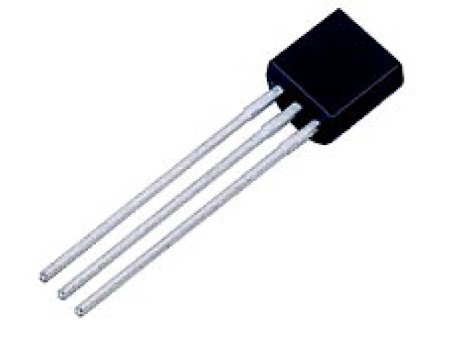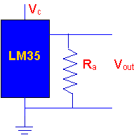

The temperature sensor sends a digital high signal to the microcontroller when the temperature reaches 125°F. It functions by using a temperature sensor, whose voltage output is equal to 1°F/10mV.

 (1)

🡺



A 1.25V voltage reference is connected to Vin- of a voltage comparator, and the output voltage of the temperature sensor is connected to Vin+ of the voltage comparator. Thus, the voltage comparator outputs a digital high when Vin+ is greater than Vin-, which is when the temperature rises above 125°F. The output of the voltage comparator is connected to the microcontroller, which in turn flags the digital high condition to run the correct program sequence and to output the signals to the tone generator to sound the temperature alarm.

What Can You Expect When You Use An LM35?

You will need to use a voltmeter to sense Vout.

The output voltage is converted to temperature by  a simple conversion factor.

The sensor has a sensitivity of 10mV / oC.

Use a conversion factor that is the reciprocal, that is 100 oC/V.

The general equation used to convert output voltage to temperature is:

Temperature ( oC) = Vout * (100 oC/V)

So if  Vout  is  1V , then, Temperature = 100 oC

The output voltage varies linearly with temperature

Here is a photo of the LM 35 wired on a circuit board.

The white wire in the photo goes to the power supply.

Both the resistor and the black wire go to ground.

The output voltage is measured from the middle pin to ground.

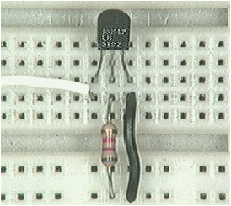

**7.4 Smoke Sensor**

The module provides a mean to detect smoke and to serve as an early fire warning.

The premise of the smoke sensor is a T-shaped chamber with an infrared LED that emits a beam of light across the horizontal portion of the chamber. A mechanical drawing is shown below in Figure 1.



Figure 1. Smoke Sensor T-Shaped Chamber.

The left opening of the chamber is for the LED; the right opening, for smoke particles to enter the chamber; and the base opening, for the phototransistor. The chamber itself is made of PVC plastic.

The infrared LED is positioned at the left of the chamber; the phototransistor, at the vertical base of the T. The phototransistor generates a current when exposed to light. Figure 2 below illustrates the setup.

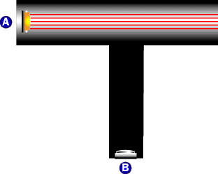

Figure 2. “A” is the infrared LED. “B” is the phototransistor.

If there is no smoke present inside the chamber, the beam of light is emitted across the top of the T-shaped chamber. Thus, the phototransistor does not generate current as no light has hit it.

When smoke particles enter the T-shaped chamber, however, the beam of light is scattered by smoke particles. Subsequently, some of the light is directed down into the vertical portion of the T-shaped chamber and strikes the phototransistor. Figure 3 below illustrates this.

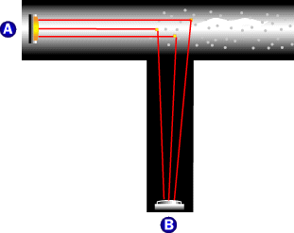

Figure 3. “A” is the infrared LED. “B” is the phototransistor.

Once the phototransistor detects light and generates current, a voltage is generated across the 10K resistor. The collector voltage of the phototransistor is connected to the Vin- input of comparator 1 in the microcontroller. Since the Vin+ input of comparator 1 is connected to ground, comparator 1 outputs a digital high, as the input to Vin- is higher than the input to Vin+. Therefore, after flagging a digital high from comparator 1, the microcontroller processes the correct program sequence and outputs the signals to the tone generator and speaker module to sound the smoke

**Smoke Sensor**



**7.5Tone Generator / Speaker**

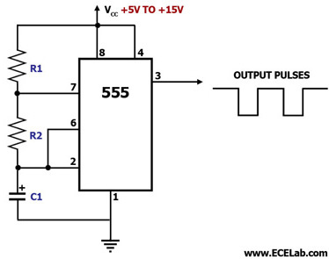

Tone Generator / Speaker

555 Tone Generator (8 ohm speaker)

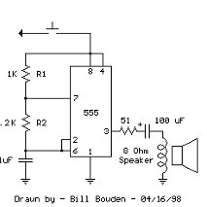

This is a basic 555 squarewave oscillator used to produce a 1 Khz tone from an 8 ohm

speaker. In the circuit on the left, the speaker is isolated from the oscillator by the NPN medium power transistor which also provides more current than can be obtained directly from the 555 (limit = 200 mA). A small capacitor is used at the transistor base to slow the switching times which reduces the inductive voltage produced by the speaker. Frequency is about 1.44/(R1 + 2*R2)C where R1 (1K) is much smaller than R2 (6.2K) to produce a near squarewave. Lower frequencies can be obtained by increasing the 6.2K value, higher frequencies will probably require a smaller capacitor as R1 cannot be reduced much below 1K. Lower volume levels can be obtained by adding a small resistor in series with the speaker (10-100 ohms). In the circuit on the right, the speaker is directly driven from the 555 timer output. The series capacitor (100 uF) increases the output by supplying an AC current to the speaker and driving it in both directions rather than just a pulsating DC current which would be the case without the capacitor. The 51 ohm resistor limits the current to less than 200 mA to prevent overloading the timer output at 9 volts. At 4.5 volts, a smaller resistor can be used..

**7.6 Xbee(zigg-bee)**

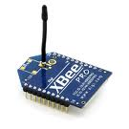

**Flow Control**



## **Configure the remote modules**

For each of the remote modules, we'll want to:

Set their address, so we can tell them apart

Configure which inputs they should be reading

Set how often they should read the inputs

To configure an XBee module it must be connected to the Make Controller's serial port

**Xbee-interface**

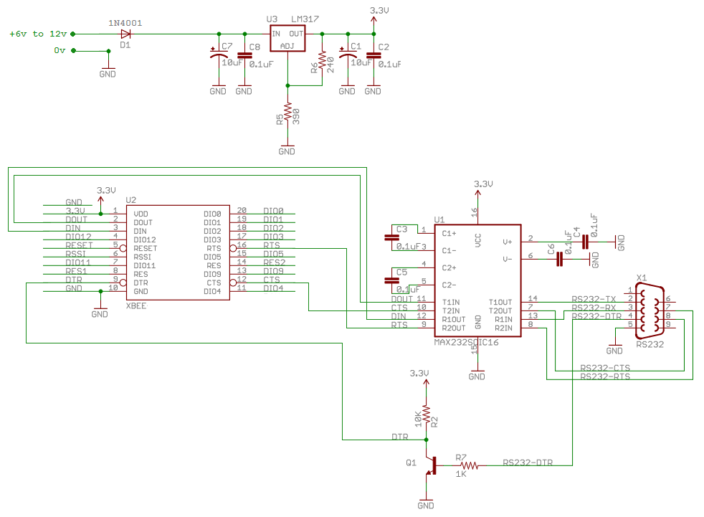

##### **Set the address**

The specific address you choose doesn't matter too much, but you should remember which address you've given to which board, so you know which messages are coming back from it

## **IO Configuration**

Configure the input/output capabilities of an XBee module.

There are 4 IO pins on the XBee module, abeled   
Pins can be set to one of 5 values:

* **0** - Disabled
* **2** - Analog Input
* **3** - Digital Input
* **4** - Digital Out High/On
* **5** - Digital Out Low/Off

More about our xbee

X-Bee is a home-area network designed specifically to replace the proliferation of individual

remote controls. ZigBee was created to satisfy the market's need for a cost-effective,

standards-based wireless network that supports low data rates, low power consumption,

security, and reliability The alliance is working closely with the IEEE to ensure an integrated,

complete, and interoperable network for the market. The ZigBee Alliance will also serve as

the official test and certification group for ZigBee devices. ZigBee is the only standardsbased

technology that addresses the needs of most remote monitoring and control and sensory

network applications.

The 802.15.4 specification only covers the lower networking layers (MAC and PHY). To

achieve inter-operability over a wide range of applications such as Home, Industrial or

Building Automation, the higher layers must be standardized as well.

The Zigbee Alliance has produced such a standard, using 802.15.4 wireless (generally in the

2.4 GHz band) as the low-level transport. Through the use of 'profiles', the specification may customized to suit various application areas.

**Power saving:**

Ultra-low power consumption is how ZigBee technology promotes a long lifetime for devices with nonrechargeable batteries.

ZigBee networks are designed to conserve the power of the slave nodes. For most of the time, a slave device is in deep-sleep mode and wakes up only for a fraction of a second to confirm its presence in the network. For example, the transition from sleep mode to data transition is around 15ms and new slave enumeration typically takes just 30ms.

**Security:**

Security and data integrity are key benefits of the ZigBee technology. ZigBee leverages the security model of the IEEE 802.15.4 MAC sublayer which specifies four security services:

• access control—the device maintains a list of trusted devices within the network

• data encryption, which uses symmetric key 128-bit advanced encryption standard

• frame integrity to protect data from being modified by parties without cryptographic

keys

• sequential freshness to reject data frames that have been replayed—the network

controller compares the freshness value with the last known value from the device and

rejects it if the freshness value has not been updated to a new value

The actual security implementation is specified by the implementer using a standardized

toolbox of ZigBee security software.

**Size :**

As silicon processes and radio technology progress, transceiver systems shrink in physical

size. A transceiver might easily fit inside a thimble. In the case of ZigBee systems, the radio transceiver has become a single piece of silicon, with a few passive components and a relatively noncritical board design.

Microcontrollers that have native ability to interface with sensors have eclipsed even the

radios rapid reduction in size. Today, the 8-bit MCU that hosts the application may already include dozens of kilobytes of flash memory, RAM, and various hardware-based timer functions, along with the ability to interface directly to the radio transceiver IC. The MCU requires only a few external passive components to be fully functional.

**Data Security :**

It’s important to provide your sensor network with adequate security. IEEE 802.15.4 provides authentication, encryption, and integrity services for wireless systems that allow systems developers to apply security levels as required. These include no security, access control lists, and 32-bit to 128-bit AES encryption with authentication. This security suite lets the developer pick and choose the security necessary for the application, providing a manageable tradeoff against data volume, battery life, and system processing power requirements. The IEEE 802.15.4 standard doesn’t provide a mechanism for moving security keys around a network; this is where ZigBee comes in.

The ZigBee security toolbox consists of key management features that let you safely manage a network remotely. For those systems where data security is not critical (e.g., a set of sensors monitoring microclimates in a forest), you may decide not to implement security features but instead optimize battery life and reduce system cost. For the developer of an industrial or military perimeter security sensor system, data security and more importantly the ability to defend against sensor masking or spoofing may have the higher priority. In many ZigBeeapproved applications, security will already be a seamless part of the overall system.

**8 Software**

**in our program we use the (AT) commands in xbee :_**

AT Command Mode

To modify or read RF Module parameters, the module must first enter into Command Mode - a state in which incoming serial characters are interpreted as commands. Refer to the API Mode section for an alternate means of configuring modules.

**To Enter AT Command Mode:**

Send the 3-character command sequence “+++” and observe guard times before and after the command characters.

[Refer to the “Default AT Command Mode Sequence” below.]

Default AT Command Mode Sequence (for transition to Command Mode):

• No characters sent for one second [GT (Guard Times) parameter = 0x3E8

• Input three plus characters (“+++”) within one second [CC (Command Sequence Character) parameter = 0x2B.]

• No characters sent for one second [GT (Guard Times) parameter = 0x3E8]

All of the parameter values in the sequence can be modified to reflect user preferences.

NOTE: Failure to enter AT Command Mode is most commonly due to baud rate mismatch. Ensure the ‘Baud’ setting on the “PC Settings” tab matches the interface data rate of the RF module. By default, the BD parameter = 3 (9600 bps).

**To Send AT Commands:** Send AT commands and parameters using the syntax shown below



. **Syntax for sending AT Commands**

To read a parameter value stored in the RF module’s register, omit the parameter field. The preceding example would change the RF module Destination Address (Low) to “0x1F”. To store the new value to non-volatile (long term) memory, subsequently send the WR (Write) command. For modified parameter values to persist in the module’s registry after a reset, changes must be saved to non-volatile memory using the WR (Write) Command. Otherwise, parameters are restored to previously saved values after the module is reset

. **System Response.** When a command is sent to the module, the module will parse and execute the command. Upon successful execution of a command, the module returns an “OK” message. If execution of a command results in an error, the module returns an “ERROR” message.

**To Exit AT Command Mode**: 1. Send the ATCN (Exit Command Mode) command (followed by a carriage return). [OR] 2. If no valid AT Commands are received within the time specified by CT (Command Mode Timeout) Command, the RF module automatically returns to Idle Mode. For an example of programming the RF module using AT Commands and descriptions of each config-urable parameter, refer to the "Command Reference Tables"

9 Problems that we faced

1. The lack of pieces required an example of this is xbee
2. Non-validity of the tools in the workshop
3. We faced problems in programming,it was the biggest problems that we faced since we have to learn anew language ..and lear all at commands that we need

10 Economical cost

|  |  |  |  |  |
| --- | --- | --- | --- | --- |
| Total  Cost | Cost/Element | Number | Element |  |
| e840 NIS | **280 NIS** | **3** | **xbee** | **1** |
| 75 NIS | **15 NIS** | **5** | **Regulator**  **3.3** | **2** |
| 40 NIS | **10 NIS** | **4** | **Regulator**  **5** | **3** |
| 30 NIS | **15 NIS** | **2** | **Temperature**  **Sensor** | **4** |
| 200 NIS | **100 NIS** | **2** | **Smoke**  **Sensor** | **5** |
| 10 NIS | **5 NIS** | **2** | **Speaker** | **6** |
| 6 NIS | **.5 NIS** | **12** | **Resistance** | **7** |
| 20 NIS | **10 NIS** | **2** | **Resistance**  **0-10 k** | **8** |
| 15 NIS | **1.5 NIS** | **10** | **Capacitor** | **9** |
| 10 NIS | **10 NIS** | **1** | **Max 232** | **10** |
| 6NIS | **3 NIS** | **2** | **Timer**  **555** | **11** |
| 120 NIS | **40 NIS** | **3** | **Special**  **Socket xbee** | **12** |
| 30 NIS | **15 NIS** | **2** | **Board**  **xbee** | **13** |
| 1412 NIS |  |  | **total** |  |

References:-

1] Dr. MazenRashekh , Palestine, An-Najah University, Electrical Engineering Dept.

2] Microchip Technology Company, *PIC16F87XA Data Sheet*, Microchip Technology Inc., USA, 2003.

[3] John S. Seybold, *Introduction to RF Propagation*, Wiley Interscience, 2005.

[4] Jan Sinclair, *Sensors and Transducers,* Newnes, 3rd Edition, 2001.

[5] William H. Hayt, *Engineering Electromagnetics*, McGraw-Hill, 6ed, 2001.

**Web Resources:**

[6] <http://www.datasheetdirect.com>

[7] http://www.wikipedia.org

[8] <http://compnetworking.about.com>

[9]<http://www.digi.com/support/kbase/kbaseresultdetl.jsp?kb=188>

[10]<http://www.sparkfun.com/products/8691>

Note:

The code of the software will be added soon and attached to the file