Table of content
.........................................................................................................................الإهداء3
الشكر والتقدير……………………………………………………………………………………...4
1. Introduction 6
1.1 Groundwater Aquifers in the West Bank 6
1.2 Background 7
1.3 Objectives 7
1.4 Methodology 8
2. Study area 10
2.1. Location and Topography 10
2.2. Climate 11
2.3. Field study 14
2.3.1.Questionnaire 14
3. Population Forecast 19
3.1. Geometric growth method 19
3.2. Future water consumption 20
3.3. Present Population density 20
3.4. Future Population density 21
4. Water Distribution System 23
4.1. Water distribution systems 23
4.2. Water uses 23
4.3. Water Demand 24
4.4. Water distribution methods 25
4.5. Pressure and velocities……. 27
4.6. Pipelines………… 27
4.7. Valves 29
5. Simulation Model (Water CAD) 31
5.1. Acknowledgements 31
5.2. Graphical editor 31
5.3. Network hydraulics theory 32
5.4. Equations used in Water cad …………………………………………………………32
5.4.1. Hazen-Williams Equation: 32
5.4.2. Darcy-Weisbach Equation: 33
5.4.3. Manning’s Equation: 34
5.5. Typical roughness values 35
5.6. Advantages of water cad 36
6. Design and analysis 38
6.1. Generating Thiessen Polygons 38
6.2. Design criteria 41
6.3. Methodology applied 41
6.4. Data processing and results 43
6.4.1. Introduction 43
6.4.2. The junctions in the system 43
6.4.3. The links in the system 45
6.4.4. Information that must be insert to model 47
6.4.5. Layout of water distribution network………. 50
7. Data Result 52
7.1. Pipe result 52
7.2. Node analysis 54
7.3. Conclusion 56
7.4. Recommendation 56
8. Appendix 58
81. Table of questionnaire…. 58
8.2. Questionnaire 61
8.3. Layout of water distribution network………………………………………………….63
References…………………………………………………………………………………..63

الإهــداء
*إلى نبع العطاء.. إلى الماس الذي لا ينكسر.. إلى من أفنى عمره لنكون، وأعطانا شبابه لنشب............................................................................................ إلى والدي
*إلى الزهرة التي لا تذبل.. إلى من قضت ليلها ونهارها ترفع لله يديها بالدعاء والابتهال أن يملأ دربي دراً وفيروزاً ومحاراً، إلى نبع الحنان .................... إلى أمي
*إلى ملائكة الأرض.. وشقائق النعمان.. إلى من عشت معهم مرارة الحياة وحلوها تحت سقف واحد................................................................................... إلى أشقائي
*إلى قناديل الدرب.. والشموع التي لا تنطفئ...................................... إلى أساتذتي
*إلى رفاق الدرب.. وبناة المستقبل.. إلى من ضاقت السطور من ذكرهم فوسعهم قلبي................................................................................................... إلى أصدقائي
*إلى رايات المجد.. وصناع الكرامة.. إلى من روا بدمائهم الطاهرة أرضنا المقدسة............................................................................................... إلى شهدائنا
*إلى من طلبوا العزة.. ورفضوا الخضوع.................................................. إلى أسرانا
*وإليك يا تراب بلادي ... أقدم حياتي.. حبة رمل في صحرائك النقية.. وقطرة ماء في بحر نضالك المقدس.... وحصاة صلبة في بنائك الشامخ.. ونافذة معرفة تطل على تراثك العريق....................................................................................... إلى فلسطين
الشكـر والتقديـر
الحمد لله رب العالمين الذي أعاننا على إنجاز هذا العمل المتواضع، والصلاة والسلام على خاتم الأنبياء سيدنا محمد – صلى الله عليه وسلم –.
لا يسعنا وقد أنهينا هذه الدراسة، بعد عناء طويل إلا أن نتقدم بجزيل الشكر وعميق الامتنان لمن كان له الفضل الكبير في إخراج هذا المشروع إلى حيز الوجود أستاذنا الدكتور حافظ شاهين، فقد قدم من جهده الكثير من أجلنا مما أتاح لنا فرصة إظهار المشروع بصورته الحالية، فله منا الشكر الجزيل،وأدامه الله ومكنه من مواصلة خدمة العلم والبحث العلمي.
كما نشكر الأخ المهندس براء جرارعة لما قدمه من جهد كبير في إتمام هذا المشروع
كما نتقدم بالشكر والتقدير للمجموعة العالمية للهندسة والاستشارات (معالم) لما قدمته من مساعدة قيمة لتمام هذا المشروع
كما نشكر الأخ أسامة باسم صلاح لما قدمه من مساعدة في إخراج هذا المشروع
ولا يفوتنا أن نتقدم بالشكر والتقدير لكل الهيئة الإدارية والتعليمية في جامعة النجاح الوطنية، الذين قدموا لنا الكثير، ونحن عاجزون عن عدهم وذكر أسمائهم، ونخص بالذكر قسم الهندسة المدنية برئيس القسم مرورا بالدكاترة والمحاضرين فلهم جزيل الشكر.
وأخيرا نتقدم بالشكر الجزيل لكل من ساهم في إخراج هذا العمل المتواضع
خالد جلغوم
شادي عصاعصة

CHAPTER 1
Introduction

Introduction
Water is an extremely important issue, not only in the Middle East, but also in every community in the World. Without water, there is no life. Water can create wars or be the key to regional cooperation. There for it is of great importance to manage the limited available water resources. The effective management of water resources is essential to the development of medical, social, agricultural and industrial development in all countries.
Satisfactory (adequate, safe and accessible) water supply must be available to human beings. Improving access to safe drinking-water can result in tangible benefits to human health. Every effort should be made to achieve a drinking water quantity and quality as safe as practicable.
West Bank is the part of Palestine which was occupied by Israel during the 1967 war. Until now Israel has been in full control of the natural resources in the West Bank including water. Most of the Palestinian groundwater resources from the West Bank are utilized by Israel and Israeli colonies, causing the Palestinian to suffer water shortages.

Groundwater Aquifers in the West Bank
West Bank overlies three groundwater basins jointly known as the Mountain Aquifer Basins; Eastern Aquifer Basin, Western Aquifer Basin, and Northeastern Aquifer Basin. The Palestinians are currently denied the right to their water from Jordan River by Israel. Therefore groundwater is considered the major water source; not denying the Palestinian rights in all water resource in Palestine including the Jordan River.
Rainfall in Palestine is under the influence of the Mediterranean climate that is characterized by a long, hot, dry summer, cool rainy winter. So the amounts of water are not sufficient. Table 1.1 shows the amount of recharge to the three aquifers. According to the Palestinian Water Authority.

Table1.1: Amount of recharge to the aquifers
Basin | Recharge(MCM/yr)
Eastern | 100-172
Northeastern | 130-200
Western | 335-450
Total | 565-822

Background
Faqua is a Palestinian village in the West Bank, located 12 km northeast of Jenin City in the northern part of the West Bank. It rises about 430 m above mean see level, and it has a population of about 3700 inhabitants. Faqua has no water distribution network and no wastewater network. Water is purchased from groundwater wells of nearby villages. The people of Faqua work mainly in agriculture and in growing livestock.
The main source of water in Faqua is the rain water collected from the roofs and the area around houses. When the collected water is used and cisterns are employed water is purchased by tanks. This is an old way to get water and store it by sufficient amounts to cover the domestic water such as kitchen, bathing, etc. External usage in irrigation, animal farming, etc. cisterns have two shapes the first is old well which approximately 53% of wells and the second wells is cubic shape (47%). The volume of these wells is different for each house depending on the size of family and its need of water, the average water volume of wells as obtained from the questionnaire is 61 cubic meter.

Objectives
The main aim of the project Estimate the population and their densities for Faqua area up to planning horizon of 2030 and design water distribution network for Faqua village. The network should meet the residential needs for present and future and should solve the problem of purchasing water by tanks and to reduce cost and effort.

Methodology
- Information and data collection. These include the nature of the area, its climate, water resources, per capita water consumption, statistics information, and contour map, etc.
- Preparing a questionnaire. Applying and analyzing it.
- Evaluate the current water situation and design water network
- Design requirements using the computer program (Water Cad).
- Result of analysis and design network.

CHAPTER 2
Study Area

Study area

Location and Topography
Fuqua is a Palestinian village in the West Bank, located 12 km north east of the city of Jenin in the northern part of the West Bank. Faqua rises about 430m above mean see level and it has a population about 3700 inhabitants. Faqua area extends to 1200 hectares. The village is surrounded by Derghazaleh, Arrani, and Betcad village and is near the green line between West Bank and the 1948 occupied Palestine near Bissan. The location and topography of the Faqua can be known from the Figure 2.1and Figure 2.2.
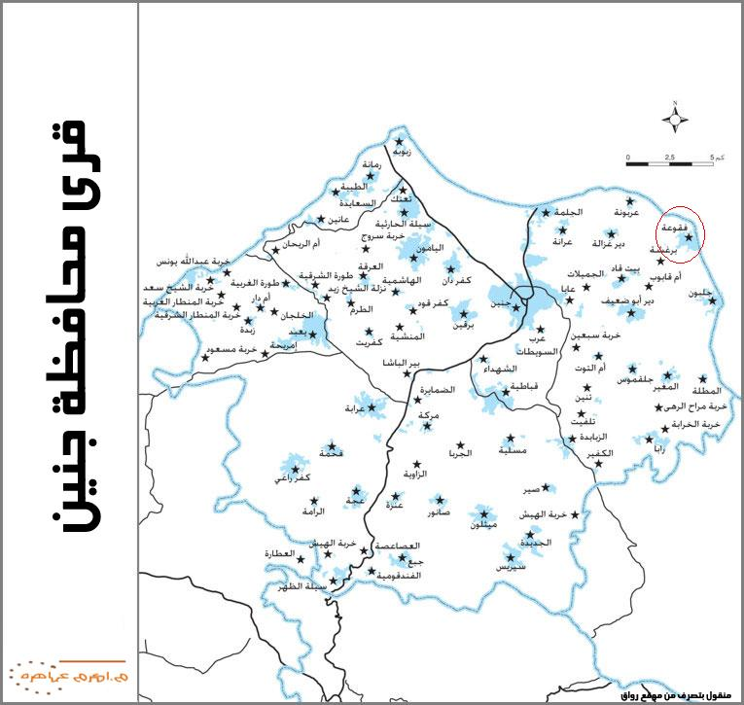

Figure2.1: location of Faqua

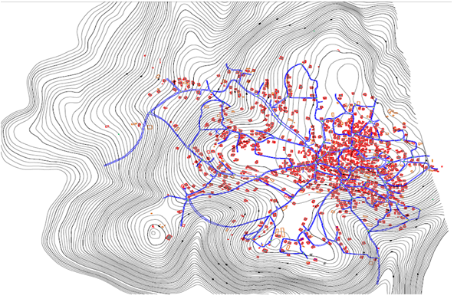
Figure 2.2: Topography of Faqua

Climate
The hydrology of a region depends on its climate, secondary on topography, geography and geology. Climate is largely dependent on the geographical position of earth. Faqua is located at 32o21l latitude and 35o32l longitudinal which makes the area under the influence of the Mediterranean climate that is characterized by a long, hot and dry summer and cool rainy winter.
Climate factors include precipitation, humidity, temperature, evaporation and solar radiation. These factors must be included in any water study to get a good indication about water situation.

1. Temperature
Climate characteristics are affected by temperature condition. In January the coldest month in Jenin the minimum temperature is recorded. But during August, the hottest month, the maximum temperature is recorded.
Figure2.3 shows Jenin meteorological station records of maximum, minimum and average air temperatures between 1997and 2008.
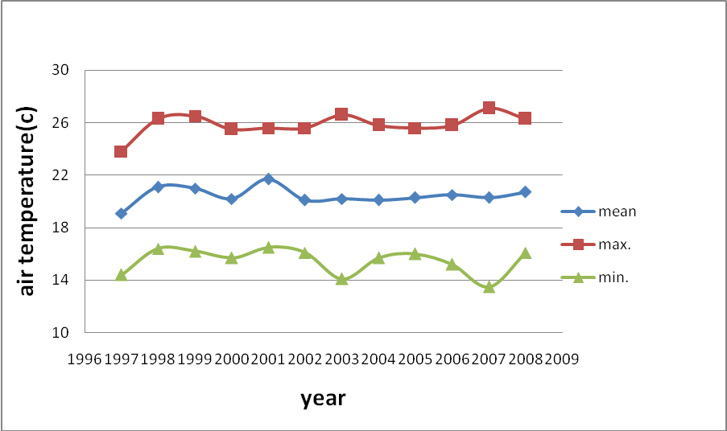
Figure2.3: Air Temperature as recorded by Jenin meteorological station (1997-2008)

2. Precipitation
The rainy season in Jenin district usually start in October and continues through May. Between December and February, almost 70% of the annual rainfall occurs, while 20% of the annual rainfall occurs in October and November.
Figure 2.4 shows the annual rainfall quantity from 1997 to 2008 according to Jenin meteorological station.
Figure2.4: Annual rainfall quantity from 1997-2008

3. Relative humidity
The relative humidity changes during the season, as illustrated by Figure 2.5 which shows the variation relative humidity in 2008. This Figure shows high relative humidity in Jenin which indicate that Jenin rich in agriculture.
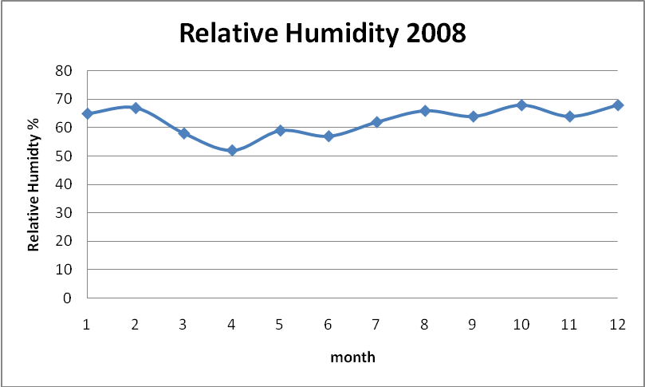
Figure2.5: Variation of the relative humidity in 2008

4. Evaporation
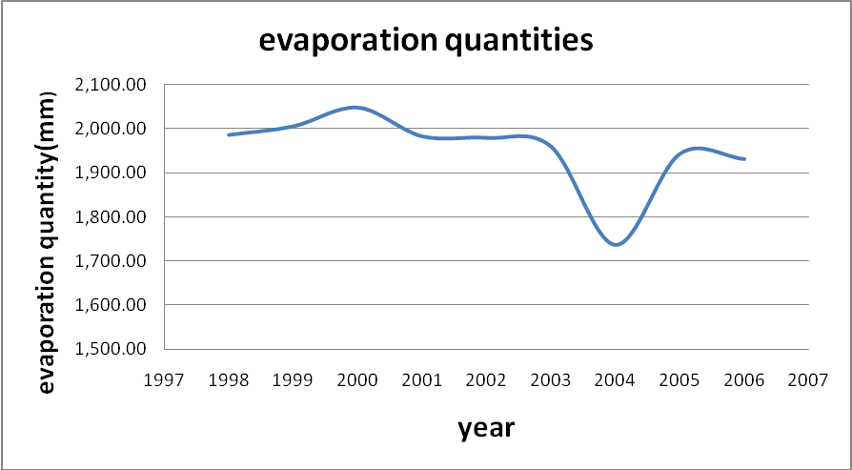
Evaporation quantities variation during 1997 to 2008 as recorded by Jenin metrological shown in Figure 2.6
Figure 2.6: Evaporation quantities as recorded by Jenin from 1997 to2008

Field study

Questionnaire
The field study is considered important step in the design and implementation of the water network project. The knowledge of the facts field gives you the impression of the nature of the region and its problems and thereby contributes to solving these problems.
Purpose of questionnaire
1 - Study the existing situation
2 - Knowledge of the services provided to citizens
3 - Knowledge of the health, environmental and social status in the village
4 - An important source of information that can be used during the study.
5 - Views the participation of citizens benefit from the citizens, take their suggestions.
6 - Strengthening the study.

The Questionnaire has been designed to include four sections.
These are:
1- Information about family.
2 - Information on the status of water in the village.
3 - Information on the disposal of wastewater.
4- General information.
The Questionnaire has been applied to a sample of 30 households. The following sections present the results and information obtained by questionnaire
1. Family studies
Based on the questionnaire the average size family in Faqua village is 5.5. According to the Palestinian Central Bureau of Statistics (PCBS, 2007), the average size of the family size in Faqua is 5.1 which is almost same as that obtained by the questionnaire. Figure 2.7 shows the distribution of the family size as obtained by the questionnaire.

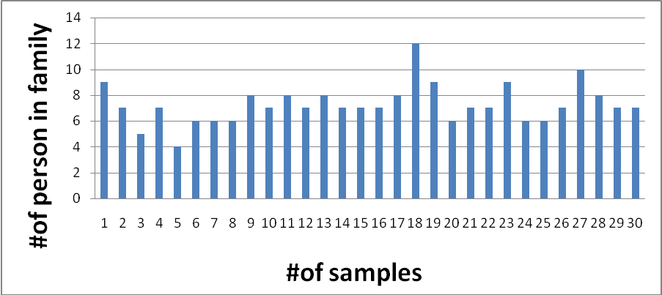
Figure 2.7: Distribution of the family size

2. Age distribution
According to PCBS 2007, the largest age class in Faqua is (15-65) at about 58% of total people in village. The second class is (0-14) at about 38% and the last class is more than 65 at about 4% as shown in Figure2.8.

Figure2.8: Age distribution in Faqua.
3. Level of education
According to the PCBS 2007, the level of education is divided into three groups:
1. Lower than Tawjehi (70%)
2. Tawjehi (18%)
3. Academic (university and high education) (12%)
Figure2.9 shows that most of Faqua populations are lower than Tawjehi.
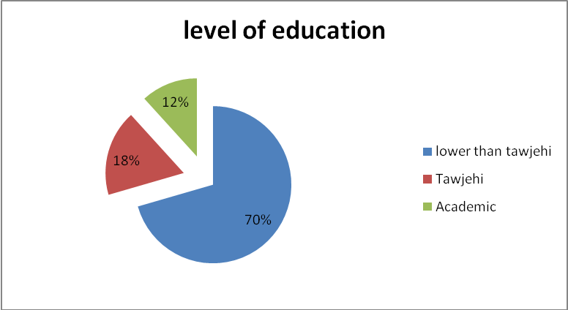

Figure2.9: Level of education in Faqua.
4. The average consumption water of water by person
Faqua purchase water from nearby private wells. Most of the rain collection cisterns are sufficiently used up to April of each year. About 33% claimed that they start purchasing water starting May, and 16% starting June.
Based on the questionnaire the average consumption per person shown in Table 2.1
Table 2.1: Average water consumption per person
#of persons/family | #of cubic purchased / month | average (l/c/d)
9 | 22 | 82
7 | 12 | 57
5 | 7 | 47
7 | 9 | 43
4 | 6 | 50
6 | 15 | 84
6 | 11 | 61
6 | 10 | 56
8 | 10 | 42
7 | 10 | 48
8 | 20 | 84
7 | 15 | 72
8 | 20 | 83
7 | 22 | 105
7 | 20 | 95
7 | 11 | 52
8 | 15 | 63
12 | 25 | 69
9 | 25 | 93
6 | 12 | 67
7 | 15 | 71
7 | 15 | 71
9 | 20 | 74
6 | 22 | 122
6 | 11 | 61
7 | 11 | 52
10 | 22 | 74
8 | 22 | 92
7 | 15 | 71
7 | 15 | 71
 |  | average
 |  | 70

CHAPTER 3
Population Forecast

Population Forecast
It is necessary to estimate the amount of water needed by the people who will be served. It is also important to estimate the number of people and the factors that affect their water consumption. Mainly the population growth and social-economic development control water demand for the different uses. When forecasting demand, the following assumptions are taken into consideration:
- Standard of living will be improved and the water consumption will increase.
- Population growth and this is a major factor that influences water demand increase.
The design period for this project is chosen to be 20 year. This is design period recommended for water supply system between 20-30 years.

Geometric growth method
Population of the Faqua is estimated to be 3700 capita according to PCBS (2007). The population growth rate can be calculated by taking the population between two period like 1997 and 2007 (2625 and 3700) respectively. And applying the geometric growth equation.
Pf=Pp (1+i) ^{n}……………………………………………………..........3.1
Where:
Pf: Future population (3700).
Pp: Present population (2625).
i: growth rate (3.5%).
n: number of years is designed for (10 years).
3700=2625(1+i) ¹⁰
Then i=3.5%.

Based on PCBS (1997) Faqua population were recorded at 2625 using a conservation growth rate 3.5% the estimated population 2007 was 3700 and forecast population in 2030 is 8168 capita.
Pf=Pp (1+i) ^{n}
Pf= 3700(1+3.5%) ²³ = 8168 capita.

Future water consumption
Since the population increase with time, the water consumption will increase. The consumption in Palestine increases with 2L per capita per one year. The design period for this project is 20 years and the present water consumption based on questionnaire is 70 L/c/d. The future water consumption will be 70+ (20*2) =110 L/c/d
We assume losses in the newly constructed water distribution network about (12-15)% estimated at about 15L/c/d then the design water supply is =110+15=125 L/c/d

Present Population density
Faqua can be divided in two different population densities in terms of the distribution of the houses within the village and from the village center and outside.
The town center as shown in Figure 3.1 has an area of 260 dounums. The estimated number of household is 350. According to PCBS the average of family size is 5.1 person/ family. Therefore the number of persons who live on old town is about 1800 persons. The density on the town center is 1800/260=7 persons/dounum
The second area is the rest of the village, which is about 1105 dounums has a present population of 3700-1800=1900 persons, the density on this region is the =1900/1105 = 2 person/dounum.

Future Population density
The future density in the center town will increase shortly, may be increase from 7 to 10 persons/dounum, then the population will become (1800+3*260)=2580 persons. This is because the area available to build is small and the changes in their density are small.
The future density in the rest of the town is = (total population in2030-population in old town in 2030)/ area of rest area.
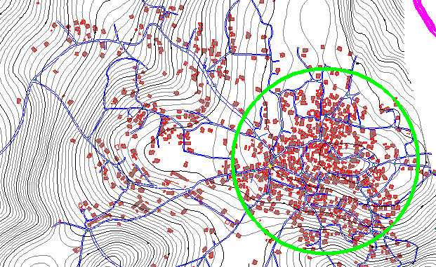
= (8168-2580)/1105 is estimated at 5 person/dounum.

Figure 3.1: The distribution of the houses within Faqua and the town center (old town)

CHAPTER 4
Water Distribution System

Water Distribution System

Water distribution systems
Water network is necessary to distribute water to the houses, state and public places by means of network , the distribution system consists of pipes of various sizes, valves, meters, pumps, distribution reservoirs and hydrants. Valves control the flow of water through the pipes. Meters are provided to measure the quantity of water consumed by individual as well as by the village. Hydrants are provided to connect water to the firefighting equipment during fire.
Service connection, are to connect the individual building and houses with the water line passing through the streets. Pumps are provided to pump the water to the elevated service reservoirs or directly to the water mains to obtain the required pressure in the pipelines.

Surface water may be come from the following resources:
A-ground water: by the recharge and well drilling.
B- Rain water: It is generally collected from the roots of the building and stored in wells for domestic consumption, but is rarely used directly for municipal supply.
C- River water: It must be properly treated due to pollution.

Water uses
Municipal water demand is commonly classified according to the nature of the use. According to the Palestinian Water Authority the ordinary classifications are:-
1 - Domestic: - water furnished houses, hotels, culinary and other purposes. Use varies with economical level of the consumer, the range in Palestine being 40 to 200 l\c\d (Litter per capita par day). As to the WHO the recommended water demand is 150 l/c/d.

2 – Commercial and industrial: water furnished to industrial and commercial establishment such as factories and offices. The importance of this depend on whether there are large industries and weather the industries obtain their water from the municipality.
3 - Public use: water furnished to public building and use for public services.
4 - Loss and waste: water, which is uncounted for in the sense that it is not assigned to specific user.
5 – Uncounted for water: is attributed to errors in meter readings, unauthorized connection, and leaks in the distribution system.
6 – Agricultural: for farms farmhouses, livestock, dairies, greenhouses, spray irrigation, etc.
The total consumption is the sum of the individual elements listed above.

Water Demand
The average daily per capita water consumption in Palestine cities range from (40 to 200) l\c\d (typical value is 150 l\c\d). Local use depends upon such factors as the size of the community, presence of industrial quality of the water, its costs, its pressure, water fees, the climate characteristics of population and the efficiency with which the system is maintained. It is often difficult to obtain accurate measurement of consumption because standards of supply and maintenance.
Vary widely though the world, reported losses may vary from 5% to 55% of the supply; meters may not register correctly; supplies may intermittent; and consumers may waste if their plumbing systems are not of a proper standard.

Water distribution methods
Water is distributed to the consumers in different ways, as local conditions or other considerations may dictate. The methods are:-
1 – The gravity distribution : This is possible when the of supply is a lake or reservoir at some elevation above the city so that sufficient pressure can be maintained in the mains for domestic and fire services and this is the most satisfactory means of water distribution. It is common in small distribution areas because of one slope direction, more economic and easier in execution than the others. The advantages of the gravity system that there is no operating energy cost, simple operation, low maintenance cost and no sudden pressure change compared to pumping system.
Disadvantages of the system are that it is less flexible for future extension and needs larger diameters due to small gradient available.

2- Distribution by means of pumps: water is pumped directly into the mains. The variation in water consumptions affects the pressures in the mains. A number of pumps of varying capacities are installed and they have to be put in operation according to the water requirements .This method requires careful operation and good maintenance.
3- Combined distribution system: It operates with reservoirs and pumping stations. The storage, with a considerable volume is provided for balancing of daily variation in consumption. In this method the excess water is pumped during periods of low consumption and is stored in elevated tanks or reservoirs. This method allows fairly uniform rates of pumping and hence is economical. It is for large distribution areas.

The pipe in a water network consists of the following different pipes:
1- Primary feeders: They are used to carry large quantity of water from the pumping station to the storage tank and from the tank to the different areas to be served. It should have valves not over 1.5 km apart and mains connecting to them should also be valves to be closed in the emergency cases.
2- Secondary feeder: They carry large quantities of water to the supply area, which are feed enough for the normal uses and fire fighting.
3- Small distribution mains: Are mains from a network over the area, which will be served. This will supply water to the service pipe of the residence and the fire hydrants. The pipe sizes are determined usually by the fire flow requirements.
4- Service pipe: Individual supply lines to houses, farms, block of flat and underground from main to the building.
5- Plumping pipes: Pipes within a building through the distribution of water to variance application.
The demand of water varies according to a number of factors:
1- The physical limitations of the distribution system.
2- The type of supply afforded.
3- The extent of leakage.
4- The amounts of consumers are called upon to pay for their water.
5- The price of supply to the consumer.
The “standard” conditions of reasonable demand that will meat the needs of the majority of consumers may said to be as follows:
1- The supply must be a full 24-hour supply.
2- The source meters must register correctly.
3- The distribution system must be in a good condition, regularly surveyed for leakage and overflows and regularly maintained.
4- The meters to individual consumers must be regularly maintained and read.
5- The plumping systems of consumers must be a good standard and likely to consumers keep these plumping systems in good repair.
6- No large number of authorized connections to main should exist and no large quantities of water should be made available free of charge (as for watering streets, public gardens, flushing sewers).
7- The price of water must not be low that consumers pay, no attention to waste, or so high, that many consumers cannot afford to take what they reasonable require.
8- The water authority must regularly ensure that all consumers do not unnecessarily waste or misuse water and that pay the due charge for water used.

Pressure and velocities
There are wide differences in the pressure maintained in the distribution system in various sites. For ordinary service they range from 130 to 150 kpa (20-40m) In residential districts having houses not over four heights and about 400 kpa are used for five fighting and 500 kpa for commercial districts. The American water works association recommends a static normal pressure of 400 to 500 kpa as a representative value.
Velocities in the pipe should not exceed 0.1 to 2 m\s to control corrosion of the pipes.
According to the Palestinian Water Authority, velocity and pressure limits are as follows:-
• The velocities her are in the range of (0.1-2) m\s.
• The pressure limits are in the range of (20-70) m.
And these data were taken from Palestinian Water Authority, planning and design guidelines.

Pipelines
Preliminary estimates for the size of pipes in the distribution system are frequently based on experience. When the rate of flow is know, the diameter can be determined by assuming a velocity between limiting values.
There are three requirements for a pipeline mainly:-
1 - It must convey the quantity of water requirements.
2 - It must resist external and internal force coming upon it.
3 – It must be durable and have a long life.
The following types of pipe are in use construction of mains:
1- Cost iron pipe.
2-A asbestos cement pipe.
3- Steel pipe.
4- Pretested concrete pipe.
- Rigid PVC pipe

Valves
There are several type of valves, which may be in a typical pressurized system. These valves have different behavior and different responsibilities, but all valves are used automatically controlling parts of the system opening and closing or throttling to achieve the desired result. System as following:
1- Check valves (CVS).
Check valves are used to minting flow in one direction only , by closing when the flow begins to reverse when the flow is in the specified direction of the check valves , it is consider to be fully opine . Check valves are added to the network on a pipe element
2- Flow control valves (FCVS):
A flow control valves limits the flow rate through the valve to a specified valve in specified direction, the valves are commonly found in areas where a water district or private developer to limit the maximum demand to a value that will not adversely affect the provider system.
3- Pressure reducing valves (PSVS).
Pressure reducing valves are often used to separate pressure zones in water distribution network. These valves prevent the pressure downstream from exceeding a specified level, to avoid pressure, which could otherwise have damaging effects in the system.
4- Pressure sustains valves (PSVS):
Pressure sustain valves maintain a specified pressure upstream from valve. Similar to the other regulating valves, these are often used to insure that pressure in the system will not drop to unacceptable level.
5- Pressure breaker valves (PBVS):
- Pressure breaker valves create a specified head loss across the valve.

CHAPTER 5
Simulation Model (Water CAD)

Simulation Model (Water CAD)

Acknowledgements
Water CAD and were designed, developed and programmed by Harvested Methods’ staff of software Engineers and civil Engineers. These programs are intended to represent the state of-the-art for stand alone, Windows based, Water Distribution Analysis and Design.
Water Cad’s numerical computation are based on research conducted by the U.S. Environmental Protection agency (EPA), drinking water research division, risk reduction engineering laboratory, is employees and its consultants. As a result, water cad --- will generate results consistent with versions of the EPA computer program (EPANET).
Water cad is powerful, yet easy to use program that helps engineer’s design and analyze complex pressurized piping systems. You can use water cad to:
- Perform steady state analyses of water distribution systems with pumps, tanks, and control valves.
- Perform water quality simulations and determine the water source and age, or track the growth or decay of a chemical constituent throughout the network.

Graphical editor
Use Water cad’s powerful CAD-like interface to quickly and easily layout a complex network of pipes, tanks, pumps, and more Scenario Managers.
Create multiple sets of hydraulic alternatives, physical property alternatives, operational alternatives, initial setting alternatives, fire flow alternatives, and water quality alternatives. Create and run any number of scenarios, then view and compare the results quickly and easily with water cad’s flexible scenario management feature.

Network hydraulics theory
In practice pipe networks consist not only of pips, but also miscellaneous fittings, services, storage tanks and reservoirs, meters, regulating valves, pumps, and electronic and mechanical controls. For modeling purposes, these system elements are most commonly organized into three fundamental categories:-
- Junction’s Nodes: Junction is specific point (nodes) in the system at which an event of interest is occurring. This includes points where pipes intersect, major demands on the system (such as a large industry, a cluster of houses, or a fire hydrant), or critical points in the system where pressures are important for analysis purposes.
- Boundary Nodes: Boundaries are nodes in the system of known hydraulic grade, which define the initial hydraulic grades for any computational cycle. They from the baseline hydraulic constraints used to determine the condition of all other nodes during system operation. Boundary nodes are elements such as tanks, reservoirs, and pressure sources.
- Links: Links include pipes, pumps, and various valves. These are system components, which connect to junctions or boundaries, and control the flow rates and energy losses (or gains) between nodes.

Equations used in Water cad

Hazen-Williams Equation:
The Hazen-Williams equation is the most frequently used in the design and analysis of pressure pipe systems for water distribution. The equation was developed experimentally and therefore should not be used for fluids other than water (within temperatures normally experienced in potable water distribution systems)
The Hazen-Williams equation includes a roughness factor, C, which is constant over a wide range of (turbulent) flows. There is also an empirical constant, which is different for the U.S. standard (English) and S.I. units.

This results in the following two representations of the Hazen-Williams equation:
Where hf is the head loss (ft, m)
L is the pipe length (ft, m)
D is the pipe diameter (ft, m)
V is the velocity (ft/s, m/s)
C is the Hazen-Williams friction coefficient

Darcy-Weisbach Equation:
Darcy-Weisbach equation is a theoretically based equation for use in the analysis of pressure pipe systems. It is a general equation that applies equally well to any flow rate and any incompressible fluid. The Darcy-Weisbach equation is:
Where hf is the head loss (ft,m)
L is the pipe length (ft, m)
D is the pipe diameter (ft, m)
V is the velocity (ft/s, m/s)
f is the Darcy-Weisbach friction factor

Manning’s Equation:
The manning equation is most frequently used in the analysis of water flow in open channels, but can be applied to water flow in closed conduits as well. The resistance component of this equation includes a factor, n, which is generally a function of pipe material and condition. The manning’s equation is as follows:
Where hf is the head loss (ft,m)
L is the pipe length (ft, m)
RH is the hydraulic radius, A/WP (ft, m)
V is the velocity (ft/s, m/s)
n is the Manning’s friction coefficient
RH is the hydraulic radius, A/WP (ft, m)
A is the cross sectional area (ft2, m2)
WP is the wetted perimeter (ft, m)

Typical roughness values
Typical pipe roughness values are shown below. Of course, these values may vary depending on the manufacturer, workmanship, age, and many
Material |  |  | Manning’s Coefficlent n | Hazen-williams C | Darcy-Weisbach Roughness Height
 |  |  |  |  | K(mm) | K(ft)
Asbestos cement |  |  | 0.011 | 140 | 0.0015 | 0.000005
Brass |  |  | 0.011 | 135 | 0.0015 | 0.000005
Brich |  |  | 0.015 | 100 | 0.6 | 0.002
Cast-iron, new |  |  | 0.012 | 130 | 0.26 | 0.00085
Concrete: | Steel forms |  | 0.011 | 140 | 0.18 | 0.006
 | Wooden forms |  | 0.015 | 120 | 0.6 | 0.002
 | Centri fug ally spun |  | 0.013 | 135 | 0.36 | 0.0012
Copper |  |  | 0.011 | 135 | 0.0015 | 0.000005
Cooru gated metal |  |  | 0.022 | ------- | 45 | 0.15
Galvanized iron |  |  | 0.016 | 120 | 0.15 | 0.0005
Glass |  |  | 0.011 | 140 | 0.0015 | 0.000005
Lead |  |  | 0.011 | 135 | 0.0015 | 0.000005
Plastic |  |  | 0.009 | 150 | 0.0015 | 0.000005
Steel: |  | Coal-tar enamel | 0.010 | 148 | 0.0048 | 0.000016
 |  | New unlined | 0.011 | 145 | 0.045 | 0.00015
`

Advantages of water cad
1-Easy to enter the data and the output is very simple and easy to read and understand.
2- It can accept AutoCAD files, and so we do not provide all coordinate but only the z-coordinate.

CHAPTER 6
Design and Analysis

Design and analysis
In this project the demand was calculated using Thiessen Polygons method

Generating Thiessen Polygons
A Thiessen polygon is a Voronoi Diagram that is also referred to as the Dirichlet Tessellation. Given a set of points, it defines a region around each point. A Thiessen polygon divides a plane such that each point is enclosed within a polygon and assigns the area to a point in the point set. Any location within a particular Thiessen polygon is nearer to that polygon's point than to any other point. Mathematically, a Thiessen is constructed by intersecting perpendicular bisector lines between all points.
Thiessen polygon has many applications in different location-related disciplines such as business planning, community services, transportation and hydraulic/hydrological modeling. For water distribution modeling, the Thiessen Polygon Creator was developed to quickly and easily define the service areas of demand nodes. Since each customer within a Thiessen polygon for a junction is nearer to that node than any others, it is assumed that the customers within a particular Thiessen polygon are supplied by the same demand node. Figure 6.1shows Thiessen polygon for Faqua village
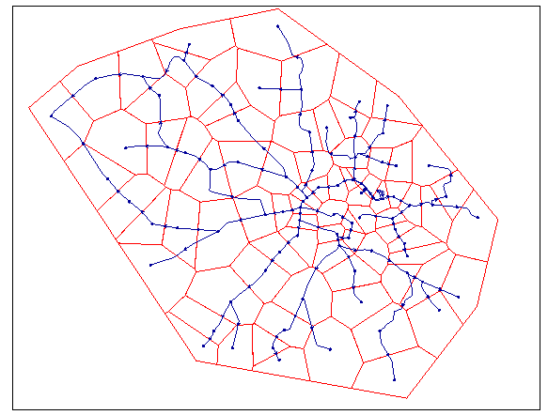

Figure 6.1: Thiessen polygon for Faqua village
Table 6.1: area and demand and elevation for each node
Nods # | Area (dunom) | Elevation (m) | Density (prn/donm) | Persons | Base Demand (L/d) | Demand (m3/d)
1 | 23.7 | 356.2 | 5 | 119 | 14813 | 15
2 | 18.84 | 400.3 | 5 | 95 | 11778 | 12
3 | 25.94 | 401 | 5 | 130 | 16214 | 17
4 | 22.61 | 403.5 | 5 | 114 | 14130 | 15
5 | 36.43 | 397 | 5 | 183 | 22772 | 23
6 | 17.01 | 395 | 5 | 86 | 10630 | 11
7 | 29.21 | 395.7 | 5 | 147 | 18260 | 19
8 | 15.09 | 400.4 | 5 | 76 | 9432 | 10
9 | 30.73 | 386 | 5 | 154 | 19208 | 20
10 | 22.3 | 371 | 5 | 112 | 13939 | 14
11 | 17.84 | 385.5 | 5 | 90 | 11151 | 12
12 | 23.2 | 398 | 5 | 117 | 14502 | 15
13 | 18.76 | 403.2 | 5 | 94 | 11725 | 12
14 | 11.61 | 407 | 5 | 59 | 7255 | 8
15 | 20.08 | 406 | 5 | 101 | 12554 | 13
16 | 27.27 | 402.2 | 5 | 137 | 17044 | 18
17 | 20.58 | 400 | 5 | 103 | 12863 | 13
18 | 23.69 | 394.5 | 5 | 119 | 14807 | 15
19 | 16.41 | 414.5 | 10 | 165 | 20513 | 21
20 | 5.85 | 416 | 10 | 59 | 7312 | 8
21 | 10.55 | 404.5 | 10 | 106 | 13188 | 14
22 | 14.43 | 416.5 | 10 | 145 | 18042 | 19
23 | 3.57 | 419.5 | 10 | 36 | 4464 | 5
24 | 8.54 | 414 | 10 | 86 | 10674 | 11
25 | 4.49 | 418 | 10 | 45 | 5616 | 6
26 | 3 | 417.2 | 10 | 30 | 3747 | 4
27 | 12.39 | 402 | 10 | 124 | 15489 | 16
28 | 6.33 | 413.8 | 10 | 64 | 7919 | 8
29 | 4.9 | 418 | 10 | 49 | 6125 | 7
30 | 10.33 | 408 | 10 | 52 | 6457 | 7
31 | 8.99 | 417 | 10 | 90 | 11243 | 12
32 | 7.4 | 422.5 | 10 | 74 | 9249 | 10
33 | 3.73 | 428 | 10 | 38 | 4660 | 5
34 | 5.25 | 431 | 10 | 53 | 6561 | 7
35 | 6.58 | 431 | 10 | 66 | 8230 | 9
36 | 6.73 | 433 | 10 | 68 | 8413 | 9
37 | 6.44 | 423.8 | 10 | 65 | 8050 | 9
38 | 4.95 | 424.2 | 10 | 50 | 6187 | 7
39 | 16.79 | 410.5 | 5 | 84 | 10493 | 11
40 | 19.05 | 411 | 5 | 96 | 11909 | 12
41 | 16.71 | 405 | 5 | 84 | 10446 | 11
42 | 16.65 | 400.5 | 5 | 84 | 10405 | 11
43 | 26.95 | 386 | 5 | 135 | 16844 | 17
44 | 28.96 | 375 | 5 | 145 | 18102 | 19
45 | 32.79 | 368 | 5 | 164 | 20494 | 21
46 | 17.04 | 382 | 5 | 86 | 10649 | 11
47 | 19.56 | 395.5 | 5 | 98 | 12225 | 13
48 | 11.29 | 402 | 5 | 57 | 7059 | 8
49 | 16.67 | 407 | 5 | 84 | 10420 | 11
50 | 15.1 | 419 | 10 | 151 | 18875 | 19
51 | 4.25 | 421 | 10 | 43 | 5316 | 6
52 | 4.77 | 423.5 | 10 | 48 | 5960 | 6
53 | 7.08 | 426 | 10 | 71 | 8857 | 9
54 | 4.66 | 429 | 10 | 47 | 5823 | 6
55 | 7.48 | 431 | 10 | 75 | 9356 | 10
56 | 10.45 | 422 | 10 | 105 | 13064 | 14
57 | 9.49 | 425.8 | 10 | 95 | 11859 | 12
58 | 5.48 | 426.4 | 10 | 55 | 6850 | 7
59 | 8.6 | 426.5 | 10 | 87 | 10756 | 11
60 | 9.8 | 423 | 10 | 99 | 12252 | 13
61 | 8.3 | 425 | 5 | 42 | 5185 | 6
62 | 12 | 424 | 10 | 121 | 15006 | 16
63 | 15.69 | 421.8 | 5 | 79 | 9806 | 10
64 | 10.19 | 427 | 5 | 51 | 6369 | 7
65 | 12.21 | 424 | 5 | 62 | 7631 | 8
66 | 25.41 | 422.7 | 5 | 128 | 15881 | 16
67 | 12.05 | 405 | 5 | 61 | 7531 | 8
68 | 26.58 | 382.7 | 5 | 133 | 16612 | 17
69 | 36.6 | 372.6 | 5 | 183 | 22874 | 23
70 | 29.43 | 384 | 5 | 148 | 18392 | 19
71 | 36.74 | 348.5 | 5 | 184 | 22962 | 23
72 | 51.83 | 354 | 5 | 260 | 32392 | 33
73 | 22.76 | 411 | 5 | 114 | 14225 | 15
74 | 30.82 | 420.5 | 5 | 155 | 19262 | 20
75 | 17.12 | 424 | 5 | 86 | 10701 | 11
76 | 45.34 | 413.5 | 5 | 227 | 28337 | 29
77 | 34.19 | 382 | 5 | 171 | 21369 | 22
78 | 28.3 | 391 | 5 | 142 | 17690 | 18
79 | 28.65 | 416 | 5 | 144 | 17908 | 18
80 | 17.84 | 421 | 5 | 90 | 11150 | 12

After drawing these polygons by using GIS we can find areas for each node, and then each area will be multiplied by density.
For example to calculate nodal demand,
=area (donums) x density (capita/donum) x demand (L/c/d)
For node 2= 18.84 x 5 x 125=11775 L/d

Design criteria
The design criteria used to analyze the result of water CAD runs can be summarized in the
1-The pressure is not exceeding 100 m to prevent erosion to the pipes and to prevent the increase of leakage.
2- The pressure is not to be less than 20 m to allow water to reach the roof tank.
3- The velocity is not to be exceeding 2 m/s to prevent pipes erosion and to prevent high head loss.
4- The velocity is not to be less than 0.1m/s to prevent deposition in the pipes.

Methodology applied
1- Bring the map and climatic and hydrological data from Faqua municipality. These maps are available as AutoCAD files
2- Layout of proposed net work was prepared on map taken into consideration that pipes must be laid in Main Street as possible.
3- Taking consideration the possibility of supplying water to all houses.
4- A questionnaire was applied to estimate water supply and consumption of the village.
5- The present demand was estimated.
6- The questionnaire gives indication about the nature of the population and the use of water, it was found that the present demand id 70 L/c/d.
7- the future demand based on the assumption that there is increase 2 letter per year in the Palestine and add losses in network =15 L/c/d ,so the future demand is 70+(20*2)+15 = 125 L/c/d
8- From questionnaire and self research, it found that two population densities were applied in the village; the old town at (10 c/donum) , and the rest of the village (5 c/donum) .
9- The demand for each nod was estimated by Thiessen Polygons method which gives each node the serve area by it then this area multiplied by the population densities and per capita per day consumption. This method explained before.
10- The elevation for each node was calculated by AutoCAD map and contour lines.
11- The layout of network was prepared as AutoCAD file.
12- WaterCAD then used to model the proposed network.
13- The calculated demand and the suggested diameter for every node and pipe were entered.
14- The output of the WaterCAD was checked for the velocity of the water for every pipe and pressure at every node.

Data processing and results

Introduction
In design a new sustainable water distribution network it must satisfy the design criteria and deliver water for all houses in sufficient quality, quantity and, lowest price. The project was planned to serve the area for 20 years so the demand for this projection was taken in consideration and the design and analysis based on the future demand and pollution.
Study, analysis and design of the water distribution system at Faqua carried out. The total length of the pipes in the proposed network was estimated at about 8841m with pipes diameters of 8” 6”, 4”, 3”, 2”, and 1”.
The system is get water from an elevated reservoir has an elevated of 449m AMSL and ground reservoir has an elevated of 435m AMSL and both distribute water by gravity to all part of the system.

The junctions in the system
To study the water supply system using water CAD, many nodes was located in the system;
At the start of link
At the end of link
At the inter section of pipes
When there is difference in pipe diameter
The Table 6.2 shows the different nodes, and the elevation of each node.
From Table 6.2 we find that: All nodes were marked, the first node has ID of J-1 and label and the last one has ID of J-80 and label Elevation of each node was from the contour map of Faqua

Table 6.2: Elevation of each node
Label | Elevation (m) | Label | Elevation (m)
J-1 | 356.2 | J-42 | 400.5
J-2 | 400.3 | J-43 | 386
J-3 | 401 | J-44 | 375
J-4 | 403.5 | J-45 | 368
J-5 | 397 | J-46 | 382
J-6 | 395 | J-47 | 395.5
J-7 | 395.7 | J-48 | 402
J-8 | 400.4 | J-49 | 407
J-9 | 386 | J-50 | 419
J-10 | 371 | J-51 | 421
J-11 | 385.5 | J-52 | 423.5
J-12 | 398 | J-53 | 426
J-13 | 403.2 | J-54 | 429
J-14 | 407 | J-55 | 431
J-15 | 406 | J-56 | 422
J-16 | 402.2 | J-57 | 425.8
J-17 | 400 | J-58 | 426.4
J-18 | 394.5 | J-59 | 426.5
J-19 | 414.5 | J-60 | 423
J-20 | 416 | J-61 | 425
J-21 | 404.5 | J-62 | 424
J-22 | 416.5 | J-63 | 421.8
J-23 | 419.5 | J-64 | 427
J-24 | 414 | J-65 | 424
J-25 | 418 | J-66 | 422.7
J-26 | 417.2 | J-67 | 405
J-27 | 402 | J-68 | 382.7
J-28 | 413.8 | J-69 | 372.6
J-30 | 408 | J-70 | 384
J-31 | 417 | J-71 | 348.5
J-32 | 422.5 | J-72 | 354
J-33 | 428 | J-73 | 411
J-34 | 431 | J-74 | 420.5
J-35 | 431 | J-75 | 424
J-36 | 433 | J-76 | 413.5
J-37 | 423.8 | J-77 | 382
J-38 | 424.2 | J-78 | 391
J-39 | 410.5 | J-79 | 416
J-40 | 411 | J-80 | 421
J-41 | 405

The links in the system
The links (pipes) in the system are also identified on the model. Each link consists of pipe between two nodes. The link has one diameter size. In the designed water distribution system of Faqua village, HDPE pipe of diameter ranging from 6 to1 inch were used. The ID is given to links and nodes as shown in table 6.3.
Table 6.3: links and nodes
Label | Scaled Length (m) | Diameter (in) | Start Node | Stop Node
P-1 | 184.83 | 1 | J-71 | J-72
P-2 | 149.35 | 2 | J-72 | J-45
P-7 | 171.98 | 2 | J-45 | J-46
P-8 | 53.41 | 1 | J-46 | J-77
P-11 | 122.16 | 2 | J-46 | J-47
P-18 | 59.63 | 2 | J-41 | J-42
P-19 | 171.63 | 2 | J-42 | J-44
P-23 | 268.62 | 1 | J-70 | J-71
P-27 | 126.5 | 4 | J-22 | J-25
P-28 | 37.72 | 3 | J-25 | J-24
P-31 | 65.43 | 1 | J-38 | J-37
P-32 | 48.45 | 1 | J-37 | J-26
P-34 | 48.59 | 3 | J-22 | J-21
P-36 | 149.61 | 2 | J-13 | J-7
P-37 | 152.8 | 2 | J-7 | J-4
P-38 | 105.47 | 2 | J-7 | J-6
P-42 | 161.45 | 3 | J-19 | J-15
P-44 | 238.71 | 1 | J-15 | J-69
P-45 | 128.43 | 2 | J-15 | J-16
P-47 | 80.1 | 2 | J-16 | J-17
P-60 | 133.33 | 2 | J-30 | J-28
P-62 | 93.48 | 2 | J-24 | J-27
P-65 | 234.73 | 2 | J-10 | J-30
P-66 | 55.65 | 2 | J-30 | J-67
P-69 | 77.87 | 2 | J-64 | J-35
P-70 | 155.72 | 1 | J-64 | J-79
P-72 | 168.38 | 2 | J-65 | J-66
P-78 | 126.44 | 2 | J-57 | J-61
P-80 | 173.93 | 3 | J-60 | J-57
P-83 | 209.15 | 2 | J-24 | J-12
P-84 | 195.81 | 1 | J-12 | J-9
P-86 | 118.64 | 2 | J-12 | J-8
P-87 | 72.08 | 2 | J-8 | J-3
P-93 | 233.65 | 2 | J-74 | J-76
P-101 | 41.19 | 6 | J-22 | J-23
P-102 | 38.47 | 6 | J-51 | J-23
P-112 | 122.6 | 2 | J-63 | J-56
P-113 | 153.26 | 2 | J-74 | J-63
P-115 | 44.74 | 1 | J-59 | J-58
P-116 | 94.71 | 2 | J-58 | J-57
P-121 | 101.42 | 2 | J-70 | J-18
P-122 | 99.57 | 2 | J-18 | J-17
P-123 | 56.56 | 3 | J-19 | J-20
P-124 | 56.78 | 6 | J-20 | J-23
P-125 | 77.06 | 2 | J-21 | J-14
P-126 | 73.21 | 2 | J-14 | J-13
P-128 | 58.21 | 2 | J-6 | J-5
P-133 | 41.56 | 1 | J-3 | J-2
P-134 | 165.27 | 1 | J-10 | J-1
P-136 | 107.12 | 1 | J-11 | J-27
P-141 | 41.71 | 1 | J-31 | J-32
P-142 | 35.06 | 2 | J-34 | J-33
P-143 | 53.23 | 1 | J-33 | J-32
P-145 | 56.76 | 4 | J-36 | J-35
P-148 | 92.45 | 3 | J-40 | J-39
P-149 | 96.45 | 2 | J-39 | J-41
P-151 | 130.88 | 2 | J-42 | J-43
P-153 | 81.41 | 2 | J-44 | J-45
P-154 | 84.29 | 2 | J-47 | J-48
P-156 | 52.8 | 2 | J-48 | J-49
P-158 | 132.26 | 2 | J-74 | J-73
P-160 | 52.73 | 1 | J-61 | J-75
P-161 | 61.29 | 2 | J-65 | J-64
P-162 | 109.1 | 1 | J-68 | J-67
P-163 | 122.72 | 1 | J-67 | J-78
P-165 | 123.73 | 2 | J-57 | J-62
P-166 | 87.3 | 1 | J-62 | J-80
P-167 | 237.33 | 3 | J-49 | J-50
P-168 | 159.25 | 3 | J-50 | J-40
P-169 | 92.55 | 4 | J-51 | J-50
P-174 | 19.12 | 1 | J-132 | J-55
P-176 | 19.89 | 4 | T-elevated | J-133
P-177 | 72.2 | 4 | J-133 | J-132
P-178 | 35.02 | 4 | J-133 | J-36
P-181 | 103.53 | 3 | J-24 | J-28
P-184 | 67.49 | 3 | J-34 | J-35
P-193 | 49.7 | 3 | J-132 | J-54
P-194 | 72.87 | 3 | J-54 | J-57
P-195 | 294.01 | 8 | T ground | J-51
P-196 | 55.42 | 1 | J-54 | J-53
P-197 | 57.31 | 1 | J-53 | J-52
P-198 | 130.82 | 2 | J-34 | J-37
P-200 | 54.83 | 2 | J-60 | J-63

Analysis of the system under the stress of the future demand where Q _{design} =3Q _{average}
To deign this system the hydraulics calculation was done using waterCAD software. To do that the demand and diameter was inserted for each node and pipe.

Information that must be insert to model
- In Junction
- Demand
- elevation
Demand input
Demand was inserted for each node as shown in this Figure 6.2.
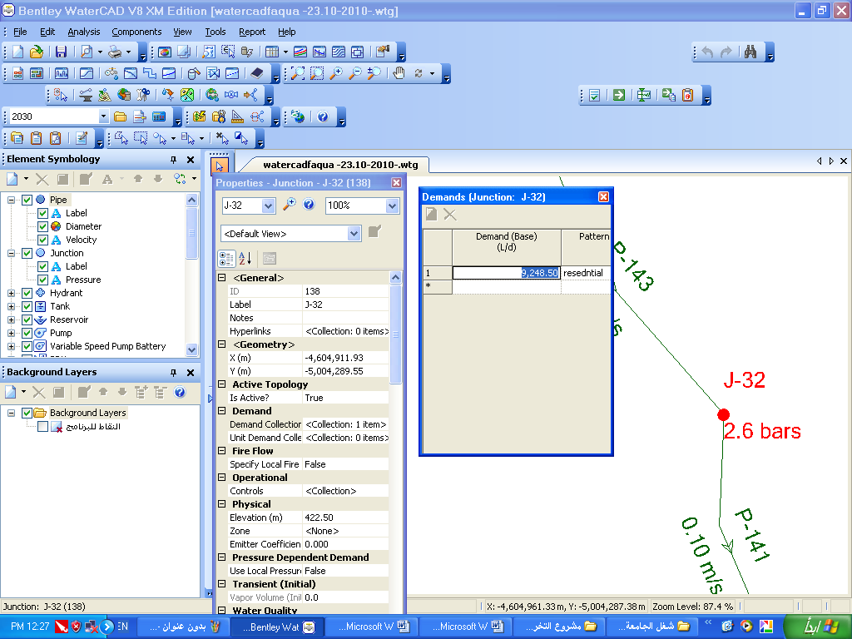
Figure 6.2: demand allocation at the junction in network

2- Pipe
A) Hazen-William coefficient.
B) Material.
C) Section size (diameter).
Diameter proposed for each pipe was estimated to check its suitability for pressure at nodes and velocity in the pipes as shown in Figure 6.3.
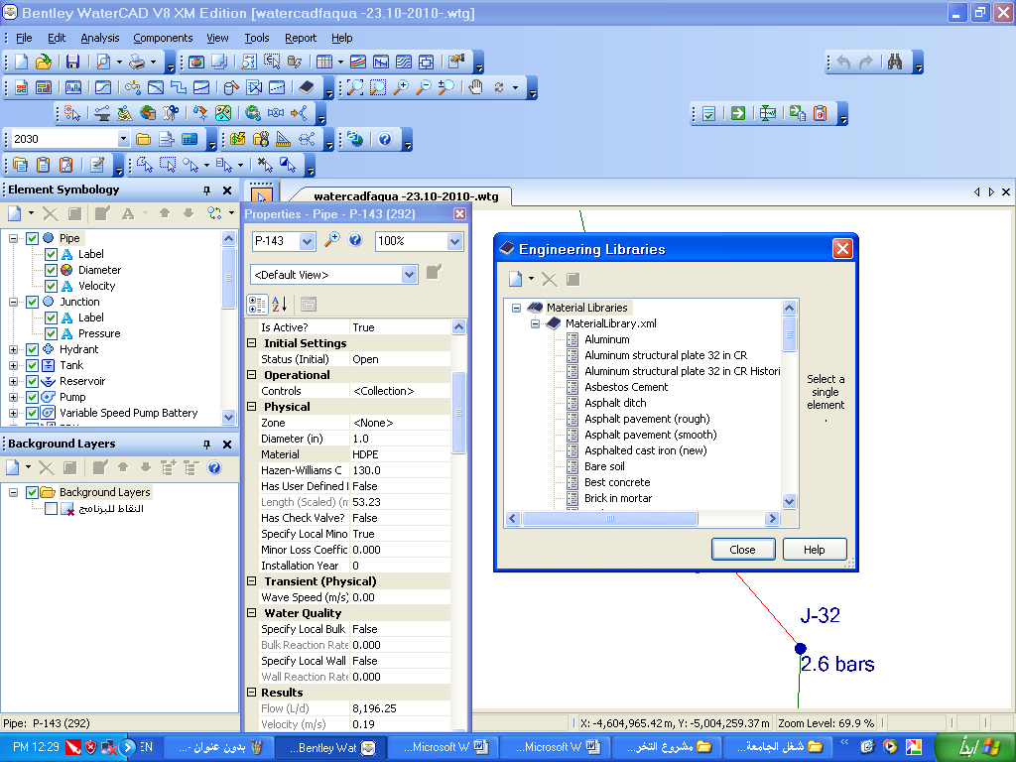

Figure 6.3: Diameter proposed for each pipe
3- In Tank:
A) Elevation (Base, Min., Max., Initial, Alarm).
B) Section.
C) Dimension.
D) Volume.
4- Distribution hourly factor
When we design network distribution demand is variable by time so we multiply demand by hourly factor. When we find the result we choose beak hourly factor to find ultimate demand for each node as shown in Figure 6.4

Figure 6.4: Distribution hourly factor
We divide the network into two parts, first part provide elevated areas which get water from an elevated reservoir at 449m AMSL. Second part provides low areas which get water from ground reservoir has an elevated of 435m AMSL. Both distribute water by gravity to all part of the system. In this network we design two tanks the first one is on ground and the second is elevated 15m above the ground , capacity of ground water tank =1500 m3 and capacity of elevated tank =500 m3

Layout of water distribution network

CHAPTER 7
Data Result

Data Result

Pipe result
Table 7.1: the results of the analyses of proposed network diameter
These result at Q _{design} =3Q demand
Label | Scaled Length (m) | Diameter (in) | Flow (L/d) | Velocity (m/s)
P-1 | 184.83 | 1 | -33,155.33 | 0.76
P-2 | 149.35 | 2 | -130,329.08 | 0.74
P-7 | 171.98 | 2 | -99,736.80 | 0.57
P-8 | 53.41 | 1 | 64,106.25 | 1.46
P-11 | 122.16 | 2 | -195,787.79 | 1.12
P-18 | 59.63 | 2 | 228,122.76 | 1.3
P-19 | 171.63 | 2 | 146,378.40 | 0.84
P-23 | 268.62 | 1 | 35,730.29 | 0.82
P-27 | 126.5 | 4 | 615,423.86 | 0.88
P-28 | 37.72 | 3 | 598,576.27 | 1.52
P-31 | 65.43 | 1 | -18,560.25 | 0.42
P-32 | 48.45 | 1 | 11,239.13 | 0.26
P-34 | 48.59 | 3 | 293,871.75 | 0.75
P-36 | 149.61 | 2 | 197,370.37 | 1.13
P-37 | 152.8 | 2 | 42,387.37 | 0.24
P-38 | 105.47 | 2 | 100,204.86 | 0.57
P-42 | 161.45 | 3 | 331,324.80 | 0.84
P-44 | 238.71 | 1 | 68,621.25 | 1.57
P-45 | 128.43 | 2 | 225,044.16 | 1.29
P-47 | 80.1 | 2 | 173,912.54 | 0.99
P-60 | 133.33 | 2 | -231,118.49 | 1.32
P-62 | 93.48 | 2 | 79,915.50 | 0.46
P-65 | 234.73 | 2 | -86,253.76 | 0.49
P-66 | 55.65 | 2 | 125,493.75 | 0.72
P-69 | 77.87 | 2 | -143,361.01 | 0.82
P-70 | 155.72 | 1 | 53,723.62 | 1.23
P-72 | 168.38 | 2 | 47,640.38 | 0.27
P-78 | 126.44 | 2 | 47,655.76 | 0.27
P-80 | 173.93 | 3 | -290,827.13 | 0.74
P-83 | 209.15 | 2 | 213,393.37 | 1.22
P-84 | 195.81 | 1 | 57,621.38 | 1.32
P-86 | 118.64 | 2 | 112,266.00 | 0.64
P-87 | 72.08 | 2 | 83,971.88 | 0.48
P-93 | 233.65 | 2 | 85,009.13 | 0.49
P-101 | 41.19 | 6 | -963,420.85 | 0.61
P-102 | 38.47 | 6 | 1,406,268.53 | 0.89
P-112 | 122.6 | 2 | 39,190.50 | 0.22
P-113 | 153.26 | 2 | -185,465.24 | 1.06
P-115 | 44.74 | 1 | -32,265.38 | 0.74
P-116 | 94.71 | 2 | -52,815.38 | 0.3
P-121 | 101.42 | 2 | -90,904.79 | 0.52
P-122 | 99.57 | 2 | -135,323.54 | 0.77
P-123 | 56.56 | 3 | -407,523.78 | 1.03
P-124 | 56.78 | 6 | -429,458.25 | 0.27
P-125 | 77.06 | 2 | 254,307.76 | 1.45
P-126 | 73.21 | 2 | 232,545.37 | 1.33
P-128 | 58.21 | 2 | 68,314.87 | 0.39
P-133 | 41.56 | 1 | 35,332.12 | 0.81
P-134 | 165.27 | 1 | 44,437.50 | 1.02
P-136 | 107.12 | 1 | -33,451.13 | 0.76
P-141 | 41.71 | 1 | -33,726.37 | 0.77
P-142 | 35.06 | 2 | 75,451.13 | 0.43
P-143 | 53.23 | 1 | 61,471.87 | 1.4
P-145 | 56.76 | 4 | 341,282.25 | 0.49
P-148 | 92.45 | 3 | 276,277.91 | 0.7
P-149 | 96.45 | 2 | 259,460.77 | 1.48
P-151 | 130.88 | 2 | 50,531.25 | 0.29
P-153 | 81.41 | 2 | 92,072.40 | 0.53
P-154 | 84.29 | 2 | -232,460.18 | 1.33
P-156 | 52.8 | 2 | -253,634.95 | 1.45
P-158 | 132.26 | 2 | 42,672.75 | 0.24
P-160 | 52.73 | 1 | 32,100.75 | 0.73
P-161 | 61.29 | 2 | -70,533.00 | 0.4
P-162 | 109.1 | 1 | -49,835.25 | 1.14
P-163 | 122.72 | 1 | 53,067.75 | 1.21
P-165 | 123.73 | 2 | 78,463.50 | 0.45
P-166 | 87.3 | 1 | 33,448.13 | 0.76
P-167 | 237.33 | 3 | -284,892.30 | 0.72
P-168 | 159.25 | 3 | 312,002.29 | 0.79
P-169 | 92.55 | 4 | 653,519.63 | 0.93
P-174 | 19.12 | 1 | 28,066.12 | 0.64
P-176 | 19.89 | 4 | 961,836.85 | 1.37
P-177 | 72.2 | 4 | 595,316.29 | 0.85
P-178 | 35.02 | 4 | 366,520.52 | 0.52
P-181 | 103.53 | 3 | 273,245.41 | 0.69
P-184 | 67.49 | 3 | -173,231.64 | 0.44
P-193 | 49.7 | 3 | 567,250.16 | 1.44
P-194 | 72.87 | 3 | 505,336.15 | 1.28
P-195 | 294.01 | 8 | 2,075,733.92 | 0.74
P-196 | 55.42 | 1 | 44,446.53 | 1.02
P-197 | 57.31 | 1 | 17,878.14 | 0.41
P-198 | 130.82 | 2 | 78,099.38 | 0.45
P-200 | 54.83 | 2 | 254,071.52 | 1.45

Table 7.1 shows velocity range between (0.24 to 1.52) m/s

Node analysis
Table 7.2shows Node analysis
Label | Elevation (m) | Pressure Head (m)
J-1 | 356.2 | 60.8
J-2 | 400.3 | 23.83
J-3 | 401 | 24.81
J-4 | 403.5 | 21.63
J-5 | 397 | 27.14
J-6 | 395 | 29.42
J-7 | 395.7 | 29.72
J-8 | 400.4 | 25.91
J-9 | 386 | 22.07
J-10 | 371 | 56.24
J-11 | 385.5 | 45.79
J-12 | 398 | 29.71
J-13 | 403.2 | 27.24
J-14 | 407 | 26.76
J-15 | 406 | 29.48
J-16 | 402.2 | 27.79
J-17 | 400 | 27.87
J-18 | 394.5 | 31.71
J-19 | 414.5 | 22.94
J-20 | 416 | 22.45
J-21 | 404.5 | 33.39
J-22 | 416.5 | 21.86
J-23 | 419.5 | 18.99
J-24 | 414 | 21.8
J-25 | 418 | 19.17
J-26 | 417.2 | 32.98
J-27 | 402 | 33.22
J-28 | 413.8 | 21.13
J-30 | 408 | 20.94
J-31 | 417 | 26.44
J-32 | 422.5 | 22.49
J-33 | 428 | 23.01
J-34 | 431 | 20.21
J-35 | 431 | 20.45
J-36 | 433 | 18.63
J-37 | 423.8 | 26.62
J-38 | 424.2 | 25.41
J-39 | 410.5 | 24.72
J-40 | 411 | 25.02
J-41 | 405 | 24.85
J-42 | 400.5 | 26.74
J-43 | 386 | 40.89
J-44 | 375 | 48.93
J-45 | 368 | 55.27
J-46 | 382 | 42.9
J-47 | 395.5 | 33.43
J-48 | 402 | 30.75
J-49 | 407 | 28.57
J-50 | 419 | 18.75
J-51 | 421 | 17.72
J-52 | 423.5 | 21.89
J-53 | 426 | 20.05
J-54 | 429 | 20.49
J-55 | 431 | 19.61
J-56 | 422 | 20.76
J-57 | 425.8 | 21.75
J-58 | 426.4 | 20.88
J-59 | 426.5 | 19.24
J-60 | 423 | 22.9
J-61 | 425 | 22.25
J-62 | 424 | 22.8
J-63 | 421.8 | 21.16
J-64 | 427 | 23.01
J-65 | 424 | 25.7
J-66 | 422.7 | 26.6
J-67 | 405 | 23.13
J-68 | 382.7 | 37.07
J-69 | 372.6 | 29.8
J-70 | 384 | 41.4
J-71 | 348.5 | 65.79
J-72 | 354 | 66.95
J-73 | 411 | 27.13
J-74 | 420.5 | 17.89
J-75 | 424 | 21.46
J-76 | 413.5 | 23.24
J-77 | 382 | 36.37
J-78 | 391 | 26.57
J-79 | 416 | 20.29
J-80 | 421 | 22.6
Table 7.2 shows range pressure between (18-67) m

Conclusion
- Velocity range between (0.24 to 1.52) m/s.
- pressure between (18-67) m.
- Range of diameter (8 in -1 in)
- Total length of pipes 8841m
- Average flow from zone one= 320 m3/d
- Average flow from zone two=700 m3/d
- Volume of elevated reservoir =500 m3
- Volume of ground reservoir= 1500 m3

Recommendation
- This work should be introduced to Faqua council.
- Calculation for the capital cost of this project.
- Find donors or sponsors of the project because the village need for such projects

CHAPTER 8
Appendix

Appendix

Table of questionnaire
السؤال | 1 | 2 | 3 | 4 | 5 | 6 | 7 | 8
معلومات عن الاسرة
عدد الاسر في المنزل | 2 | 2 | 1 | 1 | 1 | 1 | 1 | 1
عدد أفراد الاسرة | 9 | 7 | 5 | 7 | 4 | 6 | 6 | 6
الوضع الاجتماعي | متوسط | متوسط | متوسط | متوسط | ضعيف | متوسط | جيد | متوسط
السكن | ملك | ملك | ملك | ملك | ايجار | ملك | ملك | ملك
طبيعة عمل رب الاسرة | عسكري | عامل | نجار | عامل | عامل | عامل | موظف | موظف
التزود بالمياه
شكل البئر | اجاصة | اجاصة | منتظم | منتظم | اجاصة | اجاصة | اجاصة | منتظم
حجم البئر(م³) | 60 | 100 | 90 | 80 | 40 | 80 | 50 | 40
مساحة الجمع(م²) | 200 | 130 | 80 | 120 | 250 | 100 | 50 | 120
موقع البئر بالنسبة للبيت | جنوب غرب | شرق | شرق | غرب | غرب | شمال | غرب | جنوب
كمية شراء المياه في الشهر(م³) | 22 | 12 | 7 | 9 | 6 | 15 | 11 | 10
فترة تنظيف البئر | لا يتم | 5 سنين | كل سنة | 9 | كل سنة | كل سنة | كل 5سنوات | كل سنة
تعقيم مياه البئر | نعم | لا | لا | 9 | نعم | نعم | لا | لا
مادة التعقيم | كلورايد | لا | لا | 9 | الكلور | كلور | لا | لا
بداية شراء الماء | 4 | 6 | 4 | 9 | 5 | 4 | 4 | 5
حجم البئر كافي | نعم | لا | نعم | 9 | لا | لا | نعم | نعم
الصرف الصحي
حجم الحفرة الامتصاصية(م³) | 30 | 8 | 60 | 80 | 20 | 50 | 10 | 10
موقع الحفرة من البئر | الجنوب الشرقي | شمال | غرب | شرق | شرق جنوب | غرب | شرق | غرب
بعد الحفرة عن البئر(م) | 35 | 6 | 70 | 100 | 25 | 60 | 20 | 30
مدة نضح الحفرة | كل شهر | كل شهرين | كل شهرين | لا | لا | لا | شهري | كل 3شهور
هل جميع المياه تذهب للحفرة | لا | نعم | نعم | نعم | نعم | نعم | نعم | نعم
معلومات عامة
طبيعة ارض المنزل | صخر | ترابية | ترابية | حور | حور | حور | صخر | حور
استخدامات اخرى للماء | نعم | لا | لا | لا | لا | لا | لا | لا
تربية حيوانات وطيور | نعم | لا | لا | لا | لا | لا | لا | لا
كمية الاستهلاك شهريا (م³) | 5
زراعة اشجار في الحديقة | نعم | لا | لا | لا | لا | لا | لا | لا
مساحة الحديقة(م²) | 400م^2
اعادة استخدام مياه الجلي والغسيل لريها | نعم | لا | لا |  | لا | لا | لا | لا
نوع الغسالة | اتوماتيك | عادي | عادي | عادي | عادي+افرنجي | عادي | اتوماتيك | عادي
نوع الحمام المستخدم | عادي | افرنجي | افرنجي | عادي+افرنجي |  | عادي | عادي+افرنجي | عادي
هل هناك مشكلة تلوث للمياه | لا | لا | لا | لا | لا | لا | لا | لا
السؤال | 9 | 10 | 11 | 12 | 13 | 14 | 15 | 16
معلومات عن الاسرة
عدد الاسر في المنزل | 1 | 1 | 1 | 1 | 1 | 1 | 1 | 1
عدد أفراد الاسرة | 8 | 7 | 8 | 7 | 8 | 7 | 7 | 7
الوضع الاجتماعي | ضعيف | متوسط | جيد | متوسط | ضعيف | جيد | متوسط | متوسط
السكن | ملك | ملك | ملك | ملك | ملك | ملك | ملك | ملك
طبيعة عمل رب الاسرة | عامل | عامل | عامل | تاجر | عامل | تاجر | عامل | عامل
التزود بالمياه
شكل البئر | اجاصة | منتظم | منتظم | منتظم | اجاصة | اجاصة | منتظم | منتظم
حجم البئر(م³) | 40 | 80 | 13 | 70 | 60 | 40 | 60 | 70
مساحة الجمع(م²) | 120 | 180 | 120 | 120 | 300 | 200 | 150 | 180
موقع البئر بالنسبة للبيت | غرب | اسفل البيت | شمال | شرق | غرب | غرب | اسفل المنزل | شرق
كمية شراء المياه في الشهر(م³) | 10 | 10 | 20 | 15 | 20 | 22 | 20 | 11
فترة تنظيف البئر | كل سنتين | كل سنة | كل سنة | كل5سنوات | لا | كل سنتين | كل3سنوات | كل سنة
تعقيم مياه البئر | لا | لا | لا | لا | لا | نعم | لا | لا
مادة التعقيم | لا | لا | لا | لا | لا | كلور | لا | لا
بداية شراء الماء | 3 | 4 | 5 | 4 | 4 | 3 | 4 | 6
حجم البئر كافي | لا | تقريبا | لا | لا | لا | لا | نعم | نعم
الصرف الصحي
حجم الحفرة الامتصاصية(م³) | 10 | 30 |  | 15 | 50 | 30 | 40 | 20
موقع الحفرة من البئر | غرب | غرب | غرب | جنوب | شمال | جنوب | شرق
بعد الحفرة عن البئر(م) | 20 | 20 | 30 | 12 | 25 | 15 | 15 | 15
مدة نضح الحفرة | كل3شهور | لا | لا | لا | لا | لا | لا | لا
هل جميع المياه تذهب للحفرة | نعم | نعم | نعم | نعم | نعم | لا | نعم | لا
معلومات عامة
طبيعة ارض المنزل | صخر | ترابية | صخر | ترابية | حور | حور | حور | حور
استخدامات اخرى للماء | لا | لا | نعم | نعم | نعم | نعم | لا | لا
تربية حيوانات وطيور | لا | نعم | نعم | نعم | نعم | نعم | لا | لا
كمية الاستهلاك شهريا (م³) |  |  | 40 | 15 | 30 | 12
زراعة اشجار في الحديقة | لا | نعم | لا | نعم | لا | نعم | لا | لا
مساحة الحديقة(م²) |  | 200 |  | 800 | لا | 200
اعادة استخدام مياه الجلي والغسيل لريها | لا | نعم | لا | لا | لا | نعم | لا | لا
نوع الغسالة | عادي | عادي | اتوماتيك | اتوماتيك | عادي | اتوماتيك | عادي | عادي
نوع الحمام المستخدم | افرنجي | افرنجي | عادي | عادي+افرنجي | عادي | عادي+افرنجي | عادي | افرنجي
عددها | 1 | 3 | 2 |  |  |  | 1 | 1
هل هناك مشكلة تلوث للمياه | لا | لا | لا | لا | لا | لا | لا | لالا

السؤال | 23 | 24 | 25 | 26 | 27 | 28 | 29 | 30
معلومات عن الاسرة
عدد الاسر في المنزل | 2 | 2 | 2 | 1 | 2 | 2 | 2 | 1
عدد أفراد الاسرة | 9 | 6 | 6 | 7 | 10 | 8 | 7 | 7
الوضع الاجتماعي | جيد | ممتاز | متوسط | جيد | جيد | جيد | جيد | ممتاز
السكن | ملك | ملك | ملك | ملك | ملك | ملك | ملك | ملك
طبيعة عمل رب الاسرة | مزارع | حداد | عامل | تاجر | مزارع | عامل | موظف | مدير دائرة
التزود بالمياه
شكل البئر | منتظم | منتظم | اجاصة | منتظم | اجاصة | اجاصة | اجاصة | اجاصة
حجم البئر(م³) | 70 | 42 | 60 | 70 | 80 | 50 | 25 | 45
مساحة الجمع(م²) | 250 | 230 | 150 | 150 | 150 | 100 | 100 | 200
موقع البئر بالنسبة للبيت | شرق | غرب | جنوب | شرق | غرب | شرق | شمال | غرب
كمية شراء المياه في الشهر(م³) | 20 | 22 | 11 | 11 | 22 | 22 | 15 | 15
فترة تنظيف البئر | كل سنة | كل سنة | كل سنتين | كل سنة | كل 5سنوات | لا | كل اربع سنوات | كل سنتين
تعقيم مياه البئر | لا | لا | لا | نعم | نعم | لا | نعم | نعم
مادة التعقيم | لا | لا | لا | كلور | كلور | لا | كلور | كلور
بداية شراء الماء | 3 | 6 | 5 | 5 | 6 | 4 | 4 | 4
حجم البئر كافي | نعم | نعم | لا | لا | نعم | نعم | لا | لا
الصرف الصحي
حجم الحفرة الامتصاصية | 50 | 25 | 25 | 11 | 10 | 10 | 8 | 30
موقع الحفرة من البئر | جنوب | شرق | جنوب شرق | شمال | شرق | شرق | جنوب | شرق
بعد الحفرة عن البئر(م) | 15 | 50 | 8 | 15 | 8 | 35 | 20 | 20
مدة نضح الحفرة | لا | لا | كل شهر | كل شهرين | كل شهر | كل شهر | كل شهر | لا
هل جميع المياه تذهب للحفرة | لا | لا | نعم | لا | نعم | نعم | لا | لا
معلومات عامة
طبيعة ارض المنزل | ترابية | ترابية | صخر | صخر | صخر | صخر | صخر | حور
استخدامات اخرى للماء | نعم | نعم | نعم | لا | نعم | نعم | نعم | لا
تربية حيوانات وطيور | نعم | نعم | نعم | لا | نعم | نعم | نعم | لا
كمية الاستهلاك شهريا (م³) | 10 | 11 | 5 |  | 11 | 4 | 5 | لا
زراعة اشجار في الحديقة | نعم | نعم | لا |  | لا | لا | نعم | نعم
مساحة الحديقة(م²) | 300 | 250 |  | 60 | 0 | 0 | 400 | 300
اعادة استخدام مياه الجلي والغسيل لريها | لا | لا | لا | لا | لا | لا | نعم | نعم
نوع الغسالة | عادي | عادي | عادي | عادي | عادي | عادي | اتوماتيك | عادي
نوع الحمام المستخدم | عادي+افرنجي | افرنجي | عادي+افرنجي | عادي | عادي | افرنجي | افرنجي | افرنجي
عددها |  | 3 |  | 1 |  | 1 | 2 | 2
هل هناك مشكلة تلوث للمياه | لا | لا | لا | لا |  | لا | لا | لا

Questionnaire

بسم الله الرحمن الرحيم
جامعة النجاح الوطنية
قسم الهندسة المدنية
استبيان( )
اولا: معلومات عن الاسرة
1-عدد الاسر في المنزل ...........
2-عدد افراد الاسرة :................
3- الوضع الاجتماعي
- ضعيف ب- متوسط
ج- جيد ج- ممتاز
4- السكن: أ- ملك ب- ايجار
5- ماذا يعمل رب الاسرة........................................................................
ثانيا : التزود بالمياه
1- شكل البئر:
- اجاصة ب-منتظم الشكل (مستطيل او مربع)
2- حجمه..............متر مكعب N
3-مساحة الجمع ...........متر مربع
4- موقعه بالنسبة للبيت .......................................................
5- كمية شراء الماء في الشهر.................متر مكعب
6-ما هي فترة تنظيف البئر؟............
7-هل تقومون بتعقيم مياه البئر ؟...........
8-مادة التعقيم؟.............
9- بداية شراء الماء في اي شهر ..........
10 – هل حجم البئر كافي لتلبية احتياجات البيت .............
ثالثا :- الصرف الصحي
- حجم الحفرة الامتصاصية............
- موقع الحفرة من بئر الشرب.............
- بعد الحفرة عن البئر..............متر
- مدة نضح الحفرة..............
- هل جميع مياه العادمة تذهب الى الحفرة؟ ..............

رابعا : معلومات عامة
1-طبيعة ارض المنزل:
- ترابية ب- صخر ج- حور
2- استخدامات اخرى للماء :
- تربية حيوانات وطيور ....................... ب- كمية الاستهلاك شهريا......
3-هل تقوم بزراعة خضروات في حديقة المنزل؟..............
أ-ما مساحة الحديقة........... ب-هل تعيد استخدام مياه الجلي والغسيل ...........
4- ما نوع الغسالة المستخدمة ؟
أ-عادي ب- اتوماتيك
5-نوع الحمام المستخدم عادي فرنجي
6-هل هناك مشاكل تلوث للمياه؟...............................

References
- Country Paper, water recourses statistical records in Palestine.
- Palestine Water Authority (PWA).
- Faqua Municipality.
- Palestinian Central Bureau of Statistics (PCBS). Report for climate and population, 2007.
- Course of Fluid, Hydraulic, and Environmental Engineering (2).

- براء جرارعه , مشروع تخرج (تصميم شبكة مياه لقرية عصيرة الشمالية)

