بسم الله الرحمن الرحيم""

AN-NAJAH NATIONAL UNIVIRSITY
FUCLTY OF ENGINEERING
COMPUTER ENGINEERING DEPARTMENT


Plate Number Recognition
Prepared by:
Leen Ali.
Supervisor:
Dr. LUAI MALHEES

الإهداء
الحمد لله كما ينبغي لجلاله.. الحمد لله حمداً كثيراً مباركاً ملء السموات و ملء الأرض , و ملء ما شئت يا ربنا من شيء بعد. و الصلاة والسلام على عبده الذي أسرى إلى المسجد الأقصى, وعرج به إلى السموات العلى..
لأنها فاسطين الأنياء, فلسطين عمر و صلاح الدين و القسام والشهداء.. فلسطين الجريحة النازفة التي من جرحها و دمائها و معاناة شعبها انبثق مشروعنا..
و رغم الصعوبات الجمة, و الظروف القاسية إلا أننا اخترناه متسلحين بالصبر و المثابرة..
وإلى فلسطين الأبية نقدم ثمرة جهدنا المتواضع, و إلى جامعتنا حماها الله التي وضعنا اسمها " النجاح" نصب أعيننا, إلى من رعانا و مهد لنا سبل النجاح أساتذتنا المخلصين حفظهم الله و رعاهم.. و نخص بالذكر الدكتور لؤي ملحيس الذي كان لن الناصح المرشد. وكما و نشكر الأستاذ سفيان سمارة الذي لم يبخل علينا بتقديم أي مساعدة.
,إلى الوالدين العزيزين..
و إلى عمتنا الغالية أم حسام التي لم تأل جهداً في مساعدتنا..
والى أخواني الذين دعمونا معنوياٌ و مادياٌ بكل معنى الكلمة محمد, نور و مصطفى.
وإلى أخواتي الاتي لم تلدهم أمي, رفقاء دربي أرجو أن يجمعنا الله بهم على منابر من نور, فإلى صفاء, إيمان حواري, إيناس, أريج خويلد ...
إلى كل هؤلاء نهدي مشروعنا.. اللهم ما كان من توفيق ونجاح فمن عندك.. و ما كان من تقصير و أخطاء فمن أنفسنا.. نسأل الله التوفيق و الإخلاص في العمل..

ثراء و لين.
ABSTRAC:
The aim of our project is to enable or disable the car entering to the secure place.
This is done by controlling parking system (DC motors), by the microcontroller (PIC16F877), that is connected to Infrared LEDs, Alarming system (for any strange action) and with PC, which connected to video camera that placed in suitable place).in addition we activate jammer for cell phone (GSM) that not allow the calling to be received. The range we jammed it is 935-960MHz.

Introduction:
License plate recognition technology is gaining popularity in security and traffic installations. The technology concept assumes that all vehicles already have the identity displayed (the plate) so no additional transmitter or responder is required to be installed on the car.
The system uses illumination (such as Infra-red) and a camera to take the image of the front or rear of the vehicle, then image-processing software analyzes the images and extracts the plate information. This data is used for enforcement, data collection, and (as in the access-control system) can be used to open a gate if the car is authorized or keep a time record on the entry or exit for automatic payment calculations.
The LPR system significant advantage is that the system can keep an image record of the vehicle which is useful in order to fight crime and fraud ("an image is worth a thousand words"). An additional camera can focus on the driver face and save the image for security reasons. Additionally, this technology does not need any installation per car (such as in all the other technologies that require a transmitter added on each car or carried by the driver).

Typical applications
LPR applications have a wide range of applications, which use the extracted plate number and optional images to create automated solutions for various problems. These include the following sample applications:
Parking - the plate number is used to automatically enter pre-paid members and calculate parking fee for non-members (by comparing the exit and entry times). The optional driver face image can be used to prevent car hijacking.
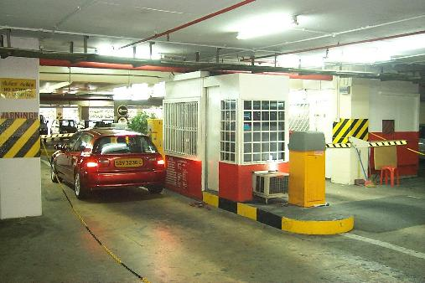
In this example, a car is entering a car park in a busy shopping center. The car plate is recognized and stored. When the car will later exit (through the gate on the right side) the car plate will be read again. The driver will be charged for the duration of the parking. The gate will automatically open after payment - or if the vehicle has a monthly permit.
Access Control - a gate automatically opens for authorized members in a secured area, thus replacing or assisting the security guard. The events are logged on a database and could be used to search the history of events.
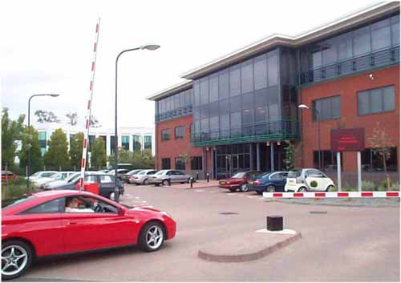
In this example, the gate has just been automatically raised for the authorized vehicle, after being recognized by the system. A large outdoor display greets the driver. The event (result, time and image) is logged in the database.
Tolling - the car number is used to calculate the travel fee in a toll-road, or used to double-check the ticket.
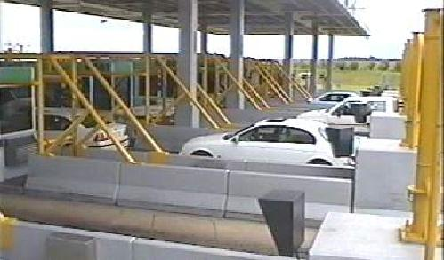
In this installation, the plate is read when the vehicle enters the toll lane and presents a pass card. The information of the vehicle is retrieved from the database and compared against the pass information. In case of fraud the operator is notified.
Border Control - the car number is registered in the entry or exits to the Country, and used to monitor the border crossings. It can short the border crossing turnaround time and cut short the typical long lines.
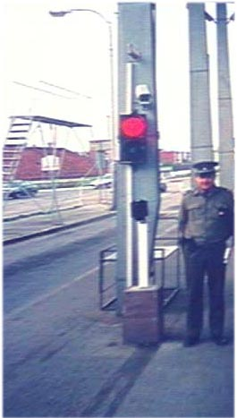
This installation covers the borders of the entire Country. Each vehicle is registered into a central database and linked to additional information such as the passport data. This is used to track all border crossings.

Stolen cars - a list of stolen cars or unpaid fines is used to alert on a passing 'hot' cars. The 'black list' can be updated in real time and provide immediate alarm to the police force. The LPR system is deployed on the roadside, and performs a real-time match between the passing cars and the list. When a match is found a siren or display is activated and the police officer is notified with the detected car and the reasons for stopping the car.
Enforcement - the plate number is used to produce a violation fine on speed or red-light systems The manual process of preparing a violation fine is replaced by an automated process which reduces the overhead and turnaround time. The fines can be viewed and paid on-line.
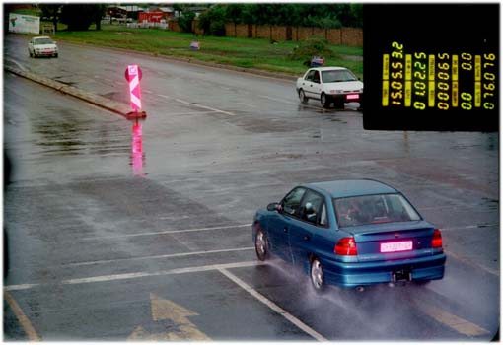
The photo is an example of a speeding car caught by the traffic camera. The rear vehicle plate is automatically extracted off the scanned film image, replacing a tedious manual operation and the need to develop and print the violation. The data block on the top-right side is additional speeding information that is automatically extracted from the developed film and used to complete the fine notice and inserted to a database. The violators can pay the fine on-line and are presented with this photo as a proof with the speeding information.
Traffic control - the vehicles can be directed to different lanes according to their entry permits (such as in University complex projects). The system effectively reduces traffic congestions and the number of attendants.
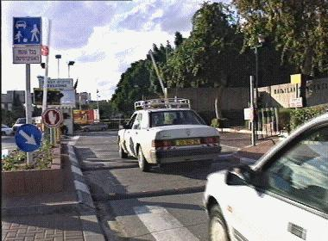
In this installation the LPR based system classifies the cars on a congested entrance to 3 types (authorized, known visitors, and unknown cars for inquiry) and guides them to the appropriate lane. This system reduced the long waiting lines and simplified the security officers work load.
Marketing Tool - the car plates may be used to compile a list of frequent visitors for marketing purposes, or to build a traffic profile (such as the frequency of entry verses the hour or day).
Travel - A number of LPR units are installed in different locations in city routes and the passing vehicle plate numbers are matched between the points. The average speed and travel time between these points can be calculated and presented in order to monitor municipal traffic loads. Additionally, the average speed may be used to issue a speeding ticket.
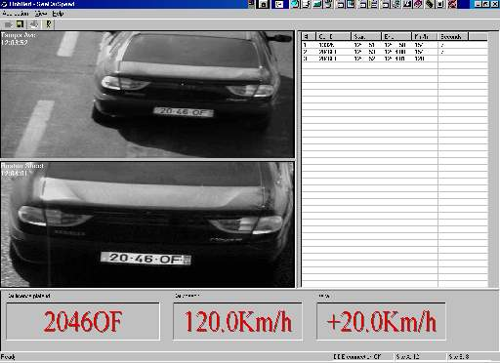
In this example the car is recognized at two points, and the violation shows the photos of both locations which were taken on bridges on top of the highway. The average speed of the car is calculated from both points, and displayed if the speed passed a violation threshold, and optionally printed.
Airport Parking - In order to reduce ticket fraud or mistakes, the LPR unit is used to capture the plate number and image of the cars. The information may be used to calculate the parking time or provide a proof of parking in case of a lost ticket - a typical problem in airport parking which have relatively long (and expensive) parking durations.
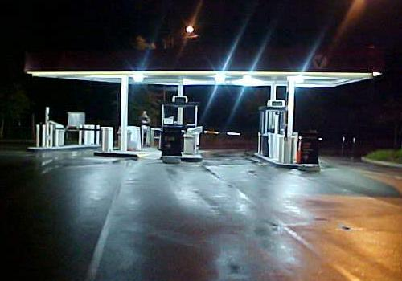
This photo shows the gate of a long term airport parking. The car is recognized on entry and the data is later used to track the real entry time in case of a lost ticket.

Other Names
LPR is also called in different references as:
- Automatic Vehicle Identification (AVI)
- Car Plate Recognition (CPR)
- Automatic Number Plate Recognition (ANPR)
- Car Plate Reader (CPR)
- Optical Character Recognition (OCR) for Cars

The aim of the project:
The aim of this project is to identify the number of car that inter to specific secure place. This processing done by taking image from camera that fixed in suitable place and connected to PC. After plate number recognition the system allows entering the car or not depending on the database stored in the PC.
In this place we activate the jammer for GSM cell phone mobile system in range 935-960MHZ. That means we can't receive any calling in this place.
After the car passed this place the Infra-Red LEDs gives the microcontroller (PIC16F877) Signal to take the image after the car stopped, and the PC analyses the image and recognizes the number of car by using MATLAB7.1 language, after that it compares this number with database stored in Microsoft Access that linked with MATLAB, and upon to the number it inter to the place or not, if it can not, the parking system stay static. But if it can, the parking system will open by rotating the DC motor 90◦ (programmed by the PIC) and stores the date and time of entering in the database.

The flow chart of the project:
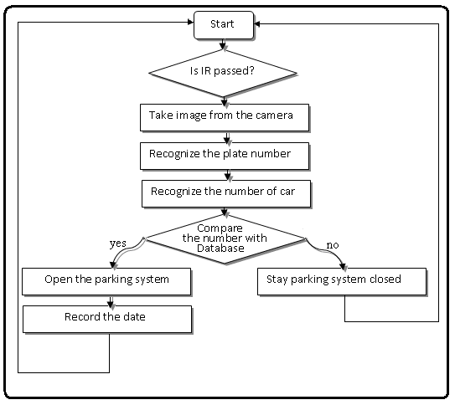

The block diagram for Plate number recognition:
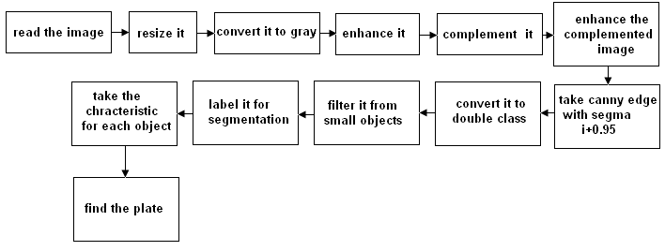

The block diagram for number recognition:
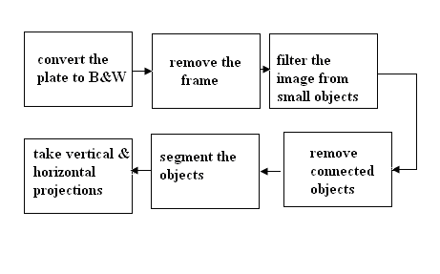

Plate number recognition
The idea of this project is to recognize the plate number of the car, we take the image by the camera that lies in a suitable place. Then we compare this number with the specific database, and if it matches any one of them we send signal to take any action.
In this report we explain the algorithm that we use by MATLAB language due to its flexibility in dealing with matrices (images).
THE ALGORITHM:
- Read and resize the image:
The first step is to red the image, Then we take information about its height and its width to resize the image in suitable ratio, we choose width = 400 and the height = 400 * width/height.
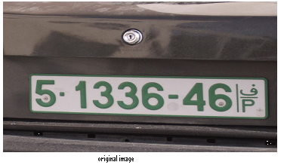
- convert the image to gray:
After that we convert the image to gray scale, this conversion is important because we will take the edge which needs this form of image. Then we enhance the image, this step gets good results in some cases and approximately gets the same results in other cases.
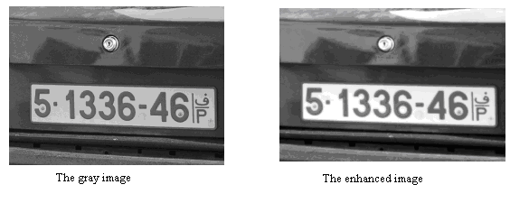

- take the complement of the image:
In this step we take the complement and we enhance it and we take canny method to find the edge, The Canny method finds edges by looking for local maxima of the gradient of the image. The gradient is calculated using the derivative of a Gaussian filter. The method uses two thresholds, to detect strong and weak edges, and includes the weak edges in the output only if they are connected to strong edges. This method take sigma as the standard deviation of the Gaussian filter, this factor control the amount of details of image, if sigma increases the details will decrease.
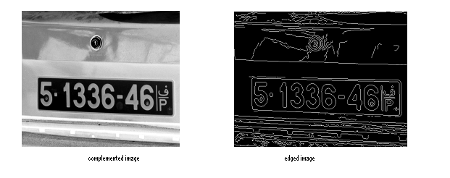

We choose segma = .95, but if the process can not get the plate we change it until we reached to correct result.

- Filter the image from small objects:
Then we convert the image to double class because the functions that we use need this class. and then we filter the image from any object less than 280 pixels and we close the image:
- label the image to objects:
Now we have an image consists of objects, to decide the correct plate from these objects we label them and we find the characters of each object

- separate every object:
Then we separate, fill and rotate every object to give them specific characteristics that help us to know the plate like below pictures:
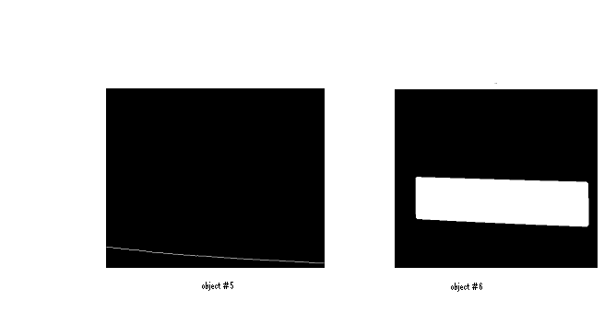
- Recognize the plate:
Now we have an image consists of objects, to decide the correct plate from these objects we label them and we find the characters of each object

By trial and error we specify the suitable description Solidity, the ratio between the height and width, convex area and bounding box.
The last step is to display the plate by multiplying the plate object with the original image:

Number recognition
In this section we have image consist of the plate found and the numbers inside it, the next step is to recognize the numbers.
Our algorithm:

- Convert the image to black and white:
We need this process to use functions that segment the objects:
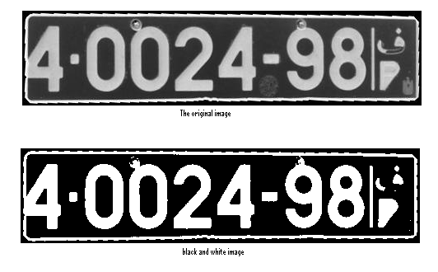
- Remove the frame:

- Filter the image from objects:
We do this step to remove objects which have area less than 100 pixels, this area can be change depending on the resolution of camera and the distance taken from the camera and the car:

- Remove connected objects:
In this step we remove unwanted objects that connected to the numbers by taking the projection of columns and removing the values of amplitude less than .15 as shown below:
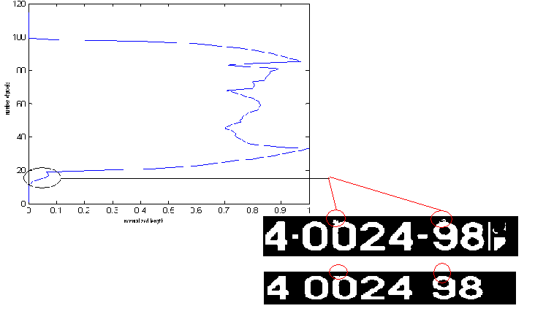
The image after this process is:
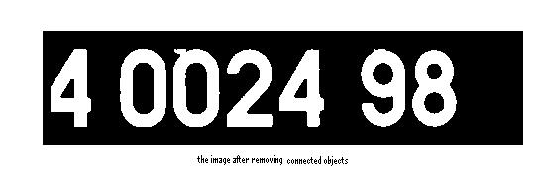
we do the same process for the rows to remove connected objects.

- Segment the numbers by taking the boundary box:
Now we have image consist of only the numbers that we want. Then we segment the number by taking boundary box for every one as shown below:
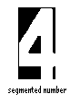
This process doen for every number
- Take the horizontal and vertical projections for each number
And then we take the horizontal and vertical projection(number of pixels versus its position) for each number to identify it . and we take every number after we fill it to increase the proparities to describe any number.

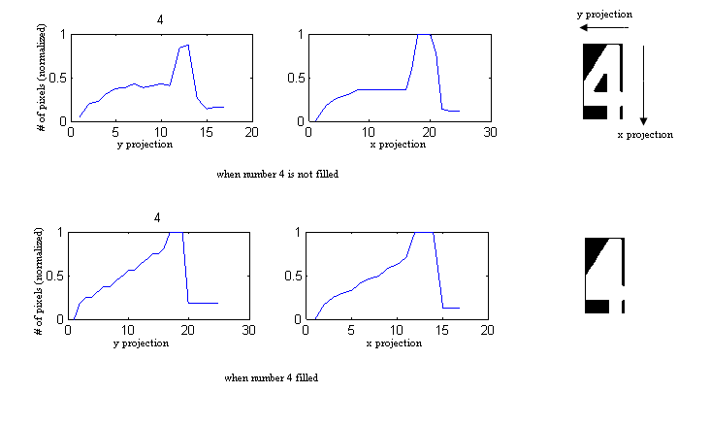
***The code of number recognition is in APPENDIX B.
***The wave form of every number is in APPENDIX C.
*** The next step is to connect the programm with database, our program test the number that we idintify, if the number accessable to pass we allow the parking system to open (i.e to rotate 90 degrees) and we take the data of taking the image, depanding on the table in database, else the parking system stay static.
***We use Microsoft Access program to insert the data.

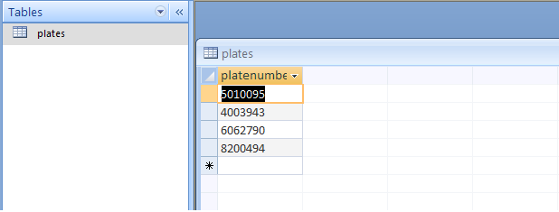
IF is Not a Member
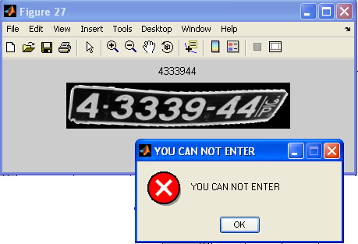

If a Member

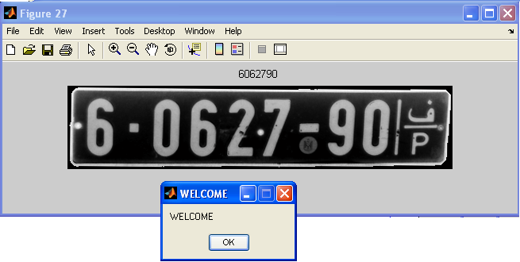
***The code of how we connect the matlab with database is in APPENDIX D.
And in our application the adminstrator can only add new member ,delete or search,and if any one try to add any one he must enter the password and the user name to do that as show below: 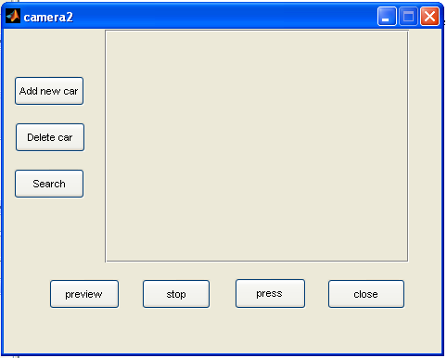
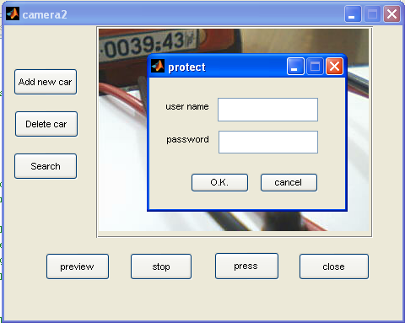

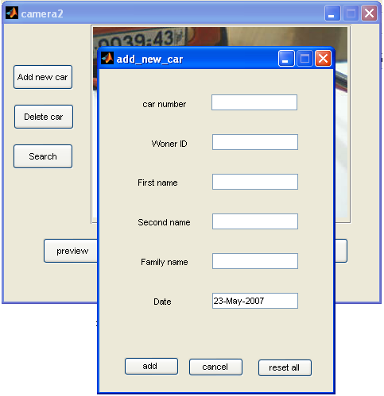

JAMMER
What is the jammer, why and where we need it?
A cell phone jammer is an instrument used to prevent cellular phones from receiving and transmitting the mobile signals to a base station. When used, the jammer effectively disables cellular phones in the area. These devices can be used in practically any location, but are found primarily in locales where a phone call would be particularly disruptive. These include places of worship (mosques, etc.), libraries, lectures, meeting rooms, and other places where silence is expected.
How it works?
Jammers block cell phone use by sending out radio waves along the same frequencies that cellular phones use. This causes enough interference with the communication of cell phones and the towers to render the phones unusable. On most retail phones, the network would simply appear out of range. Most cell phones use different bands to send and receive communications from towers. Thus jammers can work by either disrupting phone to tower frequencies or tower to phone frequencies. Smaller handheld models block all bands from 800mhz to 1900mhz within a 30 foot range. Small devices tend to use the former method, while larger more expensive models may interfere directly with the tower. The radius of cell phone jammers can range from a dozen feet for pocket models to kilometers for more dedicated units. The TRJ-89 jammer can block cellular communications for a 5-mile (8 km) radius.
Older jammers sometimes were limited to working on phones using only analog or older digital mobile phone standards. Newer models such as the double and triple band jammers can block all widely used systems (AMPS, iDEN, GSM, et al) and are even very effective against newer phones which hop to different frequencies and systems when interfered with. As the dominant network technology and frequencies used for mobile phones vary worldwide, some work only in specific regions such as Europe or North America.
The power of the jammer's effect can vary widely based on factors such as proximity to towers, indoor and outdoor settings, presence of buildings and landscape, even temperature and humidity play a role.
There are concerns that crudely designed jammers may disrupt the functioning of medical devices such as pacemakers. However, like cell phones, most of the devices in common use operate at low enough power output (<1W) to avoid causing any problems.
The main electronic components of a jammer
- Voltage-controlled oscillator - Generates the radio signal that will interfere with the cell phone signal
- Tuning circuit - Controls the frequency at which the jammer broadcasts its signal by sending a particular voltage to the oscillator
- Noise generator - Produces random electronic output in a specified frequency range to jam the cell-phone network signal (part of the tuning circuit)
- RF amplification (gain stage) - Boosts the power of the radio frequency output to high enough levels to jam a signal

The next circuit show printed circuit of JAMMER:

APPENDIX A:
clc;
close all;
clear all;
counter = 1;
segma = .95;
index = -1;
ex= '.jpg';
%for(uu =2:39)
uu=4000;
str = int2str(uu);
ww = strcat(str,ex);
i = imread(ww);
info = imfinfo(ww);
width = 400;
height = ceil(width * (info. Width/info.Height));

i = imresize(i,[width height],'bilinear');
%figure,imshow(i);
g = rgb2gray(i);
%figure,imshow(g);
ag = imadjust(g);
%figure,imshow(ag);

IM2 = imcomplement(ag);
%figure,imshow(IM2);

IM2ag = imadjust(IM2,[0.01 .99],[]);

%figure,imshow(IM2ag);

%level = graythresh(IM2ag);
while(index==-1)
counter
eo = edge(IM2ag,'canny',[],segma);

%figure,imshow(eo);

bw= double(eo);

filtered = bwareaopen(bw,280,8);

se = strel('disk',1);

bw = imclose(filtered,se);
%figure,imshow(bw)
[L,NUM] = bwlabel(bw,8);

%figure,imshow(label2rgb(L, @jet, [.5 .5 .5])),title(uu)

a = regionprops(L,'all');

objects = zeros(size(i,1),size(i,2),NUM);
isr = zeros([NUM 1]);
ra = zeros([NUM 1]);
ara = zeros([NUM 1]);
torf = zeros([NUM 1]);
area1 = zeros([NUM 1]);
for(j=1:NUM)
objects(:,:,j) = L(:,:) & (j==(L(:,:)));
objects1(:,:,j) = imfill( objects(:,:,j),'holes');
%figure,imshow(objects1(:,:,j)),title(j)

x_width=0;
y_width = 0;
x = floor(a(j).BoundingBox(1));
y = floor(a(j).BoundingBox(2));
x_width = ceil(a(j).BoundingBox(3))+(a(j).BoundingBox(1)>x);
y_width = ceil(a(j).BoundingBox(4))+(a(j).BoundingBox(2)>y);
if(y==0)
y=1;
y_width = y_width-1;
end
if(x==0)
x=1;
x_width = x_width-1;
end

if(x_width+x >= height)
x_width = x_width -1;
end
if(y_width+y >= width)
y_width = y_width -1;
end
subimage = zeros([width height]);

subimage(1:y_width+1,1:x_width+1) = objects1(y:y+y_width,x:x+x_width,j);
% figure, imshow(subimage(:,:));
y = subimage(:,:);

gf = imrotate(y,-1*a(j).Orientation);
% figure,imshow(gf),title(j)
b = regionprops(gf,'all');

ara(j) = b.MajorAxisLength/b.MinorAxisLength;

ar(j) = b.BoundingBox(3)/b.BoundingBox(4);

ca(j) = b.ConvexArea/(b.BoundingBox(3)*b.BoundingBox(4));

s(j) = b.Solidity;
area1(j) = b.Area;
end

for(j=1:NUM)
if(((ara(j)>2.5)&(ara(j)<7))&((ar(j)>2.5)&(ar(j)<7))&(ca(j)>.77)&((s(j)>.85)|(s(j)<.2))&(area1(j)>400))
index = j;
torf(j)=1;
end
end

coun = sum(torf);
%for(j=1:NUM)
% if( torf(j)==1)
% figure,imshow(objects1(:,:,j)),title(j)
%

% end
% end

segma = segma+1;
counter = counter +1;
end
figure,imshow(objects1(:,:,index)),title(index)
se = strel('disk',9);
objects1(:,:,index) = imdilate(objects1(:,:,index),se);
figure,imshow(objects1(:,:,index)),title(index)
objects1(:,:,index) = imfill(objects1(:,:,index));
figure,imshow(objects1(:,:,index)),title(index)
reg = regionprops(objects1(:,:,index),'all');

if(reg.Solidity<.70)

reg = regionprops(objects1(:,:,index),'all');
x_width=0;
y_width = 0;
x = floor(reg.BoundingBox(1));
y = floor(reg.BoundingBox(2));
x_width = ceil(reg.BoundingBox(3))+(reg.BoundingBox(1)>x);
y_width = ceil(reg.BoundingBox(4))+(reg.BoundingBox(2)>y);
if(y==0)
y=1;
y_width = y_width-1;
end
if(x==0)
x=1;
x_width = x_width-1;
end

if(x_width+x >= height)
x_width = x_width -1;
end
if(y_width+y >= width)
y_width = y_width -1;
end

object1= objects1(y:y+y_width,x:x+x_width,index);
%figure,imshow(object1),title('obj1')

%%%%%%%%%%%%%
[La,num] = bwlabel(object1,8);
reg1 = regionprops(La,'all');

x_width1=0;
y_width1 = 0;
x1 = floor(reg1.BoundingBox(1));
y1 = floor(reg1.BoundingBox(2));
x_width1 = ceil(reg1.BoundingBox(3))+(reg1.BoundingBox(1)>x1);
y_width1 = ceil(reg1.BoundingBox(4))+(reg1.BoundingBox(2)>y1);
if(y1==0)
y1=1;
y_width1 = y_width1-1;
end
if(x1==0)
x1=1;
x_width1 = x_width1-1;
end

if(x_width1+x1 >= height)
x_width1 = x_width1 -1;
end
if(y_width1+y1 >= width)
y_width1 = y_width1 -1;
end
%%%%%%%%%%%%%

object(y1:y1+y_width1,x1:x1+x_width1) = 1;

object = imrotate(object(y1:y1+y_width1,x1:x1+x_width1),reg1.Orientation,'bicubic');
%figure,imshow(object),title('objr')
object= imresize(object,[size(object1,1) size(object1,2)],'bicubic');
%figure,imshow(object),title('objre')
object1 = or(object,object1);
%figure,imshow(object1),title('or')

objects1(y:y+y_width,x:x+x_width,index) = object1(:,:);

%figure,imshow(objects1(:,:,index)),title(index)
objects1(:,:,index) = imfill(objects1(:,:,index));
end

plate = uint8(zeros([size(i,1) size(i,2)]));
plate = IM2ag(:,:).*uint8(objects1(:,:,index));
%figure,imshow(plate)
colorplate(:,:,1) = i(:,:,1).*uint8(objects1(:,:,index));
colorplate(:,:,2) = i(:,:,2).*uint8(objects1(:,:,index));
colorplate(:,:,3) = i(:,:,3).*uint8(objects1(:,:,index));

reg = regionprops(objects1(:,:,index),'all');

x_width=0;
y_width = 0;
x = floor(reg(1).BoundingBox(1));
y = floor(reg(1).BoundingBox(2));
x_width = floor(reg(1).BoundingBox(3))+(reg(1).BoundingBox(1)>x);
y_width = floor(reg(1).BoundingBox(4))+(reg(1).BoundingBox(2)>y);
if(y==0)
y=1;

end
if(x==0)
x=1;

end

if(x_width+x >= size(plate,2))
x_width = size(plate,2)-x;
end
if(y_width+y >=size(plate,1))
y_width = size(plate,1)-y;

end

last_plate= plate(y:y+y_width,x:x+x_width);
last_plate_color = colorplate(y:y+y_width,x:x+x_width,:);
%figure,imshow(last_plate)
last_plate = imrotate(last_plate,-1*reg(1).Orientation,'bicubic');
last_plate_color = imrotate(last_plate_color,-1*reg(1).Orientation,'bicubic');
% figure,imshow(last_plate)

c = imrotate(objects1(y:y+y_width,x:x+x_width,index),-1*reg(1).Orientation,'bicubic');
c= bwlabel(c);
reg = regionprops(c,'all');

x_width=0;
y_width = 0;
x = floor(reg(1).BoundingBox(1));
y = floor(reg(1).BoundingBox(2));
x_width = floor(reg(1).BoundingBox(3))+(reg(1).BoundingBox(1)>x);
y_width = floor(reg(1).BoundingBox(4))+(reg(1).BoundingBox(2)>y);
if(y==0)
y=1;

end
if(x==0)
x=1;

end
if(x_width+x >= size(last_plate,2))
x_width = size(last_plate,2)-x;
end
if(y_width+y >=size(last_plate,1))
y_width = size(last_plate,1)-y;

end
newone= last_plate(y:y+y_width,x:x+x_width);
new_color_one = last_plate_color(y:y+y_width,x:x+x_width,:);
figure,imshow(newone)

str = int2str(uu+39);
ww = strcat(str,ex);
imwrite(newone,ww);
str = int2str(uu+(39*2));
ww = strcat(str,ex);
imwrite(new_color_one,ww);

APPENDIX B:
clc
close all
clear all

original = imread('3039.jpg');
[n m] = size(original);
figure,imshow(original)

level = graythresh(original);

J = imadjust(original);
bw = im2bw(J);
figure,imshow(bw)
[x y ] = size(original);

for(i=1:y)
yyy(i) = (sum(original(:,i)));
end
for(i=1:x)
xxx(i) = (sum(original(i,:)));
end
maxy = max(max(yyy(:)));
maxx = max(max(xxx(:)));
%figure,plot([1:y],yyy(:));
%figure,plot([1:x],xxx(:));
bw(:, 1:ceil(y*.015))=0;
bw(1:ceil(x*.08),:)=0;
bw(floor(x*.9):x,:)=0;
bw(:,floor(y*.95):y)=0;
for(i=1:ceil(y*.05))
if(yyy(i)/maxy>.8)
bw(:,i)=0;
end
end
for(i=1:ceil(x*.2))
if(xxx(i)/maxx>.5)
bw(i,:)=0;
end
end
%figure,imshow(bw)
filtered2 = bwareaopen(bw,100,4);
% figure,imshow(filtered2)
% hold on
[L NUM] = bwlabeln(filtered2);
%title(NUM)

reg2 = regionprops(L,'all');

for(i=1:NUM)
areaa(i) = reg2(i).Area;
widtha(i) = reg2(i).BoundingBox(3);

heighta(i) = reg2(i).BoundingBox(4);
end
area1 = sort(areaa);
height1 = sort(heighta);
width1=sort(widtha);
LL = zeros([size(L,1) size(L,2) ]);
mw = median(width1);
mh = median(height1);
ma = median(area1);
for(i=1:NUM)
max1y = max(widtha(i),mw);
max1x = max(widtha(i),mw);
min1y = min(widtha(i),mh);
min1x = min(heighta(i),mh);
max1a = max(areaa(i),ma);
min1a = min(areaa(i),ma);
if((min1y/max1y>.5)&(min1x/max1x>.9)&(min1a/max1a>.5))
LL(:,:) = LL(:,:)|(L(:,:)&L(:,:)==i);
end
end
for(i=1:size(LL,1))
projhhh(i) = sum(sum(LL(i,:)));
end
maxd = max(projhhh);
projhhh = projhhh./maxd;
for(i=1:size(LL,1))
if(projhhh(i)<.15)
LL(i,:) = 0;
end
end
%figure,plot(projhhh,[1:size(LL,1)])
[LL NUM] = bwlabeln(LL);
projection = zeros([m 1]);

figure,imshow(LL)
hold on
for(i=1:NUM)
LLL(:,:,i) = LL(:,:) & LL(:,:) == i;

end

LLL = double(LLL);
proj2222 = zeros([m 1]);

LL(:,:) = LL(:,:) &LL(:,:)>0;
for(i=1:m)
proj2222(i) = (sum(LL(:,i)));
end

%figure,plot([1:m],proj2222(1:m))
rec(1:NUM) = 'u';

for(i=1:NUM)

regdig = regionprops(LLL(:,:,i),'all');
wx = floor(regdig.BoundingBox(2));
wl = floor(regdig.BoundingBox(2))+floor(regdig.BoundingBox(4));

hx = floor(regdig.BoundingBox(1));
hl = floor(regdig.BoundingBox(1))+floor(regdig.BoundingBox(3));
digit = zeros([wl hl]);
digit = LLL(wx:wl,hx:hl,i);
% figure,imshow(digit)
projhdigit = zeros([size(digit,1) 1]);
projwdigit = zeros([size(digit,2) 1]);
for(j=1:size(digit,1))
projhdigit(j) = sum(sum(digit(j,:)));
end
maxdh = max(projhdigit);

projhdigit = projhdigit./maxdh;
%figure,subplot(2,2,1),plot([1:size(digit,1)],projhdigit)
for(j=1:size(digit,2))
projwdigit(j) = sum(sum(digit(:,j)));
end
maxdw = max(projwdigit);
projwdigit = projwdigit./maxdw;
%subplot(2,2,2),plot([1:size(digit,2)],projwdigit)

digit1 = zeros([wl hl]);
digit1 = imfill(digit);
% figure,imshow(digit1)
projhdigit1 = zeros([size(digit1,1) 1]);
projwdigit1 = zeros([size(digit1,2) 1]);
for(j=1:size(digit1,1))
projhdigit1(j) = sum(sum(digit1(j,:)));
end
maxdh1 = max(projhdigit1);

projhdigit1 = projhdigit1./maxdh1;
%subplot(2,2,3),plot([1:size(digit1,1)],projhdigit1)
for(j=1:size(digit1,2))
projwdigit1(j) = sum(sum(digit1(:,j)));
end
maxdw1 = max(projwdigit1);
projwdigit1 = projwdigit1./maxdw1;
%subplot(2,2,4),plot([1:size(digit1,2)],projwdigit1)

wl = size(digit,2);

hl = size(digit,1);
[max1 ind1m] = max(projhdigit(1:(floor(.5*hl))));
[max2 ind2m] = max(projhdigit(hl:-1:ceil(.5*hl)));
[min1 indmin1] = min(projhdigit1(ceil(.3*hl):floor(.8*hl)));
max11 = max(max1,max2);
max21 = min(max1,max2);
%%%%%%%%%%%%%%%TWOOOOOOOOOOOOOOOO%%%%%%%%%%%%%%%%%%%%%%
if((max21/max11>.8)&(max2>.95)&(projhdigit(ceil(.4*hl):floor(.8*hl))<.5)&(max1>.8))
if((projwdigit(ceil(.3*wl):floor(.8*wl))>.5))
rec(i)='2';
end
end

[max1_5 ind1m_5] = max(projhdigit(1:(floor(.33*hl))));
[max2_5 ind2m_5] = max(projhdigit((ceil(.33*hl)):floor(.66*hl)));
[max3_5 ind3m_5] = max(projhdigit(floor(.66*hl):hl));

%%%%%%%%%%%%%%%%SIXXXXXXXXXXXXX%%%%%%%%%%%%%%%%
if((max1_5>.8)&(max2_5>.8)&(max3_5>.8))
if((projhdigit1(ceil(.5*hl):floor(.7*hl))>.8)&(indmin1<floor(.5*hl)))
rec(i)='6';
end
%%%%%%%%%%%%%%%%NINEEEEEEEEEEEEEEEE%%%%%%%%%%%%%%%%%%%%%%
if((projhdigit1(ceil(.3*hl):floor(.5*hl))>.8)&(indmin1>floor(.2*hl)))
rec(i)='9';
end
%%%%%%%%%%%%%%%%%EIGHTTTTTTT%%%%%%%%%%%%%%%%%%%
if((projhdigit1(ceil(.3*hl):floor(.8*hl))>.6))
rec(i)='8';
end
%%%%%%%%%%%FIVEEEEEEEEEEEEEEEEE%%%%%%%%%%%%%%%%%
if( rec(i)=='u')
if(projwdigit(ceil(.2*wl):floor(.8*wl))>.4)
rec(i)='5';
end
end
end
max_3 = max(max1_5,max3_5);
min_3 = min(max1_5,max3_5);
[mmax3 indmmax3] = max(projwdigit1(ceil(.3*wl):floor(.8*wl)));
%%%%%%%%%%%%%%%%%%%%%%%%%%%%%%%%%%%%%%%THREEEEEEEEEEEEEEEEEEEE%%%%%%%%%%%%%

if( rec(i)=='u')
if(((min_3/max_3)>.8)&(max2_5/max1_5<.8)&(max2_5/max3_5<.8)&(indmmax3>(floor(.3*wl))))
rec(i)='3';
end
end
%%%%%%%%%%%%%%%%%%ZEROOOOOOOOOOOOOOOOOOOOOoo%%%%%%%%%%%%%%%%%%%
if( rec(i)=='u')
if((projhdigit1(ceil(.3*hl):floor(.7*hl))>.7))
if((projwdigit1(ceil(.3*wl):floor(.7*wl))>.7))
rec(i)='0';
end
end
end
%%%%%%%%%%%%%%%%%%ONEEEEEEEEEEEEEEEEEEE%%%%%%%%%%%%%%%%%%%%%

if(rec(i)=='u')
if((mmax3>.90)&(indmmax3>(floor(.3*wl)))&(max1>.90)&(ind1m<(ceil(.3*hl))))
if(projwdigit1(ceil(.1*wl):floor(.4*wl))<.5)
rec(i)='1';
end
end
end
%%%%%%%%%%%%%%%%%%%%SEVEEEEEEEEEEEEEEN%%%%%%%%%%%%%%%%%%
if(rec(i)=='u')
if((max1>.90)&(ind1m<(ceil(.3*hl))))
if(projwdigit1(ceil(.3*wl):floor(.7*wl))>.6)
rec(i)='7';
end
end
end
%%%%%%%%%%%%%%%%%%%%%%%FOUR%%%%%%%%%%%%%%%%%%%%%%%%%%
[max4 ind4] = max(projhdigit(ceil(.1*hl):hl));
[min4 indmin4] = min(projhdigit(ceil(.1*hl):hl));
[max42 ind42]= max(projwdigit(ceil(.1*wl):wl));
if(rec(i)=='u')
if((ind4>floor(.5*hl))&(indmin4>floor(.5*hl))&(max4>.9))
rec(i)='4';
end
end
if(rec(i)=='u')
if((ind4>floor(.5*hl))&(max4>.9)&(max42>.9)&(ind42<floor(.5*wl)))
rec(i)='4';
end
end
end
title(rec)

APPENDIX C:

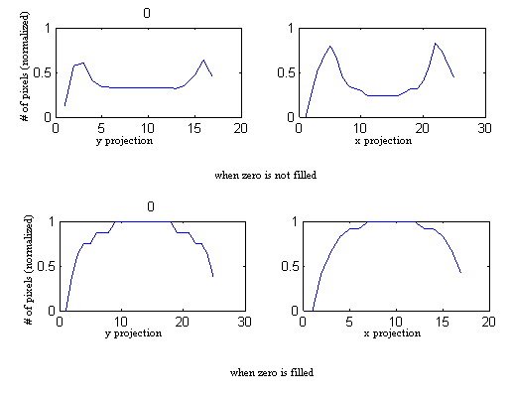

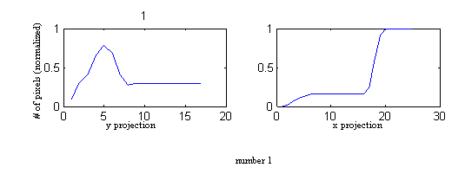

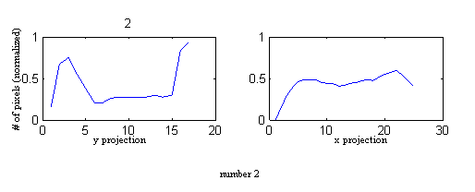
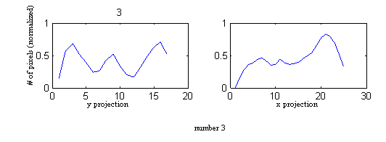

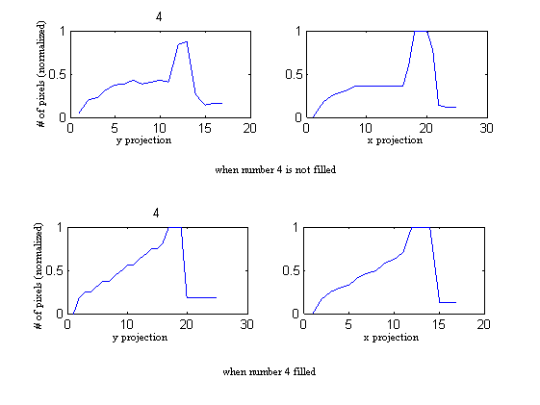
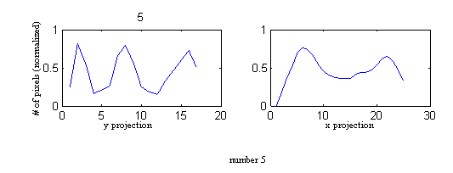
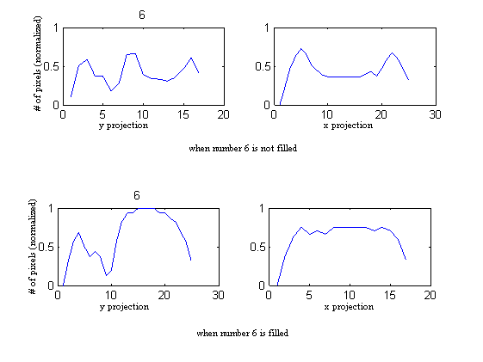
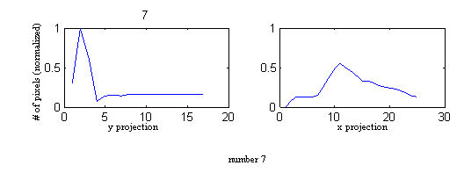
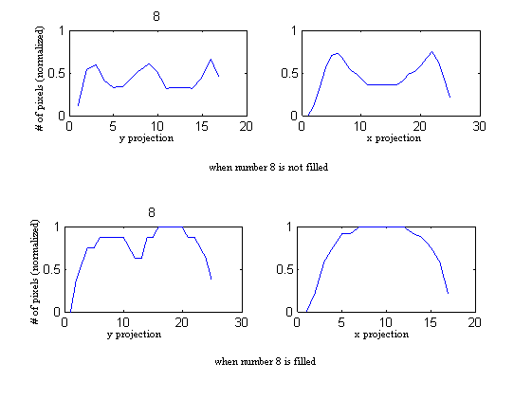
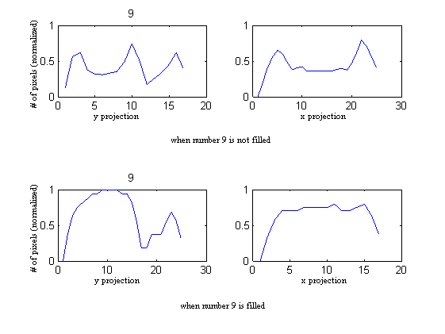
APPENDIX D:

function test_num(found)

logintimeout(5)
conn = database('lolo', '', '');

curs = exec(conn, ['select * from plates where platenumber = ''', found, '''']);
curs=fetch(curs);
curs.DATA
if(strcmp(curs.DATA,'No Data'))

msgbox('YOU CAN NOT ENTER','YOU CAN NOT ENTER','error')
else
msgbox('WELCOME','WELCOME','none')

end

close(conn)

% GUI for adding new car
function varargout = add_new_car(varargin)
% ADD_NEW_CAR M-file for add_new_car.fig
% ADD_NEW_CAR, by itself, creates a new ADD_NEW_CAR or raises the existing
% singleton*.
%
% H = ADD_NEW_CAR returns the handle to a new ADD_NEW_CAR or the handle to
% the existing singleton*.
%
% ADD_NEW_CAR('CALLBACK',hObject,eventData,handles,...) calls the local
% function named CALLBACK in ADD_NEW_CAR.M with the given input arguments.
%
% ADD_NEW_CAR('Property','Value',...) creates a new ADD_NEW_CAR or raises the
% existing singleton*. Starting from the left, property value pairs are
% applied to the GUI before add_new_car_OpeningFunction gets called. An
% unrecognized property name or invalid value makes property application
% stop. All inputs are passed to add_new_car_OpeningFcn via varargin.
%
% *See GUI Options on GUIDE's Tools menu. Choose "GUI allows only one
% instance to run (singleton)".
%
% See also: GUIDE, GUIDATA, GUIHANDLES

% Edit the above text to modify the response to help add_new_car

% Last Modified by GUIDE v2.5 29-Apr-2007 13:03:28

% Begin initialization code - DO NOT EDIT
gui_Singleton = 1;
gui_State = struct('gui_Name', mfilename, ...
'gui_Singleton', gui_Singleton, ...
'gui_OpeningFcn', @add_new_car_OpeningFcn, ...
'gui_OutputFcn', @add_new_car_OutputFcn, ...
'gui_LayoutFcn', [] , ...
'gui_Callback', []);
if nargin && ischar(varargin{1})
gui_State.gui_Callback = str2func(varargin{1});
end

if nargout
[varargout{1:nargout}] = gui_mainfcn(gui_State, varargin{:});
else
gui_mainfcn(gui_State, varargin{:});
end
% End initialization code - DO NOT EDIT

% --- Executes just before add_new_car is made visible.
function add_new_car_OpeningFcn(hObject, eventdata, handles, varargin)
% This function has no output args, see OutputFcn.
% hObject handle to figure
% eventdata reserved - to be defined in a future version of MATLAB
% handles structure with handles and user data (see GUIDATA)
% varargin command line arguments to add_new_car (see VARARGIN)

% Choose default command line output for add_new_car
handles.output = hObject;

% Update handles structure
guidata(hObject, handles);

% UIWAIT makes add_new_car wait for user response (see UIRESUME)
% uiwait(handles.figure1);

% --- Outputs from this function are returned to the command line.
function varargout = add_new_car_OutputFcn(hObject, eventdata, handles)
% varargout cell array for returning output args (see VARARGOUT);
% hObject handle to figure
% eventdata reserved - to be defined in a future version of MATLAB
% handles structure with handles and user data (see GUIDATA)

% Get default command line output from handles structure
varargout{1} = handles.output;

% --- Executes on button press in CANCEL.
function CANCEL_Callback(hObject, eventdata, handles)
% hObject handle to CANCEL (see GCBO)
% eventdata reserved - to be defined in a future version of MATLAB
% handles structure with handles and user data (see GUIDATA)

close;
% --- Executes on button press in ADD.
function ADD_Callback(hObject, eventdata, handles)
% hObject handle to ADD (see GCBO)
% eventdata reserved - to be defined in a future version of MATLAB
% handles structure with handles and user data (see GUIDATA)
car = get(handles.carnum,'String');
id = get(handles.ID,'String');
name = get(handles.name,'String');

if((length(car)~=7)||(isempty(str2num(car)))||(isempty(car)))
msgbox('the car number must be 7 digits','WARRNING','warn')
elseif(isempty(name))
msgbox('enter the winner name','WARRNING','warn')
elseif((isempty(id)||(length(id)~=7)))||(isempty(str2num(id)))
msgbox('the ID must be 7 digits','WARRNING','warn')
else
add_new_one(car,id,name);
end

% --- Executes on button press in RESETALL.
function RESETALL_Callback(hObject, eventdata, handles)
% hObject handle to RESETALL (see GCBO)
% eventdata reserved - to be defined in a future version of MATLAB
% handles structure with handles and user data (see GUIDATA)

set(handles.carnum,'String',' ');
set(handles.name,'String',' ');
set(handles.ID,'String',' ');

function carnum_Callback(hObject, eventdata, handles)
% hObject handle to carnum (see GCBO)
% eventdata reserved - to be defined in a future version of MATLAB
% handles structure with handles and user data (see GUIDATA)

% Hints: get(hObject,'String') returns contents of carnum as text
% str2double(get(hObject,'String')) returns contents of carnum as a double

% --- Executes during object creation, after setting all properties.
function carnum_CreateFcn(hObject, eventdata, handles)
% hObject handle to carnum (see GCBO)
% eventdata reserved - to be defined in a future version of MATLAB
% handles empty - handles not created until after all CreateFcns called

% Hint: edit controls usually have a white background on Windows.
% See ISPC and COMPUTER.
if ispc && isequal(get(hObject,'BackgroundColor'), get(0,'defaultUicontrolBackgroundColor'))
set(hObject,'BackgroundColor','white');
end

function name_Callback(hObject, eventdata, handles)
% hObject handle to name (see GCBO)
% eventdata reserved - to be defined in a future version of MATLAB
% handles structure with handles and user data (see GUIDATA)

% Hints: get(hObject,'String') returns contents of name as text
% str2double(get(hObject,'String')) returns contents of name as a double

% --- Executes during object creation, after setting all properties.
function name_CreateFcn(hObject, eventdata, handles)
% hObject handle to name (see GCBO)
% eventdata reserved - to be defined in a future version of MATLAB
% handles empty - handles not created until after all CreateFcns called

% Hint: edit controls usually have a white background on Windows.
% See ISPC and COMPUTER.
if ispc && isequal(get(hObject,'BackgroundColor'), get(0,'defaultUicontrolBackgroundColor'))
set(hObject,'BackgroundColor','white');
end

function ID_Callback(hObject, eventdata, handles)
% hObject handle to ID (see GCBO)
% eventdata reserved - to be defined in a future version of MATLAB
% handles structure with handles and user data (see GUIDATA)

% Hints: get(hObject,'String') returns contents of ID as text
% str2double(get(hObject,'String')) returns contents of ID as a double

% --- Executes during object creation, after setting all properties.
function ID_CreateFcn(hObject, eventdata, handles)
% hObject handle to ID (see GCBO)
% eventdata reserved - to be defined in a future version of MATLAB
% handles empty - handles not created until after all CreateFcns called

% Hint: edit controls usually have a white background on Windows.
% See ISPC and COMPUTER.
if ispc && isequal(get(hObject,'BackgroundColor'), get(0,'defaultUicontrolBackgroundColor'))
set(hObject,'BackgroundColor','white');
end

% DB for adding new car.
function add_new_one(car,id,name)
conn = database('new_car', '', '');

D = date;
exdata(1,1) = {car};
exdata(1,2) = {id};
exdata(1,3) = {name};
exdata(1,4) = {D};
colnames = {'car_number','winner_id','winner_name','insertion_date'};
fastinsert(conn, 'new_car', colnames, exdata)

close(conn)

% DB for testing the administrator that can add new car
function test_user_pass(user,pass)

logintimeout(5);
conn = database('checkpassword', '', '');

curs = exec(conn, ['select * from user_pass where username = ''', user, '''and password = ''', pass, '''']);
curs=fetch(curs);

if(strcmp(curs.DATA,'No Data'))

msgbox('YOU CAN NOT ADD','WARRNING','warn')
else

add_new_car();
end

close(conn)

Schematic diagram of jammer:
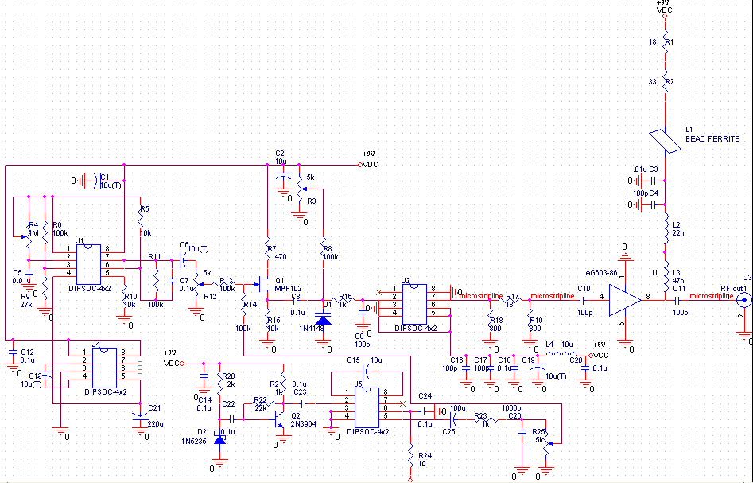
Schematic diagram of power amplifier of jammer:

