**An-Najah National University**

**Faculty Of Engineering**

**Electrical Engineering Department**



**Electrical Circuits Lab**

**Revised By:**

Yousef Dama

HaneenJaloudi

KhadejaDweikat

NasimZayed

**2013**

**2013**



**An-Najah National University**

**Faculty of Engineering**

**جامعة النجاح الوطنية**

**كلية الهندسة**

|  |  |
| --- | --- |
| Student Name/s and Registration Number/s  1.  2.  3.  4. | Instructor Name: |
| Section:  Day: Time: | Assistant Name: |
| Academic Year: |
| Semester: |
| Report Mark:10 | Credit Hours: 1 |
| Reports Weight: 40% | Date: |

|  |  |  |  |  |
| --- | --- | --- | --- | --- |
| **Grade** | **ILO’s %** | **ILO’s** | **Points** | **Evaluation Criterion** |
|  |  |  | 2 | **Writing skills**  Clear and complete statement of objectives and sufficient the theoretical basis |
|  |  |  | 3 | **Evaluation of scientific results**  Results analyzed correctly. Experimental findings adequately and specifically summarized, in graphical, tabular, and/or written form. |
|  |  |  | 3 | **Discussion**  Explanation of experimental results. Comparison of theoretical predictions to experimental results, including discussion of accuracy and error analysis in some cases. |
|  |  |  | 1 | **Conclusions**  Conclusions summarize the major findings from the experimental results |
|  |  |  | 1 | **Using Computer aided software** |
|  | **Student Grade** | | | |

**Experiment Name:……………………………………………………………………**

**Department Name: Electrical Engineering**

**Experiment Number:…..**

**Electrical Circuits Lab (63215)**

**ELECTRICAL SAFETY GUIDELINES**

1. Be familiar with the electrical hazards associated with your workplace.
2. You may enter the laboratory only when authorized to do so and only during authorized hours of operation.
3. Be as careful for the safety of others as for yourself. Think before you act, be tidy and systematic.
4. Avoid bulky, loose or trailing clothes. Avoid long loose hair.
5. Food, beverages and other substances are strictly prohibited in the laboratory at all times. Avoid working with wet hands and clothing.
6. Use extension cords only when necessary and only on a temporary basis.
7. Request new outlets if your work requires equipment in an area without an outlet.
8. Discard damaged cords, cords that become hot, or cords with exposed wiring.
9. Before equipment is energized ensure, (1) circuit connections and layout have been checked by a laboratory technician and (2) all colleagues in your group give their assent.
10. Know the correct handling, storage and disposal procedures for batteries, cells, capacitors, inductors and other high energy-storage devices.
11. Experiments left unattended should be isolated from the power supplies. If for a special reason, it must be left on, a barrier and a warning notice are required.
12. Equipment found to be faulty in any way should be reported to the laboratory technician immediately and taken out of service until inspected and declared safe.
13. Voltages above 50 V rms AC and 120 VDC are always dangerous. Extra precautions should be considered as voltage levels are increased.
14. Never make any changes to circuits or mechanical layout without first isolating the circuit by switching off and removing connections to power supplies.
15. Know what you must do in an emergency, i.e. Emergency Power Off

**Electrical Emergency Response**

The following instructions provide guidelines for handling two types of electrical emergencies:

1. ***Electric Shock***:

When someone suffers serious electrical shock, he or she may be knocked unconscious. If the victim is still in contact with the electrical current, immediately turn off the electrical power source. If you cannot disconnect the power source, depress the Emergency Power Off switch.

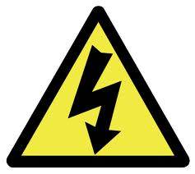

**IMPORTANT:**

Do not touch a victim that is still in contact with a live power source; you could be electrocuted.

Have someone call for emergency medical assistance immediately. Administer first-aid, as appropriate.

1. 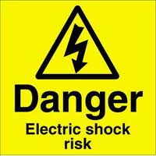***Electrical Fire:***

NEVERuse water to extinguish an electrical fire.

If an electrical fire occurs, try to disconnect the electrical power source, if possible. If the fire is small and you are not in immediate danger; and you have been properly trained in fighting fires, use the correct type of fire extinguisher to extinguish the fire. When in doubt, push in the Emergency Power Off button.

**Laboratory Notebook**

The laboratory notebook is a record of all work pertaining to the experiment. This record should be sufficiently complete so that you or anyone else of similar technical back ground can duplicate the experiment and data by simply following your laboratory notebook. Record everything directly into the note book during the experiment. Do not use scratch paper for recording data. Do not trust your memory to fill in the details at a later time.

**Guidelines for laboratory notebook**

* State the objective of the experiment.
* Draw the circuit diagram and mention the values of resistances etc. which are used.
* Make a note of all the measuring instruments you have used.
* Mention the formulas used.
* Create a table and write down the readings, including the units.
* Show all your calculation neatly and SYSTEMATICALLY. Do this is an organized manner.
* Attach graph if any.
* Be concise. Complete sentences are not necessary as long as the context is clear.
* If mistakes are made, they should not be erased .Just bracket them and makea short note explaining the problem.
* Make entries a the lab progresses; don't assume you can fill it in later. The instructor will ask to see it during the lab.
* Date every page.
* All important results must be underlined.
* Attach simulation and hand calculation to your note book.
* Draw the figure using pencil before you come to the lab so that you can make corrections to it in case you need to do so by erasing and redrawing. This will ensure tidy and neat work.
* Prepare the READINGTABLE using pencil and ruler and not just by sketching lines. Sketching gives rise to crooked lines and gives the lab notebook a haphazard look.
* Take a few short notes (2-3lines),which explains some of the problems you encountered while doing the experiment. This will help you write better reports.

**General Lab Report Format**

Following the completion of each laboratory exercise, a report must be written and submitted for grading. The purpose ofthe report is to completely document the activities of the design and demonstration in the laboratory. Reports should be complete in the sense that all information required to reproduce the experiment is contained within. Writing useful reports is a very essential part of becoming an engineer. In both academic and industrial environments, reports are the primary means of communication between engineers.

There is no one best format for all technical reports but there are a few simple rules concerning technical presentations which should be followed. Adapted to this laboratory they may be summarized in the following recommended report format:

* ABET Cover Page
* Title page
* Introduction
* Experimental Procedure
* Experimental Data
* Discussion
* Conclusions

Detailed descriptions of these items are given below.

**Title Page:**

The title page should contain the following information

* Your name
* ID
* Experiment number and title
* Date submitted
* Instructors Name

**Introduction:**

It should contain a brief statement in which you state the objectives, or goals of the experiment. It should also help guide the reader through the report by stating, for example, that experiments were done with three different circuits or consisted of two parts etc. Or that additional calculations or data sheets can be found in the appendix, or at the end of the report.

**The Procedure**

It describes the experimental setup and how the measurements were made. Include here circuit schematics with the values of components. Mention instruments used and describe any special measurement procedure that was used.

**Results/Questions:**

This section of the report should be used to answer any questions presented in the lab hand-out. Any tables and /or circuit diagrams representing results of the experiment should be referred to and discussed / explained with detail. All questions should be answered very clearly in paragraph form. Any unanswered questions from the lab hand-out will result in loss of points on the report.

The best form of presentation of some of the data is graphical. In engineering presentations a figure is often worth more than a thousand words. The reare some simple rules concerning graphs and figures which should always be followed. If there is more than one figure in the report , the figures should be numbered. Each figure must have a caption following the number. For example, *“Figure 1.1:DSB-SC ”* In addition, it will greatly help you to learn how to use headers and figures in MS Word.

**The Discussion**

It is a critical part of the report which testifies to the student’s understanding of the experiments and its purpose. In this part of the report you should compare the expected outcome of the experiment, such as derived from theory or computer simulation, with the measured value. Before you can make such comparison you may have to do some data analysis or manipulation.

When comparing experimental data with numbers obtained from theory or simulation, make very clear which is which. It does not necessarily mean that your experiment was a failure. The results will be accepted, provided that you can account for the discrepancy. Your ability to read the scales may be one limitation. The value of some circuit components may not be well known and a nominal value given by the manufacturer does not always correspond to reality. Very often, however, the reason for the difference between the expected and measured values lies in the experimental procedure or in not taking into account all factors that enter into analysis.

**Conclusion:**

A brief conclusion summarizing the work done, theory applied, and the results of the completed work should be included here. Data and analyses are not appropriate for the conclusion.

***Notes***

Typed Reports are required. Any drawings done by hand must be done with neatness, using a straightedge and drawing guides wherever possible.

Freehand drawings will not be accepted.

**Table of contents**

1. **Introduction to circuits …………………………………………………...7**
2. **Ohm’s law, resistors-series and parallel connection...…………....11**
3. **Network theorems………………………………………………………..18**
4. **Voltage source…………………………………………………………….23**
5. **Properties of ac signals………………………………………………....30**
6. **Capacitor in the AC circuit………………………................................35**
7. **Inductors…………………………………………………………………...42**
8. **RLC series & parallel circuits…………………………………………..47**
9. **Three-phase alternating current……………………………………….50**

# Series resonance…………………………………………………….......55

# Parallel resonance………………………………………………………..64

1. **Computer simulation of RLC circuit response……………………...68**
2. **Filters……………………………………………………………………….70**

FACULTY OF ENGINEERING

ELECTRICAL ENGINEERING DEPARTMENT

EXPERIMENT # 1

**INTRODUCTION TO CIRCUITS**

**Objective:**

The objective of this experiment is to familiarize the students with the equipment in the electronics lab, specially

1. To learn the operational controls of function generator.

2. To learn the operational controls of Oscilloscope.

**Apparatus and components:**

1. Digital Multi-meter (DMM).
2. Oscilloscope (sometimes called “Cathode Ray Oscilloscope or CRO)
3. Training boards and electronic Components.

**Introduction:**

Since students come from different back grounds; therefore, this section may seem easy for some , while others may want to spend more time becoming familiar with the equipment. If you have not used the equipment before, spend some time with the equipment in this lab to insure you know how to correctly use it.

**Measuring with a Multi-meter**

This instrument can provide a measure of DC signals as well as the r.m.s values of AC signals. Such signals can be that of the output voltage or the currents passing through a particular component in a given circuit.

A DMM shown in Fig. 1 can also provide resistance, capacitance and Transistor DC amplification factor measurements

|  |
| --- |
| http://people.sinclair.edu/nickreeder/eet114/PageArt/DMMFluke8050.jpg |
| Fig. 1: Digital Multi-meter |

For measuring the three variables Current, Voltage and Resistance a multi-meter is used. Please regard the following parameters when

Connecting the multi-meter:

• Checking of zero point (calibration) after switching on the meter.

• Correct connection of multi-meter. Misconnection may destroy the device.

• Choose correct measuring range. Current- / Voltage type: - / ~ (DC / AC)

• Correct connection of measuring leads or components to the circuit.

• Measuring range has to be adjusted to the prognostic measuring value*.* ***In doubtful cases a higher range should be chosen***

**Oscilloscope:**

The oscilloscope is the most widely used general-purpose measuring instrument becauseitallowsyouseeagraphofthevoltageasafunctionoftimeinacircuit. Many circuits have specific timing requirements or phase relationships that can be measured with a two-channel oscilloscope. One can measure almost anything with the two-dimensional graph drawn by an oscilloscope. This general-purpose display presentsformoreinformationthanisavailablefrom othertestandmeasurement instruments like frequency counters or multi-meters.

**Training Electronic Board**

Using this training board and employing suitable electronic components, then many electronic circuits may be realized e.g. Power supplies, A.C generators etc.

**Experimental procedure:**

**Ι- Using the Digital multi-meter**:

**Resistance measurement:**

1. Connect the circuit as shown in Fig.2



Fig.2

|  |  |  |  |  |  |  |
| --- | --- | --- | --- | --- | --- | --- |
| R | 100 | 220 | 330 | 470 | 680 | 1000 |
| Resistance  (Ω) |  |  |  |  |  |  |

Table 1

1. Tabulate your results as in Table1.
2. How you can read the value of a resistor? (Color code)

**Voltage measurement:**

1. Connect the circuit as shown in Fig.3



Fig.3

|  |  |  |  |  |  |
| --- | --- | --- | --- | --- | --- |
| Setting* | 0 | 1/4 | 1/2 | 3/4 | 1 |
| Voltage |  |  |  |  |  |

Table 2, *DC supply setting

2-Tabulate you are results as in Table-2 (voltage reading raw).

**Current measurements:**

1. Connect the circuit as shown in Fig.4.



Fig. 4.

**At V=8 volt**

|  |  |  |  |  |  |  |
| --- | --- | --- | --- | --- | --- | --- |
| R (ideal) | 100 | 220 | 330 | 470 | 680 | 1000 |
| Current (I mA)  Measured |  |  |  |  |  |  |
| Current (I mA)  calculated |  |  |  |  |  |  |

**At V=12 volt**

|  |  |  |  |  |  |  |
| --- | --- | --- | --- | --- | --- | --- |
| R (ideal) | 100 | 220 | 330 | 470 | 680 | 1000 |
| Current (I mA)  Measured |  |  |  |  |  |  |
| Current (I mA)  calculated |  |  |  |  |  |  |

Table 2.

2- Tabulate your results as in Table-3 (current reading row).

AN-NAJAH NATIONAL UNIVERSITY

FACULTY OF ENGINEERING

ELECTRICAL ENGINEERING DEPARTMENT

EXPERIMENT # 2

**OHM’S LAW, RESISTORS-SERIES AND PARALLEL CONNECTION**

**Objective**

1- To investigate the various applications of ohm's law.

2- To investigates series and parallel resistive circuits.

**Apparatus and components:**

1. Training Electronic Board.
2. A DMM.
3. Resistors: 22 Ω , 100 Ω , 150Ω, 220 Ω , 330 Ω , 470 Ω , 680 Ω and 1 KΩ.

**Theoretical Background:**

Ohm’s lawstates that the voltage (V) across a resistor (R) is directly proportional to the current (I) flowing through the resistor.

Ohm defined the constant of proportionality for a resistor to be the resistance; *R*. The resistance is material properties which can change if the internal or external conditions of the element are altered, e.g., if there are changes in the temperature. The mathematical form of Ohm’s law is given by,



The resistance R of an element denotes its ability to resist the flow of electric current; it is measured in ohms (Ω).

More attributes of these components are, besides the resistance value, power rating, temperature behaviour and frequency-dependence. Power rating (power loss) of a resistor can be calculated with following formula.



Where, P is the electronic power in Watt (W)

**Series Resistors and Voltage Division**

The need to combine resistors in series or in parallel occurs so frequently that it warrants special attention. The process of combining the resistors is facilitated by combining two of them at a time. With this in mind, consider the single-loop circuit of Fig. 1



Fig. 1

If the resistors or loads are connected in series, same current flows through each component. Then the voltage V can be calculated by,



Where, Reqis the equivalent resistance of the circuit

The equivalent resistance of any number of resistors connected in series is the sum of the individual resistances. Thus For N resistors in series then



To determine the voltage across each resistor



**Parallel Resistors and current Division**

Consider the circuit in Fig. 2, where two resistors are connected in parallel and therefore have the same voltage across them,





Fig. 2

In parallel circuits the input current is divided, the sum of all components is the total current,



The value of all partial currents depends on the voltage supply and the resistance,

and

The value of the total current depends on the voltage applied and the total resistance,



Where the total or equivalent resistance for N resistors can be calculated by,



To determine the current throw each resistor

and

**Voltage Divider**

Voltage dividers (potentiometer) consist of two series resistors, R1 and R2 connected as shown, in the following diagram.

In this case we may write the following equation:



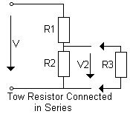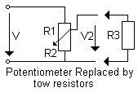

When a load resistor (R3) is connected in parallel with R2, the voltage ratios change, since current branching takes place

 **-- Since R2 in parallel with R3**



**Experimental procedure:**

**Ι- Ohm’s law**

**Test proceeding**

1. Set up the circuit as shown in Fig. 3
2. Measure the currents at resistors R = 100, 150 and 330Ω, respectively for voltage values 0, 2, 4, 6, 8, 10 and12 volts, Tabulate your result as in Table 1.
3. Plot the current against the voltage at each value of resistor. I = f (V) ⏐R constant
4. Set the DC supply voltage to 4 V, then complete Table 2, then change the DC supply to 8 and 12 voltage respectively then fill out the second and third rows of the same table.
5. Plot the current against the resistance I = f(R) ⏐v constant

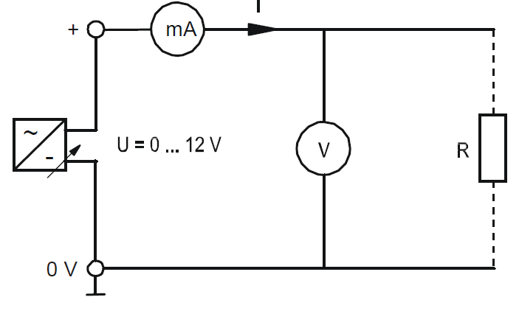

Fig. 3

|  |  |  |  |  |  |  |  |  |
| --- | --- | --- | --- | --- | --- | --- | --- | --- |
| V | | 0 | 2 | 4 | 6 | 8 | 10 | 12 |
| R=100Ω | I (mA) |  |  |  |  |  |  |  |
| P (mW) |  |  |  |  |  |  |  |
| R(Ω) |  |  |  |  |  |  |  |
| R=220Ω | I (mA) |  |  |  |  |  |  |  |
| P (mW) |  |  |  |  |  |  |  |
| R(Ω) |  |  |  |  |  |  |  |
| R=330Ω | I (mA) |  |  |  |  |  |  |  |
| P (mW) |  |  |  |  |  |  |  |
| R(Ω) |  |  |  |  |  |  |  |

Table 1

|  |  |  |  |  |  |  |
| --- | --- | --- | --- | --- | --- | --- |
| R(Ω) | 100 | 220 | 330 | 470 | 680 | 1000 |
| I (mA) at 4 V |  |  |  |  |  |  |
| I (mA) at 8 V |  |  |  |  |  |  |
| I (mA) at 12 V |  |  |  |  |  |  |

Table 2

**ΙΙ- Series and parallel resistive connection**

1. Connect the circuit as shown in Fig. 3.

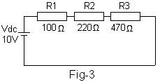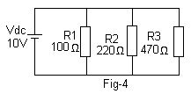

1. Measure the voltage **VR1, VR2, VR3** and the respective currents **IR1, IR2, IR3**
2. Calculate the equivalent resistance of R1, R2, R3, then find the relation between the total resistance and R1, R2, R3.
3. Connect the circuit as shown in Fig. 4.
4. Measure the Voltage **VR1, VR2, VR3**, and the respective currents **IR1, IR2, IR3** and **IRtot**
5. Calculate the equivalent resistor of R1, R2, R3, then find the relationship between the resistances.

ΙΙΙ**- Voltage divider:**

1. Connect the circuit as shown in Fig. 5.

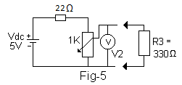

1. Measure the voltage **V2** at each of the potentiometer positions (α≅ 0 to 10) **without R3** as in table – 3 and **with R3**. Plot V2 (without load) against α, And V2 (with load) against α.

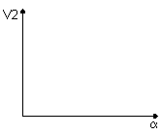

|  |  |  |  |  |  |  |  |  |  |  |
| --- | --- | --- | --- | --- | --- | --- | --- | --- | --- | --- |
| α | 1 | 2 | 3 | 4 | 5 | 6 | 7 | 8 | 9 | 10 |
| V2(R3 not conn.) |  |  |  |  |  |  |  |  |  |  |
| V2 (R3 conn. ) |  |  |  |  |  |  |  |  |  |  |

1. table - 3

*Note: Take reading in the column direction.*

**Question**

1- Describe the shape of the curves?

2- Without load, find the value of R2 when the potentiometer in position 3? (From the graph, calculation and measured.)

1. Setting the potentiometer at position 5 (in the mid) and R3 =330Ω calculate V2?

AN-NAJAH NATIONAL UNIVERSITY

FACULTY OF ENGINEERING

ELECTRICAL ENGINEERING DEPARTMENT

EXPERIMENT # 3

**NETWORK THEOREMS**

**Objectives:**

1. To study the effect of more than one voltage source in a network.
2. To find a method of simplifying a network in order to obtain the current in one particular branch of the network.
3. To study the parameters of the voltage source.

**Introduction:**

**Kirchhoff’s law:**

Kirchhoff’s current law (KCL) states that the algebraic sum of currents entering a node (or a closed boundary) is zero. , i.e. the sum of the currents entering a node is equal to the sum of the currents leaving the node.



where N is the number of branches connected to the node and $i_{n}$ is the $n^{th}$ current entering (or leaving) the node. By this law, currents entering a node may be regarded as positive, while currents leaving the node may be taken as negative or vice versa.

Kirchhoff’s voltage law (KVL) states that the algebraic sum of all voltages around a closed path (or loop) is zero,



where M is the number of voltages in the loop (or the number of branches in the loop) and $v_{m}$ is the $m^{th}$ voltage.

**Superposition Theorem:**

The superposition principle states that the voltage across (or current through) an element in a linear circuit is the algebraic sum of the voltages across (or currents through) that element due to each independent source acting alone.

**Thevenin’s Theorem**:

Thevenin’s theorem states that a linear two-terminal circuit can be replaced by an equivalent circuit consisting of a voltage source Vth in series with a resistor Rth, where Vth is the open-circuit voltage at the terminals and Rth is the input or equivalent resistance at the terminals with all sources replaced by their internal resistance.



**Experimental Procedure**

1. **Kirchhoff’s laws**
2. Connect the circuit as shown in Figure 3.



**Figure 3:** Kirchhoff’s laws experiment setup.

*Note the polarity of the voltage and current.*

1. Adjust the applied voltage to be 15 V. Measure the voltage across R1, R2, R3, R4, R5, and the current in each component. Tabulate your results as shown in Table 1. **Verify your results using Kirchhoff’s.**
2. By using the current and the voltage measured values for every branch calculate the value of the resistance R1 to R5.
3. Using KCL, KVL, calculate the currents and voltages theoretically.

Table 1

|  |  |  |
| --- | --- | --- |
| Resistance | Voltage (v) | Current (mA) |
| R1 |  |  |
| R2 |  |  |
| R3 |  |  |
| R4 |  |  |
| R5 |  |  |

1. **Superposition Theorem**:
2. Connect the circuit as shown in Figure 4.



**Figure 4:** Superposition theorem

1. Measure the current in R1 to R5, note both the magnitude and the polarity of each current and tabulate them in Table 2.
2. Disconnect the 15V source, as shown in shown in Figure 5. Measure and tabulate the current $I_{1}^{'}$, $I_{2}^{'}$ and $I_{3}^{'}$ as in Table 2.



**Figure 5.**

1. Connect the circuit as shown in Figure 6, then measure and tabulate the currents $I_{1}^{''}$, $I_{2}^{''}$ and ${I'}_{3}^{'}$ as in Table 2. You should have found that the sum of the currents due to individual voltage source is equal to the current resulting when both sources are present in the network.



**Figure 6**

Table 1.

|  |  |  |  |  |  |  |  |  |  |
| --- | --- | --- | --- | --- | --- | --- | --- | --- | --- |
| **I**  ***measure*** | ***Current (mA)*** |  | ***Current (mA)*** |  | ***Current (mA)*** | **I *sup*** | ***Current (mA)*** | **I**  ***calc*** | ***Current (mA)*** |
| *I1* |  |  |  |  |  | *I1* |  | *I1* |  |
| *I2* |  |  |  |  |  | *I2* |  | *I2* |  |
| *I3* |  |  |  |  |  | *I3* |  | *I3* |  |

**Questions:**

Q1) Do the currents direction agrees with those in the Figure?

Q2) Is there a relationship between $I_{1}$, $I_{1}^{'}$ and $I_{1}^{''}$?

Q3) Does the same relationship holds for ($I_{2}$, $I_{2}^{'}$, $I_{2}^{''}$), and for ($I_{3}$, $I_{3}^{'}$, $I_{3}^{''}$) ?

1. **Thevenin’s Theorem:**
2. Connect the circuit as shown in Figure 7.

|  |  |
| --- | --- |
|  |  |
| **Figure 7** | **Figure 8** |

1. Measure the current in the 680 Ω resistors.
2. Remove the 680 Ωresistor, and measure the voltage between terminals X, Y, i.e. (Vth).
3. To find Rth Remove the voltage source, as shown in **Figure 8**. The resistance of this network may be found by connecting a test voltage source between points X and Y. Measure the total current by applying 2,4,6 and 8 V, calculate the resistance using ohm’s law, and take the average of the values to find Rth,

|  |  |  |  |  |  |
| --- | --- | --- | --- | --- | --- |
| V | 2 | 4 | 6 | 8 |  |
| I |  |  |  |  |
| R |  |  |  |  | Raverage |

5 Find the current through the 680 Ω. Compare the calculated and measured current values in step 2 .

AN-NAJAH NATIONAL UNIVERSITY

FACULTY OF ENGINEERING

ELECTRICAL ENGINEERING DEPARTMENT

EXPERIMENT# 4

# Voltage Source

**Objectives:**

1. To study the parameters of the voltage source.
2. To study the Series Circuiting of Voltage Sources.

### To study the Parallel Circuiting of Voltage Sources.

1. **Introduction:**

* **Voltage Sources**

Voltage sources used in circuit analysis are usually "ideal" sources. By ideal we mean that the value of the voltage of the source does not change regardless of how much current it supplies. Practical sources are limited in the amount of current they can supply.

* **Voltage Measurement**

The DMM will be used to measure voltage. To measure voltage the meter leads are connected across (in parallel with) the device. Voltage is measured between two nodes. Voltage is a potential difference. You are measuring the potential difference between two nodes.

* **Current Measurement**

To measure current the meter must be connected in series with the circuit so that the current flowing through the ammeter is the same as the current flowing through the circuit. The circuit must be temporarily disconnected to insert the ammeter in series with it.

1. **Equivalent Voltage Source**
2. **Basics**

As the set-ups of voltage sources in electrics and electrical engineering are very complex, an equivalent circuit diagram is used for the required calculations.

|  |
| --- |
|  |
| **Figure 1:Circuit diagram of an equivalent voltage source** |

**Where,**

VO: initial voltage

Ri: Internal resistance

Vi: Voltage drop at the internal resistance Ri

V12: Terminal voltage

RL: Load resistance

IL: Load current

A voltage source consists of input voltage V0 and an internal resistance Ri. Is the equivalent voltage source unloaded **(unload mode)**, no current flows within the circuit (open circuit), means:

$$V_{12}=V_{O}$$

Is the equivalent voltage source loaded **(load mode)**, following voltage ratios are given:

$$V_{12}=V_{O}-I_{L}×R_{i}$$

Load current according Ohm’s law is as follows:

$$I_{L}=\frac{V_{O}}{R_{i}+R_{L}}$$

In the equivalent voltage source in short circuit **(short circuit mode)**, voltage is:

$$V_{12}=0$$

A short circuit current ISC is limited by the internal resistance Ri

The parameters Vo, Ri and ISC of an equivalent voltage source can be determined by characteristic curve shown in Figure 2

|  |
| --- |
|  |
| Figure 2: characteristic curve |

1. **Series Circuiting of Voltage Sources**

Series circuiting of voltage sources as in the Figure 3 (The precondition is that the poles of the voltage source are connected correctly, plus pole of one voltage source to the minus of the next one) gives a higher total voltage:

$$V_{tot}=V_{1}+V_{2}$$

|  |
| --- |
|  |
| **Figure 3** |

If the poles are reversed the total voltage corresponds to the difference between the initial voltages:

$$V_{tot}=V_{1}-V_{2}$$

The internal resistors of the series-connected voltage sources add to a total internal resistance of:

$$R_{itot}=R_{i1}+R_{i2}$$

A load resistor RL a current IL:



### **Parallel Circuiting of Voltage Sources**

If multiple voltage sources with same voltage are parallel connected, current IL increases. Therefore same poles have to be interconnected. If voltages are not equal there is an equalizing current flow I0 within the voltage sources. The current value is dependent on the voltage difference and each internal resistance

|  |
| --- |
|  |
| **Figure 4** |

Load current IL depends on the load resistance RL, on internal resistances of each voltage supply and on the initial voltages.



The internal resistors are in parallel, which gives a total internal resistance of:



1. **Experimental Procedure**
2. **Voltage Source :**

Connect the circuit as shown in Figure 5,we add 22Ω resistor as an internal resistant Ri.

|  |
| --- |
|  |
| **Figure 5** |

1. Measure the open circuit voltage VOC at points (1, 2), connect a 100 Ω resistor and measure V12 at points (1,2) and IL, replace 100 Ω by 33 Ω, measure IL and V12, disconnect RL and connect Ammeter to the points 1,2 then measured ISC, record your results as in Table 1.

**Table1**

|  |  |  |  |  |  |
| --- | --- | --- | --- | --- | --- |
|  | | RL=100 Ω | | RL=33 Ω | |
| VO (V) | ISC (mA) | V12 (V) | IL (mA) | V12 (V) | IL (mA) |
|  |  |  |  |  |  |

1. Plot the voltage source Characteristic curve, showing load lines (100 Ω, 33 Ω ).

*Q1) How much is the voltage drop Vi at the internal resistance Ri when loaded with an equivalent power source of RL = 100 Ω?*

*Q2) How does a reduction of the internal resistance Ri (e.g. 5 Ω) affect the curve of an equivalent voltage source?*

1. **Series Circuiting of Voltage Sources**:

Connect the circuit as shown in Figure 6.

|  |
| --- |
|  |
| **Figure 6** |

2- What is the value of Vtot:

* Opposite poles connected(+with-)

Vtot=

* Matching poles connected (+with+)

Vtot=

1. **Parallel Circuiting of Voltage Sources**

1-Connect the circuit as shown in Figure 7, we add internal resistance Ri= 100Ω.

|  |
| --- |
|  |
| **Figure 7** |

2-Connect two voltage sources in parallel and perform the flowing measurements at equal and unequal initial voltages. Measurements should be made on both no-load and load operation, as in Table 2

**Table 2**

|  |  |  |  |  |  |  |  |  |  |
| --- | --- | --- | --- | --- | --- | --- | --- | --- | --- |
| **Equal initial voltages VO1=VO2=15V** | | | | | | | | | |
| **No-load** | | | | **Load=1KΩ** | | | | | |
| **Vi1 (V)** | **Vi2 (V)** | **V12 (V)** | **Io (mA)** | **Vi1 (V)** | **Vi2 (V)** | **V12 (V)** | **I1 (mA)** | **I2 (mA)** | **IL (mA)** |
|  |  |  |  |  |  |  |  |  |  |
| ***Check the results by calculation.*** | | | | | | | | | |
| **Unequal initial voltages VO1=10 VO2=15V** | | | | | | | | | |
| **No-load** | | | | **Load=1KΩ** | | | | | |
| **Vi1 (V)** | **Vi2 (V)** | **V12 (V)** | **Io (mA)** | **Vi1 (V)** | **Vi2 (V)** | **V12 (V)** | **I1 (mA)** | **I2(mA)** | **IL (mA)** |
|  |  |  |  |  |  |  |  |  |  |
| ***Check the results by calculation.*** | | | | | | | | | |

AN-NAJAH NATIONAL UNIVERSITY

FACULTY OF ENGINEERING

ELECTRICAL ENGINEERING DEPARTMENT

Experiment 5

**Properties of AC signals**

## Objective:

The aim of this experiment is to study the basic properties of Alternating Current (AC) wave forms.

## **Introduction**

The AC wave forms may be sine wave, square wave, and triangular wave or saw tooth wave. These different waveforms are illustrated in

|  |
| --- |
|  |

Figure 1 diferent wave forms

Alternating current changes its direction of flow continuously, in contrast to direct current (DC), which always flows always in same direction.

The basic parameters of the AC waveform that will be studied in this experiment are the peak amplitude, frequency, period and the wave length of the wave.

Since the sinusoidal waveform is the most commonly used waveform in electrical systems, the theory in this experiment will be briefly reviewed for sinusoidal wave form which is expressed mathematically by

$$v\left(t\right)=v_{p}\sin\left(ω_{0}t+θ_{v}\right)$$

$$i\left(t\right)=i_{p}\sin\left(ω_{0}t+θ_{i}\right)$$

Where $v_{p}$ is the peak amplitude of the voltage waveform, $i_{p}$ is the peak amplitude of the current waveform, $ω_{o}$ is the angular frequency, $θ_{v}$ is the phase of the voltage wave and $θ_{i}$ is the phase of the current wave. A sinusoidal voltage wave form is plotted in

|  |
| --- |
|  |

Figure 2

The peak amplitude of AC voltage can be measured directly by using the oscilloscope or by using digital voltmeter. However the digital voltmeter measures the RMS value of the voltage waveform. In order to convert the measured RMS voltage into peak amplitude we can use the following equation

$$v_{p}=\sqrt{2}×V_{RMS}$$

Recall that from the electrical circuit course that the frequency and the period and the wave form are related by

$$f=\frac{1}{T}$$

Also the angular frequency is related to the frequency of the wave form by

$$ω_{0}=2πf$$

The wavelength and the frequency of the waveform are related by $λ=\frac{c}{f}$, where $c$ is the speed of light which is given by $c=3×{10}^{8} m/s$

The average power of an AC wave form flowing into resistor $R$ is given by

$$P_{av}=\frac{1}{2}v_{p}i_{p}\cos\left(θ_{v}-θ_{i}\right)=\frac{1}{2}\frac{v_{p}^{2}}{R}=\frac{1}{2}i_{p}^{2}R$$

In terms of RMS quantities the average power is given by

$$P_{av}=v_{RMS}i_{RMS}\cos\left(θ_{v}-θ_{i}\right)=\frac{v_{RMS}^{2}}{R}=i_{RMS}^{2}R$$

The oscilloscope cannot y1` across this $1 Ω$ resistor. By Ohm’s law the current is given by

$$i=\frac{v}{R}=\frac{v}{1}=v$$

Therefore the voltage measured by the oscilloscope is the current flowing in the desired branch of the circuit. However it is sometimes difficult to obtain precise $1 Ω$ resistor, for the purpose of demonstration we can use for example a series $10 Ω$ or $100 Ω$ resistor, then measure the voltage across the series added resistor. The voltage divided by the resistor value is the desired current.

## **Experiment procedure**

1. Connect the circuit as shown in

|  |
| --- |
|  |

**Figure 3**

1. Connect channel one of the oscilloscope to point A in the circuit. adjust the voltage and time scales of the oscilloscope to display one cycle of the sinusoidal waveform
2. Sketch the signal as it appears on the screen of the oscilloscope
3. From the signal shown on the oscilloscope screen determine the quantities listed in

|  |  |  |  |
| --- | --- | --- | --- |
|  |  |  |  |
|  |  |  |  |
|  | **The instantaneous voltage at one third of the period $$v\left(t=\frac{T}{3}\right)=$$** | | |

**Table 1**

1. To demonstrate how can the oscilloscope be used to measure current connect the circuit as shown in

|  |
| --- |
|  |

**Figure 4**

1. On channel Ch1 measure the voltage across $R_{1}$
2. Measure the AC current flowing in the circuit by using the oscilloscope. This can be done by measuring the voltage across $R_{2}$, then divided the measured waveform by the value $R_{2}$.
3. Determine the average power for the measured signals by using different average power equations as shown in :

|  |  |  |  |
| --- | --- | --- | --- |
|  |  |  |  |
|  |  |  |  |

**Table 2**

1. Compute the instantaneous power at different time instants and fill the calculations in

|  |  |  |  |
| --- | --- | --- | --- |
| Time (ms) | Instantaneous voltage (V) | Instantaneous current (mA) | Instantaneous P (mW) |
| 0.1 |  |  |  |
| 0.2 |  |  |  |
| 0.3 |  |  |  |
| 0.4 |  |  |  |
| 0.5 |  |  |  |
| 0.6 |  |  |  |
| 0.7 |  |  |  |
| 0.8 |  |  |  |
| 0.9 |  |  |  |
| 1 |  |  |  |

**Table 3**

1. **Plot the curves of $v\left(t\right)$, $i(t)$ and $P\left(t\right)$ versus time on the same graph paper. You may use either excel or MATLAB to perform the plot**

AN-NAJAH NATIONAL UNIVERSITY

FACULTY OF ENGINEERING

ELECTRICAL ENGINEERING DEPARTMENT

Experiment # 6

**Capacitor in the AC. Circuit**

**Objectives**

1. To study the voltage and current response of capacitor under the application of step response
2. To study the series and parallel combinations of capacitors
3. To study the phase relation between current and voltage on the capacitor under AC excitation.

## **Introduction**

In this experiment a basic RC circuit will be analyzed under both step and AC excitations. The RC circuit is an essential circuit used in many applications such as the design of low pass, high pass, band pass, band stop filters. It is also used in the design of relaxation oscillators.

### **Step response analysis**

This experiment aims to demonstrate the voltage and current relations on the capacitor under step response excitation. Recall that from the electrical circuits course that the current on the capacitor is given

$$i_{c}\left(t\right)=C\frac{dv}{dt}$$

If a DC voltage is applied to the RC circuit shown in Figure 5 then the capacitor voltage starts to increase from its initial value $V_{0}$ to its final value which is equal to the source voltage $V_{s}$ in this case.

|  |
| --- |
|  |

**Figure 5 basic RC circuit**

If the switch is in position 1 and the initial voltage on the capacitor is $V_{0}=0$*,* then the current and the voltage on the capacitor can be found by applying KVL, as shown below

$$-V_{S}+{Ri}_{c}+\frac{1}{C}\int_{0}^{t}{i_{c}\left(τ\right)dτ}=0$$

By solving the above first order differential equation we have the following expressions for the voltage and current on the capacitor

$$v_{c}\left(t\right)=V_{s}\left(1-e^{-\frac{t}{τ}}\right)$$

$$i_{c}\left(t\right)=\frac{V_{s}}{R}e^{-t/τ}$$

Where $τ$ is the time constant of the circuit which is given by $τ=RC$.

The above tow equations represent the voltage and current behavior on the capacitor during the charging state. However when the time instant is equal to $t=τ$, the voltage reaches 63% of its final value and the current reaches 37% of its final value

If the switch is thrown to position 2 in , then the voltage and current equations representing the discharging behavior of the capacitor can be found by applying KVL to the circuit shown in

Again by solving the discharge first order differential equation we have the following tow expressions for the voltage and current on the capacitor

$$v_{c}\left(t\right)=V_{s}e^{-\frac{t}{τ}}$$

$$i_{c}\left(t\right)=-\frac{V_{s}}{R}e^{-\frac{t}{τ}}$$

The discharge voltage equation shows that the voltage on the capacitor reaches to 37% of its initial value $V_{s}$ when $t=τ$

### **AC analysis**

If the capacitor is used in a circuit excited by an AC source, then it is more convenient to analyze the circuit in phasor domain rather than time domain. The phasor domain analysis eliminates the need for the use of differential equations when dealing with circuits containing capacitors, inductors or both. When analyzing circuits containing capacitors, it is worthy to mention that the current on the capacitor leads the voltage by 90º.

In the phasor domain we treat the capacitor as capacitive impedance whose reactance is given by

$$X_{c}=\frac{1}{2πfC}$$

If the AC current and voltages on the capacitor are unknown, then we can determine the reactance of the capacitor from the following equation

$$X_{c}=\frac{V_{c}}{I_{c}}$$

If a group of capacitors are connected in series, then the equivalent capacitance can be computed from the following equation

$$\frac{1}{C_{equ}}=\frac{1}{C_{1}}+\frac{1}{C_{2}}+…+\frac{1}{C_{n}}$$

The equivalent voltage on the capacitors is given by

$$V_{equ}=V_{1}+V_{2}+…+V_{n}$$

If the capacitors are connected in parallel, then the equivalent capacitance can be found from

$$C_{equ}=C_{1}+C_{2}+…+C_{n}$$

The equivalent current on all the capacitors is given by

$$I_{equ}=I_{1}+I_{2}+…+I_{n}$$

1. **Experimental procedure :**

## **Charging and discharging process of a capacitor**

## Connect the circuit shown in and connect the generator with a positive square wave voltage.

|  |
| --- |
|  |

**Figure 6**

1. Connect channel Ch1 of the oscilloscope to point A for reading out the input voltage
2. Connect channel Ch2 to point B of the oscilloscope for reading out the capacitor voltage.
3. For presentation of the capacitor current substitute the resistor $4.7KΩ$ and the capacitor $0,22 μF$ within the circuit. Then measure the voltage at the resistor.
4. Draw the resulting waveform as you see on the screen of the oscilloscope. From the measured signals determine
5. The time constant $τ$
6. The capacitance C
7. The instantaneous voltage on the capacitor at 2 ms from the beginning of the charging time. Confirm the measured value of the voltage capacitance by using calculations
8. The charge on the capacitor Q

### **Voltage and current phase shift measurements:**

1. Connect the circuit as shown in Figure 7, such that the voltage source is replaced by a sinusoidal signal whose peak to peak amplitude is $v_{pp}=3 V$ and the frequency is $f=1 kHz$.

|  |
| --- |
|  |

**Figure 7**

To display the phase shift between voltage and current, connect Ch1 of the oscilloscope to point A (capacitor current), and Ch2 (Inv) to point B (capacitive voltage). Make point C is the GND of the oscilloscope. Draw the curves and determined the phase shift between $V_{c}$ and $I_{c}$.

1. **Capacitive Reactance Xc .**
2. Connect the circuit as shown in Figure 8

|  |
| --- |
|  |

**Figure 8**

1. Set the function generator to 4 $V_{RMS}$ at 200 Hz, 500 Hz, 700 Hz and 1000 Hz. Tabulate your result in Table 4 then plot the characteristic curve $Xc$ versus the frequency on the x-axis for capacitance values of $c=1F$ and $c=0.22F$.

|  |  |  |  |  |  |
| --- | --- | --- | --- | --- | --- |
| Frequency (Hz) | | 200 | 500 | 700 | 1000 |
| $$V_{c}(rms)$$ | 1.0 μF |  |  |  |  |
| 0.22 μF |  |  |  |  |
| $$I_{c}(mA)$$ | 1.0 μF |  |  |  |  |
| 0.22 μF |  |  |  |  |
| $$X_{c}()$$ | 1.0 μF |  |  |  |  |
| 0.22 μF |  |  |  |  |
|  | 1.0 μF |  |  |  |  |
| 0.22 μF |  |  |  |  |
| $$V_{R}$$ | 1.0 μF |  |  |  |  |
| 0.22 μF |  |  |  |  |

**Table 4**

**Note:** Please make sure measuring point C is not connected by earth of the instruments (function generators, oscilloscope) to measuring point B and A. Resistor (1kΩ) in the circuit serves as measuring resistor. Its voltage drop VR is proportional to capacitor current IC.

Capacitor current is calculated according to following formula:

$$I_{c}=\frac{V_{R}}{R}$$

**Questions**

1. Explain the shape of the curves you got from the plotting Xc as a function of frequency
2. *What is the value of $X_{c}$ of the capacitor 0.22μF at 220 Hz from the graph and calculation?*
3. **Capacitor in series and parallel**
4. Connect the circuit as shown in Figure 9.

|  |
| --- |
|  |

**Figure 9**

1. Measure the current in the circuit using digital ammeter, then measure the total voltage between point B and the GND of the circuit $V_{ctot}$. Measure the voltage across $V_{R1}$, $V_{C1}$, $V_{C2}$, $V_{C3}$. Calculate from the measured current and the measured voltages the values of $X_{C1}$, $X_{C2}$, $X_{C3}$ and $X_{ctot}$
2. Compute the values of $C_{1}$, $C_{2}$, $C_{3}$ and $C_{tot}$ using the following equation
$$C=\frac{1}{2πfX_{c}}$$

3. Calculate (from result) the $C_{tot}$ and compare between measured and calculated values for $C_{tot}$.
4. Connect the circuit as shown in Figure 10.Measure the voltage $V$ and the currents $V_{C1}$, $V_{C2}$, $V_{C3}$, and $V_{ctot}$ and $I_{ctot}$, $I_{C1}$, $I_{C2}$, and $I_{C3}$. Calculate (from the measured voltage and measured currents the values of $X_{C1}$, $X_{C2}$, $X_{C3}$ and $X_{ctot}$, then $C_{1}$, $C_{2}$, $C_{3}$ and $C_{tot}$.
5. Calculate (from result) the $C_{tot}$ and compare between $C_{tot}$ measured and calculated.

|  |
| --- |
|  |

**Figure 10**

AN-NAJAH NATIONAL UNIVERSITY

FACULTY OF ENGINEERING

ELECTRICAL ENGINEERING DEPARTMENT

**EXPEREMENT # 7**

**INDUCTORS**

**Objectives:**

1. To describe the characteristics of an inductor under DC and AC conditions.
2. To investigate series and parallel inductive circuits
3. To determine the phase shift that exists between current and voltage in inductive circuits.

**Introduction :**

When switching on/ off DC voltage at an inductor, current and voltage progress according to an exponential function. If DC voltage is applied, current rises in the time of 1 τ to 63 % of its final value and drops when switched off to 37% of its initial value. Current reaches its final value or zero each 5 τ .

τ is the time constant, it depends on the inductivity of the coil and on ohm’s resistance affecting the circuit

$$τ=\frac{L}{R}$$

$τ$: Time constant in s

$L$: Inductance in H

$R$: the sum of the ohmic resistance of the coil in (Ω ) and the internal resistance of the voltage source.

Voltage within the coil decreases from its maximum value (when applying DC voltage) after $1τ$ to 37 % and reaches its lowest value after $5τ$, dependent on the ohm’s resistance of the coil.

Instantaneous value of current iL and instantaneous value of voltage VL in a coil when switching on/ off DCvoltage is calculated by following formulas:

|  |  |
| --- | --- |
| Instantaneous value of current iL at switching on |  |
| Instantaneous value of voltage VL at  switching on |  |
| Instantaneous value of current iL at  switching off |  |
| **I**nstantaneous value of voltage VL at  switching off |  |

**Inductive reactance**

As the frequency of the sine wave increases, the rate of change of the current also increases, andso the induced (reacting) voltage across the inductor increases. As a result, the net currentthrough the inductor decreases. That means, the inductor’s reactance increases with frequency.The inductive reactance is given by

$$X_{L}=2πfL$$

As with capacitors and resistors, Ohm’s law can be applied to inductive circuits:

$$X_{L}=\frac{V_{L}}{I_{L}}$$

The voltage induced across the inductor is a maximum when the change in current is a maximum. When a sinusoidal current is applied to an inductor, the largest induced voltage appears across the inductor when the current is passing through zero. At the peaks of the applied current, the slope is zero and the current is not changing, so the induced voltage is zero. Therefore, the voltage that appears across an inductor leads the current in the inductor by 1/4 cycle i.e. ${90}^{0}$ degrees.

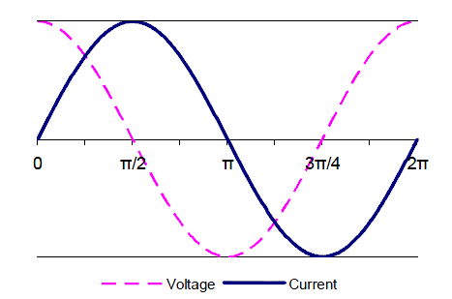

When inductors are connected in parallel then the total inductance will be determined using the following equation:



Also when inductors are connected in series then the total inductance will be determined using the following equation:



**Experimental Procedure:**

1. Connect the circuit as shown in Fig .1 and set the function generator to positive square wave, amplitude of voltage 6 V and at 1 kHz.

|  |
| --- |
|  |
| **Figure 1** |

1. the input signal at point A.
   1. Plot the***Inductance voltage*** signal at point B.
   2. Using Fig. 2 Plot***Inductance current*** signal at point B.

|  |
| --- |
|  |
| **Figure 2** |

* 1. Determine τ(from graph). Then calculate the inductance L.

1. Calculate the values of τ and L and compare the calculated values with those obtained from step 2.
2. To determine the phase shift between the current IL and the voltage VL. Change the positive square wave to sin wave with amplitude 3Vpp, then connect ch1 at point B (voltage monitor), and ch2 at point D (current monitor) as in Fig. 3

|  |
| --- |
|  |
| **Figure 3** |

1. Plot the voltage curvesand determine the phase shift.
2. To determine the inductive reactance XL, connect the circuit as shown in Fig. 4

|  |
| --- |
|  |
| **Figure 4** |

1. Set the function generator to 4 Vrms at 1 to 6kHz , tabulate your result in Table.1, then plot the characteristic curve XL = f (F) for 100 mH and 200mH .

Table.1

|  |  |  |  |  |  |  |  |
| --- | --- | --- | --- | --- | --- | --- | --- |
| **F(kH)** |  | **1** | **2** | **3** | **4** | **5** | **6** |
| VL | 100mH |  |  |  |  |  |  |
|  | 200 mH |  |  |  |  |  |  |
| IL | 100mH |  |  |  |  |  |  |
|  | 200mH |  |  |  |  |  |  |
| XL | 100mH |  |  |  |  |  |  |
|  | 200mH |  |  |  |  |  |  |

**Question**

* *What can you deduce from the curve?*
* *Check the value of XL, from graph, for L= 100mH at 3 kHz and compare it with calculated value?*
* *What you think would happen to the current in this RL series circuit if the frequency were decreased? Why?*

1. Connect the circuit as shown in Fig.5.

|  |
| --- |
|  |
| **Figure 5** |

1. Measure the currents and the voltages **IL1, IL2, VL1, VL2 and VLtot**.

**Q)** Calculate (from the measured values) **XL1, XL2, XLtot** then **L1, L2** and **Ltot** and subsequently, compare between the measured and calculated value for **Ltot.**

1. Connect the circuit as shown in Fig.6, measure the voltage **VL1, VL2, VLtot and ILtot , IL1 and IL2** .

|  |
| --- |
|  |
| **Figure 6** |

**Q)** Calculate (from the measured values) **XL1,XL2 and XLtot ,then L1, L2,Ltot.**

Calculate (from result) the **Ltot** and compare it with **Ltot**

AN-NAJAH NATIONAL UNIVERSITY

FACULTY OF ENGINEERING

ELECTRICAL ENGINEERING DEPARTMENT

**EXPERIMENT #8**

**RLC Series & Parallel Circuits**

**Objective of experiment**

1. To investigate the impedance of RLC circuit.
2. To determine the distribution of the applied voltage V and current I in the R, L and C elements.
3. To determine the phase angle between the voltage and the current for each element in the RLC circuit.

**Theoretical aspects:**

1. **Series circuits**

If a sinusoidal AC voltage is applied across a series circuit, containing resistor, capacitor and coil, the same current would flow through all the components. In the case of the resistor, the voltage across the resistor, VR will be in phase with the current, IR passing through it. However, the voltages across the capacitor and across the coil experience a phase shift with their respective currents.

The Apparent voltage V (the voltage applied to the circuit) may be defined as follows:



or



Where Z is called the apparent resistance Z (or more commonly known as the Impedance):

The Impedance Z may be calculated as follows:

, , 

The phase angle   being the angle between the applied voltage & current for the circuit),



# Parallel circuits

In a parallel RLC circuit, the voltages across all the components are the same. and the total current , I , is divided into active current IR, capacitor current IC, and coil current IL. A phase shift occurs between each of the currents IL, IC, and the total current I ( it is clear that no phase shift exist between IR and I ) , due to the reactance’s XL of the coil and XC of the capacitor.

The current IC precedes (leads) IR ( and therefore I ) constantly by 90° -- assuming that the capacitor contains no resistance , While the current IL lags the active current IR constantly by 90° -- also assuming that the coil is pure inductive , i.e. Contains no resistance .The Currents IC opposes IL (180° angle phase) and thus tends to equalize each other depending on their magnitude.

The apparent current I (the total current supplied to the circuit) can be calculated using the following equation:



Also the **apparent conductance Y** of the circuit may be obtained from the following equation:

 , and 

Tan of the phase angle  :



**Experimental procedure**

**Ι - Series circuit**

1. Connect the circuit as shown in Fig. 1,

|  |
| --- |
|  |
| **Figure 1** |

1. Set the function generator as follows Vrms = 3V (sinusoidal), f = 1kHz.
2. With the DMM measure **VL(AB), VC(BC) and VR(CD)**as in Tabl.

* Using the appropriate calculation and the respective vector diagram, determine the above voltages as well as the phase angle,     between the total voltage supplied to the circuit and the total current.

  

|  |  |  |  |  |  |  |
| --- | --- | --- | --- | --- | --- | --- |
| C | **VL(AB)** | **VC(BC)** | **VR(CD)** | Itot | Vtotcal |  cal   |
| 0.1µF |  |  |  |  |  |  |
| 0.22µF |  |  |  |  |  |  |
| 1µF |  |  |  |  |  |  |

1. Connect the oscilloscope’s **ch-1 to point C, ch-2 to point A and connect point D to ground** , and draw the displayed voltage waveforms and determines the phase angle ****

**ΙΙ  Parallel circuits:**

1. Connect the circuit as shown in Fig. 2,

|  |
| --- |
|  |
| **Figure 2** |

1. Set the function generator to **Vrms = 3V (sinusoidal), f = 1 kHz**.
2. With the DMMs measure **I, IR, IC, IL**and deduce from calculations the total **current I** and **phase angle $φ$.**

|  |  |  |  |  |  |  |
| --- | --- | --- | --- | --- | --- | --- |
| C | **I** | **IR** | **IC** | **IL** | **I**tot cal |  cal   |
| 0.1µF |  |  |  |  |  |  |
| 0.22µF |  |  |  |  |  |  |
| 1µF |  |  |  |  |  |  |

1. Using the related calculations, constructs the victor diagrams.

AN-NAJAH NATIONAL UNIVERSITY

FACULTY OF ENGINEERING

ELECTRICAL ENGINEERING DEPARTMENT

**EXPERIMENT # 9**

**Three-Phase Alternating Current**

**Objectives**

1. To learn the main two configurations of three phase systems Y and delta
2. To learn the relation between phase and line voltages and current in both Y and delta connected loads
3. Study the effect of balanced unbalanced load on the three phase load

**INTRODUCTION**

Three phase system has many advantages over single phase system. The main benefit for using three phase for electrical power transmission is that smaller cross sectional area power cables can be used for the transmission of electrical power. Smaller cross sectional area cables means less cost of the power system and less power is lost in form of heat.

Another advantage of three phase system is that when an AC motors are operating using three phase system the voltage at any instant of time is not zero. This means that the motor will experience less mechanical vibration compared with single phase voltage whose magnitude crosses the zero at multiple instants of time. If the instantaneous voltage falls to zero then the motor instantaneous torque is zero and the motor vibrates mechanically. This mechanical vibration is a disadvantage of the motor.

In three phase system we have three sinusoidal voltage sources have the same frequency but differ in phase by 120° as illustrated by

|  |
| --- |
|  |

Figure 1 Three phase voltages

The source (generator) can be either Y or delta connected. Also the load can be connected to the source either in Y or delta configuration. Delta connected source is less common in practice because any unbalance in the load may cause large circulating current in the source (generators) windings. These circulating current heats up the generator windings and may cause an unexpected damage in the generator

The Y and delta connected source are illustrated by

|  |
| --- |
|  |

Figure 2 starr and delta connectd source

If the three phase system is star connected source, star connected load configurations there are two type voltages available the conductor (line to line) voltage and the phase voltage (line to neutral). The conductor voltage and the phase voltage are related by

$$V_{L}={\sqrt{3}V}_{ϕ}$$

The conductor (line) voltage supplied by the commercial power distribution network is $V_{L}=380 V$ rms, whereas the phase voltage is ($V_{ϕ}=220 V$)rms

The conductor and the phase currents in the star connected load are equal to each other and given by $I_{L}=I_{ϕ}$

If the three phase system is star connected source, delta connected load, then the conductor voltage and the phase voltage at the load side are the same ($V_{L}=V_{ϕ}$), but the line current is larger than the phase current. The line and phase current are related by

$$I_{L}=\sqrt{3}V_{ϕ}$$

In this experiment the conductor and phase voltages are $V_{L}=12 V_{eff}$ and $V_{phi}=7 V_{eff}$ respectively. These voltage levels are selected to simulate real three phase systems and to avoid the risk of electrical shock when the students perform the experiment.

In this experiment the source is star connected and the load may be either star or delta connected.

**EXPERIMENTAL PROCEDURE:**

Ι- Potential gradient in three-phase current systems

1. Display the phase voltages of a three-phase current system on the oscilloscope draw the displayed voltage curves in a diagram and determine the angle of phase shift between the individual voltages.

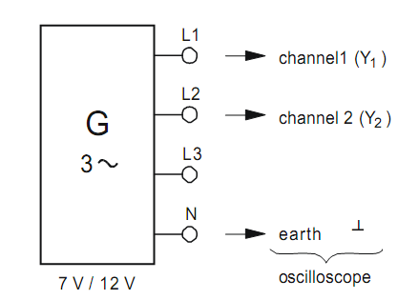

1. Measure the phase and conductor voltages with a multimeter and verify that the conductor (line voltage) is related to the phase voltage by

$$V_{L}=\sqrt{3}V_{ϕ}$$

|  |  |  |  |
| --- | --- | --- | --- |
| VL1 |  | VL1L2 |  |
| VL2 |  | VL2L3 |  |
| VL3 |  | VL1L3 |  |

Q) What is the peak value of phase and conductor voltage?

**ΙΙ-Star connected source star connected load**

1. Connect the circuit as shown in . Set the three load resistor to 1 kΩ each $R_{1}=R_{2}=R_{3}=1 k$ (balanced load).

|  |
| --- |
|  |

Figure 3

1. Measure the conductor (line) currents ($I_{L1}, I_{L2}, I_{L2}$) and the neutral current $I_{N}$. Fill the measured results in
2. Measure the conductor (line) and phase voltages and tabulate your measurements in
3. Change the values of the load resistances such that $R_{1}=1 k, R_{2}=680 , R_{3}=330$. In this case you will have an unbalance load which is the case in many practical three phase systems
4. Measure the conductor and phase currents and voltages, tabulate your result in .

|  |  |  |  |
| --- | --- | --- | --- |
| Star circuit | | Load | |
| Balanced | Unbalanced |
| Conductor | $$I_{L1}$$ |  |  |
| currents | $$I_{L2}$$ |  |  |
| $I_{L}$, $I_{N}$, $I_{ϕ}$ | $$I_{L3}$$ |  |  |
|  | $$I_{N}$$ |  |  |
| Conductor | $$V_{L1-L2}$$ |  |  |
| voltages | $$V_{L2-L3}$$ |  |  |
| $$V_{L}$$ | $$V_{L3-L1}$$ |  |  |
| Phase | $$V_{L1-N}$$ |  |  |
| voltages | $$V_{L2-N}$$ |  |  |
| $$V_{ϕ}$$ | $$V_{L3-N}$$ |  |  |
| Power | PR1 |  |  |
|  | PR2 |  |  |
|  | PR3 |  |  |
|  | Tot power |  |  |

Table 1

***Questions***

1. Is there any current flowing in the neutral when the load is balanced? Can we ignore the neutral line connecting between the source and the load in the balanced load? Justify your answers
2. Is there any current flowing in the neutral line when the load is unbalanced? Why?

**ΙΙΙ-Star connected source delta connected load.**

1. Connect the circuit as shown in
2. Measure the conductor (line) and phase currents as well as the conductor voltages when $R_{1}=R_{2}=R_{3}=1k$. In this case we have a balanced load. Tabulate your result in .
3. Change the load to an unbalanced load by setting the load resistances to $R_{1}=1 k, R_{2}=680 , R_{3}=330$. Measure the conductor, phase currents and voltages and tabulate your result in .

|  |
| --- |
|  |

Figure 4

|  |  |  |  |
| --- | --- | --- | --- |
| Delta Connected load | | Load | |
| balanced | Unbalanced |
| Conductor | $$I_{L1}$$ |  |  |
| currents | $$I_{L2}$$ |  |  |
| $$I_{L}$$ | $$I_{L3}$$ |  |  |
|  |  |  |  |
| Phase | $$I_{R1}$$ |  |  |
| currents | $$I_{R2}$$ |  |  |
| $$I_{ϕ}$$ | $$I_{R3}$$ |  |  |
|  | $$V_{L1-L2}$$ |  |  |
| $$V_{L}=V_{ϕ}$$ | $$V_{L2-L3}$$ |  |  |
|  | $$V_{L3-L1}$$ |  |  |
| Power | PR1 |  |  |
|  | PR2 |  |  |
|  | PR3 |  |  |
|  | Tot power |  |  |

Table 2

***Questions***

1. From the measure line and phase currents what is the relation between line and phase currents
2. What would be the algebraic sum of all line currents if the load is balanced?
3. Is there any change on the line voltages If the load is unbalanced? Why?

AN-NAJAH NATIONAL UNIVERSITY

FACULTY OF ENGINEERING

ELECTRICAL ENGINEERING DEPARTMENT

**EXPERIMENT # 10**

# SERIES RESONANCE

**Objective:**

1. Learn the definition of resonance in AC circuits.
2. Learn to calculate resonant frequencies, band widths, and quality factors for Series resonance circuits

**Introduction:**

The response of a circuit containing both inductors and capacitors in series or in parallel depends on the frequency of the driving voltage or current. This laboratory will explore one of the more dramatic effects of the interplay of capacitance and inductance, namely, resonance, when the inductive and capacitive reactances cancel each other. Resonance is the fundamental principle upon which most filters are based — filters that allow us to tune radios, televisions, cell phones, and a myriad of other devices deemed essential for modern living.

**Background:**

The reactance of inductors increases with frequency: $X_{L}=2πfL$

The reactance of capacitors decreases with frequency: $X_{C}=\frac{1}{2πfC}$

In an LC circuit, whether series or parallel, there is some frequency at which the magnitudes of these two reactances are equal. That point is called **resonance**.

Setting $X_{L}=X_{C}$, and solving for $f$, we find that the resonant frequency $f_{o}$ of an $LC$ circuit is,

$$f_{o}=\frac{1}{2π\sqrt{LC}}$$

The frequency $f$ has units $cycles/second$ or $\sec^{-1}$. The frequency may also be expressed as angular frequency, $ω$, where $ω=2πf$ and has units $radians/sec$. Thus, the resonant frequency may also be written as,

$$ω_{o}=2πf_{o}=\frac{1}{\sqrt{LC}}$$

The resonant frequency is generally the highest point of a peak (or the deepest point of a valley) with bandwidth $BW (cycles/sec)$ or $β (radians/sec)$. The resonant frequency is also called the center frequency, because it is at the mid-point of the peak frequency response.

The lowest frequency $(f_{1} or ω_{1})$ and the highest frequency $(f_{2} or ω_{2})$ of the band are the **“half-power points”** at which the power is $½$ that at the peak frequency. Since power goes like the square of the current, the current at the half-power points is $1/{\sqrt{2}}(= 0.707)$ times the current at the maximum. Thus, the bandwidth of a resonant circuit is the frequency range over which the current is at least $70.7\%$ of the maximum.

$$BW = f_{2} – f_{2} or β = ω_{2} – ω_{1}$$

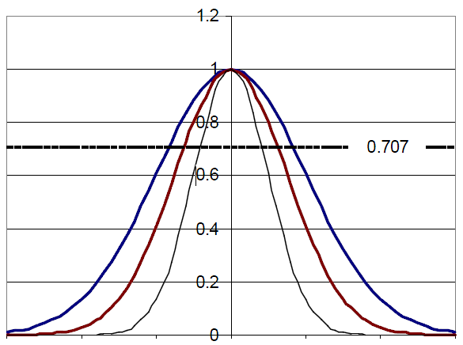

As the bandwidth narrows, the circuit becomes more highly selective, responding to a narrow range of frequencies close to the center frequency. The sharpness (narrowness) of that resonant peak is measured by the *quality factor $Q$* . The quality factor is a *unitless* quantity that is defined as,

$$Q=2π\left(\frac{maximum energy stored}{energy dissipated per cycle}\right)$$

In more practical terms,

$$Q=\frac{f_{o}}{BW} or Q=\frac{ω_{o}}{β}$$

**Series Resonance:**

For a series LC circuit, the current is the same throughout. What about the voltages? To visualizethe concept of resonance, consider the simple series RLC circuit in Figure 1 operating at resonance,and its associated reactance diagram.

|  |
| --- |
|  |
| **Figure 1** |

The phase shift caused by the capacitor is directly opposite the phase shift caused by the inductor; that is, they are 180° out of phase. Therefore, in the reactance phasor diagram (b) for the circuit, the two phasors point in opposite directions. At resonance, the magnitudes of the capacitor reactance and the inductor reactance are equal, so the sum of the two phasors is zero, and the only remaining impedance is due to the resistor. Notice in the voltage phasor diagram (c) that the voltage drop across the inductor and the capacitor may be quite large — bigger even than the source voltage — but those voltages are opposite in phase and so cancel each other out as voltages are summed around the circuit. Kirchhoff’s voltage law remains valid, and the generator’s voltage output is dropped entirely over the resistor R.

Since at resonance the only impedance is the resistance R, the impedance of the series circuit is at a minimum, and so the current is a maximum. That current is $VS/R$. The source voltage and the current are in phase with each other, so $thepowerfactor = 1$, and maximum power is delivered to the resistor

But what happens at neighbouring frequencies? At lower frequencies, the inductor’s reactance decreases, and the capacitor has greater effect. At higher frequencies, the inductor dominates, and the circuit will take on inductive characteristics.

How sharply defined is the resonance? How selective is it? We have said that for a resonant circuit, the quality factor $Q$ is the ratio of the resonant frequency to the bandwidth. Thus, $Q$ gives a measure of the bandwidth normalized to the frequency, thereby describing the shape of the circuit's response independent of the actual resonant frequency.

$$Q=\frac{f_{o}}{BW}$$

We list here two other useful relationships for $Q$**in a series resonant circuit**. The first relates $Q$ to the circuit’s capacitance, inductance, and total series resistance:

$$Q=\frac{1}{R}\sqrt{\frac{L}{C}}$$

The value of $R$ in this equation is the **total equivalent series resistance** in the circuit. This form of the equation makes it easy to see ways to optimize the $Q$ for the desired circuit. Decreasing $R$, increasing inductance, or decreasing capacitance will all tend to make $Q$ larger and increase the circuit's selectivity

The second useful relationship for Q can be derived from the previous equation. Recall that $X_{L}=2πfL$ and $X_{C}=\frac{1}{2πfC}$. Then the previous equation can be rewritten as,

$$Q=\frac{1}{R}\sqrt{X_{L}∙X_{C}}$$

Since *at resonance* the inductive and capacitive reactances are equal, this equation can be reduced to

$$Q=\frac{X_{L}}{R} Or Q=\frac{X_{C}}{R}$$

where $R$ is again the total equivalent series resistance of the circuit. Usually the $X_{L}$ form is used because the resistance of the inductor frequently is the dominant resistance in the circuit.

An equivalent form of this last equation is

$$Q=\frac{{2πf}_{o}L}{R} or Q=\frac{1}{{2πf}_{o}CR}$$

**Procedure:**

1. For the circuit shown in Figure 6.3, calculate predictions for $f_{o}$, $Q$, $BW$, $f_{1}$, *and $f_{2}$* .Record the results in the first “predicted” column in a table such as Table 1.
2. Construct the circuit shown in Figure 2. Adjust the function generator to generate a sine wave with voltage $3.0 V_{PP}$. Initially set the frequency to $1 kHz$.

|  |
| --- |
|  |
| **Figure 2** |

1. Connect oscilloscope CHANNEL 1 across the function generator**A** (FGEN and GND) and confirm that the voltage is $3.0 V_{PP}$.
2. Connect oscilloscope CHANNEL 2 across the resistor R and observe the voltage.
3. Using your predicted values as a guide, adjust the frequency of the function generator to tune for resonance, or by adjusting the frequency in small amounts, up and down, until the maximum voltage is found and phase between V and I . This is the experimental resonance frequency as observed on CHANNEL *2* of the oscilloscope. Measure the resonant frequency $f_{o}$ on the oscilloscope, and record the value in the first “measured” column of Table 1.

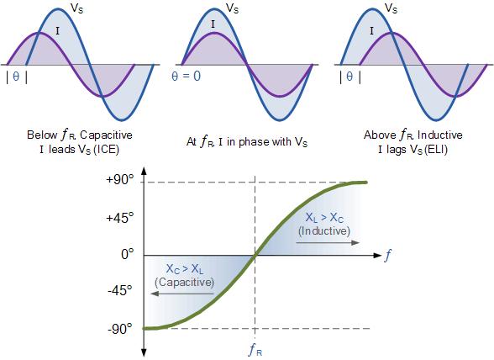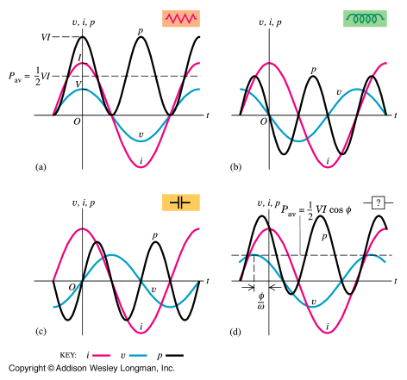

1. Confirm that the voltage on CHANNEL 1 of the scope is $3.0 V_{PP}$, and adjust it if necessary. The current through the circuit and resistor $R$ is proportional to the voltage across R. Record the voltage across resistor $R$

**Table 1: Experimental values**

|  |  |  |  |  |
| --- | --- | --- | --- | --- |
| $$L$$ | 100mH | 100mH | 100mH | 100mH |
| $$C$$ | 0.01µF | 0.01µF | 0.01µF | 0.01µF |
| $$R$$ | $$100 Ω$$ | $$100 Ω$$ | $$10 Ω$$ | $$10 Ω$$ |
|  |  |  |  |  |
|  | **Predicted** | **Measured** | **Predicted** | **Measured** |
| $$f_{o}$$ |  |  |  |  |
| $$Q$$ |  |  |  |  |
| $$BW$$ |  |  |  |  |
| $$f_{1}$$ |  |  |  |  |
| $$f_{2}$$ |  |  |  |  |

**For steps 7 and 8, DO NOT adjust the voltage output of the function generator.**

1. Reduce the **frequency on the function generator** until the voltage across $R$ is 70.7% of the initial value. This is the lower half-power point $f_{1}$. Record the measured frequency $f_{1}$ in the first “measured” column of Table 1.
2. Increase **the frequency through resonance and continue to increase it** until the voltage across $R$ is 70.7% of the value at resonance. This is the upper half-power point $f_{2}$. Record the measured frequency $f_{2}$ in the first “measured” column of Table 1.
3. Calculate **the bandwidth $BW = f_{2}–f_{1}.$** Record the result in the first “measured” column of Table 1.
4. Record the experimental frequencies of Table 1 to the top three entries of Table 2.
5. For **all of the frequencies** in Table 2, **measure and record the voltage** across the resistor. Also measure and record the inductor and capacitor voltages. Note that the inductor and capacitor will have to be swapped with the resistor position in order to maintain proper ground reference with the oscilloscope.
6. Plot $V_{R}, V_{C}, andV_{L}$ as a function of frequency and obtain $f_{o}$, $BW$, $f_{1}$, *and $f_{2}$*

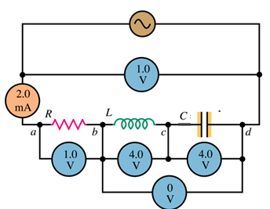

**Table. 2**

|  |  |  |  |
| --- | --- | --- | --- |
| Frequency | $$V_{R}$$ | $$V_{C}$$ | $$V_{L}$$ |
| 1 kHz |  |  |  |
| 2 kHz |  |  |  |
|  |  |  |  |
|  |  |  |  |
|  |  |  |  |
| kHz( fo-150Hz) |  |  |  |
| kHz( fo-100Hz) |  |  |  |
| kHz( fo-50Hz) |  |  |  |
| kHzfo resonance |  |  |  |
| kHz fo+50Hz |  |  |  |
| kHz fo+100Hz |  |  |  |
|  |  |  |  |
|  |  |  |  |
|  |  |  |  |
| 6 kHz |  |  |  |
| 8 kHz |  |  |  |
|  |  |  |  |
| f0= |  |  |  |
| f1= |  |  |  |
| f2= |  |  |  |

1. **Stop the function generator. Remove the $100 Ω$ resistor from the circuit and replace it with the $1000 Ω$ resistor measured earlier.**
2. Calculate predictions for $f_{o}$, $Q$, $BW$, $f_{1}$, *and $f_{2}$* and record the results in the second “predicted” column in Table 1.
3. Start the function generator and, as before, adjust the function generator to create a sine wave with voltage $3.0 V_{PP}.$
4. Repeat steps 4 through 9, recording the measured values in the *second* “measured” column.
5. Repeat steps 10 – 13 for Table 3.

|  |  |  |  |
| --- | --- | --- | --- |
| Frequency | $$V_{R}$$ | $$V_{C}$$ | $$V_{L}$$ |
| 1 kHz |  |  |  |
| 2 kHz |  |  |  |
|  |  |  |  |
|  |  |  |  |
|  |  |  |  |
| kHz( fo-150Hz) |  |  |  |
| kHz( fo-100Hz) |  |  |  |
| kHz( fo-50Hz) |  |  |  |
| kHz fo resonance |  |  |  |
| kHz fo+50Hz |  |  |  |
| kHz fo+100Hz |  |  |  |
|  |  |  |  |
|  |  |  |  |
|  |  |  |  |
| 6 kHz |  |  |  |
| 8 kHz |  |  |  |
|  |  |  |  |
| f0= |  |  |  |
| f1= |  |  |  |
| f2= |  |  |  |

**Table. 3**

**Questions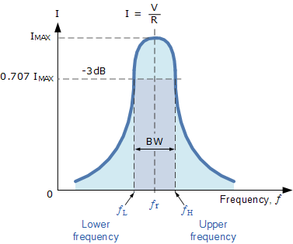**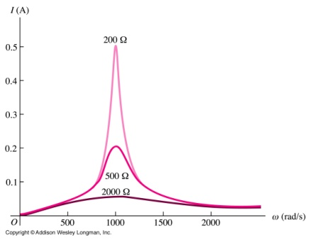

1. From the measured $L, C, f_{o}, andBW$, compute the total series resistance of the circuit. Suggest and explain likely causes for any discrepancy; what might not have been taken into account for the predictions?
2. Discuss the effect of changing the resistor $R$ from $100 Ω to 1 k Ω$. How dramatic was the impact?
3. What would happen to the resonant frequency if the inductance were doubled and the capacitance cut in half? What would happen to the bandwidth? What would happen to the quality factor?
4. Are the $V_{C}, and V_{L}$ curves the same as the $V_{R}$ curves? If not, why?

An-NAJAH NATIONAL UNIVERSITY

FACULTY OF ENGINEERING

ELECTRICAL ENGINEERING DEPARTMENT

**EXPERIMENT # 11**

# PARALLEL RESONANCE

**Objective:**

1. Learn to calculate resonant frequencies, band widths, and quality factors for Parallel resonance circuits

**Theory Overview**

A parallel resonant circuit consists of a resistor, a capacitor, and an inductor in parallel, typically driven by a current source. At some frequency the capacitive and inductive reactance will be of the same magnitude, and as they are 180 degrees in opposition, they effectively nullify each other. This leaves the circuit purely resistive, the source “seeing” only the resistive element. At any lower or higher frequency the inductive or capacitive reactance will shunt the resistance. The result is a maximum impedance magnitude at resonance, and thus, a maximum voltage. Any resistance value in series (such as the inductor’s coil resistance) should be transformed into a parallel resistance in order to gauge its effect on the system voltage. The combined parallel resistance sets the $Q$ of the circuit and can be defined as the ratio of the combined resistance to the resonant reactance, $Q=R/X$, which also corresponds to the ratio of the resonant frequency to the circuit bandwidth, $Q=f_{o}/BW$.

**Procedure**

1. Using Figure 1 with $Rs=10 k, , L=100 mH and C=0.01 μF$, determine the theoretical resonance frequency and Q, and record the results in Table 1. Based on these values determine the upper and lower frequencies defining the bandwidth, f1 and f2, and record them in Table 1 also.
2. Build the circuit of Figure1 using $Rs=10 k, L=100 mH and C=0.01 μF$.
3. Set the output of the generator to a $4 V_{pp}$ sine wave at the theoretical resonant frequency. The large value of Rs associated with the voltage source will make it appear as a current source of approximately. $1 {mA}_{pp}$, assuming the parallel branch impedance is much less than Rs. **Place a probe across the parallel branch**. Set the frequency to the theoretical resonance frequency of Table 1.

|  |
| --- |
|  |
| Figure 1 |

1. Adjust the frequency in small amounts, up and down, **until the maximum voltage is found**. This is the experimental resonant frequency. Record it in Table 1. Note the amplitude. Sweep the frequency above and below the resonance frequency until the experimental f1 and f2 are found. These will occur at voltage amplitude of approximately 0.707 times the resonant voltage (i.e., the half-power points). Record these frequencies in Table 1. Also, determine and record the experimental Q based on the experimental f0, f1, and f2.
2. Transcribe the experimental frequencies of Table1 to the top three entries of Table2. For all of the frequencies in Table 2, measure and record the currents in each parallel branch.
3. Based on the data from Table 2, plot the branch currents as a function of frequency.
4. **Change $R_{p}$ to 22 Ω and repeat steps 1 through 5 but using Tables 3 and 4.**

## *Table 1*

|  |  |  |  |
| --- | --- | --- | --- |
|  | Theory | Experimental | % Deviation |
| f0 |  |  |  |
| Q |  |  |  |
| f1 |  |  |  |
| f2 |  |  |  |

## *Table 2*

|  |  |  |  |
| --- | --- | --- | --- |
| Frequency |  |  |  |
| 1 kHz |  |  |  |
| 2 kHz |  |  |  |
|  |  |  |  |
|  |  |  |  |
|  |  |  |  |
| kHz( fo-150Hz) |  |  |  |
| kHz( fo-100Hz) |  |  |  |
| kHz( fo-50Hz) |  |  |  |
| kHz fo resonance |  |  |  |
| kHz fo+50Hz |  |  |  |
| kHz fo+100Hz |  |  |  |
|  |  |  |  |
|  |  |  |  |
|  |  |  |  |
| 6 kHz |  |  |  |
| 8 kHz |  |  |  |
|  |  |  |  |
| f0= |  |  |  |
| f1= |  |  |  |
| f2= |  |  |  |

## *Table 3*

|  |  |  |  |
| --- | --- | --- | --- |
|  | Theory | Experimental | % Deviation |
| f0 |  |  |  |
| Q |  |  |  |
| f1 |  |  |  |
| f2 |  |  |  |

## 

*Table 4*

|  |  |  |  |
| --- | --- | --- | --- |
| Frequency | $$V_{R}$$ | $$V_{C}$$ | $$V_{L}$$ |
| 1 kHz |  |  |  |
| 2 kHz |  |  |  |
|  |  |  |  |
|  |  |  |  |
|  |  |  |  |
| kHz( fo-150Hz) |  |  |  |
| kHz( fo-100Hz) |  |  |  |
| kHz( fo-50Hz) |  |  |  |
| kHz fo resonance |  |  |  |
| kHz fo+50Hz |  |  |  |
| kHz fo+100Hz |  |  |  |
|  |  |  |  |
|  |  |  |  |
|  |  |  |  |
| 6 kHz |  |  |  |
| 8 kHz |  |  |  |
|  |  |  |  |
| f0= |  |  |  |
| f1= |  |  |  |
| f2= |  |  |  |

### Questions

1. What is the effect of changing resistance on Q?

2. Are f1 and f2 spaced symmetrically around f0?

3. In practical terms, what sets the limit on how high Q may be?

An-NAJAH NATIONAL UNIVERSITY

FACULTY OF ENGINEERING

ELECTRICAL ENGINEERING DEPARTMENT

**EXPERIMENT # 12**

**Computer Simulation of RLC Circuit Response**

**Objectives:**

In Labs 8, 10 and 11, students investigated the frequency response of the series and parallel RLC circuits through computer simulation students will analyse the RLC circuits in Frequency and time domain.

**Procedure**

**Each instructor will choose a circuit for his or her students to simulate**, as the example shown below,

***Example:Analyse the following circuit in time and frequency domain, measuring all the parameters needed to analyse the response****.*



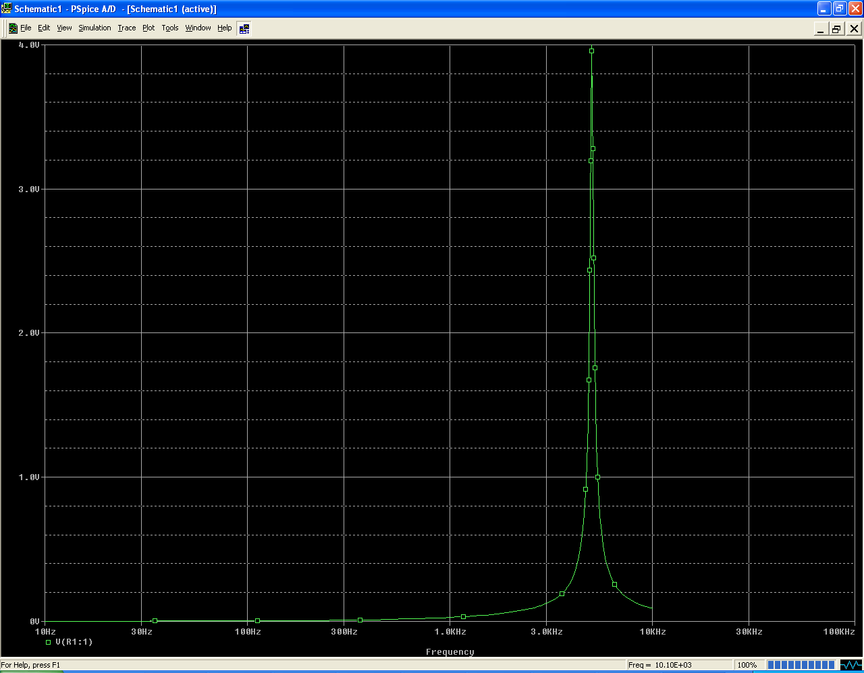

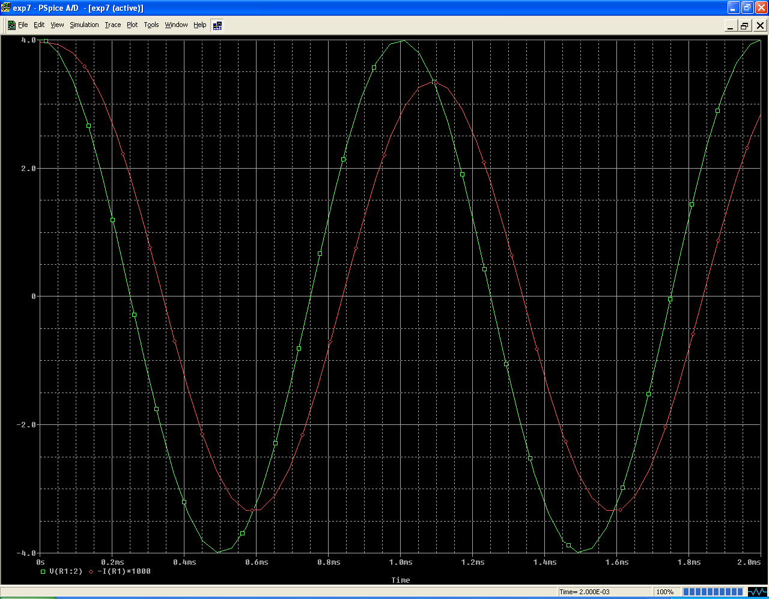

An-NAJAH NATIONAL UNIVERSITY

FACULTY OF ENGINEERING

ELECTRICAL ENGINEERING DEPARTMENT

**EXPERIMENT # 13**

**Filters**

**OBJECTIVES:**

1. Learn theuse of passive components to create Low-pass filter.
2. Learn phase angle at cutoff for simple RC circuit.

**INTRODUCTION:**

This laboratory introduces the use of passive components to create filters to separate portions of time-dependant waveforms. Filters are an essential tool in our complex world of mixed signals — both electronic and otherwise. Passive components (resistors, capacitors, and inductors) have long served as filter components for everything from selecting radio stations to filtering out electrical noise.

**BACKGROUND**

In many circuits, a wide range of different frequencies are present, some of which are desired, while others are not. The frequency response of capacitors and inductors allows us to construct filters that will pass or reject certain ranges of the electrical frequencies that are applied to them. "Passive filters" created from “passive” components (inductors, capacitors, and resistors) have served us well for a long time for such purposes as selecting radio and television stations and filtering noise out of various signals. Indeed, much of the electronics we take for granted today would not be possible without the use of such filters.

The four typical types of filter behaviours are illustrated in **Figure 1**, along with schematics of simple filters that exhibit the indicated behaviour

|  |
| --- |
|  |
| **Figure 1:** Types of passive filters |

The filter types are low-pass, high-pass, bandpass, and notch (or band-reject) filters. In Figure 1, the grayed area is the **passband**, that is, the part of the signal that is passed to the output of the filter. The rejected portions are called the **stopband**. The frequency that separates the passband from the stopband is called the **cutoff frequency**. The cut-off frequency is equivalent to the half-power points discussed in Laboratory 10 and 11. The cut-off frequency is also sometimes called the **corner frequency**.

A *low-pass* filter would allow extracting a low frequency, such as an audio signal, that is mixed with a high frequency radio wave. A *high-pass* filter would do the opposite. A resonant circuit can be tuned as a *bandpass* filter to retain signals in a narrow range of frequencies, while rejecting frequencies outside that range. Such is the case with a radio tuner. A *notch* filter generally keeps all frequencies except those in a narrow band. Notch filters are widely used to block interfering signals from noise sources. Bandpass and notch filters require resonant circuits, studied in Lab 10 and 11.

Notice that the components making the low-pass and high-pass filters in Figure 1 are the same. Whether the circuit is low-pass or high-pass depends only upon which voltage we look at: the voltage across the capacitor or the voltage across the resistor. (Equivalent circuits could have been made using an inductor and a resistor.) Similarly, the notch filter is identical to the RLC series resonant circuit we looked at in Lab 6, however in Lab 6 we looked at the voltage across the resistor, and so saw a bandpass filter. *Caution*: While one may be able to obtain the opposite response from the filter simply by putting the output terminals across a different filter component, one must be sure to stay within the power and current limitations of the circuit and its components.

RC and RL filters are simple, inexpensive, and often used effectively as filters. Their major problem is their generally slow (in frequency) transition from passband to stopband. The addition of a few simple components in filter “stages” can increase the transition rate, giving the filter a sharper cut-off.

The ratio of an output response to an input signal is referred to as a ***transfer function****.* The input signal and the output response do not need to be the same entity type. For example, a transfer function may prescribe an output voltage resulting from an input current. Transfer functions are often used as a tool to characterize the effect of a filter regardless of the details of the filter’s structure. It can make the analysis of complex circuits easier. In this lab, however, we will mostly be studying the filter itself.

**Cutoff Frequency for series RC and RL circuits**

As mentioned, the *cutoff frequency*, sometimes called the corner frequency, is equivalent to the *half-power points* discussed in Laboratory 10 and 11. Since the power is half that at the peak, the voltage (or current) will be the peak voltage (or current) multiplied by $1/\sqrt{2} = 0.707$. For a simple 2- component RC or RL circuit, the half-power point will occur when half the power is dropped on the resistor and half on the capacitor or inductor. Thus, the cut-off frequency will occur when the reactance of the capacitor or inductor equals the total series resistance in the circuit. That is,

$$X_{C}=\frac{1}{2πf_{c}C}=R and X_{L}=2πf_{c}L=R$$

And also,

$$f_{c}=\frac{1}{2πRC} and f_{c}=\frac{R}{2πL}$$

Resonant frequencies for RLC circuits were discussed in **Laboratory 10 and 11**.

**PROCEDURE:**

1. Set up the circuit as shown in Figure 2.

|  |
| --- |
|  |
| **Figure 2** |

1. Calculate the cut-off frequency for the circuit, assuming the output is at $V_{o}$. At the cut-off frequency, what, theoretically, will be the voltage $V_{o}$?
2. Connect CHANNEL1 of the oscilloscope to measure the $V_{in}$ (i.e., FGEN).
3. Connect CHANNEL2 of the oscilloscope to measure the filter’s output voltage Vo.Vary the frequency from 500 Hz to 10 kHz in steps indicated in Table 1, and record the indicated values..For the $V_{in}$ and $V_{o}$ measurements, be sure the time scale is sufficient to show at least a few cycles, or the instrument may not properly calculate the PP and RMS values.
4. Use the oscilloscope the phase shift $Δt$ and then calculate the phase angle $ϕ$ between $V_{in}$ and $V_{o}$ at 500 Hz, at 10000 Hz, and at the cutoff frequency.

**Table 1**

|  |  |  |  |  |  |  |  |
| --- | --- | --- | --- | --- | --- | --- | --- |
| Freq.  KHz | Actual $f$ KHz | $$V_{in}$$ RMS | $$V_{in}$$ PP | $$V_{o}$$ RMS | $$V_{o}$$ PP | $$Δt$$ $$μs$$ | $$ϕ$$ degrees |
| 0.5 |  |  |  |  |  |  |  |
| 1 |  |  |  |  |  |  |  |
| 2 |  |  |  |  |  |  |  |
| 4 |  |  |  |  |  |  |  |
| 6 |  |  |  |  |  |  |  |
| 8 |  |  |  |  |  |  |  |
| 10 |  |  |  |  |  |  |  |
| Cut-off |  |  |  |  |  |  |  |