بسم الله الرحمن الرحيم

An-Najah National University

Faculty of Engineering

Computer Engineering Department

Hardware Graduation Project

Water Screen

|  |  |
| --- | --- |
| *Students*: |  |
|  | *Anas M. N. Khraim* |
|  | *Mahmoud A. M. Sharaf* |
|  |  |
| *Supervisors*: |  |
|  | *Dr. Raed Al-Qadi* |
|  |  |

Spring 2012

Contents

|  |  |
| --- | --- |
| * Abstract …………………………………………………………………. | 3 |
| * List of figures …………………………………………………………. | 4 |
| * Introduction …………………………………………………………….. | 5 |
| * **Chapter 1: Mechanical subsystem** …………………..…….   + - Section 1.1: Water valves………………………………..     - Section 1.2: Main water pipe…………….………………     - Section 1.3: Water pump…………………………………     - Section 1.4: The stand…………………………………… | 7  7  9  10  12 |
| * **Chapter 2: Electrical & Computer subsystems**…..….… | 13 |
| * + **Section 2.1: Electrical subsystem**………………………………. | 13 |
| * + - Section 2.1.1: Power supply Circuit …………………..…     - Section 2.1.2: Microcontroller Circuit ………….……….. | 13  15 |
| * + - Section 2.1.3: Programmer Circuit ………………….…….     - Section 2.1.4: Port expansion Circuit ……………………. | 16  17 |
| * + - Section 2.1.5: Driving Circuit ………………………..…... | 18 |
| * + **Section 2.2: Computer subsystem** …………………...………… | 20 |
| * + - Section 2.2.1: Image drawing software ……….…….……. | 20 |
| * + - Section 2.2.2: Microcontroller compiler software…….…. | 21 |
| * + - Section 2.2.3: Network Interface……….……………..…. | 21 |
| * **Chapter 3: Evaluation and Validation**…………………..…. | 22 |
| * + - Section 3.1: Valves delay ……………..............................     - Section 3.2: Falling water drops delay ……………..........     - Section 3.3: Water pressure ……………………...............     - Section 3.4: The structure of the stand………………….. * Conclusion ………………………………………..…………………….. | 22  22  23  23  24 |
| * Thanks ………………………………………………………………….. | 25 |

**Abstract**

Since advertising is an important form of communication used to encourage or persuade an audience (viewers, readers or listeners) to continue or take some new action, we can find a large number of firms that compete to provide the best and most attractive advertisement. Most commonly, the desired result is to drive consumer’s behavior with respect to a commercial offering, and that’s why the firms keep looking for new innovative ways to market their products.

Our project comes with a new idea of advertising- other than the traditional ideas like boards, buses and advertising screens – which is considered as an effective brilliant way to attract customers in different age to see the advertisement and get its message. This idea is using falling water by controlling an array of valves to open and close in a special manner to form shapes or writing as water falls down.

Moreover, the project achieves the competitive advantage with a special idea and low cost (including fixed, variable and operating costs) comparing with the other advertising projects available, and that’s because our project is based on using water to advertise without the need of any tools (like sheets, paints and expensive hardware) used in those advertising projects.

Additionally, we find that our project is an excellent mean of entertainment especially in summer when the weather is hot. Using such project can give a beautiful view and moisten the air in the place, and of course it’s an attractive advertisement as well.

Anas khraim

Mahmoud Sharaf

List of figures

Figure 1: Valve Unit 8

Figure 2: Valves Pipe 9

Figure 3: Water pump and water source 11

Figure 4: System Stand 12

Figure 5: Hi-Power Power supply 14

Figure 6: Microcontroller circuit 15

Figure 7: Programmer Circuit Schematic 16

Figure 8: Programmer Circuit board 16

Figure 9: 74HC595 shift register 17

Figure 10: Cascaded Shift registers schematic 17

Figure 11: schematic of whole Driving Circuit 19

Figure 12: Driving Circuit Board 19

Figure 13: WIZNET Board 21

Introduction

This documentation is presented to the computer department of engineering faculty at An-Najah National University about our hardware graduation project, to be discussed in the Committee discussion.

We divided it in chapters and sections to achieve the readability as the following:

***In chapter 1,*** we discuss the mechanical subsystem of the project that is used to assemble and gather the different hardware parts together in a way that will handle the process of operating the project and allow it to function well according to the requirements. This includes a brief description of each hardware part in our system and how it is selected to complete the system. These parts include the stand of our project, water tank, water pump, water tubes, main water pipe, electrically-controlled water valves and their input and output required pieces and finally the lights.

***In the chapter 2*** that talks about Electrical & Computer subsystems, we described it in 2 parts; the Electrical part that shows how the system is driven electrically. Since we have multiple electrically-controlled water valves that need total sufficient electric current to operate, the need of suitable power supply become a necessity. The microcontroller, programmer, port expansion and driving circuits and their aggregation are discussed as well.

The second part is the Computer part. As our system displays images and writings, software is needed to transfer the image or writing to a pattern of water drops; this is because it is a water screen which tends to simulate each bit with a water drop. The system also needs microcontroller compiler software to compile the code needed to operate the system and display the required images on the screen. The network interface is added to the system to allow remote control and a very flexible interface to the system.

***In chapter 3***, we try to show a brief evaluation and validation of our system, in order to discuss the different problems we faced and the best available solutions to be found. These problems include: valves’ delay, adjacent falling water drops delay, water pressure in the main water pipe and the structure of the stand.

Anas khraim

Mahmoud sharf

Chapter 1

The Mechanical subsystem

The Project we have built is following a well organized development process that comes to meet the system requirements, and the followed methodology is very useful in studying and analyzing each problem, that allows us to accomplish each task, and guides us to the well known techniques, by applying the best practice available in every field.

According to the mechanical subsystem, we have faced many difficulties while building it since we have a lack of experience in such fields adding that the fields related to mechanical systems is far a little bit from our specialization.

Section 1.1: Water valves

The major and most important (and also the most expensive) part in our project are the water valves. Not only they are the core of our system, but also they define how accurate our system is. We have made a huge research about the available types of valves (especially the electrically-controlled water valves). Our research was focused on the pneumatic valves since they are known to have a short delay and a very good response time due to the fact that these pneumatic valves are solenoid based.

In order to satisfy the requirements of our water screen, we try to keep the actual bit (simulated as water drop) as small as possible to control the resolution and accuracy of the screen. After the searching process is done, we choose the pneumatic valve with a minimum delay of 10 ms that is measured to give a good shape of water drops.

On the other hand, we establish the system using 40 of these pneumatic valves, so that we can have an acceptable resolution of the screen. Each valve has an input piece to allow the flow of water into the valve and an output piece to pass the water out. The input piece is welded to the main pipe (which provide the valve with water from the water source), and the output piece is responsible for connecting the valve with a tube to form a water stream. The output tube has a diameter of (4mm).

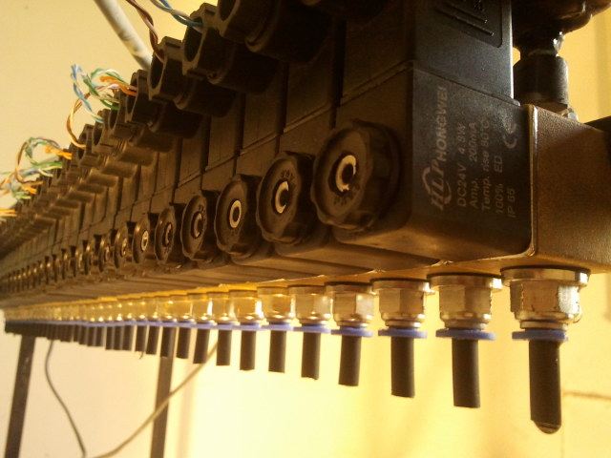

Figure 1: Valve Unit

Section 1.2: Main water pipe

Since we need a way to distribute water from its source to the valves, we found that there are many ways available, like providing each valve with water separately, but the most suitable way was by using a water pipe. This water pipe was drilled according to the number of valves needed to be supplied with water.

Each drill is measured to fit exactly the input of each valve and this needs a high accuracy in the drilling process especially that the valves are aligned with an exact spacing between each two adjacent valves, so the manual lathe was not an option, and we use the CNC instead to achieve this high accuracy.

The diameter of the pipe is 0.75 inch that is suitable with the diameter of each valve (0.25 inch) to ensure a good distribution of water pressure between all the valves. The water pipe is configured to connect it with water tubes from both sides to allow more stability in water pressure inside the pipe during the flow of water from its source.

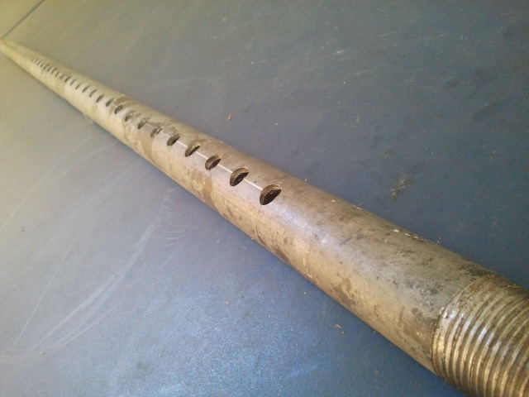

Figure 2: Valves Pipe

Section 1.3: Water pump

Since we need a way to transfer water from its source to the main water pipe, we found that there are many ways available to do so, like using a water tank as a water source to feed the valves or provide them directly from a water pump through tubes. Although in both of these ways a water pump is needed, our target is to provide the valves with water that has as low pressure as possible to allow it fall freely so that we can draw some shapes in water.

According to the equations of motion (that describe the behavior of a physical system in terms of its motion as a function of time) we use the law **d = vt + 1/2 at^2**

Where: **d** is the distance, **v** is the velocity, **t** is the time and **a** stands for the acceleration.

The water pump we used has a flow rate of 90 liters/min, and this number is calculated due to the fact that we need to feed 40 valves each has a radius of 0.2 cm according to the equation:

Pump’s flow rate >= **n*r^2 $π$**d*t**

Where: **n** is the number of valves, **r** is the radius of the valve’s output, **d** is the distance the water fall and **t** is the time during falling, so when we calculate we have that 40 valves*.002^2 m $π$**3*1s*60*1000 $≅$ 90 liters/min.

(Note that we multiply by 60 to convert to min and we multiply with 1000 to convert to liter).

Additionally, the water pump can give a pressure up to 1 horse, and we used some mechanical techniques to reduce its high pressure. More over we used a device that work as an automatic control of pump to control when it should be start and stop pumping water according to the water pressure inside the main water pipe.

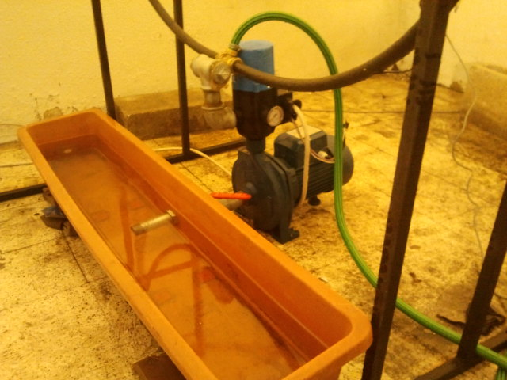

Figure 3: Water pump and water source

Section 1.4: The stand

Our system needs to have a stand to keep the valves at the appropriate height about 3 meters from ground (which is calculated by the law of motion in section 1.3). These valves are fixed in the stand using a bridge. Many bridges are used in the stand to add strength and solidity, and also to fix other tools like valves, electrical circuits and lights to the stand.

The stand is made from iron metal called profile, which has thickness of 2 mm and is suitable to be used in our project. We conduct welding while making the stand according to the standards in the engineering Welding and soldering workshops.

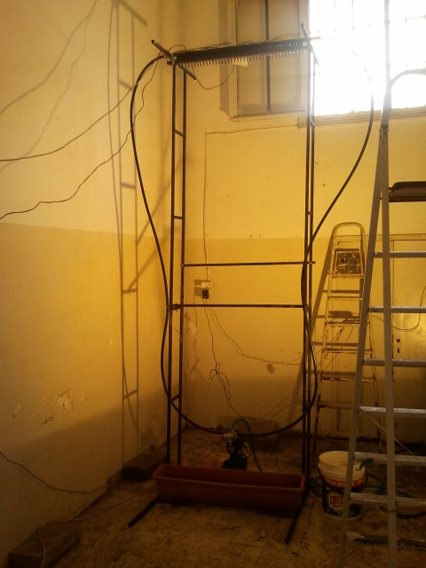

Figure 4: System Stand

Chapter 2

Electrical & Computer subsystems

Our system must have electrical and computer subsystems to allow controlling driving and managing the whole system. This is also important because there are many things should be considered during the designing of the electrical circuits and establishing the control interface with computer software.

Section 2.1: Electrical subsystem:

The need of an electrical subsystem comes from the requirements of driving many electrical devices and ICs. First we need to drive the valves, which is basically electrically-driven. Additionally, we need to provide the Microcontroller circuit and each IC in our system with the electric power, so we have to consider all of these issues in our system.

Section 2.1.1: Power supply Circuit

The power supply of our system has to provide electric power to the various parts of the system. These parts are included in:

1. Electrically-controlled water valves.
2. Microcontroller circuit.
3. Valves’ driving circuit.
4. Port expansion circuit.

Each valve needs 24 volts and 200mA driving current to operate. Since we have 40 valves that means we need about 8 A to drive only the valves. The microcontroller circuit needs 5 volts and 100mA to operate, and both the valves’ driving circuit and port expansion circuit need about 100mA and 5 volts as well. As a result we need a power supply that can provide us with the required voltages of 24 and 5 volts, and also the required current of 8.4 A.

We used the MLT198TX power supply which can give up to 8.5A and provide many levels of voltages like 5, 12 and 24 volts.

The pump and the lights are powered using a separate power source other than this power supply.

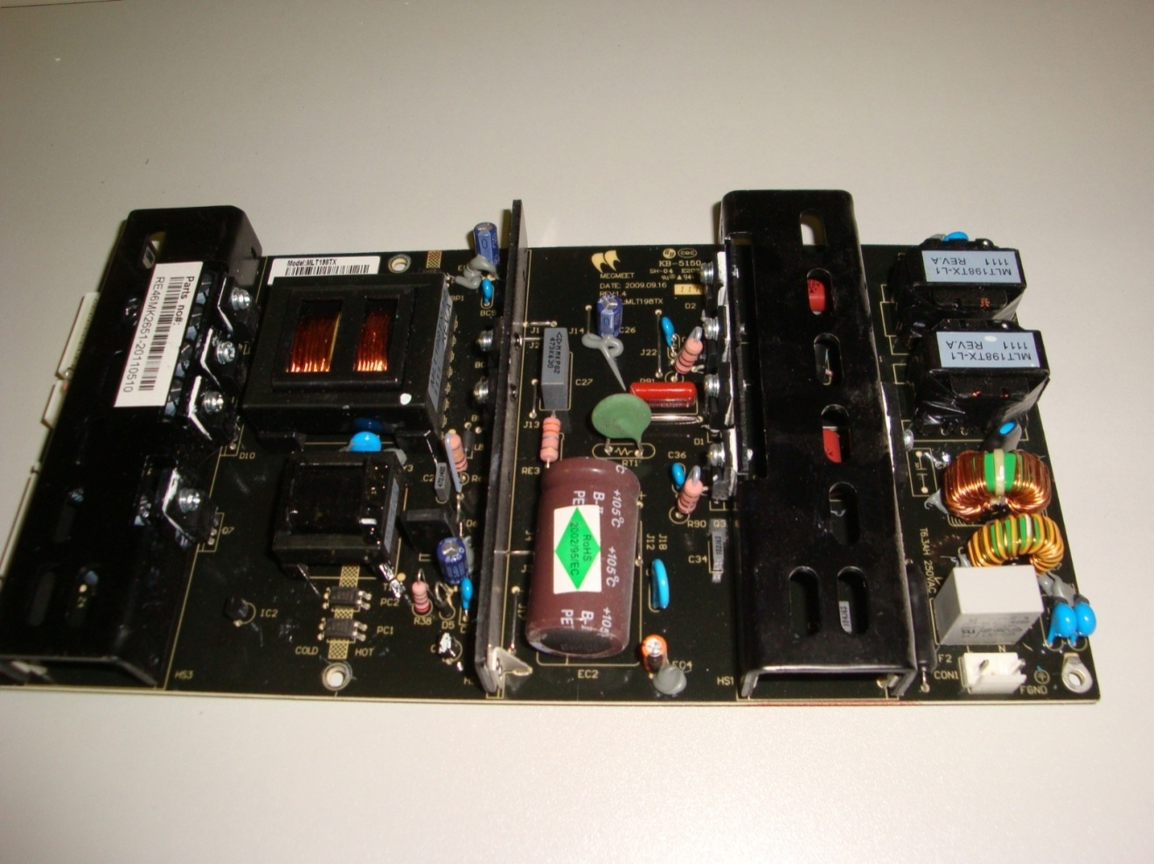

Figure 5: Hi-Power Power supply

Section 2.1.2: Microcontroller Circuit

In order to control the system we need a special circuit for this purpose. This circuit is responsible for displaying the shapes using water by sending the correct commands about the timeline of when the valves should be opened or closed.

The microcontroller we have used is PIC18f4620 that has many peripherals and modules necessary to accomplish our tasks required in our system. The basic circuit needs 5 volts and 100mA to operate, and this is provided by the power supply (as mentioned in section 2.1.1).

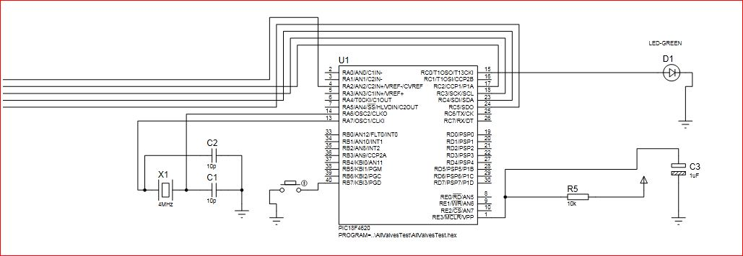

Figure 6: Microcontroller circuit

Section 2.1.3: Programmer Circuit

During the development phase of our system we had to use Hardware programmer instead of sending our HEX file by BOOTLOADER, since we wrote the code using “MiroC PRO” IDE the code will destroy the bootloader by itself.

We have used JDM programmer from ”Olimex” and implement it from following schematic .

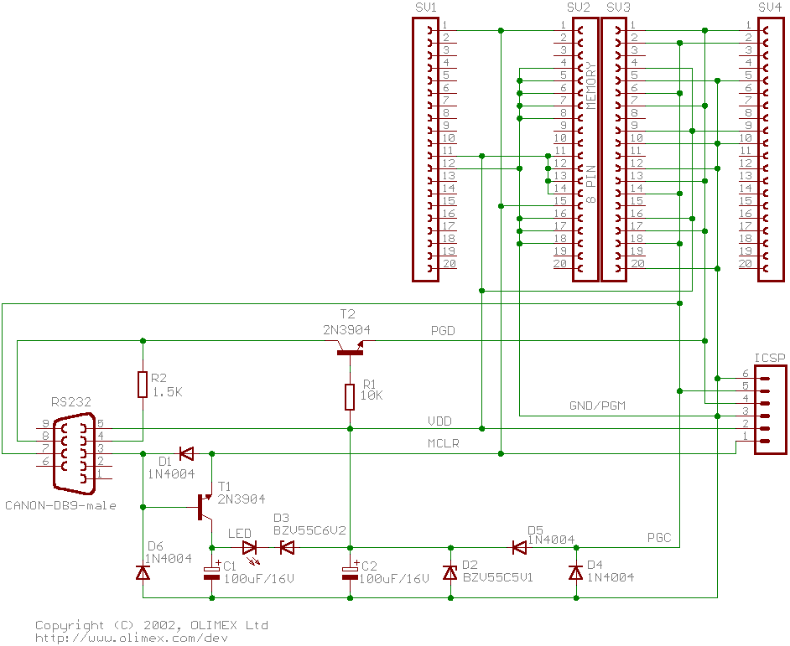

Figure 7: Programmer Circuit Schematic

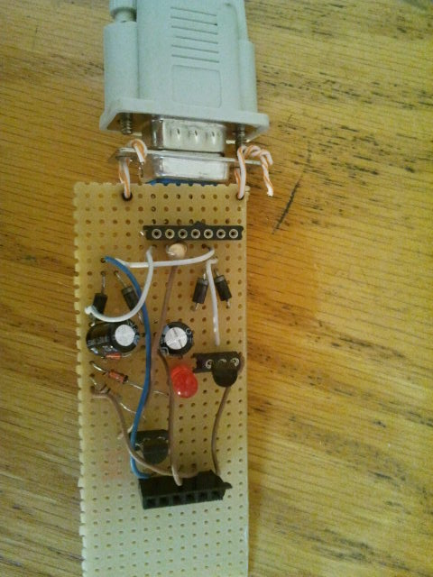

Figure 8: Programmer Circuit board

Section 2.1.4: Port expansion Circuit

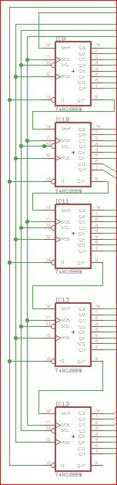 As our system needs to drive a number of valves (40 valves in our case), each valve should have a separate control line to correctly control the system. This can’t be done using only the available ports in the microcontroller PIC18f4620 because it has limited number of pins (less than 40 pins) to be controlled, and so we need a circuit to expand the ports in order to drive a large number of valves.

There are many designs to be thought about to build this circuit, and we conduct the best one in our case by using Cascaded shift registers 74HC595. These shift registers can be run at 1 MHz so that the shifting delay is neglected.

As our system contains 40 valves and each shift register has 8 outputs, we need 5 shift registers to build the circuit. These shift registers are cascaded to allow the data to be shifted serially from one pin of the microcontroller (and so we only need to use one pin and save the other pins for other different purposes) through the 5 cascaded shift registers, and then we output the controlling signals to the 40 valves in parallel with a delay about 1ms (less than the delay of the single valve 10ms).

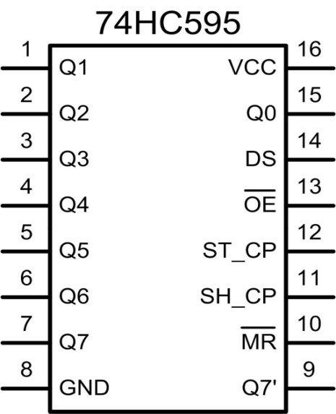

Figure 9: 74HC595 shift register

Figure 10: Cascaded Shift registers schematic

Section 2.1.5: Driving Circuit

It’s the circuit implemented to drive each valve separately according to the controlling signals coming from the microcontroller through the port expansion circuit (cascaded shift registers). Since the controlling signals are either zero ore one, we first think about a transistor to do this task. Unfortunately, the driving current coming from the port expansion circuit to the transistor was not enough, and so we think about the Darlington pair transistors to drive each valve.

Although the current was sufficient to drive the valves using Darlington pair, the gain factor was large enough to convert the leakage current while the signal is zero to a one signal. This makes us to reconsider the issue of leaking current and we think of a new way to drive the valves.

Since we need to dive a valve that is run by 24 volts, we think about the ULN2003a driver. This driver is based on open collector which is perfectly suitable for high-voltage driven devices like motors and valves (as in our case).

The ULN2003a driver has 7 outputs to be driven, and the problem of the non-sufficient current is not a problem anymore. Since we have 40 valves we need 6 ULN2003a drivers.

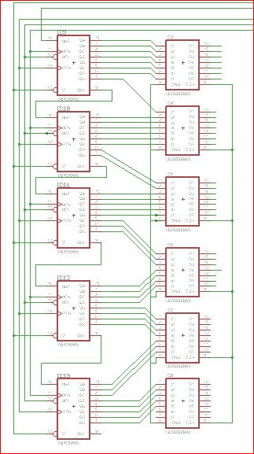

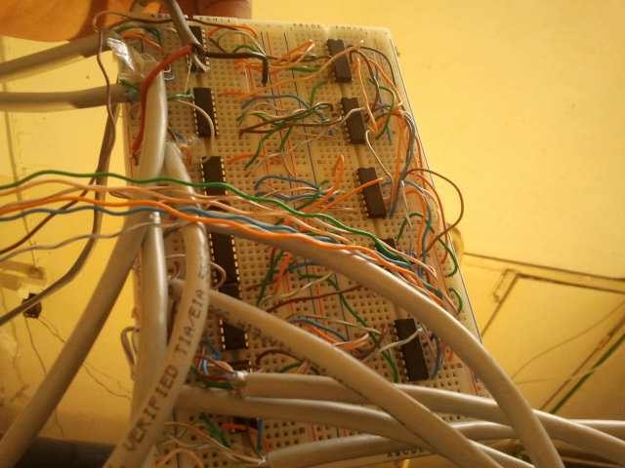

Figure 11: schematic of whole Driving Circuit

Figure 12: Driving Circuit Board

Section 2.2: Computer subsystem

The computer subsystem is necessary in every application which is considered as an interface between the software part and hardware part. The software part allows writing the code responsible for controlling the valves. This code receives the shapes to be drawn as data from other image-drawing software, and then the code will be compiled in the microcontroller compiler software in order to be run to generate the controlling signals as required.

There are many modules can be added to the computer subsystem to facilitate the process of running and controlling the system. These modules include wireless interface to allow controlling the system remotely, and many additional devices can be added like camera to form an interactive system. Moreover, a sound effect system can be added which will add value to our project.

Section 2.2.1: Image drawing software

This software is responsible of changing the images and shapes to be drawn to an array of bytes. This array of bytes is made according to the shape or image, so that each bit in every Byte is simulated by a water drop. This array of bytes also is saved as a hex file so that it can be used easily in our system.

We use the “Fast LCD” software which is basically used to draw images to LCD, and we use this software since the principle of our project is the same. According to our system, the image resolution in our system is 40 $×$ 40 (where the first 40 is the number of rows, with each row is simulated by a drop of 3cm long, and the second 40 is determined according to the available number of valves).

Note that we can have drawings that have resolutions with n $×$ 40, where n can be larger than 40 rows, and this can be done to draw a large extended image.

Section 2.2.2: Microcontroller compiler software

After the array being made using the image drawing software, we need to draw it with water using a code to control the whole system. This code is written for the microcontroller PIC18f4620 in assembly, and so we need microcontroller compiler software to compile this code.

Our system uses the “Micro C Pro” software as microcontroller compiler software in our system. This software is very flexible to deal with and has many libraries that facilitate the code writing.

Note that the code is being developed continuously in order to provide the best display possible in our system, and this is according to many factors like the adjacent falling water drops delay and many other factors.

Section 2.2.3: Network Interface

In order to make our system more flexible to the user, we can add some part that will allow user to access the system with more flexibility remotely. We will use Embedded networking board from “WIZNET” that gives an ip to our system so transmit data to it remotely.

In order to take a wireless feature we will use a wireless access point from “TPLINK” which can be connected to “WIZNET” to provide wireless access from laptop or smart phone that provided with special application that serve our system.

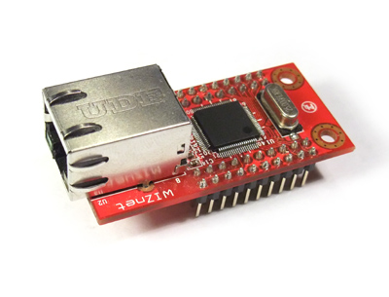

Figure 13: WIZNET Board

Chapter 3

Evaluation and Validation

This chapter is about the unexpected problems we have faced during building our project, and the available solutions according to the different scenarios that can be applied. These problems are basically found in the mechanical subsystem since we don’t have a previous enough knowledge in such field.

Section 3.1: Valves delay

The solenoid valves which we have used have a minimum delay between each open and close about 10ms. This delay when each valve tested separately was very efficient and gave a suitable water drop to simulate the actual bit in an image array. Unfortunately, when all the valves were combined together, the behavior was completely unexpected and the water drop length varied from one valve to another.

Section 3.2: Falling water drops delay

This problem is related to the adjacent valves, and causes the water streams to be delayed so that we can’t achieve a straight line when opening all the valves at the same time. The noticed behavior of valves was not so only because of the differences in water pressure at the input of each valve, but also the differences in the individual response time of each valve due to its manufacturing.

Section 3.3: Water pressure

In this problem we discuss the varied water pressure inside the main water pipe. Since our water pump has an excellent flow rate but unfortunately a very strong pressure, we need to decrease this high pressure to achieve the free fall of water, and so to achieve a more stable drawing with water.

There are many scenarios to achieve a suitable water pressure inside the main pump:

1. Connecting the pump with the main water pipe with one end only.
2. Connecting the pump with the main water pipe with one end and keep a feedback line of water, so that the running water will have less pressure.
3. Using a pump with less pressure and so here we are scarifying the wanted level of flow rate required so that our system will function well.
4. Using a water buffer (water tank) to maintain a constant low pressure inside the water pipe.

These scenarios are still being tested, and soon we will reach to the best scenario that gives the most suitable water pressure inside the main water pipe.

Section 3.4: The structure of the stand

While the best scenario to be applied is not yet defined, we face a problem to reconfigure the project’s stand to work in case of applying a new scenario. The stand main function is to keep a constant height of valves from ground to allow drawing the shapes in water, and also fix the lights and the microcontroller and driving circuits near the valves, and this is common in all the scenarios that could be applied.

Unfortunately, some scenarios assign more functions to the stand, like in the case of using buffer water tank to maintain a constants low pressure inside the main water pipe, and this needs more complex modification to the structure of the stand, and it is really an important unexpected problem!!

Conclusion

We build the system which firstly consists of mechanical subsystem that is built and developed totally by us (especially designing shape, estimating calculations and building the structure of our project), and then we move to build the electrical and computer subsystems to exactly meet the needs of the project and fit the mechanical subsystem, and the testing and evaluation phase is applied during the whole period of establishing and building the entire system.

We spent 3 months in collecting requirements about the essential parts necessary to build our system in standard and appropriate way so that the system would work correctly, especially that the system is very large and many of the technical problems we faced were about the mechanical subsystem which we didn’t study the sufficient courses about to proceed and establish it well.

The testing and evaluation process consumed a lot of time because our system is critical to any technical problems we may face since mechanical and hydrodynamic systems are new fields to us, so we had the opportunity to gain the experience in.

The fact that using the water as a new cheap durable technology in the display screens is really an incredible movement in the world of advertising, especially that some features as sound effects or colors can be added to the system. Also, extra modules as cameras or wireless modules can be connected to the system in order to provide an interactive display.

Our system is highly rated to be applied in our community and will take big chance to be in the market (God willing) soon.

Thanks

First, we present our thanks for the computer engineering department in AN-Najah National University. Second, we would like to thank the mechanical engineering department and precisely the engineering Welding and soldering workshops for giving us the full support and help needed to accomplish some of the project’s tasks.

Thanks to:

Dr. Ahmad Al-Ramahi  
Eng. Menem Masri  
Eng. Abdel Mueen Daglas

Thanks to our supervisor:

Dr. Raed Al-Qadi

Thanks to the Committee discussion members:

Dr. Luai Malhis

Dr. Samer Arandi

Dr. Hanal Abu-Zant

Anas khraim

Mahmoud sharaf