

**Hpad**

Prepared by

Abdalrahim S. A. Mansour

Submitted to

**Dr. Ashraf Armosh**

A documentation report of graduation project (66581/3)

Computer Engineering Department

Faculity of Engineering

An-Najah National University

Thursday, Dec, 15, 2011

Content List

Abstract………………………………………………………………………………1

1 Introduction ……….………………………………………………………2

1.1 Overview …………………………………………………………2

1.2 Existing Problems …………………………………………….2

1.3 Related work ……………………………………………………2

1.4 Motivation for Carrying out project …………………3

1.5 Main Contribution …………………………………………….3

1.6 Report Organization ………………………………………….3

2 Methodology ……………………………………………………………….4

3 Result and Discussion …………………………………………………12

4 Conclusions and Recommendations ……………………………12

4.1 Conclusions ……………………………………………………12

4.2 Recommendation ……………………………………………12

5 References …………………………………………………………………13

6 Appendix ………………………………..………………………………….13

Abstraction

In these days most of product and application are move to real time and interactive area like most of apple product and other company are in competition to produce the most friendly and cheapest touch device , and some of them now try to do the interactive devices that detect the movement and convert it to action on device like kenict an Wii , so my project main idea is like them to convert movement to action but using things that everyone have in his device like web-cam without adding any extra expensive hardware the device .

My project focus on making something special in any device without spending a lot of money and using things already include in any device like web-cam which most of laptops have, the main aspect is making your device more funny and exited by using things already you have.

The main object of my project is to convert the computer screen from normal screen to interactive screen by detecting the hand movement of the user and the webcam which may be already in the computer or it’s easily and cheaply to add.

The application will mainly be a C# application, which can detect the hand movement by getting the photo from the web-cam and convert it to action.

When I ask about this idea I heard that it made before but the application was so slowly and can’t detect every movement of the user , so the main object of this project is to made the application more faster and reliable .

(1)

1. Introduction
   1. Overview

In this application I do a simulation for the mouse movement without using mouse or mouse pad, but I use’s the webcam and some software in order to simulate the mouse movement by detecting the human hand movement and translate his hand movement into cursor position and right click and left one. So I move the user from the normal screen into interactive one without spending a lot of money and with the thing that the most of us already have in his PC.

* 1. Existing Problems

The main thing that I try to solve in this software is to do something fancy, creative and funny without spending a lot of money, by using presents resource and just adding some software that can add all these resource together to achieve the intended results.

* 1. Related work

In the real life there is many devices that work on the idea of moving from basic screen and normal ones to the inter active ones like Wii and kinect which there are special devices that added for PS and Xbox then they can understand the human actions and transfer it to the machine which do some action due to received data. The main usage of this device is just for games and things like that but now a day there is much application and thing work on the same idea of making the computer cleverer so he can understand what you want to do just by moving your body or your hand or any way that human could communicate with it and make other understands what they want.

(2)

* 1. Motivation for Carrying out project

Now a day I see that most of the software and hardware venders are going to invent thing that make u a part of the things that they make. So I try to do the same thing and make the user as a main part of my application.

After that, I try to make my software that make the human feel that he can control the mouse movement by using his hand.

* 1. Main Contribution

The main object of this software is to supply the computer users with software that can many ideas build on the top of this software concept, like making a robot that can detect a color and go around following that color, or some software that keep tracking a colored object and save the path that the object go through and transfer this path to a group of lines and by some special software move them to a characters. And there are many games depend on the mouse movement and clicking.

1.6 Report Organization

In this report I start with an abstraction of my application and then small introduction about what my software will do.

After that I the methodology I wrote about everything I do and the main ideas I use them in order to achieve the goals of this software.

And at least I consider the result and the challenges I face for achieving the first version of this software.

(3)

1. Methodology

In this section, we will discuss the methods we used for, detecting the object, and how we get more accurate results.

(fig 1)

We are using the following hardware in the system:

-Laptop

- Camera

- Background doesn’t containing object color

- Contrasting colored

When the application runs, the camera continuously captures images of the colored objects moving on and sends these images to the computer.

(4)

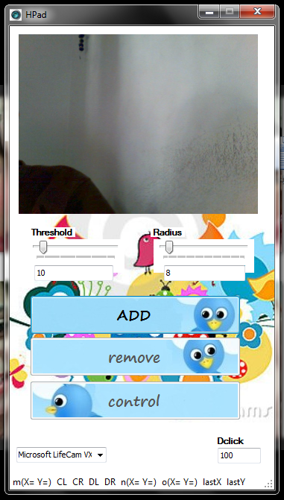(The interface of my App (Fig. 2))

At first u must satisfy the “Threshold” and “Radius” of the object that you want to keep track and move the mouse and do click due them, then to start controlling the mouse you can click “add” which allow you to add three objects to track them, after that

(5)

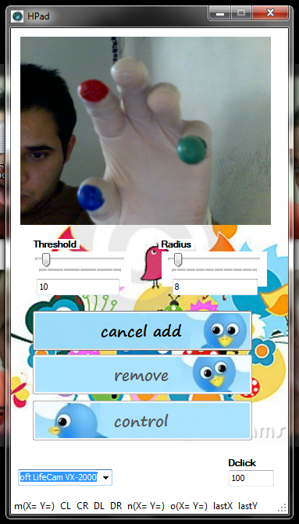(Fig. 3)

The camera get the current image that appear to you and capture it , so it allow you to choose the three object the first one will do the right click the second the left one and the third will be responsible of the position of the cursor.

If you do anything wrong and you want to cancel your colors simply you can click on “cancel add” button.

(6)

If the app get the object correctly then u will see a square around each object , but if don’t have a square around every object you must remove them and do “add” for them until you get a good detection form them.

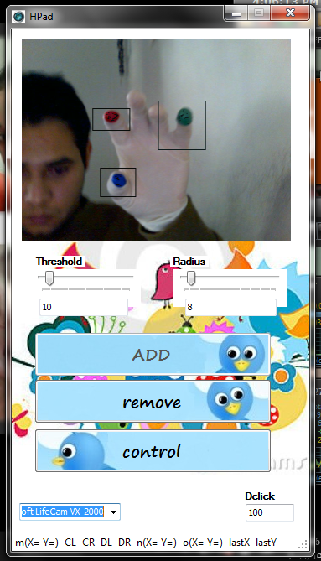(Fig. 4)

(7)

Then the “remove” and “control” button are active , the “remove” button will make you be able to remove the objects that detects if you want to change them , and the ”control” will start controlling the mouse movement , but before press “control” you must enter “Dclick” which detect the distance between the objects to cause click even left or right ,

If we press the “control” button the following will appear

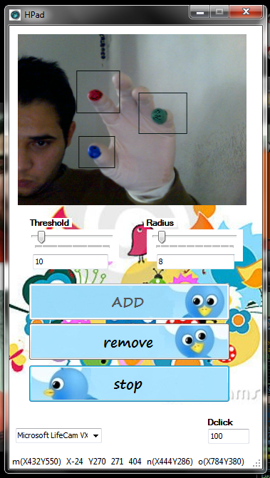(Fig. 5)

In the StatusBar we have m(X Y ) which give you the current position of cursor which detect by the green object , and the n(X Y ) gives you the current position of the red object which cause the left click and the last one o(X Y ) it give the blue object position which make the right click. To make the left and right clicks I use a special windows API’s which do the click depend on the distance between ‘n’ or ‘o’ points and ‘m’ point.

(8)

System Architecture as is shown in Fig. 6, images captured by camera are passed to the image processing module. Then processes these images, matches them with object color pattern and translates the result into movement data. The movement data are then received by the pre-recognition processing module, where these data are preprocessed–smoothing, deduplicating, and normalization. The data are then translated into path information that indicates the strokes of the writing. Followed by that, the handwriting recognition module processes the path information and recognizes the character being written.

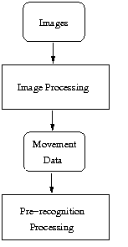(Fig. 6)

The Software Specification as mentioned previously, our application contains two

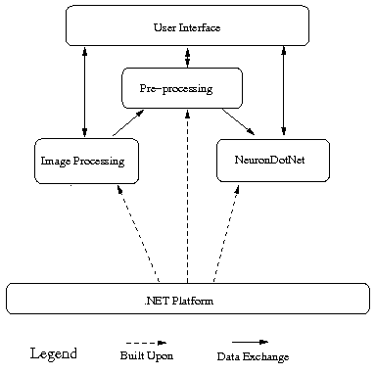F(9)

-Image Processing Module

Pre-recognition Processing Module

Their relation can be seen as in Fig.7.

My app offers the ability to track multiple objects through cameras. (Fig. 7)

In this project, we specifically track three objects: the three colors we specify at the first. Note that we include a background doesn’t containing object color.

We do this to provide the maximal contrast for objects colors from the background.

For effectively track, it is required that the color of the objects should be unique in the environment to be different from the colored objects and contrast from the color of the background.

In the experiment, we use a three object with green, blue, red and a background doesn’t containing object color. Once we mark the object it’s become as the target object, the position data of its movement is tracked automatically. As shown in Fig. 5, the square in black highlights the object being tracked.

NeuronDotNet: Our objects recognition neural network is built upon NeuronDotNet, an open source engine which can be used to build different types of neural networks and use them in various applications. It also provides API to extend existing features and incorporate new algorithms. It is written in C# and is compatible with the .NET platform.

Pre-recognition Processing: Before the path information obtained by image processing could be processed by neural network, they need to be preprocessed. Most digital tablets have low-pass hardware filters. Thus, when such devices are used to capture handwriting strokes, the shapes of the strokes present the jagged forms. Furthermore, some points of a stroke may be missing, and some wild points might exist in a stroke, etc. Generally, such noise information influences the exploration of the profile of the handwriting in such a way as to influence further processes, such as feature extraction and classification. Three operations are involved here:

_ Smoothing: Remove hooks and sharp points by down sampling the stroke data.

_ Deduplicate: Remove duplicated points from the strokes.

_ Spatial Normalization: Scale the strokes into the same size. (10)

The result of the above operations can be seen in Fig. 6.

Neural Network Training: Given that the training samples are fixed, it is usually the case that larger amount of training cycles yield better mean square error, which possibly indicates better test result. However, more training cycles spend more training time as well. This is because for general training algorithm, majority of the training time is spent on propagating data along the connection between neurons, which determines the traversing time for each cycle. We run the training algorithm upon the same training samples for different cycles and examine the relation between the number of cycles and the output mean square error.

After we show the software specification we go back to app, we add something in order to get more something for cursor movement by moving the cursor through all point between on the path between the current position and the next one, so the cursor walk through all the point between the current point and the next one. And in order to get more accurate result if the object go so quickly from position to other one so far and if the object lost the app will go back to the last good data that app know about the object.

I add some class to my app that keeps listing to the keyboard, so that if you controlling the mouse and you want to stop controlling even your app in the background and press “esc” so that it will stop your contorting of cursor and go back to mouse as usual in all computers.

So that we have and funny app that can move your computer screen to an interactive one using thing that the most of computers have or simply and cheaply can be add (webcam), we have many things that we can apply this project idea on them to move them from small mouse or mouse pad world to more free world and real one without spending a lot of money and needing expansive extra hardware.

(11)

**3. Result and Discussion**

After I working in previous software at the end I get an application that can keep tracking a colored object and obtain its position related to the coordinate of the computer screen. But due to the heavy over head load that image processing but on the computer performance, on the computer I use to make the software the speed of detecting the motion is relatively slow, but when I test my application on other computer with higher specifications it’s work exactly as u using a real mouse. I have some challenges due to the camera rates (FPS) and in some places where the lighting is bad the software not work correctly, also in old computer the software work relatively slowly.

**4. Results and Discussion**

4.1 Conclusions

As a result of me work I get an app that simply you can use to control your mouse with the movement of your hand and doing all the functionality that you want to do with the usual mouse, just by using your simple webcam that’s may be already exist in your computer.

So that I get and app that work as Wii or a cincket that tracking your movement and transform it to an action that you see on the top of your computer.

4.2 Recommendation

This app still a first version of my idea and may be some work in order to achieve more performance and get more accurate result. We can apply this idea in more interesting and effective app like making a software pen that you can write throw it or funny app like game passed on the mouse movement.

(12)

5 References

[1] [www.google.com](http://www.google.com)

[2] [www.codeproject.com](http://www.codeproject.com)

[3][http://books.google.ps/books?id=AiPO93hBfswC&dq=0470635991&as_brr=3& ie=ISO-8859-1&source=gbs_gdata&redir_esc=y](http://books.google.ps/books?id=AiPO93hBfswC&dq=0470635991&as_brr=3&%20%20%20%20%20%20%20%20%20%20%20%20%20%20%20%20%20%20%20%20%20%20%20%20%20%20ie=ISO-8859-1&source=gbs_gdata&redir_esc=y)

[4] <http://msdn.microsoft.com/en-us/dd299405>

[5] [http://www.koders.com](http://www.koders.com/)

[6] <http://www.wikipedia.org/>

6 Appendix

[1] An executable file of my software.

[2]The source code of my software.

(12)