**PHONE**

**HOME AUTOMATION**

**Ola husam saeed**

**Ruba ghaleb abubaker**

**CONTENTS**

**SI NO Content Page No**

**1. Cover Page**

**2. Content**

**3. Abstract**

**4. Introduction**

**5. Circuit description**

**6. Block diagram**

**Abstract**

**Home automation is simplified all about control electrical, electronics, security and entertainment at a touch of a finger, all working from remote control.**

**Home automation is becoming more and more popular around the world and is becoming a common practice.**

**The process of home automation works by making everything in the house automatically controlled using technology to control and do the jobs that we would normally do manually.**

**We are coming up with one of such interesting systems by which we can access even our bedroom electronic devices even from the most far off places in the world, provided the network under use has good range everywhere.**

INTRODUCTION

**In our project the main principle relies up on the ability**

**of DTMF (Double Tune Multi Frequency) ICs to generate DTMF**

**corresponding to a number or code in the number pad and to**

**detect the same number or code from its corresponding DTMF.**

**In detail, a DTMF generator generates two frequencies**

**corresponding to a number or code in the number pad which will**

**be transmitted through the communication networks,**

**constituting the transmitter section which is simply equivalent**

**to a mobile set. In the receiver part, the DTMF detector IC, for**

**example IC MT 8870 detects the number or code represented by**

**DTMF back, through the inspection of the two transmitted**

**frequencies. The DTMF frequencies representing the**

**number/codes are shown below:**

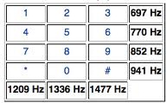

**BLOCK DIAGRAM**

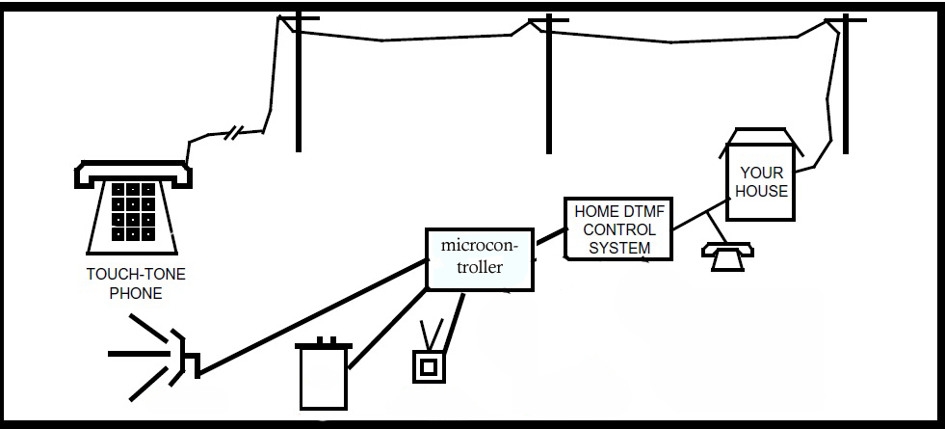

**Ring Detection**

**INPUT**

**Open line**

**Detection section**

**Interface**

**Output**

**CIRCUIT DESCRIPTION**

**Now let’s have a detailed look into the whole circuit section**

**wisely.**

**We are supposed to send a code word from the phone, which is**

**the transmitter and is sending the corresponding DTMF**

**frequencies along. At the receiver end, i.e. at the land line end**

**we need to detect the code back using our circuitry and it is to**

**be used for driving the devices, represented by the LEDs.**

**RING DETECTION_SECTION**

**Refer the circuit diagram of this section….Regarding the need of this section, we want to use this circuitry in the device mode i.e. to control the device’s turn off and turn on while maintaining the normal functionality and usage of the land line to make and accept calls. So we must allow**

**Some time for the land line to get into the off hook mode, also it is necessary to get the land line from on hook mode to off hook mode to enable the DTMF reception. If the land line is already in the off hook mode, t hen it won’t be able to receive any signal as in the normal speech communication through networks. So using this section we are aiming to automatically activate our circuitry after a number of rings are heard from the landline, while the coupling for automation is done using a relay. Here we have designed such that the DTMF signals will automatically be coupled to the Decoding section just after the 3th ring.**

**Now getting into the detailed analysis, the initial**

**high ring voltage is coupled to a zener diode circuitry to reduce the voltage level for protection, at the same time maintaining the enough magnitude for  
detect ion using the opto-coupler. See the details in the circuit diagram.  
Whenever a ring occurs a sufficient amount of ring voltage is established across the inputs of the opto-coupler which causes the internal transistor to conduct and effectively the output 5th and 4th pin to get short . This results in an effective coupling of input ring voltage to pass through.**

**DECODING SECTION**

**We are use the IC MT8870DE as** **DTMF decoder**

**The main component to decode the input dial tone to 5 digital output.**

**On the telephone exchange side, it has a decoder circuit to decode the tone to digital code. For example, the tone of 941hz + 1336hz will be decoded as binary '1010' as the output. This digital output will be read in by a computer, which will then act as an operator to connect the caller's telephone line to the designated phone line. The telephone exchange center will generate a high voltage signal to the receiving telephone, so as to ring the telephone bell, to notified the receiving user that there is an incoming call.**

**Detection of dial tones is reflected on the bit TOE, while the output Q4, Q3, Q2, Q1 indicate the dial tone that is being detected on the telephony system. A complete table of the decoded digital output for individual dial tone is available in the coming section.**

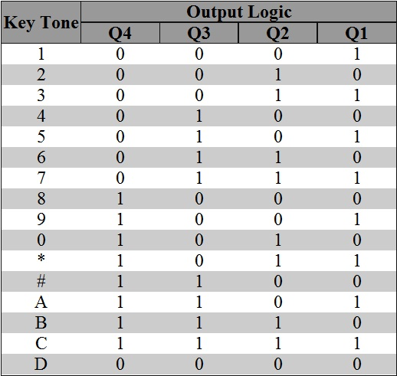

**VOICE SECTION**

**We use ISD25120 single chip, multiple message voice recorder/playback device.**

**ISD2500 series provides high-quality, single-chip, nonvolatile record/playback for 45, 60, 75, 90 and now 120 seconds. These cmos devices include an on-chip oscillator, microphone preamplifier, automatic gain control, antialiasing filter, smoothing filter and speaker amplifier.**

**Recordings are stored in on-board non-volatile memory cells, providing zero power message storage. The proprietary storage method allows natural voice analogue storage.**

**The ISD25120 has several modes of operation we use it here as a multi-message recorder.**

**You may record as many messages as you want up to 120 seconds of memory space.**

**We record our messages which will play when the line open as: insert your password please.**

**We connect it to the microcontroller to control it .**

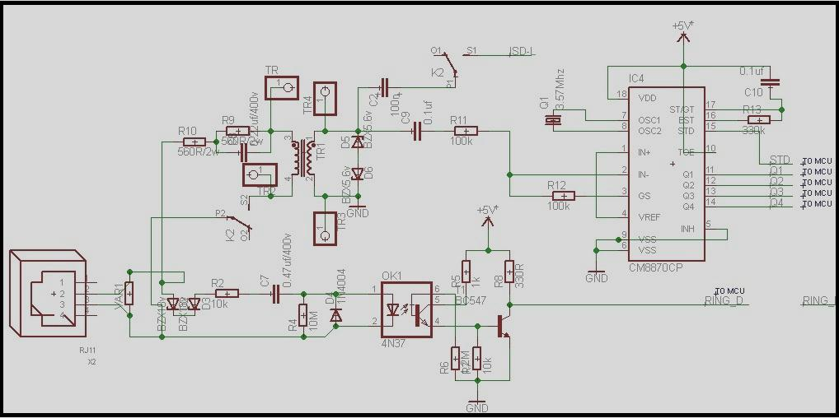

**Ring detection and DTMF section**

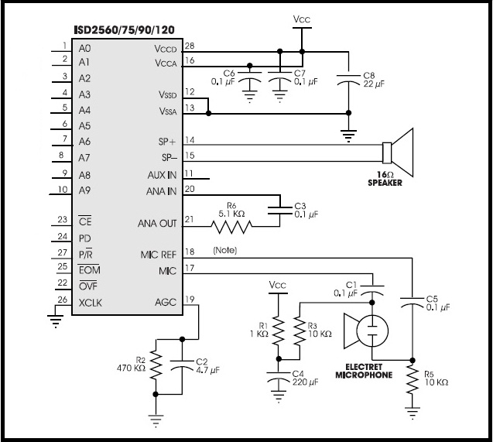

**Voice section**

