

AN-Najah National University
Computer Engineering Department
Hardware Project

Project:
Heartbeats Monitor.

Made by:
Mohammad Zorba.
Mohammad Zahlan.

What should our project do?

The goal of this project is to build a system to measure the number of heartbeats per minute of any person who want to measure the speed of his blood flow that fits comfortably into daily living.

After putting the finger in the specific place, the number of the heartbeats will be shown on the LCD automatically.

Work principle of our project:

When the person put his finger inside the hollow, indeed his finger become between a high intensity LED 4200mcd and a responsive resistor (photo resistor ), On every heartbeat reaches his finger it makes light isolation on the resistor, this mean that the heartbeat will prevent the rays from the intensity LED to reach the responsive resistor, and this makes the responsive resistor change its resistance to be lower than initial value when the high intensity light is on it directly, so this brings bigger current to the resistor branch, this current will enter the Operational Amplifier OpAmp(LM358) that in his tern amplify the current to max scale of 5 volts which will be translated to pulses, each beat represents one pulse, then these sequence of pulses enters to the microcontroller On pin A0 That capture the pulse happening and also the next pulse and take time between them, in the system 3 pulses is enough to give pulse indication speed but for the accuracy we tacked 5 pulses and then we computed the time for the one pulse to make sure that’s no wrong reading in the pulses that arrives and show the number of heartbeats per minute on the LCD that connected to the pic16f877A and the Multiplexed Display that connected to the pic16f84A.

The figure below shows the Signals detected and processed by our project:

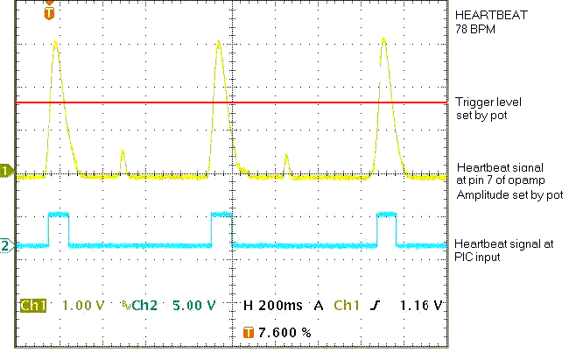

Structure of our project:

Regulator Circuit:

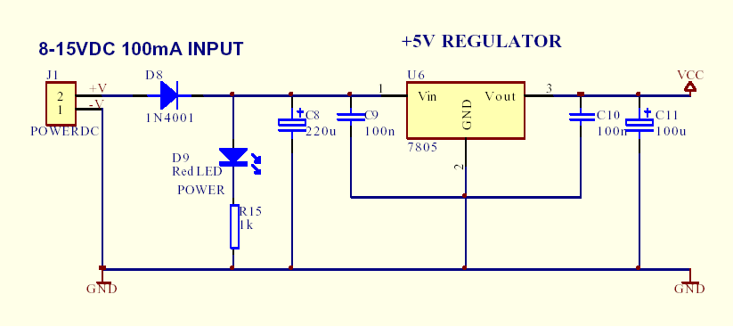
- As known this part of project is to transform 8-15VDC 100mA input
To 5VDC output to provide safety of the hardware pieces.

Heartbeat Sensor Circuit:

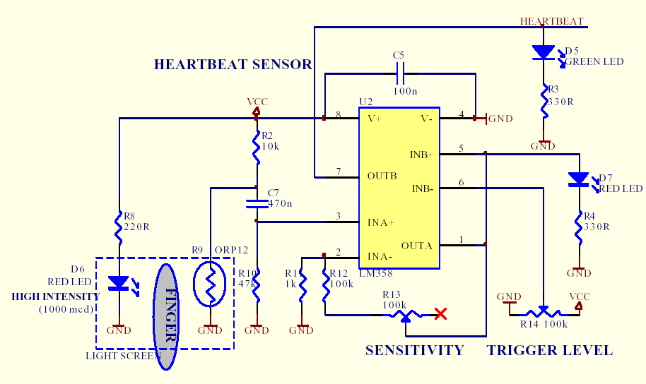

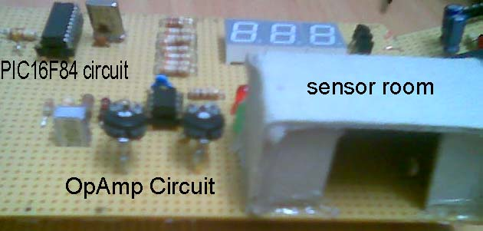

- This circuit aims to produce suitable heartbeat pulse to enter the
microcontrollers.

- As seen in the pictures above, there is a hollow to put a finger inside it, inside the hollow there is a high intensity LED and responsive resistor to detect each heartbeat.

- The produced signal is sent to the LM 358 (OpAmp) to make the inputs suitable to be detected on the microcontroller.

- There is two variable resistors to control with trigger level. ((the current that enters the OpAmp to be amplified)) and sensitivity ((to what extend resistor catch changes in light)).

- There is also two LEDs connected to the OpAmp output indicates the pulse sequence that enters the controller and to show the accuracy of the produced signal.

Pic16F84 Microcontroller Circuit:

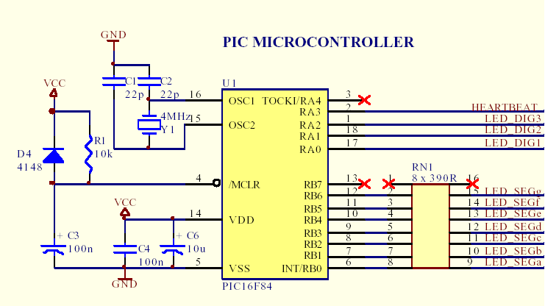

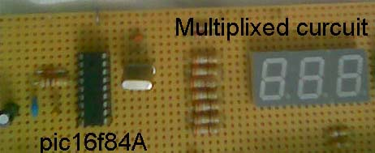

- This microcontroller control the reached signals and do its calculations to show the result output which is the number of heartbeats per minute on the multiplexed display.

Multiplexed Display Circuit:

- This multiplexed display is to show the number of heartbeats per minute.

- It is controlled by the pic16F84 microcontroller.

- It consists of three common cathode Seven Segment LEDs.

Pic16F877 Microcontroller and LCD Circuit:

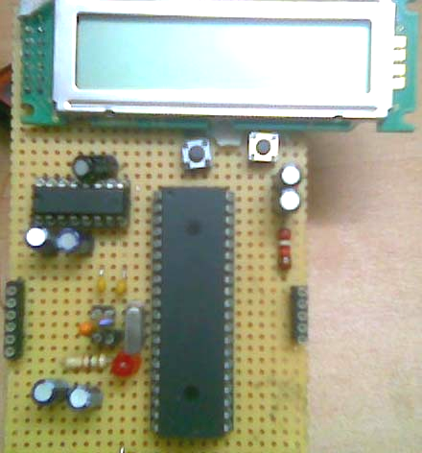

- This microcontroller control the reached signals by calculate the time between the pulses that comes over Pin A0 and do its calculations to show the result output which is the number of heartbeats per minute on the LCD.

Complete Circuit:

- A number of pictures taken to the project from many angles is shown below:

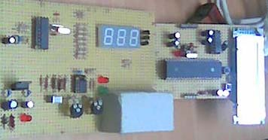

Programming in our project:

- As mentioned above this project contains two microcontrollers.

- Pic16F84A microcontroller is programmed by 'assembly'.
- Pic16F877A microcontroller is programmed by 'C' language.

- This is the program of pic16F84 microcontroller.

list p=16f84,r=hex ;microcontroller & base

include "reg16c84.inc" ;register memory mapping file
include "project.inc" ;heartbeat definitions

;****************************************************************
;global variables
;****************************************************************
count equ 0x0c ;general purpose counter
display3 equ 0x0d ;data for 7-segment display 100's
display2 equ 0x0e ;data for 7-segemnt display 10's
display1 equ 0x0f ;data for 7-segment display 1's
beatlsb equ 0x10 ;heartbeat counter,lsb
beatmsb equ 0x11 ;heartbeat counter,msb
aargb0 equ 0x12 ;dividend,lsb
aargb1 equ 0x13 ;dividend,msb
bargb0 equ 0x14 ;divisor,lsb
bargb1 equ 0x15 ;divisor,msb
remb0 equ 0x16 ;remainder,lsb
remb1 equ 0x17 ;remainder,msb
timera equ 0x18 ;general purpose timer
timerb equ 0x19 ;general purpose timer
timerc equ 0x1a ;general purpose timer
timerd equ 0x1b ;general purpose timer

;****************************************************************
;reset vector
;****************************************************************
reset: org 0x00 ;reset vector address
goto start ;start program execution

start: org 0x06 ;start of program
goto Initialisation

;****************************************************************
; LED DISPLAY DECODER FROM BINARY TO 7-SEGMENT
;****************************************************************
LedDecoder:
addwf pcl,f ;W DISPLAY
retlw LED_SEGa|LED_SEGb|LED_SEGc|LED_SEGd|LED_SEGe|LED_SEGf ;0 - "0"
retlw LED_SEGb|LED_SEGc ;1 - "1"
retlw LED_SEGa|LED_SEGb|LED_SEGd|LED_SEGe|LED_SEGg ;2 - "2"
retlw LED_SEGa|LED_SEGb|LED_SEGc|LED_SEGd|LED_SEGg ;3 - "3"
retlw LED_SEGb|LED_SEGc|LED_SEGf|LED_SEGg ;4 - "4"
retlw LED_SEGa|LED_SEGc|LED_SEGd|LED_SEGf|LED_SEGg ;5 - "5"
retlw LED_SEGa|LED_SEGc|LED_SEGd|LED_SEGe|LED_SEGf|LED_SEGg ;6 - "6"
retlw LED_SEGa|LED_SEGb|LED_SEGc ;7 - "7"
retlw LED_SEGa|LED_SEGb|LED_SEGc|LED_SEGd|LED_SEGe|LED_SEGf|LED_SEGg ;8 - "8"
retlw LED_SEGa|LED_SEGb|LED_SEGc|LED_SEGd|LED_SEGf|LED_SEGg ;9 - "9"
retlw LED_BLANK ;10- " "

;****************************************************************
;Name : Initialisation
;Description : system initialisation and mainloop
;Inputs : none
;Outputs : none
;****************************************************************
Initialisation:

;system initialisation

;port A and port B initialisation

bcf status,rp1 ;select bank1 register
bsf status,rp0

movlw PORTA_CONFIG1 ;porta configuration
movwf trisa
movlw PORTB_CONFIG1 ;portb configuration
movwf trisb

bcf status,rp0 ;select bank0 registers

movlw 0x00 ;disable all displays
movwf porta

;****************************************************************
;Name : Mainloop
;Description : measure and display heartbeat
;Inputs : none
;Outputs : none
;****************************************************************
Mainloop:
call Heartbeat ;measure heartbeat
call Convert ;convert to bpm
call Display ;show on display

goto Mainloop ;endless loop

;****************************************************************
;Name : Heartbeat
;Description : measures the time between two heartbeat signals.
; : Triggered on rising-edge of signal, then measures
; : amount of milli-seconds before next rising-edge.
;Inputs : none
;Outputs : beatlsb,beatmsb = length between two heartbeats
; : in milli-seconds
;****************************************************************
Heartbeat:
btfss porta,HEARTBEAT_SENSOR ;wait until signal goes high
goto Heartbeat
call Delay150 ;wait 150msec - wait until signal has gone low

clrf beatmsb ;preset beat registers with 150msec
movlw 0x96
movwf beatlsb

HL1: call Delay1 ;wait 1msec
incf beatlsb,w ;increment beatlsb by 1msec
movwf beatlsb
btfsc status,z ;lsb rollover?
incf beatmsb,f ;yes -increment msb
btfss porta,HEARTBEAT_SENSOR ;keep looping till signal goes back high
goto HL1

return

;****************************************************************
;Name : Convert
;Description : convert the measured heartbeat from milliseconds
; : to beats-per-minute. (maybe there's a quicker way!)
;Inputs : beatlsb, beatmsb
;Outputs : display1,display2,display3 = contain hearbeat
; : in bcd format
;****************************************************************
Convert:
;calculate bpm = 60000/beat (lsb and msb)

;Make dividend 60000 == 0xEA60
movlw 0xea ;msb
movwf aargb1
movlw 0x60 ;lsb
movwf aargb0

;Get measured heartbeat values, as divisor
movf beatmsb,w ;msb
movwf bargb1
movf beatlsb,w ;lsb
movwf bargb0

clrf remb0 ;initialise remainder registers
clrf remb1

; do an unsigned 16-bit by 16-bit division
movlw 0x10
movwf count

Lu16: rlf aargb1,w
rlf remb0,f
rlf remb1,f
movf bargb0,w
subwf remb0,f
movf bargb1,w
btfss status,c
incfsz bargb1,w
subwf remb1,f
btfsc status,c
goto uok16
movf bargb0,w
addwf remb0,f
movf bargb1,w
btfsc status,c
incfsz bargb1,w
addwf remb1,f
bcf status,c

uok16: rlf aargb0,f
rlf aargb1,f
decfsz count,f
goto Lu16

;convert the lsb result of the previous division to unpacked bcd
movlw 0x08 ;an 8-bit division
movwf count

movlw 0x0a ;divide the previous lsb result by 10
movwf bargb0
clrf remb0 ;initialise remainder

Lu8: rlf aargb0,w
rlf remb0,f
movf bargb0,w
subwf remb0,f
btfsc status,c
goto uok8
addwf remb0,f
bcf status,c
uok8: rlf aargb0,f
decfsz count,f
goto Lu8

movlw 0x0a ;3rd bcd digit - 100's is blank(if not changed further down code!)
movwf display3

movf remb0,w
movwf display1 ;1st bcd digit - 1's

movf aargb0,w
movwf display2 ;2nd bcd digit - 10's(if not changed further down code!)

sublw 0x09 ;is the quotient >=10?
bnc $+2 ;yes -quotient is >=10, so divide by 10 again!
return ;go back

movlw 0x08 ;an 8-bit division
movwf count

movlw 0x0a ;divide the previous lsb result by 10
movwf bargb0
clrf remb0 ;initialise remainder

Lu81: rlf aargb0,w
rlf remb0,f
movf bargb0,w
subwf remb0,f
btfsc status,c
goto uok81
addwf remb0,f
bcf status,c
uok81: rlf aargb0,f
decfsz count,f
goto Lu81

movf remb0,w
movwf display2 ;2nd bcd digit - 10's

movf aargb0,w
movwf display3 ;3rd bcd digit - 100's

return ;go back

;****************************************************************
;Name : Display
;Description : updates display with current measurement
;Inputs : display1 - 7-segment display 1's
; : display2 - 7-segment display 10's
; : display3 - 7-segment display 100's
;Outputs : none
;****************************************************************
Display:
movf display1,w ;convert bcd to 7-segment
call LedDecoder
movwf display1

movf display2,w
call LedDecoder
movwf display2

movf display3,w
call LedDecoder
movwf display3

movlw 0x4 ;update display for a little while
movwf timerc

DL2: movlw 0xff
movwf timerd

DL1: clrf porta
bsf porta,LED_DIGIT1
movf display1,w
movwf portb
call Delay1

clrf porta
bsf porta,LED_DIGIT2
movf display2,w
movwf portb
call Delay1

clrf porta
bsf porta,LED_DIGIT3
movf display3,w
movwf portb
call Delay1
clrf porta

decfsz timerd,f
goto DL1
decfsz timerc,f
goto DL2

return ;go back

;****************************************************************
;Name : Delay
;Description : causes a delay of 1msec
;Inputs : none
;Outputs : none
;****************************************************************
Delay1:
movlw 0x02 ;number of wait states
movwf timerb
L2:
movlw 0xa5 ;number of wait states
movwf timera
L3: decfsz timera,f
goto L3
decfsz timerb,f
goto L2

return ;go back

;****************************************************************
;Name : Delay
;Description : causes a delay of 150msec
;Inputs : none
;Outputs : none
;****************************************************************
Delay150:
movlw 0xc3 ;number of wait states
movwf timerb
L4:
movlw 0xff ;number of wait states
movwf timera
L5: decfsz timera,f
goto L5
decfsz timerb,f
goto L4

return ;go back

end

- This is the C program of pic16F877 microcontroller.
#include "pulse.h"
#include<LCD.C>

void print_pulse();
int pulse_n;
int i,j;
//int pulse_nnn;
double result;
void noob();
void main()
{

setup_adc_ports(NO_ANALOGS);
setup_adc(ADC_OFF);
setup_psp(PSP_DISABLED);
setup_spi(FALSE);
setup_counters(RTCC_INTERNAL,RTCC_DIV_1);
setup_timer_1(T1_DISABLED);
setup_timer_2(T2_DISABLED,0,1);
setup_comparator(NC_NC_NC_NC);
setup_vref(FALSE);
lcd_init();
pulse_n=0;
result=0;

restart_wdt();
i=0;

while(1)
{
result=0; // time for one pulse
noob(); // to test if there no finger putted
restart_wdt();

for(j=0;j<5;j++) //for take 5 pulse value and compute the time for pulse
{
pulse_n=0;
delay_ms(250);
restart_wdt();
pulse_n=250;
restart_wdt();
while(!input(PIN_A0))
{
restart_wdt();
delay_ms(1);
pulse_n++;
restart_wdt();
}
result=result+pulse_n; // result is the time for 5 pulses

}
result=result/5; // result is the average time for for the pulse
result=60000/result; // pulse / min
restart_wdt();
if(result>60 && result<100) // regect the error pulses
{
restart_wdt();
print_pulse(); // print function
}
}

}

void print_pulse()

{
restart_wdt();

printf(LCD_PUTC, "\f");
restart_wdt();
printf(LCD_PUTC, "pulse=");
restart_wdt();
printf(LCD_PUTC, "%ld",result);
delay_ms(300);
restart_wdt();

//result=0;
// pulse_n=0;
return;
}

void noob() // test if no fingure putted on the sensor room
{
while(!input(PIN_A0))
{

i++;
delay_ms(1);

if(i>3000) // sensor room empty for 3 seconds
{
restart_wdt();
printf(LCD_PUTC, "\f");
printf(LCD_PUTC, "PUT FINGER");
restart_wdt();
i=0;
}
}
restart_wdt();

return;
}

