

An-Najah National University

Faculty of Engineering & IT

Computer Science Department

***“******Vaccination Project “***

Project Team:

Amr Badawi

Ahmad Nasasrah

Mohammad Saleem

Submitted to:

Dr. Hussam A. Halim

1st Semester 2016-2017

**Contents:**

* Abstract ……………………………………………………………………………….. 2
* Introduction …………………………………………………………………………....2
* Functional Requirements ……………………………………. 3
* Non-Functional Requirements ……………………3
* Scenario ……………………………………………………………………………………….4
* System Model …………………………………………………………………….
* Interface ……………………………………………………………………………………….

**Abstract:**

Mother and child need special care, the project will be talking about the possibility of making the vaccination process and attention to the child's health and his mother's best and most comfortable, when the child takes the vaccination at right time it protects against many diseases, there will be a complete system on the subject so that the mother notice about the date and details vaccination before a specific time period, and the guidance of a doctor for the child to make a child's life safer and healthy.

**Introduction:**

Health care provided by health centers in Palestine suffer from lack of timeliness of vaccination, when the mother lost her son to date vaccination becomes the possibility of having a child with the disease more. Our project helps medical staff in many operations, for example when a doctor coming to the health center is to hold calls for mothers to come to the health center, this work is very difficult and boring.

Organize the time to review the mother to her doctor became more difficult the noise made by mothers at the health center, which give a negative for the doctor and for each medical staff, in our project will be to organize the time of every mother, every mother has the time predetermined by the doctor, this work to eliminate the noise inside the center and the provision of means of comfort for everyone inside the health center.

The instructions provided by the doctor for each child exposed to forget that, there must be something written by a doctor to be refer to it when needed, in our project there to write instructions for the mother and the child are written by a doctor and are specific to each child.

**Functional Requirements :**

* The system shall provide forms to enter childs and mothers infomations such as name, age , health state , address and phone .
* The system shall notify mothers with the date of next vaccine before a specific time.
* The system shall produce reports for all vaccine that take every child , date of take and the doctor was supervise the vaccine.
* The system shall provide appropriate viewers for the user to read document in the document store.

**Non-Functional Requirements :**

* The system should be easy to use by all employees.
* The system should be available in English & Arabic.
* The system should decrease time needed for vaccine process.
* The system should be flexible in terms of being able to integrate other popular social networking sites.
* The system should be available to users at anytime.
* The system shall not disclose any personal information about childs or mothers apart from their name and reference number to the operators of the system .

**Scenario :**

The system require username and password to login , the employee in the health center has an account created by the admin of the system .

When the mother make her first visit to the center , the employee will fill all information about her such as name ,a age , address and phone . In addition her child info such as name , date of birth and health status , and will give to him the first vaccine if the child age.

After that the mother will get her own user on the system from the admin that can access to the report part of the system , she will find all her child visits , all vaccine that give to him and the doctor that supervised each process.

**System Model :**

**Data Flow Diagram:**

1-The Context Diagram :

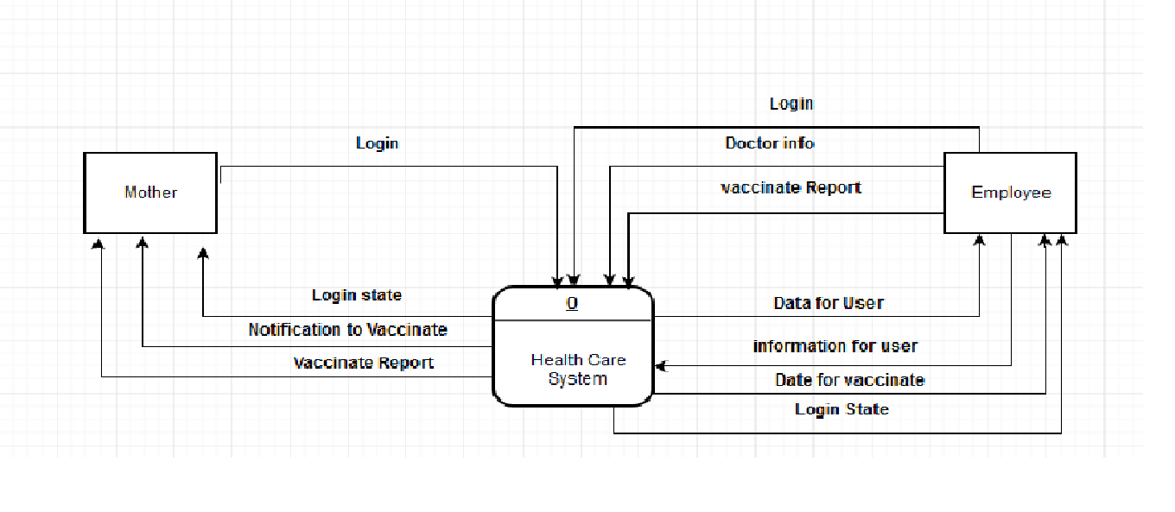

2- Final Level

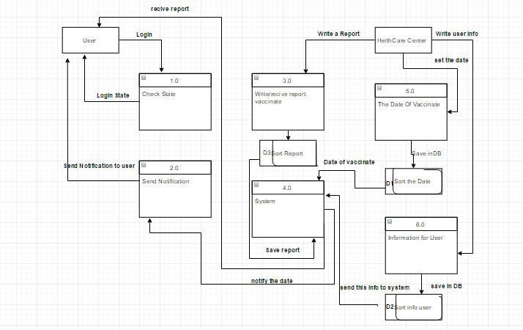

**Use Case Diagram :**

F:\use case.png

**Sequence Diagram :**

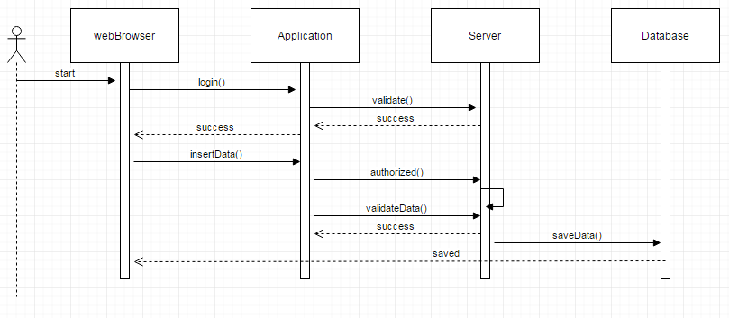

**Interface :**

