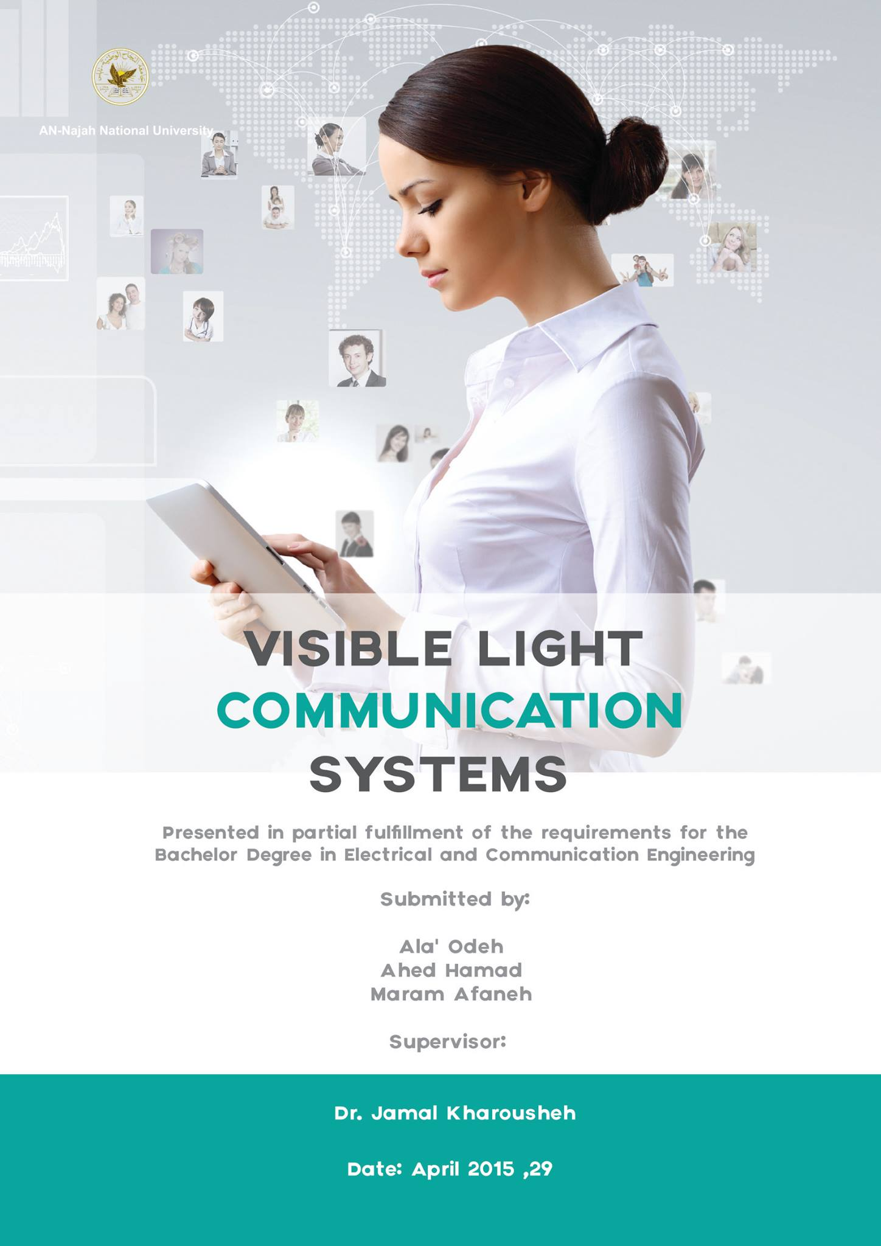

**Acknowledgment:**

This report could not be written to its fullest without [Doctor Jamal Kharousheh], who served as my supervisor, as well as one who challenged and encouraged me throughout my time spent studying under him. He would have never accepted anything less than my best efforts, and for that, I thank him**.**

Also, we wish to thank everyone who helped us complete this dissertation. Without their continued efforts and support, we would have not been able to bring our work to a successful completion. Dr. Mazen Rasekh and Dr. Falah Mohammad.

**Table of Contents (TOC)**

Abstract………………………………………………………………….7

1. Introduction…………………………………………………………..8-10

* 1. statement of the problem……………………………………8
  2. Motivation and Objectives………………………………..8
  3. scope of the work …………………………………...........9
  4. significance(importance)……………………………..…..9-10
  5. Organization of the Report…………………………….…10

1. Constraints and Standards……………………………………..11-16
   1. Constraints………………………………………………11
   2. Standards…………………………………………………11-12
   3. Earlier course work…………………………………........12-16
2. Literature review………………………………………………17-20
   1. The Visible Light Communication System Considered…..17

3.2 Traffic Light………………………………………………….18

3.3 Intelligent Transport System………………………………18-19

3.4 Visible Light Communication for Advanced Driver Assistant Systems…………………………………………………………….19

3.5 Visible Light Communication Link for Video & Audio Transmission……………………………………………………….20

1. Materials and Methods……………………………………………21-26
2. Results and Analysis……………………………………………….27-32
3. Discussion…………………………………………………………..33
4. Conclusions and Recommendations……………………………..34
   1. Conclusions…………………………………………………34.
   2. Recommendations…………………………………………..34
5. References………………………………………………………….35-36
6. Appendices………………………………………………………..37-53

**List of Figures (LOC)**

**1. VLC system (Fig. 1.1)………………………………………………………………….8**

**2. VLC Advantages (Fig. 1.2)…………………………………………………………….9**

**3. How LED work (Fig. 2.1)………………………………………………………………13**

**4. Typical Led Characteristics (Fig. 2.2)………………………………………………….13**

**5. Phototransistor (Fig .2.3) ............................................................................…………….13**

**6. Arduino UNO pins (Fig.2.4) ……………………………………………………………14**

**7. Universal Serial Bus (USB) (Fig.2.5) …………………………………………………..14**

**8. 220 Ω resistor (Fig.2.6) ………………………………………………………………….15**

**9. 1 K Ω resistor (Fig.2.7) …………………………………………………………………15**

**10.** Pin Configurations for opa847 **(Fig.2.8)………..**………………………………………15

**11.** Pin Configurations for opa358 **(Fig.2.9)** …………………….…………………………16

**12. Arrangement of LEDs & receivers in an indoor system (Fig 3.1) ……………………17**

**13. Distribution of LEDs inside model room (Fig 3.2) ……………………………………17**

**14. Road-to-vehicle visible light communication (Figure 3.3)…………………………….. 18**

**15. Traffic lights and tail lights can be used as communication source (Fig3.4) ………….19**

**16. General architecture for a full duplex VLC system (Figure 3.5) ………………………19**

**17. Block diagram of real-time video/audio VLC transmission system (Fig.3.6) …………20**

**18. The VLC circuit (Fig.4.1)………………………………………………………………21**

**19. Experimental circuit (Fig.4.2)…………………………………………………………...22**

**20. The final transmitter circuit (Fig4.3)……………….……………………………………23**

**21. The final receiver circuit (Fig.4.4)………………………………………………………24**

**22. Transmitter application (Fig4.5)………………………………………………………..24**

**23. Receiver application (Fig.4.6)…………………………………………………………24**

**24. The Flowchart (Fig.4.7)……………………………………………………………….25**

**25. Testing result (Fig.5.1)…………………………………………………………………28**

**26. Transmission and Reception operations (Fig.5.2)…………………………………….29**

**27. Selecting Image (Fig.5.3)…………………………………………………………….30**

**28. Show receiving image (Fig.5.4)………………………………………………………31**

**29. Distance testing (Fig.5.5)……………………………………………………………..32**

**List of Tables (LOT)**

Table 1: Comparison between VLC System and other Communication systems……....27

Table 2: Comparison between VLC System and RF ……………………..…………….28

Table 3: The Voltage at Photo transistor………………………………………...………29

**Abstract:**

The increase of mobile applications using radio frequencies (RFs) has highlighted concerns about the adequate availability of RF bands and the limits of transmission capacity in mobile telecom networks, as well as the data security issues involved. Visible Light Communication (VLC) technology is used as a medium for data transmission which is one of the most advanced optical wireless communication technologies, in which light in the visible region (375nm-780nm). This technology is more secure and achieves high data rates as compared to conventional wireless technologies.

**Chapter 1: Introduction**

**1.1 statement of the problem**

Nowadays people are using several types of communication system such as infrared, radio communication, Bluetooth …… etc. these types face some problems including limited transmission power, security, limited data rates …etc. in our project we are developing a new communication system that will solve almost all these problem. This system is called visible light communication.

**Visible Light Communication (VLC):**  is free space optical communication, and line of sight (LOS) is the common link between two points in optical wireless communication system, where the transmitter directs the visible light beam in a straight and unobstructed path to the receiver **[1]**. In this technology LEDs are used as transmitter, the Air as a transmission medium and the Photodiodes as a receiver.

*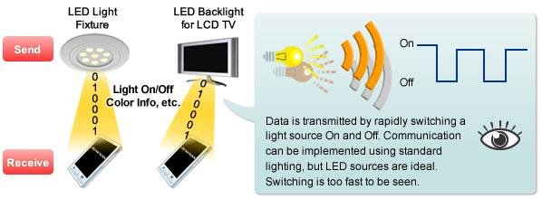****Fig.1.1 VLC system. [2]***

**1.2 Motivation and Objectives**

From our review of the literature, it became evident that work should be done to look into the possibility of designing a new model that could fit the present infrastructure for indoor applications **[3].** Therefore, the objectives of the research presented in this thesis can be summarized as follows:

* Build a circuit for **VLC** by using LED to LED.
* Test the circuit then take notes and discus the performance.
* Suggest a guideline for the design and implementation of future development of the prototypes.

**1.3 Scope of the work**

we hope that the achievement of this project in reality will make everyone in everywhere and at all times be able to send and receive text, image, audio and video with lowest cost, reasonable rate and more security without using the internet.

**1.4 Significance (importance)**

**VLC Advantages:**

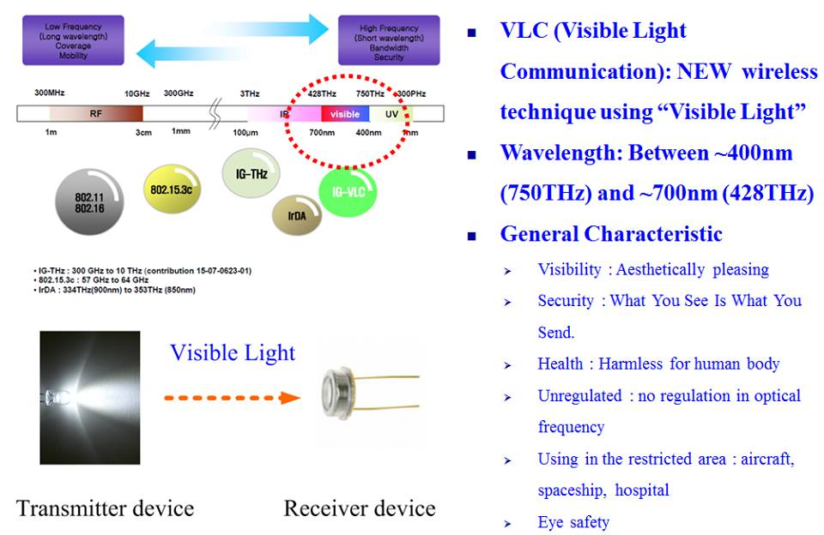

**Fig.1.2 VLC Advantages [4]**

VLC System has many advantages over the other Communication Systems:

1. **Security:** VLC is use light communication and it's visible so in this case it's easy to determine who can receive the message and it's impossible to tap the communication without breaking the link.
2. **Human Safety:** VLC doesn't effect at the human body. Thus, the transmission power can be kept high if needed.
3. **Bandwidth**: VLC has a bandwidth range from 430 THz to 750 THz and this range is larger than the bandwidth in the RF Communications from 3 kHz to 300 GHz.
4. **High Data Rates.**
5. **Unlicensed Spectrum**: No company owns property rights for visible light and thus no royalty fees have to be paid nor does expensive patent-license have to be purchased in order to use visible light for communication purposes **[5]**.
6. **Ubiquitous Nature**: visible light is present in many places, so there is the opportunity to combine light communication with lighting design to let Visible Light Communication (VLC) coexist with the lighting setup present in many offices, homes, or institutions.

**1.5: Organization of the Report**

Chapter 1 of this thesis serves to provide an overview of the basic concepts and  
techniques in physics and engineering and also shows several designs that are required for the implementation of VLC. Chapter 2 provides the constraints, standards /codes and earlier course work. Chapter 3 literature review. Chapter 4 methodology .Chapter 5 results and analysis. Chapter 6 discussion the results. Chapter 7 presents recommendations for improving the designs, as well as the conclusion with suggestions for further improvements in the work.

**Chapter 2:**

* 1. **Constraints**

The main problem was with dealing with the Arduino Where we encountered a problem in writing the code. Also we had two problems with the hardware circuit. The first one is LOS Communication which means that we need line of sight communication. The second problem was the short Range i.e. this technology usually works over a short distance range. Also we faced many other problems such as:

1. Important elements of the circuit were unavailable in Palestine so we had to order them from other countries. They took a lot of time to be available in our hands and thus there was a very short time for the implementation of the circuit.
2. The size of the elements is very small, so we needed special equipments for the implementation.
3. Part of the project needed new software which required us to learn a new software programs.

**2.2Standards**

* the Visible Light Communication Consortium was established   
  in 2003 by Japanese tech-companies
* aims to standardize VLC technology  
  ♣ avoid fragmentation of different protocols and implementations
* two standards are proposed:  
  ♣ JEITA CP-1221  
  ♣ JEITA CP-1222
* also tries to raise public awareness for VLC and promote its   
  applications
* Standardization efforts for physical and media access layer are   
  also done by IEEE 802.15, Task Group 7.
* in 2007, the VLCC proposed two different standards:  
  ♣ Visible Light Communication System Standard  
  ♣ Visible Light ID System Standard
* JEITA (Japan Electronics and Information Technology   
  Industries Association) accepted these standards as JEITA   
  CP-1221 and JEITA CP-1222

JEITA CP-1221 (1/2)

* motivation:  
  ♣ avoid fragmentation and proprietary protocols  
  ♣ prevent interference
* light that is used for communication purposes must be within a   
  range of 380nm to 750nm emitted light must be within a particular range with an accuracy of 1nm sub-carrier (SC) modulation is proposed (as opposed to modulating the frequency of the actual light)

JEITA CP-1221 (2/2)

* there are three major frequency ranges:  
  ♣ range 1 (15 kHz to 40 kHz):  
  - communication purposes  
  ♣ range 2 (40kHz to 1 MHz):  
  - fluorescent lights cannot use this range  
  - they are too slow and generate too much noise  
  ♣ range 3 (> 1 MHz):  
  - should only be used for vast data transmission with special LEDs19 JEITA CP-1222
* according to Shinichiro Haruyama (vice chairman of the VLCC)   
  the following recommendations are proposed by JEITA CP-1222 :  
  ♣ SC frequency: 28.8 kHz  
  ♣ transmission rate: 4.8 kbps  
  ♣ modulation: SC-4PPM (chosen to avoid flickering)  
  ♣ cyclic redundancy checks (CRC) for error detection/correction .**[5]**

**2.3 Earlier Coursework**

In this project we made use in some subjects such as electronic, digital communication,……. Etc.

**\*Light Emitting Diode (LED)**

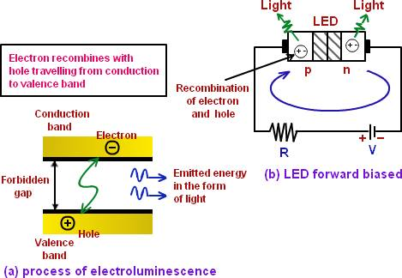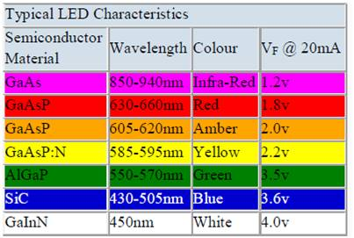**Fig.2.1 How LED work [6] Fig.2.2 Typical Led Characteristics [7]**

**\*Phototransistor:**

**the st-1kla is a high-sensitivity phototransistor mounted in durable , hermetically sealed TO-18 metal can which provide years of reliable performance even under demanding conditions such as use outdoors. It has two leads. It can be used in various applications such as smoke detectors, infrared sensor, optical switches and optical detectors. [8]**

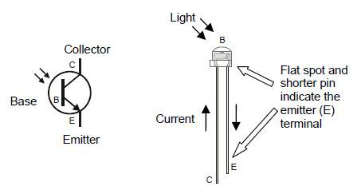

**Fig .2.3 Phototransistor [9]**

***\*Arduino UNO***

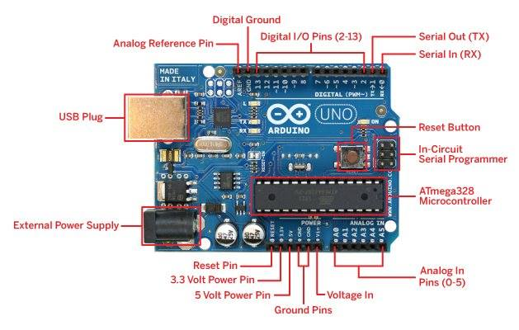

**Fig.2.4 Arduino UNO pins [10]**

The Arduino Uno is a microcontroller board based on the ATmega328. It has 14 digital input/output pins (of which 6 can be used as PWM outputs), 6 analog inputs, a 16 MHz crystal oscillator, a USB connection, a power jack, an ICSP header, and a reset button. It contains everything needed to support the microcontroller; simply connect it to a computer with a USB cable or power it with an AC-to-DC adapter or battery to get started. The Uno differs from all preceding boards in that it does not use the FTDI USB-to-serial driver **[11]**

***\** Universal Serial Bus (USB)**

Used to communicate via the USB protocol with a host computer (for programming or sending/receiving serial data).

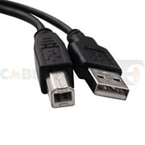

**Fig.2.5 Universal Serial Bus (USB)**

**\*Resistors:**

Resistor is an electrical component that reduces the electric current.  
The resistor's ability to reduce the current is called resistance and is measured in units of ohms (symbol: Ω).

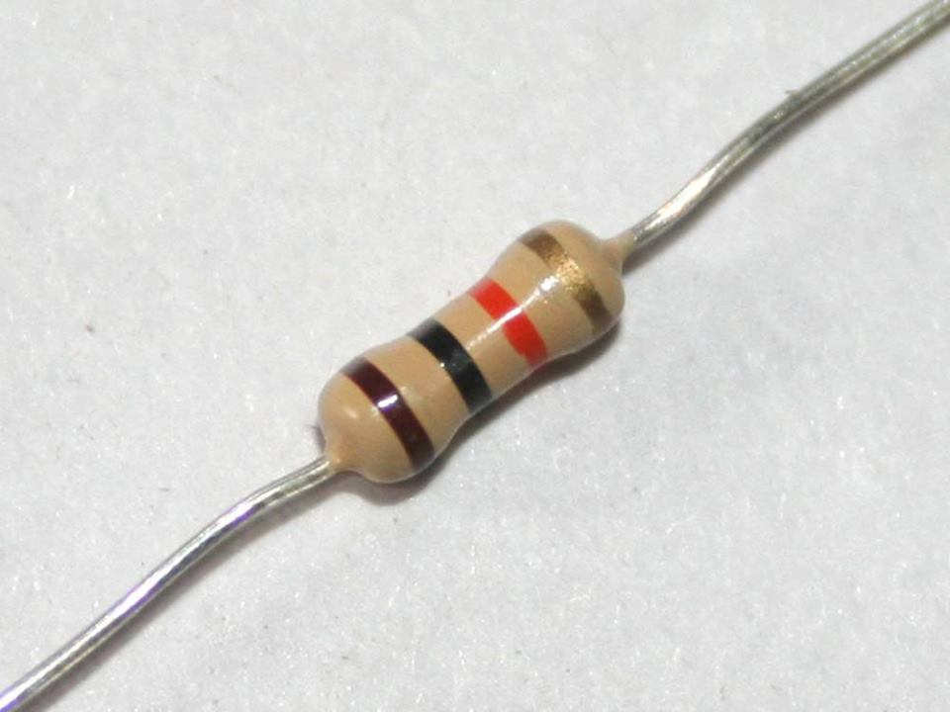

***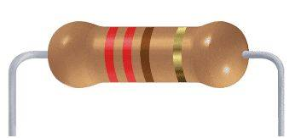* Fig.2.6 220 Ω resistor Fig.2.7 1 K Ω resistor**

**OPA847**

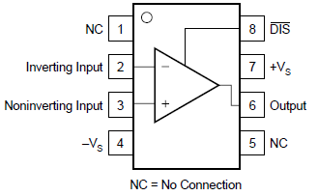

**Fig.2.8 Pin Configurations for opa847 [12].**

**OPA358:**

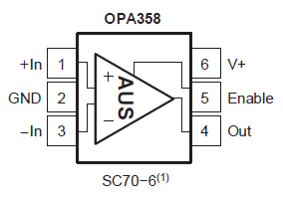

**Fig.2.9 Pin Configurations for opa358 [13]**

**Chapter 3 Literature Review**

This chapter provides an overview of the topics that supplied the ideas for this report and the following sections examine the previous works which have been done on implementing Visible Light Communication technology.

**3.1 The Visible Light Communication System Considered**

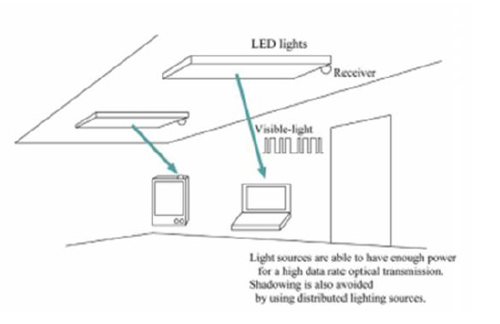**Fig 3.1: Arrangement of LEDs & receivers**

**In an indoor system [14]. Fig 3.2: Distribution of LEDs**

**Inside model room [14].**

The final objective of VLC development is the application of off-the-shelf LEDs in home environment wireless network to satisfy the needs of both illumination and data transmission. An indoor visible light communication system using white LEDs under consideration is shown in Fig. 3.1& 3.2**[14]**. All the lights in the room are replaced by LEDs. The LEDs are not only used for illuminating the room but also for an optical wireless communication system*.*

**3.2 Traffic Lights**



**Figure 3.3: Road-to-vehicle visible light communication [15].**

The above Fig. 3.3 shows the basic usage of LED as a transmitter and CAMERA as a Receiver. In this model, they mounted a camera before the front end of the car. The Camera is used as the information receiver from traffic signal lights. The advantage of using the camera is that multiple data can be transmitted by the LEDs and received by High-speed cameras **[15].**

**3.3Intelligent Transport System**

This technology can be used to design an intelligent transport system to ensure road safety. Nowadays, solid state lighting is widely used in traffic signals and vehicle lights. So, these sources can also be used for both car-to-car and car-to-traffic signal information communication.

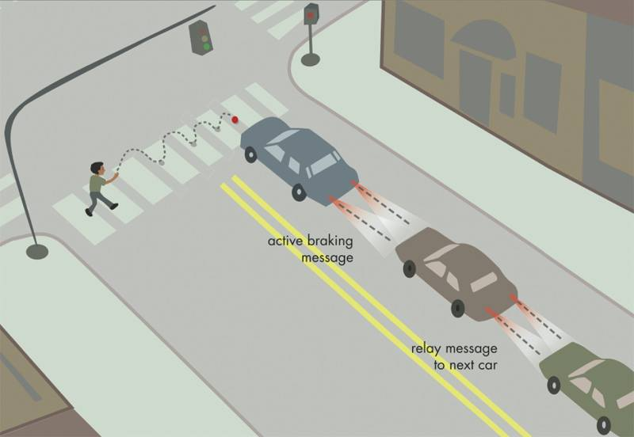

**Fig3.4 Traffic lights and tail lights can be used as communication source [16].**

For instance it has been proposed a traffic light can be used to transmit the time for which it would remain yellow to the vehicles as far as 50m away .In addition to it, car –to car communication can be used for data logging at the time of accident. This information can be used to investigate the nature of the accident **[16].**

**3.4 Visible Light Communication for Advanced Driver**

**Assistant Systems**



**Figure 3.5: General architecture for a full duplex VLC system [3].**

Optical communications for outdoor communication has been discussed and elaborated upon. Devices such as laptops and mobile phones can be used for transmitting and receiving information, using transceivers, as shown in Fig. 3.5. Transceiver systems use both LEDs and photodiodes. Intensity modulation was implemented to reach the most viable modulation. Various important design parameters were optimized by using intensive investigation based on gain variation over 100m of transmission range [3].

**3.5Visible Light Communication Link for Video & Audio Transmission**

***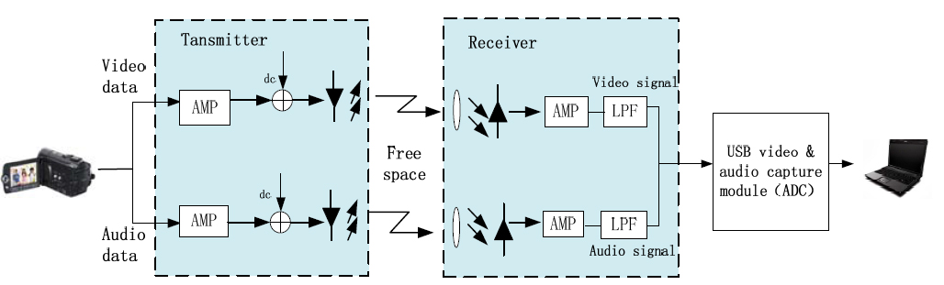*Fig.3.6 Block diagram of real-time video/audio VLC transmission system [1]*.***

Video and audio signal captured by video camera are amplified by a self-designed amplifier and then superimposed onto two LED lamps. Thus, the output light rays changes in intensity corresponding to the variation in signal, which however is insensitive to human eyes due to the rapid frequency response of LED devices. The distance between two LEDs was about 10 cm in order to avoid mutual interference caused by light sources. At the receiver, two highly sensitive photodiodes are used to detect light transmitted over two separate optical channels. And the directionality of the PDs is required to be aligned with the most intense portion of the emitted light beams. After detection, optical signals are converted into photo electric current proportional to the variation of incident light which then is amplified and filtered by a low pass filter (LPF) **[1]***.*

**Chapter 4 Materials and Methods**

**4.1 Design of VLC Prototype**

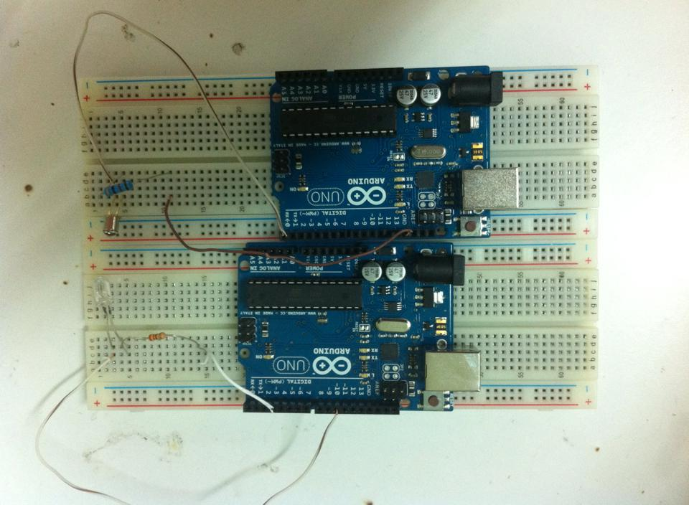

**Fig 4.1 The VLC circuit**

VLC is typically implemented using white LED light bulbs at the transmitter. These devices are normally used for illumination only by applying a constant current. However, by fast and subtle variations of the current, the optical output can be made to vary at extremely high speeds. This very property of optical current is used in VLC setup. The operational procedure is very simple, if the LED is on, you transmit a digital 1, if it’s off you transmit a 0. The LEDs can be switched on and off very quickly, which gives nice opportunities for transmitting data. Hence all that is required is some LEDs and an Arduino that code data into those LEDs. All one has to do is to vary the rate at which the LED’s flicker depending upon the data we want to encode. Further enhancements can be made in this method, like using an array of LEDs for parallel data transmission to transmit larger data like, videos, audios and pictures.

After building the previous circuit that shown in Fig.4.1 and sending a message from 5cm distance between the transmitter and receiver circuits we worked to improve our VLC system in order to increase the distance and to send more types of data in addition to the message such as images and voice.

At first, we tried to build the circuit shown in fig.4.2 but unfortunately it didn’t work as we wanted.

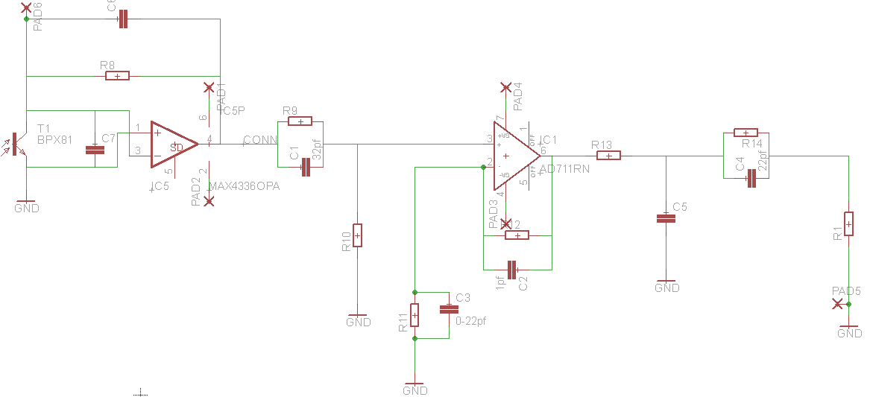

**Fig.4.2 Experimental circuit**

Because of that we tried other ways to make the distance larger as:

* + - 1. Changing resistors values in the transmitter and receiver circuits and put instead of old ones smaller values. So we put a 60Ω resistor at the transmitter circuit and 20Ω resistor at the receiver circuit.

This increased the distance from 5cm to 30cm.

* + - 1. Put two convex lenses, one (30cm focal length) after the white LED and the other (taken from car) before the photo transistor.

And this way increased the distance between the transmitter and the receiver to 1.6m.

The final circuits that we achieved are shown in the figure below:

1. The final transmitter circuit :

We put the LED in the center of the convex lens to be sure that we use all the light.

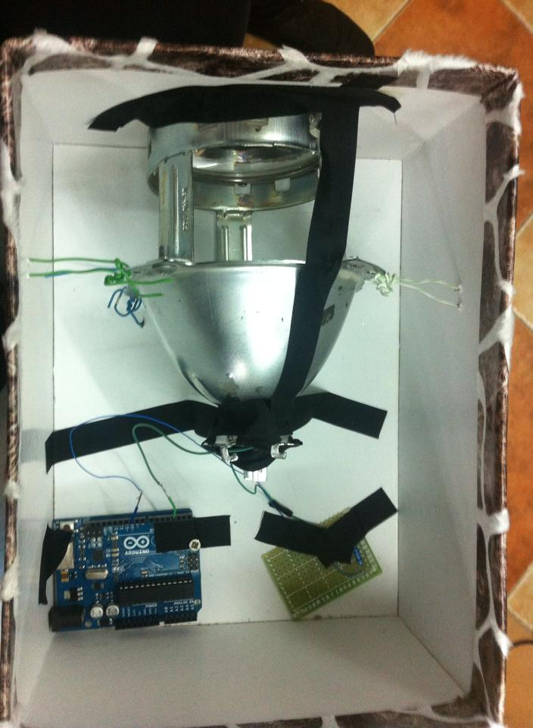

**Fig4.3 The final transmitter circuit**

1. The final receiver circuit:

The distance between the photo transistor and the convex lens is 15cm and we choose it after testing many distances.

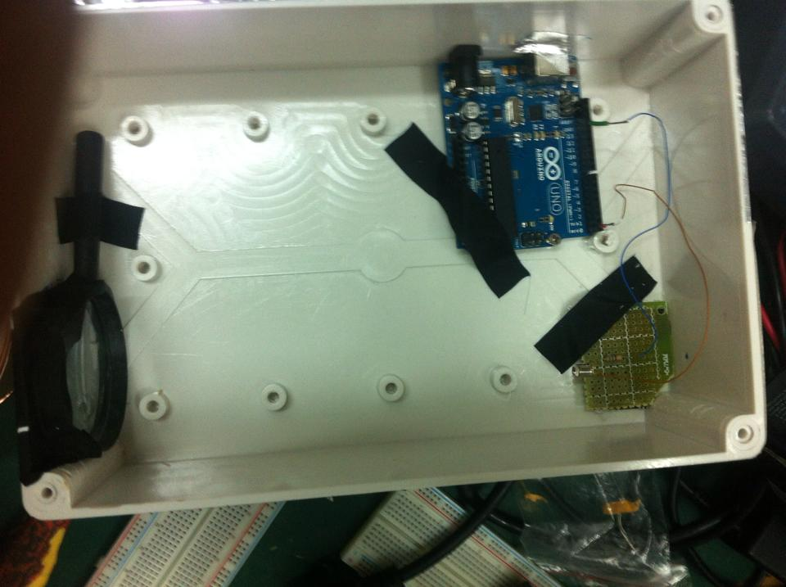

**Fig4.4 The final receiver circuit**

**4.2 Software Design**

In order to send more data such as, images we designed a new applications (transmitter and Receiver) using C sharp programme.

The figures below show the two applications:

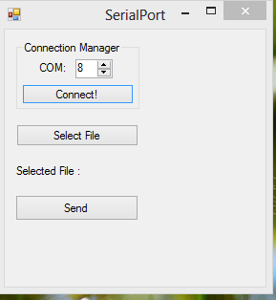 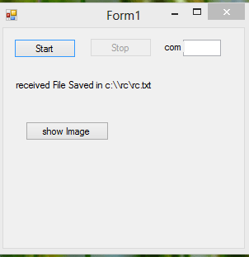**Fig4.5 Transmitter application Fig4.6 Receiver application**

**4.3 Flow Chart**



**Fig 4.7 the Flowchart**

**Arduino**

We used it to convert the input data into bits in order to transmit it into the LED.

**Resistors**

To protect the LED and Phototransistor from the high current.

**LED:**

It modulates the Bits received from the Arduino by converts the electrical current into light pulses

**Why we used LEDs ?**

With LEDs, it is possible to control light brightness at a frequency much higher than conventional light bulbs: LEDs can be switched on and off at very high rates. As result, LED-based lighting can be used for wireless communication services by modulating the intensity of the emitted light. Further, LEDs can also be used as receivers just like photodiodes. We call this concept Visible Light Communication (VLC) with LED-to-LED networking **[17]**.

**Phototransistor**

In order for data transmission to have any significance there must be a way to receive the signal at the other end of the design. This is the purpose of the photodiodes as they react to the light emitted from the LEDs and allow for current to flow to the rest of the receiver circuit. When there is no light emitted from the LEDs the photodiodes do not allow current to flow through to the Arduino on the receiver.

**USB**

It used to transmit the data from the device to Arduino.

**Chapter 5 Results**

After research we found that the VLC system is different from the other Communication systems and we summarize these differences in the following tables:

|  |  |  |  |  |  |
| --- | --- | --- | --- | --- | --- |
|  | GPS | RFID | WIFI | QR code | Visible light communication |
| Position accuracy | Several meters | Several millimeters to Several meters | Several meters to Several hundred meters | Several millimeters to Several meters | Several meters |
| Measurement time | A few minutes | Less than a second | Several seconds | Several seconds | Less than a seconds |
| Measurement device | GPS receiver | RFID reader | WIFI transceiver | Image sensor | Visible light receiver |
| Database | Not necessary | necessary | necessary | necessary | Not necessary |
| The use of indoor and underground | impossible | possible | possible | possible | possible |
| Recognition of building floors | Impossible | possible | difficult | possible | possible |
| Applications | Outdoor | In\outdoor | In\outdoor | In\outdoor | In\outdoor |
| Possibility of widespread use | Already widely used for outdoor | Need to install RFID tags all over the place | Need to install WIFI base stations all over the place | Need to install QR code stickers all over the place | Need to install Visible light transmitters all over the place illumination lights can be used as transmitter |

**Table 2: Comparison Between VLC System and other Communication system.**

|  |  |  |
| --- | --- | --- |
| **RF** | **VLC** | **Property** |
| NO | Yes | **Visibility** |
| 850-950nm | 400THZ-790THZ | **Frequency** |
| 1-2 mb/s | 3.25 Gb/s | **Data rate** |
| Less comp. to VLC | More | **Security** |
| Medium | Relative low | **Power Consumption** |
| Medium | Short | **Coverage Distance** |
| Yes | NO | **Harmless for human body** |

**Table 3: Comparison Between VLC System and RF.**

After building the basic circuit of the VLC system we test it by connect the receiver to an oscilloscope and got the following result:

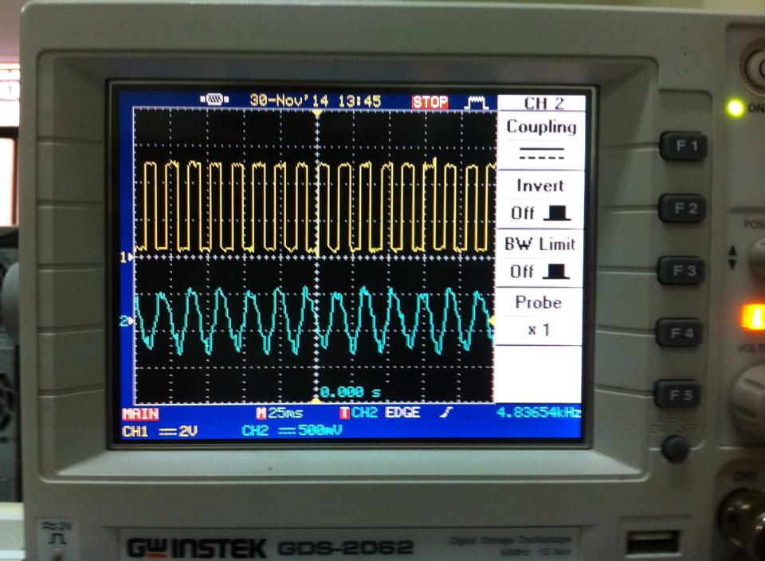  
 **Fig.5.1 testing result**

This result mean that the message was sent from the transmitter should be the same at the receiver in order to make sure that the phototransistor receives data from the LED.  
Next, a measurement was made on the voltage at several distances in order to know at what distance the receiver (phototransistor) will not receive any data from the transmitter (LED). The results are showed in the following table:

|  |  |
| --- | --- |
| **Output Voltage (p)** | **Distance** |
| **400 mv** | **2cm** |
| **178 mv** | **4cm** |

**Table 1: The Voltage at Photo transistor**

After measuring the voltage, the code was downloaded into the arduino and a text message was inserted into it then the transmission operation begun. The photo below shows transmission and reception operations

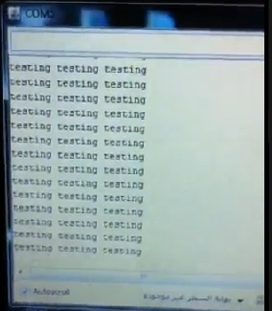

**Fig.5.2 Transmission and Reception operations**

As we mentioned earlier we tried to send other types of data like images by writing C# code.

The result we got is shown in the figures below:

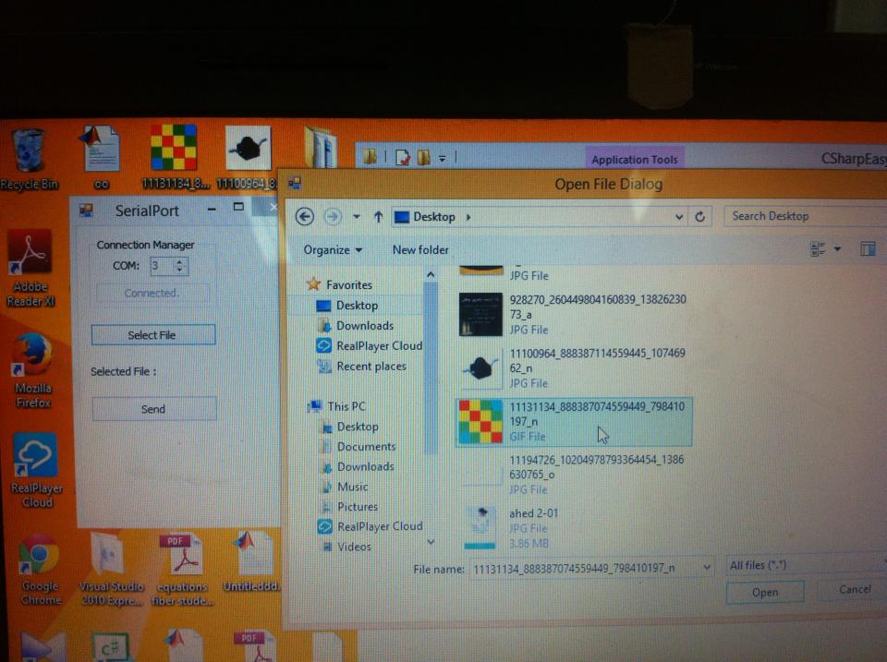

**Fig.5.3 Selecting Image**

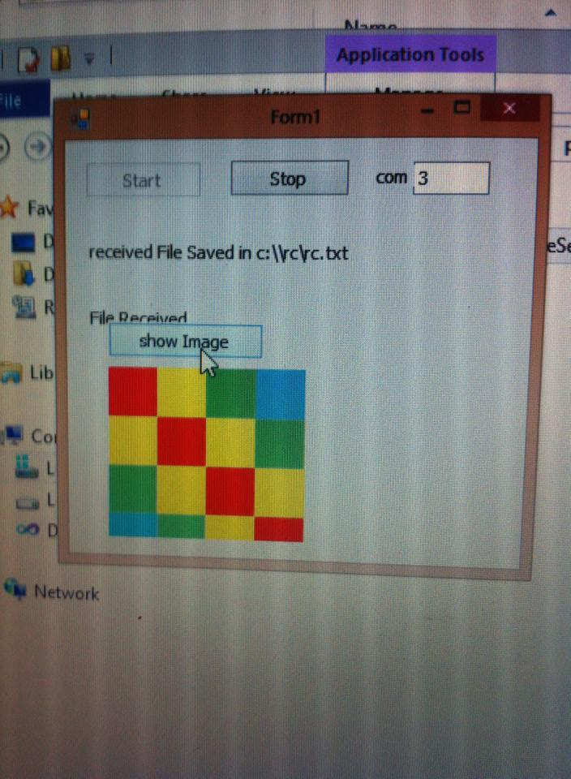

**Fig.5.4 Show Receiving Image**

Then after increasing the distance we test the circuit and we succeed to send messages from 1.6m distance

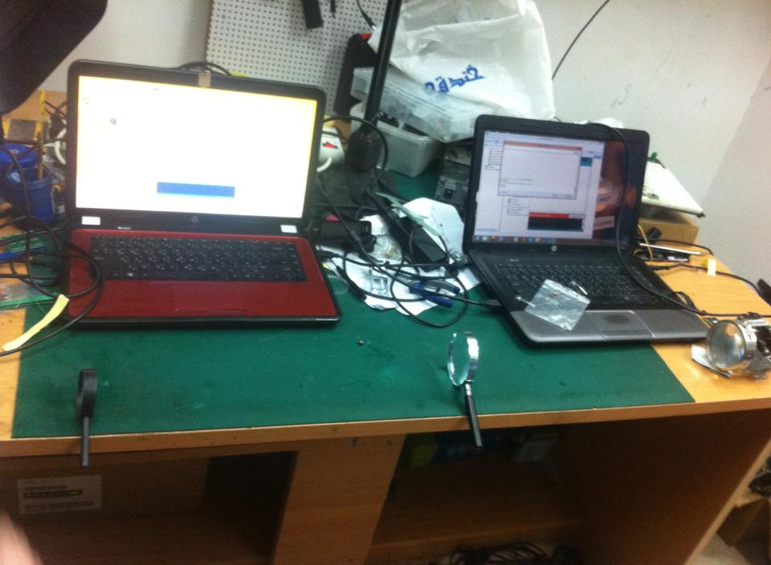

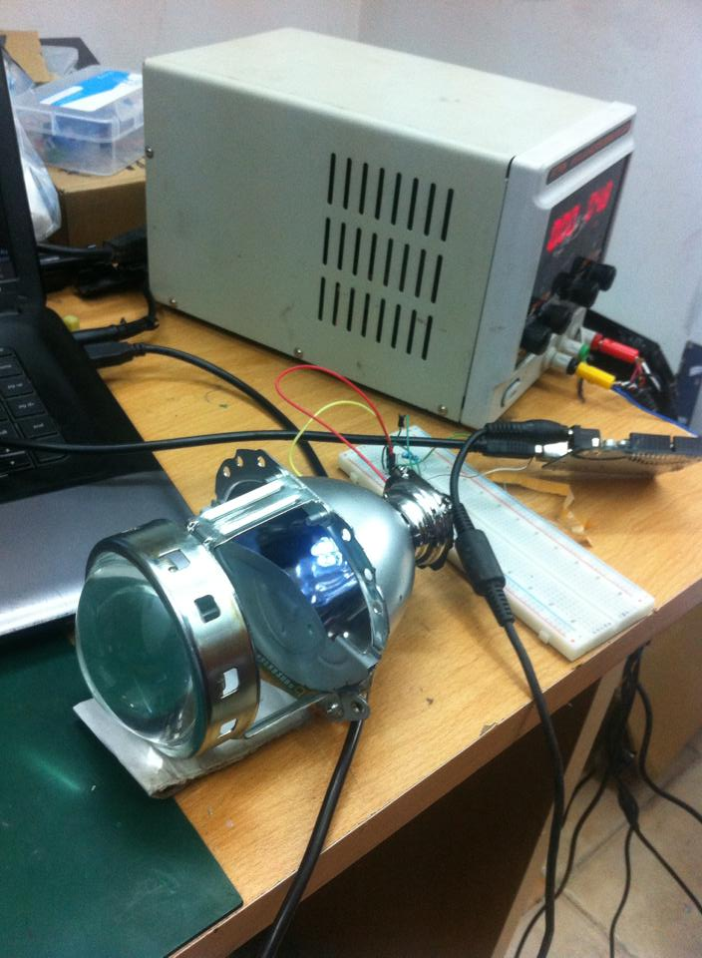

**Fig.5.5 Distance testing**

**Chapter6 Discussion**

At the beginning of our project we hoped (or expected) that we will be able to send and receive data through light with relatively high data rate and at acceptable distance (at first we looked forward to send and receive data at least at 3 meters). on one hand, we succeeded to send receive the data. But on the other hand, there was a problem in the distance, i.e. the highest distance the receiver was able to receive data from the transmitter with relatively low error is 5 cm. There were two suggested problems; the first problem is that the LED needed relatively high power in order to send the data to high distance, the second problem is that the light distract along high distances.

We solved these two problems by decreasing the resistors values in the transmitter and receiver circuits and by adding two convex lenses after the white LED and before the photo transistor.

**Chapter7: Conclusion and Recommendation**

At the end of this project we were able to send and receive text message through led-to-led communication. This proved that at the future we will be able to send and receive any kind of data using every light bulb everywhere like the Wi-Fi hotspots.

In the future we hope to send and receive all kind of data such as video and audio. In addition, we hope to have mobile-to-mobile communication instead of computer-to-computer communication.

**References**

**[1]Yingjie He, Liwei Ding, Yuxian Gong, Yongjin Wang , *“ Real-time Audio & Video Transmission System Based on Visible Light Communication”* Optics and Photonics Journal, 2013, 3, 153-157.**

# [2] renesas, *Renesas Solutions for Wireless Sensor Networks―Part 4: Visible Light Communication (VLC)*. [Online] Available from: <http://www.renesas.com/edge_ol/features/10/index.jsp>

# [Last Access: 27th, November, 2014].

**[3] Durgesh Gujjari, “VISIBLE LIGHT COMMUNICATION”**

# [4] [web.it.nctu.edu.tw](http://web.it.nctu.edu.tw), *****Visible Light Communication*****. [Online]Available from: <http://web.it.nctu.edu.tw/~lab332/research2.html>.

# [Last Access: 29th, November, 2014].

**[5] Christian Pohlmann, “Visible Light Communication”, June 2010.**

# [6] physics.tutorvista, *Light Emitting Diode.* [Online]Available from: <http://physics.tutorvista.com/electricity-and-magnetism/light-emitting-diode.html>

# [Last Access: 27th, November, 2014].

**[7]** **expertsmind, *Light Emitting Diode Colors***. **[Online]Available from:** [**http://www.expertsmind.com/learning/light-emitting-diode-colours-assignment-help-7342873207.aspx**](http://www.expertsmind.com/learning/light-emitting-diode-colours-assignment-help-7342873207.aspx)

**[Last Access: 27th, November, 2014].**

**[8] alldatasheet, *Photo transistor ST-1KL.* [Online]Available from:** [**http://pdf1.alldatasheet.com/datasheet-pdf/view/253316/KODENSHI/ST-1KLA.html**](http://pdf1.alldatasheet.com/datasheet-pdf/view/253316/KODENSHI/ST-1KLA.html)

**[Last Access: 27th, November, 2014].**

# [9] LindsayAndy, (2012), Introducing *the Phototransistor*. [Online]Available from: <http://learn.parallax.com/lightspectrum>

**[Last Access: 27th, November, 2014].**

# [10] store.fut-electronics, *Arduino Uno*.[Online]Available from:

# <http://store.fut-electronics.com/11Ard-Uno+r3.html>

**[Last Access: 27th, November, 2014].**

## [11] arduino, *Arduino Uno*. [Online]Available from: <http://arduino.cc/en/Main/arduinoBoardUno>.

**[Last Access: 27th, November, 2014].**

**[12] alldatasheet, *Wideband, Ultra-Low Noise, Voltage-Feedback***

***OPERATIONAL AMPLIFIER with Shutdown.* [Online]Available from:** [**http://pdf1.alldatasheet.com/datasheet-pdf/view/89734/BURR-BROWN/OPA847.html**](http://pdf1.alldatasheet.com/datasheet-pdf/view/89734/BURR-BROWN/OPA847.html)

**[Last Access: 28th, April, 2015].**

**[13] alldatasheet, *3V Single-Supply 80MHz High-Speed Op Amp in SC70.* [Online]Available from:**

[**http://pdf1.alldatasheet.com/datasheet-pdf/view/156278/BURR-BROWN/OPA358.html**](http://pdf1.alldatasheet.com/datasheet-pdf/view/156278/BURR-BROWN/OPA358.html)

**[Last Access: 28th, April, 2015].**

**[14] T. Komine and M. Nakagawa, “Fundamental Analysis for Visible-Light**

**Communication System Using LED Lights”, IEEE Transactions on Consumer**

**Electronics, Vol. 50, no. 1, pp. 100-107, February 2004**

**[15] S. Iwasaki, C. Premachandra, T. Endo, T. Fujii, M. Tanimoto, and Y. Kimura.**

**"Visible light road-to-vehicle communication using high-speed camera", in Proc.**

**IEEE IVS’08, June 2008, Eindhoven, Netherlands, pp. 13-18.**

**[16] Nishant Bharti, Nishant Gupta, R Kritika, Saurabh Singh “Visible Light Communication”.**

**[17] Stefan Schmid, Giorgio Corbellini, Stefan Mangold, Thomas R. Gross “An LED-to-LED Visible Light Communication System with Software-Based Synchronization” 3rd IEEE Workshop on Optical Wireless Communications (OWC'12).**

**Appendix A**

**Arduino Codes**

**Testing Code:**

**Transmitter code:**

void setup()

{

pinMode(9, OUTPUT);

pinMode(10, OUTPUT);

// Clear Timer on Compare Match (CTC) Mode

bitWrite(TCCR1A, WGM10, 0);

bitWrite(TCCR1A, WGM11, 0);

bitWrite(TCCR1B, WGM12, 1);

bitWrite(TCCR1B, WGM13, 0);

// Toggle OC1A and OC1B on Compare Match.

bitWrite(TCCR1A, COM1A0, 1);

bitWrite(TCCR1A, COM1A1, 0);

bitWrite(TCCR1A, COM1B0, 1);

bitWrite(TCCR1A, COM1B1, 0);

// No prescaling

bitWrite(TCCR1B, CS10, 1);

bitWrite(TCCR1B, CS11, 0);

bitWrite(TCCR1B, CS12, 0);

OCR1A = 210;

OCR1B = 210;

Serial.begin(2400);

}

void loop()

{

Serial.println("testing testing testing");

delay(500);

}

**Receiver code:**

void setup()

{

Serial.begin(2400);

pinMode(13, OUTPUT);

}

void loop()

{

// if incoming serial

if (Serial.available()) {

readSerial();

digitalWrite(13, HIGH);

} else {

digitalWrite(13, LOW);

}

delay(10);

}

void readSerial() {

char val = Serial.read();

Serial.print(val);

}

**The final Code for Arduino:**

**Transmitter code:**

#include <SoftwareSerial.h>

SoftwareSerial altSerial(2, 3); // RX, TX

//generates 38kHz carrier wave on pin 9 and 10

//sends data via TX every 500ms

void setup()

{

Serial.begin(2400);

altSerial.begin(2400);

pinMode(9, OUTPUT);

pinMode(10, OUTPUT);

pinMode(13, OUTPUT);

// Clear Timer on Compare Match (CTC) Mode

bitWrite(TCCR1A, WGM10, 0);

bitWrite(TCCR1A, WGM11, 0);

bitWrite(TCCR1B, WGM12, 1);

bitWrite(TCCR1B, WGM13, 0);

// Toggle OC1A and OC1B on Compare Match.

bitWrite(TCCR1A, COM1A0, 1);

bitWrite(TCCR1A, COM1A1, 0);

bitWrite(TCCR1A, COM1B0, 1);

bitWrite(TCCR1A, COM1B1, 0);

// No prescaling

bitWrite(TCCR1B, CS10, 1);

bitWrite(TCCR1B, CS11, 0);

bitWrite(TCCR1B, CS12, 0);

OCR1A = 210;

OCR1B = 210;

}

void loop()

{

char c;

if (Serial.available()) {

c = Serial.read();

altSerial.print(c);

altSerial.flush();

Serial.flush();

}

if (altSerial.available()) {

c = altSerial.read();

Serial.print(c);

}

}

**Receiver code:**

void setup()

{

Serial.begin(2400);

pinMode(13, OUTPUT);

Serial.flush();

}

void loop()

{

// if incoming serial

if (Serial.available()) {

readSerial();

// Serial.flush();

digitalWrite(13, HIGH);

} else {

// Serial.flush();

digitalWrite(13, LOW);

}

delay(2);

}

void readSerial() {

char val = Serial.read();

Serial.flush();

Serial.print(val);

}

**Appendix B**

**C Sharp Code:**

**Transmitter Application code:**

using System;

using System.Collections.Generic;

using System.ComponentModel;

using System.Data;

using System.Drawing;

using System.Linq;

using System.Text;

using System.Windows.Forms;

using System.IO;

using System.IO.Ports;

namespace CSharpEasySerial

{

public partial class frmSerial : Form

{

public string strFileName = "";

public static System.IO.Ports.SerialPort serialPort1;

private delegate void LineReceivedEvent(string line);

System.IO.FileStream _FileStream = new System.IO.FileStream("c:\\rc\\rc.txt", System.IO.FileMode.Append, System.IO.FileAccess.Write);

public frmSerial()

{

InitializeComponent();

}

private void btnConnect_Click(object sender, EventArgs e)

{

System.ComponentModel.IContainer components = new System.ComponentModel.Container();

serialPort1 = new System.IO.Ports.SerialPort(components); // Creating the new object.

serialPort1.DataReceived += serialPort1_DataReceived;

serialPort1.PortName = "COM" + numCom.Value.ToString(); // Setting what port number.

serialPort1.BaudRate = 2400; // Setting baudrate.

serialPort1.DtrEnable = true; // Enable the Data Terminal Ready

serialPort1.Open(); // Open the port for use.

btnConnect.Text = "Connected.";

btnConnect.Enabled = false;

numCom.Enabled = false;

}

private void btnSend_Click(object sender, EventArgs e)

{

try {

// Sends the text as a byte.

// serialPort1.Write(new byte[] { Convert.ToByte(txtDatasend.Text) }, 0, 1);

byte[] bytes = System.IO.File.ReadAllBytes(strFileName);

serialPort1.Write(bytes, 0, bytes.Length );

lblSucceed.Visible = true;

}

catch( Exception exc){

Console.WriteLine("Exception caught in process: {0}", exc.ToString());

}

}

private void btnSelect_Click(object sender, EventArgs e)

{

lblSucceed.Visible = false;

OpenFileDialog fd = new OpenFileDialog();

// string strFileName = null;

fd.Title = "Open File Dialog";

fd.InitialDirectory = "C:\\";

fd.Filter = "All files (*.*)|*.*|All files (*.*)|*.*";

fd.FilterIndex = 2;

fd.RestoreDirectory = true;

if (fd.ShowDialog() == DialogResult.OK)

{

strFileName = fd.FileName;

lblFileName.Text = lblFileName.Text + strFileName;

}

}

private void serialPort1_DataReceived(object sender, System.IO.Ports.SerialDataReceivedEventArgs e)

{

int bytes = serialPort1.BytesToRead;

byte[] buffer = new byte[bytes];

serialPort1.Read(buffer, 0, bytes);

ByteArrayToFile("c:\\rc\\rc.txt", buffer);

//RxString = serialPort1.ReadExisting();

//this.Invoke(new EventHandler(DisplayText));

}

public bool ByteArrayToFile(string _FileName, byte[] _ByteArray)

{

try

{

// Open file for reading

// Writes a block of bytes to this stream using data from a byte array.

_FileStream.Write(_ByteArray,0, _ByteArray.Length);

// close file stream

_FileStream.Close();

return true;

}

catch (Exception _Exception)

{

// Error

Console.WriteLine("Exception caught in process: {0}", _Exception.ToString());

}

// error occured, return false

return false;

}

private void frmSerial_FormClosing(object sender, FormClosingEventArgs e)

{

if (serialPort1.IsOpen) serialPort1.Close();

}

}

}

**Receiver application code:**

using System;

using System.Collections.Generic;

using System.ComponentModel;

using System.Data;

using System.Drawing;

using System.Text;

using System.Windows.Forms;

using System.IO;

namespace SimpleSerial

{

public partial class Form1 : Form

{

// Add this variable

System.IO.FileStream _FileStream = new System.IO.FileStream("c:\\rc\\rc.txt", System.IO.FileMode.Append, System.IO.FileAccess.Write);

public Form1()

{

InitializeComponent();

serialPort1.DataReceived += serialPort1_DataReceived;

}

private void buttonStart_Click(object sender, EventArgs e)

{

serialPort1.PortName = "COM" + textBox2.Text ;

serialPort1.BaudRate = 2400;

serialPort1.Open();

if (serialPort1.IsOpen)

{

buttonStart.Enabled = false;

buttonStop.Enabled = true;

// textBox1.ReadOnly = false;

}

}

private void buttonStop_Click(object sender, EventArgs e)

{

if (serialPort1.IsOpen)

{

serialPort1.Close();

buttonStart.Enabled = true;

buttonStop.Enabled = false;

//textBox1.ReadOnly = true;

}

}

//private void textBox1_KeyPress(object sender, KeyPressEventArgs e)

//{

// // If the port is closed, don't try to send a character.

// if (!serialPort1.IsOpen) return;

// // If the port is Open, declare a char[] array with one element.

// char[] buff = new char[1];

// // Load element 0 with the key character.

// buff[0] = e.KeyChar;

// // Send the one character buffer.

// serialPort1.Write(buff, 0, 1);

// // Set the KeyPress event as handled so the character won't

// // display locally. If you want it to display, omit the next line.

// e.Handled = true;

//}

private void DisplayText(object sender, EventArgs e)

{

// textBox1.AppendText(RxString);

}

private void serialPort1_DataReceived(object sender, System.IO.Ports.SerialDataReceivedEventArgs e)

{

int bytes = serialPort1.BytesToRead;

byte[] buffer = new byte[bytes];

serialPort1.Read(buffer, 0, bytes);

ByteArrayToFile("c:\\rc\\rc.txt", buffer);

//RxString = serialPort1.ReadExisting();

//this.Invoke(new EventHandler(DisplayText));

}

public bool ByteArrayToFile(string _FileName, byte[] _ByteArray)

{

try

{

// Open file for reading

// Writes a block of bytes to this stream using data from a byte array.

_FileStream.Write(_ByteArray, 0, _ByteArray.Length);

// close file stream

_FileStream.Close();

lblfileRec.Text = "File Received";

return true;

}

catch (Exception _Exception)

{

// Error

Console.WriteLine("Exception caught in process: {0}", _Exception.ToString());

}

// error occured, return false

return false;

}

private void button1_Click(object sender, EventArgs e)

{

MemoryStream stream = new MemoryStream(File.ReadAllBytes(@"c:\\rc\\rc.txt"));

Image image = Image.FromStream(stream);

this.pictureBox1.Image = image;

}

private void Form1_FormClosing(object sender, FormClosingEventArgs e)

{

if (this.serialPort1.IsOpen)

{

this.serialPort1.Close();

}

}

}

}