**بسم الله الرحمن الرحيم**

**AN-NAJAH NATIONAL UNIVERSITY**



**FACULTY OF ENGENEERING**

**COMPUTER ENGENEERING DEPARTMENT**

**GRADUATION PROJECT (2)**

**66582**

**2008-2009**

**Car Driving Simulation**

Prepared by:

Alaa’ Shafiq and Tasneem Abu_Eideh

Supervised by:

Dr. Raed Al-Qadi

**Introduction:**

The Car Driving Simulator is a fully functional, pre-configured simulator that contains all necessary HW and SW modules. A driving simulator is a computerized device that allows us to place a student in a situation that resembles real driving. It is a part of Virtual Reality and it has many advantages over comparable vehicle testing including economy, safety and ease of data acquisition.

Driving simulators are being increasingly used for [training](http://en.wikipedia.org/wiki/Training) drivers all over the world. Research has shown that driving simulators are proven to be excellent practical and effective educational tools to impart safe driving training techniques for all drivers. There are various types of driving simulators that are being used like train simulators, bus simulator, car simulator, truck simulator etc.

In general, car driving simulation can be used for:

* User training
* Training in critical driving conditions
* Training for impaired users
* Analysis of the driver behaviours
* Analysis of driver responses
* Analysis of the user performances
* Evaluating user performances in different conditions (handling of controls)

**Where to use the project:**

This project could be used in car driving schools as a way to learn driving specially for the beginners.

It also can be used as a game in entertainment places.

**Project Parts:**

1. Steering.
2. Accelerator pedal.
3. Brake pedal.
4. Gearbox.
5. Communication.
6. Software.

**1. Steering:**

Steering was made of a potentiometer. A voltage divider was made from the potentiometer and the output entered to and analog input of the PIC (AN0).

Depending on the inputs from the steering, the PIC sends different data to the Flash program through the serial (will be explained later in the communication part).

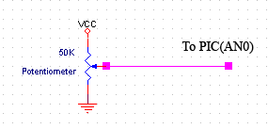

**2. Accelerator pedal:**

It was made of a sewing machine pedal which has inside a logarithmic variable resistor. We put another resistor (100K) and made a voltage divider from the sewing machine pedal and the resistor and entered the output to an analog input of the PIC (AN4). Also because of the voltage ranges that the voltage divider gave, where most the values were between 4-5 volts, we entered the output voltage to an amplifying circuit to convert the values from 4-5v to 0-5v, then to a diode (to get rid of negative ranges not to destroy the PIC) and then to another analog input of the PIC (AN2).

The PIC sends then instructions to the flash program to move the car depending on the inputs from both AN2 and AN4. When the output voltage less than 4volts, the PIC processes the analog input from AN4 (unamplified) but when the voltage is higher than 4volts, it processes the analog input AN2 (amplified) to get better ranges.

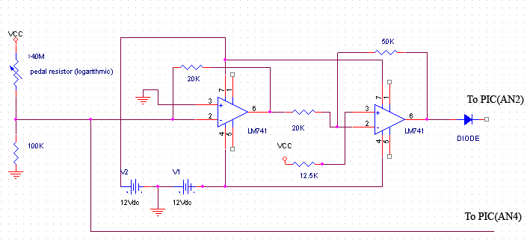

**3. Brake pedal:**

Brake pedal is constructed as the accelerator pedal but the voltage divider output is entered to AN1 in the PIC and the amplified output is entered to AN5 analog input of the PIC. It also has different communication with the flash program depending on the two analog readings.

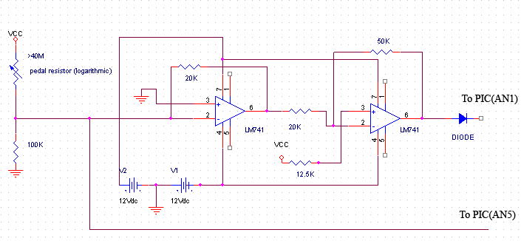

**4. Gearbox:**

It was made of a slide resistor that a voltage divider was made of. The output of the voltage divider entered to an analog input of the PIC (AN3). Depending on the values entered to AN3, the PIC sends to the flash if the chosen is park, drive or reverse.

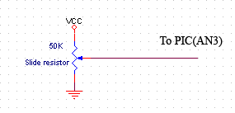

**5. Communication:**

The flash communicates with the PIC through the serial using a Zinc library. The PIC sends different instructions, depending on those instructions the car move or some values changes.

In the PIC, it reads the values from ADC, and then sends a code serially to flash, where these codes are translated into actions.

At First, PIC sends initialization to flash, including steering position, Geer box selection, in order to get the start position of the steering and the gear. For the steering, it reads the steering analog input and converts the value to a rotation value where 2.5 volts means 0 rotation, below it negative values and after it positive values (every 0.3v are considered as 1 rotation) and then send it after an ‘I’ letter which is understood in the flash as the rotation initialization letter. This rotation will be the start rotation value of the car in the flash.

For the gearbox initialization, it reads its analog input, if it is more than 4.5v it sends ‘L 0’, where L understood as the gear selection by the flash, and the zero is for Park (the car can’t move). If the value between 2.1 to 2.9 it sends ‘L 1‘, that 1 means that the car is moving forward. And if the value is less than 0.5 it sends ‘L 2‘, that 2 means that the car is moving reversed. Those values are used also later while moving not only for initialization.

After sending initialization, the PIC continues polling the analog inputs and sends values to the flash for everything changes as the following:

* + S num: it sends this for the steering changes. Every0.3 volts are considered as 1, and the number is positive if clockwise and negative if counter clockwise. The flash adds the number sent to the rotation of the car.
  + D num: it sends this for the accelerator pedal changes. Every time it sends a different number depending on the voltage ranges. This number is used as the maximum speed of the car in the flash.
  + B num: it sends this for the brake pedal changes. Every time it sends a different number depending on the voltage ranges. This number is used as the speed decay in the flash, and it is always less than one to slow the car.

**6. Software:**

The software was made of flash and actionscript. The flash communicates with the PIC through the serial using a Zinc library. The PIC sends different instructions, depending on those instructions the car move or some values changes.

The following two pictures show the start page and the main page (menu).

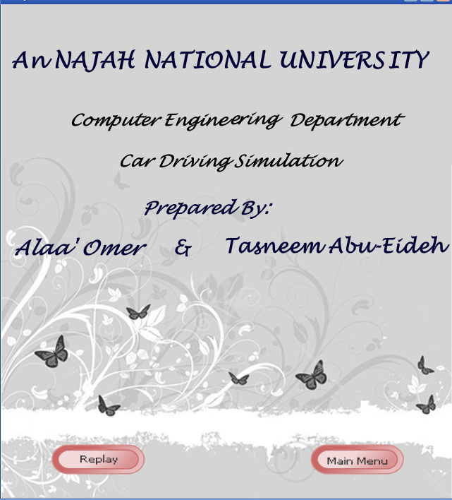

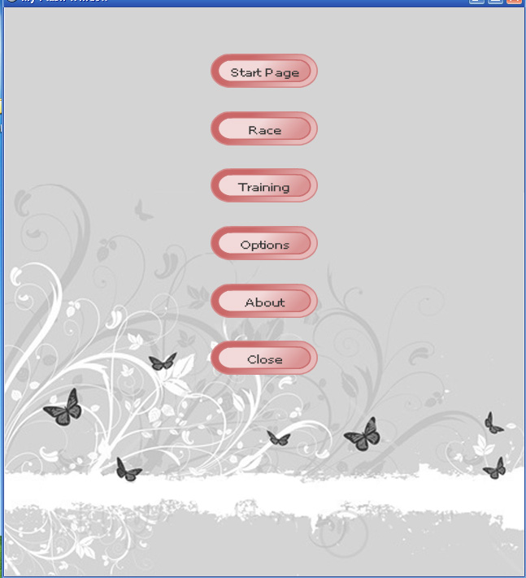

There are two modes for the game; the race mode and the training mode. In the race mode the player plays timed game in a round street for three laps as default, number of laps can be changed from the options page. While playing, the time is shown and the best lap time is shown and changed if the best lap time changed. The following picture shows the race mode game.

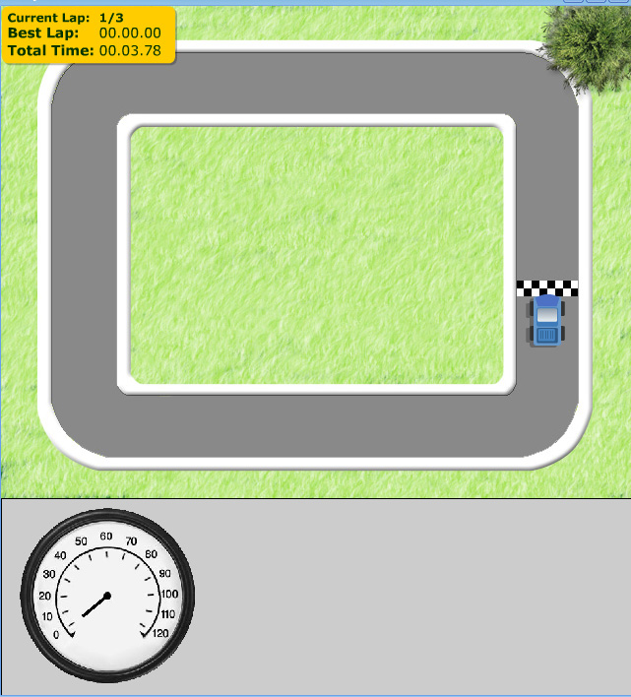

At the end of the race, the best lap time is shown and the car stops moving. The following picture shows a screenshot when the race finishes.

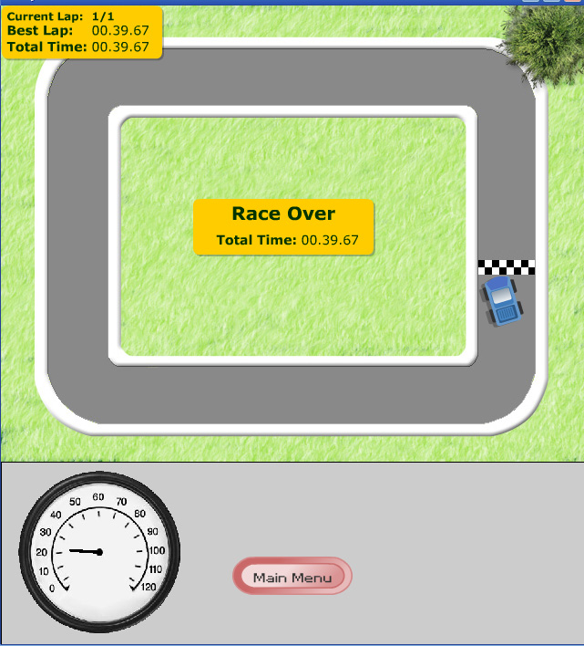

In the training mode, the player plays untimed game in streets of a city. A main menu button is put in order to stop the game and return to the main menu. The following screenshot shows the training page.

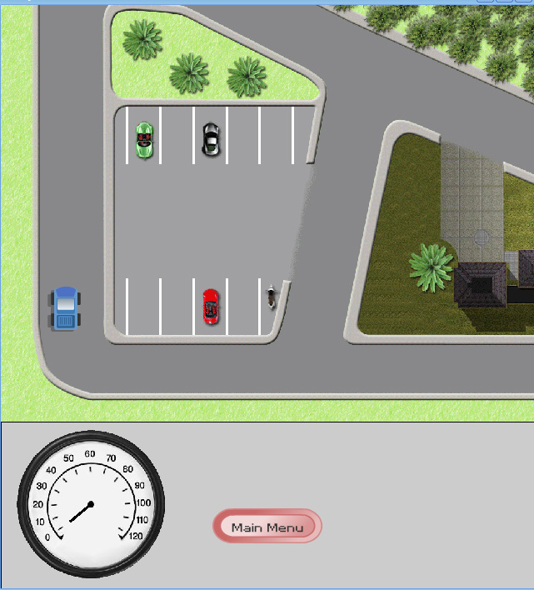

In both modes, collisions were taken in consideration. When a car hits another car or the road sides or a building it slows its speed.

A meter was also put to show the car speed while playing.

In general the car has many variables that the flash give like rotation and position (X and Y) and has some other variables that we defined to control the car like speedDecay, speed, acceleration and maxSpeed. Acceleration is a fixed value that is always added to the car speed as long as it is moving and the maximum speed is not reached. Speed is the speed of the car which we change the position of the car depending on, the speed is multiplied by the speedDecay which is a number less than 1 to slow its movement as a result of the friction. speedDecay is also used in stopping the car by slowing it until reaches its zero speed as a result of not pressing the accelerator pedal or as a result of the brake.

**Conclusion:**

Virtual reality (VR) is a technology which allows a user to interact with a [computer-simulated](http://en.wikipedia.org/wiki/Computer-simulated) environment, whether that environment is a simulation of the real world or an imaginary world.

Virtual Reality is often used to describe a wide variety of applications, commonly associated with its immersive, highly visual, 3D environments.

Driving Simulators are used for [entertainment](http://en.wikipedia.org/wiki/Entertainment) as well as in [training](http://en.wikipedia.org/wiki/Training) of driver's education courses taught in educational institutions and private businesses. They are also used for [research](http://en.wikipedia.org/wiki/Research) purposes in the area of human factors and medical research, to monitor driver behavior, performance, and attention and in the car industry to design and evaluate new vehicles or new advanced driver assistance systems (ADAS).