AN-NAJAH NATIONAL UNIVERSETY

FACULITY OF ENGINEERING

Computer Engineering Department

Graduation Project
E_ commerce Website

Students: Mona Abed Alghani
Ghada Kettani

Instructors: Dr. Lu'ai Malhees
Dr. Ra'ed Al-Qadi
Dr. Ashraf Armoush

Engineer. Anas To’meh

Overview: This E-Commerce WebSite target is to Help Customers finding all their needs in one place..
All things in this website is completely dynamic so that any one can be an administrator for this website although if he dose not know anything about programming or designing because every thing in this website is a form and the user only have to enter what ever he want and it is automatically will store in the database and then display at specific page.
Nablus e-Store.com is the Internet retailer of choice. With categories ranging from computer hardware to software, from electronics to mobiles, from books to movies, from music to toys, and more..
At Nablus e-Store.com, we ensure the integrity of every order by using with state-of-the-art SSL (Secure Sockets Layer) encryption.
Material :to program this website we use PHP and Mysql.
To design it we use flash mx , Swish max , Photoshop , Mix-fx,.

Description: in the first page which is called home page we write an overview about our website which we called it Nablus e_ store then at the right side we put the categories we have in our store , each category is a link which will open another page that includes another links for sub category for the selected one , the category is :
Computers, electronics, toys, mobiles, music, furniture, books.
Then below this product you will see a poll question which is a dynamic that the administrator can add it from his page and also he can deleted this poll question is for voting the customers can choose one of the choice and click vote to show his and all other customers voting about this question as bellow:

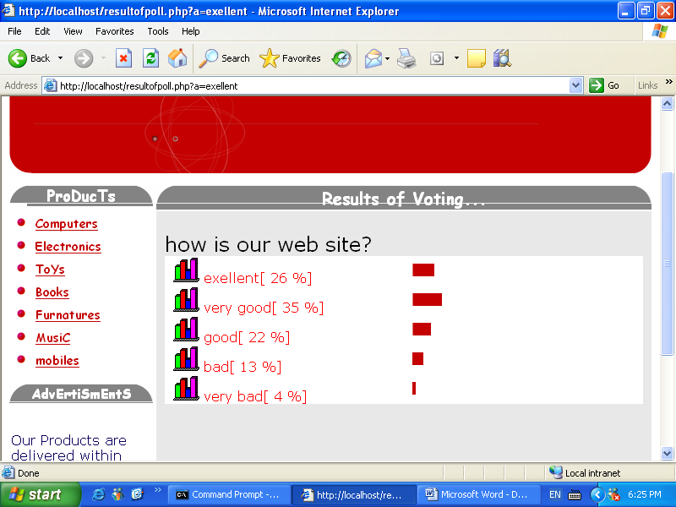
then you will see the advertisements field which is a dynamic one so any customers can upload his advertisement and we will display it in this field the last field in this side is customers login and log up so each customer can be one of our customers by register him self by clicking signup and fill the following information:
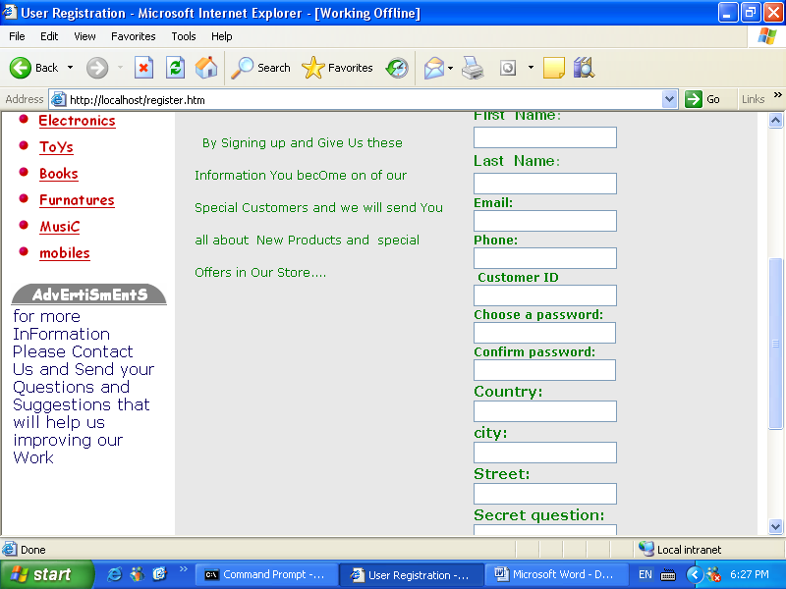
link if the user that is register before forget his password he can press the forget your password link and enter his secret question and the answer and we will return his user name and password as below:
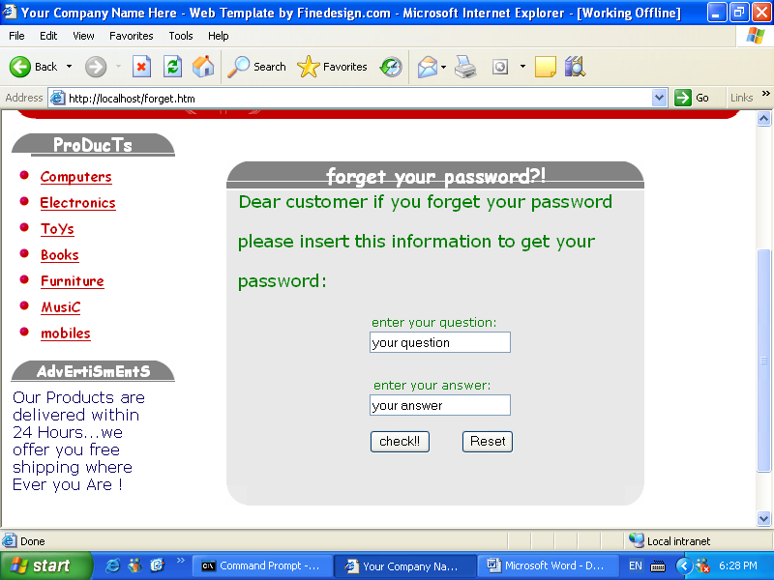

this field is not a necessary for shopping but only to create a data for our customers to give them some privileges in the future and to help us to email him for any problem will occur
You will see in the bottom of this page field for special offers on our store that any one can buy it if he want .
In the upper side you will see some links that will direct you to anther pages this links are: add flashes which a talk about it before which allow customers to up load their advertisements, administrator which is the page for the coordinator of this website ,faq which is the new in the shopping website that give the customers the chance to enter any question he want to ask about the site and any one can answer the question ,tracing this link is very important for the user because it gives him the chance to trace his shopping by inter his order number that we give him in the last stage ,help which is to help user to deal with site help to know how to buy
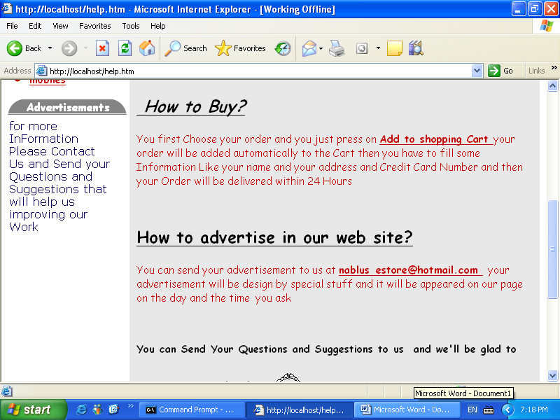

the last link is contact us which help the user to contact us by the telephones , fax , mobile or with email.
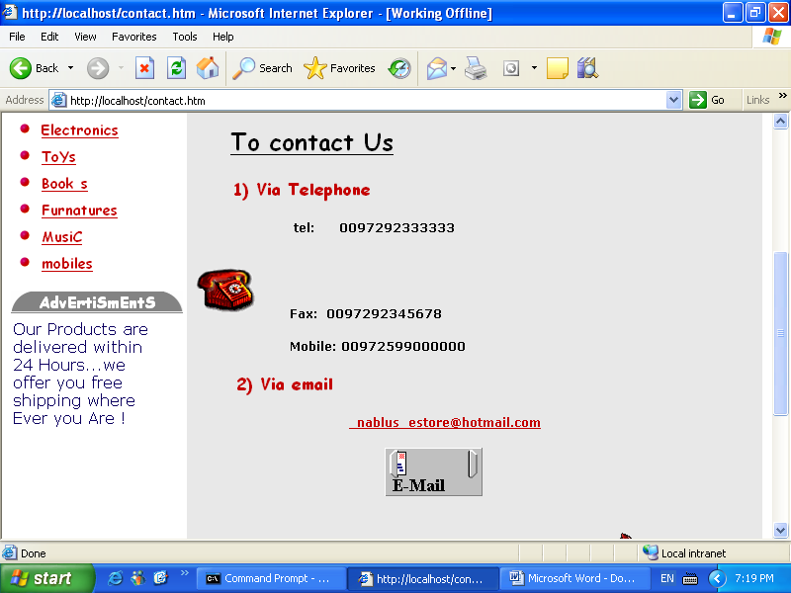
This picture is the home page of our website:
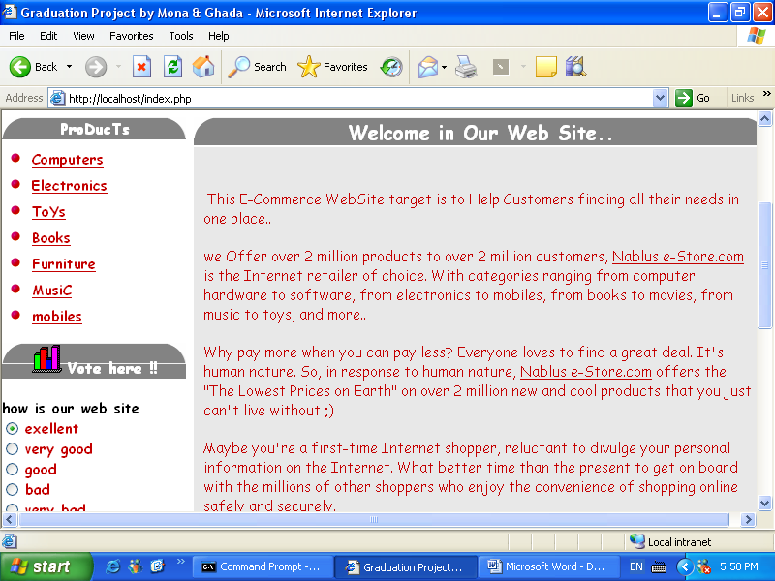
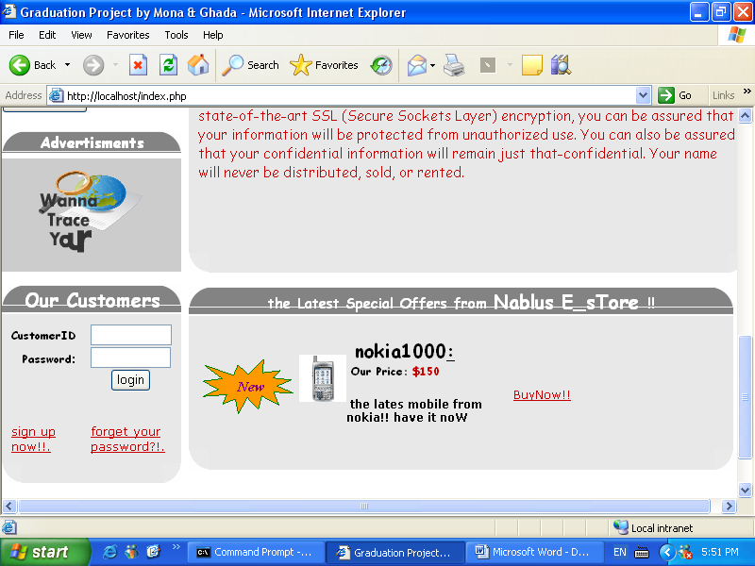
Now if any customers want to buy any product he can choose one of the category and press the link let us choose electronics for example
You will see sub category which is show in the figure below:
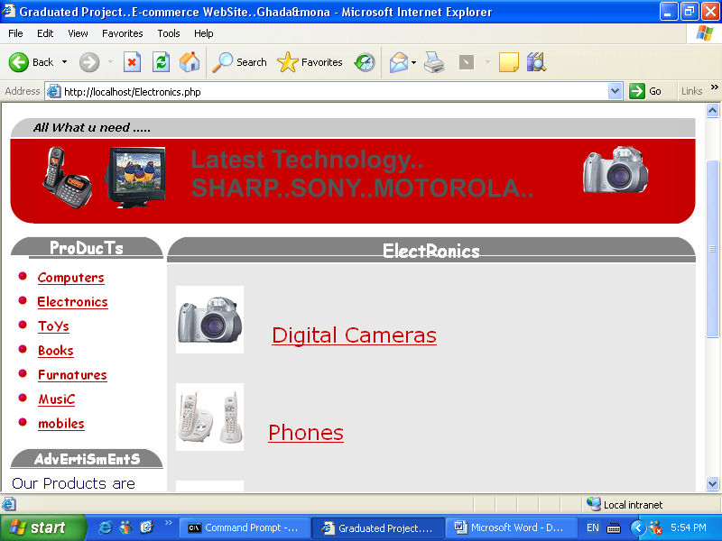
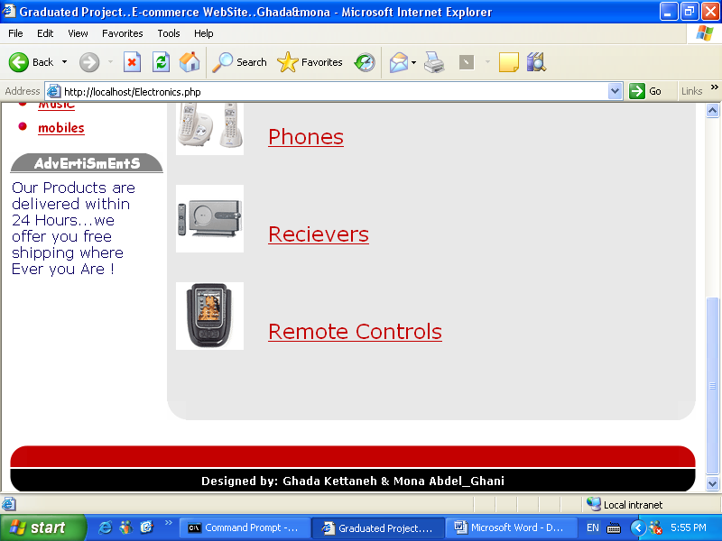

Then he choose any of this sub links and he will see all the stocks that are related to that sub category , in this page ( I mean the socks page ) we arrange the socks so the customers could see the picture of the socks and the name of it , the price , the shipment and brief description about it as you see below:
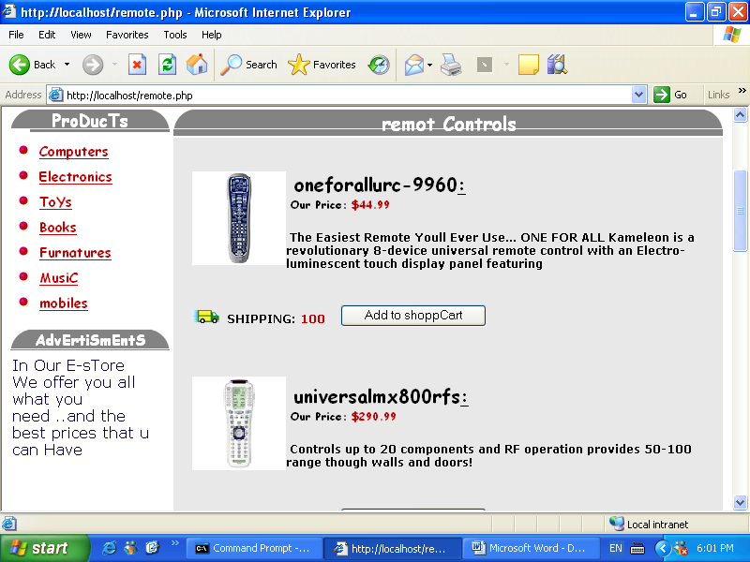

Then the customer choose one of this stocks and press add to shopping cart button to add it to his shopping cart
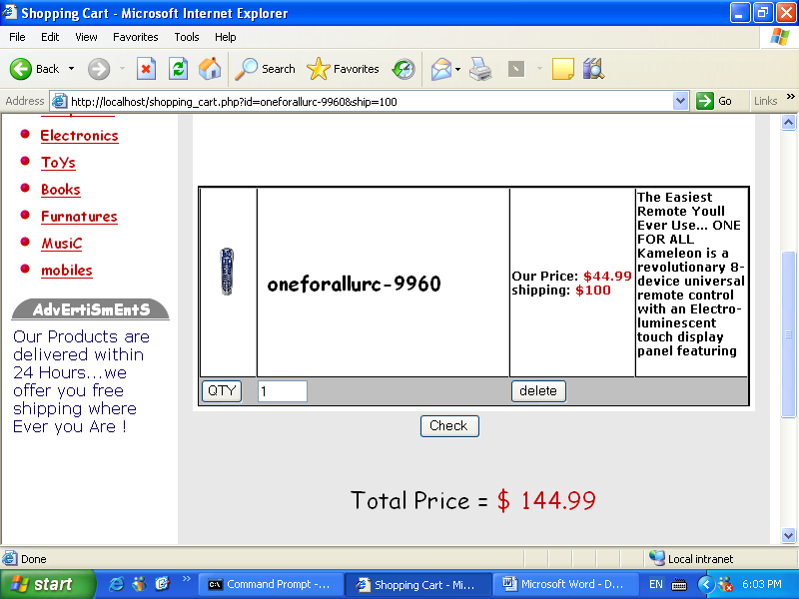
In this page the customers shopping will appear here and he have three choices : to change the quantity or to remove the stock from the cart or finally to bye it by pressing check buttons also in this page you will see the total price you have to pay for your shopping.
If you press check button you will have to enter you credit card number and it is automatically will be checked to ensure that this number is correct ( we emulate a real bank with many credit card for many users) and to ensure that you have enough money in this credit card to buy the stocks you choose before this is the page we talk about:
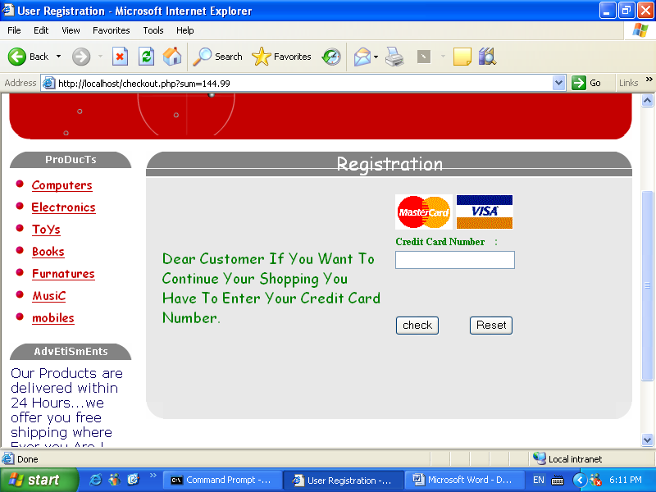

Then you will go to another page to tell you that your credit number is correctly;

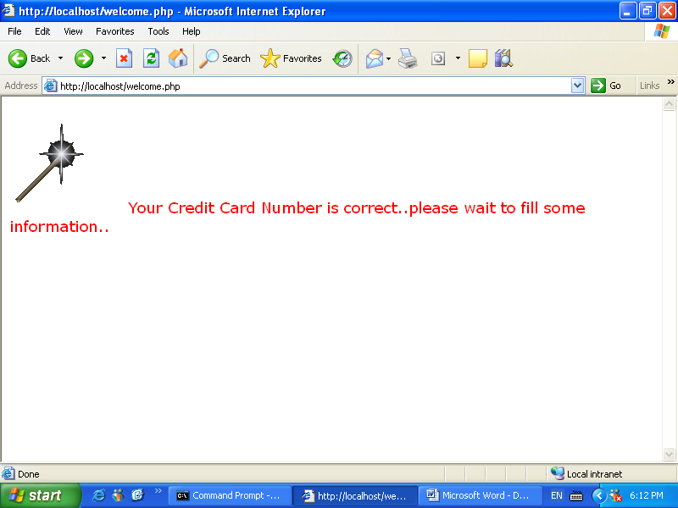

This page is meta data this means that you will redirect automatically to another page to enter you information as below:

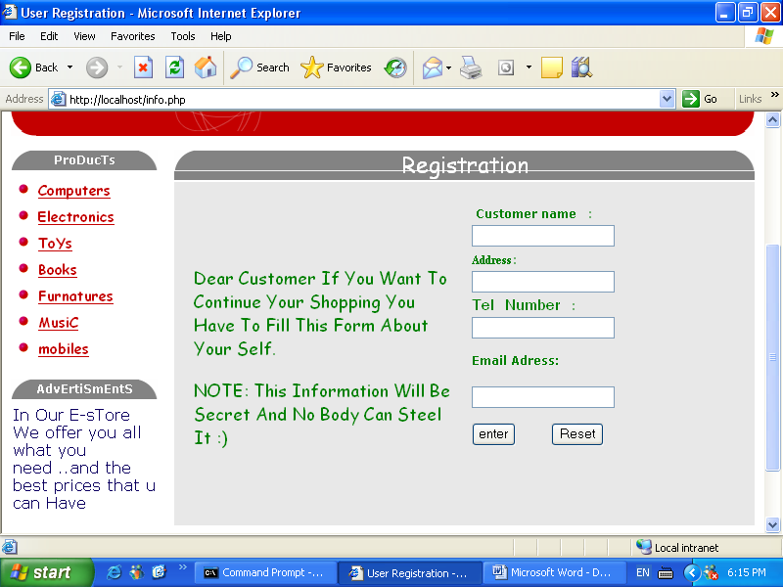

Then after fill the this information you will finish you shopping and this page will direct you to the last page shown below:

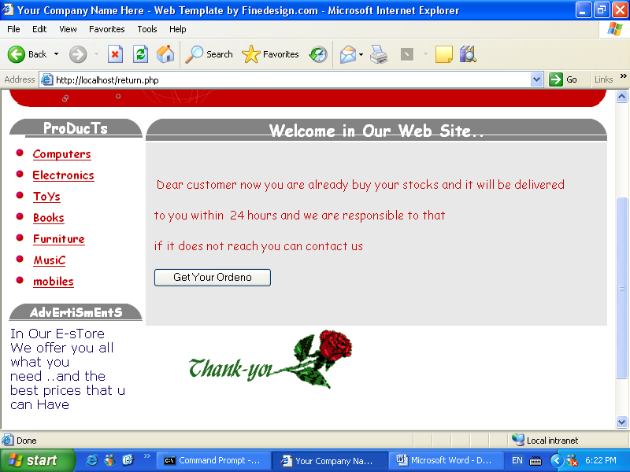

The customers have to press the button to get his order number to trace his shopping in the future:

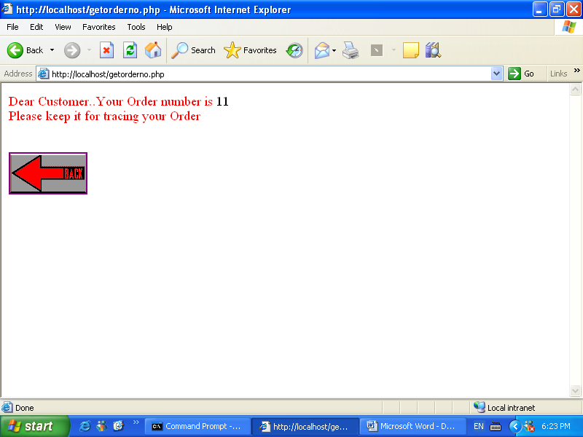

Now we will talk about the very important part in this web site which is the administrator page:
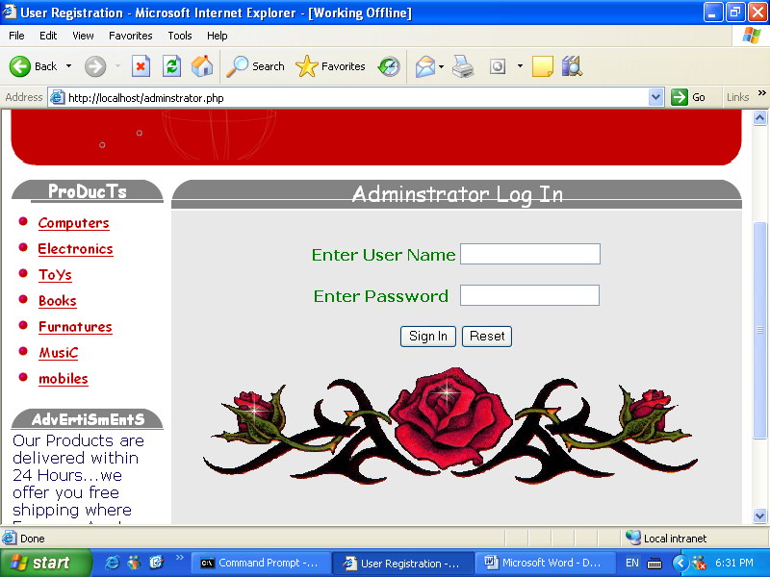

The administrator should enter his user name and password to ensure that no body could enter this part without a permission , after that this page will redirect to the page that the admin could choose so many choices such as below:

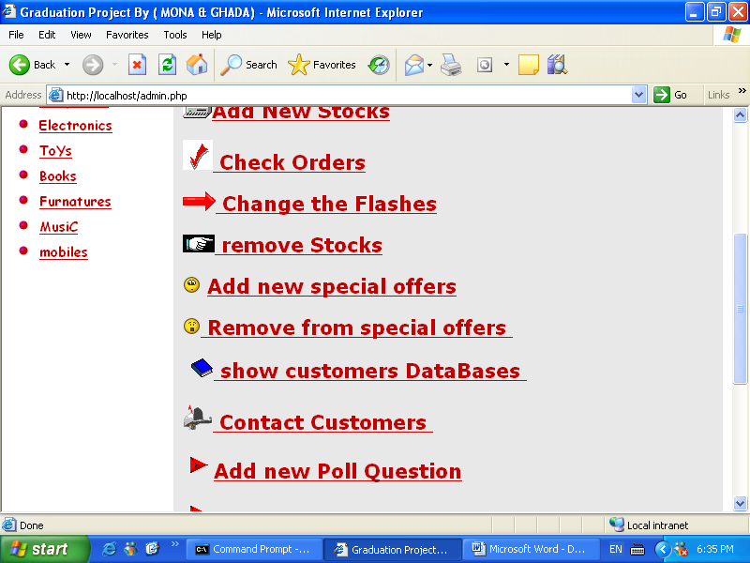

If he choose add new stocks he will be able to add the stocks to the specific category he want :

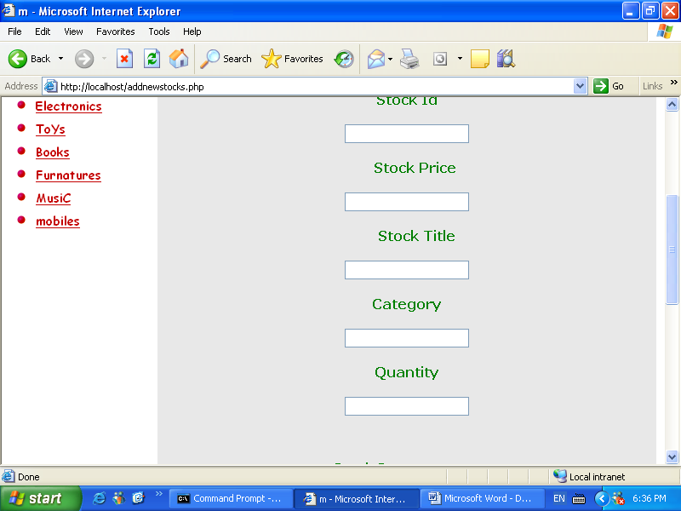

This will insert to the data base directly and displayed in the page related to it.
If he want to delete some stocks that is finished in his stocks he can choose the link remove from stocks

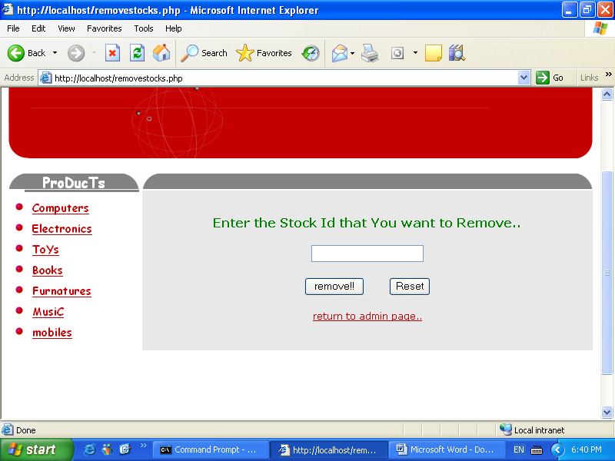
Also he can do the same thing with special offers .
He could also to see the customers that they were registers in the web and to delete the user he want by entering its customer id as bellow:

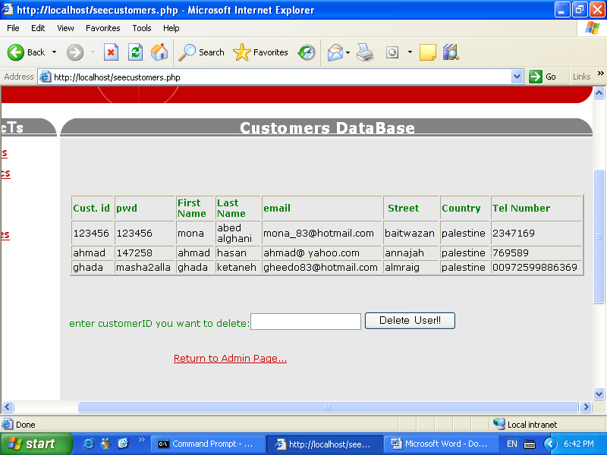

Also he able to add the poll question we talk about it before on the home page and to delete it as the fig below:
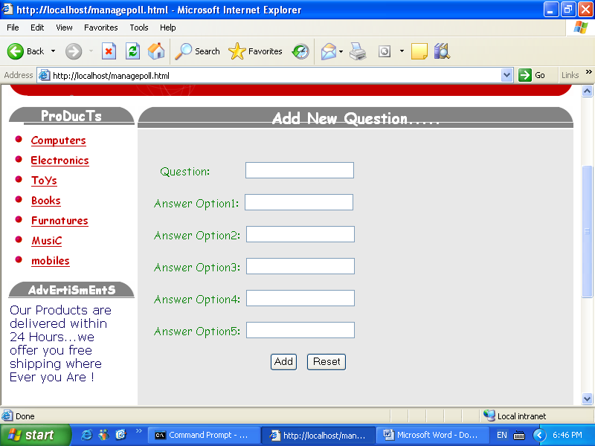
If he choose the contact customers link he will be able to send an email for him:

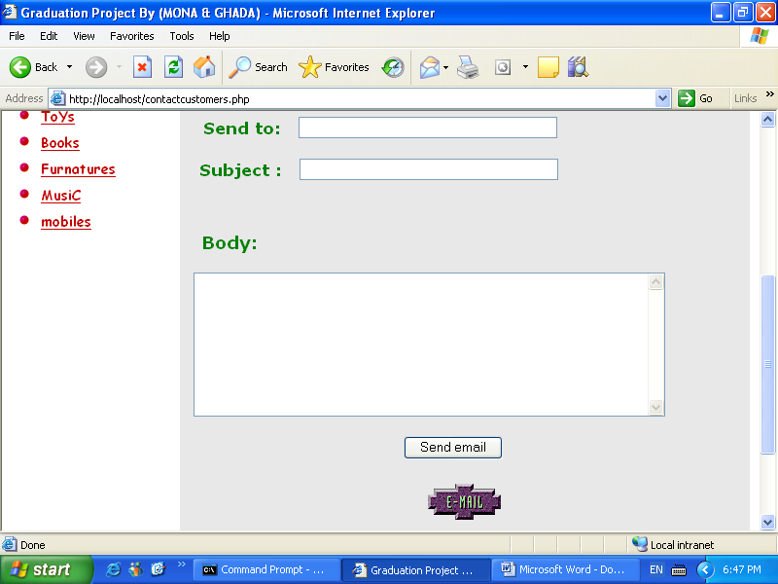

Change flashes link is page that the admin display the customers upload advertisements

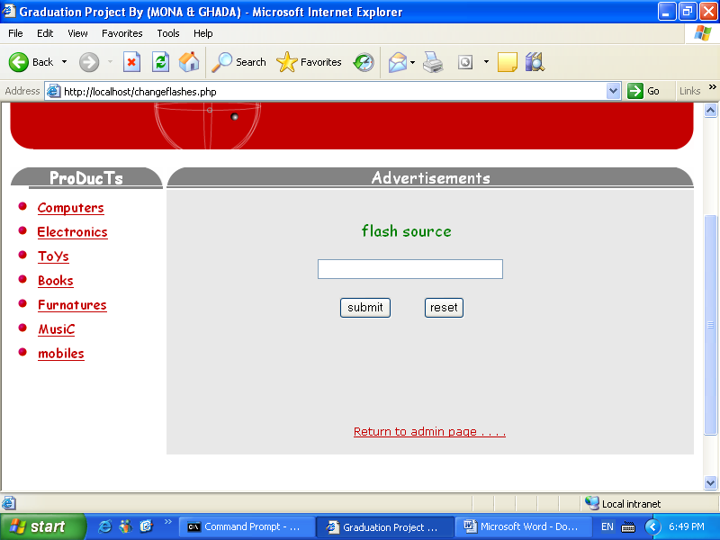

Finally the last link that make the admin be able to show
The orders of each customers and delivered it to the place he live :

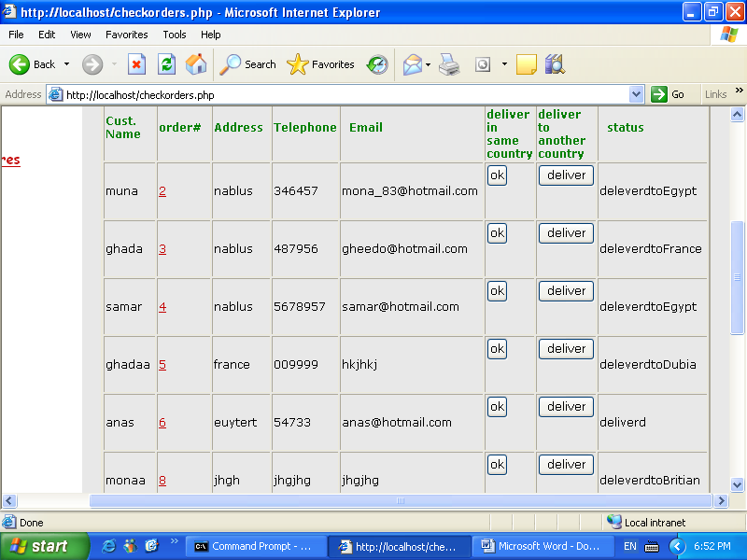

In this page there is a field that tell the admin the status of each order ( I mean if it is delivered or not and to what country)
If he press ok this mean that this order will delivered in the same country of the store so the admin must enter the time and the date of the delivery :

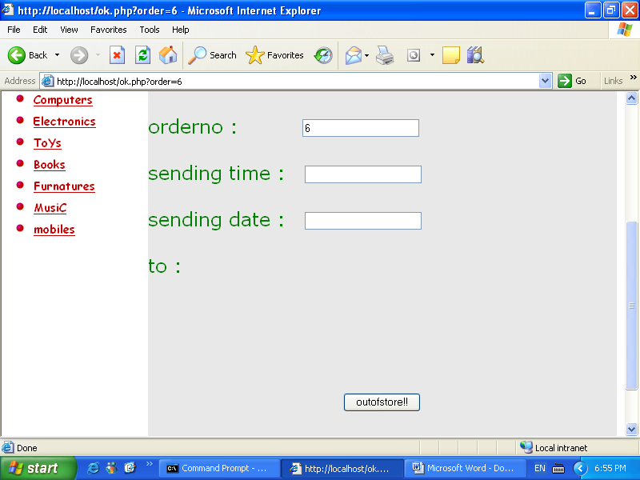

Or he can choose deliver to another country if the customers is no from the same country so the admin should enter the date and the time of delivery and the he have to choose one the store center that is spread all over the world as below:

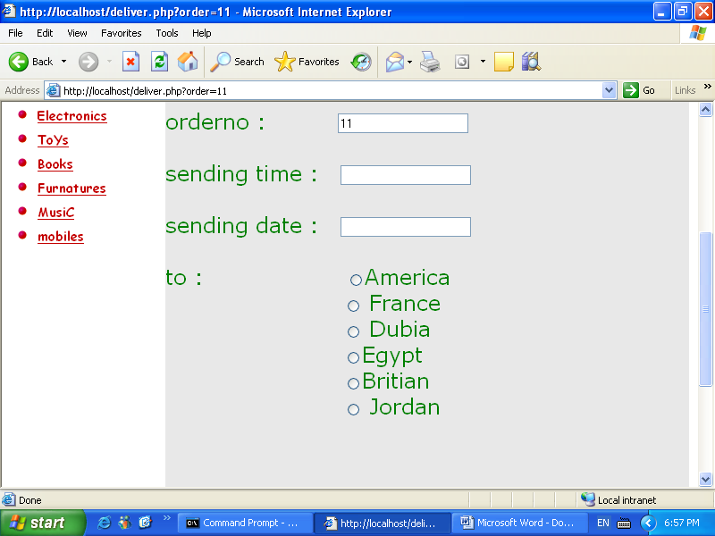

Then the admin of each center in each country will receive the order and he continue sending it until it deliver the customers.
This operation will be very useful to the customers to trace his shopping; this will achieved by pressing tracing link in the home page then it will redirect to the page including form so he only have to enter his order number as below:

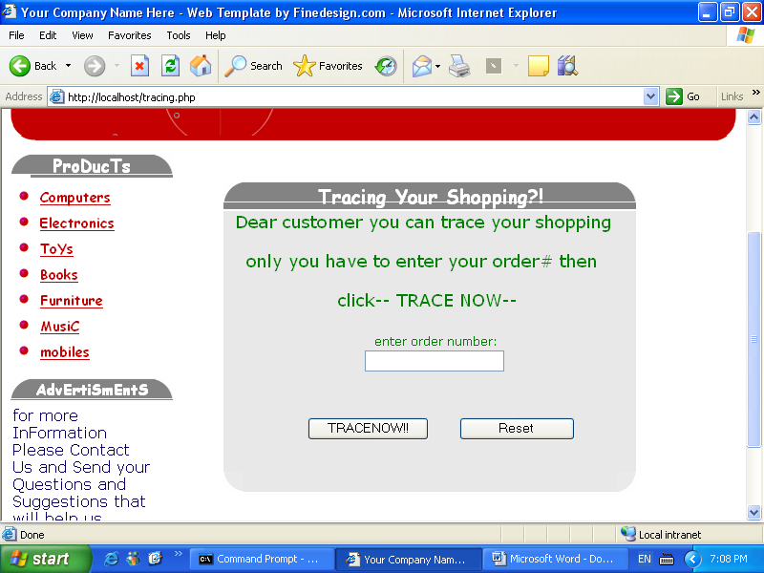

then he will see the route that it travel throw and he will know the time and the date of delivery from each country and where it now see the picture below :
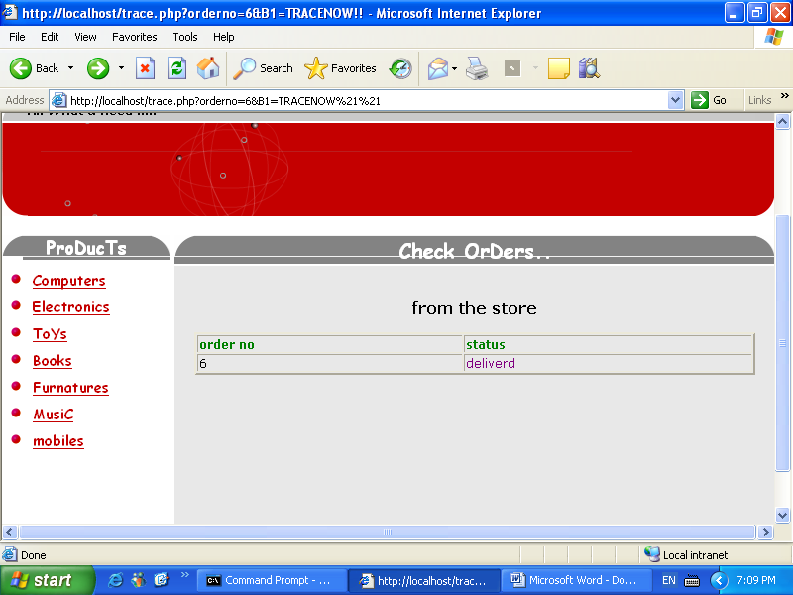

This for example an order that delivery in the same country if the customers press delivered he will see the time and the date of delivery out of the store as below:

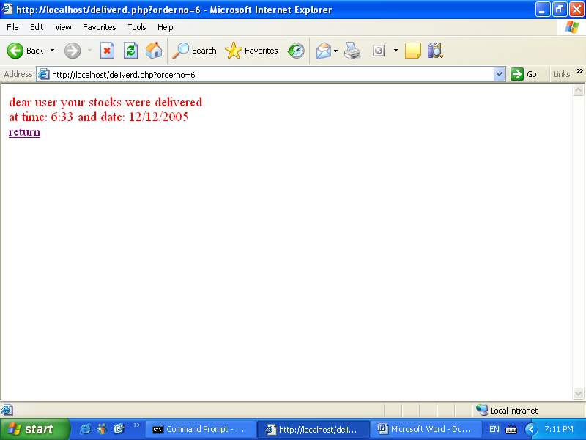

And this is an example for delivery to another country:
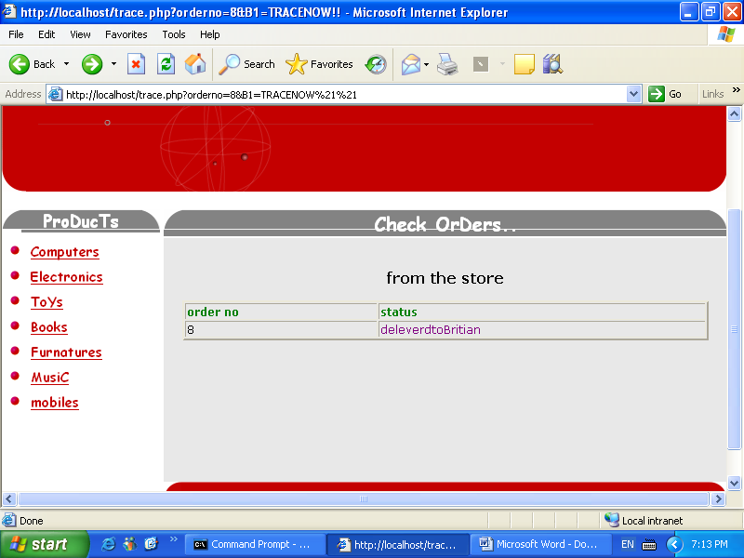

If he press the link he will show the another place the stocks travel through as below

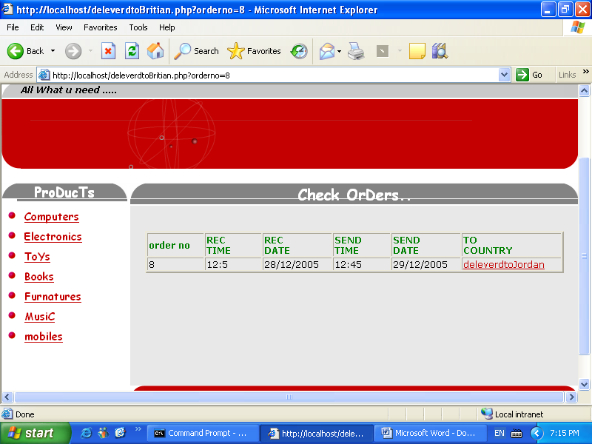
If he press the link again he will know that the last place is in that country and it is not delivered yet

