Introduction
The operating principles for wireless power transmission were well established in the early 1900’s by Nikola Tesla. Since Tesla’s initial experiments in this field, very little research has been done to develop and improve his theories. With the increased popularity of wireless technology in recent years, interest in magnetic power transmission has reemerged. Wireless transmission of power has many potential applications. It provides the opportunity to reduce clutter and remove the tripping hazards associated with conventionally powered from offices, homes, and medical facilities. It can also provide a non-invasive method for re-charging and running medical implants, and can allow several unique advantages in powering devices operating beyond an intrinsic barrier, where running traditional power lines is a non-viable option.

1.1 History of wireless power transmission
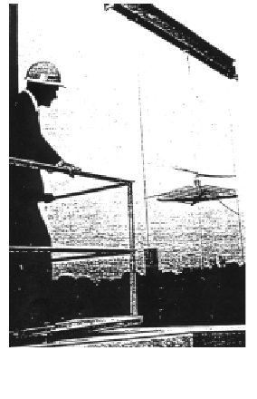
In 1864, James C. Maxwell predicted the existence of radio waves by means of mathematical model. In 1884, John H. Pointing realized that the Pointing Vector would play an important role in quantifying the electromagnetic energy. In 1888, bolstered by Maxwell's theory, Heinrich Hertz first succeeded in showing experimental evidence of radio waves by his spark-gap radio transmitter. The prediction and Evidence of the radio wave in the end
power transmission. At the same period of Marches G. Marconi and Reginald Fessenden who are pioneers of communication via radio waves, Nicola Tesla suggested an idea of the wireless power transmission and carried out the first WPT experiment in 1899. He said “This energy will be collected allover the globe preferably in small amounts, ranging from a fraction of one to a few horse-power .One of its chief uses will be the illumination of isolated homes”. He actually built a gigantic coil which was connected to a high mast of 200-ft with a 3 ft -diameter ball at its top. He fed 300 kW power to the Tesla coil resonated at 150 kHz. The RF potential at the top sphere reached 100 MV. Unfortunately, he failed because the transmitted power was diffused to all directions with 150 kHz radio waves whose wave length was 21 km .To concentrate the transmitted power and to increase transmission efficiency, we have to use higher frequency than that used by Tesla. In 1930s, much progress in generating high-power microwaves, 1-10 GHz radio waves, was achieved by invention of the magnetron and the klystron .After World War II, high power and high efficiency microwave tubes were advanced by development of radar technology. We can concentrate a power to receiver with microwaves .We call the wireless power transmission with microwaves as microwave power transmission(MPT).Based on the development of the microwave tubes during the World War II, W. C. Brown started the first MPT research and development in 1960s. First of all, he developed a rectenna, rectifying antenna which he named, for receiving and rectifying microwaves. The efficiency of the first rectenna developed in 1963 was 50 % at output 4WDC and40% at output 7WDC, respectively With the rectenna, he succeeded in MPT experiments to wired helicopter in 1964 and to free-flied helicopter in1968 In 1970s, he tried to increase

DC -RF-transmission-RF-DC total efficiency with 2.45 GHz microwave. In 1970, overall DC-D C total efficiency was only 26.5 % at 39WDC in Marshall Space Flight Center. In 1975, DC-DC total efficiency was finally 54 % at 495WDC with magnetron in Raytheon Laboratory (In parallel, He and his team succeeded in the largest MPT demonstration in 1975 at the Venus Site of JPL Goldstone Facility. Distance between a transmitting parabolic antenna, whose diameter MPT Laboratory Experiment in 1975 by W. Brown First Ground-to-Ground MPT Experiment in 1975 at the Venus Site of JPL Goldstone Facility

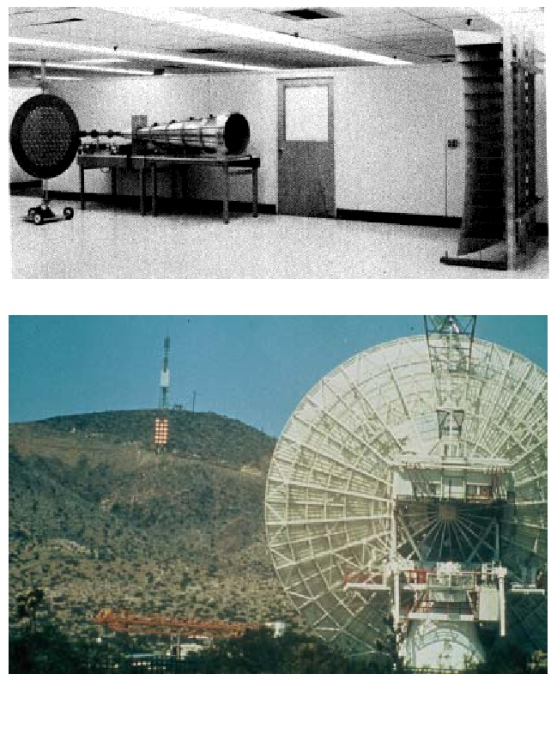

First Ground-to-Ground MPT Experiment in 1975 at the Venus Site of JPL Goldstone
facility
was 26m, and a rectenna array, whose size was 3.4 mx 7.2 m, was 1 mile. The transmitted microwave of 2.388GHz was 450 kW from klystron and the achieved rectified DC power was 30 kW DC with82.5% rectifying efficiency. Based on the Brown’s work, P. E. Glaser proposed a Solar Power Satellite (SPS) in 1968[5].In 1980s, Japanese scientists progressed the MPT technologies and research[6][7]. In 1983 and 1993, Hiroshi Matsumoto’s team carried out the first MPT experiment in space. The rocket experiment were called MINIX (Microwave Ionosphere Nonlinear Interaction experiment) in 1983 (Fig.2.4) and ISY-METS (International Space Year – Microwave Energy Transmission in Space) in 1993, respectively .They focused nonlinear interaction between intense microwave and ionospheric plasmas. In the MINIX experiment, they used cooker-type 800W-2.45GHzmagnetron for microwave transmitter. New wave-wave-particle interaction phenomenon's were observed in the MINIX. Plasma theory and computer experiments supported the observations [After 1990s, many MPT laboratory and field experiments were carried out in the world. We often uses 2.45 GHz or 5.8 GHz of the ISM band (ISM=Industry, Science, and Medical) for the MPT system. Canadian group succeeded fuel-free airplane flight experiment with MPT in 1987 which was Fig. 2.4 MINIX rocket experiment in1983Fig. 2.5 SHARP flight experiment and 1/8 model in 1987

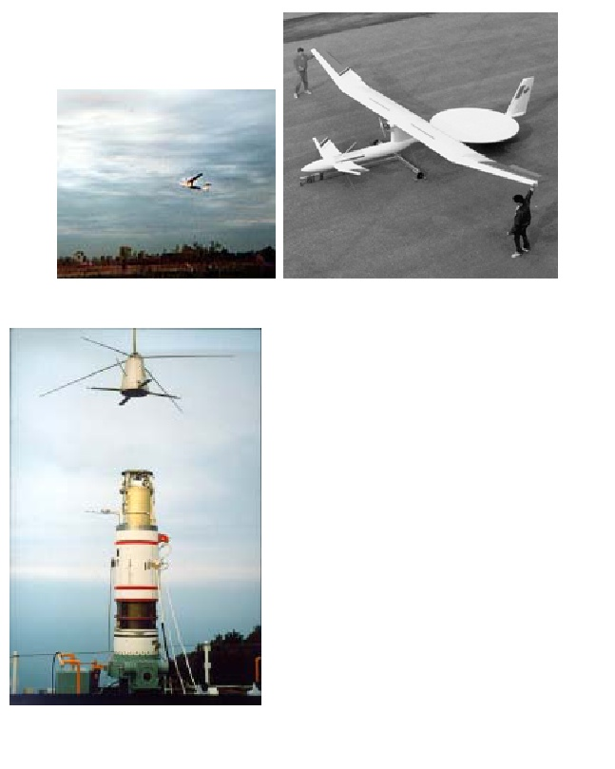

called SHARP(Stationary High Altitude Relay Platform)
with 2.45 GHz In USA, there are many MPT research and development after W. C. Brown, for instance, retro directive microwave transmitters, recentness, new devices and microwave circuit technologies[12]. In Japan ,there were many field MPT experiments such as fuel-free airplane flight experiment with MPT phased array with 2.411 GHz in 1992 (Fig.2.6)[13], ground-to-ground MPT experiment with power Fig. 2.5 MILAX Airplane Experiment and Model Airplane with Phased Array in 1992Fig. 2.6 Ground-to-Ground MPT Fig.2.7 SPS Demonstrator “SPRITZ” with 5.8 GHz experiment in Japan in 1994-95 (Demonstration in IAC2005)

company and universities in 1994-95 with 2.45 GHz, fuel-free airship light experiment with MPT in 1995with 2.45 GHz, development of SPS demonstrator with 5.8 GHz in 2000(Some kinds of microwave transmitters, some kinds of retro directive microwave transmitters, and many recentness were also developed in Japan. In Europe, some unique technologies are developed. They plan ground-to-ground MPT experiment in Re-union Island As described before, there is only quiet small difference between the WPT and wireless communications.

1.2The project progressed
The primary objective of this project was to simply transmit power. The current project will be designed to meet the following specifications:
- System must operate at a frequency above 2 MHz
- System must supply 5V/ 10W to the receiver at a range of 2 ft.
- System must use Magnetic Induction
- System will be powered by 10-24 V variable DC source connected to a wall outlet
As an application on this idea, the wireless power transmitted will be used to power a battery charger

2. Source Side

2.1 Design
For the source side of the project, the primary objective was to amplify power at a frequency capable of providing resonance. The basic idea is to take a DC power from the wall outlet and convert this power into AC signal at a frequency greater than 2 MHz using Colpitts oscillator. The Colpitts oscillator generates small signal which is then amplified by a power amplifier. The output of the power amplifier is terminated by an LC filter whose center frequency is selected as the resonant frequency of the colppits oscillator to enable power transmission. Colpitts oscillator has several advantageous the makes it a suitable oscillator for this particular project. This particular oscillator is simple to construct and extremely robust. The main feature of the Colpitts oscillator is the simplicity of tuning the frequency of oscillation through the only inductor located in the Colpitts. Also, we initially chose to implement a PA107 DP power amplifier from APEX. The amplifier was capable of producing 30 W on the receiving side and it operates at a frequency of 7 MHz frequency. However, we felt this plan had its flaws. First, it has been well documented that the Colpitts oscillator has difficulties simulating in PSPICE and MATLAB. We were also worried about mounting the circuit and problems caused by heat dissipation as well as keeping a clean signal. Furthermore, while the power amplifier was capable of producing 7 MHz, our resonant frequency goal was between the 8-10 MHz ranges for maximum transmission
In an effort to resolve the problems arisen in the design of the transmission side of the system, we decided to consolidate the Colpitts oscillator and amplifier into one single mechanism. An alternate oscillator to the Colpitts oscillator can be the royer oscillator which will be presented briefly in this project.

we'll talk about two circuits which will do the work for them in this project,
- Collpitts oscillator
- Royer oscillator
2.1.1collpitts oscillator
Definition and how it works
A commonly used Colpitts oscillator circuit with an open feedback loop is shown in Figure 1. Explain how does this oscillator works
Figure 1 Colpitts oscillator circuit
The Colpitts oscillator is widely used in communications systems. Some advantages of this circuit are good frequency selectivity, higher oscillation frequency, and self-limiting behavior.
The design process of the Colpitts oscillator starts by selecting proper bias conditions to start the oscillation (The bias conditions are determined by selecting proper values for R_{l}, R₂, and RE such that the quiescent collector current I_{CQ} equals l mA DC. (Hint: Use low values of resistance and make I_{R1} = 4 I_{B}.)
The oscillation frequency can be controlled by the inductor and capacitors shown in Fig. 1. The values of the inductance and capacitance can be selected from commercially available coponents to produce an oscillation frequency of 8.5 MHz. The power supply voltage is determined to be as V_{cc} = 12 volts.
The selection of the unspecified components is left as a design problem. (Are you giving the reader a design problem, you are writing a report not a text book)

2.1.1.1 Testing Procedure
After connected the circuit and see the result
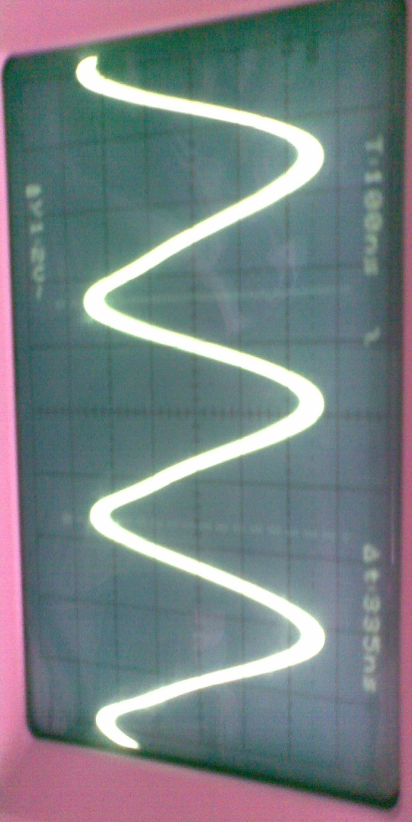
Figure 2 Testing Colpitts oscillator circuit

2.3 Results and Discussion
We note the circuit give us the signal and that signal is pure and we have obtained at a frequency of average 3 M We have used this circuit because it is simple and easy to handle and use it successfully there is no need because we are experimenting with other
2.1.2 Royer Oscillator
A Royer oscillator is an electronic oscillator which has the advantages of simplicity, low component count, sinusoidal waveforms and easy transformer isolation, Figure 2. It was first described by George H. Royer in December 1954 .
The circuitry consists of a transformer with a primary winding, a feedback winding and (optionally) a secondary winding. The primary winding is center-tapped, with each half driven by a transistor collector. The feedback winding couples a small amount of the transformer flux back in to the transistor bases to generate the oscillations. A capacitor across the primary winding gives the transformer a resonance, which sets the oscillation frequency. An inductor in the center-tap transformer supply reduces harmonic content and improves efficiency application. The most common use of the Royer oscillator is to drive the cold cathode fluorescent lamp (CCFL) backlight of an LCD display. CCFL lamps need a sinusoidal waveform for good efficiency, which is necessary for good battery life on portable equipment

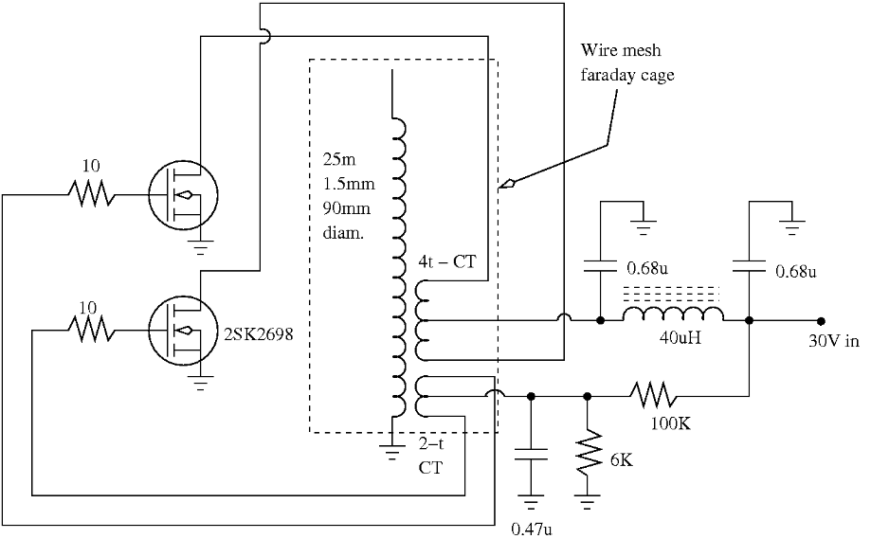
Figure 2 Royer Oscillator circuit

3.Power Amplifier

3.1 class D ampilfer
class D amplifiers work by generating a square wave of which the low-frequency portion of the spectrum is essentially the wanted output signal, and of which the high-frequency portion serves no purpose other than to make the wave-form binary so it can be amplified by switching the power devices.

A passive low-pass filter removes the unwanted high-frequency components, i.e., smooths the pulses out and recovers the desired low-frequency signal. To maintain high efficiency, the filter is made with purely reactive components (inductors and capacitors), which store the excess energy until it is needed instead of converting some of it into heat. The switching frequency is typically chosen to be ten or more times the highest frequency of interest in the input signal. This eases the requirements placed on the output filter

Figure 4. class d amplifer circuit

3.1.1 Testing Procedure
As we have shown using this circuit and we have introduced the frequency of the circle colpitts oscillator and we got the results, as we see the photos
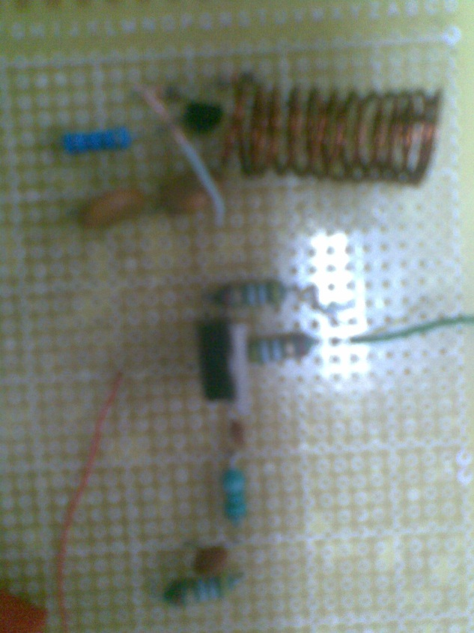
Figure 5. testing class d amplifer circuit
3.1.2 Results and Discussion
Note of this circle, we got on the voltage by 2 volts as we got resonate when the frequency and amount of 3 M energy by 1WATT and this helped us to lighting LEDs and frequency as that was pure as shown in the picture
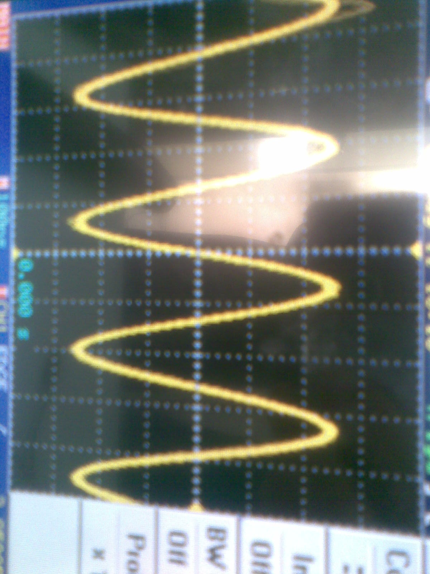
Figure 6 RESULT class d amplifer circuit

3.2 High Output Power RF Push-Pull MOSFET Oscillator
We also can compensate for the Colpitts oscillator and class D amplifier by the High Output Power RF Push-Pull MOSFET Oscillator we give us the values ​​of a higher frequency and more energy
ith the circuit shown here you can create high frequency electromagnetic waves with very high output power.
Possible applications are experiments with wireless power transmission, RFID Transponder, tesla coils and the like.
Dependent on the coil, capacitor and cooling of the transistors output power in the range of 20W and more can be obtained.
At short distances, other electronic circuits may be disturbed or even destroyed. Broadcasting, RFID, AntiTheft, Wlan, medical appliances (pacemakers!) can be disturbed in a large area!
The Circuit:
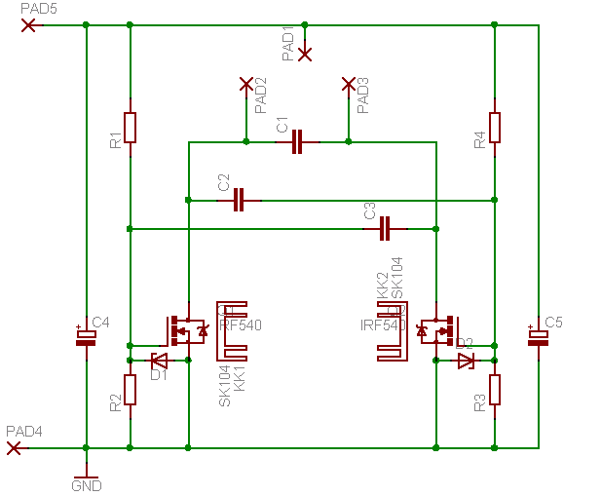
Figure 7 High Output Power RF Push-Pull MOSFET Oscillator

It is a standard Push Pull Oscillator, based on Power Mosfet Transistors.
The PCB provides mounting space for two SK104 heat sinks, this allows for remarkable output power for such a small device.
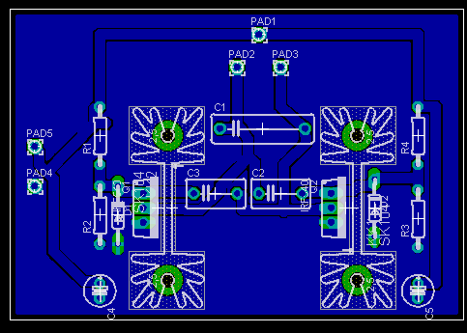
Component Values:
Operation Voltage is about 15V DC
If you wish to use smaller operating voltages, you must increase R2 and R3. Oscillation starts when the voltage drop across R2 resp. R3 reaches the MOSFET’s thresold Voltage, approx. 4..6V
Mosfet: IRF510
R1, R4 100k
R2, R3 27K
C4, C5 100u
C1 choose for your desired frequency
C2,C3 ca 10% of C1
D1,D2 15V Z-Diodes
A PushPull Oscillator requires a coil with a Center Tap. For my tests i used 12 Turn 1mm insulated Copper Wire, ca 40mm Diameter.
The Center Tap is connected to PAD1
A Frequency Range from 200kHz to 10MHz was generated using this coil.
The Resonance Frequency of the is calculated by (approx)
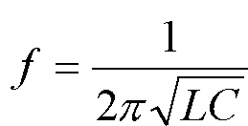
Important!
The Capacitors, especially C1 should be low ESR, otherwise they will heat up and be destroyed!
A LED connected to a small receiver coil lit up at about 20cm distance. At 10 cm, it became hot and was destroyed eventually

3.2.1 Testing Procedure
We have proving connectivity to this circuit We have wrapped the wire with 12 laps to get the required values ​​for the inductance show in picture
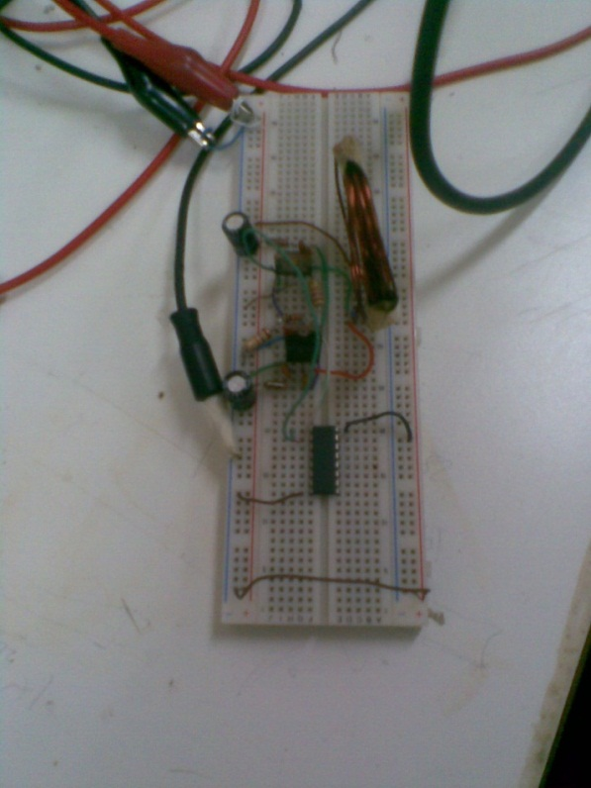
Figure 8 .testing High Output Power RF Push-Pull MOSFET Oscillator
3.2.2 Results and Discussion
we have the result as you can see have a high frequency and large output power
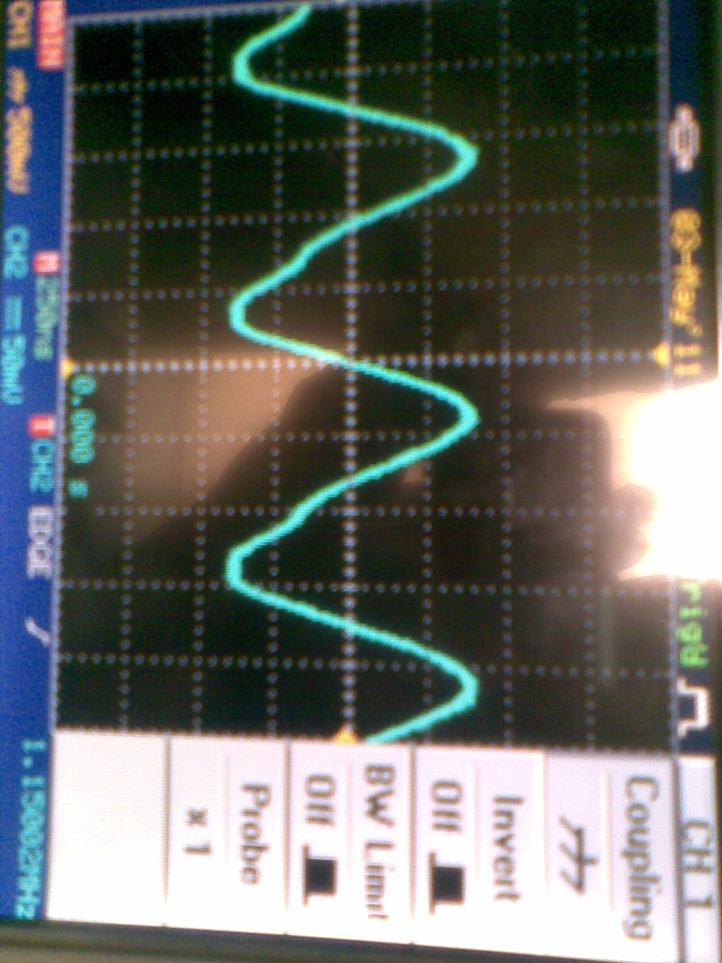
Figure 9 . result and discussion testing High Output Power RF Push-Pull MOSFET Oscillator

4.Wirless Channel
4.1 Design
The wireless channel refers to the actual transmission of power, and not the processing of that power. The transmission of power occurs in this system through the magnetic field created by a transmission coil in much the same way that a transformer operates. Where the operation of this system differs from a transformer is in the distance and ‘core’ of the magnetic circuit. A standard transformer utilizes a ferromagnetic core that operates as a channel for the magnetic field, and the windings of the two sides are typically within several millimeters of one another. Since this project is transmitting power across several feet of open air, the basic principle of transformer operation has to be modified to achieve power transfer. The solution to this problem is resonant magnetic induction.
Any circuit contains inductive and capacitive elements will resonate at a resonant frequency given by (1)
$f=\frac{1}{2π\sqrt{\text{LC}}}$ (1)

When resonance is achieved, the impedance between the two coils is minimized and thus current and voltage transfer is increased exponentially. Additionally, objects that do not resonate at the operating frequency will be effectively invisible to the resonant circuit, drawing no power from the magnetic field.
To meet the objectives of power transfer, we selected a single-layer helical coil design. A helical coil creates both inductance and capacitance, and thus precise calculations of coil geometry were required to achieve resonance at 8.5 MHz as shown in table 1. For maximum power transfer, it is important that the magnetic field is as large as possible while the electric field is minimized; in other words, we need a large inductance and small capacitance. Because the coil itself creates a capacitance value on the same order of magnitude as the capacitance require for resonance at our operating frequency, this system has a physical limit for inductance, and as a result a physical limit for magnetic field strength.

Wire Gauge | Diameter | Turns | Spacing | L | C-coil | C-total
18 | 2.5 in | 37 | 2 mm | 39.3 μH | 3 pF | 9 pF
18 | 2.5 in | 50 | 2 mm | 56.0 μH | 3.3 pF | 6.26 pF
18 | 4.5 in | 23 | 2 mm | 59.9 μH | 5.9 pF | 5.97 pF
12 | 2.5 in | 65 | 3 mm | 49.1 μH | 5.0 pF | 7.1 pF
12 | 2.5 in | 70 | 2.5 mm | 58.5 μH | 4.9 pF | 5.9 pF
12 | 4.5 in | 28 | 2.5 mm | 60.3 μH | 5.5 pF | 5.8 pF
10 | 2.5 in | 75 | 3mm | 52.2 μH | 5.9 pF | 6.7 pF
Table 1coil geometry calculations
Two coil geometries were selected from this table for our project (see the highlighted rows on Table 2). To construct these coils, solid core copper wire of the appropriate gauge was wound around a 2.5 in diameter section of PVC. The windings were secured in place with electrical tape. To account for the additional capacitance required for resonance, a variable air-gap capacitor was connected to each coil and tuned to maximize the open circuit voltage of the system All coils used in this project are pictured in this Figure
Figure. Testing Coils


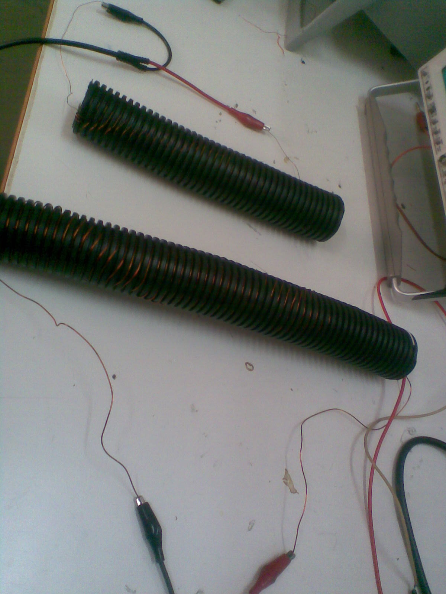
12WG
65
49.1MH

Figure 10 . the coil use in my project
The first phase of testing was the confirmation of resonance within the system. To begin the testing a pair of RF transmission coils with a wide range of tunable frequencies was used. The power source was turned on, and an oscilloscope was used to observe the open circuit voltage waveform. Each capacitor was adjusted, starting with the transmission side, to maximize the waveform value.
The first phase of testing was the confirmation of resonance within the system. To begin the testing a pair of RF transmission coils with a wide range of tunable frequencies was used. The power source was turned on, and an oscilloscope was used to observe the open circuit voltage waveform. Each capacitor was adjusted, starting with the transmission side, to maximize the waveform value.

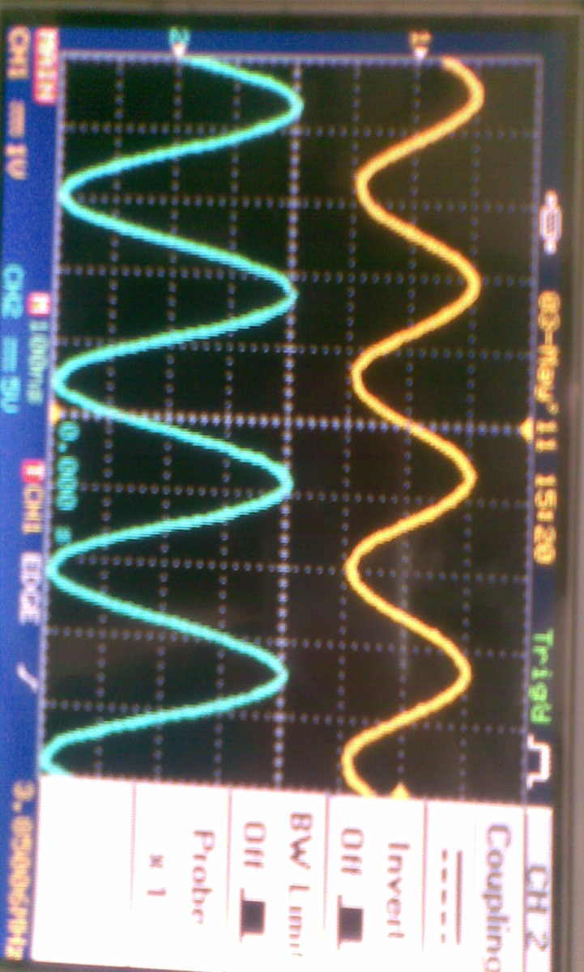
Figure 11 . see the output and input voltag

4.4.1 Testing Procedure
The first phase of testing was the confirmation of resonance within the system. To begin the testing a pair of RF transmission coils with a wide range of tunable frequencies was used. The power source was turned on, and an oscilloscope was used to observe the open circuit voltage waveform. Each capacitor was adjusted, starting with the transmission side, to maximize the waveform value.
With these testing coils (BC-610 PA transmitter coils), power transfer was not sufficient to operate the receiving charger due to their relatively low inductance. To achieve our objectives, we had to use the coils that we designed, each with an inductance at least 8 times larger than the BC-610 PA’s.
By carefully tuning the capacitance connected to our constructed coils, we were able to achieve resonance with the wireless channel; and transfer sufficient power to operate the charging circuit at our required separation.
During our tests, we were not able to accurately obtain current and power readings for our transfer. There are two factors that contribute to this. First, the operating frequency we used was beyond the limit of conventional multimeters. Since no accurate current readings could be obtained, this made optimizing the system extremely difficult. The next factor was the inability to accurately measure the capacitance value of the variable capacitors used in the system. This is mostly due to the frequency dependence of capacitance and the inability to access the appropriate test equipment.

We have to do a number of coil forms, we have Game discernible distance between them and do the same number of laps as you see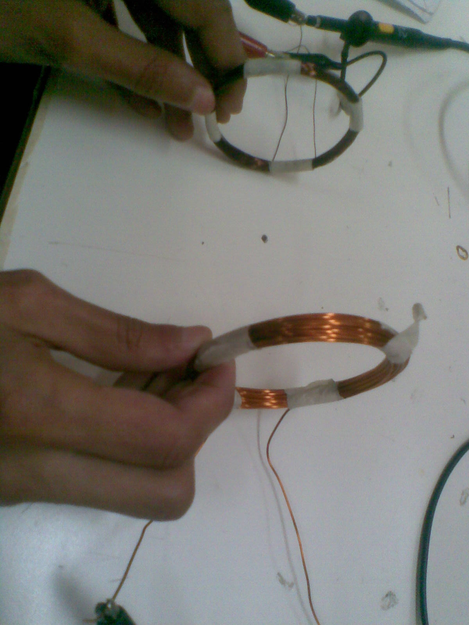

Figure 12 . another coil testing

we have also the work of the inductance and discernible distance of approximately b or as the form and we have conducted a number of experiments that show that it was better to be vertically and because it helped To be the largest magnetic field
12WG
65
49.1MH

3.3 Results and Discussion
Although we were successful in transferring power wirelessly, there still exist a number of things that can be done to optimize the system. Beyond accurate power measurements, understanding of magnetic field shape/orientation, optimization of I-V characteristics inside of the coils, and minimization of losses in the circuit elements.
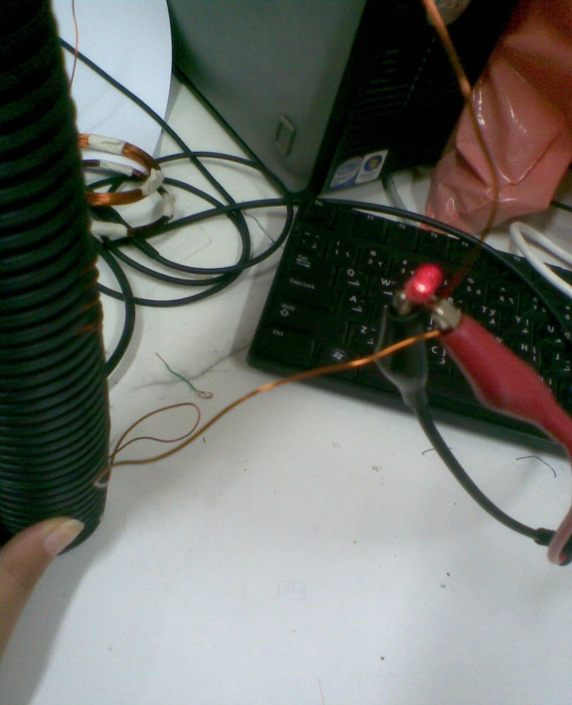
That being said, the wireless channel successfully operated to the required specifications.
Figure 13 . LED IS light
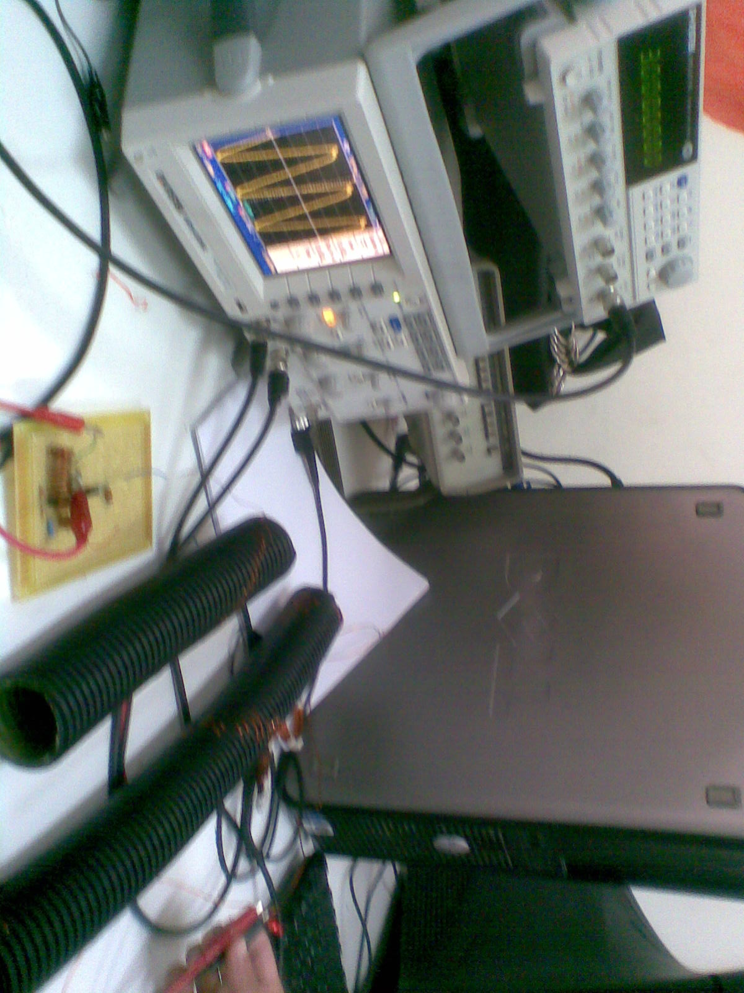

5. Charging receiver

5.1 Design
For the receiving side of the project, the primary objective was to take the output from the coils, and translate it into something useful by means of rectification and regulation. Initially, what we decided to build was the circuit shown below Figure .
Tuning Capacitor
Voltage Regulator
USB Out
Receiving Coil
Figure 14 Schematic diagram of the charging receiver

Our requirements included a 5 volt, 10 watt output from some sort of terminal. We decided that a USB port would be a fairly practical application for our project. To complete this circuit, we bought numerous GBJ 2506 full wave rectifier .

5.2 Testing Procedure
These full wave rectifiers are very simple to implement. We connected the two input leads to our receiving coil and the two output leads to our testing devices. The resulting output waveform is shown in Figure 5.
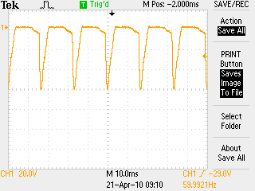
Figure 15. Oscilloscope waveform for Charging Reciever

After rectifying our signal, we measured our output results to verify that we had achieved our minimum requirements. After proving these conditions were met, we decided to use existing electronics to regulate the power to a specific level for a task such as charging a phone. We did this by adding a cell phone charger with a built in USB output. This worked successfully in our tests. Upon completing this phase of our testing, we began thinking about practicality and efficiency.

5.3 Results and Discussion
Essentially what we have created is wireless battery. Mobile ac power is actually a much more powerful tool. After all of our work, performed calculations and ran various tests to prove that existing ac wall outlet devices will operate in our system without the need for extra hardware. Devices that do not require large amounts of power can simply by connected to the two leads of the receiving coil. If not enough power is received by this coil, the device simply will not turn on. There is no limitation to prevent these electronics from being damaged due to too much power though. We are under the strict assumption that we will not be transmitting as much power as a wall outlet delivers. The only real error we noticed when testing this is that the frequency our power is being delivered at is far too high. While not evident at the time, this frequency may be damaging our chargers. Future study in this area should most likely look into stepping this frequency back into a more natural range for power delivery. While we were not entirely concerned with form factor, implementing a wall outlet socket to the final output would also be an excellent addition to our project. This way any standard device can be plugged into our circuitry without modification.

6.Testing Device
6.1 Design
The initial idea was to design an additional receiver assembly that will provide a variety of system analysis outputs.
- Sensor coil that will be built to a different geometry than the charging receiver to showcase the versatility in size and form factor of a wireless power system.
- Showcases a commercial design component for locating ideal receiver positions during system deployment.
- Will have a power sensor to display power received.
- Will have indicator LED that will illuminate when the station is within sufficient range to receive required output power.
- (Optional) Design sensing coil for variable resonant frequency so that it may be used to test/deploy several wireless power systems running at different frequencies.

6.2 Testing Procedure
What we have in the final design after researching the best design methods and working with the wireless channel to get the best results possible we lumped the requirements to three points:

- We joined step 3 & 4 into one device, as seen in Figure 6, which will do the following:
- 3 stage LED array to identify field strength.
- Each LED has a different resistor in series.
- As field strength increases, enough power is increased to illuminate each successive LED.
Tuning Capacitor
Test Receiver
Receiving Coil
LED Array
Figure 6. Schematic Diagram for Testing Receiver

- We accomplished step 1 by designing a coil with less turns than the original charging coil and that give it a different geometry but the same receiving abilities.
- We designed the led testing receiver circuit as shown in figure 1 on a small board that was attached to the receiver coil and by that we accomplished step 2 in the requirements.

To accomplish the optional requirement that you have to have different sending coils so it can resonate with the receiving coils on the other side and in our design we only had one sending coil and that’s why we had that part to be optional and can be done in later projects by different group.

6.3 Results and Discussion
As far as the testing phase we had a problem with achieving virtual ground which was very needed to maximize the result in the receiving side and while real ground is acceptable for some real life application it is not acceptable for all and having to deal with 8.5 MHz we couldn’t use the wattmeter as it was in our original plane because it is rated for 50/60 Hz and because that we tested the led receiving circuit as shown in Figure 7 with real ground and another problem we had was changing the resistors to make the circuit work every time because they are not rated to handle that high frequency.

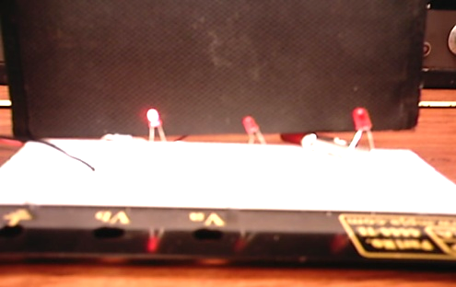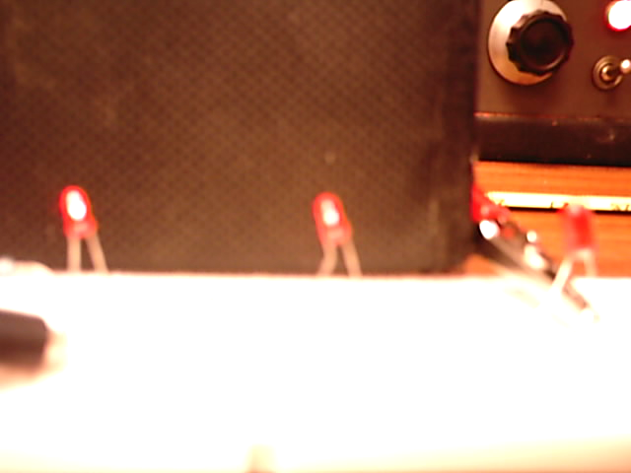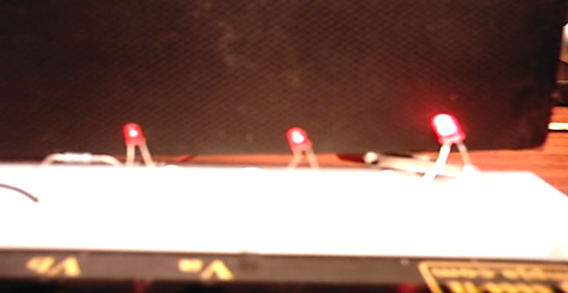
Led 1 on
Led 1 & 2 on
Led 1 & 2 & 3 on
Figure 16. Testing Reciever Functionality Test

7. Conclusion
With this project, we were successful in creating a proof of concept system that obtained the required objectives. The system that we have created has given us a lot of insight into the feasibility and applications of this technology. Until a method for effectively shaping and directing the magnetic field can be obtained, the inherent inefficiencies in wireless power transmission will limit it’s viability to very specific applications.

Time Schedule:
- Designing collpits osillater and testing ……….….… 2 weeks
- Designing the amplifer Circuit ……………….…….….. 3 weeks
- Reviews ……………………….……….………..…….…... 1 week
- Designing the coil ……….………….…….. 2 week
- Testing the projects ……………….. 1 week

References:
[1]: http://skemarangkaian.com/high-output-power-rf-push-pull-mosfet-oscillator/
[2]: http://www.hobbybroadcaster.net/info_low_power_AM.html
[3]: http://johnbrashear.tripod.com/wlcr.html
[4]: http://wireless-energy-transfer.co.tv/
[5]: The Authoritative Dictionary of IEEE
[6]: Electric Circuits (8th Edition) ~ James William Nilsson
[7]: Electronic Devices and Circuit Theory ~ Robert L. Boylestad
[8]: Digital Design: Principles and Practices. ~ John F. Wakerly
[9]: Wikipedia web site: www.wikipedia.com

