Controlling Fridge Via Internet

Introduction:

Controlling fridge via internet contains an application (hardware) connecting with
Internet through software by opening an URL conection through internet.

Software:

First I used MFC for building an application connecting with the hardware(fridge) through serial port and this application connecting an internet

Through open an URL connection to internet (http request) . as in figure (1)



The previous application shows connection to internet and get data from fridge
Through serial port to internet through httprequest and internet give command
To fridge through response from internet so you can controlling fridge
Via internet and send fridge information such as (number of eggs , amount of milk
And temperature ) to server and server put it in the database so users can show
Fridge information via internet.

Too, users can control the fridge via internet such as he can increase and decrease
Thermostat switch , also this action can be done through the response when fridge was connecting to internet.

Also I used php and mysql to design a web site for controlling fridge .this web
Site takes data from server database and sends data to server web site also.

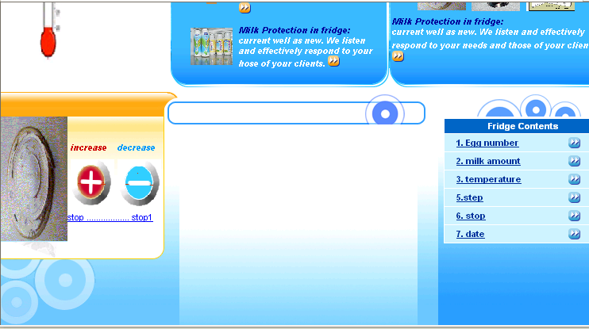

Then I used PICC software for writing pic software code as shown below:

#include "C:\Documents and Settings\Administrator\Desktop\final\final.h"

#include <string.h>

float value,temp;
float t;
char s[16];
char ss[16];
char c;
int i;
#INT_RDA
tt()
{
c=getc();
// restart_wdt();

if(c=='I')
{

output_high(PIN_D4);

output_low(PIN_D3);
output_low(PIN_D2);
output_low(PIN_D1);

delay_ms(300);

output_low(PIN_D4);
output_high(PIN_D3);
output_low(PIN_D2);
output_low(PIN_D1);

delay_ms(300);

output_low(PIN_D4);
output_low(PIN_D3);
output_high(PIN_D2);
output_low(PIN_D1);

delay_ms(300);

output_low(PIN_D4);
output_low(PIN_D3);
output_low(PIN_D2);
output_high(PIN_D1);

delay_ms(300);
}

else if(c=='D')
{

output_high(PIN_D4);

output_low(PIN_D3);
output_low(PIN_D2);
output_low(PIN_D1);

delay_ms(300);

output_low(PIN_D4);
output_high(PIN_D3);
output_low(PIN_D2);
output_low(PIN_D1);

delay_ms(300);

output_low(PIN_D4);
output_low(PIN_D3);
output_high(PIN_D2);
output_low(PIN_D1);

delay_ms(300);

output_low(PIN_D4);
output_low(PIN_D3);
output_low(PIN_D2);
output_high(PIN_D1);

delay_ms(300);

}
//printf("responce=%c",c);

/*output_high(PIN_C1);
output_low(PIN_C2);
restart_wdt();

}
//restart_wdt();
else if(c=='d')
{
printf("nooo \n");
restart_wdt();
output_low(PIN_C2);
output_low(PIN_C1);
}
*/

//printf("teerr=%c",c);
//sprintf(s,"temp=%c \r\n", c);
// restart_wdt();
// printf(s);
// restart_wdt();
restart_wdt();
}

void main()
{

int num;
int i;
int count;

setup_adc_ports(RA0_ANALOG);
setup_adc(ADC_CLOCK_INTERNAL);
setup_psp(PSP_DISABLED);
setup_spi(FALSE);
setup_counters(RTCC_INTERNAL,RTCC_DIV_1);
setup_timer_1(T1_DISABLED);
setup_timer_2(T2_DISABLED,0,1);

enable_interrupts(GLOBAL);

enable_interrupts(INT_RDA);

while(1)
{

// delay_ms(3000);

restart_wdt();

count=0;
num=0;

while(num<8)
{
restart_wdt();

switch(num)
{
case 0:

output_low(PIN_E0);
output_low(PIN_E1);
output_low(PIN_E2);

if(!input(PIN_A3))

count++;

break;

case 1:

output_high(PIN_E0);
output_low(PIN_E1);
output_low(PIN_E2);

if(!input(PIN_A3))

count++;

break;

case 2:

output_low(PIN_E0);
output_high(PIN_E1);
output_low(PIN_E2);

if(!input(PIN_A3))

count++;

break;

case 3:

output_high(PIN_E0);
output_high(PIN_E1);
output_low(PIN_E2);

if(!input(PIN_A3))

count++;

break;

case 4:

output_low(PIN_E0);
output_low(PIN_E1);
output_high(PIN_E2);

if(!input(PIN_A3))

count++;

break;

case 5:

output_high(PIN_E0);
output_low(PIN_E1);
output_high(PIN_E2);

if(!input(PIN_A3))

count++;

break;

case 6:

output_low(PIN_E0);
output_high(PIN_E1);
output_high(PIN_E2);

if(!input(PIN_A3))

count++;

break;

default:
output_high(PIN_E0);
output_high(PIN_E1);
output_high(PIN_E2);

if(!input(PIN_A3))

count++;

}
//delay_ms(100);
num++;

}

//printf("EggNum=%d \r\n",count);
//sprintf(ss,"egg=%d \r\n", count);
// restart_wdt();
// printf(ss);
//restart_wdt();

set_adc_channel(0);
delay_ms(10);
value = read_adc();
delay_ms(10);
temp = (value*5)/1023;
t = temp;
temp = 98 * temp;
temp = temp - 273;
restart_wdt();
sprintf(s,"temp=%6.2f \r\n", temp);
restart_wdt();
printf(s);
restart_wdt();

sprintf(ss,",%d \r\n", count);
restart_wdt();
printf(ss);
//restart_wdt();
// sprintf(ss,",=%6.2f \r\n", temp);
// restart_wdt();
// printf(ss);
// restart_wdt();

// delay_ms(300);

restart_wdt();
}

}

Hardware:

I used PIC 16F877 and build basic serial with PC ,also I used photo cells sensor with digital chip 244 to check each egg if found or not found ,also
I used temperature sensor to measure temperature also I used stepper motor
To control thermostat .

Problems:

1.the difference of delay between serial port and internet connection.

2.out of memory since need more memory for internet connection and

Serial port .

3. the software is hard special with MFC .

An-najah National University
Department Of Computer Engeneering

Controlling Fridge Via Internet

Director: Dr.Raed Alqadi

Student:hanya radwan

