Project documentation

Online Financial Account System

# Introduction:

In this project I introduce an idea about general operation that is done in company that include money transaction, financial account management, all type of the company members include vendor, customer and employee and their related information.

We will manage the checks and bills and direct payments and all components related to them, I will introduce each form and brief notes about each in this documentation.

# Login Page

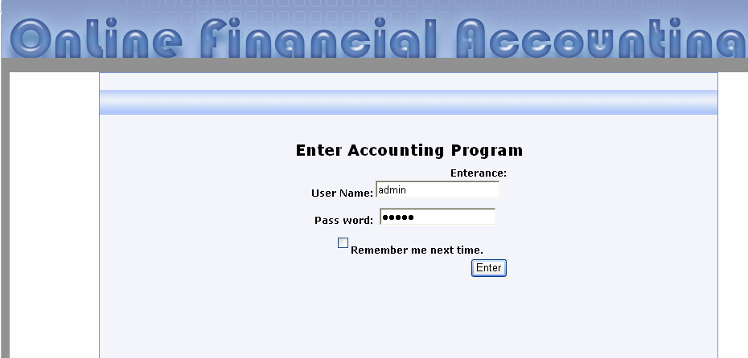

This page is login page that control access to all forms in the project, it provide security and type of authorization to user.

# Welcome Page:

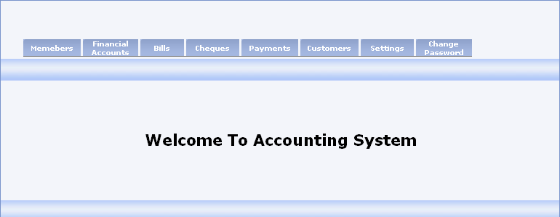

After success login to project you will access to welcome page, you can see main menu which contain the following items:

Member: this field specified to manage all type of members and all related information.

Financial Accounts: in this form we will add new account and all related information.

Bills: to add new bill and all it's item and expenses.

Check: add new check.

Payments: this page introduces and specifies the payment terms.

## *Customers: this form specify the customer detail*

## *Settings: that manages lot of customer detail.*

# *Change Password*

After this moment we will see item and its component in detail.

# Members Menu

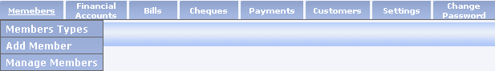

We will see under this field the following items

1. Member's type: in this field we add main groups of all members in company and grid view.

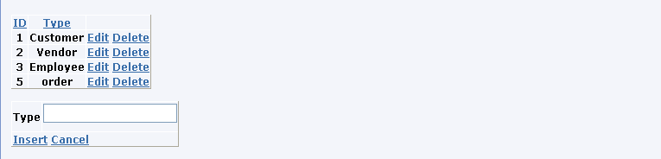

1. Add member: in this form we specify member type and the main member information

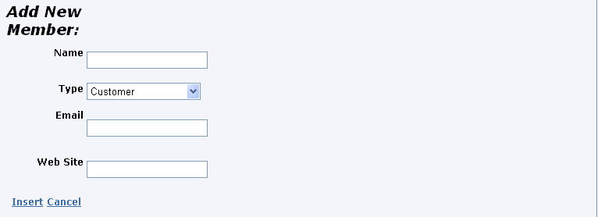

In this form we use navigator for the required fields where inserting process can't complete without them.

In the code we use power feature for more reliable that asp can provide as follows

trans = conn.BeginTransaction();

cmd.Transaction = trans;

reader = cmd.ExecuteReader();

if (!reader.HasRows)

return;

reader.Read();

string id = reader["member_id"].ToString();

reader.Close();

sql = "INSERT INTO adds_table (member_id) VALUES (" + id + ")";

cmd.CommandText = sql;

cmd.ExecuteNonQuery();

sql = "INSERT INTO phone_fax (member_id) VALUES (" + id + ")";

cmd.CommandText = sql;

cmd.ExecuteNonQuery();

if (Int32.Parse( e.Values["member_type"].ToString()) == 1)

{

sql = "INSERT INTO cutomer_detail (mem_id) VALUES (" + id + ")";

cmd.CommandText = sql;

cmd.ExecuteNonQuery();

}

trans.Commit();

this property called transaction.

1. Manage Members: in this form we edit each member to add more information about each.

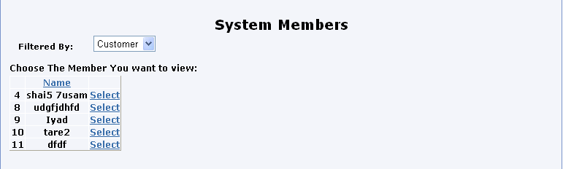

If one is selected we will go to the following page to add more information about as phones numbers and address

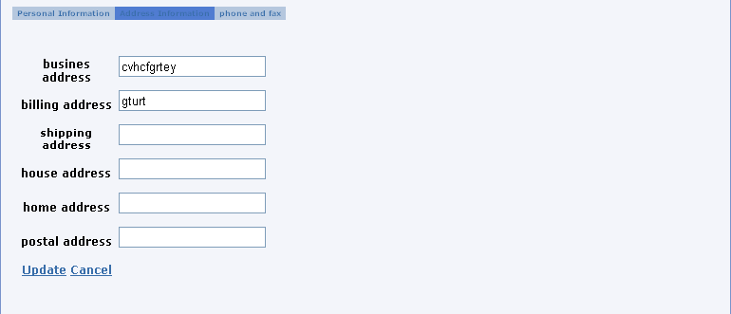

# Financial Accounts

Under this menu item we will find the following items

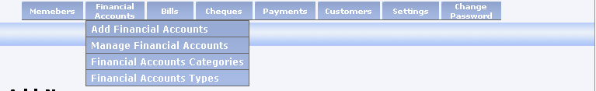

* Add New Financial Account

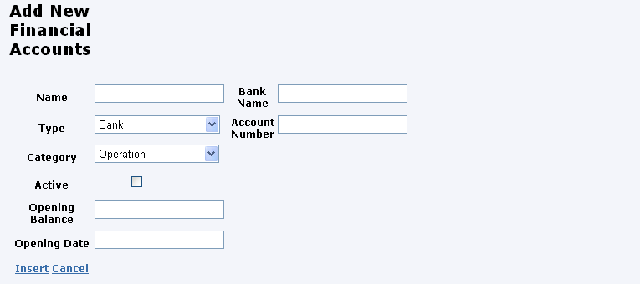

In this page we will add some information about financial account related to company where it's financial operations done

* Manage Financial Accounts

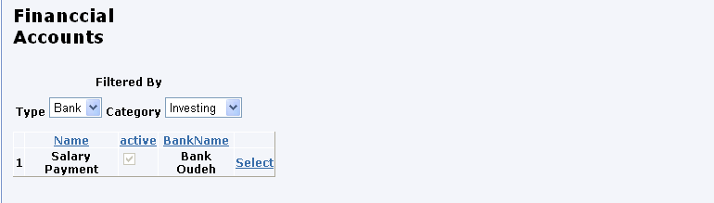

This page we can select financial account and edit its field the appearance will change as follow

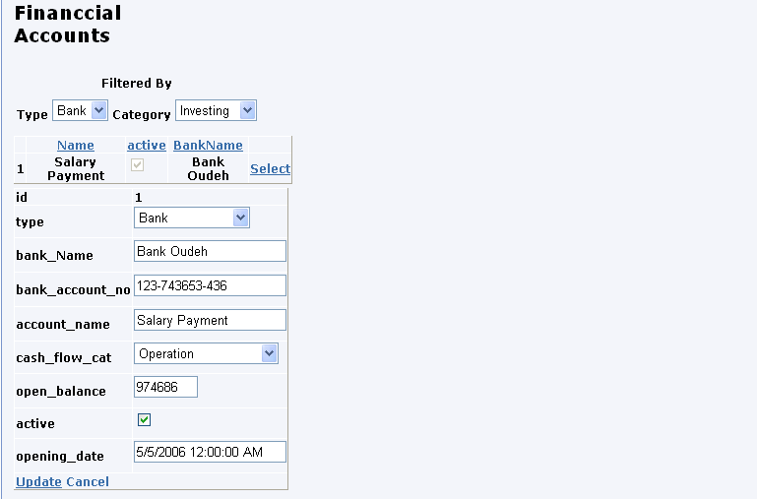

* Financial Account Categories

This is a simple page to add Main categories

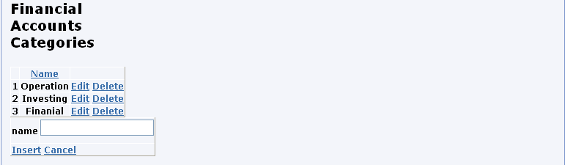

* Financial Accounts Types

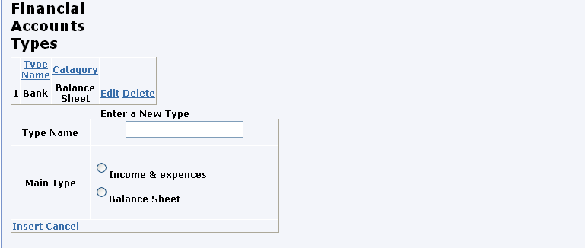

# Bills

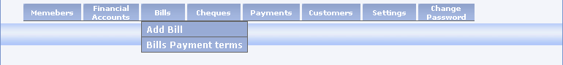

This page to manage bills and to add new bills and there items

* Add New Bill

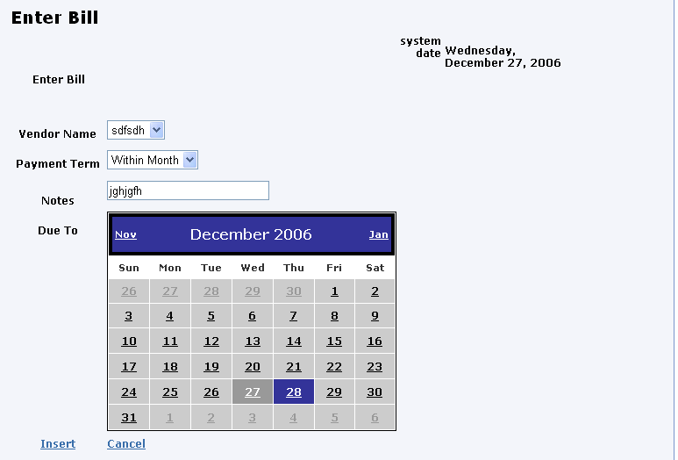

After success inserting process done we will change to the following view to add items and expensive related to last inserted bill:

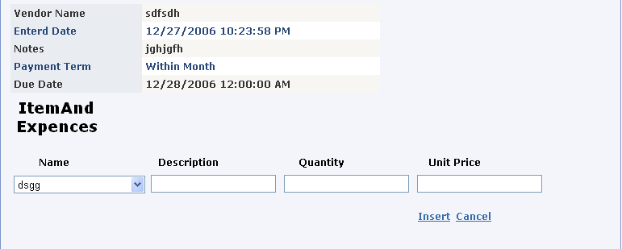

* Bills Payment Term

In this page we will add new payment term that determine discount ratio if customer

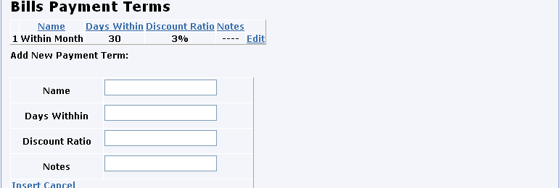

# Manage Checks

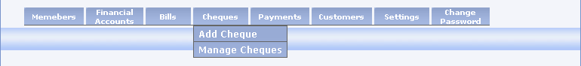

Under this item we will see the following item:

* Add New Checks

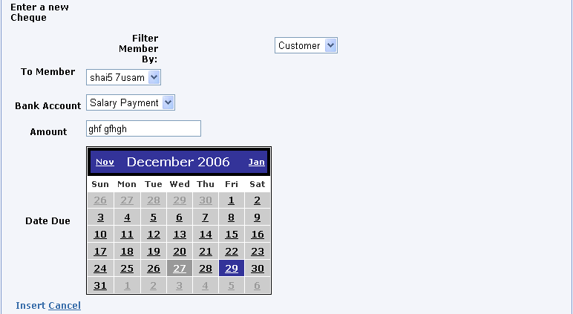

* Manage Checks

Under this page we have multi view where if any of bill selected we will change view to the next one

First one display grid view for all bill in the database

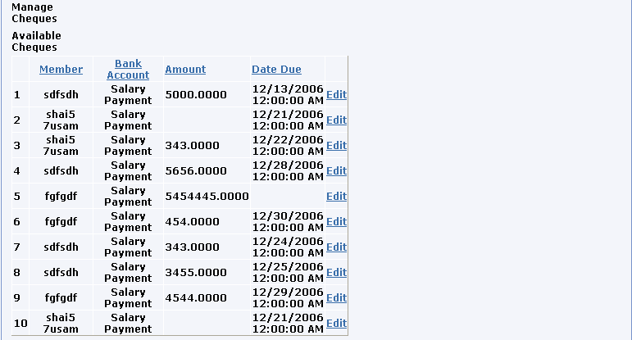

When a record selected we will change to the second view where field in the selected row will change to editable item and some will replaced by another control

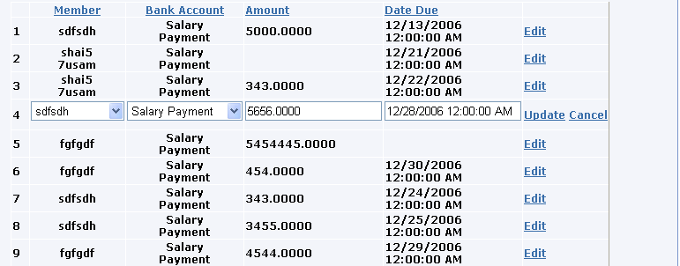

# Payments

Under this menu will see page of multview where changes according to payment that you interested to pay as follow

Bills

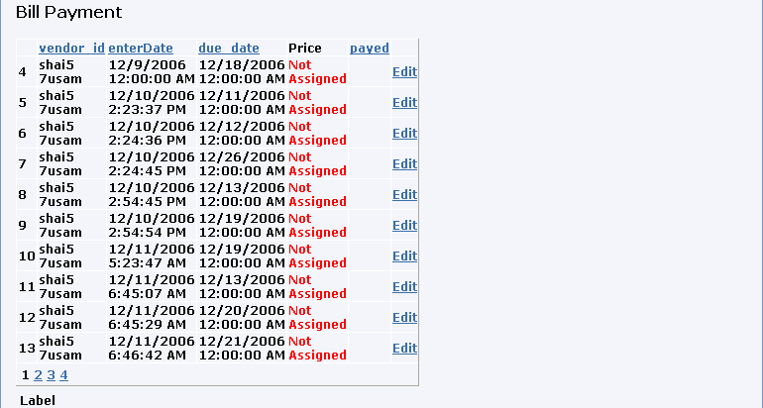

Note if one item is selected then all the line view will changed for example let us choose bill No.31

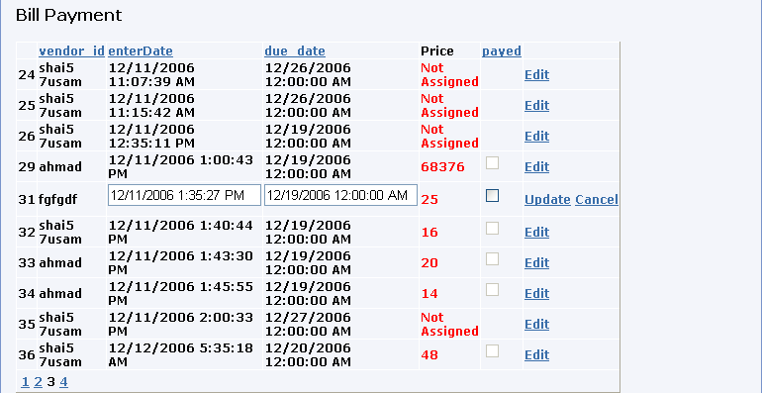

Then if check box selected this bill will removed from table and assigned as paid

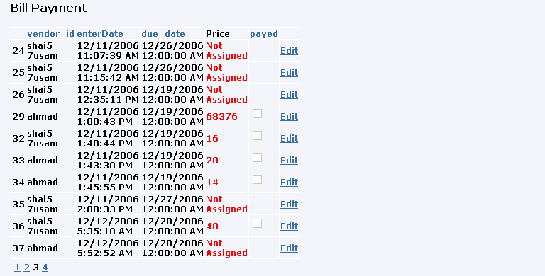

Checks

This page appear when drop down list assigned to checks and the following form will appear 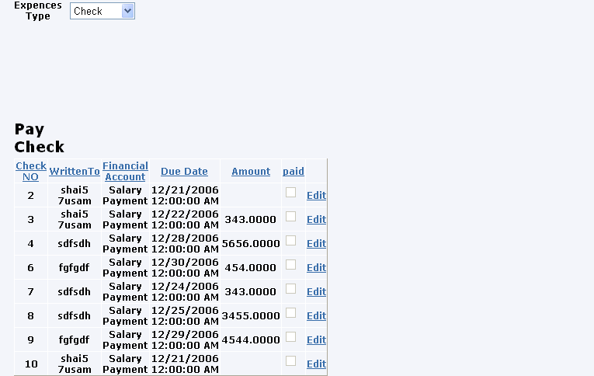

Direct Payments

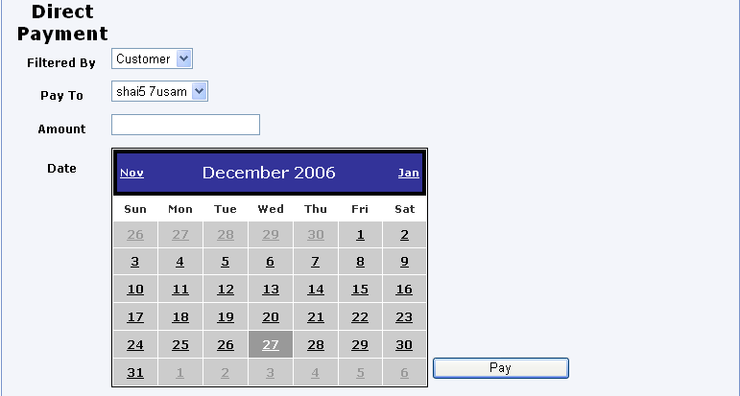

# Customer Detail

This is grid view that display all terms related to customer s and how financial treatment must be

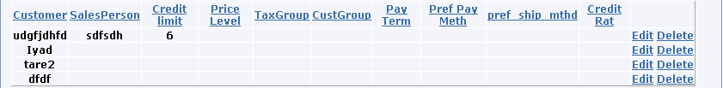

If one customer selected then its row record will change to editable view where lot of textbox are replaced by dropdown list

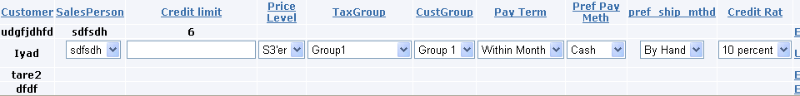

# Settings:

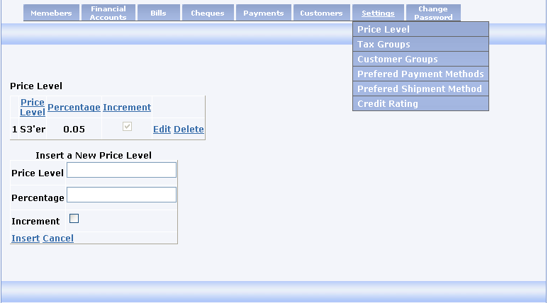

* Price level

This field determine price level which determine how we treat payments of customers for discount .

* Tax Group

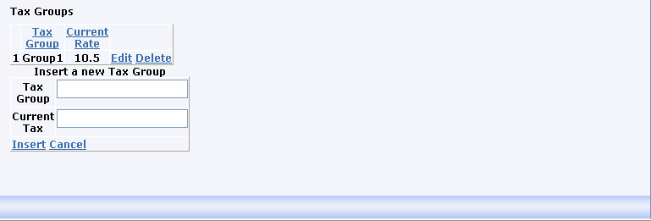

* Customer Group

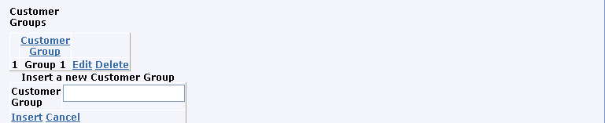

* Preferred Payment Methods

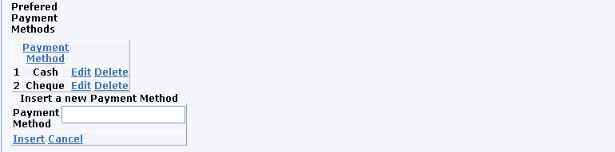

* Preferred Shipment Methods

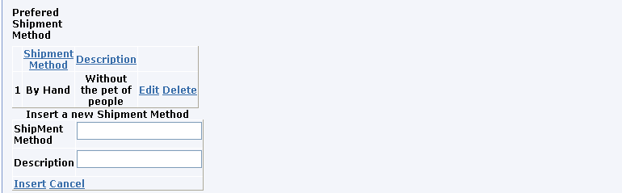

* Credit Rating

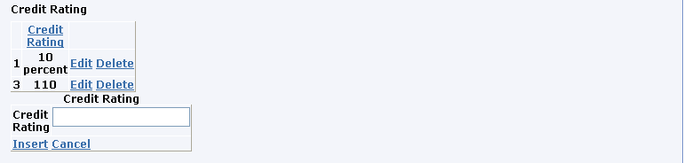

# Change Password

