بِسْــــمِ اللهِ الرَّحمن الرّحيم

An-Najah National University
Chemical Engineering Department
Effect of Using Different Types of Coagulant on Sludge Conditioning at Different Temperatures

Submitted by:
Juman Aqra'
Nahla Salameh
Rawan Nummor

Supervisor:
Dr. Ola Sawalha
A Graduation Project Submitted to Chemical Engineering Department in Partial Fulfillment of the Requirements for B.S.C/Degree in Chemical Engineering

December 24, 2012
Abstract:
Sludge dewaterability is an important process in wastewater treatment before disposal. Solids removal is a primary objective of wastewater treatment. There are many coagulants that are commonly used in this process and the most widely used is aluminum sulfate (alum).
Filtration without coagulation will not remove the fine particles if the filter medium is too coarse. Coagulation is required to agglomerate the fine particles, thus making the wastewater more suitable for filtration and also resulting in much of the coagulated matter to settle out prior to filtration.
This project aims to study the effect of sludge conditioning using two types of sludge conditioning, Aluminum sulfate and cationic polymer (PRAESTOL). Possible effect of temperature is also studied.
Sludge samples were collected from local municipal wastewater treatment plant and were stored at 4˚C. Then conditioning of these samples was investigated using two types of conditioners: aluminum sulfate and cationic polymer (PRAESTOL) at three different temperatures (10, 20, 30 ˚C). The optimal dose of each type of conditioner was estimated at each temperature. Physical and chemical properties were measured including chemical oxygen demand(COD), Biochemical oxygen demand (BOD), total solid (TS), total suspended solid (TSS), pH, flock structure, turbidity and viscosity.
The conditioned samples were dewatered using capillary suction time test (CST).
The data was analyzed using statistical methods, such as t-test and regression.
The results showed that the optimum alum conditioner dosages at 30, 20, 10º C were, 300, 150, and 120 mg/L, respectively. Similarly, the optimum polymer conditioner concentrations were 0.236, 0.634, and 0.72 mg/L at 30, 20, and 10 ºC, respectively. The relationship between optimal conditioner concentrations and temperature was quadratic for both alum and polymer but in opposite direction. So the optimum concentration of alum increased with the increase of the temperature but optimum concentration of polymer decreased with temperature increase.

Disclaimer
This report was written by students at the Chemical Engineering Department, Faculty of Engineering, An-Najah National University. It has not been altered or corrected, other than editorial corrections, as a result of assessment and it may contain language as well as content errors. The views expressed in it together with any outcomes and recommendations are solely those of the students. An-Najah National University accepts no responsibility or liability for the consequences of this report being used for a purpose other than the purpose for which it was commissioned.

Table of Contents page
Chapter 1 - 1 -
Introduction - 1 -
Introduction - 1 -
1.1 Sewage Sludge - 1 -
1.2 Sludge Conditioning - 2 -
1.3 Waste Water Treatment Plant: - 2 -
1.3.1 Treatment Methods : - 3 -
1.3.2 Wastewater Treatment Plant In Palestine: - 5 -
Chapter 2: - 8 -
Theoretical Background - 8 -
2.1. Activated Sludge - 9 -
2.1.1 Activated Sludge Historical Development - 9 -
2.1.2 The Biological Component of The Activated Sludge - 9 -
2.1.3 Activated Sludge Process - 9 -
2.1.4Advantages and Disadvantages of Activated Sludge Process - 10 -
2.1.5Factors That Affect Activated Sludge - 11 -
2.2 Coagulation and Flocculation - 11 -
2.2.1 Purpose of Coagulation - 12 -
2.2.2 Factors Influencing Coagulation - 12 -
2.2.3 Purpose of Flocculation - 12 -
2.2.4 Process Description - 13 -
2.2.5 Common Coagulants - 15 -
2.2.6 Alum - 15 -
2.2.7 Polymers: - 16 -
2.2.8 Tests - 18 -
Chapter 3: - 22 -
Methodology - 22 -
3.1 Activated Sludge Sample - 23 -
3.2 Tests - 23 -
3.2.1 Total suspended solid test (TSS) - 23 -
3.2.2 Total Solid Test (TS) - 24 -
3.2.3 Turbidity Test: - 24 -
3.2.4 Viscosity Test - 25 -
3.2.5 PH Test - 25 -
3.2.6: Chemical Oxygen Demand (COD) Test - 26 -
3.2.7 BOD₅ Standard Test - 26 -
3.2.8 Jar Test - 27 -
3.2.9 Capillary Suction Time Test (CST): - 27 -
3.2.10 T-Test - 28 -
3.3 Coagulation - 29 -
3.3.1 Alum Coagulation - 29 -
3.3.2 Polymer Coagulation - 30 -
Chapter 4: - 32 -
Results and Discussion - 32 -
4.1.2 Conditioning with alum: - 34 -
4.1.3 Conditioning with Polymer (PRAESTOL): - 35 -
4.2 Effect of temperature on sludge conditioning using alum and polymer: - 36 -
4.2.1 Effect of Temperature on Sludge Conditioning Using Alum: - 36 -
4.2.2 Effect of Temperature on Sludge Conditioning Using Polymer: - 40 -
4.2.3 Comparison Between the Results of Sludge Conditioning Using Alum and Polymer With the Effect of Temperature: - 43 -
4.3 Flock Structure of Waste Activated Sludge Samples - 45 -
4.3 T-Test - 46 -
4.4 Conclusions and Recommendations: - 47 -
Chapter 5 :………………………………………………………………………………. - 48 -
References : - 49 -

List of Tables page
Table 1. Municipalities Treatment Plants in Palestine - 5 -
Table 2. Physical and Chemical Properties of Waste Activated Sludge. - 33 -
Table 3. Conditioning with alum at 30 ᵒC. - 34 -
Table 4. Conditioning with alum at 20 ᵒC. - 34 -
Table 5. Conditioning with alum at 10 ᵒC. - 35 -
Table 6. Conditioning with Polymer at 30 ᵒC . - 35 -
Table 7. Conditioning with Polymer at 20 ᵒC. - 36 -
Table 8. Conditioning with Polymer at 10 ᵒC . - 36 -
Table 9. The Optimum Doses for Both Polymer (PRAESTOL) and Alum at Different Temperatures - 45 -
Table 10. Turbidity Values. - 46 -
Table 11. T-Test Results. - 46 -

List of Figures page
Figure 1. Completely Mixed Activated Sludge Plant - 10 -
Figure 2. Destabilizes the Particle’s Charges Before and After Coagulation - 14 -
Figure 3. Function of Coagulation. - 14 -
Figure 4. Definition Sketch for Interparticle Bridging with Organic Polymers. - 18 -
Figure 5. CST device - 19 -
Figure 6. Turbidity Test Device - 25 -
Figure 7. COD test device - 26 -
Figure 8. BOD test device - 27 -
Figure 9. CST hand method - 28 -
Figure 10. Samples in the Beakers of Jar Test. - 29 -
Figure 11. Flock Structure of Samples - 45 -

List of plots page
Plot 1. Jar Test with Variable Alum Dose at 30 ᵒC. - 37 -
Plot 2.CST Test Experimets with Variable Alum Dose at 30 ᵒC. - 37 -
Plot 3. Jar Test with Variable Alum Dose at 20 ᵒC - 38 -
Plot 4. CST Test Experiments with Variable Alum Dose at 20 ᵒC - 38 -
Plot 5. Jar Test with Variable Alum Dose at 10 ᵒC - 39 -
Plot 6. CST Test Experimets with Variable Alum Dose at 10 ᵒC - 39 -
Plot 7. Jar Test with Variable Polymer Dose at 30 ˚C - 40 -
Plot 8. CST Test Experiments with Variable Polymer Dose at 30 ᵒC - 40 -
Plot 9. Jar Test with Variable Polymer Dose at 20 ˚C. - 41 -
Plot 10. CST Test Experiments with Variable Polymer Dose at 20 ᵒC. - 41 -
Plot 11. Jar Test with Variable Polymer Dose at 10 ˚C - 42 -
Plot 12. CST Test Experiments with Variable Polymer Dose10 ˚C - 42 -
Plot 13. Relationship Between Optimum Alum Doses and Temperature. - 43 -
Plot 14. Relation Between the Optimum Polymer Doses with Temperature - 44 -

Chapter 1

Introduction

Introduction
Natural water in lakes, rivers, springs, and wells may contain various materials that some are harmful when used directly from the source by humans, animals, fish, and in agricultural, industrial, and even recreational purposes. On the other hand, raw / untreated wastewater contains pathogens, organics, salt, and various toxins which should be treated and reduced before transferred to water body.
The treatment of wastewater is not only important for our own health but also to keep our environment clean and healthy. Without the proper wastewater treatment many ecosystems would be severely damaged once the untreated water gets recharged back into the environment.
The main objectives of wastewater treatment processes are to reduce the biochemical oxygen demand, suspended solids, and pathogenic organisms. In addition it may be necessary to remove nutrient such as nitrogen and phosphorous, toxic component, non -biodegradable compounds, and dissolved solids. Since most contaminants are present in low concentrations.[1]

1.1 Sewage Sludge
Sludge is the residue left from wastewater treatment processes which is a two phases mixture of water and solids, and its water content is generally in the level between 95% to 99% [2].
Sewage sludge contains many nutrients and may also be contaminated with toxic substances such as heavy metals. Sewage sludge therefore has to be managed responsibly. Today most sewage sludge is stored temporarily on the site of the treatment plant. Sewage sludge contains water that may seep into the ground or flow into rivers or the sea. This has a consequence on public health, environment and drinking water resources. The uncontrolled disposal of sewage sludge also increases the emission of greenhouse gases. It causes lasting and considerable damage to the environment [3].

1.2 Sludge Conditioning
There are several types of sludge with specific characteristics that influence:
-The choice of the conditioning chemical (cationic flocculants, ferric chloride, lime)
-The choice of the dewatering equipment to be used (filtration, centrifuge)
These choices also depend on the final use of the sludge
Sludge processing is a very important part of wastewater treatment plant because of the large quantities of sludge produced. In order to improve the dewaterability of sludge, coagulation and flocculation process is used.
This project aims to study the effect of sludge conditioning using two types of sludge coagulants, Aluminum sulfate and cationic polymer (PRAESTOL) with effect of temperature.

1.3 Waste Water Treatment Plant:
In wastewater treatment plant each type of process produces sludge. In primary settling process the sludge produced is called primary sludge, approximately 50% of the suspended solid matter will settle out in the period of an hour and a half or so. This collection of solids is known as fresh sludge. Such sludge will become actively putrescent in a short time and must be removed from the sedimentation tank before this happens.[4]
Primary sludge comes from the settling process. It is therefore made of easily decantable suspended particles: large and/or dense particles. It has volatile solids around 55% to 60%. [5]
The sludge produced in the activated sludge process is called activated sludge. This study will focus on activated sludge and its conditioning.

1.3.1 Treatment Methods [6]:
Before water can be accepted for use in irrigation, wastewater goes through a series of treatment steps, these steps includes:
- Preliminary treatment.
- Primary treatment.
- Secondary treatment.
- Tertiary treatment.
- Sludge management.

1.3.1.1 Steps of Treatment:
- Preliminary treatment: preliminary treatment of sewage removes materials that can cause operational problems (like plugging pipes or channels in the treatment plant). Preliminary treatment of sewage removes major portion of settleable and large suspended solids. It consists of screening (fine and/or coarse and with or without comminutors), and grit removal facilities. This group is classified as physical treatment methods.

- Screening : it is a physical water and wastewater treatment process used to remove or separate the large or suspended materials, it includes screens made of sets of bars (parallel or perpendicular).

- Grit removal: is the process of removing particles that pass the screens openings, and have density larger than water density so it settles down with low detention time. The process includes holding water in small tank with detention time so the particles settle down.

- Primary treatment: the major goal of primary treatment is to remove those pollutants which either settle (materials and suspended organic or inorganic solids) or float (grease, oil, and fats). Primary treatment will typically remove about 60% of total suspended solids, and 35% of BOD . Soluble mainly inorganic salts and minerals pollutants are not removed in primary treatment. This group of treatment processes is also classified as physical treatment methods.

- Sedimentation : sedimentation or (gravity separation) is a physical treatment process in which suspended solids are removed from water by the force of gravity, in which water is collected in basins and given proper detention time during which suspended solids present in water is allowed to settle at the bottom of the basin.

- Secondary treatment: the major goal of secondary treatment is to remove the soluble organics (BOD) that escape the primary treatment process and to provide additional removal of suspended solids. These removals are typically achieved using biological means.
Secondary treatment is designed to speed up the natural break down of organics. It removes up to 85% of the BOD, and very few of nitrogen, phosphorous, heavy metals, bacteria, and viruses.

- Aeration : is physical treatment process where gases are either added to or removed from water by physical means. Mainly aeration process involved in adding oxygen to water and mixing water with microorganisms brought from the lowest layer of sedimentation tank so it can decompose or eat (live on)the pollutant in water (BOD).

- Advanced or tertiary wastewater treatment : it is the further removal of pollutants and may involve chemical treatment and filtration or applying secondary effluent to land. Advanced treatment may remove 99% of the soluble BOD, 100% of suspended solids, 99% of phosphorus, 100% of bacteria, and 95% of nitrogen.

- Sludge may be dried, mechanically dewatered, or buried in landfills. Sludge processing is a very important part of every wastewater treatment plant because of the large quantities of sludge produced.

- Sludge management in this process, the sludge taken from the sedimentation tanks is dewatered so the sludge represents only 20% of the new product and the remaining 80% represents water. This new product can be buried or used as fertilizers or embankment material.

1.3.2 Wastewater Treatment Plant In Palestine:
There are many sources of water in Palestine such as surface water (Jordan river, Wadis and Cisterns , ground water.[9]
These resources need to be treated in order to be able to use for industrial, agriculture, and drinking.[9]
There are many waste water treatment plants to treat the water from these resources in West bank. Table 1. Shows Municipalities WWTP and the type of treatment in each one:

Table 1. Municipalities Treatment Plants in Palestine¹
Municipalities WWTP | Type of Treatment
Al-Bireh | Screening
Al-Bireh | Aeration tanks
Al-Bireh | disinfection by UV radiation
Jenin | Aerated lagoon
Ramallah | two aerated lagoons
Tulkarem | Stabilization ponds.

1.3.2.1 Al-Bireh WWTP[2]
The wastewater treatment plant is successfully operating since August 2000. The WWTP has been designed for a capacity of 50,000 population equivalents and is extendable to a capacity of 100,000 population equivalents. The maximum daily dry weather flow is 5,750 m³/day and the peak hourly flow is 480 m³/hour at dry weather and 720 m³/hour during rainy weather conditions.
The treatment plant consists of the following structures:
• 2 screens, bar spacing15 mm .
• 2 circular grit chambers.
• 1 balancing tank with a volume of 480 m³.
• 2 aeration tanks, each with a volume of 6,900 m³.
• 2 x 3 mammoth aerators, 2 x 4 submersible mixers.
• Final sedimentation tanks with a volume of 2 x 1,700 m³ and a diameter of 240 m.
• UV disinfection unit.
• Effluent regulation tank, volume: 2,000 m³.
• Sludge thickening tank, volume: 360 m³.
• Belt filter presses, capacity 2 x 15 m³/h.
• Septage storage tank, volume 80 m³.
• Emergency generator 630 kVA.
• Administration building with control room, laboratory, workshop, etc.

Chapter 2:

Theoretical Background

2.1. Activated Sludge
Activated sludge is a biomass produced in raw or settled wastewater (primary effluent) by the growth of organisms in aeration tanks in the presence of dissolved oxygen. Microorganisms convert dissolved organic matter into their own biomass. The term "activated" comes from the fact that the particles are teeming with bacteria, and protozoa. Activated sludge is different from primary sludge in that the sludge contains many living organisms which can feed on the incoming wastewater.[10]

2.1.1 Activated Sludge Historical Development [11]
- Invented in 1914 by Ardern and Lockett in England. They aerated a batch of sewage. They aerated a batch of sewage.
- During aeration sewage is mixed with a large mass of previously grown organisms.
- The solids formed are flocculent and can be removed from the liquid by settling.
- The activated sludge process is used to treat waste streams that are high in organics and biodegradable compounds.

2.1.2 The Biological Component of The Activated Sludge [11]
- The biological component of the activated sludge system is comprised of microorganisms.
- The composition of these microorganisms is 70 to 90percent organic matter.
- Bacteria, fungi, protozoa, and rotifers constitute the biological component, or biological mass, of activated sludge.

2.1.3 Activated Sludge Process
Activated sludge process consist of the following steps[12]:
- Mixing the activated sludge with the waste water to be treated (mixed liquor),
- Aeration and agitation of this mixed liquor for the required length of time
- Separation of the activated sludge from the mixed liquor, in the final clarification process
- Return the proper amount of activated sludge for mixing with the wastewater, and Disposal of the excess activated sludge.

In the process, large quantities of air are bubbled through wastewaters that contain dissolved organic substances in open aeration tanks. Oxygen is required by bacteria and other types of microorganisms present in the system to live, grow, and multiply in order to consume the dissolved organic "food", or pollutants in the waste. After several hours in a large holding tank, the water is separated from the sludge of bacteria and discharged from the system. Most of the activated sludge is returned to the treatment process, while-the remainder is disposed of by one of several accepted methods.[10]
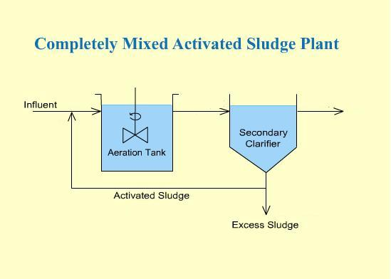
Figure 1. Completely Mixed Activated Sludge Plant [11]

2.1.4Advantages and Disadvantages of Activated Sludge Process[11]
2.1.4.1 Advantages of Activated Sludge Process:
- Low installation cost
- Good quality effluent
- Low land requirement
- Loss of head is small
- Freedom from fly and odor nuisance high degree of treatment

2.1.4.2 Disadvantages of Activated Sludge Process
- Not very flexible method, If there is sudden increase in the volume of sewage or if there is sudden change in the character of sewage, there are adverse effects on the working of the process and consequently the effluent of bad quality is obtained.
- Operation cost is high
- Sludge disposal is required on large scale
- This process is sensitive to certain industrial wastes
- Skilled supervision is required to check that the returned sludge remains active

2.1.5 Factors That Affect Activated Sludge[11]
- Temperature.
- PH.
- Amount of oxygen available.
- Amount of organic matter available.
- Types of microorganisms:

2.2 Coagulation and Flocculation
All waters, especially surface waters, contain both dissolved and suspended particles. Coagulation and flocculation processes are used to separate the suspended solids portion from the water.[17]
Coagulants neutralize the electrical charges of particles in the water which causes the particles to clump together. Chemically, coagulant water treatment chemicals are either metallic salts (such as alum) or polymers. Polymers are man-made organic compounds made up of a long chain of smaller molecules. Polymers can be either cationic (positively charged), anionic (negatively charged), or nonionic (neutrally charged.) [13]
Following the first step of coagulation, a second process called flocculation occurs. Flocculation, a gentle mixing stage, increases the particle size from submicroscopic, microfloc to visible suspended particles.[17]
The theory of chemical coagulation reaction is very complex. The simplified reactions are used to describe coagulation and chemical precipitation process can only be considered approximation as the reactions may not necessarily proceed as indicated.[23]
Coagulation reaction are often incomplete, and numerous side reaction with other substances in wastewater may take place depending on the characteristics of wastewater which will vary throughout the day as well as seasonally.[23]

2.2.1 Purpose of Coagulation
The main purpose of the coagulation is to destabilize the charged colloidal particles in water and make them to settle so as to remove turbidity from the water. In addition to removing turbidity from the water, coagulation process removes many bacteria which are suspended in the water and can be used to remove color from the water.[14]

2.2.2 Factors Influencing Coagulation
Coagulation can be affected by changes in the water’s pH, salt content, alkalinity, turbidity, and temperature. Within the plant, mixing effects and coagulant effects will influence the coagulation/ flocculation process. The levels of pH, salts, and alkalinity in water are all ways of measuring the amounts of positively charged particles (cations) and negatively charged particles (anions) in the water. [14]

2.2.3 Purpose of Flocculation [23]
The purpose of flocculation is to form aggregates or flocks from finely divided particles and from chemically destabilized particles.
Flocculation is a transport step that brings about the collisions between the destabilized particles that can be removed by settling or filtration
Flocculation typically follows rapid mixing where chemicals have been added to destabilize the particles. The destabilization of particles resulting from the addition of chemicals is defined as coagulation

2.2.3.1 Types of Flocculation
There are two types of flocculation:
- micro flocculation known as (perikinetic) flocculation is the term used to refer to the aggregation of particles brought about by the random thermal motion of fluid molecules. The random thermal motion of fluid molecules is also known as Brownian motion or movement. Micro flocculation is significant for particles that are in size range from 0.001 to about 1 µm
- Macro flocculation also known as(orthokinetic) flocculation is term used to refer to the aggregation of particles greater than 1 or 2 µm. Macro flocculation can brought together (flocculated) by inducing velocity gradients in a fluid containing the particles to be flocculated
Faster moving particles will overtake slower-moving particles in a velocity field. If the particles that colloid stick together, a larger particles will be formed that will be easier to remove by gravity separation
In macro flocculation by differential settlings, large particles over take smaller particles during gravity settling. When the two particles colloid and stick together, a larger particle is formed that settles at rate that is greater than that of the larger particle before the two particles collided

2.2.4 Process Description
The first step destabilizes the particle’s charges. Coagulants with charges opposite those of the suspended solids are added to the water to neutralize the negative charges on dispersed nonsettlable solids such as clay and color-producing organic substances.[11]
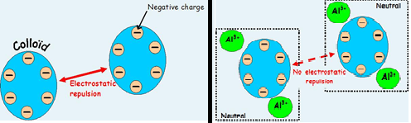
Figure 2. Destabilizes the Particle’s Charges Before and After Coagulation[13]

Once the charge is neutralized, the small suspended particles are capable of sticking together. The slightly larger particles formed through this process and called microflocs, are not visible to the naked eye. The water surrounding the newly formed microflocs should be clear. If it is not, all the particles’ charges have not been neutralized, and coagulation has not been carried to completion. More coagulant or coagulant aids-such as polyelectrolytes- may need to be added.[15]

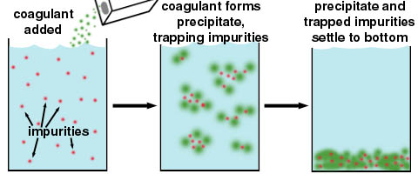
Figure 3. Function of Coagulation [14]

2.2.5 Common Coagulants [14]
The common water treatment coagulant chemicals used are
- Aluminum salts (alum)
- Ferric and ferrous salts
- Cationic, anionic and non-ionic polymers.
The choice of coagulant chemical depends upon the nature of the suspended solid to be removed, the raw water conditions, the facility design, and the cost of the amount of chemical necessary to produce the desired result.

2.2.6 Alum
One of the earliest, and still the most extensively used coagulant, is aluminum sulfate (Al/S04)3 ·14 HP), also known as alum. Alum is acidic with light tan to grey in color and available in blocks, lumps and powder with a density of 1000 -1100 kg/ m³. Alum can be bought in liquid form or in dry form. It is readily soluble in water. When alum is added to water, it reacts with the water and results in positively charged ions.[13]
The ions can have charges as high as +4, but are typically bivalent (with a charge of +2.) The bivalent ion. Resulting from alum makes this a very effective primary coagulant.[15]
The reaction equation [15]:
A12 (SO4)3 + 3 Ca (HCO3)2 ------------> 2 Al (OH)3 + 3CaSO4 + 6 CO2
Aluminum + Calcium giveAluminum + Calcium + Carbon
Sulfate Bicarbonate Hydroxide Sulfate Dioxide
(Already in the(Sludge)
Water)

2.2.6.1 Advantages and Disadvantages of Alum
Advantages of alum are:
- It readily dissolves with water.
- It does not cause the unsightly reddish brown staining of floors, walls and equipment like ferric sulphate.
Disadvantages of alum are:
- It is effective only at certain pH range.
- Good flocculation may not be possible with alum in some waters.

2.2.6.1 Mechanism of Alum [23]:
The action of hydrolyzed metal ions in bringing about the destabilization and removal of colloidal particles may be divided into the three categories:

Adsorption and discharge neutralization: Sufficient coagulant reduction surface charge occur due to presence of mononuclear hydrolysis species.
- Adsorption and interparticle bridging: the colloidal particles have been destabilized by the adsorption of mono and polynuclear hydrolysis species and if allowed to flocculate and settle, the residual turbidity would be lowered.
- Enmeshment in sweep flock: where a large amounts of hydroxide flock will form as the flock particles settle the colloidal particles will be removed by the sweep action of the settling flock particles.

2.2.7 Polymers:
Polymers--long-chained, high molecular weight, organic chemicals that are becoming widely used, especially as coagulant aids together with the regular inorganic coagulants. Anionic (negatively charged) polymers are often used with metal coagulants. Low-to-medium weight positively charged (cationic) polymers might be used alone or in combination with the aluminum and iron type coagulants to attract the suspended solids and neutralize their surface charge and to optimize the conditioning process. [15]
The manufacturer can produce of polymers a wide range of products that meet a variety of source-water conditions by controlling the amount and type of charge and relative molecular weight of the polymer. [15]
Polymers are effective over a wider pH range than inorganic coagulants. They can be applied at lower doses, and they do not consume alkalinity. They produce smaller volumes of more concentrated, rapidly settling flock. The flock formed from use of a properly selected polymer will be more resistant to shear, resulting in less carryover and a cleaner effluent. [15]
Polymers are generally more expensive in their price per pound than inorganic coagulants.[15]

2.2.7.1 PRAESTOL® Cationic Polymers
PRAESTOL cationic polymers are high molecular weight, water-soluble flocculating agents made by the copolymerization of acrylamide with various cationic monomers. These polymers are available in both liquid emulsion and granular dry solid grades and cover the full spectrum of cationic charges. These products have found wide applicability in municipal, industrial, pulp and paper and mining liquid-solids separation systems.[16]

2.2.7.2 Dry Polymer Solution Preparation
PRAESTOL dry polymers cannot be fed into an application without pre-diluting in water.[16]

2.2.7.3 Mechanism of Polymer[23]:
The action of poly electrolytes may be divided into the following three general categorises:
- Charge neutralization: Polyelectrolytes act as coagulants that neutralize or lower the charge of wastewater particles, particles normally are charged negatively, cationic polyelectrolytes are used for this purpose, and the polyelectrolyte must be adsorbed on to the particle.
- Polymer bridge formation: In this case, polymers that are anionic and non-ionic become attached at a number of adsorption sites to the surface of the particles found in the wastewater, the size of the resulting three-dimensional particles grows until they can be removed easily by sedimentation
- Charge neutralization and polymer bridge formation: The third type of polyelectrolyte action may be classified as charge neutralization and bridging phenomenon, which results from using cationic polyelectrolytes of extremely high molecular weight. Besides lowering the surface charge on the particle, these polyelectrolytes also form particle bridges.
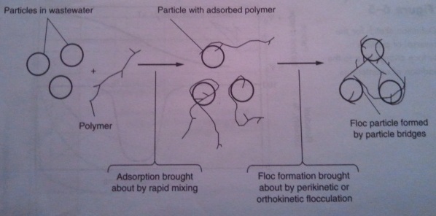
Figure 4. Definition Sketch for Antiparticle Bridging with Organic Polymers [23].

2.2.8 Tests

2.2.8.1 Jar Testing
In many plants, changing water characteristics require the operator to adjust coagulant dosages at intervals to achieve optimal coagulation. Different dosages of coagulants are tested using a jar test, which mimics the conditions found in the treatment plant. The first step of the jar test involves adding coagulant to the source water and mixing the water rapidly to completely dissolve the coagulant in the water. Then the water is mixed more slowly for a longer time period, mimicking the flocculation basin conditions and allowing the forming flock particles to cluster together. Finally, the mixer is stopped and the flock is allowed to settle out, as it would in the sedimentation basin.[19]

2.2.8.2 Capillary Suction Time Test (CST)
The capillary suction time method was introduced in 1967 as an easy-to-conduct test for measuring the dewater ability of sludge.[18]
This original circular setup consists of a soil or sludge column contained in a sample cylinder as shown in Fig. 3. Which is centered in the middle of two concentric electrodes located at diameter D1 and D2 resting on a Whatman-17 filter paper. A timing device is started when the waterfront reaches the inner electrode (1) at D1, and is stopped when the water reaches the outer electrode (2) at D2. The time elapsed is the Capillary Suction Time or CST.[18]
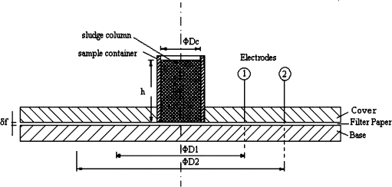
Figure 5. CST device [9]

2.2.8.3 BOD₅ , COD , TSS & TS tests
-BOD is defined as the amount of oxygen required by microorganisms to stabilize decomposable organic matter at a particular time and temperature.[15]
-COD may be defined as the amount of (dissolved) oxygen required to oxidize and
Stabilize (organic and inorganic content of) the sample solution
- The advantages of the COD test as compared to the BOD test are:
      - COD results are available much sooner.
      - The COD test requires fewer manipulations of the sample.
      - The COD test oxidizes a wider range of chemical compounds.
      - It can be standardized more easily.
The major disadvantage of the COD test is that the results are not directly applicable to the 5-day BOD results without correlation studies over a long period. The samples used for the COD analysis may be grab or composite.
- TS are the total of all solids in a water sample. They include the total suspended solids, total dissolved solids, and volatile suspended solids.
- TSS Total Solids suspended in water may consist of inorganic or organic particles.

2.2.8.4 T-Test
It is used for comparing the means of two samples (or treatments), even if they have different numbers of replicates. In simple terms, the t-test compares the actual difference between two means in relation to the variation in the data (expressed as the standard deviation of the difference between the means). [21]
Statistical tests allows making statements with a degree of precision. A significant result at the 95% probability level tells that the data are good enough to support a conclusion with 95% confidence ^{[12]}. So, a value of 5% or greater suggests that there is no significant difference between the means. Any actual difference is likely to be due to chance. If the value is less than 5%, an alternative hypothesis needs to be made since the means appear to be significantly different since they do not overlap significantly. [22]

Chapter 3:

Methodology

3.1 Activated Sludge Sample
Activated sludge samples were taken from Al-Bireh WWTP and collected from the aeration tank. The samples were filled in plastic containers and placed in ice cooler during the transportation from site to laboratory, and were kept in a refrigerator at constant temperature of 4 ◦C.

3.2 Tests

3.2.1 Total suspended solid test (TSS)
Total suspended solid test is done in order to find out how much solids is in the samples.
The procedure for this test:
- Weighing the filter paper.
- Put the filter paper in the Buchner funnel.
- Turn on the vacuum.
- Pour the known volume of the sample in the funnel.
- Wait for the solid particle to appear above the paper.
- Take the sample on the filter paper into the oven. The drying oven should be turned on before the test is ever started at 105 °C for 2 hours.
- Then the filter paper with solids is weighed.
- Calculate TSS by using this equation:

(A-B) X 1000
mg total suspended solids/L =
Sample volume, mL
Where:

A = weight of filter + dried residue, mg, and
B = weight of filter paper, mg.

3.2.2 Total Solid Test (TS)
Total solids includes not just suspended solids, but also dissolved solids such as the mineral ions calcium, phosphorus, iron, sulfur and bicarnonate. A certain level of these ions is essential for life [28]

The procedure for this test:
- Weighing the crucible.
- Pour 20 ml of the sample in the crucible.
- Take the crucible into the oven . The drying oven should be turned on before the test is ever started at 105°C for 2 hours.
- weigh it After it cooled.

3.2.3 Turbidity Test:
Turbidity is the measure of water clarity. It is known that as the suspended solid increase the turbidity increase.
The increased turbidity of water can reduce the diversity of life in three ways:
- Suspended particles absorb heat from sunlight and warm the water. Warmer water holds less oxygen and organisms begin to suffer. Also, some organisms cannot live in the warmer water.
- Particles also block sunlight. Plants and algae grow less and release less oxygen from photosynthesis.
- Particles also settle on the bottom and can cover and suffocate fish eggs and insect larvae.[24]
This test was done after and before the coagulation process
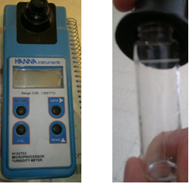
Figure 6. Turbidity Test Device
The procedure:
- Clean the glass bottle of the device.
- When measuring turbidity before coagulation, shake the sample, but in other glass, don’t shake it, take the sample from the place which is under the surface of the sample.
- Fill the glass with the sample until it reaches the mark.
- Then put the glass on its place in the device.
- Turn on the device and press the bottom (read).

3.2.4 Viscosity Test
Viscosity of the sample was measured by viscosity meter device.

3.2.5 PH Test
pH is a measure of the acidic or basic nature of a solution [25]. pH greatly affects biological activity. High values of pH may injure or kill many bacteria and even cause a halt to all biological activity. Most bacteria perform best at pH between 6.5 to 8.0. [26]

3.2.6: Chemical Oxygen Demand (COD) Test
It measures the oxygen equivalent consumed by organic matter in a sample during strong chemical oxidation
The device:
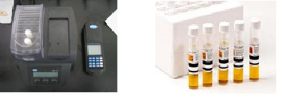
Figure 7. COD test device⁴

Procedure:
- The COD heater is turned on at 150 ̊C before starting.
- After dilution of the sample Put 2 ml of wastewater on the tube.
- Put 2 ml of distilled water on the other tube ( standard tube)
- Put the two tubes in the heater for 2 hr.
- Put the standard tube in the device , and press zero.
- Then put the other tube to measure the COD.

3.2.7 BOD₅ Standard Test
Principle: microorganisms such as bacteria are responsible for decomposing organic waste. When organic matter is present in water, the bacteria will begin the process of breaking down this waste. In this case, aerobic bacteria, robbing other aquatic organisms of the oxygen they need to live, consume much of the available dissolved oxygen. Biological oxygen demand (BOD) is a measure of the oxygen used by microorganisms to decompose this waste. If there is a large quantity of organic waste in the water, there will also be a lot of bacteria present working to decompose this waste. In this case, the demand for oxygen will be high (due to all the bacteria) and subsequently the dissolved oxygen levels in the water may begin to decline, BOD₅ read after five days, and BOD or BOD_{u} read after twenty days.
Procedure:
- The temperature of incubator is adjusted to 20 ̊C.
- A magnetic bar is put in the BOD bottle.
- 100ml of sample is added to the bottle.
- Some pieces of KOH is added to the bottle.
- The bottle is installed on the incubator unit after closing it.
- Read BOD directly after 5 days to obtain mg/l BOD₅.

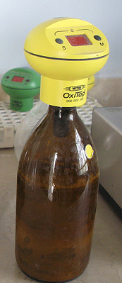
Figure 8. BOD test device

3.2.8 Jar Test
Procedure:
1) waste waters were stirred rapidly at 200rpm for 2 min during coagulant
addition
2) the stirring rate was slowed down to 30rpm for 30 min.
3) the stirring was stopped and the flocks settled for 30 min. After sedimentation, a supernatant sample was withdrawn for further analysis.

3.2.9 Capillary Suction Time Test (CST):
CST test is done after the coagulation process. Because of the lack of the device a handmade method used instead of the standard method.

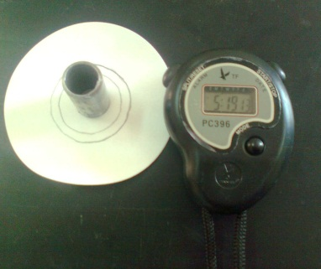
Figure 9. CST hand method
Procedure:
- Draw two circles on the filter paper (fisher QT 205 type).
- Put the stainless steel cylinder with 18 mm inside diameter above the filter paper.
- Pour the sample in the cylinder and turn on the timer.
- Timing device is started when the waterfront reaches the inner circle and is stopped when the water reaches the outer circle.

3.2.10 T-Test
To compare two sets of measured data Excel was used.
Procedure:
1. Data were entered down columns.
2.Formula was entered to calculate means for each set of data in the row below the last data items.
The general formula is: =AVERAGE(RANGE).
3. The standard deviations for each mean were calculated by entering its formula.
The general formula is:=STDEV(RANGE)
The standard deviation gives an indication of the degree of spread of the data around the mean. A high standard deviation suggests that there is a lot of variation in the data.
4.finally T-Test formula was entered to compare the difference between the two means.
The general formula is: =TTEST(RANGE1,RANGE2,2,2)
The numbers at the end indicate the type of test to be performed.

3.3 Coagulation
Coagulation process achieved by using alum (AluminiumSulphateAl₂(SO₄)₃ · 14 H₂O ) and Cationic Polymers.(PRAESTOL®). At different three temperatures ( 10 , 20 , 30 ˚C)

3.3.1 Alum Coagulation
This achieved by using different concentrations of alum in the samples.
According this procedure:
- Shaking the sample and make sure that the temperature is the required by using water bath.
- By using 4 beakers of the jar test , pour 1000 ml of the sample in each one.
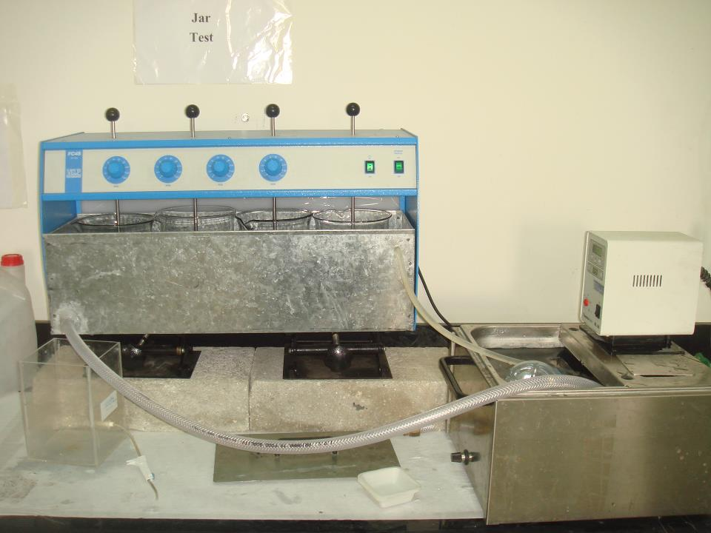
Figure 10. Samples in the Beakers of Jar Test.
- Weighing the required amounts of alum.
- Put the beakers on its place in the jar test.
- Turn on the mixer.
- Put in each beaker one of the quantities which have been prepared .
- After the test finished , turbidity test was achieved .
- Then CST test was done.

3.3.2 Polymer Coagulation
In this coagulants different concentrations were prepared .
By the following procedure:
1) After Weighing the required amounts of polymer , each amount was diluted in 1L of distilled water.
2) Shaking the sample and make sure that the temperature is the required by using water bath.
3) By using 4 beakers of the jar test , pour 1000 ml of the sample in each one.
4) Put the beakers on its place in the jar test.
5) Turn on the mixer.
6) Put in each beaker 2 ml of the diluted sample.
7) After the test finished , turbidity test was achieved .
8) Then CST test was done.

Chapter 4:

Results and Discussion

4.1 Results
4.1.1 Properties of sludge samples:
Waste activated sludge samples were brought from Al-Beirah wastewater treatment plant. Table 2 shows physical and chemical properties of the sludge samples.
Table 2. Physical and Chemical Properties of Waste Activated Sludge.
Property | Sample 1 | Sample 2
COD (mg/L) | 1137 | 1310
pH | 6.9 | 6.77
Viscosity (cp) | 33 | 38.3
Turbidity (NTU) | 258 | 233
TSS (g/L) | 5.328 | 5.72
TS (g) | 9.65 | 8.701
BOD (mg/L) | 500 | 580
CST (s) | 6.41 | 5.97

4.1.2 Conditioning with alum:
Table 3 presents the properties of the samples when conditioning with alum at 30 ᵒC. There was a very clear decrease in Turbidity with the addition of alum. The lowest turbidity was at 4.455 (NTU). Similarly, the corresponding CST values at this level of conditioner was 3.15 (s)
Table 3. Conditioning with alum at 30 ᵒC.
Concentration (mg/L) | Turbidity (NTU) | CST (s)
700 | 14.750 | 5.22
50 | 18.213 | 8.03
100 | 16.385 | 6.50
250 | 9.595 | 4.62
500 | 7.770 | 5.44
293 | 4.455 | 3.15
590 | 6.425 | 2.82
407.9 | 6.420 | 4.03

Table 4 presents the properties of the samples when conditioning with alum at 20 ᵒC. There was a very clear decrease in Turbidity with the addition of alum until specific limit. The lowest turbidity was at 9.110 (NTU) Similarly, CST values 3.69 (s)
Table 4. Conditioning with alum at 20 ᵒC.
Concentration (mg/L) | Turbidity (NTU) | CST (s)
30 | 26.033 | 6.84
50 | 19.257 | 8
70 | 16.500 | 5.41
100 | 14.117 | 9.06
130 | 12.927 | 8.18
150 | 9.110 | 3.69
170 | 16.063 | 5.94
200 | 9.235 | 10.9
250 | 16.213 | 7.62
300 | 17.090 | 8.97

Table 5 presents the properties of the samples when conditioning with alum at 10 ᵒC . There was a very clear decrease in Turbidity with the addition of alum. The lowest turbidity was at 2.900 (NTU) Similarly, CST values 5.00 (s)
Table 5. Conditioning with alum at 10 ᵒC.
Concentration (mg/L) | Turbidity (NTU) | CST (s)
50 | 16.395 | 6.41
104.8 | 12.105 | 7.69
122 | 2.900 | 5.00
151.3 | 5.010 | 9.97
173 | 9.165 | 8.12
206 | 12.420 | 7.16
251 | 11.703 | 5.54
300 | 12.007 | 5.41

4.1.3 Conditioning with Polymer (PRAESTOL):
The result in Table 6 shows that properties of the samples when conditioning with polymer at 30 Cᵒ. The lowest turbidity was at 8.043 (NTU) Similarly, CST values 4.10 (s)
Table 6. Conditioning with Polymer at 30 ᵒC .
Concentration (mg/L) | Turbidity (NTU) | CST (s)
0.02 | 19.540 | 4.69
0.06 | 21.350 | 5.31
0.1 | 18.565 | 6.19
0.74 | 9.480 | 6.38
0.154 | 18.560 | 5.66
0.1674 | 10.000 | 4.90
0.18 | 20.300 | 5.84
0.2358 | 8.043 | 4.10
0.406 | 18.866 | 4.78
0.618 | 19.093 | 6
0.896 | 14.040 | 6.91

Table 7 presents the properties of the samples when conditioning with polymer at 20 Cᵒ . There was a very clear decrease in Turbidity with the addition of polymer until specific limit . The lowest turbidity was at 16.863 (NTU) Similarly, CST values 7.72 (s)

Table 7. Conditioning with Polymer at 20 ᵒC.
Concentration (mg/L) | Turbidity (NTU) | CST (s)
0.119 | 20.743 | 5.50
0.226 | 20.645 | 10.81
0.302 | 22.380 | 5.68
0.398 | 21.667 | 5.50
0.508 | 18.927 | 4.31
0.634 | 16.863 | 7.72
0.720 | 19.725 | 3.62
0.800 | 17.863 | 4.62

Table 8 presents the properties of the samples when conditioning with polymer at 10 Cᵒ .The lowest turbidity was at 15.497 (NTU) Similarly, CST values 8.28 (s)
Table 8. Conditioning with Polymer at 10 ᵒC .
Concentration (mg/L) | Turbidity (NTU) | CST (s)
0.1192 | 17.003 | 4.26
0.226 | 18.590 | 8.15
0.42 | 26.453 | 4.78
0.60 | 21.120 | 6.69
0.72 | 15.497 | 8.28
0.80 | 18.930 | 3.97
0.90 | 25.367 | 6.32
1.00 | 20.195 | 5.69

4.2 Effect of temperature on sludge conditioning using alum and polymer:
The effect of the three different temperatures were investigated in this research study using two different types of conditioning alum and polymer (PRAESTOL). The optimum dose of sludge conditioning were estimated using jar test, then the results of the jar test were verified by using Capillary Suction Time test (CST).

4.2.1 Effect of Temperature on Sludge Conditioning Using Alum:
The effect of temperature were studied on sludge conditioning at three different temperatures 10, 20, and 30 ˚C.

4.2.1.1 Alum conditioning at 30 ᵒC:

Plot 1 shows the relationship between alum conditioner concentration (mg/L) and turbidity (NTU) at 30 ᵒC. It shows that as the concentration of alum increased, the turbidity decreased until it reached a concentration of 300 (mg/L), and then started to increase again.
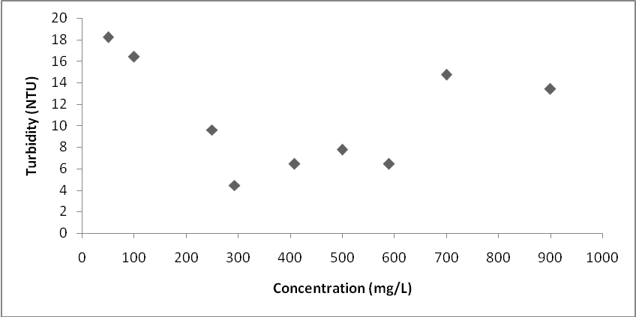
Plot 1. Jar Test with Variable Alum Dose at 30 ᵒC.

Plot 2 shows the relationship between the alum concentration and CST test at 30 ᵒC. As the concentration of conditioner increased, the CST decreases until it reached the concentration of 300 mg/L then the CST values increased. A low CST value was also reported at 600 mg/L conditioner concentration. 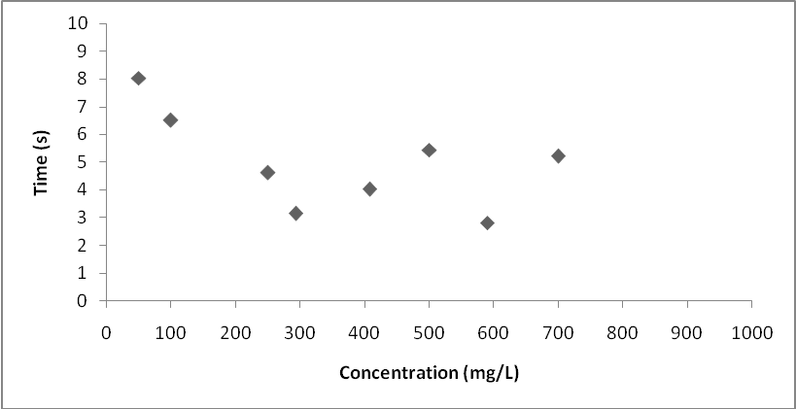
Plot 2.CST Test Experimets with Variable Alum Dose at 30 ᵒC.

From plot 1 &2, the optimum dose of alum conditioning at 30 ºC can be seen at 300 mg/L of alum conditioner concentration.

4.2.1.2 Alum conditioning at 20 ᵒC:

From Plot 3, it is noticed that the optimum concentration of alum at 20 C is 150 (mg/L). This result is also supported by CST test which shows the same optimum concentration in Plot 4.
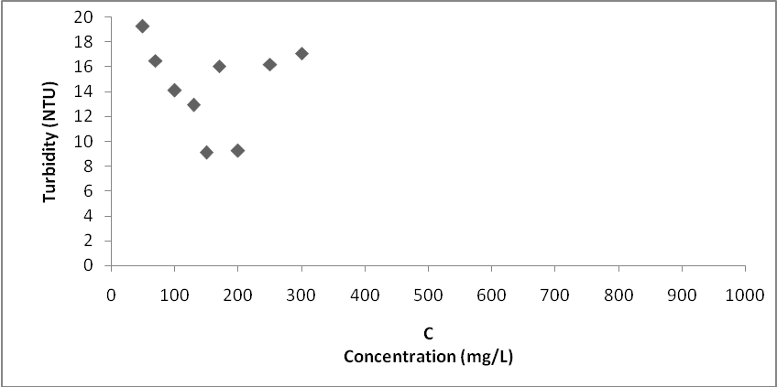
Plot 3. Jar Test with Variable Alum Dose at 20 ᵒC
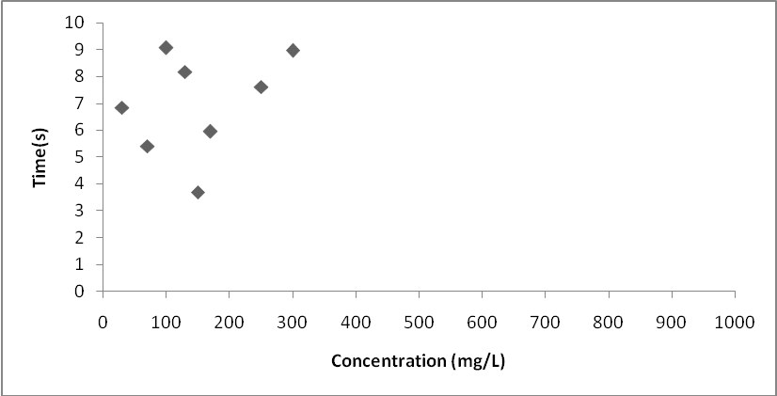
Plot 4. CST Test Experiments with Variable Alum Dose at 20 ᵒC

4.2.1.3 Alum conditioning at 10 ᵒC:

Plot 5 and 6 show that the optimum alum conditioning at 10ᵒC is around 120 (mg/L).
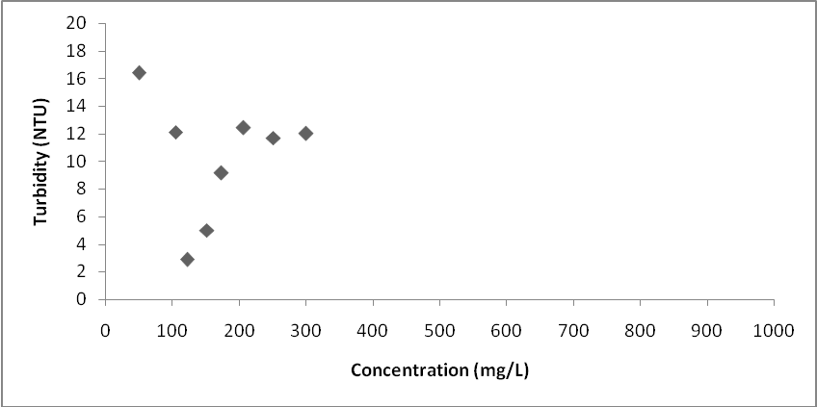
Plot 5. Jar Test with Variable Alum Dose at 10 ᵒC

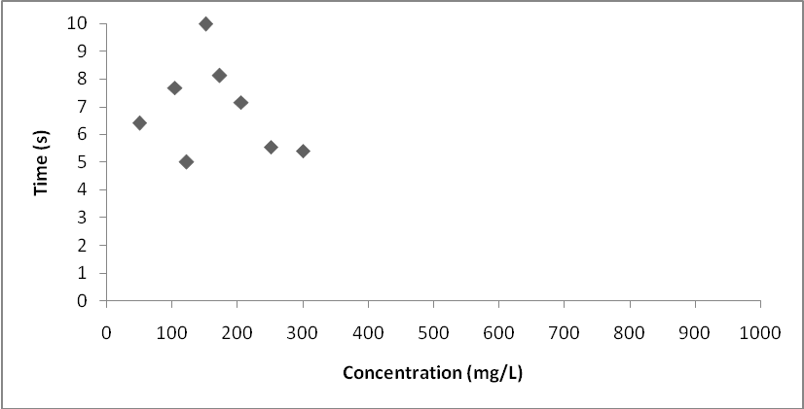
Plot 6. CST Test Experimets with Variable Alum Dose at 10 ᵒC

4.2.2 Effect of Temperature on Sludge Conditioning Using Polymer:
The effect of different temperatures on sludge conditioning were investigated using polymer (PRAESTOL).

4.2.2.1 Polymer conditioning at 30 ˚C:
Plot 7 shows that when the concentration of polymer increases the turbidity decreases until it reached 0.236 (mg/L) then it increases again to reach 0.74 (mg/L) which also gives the lower value of turbidity. However, the optimum dose is 0.236 (mg/L) because it's lower than 0.74 (mg/L). The CST Test supports this result as shown in plot 8.

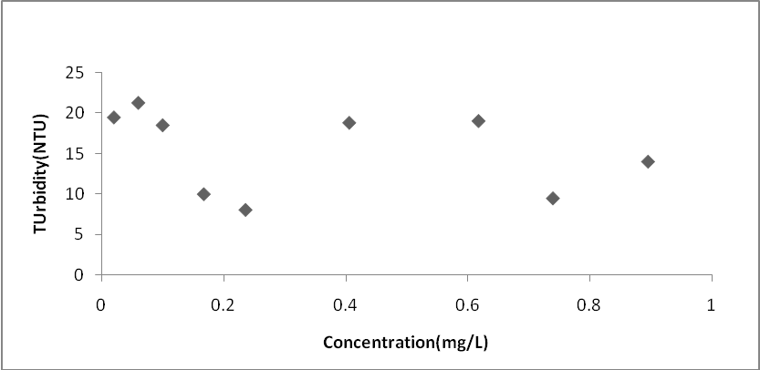
Plot 7. Jar Test with Variable Polymer Dose at 30 ˚C
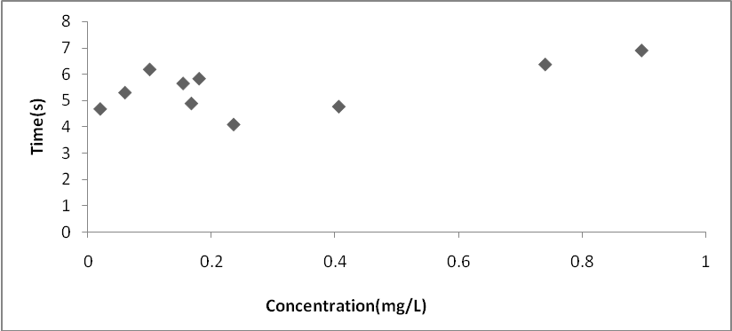
Plot 8. CST Test Experiments with Variable Polymer Dose at 30 ᵒC

4.2.2.2 Polymer conditioning at 20 ˚C :
Plot 9 and 10 show that the optimum polymer conditioning dose to achieve lowest turbidity and CST values is at 0.634 (mg/L).

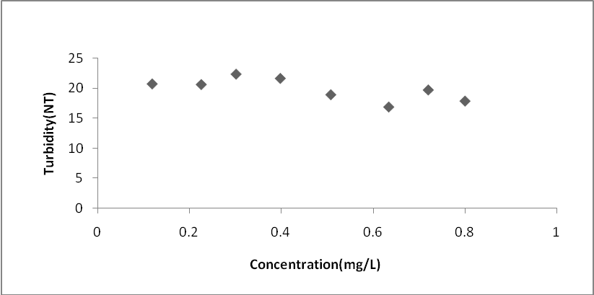
Plot 9. Jar Test with Variable Polymer Dose at 20 ˚C.

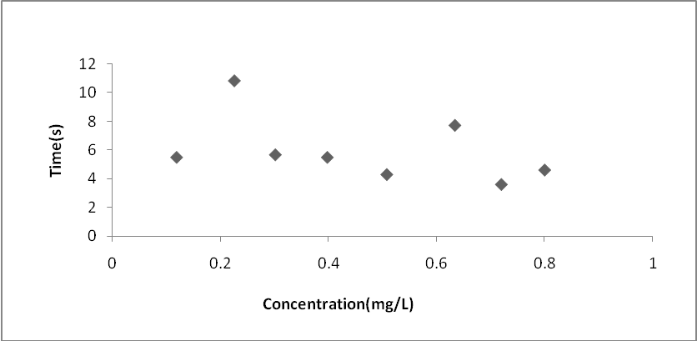
Plot 10. CST Test Experiments with Variable Polymer Dose at 20 ᵒC.

4.2.2.2 Polymer conditioning at 10 ˚C:

Plot 11 shows that as the concentration of polymer conditioner increases, the turbidity decrease until reaching a concentration of 0. 72 (mg/L), then it increase., The same result can be reached looking at CST test results.
It's clear that in the case of polymer conditioning the optimum value decrease with decreasing the temperature.

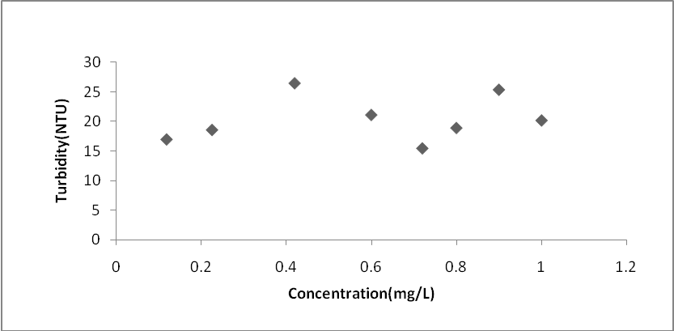
Plot 11. Jar Test with Variable Polymer Dose at 10 ˚C

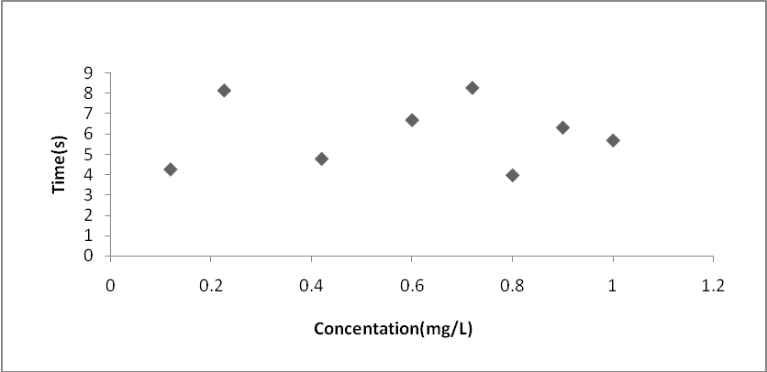
Plot 12. CST Test Experiments with Variable Polymer Dose10 ˚C

4.2.3 Comparison Between the Results of Sludge Conditioning Using Alum and Polymer With the Effect of Temperature:

Alum conditioner and temperature:
Plot 13 shows that the relationship between the optimum doses of conditioner and the temperature could be described by a quadratic polynomial regression. This indicates a nonlinear relationship between alum doses and the temperature. The coefficient of determination R² which is equal 1.0 indicates that the regression fits the data perfectly.
The reaction of alum in wastewater is endothermic reaction, so at low temperatures (less than 10 C˚), there is no enough heat to complete the reaction, which affects the rate of reaction. This is because aggregation rates and kinetics decrease with decrease in temperature [29].
Its noticed that at 30 ˚C, the optimum conditioner dose is almost double that at 20 C˚ and 10 C˚. this is because at high temperature the viscosity of the mono and polynuclear hydrolysis decrease and solubility increase, so larger dose is needed.[30]

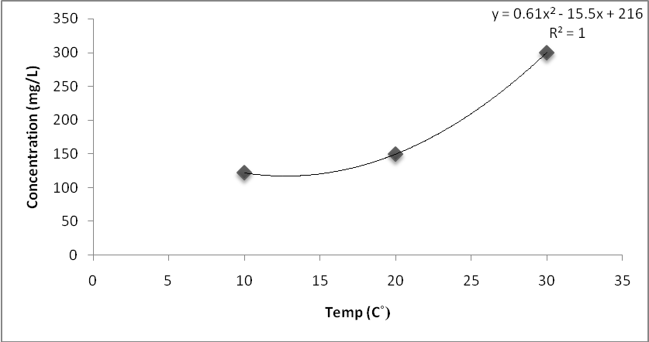
Plot 13. Relationship Between Optimum Alum Doses and Temperature.

Polymer conditioner and temperature:
Plot 14 shows that the relationship between the optimum doses of polymer with temperature could be also be described by quadratic polynomial regression as was with alum conditioner but in the opposite quadratic dimension (i.e. decreasing with the increase in temperature). This indicates a nonlinear relationship between polymer doses and temperature. The coefficient of determination R² is 1 which indicates that the none linear regression curve fits the data very well.
At higher temperature values, a larger area of contact is achieved which results in stronger adhesion. When the contact area increase, the number of particles sticking on the surface increase. High temperatures can also increase diffusion across the interface [31].
These two reasons cause less optimum polymer dose at 30 C˚ when it compares with doses at10ºC and 20ºC.

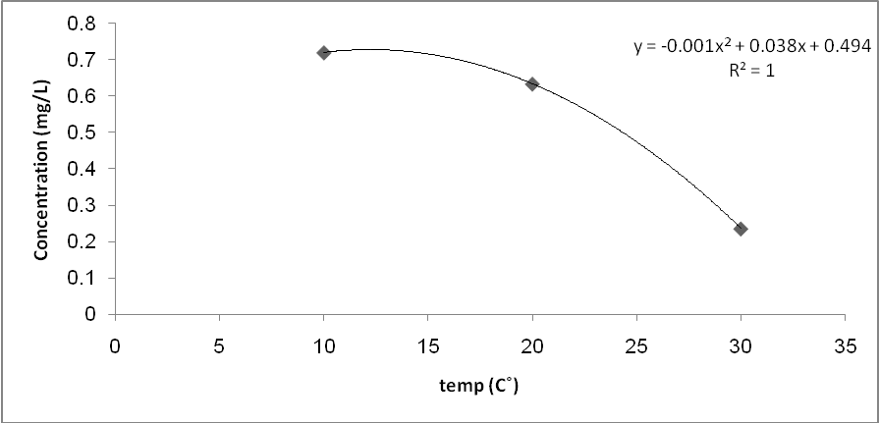
Plot 14. Relation Between the Optimum Polymer Doses with Temperature

Table 9 shows summary of optimum doses of polymer and alum at different temperatures.

Table 9. The Optimum Doses for Both Polymer (PRAESTOL) and Alum at Different Temperatures
Temperature (C˚) | Optimum Alum concentration (mg/L) | Optimum polymer concentration (mg/L)
30.0 | 0300.00 | 0000.24
20.0 | 0150.00 | 0000.63
10.0 | 0122.00 | 0000.72

4.3 Flock Structure of Waste Activated Sludge Samples
Figure (10-a) shows that the flock particles are small and homogenously distributed through the liquid.
In Figure (10-b), the particles aggregate together and form larger ones. And shows less small particle.
In Figure (10-c) the particles also aggregate to form flocks, but the size of flocks are smaller when compared with those when alum is used, and turbidity higher than in alum.
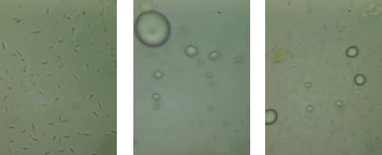
a) Before Conditioning b) After Alum Conditioning c) After Polymer Conditioning
Figure 11. Flock Structure of Samples

Table 10. Turbidity Values.
 | No conditioner | Alum conditioning | Polymer conditioning
Turbidity (NTU) | 233 | 0005.50 | 0009.06

The results of t test comparing the change in turbidy by temperature for both types of conditioner (alum and polymer) are shown in Table 11. The results were found to be statisitcally significant indicating that there is a significant differnce between polymenr and alum concentration at different testing temperatures.

4.3 T-Test
Table 11. T-Test Results.
 | Variable 1 | Variable 2
0Mean | 0191.00 | 0000.53
Variance | 9161.00 | 0000.07
Observations | 0003.00 | 0003.00
Pearson Correlation | -0000.99
Hypothesized Mean Difference | 0000.00
Df | 0002.00
t Stat | 0003.43
P(T<=t) one-tail | 0000.04
t Critical one-tail | 0002.90
P(T<=t) two-tail | 0000.07
t Critical two-tail | 0004.30

4.4 Conclusions and Recommendations:
- Optimal doses of alum conditioner at different temperatures were obtained and were 300, 150, 120 mg/L for 30, 20 and 10º C, respectively.
- Optimal doses of polymer conditioner at different temperatures were 0.236, 0.634, 0.72 mg/L for 30, 20 and 10º C, respectively.
- The relationship between optimal conditioner dose and temperature was quadratic.
- Optimum concentration of alum increased with the increase of the temperature.
- Optimum concentration of polymer decreased with the increase of the temperature.
- There was a significant difference between optimal dose of alum and polymer dose at different temperatures.
- It may be recommended that the optimal dose of conditioner is determent for each specific temperature and used at wastewater plant. This may result in better and more economical wastewater treatment.

References

[1]http://www.fao.org/docrep/t0551e/t0551e05.htm, accessed on April 25,2012
[2] www.sciencedirect.com, accessed on April 5,2012
[3] www.kfw-entwicklungsbank.de, accessed on April 7,2012
[4] (http://www.bionewsonline.com/x/what_is_activated_sludge.htm), accessed on April 25,2012
[5] http://www.snf-group.com/IMG/pdf/Water_Treatment_3_E.pdf , accessed on April 28,2012
[6] Al-Bireh Wastewater treatment process
[7] http://www.dahlem-consult.com/data/palestine_albirehwwtp_1603.pdf accessed on May 3,2012
[8] http://www.dahlem-consult.com/data/palestine_albirehwwtp_1603.pdf accessed on May 3,2012
[9] http://ag.arizona.edu/azwater/pdfs/Al-Sa%27ed.Al-Hindi.pdf accessed on May 3,2012
[10] http://www.bionewsonline.com/x/what_is_activated_sludge.htm. Accessed in 20 March 2012.
[11]http://alazhar.academia.edu/MhamadMohamad/Teaching/21988/Activated_sludge_process. Accessed in 25 March 2012.
[12] http://www.thewatertreatments.com/wastewater-sewage-treatment/activated-sludge-process/. Accessed in 20 March 2012.
[13] http://www.thewatertreatments.com/wastewater-sewage-treatment/coagulation-types/. Accessed in 9 April 2012.
[14]www.thewatertreatments.com/wastewater-sewage-treatment/coagulation-flocculation-process/. Accessed in 20 April 2012.
[15] http://www.uacg.bg/filebank/att_1846.pdf. Accessed in 15 April 2012.
[16] http://www.demolscorp.com/pdf/Anionic-Nonionic_TechData.pdf. Accessed in 19 April 2012.
[17] http://www.uacg.bg/filebank/att_1846.pdf. Accessed in 19 April 2012.
[18] Xuan Yin, Pingfang Han, Xiaoping Lu, Yanru Wang. A review on the dewaterability of bio-sludge and ultrasound pretreatment; Ultrasonics Sonochemistry; 2004; Volume 11, issue 6, pages 337-348.
[19] http://water.me.vccs.edu/courses/env110/coagulation.htm. Accessed in 19 April 2012.
[20] http://nptel.iitm.ac.in/courses/Webcourse-contents/IIT KANPUR/wasteWater/Lecture%2024.htm. Accessed in 19 April 2012.
[21] http://www.biology.ed.ac.uk/archive/jdeacon/statistics/tress4a.html . Accessed in 20 December 2012.
[22] http://www.kscience.co.uk/as/module5/ttest.htm accessed in 20 December 2012.
[23] Wastewater Engineering Treatment and Wastewater and Reuse by Metcalf & Eddy; 4th edition .
[24] http://www.laep.org/target/units/river/tour/solids.html, accessed on May 1,2012
[25] http://www.state.ky.us/nrepc/water/wcpph.htm , accessed on May 1,2012
[26] http://water.me.vccs.edu/courses/env149/ph.htm , accessed on May 1,2012
[27] http://halmapr.com/news/palintest/, accessed on May 1,2012
[28] http://water.me.vccs.edu/courses/env149/bod_test2.htm , accessed on May 1,2012
[29] http://www.sciencedirect.com/science/article/pii/S001191640800684X .Accessed on 13 December 2012
[30] (http://www.fishlarvae.com/e/bigbang/huntvonherbing.pdf) .Accessed on 13 December 2012
[31]http://www.micronano.ethz.ch/education/Lecture_1_Paper_JVST_Adhesion_Stiction_BB_03.pdf.Accessed on 13 December 2012 (

