AN-NAJAH NATIONAL UNIVERSITY
FACULTY OF ENGINEERING
ELECTRICAL ENGINEERING DEPARTMENT

Graduation Project
Performance analysis for algorithms in noise cancellation

Supervisor:
D. Allam Mousa

Prepared by:
Marwa Yahia Qadous
Shereen Awni Bader

2009 - 2010

الاهداء
إذا كان الإهداء يعبر ولو بجزء من الوفاء فالإهداء إلى معلم البشرية ومنبع العلم نبينا محمد ( صلى الله عليه وسلم ( إلى...مثل الأبوة الأعلى... والدي العزيز إلى....حبيبة قلبي الأولى...أمي الحنونة إلى ....رمز الحنان... إلى أم كل الناس... جدتي الغالية إلى....الحب كل الحب.... أخوتي وأخواتي إلى كافة الأهل والأصدقاء إلى من مهدوا الطريق أمامي للوصول إلى ما وصلنا اليه من العلم و اخص بالذكر الدكتور علام موسى اهدي هذا الجهد المتواضع.

المهندسة:
شيرين عوني بدر ,مروى يحيى قادوس

Table of Contents
Abstract 6
Chapter (1) 8
Introduction 8
Chapter (2) 10
Adaptive noise cancellation 10
2.1.0 What is noise? 10
2.1.1 Noise Classifications 11
2.1.1.1 White noise 11
2.1.1.2- Colored noise. 13
2.1.1.3 Impulsive noise 14
2.1.2 Effect of Noise 15
2.2 Speech 17
2.3 Adaptive Noise Cancellation 19
2.4 Adaptive filter: 19
2.4.1 Digital filter 20
2.4.1.1 Advantages of Digital Filtering 21
2.4.1.2 Disadvantages of Digital Filtering 21
2.4.1.3 FIR and IIR Filters 22
2.4.2 Algorithms used to adjust the coefficients of the digital filter 23
2.4.2.1 The LMS Algorithm 23
2.4.2.2 Normalized LMS: 24
2.4.2.3 Recursive least squares (RLS) algorithms 25
2.5 Performance Measures 27
2.5.1. Convergence Rate 27
2.5.2. Mean Square Error 28
2.5.3. Computational Complexity 28
2.5.4 Stability 28
2.5.5 Robustness 29
2.5.6 Filter Length 29
2.5.7 Segmental SNR and SNR 30
Chapter (3) 32
Simulation 32
Section (1): Analysis of Estimation Techniques Performance 32
3.1.1 LMS algorithm 32
3.1.2 NLMS algorithm 37
3.1.3 RLS algorithm: 44
Conclusion: 52
References: 55

LIST OF TABLES
Table ( 1):FIR vs. IIR filter 22
Table (2): comparison between algorithms. 50
Table 3: LMS resources 52
Table 4: NLMS resources 52
Table 5: RLS resources 53

LIST OF FIGURES
Figure (1.1): usual method of estimating noisy signal. 8
Figure (‎2.1): Realization of a Gaussian white noise process. 11
Figure (3.1): behavior of LMS algorithm for different filter length. 32
Figure (3.2): behavior of LMS algorithm for different step size (mu). 33
Figure (3.3): convergence curve of the LMS algorithm weights 34
Figure ‎(3.4): convergence curve of the LMS algorithm weights 35
Figure (3.5): convergence curve of the LMS algorithm weights 36
Figure (3.6): convergence curve of the LMS algorithm weights 36
Figure ‎(3.7): behavior of NLMS algorithm for different filter length. 37
Figure (3.8): behavior of N LMS algorithm for different step size (mu). 38
Figure (‎3.9): behavior of N LMS algorithm for different step size (mu). 39
Figure (3.10): convergence curve of the N LMS algorithm weights 40
Figure (3.11): convergence curve of the N LMS algorithm weights. 40
Figure ‎(3.12): convergence curve of the N LMS algorithm weights. 41
Figure (3.13): convergence curve of the N LMS algorithm weights. 41
Figure (3.14): convergence curve of the N LMS algorithm weights. 42
Figure ‎(3.15): convergence curve of the N LMS algorithm weights. 42
Figure(3.16): convergence curve of the N LMS algorithm weights. 43
Figure (3.17):behavior of R LS algorithm for different filter length. 44
Figure (3.18): convergence curve of the R LS algorithm weights. 45
Figure (3.19): convergence curve of the R LS algorithm weights. 45
Figure (‎3.20): convergence curve of the R LS algorithm weights. 46
Figure (‎3.21): convergence curve of the R LS algorithm weights. 47
Figure (3.22): convergence curve of the R LS algorithm weights. 47
Figure (3.23): convergence curve of the R LS algorithm weights. 48
Figure (3.24): convergence curve of the R LS algorithm weights. 48
Figure(‎3.25): convergence curve of the R LS algorithm weights. 49
Figure(3.26): convergence curve of the R LS algorithm weights. 49
Figure ‎(3.27): convergence curve of the R LS algorithm weights. 50

Abstract
One of the most problems that affect almost all of our daily life is the background noise, which has many sources such as Transportation vehicles, aircraft, railroad stock, trucks, buses, automobiles, and motorcycles all producing excessive noise.
These sources can be fall under some kind of noise; it may be white, colored or impulsive noise according to its power, and at what range of frequency it is occur.
Since noise is unwanted and undesirable changes to our environment, needed arise to get rid of noise, and many attempts were held for this purpose, one of the most effective methods is the adaptive noise cancellation.
Here we apply this method of adaptive noise cancellation on speech signal which has two main types voiced and unvoiced speech.
An adaptive filter is a digital filter that can adjust its coefficients to give the best match to a given desired signal. When an adaptive filter operates in a changeable environment the filter coefficients can adapt in response to changes in the applied input signals. Adaptive filters depend on recursive algorithms to update their coefficients and train them to near the optimum solution.
There are two main types of digital filters, finite impulse response (FIR) and infinite impulse response (IIR) filters. The filter output is calculated in a similar manner for both types.
Also, we have many algorithms we can use to adjust the filter coefficients, such as least mean square LMS, normalized LMS, leaky LMS, recursive least square RLS which we discuss briefly in chapter 2.
Using matlab we study and analyze the response of these algorithms as we change many parameters such as filter length and step size. These parameters affects convergence rate, MSE, computational complexity, number of iterations and stability, and all these are measures for the performance of our system of adaptive noise cancelation.
Here we use two types of tests to compare between these algorithms and find the most effective one; objective and subjective tests.
In objective test we use SNR and Segmental SNR as performance measure for this test; we examine the effect of changing language, speakers and gender on these algorithms.
The subjective test which depends on listening to the output of our system, the input for the system is the noisy signal and the noise; the output should be the signal without noise.
Finally we are going to compare between the results wither they matched or not.

Chapter (1)

Introduction
Speech is a very basic way for humans to convey information to one another with a bandwidth of only 4 kHz; speech can convey information with the emotion of a human voice. The speech signal has certain properties: It is a one-dimensional signal, with time as its independent variable, it is random in nature, it is non-stationary, i.e. the frequency spectrum is not constant in time. Although human beings have an audible frequency range of 20Hz to 20 kHz, the human speech has significant frequency components only up to 4 kHz.
The most common problem in speech processing is the effect of interference noise in speech signals. Interference noise masks the speech signal and reduces its intelligibility. Interference noise can come from acoustical sources such as ventilation equipment, traffic, crowds and commonly, reverberation and echoes. It can also arise electronically from thermal noise, tape hiss or distortion products. If the sound system has unusually large peaks in its frequency response, the speech signal can even end up masking itself.
One relationship between the strength of the speech signal and the masking sound is called the signal-to-noise ratio, expressed in decibels. Ideally, the S/N ratio is greater than 0dB, indicating that the speech is louder than the noise. Just how much louder the speech needs to be in order to be understood varies with, among other things, the type and spectral content of the masking noise.
The most uniformly effective mask is broadband noise. Although, narrow-band noise is less effective at masking speech than broadband noise, the degree of masking varies with frequency.
High-frequency noise masks only the consonants, and its effectiveness as a mask decreases as the noise gets louder. But low-frequency noise is a much more effective mask when the noise is louder than the speech signal, and at high sound pressure levels it masks both vowels and consonants.
The usual method of estimating a signal corrupted by additive noise is to pass it through a filter that tends to suppress the noise while leaving the signal relatively unchanged i.e. direct filtering.
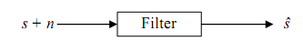
Figure (1.1): usual method of estimating noisy signal.
Filters used for direct filtering can be either Fixed or Adaptive.
1. Fixed filters - The design of fixed filters requires a priori knowledge of both the signal and the noise, i.e. If we know the signal and noise beforehand, we can design a filter that passes frequencies contained in the signal and rejects the frequency band occupied by the noise.
2. Adaptive filters - Adaptive filters, on the other hand, have the ability to adjust their impulse response to filter out the correlated signal in the input. They require little or no a priori knowledge of the signal and noise characteristics.

Chapter (2)

Adaptive noise cancellation
In this chapter we are going to talk about adaptive noise cancellation for speech signal, so before we start we must talk about speech and noise signals.

2.1.0 What is noise?
There are many definitions for noise, but all of these definitions agree that it is undesired signal; physics and electrical point of view about noise are being described below.
- In physics, the term noise has the following meanings:
- An undesired disturbance within the frequency band of interest; the summation of unwanted or disturbing energy introduced into a communications system from man-made and natural sources.
- A disturbance that affects a signal and that may distort the information carried by the signal.
- Random variations of one or more characteristics of any entity such as voltage, current, or data.
- A random signal of known statistical properties of amplitude, distribution, and spectral density.
- Loosely, any disturbance tending to interfere with the normal operation of a device or system.
- In electrical terms, noise defined as any unwanted introduction of energy tending to interfere with the proper reception and reproduction of transmitted signals. Many disturbances of an electrical nature produce noise in receivers modifying the signal in an unwanted manner.

2.1.1 Noise Classifications

2.1.1.1 White noise
White noise is a random signal (or process) with a flat power spectral density. In other words, the signal contains equal power within a fixed bandwidth at any center frequency.
White noise draws its name from white light in which the power spectral density of the light is distributed over the visible band in such a way that the eye's three color receptors (cones) are approximately equally stimulated.
An infinite-bandwidth white noise signal is purely a theoretical construction. By having power at all frequencies, the total power of such a signal is infinite and therefore impossible to generate. In practice, however, a signal can be "white" with a flat spectrum over a defined frequency band.
Statistical properties
The image displays a finite length, discrete time realization of a white noise process generated from a computer.
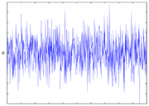
Figure (‎2.2): Realization of a Gaussian white noise process.
Being uncorrelated in time does not restrict the values a signal can take. Any distribution of values is possible (although it must have zero DC components). Even a binary signal which can only take on the values 1 or -1 will be white if the sequence is statistically uncorrelated. Noise having a continuous distribution, such as a normal distribution, can of course be white.
It is often incorrectly assumed that Gaussian noise (i.e., noise with a Gaussian amplitude distribution) is necessarily white noise, yet neither property implies the other.
Gaussianity refers to the probability distribution with respect to the value i.e. the probability that the signal has a certain given value, while the term 'white' refers to the way the signal power is distributed over time or among frequencies.
Gaussian white noise is a good approximation of many real-world situations and generates mathematically tractable models. These models are used so frequently that the term additive white Gaussian noise has a standard abbreviation: AWGN. Gaussian white noise has the useful statistical property that its values are independent.
In communications, the additive white Gaussian noise (AWGN) channel model is one in which the only impairment is a linear addition of wideband or white noise with a constant spectral density (expressed as watts per hertz of bandwidth) and a Gaussian distribution of amplitude. The model does not account for the phenomena of fading, frequency selectivity, interference, nonlinearity or dispersion. However, it produces simple and tractable mathematical models which are useful for gaining insight into the underlying behavior of a system before these other phenomena are considered.
Wideband Gaussian noise comes from many natural sources, such as the thermal vibrations of atoms in antennas (referred to as thermal noise or Johnson-Nyquist noise), shot noise, black body radiation from the earth and other warm objects, and from celestial sources such as the Sun.
The AWGN channel is a good model for many satellite and deep space communication links. It is not a good model for most terrestrial links because of multipath, terrain blocking, interference, etc. However, for terrestrial path modeling, AWGN is commonly used to simulate background noise of the channel under study, in addition to multipath, terrain blocking, interference, ground clutter and self interference that modern radio systems encounter in terrestrial operation.

2.1.1.2- Colored noise.
Any kind of filtered noise signal can be called 'colored noise', which is just to say that it is not a pure white noise. In audio, the most common color encountered is 'pink noise': Realized as sound, white noise sounds like the hiss of an untuned FM radio, or the background noise on a cassette tape player.
Because of the particular characteristics of the human ear, the sound of white noise is dominated by the very highest frequencies. To make an audible noise that sounds more as if it is balanced across the full range of audible frequencies, we have to boost the low range (the 'bass' of a conventional stereo) and cut the high frequency; there is still energy at every frequency, but now the balance is shifted. If we were to do the same thing with visible light - which is an electromagnetic wave varying through the colors of the rainbow from red at the lowest frequencies through to blue at the highest frequencies - we would get a pinkish color. Hence this kind of noise is called pink noise. Pink noise sounds more like a hiss mixed with a rumble, like the noise inside a flying passenger jet.
(Red light has a frequency of about 5x10^14 Hz, or about 10^12 times higher than the frequencies we can hear. The other big difference between sound waves and light waves is that sound is carried as variations in air pressure, so there is no sound in a vacuum, whereas light, like radio waves, exists as variations in electric field, which exists everywhere - so we can still see distant stars across the vacuum of outer space.)
In audio, you also see references to brown noise, which has an even stronger shift in energy towards the lower spectrum. In fact, the analogy with light would suggest we should call this deep red light, but by a neat coincidence, this kind of noise corresponds to a random-walk process in physics called Brownian motion (after the physicist who described it in 1828), and the color isn't far off. Brown noise sounds like rumbling.
The converse of pink noise, where energy increases for higher frequencies, is called blue noise, again by analogy with light. Blue noise isn't very interesting as a sound (it also sounds like a hiss) but has some important applications in image and video signals.
In general, all noise signals have parallels in the image domain. White noise looks pretty much like the static of an untuned TV set. Some of the more interesting colored noise sequences in images have energy in a limited range of frequencies (analogous to, say, green light) which can look like disordered patterns of ripples in sand or water.
pink noise, it doesn't much matter exactly how you map sound frequencies to light frequencies, since the rule is just that the energy decreases steadily with higher frequencies. For more specific colors, we would have to exactly specify the mapping between the two, and in fact there's no good mapping, since the range of visible light frequencies represents less than one factor-of-two or octave (430 trillion Hz to 750 trillion Hz), whereas the range of audible frequencies covers almost ten octaves (about 20 Hz to 20 thousand Hz; one Hz (Hertz) is one cycle per second). So there is no existing convention for mapping more specific colors to particular sounds.

2.1.1.3 Impulsive noise
It is a noncontinuous series of irregular pulses or noise "spikes" of short duration, broad spectral density and of relatively high amplitude. In the language of the trade, these spikes are often called "hits." Impulse noise degrades telephony only marginally, if at all. However, it may seriously corrupt error performance of a data circuit.
A noise level that fluctuates over a range greater than 10 dB during observation is classified as impulsive.
Impulsive sounds, such as gun shots, hammer blows, explosions of fireworks or other blasts, are sounds that significantly exceed the background sound pressure level for a very short duration.
- There is no clearly defined psychoacoustic concept of impulsiveness
- Impulsiveness is related to rapid onsets in signal
- If the repetition rate of impulses is >10-15 Hz, roughness is perceived
- In noise control, impulsiveness is considered to increase hearing damage risk compared to non-impulsive sound of same energy
- Measurements with the meter set to ‘Fast’ response do not accurately represent impulsive sounds.
However, man-made noise which appears urban environments cannot be assumed to be Gaussian. As it presents a shot nature, it has to be represented by an impulsive model. Gaussian and impulsive noise models present some differences.
The Gaussian model defines a Gaussian probability density function and a constant power spectral density. The power spectral density of the Gaussian noise is affected by linear filtering, while its probability density function is not. Therefore, after filtering, both in-phase and quadrature components are still independent Gaussian noises. Gaussian noise degrades slowly the objective quality of a digital communication system as its power level relative to the signal level increases. The main parameter of the Gaussian model is the noise power.
Conversely, impulsive noise is modeled as a random train of pulses with a very wide band power spectral density.
The probability density function of the impulsive noise changes by the filtering process. The resulting in-phase and quadrature components are uncorrelated but dependent .This kind of noise may jam the system, even in case of high signal to noise ratios.

2.1.2 Effect of Noise
Whether or not a sound is undesired by a person will depend on a number of factors:
(a) Loudness.
(b) Frequency.
(c) Continuity.
(d) Variation with time.
(e) Time of occurrence.
(f) Information content.
(g) Origin of the sound.
(h) Recipient's state of mind and temperament.
(i) Background noise level.
In general, the effects of noises are:
(a) Hearing Loss
Exposure to high noise levels causes hearing loss. This loss of hearing may be temporary, permanent, or a combination of both.
Temporary hearing loss results from exposure to short-term loud noises. As time passes, temporary hearing loss will disappear. Permanent hearing losses cannot be treated.
(b) Other Health Effects
People living or working in noisy environments develop the habit of shouting; some are stressed. There is evidence that noise can lead to psychiatric disorders. When human beings are exposed to high noise levels, the blood vessels constrict and muscles tense.
(c) Speech Interference & masking
One cannot effectively use speech communication in an environment in which the background noise level is too high. Sometimes, the masking of warning shouts by background noise is responsible for industrial accidents.
Nevertheless, a reasonable level of background noise is sometimes useful, e.g.
(i) The masking of speech so that speech privacy in large areas is maintained.
(ii) Minimizing the effect of intruding noises.
(iii) Maintaining the sanity of human beings: human beings cannot tolerate absolute silence in a perfect soundproof environment for any length of time.

2.2 Speech
Speech is an acoustic waveform that conveys information from a speaker to a listener. Given the importance of this form of communication, it is no surprise that many applications of signal processing have been developed to manipulate speech signals.
Speech sounds can be divided into two broad classes according to the mode of excitation. The two classes are voiced sounds, unvoiced sounds.
At a linguistic level, speech can be viewed as a sequence of basic sound units called phonemes. The same phoneme may give rise to many different sounds or allophones at the acoustic level, depending on the phonemes which surround it.
Different speakers producing the same string of phonemes convey the same information yet sound different as a result of differences in dialect and vocal tract length and shape.
Nearly all information in speech is in the range 200Hz to 8 kHz. Humans discriminate voices between males and females according to the frequency. Females speak with higher fundamental frequencies than males. The adult male is from about 50Hz to 250Hz, with an average value of about 120Hz. For an adult female, the upper limit of the range is of much higher, perhaps as high as 500Hz.
However different languages vary in its perceptibility due to differences in its phonetic contents and variations in distribution of different phonemes, stress level distribution among phonemes and of course intonation pattern, nasality usage, allophonic variants, contextual, phonotactic, or coarticulatory constraints etc.
Humans do have an intuitive understanding of spoken language quality, however this may not be easy to quantify. In a number of studies, it has been shown that impact of noise on degradation of speech quality is non uniform. Since speech frequency content varies, across time, due to sequence of phonemes, needed to produce the sentence, impact of background distortion will also vary, causing some phone classes to get more effected than others, when produced in a noisy environment.
Voiced and unvoiced speech:
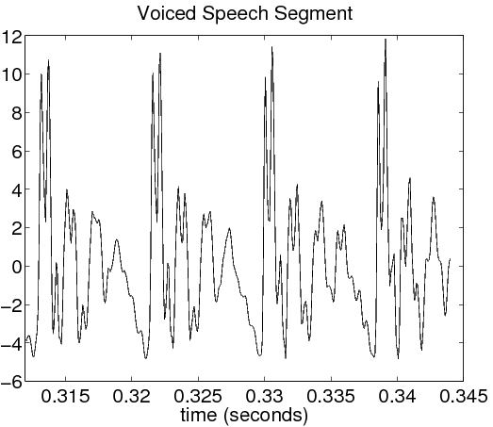
Figure (2.3): voiced speech segment
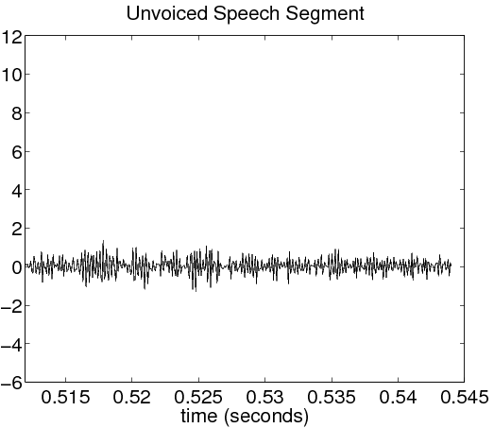
Figure (2.4): unvoiced speech segment
Notice that the voiced speech is much more periodic, while the unvoiced speech is much more random. Also the voiced speech power signal is higher than that of unvoiced speech.

2.3 Adaptive Noise Cancellation
The purpose of adaptive noise cancellation is to improve the signal-to-noise ratio (SNR) of a signal by removing noise from the signal that we receive.
In this configuration the input x (n), a noise source N1 (n), is compared with a desired signal d (n), which consists of a signal s (n) corrupted by another noise N0 (n). The adaptive filter coefficients adapt to cause the error signal to be a noiseless version of the signal s (n).
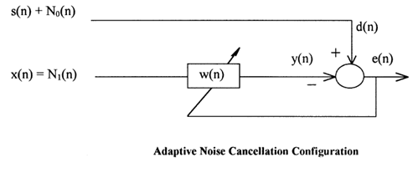
Figure (2.5): adaptive noise cancellation configuration.
Both of the noise signals for this configuration need to be uncorrelated to the signal s (n). In addition, the noise sources must be correlated to each other in some way, preferably equal, to get the best results.
Do to the nature of the error signal; the error signal will never become zero. The error signal should converge to the signal s (n), but not converge to the exact signal. In other words, the difference between the signal s (n) and the error signal e (n) will always be greater than zero.
The only option is to minimize the difference between those two signals

2.4 Adaptive filter:
An adaptive filter is no more than a digital filter, which can adjust its characteristics. It adapts to changes in its input signals automatically according to a given algorithm. The algorithm will vary the coefficients according to a given criteria, typically an error signal to improve its performance.
In essence an adaptive filter is a digital filter combined with an adaptive algorithm, which is used to modify the coefficients of the filter.
Adaptive filters are used in many diverse applications in today's world for example telephone echo canceling, radar signal processing, equalization of communication channels and biomedical signal enhancement.
Adaptive filters are useful:
- when the characteristics of a given filter must be variable
- when the spectrum of a given signal overlaps with the noise spectrum
- If the frequency band occupied by noise is unknown or may vary with time.
In most real world scenarios adaptive filters are realized using Finite Impulse Response (FIR) filters, since they are guaranteed to be stable and are simple to use.

2.4.1 Digital filter
The system or network in the case of digital filters are mathematical algorithms, these algorithms operate on digital signals and attempt to modify these signals in the same way analogue filters modify analogue signals. Equation2.1 defines the operation of linear digital filters .
$y(n)=\sum_{k=0}^{N−1}{h(k)−x(n−k)}$ 2.1

Where h (k), k = 0, 1…N-1 are the filter coefficients, x (n) is the filter input and y (n) is the filter output. We note at this point that the above Equation represents the convolution of the input signal x(n) with the filter’s impulse response h(k) to give the filter output y(n).

2.4.1.1 Advantages of Digital Filtering
- Automatic updating of frequency Response if a programmable processor is used, which means that adaptive filtering can be implemented more easily.
- The filter output and input can be stored for further use.
- Some characteristics are not possible with analogue filters.
- Can easily take advantage of advances in VLSI technology.
- Performance is not affected by temperature variations or by slight differences in components making it possible to repeat the characteristics from one filter to the next.
- More than one signal can be filtered at a time.
- Precision is only limited by word length.
- It is possible to use digital filters at lower frequencies, which are often found in biomedical applications.

2.4.1.2 Disadvantages of Digital Filtering
- The speed at which the filter operates may be limited by the speed of the processor or by the number of arithmetic operations involved. This number increases as the specifications of the filter are tightened.
- Digital filters are subject to round-off noise encountered in computation and if the input signal was sampled to Analogue to Digital Conversion noise.
- The design of digital filters is a far more complex task than designing an analogue filter. Computer aided design techniques in the right hands however do help to overcome this problem. Also once designed the system is usable with little or no modification for other different digital signal processing tasks.

2.4.1.3 FIR and IIR Filters
There are two main types of digital filters, finite impulse response (FIR) and infinite impulse response (IIR) filters. The filter output is calculated in a similar manner for both types. Equation 2.1 gives the equation for an FIR filter, the equation for an IIR filter is of the same form only that the sum is taken to infinity rather than to N-1 . From this it is clear that for IIR filters the impulse response is of infinite duration whereas for FIR filters it is only of length N.

Table ( 1):FIR vs. IIR filter
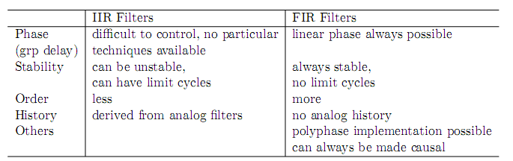
- The only way to achieve integer or fractional constant delays is by using FIR ﬁlters.
- Limit cycles are instability of a particular type due to quantization, which is severely non-linear.
- The number of arithmetic operations needed per unit time is directly related to ﬁlters order. #MAD stands for number of multiplications and additions. When using this as a criterion for comparing deferent ﬁlters, one should pay attention to whether the #MAD is measured per input sample, per output sample, or per unit time (clock cycle). It is possible that an IIR of lower order actually requires more #MAD than an FIR of higher order, because FIR ﬁlters may be implemented using polyphase structures.

2.4.2 Algorithms used to adjust the coefficients of the digital filter
There are many algorithms used to adjust the coefficients of the digital filter in order to match the desired response as well as possible. The LMS Algorithm is the more successful of the algorithms because it is the most efficient in terms of storage requirement and indeed computational complexity, the basic LMS algorithm updates the filter coefficients after every sample.

2.4.2.1 The LMS Algorithm
The Least-Mean-Square algorithm in words:
Figure (2.6): the LMS Algorithm in words
The simplicity of the LMS algorithm and ease of implementation means that it is the best choice for many real-time systems.
The implementation steps for the LMS algorithm
- Define the desired response. Set each coefficient weight to zero.

For each sampling instant (n) carry out steps (2) to (4):
- Move all the samples in the input array one position to the right, now load the current data sample n into the first position in the array. Calculate the output of the adaptive filter by multiplying each element in the array of filter coefficients by the corresponding element in the input array and all the results are summed to give the output corresponding to that data that was earlier loaded into the input array.
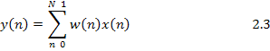
- Before the filter coefficients can be updated the error must be calculated, simply find the difference between the desired response and the output of the adaptive filter.
- To update the filter coefficients multiply the error by µ, the learning rate parameter and then multiply the result by the filter input and add this result to the values of the previous filter coefficients.
Where
µ: is the step size of the adaptive filter
Is the filter coefficients vector
Is the filter input vector
Then LMS algorithms calculate the cost function J (n) by using the following equation:
Where e² (n) is the square of the error signal at time n

2.4.2.2 Normalized LMS:
The normalized LMS (NLMS) algorithm is a modified form of the standard LMS algorithm. The NLMS algorithm updates the coefficients of an adaptive filter by using the following equation:
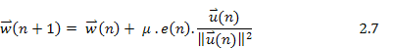
You also can rewrite the above equation to the following equation:
Where . In the previous equation, the NLMS algorithm becomes the same as the standard LMS algorithm except that the NLMS algorithm has a time-varying step size μ (n). This step size can improve the convergence speed of the adaptive filter.
The NLMS algorithm is a potentially faster converging algorithm compared to the LMS algorithm. Faster convergence, however, comes at a price of greater residual error.
The main drawback of the pure LMS algorithm is that it is sensitive to the scaling of its Input x (n). This makes it very hard to choose a learning rate μ that guarantees stability of the algorithm .The normalized least mean squares filter (NLMS) is a variant of the LMS algorithm that solves this problem by normalizing with the power of the input.

2.4.2.3 Recursive least squares (RLS) algorithms
The standard RLS algorithm performs the following operations to update the coefficients of an adaptive filter.
- Calculates the output signal y (n) of the adaptive filter.
- Calculates the error signal e (n) by using the following equation:
e (n) = d (n)–y (n).
- Updates the filter coefficients by using the following equation:
2.9
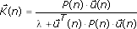
Where is the filter coefficients vector and is the gain vector. is defined by the following equation:
2.10
Where λ is the forgetting factor and P (n) is the inverse correlation matrix of the input signal.
P (n) has the following initial value P (0):
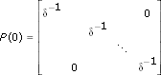
Where δ is the regularization factor. The standard RLS algorithm uses the following equation to update this inverse correlation matrix.
2.11
RLS algorithms calculate J (n) by using the following equation
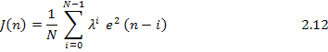
Where N is the filter length and λ is the forgetting factor.
This algorithm calculates not only the instantaneous value e² (n) but also the past values, such as e² (n–1), e² (n–2)... e² (n–N+1). The value range of the forgetting factor is (0, 1]. When the forgetting factor is less than 1, this factor specifies that this algorithm places a larger weight on the current value and a smaller weight on the past values. The resulting E [e² (n)] of the RLS algorithms is more accurate than that of the LMS algorithms.
The LMS algorithms require fewer computational resources and memory than the RLS algorithms. However, the eigenvalue spread of the input correlation matrix, or the correlation matrix of the input signal, might affect the convergence speed of the resulting adaptive filter. The convergence speed of the RLS algorithms is much faster than that of the LMS algorithms. However, the RLS algorithms require more computational resources than the LMS algorithms.
Understanding Eigen value Spread
The Eigen value spread, defined by the following equation, is the ratio between the maximum and minimum Eigen value of the input correlation matrix.
χ = λ_{max}/λ_{min} 2.13
Where λ_{max} and λ_{min} are the maximum and minimum eigenvalue of the input correlation matrix, respectively. The input correlation matrix has dimensions of N×N, where N is the filter length. The input correlation matrix is defined by the following equation:
2.14
Where is the filter input vector and E[x] is the mathematical expectation of x.
A large eigenvalue spread value of the input correlation matrix degrades the convergence of the resulting adaptive filter.

2.5 Performance Measures
In order to measure the performance of our system of noise cancellation we can use one or more of the following:
- Convergence rate.
- Mean square error.
- Computational complexity.
- Stability.
- Robustness.
- Filter length.
- SNR and Segmental SNR.
Next we will discuss all of the above.

2.5.1. Convergence Rate
The convergence rate determines the rate at which the filter converges to its resultant state.
Usually a faster convergence rate is a desired characteristic of an adaptive system. Convergence rate is not, however, independent of all of the other performance characteristics. There will be tradeoff, in other performance criteria, for an improved convergence rate and there will be a decreased convergence performance for an increase in other performance.
For example, if the convergence rate is increased, the stability characteristics will decrease, making the system more likely to diverge instead of converge to the proper solution. Likewise, a decrease in convergence rate can cause the system to become more stable.

2.5.2. Mean Square Error
The minimum mean square error (MSE) is a metric indicating how well a system can adapt to a given solution.
A small minimum MSE is an indication that the adaptive system has accurately modeled, predicted, adapted and/or converged to a solution for the system.
A very large MSE usually indicates that the adaptive filter cannot accurately model the given system or the initial state of the adaptive filter is an inadequate starting point to cause the adaptive filter to converge.

2.5.3. Computational Complexity
Computational complexity is particularly important in real time adaptive filter applications.
When a real time system is being implemented, there are hardware limitations that may affect the performance of the system. A highly complex algorithm will require much greater hardware resources than a simplistic algorithm.

2.5.4 Stability
Stability is probably the most important performance measure for the adaptive system. By the nature of the adaptive system, there are very few completely asymptotically stable systems that can be realized.
In most cases the systems that are implemented are marginally stable, with the stability determined by the initial conditions, transfer function of the system and the step size of the input.

2.5.5 Robustness
Robustness is a measure of how well the system can resist both input and quantization noise. It is directly related to the stability of a system.

2.5.6 Filter Length
The filter length of the adaptive system is inherently tied to many of the other performance measures.
The length of the filter specifies how accurately a given system can be modeled by the adaptive filter.
In addition, the filter length affects the convergence rate, by increasing or decreasing computation time, it can affect the stability of the system, at certain step sizes, and it affects the minimum MSE.
If the filter length of the system is increased, the number of computations will increase, decreasing the maximum convergence rate. Conversely, if the filter length is decreased, the number of computations will decrease, increasing the maximum Convergence rate.
For stability, due to an increase in length of the filter for a given system, you may add additional poles or zeroes that may be smaller than those that already exist. In this case the maximum step size, or maximum convergence rate, will have to be decrease to maintain stability.
Finally, if the system is under specified, meaning there is not enough pole and/or zeroes to model the system, the mean square error will converge to a nonzero constant. If the system is over specified, meaning it has too many poles and/or zeroes for the system model, it will have the potential to converge to zero, but increased calculations will affect the maximum convergence rate possible.

2.5.7 Segmental SNR and SNR
Let s (n) denote the noise-free speech signal at time n and ˆ s (n) the corresponding output of the noise reduction module, applied to the speech signal recorded under noisy conditions. S (n) and ˆ s (n) are scaled in amplitude and aligned in time.
General SNR
The signal-to-noise ratio (SNR) provides a comparison of the amount of signal with the amount of background noise in a particular signal, such that a higher SNR indicates the background noise is less noticeable. The decibel is defined in such a way that the SNR may be applied to any signal, regardless of its source
The general SNR is deﬁned as:
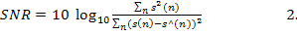15

What is Noise Power?
In telecommunication, the term noise power has the following meanings:
- The measured total noise per bandwidth unit at the input or output of a device when the signal is not present.
- The power generated by a random electromagnetic process.
- Interfering and unwanted power in an electrical device or system.
- In the acceptance testing of radio transmitters, the mean power supplied to the antenna transmission line by a radio transmitter when loaded with noise having a Gaussian amplitude-vs.-frequency distribution.
Next we are going to study the relation between noise power and SNR, and we should see that by increasing noise power SNR will decrease.

Segmental SNR
The segmental SNR (SNR) is deﬁned as averages of measurements of SNR over short, “good frames”. The "good frames” are frames where the SNR is above a lower threshold (for example -10 dB), and saturated at an up- per threshold (in our application +30 dB). “Short frames "have a typical length of 15-25 ms. The SNR is deﬁned as:
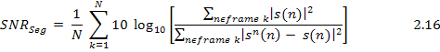

With: N the number of good frames and n ∈ k the time instances n that are in the time window of the kth frame.
In a speech enhancement In general speech enhancement or noise reduction is measured in terms of improvement in SNR and segmental SNR.

Chapter (3)

Simulation

Section (1): Analysis of Estimation Techniques Performance
Here we are going to study the effect of changing filter length, step size and number of coefficients on estimation techniques.
How these parameters affects the performance measures of our system, like convergence rate, MSE, computational complexity and stability.

3.1.1 LMS algorithm
- Filter length effect:
Figure (3.3): behavior of LMS algorithm for different filter length.
The above figure shows the behavior of the LMS algorithm for different filter length, and fixing all other parameters like step size, number of iteration,…, etc.
As we see if we increase the filter length we can get faster convergence, i.e. we need less iteration to reach the steady state.
For example if we look to the curves corresponding to 6 and 20 filter lengths, we reach the steady state in approximately 1200 iteration for 20 filter length, but we reach 40000 iteration and still need more to reach the steady state for the 6 filter length.
On the other hand, the filter complexity will increase, because we need more computations like addition and multiplication.
- Step size effect:
The variable mu is the step size, which controls how much the correction aﬀects the old coeﬃcient. If the step size is chosen small, the system will converge slowly, however, choosing a big step size, the system will converge faster, also we need less number of iteration to reach the steady state.
Figure (3.4): behavior of LMS algorithm for different step size (mu).
As we see from above figure, if we increase the step size, we have faster convergence.
We can notice that if we look to the curves corresponding to 2 and 0.1 values of mu, we reach the steady state at approximately 600 iteration for mu=2, but we reach 4000 iteration and still we need more iteration to reach the steady state.
- Convergence of the weights:
The numbers of weights or filter coefficients are equal to the filter length.
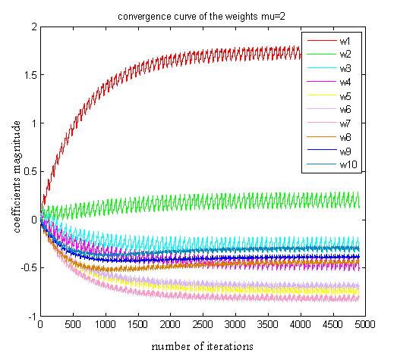
Figure (3.5): convergence curve of the LMS algorithm weights

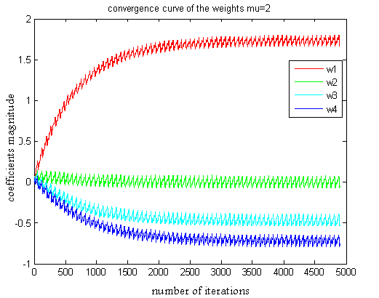
Figure ‎(3.6): convergence curve of the LMS algorithm weights
As we mention before the LMS algorithm is stable one, and we can note that from the weights curve, there is no ripples, but it need a large number of iteration to converge and to reach the steady state.
As we can see from the above curves, we need more and more iteration as we decrease the number of coefficient to reach the steady state of our system, so will increase the system complexity since it needs more computational operation, and longer time to process.

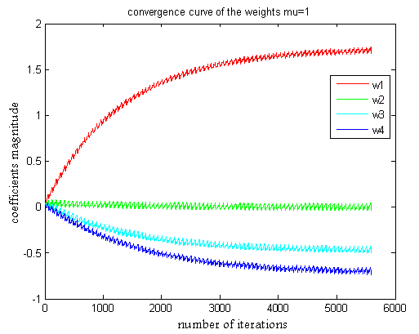
Figure (3.7): convergence curve of the LMS algorithm weights
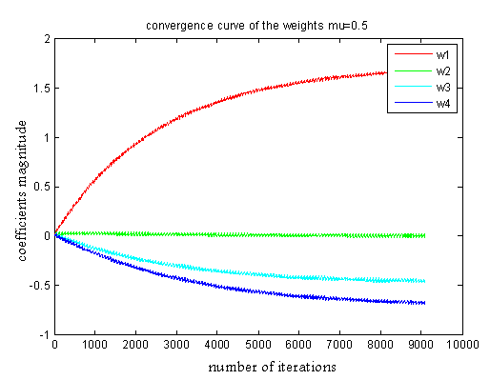
Figure (3.8): convergence curve of the LMS algorithm weights
For a system with a number of coefficients equal to 4, if we increase mu, our system will converge faster.

3.1.2 NLMS algorithm
- Filter length effect:

Figure ‎(3.9): behavior of NLMS algorithm for different filter length.
The NLMS algorithm is a fast convergence algorithm, at the expense of having larger steady state error for small filter length, but for larger filter length we have faster convergence and minimum steady state error.
We also need less number of iteration to reach the steady state of our system.

- Step size effect:
Figure (3.10): behavior of N LMS algorithm for different step size (mu).
For a very large mu the system the system will ripple until reach the steady state, this will affects the stability of the system, it maybe unstable, but if we decrease the value of mu the ripple will decrease, system becomes stable and converge faster.
For a suitable step size our system will converge fast, will be stable and we can get minimum steady state error.

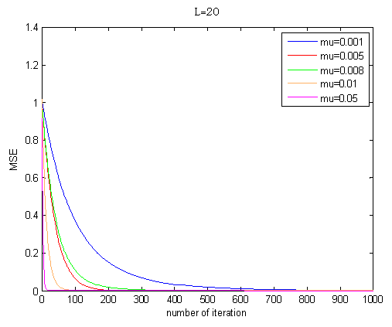
Figure (‎3.11): behavior of N LMS algorithm for different step size (mu).
Here for small step size our system will be slow, more stable, we need more iteration to reach the steady state, and so, we need more computation time and operation.
The value of MSE when large mu used is less than that when small mu is used.
- Convergence of the weights:
The NLMS is a fast convergence algorithm but its coefficients will ripple up and down before reaching their steady state.
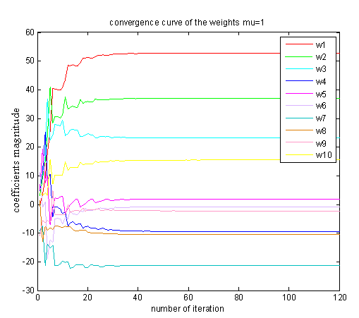
Figure (3.12): convergence curve of the N LMS algorithm weights
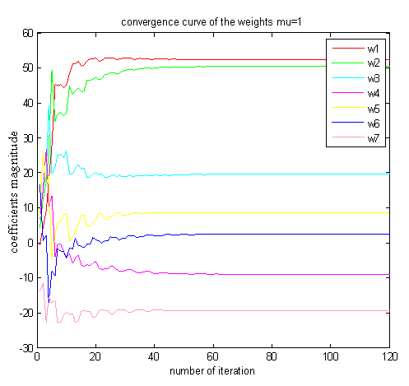
Figure (3.13): convergence curve of the N LMS algorithm weights.

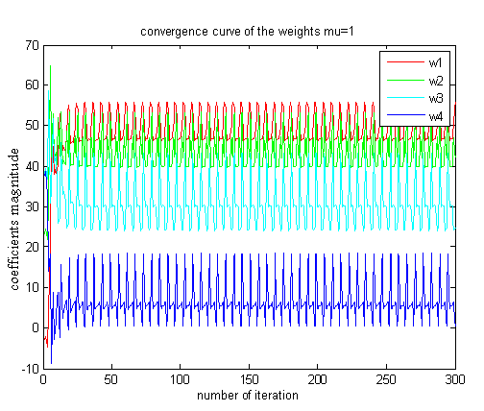
Figure ‎(3.14): convergence curve of the N LMS algorithm weights.
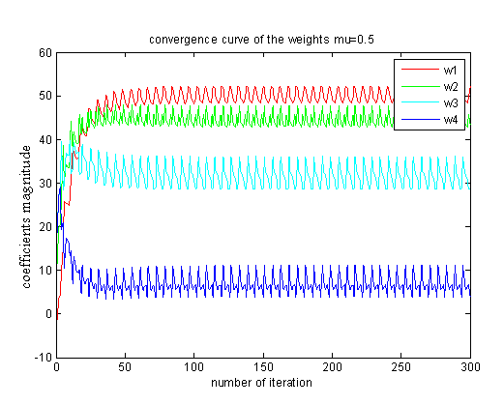
Figure (3.15): convergence curve of the N LMS algorithm weights.
Figure (3.16): convergence curve of the N LMS algorithm weights.
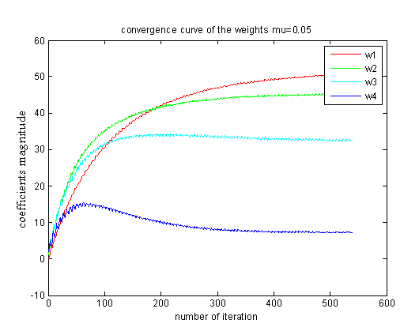
Figure ‎(3.17): convergence curve of the N LMS algorithm weights.
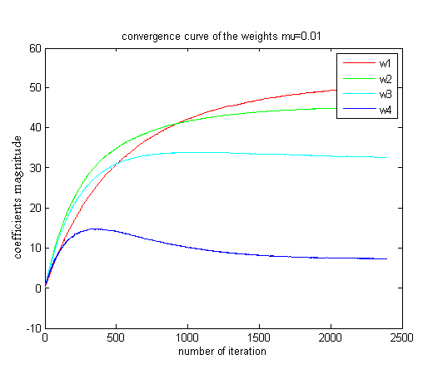
Figure(3.18): convergence curve of the N LMS algorithm weights.
As we see from the above figures, when the number of coefficients are large our system will converge faster, and the steady state error will be minimum.
But by decreasing the number of coefficients we need more iteration to converge, and the steady state error will increase.
For a system having 4 coefficients, we note that if we decrease the value of mu the steady state error will decrease, but we need more iteration to converge and reach the steady state.

3.1.3 RLS algorithm:
- Filter length effect:
Figure (3.19):behavior of R LS algorithm for different filter length.
RLS algorithm has a fast convergence characteristic, and if we increase filter length we obtain faster convergence, but at small filter length we have a large steady state error, and it will be minimum for a large filter length.
- Convergence of the weights:
Also the RLS is a fast convergence algorithm and its coefficients will ripple up and down before reaching their steady state.
RLS algorithm doesn’t depend on step size, it depends on another parameter called lambda.

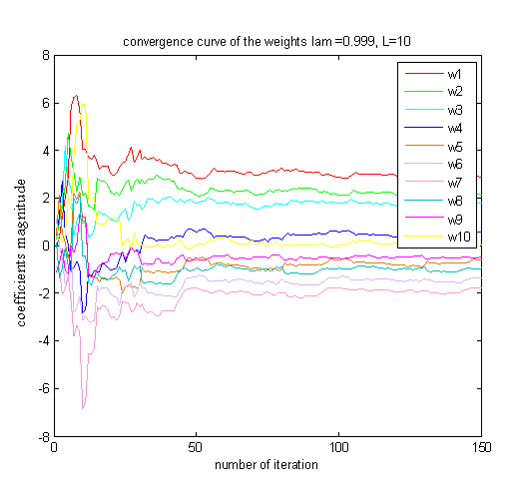
Figure (3.20): convergence curve of the R LS algorithm weights.
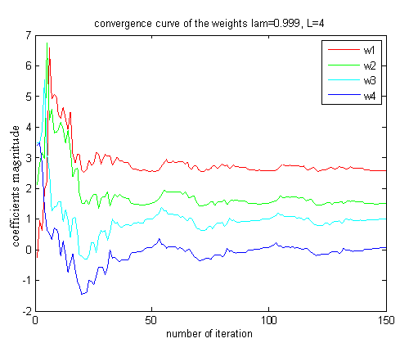
Figure (3.21): convergence curve of the R LS algorithm weights.
As we see from the above figures, if we decrease the number of coefficients our system will need more iteration to converge.
- Effects of lambda (forgetting factor)
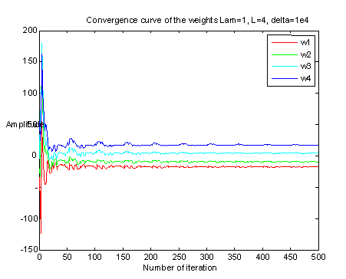
Figure (‎3.22): convergence curve of the R LS algorithm weights.
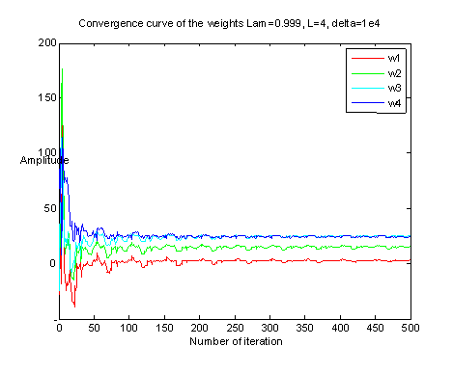
Figure (‎3.23): convergence curve of the R LS algorithm weights.
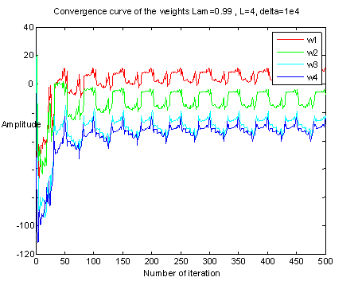
Figure (3.24): convergence curve of the R LS algorithm weights.
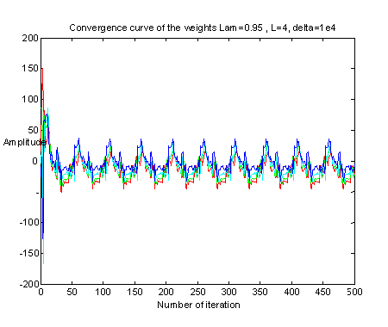
Figure (3.25): convergence curve of the R LS algorithm weights.
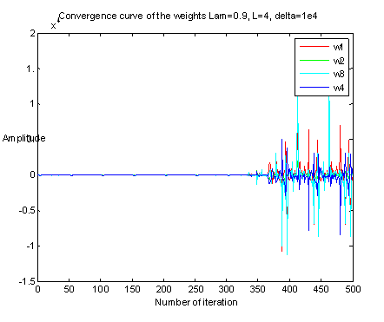
Figure (3.26): convergence curve of the R LS algorithm weights.
If we reduce the value of lambda steady state error will increase, and as we see from the last figure system will be unstable.
So, from this point we see that in using RLS algorithm we have limitation in using lambda.
- Effect of delta (regularization factor)
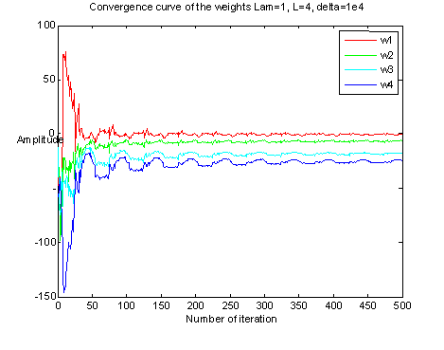
Figure(‎3.27): convergence curve of the R LS algorithm weights.
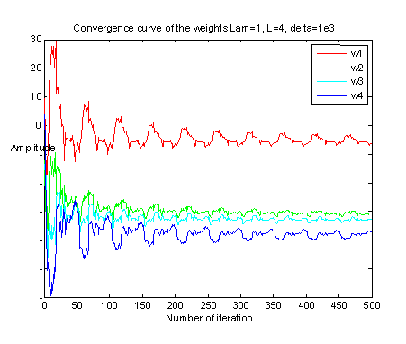
Figure(3.28): convergence curve of the R LS algorithm weights.
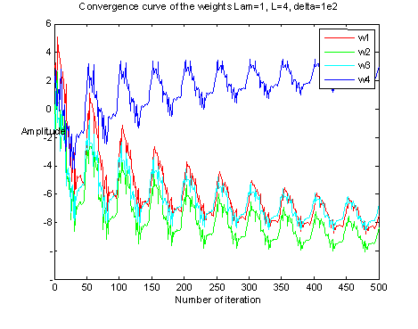
Figure ‎(3.29): convergence curve of the R LS algorithm weights.
If we increase the value of delta, we need less iteration to converge, and steady state error will decrease.
Table (2): comparison between algorithms.
Algorithm | Filter length | Step size | Convergence of the weights
LMS | - Need more iteration to converge and reach steady state.  - Has mediate value of MSE. | - As we increase mu we need less number of iteration to converge.  - Has larger value of MSE than NLMS. | - Need more iteration to converge than NLMS and RLS.  - As we decrease number of weight we need more iteration to reach steady state.  - As we decrease mu we need more iteration to converge but steady state error (ripple) will be decreased.
NLMS | - Need less iteration than LMS and RLS to converge and reach steady state.  - Has the lowest value of MSE. | - For large value of mu the system will be unstable where as for small value of mu the system will be stable and it need less number of iteration to converge than LMS.  - Has less value of MSE than LMS. | - Need less iteration to converge than LMS and RLS.  - As we decrease number of weight we need more iteration to reach steady state.  - As we decrease mu we need more iteration to converge but steady state error (ripple) will be decreased.
RLS | - Need less iteration than LMS to converge and reach steady state.  - Has the highest value of MSE. |  | - Need less iteration to converge than LMS and more iteration than NLMS.  - As we decrease number of weight we need more iteration to reach steady state.

According to these results NLMS algorithm gives the best performance.

Conclusion:
In LMS and NLMS algorithms the mean values of the filter coefficients converge towards their optimal solution. Therefore, the filter coefficients will fluctuate about their optimum values. The amplitude of the fluctuations is controlled by the step size. The smaller the step size, the smaller the fluctuations (less final misadjustment) but also the slower the adaptive coefficients converge to their optimal values.
The resources required to implement the LMS algorithm for a transversal adaptive FIR filter of coefficients in real time is given in the table below. The computations given are those required to process one sample.

Table 3: LMS resources
MULTIPLY | 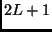
ADD
DIVIDE | 0

The resources required to implement the NLMS algorithm for a transversal adaptive FIR filter of coefficients in real time is given in the table below. The computations given are those required to process one sample and assume that recursive estimation of the input power is used.

Table 4: NLMS resources
MEMORY | 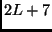
MULTIPLY | 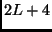
ADD | 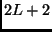
DIVIDE | 1

Compared to least mean squares (LMS) algorithms, recursive least squares (RLS) algorithms have a faster convergence speed and do not exhibit the eigenvalue spread problem. However, RLS algorithms involve more complicated mathematical operations and require more computational resources than LMS algorithms.
The resources required to implement the RLS algorithm for a transversal adaptive FIR filter of coefficients in real time is given in the table below. The computations given are those required to process one sample.

Table 5: RLS resources
MEMORY | 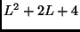
MULTIPLY | 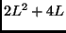
ADD | 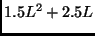
DIVIDE | L

According to the above tables, we can see that the LMS algorithm is the simplest algorithm; it doesn’t need too much operation and computation, whereas the RLS algorithm is the most complex one.

As we mention at the beginning we divided our work in this project in to two tests, objective and subjective.
In objective test, SNR test, we see that RLS algorithm gives better performance but sometimes NLMS algorithm becomes better, depending on the input signal power, whereas LMS algorithm gives worst performance.
Also, in subjective test, listening test, NLMS algorithm remove all the noise but we can hear that the output is throttled, but if we increase the filter length we can overcome this problem, then it will be the best performance.
In RLS algorithm, the noise is not completely removed, we still hear some noise in the output, but we don't have the problem that we have in NLMS algorithm, sound is not throttled when we use small filter length, so if we compare RLS and NLMS at the case of small filter length, we prefer to use RLS because it doesn’t alter the speech itself, speech not throttled.
LMS algorithm gives the worst result, the amount of noise exist in the output is heard very well, and it is nearly the same as that noise exists in the noisy signal.
From all the above results, we can say that according to our application, and the requirement of this application; if it is required to be fast, simple, the level of accepted error,….,etc, it is easy to choose the suitable algorithm that match our need.

References:
- http://searchenterprisewan.techtarget.com/generic/0,295582,sid200_gci1071926,00.html
- http://personal.cityu.edu.hk/~bsapplec/effectof.htm
- ocw.mit.edu/NR/rdonlyres/89A0504C-6C10-463B.../0/lec08.pdf
- http://en.wikipedia.org/wiki/Noise_power
- www.ktu.lt/lt/mokslas/zurnalai/elektros_z/.../03_T170_vr-vijay.pdf
- Least Mean Squares (LMS) Algorithms (Adaptive Filter Toolkit) - LabVIEW Adaptive Filter Toolkit 1_0 Help.htm (zone.ni.com ‏› Support ‏› Product Reference ‏› Manuals)
- Thesisweb.html
- Filtered-X LMS Algorithms (Adaptive Filter Toolkit) - LabVIEW Adaptive Filter Toolkit 1_0 Help.htm
- anr_tech.htm
- cwww.ee.nctu.edu.tw/course/asp/ASP04.pdf
- personal.ee.surrey.ac.uk/Personal/T.Windeatt/word_bkp/.../nn2.pdf
- en.wikipedia.org/wiki/Noise
- en.wikipedia.org/wiki/White_noise
- en.wikipedia.org/wiki/Colors_of_noise
- what-is-what.com/what_is/noise_pollution.html
- ptolemy.eecs.berkeley.edu/~eal/ee225a/lab/lab3.pdf
- http://cnx.org/content/m12009/latest/
- www.ece.gatech.edu/~barry/digital/supp/20echo.pdf
- http://www.school-for-champions.com/science/noise_cancellation.htm
- www.freewebs.com/hpramono/195%20Final%20Project.doc
- http://www.ehow.com/how_5139937_calculate-signal-noise-ratio.html
- http://zone.ni.com/reference/en-XX/help/372357A-01/lvaftconcepts/aft_ rls_algorithms/
- http://zone.ni.com/reference/en-XX/help/372357A-01/lvaftconcepts/aft_ algorithms/#eigenvalue
- http://www.dspalgorithms.com/aspt/asptnode54.html
- http://www.dspalgorithms.com/aspt/asptnode59.html

