

AN-Najah National University

Factuality of Engineering

## Department of Electrical Engineering

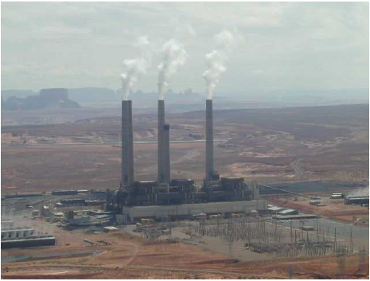

***Analysis ,Improvement,Conservation,and Design PV System For Electrical Network of the Beat Ommar Twon***

*Prepared by :-*

***Iyad Obaid***

***Osama Yousef***

*Presented to :-*

***Dr. Imad Ibrik***

***2010***

**Table of Contents**

|  |  |  |
| --- | --- | --- |
| ***Page*** | ***Content*** | ***NO****.* |
|  | *Acknowledgment* |  |
|  | *Abstract* |  |
|  | *Introduction* |  |
|  | ***Electrical network*** | ***Chapter 1*** |
|  | *Electrical supply* | *1.1* |
|  | *Energy consumption* | *1.2* |
|  | *The nature of the load* | *1.2.1* |
|  | *The growth rate of the load* | *1.2.2* |
|  | *Daily load curve* | *1.2.3* |
|  | *Element of beat Ommar network* | *1.3* |
|  | *Distribution transformer* | *1.3.1* |
|  | *Medium voltage 33kv line* | *1.3.2* |
|  | ***Analysis of the network*** | ***Chapter 2*** |
|  | *ETAP power station* | *2.1* |
|  | *One line diagram* | *2.2* |
|  | *Data needed for the load flow analysis* | *2.3* |
|  | *The real and reactive power* | *2.3.1* |
|  | *The length and the resistance* | *2.3.2* |
|  | *Load flow analysis* | *2.4* |
|  | *The medium voltage* | *2.4.1* |
|  | *Low tension voltage* | *2.4.2* |
|  | *Power factor* | *2.4.3* |
|  | *Load factor* | *2.4.4* |
|  | *Summary* | *2.4.5* |
|  | *Load flow analysis for minimum case* | *2.5* |
|  | *The medium voltage* | *2.5.1* |
|  | *The low tension voltage* | *2.5.2* |
|  | *Summary* | *2.5.3* |
|  | *Problem of the network* | *2.6* |
|  | *Solution and recommendation* | *2.7* |
|  | ***Electrical network improvement*** | ***Chapter 3*** |
|  | *Power factor improvement* | *3.1* |
|  | *problem of low power factor* | *3.1.1* |
|  | *How to improve the power factor* | *3.1.2* |
|  | *Distribution of the capacitor* | *3.1.3* |
|  | *The result of maximum case* | *3.1.4* |
|  | *Power factor after adding capacitor for max case* | *3.1.4.1* |
|  | *Summary of maximum case after correction* | *3.1.4.2* |
|  | *The result for minimum case* | *3.1.5* |
|  | *Power factor after adding the capacitor for min case* | *3.1.5.1* |
|  | *Summary of min case after correction* | *3.1.5.2* |
|  | *Comparison between the original and improvement case* | *3.1.6* |
|  | *Voltage correction* | *3.2* |
|  | *Economy study* | *3.3* |
|  | ***Energy conservation*** | ***Chapter 4*** |
|  | *Energy conservation for street lighting* | *4.1* |
|  | *Energy conservation for water pump* | *4.2* |
|  | *Energy conservation in residential sector* | *4.3* |
|  | *Replacing the incandescent lamp by the CFL lamp* | *4.3.1* |
|  | *Energy conservation for refrigerators* | *4.3.2* |
|  | *Load factor improvement* | *4.4* |
|  | ***Design PV system for electrification of Safa village*** | ***Chapter 5*** |
|  | *Introduction* | *5.1* |
|  | *The electrical loads of house hold for Safa village* | *5.2* |
|  | *Design of centralized PV system component for the Safa village* | *5.3* |
|  | *PV generating sizing* | *5.3.1* |
|  | *The battery , charge regulator , and inverter* | *5.3.2* |
|  | *Electrical network map for centralized case* | *5.3.3* |
|  | *Design decentralized PV system component for Safa village* | *5.4* |
|  | *PV generating sizing* | *5.4.1* |
|  | *The battery, charge regulator ,inverter* | *5.4.2* |
|  | *Economy evaluation of centralized and decentralized PV system for Safa village* | *5.5* |
|  | *The cost of centralized and decentralized PV system for Safa village* | *5.5.1* |
|  | *Which project we select centralized or decentralized* | *5.5.2* |
|  | *Cash flow for centralized PV system* | *5.5.2.1* |
|  | *Cash flow for decentralized PV system* | *5.5.2.2* |
|  | *Max overall efficiency for centralized and decentralized PV system* | *5.6* |
|  | *Building integrated photovoltaic (BIPV) system* | *5.7* |

***Acknowledgment***

* We would like to take the opportunity to thank people who guided and supported us during this work.
* We are very grateful to our parents whose have always given us their encouragement and support.
* We wish to express our deepest gratitude to our supervisor " **Dr. Imad Ibrik** " for showing great interest in our work and for the guidance that he has given us.
* Thanks to our doctors especially “**Dr.prof.Marwan Mahmud**” and “Dr.Maher khammash” Head of Elec.Eng.Dep .
* Thanks to our friends for their encouragement and mental support during this work.
* Our thanks is also directed to everyone gives us information and help in our project, especially the electrical department in BEAT OMMAR.

**Abstract**

Our project is to make a load flow study and analysis for BEAT OMMAR Electrical Network using ETAP software to improve the power factor and to reduce the electrical losses in the network and so, reducing the penalties in the total tariff for the municipality, increasing the reliability of the network. More over we want to increase the capability of the transformers and the transmission lines.

We made a conservation energy study in order to decrease the consumption and the peak demand. We made that study on all sectors of the network such as houses, street lighting, water pumping .. etc.

we made analysis for three houses on SAFA site, and design of centralized and decentralized PV system component for these houses and we made economic model for selection optimum configuration of PV system (centralized and decentralized ).

To do that we will follow the sequence bellow :

* Analyzing this network by collecting data such as resistance and reactance, length, rated voltages, max power and reactive power on each bus .
* We entered these data to the software ( ETAP) and getting the results .
* We will give recommendations and conclusions.
* The improvements for elements of the network.
* Study the three houses load.
* Design of centralized and decentralized PV system for these houses.

**Introduction**

The power system in general consists of these parts:

1. **Generating station**: And this part consists of
2. Generators in which electric power is produced by 3-phase alternators operating in parallel. And usually electric power is generated at voltages of 12kv to 25kv.
3. Sub-station, where the power transformers step up the voltage to between 66kv 1000kv.
4. **Primary transmission**. The electric power at high voltages is transmitted by 3-phase 3-wire over head system to the outskirts of the city. This forms the primary transmission.
5. **Secondary transmission**. The primary transmission line terminates at the receiving station which usually lies at the outskirts of the city. At the receiving station the voltage is reduced to 33kv or 22kv by step-down transformers. From this station, electric power is transmitted at one of these voltages by 3-phase 3-wire overhead system to various sub-stations located at strategic points in the city. This forms the secondary transmission.
6. **Primary distribution**. the secondary transmission line terminates at the sub-station where voltage is reduced from the secondary voltage to the primary distribution voltage usually 11kv ,could be 6.6kv 3-phase 3-wire .the 11kv lines run along the important road sides of the city . And forms the primary distribution.
7. **Secondary distribution**. The electric power form primary distribution line is delivered to distribution sub-stations. These sub-stations are located near the consumers localities and step down the voltage to 400v 3-phase 4-wire for secondary distribution. And this forms secondary distribution.

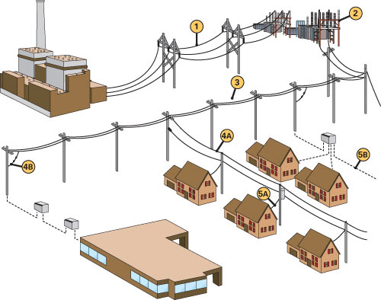

**Energy sector in Palestine**

Energy sector in Palestine faced sever since the Israeli occupation , financial and management obstacles due to the severe restrictions imposed by the Israeli occupation. as a result of this situation Palestine has not yet a unified power system , the existing network is local low voltage distributions networks connected to Israeli electrical corporation (IEC) , where around 97% of consumed energy were and still supplied by the IEC .

The voltages of the existing distribution networks are :

( 0.4 , 6.6 , 11 , 22 , and 33 KV ) . IEC supplies electricity to the electrified communities by 22 or 33 KV by overhead lines . electricity is purchased from IEC and then distributed to the consumers.

The existing electricity situation is characterized in old fashion over loaded networks , high power losses ( more than 20% ) , low power factor ,poor system reliability , high prices of electricity supplied to the consumer due to high tariff determined by the IEC in addition , many villages depend on diesel generators to provide their own needs of electrical energy .

Due to all factors mentioned above, it becomes very important to design a national independent power system for the west bank of Palestine which will connect all the west bank areas by a reliable network to a national generating plant . the national power system should have the minimum annual cost and provide the consumer with a high quality of electric energy . this power system should also reduced the cost of KWH and be able to provide electricity to any area in the west bank .

**Load flow analysis**

In power system analysis The Load Flow study is a basic and commonly needed electrical study. The Load Flow study will show the power in KVA or Amperes that is being handled by all of the individual electrical components, e.g. transformers, conductors and panels in the system. This allows a determination of equipment rating margins and reserve capacity loading percentage.

Analysis and study of distribution electrical networks may cover conventional voltage drop analysis, power losses analysis, power factor considerations, capacitors’ placements (correction of power factor).

**Prospective goals of the study :-**

1. Reduction of power losses

2. Increasing of voltage levels

3. Reducing the penalties by improving the P.F.

4. Increasing the capability of the transformers.

5. Increasing the reliability of the network .

**Methods of improvement of operating condition in electrical networks :-**

1. Swing bus control

2. Transformer taps

3. Installation of capacitor banks (reactive power compensation)

4. Changing the configuration of distribution network (radial ring)

**Power factor improvement**

The cosine of angle of Phase displacement between voltage and current in an AC circuit is known as Power Factor. The Reactive component is a measure of the Power Factor.

Under normal operating conditions certain electrical loads (e.g. induction motors, welding equipment, arc furnaces and fluorescent lighting (draw not only active power from the supply (kilowatts, kW) but also reactive power (reactive KVAR). This reactive power is necessary for the equipment to operate correctly but could be interpreted as an undesirable burden on the supply.

**Capacitor banks**

The important method of improvement power factor is by adding shunt capacitor banks at the buses at both transmission and distribution levels and loads and there are more effective to add them in the low level voltages.

**Effect of Low Power Factor**

* Higher Apparent Current
* Higher Losses in the Electrical Distribution network
* Low Voltage in the network

**Benefits of Improving Power Factor**

* Lower Apparent Power.
* Reduces losses in the transmission line .
* Improves voltage drop.
* Reduces load factor on transformers.
* Avoiding the penalties.

**Information about Beat Ommar town :**

Beat Ommar Palestinian town located in the north of the city of Hebron, the distance between Beat Ommar and the city is about 11 km. Beat Ommar rise 765 meters above sea level and covers an area of land (30129) dunum , Beat Ommar has a population of about 23000 people .

Khirbat Safa is located northwest of the town of Beat Ommar of the town, which suffers from the problem of roads, and electricity.

Surrounding the town of Beat Ommar from all sides of many of the colonies as a colony and the colony of Bat Ayin Gush Etzion.

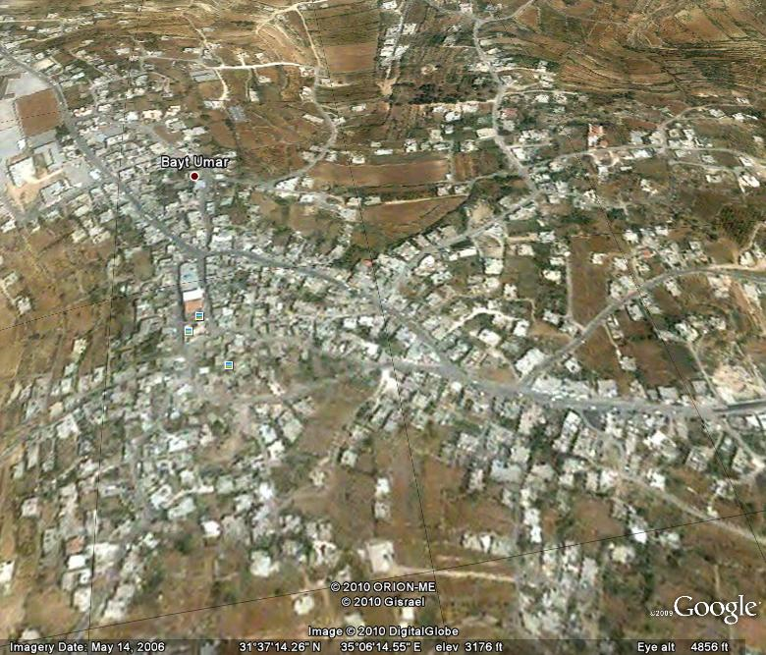

Chapter One

**1.1 Electrical Supply**

Beat Ommar distribution network is supplied by the IEC ( Israel electrical company ) directly, there is only one connection point at Safa through an overhead lines of 33kv . the main circuit breaker is rated at 129A . the max demand is reached 5.391 MVA.

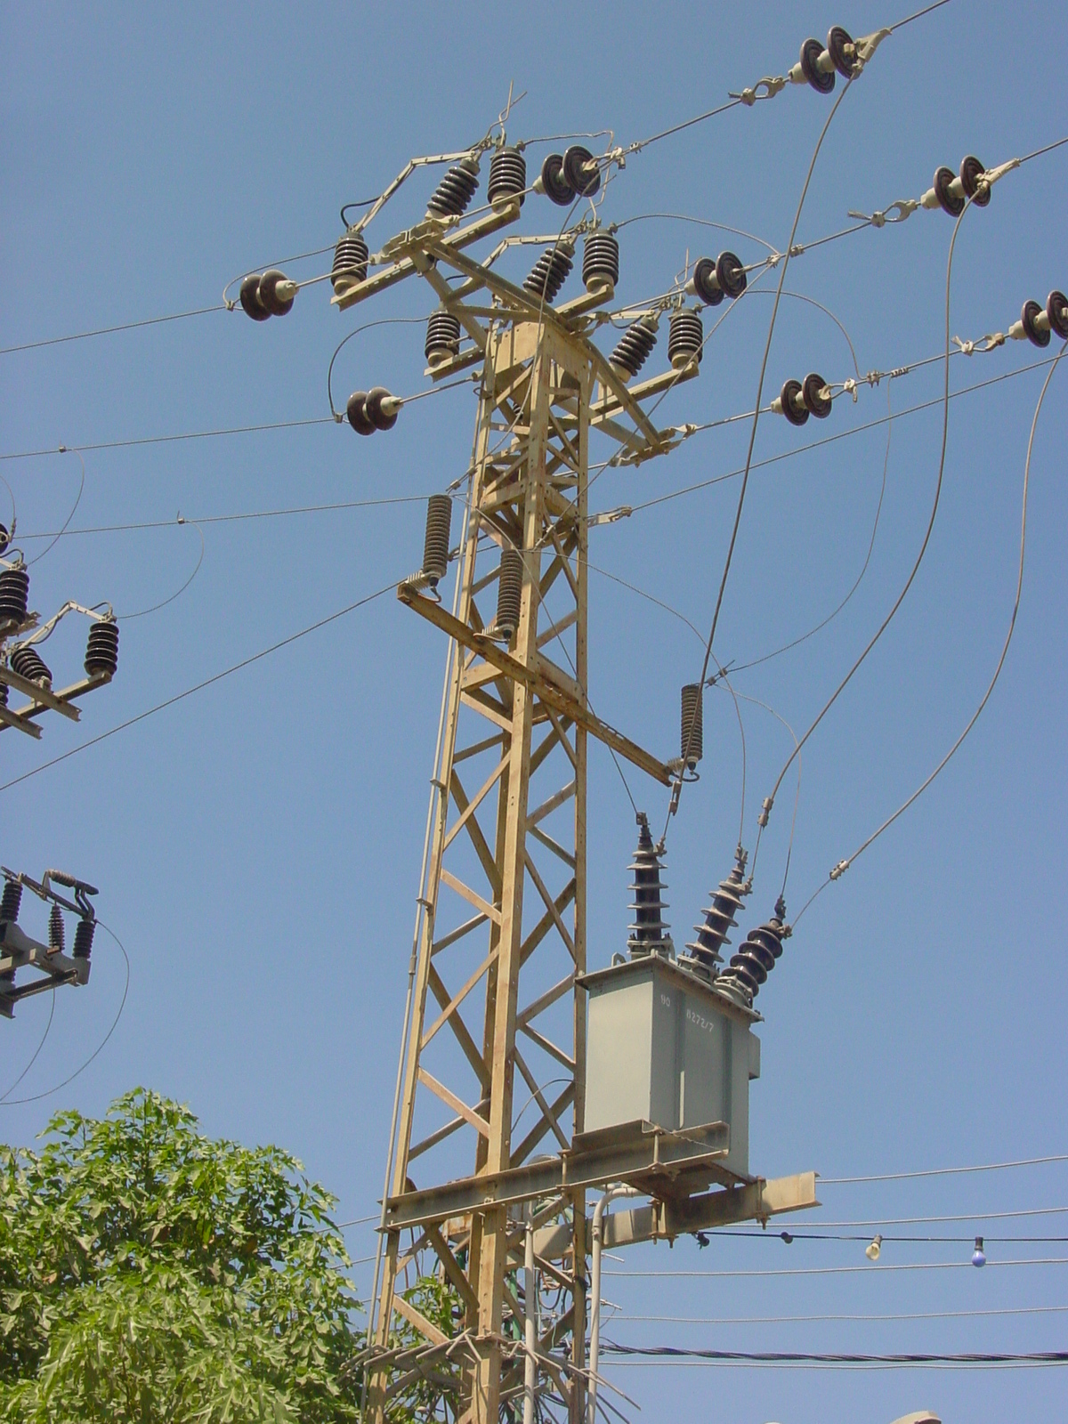

We have the only connection point in the town Safa . The IEC supplies the network with 108A, which is very little value comparing with the needs of the consumers, for example; the maximum demand reach the value of 108A in the summer which exposes the network to the danger and the cutoff of supply. so we have to demand ( purchase) another 60A from the IEC to cover the needs of Beat Ommar from electricity and put the network in the Safe side and increase the reliability of the network.

**1.2 Energy Consumption :**

In this section we will talk about the consumption of energy in Beat Ommar network.

**1.2.1 The Nature Of The Load.**

The table bellow shows the consumers classification and their size.

|  |  |
| --- | --- |
| *Type of load* | *Consumption %* |
| Residential | 62% |
| Industrial | 11% |
| Commercial | 13% |
| Water pumps+ light | 14% |

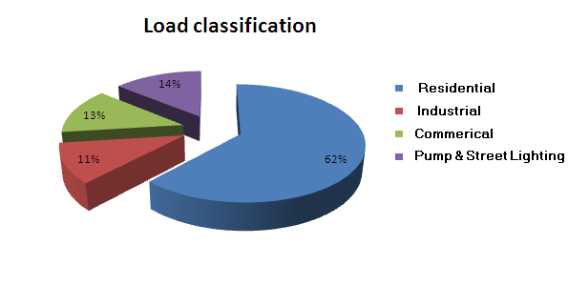

We see that the biggest consumer is the residential sector which achieve about 62 % from the total consumption, also the water pump and street lighting sector has a high percentage from the total consumption. There are many factories in Beat Ommar that consume a big amount of power.

**1.2.2 The growth rate of the load**

The table below shows the total consumption of energy for 4 years .

|  |  |  |
| --- | --- | --- |
| Year | Average Monthly consumption  In MWH | Percentage growth  % |
| 2006 | 646 | --------------- |
| 2007 | 717 | 10.99% |
| 2008 | 797 | 11.15% |
| 2009 | 880 | 10.41% |

* We notice that the energy purchased from the ICE is changing during the

Years.

* A jump in the power consumption happened in 2008 by nearly 80 MWH.
* And here is the monthly energy consumption in MWH in the last 4 years

|  |  |  |  |  |  |  |  |  |  |  |
| --- | --- | --- | --- | --- | --- | --- | --- | --- | --- | --- |
|  | **2009** |  |  | **2008** |  |  | **2007** |  |  | **2006** |
| **month** | **P**  **(MWH)** |  | **month** | **P**  **(MWH)** |  | **month** | **P**  **(MWH)** |  | **month** | **P**  **(MWH)** |
| 1 | 875.1 |  | 1 | 790.3 |  | 1 | 710.3 |  | 1 | 640.1 |
| 2 | 865.9 |  | 2 | 788.7 |  | 2 | 708.3 |  | 2 | 637.9 |
| 3 | 861.3 |  | 3 | 781.9 |  | 3 | 703.1 |  | 3 | 630.2 |
| 4 | 873.6 |  | 4 | 777.8 |  | 4 | 701.5 |  | 4 | 619.5 |
| 5 | 875.2 |  | 5 | 771.9 |  | 5 | 699.6 |  | 5 | 611.1 |
| 6 | 869.4 |  | 6 | 762.7 |  | 6 | 697.7 |  | 6 | 607.3 |
| 7 | 881.6 |  | 7 | 774.1 |  | 7 | 692.1 |  | 7 | 599.8 |
| **8** | 890.6 |  | **8** | 800.1 |  | **8** | 725.5 |  | 8 | 600.2 |
| 9 | 880.1 |  | 9 | 797 |  | 9 | 716.3 |  | 9 | 643.3 |
| 10 | 882.3 |  | 10 | 793.3 |  | 10 | 709.2 |  | **10** | 660.2 |
| 11 | 876.3 |  | 11 | 789 |  | 11 | 701.6 |  | 11 | 629.7 |
| 12 | 872.1 |  | 12 | 785.2 |  | 12 | 699.6 |  | 12 | 622.7 |
| **TOTAL =** | **10560 MWH** |  | **TOTAL =** | **9564 MWH** |  | **TOTAL =** | **8604.8 MWH** |  | **TOTAL =** | **7752 MWH** |

***Note:*** *We note that the peak power is occurs in August and October* ***.***

* **In graphical mode :**

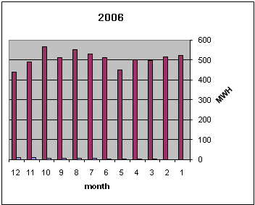

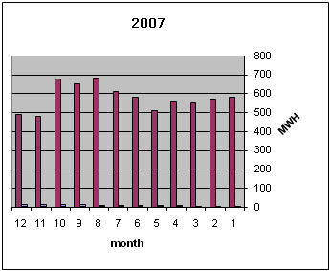

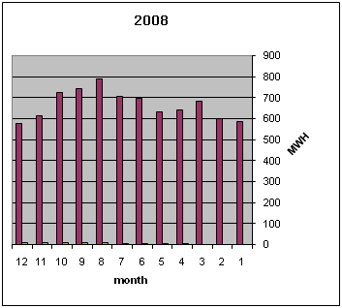

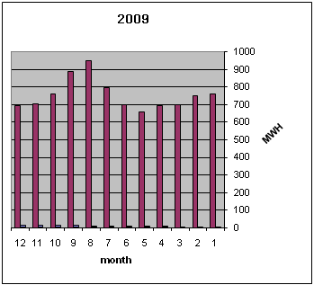

**1.2.3 Daily load curve**

We take readings to the load changes during the day, the result gives the graph below :

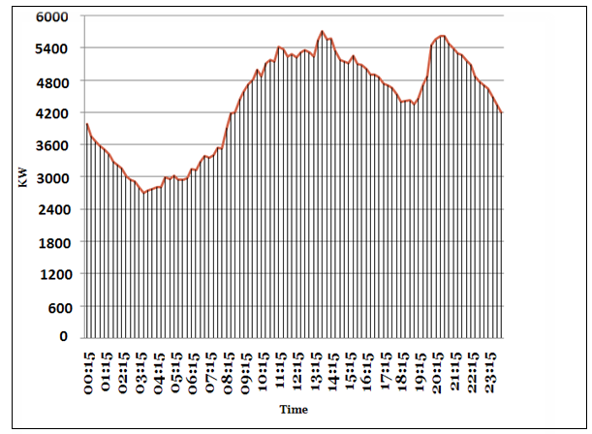

***Note*** *: that readings were taken in September 2009*

From the above graph we notice the following :

* The maximum power consumed **5.463 MW** and occurred at **1:45 pm .**
* The peak demand occurs at two intervals :

1. { 10:30 am – 03:15 pm }
2. { 07:30 pm – 10:00 pm }

* The average demand is about **4.1 MW**
  1. **Elements Of Beat Ommar Network**

In this section we will study the elements of the network such as transformers, over head lines and underground cables.

**1.3.1 Distribution Transformers:**

Beat Ommar network consists of **26 - Δ/Υ - , 33/0.4 KV** distribution transformers.

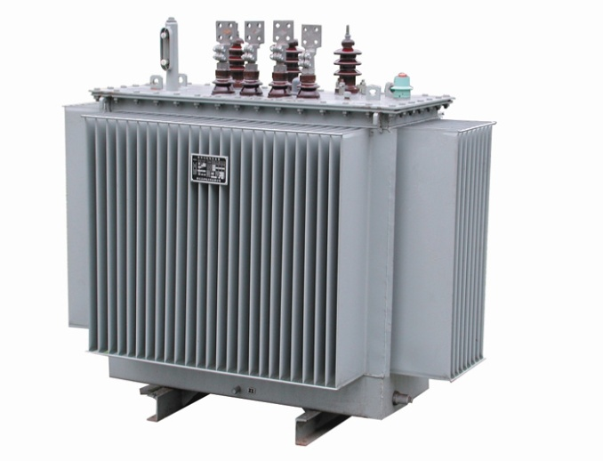

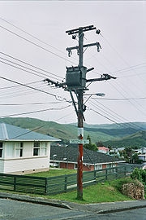

And the table shows the number of each of them and the rated KVA.

|  |  |
| --- | --- |
| Number of Transformers | Transformer Ratings (KVA) |
| 11 | 630 |
| 9 | 400 |
| 6 | 250 |

**1.3.2 Medium voltage 33kv lines :**

1. **Overhead lines**

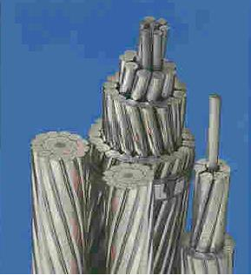

* The conductors used in the network are **ACSR** (**50mm2**) , and their
* Resistance R=(**0.543/Km**)
* and Reactance X= (**0.297 /Km**) ,

1. **Underground cables**

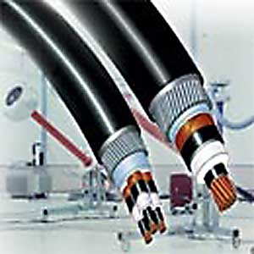

* The Underground cables used in the network are **XLPE Cu** (**120 mm2**) and their
* Resistance R= (**0.303 /Km**) and
* Reactance X= (**0.27 /Km**)

Chapter Two

Analysis Of The Network

**2.1 ETAP power station :-**

ETAP PowerStation allows us to work directly with graphical one line diagram.

And it provides us with text reports such as:

* complete report.
* Input data.
* Results .
* Summary reports

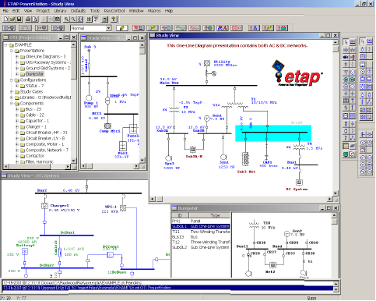

**2.2 One line diagram**

In order to have the one line diagram, we followed the network diagram from the network plans , and so we get this plan considered as an input to the ETAP program .

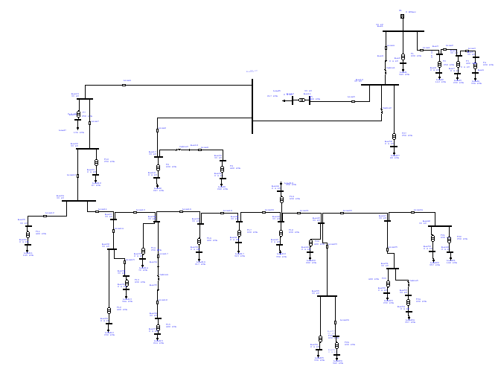

**2.3 Data needed for the load flow analysis.**

**2.3.1 The real and reactive power**

**( OR** apparent power and P.F **OR** Ampere and P.F ).

And the given table gives the real and reactive power on each bus.

|  |  |  |
| --- | --- | --- |
| ***Number of bus*** | ***P (kw)*** | ***Q (kvar)*** |
| **1** | **5.463** | **2.896** |
| **2** | **0.295** | **0.143** |
| **3** | **0.580** | **0.323** |
| **4** | **0.483** | **0.271** |
| **5** | **0.280** | **0.170** |
| **6** | **0.278** | **0.158** |
| **7** | **0.201** | **0.092** |
| **8** | **0.096** | **0.049** |
| **9** | **4.584** | **2.416** |
| **10** | **4.583** | **2.415** |
| **11** | **0.185** | **0.102** |
| **12** | **0.184** | **0.094** |
| **14** | **4.327** | **2.276** |
| **15** | **3.844** | **2.030** |
| **16** | **0.118** | **0.054** |
| **17** | **0.477** | **0.243** |
| **18** | **0.248** | **0.120** |
| **19** | **0.227** | **0.114** |
| **20** | **0.277** | **0.114** |
| **21** | **0.225** | **0.103** |
| **22** | **3.725** | **1.971** |
| **23** | **0.076** | **0.037** |
| **24** | **3.640** | **1.927** |
| **25** | **0.139** | **0.079** |
| **26** | **0.138** | **0.075** |
| **27** | **3.498** | **1.847** |
| **28** | **0.512** | **0.260** |
| **29** | **0.196** | **0.095** |
| **30** | **0.314** | **0.156** |
| **31** | **0.312** | **0.142** |
| **32** | **2.985** | **1.585** |
| **33** | **0.055** | **0.041** |
| **34** | **0.185** | **0.097** |
| **35** | **0.185** | **0.097** |
| **36** | **0.185** | **0.097** |
| **37** | **0.183** | **0.089** |
| **38** | **2.743** | **1.445** |
| **39** | **0.184** | **0.089** |
| **40** | **2.554** | **1.346** |
| **41** | **0.267** | **0.129** |
| **42** | **2.282** | **1.204** |
| **43** | **0.301** | **0.146** |
| **44** | **0.291** | **0.149** |
| **45** | **1.685** | **0.883** |
| **46** | **0.173** | **0.079** |
| **47** | **0.934** | **0.495** |
| **48** | **0.436** | **0.233** |
| **49** | **0.132** | **0.068** |
| **50** | **0.300** | **0.145** |
| **51** | **0.499** | **0.262** |
| **52** | **0.195** | **0.094** |
| **53** | **0.302** | **0.159** |
| **54** | **0.300** | **0.145** |
| **55** | **0.577** | **0.302** |
| **56** | **0.283** | **0.137** |
| **57** | **0.291** | **0.152** |
| **58** | **0.289** | **0.140** |
| **59** | **0.070** | **0.034** |

* + 1. **The length and Resistances**
* R in (Ω) and X in (Ω) of the lines.

After formatting the one line diagram of the network, and dividing it into buses we formed this table which shows the length of the lines and their resistance and reactance.

|  |  |  |  |
| --- | --- | --- | --- |
| Cables and Lines | Length (m) | Resistance (Ω) | Reactance (Ω) |
| Cable 1 | 110 | 0.0333 | 0.0312 |
| Cable 2 | 105 | 0.3180 | 0.0311 |
| Cable 3 | 100 | 0.3030 | 0.0270 |
| Cable 4 | 100 | 0.3030 | 0.0270 |
| Cable 5 | 100 | 0.3030 | 0.0270 |
| Line 1 | 100 | 0.0543 | 0.0297 |
| Line 2 | 90 | 0.0488 | 0.0267 |
| Line 3 | 100 | 0.0543 | 0.0297 |
| Line 4 | 210 | 0.1140 | 0.0623 |
| Line 5 | 650 | 0.3529 | 0.1930 |
| Line 6 | 610 | 0.3312 | 0.1811 |
| Line 7 | 110 | 0.0597 | 0.0326 |
| Line 8 | 200 | 0.1086 | 0.0594 |
| Line 9 | 320 | 0.1737 | 0.0950 |
| Line 10 | 1000 | 0.5430 | 0.2970 |
| Line 11 | 310 | 0.1683 | 0.0920 |
| Line 12 | 220 | 0.1194 | 0.0653 |
| Line 13 | 190 | 0.1031 | 0.0564 |
| Line 14 | 110 | 0.0597 | 0.0326 |
| Line 15 | 210 | 0.1140 | 0.0623 |
| Line 16 | 310 | 0.1683 | 0.0920 |
| Line 17 | 850 | 0.4615 | 0.2524 |
| Line 18 | 100 | 0.0543 | 0.0297 |
| Line 19 | 900 | 0.4887 | 0.2673 |
| Line 20 | 900 | 0.4887 | 0.2673 |
| Line 21 | 100 | 0.0543 | 0.0297 |
| Line 22 | 220 | 0.1194 | 0.0653 |
| Line 23 | 100 | 0.5430 | 0.0297 |
| Line 24 | 200 | 0.1086 | 0.0594 |
| Line 25 | 120 | 0.0650 | 0.0356 |
| Line 26 | 100 | 0.0543 | 0.0297 |

*.*

**2.4 load flow analysis for max case**

**2.4.1 the medium** **voltages**

The actual medium voltages on each transformer is shown in the table below :

|  |  |  |
| --- | --- | --- |
| **Transformer**  **number** | **Medium voltage(rated)**  **kv** | **Medium voltage(actual)**  **kv** |
| **T1** | **33** | **33** |
| **T2** | **33** | **32.99** |
| **T3** | **33** | **32.99** |
| **T4** | **33** | **32.997** |
| **T5** | **33** | **32.97** |
| **T6** | **33** | **32.973** |
| **T7** | **33** | **32.917** |
| **T8** | **33** | **32.965** |
| **T9** | **33** | **32.96** |
| **T10** | **33** | **32.908** |
| **T11** | **33** | **32.83** |
| **T12** | **33** | **32.806** |
| **T13** | **33** | **32.805** |
| **T14** | **33** | **32.795** |
| **T15** | **33** | **32.791** |
| **T16** | **33** | **32.777** |
| **T17** | **33** | **32.728** |
| **T18** | **33** | **32.684** |
| **T19** | **33** | **32.684** |
| **T20** | **33** | **32.68** |
| **T21** | **33** | **32.674** |
| **T22** | **33** | **32.674** |
| **T23** | **33** | **32.675** |
| **T24** | **33** | **32.674** |
| **T25** | **33** | **32.679** |
| **T26** | **33** | **32.679** |

***Note :*** *the colored values refers to the least medium voltages which has more drop of voltages.*

**2.4.2 The low tension** **voltages**

The actual low voltages on each transformer is shown in the table below :

|  |  |  |
| --- | --- | --- |
| **Transformer**  **number** | **Low voltage(rated)**  **kv** | **Low voltage(actual)**  **v** |
| **T1** | **0.4** | **391** |
| **T2** | **0.4** | **392** |
| **T3** | **0.4** | **392** |
| **T4** | **0.4** | **39** |
| **T5** | **0.4** | **39** |
| **T6** | **0.4** | **394** |
| **T7** | **0.4** | **39** |
| **T8** | **0.4** | **392** |
| **T9** | **0.4** | **389** |
| **T10** | **0.4** | **393** |
| **T11** | **0.4** | **391** |
| **T12** | **0.4** | **388** |
| **T13** | **0.4** | **388** |
| **T14** | **0.4** | **392** |
| **T15** | **0.4** | **388** |
| **T16** | **0.4** | **388** |
| **T17** | **0.4** | **388** |
| **T18** | **0.4** | **387** |
| **T19** | **0.4** | **387** |
| **T20** | **0.4** | **388** |
| **T21** | **0.4** | **387** |
| **T22** | **0.4** | **385** |
| **T23** | **0.4** | **386** |
| **T24** | **0.4** | **387** |
| **T25** | **0.4** | **387** |
| **T26** | **0.4** | **387** |

***Note :*** *the colored values refers to the least low voltages which has more drop of voltages.*

**2.4.3 Power factor**

The table below shows the power factor, real and reactive power on each transformer:

|  |  |  |  |
| --- | --- | --- | --- |
| **No .of transformer** | **P (KW)** | **Q (KVAR)** | **P.F %** |
| **T1** | **295** | **143** | **90** |
| **T2** | **96** | **49** | **89** |
| **T3** | **201** | **92** | **91** |
| **T4** | **278** | **158** | **87** |
| **T5** | **184** | **94** | **89** |
| **T6** | **70** | **34** | **90** |
| **T7** | **118** | **54** | **91** |
| **T8** | **248** | **120** | **90** |
| **T9** | **225** | **103** | **91** |
| **T10** | **76** | **37** | **90** |
| **T11** | **138** | **75** | **88** |
| **T12** | **196** | **95** | **90** |
| **T13** | **312** | **142** | **91** |
| **T14** | **55** | **41** | **80** |
| **T15** | **183** | **89** | **90** |
| **T16** | **184** | **89** | **90** |
| **T17** | **267** | **129** | **90** |
| **T18** | **301** | **146** | **90** |
| **T19** | **391** | **149** | **89** |
| **T20** | **173** | **79** | **91** |
| **T21** | **300** | **145** | **90** |
| **T22** | **132** | **68** | **90** |
| **T23** | **195** | **94** | **90** |
| **T24** | **300** | **145** | **90** |
| **T25** | **283** | **137** | **90** |
| **T26** | **289** | **140** | **90** |

***Note :*** *the power factor reach between 0.91 and 0.87 .*

*This causes more penalties on the total bill*

**2.4.4 Load factor**

The load factor is known as the average power divided by the rated power.

|  |  |  |  |
| --- | --- | --- | --- |
| **No .of transformer** | **T. ratings (KVA)** | **T. load(KVA)** | **Load factor**  **%** |
| **T1** | **630** | **343** | **54.4** |
| **T2** | **250** | **112** | **44.8** |
| **T3** | **400** | **232** | **58** |
| **T4** | **630** | **336** | **53.3** |
| **T5** | **400** | **217** | **54.2** |
| **T6** | **250** | **80** | **32** |
| **T7** | **250** | **136** | **54.4** |
| **T8** | **630** | **287** | **45.5** |
| **T9** | **400** | **262** | **65.5** |
| **T10** | **250** | **87** | **34.8** |
| **T11** | **400** | **165** | **41.2** |
| **T12** | **400** | **232** | **58** |
| **T13** | **630** | **364** | **57.7** |
| **T14** | **250** | **72** | **28.8** |
| **T15** | **400** | **216** | **54** |
| **T16** | **400** | **217** | **54.2** |
| **T17** | **630** | **315** | **50** |
| **T18** | **630** | **358** | **56.8** |
| **T19** | **630** | **350** | **55.5** |
| **T20** | **400** | **202** | **50.5** |
| **T21** | **630** | **357** | **56.6** |
| **T22** | **250** | **160** | **64** |
| **T23** | **400** | **232** | **58** |
| **T24** | **630** | **357** | **56.6** |
| **T25** | **630** | **336** | **53.3** |
| **T26** | **630** | **343** | **54.4** |

* L.F Somewhere reaches 65.5% , and it drops to 32% in other buses .
* There is no over loaded transformers in the network, but some of the transformers is under loaded .
  + 1. **Summery**

we have to summarize the results, total generation, demand , loading., percentage of losses, and the total power factor for the **maximum** case.

**MW MVAR MVA % PF**

**========= ========= ========= ===== =======**

**SWING BUS: 5.463 2.896 6.183 88.4 Lag**

**Total Demand: 5.463 2.896 6.183 88.4 Lag**

**--------- --------- --------- --------------**

**TOTAL LOAD: 5.391 2.646**

**APPARENT LOSSES: 0.072 0.249**

**TOTAL CURRENT : 108 A**

* The low power factor is due to the poor power factors at the loads.

**2.5 load flow analysis for min case**

**2.5.1 the medium** **voltages**

The actual medium voltages on each transformer is shown in the table below :

|  |  |  |
| --- | --- | --- |
| **Transformer**  **number** | **Medium voltage(rated)**  **kv** | **Medium voltage(actual)**  **kv** |
| **T1** | **33** | **33** |
| **T2** | **33** | **32.999** |
| **T3** | **33** | **32.999** |
| **T4** | **33** | **32.999** |
| **T5** | **33** | **32.985** |
| **T6** | **33** | **32.986** |
| **T7** | **33** | **32.958** |
| **T8** | **33** | **32.982** |
| **T9** | **33** | **32.98** |
| **T10** | **33** | **32.953** |
| **T11** | **33** | **32.913** |
| **T12** | **33** | **32.901** |
| **T13** | **33** | **32.901** |
| **T14** | **33** | **32.896** |
| **T15** | **33** | **32.894** |
| **T16** | **33** | **32.887** |
| **T17** | **33** | **32.862** |
| **T18** | **33** | **32.839** |
| **T19** | **33** | **32.839** |
| **T20** | **33** | **32.837** |
| **T21** | **33** | **32.834** |
| **T22** | **33** | **32.834** |
| **T23** | **33** | **32.835** |
| **T24** | **33** | **32.835** |
| **T25** | **33** | **32.837** |
| **T26** | **33** | **32.837** |

*.*

**2.5.2 The low tension**  **voltages**

The actual low voltages on each transformer is shown in the table below :

|  |  |  |
| --- | --- | --- |
| **Transformer**  **number** | **Low voltage(rated)**  **kv** | **Low voltage(actual)**  **v** |
| **T1** | **0.4** | **395** |
| **T2** | **0.4** | **395** |
| **T3** | **0.4** | **395** |
| **T4** | **0.4** | **395** |
| **T5** | **0.4** | **395** |
| **T6** | **0.4** | **397** |
| **T7** | **0.4** | **395** |
| **T8** | **0.4** | **396** |
| **T9** | **0.4** | **394** |
| **T10** | **0.4** | **396** |
| **T11** | **0.4** | **395** |
| **T12** | **0.4** | **394** |
| **T13** | **0.4** | **394** |
| **T14** | **0.4** | **396** |
| **T15** | **0.4** | **394** |
| **T16** | **0.4** | **394** |
| **T17** | **0.4** | **394** |
| **T18** | **0.4** | **393** |
| **T19** | **0.4** | **393** |
| **T20** | **0.4** | **394** |
| **T21** | **0.4** | **393** |
| **T22** | **0.4** | **392** |
| **T23** | **0.4** | **393** |
| **T24** | **0.4** | **393** |
| **T25** | **0.4** | **394** |
| **T26** | **0.4** | **393** |

* + 1. **Summery**

we have to summarize the results, total generation, demand , loading., percentage of losses, and the total power factor for the maximum case.

**MW MVAR MVA % PF**

**========= ========= ========= ===== =======**

**SWING BUS: 2.807 1.433 3.151 89.1 Lagging**

**TOTAL DEMAND: 2.807 1.433 3.151 89.1 Lagging**

**--------- --------- --------- --------------**

**TOTAL LOAD: 2.788 1.369**

**APPARENT LOSSES: 0.019 0.065**

**TOTAL CURRENT : 55 A**

* **The min load is equal to 50% of the max load**

* 1. **Problems Of The Network**

We can summarize the general problems of the network by the following points :

* The consumed power is reached the maximum limit , which causes over load currents .

This result in disconnecting the supply of the town .

* The P.F is less than 0.92 ; this cause penalties and power losses.
* There is a voltage drop and power losses

* 1. **Solutions And Recommendations**
* Increasing the supply from the IEC from the main circuit breaker .
* Using capacitor banks to improve the P.F and so, reducing the power losses , and avoiding the penalties.
* Managing the max peak demand by :

1. shift of max demand.

2. using other sources**.**

* Conservation of energy .
* Increasing the reliability of the system by developing another configurations ( Ring off ) .
* Using PV modules

Chapter Three

Electrical Network Improvements

**3.1 Power factor improvement**

* + 1. **The problem of low power factor**
* The low P.F is highly undesirable as it causes an increase in current, resulting in additional losses of active power in all the elements of power system from power station generator down to the utilization devices.
* In addition to the losses the low P.F causes penalties, for example for every 1% P.F below 92% and above 80% costs us 1% of the total bill.
  + 1. **How to improve the P.F**





**Where**:

* **Qc**: the reactive power to be compensated by the capacitor.
* **P**: the real power of the load.
* **Ø old**: the actual power angle.
* **Ø New**: the proposed power angle.
* **COMPENSATION AT L.V. IS PROVIDED BY**

1- Fixed values of capacitors.

2- Automatic capacitor banks.

* **AUTOMATIC COMPENSATION PF.**
* A bank of capacitors is divided into a number of sections.
* Each of which is controlled by a contactor.
* A control relay monitors the power factor of the controlled circuit(s) and is arranged to close and open appropriate contactors to maintain a reasonably constant system power factor (within the tolerance imposed by the size of each step of compensation).



**For Max Case :**

* Q**c** = Q old – Q new =P [tan cos-¹(PF old) - tan cos-¹(0.92)]
* P = 5.463 MW
* PF old = 88.4%
* PF desired = 92% and above
* Qc ≈ 550 kVAr
* **The reactive power needed to reach 92% of P.F equals :**

**Qc** ≈ 550 kVAr

**\*\* Which will cause the P.F in the min case to be 95.2% lag.**

* + 1. **The distribution of capacitors**

The following table shows the distribution of the capacitor banks and its effect on the P.F on each transformer.

|  |  |  |  |  |
| --- | --- | --- | --- | --- |
| **# of**  **Transformers** | **Qc (kvar)** | **Old P.F%** | **Max case New P.F%** | **Min case New P.F%** |
| 1 | 30 | 90 | 92.1 | 95.6 |
| 2 | 10 | 89 | 91.4 | 94.1 |
| 4 | 60 | 87 | 93 | 98 |
| 5 | 30 | 89 | 93.1 | 97.7 |
| 6 | 10 | 90 | 93.9 | 97.7 |
| 8 | 30 | 90 | 92.9 | 96.6 |
| 10 | 10 | 90 | 93.5 | 97.2 |
| 11 | 25 | 88 | 93 | 97.9 |
| 12 | 25 | 90 | 92.7 | 96.7 |
| 14 | 20 | 80 | 92.9 | 98 |
| 15 | 20 | 90 | 92.3 | 95.9 |
| 16 | 20 | 90 | 92.2 | 95.4 |
| 17 | 30 | 90 | 92.4 | 96 |
| 18 | 30 | 90 | 91.9 | 95.3 |
| 19 | 40 | 89 | 91.9 | 96.5 |
| 21 | 30 | 90 | 91.9 | 95.3 |
| 22 | 20 | 89 | 92.4 | 97 |
| 23 | 20 | 90 | 91.9 | 95.5 |
| 24 | 30 | 90 | 91.9 | 95.3 |
| 25 | 30 | 90 | 92.1 | 95.7 |
| 26 | 30 | 90 | 92.1 | 95.6 |

* + 1. **The results for max case** 
       1. **Power factor after adding capacitors for max case**

|  |  |  |  |
| --- | --- | --- | --- |
| **# of bus** | **P**  **(kw)** | **Q (kvar)** | **P.F**  **%** |
| **TR1** | 297 | 144 | 92.1 |
| **TR2** | 96 | 49 | 91.4 |
| **TR3** | 201 | 92 | 91 |
| **TR4** | 282 | 160 | 93 |
| **TR5** | 186 | 95 | 93.1 |
| **TR6** | 70 | 34 | 93.9 |
| **TR7** | 118 | 54 | 89.6 |
| **TR8** | 250 | 121 | 92.9 |
| **TR9** | 225 | 103 | 89.4 |
| **TR10** | 76 | 37 | 93.5 |
| **TR11** | 140 | 75 | 93 |
| **TR12** | 198 | 96 | 92.7 |
| **TR13** | 312 | 142 | 91 |
| **TR14** | 56 | 42 | 92.9 |
| **TR15** | 183 | 89 | 92.3 |
| **TR16** | 185 | 90 | 92.2 |
| **TR17** | 269 | 130 | 92.4 |
| **TR18** | 303 | 147 | 91.9 |
| **TR19** | 294 | 151 | 91.9 |
| **TR20** | 173 | 79 | 91 |
| **TR21** | 302 | 146 | 91.9 |
| **TR22** | 134 | 68 | 92.4 |
| **TR23** | 196 | 95 | 91.9 |
| **TR24** | 302 | 146 | 91.9 |
| **TR25** | 285 | 138 | 92.1 |
| **TR26** | 291 | 141 | 92.1 |

* + - 1. **Summary of max case after correction**

we can summarize the results, total generation, demand , loading., percentage of losses, and the total power factor for the maximum case.

**MW Mvar MVA % PF**

**===== ===== ===== ======**

**Swing Bus: 5.494 2.374 5.985 91.8 Lagging**

**Total Demand: 5.494 2.374 5.985 91.8 Lagging**

**--------- --------- --------- --------------**

**Total Load: 5.426 2.139**

**Apparent Losses: 0.068 0.235**

**Total current 105A. ( Before the capacitors the total current was 108A ).**

**Saving in the real power P = 4 KW.**

**Saving in the reactive power Q = 14 Kvar.**

* + 1. **The results for min case**

**3.1.5.1 Power factor after adding capacitors for min case**

|  |  |  |  |
| --- | --- | --- | --- |
| **# of bus** | **P**  **(kw)** | **Q (kvar)** | **P.F**  **%** |
| **TR1** | 152 | 74 | 95.6 |
| **TR2** | 58 | 30 | 94.1 |
| **TR3** | 103 | 47 | 91 |
| **TR4** | 145 | 82 | 98.5 |
| **TR5** | 96 | 49 | 97.7 |
| **TR6** | 36 | 17 | 97.7 |
| **TR7** | 60 | 28 | 91 |
| **TR8** | 128 | 62 | 96.6 |
| **TR9** | 116 | 53 | 90.2 |
| **TR10** | 39 | 19 | 97.2 |
| **TR11** | 72 | 39 | 97.9 |
| **TR12** | 102 | 49 | 96.7 |
| **TR13** | 161 | 73 | 91 |
| **TR14** | 29 | 21 | 98 |
| **TR15** | 94 | 46 | 95.9 |
| **TR16** | 96 | 46 | 95.4 |
| **TR17** | 139 | 67 | 96 |
| **TR18** | 157 | 76 | 95.3 |
| **TR19** | 152 | 78 | 96.5 |
| **TR20** | 89 | 41 | 91 |
| **TR21** | 157 | 76 | 95.3 |
| **TR22** | 69 | 36 | 97 |
| **TR23** | 102 | 49 | 95.5 |
| **TR24** | 157 | 76 | 95.3 |
| **TR25** | 147 | 71 | 95.7 |
| **TR26** | 151 | 73 | 95.6 |

* + - 1. **Summary of min case after correction**

we can summarize the results, total generation, demand , loading., percentage of losses, and the total power factor for the maximum case.

**MW Mvar MVA % PF**

**===== ======= ======= =======**

**Swing Bus: 2.823 0.896 2.962 95.3 Lagging**

**Total Demand: 2.823 0.896 2.962 95.3 Lagging**

**--------- --------- --------- --------------**

**Total Load: 2.806 0.838**

**Apparent Losses: 0.017 0.058**

**Total current 52A. ( Before the capacitors the total current was 55A ).**

**Saving in the real power P = 2 KW.**

**Saving in the reactive power Q = 7 Kvar.**

* + 1. **Comparison between the original and improved cases**

**Original case After improvement PF**

|  |
| --- |
| old new pf bbbbbbbb.bmp |

**3.2 Voltage correction**

The table bellow shows the voltage ranges before and after adding capacitor banks for the two levels of voltage.

|  |  |  |  |  |
| --- | --- | --- | --- | --- |
| **# of Transformer** | **Medium voltage**  **Kv before** | **Medium voltage**  **Kv after** | **Low voltage**  **Kv before** | **Low voltage**  **Kv after** |
| TR1 | 33 | 33 | 0.391 | 0.392 |
| TR2 | 32.99 | 32.999 | 0.392 | 0.393 |
| TR3 | 32.99 | 32.99 | 0.392 | 0.390 |
| TR4 | 32.997 | 32.997 | 0.39 | 0.393 |
| TR5 | 32.97 | 32.971 | 0.39 | 0.392 |
| TR6 | 32.973 | 32.974 | 0.394 | 0.395 |
| TR7 | 32.917 | 32.92 | 0.39 | 0.390 |
| TR8 | 32.965 | 32.966 | 0.392 | 0.393 |
| TR9 | 32.96 | 32.961 | 0.389 | 0.389 |
| TR10 | 32.908 | 93.912 | 0.393 | 0.394 |
| TR11 | 32.83 | 93.836 | 0.391 | 0.392 |
| TR12 | 32.806 | 32.813 | 0.388 | 0.393 |
| TR13 | 32.805 | 32.812 | 0.388 | 0.388 |
| TR14 | 32.795 | 32.803 | 0.392 | 0.394 |
| TR15 | 32.791 | 32.799 | 0.388 | 0.389 |
| TR16 | 32.777 | 32.785 | 0.388 | 0.390 |
| TR17 | 32.728 | 32.738 | 0.388 | 0.390 |
| TR18 | 32.684 | 32.695 | 0.387 | 0.388 |
| TR19 | 32.684 | 32.695 | 0.387 | 0.388 |
| TR20 | 32.68 | 32.692 | 0.388 | 0.388 |
| TR21 | 32.674 | 32.686 | 0.387 | 0.388 |
| TR22 | 32.674 | 32.686 | 0.385 | 0.387 |
| TR23 | 32.675 | 32.686 | 0.386 | 0.388 |
| TR24 | 32.674 | 32.686 | 0.387 | 0.388 |
| TR25 | 32.679 | 32.691 | 0.387 | 0.389 |
| TR26 | 32.679 | 32.69 | 0.387 | 0.388 |

* 1. **Economical study**

In order to make sure that adding the capacitor banks, we should make an economical study to see if that is feasible .

So we have to know how much saving in power and energy we have, also we have to calculate the simple payback period ( S.P.B.P ) which known as the investment of money through capacitors divided by the total saving in energy through a year.

***Simple payback period***

0.8≤PF<0.92 penalties is 1% of the total bill for every 0.01 of P.F. **<** 0.92

0.7≤PF<0.8 penalties is 1.25 % of the total bill for every 0.01 of P.F **<** 0.8

PF< 0.7 penalties is 1.5% of the total bill for every 0.01 of P.F **<** 0.7

Average monthly consumption = 880000 kwh

Total bill (NIS/year) = 880000kwh * 12 month * 0.5(NIS/kwh)=5280000 NIS/year

Saving in penalties = (91.8-88.4) * 1% * 5280000 NIS/year

|  |
| --- |
| Saving in penalties = 179520 NIS/year |

Saving in energy = ∆P * τ* (NIS/kwh)

= (0.072-0.0680)KW *2500h*(0.5)

|  |
| --- |
| Saving in energy = 5500 NIS/year |

Saving per year = saving in penalties + saving in energy

= 179520 + 5500

|  |
| --- |
| Saving per year = 185020 NIS/year |

Capital cost = cost of capacitors =Q(KVAR) * (15 JD/KVAR) * 6 NIS

= 550 * 15 *6

|  |
| --- |
| Capital cost = 49500 NIS |

S.P.B.P = capital cost / (saving per year)

= 49500 / 185020

|  |
| --- |
| S.P.B.P = 0.2675 year = 3.21 month = 96 day |

***Note :*** *since the S.P.B.P less than two years then the project is feasible.*

Current in max case

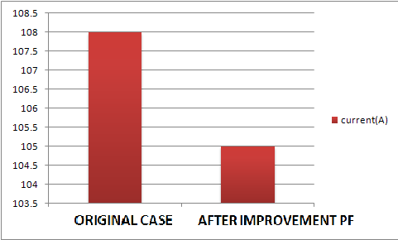

**Current in min case**

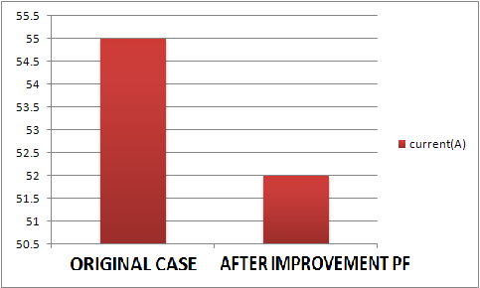

**Losses real power (KW) in max case**

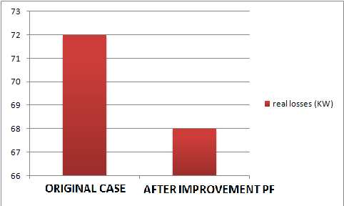

**Losses real power(KW) in min case**

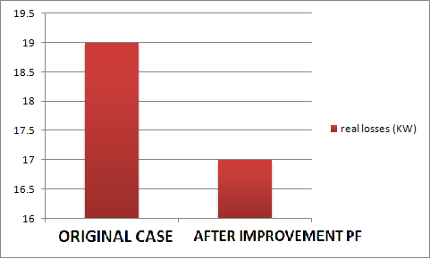

**Power factor in max case**

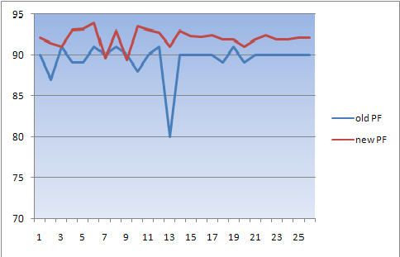

**Power factor in min case**

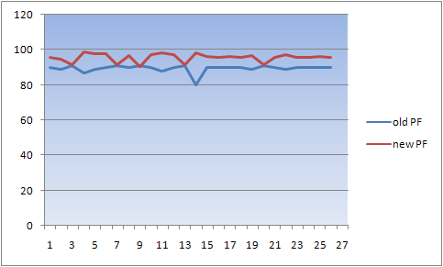

Chapter four

Energy conservation

**4.1 Energy conservation in street light**

In Beat Ommar town we have a number of street lamps ( about 1100 ) lamps distributed in the streets with rated power of 125 w for 500 lamps, and 70 w for 600 lamps .

We have to conserve energy in this sector by replacing the 125 w lamps by the 70 w lamps .

|  |  |  |  |  |
| --- | --- | --- | --- | --- |
| **#of street lamps** | **Power (W)** | **After replacement** | **Saving energy(KWH)/year** | **Saving in cost NIS/ year** |
| **600** | **70** | **70** | **0** | **0** |
| **500** | **125** | **70** | **120450** | **66247** |

* Then we should show the saving in power and energy and money.
* Also the simple payback period to recover the cost is very important .

**Calculations :**

ΔP=(125-70)=55W, for each lamp.

Working hours per day=12 Hr**,** and 4380 Hr per year

*Saving energy per year =* ΔP *#of lamps*hrs per year. =55*500*4380/1000= 120450(Kwh)/year.

Cost of energy =0.55 NIS/Kwh**.**

*Saving in cost*=0.55*120450= 66247 NIS./year**.**

Cost of each lamp=250NIS*and for all lamps =* 125000 NIS.

**S.P.B.P**=capital cost/saving per ye =125000NIS/66247(NIS/year).

=**1.8**year

=1.8*12=**22.64 months**

***Note :*** *since the S.P.B.P less than 5 years then the project is feasible.*

**4.2 Energy conservation in water pumps**

In Beat Ommar we have 9 water pumps, 3 of them are operating by using diesel fuel.

The other 6 motors are working by electricity. We can save energy in this sector by replacing the less efficient ones by another motors of high efficiency as follows :

Existing motors

|  |  |  |  |  |  |  |
| --- | --- | --- | --- | --- | --- | --- |
| **#of motor** | **Output power(KW)** | **Efficiency%** | **Input power(KW)** | **ΔP(KW)** | **Working hours** | **Working time** |
| **4** | **55** | **90** | **61.1** | **6.1** | 18 | **5 am to 11 pm** |
| **2** | **75** | **86** | **87.2** | **12.2** | **11** | **5 am to 4 pm** |

New motors

|  |  |  |  |  |  |  |
| --- | --- | --- | --- | --- | --- | --- |
| **#of motor** | **Output power(KW)** | **Efficiency%** | **Input power(KW)** | **ΔP(KW)** | **Working hours** | **Working time** |
| **4** | **55** | **94.4** | **58.2** | **3.2** | **18** | **5 am to 11 pm** |
| **2** | **75** | **94.5** | **79.36** | **4.36** | **11** | **5 am to 4 pm** |

**Economical study**

By replacing motors old motors by new motors

The saving in real power

**The first group of motors(4 motors)**

ΔP=6.1-3.2= 2.9Kw for each

ΔP for 4 motors=2.9*4=11.6kw

**The saving in energy of the motors**

=11.6*18*365=76212kw per year

**Saving in cost of motors**

=065*76212=49537.8nis per year

**The second group of motors**

ΔP=12.2_4.36=7.84kw for each motor

ΔP=7.84*2=15.68kw for 2 motors

**The saving in energy of motors**

=15.68kw*11hr*365=62955.2 kw per year

**The saving in cost of motors**

=0.65*62955.2=40920.88nis per year

The cost of 75 hp motor and Efficiency =94.4 **is 5000 $**

Corresponds to 20000 NIS

The cost of 100hp motor andEfficiency =94.4 is 6000 **$**

corresponds to 24000 NIS

The total cost of 4 motors (75hp) =80000 NIS

The total cost of 2 motors (100hp) =48000 NIS

The first group of motors (75hp)

S.P.B.P =80000/49537.8=1.61 year =19 month

The second group of motors (100hp)

S.P.B.P =48000/40920.8=1.17 year=14 month

***Note****: we can Manage the max peak demand by shifting the operating time of the first two motors in group 1 and all the motors in group 2, which works on the peak time. { 7:30 pm to 10:00 pm } From the daily load curve*

**4.3 Energy conservation in residential sector.**

**4.3.1 Replacing the incandescent lamps by the CFL lamps.**

**Note**: we have 2400 consumers.

|  |  |  |
| --- | --- | --- |
|  | **Inc.lamp75w** | **CFL lamp15w** |
| **Price(NIS)** | **1.5** | **25** |
| **Life time (hours)** | **1000** | **10000** |
| **Cost over life time(NIS)** | **10*1.5=15** | **25*1=25** |
| **Kwh in 10000 hr** | **750** | **150** |
| **Energy cost in**  **10000 hr**  **(NIS)** | **0.65*750=487.5** | **0.65*150=97.5** |
| **Total cost(NIS)** | **487.5+15=502.5** | **25+97.5=122.5** |
| **Saving in 10000 hr** | **502.5-122.5=380 (NIS)** |  |

* We notice that we can save **380(NIS)** by using the CFL lamps during the operating life for one lamp .

**Economy study**

Each home have about 5 lamps in average, and it work about 5 hours per day

Total lamps = 2400*5=12000lamps.

Energy consumption per year ( Inc 75W)

=75* 12000*5*365= 1642500 Kwh/year.

Energy consumption per year ( CFL15 W)

=15*12000*5*365=328500Kwh/year.

Saving in energy =1314000Kwh/year.

Saving in cost = 1314000 * 0.65 **=** 854100NIS/ year.

Fixed cost/year = (8760/10000)*25*12000 = 262800 NIS

S.P.B.P = 262800 NIS /854100 (NIS/year) = 0.307year

=3.69 months.

S.P.B.P for each consumer

We see that the replacement is feasible and the consumer save 356 NIS per year.

Total lamps = **5** lamps.

Energy consumption per year ( Inc 75 W)

=75*5*365*5= 684.375Kwh/year.

Energy consumption per year ( CFL15 W)

=15*5*365*5 =136.875Kwh/year.

Saving in energy =548Kwh/year.

Saving in cost = 584* 0.65 = 356.2NIS/ year.

Fixed cost/year = (8760/10000)*25*5 = 109.5NIS

S.P.B.P = 109.5NIS /356.2(NIS/year) = 0.307 year

=3.6months.

**4.3.2 Energy conservation in refrigerators:**

In this section of energy conservation in the residential sector we aim to replace the old refrigerators which consumes high energy by new refrigerators which consumes less power energy than the old one. And we will make the feasibility study using the simple payback period (S.P.B.P) method.

In beat ommar village 2600 refrigerators at least

1000 of its is old .if we replace it by new type

We notice the following

* The table below shows the old refrigerators and their size and their consumption in Kwh/day .
* And the new refrigerators to be replaced by.

|  |  |  |  |  |  |  |
| --- | --- | --- | --- | --- | --- | --- |
| **Type of refrigerator** | **Size in(Ltr)** | **KWh/day** | **Cost (NIS)** | **Type of new one** | **KWh/day** | **Cost (NIS)** |
| amcor | 430 | 2.9 | 1200 | LG | 1.2 | 3000 |

Life cycle for Amcor =5 years

Life Cycle for LG =10years

Annual fixed cost for amcor =1200/5=240 NIS

Annual fixed cost for LG =3000/10=300 NIS

Running cost /year for amcor

=2.9*365*.65=688NIS

Running cost for LG =1.2*365*.65=284NIS

Total cost /year =240+688 =928 NIS for amcor

Total cost /year =300+284 =584 NIS for LG

Saving money /year =928_584=344NIS

Difference in cost =3000_1200=1800NIS

S.P.B.P= 1800/344=5.2 years

**4.4 Load factor improvement:**

The load factor equal the average power divided by the maximum power, and so it is less than one and the best load factor which is equal to unity, and to do this we have to reduce the maximum demand as possible to be equal the average power.

* From the daily load curve , we see that the average demand is **4.1** MW.
* and the maximum peak demand is **5.463** MW.
* The total load factor = Pav/ Pmax = 72%.
* To improve the load factor and reducing the peak demand we suggest some notes :
* 1. shifting some of loads operating at the max point. The water pumps which operate through the duration of max load should work at another time .
* 2. adding capacitors in the transformers decreases the losses and the apparent power and so the peak demand .

Chapter Five

**design of PV system for electrification of Safa Villiage**

**5.1 Introduction**

The main characteristics of using PV system for electrification of

small rural villages are: the fuel is free, technology is mature and almost

worldwide available and it has modularity, low maintenance requirements,

high durability and also they can easily be connected to the utility network.

A rooftop mounted decentralized photovoltaic system is one of the

applications of solar PV systems that has attracted lots of interest among

the people in our region. The generation of electricity by this system is

attractive because :

* Generation is one-site. This results in reduction of transmission and

distribution costs and losses;

* The cost of roofing tiles can be eliminated by using mounted PV systems

instead;

* There is no need for additional land for power generation

The only factor hindering the growth of utilization of PV

decentralized systems is relatively high capital cost.

Another configuration that photovoltaic can have a major

contribution is in centralized generating electricity for people living in

isolated areas. Developing a method based on life cycle cost to select the

optimum configuration (centralized or decentralized ) will help in

increasing the utilization of PV systems

information about Safa village

Safa site is a small village that located north west of the town of Beat Ommar and away from it 4.5 km, which suffers from the problem of roads ,and electricity.

the houses lunch power from diesel generator ( 5KW, engine 9HP , fuel capacity 8 Gallons , run time at 50% load is 18 HR , number of hour operation is 14 HR as 8-12AM , 2-12 PM )

**5.2 The electrical loads of household for Safa site**

|  |  |  |  |  |
| --- | --- | --- | --- | --- |
| **appliance** | **Power (w)** | **number** | **Time (HR)** | **Energy consumption (W/day)** |
| **CFL lamps** | **13** | **4** | **5** | **260** |
| **TV** | **60** | **1** | **5** | **300** |
| **Refrigerators** | **80** | **1** | **8** | **640** |
| **Washing machine** | **160** | **1** | **0.25** | **40** |
| **Others** | **30** | **--** | **1** | **30** |
| **Total** | **343 W / house** |  |  | **1270 W/day / house** |

# of house = 3

Electrical energy consumption = 1270 * 3 = 3.810 Kwh/day

Total required power = (343*3)/D.V = 1029/1.25 = 823.2 W

**We use multicrystalline 36 rectangular cell module type (KC 130 GHT – 2)**

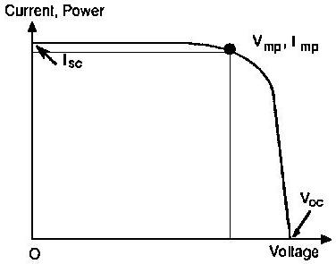

Peak power = 130 W

Vmpp=17.6 V VMPP ≈ 0.8 * Voc

Impp = 7.39 A IMPP ≈ 0.9 * ISC

Vo.c = 21.9v

I s.c = 8.02 A

**5.3 Design of centralized PV system components for safa village**

***5.3.1 PV generating sizing***

*Ppv=(* E/(ηv*ηR*PSH) )*S.F where PSH = 5.4 H in palestine

= 3.810 * 1.15/.9*.92*5.4 = 0.98 KWp

# of necessary PV module = NO.PV = Ppv/Pmpp

= 980/130=2.73 ≈3 PV module

Nominal voltage of PV generator = 48 V

# of module in series = NO.pvs=Vpv/Vmmp

=48/17.6 =2.73≈ 3

# of string = NO.pv/NO.pvs = 7.538/2.73 = 3 string

# of PV generator modulo = 3 * 3 = 9 modulo

The area of array is ( 3 * 1.425)*(3*0.652)=8.36 m²

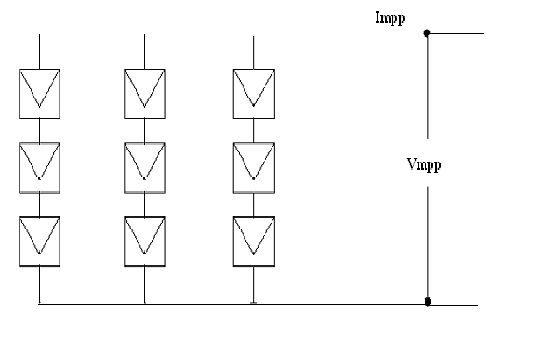

**Figure (5.1): The configuration of the centralized PV generator for safa village**

Impp = 3 * 7.39 = 22.17 A

Vmpp= 3 * 17.6 = 52.8 V DC

Vo.c = 3 * 21.9 = 65.7 V DC

Is.c = 3 * 8.02 = 24.06 A

The actual maximum power obtained from PV =Vmpp * I mpp

=52.8 * 22.17 =1.170 KWP

**5.3.2 the battery , charge regulater , and invertor**

***The Battery***

CAH = E /(Vb*DOD * ηv*ηB )

CAH for two day = 2*3.810/(48*.75*.85*.9)

= 276 .68AH

CWH = CAH * Vb= 276.68 * 48 = 13281 Wh

We use battery 2v/300Ah (sale this battery 63 $ , model No GFM-300G)

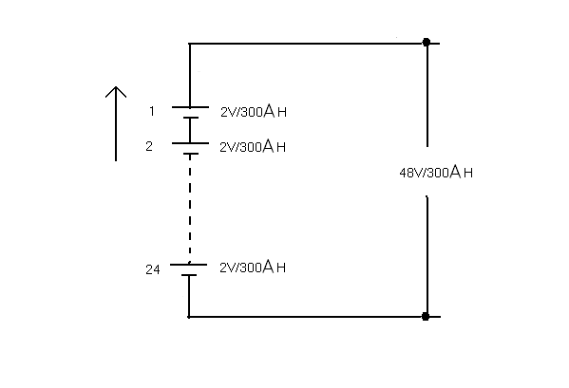

**Figure (5.2): The configuration of battery blocks of the PV system for Safa village**

**Charge Regulator**

* Voutput must be equal to Vnominal (PV) = 48*0.875-48*1.2 = (42-57.6)V DC
* The appropriate rated power of CR must be equal Ppv = 1.170KWP ≈1.5KWP
* Change regulator have been selected (30A-48V)
* Efficiency must be not less of 92%

**Inverter**

* **Vinput**  has to be matched with battery block voltage = VCR output =(42-57.6) V DC
* **Voutput** 230V AC ± 5% , one phase , 50 HZ
* Power of inverter is Pnominal ≥ 1.278KW ≈ 1.5 KW
* Efficiency must be not less than 90%

**5.3.3 Electrical network map for centralized case**

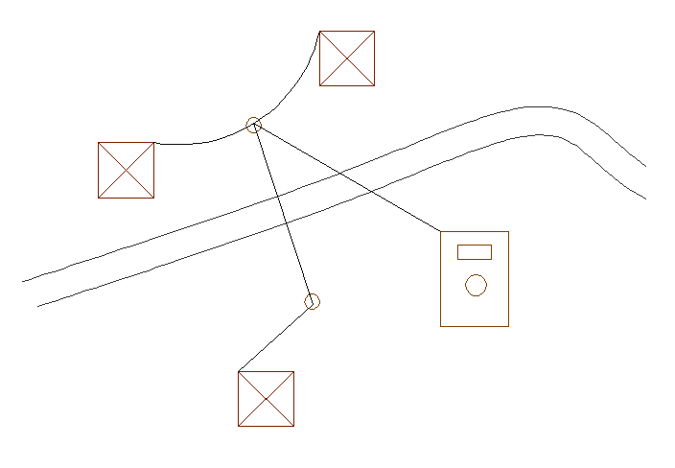

**Figure (5.3): Safa electrical network map**

**5.4 Design of decentralized PV system components for safa village**

***5.4.1 PV generating sizing***

# of house = 3

Energy consumption = 1270 wh/day for each house

*Ppv=(* E/(ηv*ηR*PSH) )*S.F where PSH = 5.4 H in palestine

= 1270 * 1.15/.9*.92*5.4 = 300 Wp

# of necessary PV module = NO.PV = Ppv/Pmpp

= 300/130 ≈ 2 PV module

Nominal voltage of PV generator = 24 V

# of module in series = NO.pvs=Vpv/Vmmp

=24/17.6 ≈ 2

# of string = NO.pv/NO.pvs = 2/2 = 1 string

# of PV generator modulo = 2 * 1 = 2 modulo

The area of array = 2 * 1.425 * 0.652=1.86 m²

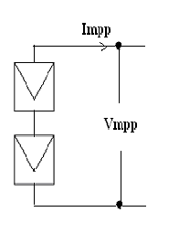

**Figure (5.4): The configuration of the decentralized PV generator for safa village**

Impp = 1 * 7.39 = 22.17 A

Vmpp= 2 * 17.6 = 35.2 V DC

Vo.c = 2 * 21.9 = 44 V DC

Is.c = 1 * 8.02 = 8.02 A

The actual maximum power obtained from PV =Vmpp * I mpp

=35.2 * 7.39 =260.1WP

**5.4.2 the battery , charge regulater , and invertor**

***The Battery***

CAH = E /(Vb*DOD * ηv*ηB )

CAH for two day = 2*1270/(24*.75*.85*.9)

= 92.2 AH

CWH = CAH * Vb= 92.2 * 24 = 4420 Wh

We use battery 12v/100Ah (block battery 12v/100ah)

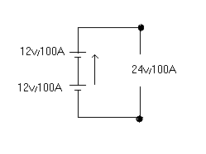

**Figure (5.5): The configuration of battery blocks of the PV system for Safa village**

**Charge regulater**

Rated power Ppv=260.1w≈300w

10A-24V

**Inverter**

Output voltage 230v ± 5% AC

Nominal power Pnominal ≥375w≈400w

**5.5 Economic Evaluation of Centralized and Decentralized PV System**

**for Safa Village as Case Study**

**5.5.1 The cost of centralized and decentralized PV system for Safa villages**

**Table (5.6): The costs of the centralized PV system**

|  |  |  |  |  |
| --- | --- | --- | --- | --- |
| **Component** | **Quantity** | **Unit price**  **$** | **Total price**  **$** | **Life time**  **year** |
| PV-module (KC) | 1170 Wp | 4/Wp | 4680 | 25 |
| Support structure | 2 | 100 | 200 | 25 |
| Batteries (2V/300AH) | 24 | 63 | 1512 | 10 |
| Charge regulator 1.5 KW | 1 | 600/KW | 900 | 12 |
| Inverter 1.5 KW | 1 | 1000/KW | 1500 | 12 |
| C.B & switches | -- | -- | 60 | 12 |
| Others as  * installation  * material  * cost  * poles  * conductors  * civil work  etc | -- | -- | 2780 | -- |
| ∑ 11632 $ |

O & M = 180 $

S.V = 1200 $

**Table (5.7): The costs of the decentralized PV system**

|  |  |  |  |  |
| --- | --- | --- | --- | --- |
| **Component** | **Quantity** | **Unit price**  **$** | **Total price**  **$** | **Life time**  **year** |
| PV-module (KC) | 260.1 Wp | 4/Wp | 1040.4 | 25 |
| Batteries (12V/100AH) | 2 | --- | 200 | 5 |
| Charge regulator 300 W | 1 | 600/KW | 180 | 12 |
| Inverter 400W | 1 | 1000/KW | 400 | 12 |
| C.B & switches | -- | -- | 18 | 12 |
| Others as  * installation  * material  * cost  * poles  * conductors  * civil work  etc | -- | -- | 900 | -- |
| ∑ 2738.4 $ |

O & M = 100 $

S.V = 500 $

**5.5.2 Which project we select centralized or decentralized ?**

In this two case the output is fixed by using present worth method where

Output is fixed select min capital cost.

**5.5.2.1 cash flow for centralized PV system**

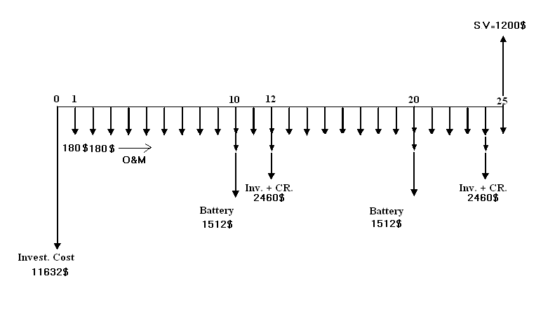

Pc = 11632 +180[P/A,10%,25] +1512[P/F,10%,10]+1512[P/F,10%,20]

+ 2460[P/F,10%,12]+ 2460[P/F,10%,24]-1200[P/F,10%,25]

Pc = 14996 $

**5.5.2.2 cash flow for decentralized PV system**

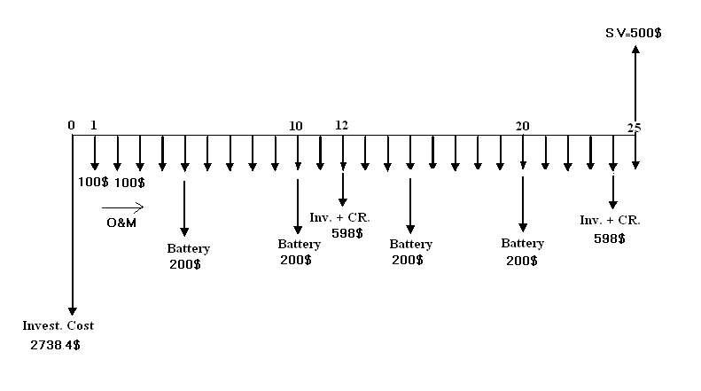

Pc = 3*[ 2738.4 +100[P/A,10%,25] +200[P/F,10%,5]+200[P/F,10%,10]

+ 200[P/F,10%,15]+ 200[P/F,10%,20]+598[P/F,10%,12]

+ 598[P/F,10%,24]-500[P/F,10%,25]]

Pc = 12390 $

Pc decentralized < PC centralized

We select the decentralized project

**5.6 Max overall efficiency for centralized and decentralized V system**

**For case centralized**

Effecincy = Pomax/Pimax =[ Vmpp*Impp/G*Apv] * ζCR* ζInv* ζDistribution line

= [52.8*22.17/1000*8.36]*0.92*0.90*0.95

Eff = 11.01%

**For case decentralized**

Effecincy = Pomax/Pimax =[ Vmpp*Impp/G*Apv] * ζCR* ζInv* ζDistribution line

= [35.2*7.39/1000*1.86]*0.92*0.90*0.95

Eff = 11.38%

We note that ζ decentralized > ζ centralized

**5.7 Building Integrated Photovoltaic (BIPV) System**

1. the PV modules (which might be thin-film or crystalline, transparent, semi-transparent, or opaque);
2. a charge controller, to regulate the power into and out of the battery storage bank (in stand-alone systems);
3. a power storage system, generally comprised of the utility grid in utility-interactive systems or, a number of batteries in stand-alone systems;
4. power conversion equipment including an inverter to convert the PV modules' DC output to AC compatible with the utility grid;
5. backup power supplies such as diesel generators (optional-typically employed in stand-alone systems); and
6. appropriate support and mounting hardware, wiring, and safety disconnects

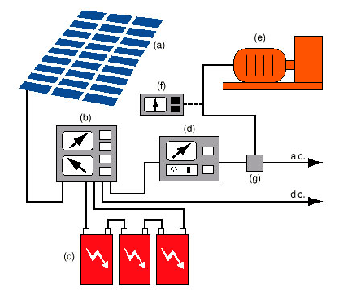

The End