Chapter one:
Wind Generators and types of grid connection.
  - Types of generators used in wind turbines.
  - On & off grid connection.
  - Direct and indirect grid connection of wind turbines.

Chapter two:
Evaluation of wind data in some of Palestinian cities.
2.1 Mean monthly and annual wind speed (m/s).
2.2 Power Density in Palestinian cities.

Chapter three:
Estimation of the Electrical Energy Produced by Using Different Wind Turbine in Palestinian Cities.
3.1 power curve & power table of using (20KW) wind turbines.
3.2 Frequency distribution curves for Palestinian cities.
3.3 Energy produced from using (20 kw) wind turbine.
3.4 power curve & power table of using (30KW) wind turbines.
3.5 Energy produced from using (30 kw ) wind turbine.
3.6 power curve & power table of using (55KW) wind turbines.
3.7 Energy produced from using (55 kw ) wind turbine

Chapter four:
Economical evaluation of using diesel and different wind turbines.
4.1 Calorific value of diesel and economical consideration.
4.1.1 Cost of diesel consumption per year
4.1.2 Cost of 1kwh output ((including the cost of generator))
4.2 Economical evaluation of using (20 kW) wind turbines.
4.2.1 Saving per year ($/year) in each Palestinian city.
4.2.2 Annuity per year ($/year) in each Palestinian city.
4.2.3 Cost ($/kWh) in each Palestinian city.
4.2.4 Saving per kwh.

4.3 Economical evaluation of using (30 KW) wind turbines.
4.3.1 Saving per year ($/year) in each Palestinian city.
4.3.2 Annuity per year ($/year) in each Palestinian city.
4.3.3 Cost ($/kWh) in each Palestinian city.
4.3.4 Saving per kwh.
4.4 Economical evaluation of using (55 kW) wind turbines.
4.4.1 Saving per year ($/year) in each Palestinian city.
4.4.2 Annuity per year ($/year) in each Palestinian city.
4.4.3 Cost ($/kWh) in each Palestinian city.
4.4.4 Saving per kwh.

Chapter five:
Design and analysis of hybrid system for small village (EL-Beren) in Hebron
5.1 The remote village El-Beren Location and living conditions.
5.2 calculation of energy needed for El-Beren village.
5.3 Using hybrid system (wind turbine 20 kW & diesel) to produce this amount of energy.
5.4 Calculation of Saving($)(for using 20 kw)=total cost of wind _total cost of diesel.
5.5 Using hybrid system (wind turbine 30 kw & diesel) to produce this amount of energy.
5.6 Calculation of Saving($)(for using 30 kw)=total cost of wind _total cost of diesel.
5. 7 Using hybrid system (wind turbine 55kw & diesel) to produce this amount of energy.
5.8 Calculation of Saving($)(for using 55kw)=total cost of wind _total cost of diesel.

Chapter six:
Batteries used in wind turbines system.
6.1 Battery types.
6.2 Sizing the battery block.

Chapter seven:
Design of Software program for evaluation of hybrid system..
7.1 related wind software.
7.2 flow chart
7.3 Software for hybrid system.
Introduction:

Electricity is very important for our life, we cannot live without it, and its need energy to get so we need new source of energy (Renewable Energy) which is costless and unavailable like solar energy, hydro water energy and wind energy, and it’s friendly for environment.
And our project respect in wind energy and how we can use to generate electricity by it.

Chapter one:
Generators and types of grid connection.
1.1Types of generators used in wind turbines.
1.2 On & off grid connection.
1.3 Direct and indirect grid connection of wind turbines.
1.1 Types of Generators:
The wind turbine generator converts mechanical energy to electrical energy. It is different compared to other generating units attached to the electrical grid because it has to work with a power source (the wind turbine rotor) which supplies very fluctuating mechanical power (torque). The wind turbine generator efficiency amounts to between 90% and 98%. There are two kinds of types of generators which are used for wind turbines asynchronous (induction) generator and synchronous generator:
1-Asynchronous (Induction) Generator
Advantages of asynchronous generators:
1-Asynchronous generators are very reliable
2-tend to be comparatively inexpensive.
3-They synchronize easily with the grid and need little repair.
4- A very useful mechanical property of the generator is that it will increase or decrease its speed slightly if the torque varies. This means less wear and tear on the gearbox. This is one of the most important reason for using an asynchronous generator rather than a synchronous generator on a turbine which is directly connected to the electrical grid.
Disadvantages of asynchronous generators:
1-the efficiency coefficient is lower than by a synchronous generator
2- Require relatively complicated controller
3-they are usually not started without an energized connection to an electric power grid..
2- Synchronous Generator:
Advantages of synchronous generator:
1-Synchronous generators have a high efficiency coefficient and can be directly connected to the grid.
2-They normally use electromagnets in the rotor which are fed by direct current from the electrical grid. Since the grid supplies alternating current, they first have to convert alternating current to direct current before sending it into the coil windings around the electromagnets in the rotor.
Disadvantages of the synchronous generator:
That the magnet which is necessary for synchronization is expensive and tends to become demagnetized by working in the powerful magnetic fields inside a generator.
1.2 On and off grid connection:

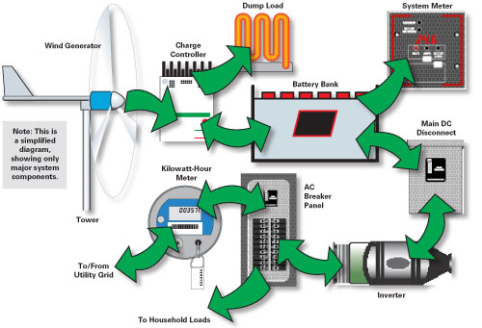
On grid:
Grid-Tied Wind-Electric System with Battery Backup
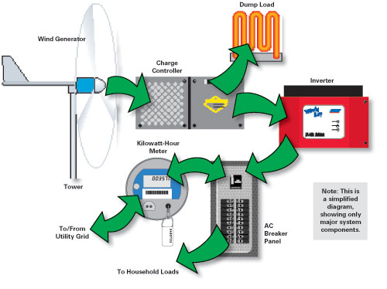
Battery less Grid-Tied Wind-Electric System.

Advantages of using on grid connection:

1- Allows renewable energy generator to use the "grid as storage" so
a- reducing the need for expensive battery storage system
b- Improving payback period for investment.

2- Eliminate the need for an expensive second meter so reducing the installed capacity.
3- Reduce the environmental impact from the disposal of lead – acid batteries.

Disadvantages:
1- Cannot permitted everywhere.
2-process to obtain approval for interconnects, from utility company can be lengthy and complicated.

Off grid:

Advantages of using off grid connection:
1- System are easy to set up

Disadvantages:
1- Cost of batteries
2- Maintenance of batteries.
3- Backup system costs (for hybrid system)
4- Higher level of skill, knowledge, and discipline required for managing electrical load according to what your generator system can provide.
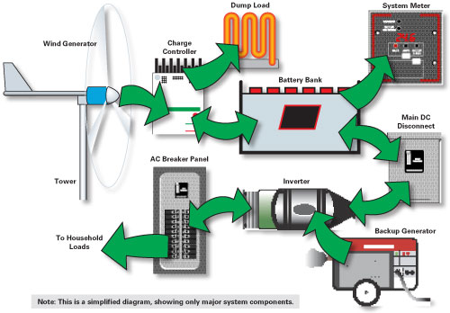

1.3 Direct and indirect grid connection:
Direct grid connection mean that the generator is connected directly to the (usually 3-phase) alternating current grid
Most wind turbines run at almost constant speed with direct grid connection. The speed of the generator and the rotor is given by the grid. Therefore the rotor cannot always work with the optimal aerodynamic efficiency unless the rotor blade can be mechanically controlled
Another possibility is a generator with a pole switching system. This allows for operation under reduced speed and a better adaptation of the current on the rotor during low wind speeds
Indirect grid connection means that the current from the turbine passes through a series of electric devices which adjust the current to match that of the grid. With an asynchronous generator this occurs automatically
Indirect Grid Connection of Wind Turbines
 |  |  |  | 

Advantages of indirect grid connection:

1- It is possible to run the wind speed at variable speed.
2- With power electronic we may control reactive power quality in the electrical grid'

Disadvantages of indirect grid connection:

1- High cost (the cost of rectifier and the inverter)
2- Energy lost due conversion (AC-DC-AC)

Chapter two:
Mean monthly and annual wind speed (m/s) &Power Density in Palestinian cities:
2.1 Power Density in Palestinian cities.
2.2 Mean monthly and annual wind speed (m/s).

2.1 Power Density in Palestinian Cities:
Wind contains energy that can be converted to electricity using wind turbines. The amount of electricity that wind turbines produce depends upon the amount of energy in the wind passing through the area swept by the wind turbine blades in a unit of time. This energy flow is referred to as the wind power density. From the power density value we can estimate the amount of power can be produced from wind in this site, and it gives indication about the capacity of suitable wind turbine can be use in this site. Wind power density depends on wind speed cubed, also depends on air density. Power density is calculated from the following equation:
Power density = 0.5*ρ*V³ (W/m2)
Where:
Ρ: air density (kg/m3)
V: wind speed
We calculated average power density for each month and yearly in the cities, by choosing the value of air density equal to (1.21 kg/m2).
The power density is classified into different classes (at 10 m) as in the following table (3.1):
Class | Power density (W/m2) | Wind Speed (m/s) | Rating
1 | <100 | <4.4 | Poor
2 | 100 - 150 | 4.4 – 5.1 | Marginal
3 | 150 - 200 | 5.1 – 5.6 | Fair
4 | 200 - 250 | 5.6 – 6 | Good
5 | 250 - 300 | 6 – 6.4 | Excellent
6 | 300 - 400 | 6.4 – 7 | Outstanding
7 | >400 | >7 | Outstanding

Wind data for different cities in Palestine:
Average Wind Speed
Average or arithmetic mean for wind speed:
V _{average} = (1/n) Σ^{n} _{i=1} V_{i}
Where V: wind speed
n: number of measured values
Wind speed varies with time. If the wind speed at a site is recorded over a year, it will be seen to vary about a mean wind speed value. This is the annual mean wind speed (AMWS) and is an indication of how much wind energy is available.
In general, we need an AMWS of at least 5 m/s to be able to generate a reasonable amount of energy.
2.2 Mean monthly and annual wind speed (m/s)in Palestinian cities:

Station | Nablus2 | Jenin | Tulkarem | kardallah | Nablus tour | Ramallah
Jan. | 4.96 | 4.96 | 2.95 | 3.64 | 4.97 | 6.8
Feb. | 4.94 | 3.66 | 3.73 | 3.08 | 4.93 | 6.57
Mar. | 4.57 | 4.35 | 4.15 | 3.2 | 2.53 | 6.49
Apr. | 4.81 | 3.87 | 2.7 | 3.485 | 4.81 | 6.75
May. | 4.35 | 4.42 | 2.67 | 3.98 | 4.97 | 4.89
Jun. | 4.24 | 5.48 | 2.66 | 4.36 | 4.25 | 5.58
Jul. | 4.42 | 5.54 | 2.63 | 4.21 | 3.6 | 5.83
Aug. | 4.3 | 4.93 | 2.63 | 4.68 | 4.17 | 5.33
Sep. | 3.95 | 5 | 2.38 | 3.24 | 3.6 | 4.9
Oct. | 3.7 | 3.74 | 2.39 | 2.74 | 2.7 | 5.2
Nov. | 3.45 | 3.51 | 2.95 | 3 | 4.38 | 3.9
Dec. | 3.6 | 3.94 | 2.67 | 3 | 4.26 | 4.5
Annual mean (m/s) | 4.27 | 4.45 | 2.87 | 3.55 | 4.09 | 5.56

Monthly and annual power density (W/m^2) in Palestinian cities:
Station | Nablus2 | Jenin | Tulkarem | kardallah | Nablus tour | Ramallah
Jan. | 73.82 | 74.27 | 15.53 | 29.17 | 74.3 | 190.23
Feb. | 72.9 | 29.66 | 31.39 | 17.67 | 72.5 | 171.57
Mar. | 57.74 | 49.79 | 43.24 | 19.82 | 9.79 | 165.4
Apr. | 67.3 | 35.06 | 11.9 | 25.6 | 67.3 | 186.1
May. | 49.7 | 52.24 | 11.51 | 38.14 | 74.2 | 70.7
Jun. | 46.1 | 99.56 | 11.386 | 50.14 | 46.44 | 105.11
Jul. | 52.2 | 102.8 | 11.00 | 45.14 | 28.22 | 119.88
Aug. | 48.1 | 72.9 | 11.00 | 62.01 | 43.86 | 91.6
Sep. | 37.2 | 75.6 | 8.15 | 20.57 | 28.22 | 71.17
Oct. | 30.6 | 31.67 | 8.25 | 12.44 | 11.9 | 85.55
Nov. | 24.8 | 26.16 | 15.5 | 16.335 | 50.8 | 35.88
Dec. | 28.2 | 37.00 | 11.5 | 16.3 | 46.7 | 55.1
Annual power | 49.09 | 57.2 | 73.07 | 102.5 | 148.7 | 261.09

Chapter three:
Estimation the Electrical Energy Produced by Using Different Wind Turbine in Palestinian Cities:
3.1 power curve & power table of using (20KW) wind turbines.
3.2 Frequency distribution curves for Palestinian cities.
3.3 Energy produced from using (20 kw) wind turbine.
3.4 power curve & power table of using (30KW) wind turbines.
3.5 Energy produced from using (30 kw ) wind turbine.
3.6 power curve & power table of using (55KW) wind turbines.
3.7 Energy produced from using (55 kw ) wind turbine

Estimation the Electrical Energy Produced by Using Different Wind Turbine in Palestinian Cities:
Wind contains energy that can be converted to electricity using wind turbines.
According to the nature of the wind speed we will choose the capacity of the wind turbine in order to give enough electrical energy suitable with capacity of the wind turbine.
So we chose wind turbines (20 KW) and comparing between the electrical energy produced from each turbine in all cities .Each turbine has certain power curve, showing the value of power can produce at each wind speed.
Characteristics of Wind turbines:
(20KW Wind Turbine)
3.1 power curve & power table of using (20KW) wind turbines.

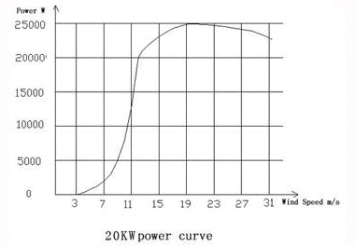

Its power curve as shown in the figure above and its characteristic as shown in the table:
Rated power | 20KW
Output DC voltage | 420v
Cut in speed | 4m/s
Rated wind speed | 12m/s
Cut out speed | 25m/s
Rotor diameter | 12m
# of blades | 3
Generator | 3 phase permanent magnetic alternator
Inverter | AC 220/380, 50HZ/60HZ

Speed range (m/s) | Power (w)
4 – 5 | 450
5 – 6 | 900
6 – 7 | 1600
7 – 8 | 2400
8 – 9 | 3900
9 – 10 | 5900
10 – 11 | 10100
11 – 12 | 16400
12 – 13 | 20000
13 – 14 | 20000
14 – 15 | 20000
15 – 16 | 20000
16 – 17 | 20000
17 – 18 | 20000
18 – 19 | 20000
19 – 20 | 20000
20 – 21 | 20000
21 – 22 | 20000
22 – 23 | 20000
Table **
3.2 Frequency distribution curves for Palestinian cities.

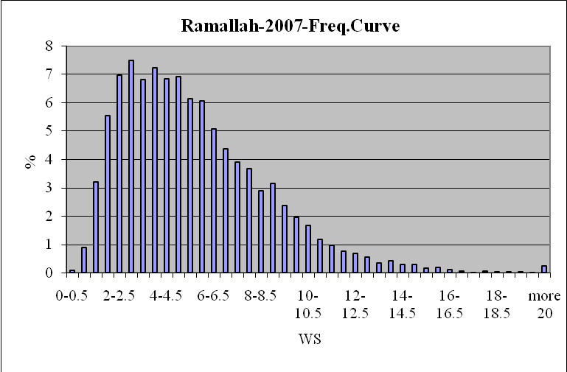

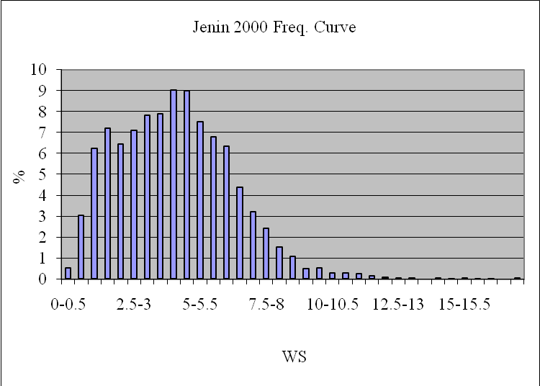

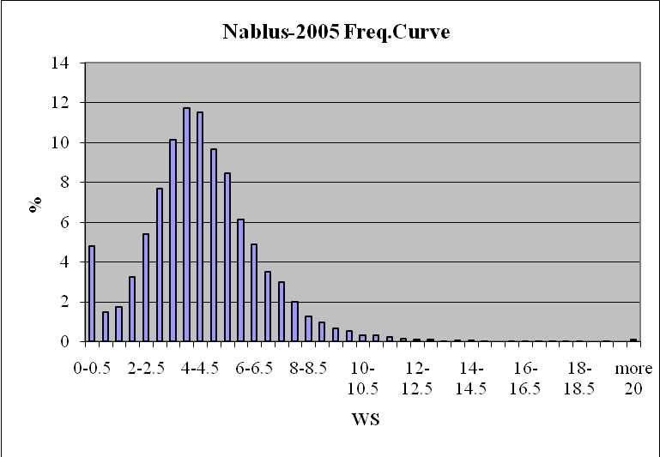
3.3 Energy produced from using (20 kw) wind turbine.

From the tables above we calculate the energy in each city by using this equation:
Energy=power*time.
Where:
The power is given in table**
Time from Frequency distribution curves.( frequency(%)* 8760)
We get the following result:
Speed range(m/s) | Power (w) | Ramallah% | Jenin% | Kardallah% | Nablus tour%
4-5 | 450 | 6.86 | 9.018 | 4.72 | 10.56
5-6 | 900 | 6.1 | 7.17 | 3.19 | 7.29
6-7 | 1600 | 4.7 | 5.37 | 2.63 | 4.195
7-8 | 2400 | 3.77 | 2.82 | 2.08 | 2.48
8-9 | 3900 | 2.93 | 1.3 | 1.89 | 1.12
9-10 | 5900 | 2.17 | 0.51 | 1.26 | 0.577
10-11 | 10100 | 1.44 | 0.268 | 0.63 | 0.308
11-12 | 16400 | 0.88 | 0.19 | 0.262 | 0.177
12-13 | 20000 | 0.62 | 0.074 | 0.057 | 0.097
13-14 | 20000 | 0.83 | 0.017 | 0.0057 | 0.023
14-15 | 20000 | 0.3 | 0.023 | 0.0057 | 0.0287
15-16 | 20000 | 0.17 | 0.03 | 0.0 | 0.0057
16-17 | 20000 | 0.089 | 0.0057 | 0.0 | 0.017
17-18 | 20000 | 0.046 | 0.023 | 0.0 | 0.0114
18-19 | 20000 | 0.040 | 0.0 | 0.0 | 0.0114
19-20 | 20000 | 0.023 | 0.0 | 0.0 | 0.0114
20-21 | 20000 | 0.251 | 0.0 | 0.0 | 0.0779
21-22 | 20000 | 0.251 | 0.0 | 0.0 | 0.0779
22-23 | 20000 | 0.251 | 0.0 | 0.0 | 0.0779

Energy Ramallah  (WH) | Energy Jenin  (WH) | Energy Kardallah  (WH) | Energy Nablus Tour  (WH)
270421.2 | 355489.56 | 186062.4 | 416275.2
480924 | 565282.8 | 251499.2 | 574743.6
658752 | 752659.2 | 368620.8 | 587971.2
792604.8 | 592876.8 | 437299.2 | 521395.2
1001005.2 | 444132 | 645699.6 | 382636.8
1121542.8 | 263588.4 | 651218.4 | 298216.68
1274054.4 | 237115.68 | 557398.8 | 272506.08
1264243.2 | 272961.6 | 376399.68 | 254285.28
1086240 | 129648 | 9986.4 | 169944
665760 | 29784 | 9986.4 | 40296
525600 | 40296 | 9986.4 | 50282.4
297840 | 52560 | 0.0 | 9986.4
155928 | 9986.4 | 0.0 | 2978.4
80592 | 40296 | 0.0 | 19972.8
70080 | 0.0 | 0.0 | 19972.8
40296 | 0.0 | 0.0 | 19972.8
439752 | 0.0 | 0.0 | 139984.8
439752 | 0.0 | 0.0 | 139984.8
439752 | 0.0 | 0.0 | 139984.8
Energy /year (WH)  Ramallah | Energy /year (WH)  Jenin | Energy /year (WH)  Kardallah | Energy /year (WH)  Nablus Tour
11105139.6 | 3786676.44 | 3594035.28 | 4088195.64

We notice that Ramallah has the maximum amount of energy, the second city is Nablus Tour city, and Kardallah has the minimum amount of energy.
Then we repeat the same procedure for 30KW and 55KW wind turbines .also we want to compare the result for the cities.

Wind turbine power curve (30 kW)
3.4 power curve & power table of using (30KW) wind turbines

Speed(m/s) | Power(k w)
4.95 | 0.9
5.98 | 2.83
7.03 | 5.44
8.03 | 9.52
9.24 | 14.53
10.23 | 18.41
11.21 | 23.42
12.29 | 26.8
13.47 | 29.81
14.55 | 30.31
15.63 | 30.68
16.71 | 27.18
17.79 | 30.18
19.08 | 31.19
25 | 31.19
26 | 0
27 | 0
28 | 0
29 | 0
30 | 0
31 | 0
32 | 0
33 | 0
34 | 0
35 | 0
36 | 0

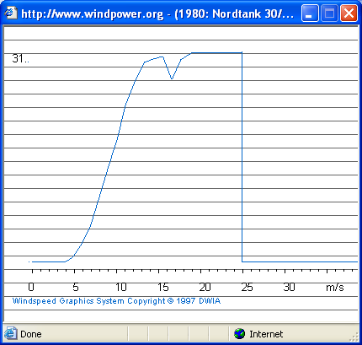 power curve

3.5 Energy produced from using (30 kw ) wind turbine.

Speed range(m/s) | Power (kw) | Ramallah% | Jenin% | Kardallah% | Nablus tour%
4.95 | 0.9 | 6.86 | 9.018 | 4.72 | 10.56
5.89 | 2.83 | 6.1 | 7.17 | 3.19 | 7.29
7.03 | 5.44 | 4.7 | 5.37 | 2.63 | 4.195
8.03 | 9.52 | 3.77 | 2.82 | 2.08 | 2.48
9.24 | 14.53 | 2.93 | 1.3 | 1.89 | 1.12
10.23 | 18.41 | 2.17 | 0.51 | 1.26 | 0.577
11.21 | 23.42 | 1.44 | 0.268 | 0.63 | 0.308
12.29 | 26.8 | 0.88 | 0.19 | 0.262 | 0.177
13.47 | 29.8 | 0.62 | 0.074 | 0.057 | 0.097
14.55 | 30.3 | 0.83 | 0.017 | 0.0057 | 0.023
15.63 | 30.68 | 0.3 | 0.023 | 0.0057 | 0.0287
16.7 | 27.18 | 0.17 | 0.03 | 0.0 | 0.0057
17.79 | 30.18 | 0.089 | 0.0057 | 0.0 | 0.017
19.08 | 31.19 | 0.046 | 0.023 | 0.0 | 0.0114
25 | 31.19 | 0.040 | 0.0 | 0.0 | 0.0114
26 | 0.0 | 0.023 | 0.0 | 0.0 | 0.0114
27 | 0.0 | 0.251 | 0.0 | 0.0 | 0.0779
28 | 0.0 | 0.251 | 0.0 | 0.0 | 0.0779
29 | 0.0 | 0.251 | 0.0 | 0.0 | 0.0779
30 | 0.0 | 0.251 | 0.0 | 0.0 | 0.0779
31 | 0.0 | 0.251 | 0.0 | 0.0 | 0.0779
32 | 0.0 | 0.251 | 0.0 | 0.0 | 0.0779
33 | 0.0 | 0.251 | 0.0 | 0.0 | 0.0779
34 | 0.0 | 0.251 | 0.0 | 0.0 | 0.0779
35 | 0.0 | 0.251 | 0.0 | 0.0 | 0.0779
36 | 0.0 | 0.251 | 0.0 | 0.0 | 0.0779

Energy Ramallah  (KWH) | Energy Jenin  (KWH) | Energy Kardallah  (KWH) | Energy Nablus Tour  (KWH)
540.8 | 710.9 | 372.12 | 832.5
1512.2 | 1777.5 | 790.8 | 1807
2239.7 | 2559 | 1253.3 | 1999
3143.9 | 2351.7 | 1734.6 | 2068.2
3729.4 | 1654.6 | 2405.4 | 1425.56
3499.55 | 822.4 | 2032 | 930.5
2954.3 | 549.8 | 1292.5 | 631.89
2065.9 | 464 | 615 | 415.5
1618.5 | 193.17 | 148.7 | 235.2
1008.6 | 45.1 | 15.1 | 61
806.3 | 61.8 | 15.3 | 77.1
404.76 | 71.43 | 0.0 | 13.57
235.3 | 15.07 | 0.0 | 44.94
125.68 | 62.84 | 0.0 | 31.14
109.28 | 0.0 | 0.0 | 31.14
0.0 | 0.0 | 0.0 | 0.0
0.0 | 0.0 | 0.0 | 0.0
0.0 | 0.0 | 0.0 | 0.0
0.0 | 0.0 | 0.0 | 0.0
0.0 | 0.0 | 0.0 | 0.0
0.0 | 0.0 | 0.0 | 0.0
0.0 | 0.0 | 0.0 | 0.0
0.0 | 0.0 | 0.0 | 0.0
0.0 | 0.0 | 0.0 | 0.0
0.0 | 0.0 | 0.0 | 0.0
0.0 | 0.0 | 0.0 | 0.0
Energy /year (KWH)  Ramallah | Energy /year (KWH)  Jenin | Energy /year (KWH)  Kardallah | Energy /year (KWH)  Nablus Tour
23994.49 | 11321.76 | 10675.4 | 10622.8

3.6 power curve & power table of using (55KW) wind turbines.

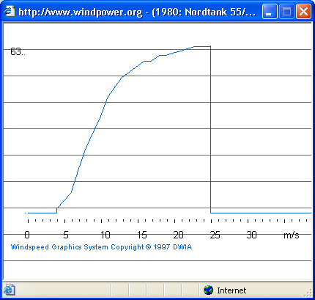 power curve
Speed range(m/s) | Power (kw) | Ramallah% | Jenin% | Kardallah% | Nablus tour%
4.98 | 4.95 | 6.86 | 9.018 | 4.72 | 10.56
5.99 | 8.05 | 6.1 | 7.17 | 3.19 | 7.29
7.0 | 16.85 | 4.7 | 5.37 | 2.63 | 4.195
8.01 | 24.91 | 3.77 | 2.82 | 2.08 | 2.48
8.96 | 30.72 | 2.93 | 1.3 | 1.89 | 1.12
9.99 | 36.64 | 2.17 | 0.51 | 1.26 | 0.577
10.98 | 44.16 | 1.44 | 0.268 | 0.63 | 0.308
12.0 | 48.2 | 0.88 | 0.19 | 0.262 | 0.177
12.97 | 51.91 | 0.62 | 0.074 | 0.057 | 0.097
14.00 | 53.93 | 0.83 | 0.017 | 0.0057 | 0.023
14.94 | 55.86 | 0.3 | 0.023 | 0.0057 | 0.0287
16.04 | 58.04 | 0.17 | 0.03 | 0.0 | 0.0057
17.01 | 58.14 | 0.089 | 0.0057 | 0.0 | 0.017
18.1 | 60.16 | 0.046 | 0.023 | 0.0 | 0.0114
19 | 60.24 | 0.040 | 0.0 | 0.0 | 0.0114
19.98 | 61.23 | 0.023 | 0.0 | 0.0 | 0.0114
20.97 | 61.85 | 0.251 | 0.0 | 0.0 | 0.0779
22.03 | 62.88 | 0.251 | 0.0 | 0.0 | 0.0779
23.04 | 63.69 | 0.251 | 0.0 | 0.0 | 0.0779
25 | 63.69 | 0.251 | 0.0 | 0.0 | 0.0779
26 | 0.0 | 0.251 | 0.0 | 0.0 | 0.0779
27 | 0.0 | 0.251 | 0.0 | 0.0 | 0.0779
28 | 0.0 | 0.251 | 0.0 | 0.0 | 0.0779
29 | 0.0 | 0.251 | 0.0 | 0.0 | 0.0779
30 | 0.0 | 0.251 | 0.0 | 0.0 | 0.0779
31 | 0.0 | 0.251 | 0.0 | 0.0 | 0.0779

3.7 Energy produced from using (55 kw ) wind turbine

Energy Ramallah  (KWH) | Energy Jenin  (KWH) | Energy Kardallah  (KWH) | Energy Nablus Tour  (KWH)
2974.6 | 3910.4 | 2046.7 | 4579
4301.6 | 5056.14 | 2249.5 | 5140.7
6937.5 | 7926.44 | 3882.04 | 6192
8226.6 | 6153.5 | 4538.8 | 5411.6
7884.84 | 3498.4 | 5086.1 | 3014
6964.97 | 1636.9 | 4044.2 | 1851.9
5570.5 | 1036.7 | 2437.1 | 1191.5
3715.6 | 802.2 | 1106.2 | 747.4
2819.34 | 336.5 | 259.2 | 441.1
1795.2 | 80.3 | 26.9 | 108.65
1468 | 121.5 | 27.89 | 140.4
864.33 | 152.5 | 0.0 | 28.98
453.28 | 29.03 | 0.0 | 86.6
242.42 | 121.2 | 0.0 | 60.07
211.08 | 0.0 | 0.0 | 60.15
123.36 | 0.0 | 0.0 | 61.14
1359.9 | 0.0 | 0.0 | 432.9
1382.5 | 0.0 | 0.0 | 440.1
1400.3 | 0.0 | 0.0 | 445.7
1400.3 | 0.0 | 0.0 | 445.7
0.0 | 0.0 | 0.0 | 0.0
0.0 | 0.0 | 0.0 | 0.0
0.0 | 0.0 | 0.0 | 0.0
0.0 | 0.0 | 0.0 | 0.0
0.0 | 0.0 | 0.0 | 0.0
0.0 | 0.0 | 0.0 | 0.0
Energy /year (KWH)  Ramallah | Energy /year (KWH)  Jenin | Energy /year (KWH)  Kardallah | Energy /year (KWH)  Nablus Tour
60096.6 | 30852.96 | 25704.7 | 30880.02

We notice that also using 55 KW Ramallah give more energy than Nablus tour.

Chapter four:
Economical evaluation of using diesel and different wind turbines.
4.1 Calorific value of diesel and economical consideration.
4.1.1 Cost of diesel consumption per year
4.1.2 Cost of 1kwh output ((including the cost of generator))
4.2 Economical evaluation of using (20 kW) wind turbines.
4.2.1 Saving per year ($/year) in each Palestinian city.
4.2.2 Annuity per year ($/year) in each Palestinian city.
4.2.3 Cost ($/kWh) in each Palestinian city.
4.2.4 Saving per kwh.

4.3 Economical evaluation of using (30 KW) wind turbines.
4.3.1 Saving per year ($/year) in each Palestinian city.
4.3.2 Annuity per year ($/year) in each Palestinian city.
4.3.3 Cost ($/kWh) in each Palestinian city.
4.3.4 Saving per kwh.
4.4 Economical evaluation of using (55 kW) wind turbines.
4.4.1 Saving per year ($/year) in each Palestinian city.
4.4.2 Annuity per year ($/year) in each Palestinian city.
4.4.3 Cost ($/kWh) in each Palestinian city.
4.4.4 Saving per kwh.

4.1 Calorific value of diesel and economical consideration:
The diesel electric generator Diesel generators are widely used in Palestine to provide remote villages with electric power.
Usually, these generators require high running cost, frequent maintenance and they
Pollute the environment.
The ratings of the diesel generator are determined by the load. The total load of the
Village is 16.7 kW. Hence, we select a 20 kV A generator type (catterpiller) with three phase output AC voltage (3*380 V), 50 Hz with a power factor of 0.85.

Data given:
1 liter diesel=5.5 NIS=1.6$
1 liter of diesel =10000 Kcal
Diesel generator=20 KVA
Efficiency=32%
Load factor= 0.4
1kwh=860 kcal

4.1.1 Cost of diesel consumption per year

From the data above we want to calculate the following:
A-cost of diesel consumption per year
B-cost of 1kwh output ((including the cost of generator))

- energy= average power *time
energy=(max power*load factor)*time
=(apperant power *power factor*load factor)*time
=20*0.8*0.4*8760=56064 kwh

1 kwh 860 kcal
56064 kwh x

X=(860*56064)/1=48215040 kcal

1 liter (10000*0.32 )kcal
Y 48215040 kcal

Y=15067.2 liter/year

1 liter 1.6$
15067.2 z
Z=24107.52 $

So the running cost is equal 24107.52$/year
1 cost of diesel =7500$
Annual cost of diesel= 7500*0.1=750$/year

2 maintenance cost per year=4%of the total fixed cost
=4%*7500=300$/year

3 cost of oil consumption per year=50 liter per year
Cost of oil=50*2=100$/year
Total cost per year=annual fixed cost +annual running cost
=diesel generator cost /year +cost of diesel
+cost of maintenance +cost of oil=
24107.52+7500+300+100=32007.52 $/year
4.1.2 Cost of 1kwh output ((including the cost of generator))

B-cost of 1kwh output=total cost per year/energy per year
= 32007.52/56064=0.57

4.2 Economical Evaluation for using (20 KW) wind turbine
Atouf village:
P max=20 KW
Energy =p av * time
Energy = pmax * l.f *t
Energy = 20 * 0.4 * 8760=70080 KWh
-Capital cost (P) for this turbine =35000$
-Lifecycle (t) =20 year
-Scrap value (S) =.2*35000= 7000$
-Maintenance (A₂) ₌.05*35000=1750$/year
In the table we will show the energy produced from the 20KW Wind turbine in each Palestinian cites.
City | Ramallah | Jenin | Kardallah | Nablus(tour)
Energy(KWH) | 11105.139 | 3786.676 | 3594.035 | 4088.195
4.2.1 Saving per year ($/year) in each Palestinian city.

And saving per year (A₁) in each Palestinian city in table
Where: saving per year= energy per year * cost per kwh of diesel

City | Ramallah | Jenin | Kardallah | Nablus(tour)
A₁($/year) | 6663.08 | 2272 | 2156.42 | 2452.917

4.2.2 Annuity per year ($/year) in each Palestinian city.

And using the Equation bellow, the result of A_{tota} in each Palestinian city will record in the table
A_{total} = A₁ + 7000 (A/F, 10%, 20) - 35000*(A/P, 10%, 20) – 1750

City | Ramallah | Jenin | Kardallah | Nablus(tour)
A_{total}($/year) | 924.19 | -3466.89 | -3582.47 | -3285.97
Table

We see that all A_{total} are negative except Ramallah , which mean that the project of using this 20KW wind turbine is not visible for the cities but visible for Ramallah .
To determine the cost of producing (1 KWH) from this Turbine (20KW) in the Palestinian city we will see the result in the table using the equation:

4.2.3 Cost ($/kWh) in each Palestinian city.
Cost ($/KWH) = (P (A/P, 10%, 20) + A₂)/ (Energy produce per year)

City | Ramallah | Jenin | Kardallah | Nablus(tour)
Cost($/KWH) | 0.5278 | 1.548 | 1.63 | 1.434

4.2.4 Saving per kwh.
Then we want to calculate saving per kwh
Saving/ kwh = A / energy

City | Ramallah | Jenin | Kardallah | Nablus(tour)
saving / kwh | 0.083 | -0.92 | -1.66 | -0.80

We see that all saving per kwh are negative except Ramallah , which mean that the project of using this 20KW wind turbine is not visible for the cities but visible for Ramallah .
The cost of using wind in Ramallah is less than using diesel but in other cities the cost of using wind is larger than using diesel.
4.3 Economical evaluation of using (30 kW) wind turbines.

We repeat the same procedure for 30 kw wind turbine :

City | Ramallah | Jenin | Kardallah | Nablus(tour)
Energy(KWH) | 23994.49 | 11321.765 | 10675.39 | 10622.85
4.3.1 Saving per year ($/year) in each Palestinian city.

City | Ramallah | Jenin | Kardallah | Nablus(tour)
A₁($/year) | 14396.694 | 6793.059 | 6405.234 | 6373.71
4.3.2 Annuity per year ($/year) in each Palestinian city.

City | Ramallah | Jenin | Kardallah | Nablus(tour)
A_{total}($/year) | 8657.804 | 1054.169 | 666.344 | 634.82
4.3.3 Cost ($/kWh) in each Palestinian city.

City | Ramallah | Jenin | Kardallah | Nablus(tour)
Cost($/KWH) | 0.24 | 0.52 | 0.55 | 0.552
4.3.4 Saving per kwh

City | Ramallah | Jenin | Kardallah | Nablus(tour)
saving / kwh | 0.36 | 0.093 | 0.062 | 0.0598
We see that all A _{total} are positive for all cities , which mean that the project of using this 30KW wind turbine is visible for the cities .
We see that all saving per kwh are positive, which mean that the project of using this 30KW wind turbine is visible for the cities .
The cost of using wind in all cities is less than using diesel .

4.4 Economical evaluation of using (55 kW) wind turbines.
We repeat the same procedure for 55 kW wind turbine:
City | Ramallah | Jenin | Kardallah | Nablus(tour)
Energy(KWH) | 60096.598 | 30852.964 | 25704.72 | 30880.019
4.4.1 Saving per year ($/year) in each Palestinian city.

City | Ramallah | Jenin | Kardallah | Nablus(tour)
A₁($/year) | 36057.958 | 18511.78 | 15422.8 | 18528.011
4.4.2 Annuity per year ($/year) in each Palestinian city.

City | Ramallah | Jenin | Kardallah | Nablus(tour)
A_{total}($/year) | 30319.068 | 12772.89 | 9683.91 | 12789.121
4.4.3 Cost ($/kWh) in each Palestinian city.
City | Ramallah | Jenin | Kardallah | Nablus(tour)
Cost($/KWH) | 0.098 | 0.19 | 0.228 | 0.19
4.4.4 Saving per kwh
City | Ramallah | Jenin | Kardallah | Nablus(tour)
saving / kwh | 0.505 | 0.414 | 0.377 | 0.414
We see that all A _{total} are positive for all cities , which mean that the project of using this 55KW wind turbine is visible for the cities .
We see that all saving per kWh are positive , which mean that the project of using this 55KW wind turbine is visible for the cities.
The cost of using wind in all cities is less than using diesel.

In general:
We notice that when we use larger wind turbine the cost ($/ kWh) will be smaller.
Chapter five:
5.1 The remote village( El-Beren )Location and living conditions.
5.2 calculation of energy needed for( El-Beren ) village.
5.3 Using hybrid system (wind turbine 20 kW & diesel) to produce this amount of energy.
5.4 Calculation of Saving($)(for using 20 kw)=total cost of wind _total cost of diesel.
5.5 Using hybrid system (wind turbine 30 kw & diesel) to produce this amount of energy.
5.6 Calculation of Saving($)(for using 30 kw)=total cost of wind _total cost of diesel.
5. 7 Using hybrid system (wind turbine 55kw & diesel) to produce this amount of energy.
5.8 Calculation of Saving($)(for using 55kw)=total cost of wind _total cost of diesel.

5.1 The remote village El-Beren in Hebron.
Location and living conditions
Its inhabitants work mainly in farming and cattle breeding. Their
Number amount to about 200 living in 25 houses. A school and a small clinic are available
The daily energy needs in such villages are very low. The households use mainly wood
And biomass for cooking and baking bread. Kerosene and gas lamps are still used for lighting.

5.2 calculation of energy needed for Atouf village.
El-Beren village:
Max power=10 kW
Load factor =0.4
Time =5*365=1825 h/year
Energy = P av * time =P max * l.F *t =7300 kWh /year
Energy= 608.3 kwh/month.
Existing (Diesel) :
Cost /month= energy *cost=608.3*0.6=365 $/month.

5.3 Using hybrid system (wind turbine 20 kW & diesel) to produce this amount of energy.
Suggested:
We need 608.3 kwh/month. The cost of using diesel is 365 $/month as mentioned above now we want to calculate the cost of using hybrid (wind&diesel)for each city:
From the table above we calculate the energy produce from wind in each month. we want to find if this amount is enough to cover the amount of energy we need if not we want to use diesel with wind (hybrid) and to compare the cost ($/kwh)of the two cases(using diesel or hybrid) as follow :
The cost of diesel=0.6 $/kWh.
The cost of 1kwh produced only from wind turbine:
Cost / kWh = [-P/ (A /P i, n) _A m +S (A / F i, n)] / E
Jenin city:

Month | Diesel | wind | Reserved | Cost of diesel | Cost of wind | Total cost
Jan. | ……….. | 1027.2 | 418.9 | ……….. | 1589.92 | 1589.92
Feb. | 379.1 | 229.2 | ……….. | 227.46 | 354.76 | 582.22
Mar. | 194.3 | 414 | ……….. | 116.58 | 640.80 | 757.38
Apr. | 361.1 | 247.2 | ……….. | 216.66 | 382.62 | 599.28
May | 283.1 | 325.2 | ……….. | 169.86 | 503.35 | 673.21
Jun. | ……….. | 716.4 | 108.1 | ……….. | 1108.86 | 1108.86
Jul. | ……….. | 744 | 135.7 | ……….. | 1151.58 | 1151.58
Aug. | 125.9 | 482.4 | ……….. | 75.54 | 746.67 | 822.21
Sep. | 75.5 | 532.8 | ……….. | 45.3 | 824.68 | 869.98
Oct. | 350.3 | 258 | ……….. | 210.18 | 399.34 | 609.52
Nov. | 483.5 | 124.8 | ……….. | 290.1 | 193.17 | 483.27
Dec. | 328.7 | 279.6 | ……….. | 197.22 | 432.77 | 629.99
Annual  Energy  (KWH) | ……….. | 5381 | ……….. | ……….. | ……….. | ………..
Nablus tour:
Month | Diesel | wind | Reserved | Cost of diesel | Cost of wind | Total cost
Jan. | ……….. | 951.8 | 343.5 | ……….. | 1364.56 | 1364.56
Feb. | ……….. | 919.7 | 311.4 | ……….. | 1318.54 | 1318.54
Mar. | 497.1 | 111.2 | ……….. | 298.26 | 159.42 | 457.68
Apr. | ……….. | 987.4 | 379.1 | ……….. | 1415.6 | 1415.6
May | ……….. | 970.45 | 362.15 | ……….. | 1391.3 | 1391.3
Jun. | 266.9 | 341.4 | ……….. | 160.14 | 489.45 | 649.59
Jul. | 403.9 | 204.4 | ……….. | 242.3 | 293.04 | 535.38
Aug. | 257.3 | 351 | ……….. | 154.38 | 503.22 | 657.6
Sep. | 432.9 | 175.4 | ……….. | 259.7 | 251.46 | 511.2
Oct. | 532.6 | 75.7 | ……….. | 319.56 | 108.53 | 428.09
Nov. | ……….. | 947 | 338.7 | ……….. | 1357.68 | 1357.68
Dec. | ……….. | 936.7 | 328.4 | ……….. | 1342.91 | 1342.91
Annual  Energy  (KWH) | ……….. | 6972 | ……….. | ……….. | ……….. | ………..
Kardallah city:
Month | Diesel | wind | Reserved | Cost of diesel | Cost of wind | Total cost
Jan. | 244.7 | 363.6 | ……….. | 146.82 | 592.95 | 739.77
Feb. | 507.5 | 100.8 | ……….. | 304.5 | 164.38 | 468.88
Mar. | 489.5 | 118.8 | ……….. | 293.7 | 193.74 | 487.44
Apr. | 431.9 | 176.4 | ……….. | 259.14 | 287.67 | 546.8
May | 403.1 | 205.2 | ……….. | 241.86 | 334.64 | 576.5
Jun. | 321.5 | 286.8 | ……….. | 192.9 | 467.7 | 660.6
Jul. | 375.5 | 232.8 | ……….. | 225.3 | 379.65 | 604.95
Aug. | 202.7 | 405.6 | ……….. | 121.6 | 661.45 | 783.07
Sep. | 500.3 | 108 | ……….. | 300.18 | 176.12 | 476.3
Oct. | 597.5 | 10.8 | ……….. | 358.5 | 17.61 | 376.1
Nov. | 472.7 | 135.6 | ……….. | 283.62 | 221.13 | 504.75
Dec. | 483.5 | 124.8 | ……….. | 290.1 | 203.52 | 493.6
Annual  Energy  (KWH) | ……….. | 2269 | ……….. | ……….. | ……….. | ………..
Ramallah city:
Month | Diesel | wind | Reserved | Cost of diesel | Cost of wind | Total cost
Jan. | ……….. | 2766.6 | 2158.3 | ……….. | 1460.16 | 1460.16
Feb. | ……….. | 2613.2 | 2004.9 | ……….. | 1379.2 | 1379.2
Mar. | ……….. | 2897.1 | 2288.8 | ……….. | 1529 | 1529
Apr. | ……….. | 3135.4 | 2527.1 | ……….. | 1654 | 1654
May | ……….. | 1065.3 | 457 | ……….. | 562.24 | 562.24
Jun. | ……….. | 1452 | 843.7 | ……….. | 766.34 | 766.34
Jul. | ……….. | 1693.4 | 1085.1 | ……….. | 893.74 | 893.74
Aug. | ……….. | 1035.1 | 426.8 | ……….. | 546.3 | 546.3
Sep. | ……….. | 772.9 | 164.6 | ……….. | 407.9 | 407.9
Oct. | ……….. | 988.7 | 380.4 | ……….. | 521.8 | 521.8
Nov. | ……….. | 1502.5 | 894.2 | ……….. | 792.9 | 792.9
Dec. | ……….. | 965.6 | 357.3 | ……….. | 509.63 | 509.63
Annual  Energy  (KWH) | ……….. | 20887 | ……….. | ……….. | ……….. | ………..

5.4 Calculation of Saving($)(for using 20 kw)=total cost of wind _total cost of diesel.
We want to calculate the saving by using the following equation:
Saving($)=total cost of wind _total cost of diesel
cities | Total cost of wind | Total cost of diesel | Saving ($)
Jenin | 8328.5 | 1548.9 | 6779.6
Nablus tour | 9995.71 | 1434.31 | 8561.4
Kardallah | 3700.56 | 3018.22 | 682.34
Ramallah | 11023.2 | 0.0 | 11023.2
5.5 Using hybrid system (wind turbine 30 kw & diesel) to produce this amount of energy.
We repeat the same procedure for 30 KW wind turbine:
Jenin city:
Month | Diesel | wind | Reserved | Cost of diesel | Cost of wind | Total cost
Jan. | ……….. | 1027.2 | 418.9 | ……….. | 531.77 | 531.77
Feb. | 379.1 | 229.2 | ……….. | 227.46 | 118.65 | 346.11
Mar. | 194.3 | 414 | ……….. | 116.58 | 214.32 | 330.90
Apr. | 361.1 | 247.2 | ……….. | 216.66 | 127.97 | 344.63
May | 283.1 | 325.2 | ……….. | 169.86 | 168.35 | 338.21
Jun. | ……….. | 716.4 | 108.1 | ……….. | 370.87 | 370.87
Jul. | ……….. | 744 | 135.7 | ……….. | 385.16 | 385.16
Aug. | 125.9 | 482.4 | ……….. | 75.54 | 249.73 | 325.27
Sep. | 75.5 | 532.8 | ……….. | 45.3 | 275.82 | 321.12
Oct. | 350.3 | 258 | ……….. | 210.18 | 133.56 | 343.74
Nov. | 483.5 | 124.8 | ……….. | 290.1 | 64.61 | 354.71
Dec. | 328.7 | 279.6 | ……….. | 197.22 | 144.74 | 341.96
Annual  Energy  (KWH) | ……….. | 5381 | ……….. | ……….. | ……….. | ………..

Nablus tour city:
Month | Diesel | wind | Reserved | Cost of diesel | Cost of wind | Total cost
Jan. | ……….. | 951.8 | 343.5 | ……….. | 525.15 | 525.15
Feb. | ……….. | 919.7 | 311.4 | ……….. | 507.44 | 507.44
Mar. | 497.1 | 111.2 | ……….. | 298.26 | 61.35 | 359.61
Apr. | ……….. | 987.4 | 379.1 | ……….. | 544.79 | 544.79
May | ……….. | 970.45 | 362.15 | ……….. | 535.44 | 535.44
Jun. | 266.9 | 341.4 | ……….. | 160.14 | 188.37 | 348.51
Jul. | 403.9 | 204.4 | ……….. | 242.3 | 112.78 | 355.12
Aug. | 257.3 | 351 | ……….. | 154.38 | 193.66 | 348.04
Sep. | 432.9 | 175.4 | ……….. | 259.7 | 96.78 | 356.52
Oct. | 532.6 | 75.7 | ……….. | 319.56 | 41.77 | 361.33
Nov. | ……….. | 947 | 338.7 | ……….. | 522.50 | 522.50
Dec. | ……….. | 936.7 | 328.4 | ……….. | 516.82 | 516.82
Annual  Energy  (KWH) | ……….. | 6972 | ……….. | ……….. | ………. | ……….
Kardallah city:
Month | Diesel | wind | Reserved | Cost of diesel | Cost of wind | Total cost
Jan. | 244.7 | 363.6 | ……….. | 146.82 | 199.63 | 346.45
Feb. | 507.5 | 100.8 | ……….. | 304.5 | 55.34 | 359.84
Mar. | 489.5 | 118.8 | ……….. | 293.7 | 65.22 | 358.92
Apr. | 431.9 | 176.4 | ……….. | 259.14 | 96.85 | 355.99
May | 403.1 | 205.2 | ……….. | 241.86 | 112.66 | 354.52
Jun. | 321.5 | 286.8 | ……….. | 192.9 | 157.46 | 350.36
Jul. | 375.5 | 232.8 | ……….. | 225.3 | 127.81 | 353.11
Aug. | 202.7 | 405.6 | ……….. | 121.6 | 222.69 | 344.31
Sep. | 500.3 | 108 | ……….. | 300.18 | 59.30 | 359.48
Oct. | 597.5 | 10.8 | ……….. | 358.5 | 5.93 | 364.43
Nov. | 472.7 | 135.6 | ……….. | 283.62 | 74.45 | 358.07
Dec. | 483.5 | 124.8 | ……….. | 290.1 | 68.52 | 358.62
Annual  Energy  (KWH) | ……….. | 2269 | ……….. | ……….. | ……….. | ………..
Ramallah city:
Month | Diesel | wind | Reserved | Cost of diesel | Cost of wind | Total cost
Jan. | ……….. | 2766.6 | 2158.3 | ……….. | 675.79 | 675.79
Feb. | ……….. | 2613.2 | 2004.9 | ……….. | 638.3 | 638.3
Mar. | ……….. | 2897.1 | 2288.8 | ……….. | 707.67 | 707.67
Apr. | ……….. | 3135.4 | 2527.1 | ……….. | 765.87 | 765.87
May | ……….. | 1065.3 | 457 | ……….. | 260.2 | 260.2
Jun. | ……….. | 1452 | 843.7 | ……….. | 354.67 | 354.67
Jul. | ……….. | 1693.4 | 1085.1 | ……….. | 413.64 | 413.64
Aug. | ……….. | 1035.1 | 426.8 | ……….. | 252.84 | 252.84
Sep. | ……….. | 772.9 | 164.6 | ……….. | 188.79 | 188.79
Oct. | ……….. | 988.7 | 380.4 | ……….. | 241.5 | 241.5
Nov. | ……….. | 1502.5 | 894.2 | ……….. | 367 | 367
Dec. | ……….. | 965.6 | 357.3 | ……….. | 235.86 | 235.86
Annual  Energy  (KWH) | ……….. | 20887 | ……….. | ……….. | ……….. | ………..

5.6 Calculation of Saving($)(for using 30 kw)=total cost of wind _total cost of diesel.
We want to calculate the saving by using the following equation:
Saving($)=total cost of wind _total cost of diesel

cities | Total cost of wind | Total cost of diesel | Saving ($)
Jenin | 2785.55 | 1548.9 | 1236.65
Nablus tour | 3846.85 | 1434.34 | 2412.51
Kardallah | 1245.86 | 3018.22 | -1772.36
Ramallah | 5102.07 | 0.0 | 5102.07
5. 7 Using hybrid system (wind turbine 55kw & diesel) to produce this amount of energy.
Jenin city:
Month | Diesel | wind | Reserved | Cost of diesel | Cost of wind | Total cost
Jan. | ……….. | 1027.2 | 418.9 | ……….. | 195.14 | 195.14
Feb. | 379.1 | 229.2 | ……….. | 227.46 | 43.54 | 271.00
Mar. | 194.3 | 414 | ……….. | 116.58 | 78.65 | 195.23
Apr. | 361.1 | 247.2 | ……….. | 216.66 | 46.96 | 263.62
May | 283.1 | 325.2 | ……….. | 169.86 | 61.78 | 231.64
Jun. | ……….. | 716.4 | 108.1 | ……….. | 136.09 | 136.09
Jul. | ……….. | 744 | 135.7 | ……….. | 141.34 | 141.34
Aug. | 125.9 | 482.4 | ……….. | 75.54 | 91.64 | 167.18
Sep. | 75.5 | 532.8 | ……….. | 45.3 | 101.22 | 146.52
Oct. | 350.3 | 258 | ……….. | 210.18 | 49.01 | 259.19
Nov. | 483.5 | 124.8 | ……….. | 290.1 | 23.71 | 313.81
Dec. | 328.7 | 279.6 | ……….. | 197.22 | 53.12 | 250.34
Annual  Energy  (KWH) | ……….. | 5381 | ……….. | ……….. | ……….. | ………..

Nablus tour city:
Month | Diesel | wind | Reserved | Cost of diesel | Cost of wind | Total cost
Jan. | ……….. | 951.8 | 343.5 | ……….. | 180.65 | 180.65
Feb. | ……….. | 919.7 | 311.4 | ……….. | 174.56 | 174.56
Mar. | 497.1 | 111.2 | ……….. | 298.26 | 21.11 | 319.37
Apr. | ……….. | 987.4 | 379.1 | ……….. | 187.41 | 187.41
May | ……….. | 970.45 | 362.15 | ……….. | 184.19 | 184.19
Jun. | 266.9 | 341.4 | ……….. | 160.14 | 64.80 | 224.94
Jul. | 403.9 | 204.4 | ……….. | 242.3 | 38.80 | 281.14
Aug. | 257.3 | 351 | ……….. | 154.38 | 66.62 | 221.00
Sep. | 432.9 | 175.4 | ……….. | 259.7 | 33.29 | 293.03
Oct. | 532.6 | 75.7 | ……….. | 319.56 | 14.37 | 333.93
Nov. | ……….. | 947 | 338.7 | ……….. | 179.74 | 179.74
Dec. | ……….. | 936.7 | 328.4 | ……….. | 177.79 | 177.79
Annual  Energy  (KWH) | ……….. | 6972 | ……….. | ……….. | ……….. | ………..
Kardallah city:
Month | Diesel | wind | Reserved | Cost of diesel | Cost of wind | Total cost
Jan. | 244.7 | 363.6 | ……….. | 146.82 | 82.91 | 229.73
Feb. | 507.5 | 100.8 | ……….. | 304.5 | 22.98 | 327.48
Mar. | 489.5 | 118.8 | ……….. | 293.7 | 27.09 | 320.79
Apr. | 431.9 | 176.4 | ……….. | 259.14 | 40.22 | 299.36
May | 403.1 | 205.2 | ……….. | 241.86 | 46.79 | 288.65
Jun. | 321.5 | 286.8 | ……….. | 192.9 | 65.40 | 258.30
Jul. | 375.5 | 232.8 | ……….. | 225.3 | 53.08 | 278.38
Aug. | 202.7 | 405.6 | ……….. | 121.6 | 92.48 | 214.10
Sep. | 500.3 | 108 | ……….. | 300.18 | 24.63 | 324.81
Oct. | 597.5 | 10.8 | ……….. | 358.5 | 2.46 | 360.96
Nov. | 472.7 | 135.6 | ……….. | 283.62 | 30.92 | 314.54
Dec. | 483.5 | 124.8 | ……….. | 290.1 | 28.46 | 318.56
Annual  Energy  (KWH) | ……….. | 2269 | ……….. | ……….. | ……….. | ………..

Ramallah city:
Month | Diesel | wind | Reserved | Cost of diesel | Cost of wind | Total cost
Jan. | ……….. | 2766.6 | 2158.3 | ……….. | 269.82 | 269.82
Feb. | ……….. | 2613.2 | 2004.9 | ……….. | 254.86 | 254.86
Mar. | ……….. | 2897.1 | 2288.8 | ……….. | 282.55 | 282.55
Apr. | ……….. | 3135.4 | 2527.1 | ……….. | 305.79 | 305.79
May | ……….. | 1065.3 | 457 | ……….. | 103.90 | 103.90
Jun. | ……….. | 1452 | 843.7 | ……….. | 141.61 | 141.61
Jul. | ……….. | 1693.4 | 1085.1 | ……….. | 165.15 | 165.15
Aug. | ……….. | 1035.1 | 426.8 | ……….. | 100.95 | 100.95
Sep. | ……….. | 772.9 | 164.6 | ……….. | 75.38 | 75.38
Oct. | ……….. | 988.7 | 380.4 | ……….. | 96.43 | 96.43
Nov. | ……….. | 1502.5 | 894.2 | ……….. | 146.54 | 146.54
Dec. | ……….. | 965.6 | 357.3 | ……….. | 94.17 | 94.17
Annual  Energy  (KWH) | ……….. | 20887 | ……….. | ……….. | ……….. | ………..

5.8 Calculation of Saving($)(for using 55kw)=total cost of wind _total cost of diesel.

We want to calculate the saving by using the following equation:
Saving($)=total cost of wind _total cost of diesel
cities | Total cost of wind | Total cost of diesel | Saving ($)
Jenin | 1022.2 | 1548.9 | -526.7
Nablus tour | 1323.33 | 1434.34 | -111.01
Kardallah | 517.42 | 3018.22 | -2500.8
Ramallah | 2037.15 | 0.0 | 2037.15

Chapter six:
Batteries used in wind turbines system.
6.1 Battery types.
6.2 Sizing the battery block.

Batteries


Storage batteries are indispensable in all stand alone wind electric systems. Their efficiencies and life times affect significantly the overall wind system performance and economics. Batteries specified especially for use in wind systems have to be distinguished with standing of very deep discharge rate and high cycling stability.

Ordinary batteries being marketed worldwide for use in automobile are mostly not appropriate for wind power systems. The most important characteristics of lead–acid batteries are presented and discussed .developing an algorithm for determining the ampere–hour capacity of batteries operating in wind systems. This algorithm enables determining the state-of-charge of a battery by measuring voltage and electrolyte-specific gravity at definite temperature and is applicable also for large battery storage systems.

6.1 Battery types
The two battery types that have been used for wind systems are lead–acid and nickel–cadmium. Due to higher cost, lower cell voltage (1.2 V), lower energy efficiency and limited upper operating temperature (40 ◦C), nickel–cadmium batteries have been employed in relatively few system. . Their use is based mainly on their long life with reduced maintenance and their capability of standing deep discharge without damage. The lead–acid battery will remain the most important storage device in the near future, especially in wind systems of medium and large size. It is a lead/sulfuric acid/lead dioxide electrochemical system, whose overall reaction is given by the following equation:

Pb + PbO2 + 2H2SO4 discharge 2PbSO4 + 2H2O

_ Charge

A battery is made up of two or more electrochemical cells interconnected in an appropriate series/parallel arrangement to provide the required operating voltage and current levels.
The familiar 12V lead–acid battery used in automobiles consists of six 2-V cells connected in series and packaged in a rubber or plastic case.
6.2 Sizing the battery block
The storage capacity of battery block for such systems is considerably large. Therefore,
Special lead–acid battery cells (block type) of long life time (more10 years), high cycling
Stability-rate (more 1000 times) and capability of standing very deep discharge should be
Selected. Such battery types are available but at much higher price than regulars batteries.
The ampere hour capacity (CAh) and watt hour capacity (Cwh) of the battery block,
Necessary to cover the load demands for a period of 1.5 days without wind, is obtained as
follows:
CAh = (1.5*EL ) / (VB * DOD *eff B * eff V)
Cwh =CAh*VB
Where:
VB and eff B are voltage and efficiency of battery block, while DOD is the permissible
depth of discharge rate of a cell. Assuming realistic values of effB=0.85, DOD=0.75 and
VB=220 V, we obtain:
CAh = (1.5*95700) / (220*0.75*0.85*0.9) =1137.2 A h ,
Cwh =1137.2*220=250.2 kWh
The charge regulator and inverter
The charge regulator (CR) is necessary to protect the battery block against deep discharge and over charge. Input/output ratings of CR are fixed by the output of the PV
array and VB . In this case the appropriate rated power of CR is 25 kW. In this power
range it is recommended that the CR should have a maximum power control unit.
The input of inverter have to be matched with the battery block voltage while its
output should fulfill the specifications of the electric grid of the village specified as:
3*380 V; 50 Hz sinusoidal voltage and 20 kV A.

Chapter seven:
7.1 related wind software.
7.2 flow chart
7.3 Software for hybrid system.

7.1 Related wind software:

1-The RET Screen Clean Energy Project Analysis Software is a unique decision support tool developed with the contribution of numerous experts from government, industry, and academia. The software can be used worldwide to evaluate the energy production and savings, costs, emission reductions, financial viability and risk for various types of Renewable-energy and Energy-efficient Technologies (RETs). The software (available in multiple languages) also includes product, project, hydrology and climate databases, a detailed user manual, and a case study based college/university-level training course, including an engineering e-textbook.
Five step standard analysis:
Start (settings and site condition)
- energy model
- cost analysis
- emission analysis
- financial analysis
- sensitivity and risk analysis

Integrated features:
- climate data
- product data
- online manual
- tools:
- distance learning course
- training material
- engineering textbook
- case study
- maps
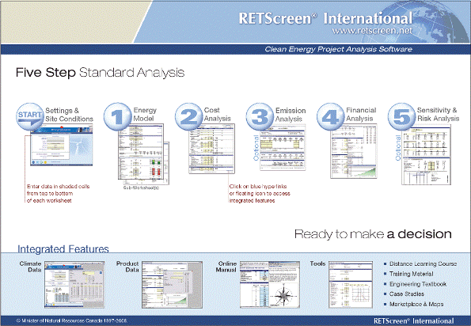

Start
As part of the RET Screen Clean Energy Project Analysis software, the Start worksheet is used to enter general information about the project, as well as site reference conditions regarding climate. It is also used to select standard settings used to perform the analysis.
Start Worksheet

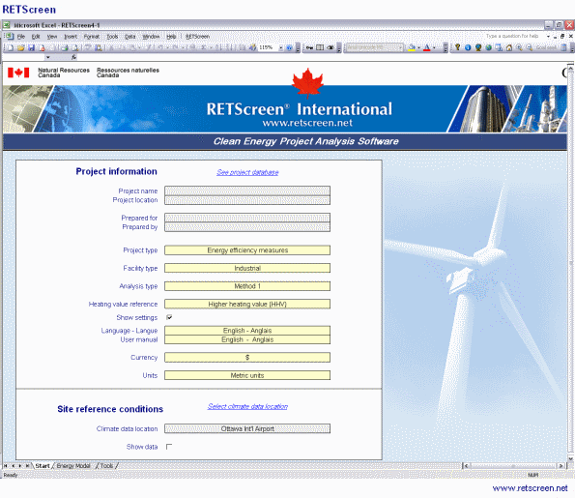

7.3 Software for hybrid system.

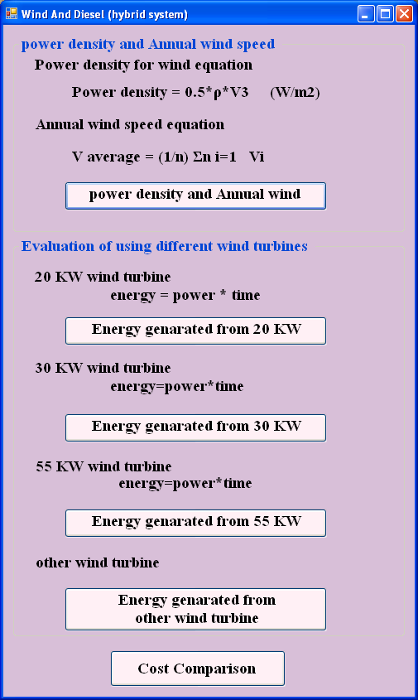
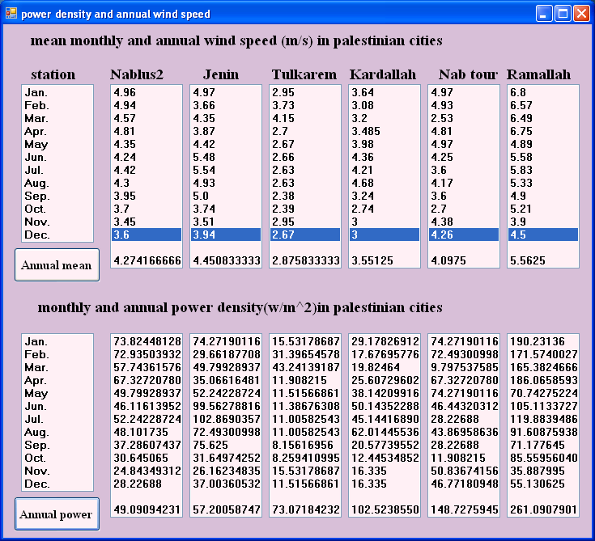

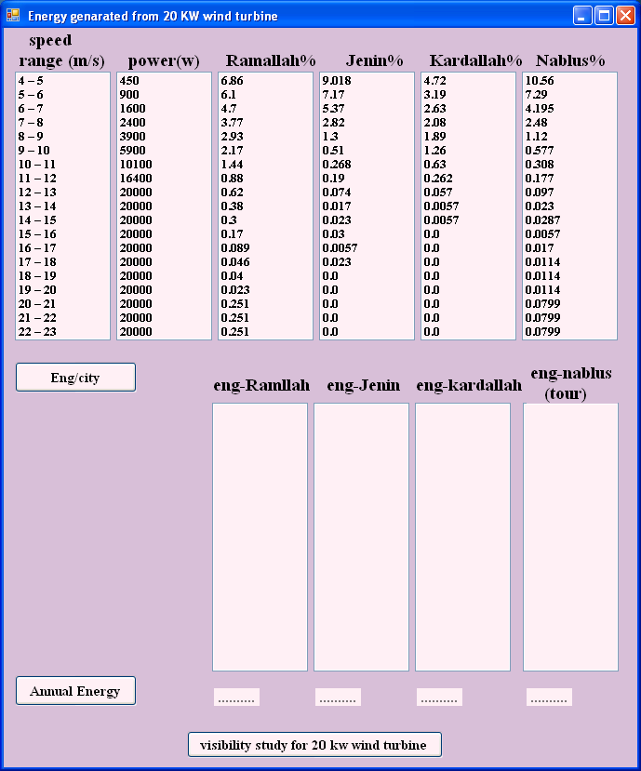

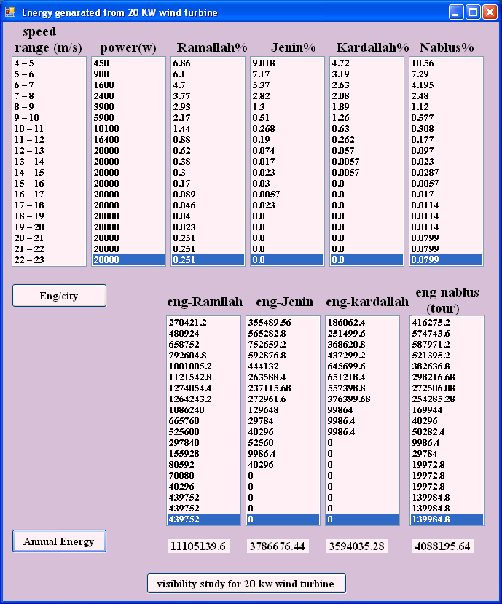

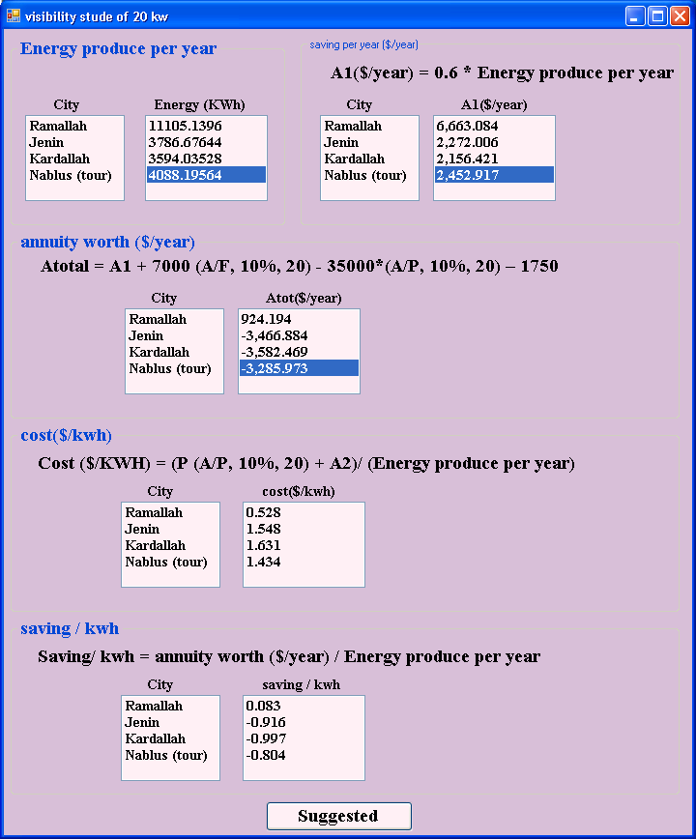

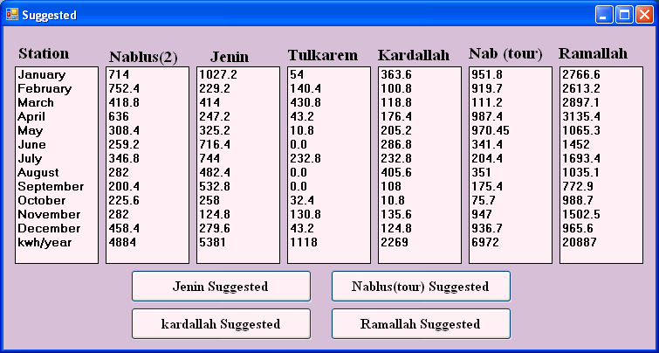
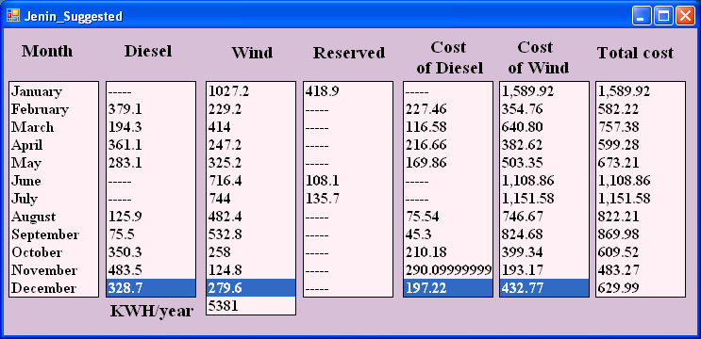

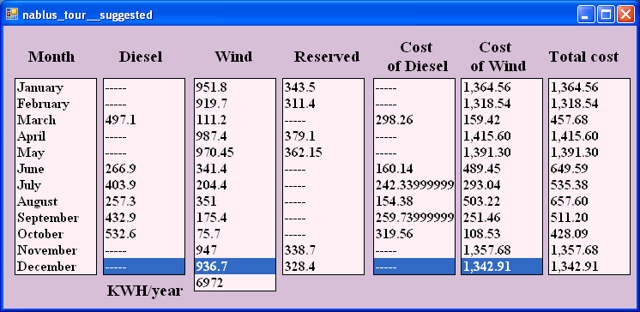

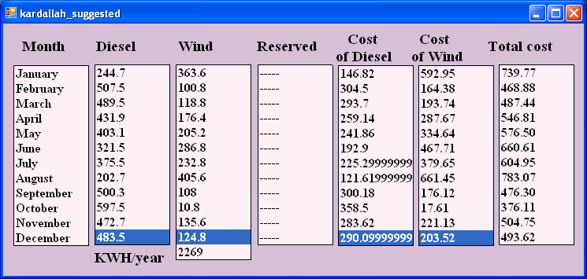

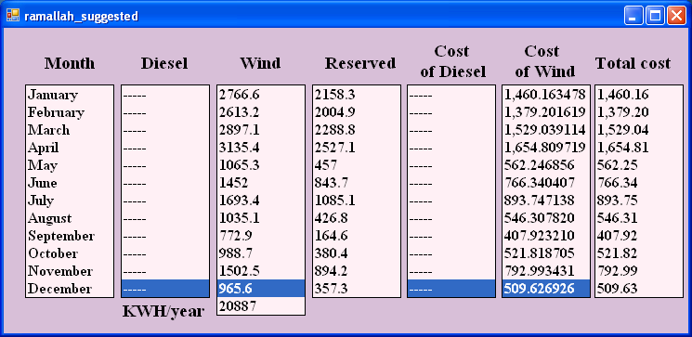

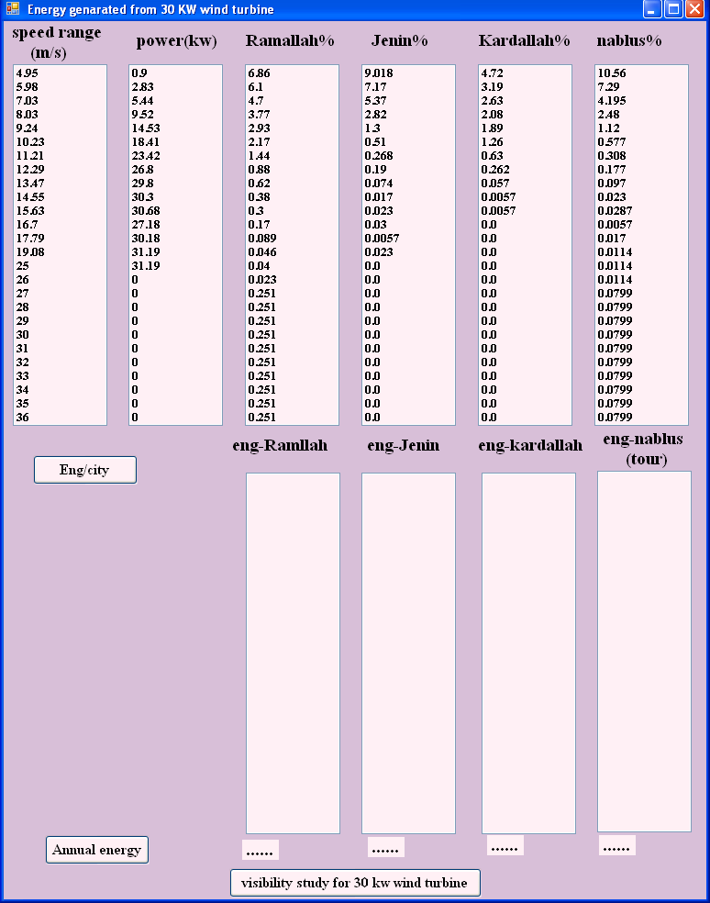

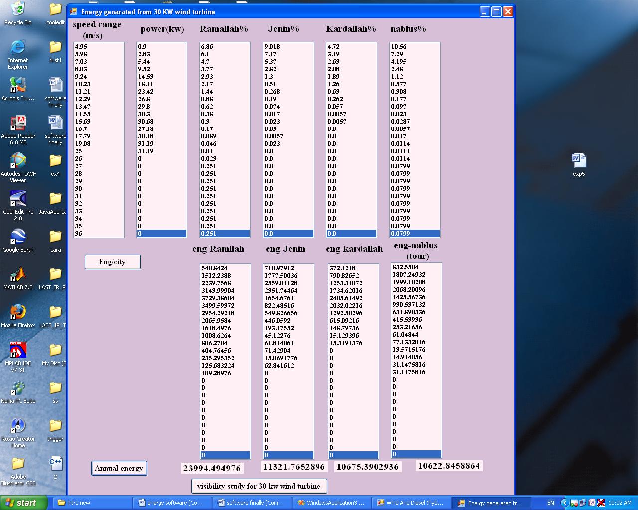

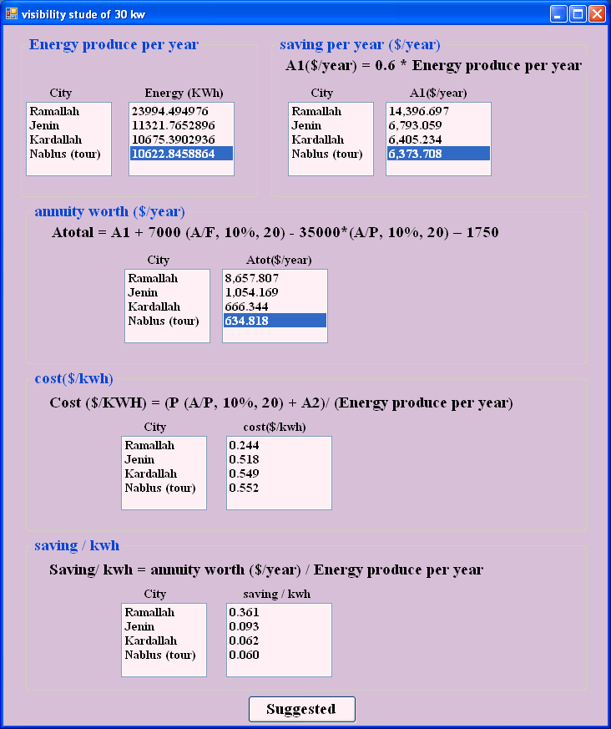

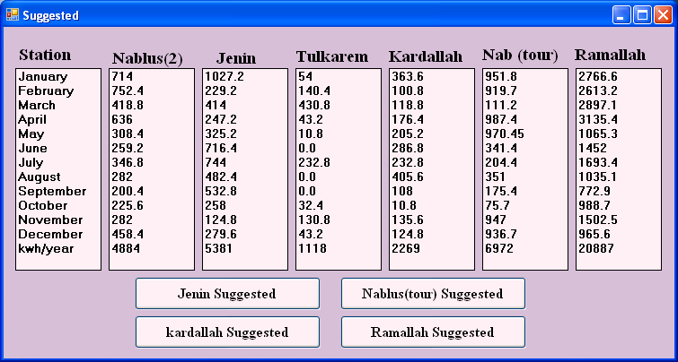

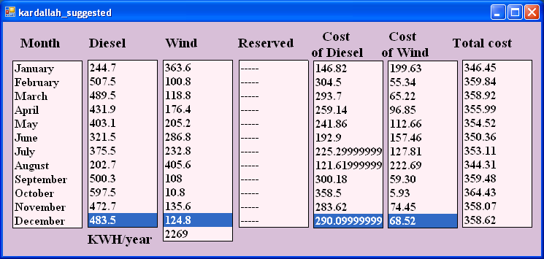

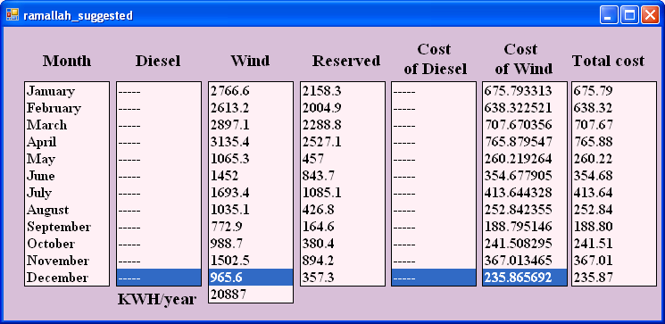

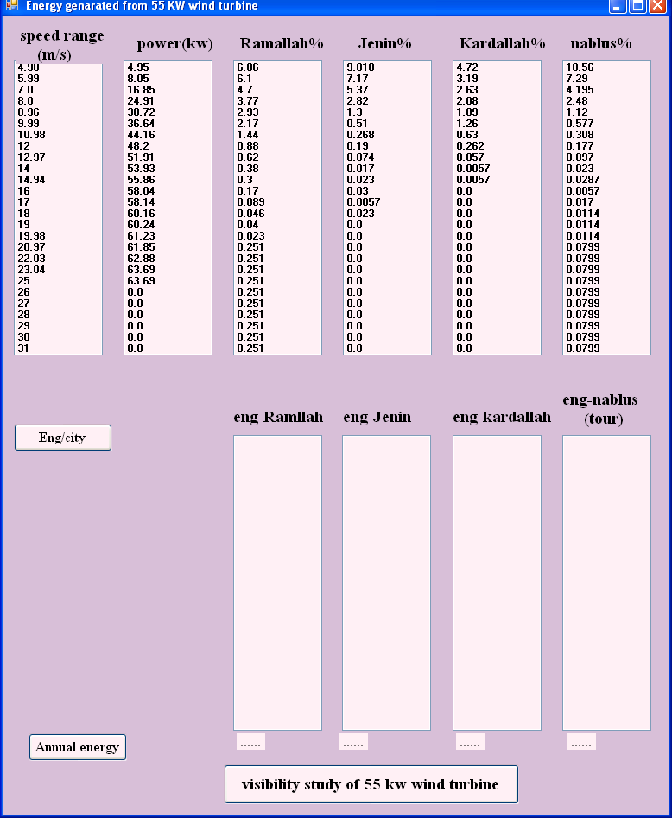
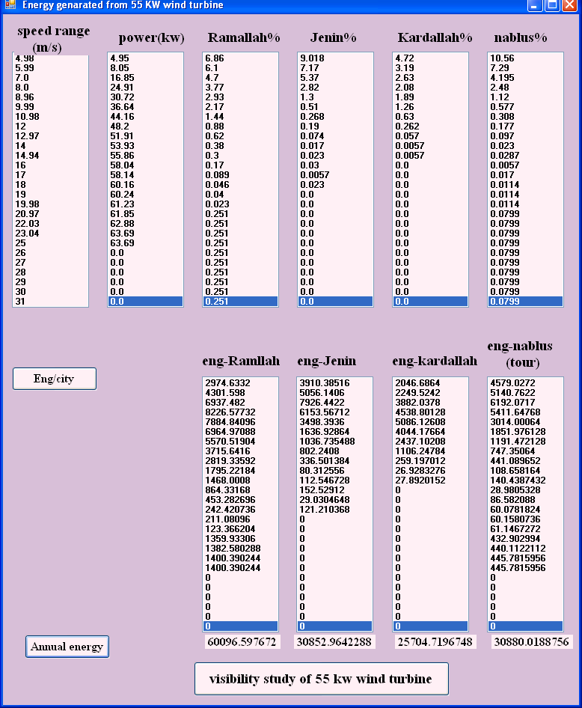

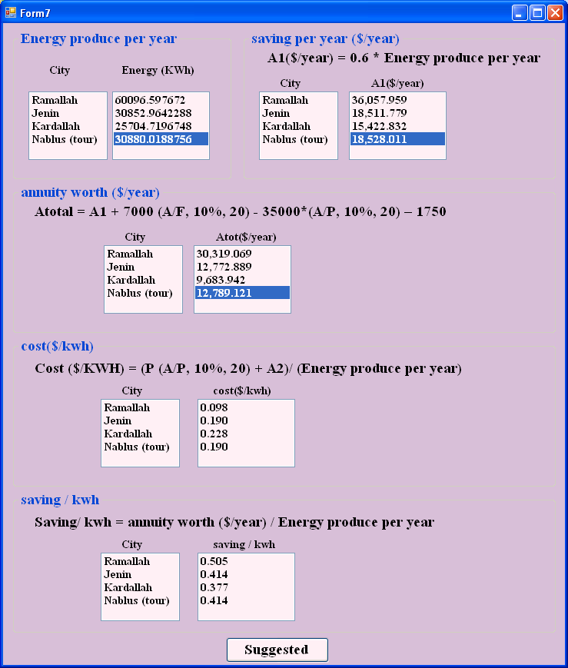

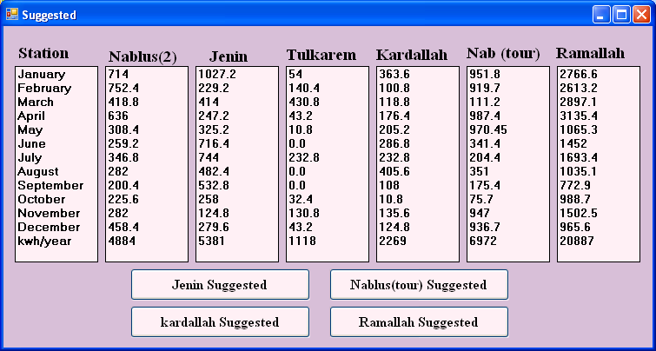

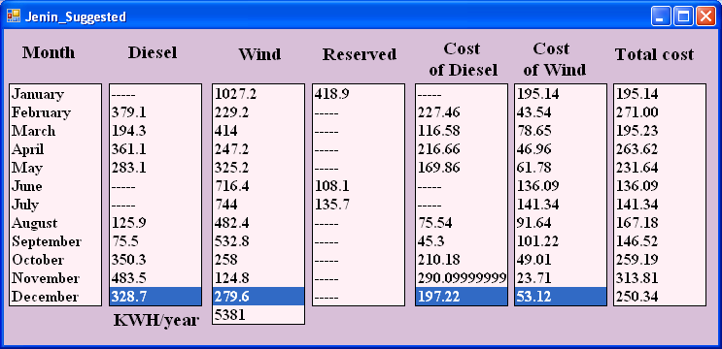

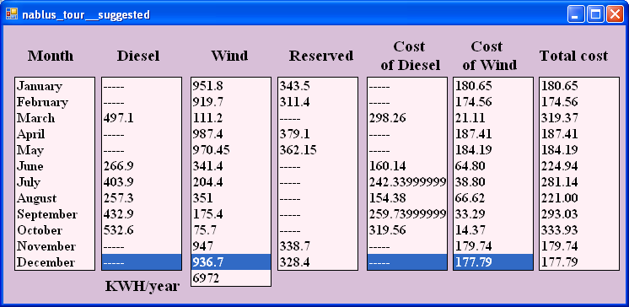

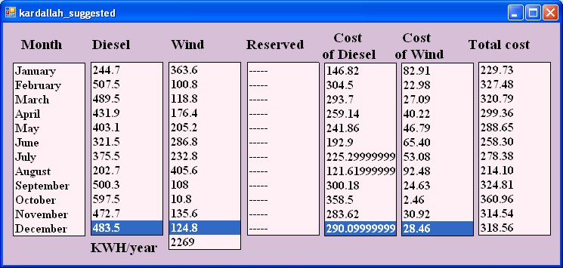

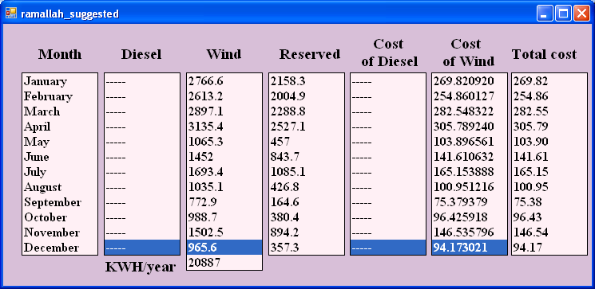
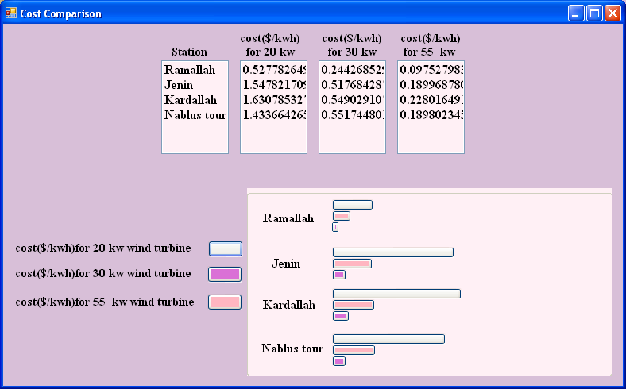

 | C | 3 | 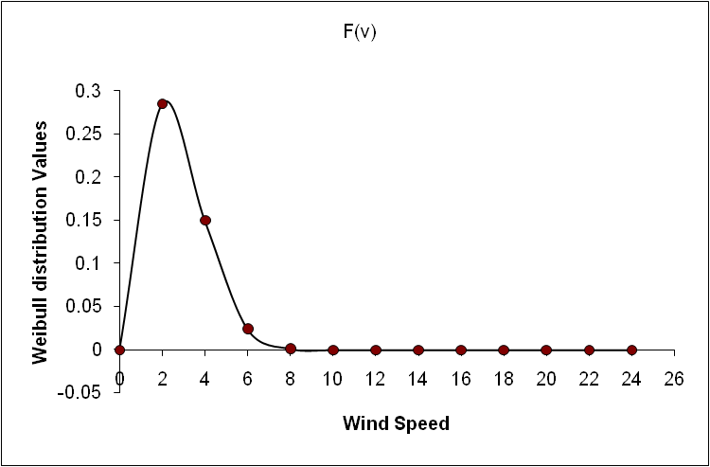
 | K | 2
 | v | F(v)
 | 0 | 0
 | 2 | 0.284969062
 | 4 | 0.150234058
 | 6 | 0.024420852
 | 8 | 0.001450645
 | 10 | 3.32119E-05
 | 12 | 3.00094E-07
 | 14 | 1.08379E-09
 | 16 | 1.57631E-12
 | 18 | 9.27809E-16
 | 20 | 2.21738E-19
 | 22 | 2.15684E-23
 | 24 | 8.55366E-28

References:

[1] Mahmoud M.M., Ibrik H.I..Techno-economic feasibility of energy supply of remote villages in Palestine by pv-system, diesel generators and electric grid. Renewable &sustainable energy reviews.10(2006) 128-138

[2] Energy Research Center(ERC) , Meteorological measurements in West Bank/Nablus and Ramallah. An Najah National University.

[3] B. Ai ,H .Yang ,H . Shen ,X .Liao . computer-aided design of PV/wind hybrid system. Renewable energy 28 (2003) 1491_1512.

[4] wind energy: our wind farms. Available at: http://www.stable windenergy/wind_energy20.htm1[access date 3 December 2007]

[5] Boyle G., 2004 , Renewable Energy, OXFORD university press.

[6] wind and hydro power technologies program. Available at:http://www.eere.energy.gov/windandhydro/wind_how.htm1[access date 3 December 2007]

[7] Basic Wind Turbine Configurations. Available at : http://www.awea.org/faq/basiccf.htm1[access date 7 December 2007]

[8] Lecture notes. Renewable Energy Technology 1&2. An-Najah National University. 2006-2007.

[9] Lakovos Tzanakis . Combining Wind and Solar Energy to Meet Demands in the Built Environment(thesis report). Energy Systems Research Unit .University of Strathclyde.2005-2006.

[10] Research and markets Brochure. Available at : http://www.research andmarkets.com/reports/328418/[access date 4 February 2008]]

An Najah National University
Faculty Of Engineering
Electrical Engineering Department



Final Graduation Project Introduction

((Electrification Of Small Villages By Using Wind Turbine And Diesel Generator Hybrid System ))

Prepared by:
Hiba Rashad Hindi
Rasha Sameer Muhsen

Supervised by:
Dr. Imad Brik

2008-2009

