

AN-NAJAH NATIONAL UNIVERSITY

FACULITY OF ENGINEERING

COMPUTER ENGINEERING DEPARTMENT

**Hardware project**

*AAS (automated attendance system)*

Supervisors: Students:

Dr.Sufian Samarah Worood zafer

Dr.luai malhes Shoroq abu omar

2010 – 2011 Semester

**Table of Contents:**

**1 Abstract…………………………….3**

* 1. **Objective ……………………………4**
  2. **Infrared: ……………………………...4**

**2. Hard Ware description………………...5**

**2.1 Design………………………………...…6**

**2.1.1 Block Diagram………………..……..6**

**2.1.2 Design description………….………7**

**2.1.2.2 LCD display:………….……..7**

**2.1.2.3 Relay …………………………7**

**2.1.2.4 Serial cable………………….7**

**2.1.2.5 Infrared………………………8**

**2.1.2.6 Door motor………………….8**

**2.1.2.7Tsop 1738 ……………………8**

**3. Software**

**3.1 Logical structure……………………………9**

**3.1 C# application ………………………………..9**

**3.2 Access database……………………..10**

**3.2.1 Login Table…………………………10**

**3.2.2 Student Table……………………….10**

**3.3 PIC C programmer………………………….11**

**3.3.1 LCD programming……………………......11**

**3.3.2 Board Driver………………………………..11**

**Conclusion…………………………………………12**

**Appendix………………………………………….13.14.15.16.17**

**Abstract:**

Due to the easy availability of almost all information on the internet these days, students are less and less motivated to come to the lecture rooms than ever before. Professors and instructors have to come up with ways to ensure ahealthy participation from the students, and make sure that the “classic” student professor interactive relationship is kept intact.

This in the some cases may be in simple forms like roll call, while in more interesting cases, can be formats like surprise quizzes, extra credit in class, etc. These things can however be very time-consuming. Valuable in-class time that could have otherwise been used for lectures need to be dedicated to “attendance” taking. In addition to all this, theattendances are entered manually and therefore are error prone. Now, there’s atechnology that can solve all this and more.

**1.1 Objective :**

Due to the easy availability of almost all information on the internet these days, students are less and less motivated to come to the lecture rooms than ever before. Professors and instructors have to come up with ways to ensure ahealthy participation from the students, and make sure that the “classic” student professor interactive relationship is kept intact.

This in the some cases may be in simple forms like roll call, while in more interesting cases, can be formats like surprise quizzes, extra credit in class, etc. These things can however be very time-consuming. Valuable in-class time that could have otherwise been used for lectures need to be dedicated to “attendance” taking. In addition to all this, theattendances are entered manually and therefore are error prone. Now, there’s atechnology that can solve all this and more.

Using A floor mat sensor, the task of taking a classroom attendance becomes just a “single click” of the mouse by scaning this mat of wires to detect student presedant and according to his/her chair position we are also able to turn on\off different devices. i.e. lights,computers.

* 1. **Infrared:**

we used infrared to enable the doctor to open and close the door from destance . see appendix picture #1 .

**2. Hard Ware description :**

Sch.EMF

**2.1 Design**

**2.1.1 Block Diagram:**

Objects

Sensors

Micro-Processor

Devices

Output Display

**Block Descriptions:**

* Objects: This can be any object(s), e.g. desks, lamps, chairs, and people, inside the room.
* Sensors: Floor detection mat will be integrated as part of the floor. Sensors within the mat will be assembled in a grid-like fashion. The micro-processor will periodically scan each sensor for a change in conditions.
* Micro-Processor: Micro-controller will interpret the inputs from the mats, determine the locations of any objects within the room, and send appropriate signals to display the x-y coordinates of each person.
* Devices: This can be any object(s), e.g. lights, computers, projectors, etc., which will automatically be turned on depending on the location of the occupants

**2.1.2 Design description**

**2.1.2.1 Floor mat**

* 30*20 cm word board
* Wires are connected in a grid matrix
* Contact is made by pressing down vertical wires to horizontal wires
* See appendix picture # 5.

**2.1.2.2 LCD display:**

It enable us to see the number of student who set now at the chair. See appendix picture # 2.

**2.1.2.3 Relay :**

Used to turn on/off the connected device as the student takes his/her place , we conected ULN2003 as interface between the PIC and Relay to Repeat the current taken from microcontroller to avoid pulling large current from the PIC. See appendix picture

#3

**2.1.2.4 Serial cable :**

used For programming the microcontroller. by sending data in hex format which we wrote it using pic c program. And also used to send date backward to display on the teacher monitor which chair is occupied and which not. See appendix picture # 4

**2.1.2.5 Infrared:**

From remote control signal which enable the doctor to open and close the door remotly. See appendix picture #1

**2.1.2.6 Door motor**

As an output load from relay controlled using infrared signal.

### 2.1.2.7Tsop 1738

It use to receiver IR (infrared) from Remote control. See appendix picture #1

**3. Software**

**3.1 Logical structure:**

**3.1 C# application :**

show which seat is occupied and which is not and also show the date& time and automatically store attendance in data base.

And its as monitor for doctor to see all the student in their seat and

Also detect when student set and when he/she leave the chair

See picture # 6 in the appendix which show the interface of our application.

**3.2 Access database :**

**3.2.1 Login Table:**

Data base table contain the student # and the time/date in which the student set also the status of student if it on his/her chair or not.

See picture # 7 in the appendix

**3.2.2 Student Table:**

Which contain all students in the doctor class and their PC number.

See appendix picture #8

**3.3 PIC C programmer:**

To programming microcontroller (pic18).

**3.3.1 LCD programming:**

Main functions:

lcd_read_nibble(void)

lcd_send_nibble(int8 nibble)

lcd_read_byte(void)

lcd_send_byte(int8 address, int8 n)

lcd_gotoxy(int8 x, int8 y)

lcd_put_array(byte d[],byte address)

**3.3.2 Board Driver :**

Main function:

char kbd_getc() // return last chair that set.

**4. Conclusion:**

Overall, we feel the project met most of our expectations, as we were able to build an automated system which could detect the student who is absent and who not. And also turn on the devices or off depend on the position of the student chair.

This was also a tremendous learning experience for us, especially with the hardware. We learn a tremendous amount about motor control systems, efficient circuit design, and hardware debugging. We also learned a lot about software. Through this project, we got valuable experience in developing efficient software.

**Appendix :**

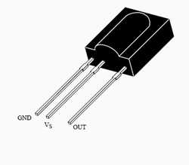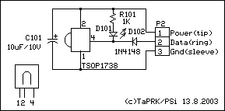

picture # 1

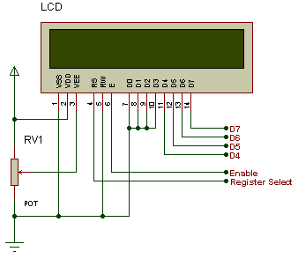

picture # 2

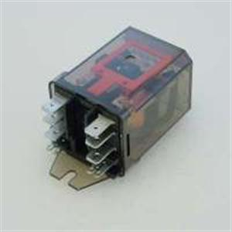Picture # 3

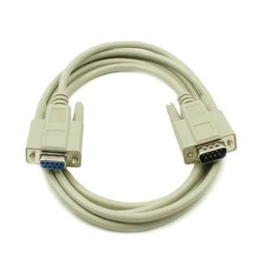

Picture # 4

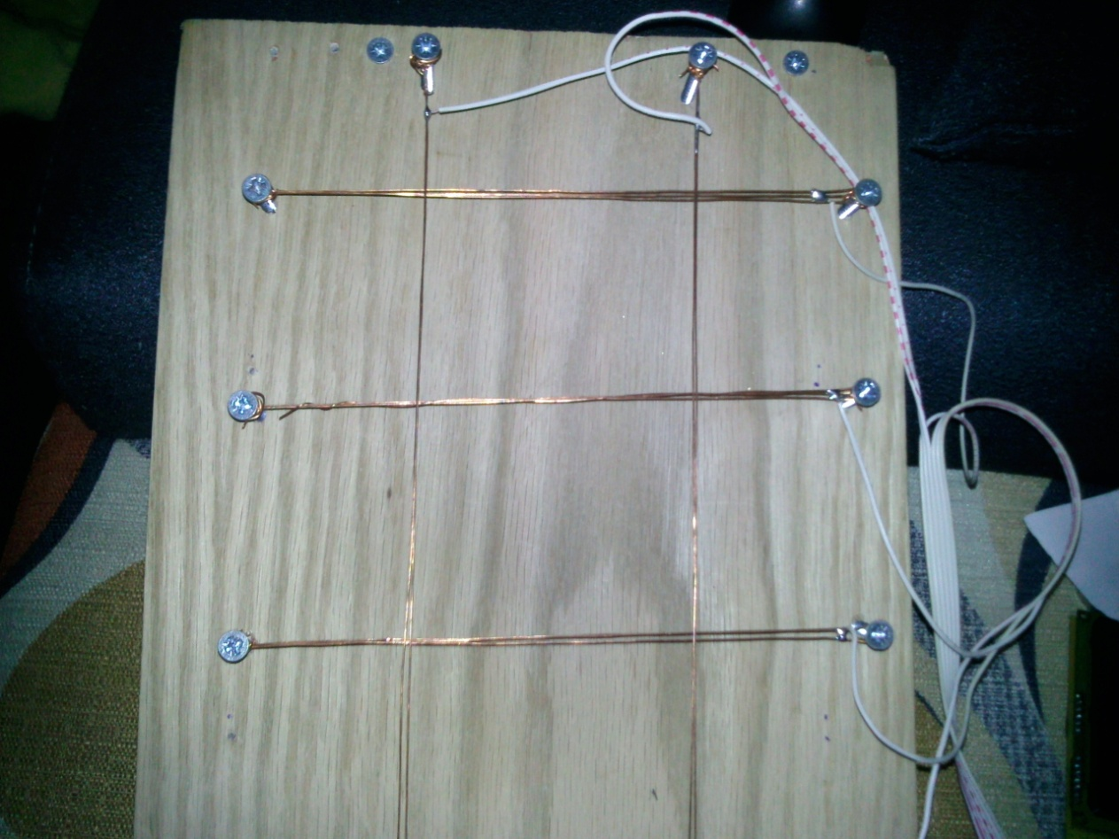

Picture # 5

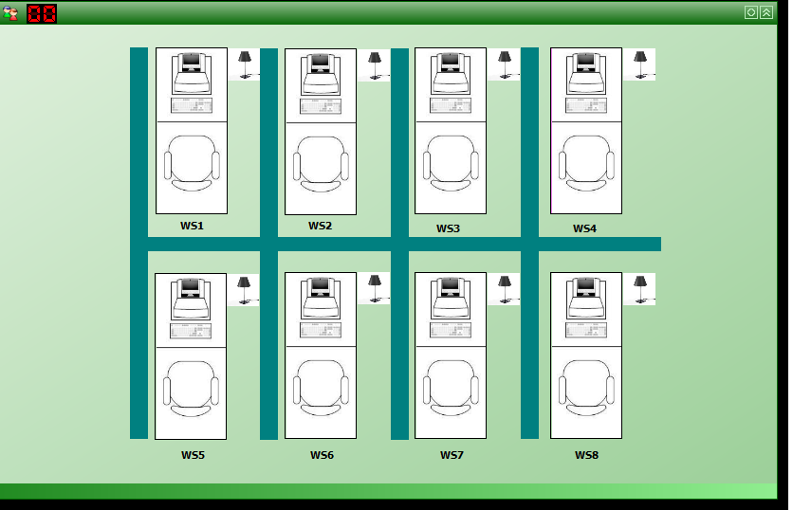

Picture # 6.

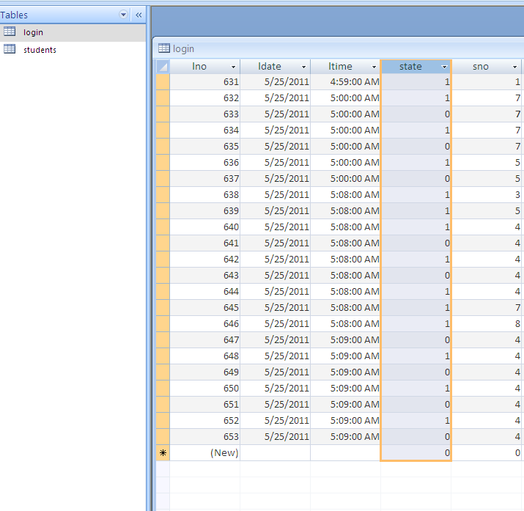

Picture # 7.

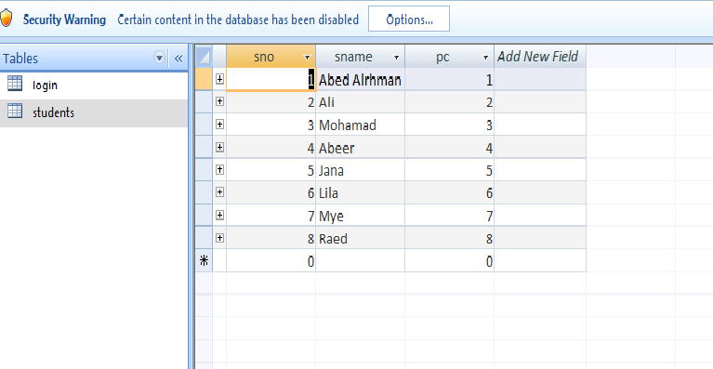

Picture# 8.

Other pictures

