Introduction To Stock Riders
STOCK RIDERS is one of the first steps to guide individuals and improve their ability to invest in the stock exchange and to avoid any wrong ideas about investment in the stock exchange. This game aims to enable players to live the real investment environment and to know many aspects of investing in the stock exchange without real financial loss and with the highest degree of entertainment for players. It is a simple game that simulates the real trading with the real prices of trading of the Cairo & Alexandria Stock Exchanges. Through this game the player is able to take correct investment decisions, either buying or selling, within the competition round and all this in a competitive and exciting atmosphere.
It is worth saying that STOCK RIDERS is reachable through the technology clubs of the Ministry of Communications according to Alexandria Stock Exchanges and many foreign countries in the different places of the world
Finally, the player of STOCK RIDERS will gain experience of investing in the real stock market with the knowledge he acquire from participating in this game.

How to Participate:

- Sign-up and fill the required information in the registration form using an active email account to receive an email from STOCK RIDERS team to activate your trading account in STOCK RIDERS.
This is the sign up forms that you should fill required information in it :
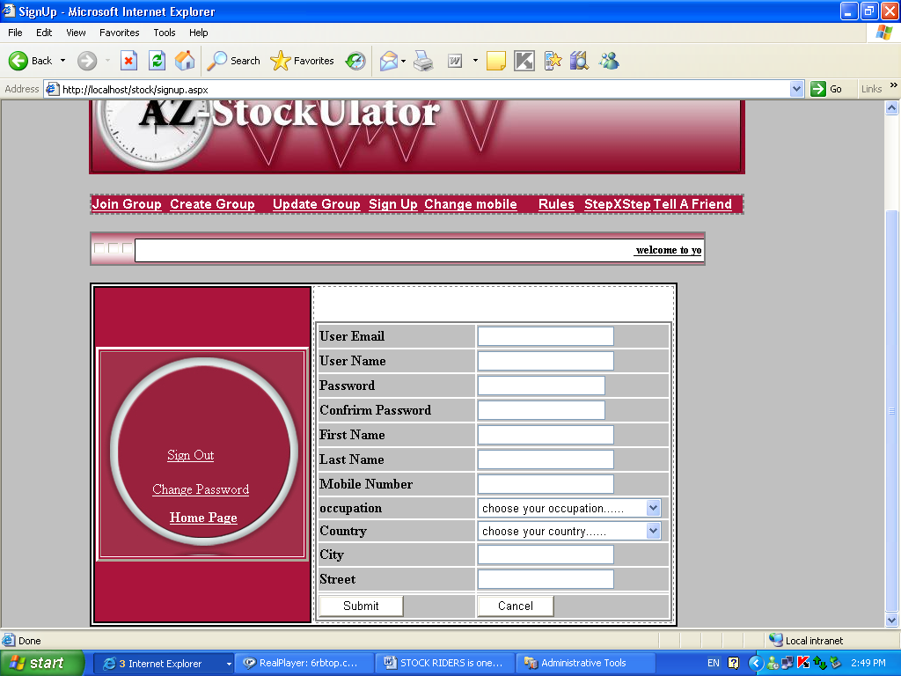
This email is a confirmation that you are now registered in the competition round of STOCK RIDERS.
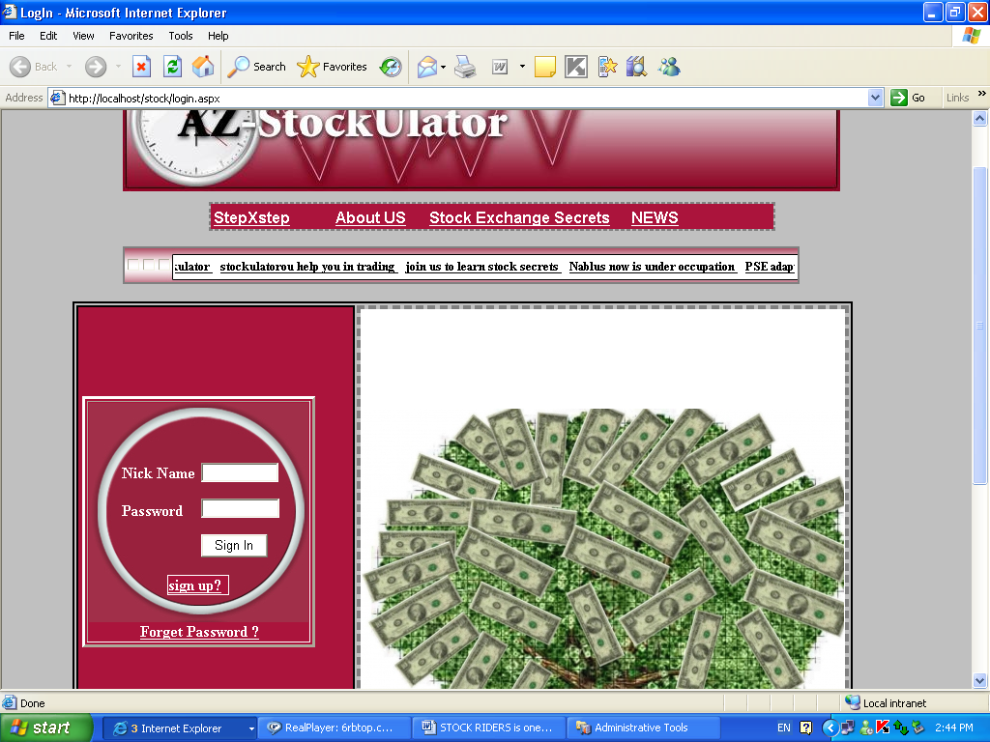
- All players must register and comply with the Game Rules as well as the terms and conditions of the STOCK RIDERS website.
- A player can only register once per round thus holding one portfolio per round.
- Winners of the game must confirm that they have adhered to the Game Rules.
- You shall be the only authorized user of the services provided under these Game Rules and you shall not allow any other person to access your account. You shall be responsible for the confidentiality and use of your username and password. You shall be solely responsible for all orders entered in STOCK RIDERS through the use of your username and password.

. Game rules
- Each player begins the game with LE 100,000 (virtual).Trading (buying/selling) is based on actual daily prices of shares. Trading (buying/selling) is based on actual daily prices of stocks.
- Trading hours will replicate the market hours of CASE with 20 minutes delay from the actual trading time for example id the trade is from 12:am to 2:00 pm, this means that trading in the game will start at 11:50 am and end at 1:50 pm, through all the days.
- When an order is placed before/after trading hours: Order placed when the market is closed will be pending in the outstanding orders table (in the trade page) until we have the same price from player who wants to buy and player who wants to sale stocks). In the event that a player does not have enough cash or shares to complete the total order, the order will not be executed.
- A 0.05% brokers fees ( commission) is charged for all trades.
- Winners will be determined on the basis of their portfolio ranking at the end of the final day of each round.
- "Portfolio ranking" is calculated using the following formula: Cash + Portfolio (total value of owned stocks)- Brokerage fees.
- If you do not "log-in" for a period of 10 consecutive days, your account will be closed, and you will lose any progress you had made.
- At the end of each round and after identifying final ranks of players, all portfolios will be reset to zero. The player cannot participate in the next round holding his old portfolio.
- in this Game we have 2 types of news :
public news ( at groups level ) and local news ( at specific group )
First : How to start a new group or join an existing group :
- The group leader :
- Sign-up for an account.
- Access (Groups) page & fill the required info to start a new group.
- The group will be activated only when 50 or more players join it. The group is activated by stock riders group team who send an email for the group confirming the selected dates of the round. This email is sent within 5 working days from the date where the group reaches 50 players.
- The players could join any group after signing-up by going to joinGroup Form:
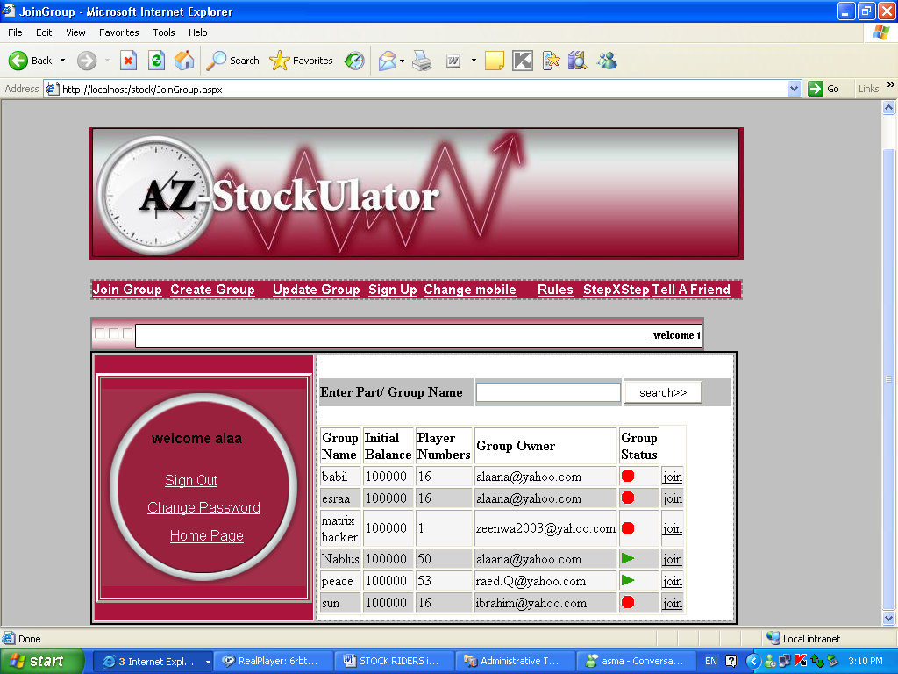
Note that the group activate/ dis-activate according to player numbers and also according to start and end date of the round (group period)

Now after you join group , you are one of the players in this group and you have 100,000 $ as an initial balance in this group , also your liquidity ( which is your imaginary pocket which decrease / increases according to your offers although the transaction happens or not )will be 100,000 $ , and the actual value ( which is your real pocket that decreases / increases if the transaction occurs ) will be 100,000 $ ,
Also Player Can be leader of group by creating group and so he will become the leader of it ( he can change the trade date and time of it ) but he can’t make trade time more than 2 hours Aday :

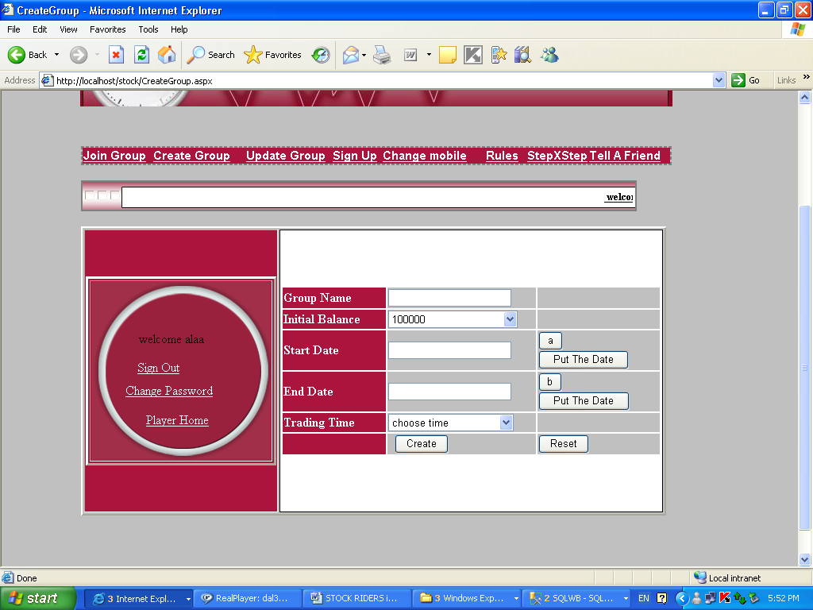

After you join group you can enter it by going to HomePage and see your joining groups with your summary account in it as this table:
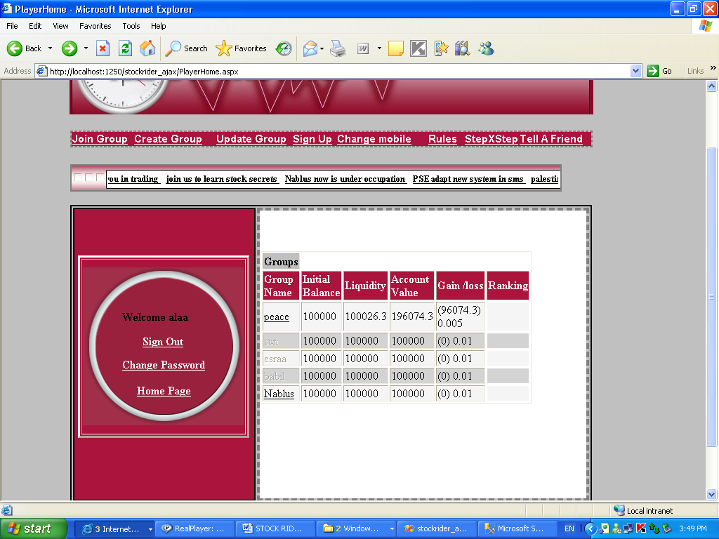
If the group name link is activated that means that this group has more than 50 players and TodayDate is between start and end Date of this group
If you click the activated group the Group Room Form will be opened to you,
This form is included the high companies and low companies according to its current stock price comparing with today opened price
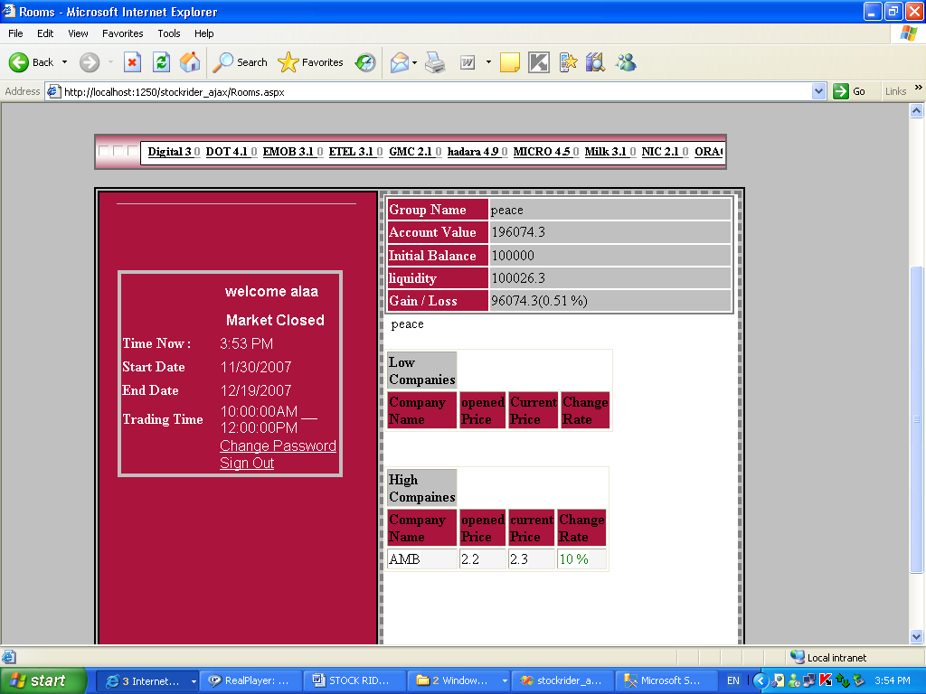
When you enter any group , you will notice that each page is designed using ajax , and you will not need to make refreshment each time , so your pocket , stock companies price …. Etc will be changed automatically
Also when you enter group , you will have 2 types of tickers :
1-local news: which contains the group news ( e.g. new company enter peace market , ‘A’ company sold its stocks ….etc )
2-stock ticker: this includes today current price and the variance changes in the stock as follows.

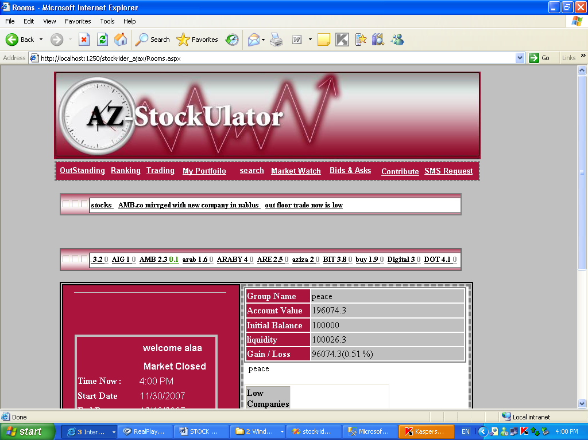

And also you will see the market state: time , start date , end date ( market state ( pre opened , opened , pre closed and closed )

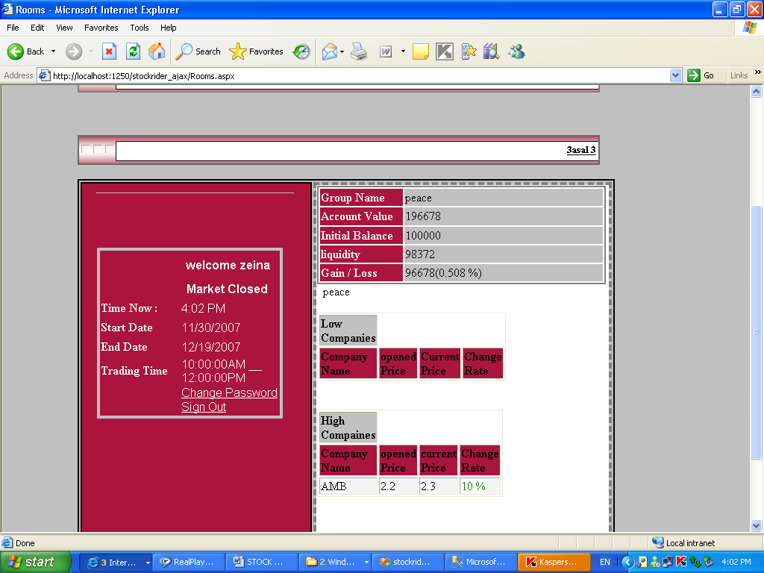
Now if player wants to trade, he can go to trade form or first go to search then trade form :
- Don’t forget to check the basic information and share price history of the company that you want to buy or sell its shares through (Search) page after you log-in.
Look at search page which shows the state of the companies (opened and closed price, buy and sell price, volume) according to section that they belong to (telecommunication, holding …etc) or according to first letter/letters in it:
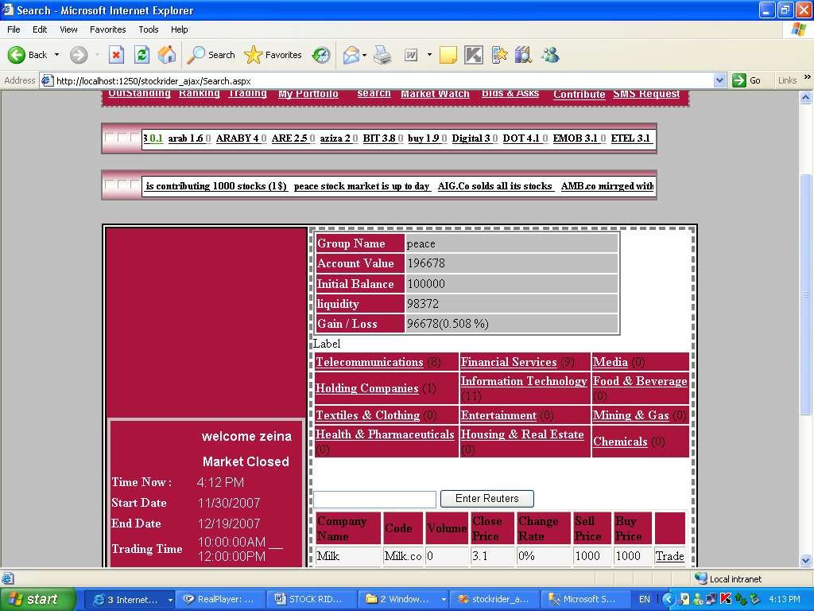
So you can goes to trade form using trade link in the search form:
HowTo Trade:
In this form you can see many tables:
One of these tables is your stocks table: which displays how many stocks you have in this group and your buy/sell stock price in that day as follows:
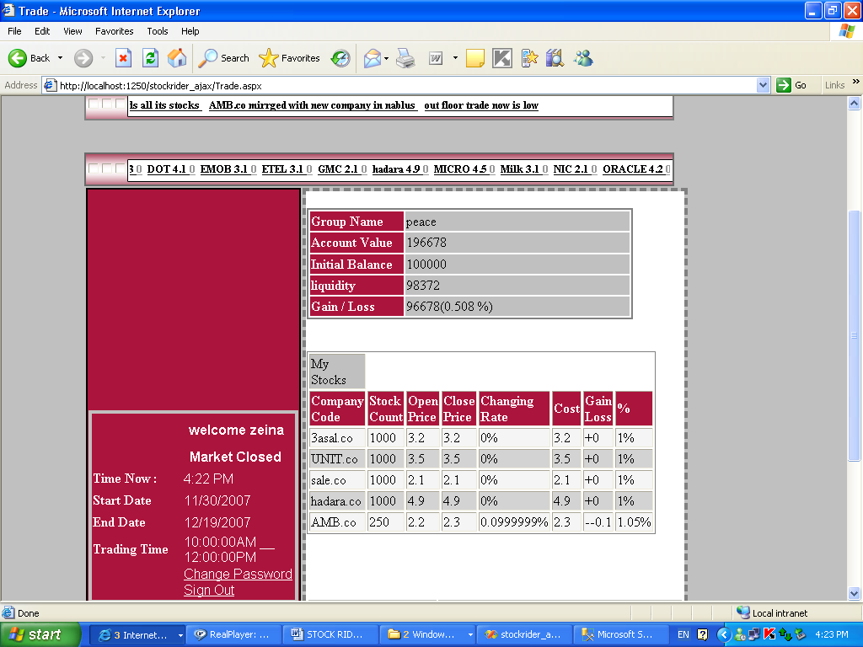
Also you can make search about today stock buy/sell orders according to stock Reuters (e.g. paltel.co …etc)
And you trade by choosing company name and click offer button as following:
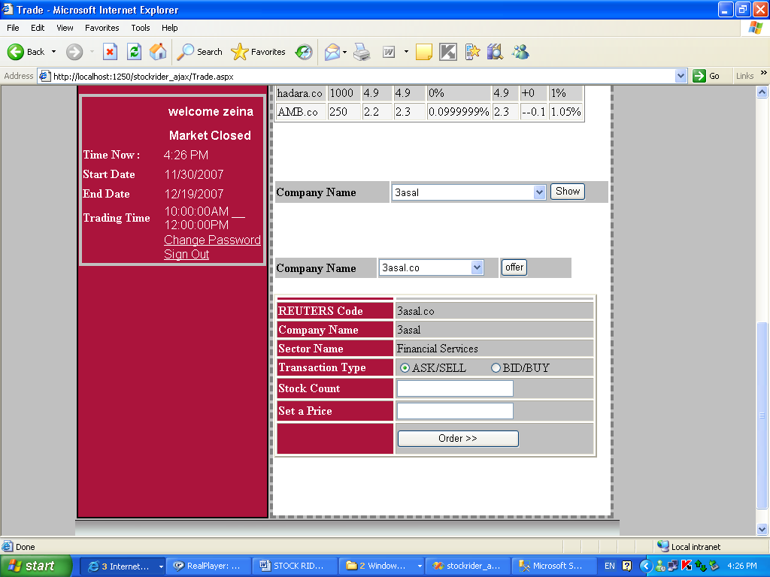
All restrictions are made in this page (price restriction , number of stocks according to your pocket and state market state ) which is the largest code in this project, when you make trade either your offer will be discarded ( deleted ) because it doesn’t suit the market restriction or it will be in outstand buy or sell , or it will be under execution and it suits all the restriction in this market .
- Be aware of dividends announcements, you can increase your cash balance by buying in a company that distribute dividends during the current round.
- Buy or sell transaction must always affect the cash balance immediately i.e. if you don’t have enough cash you will have to sell first in order to be able to buy again.

Important notes in trade:
- To ensure more flexibility in STOCK RIDERS game, we limit the trading to the 100 most active companies in the market.
- In case the 100 most active list was reviewed during the round, it will not affect the game. The change will occur in the following round.
- According to the CASE trading regulations, the price of each stock is restricted to a 5 % ceiling / floor from its previous closing price during the trading session, and this ceiling is removed only when corporate actions are undertaken.
The trade will be executed between 2 players or more if there is two or more offers with the same offer price , discarded the number of stocks for each player offer stock , for example if player ‘A’ is make buy offer for ‘paltel’ stock ( 100 stocks in 2.5 $ ) and player ‘B’ make sale offer for ‘paltel’ stock ( 50 stocks in 2.5 $) then the transaction between these 2 players will be done ( 50 stocks in 2.5$ ) and the remaining 50 stocks for player ‘A’ will be in the buy outstanding table…
You can go to your outstand form to see your buy/sell outstanding
And your buy/sell order that it is under execution as follows :

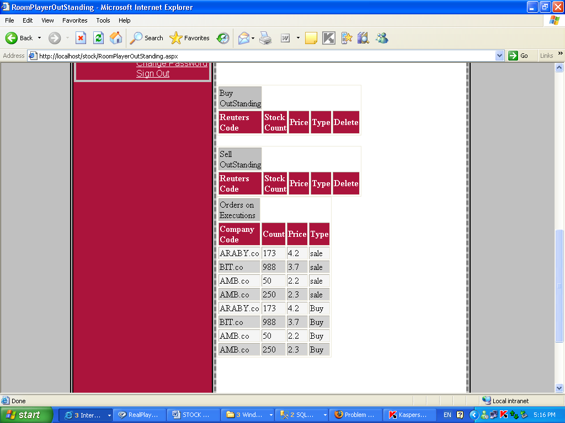

Also you can see your rank according to Players in this market as follows:

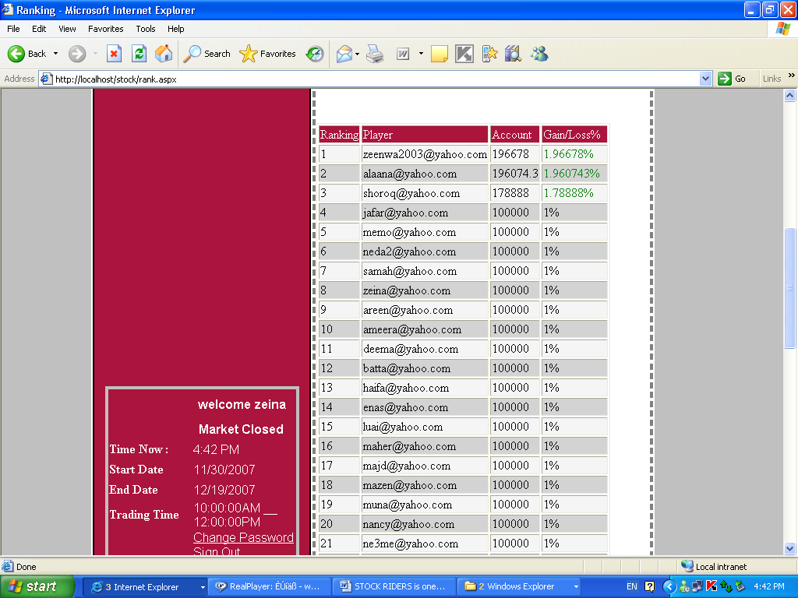

We have new service to players which is SMS service , so players can left there sms offer to choosen company/companies and specific price , so when company stock price reaches this price , the sms will be delivered to the player mobile so that he can inform about the stock state although player is outdoor as the following
:
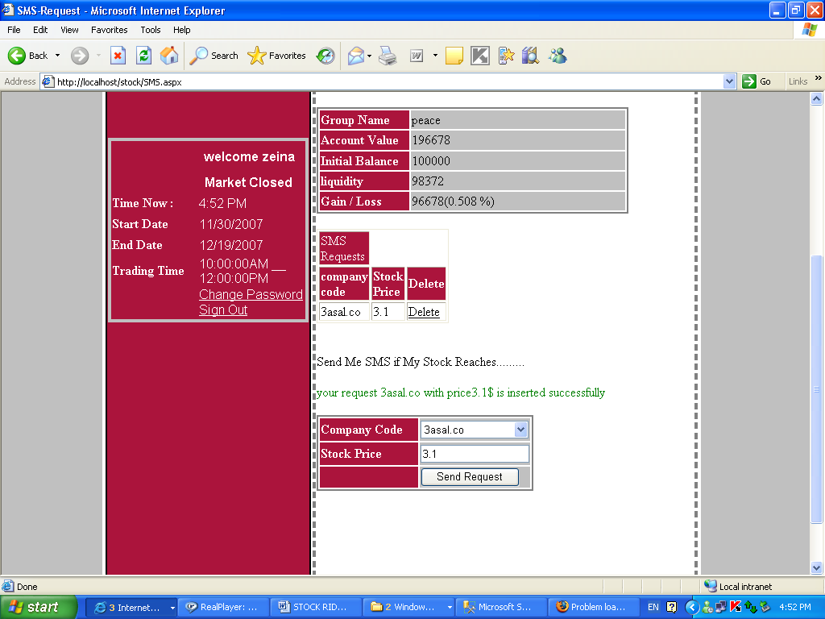

Now you can see the online market watch which changes each second according to buy/sell offers as the following:

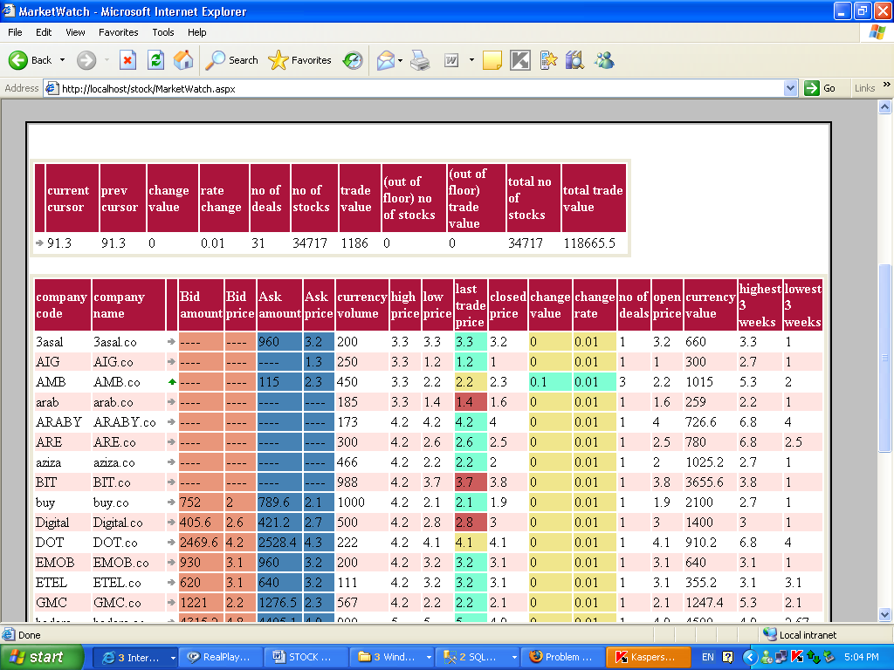

also you can show the total price / volume prices in 3 weeks ago or the current year or previous year by going to the total Volume & prices charts for all company stocks in this group ( the charts diplay the relation between day of the week ( x-axis ) and the value ( price or volume ) which is y-axis as following:

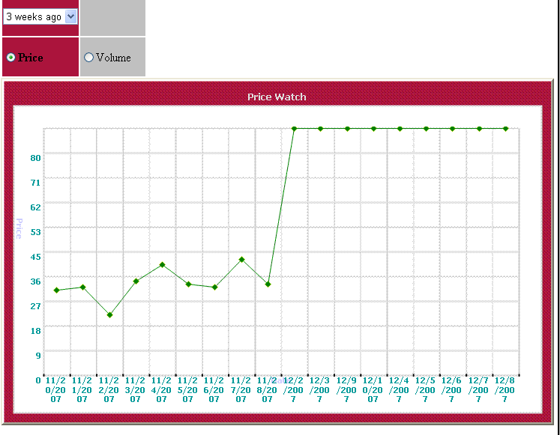

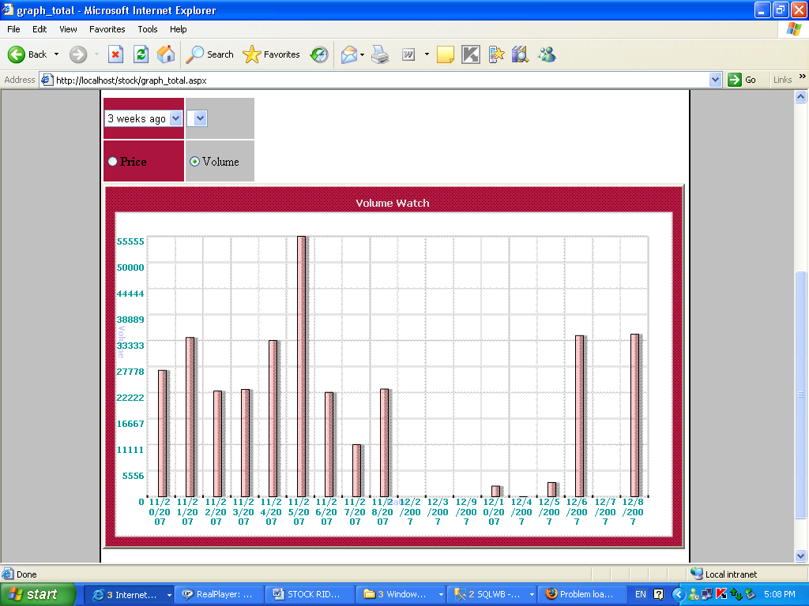
The same for ( at year choice ) but it differs because you can choose specific year ( 2007 , 2006 , 2005 , …..etc )

Also you can see the price/ volume for specific company in this stock and see the price/volume for the choosen company ( at 3 weeks ago or at specific year as follows:

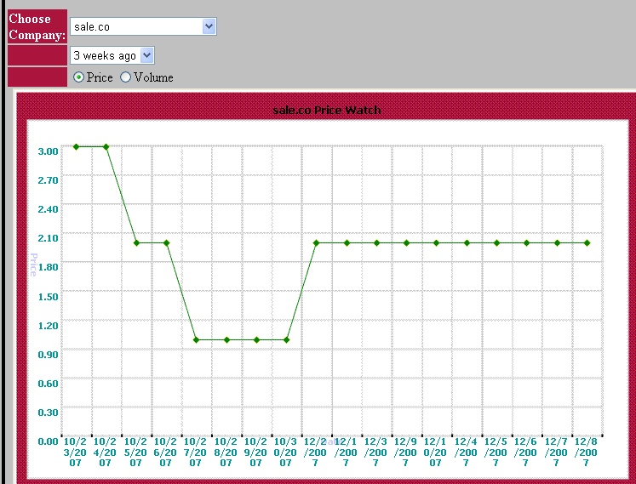

Also you can see the current volume/price for specific company in this group in the same way (chart)

Also you can see bids / asks offers for specific company by going to asks & bids forms which shows this informations as follows:
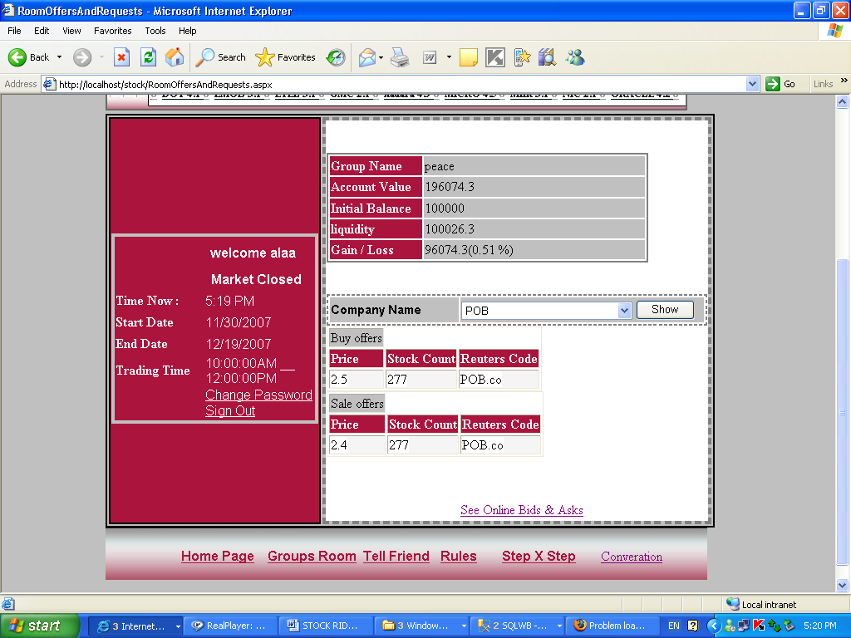

Also you can go to see Online bids and asks by clicked this link as shows above which will open this online Asks which changes evry 5 seconds.

What is Contribution:
Contribution is this operation that will done when new companies want to enter the specific market , so this company will contribute specific number of stocks e.g. 1000000 stocks and stock price is 1$ and when the players buy these stocks it will enter the market .
User can contribute by going to contribute form:
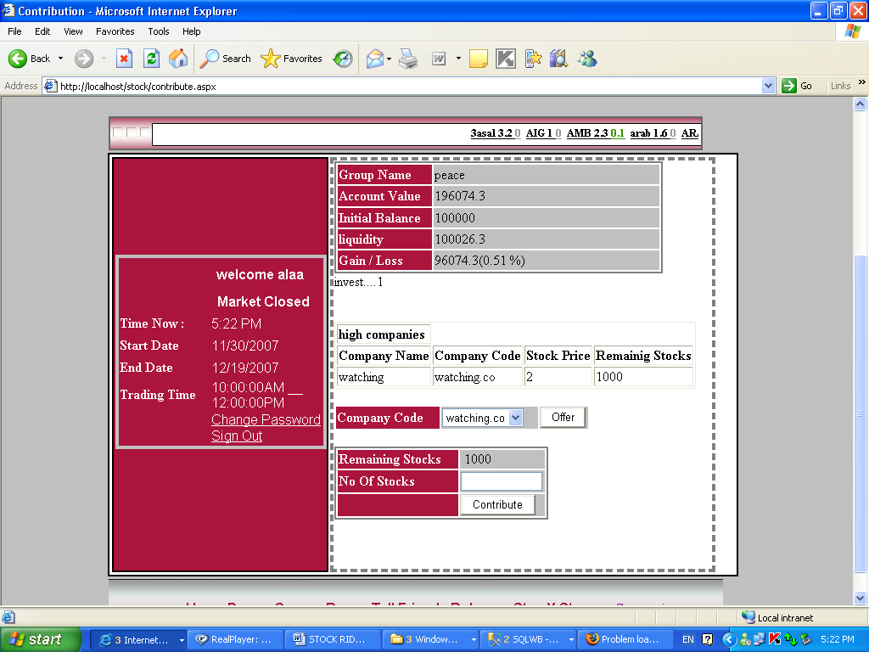

Also Players can ask questions about trading to administrator by going to conversation page

Administrator Pages:

Before we talk about administrator we will inform you that admin can’t change stock prices, only players can change stock prices by sell/buy offers with low or high prices.
All groups will be shown to Administrator: and when he clicks group link he will see (high companies /low companies) as players, but the additional thing is that admin can see the group players and some information about them as follows:
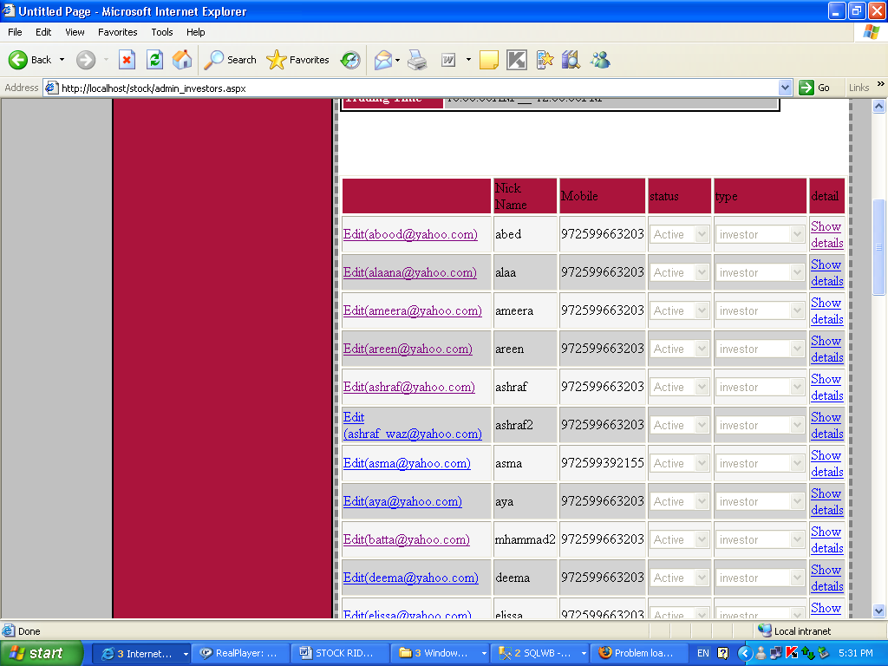
Adminstrator can change the group end/start date and end/start time as he want ( he can make trade time more than 2 hours for any wanted groups ) as follows:

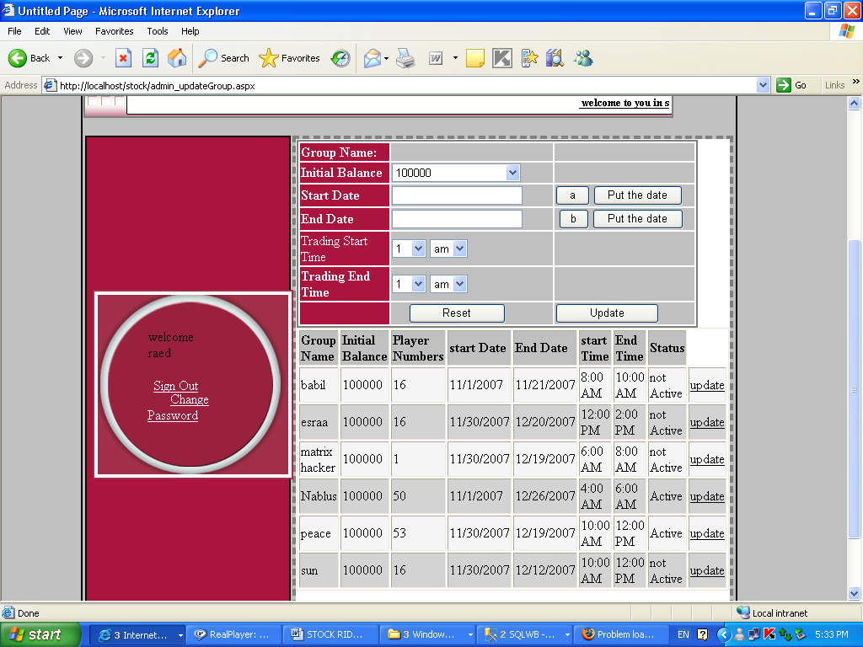

So by choosing any group he can update it , also admin can create new group as players ( and he becomes the leader of it ) but he differs from any other players because he can make trading time more than one hours , also admin can delete any group ( market ).

Only the admin can create company ( and when he creates company it will enter contribution state that we talk about it in the previous pages )

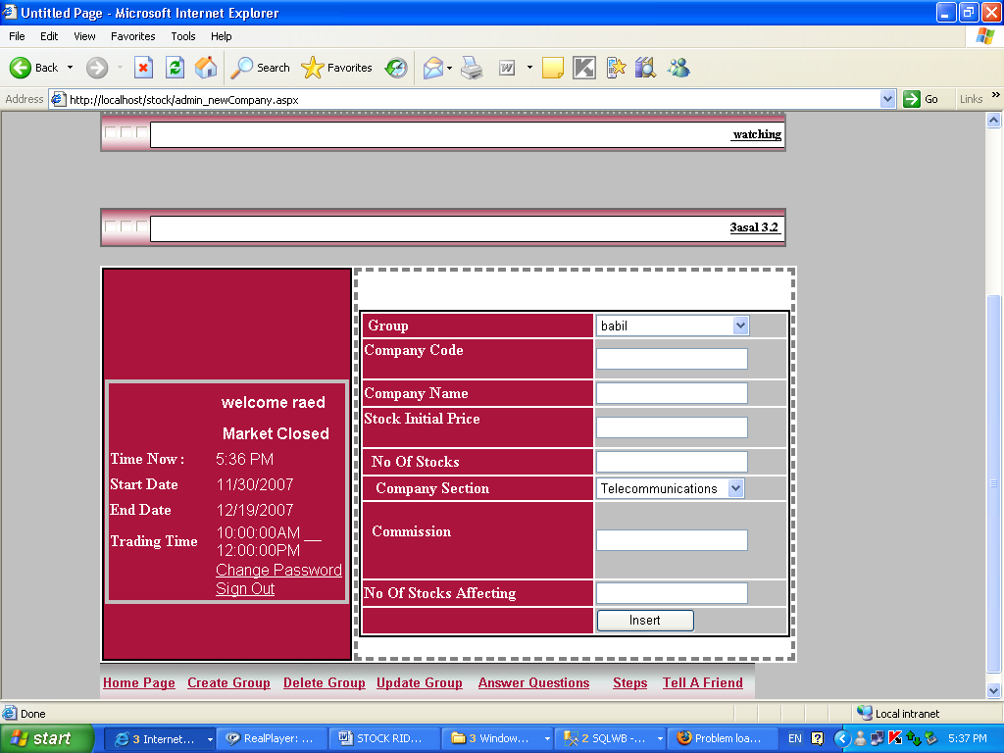

Stock Initial Price and No Of Stocks are the details that is needed for contribution, No Of stocks Affecting is the number of stocks for this new company that affect the stock price, e.g. if No Of stocks Affecting is 50 stocks and Players ‘A’ and ‘B’ make transaction in 60 stocks then the stock will be changes to the transaction price, but if they made transaction in 40 stocks then the transaction will successfully happen but the stock current price will not be changed ( it will remain as it is )

Admin also can delete any companies that he want in the chosen group.
Admin can insert Public / local news and players can see them in there pages.
Admin has the ability to answer questions that are asked from players in there pages and the players will see the administrator answers:

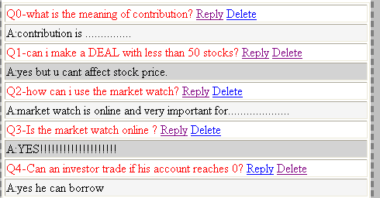

This is the general idea about the stock rider hoping that you join reading it and you understand it carefully

With Our Respect To You

Done By: Zeina Abu-Aishah
Alaa Namoos

In The Name Of Allah

Faculty of Computer Engineering
Al-Najah University

Educational Online Stock Riders project

Prepared by
Zeina Maher Abu Aisheh

Alaa’ Khaleel Namoos

Supervised By:
Dr. Raed Alqadi
Dr.Lo’ai Malhis
Eng. Haya Sama’ne

December 2007

