Content List
Abstract…………………………………………………………….…4
1 Introduction ……….………………………………………..……5
1.1 Overview …………………………………………………………5
1.2 Existing Problems …………………………………………….6
1.3 Related work ……………………………………………………7
1.4 Motivation for Carrying out project ……………….…8
1.5 Main Contribution ……………………………………………...8
1.6 Report Organization …………………………………………...9
2 Methodology ……………………………………………………..10
2.1 Connection Methodology ………………………………………10
2.2 Communication Steps ……………………………………………..12
2.3 Android Application………………………………………………….13
2.3.1 Login Activity…………………………………………………………..13
2.3.2 List View ………………………………………………………………….14
2.3.3 Functionality ……………………………………………………………15
2.4 Server Application…………………………………………………….16
2.4.1 Local Transferring……………………………………………………..17
2.4.2 Transferring via internet…………………………………………….20
2.5 Host “PC” Application …………………………………………….22
3 Result and Discussion ………………………………………….23
4 Conclusions and Recommendations …………………...24
4.1 Conclusions ……………………………………………………24
4.2 Recommendation ………………………………………………24
5 References ……………………………………………………..….25
6 Appendix ………………………………..……………….………….25

List of fingers and tables

Figure 1: Connection establlishment 11
Figure 2: Login activity 13
Figure 3:ListView activity 14
Figure 4: Thread operation Error: Reference source not found
Figure 5: local network Error: Reference source not found
Figure 6: local network transfer algorithm Error: Reference source not found
Figure 7: different networks. 20
Figure 8: Public transfer algorithm. Error: Reference source not found
Figure 9: host PC application interface Error: Reference source not found
Table1: Packet information ……………………………………..………………………………11

1 Abstract

We are going to build a system that enables us to transfer files from a host desktop using an android operating device.
Technically the system is divided into three parts; the first one is the application on the android device that will interact with the host PC. The second part is the server that will play a role in authenticating the connection between the android device and the remote PC using a customized database engine, and the third part will be the C# application on the host pc that respond to the android device requests, either locally directly from the android to the host PC or remotely through the server.

1 Introduction
  - Overview
This project is an Android application that accesses the PC to get some files. When user logs to the application, the server authenticates the information and connects both sides “PC side and android side “, then the PC responds for a list of files that exists inside a certain directory in the host file system via customized protocol that we build from the scratch. When the android user requests a file, the PC starts sending file until transfer operation completes.

  - Existing Problems
The real problem relies on how to connect the PC to the android device and send information from the Host to the client.
Another issue is that the project is divided into three different applications each application is installed in a different device, one on the server, other on the host PC, and the last one on the android device. This makes it difficult to synchronize communication between host PC and client Android through server.
Taking into account the differences between operating systems and how to guarantee access to all files and sub directories inside the shared directory on the host PC.

  - Related work
The idea of the project itself is not totally new, since android development in general is easy to learn. Thus android market place offers huge amount of free applications and commercial ones.
In market there are many application that provide remote accessing to PC such as “pocket cloud remote desktop pro “that has gained about 30,000$ in about two months.
Also ” drop box “company offers an application that provide accessing user’s files through a certain storage in “drop box “ servers by keep synchronizing files and folders inside “ drop box “ directory on the host PC .
Also there are many different applications that offers a remote accessing to the pc .But most of software vendors are trying to make something that attract users to get there products, so in this world of competition we plan to do something attractive and provide good performance so users prefers our product instead of others outside in the market.

  - Motivation for Carrying out project
We are motivated to build such an application because this application provide a very useful services such as not to be concerned with coping files you need from your desktop or laptop , grab a forgotten document ,and accessing your files no matter where you are .

  - Main Contribution
The main object of our project is to supply the user’s a remote PC access through android device. And also we can apply our idea to so many similar projects since we have established a remote access to the PC.

  - Report Organization
In this report we start with an abstraction of our project then small introduction about what the project does.
After that the methodology we wrote about everything we does and the main ideas we use them in order to achieve the goals of this project.
And at last we considered the result and the challenges we face for achieving this software.

2 Methodologies
In this chapter we will discuss the way in order to approach our target, and how we develop all of the software that represents the goals of the project:

2.1 Connection methodology
First of all the server keeps listening for connections from android and PC devices, then both the android device and the PC sends information to the Real IP server , after the TCP connection is established with the server, the server authenticates and start receiving commands from the android device and requesting them from the host, depending on the command .
When a file is requested the server sends the request to the host and then start receiving from it. At this point we have to choices:
- Receive all the packets on the server and wait until all the file is received then start transferring it to the android device
- Or to ‘Bridge’ each packet received from the host and send it immediately to the android device.
We choose to go with the second choice because we want to build our own functionality and achieve the maximum performance. Figure 1 shows how the connection is established.

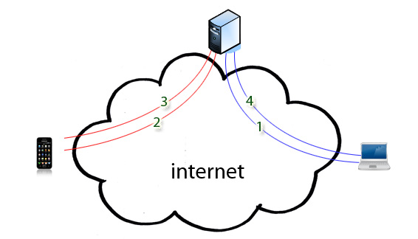
Figure 1
- PC establishes connection with the server.
- Android also sends establishes a connection with the server.
- After any request PC start sending information to the server.
- The server bridges received packets to the android device.
Note that a connection packet contains:
Control command
Username
Password
Private IP
Public IP
Table 1

2.2 Communication Steps
Before start transferring file. Establishing communication and transferring goes through the following steps:
- Android establishes a connection with the server and send communication information.
- PC also establishes connection with the server and sends information
- Android requests PC IP from the server, if both devices are in the same network, server returns private IP of the host PC, if not server returns public IP of the host PC.
- Android sends a packet to the host PC to request files & directories information.
- The host PC responds with an array containing file names and other information about files and directories in the host shared directory.
- Android requests a certain file from the host PC
- PC start sending file as a byte array to the android device through the server until transferring the file completes.
- Repeat steps from 4 – 7 when android device asks for a sub directory.
2.3 Android Application
2.3.1 Login Activity
At first we build a login interface for the user as shown in figure 2 below, the interface lets the user to login using a username and password ,after that the application will send information to the server to establish the a connection with the appropriate host PC.
The same interface is used also to sign up for a new user if this user uses the system for the first time.
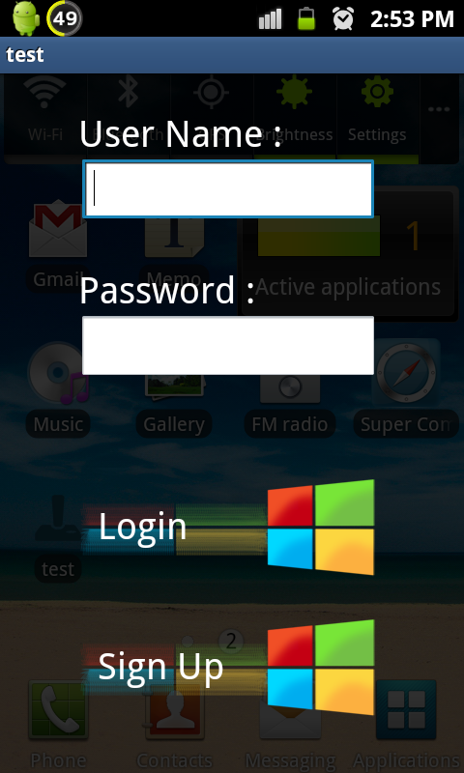
Figure 2

2.3.2 List View
After login in our application will receive a list of files that exists in the PC, then the application will show files in a custom list view that we built using a one block item that serves our purpose. Fig3 represent how the files will be presented in the list view, and the list view block details.

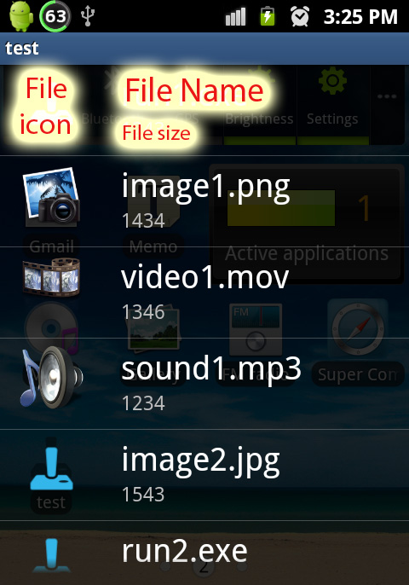
Figure 3
When the user clicks on a certain file, a request will be sent to the server to request the file form the host PC, and then start transferring the file until transfer completes.

2.3.3 Functionality
When user presses the login button a packet is sent to the server containing command, username, password, private IP and local IP as mentioned in table1.
When user request a file, a command is send to the host through the server – in case of transferring via internet -, and after that start receiving file. Note that at this point the file size is critical issue that we have to deal with, since android heap size is small even for new android phones such as “Samsung Galaxy S3”.The heap size is limited up to 67 megabytes, and we want to transfer files bigger than that even heap size is limiting us.
Another issue is: when filling the heap to its maximum size, the performance of the android device decline because the memory becomes insufficient to run other applications correctly.
Our solution was to take only 5 megabytes of the heap , so every time the application receives 5 megabytes of data , the application appends them to the file and keep the file open for the next 5 megabytes , until all the file is received .
This way we can transfer files bigger than maximum heap size since we keep transferring chunks of the data ,and appending them to the original file .
Also the memory itself is not totally used by the application since we only reserve 5 megabytes of the memory and will not worsen the performance.
2.4 Server Application
Server application is a standalone application that keeps listening to connections forever.
When android device connects to the server, the server saves username and password in the database – custom database using arrays- . Also the server looks at the public IP and the private IP for the device, and detect if they are at the same network, or on different networks.
The server application keeps track of all hosts if they are active “connected to the server “or not active. So when an android device requests for a certain host the server establishes connection in case the PC is only active.
Every connection received by the server is handled to a new thread – if there are no ideal threads- , and the server synchronizes the communication between these threads, so the server knows how to forward packets. The following figure – figure 4- represents thread operation in the server.
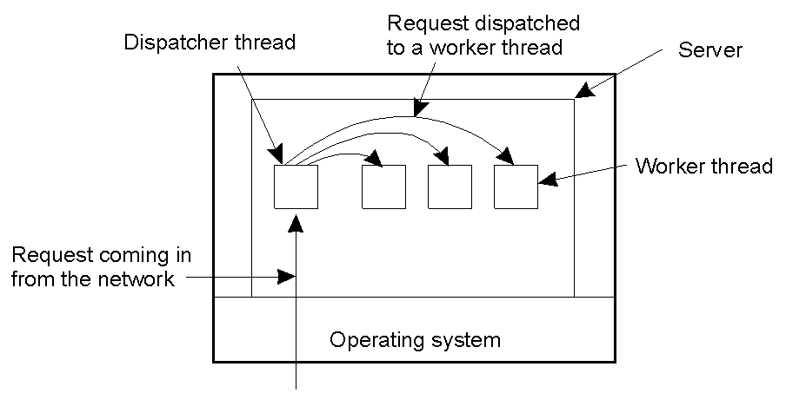 Figure 4

2.4.1 Local Transferring
When servers looks at the public IP for the android device and the requested host, if the public IP for the two devices is same, that means both devices are in the same private network, here the server sends the private IP of the host to the android device so the transfer is done locally .Figure 5 shows a remote PC and android device connecting to the server through the same local network.
.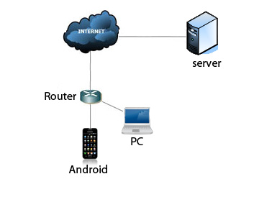
Figure 5
At this case transfer is done locally since android knows the private IP of the host PC, And so the transfer speed will reach local network speed, in our case the average speed is around 1.9 megabytes / second.

If we compare the speed achieved in our application with the speed that “drop box” offers, the speed of our application will be maximum in local network while for “drop box “it will be max internet download speed.

The first scenario was when the android user has an internet connection and tries to remotely connect to PC while both devices are in the same network – has same public IP - .
Another scenario is when the user has no internet connection and wants to remotely access the host PC in the same private network; at this case there is no server to establish communication between host PC and android device, so our application provide an interface that lets the android user to enter the private IP of the host PC and connect to it directly without the need of the server then start communication through local network.
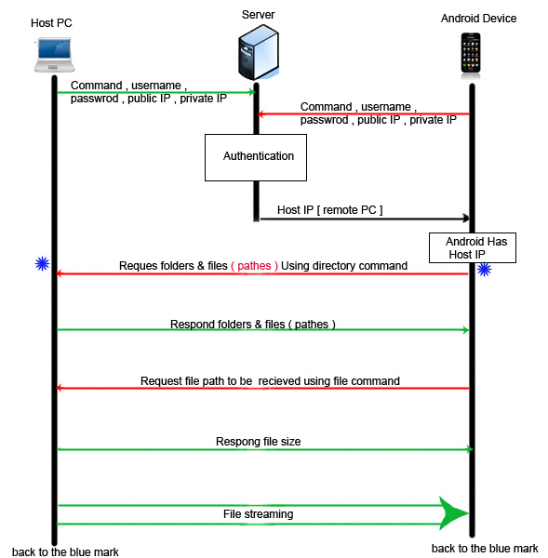
Figure 6
Figure 6 represent the algorithm of our project in case both host PC and android device are in the same network – have the same public IP -.
2.4.2 Transferring Via Internet
At this case both host PC and android device are connected to the server from different networks, since public IP for each device differs from the other. This is the general case that we build our application to rely on. Figure 7 represents internet communication model for this case .

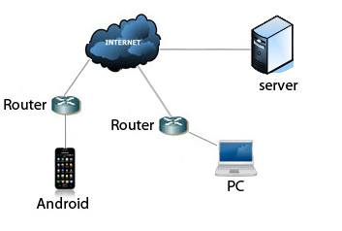
Figure 7
As shown in the previous figure, host PC and android device are in two different networks , here all the communication is done through the server – server forwards received packets from one side to the other - , which is the same communication technique used in “Skype” .
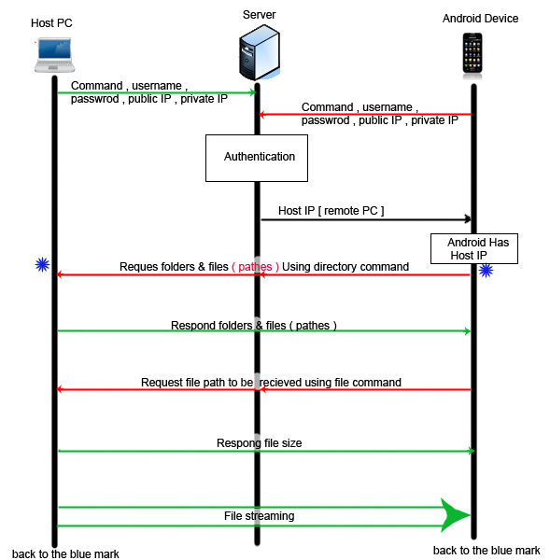
Figure 8
Figure 8 represent the algorithm of our project in case both host PC and android device are in different networks – have different public IPs -.Here server bridges all packets received from one side to the other.
2.5 Host “PC” application
This part of the project is a C# application that allows the user to authorize access to a certain directory and sub-directories of the shared directory. This shared directory can be changed flexibly by the user using a browse button on the screen , also the application shows the private IP and port that the application uses , this helps the user to identify the private IP and port in case of offline connectivity .
Note that Host application is easy to use since the application needs the user only to install it and specify the shared directory to allow outer android device to access it. The following figure – figure 9- shows the interface of the host application.
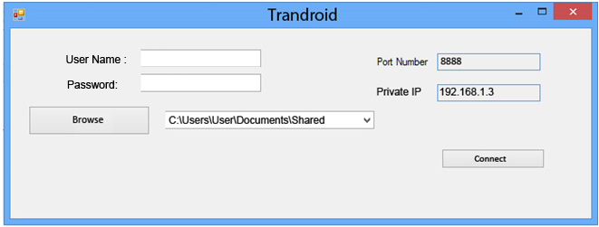
Figure 9
3. Result and Discussion
The project applies a remote access with full functionality of transferring and get files from a certain directory on the host PC to any android device that authenticates access through internet or through private network.
The main objectives that we resolve while carrying out the job are:
- Synchronization between different applications running in different machines, and communication between threads.
- Keep track of memory size while developing android.
- Develop a transparent and attractive interface for the system to take user’s attention.
- Use local network rather than transfer via internet in case both sides are in the same network.
- Achieve maximum transfer speed.

4. Conclusions and Recommendations

4.1 Conclusions
This project was undertaken to design a system that provide a service to android operating devices to offer encapsulated access to files and sub directories that user defines in the host PC .

4.2 Recommendations
For future work on this project it is better to develop any android system in a real machine, because virtual machine in general are slow and took a lot of time to give the appropriate results.

5. References

1. http://developer.android.com
2. http://stackoverflow.com/questions/7335317/file-transfer-in-android
3. http://stackoverflow.com/questions/8298100/simple-tcp-listener-thread-for-android-mine-doesnt-connect
4. http://myandroidsolutions.blogspot.com/2012/07/android-tcp-connection-tutorial.html
5. http://stackoverflow.com/questions/9745765/how-can-i-design-tcp-messages-listener-in-my-android-client
6. http://androidcookbook.com/ChapterView.seam;jsessionid=07C4F526 125CB648882FD2019011EB9B?chapterId=1873&cid=4470
7. http://stackoverflow.com/questions/8741409/android-listview-row-backgrounds-causing-outofmemory-issue
8. http://www.albahari.com/threading/
9. http://www.java2s.com/Code/CSharp/Thread/ThreadPoolTcpServer.htm
10. http://stackoverflow.com/questions/8926864/android-socket-file-transfer
11. http://www.helloandroid.com/tutorials/simple-connection-example-part-ii-tcp-communication
12. http://www.winhost.com/index-basic.aspx?gclid=CN2TlMeHwLMCFcG_3godNx0ATA
13. http://codeincodeblock.blogspot.com/2011/11/tcp-client-and-server-sample-example.html
6. Appendix
A soft copy of the documentation attached is attached with the hard copy.

